UNITED STATES
SECURITIES AND EXCHANGE COMMISSION
Washington, D.C. 20549

FORM 8-K

CURRENT REPORT
Pursuant to Section 13 or 15(d)
of the Securities Exchange Act of 1934

Date of Report (Date of earliest event reported): August 6, 2026

REPLIMUNE GROUP, INC.
(Exact name of registrant as specified in its charter)

Delaware |  | 001-38596 |  | 82-2082553
(State or other jurisdiction  of incorporation) |  | (Commission  File Number) |  | (IRS Employer  Identification Number)

500 Unicorn Park Drive
Suite 303
Woburn, MA 01801
(Address of principal executive offices, including Zip Code)

Registrant’s telephone number, including area code: (781) 222-9600

Check the appropriate box below if the Form 8-K filing is intended to simultaneously satisfy the filing obligation of the registrant under any of the following provisions:

 | ☐ | Written communications pursuant to Rule 425 under the Securities Act (17 CFR 230.425)

 | ☐ | Soliciting material pursuant to Rule 14a-12 under the Exchange Act (17 CFR 240.14a-12)

 | ☐ | Pre-commencement communications pursuant to Rule 14d-2(b) under the Exchange Act (17 CFR 240.14d-2(b))

 | ☐ | Pre-commencement communications pursuant to Rule 13e-4(c) under the Exchange Act (17 CFR 240.13e-4(c))

Securities registered pursuant to Section 12(b) of the Act:

Title of each class |  | Trading  Symbol(s) |  | Name of each exchange on which registered
Common Stock, par value $0.001 per share |  | REPL |  | The Nasdaq Stock Market LLC  (Nasdaq Global Select Market)

Indicate by check mark whether the registrant is an emerging growth company as defined in Rule 405 of the Securities Act of 1933 (§230.405 of this chapter) or Rule 12b-2 of the Securities Exchange Act of 1934 (§240.12b-2 of this chapter). Emerging growth company ☐

If an emerging growth company, indicate by check mark if the registrant has elected not to use the extended transition period for complying with any new or revised financial accounting standards provided pursuant to Section 13(a) of the Exchange Act. ☐

 | Item 8.01 | Other Events.

On August 6, 2026, Replimune Group, Inc. (the “Company”) issued a press release announcing that the U.S. Food and Drug Administration has granted accelerated approval for TUDRIQEVTM (vusolimogene oderparepvec-wtpg), previously referred to as RP1, in combination with nivolumab for the treatment of adults with unresectable advanced cutaneous melanoma who experienced disease progression on an anti-PD-1 antibody-based regimen. Continued approval for this indication may be contingent upon verification and description of clinical benefit in a confirmatory trial(s). A copy of the press release is filed as Exhibit 99.1 to this Current Report on Form 8-K and is incorporated by reference herein. In addition, the Company posted to its website a corporate presentation in connection with the approval. A copy of the corporate presentation is attached hereto as Exhibit 99.2 and is incorporated by reference herein.

 | Item 9.01 | Financial Statements and Exhibits.

Exhibit No. |  | Description
99.1 |  | News Release dated August 6, 2026
99.2 |  | Company Presentation dated August 6, 2026
104 |  | Cover page interactive data file (formatted as Inline XBRL)

SIGNATURES

Pursuant to the requirements of the Securities Exchange Act of 1934, as amended, the registrant has duly caused this report to be signed on its behalf by the undersigned hereunto duly authorized.

 | REPLIMUNE GROUP, INC.
Date: August 6, 2026 | By: | /s/ Sushil Patel
 |  | Sushil Patel
 |  | Chief Executive Officer

Exhibit 99.1

Replimune Announces FDA Accelerated Approval of TUDRIQEVTM in Combination with Nivolumab for Unresectable Advanced Cutaneous Melanoma After Progression on an anti-PD-1 Based Regimen

Broad label to address high unmet need in advanced melanoma

Replimune will host conference call on August 6, 2026 at 4:30 p.m. ET.

WOBURN, Mass., August 6, 2026 (GLOBE NEWSWIRE) -- Replimune Group, Inc. (NASDAQ: REPL), a commercial stage biotechnology company pioneering the development of novel oncolytic immunotherapies, today announced that the U.S. Food and Drug Administration (FDA) has granted accelerated approval for TUDRIQEVTM (vusolimogene oderparepvec-wtpg), previously referred to as RP1, in combination with nivolumab for the treatment of adults with unresectable advanced cutaneous melanoma who experienced disease progression on an anti-PD-1 antibody-based regimen.This indication is approved under accelerated approval based on objective response rate and duration of response. Continued approval for this indication may be contingent on verification of clinical benefit in a confirmatory trial(s).

The IGNYTE trial enrolled 140 patients with 91 patients with at least one non-injected lesion included in the efficacy-evaluable population. In this population, TUDRIQEV plus nivolumab achieved an objective response rate (ORR) of 24.2%, with a median duration of response of 14.1 months. Treatment was well tolerated with mostly mild-to-moderate adverse events. The patient population included patients with Stage 4 disease (80%), prior anti-PD-1 adjuvant treatment (13%), PD-L1 negative status (54%), lung (45%) and liver lesions (24%). The IGNYTE study data were published in the Journal of Clinical Oncology and are available here.

“This is a transformative moment for Replimune, marking years of pioneering research to bring TUDRIQEV to patients desperately in need of new treatment options for advanced melanoma,” said Sushil Patel, Ph.D., CEO of Replimune. “We are deeply grateful to the melanoma community, including patients and investigators who participated in the clinical trial, for their tremendous support of this approval. We also would like to thank the FDA for recognizing the urgency to get this therapy to patients. Replimune is now focused on critical activities to deliver TUDRIQEV to as many patients as possible.”

There are limited treatment options for advanced melanoma, and more than half of patients experience progression within six months of treatment on immune checkpoint inhibitors like anti-PD-1 therapy. These patients face a poor prognosis, with a median overall survival of less than one year following progression.

“Advanced melanoma patients have few options after anti-PD-1 therapy and face high morbidity and poor survival outcomes,” said Michael K. Wong, MD, PhD, primary investigator of the IGNYTE study and Former Physician in Chief and Professor of Oncology at Roswell Park Comprehensive Cancer Center in Buffalo, NY. “With the approval of TUDRIQEV, we have a potent oncolytic immunotherapy that can be used in a broad population, including BRAF-naïve or pretreated, and adjuvant relapsed patients. Importantly, the therapy in combination with nivolumab drives immune activation with a favorable risk-benefit profile and can be injected into superficial and visceral lesions.”

“The approval of RP1 in combination with nivolumab is a meaningful step forward for patients with advanced melanoma who have failed to benefit from immunotherapy,” said Sam Guild, President of AIM at Melanoma. “Every year, more than 8,500 people die of melanoma in the U.S., and new treatment options are urgently needed.”

TUDRIQEV combined with nivolumab was well-tolerated. The most common (incidence ≥ 10%) adverse reactions in patients treated with TUDRIQEV combined with nivolumab were nausea, diarrhea, vomiting, constipation, decreased appetite, abdominal pain, fatigue, pyrexia, chills, injection site reaction, influenza like illness, infections, musculoskeletal pain, arthralgia, headache, dizziness, cough, dyspnea, rash, pruritic and hemorrhage.1 Most treatment-related adverse reactions were grade 1 and 2 and transient.1 There were no grade 4 or 5 common adverse events. See additional Important Safety Information below.

TUDRIQEV is administered via direct intratumor injection into superficial and deep and/or visceral lesions1. For deep/visceral tumors, administration is guided by imaging technology.1 The recommended dose of TUDRIQEV is based on tumor size.1

To verify the clinical benefit of TUDRIQEV, a confirmatory Phase 3 trial, IGNYTE-3, is ongoing and assessing TUDRIQEV in combination with nivolumab (NCT06264180). For additional information about the trial, please visit https://replimune.com/clinical-trials/ignyte-3/.

Replimune is committed to helping patients in the U.S. with advanced melanoma gain access to treatment with TUDRIQEV. Eligible patients who are prescribed TUDRIQEV will have access to ReplimuneConnect Plus, a comprehensive program offering information on access, reimbursement and financial support.

Webcast Details

Replimune will host a webcast featuring members from the management team to discuss today’s developments at 4:30 p.m. ET on Thursday, August 6, 2026.

Listeners can register for the webcast via this link. Analysts wishing to participate in the question and answer session should use this link. A replay of the webcast will be available via the company’s investor website approximately two hours after the call’s conclusion. Those who plan on participating are advised to join 15 minutes prior to the start time.

About Melanoma

Melanoma is the fifth most common cancer, with approximately 105,000 new cases estimated in the U.S. in 2025, and the most lethal form of skin cancer, accounting for nearly 8,500 deaths annually. Standard of care therapy includes treatment with immune checkpoint blockade, to which approximately half of patients will not respond or will progress after treatment. Melanoma is considered advanced when the cancer spreads beyond the primary tumor to other parts of the body.

About IGNYTE

IGNYTE (NCT03767348) is an open-label, multicenter Phase 1/2 study evaluating the safety and efficacy of vusolimogene oderparepvec as monotherapy or in combination with nivolumab in adult patients with advanced solid tumors, including a registrational cohort of patients with advanced melanoma with confirmed progression on an anti-PD-1 containing regimen treated with vusolimogene oderparepvec plus nivolumab.

The anti-PD-1 failed melanoma registrational cohort included 140 patients who received vusolimogene oderparepvec plus nivolumab after confirmed progression while being treated for at least eight weeks with anti-PD-1 based therapy, with or without anti-CTLA-4. Of the 140 patients, 91 patients with at least one noninjected lesion were included in the efficacy-evaluable population.

About TUDRIQEVTM (vusolimogene oderparepvec-wtpg)

TUDRIQEV (vusolimogene oderparepvec-wtpg) is a genetically modified herpes simplex virus, type 1 (HSV-1) oncolytic viral therapy that encodes a fusogenic glycoprotein derived from gibbon ape leukemia virus with the R sequence deleted (GALV-GP-R–) and human granulocyte macrophage colony-stimulating factor (GM-CSF). The genes encoding the HSV-1 neurovirulence factor ICP34.5 and the transporter associated with antigen presentation inhibitor ICP47 are deleted from TUDRIQEV. TUDRIQEV preferentially replicates within the tumor leading to tumor lysis, release of tumor and viral antigens, proinflammatory molecules, and infiltration of T cells. The GALV-GP-R– expressed by TUDRIQEV increases direct tumor killing and the GM-CSF expressed by TUDRIQEV is intended to activate and mature dendritic cells and monocytes. In the anti-PD-1 resistant setting, TUDRIQEV and nivolumab in combination may promote anti-tumor immune response. To learn more, visit tudriqev.com.

INDICATION

TUDRIQEV (vusolimogene oderparepvec-wtpg) is indicated in combination with nivolumab for the treatment of adult patients with unresectable advanced cutaneous melanoma who experienced disease progression with a programmed death receptor-1 (PD-1)-blocking antibody-based regimen.

This indication is approved under accelerated approval based on objective response rate and duration of response. Continued approval for this indication may be contingent upon verification of clinical benefit in a confirmatory trial(s).

IMPORTANT SAFETY INFORMATION

Warnings and Precautions Accidental Exposure to TUDRIQEV: Healthcare providers, caregivers, close contacts, pregnant women, newborns, and patients should avoid direct contact with injected tumors, dressings, or bodily fluids of patients. Should accidental exposure occur, clean the affected area. Herpetic Infection or Reactivation: Assess and treat suspected herpetic lesions as clinically warranted. Visceral Injury: Monitor patients for signs and symptoms of visceral injury during and after TUDRIQEV administration and manage accordingly.

Adverse Reactions

Serious adverse reactions occurred in 35% of 140 patients who received TUDRIQEV in combination with nivolumab including 2 patients each with arthralgia, hypophysitis, immune-mediated enterocolitis, and pyrexia. Adverse reactions leading to permanent TUDRIQEV discontinuation occurred in 2.9% of 140 patients and were 1 each of amylase increased, lipase increased, myocarditis, and pneumonitis.

Most common non-laboratory adverse reactions (incidence ˃ 10%) are fatigue, pyrexia, chills, musculoskeletal pain, nausea, diarrhea/colitis, injection site reaction, headache, cough, influenza like illness, vomiting, pruritus, arthralgia, asthenia, constipation, decreased appetite, dizziness, skin/superficial infection, and dyspnea.

Drug interactions:

Antivirals: delay TUDRIQEV administration for 72 hours.

Special Populations

Females and Males of Reproductive Potential: Advise females of reproductive potential, and males with a female partner of reproductive potential to use effective contraception during TUDRIQEV treatment and for 90 days after the last dose.

Please report any adverse event or product quality complaint related to a Replimune product by calling 1-877-375-0095. If you prefer, you may contact the U.S. Food and Drug Administration (FDA) directly. Visit www.fda.gov/medwatch or call 1-800-FDA-1088.

Please click here for full Prescribing Information, including Patient Information.

About Replimune

Replimune Group, Inc., headquartered in Woburn, MA, was founded in 2015 with the mission to transform cancer treatment by pioneering the development of novel oncolytic immunotherapies, including the Company’s first commercially available product TUDRIQEVTM (vusolimogene oderparepvec-wtpg), approved under accelerated approval by the U.S. Food and Drug Administration in combination with nivolumab for the treatment of adults with advanced melanoma who experienced disease progression on a PD-1 antibody-based regimen. Replimune’s proprietary RPx platform is based on a potent HSV-1 backbone intended to maximize immunogenic cell death and induce a systemic anti-tumor immune response. Upon intratumor injection, RPx causes direct selective virus-mediated killing of the tumor resulting in the release of tumor derived antigens, alteration of the tumor microenvironment, and when dosed in combination with an immune checkpoint inhibitor immunotherapy, it may ignite a systemic anti-tumor response. The RPx product candidates are expected to be synergistic with most established and experimental cancer treatment modalities, leading to the versatility to be developed alone or combined with a variety of other treatment options. For more information on Replimune, please visit www.replimune.com and follow us on social media at LinkedIn and X.

Forward Looking Statements

This press release contains forward looking statements within the meaning of Section 27A of the Securities Act of 1933, as amended, and Section 21E of the Securities Exchange Act of 1934, as amended, including statements regarding clinical trials, clinical studies and other clinical work (including the funding therefor, anticipated patient enrollment, safety data, study data, trial outcomes, timing or associated costs, sufficiency of any resulting data), regulatory applications and related submission contents and timelines, the timelines or outcomes related to litigation, including any rehearings or appeals of decisions in any such proceedings, and our ability to execute on our strategic or financial initiatives, our estimates regarding future expenses, capital requirements and needs for additional financing, and potential commercial viability, and potential reimbursement and utilization of TUDRIQEV involve significant risks and uncertainties and actual results could differ materially from those expressed or implied herein. Our ability to maintain TUDRIQEV’s accelerated approval and to continue commercialization of TUDRIQEV may be contingent on verification of clinical benefit in a confirmatory trial(s). Other forward looking statements may be identified by words such as “could,” “expects,” “intends,” “may,” “plans,” “potential,” “should,” “will,” “would,” or similar expressions and the negatives of those terms. Forward-looking statements are not promises or guarantees of future performance and are subject to a variety of risks and uncertainties, many of which are beyond our control, and which could cause actual results to differ materially from those contemplated in such forward-looking statements. These factors include risks related to our limited experience in commercializing products for sale, our ability to successfully verify the clinical benefit of TUDRIQEV in our ongoing confirmatory Phase 3 trial, IGNYTE-3, our ability to meet our product manufacturing goal, the timing and scope of future regulatory approvals, the availability of combination therapies needed to conduct our clinical trials, changes in laws and regulations to which we are subject, competitive pressures, our ability to identify additional product candidates, the impact of political and global macro factors and military conflicts, and other risks as may be detailed from time to time in our Annual Reports on Form 10-K and Quarterly Reports on Form 10-Q and other reports we file with the Securities and Exchange Commission. Our actual results could differ materially from the results described in or implied by such forward-looking statements. Forward-looking statements speak only as of the date hereof, and, except as required by law, we undertake no obligation to update or revise these forward-looking statements.

Investor Inquiries
Chris Brinzey
ICR Westwicke
339.970.2843
chris.brinzey@westwicke.com

Media Inquiries
Arleen Goldenberg
Replimune, Inc.
917.548.1582
media@replimune.com

[i] TUDRIQEV Prescribing Information. Last updated: 08/26.

Exhibit 99.2

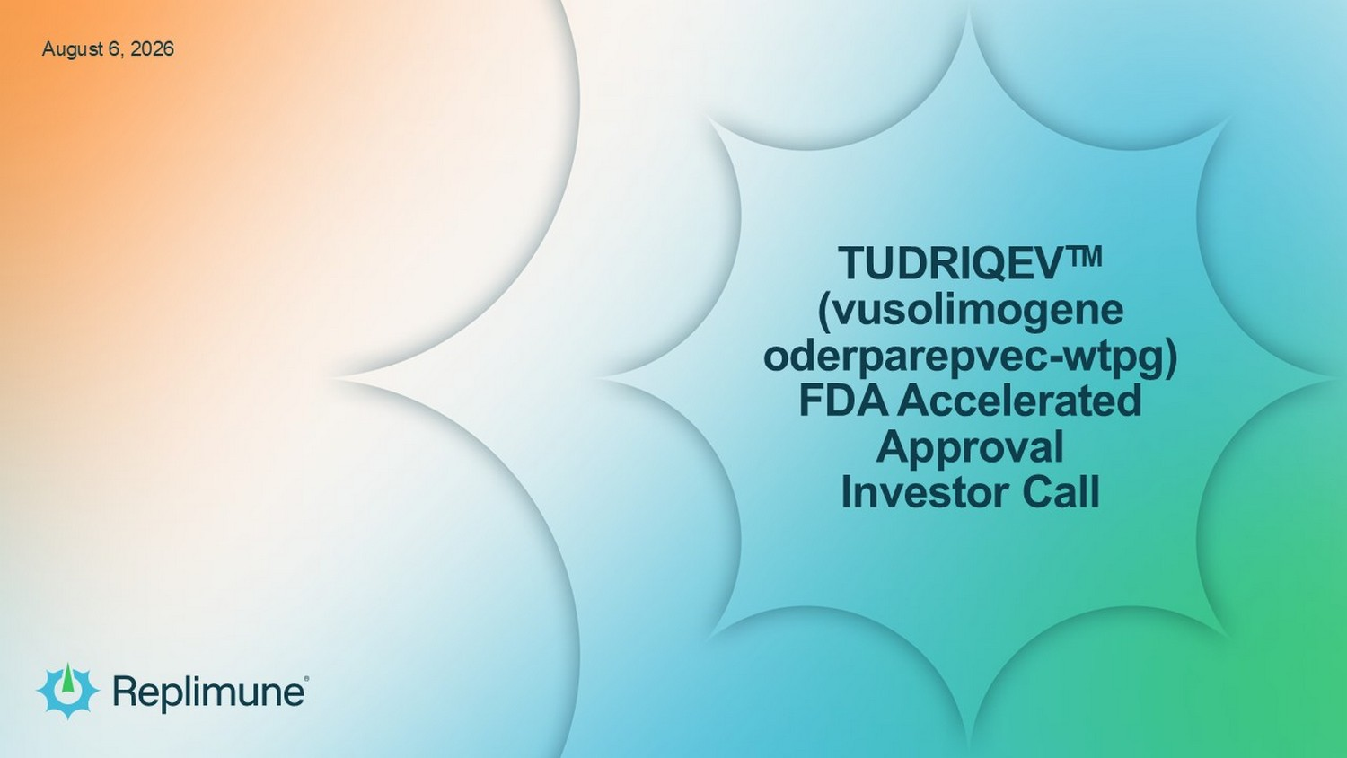
© 2026 Replimune Group Inc. TUDRIQEV TM (vusolimogene oderparepvec - wtpg ) FDA Accelerated Approval Investor Call August 6, 2026


© 2026 Replimune Group Inc. TUDRIQEV TM Approval Call © 2026 Replimune Inc. 2 Safe Harbor Any statements contained herein that are not statements of historical facts may be deemed to be forward - looking statements within the meaning of Section 27A of the Securities Act of 1933, as amended, and Section 21E of the Securities Exchange Act of 1934, as amended, including statements regarding clinical trials, clinical studies and other clinical work (including the funding therefor, anticipated patient enrollment, safety data, study data, trial outcomes, timing or associated costs, sufficiency of any resulting data), regulatory applications and related submission contents and timelines, the timelines or outcomes related to litigation, including any rehearings or appeals of decisions in any such proceedings, and our ability to execute on our strategic or financial initiatives, our estimates regarding future expenses, capital requirements and needs for additional financing, and potential commercial viability, and potential reimbursement and utilization of TUDRIQEV involve significant risks and uncertainties and actual results could differ materially from those expressed or implied herein. Our ability to maintain TUDRIQEV’s accelerated approval and to continue commercialization of TUDRIQEV may be contingent on verification of clinical benefit in a confirmatory trial(s). Other forward looking statements identified by words such as “could,” “expects,” “intends,” “may,” “plans,” “potential,” “should,” “will,” “would,” or similar expressions and the negatives of those terms. Forward - looking statements are not promises or guarantees of future performance and are subject to a variety of risks and uncertainties, many of which are beyond our control, and which could cause actual results to differ materially from those contemplated in such forward - looking statements. These factors include risks related to our limited experience in commercializing products for sale, our ability to successfully verify the clinical benefit of TUDRIQEV in our ongoing confirmatory Phase 3 trial, IGNYTE - 3, our ability to meet our product manufacturing goal, the timing and scope of future regulatory approvals, the availability of combination therapies needed to conduct our clinical trials, changes in laws and regulations to which we are subject, competitive pressures, our ability to identify additional product candidates, the impact of political and global macro factors and military conflicts, and other risks as may be detailed from time to time in our Annual Reports on Form 10 - K and Quarterly Reports on Form 10 - Q and other reports we file with the Securities and Exchange Commission. Our actual results could differ materially from the results described in or implied by such forward - looking statements. Forward - looking statements speak only as of the date hereof, and, except as required by law, we undertake no obligation to update or revise these forward - looking statements.

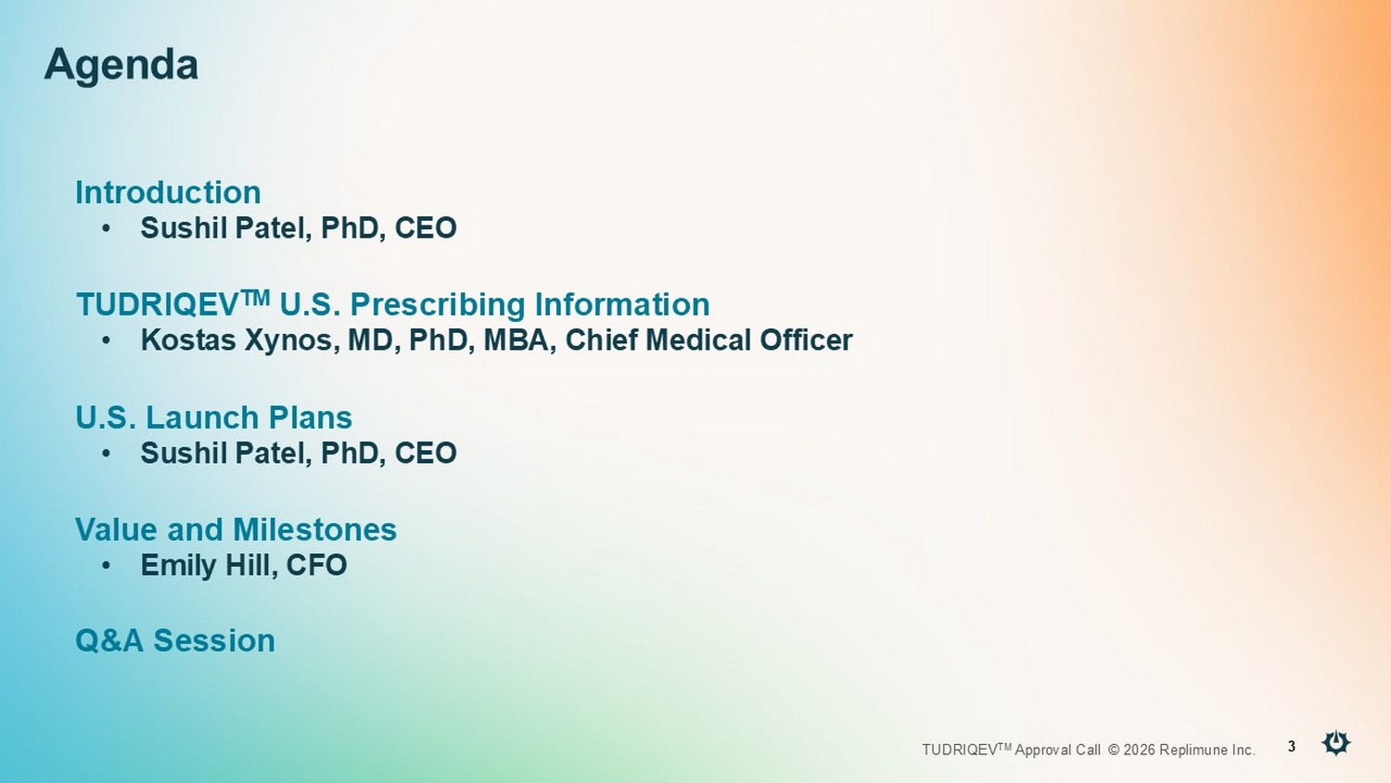
© 2026 Replimune Group Inc. TUDRIQEV TM Approval Call © 2026 Replimune Inc. 3 Agenda Introduction • Sushil Patel, PhD, CEO TUDRIQEV TM U.S. Prescribing Information • Kostas Xynos, MD, PhD, MBA, Chief Medical Officer U.S. Launch Plans • Sushil Patel, PhD, CEO Value and Milestones • Emily Hill, CFO Q&A Session


© 2026 Replimune Group Inc.

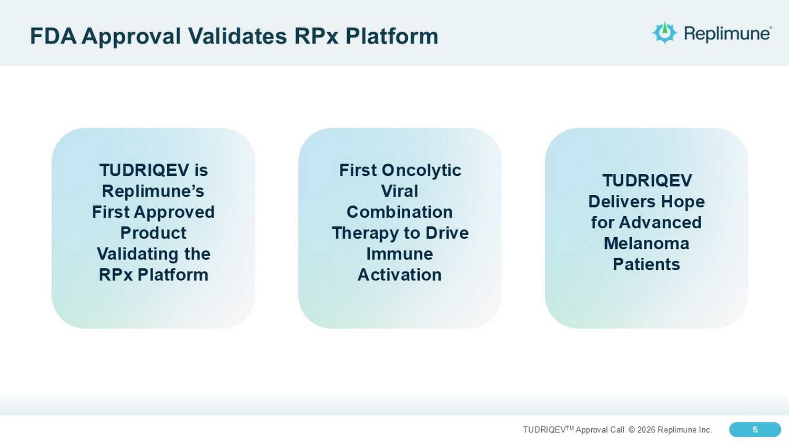
5 TUDRIQEV TM Approval Call © 2026 Replimune Inc. 5 FDA Approval Validates RPx Platform First Oncolytic Viral Combination Therapy to Drive Immune Activation TUDRIQEV is Replimune’s First A pproved Product V alidating the RPx Platform TUDRIQEV Delivers Hope for Advanced M elanoma P atients

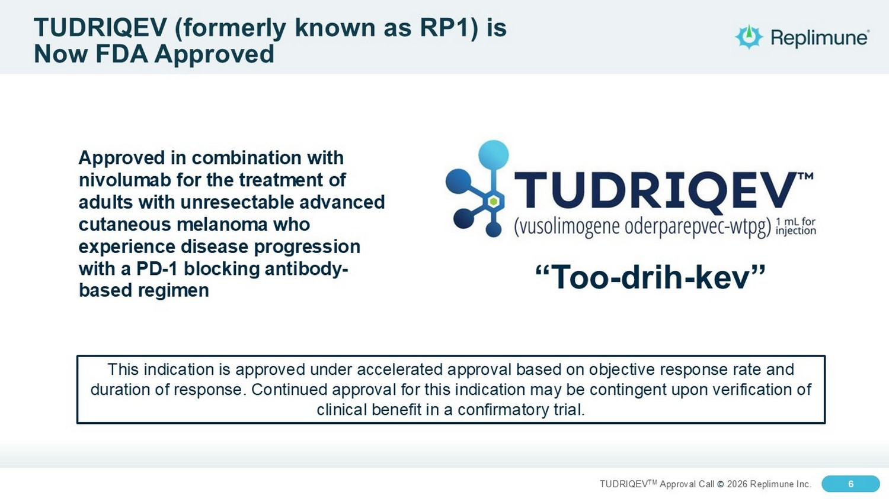
6 TUDRIQEV TM Approval Call © 2026 Replimune Inc. 6 TUDRIQEV (formerly known as RP1) is Now FDA Approved Approved in combination with nivolumab for the treatment of adults with unresectable advanced cutaneous melanoma who experience disease progression with a PD - 1 blocking antibody - based regimen “Too - drih - kev” This indication is approved under accelerated approval based on objective response rate and duration of response. Continued approval for this indication may be contingent upon verification of clinical benefit in a confirmatory trial.

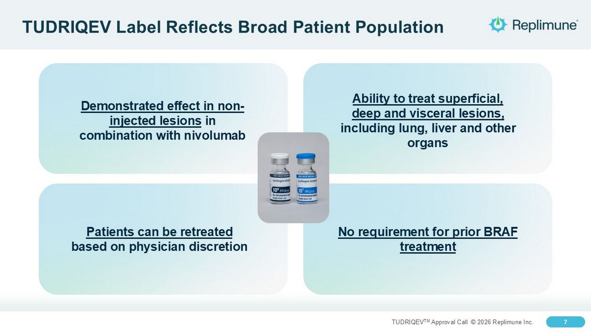
7 TUDRIQEV TM Approval Call © 2026 Replimune Inc. 7 TUDRIQEV Label Reflects Broad Patient Population Demonstrated effect in non - injected lesions in combination with nivolumab No requirement for prior BRAF treatment Ability to treat superficial, deep and visceral lesions, including lung, liver and other organs Patients can be retreated based on physician discretion

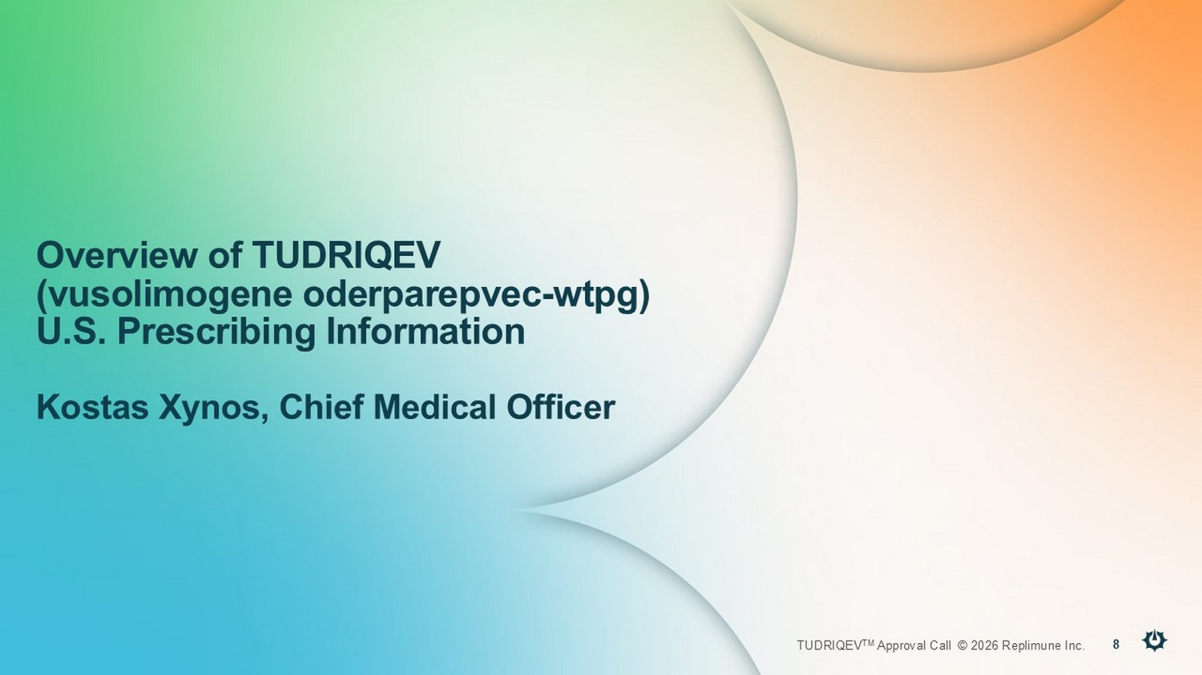
© 2025 Replimune Group Inc. TUDRIQEV TM Approval Call © 2026 Replimune Inc. 8 Overview of TUDRIQEV (vusolimogene oderparepvec - wtpg ) U.S. Prescribing Information Kostas Xynos, Chief Medical Officer

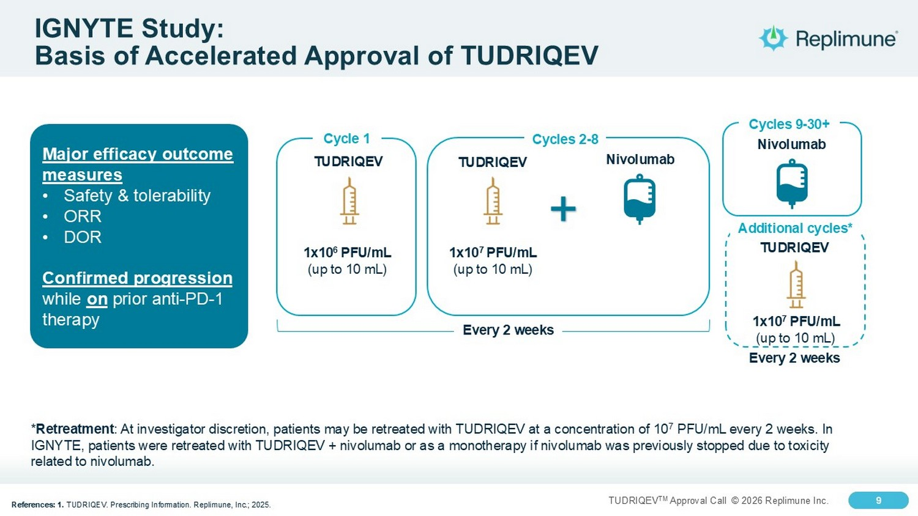
9 TUDRIQEV TM Approval Call © 2026 Replimune Inc. 9 IGNYTE Study: Basis of Accelerated Approval of TUDRIQEV References: 1. TUDRIQEV. Prescribing Information. Replimune, Inc.; 2025. TUDRIQEV Cycle 1 1x10 6 PFU/mL (up to 10 mL) TUDRIQEV 1x10 7 PFU/mL (up to 10 mL) + Nivolumab Cycles 2 - 8 Cycles 9 - 30+ Nivolumab TUDRIQEV 1x10 7 PFU/mL (up to 10 mL) Additional cycles* * Retreatment : At investigator discretion, patients may be retreated with TUDRIQEV at a concentration of 10 7 PFU/mL every 2 weeks. In IGNYTE, patients were retreated with TUDRIQEV + nivolumab or as a monotherapy if nivolumab was previously stopped due to toxi cit y related to nivolumab. Every 2 weeks Every 2 weeks Major efficacy outcome measures • Safety & tolerability • ORR • DOR Confirmed progression while on prior anti - PD - 1 therapy

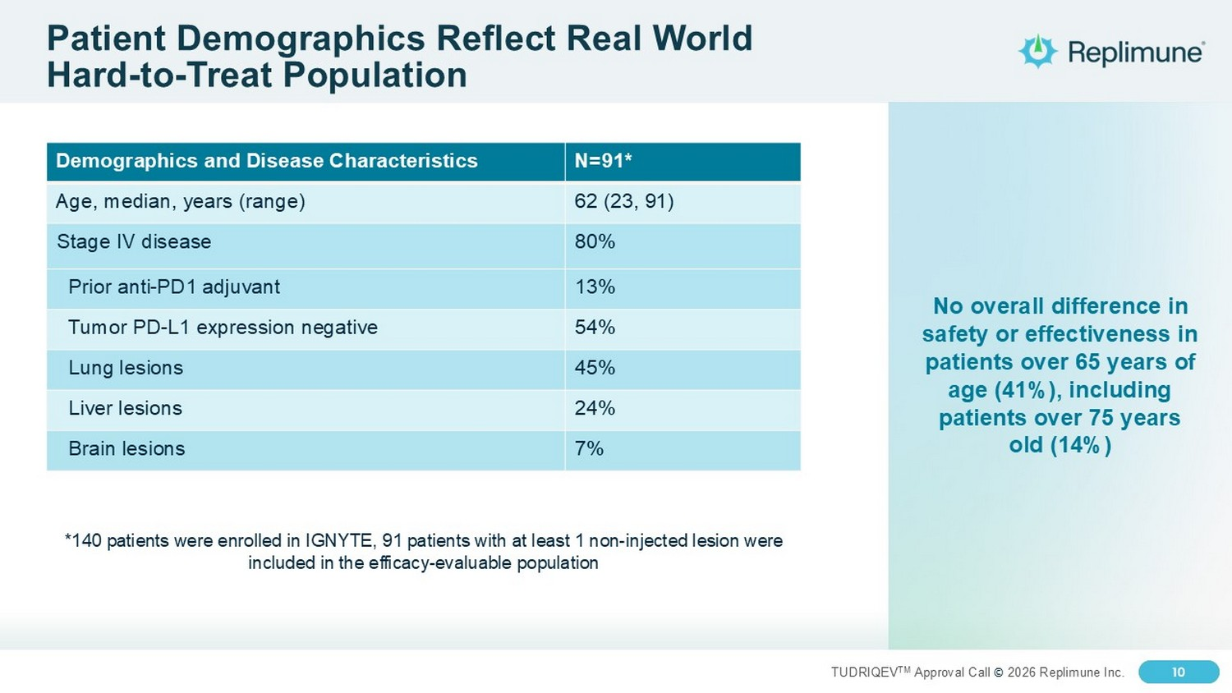
10 TUDRIQEV TM Approval Call © 2026 Replimune Inc. 10 Patient Demographics Reflect Real World Hard - to - Treat Population N=91* Demographics and Disease Characteristics 62 (23, 91) Age, median, years (range) 80% Stage IV disease 13% Prior anti - PD1 adjuvant 54% Tumor PD - L1 expression negative 45% Lung lesions 24% Liver lesions 7% Brain lesions No overall difference in safety or effectiveness in patients over 65 years of age (41%), including patients over 75 years old (14%) *140 patients were enrolled in IGNYTE, 91 patients with at least 1 non - injected lesion were included in the efficacy - evaluable population

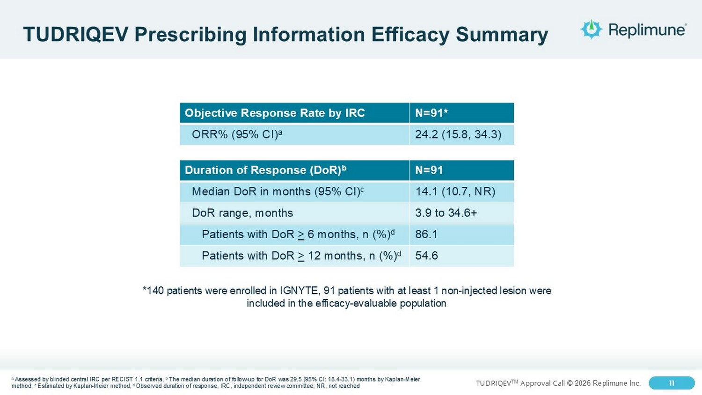
11 TUDRIQEV TM Approval Call © 2026 Replimune Inc. 11 TUDRIQEV Prescribing Information Efficacy Summary a Assessed by blinded central IRC per RECIST 1.1 criteria, b The median duration of follow - up for DoR was 29.5 (95% CI: 18.4 - 33.1) months by Kaplan - Meier method, c Estimated by Kaplan - Meier method, d Observed duration of response, IRC, independent review committee; NR, not reached N=91* Objective Response Rate by IRC 24.2 (15.8, 34.3) ORR% (95% CI) a N=91 Duration of Response (DoR) b 14.1 (10.7, NR) Median DoR in months (95% CI) c 3.9 to 34.6+ DoR range, months 86.1 Patients with DoR > 6 months, n (%) d 54.6 Patients with DoR > 12 months, n (%) d *140 patients were enrolled in IGNYTE, 91 patients with at least 1 non - injected lesion were included in the efficacy - evaluable population

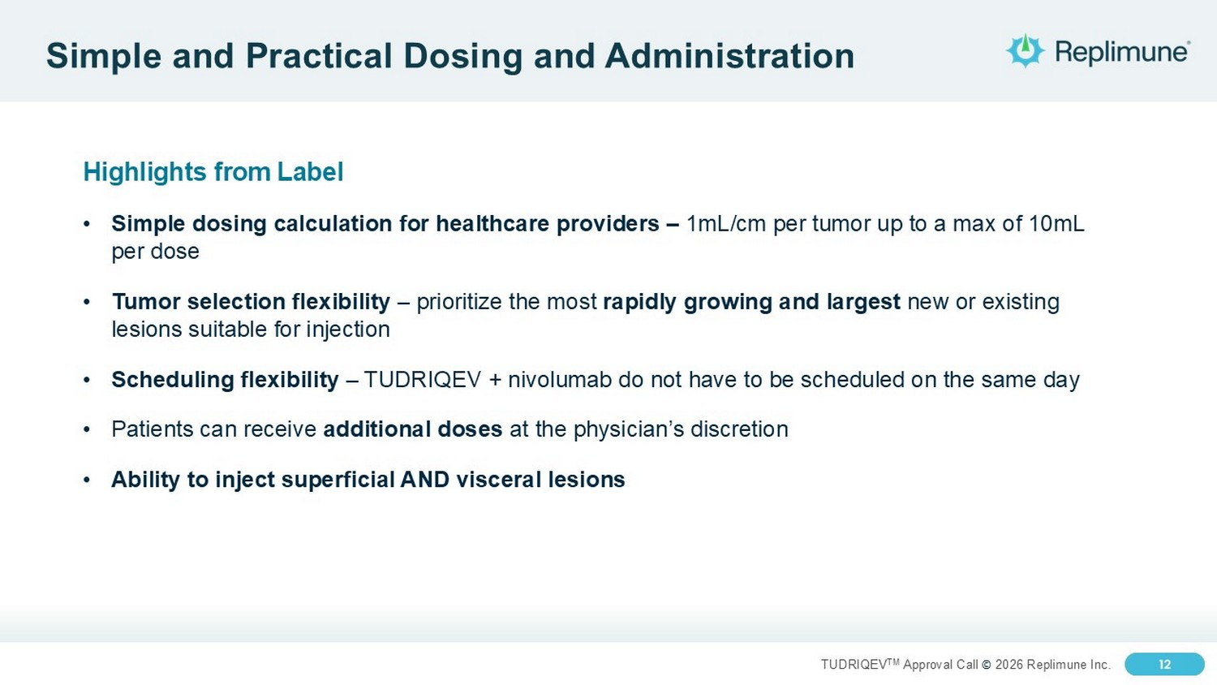
12 TUDRIQEV TM Approval Call © 2026 Replimune Inc. 12 Simple and Practical Dosing and Administration Highlights from Label • Simple dosing calculation for healthcare providers – 1mL/cm per tumor up to a max of 10mL per dose • Tumor selection flexibility – prioritize the most rapidly growing and largest new or existing lesions suitable for injection • Scheduling flexibility – TUDRIQEV + nivolumab do not have to be scheduled on the same day • Patients can receive additional doses at the physician’s discretion • Ability to inject superficial AND visceral lesions

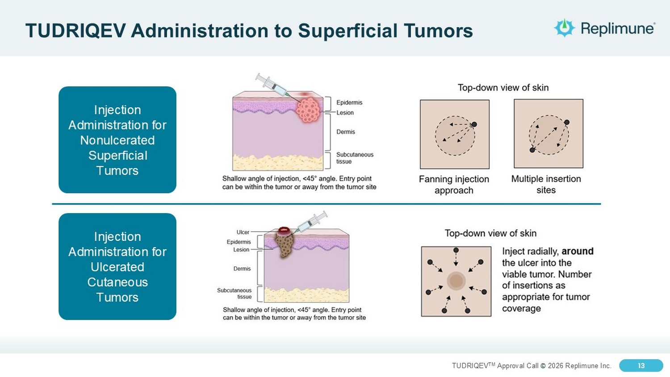
13 TUDRIQEV TM Approval Call © 2026 Replimune Inc. 13 TUDRIQEV Administration to Superficial Tumors Injection Administration for Nonulcerated Superficial Tumors Injection Administration for Ulcerated Cutaneous Tumors

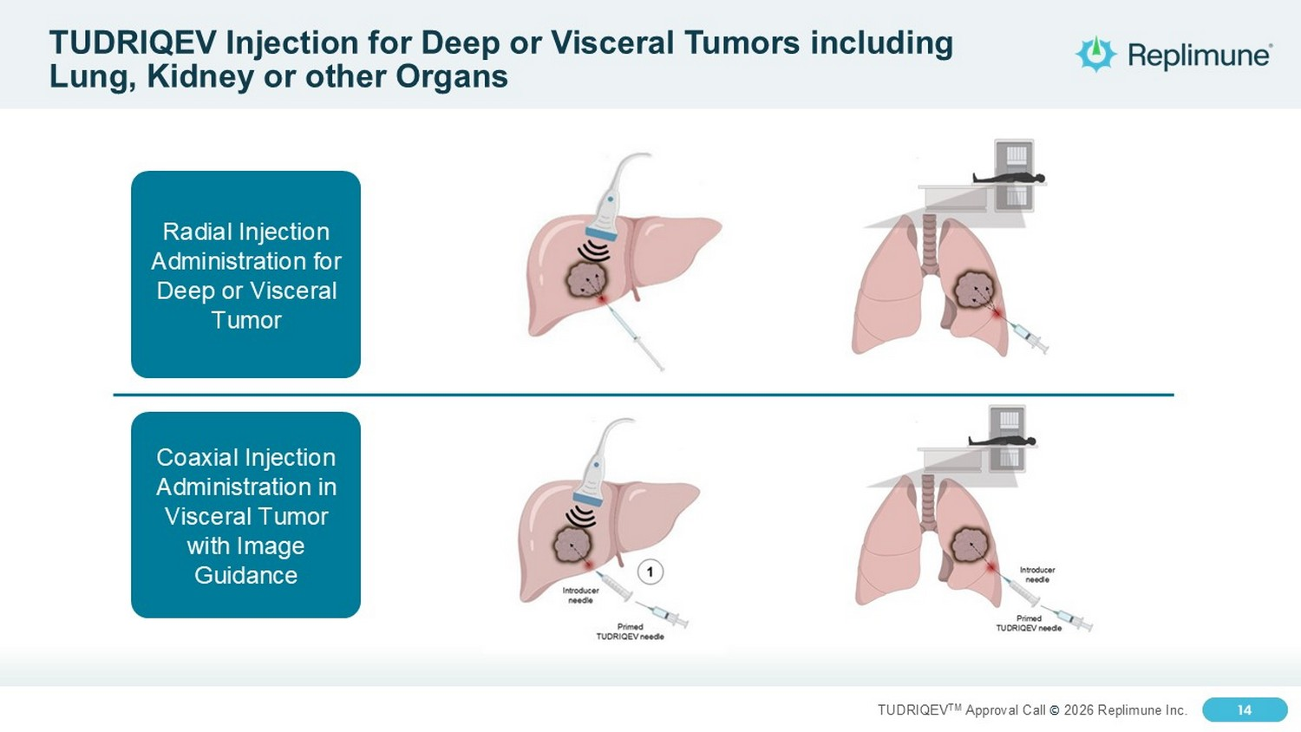
14 TUDRIQEV TM Approval Call © 2026 Replimune Inc. 14 TUDRIQEV Injection for Deep or Visceral Tumors including Lung, Kidney or other Organs Radial Injection Administration for Deep or Visceral Tumor Coaxial Injection Administration in Visceral Tumor with Image Guidance

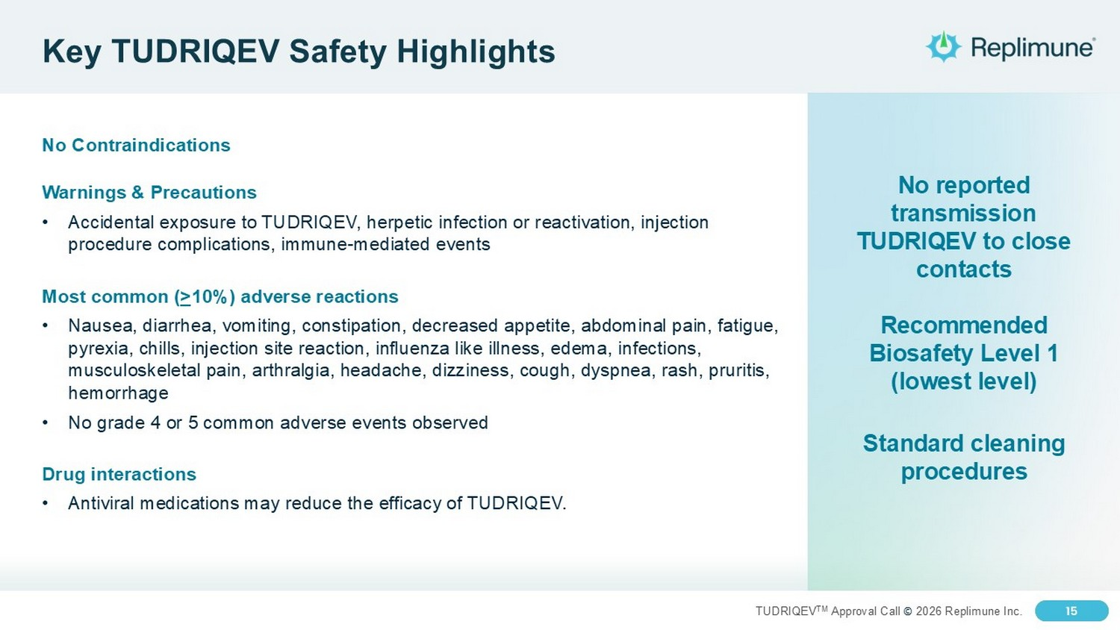
15 TUDRIQEV TM Approval Call © 2026 Replimune Inc. 15 Key TUDRIQEV Safety Highlights No Contraindications Warnings & Precautions • Accidental exposure to TUDRIQEV, herpetic infection or reactivation, injection procedure complications, immune - mediated events Most common ( > 10%) adverse reactions • Nausea, diarrhea, vomiting, constipation, decreased appetite, abdominal pain, fatigue, pyrexia, chills, injection site reaction, influenza like illness, edema, infections, musculoskeletal pain, arthralgia, headache, dizziness, cough, dyspnea, rash, pruritis , hemorrhage • No grade 4 or 5 common adverse events observed Drug interactions • Antiviral medications may reduce the efficacy of TUDRIQEV. No reported transmission TUDRIQEV to close contacts Recommended Biosafety Level 1 (lowest level) Standard cleaning procedures

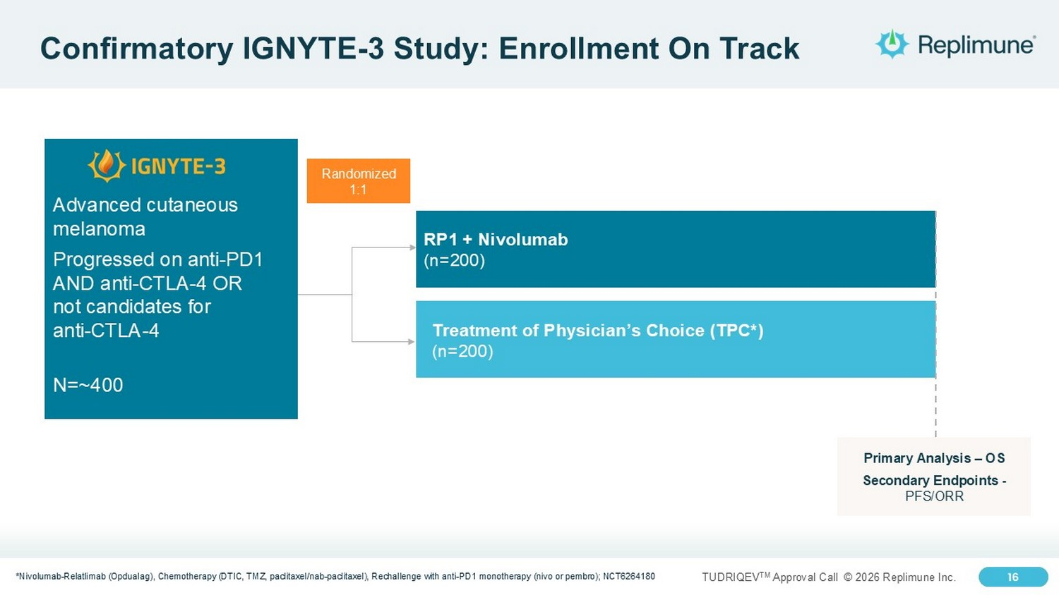
16 TUDRIQEV TM Approval Call © 2026 Replimune Inc. 16 Confirmatory IGNYTE - 3 Study: Enrollment On Track *Nivolumab - Relatlimab ( Opdualag ), Chemotherapy (DTIC, TMZ, paclitaxel/nab - paclitaxel), Rechallenge with anti - PD1 monotherapy (nivo or pembro ); NCT6264180 Randomized 1:1 RP1 + Nivolumab (n=200) Treatment of Physician’s Choice (TPC*) (n=200) Advanced cutaneous melanoma Progressed on anti - PD1 AND anti - CTLA - 4 OR not candidates for anti - CTLA - 4 N=~400 Primary Analysis – OS Secondary Endpoints - PFS/ORR


© 2025 Replimune Group Inc. TUDRIQEV TM Approval Call © 2026 Replimune Inc. 17 U.S. Launch Plans for TUDRIQEV Sushil Patel, PhD, CEO

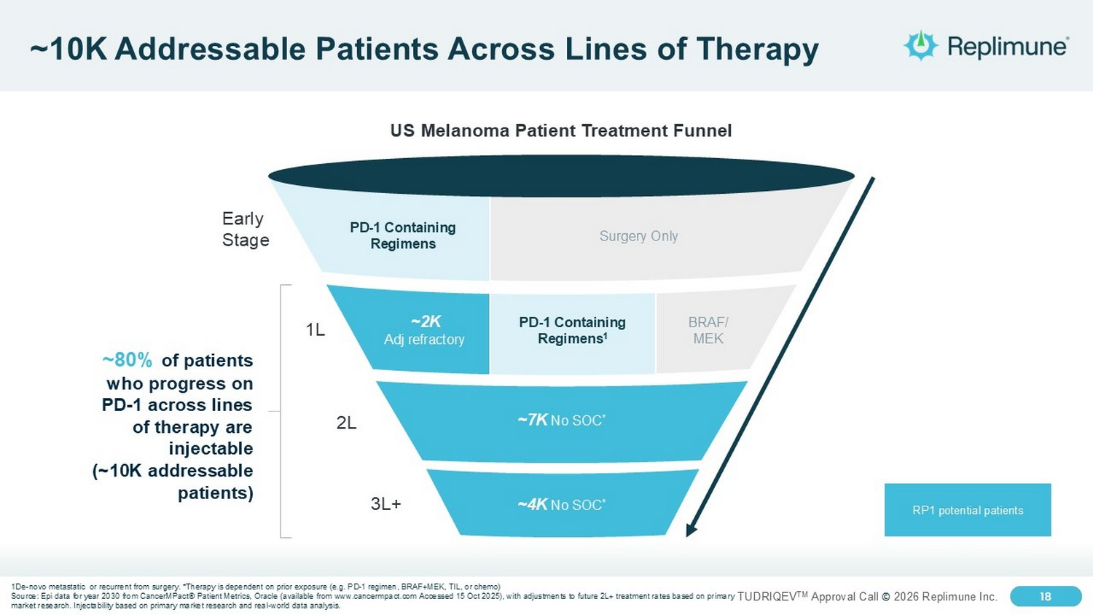
18 TUDRIQEV TM Approval Call © 2026 Replimune Inc. 18 ~10K Addressable Patients Across Lines of Therapy 3L+ 2L Early Stage 1L US Melanoma Patient Treatment Funnel ~80% of patients who progress on PD - 1 across lines of therapy are injectable (~10K addressable patients) RP1 potential patients PD - 1 Containing Regimens Surgery Only BRAF/ MEK PD - 1 Containing Regimens 1 ~2K Adj refractory ~7K No SOC * ~4K No SOC * 1De - novo metastatic or recurrent from surgery. *Therapy is dependent on prior exposure (e.g. PD - 1 regimen, BRAF+MEK, TIL, or ch emo) Source: Epi data for year 2030 from CancerMPact ® Patient Metrics, Oracle (available from www.cancermpact.com Accessed 15 Oct 2025), with adjustments to future 2L+ treatment ra tes based on primary market research. Injectability based on primary market research and real - world data analysis.

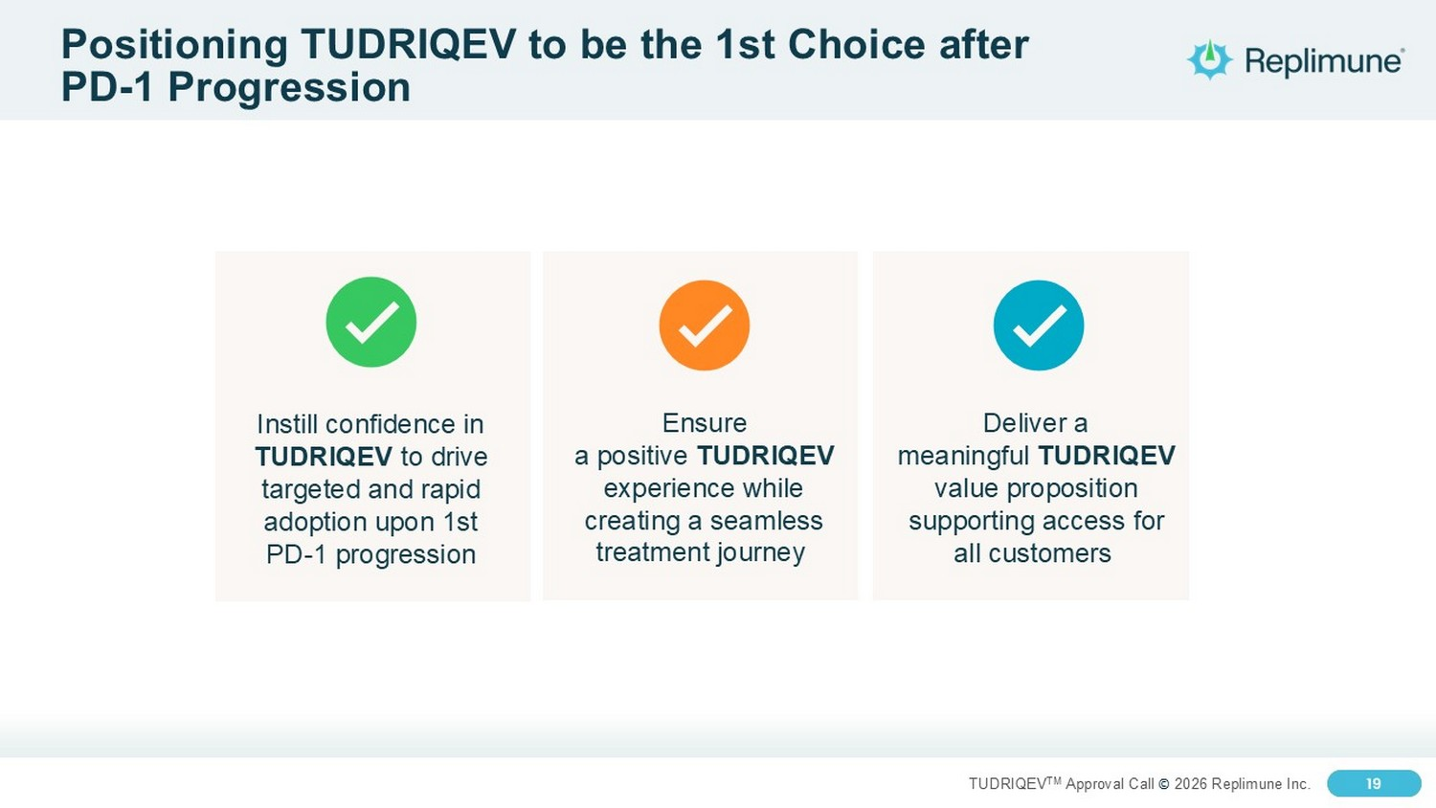
19 TUDRIQEV TM Approval Call © 2026 Replimune Inc. 19 Positioning TUDRIQEV to be the 1st Choice after PD - 1 Progression Compelling data and favorable safety profile Ensure a positive TUDRIQEV experience while creating a seamless treatment journey Deliver a meaningful TUDRIQEV value proposition supporting access for all customers Instill confidence in TUDRIQEV to drive targeted and rapid adoption upon 1st PD - 1 progression

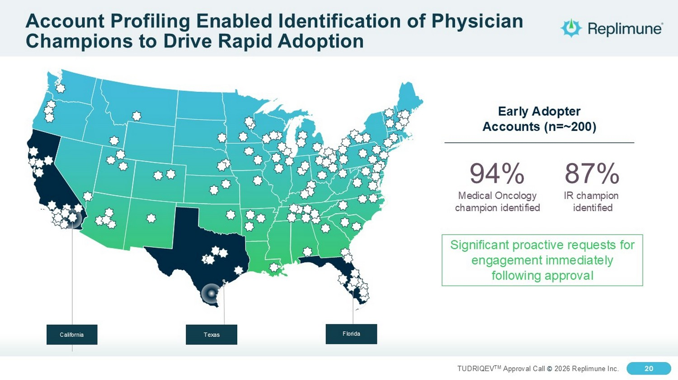
20 TUDRIQEV TM Approval Call © 2026 Replimune Inc. 20 Account Profiling Enabled Identification of Physician Champions to Drive Rapid Adoption Early Adopter Accounts (n=~200) California Texas Florida 94% Medical Oncology champion identified Significant proactive requests for engagement immediately following approval 87% IR champion identified

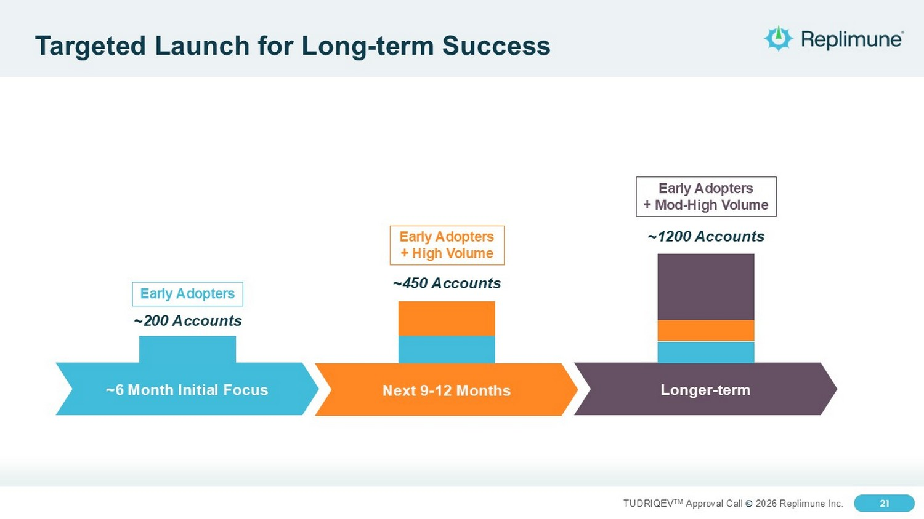
21 TUDRIQEV TM Approval Call © 2026 Replimune Inc. 21 Targeted Launch for Long - term Success ~450 Accounts ~1200 Accounts ~6 Month Initial Focus Longer - term Early Adopters Early Adopters + Mod - High Volume ~200 Accounts Early Adopters + High Volume Next 9 - 12 Months

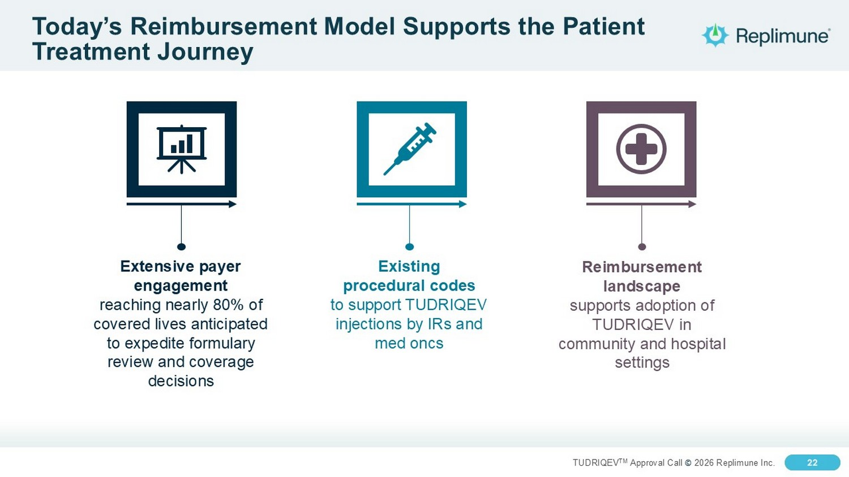
22 TUDRIQEV TM Approval Call © 2026 Replimune Inc. 22 Today’s Reimbursement Model Supports the Patient Treatment Journey Existing procedural codes to support TUDRIQEV injections by IRs and med oncs Extensive payer engagement reaching nearly 80% of covered lives anticipated to expedite formulary review and coverage decisions Reimbursement landscape supports adoption of TUDRIQEV in community and hospital settings

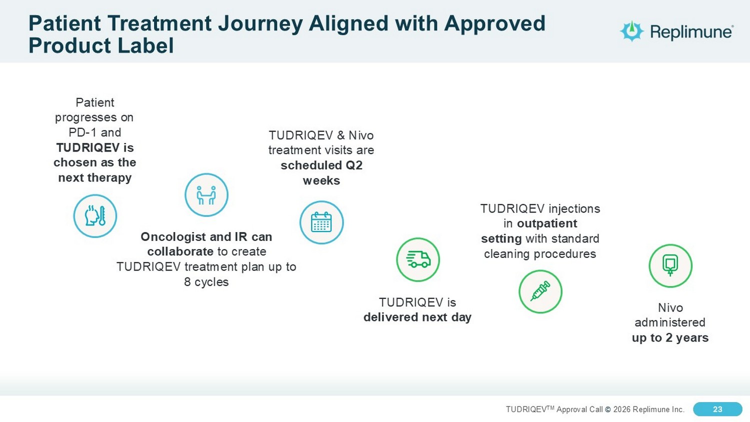
23 TUDRIQEV TM Approval Call © 2026 Replimune Inc. 23 Patient Treatment Journey Aligned with Approved Product Label Patient progresses on PD - 1 and TUDRIQEV is chosen as the next therapy Nivo administered up to 2 years Oncologist and IR can collaborate to create TUDRIQEV treatment plan up to 8 cycles TUDRIQEV & Nivo treatment visits are scheduled Q2 weeks TUDRIQEV is delivered next day TUDRIQEV injections in outpatient setting with standard cleaning procedures

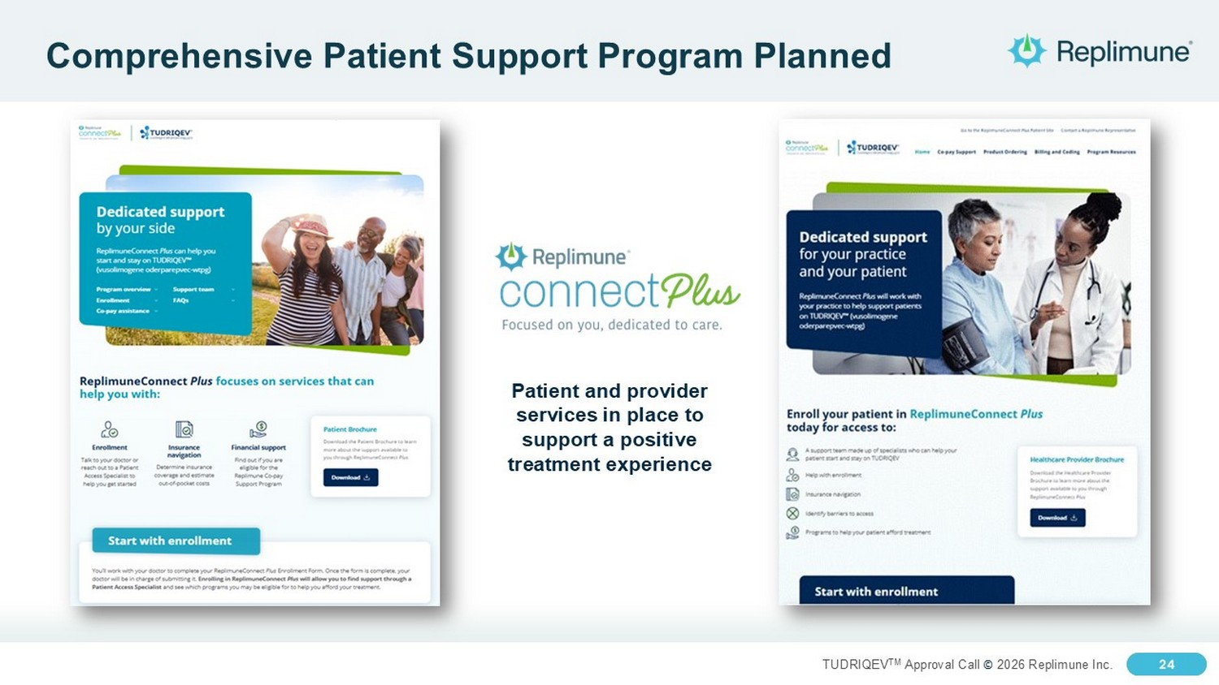
24 TUDRIQEV TM Approval Call © 2026 Replimune Inc. 24 Comprehensive Patient Support Program Planned Patient and provider services in place to support a positive treatment experience


© 2025 Replimune Group Inc. TUDRIQEV TM Approval Call © 2026 Replimune Inc. 25 Value and Milestones Emily Hill, Chief Financial Officer

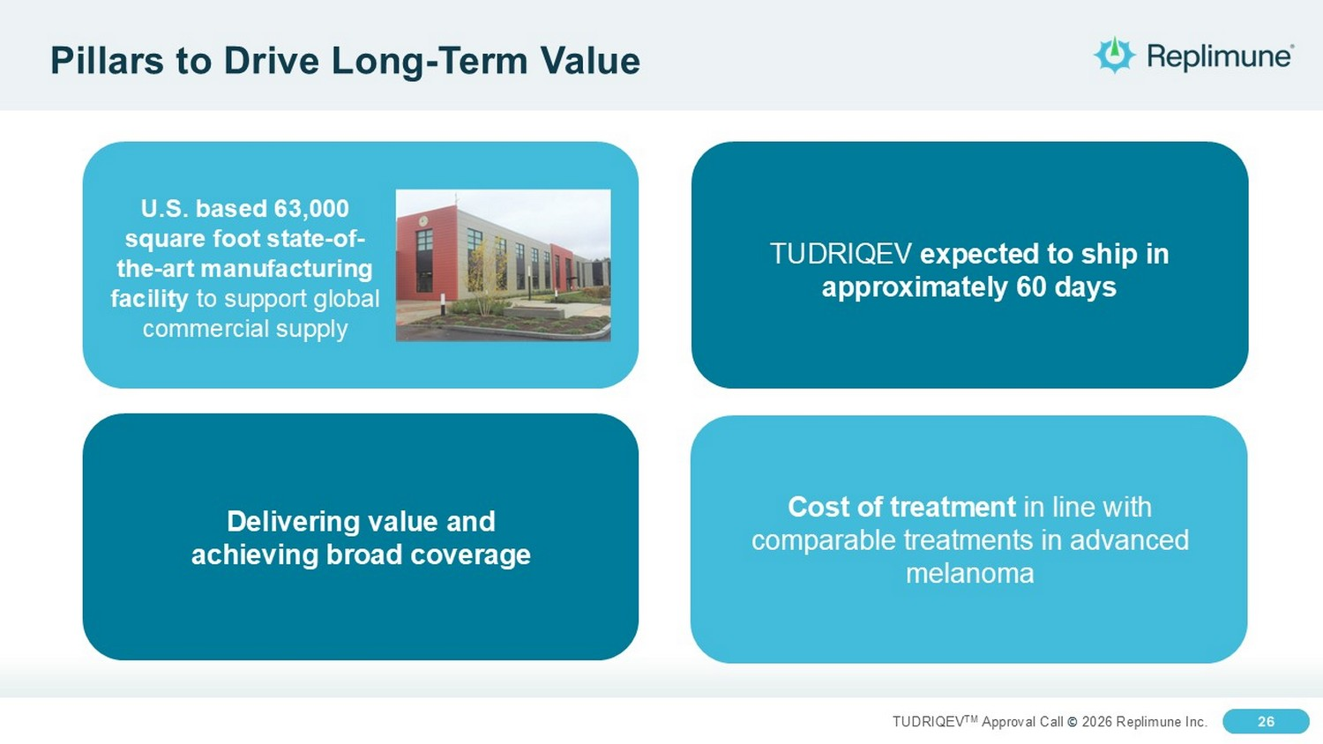
26 TUDRIQEV TM Approval Call © 2026 Replimune Inc. 26 Pillars to Drive Long - Term Value U.S. based 63,000 square foot state - of - the - art manufacturing facility to support global commercial supply TUDRIQEV expected to ship in approximately 60 days Delivering value and achieving broad coverage Cost of treatment in line with comparable treatments in advanced melanoma

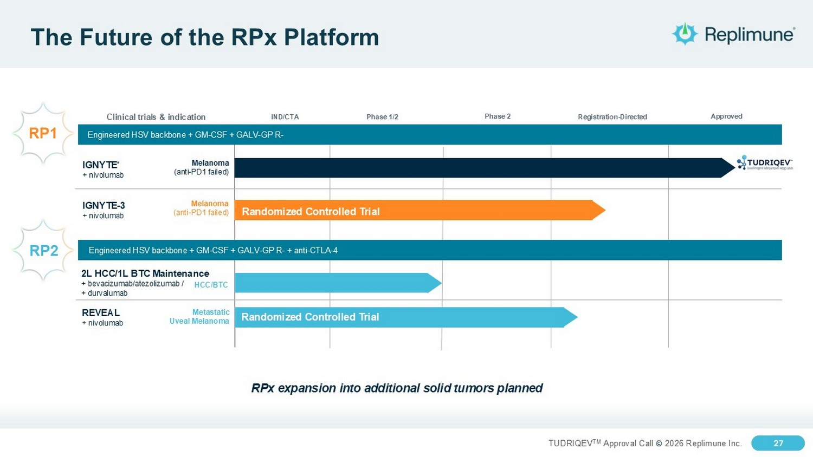
27 TUDRIQEV TM Approval Call © 2026 Replimune Inc. 27 The Future of the RPx Platform Registration - Directed Clinical trials & indication Engineered HSV backbone + GM - CSF + GALV - GP R - IND/CTA Phase 1/2 2L HCC/1L BTC Maintenance + bevacizumab/atezolizumab / + durvalumab HCC/BTC REVEAL + nivolumab Metastatic Uveal Melanoma Phase 2 IGNYTE - 3 + nivolumab Melanoma (anti - PD1 failed) Approved Engineered HSV backbone + GM - CSF + GALV - GP R - + anti - CTLA - 4 IGNYTE * + nivolumab Melanoma (anti - PD1 failed) PDUFA date July 22, 2025 RPx expansion into additional solid tumors planned RP1 RP2 Randomized Controlled Trial Randomized Controlled Trial

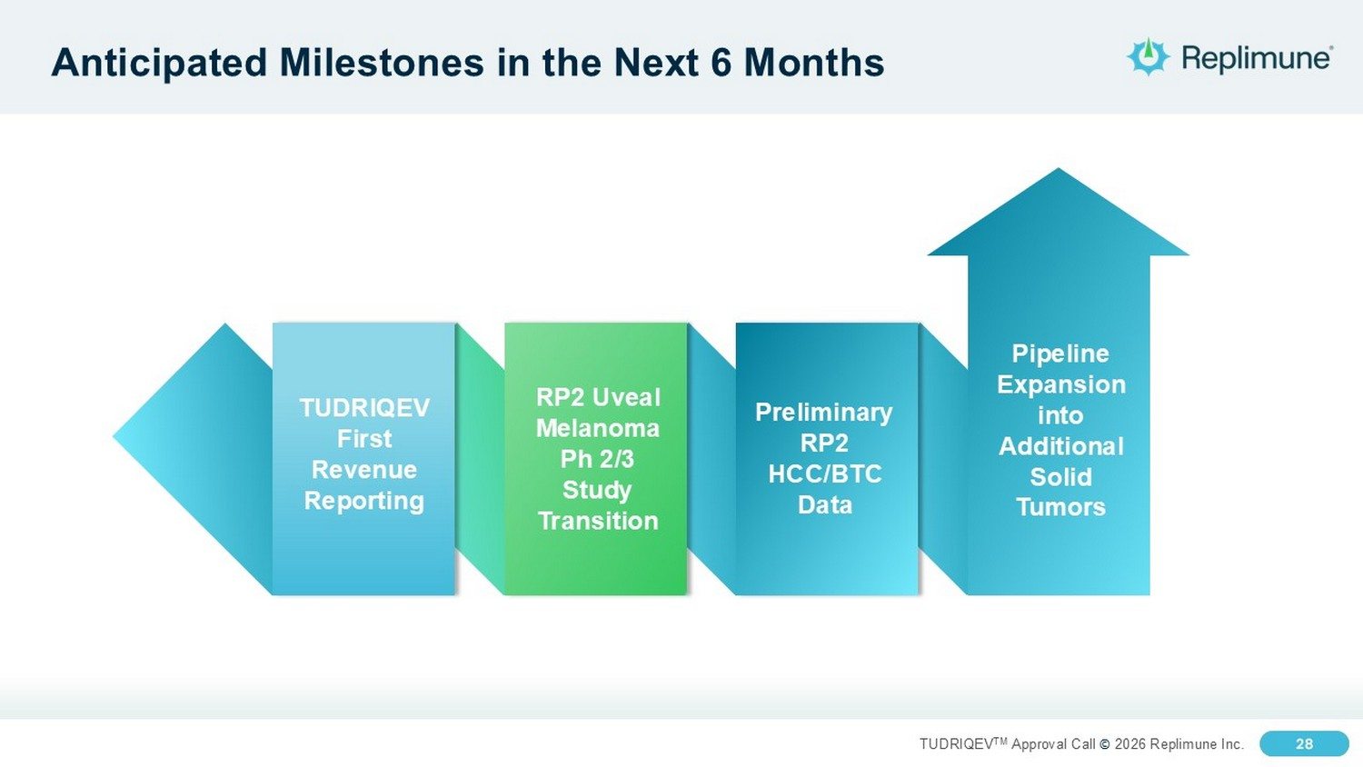
28 TUDRIQEV TM Approval Call © 2026 Replimune Inc. 28 Anticipated Milestones in the Next 6 Months TUDRIQEV First Revenue Reporting RP2 Uveal Melanoma Ph 2/3 Study Transition Preliminary RP2 HCC/BTC Data Pipeline Expansion into Additional Solid Tumors


29 TUDRIQEV TM Approval Call © 2026 Replimune Inc. TUDRIQEV TM Approval Call © 2026 Replimune Inc. Q&A


© 2025 Replimune Group Inc. TUDRIQEV Approval Call August 6, 2026 Thank You

