UNITED STATES
SECURITIES AND EXCHANGE COMMISSION
Washington, D.C. 20549

SCHEDULE 14A

Proxy Statement Pursuant to Section 14(a) of
the Securities Exchange Act of 1934
(Amendment )

Filed by the Registrant ☒

Filed by a Party other than the Registrant ☐

Check the appropriate box:

☐ Preliminary Proxy Statement

☐ Confidential, for Use of the Commission Only (as permitted by Rule 14a-6(e)(2))

☐ Definitive Proxy Statement

☒ Definitive Additional Materials

☐ Soliciting Material under §240.14a-12

REPLIMUNE GROUP, INC.
(Name of Registrant as Specified In Its Charter)

(Name of Person(s) Filing Proxy Statement, if other than the Registrant)

Payment of Filing Fee (Check the appropriate box):

☒ No fee required.

☐ Fee paid previously with preliminary materials.

☐ Fee computed on table in exhibit required by Item 25(b) per Exchange Act Rules 14a6(i)(1) and 0-11

 | 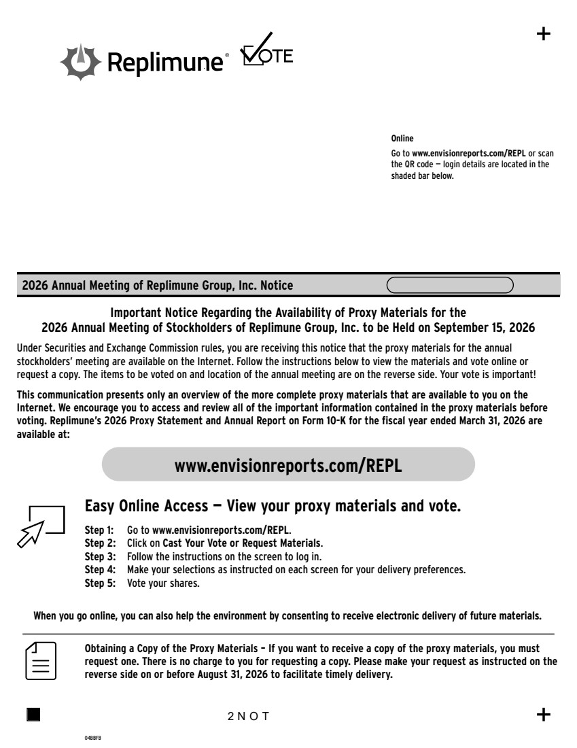 | Step 1: Go to www.envisionreports.com/REPL. Step 2: Click on Cast Your Vote or Request Materials. Step 3: Follow the instructions on the screen to log in. www.envisionreports.com/REPL Online Go to www.envisionreports.com/REPL or scan the QR code — login details are located in the shaded bar below. 2026 Annual Meeting of Replimune Group, Inc. Notice 04BBFB Important Notice Regarding the Availability of Proxy Materials for the 2026 Annual Meeting of Stockholders of Replimune Group, Inc. to be Held on September 15, 2026 Under Securities and Exchange Commission rules, you are receiving this notice that the proxy materials for the annual stockholders’ meeting are available on the Internet. Follow the instructions below to view the materials and vote online or request a copy. The items to be voted on and location of the annual meeting are on the reverse side. Your vote is important! This communication presents only an overview of the more complete proxy materials that are available to you on the Internet. We encourage you to access and review all of the important information contained in the proxy materials before voting. Replimune’s 2026 Proxy Statement and Annual Report on Form 10-K for the fiscal year ended March 31, 2026 are available at: Obtaining a Copy of the Proxy Materials – If you want to receive a copy of the proxy materials, you must request one. There is no charge to you for requesting a copy. Please make your request as instructed on the reverse side on or before August 31, 2026 to facilitate timely delivery. 2NOT Easy Online Access — View your proxy materials and vote. When you go online, you can also help the environment by consenting to receive electronic delivery of future materials. Step 4: Make your selections as instructed on each screen for your delivery preferences. Step 5: Vote your shares.
 | 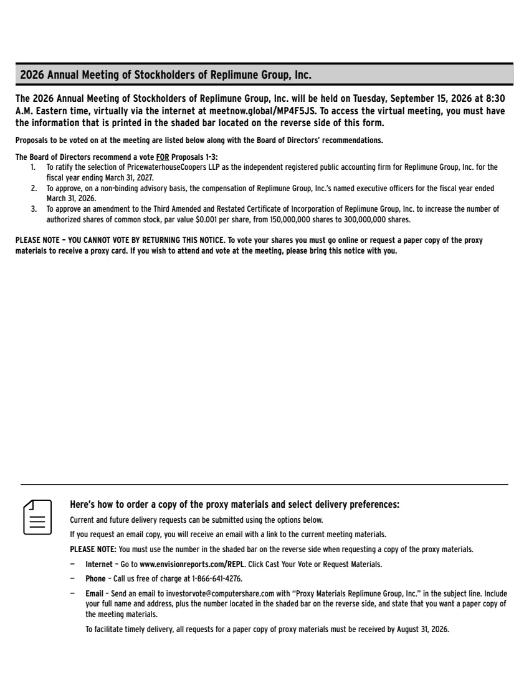 | Here’s how to order a copy of the proxy materials and select delivery preferences: Current and future delivery requests can be submitted using the options below. If you request an email copy, you will receive an email with a link to the current meeting materials. PLEASE NOTE: You must use the number in the shaded bar on the reverse side when requesting a copy of the proxy materials. — Internet – Go to www.envisionreports.com/REPL. Click Cast Your Vote or Request Materials. — Phone – Call us free of charge at 1-866-641-4276. — Email – Send an email to investorvote@computershare.com with “Proxy Materials Replimune Group, Inc.” in the subject line. Include your full name and address, plus the number located in the shaded bar on the reverse side, and state that you want a paper copy of the meeting materials. To facilitate timely delivery, all requests for a paper copy of proxy materials must be received by August 31, 2026. The 2026 Annual Meeting of Stockholders of Replimune Group, Inc. will be held on Tuesday, September 15, 2026 at 8:30 A.M. Eastern time, virtually via the internet at meetnow.global/MP4F5JS. To access the virtual meeting, you must have the information that is printed in the shaded bar located on the reverse side of this form. Proposals to be voted on at the meeting are listed below along with the Board of Directors’ recommendations. The Board of Directors recommend a vote FOR Proposals 1-3: 1. To ratify the selection of PricewaterhouseCoopers LLP as the independent registered public accounting firm for Replimune Group, Inc. for the fiscal year ending March 31, 2027. 2. To approve, on a non-binding advisory basis, the compensation of Replimune Group, Inc.’s named executive officers for the fiscal year ended March 31, 2026. 3. To approve an amendment to the Third Amended and Restated Certificate of Incorporation of Replimune Group, Inc. to increase the number of authorized shares of common stock, par value $0.001 per share, from 150,000,000 shares to 300,000,000 shares. PLEASE NOTE – YOU CANNOT VOTE BY RETURNING THIS NOTICE. To vote your shares you must go online or request a paper copy of the proxy materials to receive a proxy card. If you wish to attend and vote at the meeting, please bring this notice with you. 2026 Annual Meeting of Stockholders of Replimune Group, Inc.

