Use these links to rapidly review the document

Table of contents
Index to consolidated financial statements

As filed with the Securities and Exchange Commission on June 22, 2018

Registration No. 333-

UNITED STATES

SECURITIES AND EXCHANGE COMMISSION

Washington, D.C. 20549

FORM S-1

REGISTRATION STATEMENT
Under
The Securities Act of 1933

Replimune Group, Inc.

(Exact name of Registrant as specified in its charter)

Delaware | 2836 | 82-2082553
(State or Other Jurisdiction of | (Primary Standard Industrial | (I.R.S. Employer
Incorporation or Organization) | Classification Code Number) | Identification Number)

Replimune Group, Inc.

18 Commerce Way, Woburn, MA 01801
(781) 995-2443
(Address, including zip code, and telephone number, including
area code, of Registrant's principal executive offices)

Philip Astley-Sparke, Executive Chairman

Replimune Group, Inc.
18 Commerce Way, Woburn, MA 01801
(781) 995-2443
(Name, address, including zip code, and telephone number, including area code, of agent for service)

 | Please send copies of all communications to:
Timothy J. Corbett | William V. Fogg
Gitte J. Blanchet | Johnny G. Skumpija
Morgan, Lewis & Bockius LLP | Cravath, Swaine & Moore LLP
One Federal Street | Worldwide Plaza
Boston, MA 02110 | 825 Eighth Avenue
(617) 341-7700 | New York, NY 10019
 | (212) 474-1000

Approximate date of commencement of the proposed sale to the public:

As soon as practicable after the effective date of this Registration Statement.

If any of the securities being registered on this Form are to be offered on a delayed or continuous basis pursuant to Rule 415 under the Securities Act, check the following box. o

If this Form is filed to register additional securities for an offering pursuant to Rule 462(b) under the Securities Act, check the following box and list the Securities Act registration statement number of the earlier effective registration statement for the same offering. o

If this Form is a post-effective amendment filed pursuant to Rule 462(c) under the Securities Act, check the following box and list the Securities Act registration statement number of the earlier effective registration statement for the same offering. o

If this Form is a post-effective amendment filed pursuant to Rule 462(d) under the Securities Act, check the following box and list the Securities Act registration statement number of the earlier effective registration statement for the same offering. o

Indicate by check mark whether the registrant is a large accelerated filer, an accelerated filer, a non-accelerated filer, a smaller reporting company or emerging growth company. See the definitions of "large accelerated filer," "accelerated filer," "smaller reporting company," and "emerging growth company" in Rule 12b-2 of the Exchange Act. (Check one):

Large accelerated filer o

Accelerated filer o

Non-accelerated filer ☒

Smaller reporting company o

(Do not check if a
smaller reporting company)

Emerging growth company ☒

If an emerging growth company, indicate by check mark if the registrant has elected not to use the extended transition period for complying with any new or revised financial accounting standards provided to Section 7(a)(2)(B) of the Securities Act. ☒

CALCULATION OF REGISTRATION FEE

 | Proposed maximum
Title of each class of securities | aggregate offering | Amount of
to be registered | _{price}(1)(2) | registration fee(3)
Common stock, par value $0.001 per share | $100,000,000 | $12,450

- Includes additional shares of common stock that the underwriters have the option to purchase.

- Estimated solely for the purpose of calculating the registration fee pursuant to Rule 457(o) under the Securities Act of 1933, as amended.

- Calculated based on Rule 457(o) based on an estimated maximum aggregate offering price.

The Registrant hereby amends this Registration Statement on such date or dates as may be necessary to delay its effective date until the Registrant shall file a further amendment which specifically states that this Registration Statement shall thereafter become effective in accordance with Section 8(a) of the Securities Act of 1933, as amended, or until the Registration Statement shall become effective on such date as the Securities and Exchange Commission, acting pursuant to said Section 8(a), may determine.

Table of Contents

The information in this preliminary prospectus is not complete and may be changed. These securities may not be sold until the registration statement filed with the Securities and Exchange Commission is effective. This preliminary prospectus is not an offer to sell these securities and we are not soliciting offers to buy these securities in any jurisdiction where the offer or sale is not permitted.

Subject to completion, dated June 22, 2018


shares

Replimune Group, Inc.

Common stock

- per share

This is the initial public offering of our common stock. We are selling between $ and $ per share of common stock.

shares of our common stock. We currently expect the initial public offering price to be

Prior to this offering, there has been no public market for our common stock. We intend to apply to have our common stock listed on the Nasdaq Global Market, or Nasdaq, under the symbol "REPL."

We are an "emerging growth company" as defined in the Jumpstart Our Business Startups Act of 2012, and therefore have elected to comply with certain reduced public company reporting requirements for this prospectus and future filings. See "Prospectus summary—Implications of being an emerging growth company."

Investing in our common stock involves risks. See "Risk factors" beginning on page 12.

Neither the Securities and Exchange Commission nor any state securities commission has approved or disapproved of these securities or determined if this prospectus is truthful or complete. Any representation to the contrary is a criminal offense.

 | Per share | Total
Initial public offering price | $ | $
Underwriting discount⁽¹⁾ | $ | $
Proceeds to Replimune Group, Inc. (before expenses) | $ | $

(1) See "Underwriting" for additional information regarding total underwriting compensation.
The underwriters expect to deliver the shares to purchasers on or about |  |  | , 2018.
We have granted the underwriters an option for a period of 30 days to purchase up to |  |  |  | additional shares of our common stock at the initial public offering price
less the underwriting discount.
J.P. Morgan |  | Leerink Partners |  | BMO Capital Markets
Prospectus dated | , 2018

Table of Contents

Table of contents

 |  |  |  |  |  |  |  |  |  |  |  |  |  |  |  |  |  |  |  | Page
Prospectus summary |  |  |  |  |  |  |  |  |  |  |  |  |  |  |  |  |  |  |  | 1
Risk factors |  |  |  |  |  |  |  |  |  |  |  |  |  |  |  |  |  |  |  |  | 12
Special note regarding forward-looking statements |  |  |  |  |  |  |  |  |  |  |  |  |  |  |  |  |  |  |  |  | 67
Market data |  |  |  |  |  |  |  |  |  |  |  |  |  |  |  |  |  |  |  | 69
Use of proceeds |  |  |  |  |  |  |  |  |  |  |  |  |  |  |  |  |  |  |  |  | 70
Dividend policy |  |  |  |  |  |  |  |  |  |  |  |  |  |  |  |  |  |  |  |  | 71
Capitalization |  |  |  |  |  |  |  |  |  |  |  |  |  |  |  |  |  |  |  | 72
Dilution |  |  |  |  |  |  |  |  |  |  |  |  |  |  |  |  |  |  |  |  | 75
Selected consolidated financial data |  |  |  |  |  |  |  |  |  |  |  |  |  |  |  |  |  |  |  | 78
Management's discussion and analysis of financial condition and results of operations |  |  |  |  |  |  |  |  |  |  |  |  |  |  |  |  |  |  |  |  | 80
Business |  |  |  |  |  |  |  |  |  |  |  |  |  |  |  |  |  |  |  |  | 99
Management |  |  |  |  |  |  |  |  |  |  |  |  |  |  |  |  |  |  |  | 142
Executive and director compensation |  |  |  |  |  |  |  |  |  |  |  |  |  |  |  |  |  |  |  |  | 150
Certain relationships and related party transactions |  |  |  |  |  |  |  |  |  |  |  |  |  |  |  |  |  |  |  |  | 166
Principal stockholders |  |  |  |  |  |  |  |  |  |  |  |  |  |  |  |  |  |  |  | 171
Description of capital stock |  |  |  |  |  |  |  |  |  |  |  |  |  |  |  |  |  |  |  | 174
Material United States federal income tax consequences to non-U.S. holders of our common stock |  |  |  |  |  |  |  |  |  |  |  |  |  |  |  |  |  |  |  |  | 179
Shares eligible for future sale |  |  |  |  |  |  |  |  |  |  |  |  |  |  |  |  |  |  |  | 185
Underwriting |  |  |  |  |  |  |  |  |  |  |  |  |  |  |  |  |  |  |  |  | 188
Legal matters |  |  |  |  |  |  |  |  |  |  |  |  |  |  |  |  |  |  |  |  | 196
Experts |  |  |  |  |  |  |  |  |  |  |  |  |  |  |  |  |  |  |  | 196
Where you can find more information |  |  |  |  |  |  |  |  |  |  |  |  |  |  |  |  |  |  |  |  | 196
Index to consolidated financial statements |  |  |  |  |  |  |  |  |  |  |  |  |  |  |  |  |  |  |  |  | F-1

Unless the context otherwise requires, references in this prospectus to (i) "Replimune," the "Company," "we," "us" and "our" refer to Replimune Group, Inc. and its consolidated subsidiaries and (ii) a year are references to the applicable calendar year and not our fiscal year.

You should rely only on the information contained in this prospectus or contained in any free writing prospectus prepared by or on behalf of us and filed with the Securities and Exchange Commission, or the SEC. Neither we nor the underwriters have authorized anyone to provide you with additional information or information different from that contained in this prospectus or in any free writing prospectus prepared by or on behalf of us and filed with the SEC. We and the underwriters take no responsibility for, and can provide no assurance as to the reliability of, any other information that others may give you. We and the underwriters are offering to sell, and seeking offers to buy, our common stock only in jurisdictions where offers and sales are permitted. The information contained in this prospectus or any free writing prospectus is accurate only as of its date, regardless of its time of delivery or of any sale of our common stock. Our business, financial conditions, results of operations and prospects may have changed since that date.

Through and including , 2018 (the 25th day after the date of this prospectus), all dealers that effect transactions in these securities, whether or not participating in this offering, may be required to deliver a prospectus. This is in addition to the dealers' obligation to deliver a prospectus when acting as underwriters and with respect to their unsold allotments or subscriptions.

For investors outside the United States: Neither we nor any of the underwriters have done anything that would permit this offering or possession or distribution of this prospectus in any jurisdiction where action for that purpose is required, other than in the United States. Persons who come into possession of this prospectus in jurisdictions outside of the United States are required to inform themselves about and to observe any restrictions relating to this offering and the distribution of this prospectus outside of the United States.

i

Table of Contents


Prospectus summary

This summary highlights information contained elsewhere in this prospectus and does not contain all of the information that you should consider in making your investment decision. Before investing in our common stock, you should read the entire prospectus carefully, including the sections entitled "Risk factors" and "Management's discussion and analysis of financial condition and results of operations," and our consolidated financial statements and the related notes.

Business overview

We are a clinical-stage biotechnology company committed to applying our leading expertise in the field of oncolytic immunotherapy to transform the lives of cancer patients. We use our proprietary Immulytic platform to design and develop product candidates that are intended to maximally activate the immune system against solid tumors. The foundation of our platform consists of a proprietary, engineered strain of herpes simplex virus 1, or HSV-1, that has been "armed" with a fusogenic therapeutic protein intended to substantially increase anti-tumor activity. Our platform enables us to design multiple product candidates that incorporate various further genes whose expression is intended to augment the inherent properties of HSV-1 to both directly destroy tumor cells and induce an anti-tumor immune response.

We are currently conducting a Phase 1/2 clinical trial with our lead product candidate, RP1, in approximately 150 patients with a range of solid tumors. We have entered into a collaboration with Bristol-Myers Squibb Company, or BMS, which is providing its anti-PD-1 therapy, nivolumab, for use in combination with RP1 in this clinical trial. The first part of this clinical trial is underway in the United Kingdom and we intend to conduct the second part of the clinical trial, which will enroll patients with four solid tumor types, in both the United Kingdom and in the United States pending the opening of an Investigational New Drug Application, or IND. We have also entered into a collaboration agreement with Regeneron Pharmaceuticals, Inc., or Regeneron, under which we intend to conduct clinical development of our product candidates in combination with cemiplimab, an anti-PD-1 therapy being developed by Regeneron. The first planned clinical trial to be conducted under that agreement is a randomized, controlled Phase 2 clinical trial of RP1 in combination with cemiplimab, versus cemiplimab alone, in approximately 240 patients with cutaneous squamous cell carcinoma, or CSCC, which we intend to initiate in the first half of 2019. We are designing this clinical trial to potentially support product registration. We also intend to initiate a clinical trial with our second product candidate, RP2, in additional tumor types in the first half of 2019.

Oncolytic immunotherapy is an emerging class of cancer treatment that exploits the ability of certain viruses to selectively replicate in and directly kill tumors, as well as induce a potent, patient-specific, anti-tumor immune response. While clinically active alone, oncolytic immunotherapy may have synergy with certain other treatments and, in particular, with immune checkpoint blockade therapies. Immune checkpoint blockade therapies have recently become established for the treatment of cancer, but only for patients with an ongoing anti-tumor immune response, that is, whose tumors are immunologically "hot." Our product candidates are designed to induce a robust immune response against a patient's cancer, including to the neo-antigens that are uniquely present in tumors, with the goal of improving responses in immunologically "hot" tumors, turning immunologically "cold" tumors "hot," and enabling patients to respond to immune checkpoint blockade therapies to which they otherwise may not respond.

Our approach combines multiple mechanisms of action into single product candidates in a practical, "off-the-shelf" format. We believe that the bundling of multiple approaches for the treatment of cancer into single therapies will simplify the development path of our product candidates, while also improving patient outcomes at a lower cost to the healthcare system than the use of multiple different drugs.

Our management team has worked together for more than ten years and successfully developed the first oncolytic immunotherapy, Imlygic, also known as talimogene laherparepvec, or T-Vec, which was approved by the U.S. Food and Drug Administration, or FDA, for the treatment of advanced melanoma in 2015.

1

Table of Contents


Our product candidate pipeline

We are developing a pipeline of oncolytic immunotherapy product candidates that we believe have the potential to provide meaningful and long-lasting clinical benefits to cancer patients. The following table summarizes our current pipeline and expectations for development timelines:

We are conducting an ongoing Phase 1/2 clinical trial of RP1 in approximately 150 patients. RP1 is the first product candidate from our Immulytic platform and is armed with two therapeutic genes that are intended to increase the natural ability of HSV-1 to kill tumor cells and induce an anti-tumor immune response. In the first part of the clinical trial, which we are currently conducting in the United Kingdom, we are evaluating safety in approximately 30 patients with a range of solid tumor types both alone and in combination with nivolumab. No serious adverse events have been reported to date that have been determined to be related to RP1. In the second part of the trial, which we will conduct in both the United Kingdom and, pending the opening of an IND, in the United States, we will test RP1 in combination with nivolumab in four different tumor types in cohorts of approximately 30 patients each. These tumor types are metastatic melanoma, metastatic bladder cancer, microsatellite instability high cancer, and non-melanoma skin cancer. In this part of the study, we intend to continue to evaluate the safety and tolerability of RP1 in combination with nivolumab, assess efficacy endpoints under the clinical trial protocol, and then analyze each cohort's data to determine the indications that merit progressing into registration-directed clinical development. In addition, we are preparing to initiate a randomized, controlled

2

Table of Contents


Phase 2 clinical trial of RP1 in combination with cemiplimab, versus cemiplimab alone, in approximately 240 patients with CSCC in the first half of 2019. We are designing this trial to potentially support product registration.

We are also developing additional product candidates, including RP2 and RP3, built on our Immulytic platform that are additionally engineered to further enhance anti-tumor immune responses and to address additional tumor types. RP2 has been engineered to express an antibody-like molecule that blocks the activity of CTLA-4, a protein that inhibits immune responses to tumors. We are engineering RP3 with the intent not only to block the activity of CTLA-4, but also to further stimulate an anti-tumor immune response through activation of the immune co-stimulatory pathways. We intend to file INDs and foreign equivalents for both RP2 and RP3 and, subject to regulatory approval, expect that RP2 will enter clinical development in the first half of 2019, and that RP3 will enter clinical development in the first half of 2020. As demonstrated by our planned development timelines, we believe that a particular advantage of our Immulytic platform is that it allows us to develop new product candidates that contain additional genes encoding therapeutic proteins rapidly from conception through to the initiation of clinical trials.

We administer our product candidates by direct injection into solid tumors. We believe that direct injection maximizes virus-mediated tumor cell death, provides the most efficient delivery of virus-encoded immune activating proteins into the tumor, and limits the systemic toxicities that could be associated with intravenous administration. Activation of systemic immunity through local administration can lead to systemic clinical benefit through the induction of responses in tumors which have not themselves been injected, which is known as an "abscopal" effect.

While products and product candidates based on the oncolytic immunotherapy approach have shown single-agent activity, we believe our product candidates will demonstrate particular synergy in combination with immune checkpoint blockade therapies, including those that target the programmed cell death protein 1, or PD-1, a tumor cell surface receptor that plays an important role in inhibiting, or shutting down, immune responses, or the receptor or ligand for PD-1, called PD-L1. We are designing our product candidates with additional mechanisms of action as compared to T-Vec, as well as other oncolytic immunotherapies in development, with the goal of maximizing both direct tumor killing and the activation of the patients' immune system against their particular cancer. We believe these additional mechanisms of action of our product candidates will increase tumor susceptibility to immune checkpoint blockade therapies and, in particular, work synergistically with antibodies targeting PD-1 or PD-L1 to enhance response rates across a range of tumor types.

Our founders and core management team, including Robert Coffin, our President and Chief Executive Officer, Philip Astley-Sparke, our Executive Chairman, and Colin Love, our Chief Operating Officer, were the founder and senior management team of BioVex Group, Inc., or BioVex, where they invented and developed T-Vec. BioVex was acquired by Amgen Inc., or Amgen, in 2011. Our Chief Medical Officer, Howard Kaufman, was the principal investigator for the pivotal clinical trial upon which T-Vec was approved and previously served as President of the Society for the Immunotherapy of Cancer.

We are backed by a group of leading institutional life science investors, including affiliates of Atlas Ventures, Bain Capital Life Sciences, BVF Partners, Cormorant Capital, Forbion Capital Partners, Foresite Capital, Omega Funds and Redmile Group.

3

Table of Contents


Our strategy

Our goal is to create the leading oncolytic immunotherapy company that discovers, develops and commercializes next-generation products with multiple mechanisms of action for the treatment of a broad range of solid tumor types. Key elements of our strategy include the following:

Rapidly advance the development of, and seek regulatory approval for, our lead product candidate, RP1. In the first half of 2019, we are planning to commence a randomized, controlled Phase 2 clinical trial of RP1 in combination with cemiplimab, versus cemiplimab alone, in approximately 240 patients with CSCC. In addition, we are currently conducting an approximately 150 patient Phase 1/2 clinical trial of RP1 targeting four different tumor types in the United Kingdom and, pending the opening of an IND, in the United States. We intend to analyze data for each tumor type to determine the indications that merit progressing into registration-directed clinical development.

Initiate the development of and obtain regulatory approval for RP2, our next product candidate. We plan to initiate a Phase 1/2 clinical trial in the first half of 2019 of RP2 in combination with anti-PD-1 therapy in triple negative breast cancer and two further indications.

Leverage our Immulytic platform to build a portfolio of product candidates that target a range of immune mechanisms and progress these product candidates into the clinic. We plan to utilize our Immulytic platform to develop additional product candidates, including RP3, that express further combinations of proteins aimed at activating multiple immune mechanisms for the treatment of a broad range of solid tumor types. Our current goal in the coming years is to introduce one product candidate into the clinic each year.

Apply our extensive expertise to establish, equip, and operate our own in-house manufacturing facility. We intend to establish, equip, and operate our own manufacturing facility in Framingham, Massachusetts for multi-product current Good Manufacturing Practice, or cGMP, manufacturing. We expect our facility to be ready to produce clinical-grade material during the first half of 2020 and ultimately to be able to support commercial product launch.

Retain significant economic and commercial rights to our product candidates in key geographic areas. We intend to retain rights in the United States for our product candidates and to develop an oncology-focused commercial organization. When economically attractive, we intend to evaluate and enter into development and marketing agreements with pharmaceutical and biotechnology partners for geographic areas in which we are unlikely to pursue development and commercialization on our own.

Risks affecting our business

You should consider carefully the risks described under the "Risk factors" section beginning on page 12 and elsewhere in this prospectus. The risks that could materially and adversely affect our business, financial condition, operating results and prospects include the following:

- Our product candidates are in the early stages of development, are not approved for commercial sale and might never receive regulatory approval or become commercially viable. We have never generated any revenue from product sales and may never be profitable.

- We currently have only one product candidate, RP1, in clinical development. A failure of this product candidate in clinical development would adversely affect our business and may require us to discontinue development of other product candidates based on the same therapeutic approach.

4

Table of Contents


- We will not be able to commercialize our product candidates if our preclinical studies do not produce successful results and/or our clinical trials do not demonstrate the safety and efficacy of our product candidates.

- We anticipate that our product candidates will be used in combination with third-party drugs, some of which are still in development, and we have limited or no control over the supply, regulatory status, or regulatory approval of these drugs.

- Even if our development efforts are successful, we may not obtain regulatory approval for any of our product candidates in the United States or other jurisdictions, which could prevent us from commercializing our product candidates.

- Following submission of our IND for RP1 in February 2018, the FDA informed us that our Phase 1/2 clinical trial of RP1 may not commence at sites in the United States until we submit the results of an additional preclinical toxicology and biodistribution study that the FDA requested at a pre-IND meeting held in

October 2017, and the FDA clears us to proceed with the clinical trial. Until such time, the clinical trial is on clinical hold. If we are not able to obtain, or if we experience delays in obtaining, required regulatory approvals from the FDA, we may not be able to commercialize our product candidates in the United States as expected, and our ability to generate revenue may be materially impaired.

- Even if we obtain regulatory approval for our product candidates, any such approval may be subject to limitations, including with respect to the approved indications or patient populations, which could impair our ability to successfully commercialize our product candidates.

- If we are unable to successfully commercialize any product candidate for which we receive regulatory approval, or experience significant delays in doing so, our business will be materially harmed.

- Negative developments in the field of immuno-oncology could damage public perception of RP1 or any of our other product candidates and negatively affect our business.

- We face significant competition from other biopharmaceutical and biotechnology companies, academic institutions, government agencies, and other research organizations, which may result in others discovering, developing or commercializing products more quickly or marketing them more successfully than us. If their product candidates are shown to be safer or more effective than ours, our commercial opportunity could be reduced or eliminated.

- We are a clinical-stage biopharmaceutical company with a very limited operating history. We have incurred net losses since our inception and anticipate that we will continue to incur substantial and increasing net losses in the foreseeable future. We may never achieve or sustain profitability.

- We will require substantial additional financing to achieve our goals, and a failure to obtain this necessary capital when needed on acceptable terms, or at all, could force us to delay, limit, reduce or terminate our product development or commercialization efforts.

- If we are unable to obtain, maintain and protect our intellectual property rights for our technology and product candidates, or if our intellectual property rights are inadequate, our competitive position could be harmed.

- We have agreements with BMS and Regeneron, and in the future may have agreements with other companies, to obtain the supply of anti-PD-1 therapies for the development of RP1 and our other product

5

Table of Contents


candidates. If our relationships with BMS, Regeneron or any future collaborator or supplier are not successful, we may be delayed in completing the development of RP1 and our other product candidates.

- Our collaboration with Regeneron for the randomized, controlled Phase 2 clinical trial of RP1 in combination with cemiplimab is subject to finalizing the study plan for the clinical trial. If we are unable to finalize this study plan, we will be unable to conduct the clinical trial of RP1 in combination with cemiplimab and we would need to identify alternatives for accessing an anti-PD-1 therapy for use in the clinical trial.

- We rely, and expect to continue to rely, on third parties to conduct, supervise, and monitor our preclinical studies and clinical trials, and if those third parties do not perform satisfactorily, including failing to meet deadlines for the completion of such trials or failing to comply with regulatory requirements, we may be unable to obtain regulatory approval for our product candidates or any product candidates that we may develop in the future.

- We face potential product liability exposure, and if successful claims are brought against us, we may incur substantial liability and have to limit the commercialization of any approved products and/or our product candidates.

- We are highly dependent on our key personnel, including our founders, Robert Coffin, Ph.D., our President and Chief Executive Officer, Philip Astley-Sparke, our Executive Chairman, Howard Kaufman, M.D., our Chief Medical Officer, and Colin Love, Ph.D., our Chief Operating Officer. If we are not successful in attracting, motivating and retaining highly qualified personnel, we may not be able to successfully implement our business strategy.

- We have identified material weaknesses in our internal control over financial reporting. If we are unable to remediate these material weaknesses, or if we identify additional material weaknesses in the future or otherwise fail to maintain an effective system of internal controls, we may not be able to accurately or timely report our financial condition or results of operations, which may adversely affect our business.

Company and other information

Our parent company is Replimune Group, Inc., a Delaware corporation that was formed in July 2017. Prior to the corporate reorganization described below, the parent company of our group was Replimune Limited, a private company limited by shares incorporated in England and Wales (registered number 09496393), which was organized in March 2015.

In July 2017, all of the outstanding equity securities of Replimune Limited were exchanged for equity securities of Replimune Group, Inc., a newly formed Delaware corporation. Following the reorganization, Replimune Limited is a wholly owned subsidiary of Replimune Group, Inc. See "Management's discussion and analysis of financial condition and results of operations—Overview" for more information.

Our principal executive office is located at 18 Commerce Way, Woburn, MA 01801 and our telephone number is (781) 995-2443. Our website address is https://www.replimune.com. We do not incorporate the information on or accessible through our website into this prospectus and you should not consider any information on, or that can be accessed through, our website as part of this prospectus. Our fiscal year end is March 31.

We own various United Kingdom registered trademarks and United States federal trademark applications and unregistered trademarks, including our company name. All other trademarks, service marks and trade

6

Table of Contents


names used in this prospectus are the property of their respective owners. Solely for convenience, the trademarks and trade names in this prospectus are referred to without the symbols ® and ™, but such references should not be construed as any indicator that their respective owners will not assert, to the fullest extent under applicable law, their rights thereto.

Implications of being an emerging growth company

We are an "emerging growth company" as defined in the Jumpstart Our Business Startups Act of 2012. We will remain an emerging growth company until the earlier of (1) the last day of the fiscal year (a) following the fifth anniversary of the completion of this offering, (b) in which we have total annual gross revenue of at least

$1.07 billion, or (c) in which we are deemed to be a large accelerated filer, which means the market value of our common stock that is held by non-affiliates exceeds $700 million as of the prior June 30th, and (2) the date on which we have issued more than $1.0 billion in non-convertible debt securities during the prior three-year period. We refer to the Jumpstart Our Business Startups Act of 2012 in this prospectus as the "JOBS Act," and references in this prospectus to "emerging growth company" have the meaning ascribed to it in the JOBS Act.

An emerging growth company may take advantage of specified reduced reporting requirements and other burdens that are otherwise applicable generally to public companies. These provisions include, but are not limited to:

- being permitted to present only two years of audited financial statements and only two years of related Management's discussion and analysis of financial condition and results of operations in this prospectus;

- not being required to comply with the auditor attestation requirements of Section 404 of the Sarbanes-Oxley Act of 2002, as amended, or Sarbanes-Oxley Act;

- an exemption from compliance with any new requirements adopted by the Public Company Accounting Oversight Board requiring mandatory audit firm rotations;

- reduced disclosure obligations regarding executive compensation in our periodic reports, proxy statements and registration statements; and

- exemptions from the requirement to hold a nonbinding advisory vote on executive compensation and to obtain stockholder approval of any golden parachute payments not previously approved.

We may use these provisions until such time as we cease to be an emerging growth company.

We have elected to take advantage of certain of the reduced disclosure obligations in the registration statement of which this prospectus is a part and may elect to take advantage of other reduced reporting requirements in future filings. As a result, the information that we provide to our investors may be different from the information you might receive from other public reporting companies that are not emerging growth companies in which you hold equity interests.

The JOBS Act provides that an emerging growth company can take advantage of an extended transition period for complying with new or revised accounting standards applicable to public companies until those standards would otherwise apply to private companies. We have irrevocably elected not to avail ourselves of this exemption and, therefore, we will be subject to the same new or revised accounting standards as other public companies that are not emerging growth companies.

7

Table of Contents


The offering

Common stock we are offering

Underwriters' option to purchase additional shares

Common stock outstanding after giving effect to this offering

Use of proceeds

Dividend policy

shares.

We have granted the underwriters an option for a period of 30 days to purchase up
to additional shares of our common stock.

shares.

We estimate that the net proceeds from the sale of shares of common stock in
this offering will be approximately $ million, or approximately $ million if the
underwriters exercise their option to purchase additional shares in full, based on an
assumed initial public offering price of $ per share, the midpoint of the price range set forth on the cover page of this prospectus, after deducting underwriting discounts and commissions and estimated offering expenses payable by us. We currently expect to use the net proceeds from this offering, together with our current resources, as follows:

- approximately $ million to fund the development of RP1 through the completion of the ongoing Phase 1/2 clinical trial in four solid tumor types;

- approximately $ million to fund full recruitment of our planned Phase 2 clinical trial with RP1 in CSCC;

- approximately $ million to fund the completion of the preclinical development and the initial clinical trials of RP2 in approximately 100 patients;

- approximately $ million to fund the completion of preclinical development and a Phase 1 clinical trial of RP3;

- approximately $ million to fund capital expenditures associated with establishing and equipping our planned manufacturing facility in Framingham, Massachusetts; and

- the remainder for general corporate purposes, including working capital requirements and operating expenses.

We do not intend to pay dividends for the foreseeable future. Any future determination to pay dividends on our common stock will be at the discretion of our board of directors and will depend upon many factors, including our financial position, results of operations, liquidity and legal requirements. See "Dividend policy."

8

Table of Contents


Risk factors

See "Risk factors" beginning on page 12 and the other information included in this prospectus for a discussion of factors you should carefully consider before deciding to invest in our common stock.

Proposed Nasdaq Symbol

"REPL"

The number of shares of our common stock to be outstanding after this offering is based on 2,426,751 shares of our common stock outstanding as of March 31, 2018, after giving effect to the conversion of all outstanding shares of our preferred stock as of March 31, 2018 into an aggregate of 1,925,968 shares of our common stock upon the completion of this offering, and excludes:

- 253,375 shares of our common stock issuable upon the exercise of stock options outstanding as of March 31, 2018 at a weighted average exercise price of $27.01 per share;

- 50,000 shares of our common stock issuable upon the exercise of warrants outstanding as of March 31, 2018, at an exercise price of $10.00 per share;

- shares of our common stock reserved for future issuance under our 2018 Omnibus Incentive Compensation Plan, or our 2018 Plan, which will become effective upon the effectiveness of the registration statement of which this prospectus is a part;

- shares of our common stock reserved for future issuance under our Employee Stock Purchase Plan, or our ESPP, which will become effective upon the effectiveness of the registration statement of which this prospectus is a part;

- 13,251 shares of our common stock reserved for future issuance as of March 31, 2018 under our 2017 Equity Compensation Plan, as amended, or our 2017 Plan, which will become available for issuance under our 2018 Plan upon the effectiveness of our 2018 Plan; and

- 26,258 shares of our common A stock outstanding as of March 31, 2018, all of which will be repurchased by us and canceled immediately prior to the completion of this offering.

Unless otherwise indicated, all information in this prospectus reflects or assumes the following:

- the conversion of all outstanding shares of our preferred stock into 1,925,968 shares of our common stock upon the completion of this offering;

- the repurchase and cancellation of all outstanding shares of our common A stock immediately prior to the completion of this offering;

- no exercise by the underwriters of their option to purchase additional shares of our common stock;

- the filing of our amended and restated certificate of incorporation and adoption of our amended and restated bylaws immediately prior to the completion of this offering; and

- the conversion of all outstanding warrants to purchase shares of series seed convertible preferred stock, or series seed preferred stock, into warrants to purchase 50,000 shares of our common stock upon the completion of this offering.

9

Table of Contents


Summary consolidated financial data

You should read the following summary consolidated financial data together with our consolidated financial statements and the related notes appearing at the end of this prospectus and the "Selected consolidated financial data" and "Management's discussion and analysis of financial condition and results of operations" sections of this prospectus. We have derived the consolidated statement of operations data for the years ended March 31, 2017 and 2018 and the consolidated balance sheet data as of March 31, 2017 and 2018 from our audited consolidated financial statements appearing at the end of this prospectus. Our historical results are not necessarily indicative of results that should be expected in any future period.

 |  |  | Year ended March 31,
 |  |  | 2017 |  | 2018
 |  |  | (Amounts in thousands,
 |  |  | except share and per share
 |  |  | data)
Consolidated statement of operations data
Operating expenses:
Research and development | $ |  | 6,936 | $ | 13,516
General and administrative |  |  | 2,711 |  | 5,713
Total operating expenses |  |  | 9,647 |  | 19,229
Loss from operations |  |  | (9,647) |  | (19,229)
Other income (expense):
Research and development incentives |  |  | 1,442 |  | 2,267
Interest income |  |  | 25 |  | 288
Change in fair value of warrant liability |  |  | (150) |  | (972)
Other income (expense), net |  |  | 626 |  | (2,056)
Total other income (expense), net
Total other income (expense), net |  |  | 1,943 |  | (473)
Net loss |  |  | (7,704) |  | (19,702)
Net loss attributable to common stockholders
Net loss attributable to common stockholders |  | $ | (7,704) | $ | (19,702)
Net loss per share attributable to common stockholders, basic and diluted⁽¹⁾ |  | $ | (15.41) | $ | (39.36)
Weighted average common shares outstanding, basic and diluted⁽¹⁾ |  |  | 500,000 |  | 500,513
Pro forma net loss per share attributable to common stockholders, basic and diluted
(unaudited)⁽¹⁾ |  |  |  | $ | (8.66)
Pro forma weighted average common shares outstanding, basic and diluted (unaudited)⁽¹⁾ |  |  |  |  | 2,162,156

- See Note 12 to our consolidated financial statements appearing at the end of this prospectus for further details on the calculation of basic and diluted net loss per share attributable to common stockholders and the calculation of unaudited pro forma basic and diluted net loss per share attributable to common stockholders.

10

Table of Contents


 |  |  |  | As of March 31, 2018
 |  |  |  | Pro forma as
 |  | Actual |  | Pro forma⁽²⁾ adjusted⁽²⁾⁽³⁾
 |  | (Amounts in thousands)
Consolidated balance sheet data
Cash and cash equivalents and short-term investments | $ 61,551 |  | $ | 61,551
Working capital⁽¹⁾ | 59,539 |  |  | 59,539
Total assets | 65,151 |  |  | 65,151
Warrant liability | 1,642 |  |  | —
Total liabilities | 6,858 |  |  | 5,216
Convertible preferred stock | 86,361 |  |  | —
Total stockholders' equity (deficit) | (28,068) |  |  | 59,935

- We define working capital as current assets less current liabilities.

- The pro forma consolidated balance sheet data give effect to (i) the conversion of all outstanding shares of our preferred stock into an aggregate of 1,925,968 shares of common stock upon the completion of this offering, (ii) all outstanding warrants to purchase shares of series seed preferred stock becoming warrants to purchase shares of common stock upon the completion of this offering and (iii) all outstanding shares of our common A stock being repurchased by us and canceled immediately prior to the completion of this offering.

(3) The pro forma as adjusted balance sheet data gives further effect to our issuance and sale of sha res of our common stock in this offering at an assumed initial public offering price of $ per share, which is the midpoint of the price range set forth on the cover page of this prospectus, after deducting estimated underwriting discounts and commissions and estimated offering expenses payable by us.

The pro forma as adjusted information discussed above is illustrative only and will change based on the actual initial public offering price and other terms of this offering

determined at pricing. A $1.00 increase (decrease) in the assumed initial public offering price of $ per share, the midpoint of the price range set forth on the cover page of this prospectus, would increase (decrease) each of cash and cash equivalents and short-term investments, additional paid-in capital, total stockholders'

equity (deficit) and total capitalization on a pro forma as adjusted basis by approximately $ million, assuming the number of shares offered by us, as set forth on the cover page of this prospectus, remains the same and after deducting estimated underwriting discounts and commissions and estimated offering expenses payable by us. An increase (decrease) of 1,000,000 shares in the number of shares offered by us, as set forth on the cover page of this prospectus, would increase (decrease) each of cash and cash equivalents and short-term investments, additional paid-in capital, total stockholders' equity (deficit) and total capitalization on a pro

forma as adjusted basis by approximately $ million, assuming the assumed initial public offering price of $ per share, the midpoint of the price range set forth on the cover page of this prospectus, remains the same, and after deducting estimated underwriting discounts and commissions and estimated offering expenses payable by us.

11

Table of Contents

Risk factors

Investing in our common stock involves a high degree of risk. You should carefully consider the risks and uncertainties described below, together with all of the other information in this prospectus, including our consolidated financial statements and related notes appearing at the end of this prospectus, before deciding whether to purchase shares of our common stock. If any of the following risks are realized, our business, financial condition, operating results and prospects could be materially and adversely affected. In that event, the price of our common stock could decline, and you could lose part or all of your investment. The risks and uncertainties described below are not the only ones we face. Additional risks and uncertainties not presently known to us or that we currently believe to be immaterial may also adversely affect our business.

Risks related to product development

Our product candidates are in the early stages of development, are not approved for commercial sale and might never receive regulatory approval or become commercially viable. We have never generated any revenue from product sales and may never be profitable.

All of our product candidates are in research or early development. We have not generated any revenues from the sale of products and do not expect to do so for at least the next several years. Our lead product candidate, RP1, and any other product candidates will require extensive preclinical and/or clinical testing and regulatory approval prior to commercial use. Our research and development efforts may not be successful. Even if our clinical development efforts result in positive data, our product candidates may not receive regulatory approval or be successfully introduced and marketed at prices that would permit us to operate profitably.

We currently have only one product candidate, RP1, in clinical development. A failure of this product candidate in clinical development would adversely affect our business and may require us to discontinue development of other product candidates based on the same therapeutic approach.

RP1 is our only clinical development-stage product candidate. Although we have other product candidates, RP2 and RP3, in preclinical development and we intend to develop additional product candidates in the coming years, it will take additional investment and time for such product candidates to reach the same stage of development as RP1, and there can be no assurance that they will ever do so. Since all of the product candidates in our current pipeline are based on our Immulytic platform, if RP1 fails in development as a result of any underlying problem with our Immulytic platform, then we may be required to discontinue development of all product candidates that are based on our therapeutic approach. If we were required to discontinue development of RP1 or our other product candidates, or if any of them were to fail to receive regulatory approval or achieve sufficient market acceptance, we could be prevented from or significantly delayed in achieving profitability. We can provide no assurance that we would be successful at developing other product candidates based on an alternative therapeutic approach.

We will not be able to commercialize our product candidates if our preclinical studies do not produce successful results and/or our clinical trials do not demonstrate the safety and efficacy of our product candidates.

Our lead product candidate, RP1, is in the early stages of a Phase 1/2 clinical trial in the United Kingdom and, pending the opening of an IND, in the United States, while our other product candidates, RP2 and RP3, are in preclinical development. We expect to file INDs and foreign equivalents for RP2 and RP3 and, subject to regulatory approval, expect RP2 to begin a Phase 1/2 clinical trial in the first half of 2019 and

12

Table of Contents

expect RP3 to enter clinical development in the first half of 2020. Our product candidates will require preclinical and clinical trials before we can submit a marketing application to the applicable regulatory authorities. Our product candidates are susceptible to the risks of failure inherent at any stage of product development, including the occurrence of unexpected or unacceptable adverse events or the failure to demonstrate efficacy in clinical trials. Clinical development is expensive and can take many years to complete, and its outcome is inherently uncertain.

The results of preclinical studies, preliminary study results, and early clinical trials of our product candidates may not be predictive of the results of later-stage clinical trials. While we are currently conducting an early stage Phase 1/2 clinical trial with RP1, we do not yet have clinical results for any of our product candidates. Our product candidates may not perform as we expect, may ultimately have a different or no impact on tumors, may have a different mechanism of action than we expect in humans, and may not ultimately prove to be safe and effective.

Preliminary and final results from preclinical studies and early stage trials, and trials in compounds that we believe are similar to ours, may not be representative of results that are found in larger, controlled, blinded, and longer-term studies. Product candidates may fail at any stage of preclinical or clinical development. Product candidates may fail to show the desired safety and efficacy traits even if they have progressed through preclinical studies or initial clinical trials. Preclinical studies and clinical trials may also reveal unfavorable product candidate characteristics, including safety concerns. A number of companies in the biopharmaceutical industry have suffered significant setbacks in clinical trials, notwithstanding promising results in earlier preclinical studies or clinical trials or promising mechanisms of action. In some instances, there can be significant variability in safety or efficacy results between different clinical trials of the same product candidate due to numerous factors, including changes in trial procedures set forth in protocols, differences in the size and type of the patient populations, changes in and adherence to the clinical trial protocols and the rate of dropout among clinical trial participants. Moreover, should there be an issue with the design of a clinical trial, our results may be impacted. We may not discover such a flaw until the clinical trial is at an advanced stage.

We may also experience numerous unforeseen events during, or as a result of, clinical trials that could delay or prevent our ability to receive marketing approval or commercialize our product candidates, including:

- regulators or institutional review boards, or IRBs, may not authorize us or our investigators to commence a clinical trial, conduct a clinical trial at a prospective trial site, or amend trial protocols, or may require that we modify or amend our clinical trial protocols;

- we may experience delays in reaching, or fail to reach, agreement on acceptable clinical trial contracts or clinical trial protocols with prospective trial sites and/or clinical research organizations, or CROs;

- clinical trials of our product candidates may produce negative or inconclusive results, or our studies may fail to reach the necessary level of statistical significance, and we may decide, or regulators may require us, to conduct additional clinical trials or abandon product development programs;

- the number of patients required for clinical trials of our product candidates may be larger than we anticipate, enrollment in these clinical trials may be slower than we anticipate or participants may drop out of these clinical trials or be lost to follow-up at a higher rate than we anticipate, or may elect to participate in alternative clinical trials sponsored by our competitors with product candidates that treat the same indications as our product candidates;

13

Table of Contents

- our third-party contractors may fail to comply with regulatory requirements or the clinical trial protocol, or meet their contractual obligations to us in a timely manner, or at all, or we may be required to engage in additional clinical trial site monitoring;

- we, regulators, or IRBs may require that we or our investigators suspend or terminate clinical research for various reasons, including noncompliance with regulatory requirements or a finding that the participants are being exposed to unacceptable health risks, undesirable side effects, or other unexpected characteristics of the product candidate, or due to findings of undesirable effects caused by a chemically or mechanistically similar therapeutic or therapeutic candidate;

- changes could be adopted in marketing approval policies during the development period, rendering our data insufficient to obtain marketing approval;

- statutes or regulations could be amended or new ones could be adopted;

- changes could be adopted in the regulatory review process for submitted product applications;

- the cost of clinical trials of our product candidates may be greater than we anticipate or we may have insufficient funds for a clinical trial or to pay the substantial user fees required by the FDA upon the filing of a Biologics License Application, or BLA, or equivalent authorizations from comparable foreign regulatory authorities;

- the supply or quality of our product candidates or other materials necessary to conduct clinical trials of our product candidates may be insufficient or inadequate;

- we may decide, or regulators may require us, to conduct or gather, as applicable, additional clinical trials, analyses, reports, data, or preclinical trials, or we may abandon product development programs;

- we may fail to reach an agreement with regulators or IRBs regarding the scope, design, or implementation of our clinical trials, and the FDA or comparable foreign regulatory authorities may require changes to our study designs that make further study impractical or not financially prudent;

- regulators may ultimately disagree with the design or our conduct of our preclinical studies or clinical trials, finding that they do not support product candidate approval;

- we may have delays in adding new investigators or clinical trial sites, or we may experience a withdrawal of clinical trial sites;

- patients that enroll in our studies may misrepresent their eligibility or may otherwise not comply with the clinical trial protocol, resulting in the need to drop the patients from the study or clinical trial, increase the needed enrollment size for the clinical trial or extend its duration;

- there may be regulatory questions or disagreements regarding interpretations of data and results, or new information may emerge regarding our product candidates;

- the FDA or comparable foreign regulatory authorities may disagree with our study design, including endpoints, or our interpretation of data from preclinical studies and clinical trials or find that a product candidate's benefits do not outweigh its safety risks;

- the FDA or comparable foreign regulatory authorities may not accept data from studies with clinical trial sites in foreign countries;

- the FDA or comparable foreign regulatory authorities may disagree with our intended indications;

14

Table of Contents

- the FDA or comparable foreign regulatory authorities may fail to approve or subsequently find fault with the manufacturing processes or our manufacturing facilities for clinical and future commercial supplies;

- the data collected from clinical trials of our product candidates may not be sufficient to the satisfaction of the FDA or comparable foreign regulatory authorities to support the submission of a BLA or other comparable submission in foreign jurisdictions or to obtain regulatory approval in the United States or elsewhere;

- the FDA or comparable foreign regulatory authorities may take longer than we anticipate to make a decision on our product candidates; and

- we may not be able to demonstrate that a product candidate provides an advantage over current standards of care or current or future competitive therapies in development.

Our development costs will also increase if we experience delays in testing or approvals, and we may not have sufficient funding to complete the testing and approval process for any of our product candidates. We may be required to obtain additional funds to complete clinical trials and prepare for possible commercialization of our product candidates. We do not know whether any preclinical tests or clinical trials beyond what we currently have planned will be required, will begin as planned, will need to be restructured, or will be completed on schedule, or at all. Significant delays relating to any preclinical or clinical trials also could shorten any periods during which we may have the exclusive right to commercialize our product candidates or allow our competitors to bring products to market before we do and impair our ability to successfully commercialize our product candidates and may harm our business and results of operations. In addition, many of the factors that cause, or lead to, delays in clinical trials may ultimately lead to the denial of marketing approval of any of our product candidates. If any of these occur, our business, financial condition, results of operations, stock price and prospects may be materially harmed.

We anticipate that our product candidates will be used in combination with third-party drugs, some of which are still in development, and we have limited or no control over the supply, regulatory status, or regulatory approval of such drugs.

Our product candidates are intended to be administered in combination with checkpoint blockade drugs, a class of drugs that are intended to stop tumor cells from "switching off" an immune system attack against themselves. We have entered into an agreement with BMS for the supply of nivolumab, its anti-PD-1 therapy, for use in connection with our current Phase 1/2 clinical trial with RP1. We have also entered into a clinical collaboration agreement with Regeneron which includes the supply of cemiplimab, its anti-PD-1 therapy, for clinical trials conducted under the agreement. The first planned clinical trial to be conducted under the agreement is a randomized, controlled Phase 2 clinical trial of RP1 in combination with cemiplimab, compared to cemiplimab alone, in approximately 240 patients with CSCC. We may enter into additional agreements for the supply of anti-PD-1 products for use in connection with the development of one or more of our product candidates. Our ability to develop and ultimately commercialize our product candidates used in combination with nivolumab, cemiplimab or any other checkpoint blockade therapy will depend on our ability to access such drugs on commercially reasonable terms for the clinical trials and their availability for use with the commercialized product, if approved. We cannot be certain that current or potential future commercial relationships will provide us with a steady supply of such drugs on commercially reasonable terms or at all.

Any failure to maintain or enter into new successful commercial relationships, or the expense of purchasing checkpoint blockade therapies in the market, may delay our development timelines, increase

15

Table of Contents

our costs and jeopardize our ability to develop our product candidates as commercially viable therapies. If any of these occur, our business, financial condition, results of operations, stock price and prospects may be materially harmed. Additionally, the randomized, controlled clinical trial of RP1 in combination with cemiplimab in CSCC we plan to conduct under our collaboration with Regeneron is subject to finalizing the study plan for the clinical trial. If we are unable to finalize this study plan, we will be unable to conduct the clinical trial of RP1 in combination with cemiplimab and we would need to identify alternatives for accessing an anti-PD-1 therapy for use in the trial.

Moreover, the development of product candidates for use in combination with another product or product candidate may present challenges that are not faced for single agent product candidates. We are developing RP1 and our other product candidates for use in combination with anti-PD-1 or anti-PD-L1 therapies and may develop RP1 or our other product candidates for use with other therapies. The FDA may require us to use more complex clinical trial designs in order to evaluate the contribution of each product and product candidate to any observed effects. It is possible that the results of these trials could show that any positive previous trial results are attributable to the combination therapy and not our product candidates. Moreover, following product approval, the FDA may require that products used in conjunction with each other be cross labeled for combined use. To the extent that we do not have rights to the other product, this may require us to work with a third party to satisfy such a requirement. Moreover, developments related to the other product may impact our clinical trials for the combination as well as our commercial prospects should we receive marketing approval. Such developments may include changes to the other product's safety or efficacy profile, changes to the availability of the approved product, and changes to the standard of care.

In the event that BMS, Regeneron or any future collaborator or supplier cannot continue to supply their products on commercially reasonable terms, we would need to identify alternatives for accessing an anti-PD-1 therapy. Additionally, should the supply of products from BMS, Regeneron or any future collaborator or supplier be interrupted, delayed or otherwise be unavailable to us, our clinical trials may be delayed. In the event we are unable to source a supply of an alternative anti-PD-1 therapy, or are unable to do so on commercially reasonable terms, our business, financial condition, results of operations, stock price and prospects may be materially harmed.

If we fail to develop additional product candidates, our commercial opportunity could be limited.

We expect initially to develop our lead product candidate, RP1. A key part of our strategy, however, is to pursue clinical development of additional product candidates, including RP2 and RP3. Developing, obtaining marketing approval for, and commercializing additional product candidates will require substantial additional funding beyond the net proceeds of this offering and will be subject to the risks of failure inherent in medical product development. We cannot assure you that we will be able to successfully advance any of these additional product candidates through the development process.

Even if we obtain approval from the FDA or comparable foreign regulatory authorities to market additional product candidates for the treatment of solid tumors, we cannot assure you that any such product candidates will be successfully commercialized, widely accepted in the marketplace, or more effective than other commercially available alternatives. If we are unable to successfully develop and commercialize additional product candidates our commercial opportunity may be limited and our business, financial condition, results of operations, stock price and prospects may be materially harmed.

16

Table of Contents

Risks related to regulatory approval

Even if our development efforts are successful, we may not obtain regulatory approval for any of our product candidates in the United States or other jurisdictions, which would prevent us from commercializing our product candidates. Even if we obtain regulatory approval for our product candidates, any such approval may be subject to limitations, including with respect to the approved indications or patient populations, which could impair our ability to successfully commercialize our product candidates.

We are not permitted to market or promote or sell any of our product candidates before we receive regulatory approval from the FDA or comparable foreign regulatory authorities, and we may never receive such regulatory approval for any of our product candidates. Securing marketing approval requires the submission of extensive preclinical and clinical data and supporting information to regulatory authorities for each therapeutic indication to establish the product candidate's safety and efficacy for that indication. Securing marketing approval also requires the submission of information about the product manufacturing process to, and inspection of manufacturing facilities and clinical trial sites by, the regulatory authorities. If we do not receive approval from the FDA and comparable foreign regulatory authorities for any of our product candidates, we will not be able to commercialize such product candidates in the United States or in other jurisdictions. If significant delays in obtaining approval for and commercializing our product candidates occur in any jurisdictions, our business, financial condition, results of operations, stock price and prospects will be materially harmed. Even if our product candidates are approved, they may:

- be subject to limitations on the indicated uses or patient populations for which they may be marketed, distribution restrictions, or other conditions of approval;

- contain significant safety warnings, including boxed warnings, contraindications, and precautions;

- not be approved with label statements necessary or desirable for successful commercialization; or

- contain requirements for costly post-market testing and surveillance, or other requirements, including the submission of a risk evaluation and mitigation strategy, or REMS, to monitor the safety or efficacy of the products.

We have not previously submitted a BLA to the FDA, or a similar marketing application to comparable foreign regulatory authorities, for any product candidate, and we can provide no assurance that will ultimately be successful in obtaining regulatory approval for claims that are necessary or desirable for successful marketing, or at all.

The regulatory approval processes of the FDA and comparable foreign regulatory authorities are lengthy, time consuming and inherently unpredictable. If we are not able to obtain, or experience delays in obtaining, required regulatory approvals, we will not be able to commercialize our product candidates as expected, and our ability to generate revenue may be materially impaired.

The time required to obtain approval by the FDA and comparable foreign regulatory authorities is unpredictable but typically takes many years following the commencement of clinical trials and depends upon numerous factors, including the substantial discretion of the regulatory authorities. In addition, approval policies, regulations, or the type and amount of clinical data necessary to gain approval may change during the course of a product candidate's clinical development and may vary among jurisdictions. For example, the FDA verbally informed us on March 23, 2018 and confirmed in writing on April 18, 2018 that our Phase 1/2 clinical trial of RP1 is on clinical hold and may not commence at U.S. sites until we submit the results of a preclinical toxicology and biodistribution study with a longer follow-up period than

17

Table of Contents

was required by the regulatory authorities in the United Kingdom and the FDA clears us to proceed with the clinical trial. We anticipate that we will be submitting the results from this study to the FDA in the third quarter of 2018. These regulatory requirements may require us to amend our clinical trial protocols, conduct additional preclinical studies or clinical trials that may require regulatory or IRB approval, or otherwise cause delays in the approval or rejection of an application. Any delay in obtaining or failure to obtain required approvals could materially adversely affect our ability to generate revenue from the particular product candidate, which may materially harm our business, financial condition, results of operations, stock price and prospects.

Regulatory authorities have substantial discretion in the approval process and may refuse to accept any application or may decide that our data are insufficient for approval and require additional preclinical, clinical or other studies. In addition, varying interpretations of the data obtained from preclinical and clinical testing could delay, limit or prevent marketing approval of a product candidate. The number and types of preclinical studies and clinical trials that will be required for regulatory approval also varies depending on the product candidate, the disease or condition that the product candidate is designed to address, and the regulations applicable to any particular product candidate. Approval policies, regulations or the type and amount of clinical data necessary to gain approval may change during the course of a product candidate's clinical development and may vary among jurisdictions, and there may be varying interpretations of data obtained from preclinical studies or clinical trials, any of which may cause delays or limitations in the approval or a decision not to approve an application. It is possible that our product candidates will never obtain the appropriate regulatory approvals necessary for us to commence product sales.

If we experience delays in obtaining approval, if we fail to obtain approval of a product candidate or if the label for a product candidate does not include the labeling claims necessary or desirable for the successful commercialization of that product candidate, the commercial prospects for such product candidate may be harmed and our ability to generate revenues from that product candidate may be materially impaired.

The FDA or a comparable foreign regulatory authority may determine that our product candidates have undesirable side effects that could delay or prevent their regulatory approval or commercialization.

To date, the most commonly reported adverse events observed for RP1 are local erythematous and inflammatory reactions and systemic fevers and chills. However, there can be no assurance that additional undesirable side effects or serious adverse events will not be caused by or associated with RP1 or our other product candidates as they continue through or enter clinical development. Serious adverse events or undesirable side effects caused by our product candidates could cause us, IRBs, and other reviewing entities or regulatory authorities to interrupt, delay, or halt clinical trials and could result in a more restrictive label or the delay or denial of regulatory approval by the FDA or comparable foreign regulatory authorities. For example, if concerns are raised regarding the safety of a new therapeutic as a result of undesirable side effects identified during clinical or preclinical testing, the FDA or comparable foreign regulatory authority may order us to cease further development, decline to approve product candidate or issue a letter requesting additional data or information prior to making a final decision regarding whether or not to approve the product candidate. The FDA or comparable foreign regulatory authorities, or IRBs and other reviewing entities, may also require, or we may voluntarily develop, strategies for managing adverse events during clinical development, which could include restrictions on our enrollment criteria, the use of stopping criteria, adjustments to a study's design, or the monitoring of safety data by a data monitoring committee, among other strategies. The FDA or a comparable foreign regulatory authority requests for additional data or information could also result in substantial delays in the approval of our product candidates.

18

Table of Contents

Undesirable side effects caused by any of our product candidates could also result in denial of regulatory approval by the FDA or comparable foreign regulatory authorities for any or all targeted indications or the inclusion of unfavorable information in our product labeling, such as limitations on the indicated uses for which the products may be marketed or distributed, a label with significant safety warnings, including boxed warnings, contraindications, and precautions, a label without statements necessary or desirable for successful commercialization, or may result in requirements for costly post-marketing testing and surveillance, or other requirements, including REMS, to monitor the safety or efficacy of the products, and in turn prevent us from commercializing and generating revenues from the sale of our product candidates. Undesirable side effects may limit the potential market for any approved products or could result in the discontinuation of the sales and marketing of the product, or withdrawal of product approvals. Later discovered undesirable side effects may further result in the imposition of a REMS, label revisions, post-approval study requirements, or other testing and surveillance.

If any of our product candidates is associated with serious adverse events or undesirable side effects or have properties that are unexpected, we may need to abandon development or limit development of that product candidate to certain uses or subpopulations in which the undesirable side effects or other characteristics are less prevalent, less severe or more acceptable from a risk-benefit perspective. The therapeutic-related side effects could affect patient recruitment or the ability of enrolled patients to complete the trial or result in potential product liability claims. Any of these occurrences may materially harm our business, financial condition, results of operations, stock price and prospects.

Changes in product candidate manufacturing or formulation may result in additional costs or delay.

As product candidates are developed through preclinical studies to later-stage clinical trials towards approval and commercialization, it is common that various aspects of the development program, such as manufacturing methods and formulation, are altered along the way in an effort to optimize processes and results. Any of these changes could cause our product candidates to perform differently and affect the results of planned clinical trials or other future clinical trials conducted with the altered materials. Such changes may also require additional testing, or notification to, or approval by the FDA or a comparable foreign regulatory authority. This could delay completion of clinical trials, require the conduct of bridging clinical trials or studies, require the repetition of one or more clinical trials, increase clinical trial costs, delay approval of our product candidates and/or jeopardize our ability to commence product sales and generate revenue.

Regulatory approval by the FDA or comparable foreign regulatory authorities is limited to those specific indications and conditions for which approval has been granted, and we may be subject to substantial fines, criminal penalties, injunctions, or other enforcement actions if we are determined to be promoting the use of our products for unapproved or "off-label" uses, resulting in damage to our reputation and business.

We must comply with requirements concerning advertising and promotion for any product candidates for which we obtain marketing approval. Promotional communications with respect to therapeutics are subject to a variety of legal and regulatory restrictions and continuing review by the FDA, Department of Justice, Department of Health and Human Services' Office of Inspector General, state attorneys general, members of Congress, and the public. When the FDA or comparable foreign regulatory authorities issue regulatory approval for a product candidate, the regulatory approval is limited to those specific uses and indications for which a product is approved. If we are not able to obtain FDA approval for desired uses or indications for our product candidates, we may not market or promote them for those indications and uses, referred to as off-label uses, and our business, financial condition, results of operations, stock price and prospects

19

Table of Contents

will be materially harmed. We also must sufficiently substantiate any claims that we make for our products, including claims comparing our products to other companies' products, and must abide by the FDA's strict requirements regarding the content of promotion and advertising.

While physicians may choose to prescribe products for uses that are not described in the product's labeling and for uses that differ from those tested in clinical trials and approved by the regulatory authorities we are prohibited from marketing and promoting the products for indications and uses that are not specifically approved by the FDA. These off-label uses are common across medical specialties and may constitute an appropriate treatment for some patients in varied circumstances. Regulatory authorities in the United States generally do not restrict or regulate the behavior of physicians in their choice of treatment within the practice of medicine. Regulatory authorities do, however, restrict communications by biopharmaceutical companies concerning off-label use.

If we are found to have impermissibly promoted any of our product candidates, we may become subject to significant liability and government fines. The FDA and other agencies actively enforce the laws and regulations regarding product promotion, particularly those prohibiting the promotion of off-label uses, and a company that is found to have improperly promoted a product may be subject to significant sanctions. The federal government has levied large civil and criminal fines against companies for alleged improper promotion and has enjoined several companies from engaging in off-label promotion. The FDA has also requested that companies enter into consent decrees or permanent injunctions under which specified promotional conduct is changed or curtailed.

In the United States, engaging in the impermissible promotion of our products, following approval, for off-label uses can also subject us to false claims and other litigation under federal and state statutes. These include fraud and abuse and consumer protection laws, which can lead to civil and criminal penalties and fines, agreements with governmental authorities that materially restrict the manner in which we promote or distribute therapeutic products and conduct our business. These restrictions could include corporate integrity agreements, suspension or exclusion from participation in federal and state healthcare programs, and suspension and debarment from government contracts and refusal of orders under existing government contracts. These False Claims Act lawsuits against manufacturers of drugs and biologics have increased significantly in volume and breadth, leading to several substantial civil and criminal settlements, up to $3.0 billion, pertaining to certain sales practices and promoting off-label uses. In addition, False Claims Act lawsuits may expose manufacturers to follow-on claims by private payers based on fraudulent marketing practices. This growth in litigation has increased the risk that a biopharmaceutical company will have to defend a false claim action, pay settlement fines or restitution, as well as criminal and civil penalties, agree to comply with burdensome reporting and compliance obligations, and be excluded from Medicare, Medicaid, or other federal and state healthcare programs. If we do not lawfully promote our approved products, if any, we may become subject to such litigation and, if we do not successfully defend against such actions, those actions may have a material adverse effect on our business, financial condition, results of operations, stock price and prospects.

In the United States, the promotion of biopharmaceutical products are subject to additional FDA requirements and restrictions on promotional statements. If after one or more of our product candidates obtains marketing approval the FDA determines that our promotional activities violate its regulations and policies pertaining to product promotion, it could request that we modify our promotional materials or subject us to regulatory or other enforcement actions, including issuance of warning letters or untitled letters, suspension or withdrawal of an approved product from the market, requests for recalls, payment of civil fines, disgorgement of money, imposition of operating restrictions, injunctions or criminal prosecution, and other enforcement actions. Similarly, industry codes in foreign jurisdictions may prohibit companies

20

Table of Contents

from engaging in certain promotional activities and regulatory agencies in various countries may enforce violations of such codes with civil penalties. If we become subject to regulatory and enforcement actions our business, financial condition, results of operations, stock price and prospects will be materially harmed.

Even if our product candidates receive regulatory approval, we will be subject to ongoing obligations and continued regulatory review, which may result in significant additional expense and limit how we manufacture and market our products.

Any product candidate for which we obtain marketing approval will be subject to extensive and ongoing requirements of and review by the FDA and comparable foreign regulatory authorities, including requirements related to the manufacturing processes, post-approval clinical data, labeling, packaging, distribution, adverse event reporting, storage, recordkeeping, export, import, advertising, marketing, and promotional activities for such product. These requirements further include submissions of safety and other post-marketing information, including manufacturing deviations and reports, registration and listing requirements, the payment of annual fees, continued compliance with cGMP requirements relating to manufacturing, quality control, quality assurance, and corresponding maintenance of records and documents, and good clinical practices, or GCPs, for any clinical trials that we conduct post-approval.

The FDA and comparable foreign regulatory authorities will continue to closely monitor the safety profile of any product even after approval. If the FDA or comparable foreign regulatory authorities become aware of new safety information after approval of any of our product candidates, they may withdraw approval, issue public safety alerts, require labeling changes or establishment of a REMS or similar strategy, impose significant restrictions on a product's indicated uses or marketing, or impose ongoing requirements for potentially costly post-approval studies or post-market surveillance. Any such restrictions could limit sales of the product.

We and any of our suppliers or collaborators, including our contract manufacturers, could be subject to periodic unannounced inspections by the FDA to monitor and ensure compliance with cGMPs and other FDA regulatory requirements. Application holders must further notify the FDA, and depending on the nature of the change, obtain FDA pre-approval for product and manufacturing changes.

In addition, later discovery of previously unknown adverse events or that the product is less effective than previously thought or other problems with our products, manufacturers or manufacturing processes, or failure to comply with regulatory requirements both before and after approval, may yield various negative results, including:

- restrictions on manufacturing, distribution, or marketing of such products;

- restrictions on the labeling, including required additional warnings, such as black boxed warnings, contraindications, precautions, and restrictions on the approved indication or use;

- modifications to promotional pieces;

- issuance of corrective information;

- requirements to conduct post-marketing studies or other clinical trials;

- clinical holds or termination of clinical trials;

- requirements to establish or modify a REMS or similar strategy;

- changes to the way the product candidate is administered;

- liability for harm caused to patients or subjects;

- reputational harm;

21

Table of Contents

- the product becoming less competitive;

- warning, untitled, or cyber letters;

- suspension of marketing or withdrawal of the products from the market;

- regulatory authority issuance of safety alerts, Dear Healthcare Provider letters, press releases, or other communications containing warnings or other safety information about the product candidate;

- refusal to approve pending applications or supplements to approved applications that we submit;

- recalls of products;

- fines, restitution or disgorgement of profits or revenues;

- suspension or withdrawal of marketing approvals;

- refusal to permit the import or export of our products;

- product seizure or detention;

- FDA debarment, suspension and debarment from government contracts, and refusal of orders under existing government contracts, exclusion from federal healthcare programs, consent decrees, or corporate integrity agreements; or

- injunctions or the imposition of civil or criminal penalties, including imprisonment.

Any of these events could prevent us from achieving or maintaining market acceptance of the particular product candidate, if approved, or could substantially increase the costs and expenses of commercializing such product, which in turn could delay or prevent us from generating significant revenues from its marketing and sale. Any of these events could further have other material and adverse effects on our operations and business and could adversely impact our business, financial condition, results of operations, stock price and prospects.

The FDA's policies or those of comparable foreign regulatory authorities may change and additional government regulations may be enacted that could prevent, limit or delay regulatory approval of our product candidates, limit the marketability of our product candidates, or impose additional regulatory obligations on us. Changes in medical practice and standard of care may also impact the marketability of our product candidates.

If we are slow or unable to adapt to changes in existing requirements, standards of care, or the adoption of new requirements or policies, or if we are not able to maintain regulatory compliance, we may lose any marketing approval that we may have obtained and be subject to regulatory enforcement action.

Should any of the above actions take place, we could be prevented from or significantly delayed in achieving profitability. Further, the cost of compliance with post-approval regulations may have a negative effect on our operations and business and could adversely impact our business, financial condition, results of operations, stock price and prospects.

22

Table of Contents

Obtaining and maintaining marketing approval for our product candidates in one jurisdiction would not mean that we will be successful in obtaining marketing approval of that product candidate in other jurisdictions, which could prevent us from marketing our products internationally.

Obtaining and maintaining marketing approval of our product candidates in one jurisdiction would not guarantee that we will be able to obtain or maintain marketing approval in any other jurisdiction, while a failure or delay in obtaining marketing approval in one jurisdiction may have a negative effect on the marketing approval process in others. For example, even if the FDA grants marketing approval of a product candidate, comparable foreign regulatory authorities must also approve the manufacturing, marketing and promotion of the product candidate in those countries. Approval procedures vary among jurisdictions and can involve requirements and administrative review periods different from, and greater than, those in the United States, including additional preclinical studies or clinical trials, as clinical trials conducted in one jurisdiction may not be accepted by regulatory authorities in other jurisdictions. In many jurisdictions outside the United States, a product candidate must be approved for reimbursement before it can be approved for sale in that jurisdiction. In some cases, the price that we intend to charge for our products is also subject to approval.

Regulatory authorities in jurisdictions outside of the United States have requirements for approval of product candidates with which we must comply prior to marketing in those jurisdictions. Obtaining foreign marketing approvals and compliance with foreign regulatory requirements could result in significant delays, difficulties and costs for us and could delay or prevent the introduction of our products in certain countries. If we fail to comply with the regulatory requirements in international markets and/or receive applicable marketing approvals, our target market will be reduced and our ability to realize the full market potential of RP1 and our other product candidates will be harmed. If we obtain approval for any product candidate and ultimately commercialize that product in foreign markets, we would be subject to additional risks and uncertainties, including the burden of complying with complex and changing foreign regulatory, tax, accounting and legal requirements and the reduced protection of intellectual property rights in some foreign countries.

Risks related to commercialization

If we are unable to successfully commercialize any product candidate for which we receive regulatory approval, or experience significant delays in doing so, our business will be materially harmed.

If we are successful in obtaining marketing approval from applicable regulatory authorities for RP1 or any of our other product candidates, our ability to generate revenues from our product candidates will depend on our success in:

- launching commercial sales of our product candidates, whether alone or in collaboration with others;

- receiving an approved label with claims that are necessary or desirable for successful marketing, and that does not contain safety or other limitations that would impede our ability to market the product candidates;

- creating market demand for our product candidates through marketing, sales and promotion activities;

- hiring, training, and deploying a sales force or contracting with third parties to commercialize product candidates in the United States;

- manufacturing product candidates in sufficient quantities and at acceptable quality and cost to meet commercial demand at launch and thereafter;

23

Table of Contents

- establishing and maintaining agreements with wholesalers, distributors, and group purchasing organizations on commercially reasonable terms;

- creating partnerships with, or offering licenses to, third parties to promote and sell product candidates in foreign markets where we receive marketing approval;

- maintaining patent and trade secret protection and regulatory exclusivity for our product candidates;

- achieving market acceptance of our product candidates by patients, the medical community, and third-party payors;

- achieving appropriate reimbursement for our product candidates;

- effectively competing with other therapies; and

- maintaining a continued acceptable safety profile of our product candidates following launch.

To the extent we are not able to do any of the foregoing, our business, financial condition, results of operations, stock price and prospects will be materially harmed.

We face significant competition from other biopharmaceutical and biotechnology companies, academic institutions, government agencies, and other research organizations, which may result in others discovering, developing or commercializing products more quickly or marketing them more successfully than us. If their product candidates are shown to be safer or more effective than ours, our commercial opportunity may be reduced or eliminated.

The development and commercialization of cancer immunotherapy products is characterized by rapidly advancing technologies, intense competition and a strong emphasis on proprietary rights. We face competition with respect to our current product candidates, and will face competition with respect to any product candidates that we may seek to develop or commercialize in the future, from major biopharmaceutical companies, specialty biopharmaceutical companies, and biotechnology companies worldwide. There are a number of large biopharmaceutical and biotechnology companies that currently market and sell products or are pursuing the development of products for the treatment of solid tumors, including oncolytic immunotherapy and cancer vaccine approaches. Potential competitors also include academic institutions, government agencies, and other public and private research organizations that conduct research, seek patent protection, and establish collaborative arrangements for research, development, manufacturing, and commercialization.

While our product candidates are intended to be used in combination with other drugs with different mechanisms of action, if and when marketed they will still compete with a number of drugs that are currently marketed or in development that also target cancer. To compete effectively with these drugs, our product candidates will need to demonstrate advantages in clinical efficacy and safety compared to these competitors when used alone or in combination with other drugs.

Our commercial opportunities could be reduced or eliminated if our competitors develop and commercialize products that are safer, more effective, have fewer or less severe side effects, are easier to administer or are less expensive alone or in combination with other therapies than any products that we may develop alone or in combination with other therapies. Our competitors also may obtain FDA or comparable foreign regulatory authorities' approval for their products more rapidly than we may obtain approval for ours, which could result in our competitors establishing a strong market position before we are able to enter the

24

Table of Contents

market. In addition, our ability to compete may be affected in many cases by insurers or other third-party payors coverage decisions.

Many of the companies with which we are competing or may compete in the future have significantly greater financial resources and expertise in research and development, manufacturing, preclinical testing, conducting clinical trials, obtaining regulatory approvals, and marketing approved products than we do. Mergers and acquisitions in the biopharmaceutical and biotechnology industries may result in even more resources being concentrated among a smaller number of our competitors. Early-stage companies may also prove to be significant competitors, particularly through collaborative arrangements with large and established companies. These third parties compete with us in recruiting and retaining qualified scientific and management personnel and establishing clinical trial sites and patient registration for clinical trials, as well as in developing or acquiring technologies complementary to, or necessary for, our programs. If we are unable to successfully compete with these companies our business, financial condition, results of operations, stock price and prospects may be materially harmed.

If we are unable to establish effective marketing, sales and distribution capabilities or enter into agreements with third parties to market and sell our product candidates, if they are approved, the revenues that we generate may be limited and we may never become profitable.

We currently do not have a commercial infrastructure for the marketing, sale, and distribution of our cancer immunotherapies. If and when our product candidates receive marketing approval, we intend to commercialize our product candidates on our own in the United States and potentially with pharmaceutical or biotechnology partners in other geographies. In order to commercialize our products, we must build our marketing, sales, and distribution capabilities or make arrangements with third parties to perform these services. We may not be successful in doing so. Should we decide to move forward in developing our own marketing capabilities, we may incur expenses prior to product launch or even approval in order to recruit a sales force and develop a marketing and sales infrastructure. If a commercial launch is delayed as a result of the FDA or comparable foreign regulatory authority requirements or other reasons, we would incur these expenses prior to being able to realize any revenue from sales of our product candidates. Even if we are able to effectively hire a sales force and develop a marketing and sales infrastructure, our sales force and marketing teams may not be successful in commercializing our product candidates. This may be costly, and our investment would be lost if we cannot retain or reposition our sales and marketing personnel.

We may also or alternatively decide to collaborate with third-party marketing and sales organizations to commercialize any approved product candidates in the United States, in which event, our ability to generate product revenues may be limited. To the extent we rely on third parties to commercialize any products for which we obtain regulatory approval, we may receive less revenues than if we commercialized these products ourselves, which could materially harm our prospects. In addition, we would have less control over the sales efforts of any other third parties involved in our commercialization efforts, and could be held liable if they failed to comply with applicable legal or regulatory requirements.

We have no prior experience in the marketing, sale, and distribution of biopharmaceutical products, and there are significant risks involved in building and managing a commercial infrastructure. The establishment and development of commercial capabilities, including compliance plans, to market any products we may develop will be expensive and time consuming and could delay any product launch, and we may not be able to successfully develop this capability. We will have to compete with other biopharmaceutical and biotechnology companies, including oncology-focused companies, to recruit, hire, train, manage, and retain marketing and sales personnel, which is expensive and time consuming and

25

Table of Contents

could delay any product launch. Developing our sales capabilities may also divert resources and management attention away from product development.

In the event we are unable to develop a marketing and sales infrastructure, we may not be able to commercialize our product candidates in the United States or elsewhere, which could limit our ability to generate product revenues and materially harm our business, financial condition, results of operations, stock price and prospects. Factors that may inhibit our efforts to commercialize our product candidates include:

- the inability to recruit, train, manage, and retain adequate numbers of effective sales and marketing personnel;

- the inability of sales personnel to obtain access to physicians or persuade adequate numbers of physicians to prescribe our product candidates;

- our inability to effectively oversee a geographically dispersed sales and marketing team;

- the costs associated with training sales and marketing personnel on legal and regulatory compliance matters and monitoring their actions;

- an inability to secure adequate coverage and reimbursement by government and private health plans;

- the clinical indications for which the products are approved and the claims that we may make for the products;

- limitations or warnings, including distribution or use restrictions, contained in the products' approved labeling;

- any distribution and use restrictions imposed by the FDA or comparable foreign regulatory authorities or to which we agree as part of a mandatory REMS or voluntary risk management plan;

- liability for sales or marketing personnel who fail to comply with the applicable legal and regulatory requirements;

- the lack of complementary products to be offered by sales personnel, which may put us at a competitive disadvantage relative to companies with more extensive product lines; and

- unforeseen costs and expenses associated with creating an independent sales and marketing organization or engaging a contract sales organization.

Our product candidates are based on a novel approach to the treatment of cancer, which makes it difficult to predict the time and cost of product candidate development.

We have concentrated all of our research and development efforts on product candidates based on our Immulytic platform, and our future success depends on the successful development of this therapeutic approach. There can be no assurance that any development problems we experience in the future will not cause significant delays or unanticipated costs, or that such development problems can be solved. Should we encounter development problems, including unfavorable preclinical or clinical trial results, the FDA and foreign regulatory authorities may refuse to approve our product candidates, or may require additional information, tests, or trials, which could significantly delay product development and significantly increase our development costs. Moreover, even if we are able to provide the requested information or trials to the FDA, there would be no guarantee that the FDA would accept them or approve our product candidates. We may also experience delays in developing a sustainable, reproducible and scalable manufacturing process,

26

Table of Contents

or developing or qualifying and validating product release assays, other testing and manufacturing methods, and our equipment and facilities in a timely manner, which may prevent us from completing our clinical trials or commercializing our product candidates on a timely or profitable basis, if at all.

In addition, the clinical trial requirements of the FDA and comparable foreign regulatory authorities and the criteria these regulators use to determine the safety and efficacy of a product candidate vary substantially according to the type, complexity, novelty and intended use and market of the potential products. The FDA and comparable foreign regulatory authorities have limited experience with the approval of oncolytic immunotherapies. Only one oncolytic immunotherapy, T-Vec, has received FDA approval to date. Any product candidates that are approved may be subject to extensive post-approval regulatory requirements, including requirements pertaining to manufacturing, distribution, and promotion. We may need to devote significant time and resources to compliance with these requirements.

If our product candidates do not achieve broad market acceptance, the revenues that we generate from their sales may be limited, and we may never become profitable.

We have never commercialized a product candidate for any indication. Even if our product candidates are approved by the appropriate regulatory authorities for marketing and sale, they may not gain acceptance among physicians, patients, third-party payors, and others in the medical community. If any product candidates for which we obtain regulatory approval do not gain an adequate level of market acceptance, we could be prevented from or significantly delayed in achieving profitability. Market acceptance of our product candidates by the medical community, patients, and third-party payors will depend on a number of factors, some of which are beyond our control. For example, physicians are often reluctant to switch their patients and patients may be reluctant to switch from existing therapies even when new and potentially more effective or safer treatments enter the market.

Efforts to educate the medical community and third-party payors on the benefits of our product candidates may require significant resources and may not be successful. If any of our product candidates is approved but does not achieve an adequate level of market acceptance, we could be prevented from or significantly delayed in achieving profitability. The degree of market acceptance of any of our product candidates will depend on a number of factors, including:

- the efficacy of our product candidates in combination with marketed checkpoint blockade drugs;

- the commercial success of the checkpoint blockade drugs with which our products are co-administered;

- the prevalence and severity of adverse events associated with our product candidates or those products with which they are co-administered;

- the clinical indications for which the products are approved and the approved claims that we may make for the products;

- limitations or warnings contained in the product's FDA-approved labeling or those of comparable foreign regulatory authorities, including potential limitations or warnings for our product candidates that may be more restrictive than other competitive products;

- changes in the standard of care for the targeted indications for our product candidates, which could reduce the marketing impact of any claims that we could make following FDA approval or approval by comparable foreign regulatory authorities, if obtained;

27

Table of Contents

- the relative convenience and ease of administration of our product candidates and any products with which they are co-administered;

- the cost of treatment compared with the economic and clinical benefit of alternative treatments or therapies;

- the availability of adequate coverage or reimbursement by third parties, such as insurance companies and other healthcare payors, and by government healthcare programs, including Medicare and Medicaid;

- the price concessions required by third-party payors to obtain coverage;

- the extent and strength of our marketing and distribution of our product candidates;

- the safety, efficacy, and other potential advantages over, and availability of, alternative treatments already used or that may later be approved;

- distribution and use restrictions imposed by the FDA or comparable foreign regulatory authorities with respect to our product candidates or to which we agree as part of a REMS or voluntary risk management plan;

- the timing of market introduction of our product candidates, as well as competitive products;

- our ability to offer our product candidates for sale at competitive prices;

- the willingness of the target patient population to try new therapies and of physicians to prescribe these therapies;

- the extent and strength of our third-party manufacturer and supplier support;

- the actions of companies that market any products with which our product candidates are co-administered;

- the approval of other new products;

- adverse publicity about our product candidates or any products with which they are co-administered, or favorable publicity about competitive products; and

- potential product liability claims.

The size of the potential market for our product candidates is difficult to estimate and, if any our assumptions are inaccurate, the actual markets for our product candidates may be smaller than our estimates.

The potential market opportunities for our product candidates are difficult to estimate and will depend in large part on the drugs with which our product candidates are co-administered and the success of competing therapies and therapeutic approaches. In particular, the market opportunity for oncolytic immunotherapies is hard to estimate given that it is an emerging field with only one existing FDA-approved oncolytic immunotherapy, T-Vec, which has yet to enjoy broad market acceptance. Our estimates of the potential market opportunities are predicated on many assumptions, which may include industry knowledge and publications, third-party research reports, and other surveys. Although we believe that our internal assumptions are reasonable, these assumptions involve the exercise of significant judgment on the part of our management, are inherently uncertain, and their reasonableness has not been assessed by an

28

Table of Contents

independent source. If any of the assumptions proves to be inaccurate, the actual markets for our product candidates could be smaller than our estimates of the potential market opportunities.

Negative developments in the field of immuno-oncology could damage public perception of RP1 or any of our other product candidates and negatively affect our business.

The commercial success of our product candidates will depend in part on public acceptance of the use of cancer immunotherapies. Adverse events in clinical trials of RP1 or our other product candidates or in clinical trials of others developing similar products and the resulting publicity, as well as any other negative developments in the field of immuno-oncology that may occur in the future, including in connection with competitor therapies, could result in a decrease in demand for RP1 or our other product candidates that we may develop. These events could also result in the suspension, discontinuation, or clinical hold of or modification to our clinical trials. If public perception is influenced by claims that the use of cancer immunotherapies is unsafe, whether related to our therapies or those of our competitors, our product candidates may not be accepted by the general public or the medical community and potential clinical trial subjects may be discouraged from enrolling in our clinical trials. As a result, we may not be able to continue or may be delayed in conducting our development programs.

As our product candidates consist of a modified virus, adverse developments in anti-viral vaccines or clinical trials of other oncolytic immunotherapy products based on viruses may result in a disproportionately negative effect for RP1 or our other product candidates as compared to other products in the field of immuno-oncology that are not based on viruses. Future negative developments in the field of immuno-oncology or the biopharmaceutical industry could also result in greater governmental regulation, stricter labeling requirements and potential regulatory delays in the testing or approvals of our products. Any increased scrutiny could delay or increase the costs of obtaining marketing approval for RP1 or our other product candidates.

Risks related to our financial position and need for additional capital

We are a clinical-stage biopharmaceutical company with a very limited operating history. We have incurred net losses since our inception and anticipate that we will continue to incur substantial and increasing net losses in the foreseeable future. We may never achieve or sustain profitability.

We are a clinical-stage biopharmaceutical company with a limited operating history, and we are early in our development efforts. We have no products approved for commercial sale and have not generated any revenue from product sales to date, and we continue to incur significant research and development and other expenses related to our ongoing operations. Investment in biopharmaceutical product development is highly speculative because it entails substantial upfront capital expenditures and significant risk that any potential product candidate will fail to demonstrate adequate efficacy or an acceptable safety profile, gain marketing approval and become commercially viable. We have financed our operations to date primarily through the sale of equity securities. Since our inception, most of our resources have been dedicated to the preclinical and clinical development of our Immulytic platform, RP1 and our other product candidates. The size of our future net losses will depend, in part, on our future expenses and our ability to generate revenue, if any.

We are not profitable and have incurred losses in each period since our inception. For the years ended March 31, 2017 and 2018, we reported a net loss of $7.7 million and $19.7 million, respectively. At March 31, 2018, we had an accumulated deficit of $28.9 million. We expect to continue to incur significant losses for the foreseeable future, and we expect these losses to increase as we continue our research and

29

Table of Contents

development of, and seek marketing approvals for, RP1 and any additional product candidates we may develop.

Even if we succeed in receiving marketing approval for and commercialize RP1, we will continue to incur substantial research and development and other expenditures to develop and market additional potential products. We may encounter unforeseen expenses, difficulties, complications, delays and other unknown factors that may adversely affect our business. The size of our future net losses will depend, in part, on the rate of future growth of our expenses and our ability to generate revenue. Our prior losses and expected future losses have had and will continue to have an adverse effect on our stockholders' equity and working capital.

We have never generated any revenue from product sales, and our ability to generate revenue from product sales and become profitable will depend significantly on our success in achieving a number of goals.

We have no products approved for commercial sale, have not generated any revenue from product sales, and do not anticipate generating any revenue from product sales until after we have received marketing approval for the commercial sale of a product candidate, if ever. Our ability to generate revenue and achieve profitability depends significantly on our success in achieving a number of goals, including:

- completing research regarding, and preclinical and clinical development of RP1 and our other product candidates;

- obtaining marketing approvals for RP1 and our other product candidates for which we complete clinical trials;

- developing a sustainable and scalable manufacturing process for RP1 and our other product candidates, including establishing and maintaining commercially viable supply and manufacturing relationships with third parties;

- launching and commercializing RP1 and our other product candidates for which we obtain marketing approvals, either directly or with a collaborator or distributor;

- obtaining market acceptance of RP1 and our other product candidates as viable treatment options;

- addressing any competing technological and market developments;

- identifying, assessing, acquiring and developing new product candidates;

- negotiating favorable terms in any collaboration, licensing, or other arrangements into which we may enter;

- obtaining, maintaining, protecting, and expanding our portfolio of intellectual property rights, including patents, trade secrets, and know-how; and

- attracting, hiring, and retaining qualified personnel.

Even if our product candidates or any future product candidates that we develop are approved for commercial sale, we anticipate incurring significant costs associated with commercializing any such product candidate. Our expenses could increase beyond expectations if we are required by the FDA or comparable foreign regulatory authorities to change our manufacturing processes or assays, or to perform clinical, nonclinical, or other types of studies in addition to those that we currently anticipate.

30

Table of Contents

If we are successful in obtaining regulatory approvals to market RP1 or our other product candidates, our revenue will be dependent, in part, upon the size of the markets in the territories for which we gain marketing approval, the accepted price for the product, the ability to get reimbursement at any price, and whether we own the commercial rights for that territory. If the number of our addressable patients is not as significant as we estimate, the indication approved by regulatory authorities is narrower than we expect, the labels for our product candidates contain significant safety warnings, regulatory authorities impose burdensome or restrictive distribution requirements, or the reasonably accepted patient population for treatment is narrowed by competition, physician choice or treatment guidelines, we may not generate significant revenue from sales of such products, even if approved. If we are not able to generate revenue from the sale of any approved products, we could be prevented from or significantly delayed in achieving profitability.

We will require substantial additional financing to achieve our goals, and a failure to obtain this necessary capital when needed on acceptable terms, or at all, could force us to delay, limit, reduce or terminate our product development or commercialization efforts.

Our operations have consumed substantial amounts of cash since inception. At March 31, 2018, our cash and cash equivalents and short-term investments were
$61.6 million. We expect to continue to spend substantial amounts to continue the clinical and preclinical development of RP1 and our other product candidates. Accordingly, we will need to obtain substantial additional funds to achieve our business objectives. If we are able to gain marketing approval of any product candidate, we will require significant additional amounts of cash in order to launch and commercialize such product. In addition, other unanticipated costs may arise.

Our future capital requirements depend on many factors, including:

- the scope, progress, results and costs of researching and developing RP1 and our other product candidates, and conducting preclinical studies and clinical trials;

- the timing of, and the costs involved in, obtaining marketing approvals RP1 and our other product candidates if clinical trials are successful;

- the success of any collaborations;

- the cost of commercialization activities for any approved product, including marketing, sales and distribution costs;

- the cost and timing of establishing, equipping, and operating our planned manufacturing facility;

- the cost of manufacturing RP1 and our other product candidates for clinical trials in preparation for marketing approval and commercialization;

- our ability to establish and maintain strategic licensing or other arrangements and the financial terms of such agreements;

- the costs involved in preparing, filing, prosecuting, maintaining, expanding, defending and enforcing patent claims, including litigation costs and the outcome of such litigation;

- the timing, receipt, and amount of sales of, or royalties on, our future products, if any; and

- the emergence of competing cancer therapies and other adverse market developments.

31

Table of Contents

We do not have any committed external source of funds or other support for our development efforts. Until we can generate sufficient product revenue to finance our cash requirements, which we may never do, we expect to finance our future cash needs through a combination of public or private equity offerings, debt financings, collaborations, strategic alliances, licensing arrangements and other marketing or distribution arrangements. Based on our research and development plans, we expect that the net proceeds from this offering, together with our existing cash and cash equivalents and short-term investments, will enable us to fund our planned operating expenses and capital

expenditure requirements through . We have based this estimate on assumptions that may prove to be wrong, and we could exhaust our available capital resources sooner than we expect. In addition, because the design and outcome of our planned and anticipated clinical trials is highly uncertain, we cannot reasonably estimate the actual amounts necessary to successfully complete the development and commercialization of RP1 or our other product candidates.

Raising additional capital may cause dilution to our stockholders, including purchasers of common stock in this offering, restrict our operations or require us to relinquish rights to our technologies or product candidates.

To the extent that we raise additional capital through the sale of common stock or securities convertible or exchangeable into common stock, your ownership interest will be diluted. Debt financing, if available, would increase our fixed payment obligations and may involve agreements that include covenants limiting or restricting our ability to take specific actions, such as incurring additional debt, making capital expenditures or declaring dividends.

If we are unable to raise additional funds through equity or debt financings when needed, we may be required to grant rights to develop and market one or more of our product candidates or technologies that we would otherwise prefer to develop and market ourselves.

Risks related to intellectual property

If we are unable to obtain, maintain and protect our intellectual property rights for our technology and product candidates, or if our intellectual property rights are inadequate, our competitive position could be harmed.

Our commercial success will depend in part on our ability to obtain and maintain patent and other intellectual property protection in the United States and other countries with respect to our technology, Immulytic platform, RP1 and our other product candidates. We rely on trade secret, patent, copyright and trademark laws, and confidentiality, licensing and other agreements with employees and third parties, all of which offer only limited protection. We seek to protect our proprietary position by filing and prosecuting patent applications in the United States and abroad related to our technology and product candidates.

The patent positions of biotechnology and pharmaceutical companies generally are highly uncertain, involve complex legal and factual questions and have in recent years been the subject of much litigation. As a result, the issuance, scope, validity, enforceability and commercial value of our licensed patents and any patents we own in the future are highly uncertain. The steps we have taken to protect our proprietary rights may not be adequate to preclude misappropriation of our proprietary information or infringement of our intellectual property rights, both inside and outside of the United States.

Further, the examination process may require us to narrow the claims for our pending patent applications, which may limit the scope of patent protection that may be obtained if these applications issue. The scope of a patent may also be reinterpreted after issuance. The rights that may be granted under our future

32

Table of Contents

issued patents may not provide us with the proprietary protection or competitive advantages we are seeking. If we are unable to obtain and maintain patent protection for our technology or for RP1 or our other product candidates, or if the scope of the patent protection obtained is not sufficient, our competitors could develop and commercialize products similar or superior to ours, and our ability to successfully commercialize RP1 or our other product candidates and future technologies may be adversely affected. It is also possible that we will fail to identify patentable aspects of inventions made in the course of our development and commercialization activities before it is too late to obtain patent protection on them.

In addition, the patent prosecution process is expensive, time-consuming and complex, and we may not be able to file, prosecute, maintain, enforce or license all necessary or desirable patent applications at a reasonable cost or in a timely manner. Although we enter into non-disclosure and confidentiality agreements with parties who have access to confidential or patentable aspects of our research and development output, such as our employees, collaborators, and other third parties, any of these parties may breach the agreements and disclose such output before a patent application is filed, thereby jeopardizing our ability to seek patent protection. It is also possible that we will fail to identify patentable aspects of our research and development efforts in time to obtain patent protection.

For the core technology in our Immulytic platform and each of our product candidates, patent applications are pending under the Patent Cooperation Treaty, or PCT, and are currently at the international stage. As of June 22, 2018, we own five PCT patent applications and four U.S. provisional applications, none of which have been issued by any patent office or examined by any patent examining authority. Any future provisional patent applications are not eligible to become issued patents until, among other things, we file a non-provisional patent application within 12 months of filing of one or more of our related provisional patent applications. If we do not timely file any non-provisional patent applications, we may lose our priority date with respect to our provisional patent applications and any patent protection on the inventions disclosed in our provisional patent applications. Although we intend to timely file non-provisional patent applications relating to our provisional patent applications, we cannot predict whether any of our future patent applications will result in the issuance of patents that effectively protect our technology or RP1 or our other product candidates, or if any of our future issued patents will effectively prevent others from commercializing competitive products. Publications of discoveries in the scientific literature often lag behind the actual discoveries, and patent applications in the United States and other jurisdictions are typically not published until 18 months after filing or in some cases not at all until they are issued as a patent. Therefore, we cannot be certain that we were the first to make the inventions claimed in our pending patent applications, or that we were the first to file for patent protection of such inventions.

Our pending applications cannot be enforced against third parties practicing the inventions claimed in such applications unless and until a patent issues from such applications. Because the issuance of a patent is not conclusive as to its inventorship, scope, validity or enforceability, issued patents that we license from third parties or own in the future may be challenged in the courts or patent offices in the United States and abroad, including through opposition proceedings, derivation proceedings, inter partes review, interference proceedings or litigation. Such proceedings may result in the loss of patent protection, the narrowing of claims in such patents or the invalidity or unenforceability of such patents, which could limit our ability to stop others from using or commercializing similar or identical products, or limit the duration of the patent protection for our technology. Protecting against the unauthorized use of our patented inventions, trademarks and other intellectual property rights is expensive, time consuming, difficult and in some cases may not be possible. In some cases, it may be difficult or impossible to detect third-party

33

Table of Contents

infringement or misappropriation of our intellectual property rights, even in relation to issued patent claims, and proving any such infringement may be even more difficult. If we are unable to obtain, maintain, and protect our intellectual property our competitive advantage could be harmed, and it could result in a material adverse effect on our business, financial condition, results of operations, stock price and prospects.

If we are unable to protect the confidentiality of our proprietary information and know-how, the value of our technology and products could be adversely affected.

In addition to seeking patent protection, we also rely on other proprietary rights, including protection of trade secrets, know-how and confidential and proprietary information. To maintain the confidentiality of our trade secrets and proprietary information, we enter into confidentiality agreements with our employees, consultants, collaborators and other third parties who have access to our trade secrets. Our agreements with employees also provide that any inventions conceived by the individual in the course of rendering services to us shall be our exclusive property. However, we may not obtain these agreements in all circumstances, and individuals with whom we have these agreements may not comply with their terms. The assignment of intellectual property rights may not be self-executing or the assignment agreements may be breached, and we may be forced to bring claims against third parties, or defend claims that they may bring against us, to determine the ownership of what we regard as our intellectual property. In addition, in the event of unauthorized use or disclosure of our trade secrets or proprietary information, these agreements, even if obtained, may not provide meaningful protection, particularly for our trade secrets or other confidential information. To the extent that our employees, consultants or contractors use technology or know-how owned by third parties in their work for us, disputes may arise between us and those third parties as to the rights in related inventions.

Adequate remedies may not exist in the event of unauthorized use or disclosure of our confidential information including a breach of our confidentiality agreements. Enforcing a claim that a party illegally disclosed or misappropriated a trade secret is difficult, expensive, and time consuming, and the outcome is unpredictable. In addition, some courts in and outside of the United States are less willing or unwilling to protect trade secrets. If any of our trade secrets were to be lawfully obtained or independently developed by a competitor or other third party, we would have no right to prevent them from using that technology or information to compete with us. The disclosure of our trade secrets or the independent development of our trade secrets by a competitor or other third party would impair our competitive position and may materially harm our business, financial condition, results of operations, stock price and prospects.

Third parties may in the future initiate legal proceedings alleging that we are infringing their intellectual property rights, the outcome of which would be uncertain and could harm our business.

Our commercial success depends on our ability and the ability of our current or future collaborators to develop, manufacture, market and sell RP1 and our other product candidates, and to use our related proprietary technologies without infringing, misappropriating or otherwise violating the intellectual property and proprietary rights of third parties. The biotechnology and pharmaceutical industries are characterized by extensive litigation regarding patents and other intellectual property rights. We may become party to, or threatened with, adversarial proceedings or litigation regarding intellectual property rights with respect to our current and any other future product candidates, including interference proceedings, post-grant review, inter partes review and derivation proceedings before the U.S. Patent and Trademark Office, or USPTO. Third parties may assert infringement or other intellectual property claims against us based on existing patents or patents that may be granted in the future. If we are found to infringe a third party's intellectual property rights, and we are unsuccessful in demonstrating that such

34

Table of Contents

intellectual property rights are invalid or unenforceable, we could be required to obtain a license from such third party to continue developing, manufacturing and commercializing RP1 and our other product candidates. However, we may not be able to obtain any required license on commercially reasonable terms or at all. Even if we were able to obtain a license, it could be non-exclusive, thereby giving our competitors and other third parties access to the same technologies licensed to us, and it could require us to make substantial licensing and royalty payments. We also could be forced, including by court order, to cease developing, manufacturing, and commercializing RP1 or our other product candidates. In addition, in any such proceeding or litigation, we could be found liable for significant monetary damages, including treble damages and attorneys' fees, if we are found to have willfully infringed a patent or other intellectual property right. Any of the foregoing could have a material adverse effect on our business, financial condition, results of operations, stock price and prospects. Any claims by third parties that we have misappropriated their confidential information or trade secrets could have a similar material adverse effect on our business.

In addition, we are developing RP1 in combination with nivolumab and cemiplimab, which are covered by patents or licenses held by BMS and Regeneron, respectively, to which we do not have a license other than for use in connection with the applicable clinical trial. We also plan to develop our product candidates in combination with products developed by additional companies that are covered by patents or licenses held by those entities to which we do not have a license. In the event that a labeling instruction is required in product packaging recommending that combination, we could be accused of, or held liable for, infringement of the third-party patents covering the product candidate or product recommended for administration with RP1 or our other product candidates. In such a case, we could be required to obtain a license from the other company or institution to use the required or desired package labeling, which may not be available on commercially reasonable terms, or at all.

We may not be able to protect our intellectual property and proprietary rights throughout the world.

Filing, prosecuting and defending patents on our technology throughout the world would be prohibitively expensive, and our intellectual property rights in some countries outside the United States can be less extensive than those in the United States. In addition, the laws and practices of some foreign countries do not protect intellectual property rights to the same extent as federal and state laws in the United States. Consequently, we may not be able to prevent third parties from practicing our inventions in all countries outside the United States, or from selling or importing products made using our inventions in and into the United States or other jurisdictions. Competitors may use our technologies in jurisdictions where we have not obtained patent protection to develop and/or manufacture their own products, and may export otherwise infringing products to territories where we have patent protection but where enforcement is not as strong as that in the United States. These products may compete with our products and our patent claims or other intellectual property rights may not be effective or sufficient to prevent them from so competing.

Many companies have encountered significant problems in protecting and defending intellectual property rights in certain foreign jurisdictions. The legal systems of certain countries, particularly certain developing countries, do not favor the granting or enforcement of patents, trade secrets and other intellectual property protection, particularly those relating to biopharmaceuticals, which could make it difficult for us to obtain patent rights or stop the infringement of our patents or marketing of competing products in violation of our intellectual property and proprietary rights generally in those countries. Proceedings to enforce our intellectual property and proprietary rights in foreign jurisdictions could result in substantial cost and divert our efforts and attention from other aspects of our business, could put our patents at risk of being invalidated or interpreted narrowly and our patent applications at risk of not issuing and could

35

Table of Contents

provoke third parties to assert claims against us. We may not prevail in any lawsuits that we initiate and the damages or other remedies awarded, if any, may not be commercially meaningful. Accordingly, our efforts to protect and enforce our intellectual property and proprietary rights around the world may be inadequate to obtain a significant commercial advantage from the intellectual property we develop or license.

In addition, the laws of certain foreign countries may not protect our rights to the same extent as the laws of the United States, and those foreign laws may also be subject to change. For example, methods of treatment and manufacturing processes may not be patentable in certain jurisdictions, and the requirements for patentability may differ in certain countries. Furthermore, biosimilar product manufacturers or other competitors may challenge the scope, validity and enforceability of our patents, requiring us to engage in complex, lengthy and costly litigation or proceedings.

Moreover, many countries have compulsory licensing laws under which a patent owner may be compelled to grant licenses to third parties. Many countries limit the enforceability of patents against government agencies or government contractors. In these countries, the patent owner may have limited remedies, which could materially diminish the value of such patent. If we are forced to grant a license to third parties with respect to any patents relevant to our business, our competitive position may be impaired and our business and results of operations may be adversely affected.

Obtaining and maintaining patent protection depends on compliance with various procedural, document submission, fee payment and other requirements imposed by governmental patent agencies, and our patent protection could be reduced or eliminated for non-compliance with these requirements.

The USPTO and various foreign governmental patent agencies require compliance with a number of procedural, documentary, fee payments and other similar provisions during the patent application process and to maintain patents after they are issued. For example, periodic maintenance fees, renewal fees, annuity fees and various other government fees on issued patents and patent applications often must be paid to the USPTO and foreign patent agencies over the lifetime of our licensed patents or any patents we own in the future. In certain circumstances, we may rely on future licensing partners to take the necessary action to comply with these requirements with respect to licensed intellectual property. Although an unintentional lapse can be cured for a period of time by payment of a late fee or by other means in accordance with the applicable rules, there are situations in which noncompliance can result in abandonment or lapse of the patent or patent application, resulting in partial or complete loss of patent rights in the relevant jurisdiction. Non-compliance events that could result in abandonment or lapse of a patent or patent application include, but are not limited to, failure to respond to official actions within prescribed time limits, non-payment of fees and failure to properly legalize and submit formal documents. If we fail to obtain and maintain the patents and patent applications covering our products or procedures, we may not be able to stop a competitor from marketing products that are the same as or similar to RP1 or our other product candidates, which could have a material adverse effect on our business.

Changes to the patent law in the United States and other jurisdictions could diminish the value of patents in general, thereby impairing our ability to protect RP1 and our other product candidates.

As is the case with other biopharmaceutical companies, our success is heavily dependent on intellectual property, particularly patents. Obtaining and enforcing patents in the biopharmaceutical industry involves both technological and legal complexity and is therefore costly, time consuming and inherently uncertain. Changes in either the patent laws or interpretation of the patent laws in the United States could increase the uncertainties and costs. Patent reform legislation in the United States and other countries, including the Leahy-Smith America Invents Act, or the Leahy-Smith Act, signed into law on September 16, 2011, could

36

Table of Contents

increase those uncertainties and costs surrounding the prosecution of our patent applications and the enforcement or defense of our issued patents. The Leahy-Smith Act includes a number of significant changes to U.S. patent law. These include provisions that affect the way patent applications are prosecuted, redefine prior art and provide more efficient and cost-effective avenues for competitors to challenge the validity of patents. These include allowing third-party submission of prior art to the USPTO during patent prosecution and additional procedures to attack the validity of a patent by USPTO administered post-grant proceedings, including post-grant review, inter partes review, and derivation proceedings. After March 2013, under the Leahy-Smith Act, the United States transitioned to a first inventor to file system in which, assuming that the other statutory requirements are met, the first inventor to file a patent application will be entitled to the patent on an invention regardless of whether a third party was the first to invent the claimed invention. However, the Leahy-Smith Act and its implementation could increase the uncertainties and costs surrounding the prosecution of our patent applications and the enforcement or defense of our issued patents, all of which could have a material adverse effect on our business, financial condition, results of operations, stock price and prospects.

The U.S. Supreme Court has ruled on several patent cases in recent years, either narrowing the scope of patent protection available in certain circumstances or weakening the rights of patent owners in certain situations. Depending on future actions by the U.S. Congress, the U.S. courts, the USPTO and the relevant law-making bodies in other countries, the laws and regulations governing patents could change in unpredictable ways that would weaken our ability to obtain new patents or to enforce our existing patents and patents that we might obtain in the future.

We may become involved in lawsuits to protect or enforce our intellectual property, which could be expensive, time-consuming and unsuccessful and have a material adverse effect on the success of our business.

Competitors may infringe any future licensed patents or any patent we own in the future or misappropriate or otherwise violate our intellectual property rights. We may also be required to defend against claims of infringement and our licensed patents and any patents we own in the future may become involved in priority or other intellectual property related disputes. To counter infringement or unauthorized use, litigation may be necessary in the future to enforce or defend our intellectual property rights, to protect our trade secrets or to determine the validity and scope of our own intellectual property rights or the proprietary rights of others. Also, third parties may initiate legal proceedings against us to assert that we are infringing their intellectual property rights or to challenge the validity or scope of our owned or licensed intellectual property rights. These proceedings can be expensive and time consuming. Many of our current and potential competitors have the ability to dedicate substantially greater resources to conduct intellectual property related litigations or proceedings than we can. We may not have sufficient financial or other resources to conduct such litigation or proceedings adequately. Accordingly, despite our efforts, we may not be able to prevent third parties from infringing upon or misappropriating our intellectual property. Litigation and other intellectual property related proceedings could result in substantial costs and diversion of management resources, which could harm our business and financial results. In addition, in an infringement proceeding, a court may decide that a patent owned by or licensed to us is invalid or unenforceable, or may refuse to stop the other party from using the technology at issue on the grounds that our patents do not cover the technology in question. An adverse result in any litigation or other intellectual property related proceeding could put one or more of our patents at risk of being invalidated, held unenforceable or interpreted narrowly.

Furthermore, because of the substantial amount of discovery required in connection with intellectual property litigation in the United States, there is a risk that some of our confidential information could be

37

Table of Contents

compromised by disclosure during this type of litigation. There could also be public announcements of the results of hearings, motions or other interim proceedings or developments in any such proceedings. If securities analysts or investors perceive these results to be negative, it could have a material adverse effect on the price of shares of our common stock. Any of the foregoing may have a material adverse effect our business, financial condition, results of operations, stock price and prospects.

We may be subject to claims by third parties asserting that our collaborators, employees or we have misappropriated their intellectual property, or claiming ownership of what we regard as our own intellectual property.

Many of our employees, including our senior management team, were previously employed at, or consulted for, universities or other biotechnology or pharmaceutical companies, including our competitors or potential competitors. Our collaborators' employees may currently be or previously have been employed at universities or other biotechnology or pharmaceutical companies, including our competitors or potential competitors. Some of these persons, including each member of our senior management team, executed proprietary rights, non-disclosure and non-competition agreements, or similar agreements, in connection with such previous employment or consulting agreements, that assigned ownership of intellectual property relating to work performed under such agreements to the contracting third party. Although we try to ensure that our employees do not use, claim as theirs, or misappropriate the intellectual property, proprietary information or know-how of others in their work for us, we may be subject to claims that we or these employees have used, claimed as theirs, misappropriated or disclosed intellectual property, including trade secrets or other proprietary information, of any such individual's current or former employer. Litigation may be necessary to defend against such claims. If we fail in defending any such claims, in addition to paying monetary damages, we may lose valuable intellectual property rights or personnel or sustain damages. Such intellectual property rights could be awarded to a third party, and we could be required to obtain a license from such third party to commercialize our technology or products. Such a license may not be available on commercially reasonable terms, or at all. Even if we are successful in defending against such claims, litigation could result in substantial costs and be a distraction to management. Any of the foregoing may have a material adverse effect on our business, financial condition, results of operations, stock price and prospects.

We may be subject to damages resulting from claims that we or our employees have wrongfully used or disclosed confidential information of third parties or are in breach of non-competition or non-solicitation agreements with our competitors.

We could be subject to claims that we or our employees, including senior management, have inadvertently or otherwise used or disclosed alleged trade secrets or other confidential information of former employers or competitors or others. Although we try to ensure that our employees and consultants do not use the intellectual property, proprietary information, know-how or trade secrets of others in their work for us, we may be subject to claims that we caused an employee to breach the terms of their non-competition or non-solicitation agreement, or that we or these individuals have, inadvertently or otherwise, used or disclosed the alleged trade secrets or other proprietary information of a former employer or competitor or other party. Litigation may be necessary to defend against these claims. Even if we are successful in defending against these claims, litigation could result in substantial costs and could be a distraction to management. If our defenses to these claims fail, in addition to requiring us to pay monetary damages, a court could prohibit us from using technologies or features that are essential to RP1 and our other product candidates, if such technologies or features are found to incorporate or be derived from the trade secrets or other proprietary information of the former employers, competitors or other parties. An inability to incorporate such technologies or features would have a material adverse effect on our business, and may

38

Table of Contents

prevent us from successfully commercializing RP1 and our other product candidates. In addition, we may lose valuable intellectual property rights or personnel as a result of such claims. Moreover, any such litigation or the threat thereof may adversely affect our ability to hire employees or consultants. A loss of key personnel or their work product could hamper or prevent our ability to develop and commercialize RP1 and our other product candidates, which could have an adverse effect on our business, financial condition, results of operations, stock price and prospects.

If we obtain any issued patents covering our technology, such patents could be found invalid or unenforceable if challenged in court or before the USPTO or comparable foreign regulatory authority.

If we or one of our licensing partners initiate legal proceedings against a third party to enforce a patent covering any of our technology, the defendant could counterclaim that the patent covering our product candidate is invalid or unenforceable. In patent litigation in the United States, defendant counterclaims alleging invalidity or unenforceability are commonplace, and there are numerous grounds upon which a third party can assert invalidity or unenforceability of a patent. Grounds for a validity challenge could be, among other things, an alleged failure to meet any of several statutory requirements, including lack of novelty, obviousness, or non-enablement. Grounds for an unenforceability assertion could be, among other things, an allegation that someone connected with prosecution of the patent withheld relevant information from the USPTO, or made a misleading statement, during prosecution. Third parties may also raise similar claims before administrative bodies in the United States or abroad, even outside the context of litigation. Such mechanisms include re-examination, inter partes review, post-grant review, interference proceedings, derivation proceedings and equivalent proceedings in foreign jurisdictions, such as opposition proceedings. Such proceedings could result in revocation, cancellation or amendment to our patents in such a way that they no longer cover and protect RP1 and our other product candidates. The outcome following legal assertions of invalidity and unenforceability is unpredictable. For example, with respect to the validity of our licensed patents or any patents we obtain in the future, we cannot be certain that there is no invalidating prior art of which we, our or our licensing partner's patent counsel, and the patent examiner were unaware during prosecution. If a third party were to prevail on a legal assertion of invalidity and/or unenforceability, we would lose at least part, and perhaps all, of the patent protection on RP1 and our other product candidates. Such a loss of patent protection could have a material adverse impact on our business.

Patent terms may be inadequate to protect our competitive position on our products for an adequate amount of time, and our product candidates for which we intend to seek approval as biological products may face competition sooner than anticipated.

Given the amount of time required for the development, testing and regulatory review of new product candidates, such as RP1 and our other product candidates, patents protecting such candidates might expire before or shortly after such candidates are commercialized. In the United States, the Drug Price Competition and Patent Term Restoration Act of 1984 permits a patent term extension of up to five years beyond the normal expiration of the patent, but no longer than 14 years from the product's approval date, which is limited to the approved indication (or any additional indications approved during the period of extension). However, the applicable authorities, including the FDA and the USPTO in the United States, and any equivalent regulatory authorities in other countries, may not agree with our assessment of whether such extensions are available, and may refuse to grant extensions to our patents, or may grant more limited extensions than we request. If this occurs, our competitors may be able to take advantage of our investment in development and clinical trials by referencing our clinical and preclinical data and launch their products earlier than might otherwise be the case, which could have a material adverse effect on our business, financial condition, results of operations, stock price and prospects.

39

Table of Contents

The enactment of the Biologics Price Competition and Innovation Act of 2009, or BPCIA, as part of the Patient Protection and Affordable Care Act, or ACA, created an abbreviated pathway for the approval of biosimilar and interchangeable biological products. The abbreviated regulatory pathway establishes legal authority for the FDA to review and approve biosimilar biologics, including the possible designation of a biosimilar as "interchangeable" based on its similarity to an existing brand product. Under the BPCIA, an application for a biosimilar product cannot be approved by the FDA until 12 years after the original branded product was approved under a BLA. Certain changes, however, and supplements to an approved BLA, and subsequent applications filed by the same sponsor, manufacturer, licensor, predecessor in interest, or other related entity do not qualify for the 12-year exclusivity period.

RP1 and our other product candidates are all biological product candidates. We anticipate being awarded market exclusivity for each of our biological product candidates that is subject to its own BLA for 12 years in the United States, 10 years in Europe and significant durations in other markets. However, the term of the patents that cover such product candidates may not extend beyond the applicable market exclusivity awarded by a particular country. For example, in the United States, if all of the patents that cover our particular biological product expire before the 12-year market exclusivity expires, a third party could submit a marketing application for a biosimilar product four years after approval of our biological product, the FDA could immediately review the application and approve the biosimilar product for marketing 12 years after approval of our biological product, and the biosimilar sponsor could then immediately begin marketing. Alternatively, a third party could submit a full BLA for a similar or identical product any time after approval of our biological product, and the FDA could immediately review and approve the similar or identical product for marketing and the third party could begin marketing the similar or identical product upon expiry of all of the patents that cover our particular biological product.

There is also a risk that this exclusivity could be changed in the future. For example, this exclusivity could be shortened due to congressional action or through other actions, including future proposed budgets, international trade agreements and other arrangements or proposals. Additionally, there is a risk that the FDA will not consider our product candidates to be reference products for competing products, potentially creating the opportunity for biosimilar competition sooner than anticipated. The extent to which a biosimilar, once approved, will be substituted for any one of our reference products in a way that is similar to traditional generic substitution for non-biological products is not yet clear, and will depend on a number of marketplace and regulatory factors that are still developing. It is also possible that payers will give reimbursement preference to biosimilars over reference biologics, even absent a determination of interchangeability.

To the extent that we do not receive any anticipated periods of regulatory exclusivity for our product candidates or the FDA or foreign regulatory authorities approve any biosimilar, interchangeable, or other competing products to our product candidates, it could have a material adverse effect on our business, financial condition, results of operations, stock price and prospects.

40

Table of Contents

Risks related to manufacturing and our reliance on third parties

We have agreements with BMS and Regeneron, and in the future may have agreements with other companies, to obtain the supply of anti-PD-1 therapies for the development of RP1 and our other product candidates. If our relationships with BMS, Regeneron, or any future collaborator or supplier are not successful, we may be delayed in completing the development of RP1 and our other product candidates.

We have entered into arrangements with BMS and Regeneron as part of our clinical development for RP1. BMS is providing nivolumab, its anti-PD-1 therapy, for use in our ongoing Phase 1/2 clinical trial with RP1 and Regeneron is providing cemiplimab, its anti-PD-1 therapy, for use in our planned randomized, controlled Phase 2 clinical trial with RP1 in approximately 240 patients with CSCC and other potential clinical trials. We may also enter into agreements with additional companies for the supply of anti-PD-1 therapies for use in the development of RP1 and our other product candidates. The outcome of these clinical trials is dependent both on the performance of our partners' product and product candidate but also on our partners' ability to deliver sufficient quantities of adequately produced product. Should any of our partners' products or product candidates fail to produce the results that we anticipate, we may have to rerun clinical trials for RP1 or our other product candidates or may otherwise be delayed in the commercialization of RP1 or our other product candidates. Similarly, should any partner fail to provide us with a product or product candidate that suits our requirements we may have to rerun clinical trials for RP1 or our other product candidates or may be otherwise delayed in the commercialization of RP1 or our other product candidates.

Our collaboration agreements with any future partners may not be successful, which could adversely affect our ability to develop and commercialize our product candidates.

We may in the future seek collaboration arrangements with other parties for the development or commercialization of our product candidates. The success of any collaboration arrangements may depend on the efforts and activities of our collaborators. Collaborators generally have significant discretion in determining the efforts and resources that they will apply to these arrangements. Disagreements between parties to a collaboration arrangement regarding clinical development and commercialization matters can lead to delays in the development process or commercializing the applicable product candidate and, in some cases, termination of the collaboration arrangement. These disagreements can be difficult to resolve if neither of the parties has final decision making authority.

Collaborations with biopharmaceutical companies and other third parties often are terminated or allowed to expire by the other party. Any such termination or expiration could adversely affect us financially and could harm our business reputation.

Any future collaborations we might enter into may pose a number of risks, including the following:

- collaborators may not perform their obligations as expected;

- collaborators may not pursue development and commercialization of any product candidates that achieve regulatory approval or may elect not to continue or renew development or commercialization programs based on clinical trial results, changes in the collaborators' strategic focus or available funding, or external factors, such as an acquisition, that divert resources or create competing priorities;

- collaborators may delay clinical trials, provide insufficient funding for a clinical trial program, stop a clinical trial or abandon a product candidate, repeat or conduct new clinical trials or require a new formulation of a product candidate for clinical testing;

41

Table of Contents

- collaborators could fail to make timely regulatory submissions for a product candidate;

- collaborators may not comply with all applicable regulatory requirements or may fail to report safety data in accordance with all applicable regulatory requirements, which could subject them or us to regulatory enforcement actions;

- collaborators could independently develop, or develop with third parties, products that compete directly or indirectly with our products or product candidates if the collaborators believe that competitive products are more likely to be successfully developed or can be commercialized under terms that are more economically attractive than ours;

- product candidates discovered in collaboration with us may be viewed by our collaborators as competitive with their own product candidates or products, which may cause collaborators to cease to devote resources to the commercialization of our product candidates;

- a collaborator with marketing and distribution rights to one or more of our product candidates that achieve regulatory approval may not commit sufficient resources to the marketing and distribution of such product candidate or product;

- disagreements with collaborators, including disagreements over proprietary rights, contract interpretation or the preferred course of development, might cause delays or termination of the research, development or commercialization of product candidates, might lead to additional responsibilities for us with respect to product candidates, or might result in litigation or arbitration, any of which would be time consuming and expensive;

- collaborators may not properly maintain or defend our intellectual property rights or may use our proprietary information in such a way as to invite litigation that could jeopardize or invalidate our intellectual property or proprietary information or expose us to potential litigation; and

- collaborators may infringe the intellectual property rights of third parties, which may expose us to litigation and potential liability.

If any collaborations we might enter into in the future do not result in the successful development and commercialization of products or if one of our collaborators subsequently terminates its agreement with us, we may not receive any future research funding or milestone or royalty payments under such potential future collaboration. If we do not receive the funding we expect under the agreements, our development of our product candidates could be delayed and we may need additional resources to develop our product candidates and our product platform.

Additionally, if any future collaborator of ours is involved in a business combination, the collaborator might deemphasize or terminate development or commercialization of any product candidate licensed to it by us. If one of our collaborators terminates its agreement with us, we may find it more difficult to attract new collaborators and our reputation in the business and financial communities could be adversely affected.

We face significant competition in seeking appropriate collaborators. Our ability to reach a definitive agreement for any collaboration will depend, among other things, upon our assessment of the collaborator's resources and expertise, the terms and conditions of the proposed collaboration and the proposed collaborator's evaluation of a number of factors.

If we are unable to reach agreements with suitable collaborators on a timely basis, on acceptable terms, or at all, we may have to curtail the development of a product candidate, reduce or delay its development

42

Table of Contents

program or one or more of our other development programs, delay its potential commercialization or reduce the scope of any sales or marketing activities, or increase our expenditures and undertake development or commercialization activities at our own expense. If we elect to fund and undertake development or commercialization activities on our own, we may need to obtain additional expertise and additional capital, which may not be available to us on acceptable terms, or at all. If we fail to enter into collaborations and do not have sufficient funds or expertise to undertake the necessary development and commercialization activities, we may not be able to further develop our product candidates or bring them to market or continue to develop our product platform and our business may be materially and adversely affected.

We rely, and expect to continue to rely, on third parties to conduct, supervise, and monitor our preclinical studies and clinical trials. If those third parties do not perform satisfactorily, including failing to meet deadlines for the completion of such trials or failing to comply with regulatory requirements, we may be unable to obtain regulatory approval for our product candidates or any other product candidates that we may develop in the future.

We rely on third-party CROs, study sites, and others to conduct, supervise, and monitor our preclinical studies and clinical trials for our product candidates and do not currently plan to independently conduct preclinical studies or clinical trials of any other potential product candidates. We expect to continue to rely on third parties, such as CROs, clinical data management organizations, medical institutions, and clinical investigators, to conduct our preclinical studies and clinical trials. Although we have agreements governing their activities, we have limited influence over their actual performance and control only certain aspects of their activities. The failure of these third parties to successfully carry out their contractual duties or meet expected deadlines could substantially harm our business because we may be delayed in completing or unable to complete the studies required to support future approval of our product candidates, or we may not obtain marketing approval for or commercialize our product candidates in a timely manner or at all. Moreover, these agreements might terminate for a variety of reasons, including a failure to perform by the third parties. If we need to enter into alternative arrangements our product development activities would be delayed and our business, financial condition, results of operations, stock price and prospects may be materially harmed.

Our reliance on these third parties for development activities will reduce our control over these activities. Nevertheless, we are responsible for ensuring that each of our studies is conducted in accordance with the applicable protocol, legal, regulatory, and scientific standards and our reliance on third parties does not relieve us of our regulatory responsibilities. For example, we will remain responsible for ensuring that each of our trials is conducted in accordance with the general investigational plan and protocols for the trial. We must also ensure that our preclinical trials are conducted in accordance with the FDA's Good Laboratory Practice, or GLP, regulations, as appropriate. Moreover, the FDA and comparable foreign regulatory authorities require us to comply with standards, commonly referred to as GCPs for conducting, recording, and reporting the results of clinical trials to assure that data and reported results are credible and accurate and that the rights, integrity, and confidentiality of trial participants are protected. Regulatory authorities enforce these requirements through periodic inspections of trial sponsors, clinical investigators, and trial sites. If we or any of our third parties fail to comply with applicable GCPs or other regulatory requirements, we or they may be subject to enforcement or other legal actions, the data generated in our trials may be deemed unreliable and the FDA or comparable foreign regulatory authorities may require us to perform additional studies.

In addition, we will be required to report certain financial interests of our third-party investigators if these relationships exceed certain financial thresholds or meet other criteria. The FDA or comparable foreign

43

Table of Contents

regulatory authorities may question the integrity of the data from those clinical trials conducted by investigators who may have conflicts of interest.

We cannot assure you that upon inspection by a given regulatory authority, such regulatory authority will determine that any of our trials complies with the applicable regulatory requirements. In addition, our clinical trials must be conducted with product candidates that were produced under cGMP regulations. Failure to comply with these regulations may require us to repeat clinical trials, which would delay the regulatory approval process. We also are required to register certain clinical trials and post the results of certain completed clinical trials on a government-sponsored database, ClinicalTrials.gov, within specified timeframes. Failure to do so can result in enforcement actions and adverse publicity.

The third parties with which we work may also have relationships with other entities, some of which may be our competitors, for whom they may also be conducting trials or other therapeutic development activities that could harm our competitive position. In addition, such third parties are not our employees, and except for remedies available to us under our agreements with such third parties we cannot control whether or not they devote sufficient time and resources to our ongoing clinical, non-clinical, and preclinical programs. If these third parties do not successfully carry out their contractual duties, meet expected deadlines or conduct our preclinical studies or clinical trials in accordance with regulatory requirements or our stated protocols, if they need to be replaced or if the quality or accuracy of the data they obtain is compromised due to the failure to adhere to our protocols, regulatory requirements or for other reasons, our trials may be repeated, extended, delayed, or terminated; we may not be able to obtain, or may be delayed in obtaining, marketing approvals for our product candidates; we may not be able to, or may be delayed in our efforts to, successfully commercialize our product candidates; or we or they may be subject to regulatory enforcement actions. As a result, our results of operations and the commercial prospects for our product candidates would be harmed, our costs could increase and our ability to generate revenues could be delayed. To the extent we are unable to successfully identify and manage the performance of third-party service providers in the future, our business, financial condition, results of operations, stock price and prospects may be materially harmed.

If any of our relationships with these third parties terminate, we may not be able to enter into arrangements with alternative providers or to do so on commercially reasonable terms. Switching or adding additional third parties involves additional cost and requires management time and focus. In addition, there is a natural transition period when a new third party commences work. As a result, delays could occur, which could compromise our ability to meet our desired development timelines.

We also rely on other third parties to store and distribute our products for the clinical trials that we conduct. Any performance failure on the part of our distributors could delay clinical development, marketing approval, or commercialization of our product candidates, which could result in additional losses and deprive us of potential product revenue.

If the manufacturers upon which we rely fail to produce our product candidates in the volumes that we require on a timely basis, or to fail comply with stringent regulations applicable to biopharmaceutical manufacturers, we may face delays in the development and commercialization of, or be unable to meet demand for, our product candidates and may lose potential revenues.

Until our planned manufacturing facility is complete, we will continue to rely on third-party contract manufacturers to manufacture our clinical trial product supplies. There can be no assurance that our clinical development will not be limited, interrupted, or of satisfactory quality or continue to be available at acceptable prices. In particular, any replacement of our contract manufacturer could require significant effort and expertise because there may be a limited number of qualified replacements. Any delays in

44

Table of Contents

obtaining adequate supplies of our product candidates that meet the necessary quality standards may delay our development or commercialization.

We may not succeed in our efforts to establish manufacturing relationships or other alternative arrangements for any of our product candidates or programs. Our product candidates may compete with other products and product candidates for access to manufacturing facilities. There are a limited number of manufacturers that operate under cGMP regulations and that are both capable of manufacturing and filling our viral product for us and willing to do so. If our existing third-party manufacturers, or the third parties that we engage in the future should cease to work with us, we likely would experience delays in obtaining sufficient quantities of our product candidates for us to meet commercial demand or to advance our clinical trials while we identify and qualify replacement suppliers. If for any reason we are unable to obtain adequate supplies of our product candidates or the therapeutic substances used to manufacture them, it will be more difficult for us to develop our product candidates and compete effectively. Further, even if we do establish such collaborations or arrangements, our third-party manufacturers may breach, terminate, or not renew these agreements.

Any problems or delays we experience in preparing for commercial-scale manufacturing of a product candidate or component may result in a delay in product development timelines and FDA or comparable foreign regulatory authority approval of the product candidate or may impair our ability to manufacture commercial quantities or such quantities at an acceptable cost and quality, which could result in the delay, prevention, or impairment of clinical development and commercialization of our product candidates and may materially harm our business, financial condition, results of operations, stock price and prospects.

We currently have only one contract manufacturer for our product candidates for use in our clinical trials. In addition, we do not have any long-term commitments from our suppliers of clinical trial material or guaranteed prices for our product candidates or their components. The manufacture of biopharmaceutical products requires significant expertise and capital investment, including the development of advanced manufacturing techniques and process controls. Manufacturers of therapeutics often encounter difficulties in production, particularly in scaling up initial production. These problems include difficulties with production costs and yields, quality control, including stability of the product candidate and quality assurance testing, shortages of qualified personnel or key raw materials, and compliance with strictly enforced federal, state, and foreign regulations. Our contract manufacturers may not perform as agreed. If our manufacturers were to encounter these or other difficulties, our ability to provide product candidates to patients in our clinical trials could be jeopardized.

Contract manufacturers of our product candidates may be unable to comply with our specifications, applicable cGMP requirements or other FDA, state or foreign regulatory requirements. Poor control of production processes can lead to the introduction of adventitious agents or other contaminants, or to inadvertent changes in the properties or stability of a product candidate that may not be detectable in final product testing. If our contract manufacturers cannot successfully manufacture material that conforms to our specifications and the strict regulatory requirements of the FDA or other regulatory authorities, they will not be able to secure or maintain regulatory approval for their manufacturing facilities. Any such deviations may also require remedial measures that may be costly and/or time-consuming for us or a third party to implement and that may include the temporary or permanent suspension of a clinical trial or the temporary or permanent closure of a facility. Any such remedial measures imposed upon us or third parties with whom we contract could materially harm our business. Any delays in obtaining products or product candidates that comply with the applicable regulatory requirements may result in delays to clinical trials, product approvals, and commercialization. It may also require that we conduct additional studies.

45

Table of Contents

While we are ultimately responsible for the manufacturing of our product candidates and therapeutic substances, other than through our contractual arrangements, we have little control over our manufacturers' compliance with these regulations and standards. If the FDA or a comparable foreign regulatory authority does not approve these facilities for the manufacture of our product candidates or if it withdraws any such approval in the future, we may need to find alternative manufacturing facilities, which would significantly impact our ability to develop, obtain regulatory approval for or market our product candidates, if approved. Any new manufacturers would need to either obtain or develop the necessary manufacturing know-how, and obtain the necessary equipment and materials, which may take substantial time and investment. We must also receive FDA approval for the use of any new manufacturers for commercial supply.

A failure to comply with the applicable regulatory requirements, including periodic regulatory inspections, may result in regulatory enforcement actions against our manufacturers or us (including fines and civil and criminal penalties, including imprisonment) suspension or restrictions of production, injunctions, delay or denial of product approval or supplements to approved products, clinical holds or termination of clinical trials, warning or untitled letters, regulatory authority communications warning the public about safety issues with the product candidate, refusal to permit the import or export of the products, product seizure, detention, or recall, operating restrictions, suits under the civil False Claims Act, corporate integrity agreements, consent decrees, withdrawal of product approval, environmental or safety incidents and other liabilities. If the safety of any quantities supplied is compromised due to our manufacturers' failure to adhere to applicable laws or for other reasons, we may not be able to obtain regulatory approval for or successfully commercialize our product candidates.

Any failure or refusal to supply our product candidates or components for our product candidates that we may develop could delay, prevent or impair our clinical development or commercialization efforts. Any change in our manufacturers could be costly because the commercial terms of any new arrangement could be less favorable and because the expenses relating to the transfer of necessary technology and processes could be significant.

If there are delays in completing our planned manufacturing facility, we may be delayed in scaling up manufacturing of our product candidates, may be forced to devote additional resources and management time to completing our manufacturing facility and may face delays in our product development timelines. Additionally, the transition of our manufacturing operations to our new facility may result in further delays or expenses, and we may not experience the anticipated operating efficiencies.

We have signed a lease for an approximately 63,000 square-foot facility in Framingham, Massachusetts at which we intend to establish and equip our own manufacturing facility in order to secure supplies for pivotal studies and commercial launch. This facility is intended to give us control over key aspects of the supply chain for our products and product candidates. We may face delays in the completion of the facility. In addition, we may not experience the anticipated operating efficiencies as we commence manufacturing operations at the new facility. Any such delays may disrupt or delay the supply of our product candidates if we have not maintained a sufficient back-up supply of our product candidates through third-party manufacturers. Moreover, changing manufacturing facilities may also require that we conduct additional studies, make notifications to the regulatory authorities, make additional filings to the regulatory authorities, and obtain regulatory authority approval for the new facilities, which may be delayed or which we may never receive. We will further need to comply with the FDA's and applicable foreign regulatory authorities' cGMP requirements for the production of our product candidates for clinical trials and, if approved, commercial supply, and will be subject to FDA and comparable foreign regulatory authority

46

Table of Contents

inspection. These requirements include the qualification and validation of our manufacturing equipment and processes. We may not be able to develop or acquire the internal expertise and resources necessary for compliance with these requirements. Should we fail to comply with cGMP regulations, the opening of our manufacturing facility will be delayed. If we fail to achieve the operating efficiencies that we anticipate, our manufacturing and operating costs may be greater than expected, which could have a material adverse impact on our operating results.

In order to complete our planned manufacturing facility, we may be forced to devote greater resources and management time than anticipated, particularly in areas relating to operations, quality, regulatory, facilities and information technology. If we experience unanticipated employee turnover in any of these areas, we may not be able to effectively manage our ongoing manufacturing operations and we may not achieve the operating efficiencies that we anticipate from the new facility, which may negatively affect our product development timeline.

Any such problems could result in the delay, prevention, or impairment of clinical development and commercialization of our product candidates and may materially harm our business, financial condition, results of operations, stock price and prospects.

Risks related to legal and compliance matters

We face potential product liability exposure, and if successful claims are brought against us, we may incur substantial liability and have to limit the commercialization of any approved products and/or our product candidates.

The use of our product candidates in clinical trials, and the sale of any product for which we obtain regulatory approval, exposes us to the risk of product liability claims. We face inherent risk of product liability related to the testing of our product candidates in human clinical trials, including liability relating to the actions and negligence of our investigators, and will face an even greater risk if we commercially sell any product candidates that we may develop. For example, we may be sued if any product candidate we develop allegedly causes injury or is found to be otherwise unsuitable during clinical testing, manufacturing, marketing or sale. Any such product liability claims may include allegations of defects in manufacturing, defects in design, a failure to warn of dangers inherent in the product, negligence, strict liability or a breach of warranties. Claims could also be asserted under state consumer protection acts. Product liability claims might be brought against us by consumers, healthcare providers or others using, administering or selling our products. If we cannot successfully defend ourselves against these claims, we will incur substantial liabilities or be required to limit commercialization of our product candidates. Even successful defense would require significant financial and management resources. Regardless of merit or eventual outcome, liability claims may result in:

- loss of revenue from decreased demand for our products and/or product candidates;

- impairment of our business reputation or financial stability;

- costs of related litigation;

- substantial monetary awards to patients or other claimants;

- diversion of management attention;

- withdrawal of clinical trial participants and potential termination of clinical trial sites or entire clinical programs; 47

Table of Contents

- the inability to commercialize our product candidates;

- significant negative media attention;

- decreases in our stock price;

- initiation of investigations and enforcement actions by regulators; and

- product recalls, withdrawals or labeling, marketing or promotional restrictions, including withdrawal of marketing approval.

We believe we have sufficient insurance coverage in place for our business operations. However, our insurance coverage may not reimburse us or may not be sufficient to reimburse us for any expenses or losses we may suffer. Moreover, insurance coverage is becoming increasingly expensive, and, in the future, we may not be able to maintain insurance coverage at a reasonable cost or in sufficient amounts to protect us against losses due to liability. We intend to expand our insurance coverage to include the sale of commercial products if we obtain FDA or comparable foreign regulatory approval for our product candidates in development, but we may be unable to obtain commercially reasonable product liability insurance for any products approved for marketing, or at all. Failure to obtain and retain sufficient product liability insurance at an acceptable cost could prevent or inhibit the commercialization of products we develop. On occasion, large judgments have been awarded in class action lawsuits based on therapeutics that had unanticipated side effects. A successful product liability claim or series of claims brought against us could cause our stock price to fall and, if judgments exceed our insurance coverage, could decrease our cash, and materially harm our business, financial condition, results of operations, stock price and prospects.

We are subject to the U.S. Foreign Corrupt Practices Act, the U.K. Bribery Act and other anti-corruption laws, as well as import and export control laws, customs laws, sanctions laws and other laws governing our operations. If we fail to comply with these laws, we could be subject to civil or criminal penalties, other remedial measures, and legal expenses, which could adversely affect our business, financial condition, results of operations, stock price and prospects.

Our operations are subject to anti-corruption laws, including the U.S. Foreign Corrupt Practices Act, or FCPA, the U.K. Bribery Act 2010, or the Bribery Act, and other anti-corruption laws that apply in countries where we do business. The FCPA, the Bribery Act, and these other laws generally prohibit us and our employees and intermediaries from bribing, being bribed or making other prohibited payments to government officials or other persons to obtain or retain business or gain some other business advantage. We also may participate in collaborations and relationships with third parties whose actions, if non-compliant, could potentially subject us to liability under the FCPA, Bribery Act or local anti-corruption laws. In addition, we cannot predict the nature, scope or effect of future regulatory requirements to which our international operations might be subject or the manner in which existing laws might be administered or interpreted.

We are also subject to other laws and regulations governing our international operations, including regulations administered by the governments of the United States and the United Kingdom and authorities in the European Union, including applicable import and export control regulations, economic sanctions on countries and persons, anti-money laundering laws, customs requirements and currency exchange regulations, collectively referred to as the trade control laws.

We can provide no assurance that we will be completely effective in ensuring our compliance with all applicable anti-corruption laws or other legal requirements, including trade control laws. If we are not in compliance with applicable anti-corruption laws or trade control laws, we may be subject to criminal and

48

Table of Contents

civil penalties, disgorgement and other sanctions and remedial measures, and legal expenses, which could have an adverse impact on our business, financial condition, results of operations, stock price and prospects. Likewise, any investigation of any potential violations of these anti-corruption laws or trade control laws by U.S., U.K. or other authorities could also have an adverse impact on our reputation, our business, financial condition, results of operations, stock price and prospects.

If we fail to comply with federal and state healthcare laws, including fraud and abuse and health and other information privacy and security laws, we could face substantial penalties and our business, financial condition, results of operations, stock price and prospects will be materially harmed.

We are subject to many federal and state healthcare laws, including those described in "Business—Regulatory matters," such as the federal Anti-Kickback Statute, the federal civil and criminal False Claims Acts, the civil monetary penalties statute, the Medicaid Drug Rebate statute and other price reporting requirements, the Veterans Health Care Act of 1992, or VHCA, the federal Health Insurance Portability and Accountability Act of 1996 (as amended by the Health Information Technology for Economics and Clinical Health Act, or HITECH), or HIPAA, the FCPA, the ACA, and similar state laws. Even though we do not and will not control referrals of healthcare services or bill directly to Medicare, Medicaid or other third-party payors, certain federal and state healthcare laws, and regulations pertaining to fraud and abuse, reimbursement programs, government procurement, and patients' rights are and will be applicable to our business. We would be subject to healthcare fraud and abuse and patient privacy regulation by both the federal government and the states and foreign jurisdictions in which we conduct our business. In the European Union, the data privacy laws are generally stricter than those which apply in the United States and include specific requirements for the collection of personal data of European Union persons or the transfer of personal data outside of the European Union to the United States to ensure that European Union standards of data privacy will be applied to such data.

If we or our operations are found to be in violation of any federal or state healthcare law, or any other governmental laws or regulations that apply to us, we may be subject to penalties, including civil, criminal, and administrative penalties, damages, fines, disgorgement, suspension and debarment from government contracts, and refusal of orders under existing government contracts, exclusion from participation in U.S. federal or state health care programs, corporate integrity agreements, and the curtailment or restructuring of our operations, any of which could materially adversely affect our ability to operate our business and our financial results. If any of the physicians or other healthcare providers or entities with whom we expect to do business is found not to be in compliance with applicable laws, it may be subject to criminal, civil or administrative sanctions, including but not limited to, exclusions from participation in government healthcare programs, which could also materially affect our business.

Although an effective compliance program can mitigate the risk of investigation and prosecution for violations of these laws, the risks cannot be entirely eliminated. Moreover, achieving and sustaining compliance with applicable federal, state and foreign privacy, data protection, security, reimbursement, and fraud laws may prove costly. Any action against us for violation of these laws, even if we successfully defend against it, could cause us to incur significant legal expenses and divert our management's attention from the operation of our business.

49

Table of Contents

If the government or third-party payors fail to provide adequate coverage, reimbursement and payment rates for our product candidates, or if health maintenance organizations or long-term care facilities choose to use therapies that are less expensive or considered a better value, our revenue and prospects for profitability will be limited.

In both domestic and foreign markets, sales of our products will depend in part upon the availability of coverage and reimbursement from third-party payors. Such third-party payors include government health programs such as Medicare and Medicaid, managed care providers, private health insurers, and other organizations. Coverage decisions may depend upon clinical and economic standards that disfavor new therapeutic products when more established or lower cost therapeutic alternatives are already available or subsequently become available, even if our products are alone in a class. If reimbursement is not available, or is available only to limited levels, our product candidates may be competitively disadvantaged, and we may not be able to successfully commercialize our product candidates. Even if coverage is provided, the approved reimbursement amount may not be high enough to allow us to establish or maintain a market share sufficient to realize a sufficient return on our or their investments. Alternatively, securing favorable reimbursement terms may require us to compromise pricing and prevent us from realizing an adequate margin over cost.

There is significant uncertainty related to third-party payor coverage and reimbursement of newly approved therapeutics. Marketing approvals, pricing, and reimbursement for new therapeutic products vary widely from country to country. Current and future legislation may significantly change the approval requirements in ways that could involve additional costs and cause delays in obtaining approvals. Some countries require approval of the sale price of a therapeutic before it can be marketed. In many countries, the pricing review period begins after marketing or product licensing approval is granted. In some foreign markets, prescription biopharmaceutical pricing remains subject to continuing governmental control even after initial approval is granted. As a result, we might obtain marketing approval for a product in a particular country, but then be subject to price regulations that delay commercial launch of the product, possibly for lengthy time periods, which may negatively impact the revenues we are able to generate from the sale of the product in that country. Adverse pricing limitations may hinder our ability to recoup our or their investment in one or more product candidates, even if our product candidates obtain marketing approval. Our ability to commercialize our product candidates will depend in part on the extent to which coverage and reimbursement for these products and related treatments will be available from government health administration authorities, private health insurers and other organizations. Regulatory authorities and third-party payors, such as private health insurers, and health maintenance organizations, decide which medications they will cover and establish reimbursement levels. The healthcare industry is acutely focused on cost containment, both in the United States and elsewhere. Several third-party payors are requiring that companies provide them with predetermined discounts from list prices, are using preferred drug lists to leverage greater discounts in competitive classes, are disregarding therapeutic differentiators within classes, are challenging the prices charged for therapeutics, and are negotiating price concessions based on performance goals.

Third-party payors, whether foreign or domestic, or governmental or commercial, are developing increasingly sophisticated methods of controlling healthcare costs. In addition, in the United States, no uniform policy of coverage and reimbursement for products exists among third-party payors. Therefore, coverage and reimbursement for products can differ significantly from payor to payor. Further, we believe that future coverage and reimbursement will likely be subject to increased restrictions both in the United States and in international markets. Third-party coverage and reimbursement for our products or product candidates for which we receive regulatory approval may not be available or adequate in either the United

50

Table of Contents

States or international markets, which could have a negative effect on our business, financial condition, results of operations, stock price and prospects.

Assuming coverage is approved, the resulting reimbursement payment rates might not be adequate. If payors subject our product candidates to maximum payment amounts, or impose limitations that make it difficult to obtain reimbursement, providers may choose to use therapies which are less expensive when compared to our product candidates. Additionally, if payors require high copayments, beneficiaries may decline prescriptions and seek alternative therapies. We may need to conduct post-marketing studies in order to demonstrate the cost-effectiveness of any products to the satisfaction of hospitals, other target customers and their third-party payors. Such studies might require us to commit a significant amount of management time and financial and other resources. Our products might not ultimately be considered cost-effective. Adequate third-party coverage and reimbursement might not be available to enable us to maintain price levels sufficient to realize an appropriate return on investment in product development.

In addition, federal programs impose penalties on manufacturers of therapeutics in the form of mandatory additional rebates and/or discounts if commercial prices increase at a rate greater than the Consumer Price Index-Urban, and these rebates and/or discounts, which can be substantial, may impact our ability to raise commercial prices. A few states have also passed or are considering legislation intended to prevent significant price increases. Regulatory authorities and third-party payors have attempted to control costs by limiting coverage and the amount of reimbursement for particular medications, which could affect our ability to sell our product candidates profitably. These payors may not view our products, if any, as cost-effective, and coverage and reimbursement may not be available to our customers, or may not be sufficient to allow our products, if any, to be marketed on a competitive basis. Cost-control initiatives could cause us to decrease, discount, or rebate a portion of the price we, or they, might establish for products, which could result in lower than anticipated product revenues. If the realized prices for our products, if any, decrease or if governmental and other third-party payors do not provide adequate coverage or reimbursement, our prospects for revenue and profitability will suffer.

There may also be delays in obtaining coverage and reimbursement for newly approved therapeutics, and coverage may be more limited than the indications for which the product is approved by the FDA or comparable foreign regulatory authorities. Such delays have made it increasingly common for manufacturers to provide newly approved drugs to patients experiencing coverage delays or disruption at no cost for a limited period in order to ensure that patients are able to access the drug. Moreover, eligibility for reimbursement does not imply that any therapeutic will be paid for in all cases or at a rate that covers our costs, including research, development, manufacture, sale, and distribution. Interim reimbursement levels for new therapeutics, if applicable, may also not be sufficient to cover our costs and may only be temporary. Reimbursement rates may vary, by way of example, according to the use of the product and the clinical setting in which it is used. Reimbursement rates may also be based on reimbursement levels already set for lower cost products or may be incorporated into existing payments for other services.

In addition, third-party payors are increasingly requiring higher levels of evidence of the benefits and clinical outcomes of new technologies, benchmarking against other therapies, seeking performance-based discounts, and challenging the prices charged. We cannot be sure that coverage will be available for any product candidate that we commercialize and, if available, that the reimbursement rates will be adequate. An inability to promptly obtain coverage and adequate payment rates from both government-funded and private payors for any of our product candidates for which we obtain marketing approval could have a material adverse effect on our operating results, our ability to raise capital needed to commercialize products and our overall financial condition.

51

Table of Contents

We are subject to new legislation, regulatory proposals and healthcare payor initiatives that may increase our costs of compliance, and adversely affect our ability to market our products, obtain collaborators, and raise capital.

In the United States and some foreign jurisdictions, there have been a number of legislative and regulatory changes and proposed changes regarding the healthcare system that could prevent or delay marketing approval of our product candidates, restrict or regulate post-approval activities and affect our ability to profitably sell any products for which we obtain marketing approval. We expect that current laws, as well as other healthcare reform measures that may be adopted in the future, may result in more rigorous coverage criteria and in additional downward pressure on the price that we may receive for any approved products.

For example, legislative changes have been proposed and adopted since the ACA was enacted in 2010. These changes include, among other things, aggregate reductions to Medicare payments to providers of up to 2% per fiscal year, which went effective on April 1, 2013. In addition, the American Taxpayer Relief Act of 2012, among other things, further reduced Medicare payments to several providers and increased the statute of limitations period for the government to recover overpayments to providers from three to five years. The Centers for Medicare and Medicaid Services, or CMS, promulgated regulations governing manufacturers' obligations and reimbursement under the Medicaid Drug Rebate Program, and recently promulgated a regulation that limited Medicare Part B payment to certain hospitals for outpatient drugs purchased under the 340B program. The current Administration's budget request for fiscal year 2018 also seeks among other health care reforms legislation that would give states more tools to control their Medicaid costs. Changes imposed by recent legislative actions are further described in "Business—Regulatory matters." These new laws may result in additional reductions in Medicare and other healthcare funding, which could have a material adverse effect on customers for our products, if approved, and, accordingly, on our results of operations.

We expect that the ACA, as well as other federal and state healthcare reform measures that may be adopted in the future, may result in more rigorous coverage criteria, increased regulatory burdens and operating costs, decreased net revenue from our biopharmaceutical products, decreased potential returns from our development efforts, and additional downward pressure on the price that we receive for any approved product. Any reduction in reimbursement from Medicare or other government healthcare programs may result in a similar reduction in payments from private payors. The implementation of cost containment measures or other healthcare reforms may prevent us from commercializing our products and being able to generate revenue, and we could be prevented from or significantly delayed in achieving profitability.

In addition, there have been a number of other legislative and regulatory proposals aimed at changing the biopharmaceutical industry. For instance, the Drug Quality and Security Act imposes obligations on manufacturers of biopharmaceutical products related to product tracking and tracing. Among the requirements of this legislation, manufacturers are required to provide certain information regarding the product to individuals and entities to which product ownership is transferred, will be required to label products with a product identifier, and are required keep certain records regarding the product. The transfer of information to subsequent product owners by manufacturers is also required to be done electronically. Manufacturers are also being required to verify that purchasers of the manufacturers' products are appropriately licensed. Further, manufactures have product investigation, quarantine, disposition, and FDA, other comparable foreign regulatory authorities, and trading partner notification responsibilities related to counterfeit, diverted, stolen, and intentionally adulterated products that would result in serious adverse health consequences of death to humans, as well as products that are the subject

52

Table of Contents

of fraudulent transactions or which are otherwise unfit for distribution such that they would be reasonably likely to result in serious health consequences or death.

Compliance with the federal track and trace requirements may increase our operational expenses and impose significant administrative burdens. As a result of these and other new proposals, we may determine to change our current manner of operation, provide additional benefits or change our contract arrangements, any of which could have a material adverse effect on our business, financial condition, results of operations, stock price and prospects.

Our employees, independent contractors, consultants, commercial partners, principal investigators, CMOs, or CROs may engage in misconduct or other improper activities, including noncompliance with regulatory standards and requirements and insider trading, which could have a material adverse effect on our business.

We are exposed to the risk of employee fraud or other misconduct. Misconduct by employees, independent contractors, consultants, commercial partners, principal investigators, contract manufacturing organizations, or CMOs, or CROs could include intentional, reckless, negligent, or unintentional failures to comply with FDA regulations, comply with applicable fraud and abuse laws, provide accurate information to the FDA, properly calculate pricing information required by federal programs, report financial information or data accurately or disclose unauthorized activities to us. This misconduct could also involve the improper use or misrepresentation of information obtained in the course of clinical trials, which could result in regulatory sanctions and serious harm to our reputation. It is not always possible to identify and deter this type of misconduct, and the precautions we take to detect and prevent this activity may not be effective in controlling unknown or unmanaged risks or losses or in protecting us from governmental investigations or other actions or lawsuits stemming from a failure to be in compliance with such laws or regulations. Moreover, it is possible for a whistleblower to pursue a False Claims Act case against us even if the government considers the claim unmeritorious and declines to intervene, which could require us to incur costs defending against such a claim. If any such actions are instituted against us, and we are not successful in defending ourselves or asserting our rights, those actions could have a significant impact on our business, financial condition, results of operations, stock price and prospects, including the imposition of significant fines or other sanctions.

Violations of or liabilities under environmental, health and safety laws and regulations could subject us to fines, penalties or other costs that could have a material adverse effect on the success of our business.

We are subject to numerous environmental, health and safety laws and regulations, including those governing laboratory procedures, the handling, use, storage, treatment and disposal of hazardous materials and wastes and the cleanup of contaminated sites. Our operations involve the use of hazardous and flammable materials, including chemicals and biological and radioactive materials. Our operations also produce hazardous waste products. We would incur substantial costs as a result of violations of or liabilities under environmental requirements in connection with our operations or property, including fines, penalties and other sanctions, investigation and cleanup costs and third-party claims. Although we generally contract with third parties for the disposal of hazardous materials and wastes from our operations, we cannot eliminate the risk of contamination or injury from these materials. In the event of contamination or injury resulting from our use of hazardous materials, we could be held liable for any resulting damages, and any liability could exceed our resources. We also could incur significant costs associated with civil or criminal fines and penalties.

53

Table of Contents

Although we maintain workers' compensation insurance to cover us for costs and expenses we may incur due to injuries to our employees resulting from the use of hazardous materials, this insurance may not provide adequate coverage against potential liabilities. We do not maintain insurance for environmental liability or toxic tort claims that may be asserted against us in connection with our storage or disposal of biological, hazardous or radioactive materials.

Our internal computer systems, or those of our third-party CROs or other contractors or consultants, may fail or suffer security breaches, which could result in a material disruption of our product candidates' development programs.

Despite our implementation of security measures, our internal computer systems, and those of our CROs, CMOs, IT suppliers and other contractors and consultants are vulnerable to damage from computer viruses, cyber attacks and other unauthorized access, natural disasters, terrorism, war, and telecommunication and electrical failures. If such an event were to occur and cause interruptions in our operations, it could result in a material disruption of our product candidate development programs. For example, the loss of clinical trial data from completed, ongoing or planned clinical trials could result in delays in our regulatory approval efforts and significantly increase our costs to recover or reproduce the data. To the extent that any disruption or security breach were to result in a loss of or damage to our data or applications, or inappropriate disclosure of personal, confidential or proprietary information, we could incur liability and the further development of any of our product candidates could be delayed.

Risks related to our operations

We will need to expand the size of our organization, and we may experience difficulties in managing this growth, which could disrupt our operations.

As of June 22, we had 43 full-time employees, including 27 employees engaged in research and development. As our development and commercialization plans and strategies develop, and as we transition into operating as a public company, we expect to need additional managerial, operational, sales, marketing, financial and other personnel. Future growth would impose significant added responsibilities on members of management, including:

- identifying, recruiting, integrating, maintaining and motivating additional employees;

- managing our internal development efforts effectively, including the clinical, FDA and comparable foreign regulatory review process for our product candidates, while complying with our contractual obligations to contractors and other third parties; and

- improving our operational, financial and management controls, reporting systems and procedures.

Our future financial performance and our ability to commercialize RP1 and our other product candidates will depend, in part, on our ability to effectively manage any future growth, and our management may also have to divert a disproportionate amount of its attention away from day-to-day activities in order to devote a substantial amount of time to managing these growth activities.

We currently rely, and for the foreseeable future will continue to rely, in substantial part on certain independent organizations, advisors and consultants to provide certain services. The services include substantially all aspects of clinical trial management and manufacturing, as well as support for our finance and accounting functions. We cannot assure you that the services of independent organizations, advisors and consultants will continue to be available to us on a timely basis when needed, or that we can find qualified replacements. In addition, if we are unable to effectively manage our outsourced activities or if

54

Table of Contents

the quality or accuracy of the services provided by consultants is compromised for any reason, our clinical trials may be extended, delayed or terminated, and we may not be able to obtain marketing approval of RP1 and our other product candidates or otherwise advance our business. We cannot assure you that we will be able to manage our existing consultants or find other competent outside contractors and consultants on economically reasonable terms, or at all.

If we are not able to effectively expand our organization by hiring qualified new employees and expanding our groups of consultants and contractors, we may not be able to successfully implement the tasks necessary to further develop and commercialize RP1 and our other product candidates and, accordingly, may not achieve our research, development and commercialization goals.

We are highly dependent on our key personnel, including our founders, Robert Coffin, Ph.D., our President and Chief Executive Officer, Philip Astley-Sparke, our Executive Chairman, Howard Kaufman, M.D., our Chief Medical Officer, and Colin Love, Ph.D., our Chief Operating Officer. If we are not successful in attracting, motivating and retaining highly qualified personnel, we may not be able to successfully implement our business strategy.

Our ability to compete in the highly competitive biotechnology and pharmaceutical industries depends upon our ability to attract, motivate and retain highly qualified managerial, scientific and medical personnel. We are highly dependent on our management and particularly on the services of our founders, as well as our other scientific, manufacturing, quality and medical personnel. Robert Coffin, Ph.D., our President and Chief Executive Officer, Philip Astley-Sparke, our Executive Chairman, and Colin Love, Ph.D., our Chief Operating Officer, were the founder and senior management team of BioVex, where they invented and developed T-Vec, the only oncolytic immunotherapy to receive FDA approval. BioVex was acquired by Amgen Inc., or Amgen, in 2011. Our Chief Medical Officer, Howard Kaufman, M.D., was the principal investigator for the pivotal study upon which T-Vec was approved and previously served as President of the Society for the Immunotherapy of Cancer. We believe that their drug discovery and development experience, and overall biopharmaceutical company management experience, would be difficult to replace. The loss of the services of our key personnel and any of our other executive officers, key employees, and scientific and medical advisors, and our inability to find suitable replacements, could result in delays in product development and harm our business. Furthermore, the historical results, past performance and/or acquisitions of companies with which our founders were affiliated, including BioVex, do not necessarily predict or guarantee similar results for our company.

We conduct our operations at our facilities near Boston, Massachusetts and near Oxford, England, each of which are in regions that are home to many other biopharmaceutical companies and many academic and research institutions. Competition for skilled personnel is intense and the turnover rate can be high, which may limit our ability to hire and retain highly qualified personnel on acceptable terms or at all. We expect that we will need to recruit talent from outside of these regions, and doing so may be costly and difficult.

To induce valuable employees to remain at our company, in addition to salary and cash incentives, we have provided stock option grants that vest over time. The value to employees of these equity grants that vest over time may be significantly affected by movements in our stock price that are beyond our control, and may at any time be insufficient to counteract more lucrative offers from other companies. Although we have employment agreements with our key employees, these employment agreements generally provide for at-will employment, which means that any of our employees could leave our employment at any time, with or without notice. We do not maintain "key man" insurance policies on the lives of all of these individuals or the lives of any of our other employees.

55

Table of Contents

We have identified material weaknesses in our internal control over financial reporting. If we are unable to remediate these material weaknesses, or if we identify additional material weaknesses in the future or otherwise fail to maintain an effective system of internal controls, we may not be able to accurately or timely report our financial condition or results of operations, which may adversely affect our business.

In connection with the audits of our consolidated financial statements as of and for the years ended March 31, 2017 and 2018, we identified material weaknesses in our internal control over financial reporting. A material weakness is a deficiency, or a combination of deficiencies, in internal control over financial reporting, such that there is a reasonable possibility that a material misstatement of our annual or interim financial statements will not be prevented or detected on a timely basis. If we are unable to remediate these material weaknesses, or if we identify additional material weaknesses in the future or otherwise fail to maintain an effective system of internal controls, we may not be able to accurately or timely report our financial condition or results of operations, which may adversely affect investor confidence in us and, as a result, our stock price and ability to access the capital markets in the future.

The material weaknesses we identified were as follows:

- We did not design or maintain an effective control environment commensurate with our financial reporting requirements. We lacked a sufficient number of professionals with an appropriate level of accounting knowledge, training and experience to appropriately analyze, record and disclose accounting matters timely and accurately. Additionally, the limited personnel resulted in our inability to consistently establish appropriate authorities and responsibilities in pursuit of our financial reporting objectives, as demonstrated by, among other things, our insufficient segregation of duties in our accounting function. This material weakness further contributed to the material weakness below.

- We did not design and maintain formal accounting policies, processes and controls to analyze, account for and disclose complex transactions, including accounting for preferred stock, stock-based compensation, warrant liabilities and leases.

Each of these control deficiencies could result in a misstatement of our accounts or disclosures that would result in a material misstatement of our annual or interim consolidated financial statements that would not be prevented or detected, and accordingly, we determined that these control deficiencies constitute material weaknesses.

These material weaknesses also resulted in adjustments to preferred stock, stock compensation expense, warrant liability and deferred rent in our consolidated financial statements as of and for the year ended March 31, 2017, which were recorded prior to their issuance.

Prior to the completion of this offering, we have been a private company with limited accounting personnel to adequately execute our accounting processes and other supervisory resources with which to address our internal control over financial reporting. We are in the process of implementing measures designed to improve our internal control over financial reporting and remediate the control deficiencies that led to these material weaknesses, including hiring additional finance and accounting personnel and initiating design and implementation of our financial control environment, including the establishment of controls to account for and disclose complex transactions.

We cannot assure you that the measures we have taken to date, and actions we may take in the future, will be sufficient to remediate the control deficiencies that led to these material weaknesses in our internal control over financial reporting or that they will prevent or avoid potential future material weaknesses. In addition, neither our management nor an independent registered public accounting firm has performed an

56

Table of Contents

evaluation of our internal control over financial reporting in accordance with the provisions of the Sarbanes-Oxley Act because no such evaluation has been required. Had we or our independent registered public accounting firm performed an evaluation of our internal control over financial reporting in accordance with the provisions of the Sarbanes-Oxley Act, additional material weaknesses may have been identified. If we are unable to successfully remediate our existing or any future material weaknesses in our internal control over financial reporting, or identify any additional material weaknesses, the accuracy and timing of our financial reporting may be adversely affected, potentially resulting in restatements of our financial statements, we may be unable to maintain compliance with securities law requirements regarding timely filing of periodic reports and applicable Nasdaq listing requirements, investors may lose confidence in our financial reporting, and our share price may decline as a result.

If we fail to maintain proper and effective internal controls over financial reporting our ability to produce accurate and timely financial statements could be impaired.

We are required to maintain internal controls over financial reporting. Commencing with our fiscal year ending the year after this offering is completed, we must perform system and process design evaluation and testing of the effectiveness of our internal controls over financial reporting to allow management to report on the effectiveness of our internal controls over financial reporting in our Form 10-K filing for that year, as required by Section 404 of the Sarbanes-Oxley Act. This will require that we incur substantial additional professional fees and internal costs to expand our accounting and finance functions and that we expend significant management efforts. Prior to this offering, we have never been required to test our internal controls within a specified period and, as a result, we may experience difficulty in meeting these reporting requirements in a timely manner. In addition, in connection with the audits of our consolidated financial statements as of and for the years ended March 31, 2017 and 2018, we identified material weaknesses in our internal control over financial reporting. See "Risk factors—We have identified material weaknesses in our internal control over financial reporting. If we are unable to remediate these material weaknesses, or if we identify additional material weaknesses in the future or otherwise fail to maintain an effective system of internal controls, we may not be able to accurately or timely report our financial condition or results of operations, which may adversely affect our business."

If we are not able to comply with the requirements of Section 404 of the Sarbanes-Oxley Act in a timely manner, if our independent registered public accounting firm determines that we continue to have a material weakness or significant deficiency in our internal control over financial reporting, or if we are unable to maintain proper and effective internal controls over financial reporting, we may not be able to produce timely and accurate financial statements. If that were to happen, our investors could lose confidence in our reported financial information, the market price of our stock could decline and we could be subject to sanctions or investigations by the SEC, Nasdaq or other regulatory authorities.

We believe that any internal controls and procedures, no matter how well-conceived and operated, can provide only reasonable, not absolute, assurance that the objectives of the control system are met. We may discover weaknesses in our system of internal financial and accounting controls and procedures that could result in a material misstatement of our consolidated financial statements. Our internal control over financial reporting will not prevent or detect all errors and all fraud. Because of the inherent limitations in all control systems, no evaluation of controls can provide absolute assurance that misstatements due to error or fraud will not occur or that all control issues and instances of fraud will be detected.

These inherent limitations include the realities that judgments in decision-making can be faulty, and that breakdowns can occur because of simple error or mistake. For example, our directors or executive officers could inadvertently fail to disclose a new relationship or arrangement causing us to fail to make a required

57

Table of Contents

related party transaction disclosure. Additionally, controls can be circumvented by the individual acts of some persons, by collusion of two or more people or by an unauthorized override of the controls. Accordingly, because of the inherent limitations in our control system, misstatements due to error or fraud may occur and not be detected.

Our disclosure controls and procedures may not prevent or detect all errors or acts of fraud.

Upon the completion of this offering, we will become subject to the periodic reporting requirements of the Securities Exchange Act of 1934, as amended, or the Exchange Act. We must design our disclosure controls and procedures to reasonably assure that information we must disclose in reports we file or submit under the Exchange Act is accumulated and communicated to management, and recorded, processed, summarized and reported within the time periods specified in the rules and forms of the SEC. We believe that any disclosure controls and procedures or internal controls and procedures, no matter how well-conceived and operated, can provide only reasonable, not absolute, assurance that the objectives of the control system are met. These inherent limitations include the realities that judgments in decision-making can be faulty, and that breakdowns can occur because of simple error or mistake. For example, our directors or executive officers could inadvertently fail to disclose a new relationship or arrangement causing us to fail to make a required related party transaction disclosure. Additionally, controls can be circumvented by the individual acts of some persons, by collusion of two or more people or by an unauthorized override of the controls. Accordingly, because of the inherent limitations in our control system, misstatements due to error or fraud may occur and not be detected.

If we engage in future acquisitions or strategic partnerships, this may increase our capital requirements, dilute our stockholders, cause us to incur debt or assume contingent liabilities, and subject us to other risks.

We may evaluate various acquisitions and strategic partnerships, including licensing or acquiring complementary products, intellectual property rights, technologies, or businesses. Any potential acquisition or strategic partnership may entail numerous risks, including:

- increased operating expenses and cash requirements;

- the assumption of additional indebtedness or contingent liabilities;

- the issuance of our equity securities;

- assimilation of operations, intellectual property and products of an acquired company, including difficulties associated with integrating new personnel;

- the diversion of our management's attention from our existing product programs and initiatives in pursuing such a strategic merger or acquisition;

- retention of key employees, the loss of key personnel, and uncertainties in our ability to maintain key business relationships;

- risks and uncertainties associated with the other party to such a transaction, including the prospects of that party, their regulatory compliance status, and their existing products or product candidates and marketing approvals; and

- our inability to generate revenue from acquired technology and/or products sufficient to meet our objectives in undertaking the acquisition or even to offset the associated acquisition and maintenance costs.

58

Table of Contents

In addition, if we undertake acquisitions, we may issue dilutive securities, assume or incur debt obligations, incur large one-time expenses and acquire intangible assets that could result in significant future amortization expense. Moreover, we may not be able to locate suitable acquisition opportunities and this inability could impair our ability to grow or obtain access to technology or products that may be important to the development of our business. Any of the foregoing may materially harm our business, financial condition, results of operations, stock price and prospects.

Unfavorable market and economic conditions may have serious adverse consequences on our business, financial condition, results of operations, stock price and prospects.

Our results of operations could be adversely affected by general conditions in the global economy and in the global financial markets. The most recent global financial crisis caused extreme volatility and disruptions in the capital and credit markets. A severe or prolonged economic downturn could result in a variety of risks to our business, including a reduced ability to raise additional capital when needed on acceptable terms, if at all. A weak or declining economy could also strain our suppliers, possibly resulting in supply disruption. Any of the foregoing could harm our business and we cannot anticipate all of the ways in which the current economic climate and financial market conditions could adversely impact our business.

At March 31, 2018, we had $61.6 million of cash and cash equivalents and short-term investments. Although we are not aware of any downgrades, material losses, or other significant deterioration in the fair value of our cash equivalents or short-term investments since that date, we cannot assure you that deterioration of the global credit and financial markets would not negatively impact our current portfolio of cash equivalents or short-term investments, or our ability to meet our financing objectives. Furthermore, our stock price may decline due, in part, to the volatility of the stock market and general economic downturns.

Exchange rate fluctuations may materially affect our results of operations and financial conditions

Owing to the international scope of our operations, fluctuations in exchange rates, particularly between the U.S. dollar and the British pound and the euro, may adversely affect us. Although we are based in the United States, we have significant research and development operations in the United Kingdom, and source third-party manufacturing, consulting and other services in the United Kingdom and the European Union. As a result, our business and the price of our common stock may be affected by fluctuations in foreign exchange rates, which may have a significant impact on our results of operations and cash flows from period to period. Currently, we do not have any exchange rate hedging arrangements in place.

Risks related to our common stock and this offering

An active trading market for our common stock may not develop, and you may not be able to resell your shares at or above the initial public offering price.

Prior to this offering, there has been no public market for shares of our common stock. Although our common stock will be approved for listing on Nasdaq, an active trading market for our shares may never develop or be sustained following this offering. The initial public offering price of our common stock was determined through negotiations between us and the underwriters. This initial public offering price may not be indicative of the market price of our common stock after this offering. In the absence of an active trading market for our common stock, investors may not be able to sell their common stock at or above the initial public offering price or at the time that they would like to sell.

59

Table of Contents

The price of our common stock may be volatile and fluctuate substantially, which could result in substantial losses for purchasers of our common stock in this offering.

Our stock price is likely to be volatile. The stock market in general and the market for biopharmaceutical companies in particular have experienced extreme volatility that has often been unrelated to the operating performance of particular companies. As a result of this volatility, you may not be able to sell your common stock at or above the initial public offering price. The market price for our common stock may be influenced by many factors, including:

- the success of competitive products or technologies;

- results of clinical trials of RP1 and our other product candidates or those of our competitors;

- regulatory or legal developments in the United States and other countries;

- developments or disputes concerning patent applications, issued patents or other proprietary rights;

- the recruitment or departure of key personnel;

- the level of expenses related to the development of RP1 and our other product candidates or clinical development programs;

- the results of our efforts to discover, develop, acquire or in-license additional product candidates or drugs;

- actual or anticipated changes in estimates as to financial results, development timelines or recommendations by securities analysts;

- variations in our financial results or those of companies that are perceived to be similar to us;

- changes in the structure of healthcare payment systems;

- market conditions in the pharmaceutical and biotechnology sectors;

- general economic, industry and market conditions; and

- the other factors described in this "Risk factors" section.

Our operating results may fluctuate significantly, which makes our future operating results difficult to predict and could cause our operating results to fall below expectations or our guidance.

Our quarterly and annual operating results may fluctuate significantly in the future, which makes it difficult for us to predict our future operating results. From time to time, we may enter into license or collaboration agreements with other companies that include development funding and significant upfront and milestone payments and/or royalties, which may become an important source of our revenue. Accordingly, our revenue may depend on development funding and the achievement of development and clinical milestones under current and any potential future license and collaboration agreements and sales of our products, if approved. These upfront and milestone payments may vary significantly from period to period and any such variance could cause a significant fluctuation in our operating results from one period to the next.

In addition, we measure compensation cost for stock-based awards made to employees at the grant date of the award, based on the fair value of the award as determined by our board of directors, and recognize the cost as an expense over the employee's requisite service period. As the variables that we use as a

60

Table of Contents

basis for valuing these awards change over time, including, after the completion of this offering, our underlying stock price and stock price volatility, the magnitude of the expense that we must recognize may vary significantly.

Furthermore, our operating results may fluctuate due to a variety of other factors, many of which are outside of our control and may be difficult to predict, including the following:

- the timing and cost of, and level of investment in, research and development activities relating to our current and any future product candidates, which will change from time to time;

- the total expenses we incur in connection with establishing, equipping, and operating our planned manufacturing facility and the actual timing of the facility becoming operational;

- our ability to enroll patients in clinical trials and the timing of enrollment;

- the cost of manufacturing our current and any future product candidates, which may vary depending on the FDA's and comparable foreign regulatory authorities' guidelines and requirements, the quantity of production and the terms of any agreements with manufacturers;

- expenditures that we will or may incur to acquire or develop additional product candidates and technologies;

- the timing and outcomes of clinical and preclinical studies for RP1 and our other product candidates or competing product candidates;

- competition from existing and potential future products that compete with RP1 and our other product candidates, and changes in the competitive landscape of our industry, including consolidation among our competitors or partners;

- any delays in regulatory review or approval of RP1 or our other product candidates;

- the level of demand for RP1 and our other product candidates, if approved, which may fluctuate significantly and be difficult to predict;

- the risk/benefit profile, cost and reimbursement policies with respect to our product candidates, if approved, and existing and potential future products that compete with RP1 and our other product candidates;

- our ability to commercialize RP1 and our other product candidates, if approved, inside and outside of the United States, either independently or working with third parties;

- the success of and our ability to establish and maintain collaborations, licensing or other arrangements;

- our ability to adequately support future growth;

- potential unforeseen business disruptions that increase our costs or expenses;

- future accounting pronouncements or changes in our accounting policies; and

- the changing and volatile global economic environment.

These factors could result in large fluctuations and unpredictability in our quarterly and annual operating results. As a result, comparing our operating results on a period-to-period basis may not be meaningful. Investors should not rely on our past results as an indication of our future performance.

61

Table of Contents

This variability and unpredictability could also result in our failing to meet the expectations of industry or financial analysts or investors for any period. If our revenue or operating results fall below the expectations of analysts or investors or below any forecasts we may provide to the market, or if the forecasts we provide to the market are below the expectations of analysts or investors, the price of our common stock could decline substantially. Such a stock price decline could occur even when we have met any previously publicly stated revenue and/or earnings guidance we may provide.

We have broad discretion in how we use the proceeds of this offering and may not use these proceeds effectively, which could affect our results of operations and cause our stock price to decline.

We will have considerable discretion in the application of the net proceeds of this offering. We intend to use the net proceeds from this offering to fund our development programs, the establishment, equipping and operation of our planned manufacturing facility, and for general corporate purposes, including working capital requirements. See "Use of proceeds." As a result, investors will be relying upon management's judgment with only limited information about our specific intentions for the use of the balance of the net proceeds of this offering. We may use the net proceeds for purposes that do not yield a significant return or any return at all for our stockholders. In addition, pending their use, we may invest the net proceeds from this offering in a manner that does not produce income or that loses value.

We do not intend to pay dividends on our common stock so any returns will be limited to the value of our stock.

You should not rely on an investment in our common stock to provide dividend income. We currently anticipate that we will retain future earnings for the development, operation and expansion of our business and do not anticipate declaring or paying any cash dividends for the foreseeable future. Any return to stockholders will therefore be limited to the appreciation of their stock, which may never occur, as the only way to realize any return on their investment.

If you purchase our common stock in this offering, you will incur immediate and substantial dilution in the book value of your shares.

You will suffer immediate and substantial dilution in the pro forma as adjusted net tangible book value of the common stock you purchase in this offering. Assuming an initial

public offering price of $ per share, the midpoint of the price range set forth on the cover page of this prospectus, purchasers of common stock in this offering will experience immediate dilution of $ per share in pro forma as adjusted net tangible book value of the common stock. In addition, investors purchasing common stock in this offering will contribute % of the total amount invested by stockholders since inception but will only own % of the shares of common stock outstanding. In the

past, we have issued options and other securities to acquire common stock at prices significantly below the initial public offering price. To the extent these outstanding securities are ultimately exercised, investors purchasing common stock in this offering will sustain further dilution. See "Dilution" for a more detailed description of the dilution to new investors in the offering.

Our executive officers, directors, principal stockholders and their affiliates will continue to exercise significant influence over our company after this offering, which will limit your ability to influence corporate matters and could delay or prevent a change in corporate control.

Immediately following the completion of this offering, and disregarding any shares of common stock that they purchase in this offering, the existing holdings of our executive

officers, directors, principal stockholders and their affiliates, will represent beneficial ownership, in the aggregate, of approximately % of our outstanding common stock, assuming no exercise of the underwriters' option to acquire

62

Table of Contents

additional common stock in this offering and assuming we issue the number of shares of common stock set forth on the cover page of this prospectus. As a result, these stockholders, if they act together, will be able to influence our management and affairs and the outcome of matters submitted to our stockholders for approval, including the election of directors and any sale, merger, consolidation, or sale of all or substantially all of our assets. These stockholders acquired their shares of common stock for substantially less than the price of the shares of common stock being acquired in this offering, and these stockholders may have interests with respect to their common stock that are different from those of investors in this offering, and the concentration of voting power among these stockholders may have an adverse effect on the price of our common stock. In addition, this concentration of ownership might adversely affect the market price of our common stock by:

- delaying, deferring or preventing a change of control of our company;

- impeding a merger, consolidation, takeover or other business combination involving our company; or

- discouraging a potential acquirer from making a tender offer or otherwise attempting to obtain control of our company.

See "Principal stockholders" in this prospectus for more information regarding the ownership of our outstanding common stock by our executive officers, directors, principal stockholders and their respective affiliates.

Conflicts of interest may arise because some members of our board of directors are representatives of our principal stockholders.

Certain of our principal stockholders or their affiliates are venture capital funds or other investment vehicles that could invest in entities that directly or indirectly compete with us. As a result of these relationships, when conflicts arise between the interests of the principal stockholders or their affiliates and the interests of other stockholders, members of our board of directors that are representatives of the principal stockholders may not be disinterested. Neither the principal stockholders nor the representatives of the principal stockholders on our board of directors, by the terms of our amended and restated certificate of incorporation, are required to offer us any transaction opportunity of which they become aware and could take any such opportunity for themselves or offer it their other affiliates, unless such opportunity is expressly offered to them solely in their capacity as members of our board of directors.

Sales of a substantial number of shares of our common stock in the public market could cause our stock price to fall.

If our existing stockholders sell, or indicate an intention to sell, substantial amounts of our common stock in the public market after the lock-up and other legal restrictions on resale discussed in this prospectus lapse, the market price of our common stock could decline. Based upon the number of shares of common stock, on an as-converted

basis, outstanding as of March 31, 2018, upon the completion of this offering, we will have outstanding a total of shares of common stock, assuming no exercise of the underwriters' option to purchase an additional shares. Of these shares, as of the date of this prospectus, approximately shares or % of our common

stock, plus any shares sold upon exercise of the underwriters' option to purchase additional shares, will be freely tradable, without restriction, in the public market immediately following this offering, assuming that current stockholders do not purchase shares in this offering.

The lock-up agreements pertaining to this offering will expire 180 days from the date of this prospectus. After the lock-up agreements expire, based upon the number of shares of common stock, on an

63

Table of Contents

as-converted basis, outstanding as of March 31, 2018, up to an additional shares of common stock will be eligible for sale in the public market, approximately %
of which shares are held by directors, executive officers and other affiliates and will be subject to certain limitations of Rule 144 under the Securities Act. See "Shares eligible for future sale" for more information. J.P. Morgan Securities LLC and Leerink Partners LLC, however, may, in their sole discretion, permit our officers, directors and other stockholders who are subject to these lock-up agreements to sell shares prior to the expiration of the lock-up agreements.

Upon completion of this offering, shares of common stock that are either subject to outstanding options, reserved for future issuance under our equity incentive plans or subject to outstanding warrants will become eligible for sale in the public market to the extent permitted by the provisions of various vesting schedules, the lock-up agreements and Rule 144 and Rule 701 under the Securities Act. If these additional shares of common stock are sold, or if it is perceived that they will be sold, in the public market, the market price of our common stock could decline.

After the completion of this offering, the holders of approximately 1.9 million shares of our common stock, or their permitted transferees, will be entitled to rights with respect to the registration of their shares under the Securities Act, subject to the lock-up agreements described above. See "Certain relationships and related party transactions— Stockholder agreements—Investors' rights agreement." Registration of these shares under the Securities Act would result in the shares becoming freely tradable without restriction under the Securities Act, except for shares purchased by affiliates. Any sales of securities by these stockholders could have a material adverse effect on the market price of our common stock.

We will incur significantly increased costs as a result of operating as a public company, and our management will be required to devote substantial time to new compliance initiatives.

As a public company, we will incur significant legal, accounting and other expenses that we did not incur as a private company. We will be subject to the reporting requirements of the Exchange Act, which will require, among other things, that we file with the SEC annual, quarterly and current reports with respect to our business and financial condition. In addition, the Sarbanes-Oxley Act, and related SEC and Nasdaq rules impose significant requirements on public companies, including requiring establishment and maintenance of effective disclosure and financial controls and changes in corporate governance practices. Further, in July 2010, the Dodd-Frank Wall Street Reform and Consumer Protection Act, or the Dodd-Frank Act, was enacted. There are significant corporate governance and executive compensation-related provisions in the Dodd-Frank Act that require the SEC to adopt additional rules and regulations in these areas such as "say on pay" and proxy access. Recent legislation permits emerging growth companies to implement many of these requirements over a longer period and up to five years from the pricing of this offering. We intend to take advantage of this new legislation, but cannot guarantee that we will not be required to implement these requirements sooner than budgeted or planned and thereby incur unexpected expenses. Stockholder activism, the current political environment and the current high level of government intervention and regulatory reform may lead to substantial new regulations and disclosure obligations, which may lead to additional compliance costs and impact the manner in which we operate our business in ways we cannot currently anticipate.

We expect the rules and regulations applicable to public companies to substantially increase our legal and financial compliance costs and to make some activities more time-consuming and costly. If these requirements divert the attention of our management and personnel from other business concerns, they could have a material adverse effect on our business, financial condition, results of operations, stock price and prospects. The increased costs will decrease our net income or increase our net loss, and may require

64

Table of Contents

us to reduce costs in other areas of our business. For example, we expect these rules and regulations to make it more difficult and more expensive for us to obtain director and officer liability insurance and we may be required to incur substantial costs to maintain the same or similar coverage. We cannot predict or estimate the amount or timing of additional costs we may incur to respond to these requirements. The impact of these requirements could also make it more difficult for us to attract and retain qualified persons to serve on our board of directors, our board committees or as executive officers.

If securities analysts do not publish research or reports about our business or if they publish negative evaluations of our stock, the price of our stock could decline.

The trading market for our common stock will rely, in part, on the research and reports that industry or financial analysts publish about us or our business. We may never obtain research coverage by industry or financial analysts. If no or few analysts commence coverage of us, the trading price of our stock would likely decrease. Even if we do obtain analyst coverage, if one or more of the analysts covering our business downgrade their evaluations of our stock, the price of our stock could decline. If one or more of these analysts cease to cover our stock, we could lose visibility in the market for our stock, which, in turn, could cause our stock price to decline.

Anti-takeover provisions in our charter documents and under Delaware law could make an acquisition of our company, which may be beneficial to our stockholders, more difficult and may prevent attempts by our stockholders to replace or remove our current management.

Provisions in our amended and restated certificate of incorporation and amended and restated bylaws may delay or prevent an acquisition of our company or a change in our management. These provisions include a classified board of directors and the ability of our board of directors to issue preferred stock without stockholder approval. In addition, because we are incorporated in Delaware, we are governed by the provisions of Section 203 of the Delaware General Corporation Law, or DGCL, which limits the ability of stockholders owning in excess of 15% of our outstanding voting stock to merge or combine with our company. Although we believe these provisions collectively provide for an opportunity to obtain greater value for stockholders by requiring potential acquirers to negotiate with our board of directors, they would apply even if an offer rejected by our board were considered beneficial by some stockholders. In addition, these provisions may frustrate or prevent any attempts by our stockholders to replace or remove our current management by making it more difficult for stockholders to replace members of our board of directors, which is responsible for appointing the members of our management.

We are an emerging growth company, and we cannot be certain if the reduced reporting requirements applicable to emerging growth companies will make our common stock less attractive to investors.

We are an emerging growth company. For as long as we continue to be an emerging growth company, we may take advantage of exemptions from various reporting requirements applicable to other public companies that are not emerging growth companies, including not being required to comply with the auditor attestation requirements of Section 404 of the Sarbanes-Oxley Act, reduced disclosure obligations regarding executive compensation in this prospectus and our periodic reports and proxy statements and exemptions from the requirements of holding nonbinding advisory votes on executive compensation and stockholder approval of any golden parachute payments not previously approved. We could be an emerging growth company for up to five years following the year in which we complete this offering, although circumstances could cause us to lose that status earlier. We will remain an emerging growth company until the earlier of (1) the last day of the fiscal year (a) following the fifth anniversary of the completion of this offering, (b) in which we have total annual gross revenue of at least $1.07 billion or (c) in which we are deemed to be a large accelerated filer, which requires the market value of our common stock that is held

65

Table of Contents

by non-affiliates to exceed $700.0 million as of the prior June 30th, and (2) the date on which we have issued more than $1.0 billion in non-convertible debt during the prior three-year period.

Even after we no longer qualify as an emerging growth company, we may still qualify as a "smaller reporting company" which would allow us to take advantage of many of the same exemptions from disclosure requirements including not being required to comply with the auditor attestation requirements of Section 404 of the Sarbanes-Oxley Act and reduced disclosure obligations regarding executive compensation in this prospectus and our periodic reports and proxy statements. We cannot predict if investors will find our common stock less attractive because we may rely on these exemptions. If some investors find our common stock less attractive as a result, there may be a less active trading market for our common stock and our stock price may be more volatile.

Under the JOBS Act, emerging growth companies can also delay adopting new or revised accounting standards until such time as those standards apply to private companies. We have irrevocably elected not to avail ourselves of this exemption from new or revised accounting standards and, therefore, will be subject to the same new or revised accounting standards as other public companies that are not emerging growth companies. As a result, changes in rules of U.S. generally accepted accounting principles or their interpretation, the adoption of new guidance or the application of existing guidance to changes in our business could significantly affect our financial position and results of operations.

Our amended and restated certificate of incorporation provides that the Court of Chancery of the State of Delaware and the federal district courts of the United States of America will be the exclusive forums for substantially all disputes between us and our stockholders, which could limit our stockholders' ability to obtain a favorable judicial forum for disputes with us or our directors, officers, or employees.

Our amended and restated certificate of incorporation provides that the Court of Chancery of the State of Delaware is the exclusive forum for:

- any derivative action or proceeding brought on our behalf;

- any action asserting a breach of fiduciary duty;

- any action asserting a claim against us arising under the DGCL, our amended and restated certificate of incorporation, or our amended and restated bylaws; and

- any action asserting a claim against us that is governed by the internal-affairs doctrine.

Our amended and restated certificate of incorporation further provides that the federal district courts of the United States will be the exclusive forum for resolving any complaint asserting a cause of action arising under the Securities Act.

These exclusive-forum provisions may limit a stockholder's ability to bring a claim in a judicial forum that it finds favorable for disputes with us or our directors, officers, or other employees, which may discourage lawsuits against us and our directors, officers, and other employees. If a court were to find either exclusive-forum provision in our amended and restated certificate of incorporation to be inapplicable or unenforceable in an action, we may incur additional costs associated with resolving the dispute in other jurisdictions, which could seriously harm our business.

66

Table of Contents

Special note regarding forward-looking statements

This prospectus contains forward-looking statements concerning our business, operations and financial performance and condition, as well as our plans, objectives and expectations for our business operations and financial performance and condition. Any statements contained herein that are not statements of historical facts may be deemed to be forward-looking statements. In some cases, you can identify these forward-looking statements by the use of words such as "outlook," "believes," "expects," "potential," "continues," "may," "will," "should," "seeks," "approximately," "predicts," "intends," "plans," "estimates," "anticipates" or the negative version of these words or other comparable words. Such forward-looking statements are subject to various risks and uncertainties. Accordingly, there are or will be important factors that could cause actual outcomes or results to differ materially from those indicated in these statements. We believe these factors include, among other things:

- the timing, progress, and results of preclinical studies and clinical trials for RP1 or any of our other product candidates, including the timing of initiation and completion of studies or trials and related preparatory work and the period during which the results of the trials will become available;

- the timing, scope or likelihood of regulatory filings and approvals, including timing of our BLA filing for, and final FDA approval of, RP1 or any of our other product candidates;

- the timing, scope, or likelihood of foreign regulatory filings and approvals;

- our ability to develop our product candidates for use in combination with other checkpoint blockade therapies, including anti-PD-1;

- our ability to develop and advance any future product candidates into, and successfully complete, clinical trials;

- our expectations regarding the size of the patient populations for RP1 or our other product candidates if approved for commercial use;

- the costs and timing of establishing, equipping, and operating our planned in-house manufacturing facility;

- the implementation of our business model and our strategic plans for our business, RP1 and our other product candidates;

- the rate and degree of market acceptance and clinical utility of RP1 or our other product candidates;

- the potential benefits of and our ability to establish or maintain future collaborations or strategic relationships;

- our ability to obtain additional funding as necessary;

- our ability to retain the continued service of our key professionals and to identify, hire and retain additional qualified professionals;

- our intellectual property position, including the scope of protection we are able to establish and maintain for intellectual property rights covering RP1 and our other product candidates, claims others may make regarding rights in our intellectual property, and any potential infringement, misappropriation or other violation of any third-party intellectual property rights;

67

Table of Contents

- our ability to remediate our existing material weaknesses and to design and maintain an effective system of internal controls;

- our competitive position, and developments and projections relating to our competitors and our industry;

- negative developments in the field of immuno-oncology;

- our expectations related to the use of proceeds from this offering;

- our estimates regarding expenses and capital requirements;

- the impact of laws and regulations;

- our expectations regarding the time during which we will be an emerging growth company under the JOBS Act; and

- the other risks and uncertainties described under "Risk factors."

The forward-looking statements made in this prospectus relate only to events as of the date on which the statements are made. These factors should not be construed as exhaustive and should be read in conjunction with the other cautionary statements that are included in this prospectus. Moreover, we operate in a competitive and rapidly changing environment. New risks and uncertainties emerge from time to time, and it is not possible for us to predict all risks and uncertainties that could have an impact on the forward-looking statements contained in this prospectus. We undertake no obligation to publicly update or review any forward-looking statement, whether as a result of new information, future developments or otherwise, except to the extent required by applicable law. You should not rely on forward-looking statements as predictions of future events. We may not actually achieve the plans, intentions, or expectations disclosed in our forward-looking statements, and you should not place undue reliance on our forward-looking statements.

68

Table of Contents

Market data

This prospectus includes market and industry data and forecasts concerning our business and the markets for certain cancers, including data regarding the estimated size of those markets and the incidence and prevalence of certain medical conditions, that we have derived from independent consultant reports, publicly available information, various industry, medical and general publications, other published industry sources, government data and our internal data and estimates. Independent consultant reports, industry publications and other published industry sources generally indicate that the information contained therein was obtained from sources believed to be reliable.

Our internal data and estimates are based upon information obtained from trade and business organizations and other contacts in the markets in which we operate and our management's understanding of industry conditions.

69

Table of Contents

Use of proceeds

We estimate that the net proceeds from the sale of shares of common stock in this offering will be approximately $ million, or approximately $ million if the underwriters exercise their option to purchase additional shares in full, based on an assumed initial public offering price of $ per share, the midpoint of the price range set forth on the cover page of this prospectus, after deducting underwriting discounts and commissions and estimated offering expenses payable by us.

We currently expect to use the net proceeds from this offering, together with our cash and cash equivalents and short-term investments, as follows:

• | approximately $ | million to fund the development of RP1 through the completion of the ongoing Phase 1/2 clinical trial in four solid tumor types;
• | approximately $ | million to fund full recruitment of our planned Phase 2 clinical trial with RP1 in CSCC;
• | approximately $ | million to fund the completion of the preclinical development and the initial clinical trials of RP2 in approximately 100 patients;
• | approximately $ | million to fund the completion of preclinical development and a Phase 1 clinical trial of RP3;
• | approximately $ | million to fund capital expenditures associated with establishing and equipping our planned manufacturing facility in Framingham,
 | Massachusetts; and

- the remainder for general corporate purposes, including working capital requirements and operating expenses.

This expected use of the net proceeds from this offering represents our intentions based upon our current plans and business conditions. As of the date of this prospectus, we cannot predict with certainty all of the particular uses for the net proceeds from this offering or the amounts that we will actually spend on the uses set forth above. The amount and timing of our actual expenditures depend on several factors, including the progress and results of our research and development efforts, the amount of cash used by our operations, and the other factors described under "Risk factors." Accordingly, we will retain broad discretion in the allocation of the net proceeds from this offering. However, based on our current plans, we believe that the expected net proceeds from this offering, together with our existing cash and cash equivalents and short-term

investments, will enable us to fund our operating expenses and capital expenditure requirements through . We have based this estimate on assumptions that may prove to be wrong, and we could exhaust our available capital resources sooner than we expect. See "Management's discussion and analysis of financial condition and results of operations—Liquidity and capital resources." Pending application of the net proceeds, we intend to invest the net proceeds from this offering in short- and intermediate-term, interest-bearing obligations, investment-grade instruments, certificates of deposit or direct or guaranteed obligations of the U.S. government.

A $1.00 increase (decrease) in the assumed initial public offering price of $ per share, the midpoint of the price range set forth on the cover page of this prospectus, would increase (decrease) the net proceeds to us from this offering by approximately $ million, assuming that the number of shares offered by us, as set forth on the

cover page of this prospectus, remains the same and after deducting estimated underwriting discounts and commissions and estimated offering expenses payable by us. An increase (decrease) of 1,000,000 shares in the number of shares offered by us, as set forth on the cover page of this prospectus, would increase (decrease) the net proceeds

to us from this offering by approximately $ million, assuming no change in the assumed initial public offering price per share and after deducting estimated underwriting discounts and commissions and estimated offering expenses payable by us.

70

Table of Contents

Dividend policy

We have never declared or paid cash dividends on our capital stock. We currently intend to retain all available funds and any future earnings for use in the operation of our business and do not anticipate paying any dividends on our common stock in the foreseeable future. Any future determination to declare dividends will be made at the discretion of our board of directors and will depend on our financial condition, operating results, capital requirements, contractual restrictions, business prospects, general business conditions and other factors that our board of directors may deem relevant.

71

Table of Contents

Capitalization

The following table sets forth our cash and cash equivalents and short-term investments and capitalization as of March 31, 2018 on:

- an actual basis;

- a pro forma basis to give effect to:

  - the conversion of all outstanding shares of our preferred stock into an aggregate of 1,925,968 shares of our common stock upon the completion of this offering;

  - all outstanding warrants to purchase shares of series seed preferred stock becoming warrants to purchase shares of common stock upon the completion of this offering;

  - all outstanding shares of our common A stock being repurchased by us and canceled immediately prior to the completion of this offering; and

  - the filing and effectiveness, as of immediately prior to the completion of this offering, of our amended and restated certificate of incorporation and the adoption of our amended and restated bylaws.

•

on a pro forma as adjusted basis to give further effect to our issuance and sale of shares of common stock in this offering at an assumed initial public offering price of $ per share, the midpoint of the price range set forth on the cover page of this prospectus, after deducting estimated underwriting discounts and commissions and estimated offering expenses payable by us.

The pro forma and pro forma as adjusted information below assumes that this offering was completed on March 31, 2018. The pro forma as adjusted information below is illustrative only, and our capitalization following the completion of this offering will be adjusted based on the actual initial public offering price and other terms of this offering determined at pricing. You should read the information in this table together with the information contained in this prospectus, including "Use of proceeds," "Management's

72

Table of Contents

discussion and analysis of financial condition and results of operations" and "Description of capital stock" and our consolidated financial statements and related notes appearing at the end of this prospectus.

 |  |  |  |  | As of March 31, 2018
 |  |  |  |  |  | Pro forma
 |  |  | Actual | Pro forma |  | as adjusted
 |  |  | (Amounts in thousands, except share
 |  |  |  |  | and per share data)
Cash and cash equivalents and short-term investments | $ |  | 61,551 | $ | 61,551 | $
Warrant liability
Warrant liability | $ |  | 1,642 | $ | — | $
Convertible preferred stock (series seed, A and B), $0.001 par value; 1,975,968 shares
authorized as of March 31, 2018; 1,925,968 shares issued and outstanding as of
March 31, 2018; no shares issued or outstanding, pro forma and pro forma as adjusted as
of March 31, 2018 |  |  | 86,361 |  | —
Stockholders' equity (deficit):
Common stock, $0.001 par value; 2,769,635 shares authorized (inclusive of 26,258 shares
of common A stock) as of March 31, 2018; 527,041 shares issued and outstanding
(inclusive of 26,258 shares of common A stock) as of March 31, 2018; 2,426,751 shares
issued and outstanding, pro forma as of March 31, 2018; | shares issued and
outstanding, pro forma as adjusted as of March 31, 2018 |  |  | 1 |  | 2
Additional paid-in capital |  |  | 1,101 |  | 89,103
Accumulated deficit |  |  | (28,932) |  | (28,932)
Accumulated other comprehensive loss |  |  | (238) |  | (238)
Total stockholders' equity (deficit) |  |  | (28,068) |  | 59,935
Total capitalization | $ |  | 59,935 | $ | 59,935 | $

A $1.00 increase (decrease) in the assumed initial public offering price of $ per share, the midpoint of the price range set forth on the cover page of this prospectus, would increase (decrease) each of cash and cash equivalents and short-term investments, additional paid-in capital, total stockholders' equity (deficit) and total capitalization

on a pro forma as adjusted basis by approximately $ million, assuming the number of shares offered by us, as set forth on the cover page of this prospectus, remains the same and after deducting estimated underwriting discounts and commissions and estimated offering expenses payable by us. An increase (decrease) of 1,000,000 shares in the number of shares offered by us, as set forth on the cover page of this prospectus, would increase (decrease) each of cash and cash equivalents and short-term

investments, additional paid-in capital, total stockholders' equity (deficit) and total capitalization on a pro forma as adjusted basis by approximately $ |  | million,
assuming the assumed initial public offering price of $ | per share, the midpoint of the price range set forth on the cover page of this prospectus, remains the same, and
after deducting estimated underwriting discounts and commissions and estimated offering expenses payable by us.
 | 73

Table of Contents

The actual, pro forma and pro forma as adjusted information set forth in the table excludes:

- 253,375 shares of common stock issuable upon the exercise of stock options outstanding as of March 31, 2018 at a weighted average exercise price of $27.01 per share;

- shares of common stock reserved for future issuance under our 2018 Plan, which will become effective upon the effectiveness of the registration statement of which this prospectus is a part;

- shares of our common stock reserved for future issuance under our ESPP, which will become effective upon the effectiveness of the registration statement of which this prospectus is a part;

- 50,000 shares of common stock issuable upon the exercise of warrants outstanding as of March 31, 2018 at an exercise price of $10.00 per share; and

- 13,251 shares of our common stock reserved for future issuance as of March 31, 2018 under our 2017 Plan which will become available for issuance under our 2018 Plan upon the effectiveness of our 2018 Plan.

74

Table of Contents

Dilution

If you invest in our common stock in this offering, your ownership interest will be diluted immediately to the extent of the difference between the initial public offering price per share of our common stock and the pro forma as adjusted net tangible book value per share of our common stock immediately after this offering.

Our historical net tangible book value (deficit) as of March 31, 2018 was $(28.1) million, or $(56.05) per share of our common stock. Our historical net tangible book value (deficit) is the amount of our total tangible assets less our total liabilities and the carrying value of our preferred stock, which is not included within our stockholders' equity

(deficit). Historical net tangible book value per share represents historical net tangible book value (deficit) divided by the number of shares of our common stock issued as of March 31, 2018.

Our pro forma net tangible book value (deficit) as of March 31, 2018 was $59.9 million, or $24.70 per share of our common stock. Pro forma net tangible book value (deficit) represents the amount of our total tangible assets less our total liabilities, after giving effect to (i) the conversion of all outstanding shares of our preferred stock into an aggregate of 1,925,968 shares of common stock upon the completion of this offering and (ii) all outstanding warrants to purchase shares of series seed preferred stock becoming warrants to purchase shares of common stock upon the completion of this offering, in each case assuming that this offering was completed on March 31, 2018. Pro forma net tangible book value per share represents pro forma net tangible book value divided by the total number of shares of our common stock issued as of March 31, 2018, after giving effect to the conversion of all outstanding shares of our preferred stock into an aggregate of 1,925,968 shares of our common stock upon the completion of this offering.

After giving further effect to our sale of shares of common stock in this offering at an assumed initial public offering price of $ per share, the midpoint of the price range set forth on the cover page of this prospectus, and after deducting estimated underwriting discounts and commissions and estimated offering expenses payable

by us, our pro forma as adjusted net tangible book value as of March 31, 2018 would have been $ million, or $ per share. This represents an immediate increase in pro forma as adjusted net tangible book value per share of $ to our existing stockholders and an immediate dilution in pro forma as adjusted net tangible book value per share of $ to new investors purchasing common stock in this offering. Dilution per share to new investors purchasing common stock in this offering is

determined by subtracting pro forma as adjusted net tangible book value per share after this offering from the assumed initial public offering price per share paid by new investors.

The following table illustrates this dilution on a per share basis assuming the underwriters do not exercise their option to purchase additional shares of common stock:

 | Assumed initial public offering price per share |  |  | $
 | Historical net tangible book value (deficit) per share as of March 31, 2018 | $ |  | (56.05)
 | Increase per share attributable to the pro forma adjustments described above |  |  | 80.75
 | Pro forma net tangible book value per share as of March 31, 2018 |  |  | 24.70
 | Increase in pro forma as adjusted net tangible book value per share attributable to new investors purchasing
 | common stock in this offering
Pro forma as adjusted net tangible book value per share after this offering
 | Dilution per share to new investors purchasing common stock in this offering |  |  | $
75

Table of Contents

The dilution information discussed above is illustrative only and will change based on the actual initial public offering price and other terms of this offering determined at pricing.

A $1.00 increase (decrease) in the assumed initial public offering price of $ per share, which is the midpoint of the price range set forth on the cover page of this prospectus, would increase (decrease) our pro forma as adjusted net tangible book value per share after this offering by $ and dilution per share to new investors purchasing common stock in this offering by $ , assuming that the number of shares offered by us, as set forth on the cover page of this prospectus, remains the

same and after deducting estimated underwriting discounts and commissions and estimated offering expenses payable by us. An increase of 1,000,000 shares in the number of shares offered by us, as set forth on the cover page of this prospectus, would increase the pro forma as adjusted net tangible book value per share after this offering by

$ and decrease the dilution per share to new investors purchasing common stock in this offering by $ , assuming no change in the assumed initial public offering price and after deducting estimated underwriting discounts and commissions and estimated offering expenses payable by us. A decrease of 1,000,000 shares in the number of shares offered by us, as set forth on the cover page of this prospectus, would decrease the pro forma as adjusted net tangible book value per share after this

offering by $ and increase the dilution per share to new investors purchasing common stock in this offering by $ , assuming no change in the assumed initial public offering price and after deducting estimated underwriting discounts and commissions and estimated offering expenses payable by us.

If the underwriters exercise their option to purchase additional shares of common stock in this offering in full at the assumed initial public offering price of $ per share,
the midpoint of the price range set forth on the cover page of this prospectus and assuming the number of shares offered by us, as set forth on the cover page of this prospectus, remains the same and after deducting estimated underwriting discounts and commissions and estimated offering expenses payable by us, the pro forma as

adjusted net tangible book value per share after this offering would be $ per share, and the dilution in pro forma as adjusted net tangible book value per share to new investors purchasing common stock in this offering would be $ per share.

The following table summarizes, as of March 31, 2018 on the same pro forma as adjusted basis as described above, the total number of shares of common stock purchased from us, the total cash consideration paid to us and the average price per share of common stock paid by our existing investors and by new investors purchasing shares of

common stock in this offering at an assumed initial public offering price of $ per share, which is the midpoint of the price range set forth on the cover page of this prospectus, before deducting estimated underwriting discounts and commissions and estimated offering expenses payable by us. As the table shows, new investors purchasing common stock in this offering will pay an average price per share substantially higher than our existing investors paid.

 |  | Shares of
 | common stock |  |  |  | Total |  | Average price
 | purchased |  |  |  | consideration |  | per share of
 | Number | Percent |  |  | Amount Percent |  | common stock
Existing investors |  | % |  | $ | % |  | $
New investors
Total |  | 100.0% |  | $ | 100.0% |  | $

The table above assumes no exercise of the underwriters' option to purchase additional shares in this offering. If the underwriters' option to purchase additional shares is exercised in full, the number of shares

76

Table of Contents
of our common stock held by existing stockholders would be reduced to |  |  |  | % of the total number of shares of our common stock outstanding after this offering, and the
number of shares of common stock held by new investors participating in the offering would be increased to |  |  |  |  | % of the total number of shares outstanding after this
offering.
A $1.00 increase (decrease) in the assumed initial public offering price of $ |  |  |  | per share, the midpoint of the price range set forth on the cover page of this prospectus,
would increase (decrease) the total consideration paid by new investors by $ |  |  |  | million and, in the case of an increase, would increase the percentage of total
consideration paid by new investors by |  |  | percentage points and, in the case of a decrease, would decrease the percentage of total consideration paid by new investors
by | percentage points, assuming that the number of shares offered by us, as set forth on the cover page of this prospectus, remains the same. An increase
(decrease) of 1,000,000 shares in the number of shares offered by us, as set forth on the cover page of this prospectus, would increase (decrease) the total consideration

paid by new investors by $ million and, in the case of an increase, would increase the percentage of total consideration paid by new investors by percentage points and, in the case of a decrease, would decrease the percentage of total consideration paid by new investors by percentage points, assuming no change in the assumed initial public offering price.

The table above does not include:

- 253,375 shares of common stock issuable upon the exercise of stock options outstanding as of March 31, 2018 at a weighted average exercise price of $27.01 per share;

- shares of common stock reserved for future issuance under our 2018 Plan, which will become effective upon the effectiveness of the registration statement of which this prospectus is a part;

- shares of our common stock reserved for future issuance under our ESPP, which will become effective upon the effectiveness of the registration statement of which this prospectus is a part;

- 50,000 shares of common stock issuable upon the exercise of warrants outstanding as of March 31, 2018 at an exercise price of $10.00 per share;

- 13,251 shares of our common stock reserved for future issuance as of March 31, 2018 under our 2017 Plan which will become available for issuance under our 2018 Plan upon the effectiveness of our 2018 Plan; and

- 26,258 shares of common A stock outstanding as of March 31, 2018, all of which will be repurchased by us and canceled immediately prior to the completion of this offering.

We may choose to raise additional capital through the sale of equity or convertible debt securities due to market conditions or strategic considerations even if we believe we have sufficient funds for our current or future operating plans. New investors will experience further dilution if any of our outstanding options are exercised, new options are issued and exercised under our equity incentive plan or we issue additional shares of common stock, other equity securities or convertible debt securities in the future. See "Risk factors—If you purchase our common stock in this offering, you will incur immediate and substantial dilution in the book value of your shares."

77

Table of Contents

Selected consolidated financial data

You should read the following selected consolidated financial data together with our consolidated financial statements and the related notes appearing at the end of this prospectus and the "Management's discussion and analysis of financial condition and results of operations" section of this prospectus. We have derived the consolidated statement of operations data for the years ended March 31, 2017 and 2018 and the consolidated balance sheet data as of March 31, 2017 and 2018 from our audited consolidated financial statements appearing at the end of this prospectus. Our historical results are not necessarily indicative of results that should be expected in any future period.

 |  |  | Year ended March 31,
 |  |  | 2017 |  | 2018
 |  |  | (Amounts in thousands, except
 |  |  | share and per share data)
Consolidated statement of operations data
Operating expenses:
Research and development | $ |  | 6,936 | $ | 13,516
General and administrative |  |  | 2,711 |  | 5,713
Total operating expenses |  |  | 9,647 |  | 19,229
Loss from operations |  |  | (9,647) |  | (19,229)
Other income (expense):
Research and development incentives |  |  | 1,442 |  | 2,267
Interest income |  |  | 25 |  | 288
Change in fair value of warrant liability |  |  | (150) |  | (972)
Other income (expense), net |  |  | 626 |  | (2,056)
Total other income (expense), net
Total other income (expense), net |  |  | 1,943 |  | (473)
Net loss |  |  | (7,704) |  | (19,702)
Net loss attributable to common stockholders
Net loss attributable to common stockholders | $ |  | (7,704) | $ | (19,702)
Net loss per share attributable to common stockholders, basic and diluted⁽¹⁾ | $ |  | (15.41) | $ | (39.36)
Weighted average common shares outstanding, basic and diluted⁽¹⁾ |  |  | 500,000 |  | 500,513
Pro forma net loss per share attributable to common stockholders, basic and diluted (unaudited)
(1) |  |  |  | $ | (8.66)
Pro forma weighted average common shares outstanding, basic and diluted (unaudited)⁽¹⁾ |  |  |  |  | 2,162,156

- See Note 12 to our consolidated financial statements appearing at the end of this prospectus for further details on the calculation of basic and diluted net loss per share attributable to common stockholders and unaudited basic and diluted pro forma net loss per share attributable to common stockholders.

78

Table of Contents

 |  | March 31, |  | March 31,
 |  | 2017 |  | 2018
 |  | (Amounts in thousands)
Consolidated balance sheet data
Cash and cash equivalents and short-term investments | $ | 20,594 | $ | 61,551
Working capital⁽¹⁾ |  | 20,417 |  | 59,539
Total assets |  | 22,819 |  | 65,151
Warrant liability |  | 670 |  | 1,642
Total liabilities |  | 2,725 |  | 6,858
Convertible preferred stock |  | 31,609 |  | 86,361
Total stockholders' equity (deficit) |  | (11,515) |  | (28,068)

(1) We define working capital as current assets less current liabilities.

79

Table of Contents

Management's discussion and analysis of financial condition and results of operations

You should read this discussion and analysis of our financial condition and consolidated results of operations together with the consolidated financial statements, related notes and other financial information included in this prospectus. The following discussion and other parts of this prospectus may contain predictions, estimates and other forward-looking statements that involve a number of risks and uncertainties, including those discussed under "Risk factors" and elsewhere in this prospectus. These risks could cause our actual results to differ materially from any future performance suggested below. Accordingly, you should read "Special note regarding forward-looking statements" and "Risk factors."

Overview

We are a clinical-stage biotechnology company committed to applying our leading expertise in the field of oncolytic immunotherapy to transform the lives of cancer patients. We use our proprietary Immulytic platform to design and develop product candidates that are intended to maximally activate the immune system against solid tumors. We are conducting a Phase 1/2 clinical trial in the United Kingdom and, pending the opening of an IND, in the United States with our lead product candidate, RP1, in approximately 150 patients with a range of solid tumors. In addition, in the first half of 2019, we plan to initiate a randomized, controlled Phase 2 clinical trial of RP1 in combination with cemiplimab, versus cemiplimab alone, in approximately 240 patients with cutaneous squamous cell carcinoma, or CSCC, which we are designing to potentially support product registration. We also intend to initiate a clinical trial for our second product candidate, RP2, in the first half of 2019.

Oncolytic immunotherapy is an emerging class of cancer treatment that exploits the ability of certain viruses to selectively replicate in and directly kill tumors, as well as induce a potent, patient-specific, anti-tumor immune response. Such oncolytic, or "cancer killing," viruses have the potential to generate an immune response targeted to an individual patient's particular set of tumor antigens, including to neo-antigens that are uniquely present in tumors. Our product candidates incorporate

multiple mechanisms of action into single product candidates in a practical, "off-the-shelf" format that is intended to maximize the immune response against a patient's cancer and to offer significant advantages over personalized vaccine approaches. Our management team has worked together for more than ten years and successfully developed the first oncolytic immunotherapy, Imlygic, also known as T-Vec, which was approved by the FDA for the treatment of advanced melanoma in 2015.

The foundation of our Immulytic platform consists of a proprietary, engineered strain of herpes simplex virus 1, or HSV-1, that has been "armed" with a fusogenic therapeutic protein intended to substantially increase anti-tumor activity. Our platform enables us to design multiple product candidates that incorporate various further genes whose expression is intended to augment the inherent properties of HSV-1 to both directly destroy tumor cells and induce an anti-tumor immune response.

We believe our lead product candidate, RP1, and our other product candidates will be effective at killing tumors and inducing immunogenic, or immune-stimulating, tumor cell death and that it will be highly synergistic with immune checkpoint blockade therapies.

We began operations as Replimune Limited, an English limited company that was incorporated in 2015. On July 10, 2017, Replimune Group, Inc., a Delaware corporation, was incorporated and the shareholders of Replimune Limited effected a share-for-share exchange pursuant to which they exchanged their outstanding shares in Replimune Limited for shares in Replimune Group, Inc., on a one-for-one basis. In addition, the

80

Table of Contents

holders of warrants to purchase shares of series seed preferred stock and stock options to acquire Replimune Limited capital stock canceled their warrants and stock options in Replimune Limited and were issued replacement warrants and stock options to acquire Replimune Group, Inc. capital stock on a one-for-one basis. We refer to these transactions collectively as the reorganization. Upon completion of the reorganization, the historical consolidated financial statements of Replimune Limited became the historical consolidated financial statements of Replimune Group, Inc. because the reorganization was accounted for similar to a reorganization of entities under common control due to the high degree of common ownership of Replimune Limited and Replimune Group, Inc. and lack of economic substance to the transaction. We concluded that the reorganization resulted in no change in the material rights and preferences of each respective class of equity interests and no change in the fair value of each respective class of equity interests before and after the reorganization. On December 8, 2017, Replimune Limited transferred all outstanding shares of its wholly owned subsidiary, Replimune Inc., to Replimune Group, Inc., a Delaware corporation, Replimune Group, Inc. is the sole shareholder of Replimune Limited, Replimune Inc. and Replimune Securities Corporation, a Massachusetts corporation that was incorporated in November 2017.

Except as otherwise indicated or the context otherwise requires, all information in this prospectus is presented giving effect to the reorganization.

Financial overview

Since our inception, we have devoted substantially all of our resources to developing our Immulytic platform and our lead product candidate, RP1, building our intellectual property portfolio, conducting research and development of our product candidates, business planning, raising capital and providing general and administrative support for our operations. To date, we have financed our operations primarily with proceeds from the sale of convertible preferred stock or preferred stock. Through March 31, 2018, we had received gross proceeds of $86.9 million from our sales of preferred stock. We do not have any products approved for sale and have not generated any revenue from product sales.

Since our inception, we have incurred significant operating losses. Our ability to generate product revenue sufficient to achieve profitability will depend on the successful development and eventual commercialization of one or more of our product candidates. Our net losses were $7.7 million for the year ended March 31, 2017 and $19.7 million for the year ended March 31, 2018. As of March 31, 2018, we had an accumulated deficit of $28.9 million. These losses have resulted primarily from costs incurred in connection with research and development activities and general and administrative costs associated with our operations. We expect to continue to incur significant expenses and increasing operating losses for at least the next several years.

We anticipate that our expenses and capital requirements will increase substantially in connection with our ongoing activities, particularly as we advance the preclinical activities and clinical trials of our product candidates. In addition, we expect to incur additional costs associated with operating as a public company following the completion of this offering. We expect that our expenses and capital requirements will increase substantially if and as we:

- conduct our current and future clinical trials with RP1;

- progress the preclinical and clinical development of RP2 and RP3;

- establish, equip, and operate our own in-house manufacturing facility;

- seek to identify and develop additional product candidates;

81

Table of Contents

- seek marketing approvals for any of our product candidates that successfully complete clinical trials, if any;

- establish a sales, marketing and distribution infrastructure to commercialize any products for which we may obtain marketing approval;

- maintain, expand and protect our intellectual property portfolio;

- acquire or in-license other drugs and technologies;

- hire and retain additional clinical, quality control, scientific and finance personnel; and

- add operational, financial and management information systems and personnel, including personnel to support our research and development programs, any future commercialization efforts and our transition to operating as a public company following the completion of this offering.

We will not generate revenue from product sales unless and until we successfully complete clinical development and obtain regulatory approval for RP1 or our other product candidates. If we obtain regulatory approval for any of our product candidates and do not enter into a commercialization partnership, we expect to incur significant expenses related to developing our internal commercialization capability to support product sales, marketing, and distribution. Further, upon the completion of this offering, we expect to incur additional costs associated with operating as a public company.

As a result, we will need substantial additional funding to support our continuing operations and pursue our growth strategy. Until such time as we can generate significant revenue from product sales, if ever, we expect to finance our operations through a combination of equity offerings, debt financings, collaborations, strategic alliances, and marketing, distribution, or licensing arrangements. We may be unable to raise additional funds or enter into such other agreements or arrangements when needed on favorable terms, or at all. If we fail to raise capital or enter into such agreements as, and when, needed, we may have to significantly delay, scale back, or discontinue the development and commercialization of one or more of our product candidates.

Because of the numerous risks and uncertainties associated with pharmaceutical product development, we are unable to accurately predict the timing or amount of increased expenses or when, or if, we will be able to achieve or maintain profitability. Even if we are able to generate product sales, we may not become profitable. If we fail to become profitable or are unable to sustain profitability on a continuing basis, then we may be unable to continue our operations at planned levels and be forced to reduce or terminate our operations.

As of March 31, 2018, we had cash and cash equivalents and short-term investments of $61.6 million. We believe that the expected net proceeds from this offering, together with our existing cash and cash equivalents and short-term investments will enable us to fund our operating expenses and capital expenditure requirements

through . We have based this estimate on assumptions that may prove to be wrong, and we could exhaust our available capital resources sooner than we expect. See "—Liquidity and capital resources" and "Risk factors—Risks related to our financial position and need for additional capital."

82

Table of Contents

Components of our results of operations

Revenue

To date, we have not generated any revenue from product sales as we do not have any approved products and do not expect to generate any revenue from the sale of products in the near future. If our development efforts for RP1 or any other product candidates that we may develop in the future are successful and result in regulatory approval, or if we enter into collaboration or license agreements with third parties, we may generate revenue in the future from a combination of product sales or payments from those collaboration or license agreements.

Operating expenses

Our expenses since inception have consisted solely of research and development costs and general and administrative costs.

Research and development expenses

Research and development expenses consist primarily of costs incurred for our research activities, including our discovery efforts and the development of RP1 and our other product candidates, and include:

- expenses incurred under agreements with third parties, including CROs that conduct research, preclinical activities and clinical trials on our behalf as well as CMOs that manufacture our product candidates for use in our preclinical and clinical trials:

- salaries, benefits and other related costs, including stock-based compensation expense, for personnel engaged in research and development functions;

- costs of outside consultants, including their fees, stock-based compensation and related travel expenses;

- the costs of laboratory supplies and acquiring, developing and manufacturing preclinical study and clinical trial materials;

- costs related to compliance with regulatory requirements in connection with the development of RP1 and our other product candidates; and

- facility-related expenses, which include direct depreciation costs and allocated expenses for rent and maintenance of facilities and other operating costs.

We expense research and development costs as incurred. We recognize external development costs based on an evaluation of the progress to completion of specific tasks using information provided to us by our service providers. Payments for these activities are based on the terms of the individual agreements, which may differ from the pattern of costs incurred, and are reflected in our consolidated financial statements as prepaid or accrued research and development expenses.

Our direct external research and development expenses are tracked on a program-by-program basis and consist of costs, such as fees paid to consultants, contractors, CMOs, and CROs in connection with our preclinical and clinical development activities. To date, we have not allocated expenses to our earlier-stage programs for RP2 and RP3. In addition, we do not allocate employee costs, costs associated with our discovery efforts, laboratory supplies, and facilities, including depreciation or other indirect costs, to specific product development programs because these costs are deployed across multiple product development programs and, as such, are not separately classified.

83

Table of Contents

The table below summarizes our research and development expenses by product candidate or development program for each of the periods presented:

 |  |  | Year ended March 31,
 |  |  | 2017 |  | 2018
 |  |  |  | (Amounts in
 |  |  |  | thousands)
RP1 | $ |  | 3,874 | $ | 7,250
Unallocated research and development expenses |  |  | 3,062 |  | 6,266
Total research and development expenses | $ |  | 6,936 | $ | 13,516

Research and development activities are central to our business model. Product candidates in later stages of clinical development generally have higher development costs than those in earlier stages of clinical development, primarily due to the increased size and duration of later-stage clinical trials. We expect that our research and development expenses will continue to increase for the foreseeable future as we initiate additional clinical trials of RP1, complete preclinical development and pursue initial stages of clinical development of RP2 and RP3 and continue to discover and develop additional product candidates. The successful development and commercialization of our product candidates is highly uncertain. This is due to the numerous risks and uncertainties associated with product development and commercialization, including the following:

- the scope, rate of progress, expense and results of our ongoing clinical trials of RP1, as well as of any future clinical trials of RP2 and RP3 or other product candidates and other research and development activities that we may conduct;

- the number and scope of preclinical and clinical programs we decide to pursue;

- our ability to maintain our current research and development programs and to establish new ones;

- uncertainties in clinical trial design and patient enrollment rates;

- the successful completion of clinical trials with safety, tolerability, and efficacy profiles that are satisfactory to the FDA or any comparable foreign regulatory authority;

- the receipt of regulatory approvals from applicable regulatory authorities;

- our success in establishing, equipping, and operating a manufacturing facility, or securing manufacturing supply through relationships with third parties;

- our ability to obtain and maintain patents, trade secret protection, and regulatory exclusivity, both in the United States and internationally;

- our ability to protect our rights in our intellectual property portfolio;

- the commercialization of our product candidates, if and when approved;

- the acceptance of our product candidates, if approved, by patients, the medical community, and third-party payors;

- our ability to successfully develop our product candidates for use in combination with third-party products or product candidates;

84

Table of Contents

- negative developments in the field of immuno-oncology;

- competition with other products; and

- significant and changing government regulation and regulatory guidance.

A change in the outcome of any of these variables with respect to the development of a product candidate could mean a significant change in the costs and timing associated with the development of that product candidate. For example, if the FDA or another regulatory authority were to require us to conduct clinical trials beyond those that we anticipate will be required for the completion of clinical development of a product candidate, or if we experience significant trial delays due to patient enrollment or other reasons, we would be required to expend significant additional financial resources and time on the completion of clinical development. We may never succeed in obtaining regulatory approval for any of our product candidates.

We expect to use approximately $ million of the proceeds from this offering to fund the development of RP1 through the completion of the ongoing Phase 1/2 clinical trial in four solid tumor types, approximately $ million to fund full recruitment of our planned Phase 2 clinical trial with RP1 in CSCC, approximately $ million to fund the completion of the preclinical development and the initial clinical trials of RP2 in approximately 100 patients, approximately $ million to fund the completion of preclinical development and a Phase 1 clinical trial of RP3, and approximately $ million to fund capital expenditures associated with establishing and equipping our

planned manufacturing facility in Framingham, Massachusetts. However, because the design and outcome of planned and anticipated clinical trials is highly uncertain, we cannot reasonably estimate the actual amounts necessary to successfully complete the development and commercialization of RP1 or our other product candidates.

General and administrative expenses

General and administrative expenses consist primarily of salaries and other related costs, including stock-based compensation, for personnel in our executive, finance, corporate and business development and administrative functions. General and administrative expenses also include professional fees for legal, patent, accounting, auditing, tax and consulting services; travel expenses; and facility-related expenses, which include direct depreciation costs and allocated expenses for rent and maintenance of facilities and other operating costs.

We expect that our general and administrative expenses will increase in the future as we increase our general and administrative headcount to support our continued research and development and potential commercialization of our product candidates. We also expect to incur increased expenses associated with being a public company following the completion of this offering, including costs of accounting, audit, legal, regulatory and tax-related services associated with maintaining compliance with exchange listing and SEC requirements; director and officer insurance costs; and investor and public relations costs.

Other income (expense), net

Research and development incentives

Research and development incentives consists of reimbursements of research and development expenditures. We participate, through our subsidiary in the United Kingdom, in the research and development program provided by the United Kingdom tax relief program, such that a percentage of up to 14.5% of our qualifying research and development expenditures are reimbursed by the United Kingdom government, and such incentives are reflected as other income.

85

Table of Contents

Change in fair value of warrant liability

In connection with the issuance of the series seed preferred stock we issued to the series seed preferred stock holders warrants to purchase shares of series seed preferred stock. We classify the warrants as a liability on our consolidated balance sheets. We remeasure the warrant liability to fair value at each reporting date and recognize changes in the fair value of the warrant liability as a component of other income (expense), net in our consolidated statements of operations. We will continue to recognize changes in the fair value of the warrant liability until the warrants are exercised, expire or qualify for equity classification.

Upon the completion of this offering, the warrants to purchase shares of series seed preferred stock will become exercisable for shares of common stock instead of shares of preferred stock, and the warrant liability will be reclassified to additional paid-in capital. As a result, following the completion of this offering, we will no longer recognize changes in the fair value of the warrant liability as other income (expense), net in our consolidated statements of operations.

Interest income

Interest income consists of income earned on our cash and cash equivalents and short-term investments. Our interest income has not been significant due to low investment balances and low interest earned on those balances.

Other income (expense), net

Other income (expense), net consists primarily of realized and unrealized foreign currency transaction gains and losses.

Income taxes

Since our inception and through March 31, 2018, we have not recorded any income tax benefits for the net losses we incurred in each jurisdiction in which we operate, as we believe, based upon the weight of available evidence, that it is more likely than not that all of our net operating loss carryforwards will not be realized.

On December 22, 2017, the U.S. government enacted comprehensive tax legislation commonly referred to as the Tax Cuts and Jobs Act, or the Tax Act. The Tax Act includes a number of changes to existing tax law, including, among other things, a permanent reduction in the federal corporate income tax rate from a top marginal rate of 35% to a flat rate of 21%, effective as of January 1, 2018, as well as limitation of the deduction for net operating losses to 80% of annual taxable income and elimination of net operating loss carrybacks, in each case, for losses arising in taxable years beginning after December 31, 2017 (though any such net operating losses may be carried forward indefinitely). Under the Tax Act, our deferred tax assets and liabilities (before valuation allowance) were remeasured at the lower federal tax rate, resulting in an increase to our income tax provision with an equal and offsetting reduction in our valuation allowance. All of our recorded income tax benefits and provisions related to the Tax Act are provisional.

86

Table of Contents

Results of operations

Comparison of the years ended March 31, 2017 and 2018

The following table summarizes our results of operations for the years ended March 31, 2017 and 2018:

 |  |  |  |  |  | Year ended
 |  |  |  |  |  | March 31, |  |  |  |  |  | Change
 |  |  | 2017 |  |  |  |  | 2018
 |  |  |  |  |  | (Amounts in thousands)
 | Operating expenses:
 | Research and development | $ | 6,936 |  |  | $ | 13,516 |  |  | $ |  |  | 6,580
 | General and administrative |  | 2,711 |  |  |  | 5,713 |  |  |  |  |  | 3,002
 | Total operating expenses |  | 9,647 |  |  |  | 19,229 |  |  |  |  |  | 9,582
 | Loss from operations |  | (9,647) |  |  |  | (19,229) |  |  |  |  |  | (9,582)
 | Other income (expense):
 | Research and development incentives |  | 1,442 |  |  |  | 2,267 |  |  |  |  |  | 825
 | Interest income |  | 25 |  |  |  |  | 288 |  |  |  |  | 263
 | Change in fair value of warrant liability |  | (150) |  |  |  |  | (972) |  |  |  |  | (822)
 | Other income (expense), net |  | 626 |  |  |  | (2,056) |  |  |  |  |  | (2,682)
 | Total other income (expense), net |  | 1,943 |  |  |  |  | (473) |  |  |  |  | (2,416)
 | Net loss
 | Net loss | $ | (7,704) |  |  | $ | (19,702) |  |  | $ |  |  | (11,998)
Research and development expenses
 |  |  |  |  |  | Year ended
 |  |  |  |  |  |  | March 31, |  |  |  |  | Change
 |  |  |  |  |  | 2017 |  | 2018
 |  |  |  |  |  | (Amounts in thousands)
 | Direct research and development expenses by program:
 | RP1 |  | $ |  | 3,874 |  | $ | 7,250 |  |  |  | $ | 3,376
 | Unallocated research and development expenses:
 | Personnel related (including stock-based compensation) |  |  |  | 2,121 |  |  | 4,120 |  |  |  |  | 1,999
 | Other |  |  |  |  | 941 |  | 2,146 |  |  |  |  | 1,205
 | Total research and development expenses |  | $ |  | 6,936 |  | $ | 13,516 |  |  |  | $ | 6,580

Research and development expenses for the year ended March 31, 2017 were $6.9 million, compared to $13.5 million for the year ended March 31, 2018. The increase of $6.6 million was due primarily to an increase of approximately $3.4 million in direct research costs associated with RP1 and an approximately $3.2 million increase in our unallocated research and development costs. The increase in RP1 costs was due primarily to an increase in clinical trial costs in the year ended March 31, 2018 associated with our ongoing Phase 1/2 clinical trial, which commenced in the United Kingdom in October 2017.

The increase in unallocated research and development expenses reflected an increase of $2.0 million in personnel-related costs, including stock-based compensation, and an increase of $1.2 million in other costs. The increase in personnel-related costs was primarily due to the hiring of additional personnel in our research and development functions as we began work on our planned Phase 2 clinical trial of RP1 in patients with CSCC. Personnel-related costs for each of the years ended March 31, 2017 and 2018 included

87

Table of Contents

stock-based compensation expense of $0.2 million and $0.8 million, respectively. Other costs increased primarily due to purchases of supplies used across all of our product candidates.

General and administrative expenses

General and administrative expenses were $2.7 million for the year ended March 31, 2017, compared to $5.7 million for the year ended March 31, 2018. The increase of
$3.0 million primarily reflected increases of $1.1 million in personnel related costs and $1.6 million in professional fees. The increase in personnel related costs was due to the hiring of additional personnel in our general and administrative functions as we expanded our operations in the United States.

Other income (expense), net

Other income (expense) was $1.9 million for the year ended March 31, 2017, compared to $(0.5) million for the year ended March 31, 2018. The decrease of $2.4 million was primarily attributable to a $2.7 million increase in the expense due to a change in foreign exchange rates and a $0.8 million increase in the expense due to a change in the fair value of the warrant liability, partially offset by a $0.8 million increase in expenditure reimbursements recognized under the research and development program provided by the United Kingdom government and a $0.3 million increase in interest income.

Liquidity and capital resources

Since our inception, we have not generated any revenue from product sales and have incurred significant operating losses and negative cash flows from our operations. We have not yet commercialized any of our product candidates, which are in various phases of preclinical and clinical development, and we do not expect to generate revenue from sales of any products for the foreseeable future, if at all.

Sources of liquidity

To date, we have financed our operations primarily with proceeds from the sale of convertible preferred stock. Through March 31, 2018, we had received gross proceeds of $86.9 million from our sales of preferred stock. As of March 31, 2018, we had cash and cash equivalents and short-term investments of $61.6 million.

Cash flows

The following table summarizes our cash flows for each of the periods presented:

 |  |  | Year ended
 |  |  |  | March 31,
 |  | 2017 |  | 2018
 |  |  | (Amounts in
 |  |  | thousands)
Net cash used in operating activities | $ | (7,077) | $ | (16,014)
Net cash used in investing activities |  | (238) |  | (44,046)
Net cash provided by financing activities |  | 15,000 |  | 54,752
Effect of exchange rate changes on cash and cash equivalents |  | (1,419) |  | 2,297
Net increase (decrease) in cash and cash equivalents | $ | 6,266 | $ | (3,011)

Operating activities

During the year ended March 31, 2018, net cash used in operating activities was $16.0 million, primarily resulting from our net loss of $19.7 million, partially offset by net cash provided by changes in our operating assets and liabilities of $1.9 million and non-cash charges of $1.8 million. Net cash provided by

88

Table of Contents

changes in our operating assets and liabilities for the year ended March 31, 2018 consisted primarily of a $1.6 million increase in accounts payable and a $1.4 million increase in accrued expenses and other current liabilities, partially offset by a $0.8 million increase in the research and development incentives receivable from the United Kingdom government due to the timing and amount of our qualifying expenditures and a $0.3 million increase in prepaid expenses and other current assets due to CRO deposits related to the ongoing Phase 1/2 clinical trial for RP1.

During the year ended March 31, 2017, net cash used in operating activities was $7.1 million, primarily resulting from our net loss of $7.7 million, partially offset by non-cash charges of $0.5 million, and net cash provided by changes in our operating assets and liabilities of $0.1 million. Net cash used by changes in our operating assets and liabilities for the year ended March 31, 2017 consisted primarily of a $0.2 million increase in accounts payable and a $1.4 million increase in accrued expenses due to accrued RP1 clinical trial costs, accrued compensation costs and accrued audit fees, partially offset by a $1.2 million increase in the research and development incentives receivable from the United Kingdom government due to the timing and amount of our qualifying expenditures and a $0.3 million increase in prepaid expenses and other current assets due to value-added tax receivables and CMO deposits for RP1 clinical trial supplies.

Investing activities

During the year ended March 31, 2018, net cash used in investing activities was $44.0 million, consisting of $52.5 million in purchases of available for sale securities and $0.1 million in purchases of property, plant and equipment, partially offset by $8.6 million in proceeds from maturities of short-term investments.

During the year ended March 31, 2017, net cash used in investing activities was $0.2 million, consisting of purchases of property, plant and equipment.

We expect that purchases of property, plant and equipment will increase over the next several years resulting from our intended establishment of our own in-house manufacturing facility.

Financing activities

During the year ended March 31, 2018, net cash provided by financing activities was $54.8 million, primarily consisting of net proceeds from our issuance of series B convertible preferred stock, or series B preferred stock.

During the year ended March 31, 2017, net cash provided by financing activities was $15.0 million, primarily consisting of proceeds from our issuance of series A convertible preferred stock, or series A preferred stock.

Funding requirements

Our plan of operation is to continue implementing our business strategy, continue research and development of RP1 and our other product candidates and continue to expand our research pipeline and our internal research and development capabilities. We expect our expenses to increase substantially in connection with our ongoing activities, particularly as we advance the preclinical activities and clinical trials of our product candidates. In addition, we expect to incur additional costs associated with operating as a public company following the completion of this offering. We expect that our expenses will increase substantially if and as we:

- conduct our current and future clinical trials of RP1;

- progress the preclinical and clinical development of RP2 and RP3;

- establish, equip, and operate our own in-house manufacturing facility;

89

Table of Contents

- seek to identify and develop additional product candidates;

- seek marketing approvals for any of our product candidates that successfully complete clinical trials, if any;

- establish a sales, marketing and distribution infrastructure to commercialize any products for which we may obtain marketing approval;

- until our planned manufacturing facility is operational, require the manufacture by third parties of larger quantities of our product candidates for clinical development and potentially commercialization;

- maintain, expand and protect our intellectual property portfolio;

- acquire or in-license other drugs and technologies; and

- add operational, financial and management information systems and personnel, including personnel to support our research and development programs, any future commercialization efforts and our transition to operating as a public company following the completion of this offering.

As of March 31, 2018, we had cash and cash equivalents and short-term investments of $61.6 million. We believe that the anticipated net proceeds from this offering, together with our existing cash and cash equivalents and short-term investments, will enable us to fund our operating expenses and capital expenditure requirements

through . We have based this estimate on assumptions that may prove to be wrong, and we could exhaust our available capital resources sooner than we expect.

Because of the numerous risks and uncertainties associated with the development of RP1 and other product candidates and programs, and because the extent to which we may enter into collaborations with third parties for development of our product candidates is unknown, we are unable to estimate the timing and amounts of increased capital outlays and operating expenses associated with completing the research and development of our product candidates. Our future capital requirements will depend on many factors, including those described in this section and above under "—Operating expenses—Research and development expenses."

In addition, we intend to establish, equip, and operate an in-house manufacturing facility to manufacture RP1 and our other product candidates. We expect that such a facility

would require capital expenditures of approximately $ million to commence operations.

Developing novel biopharmaceutical products, including conducting preclinical studies and clinical trials, is a time-consuming, expensive and uncertain process that takes years to complete, and we may never generate the necessary data or results required to obtain marketing approval for any product candidates or generate revenue from the sale of any products for which we may obtain marketing approval. In addition, our product candidates, if approved, may not achieve commercial success. Our commercial revenues, if any, will be derived from sales of therapies that we do not expect to be commercially available for many years, if ever. Accordingly, we will need to obtain substantial additional funds to achieve our business objectives.

Adequate additional funds may not be available to us on acceptable terms, or at all. We do not currently have any committed external source of funds. To the extent that we raise additional capital through the sale of our equity or convertible debt securities, your ownership interest may be diluted, and the terms of these securities may include liquidation or other preferences and anti-dilution protections that could adversely affect your rights as a common stockholder. Additional debt or preferred equity financing, if available, may involve agreements that include restrictive covenants that may limit our ability to take specific actions, such as incurring debt, making capital expenditures or declaring dividends, which could

90

Table of Contents

adversely impact our ability to conduct our business, and may require the issuance of warrants, which could potentially dilute your ownership interest.

If we raise additional funds through collaborations, strategic alliances or licensing arrangements with third parties, we may have to relinquish valuable rights to our technology, future revenue streams, research programs, or product candidates or grant licenses on terms that may not be favorable to us. If we are unable to raise additional funds through equity or debt financings or collaborations, strategic alliances or licensing arrangements with third parties when needed, we may be required to delay, limit, reduce and/or terminate our product development programs or any future commercialization efforts or grant rights to develop and market product candidates that we would otherwise prefer to develop and market ourselves.

Contractual obligations and commitments

The following table summarizes our contractual obligations as of March 31, 2018 and the effects that such obligations are expected to have on our liquidity and cash flows in future periods:

 |  |  |  |  |  |  | Payments due by period
 |  |  |  |  | Less than |  | 1 to 3 |  | 4 to 5 |  | More than
 |  |  | Total |  | 1 year |  | years |  | years |  | 5 years
 |  |  |  |  |  |  | (Amounts in thousands)
Manufacturing commitments⁽¹⁾ | $ |  | 2,938 | $ | 2,938 | $ | — | $ | — | $ | —
Operating lease commitments⁽²⁾⁽³⁾ |  |  | 1,421 |  | 474 |  | 947 |  | — |  | —
Total | $ |  | 4,359 | $ | 3,412 | $ | 947 | $ | — | $ | —

- Amounts in the table reflect commitments for costs associated with our external CMO, which we engaged to manufacture clinical trial materials.

- Amounts in the table reflect minimum payments due under our two leases of laboratory and office space in Woburn, Massachusetts and Oxfordshire, United Kingdom, at a monthly commitment of $7 and $31, respectively. These leases are both operating leases. Our lease in Woburn expires in March 2021, and our lease in Oxfordshire expires in April 2026 and is terminable by us in April 2021.

- In June 2018, the Company entered into an agreement to lease approximately 63,000 square feet of office, manufacturing and laboratory space within a previously occupied building with approximately 106,000 square feet of rentable space in Framingham, Massachusetts. Pursuant to the lease agreement, the lease term is estimated to commence in November 2018, subject to the landlord completing certain agreed upon landlord improvements. The rent commencement date is estimated to be eight months after the commencement of the lease term. The initial lease term is ten years from the rent commencement date and includes two optional five year extensions. As a result of the new lease agreement, our contractual obligations will increase by the following amounts over the initial ten year lease term (which are not reflected in the table above):

 |  |  | Payments due by period
 |  | Less |  |  | More
 |  | than | 1 to 3 | 4 to 5 | than
 | Total | 1 year | years | years | 5 years
 |  |  |  | (in thousands)
Operating lease commitments | 27,205 | — | 6,496 | 5,213 | 15,496

We enter into contracts in the normal course of business with CROs, CMOs and other third parties for clinical trials and preclinical research studies and testing. Manufacturing and research commitments in the preceding table include agreements that are enforceable and legally binding on us and that specify all significant terms, including fixed or minimum quantities to be purchased; fixed, minimum or variable price provisions; and the approximate timing of the transaction. For obligations with cancellation provisions, the amounts included in the preceding table are limited to the non-cancelable portion of the agreement terms or the minimum cancellation fee.

91

Table of Contents

Collaborations

BMS

On February 26, 2018, we entered into a Clinical Trial Collaboration and Supply Agreement with Bristol- Myers Squibb Company, or BMS. Pursuant to the agreement, BMS will provide to us, at no cost, nivolumab, its anti-PD-1 therapy, for use in combination with RP1 in our ongoing Phase 1/2 clinical trial. Under the agreement, we will sponsor, fund and conduct the clinical trial in accordance with an agreed-upon protocol. Under the agreement, BMS granted us a non-exclusive, non-transferrable, royalty-free license (with a right to sublicense) under its intellectual property to use nivolumab in the clinical trial and has agreed to manufacture and supply nivolumab, at its cost and for no charge to us, for use in the clinical trial. Both parties will own and study data produced in the clinical trial, other than study data related solely to nivolumab, which will belong solely to BMS or study data related solely to RP1, which will belong solely to us.

Unless earlier terminated, the agreement will remain in effect until (i) the completion of the clinical trial, (ii) all related clinical trial data have been delivered to both parties and

- the completion of any statistical analyses and bioanalyses contemplated by the clinical trial protocol or any analysis otherwise agreed upon by the parties. The agreement may be terminated by either party (i) in the event of an uncured material breach by the other party, (ii) in the event the other party is insolvent or in bankruptcy proceedings or

- for safety reasons. Upon termination, the licenses granted to us to use nivolumab in the clinical trial will terminate. The agreement contains representations, warranties, undertakings and indemnities customary for a transaction of this nature.

Regeneron

On May 29, 2018, we entered into a Master Clinical Trial Collaboration and Supply Agreement with Regeneron Pharmaceuticals, Inc., or Regeneron. Pursuant to the agreement we agreed to undertake one or more clinical trials with Regeneron for the administration of our product candidates in combination with cemiplimab, an anti-PD-1 therapy being developed by Regeneron, across multiple solid tumor types, the first of which is intended to be our planned Phase 2 clinical trial of RP1 in patients with CSCC. Each clinical trial will be conducted pursuant to a to-be agreed upon study plan which, among other things, will identify the name of the sponsor and which party will manage the particular study, and include the protocol, the budget and a schedule of clinical obligations. As of June 22, 2018, we have not yet finalized the first study plan related to our planned Phase 2 clinical trial of RP1 in patients with CSCC.

Pursuant to the terms of the agreement, each party granted the other party a non-exclusive license of their respective intellectual property and agreed to contribute the necessary resources needed to fulfill their respective obligations, in each case, under the terms of agreed study plans. Development costs of a particular clinical study will be split equally. The agreement contains representations, warranties, undertakings and indemnities customary for a transaction of this nature and certain restrictive covenants related to similar clinical trials.

The agreement may be terminated by either party if (i) there is no active study plan for which a final study report has not been completed, (ii) the parties have not entered into a study plan for an additional clinical trial within a period of time after the delivery of the most recent final study report or (iii) in the event of a material breach.

Critical accounting policies and significant judgments and estimates

Our management's discussion and analysis of financial condition and results of operations is based on our consolidated financial statements, which have been prepared in accordance with generally accepted

92

Table of Contents

accounting principles in the United States. The preparation of our consolidated financial statements and related disclosures requires us to make estimates and assumptions that affect the reported amounts of assets and liabilities, costs and expenses and the disclosure of contingent assets and liabilities in our consolidated financial statements. We base our estimates on historical experience, known trends and events and various other factors that we believe are reasonable under the circumstances, the results of which form the basis for making judgments about the carrying values of assets and liabilities that are not readily apparent from other sources. We evaluate our estimates and assumptions on an ongoing basis. Our actual results may differ from these estimates under different assumptions or conditions.

While our significant accounting policies are described in greater detail in Note 2 to our consolidated financial statements appearing at the end of this prospectus, we believe that the following accounting policies are those most critical to the judgments and estimates used in the preparation of our consolidated financial statements.

Accrued research and development expenses

As part of the process of preparing our consolidated financial statements, we are required to estimate our accrued research and development expenses. This process involves reviewing open contracts and purchase orders, communicating with our personnel to identify services that have been performed on our behalf and estimating the level of service performed and the associated cost incurred for the service when we have not yet been invoiced or otherwise notified of actual costs. The majority of our service providers invoice us in arrears for services performed, on a pre-determined schedule or when contractual milestones are met; however, some require advanced payments. We make estimates of our accrued expenses as of each balance sheet date in the consolidated financial statements based on facts and circumstances known to us at that time. Examples of estimated accrued research and development expenses include fees paid to:

- CROs in connection with performing research activities and conducting preclinical studies and clinical trials on our behalf;

- CMOs in connection with the production of preclinical and clinical trial materials;

- investigative sites or other service providers in connection with clinical trials;

- vendors in connection with preclinical and clinical development activities; and

- vendors related to product manufacturing and development and distribution of preclinical and clinical supplies.

We base our expenses related to preclinical studies and clinical trials on our estimates of the services received and efforts expended pursuant to quotes and contracts with multiple CMOs and CROs that supply, conduct and manage preclinical studies and clinical trials on our behalf. The financial terms of these agreements are subject to negotiation, vary from contract to contract and may result in uneven payment flows. There may be instances in which payments made to our vendors will exceed the level of services provided and result in a prepayment of the expense. Payments under some of these contracts depend on factors such as the successful enrollment of patients and the completion of clinical trial milestones. In accruing service fees, we estimate the time period over which services will be performed and the level of effort to be expended in each period. If the actual timing of the performance of services or the level of effort varies from the estimate, we adjust the accrual or the amount of prepaid expenses accordingly. Although we do not expect our estimates to be materially different from amounts actually incurred, our understanding of the status and timing of services performed relative to the actual status and timing of services performed may vary and may result in reporting amounts that are too high or too low in any

93

Table of Contents

particular period. To date, there have not been any material adjustments to our prior estimates of accrued research and development expenses.

Stock-based compensation

We measure stock-based awards granted to employees and directors based on their fair value on the date of the grant and recognizes compensation expense for those awards over the requisite service period, which is generally the vesting period of the respective award. We have to date only issued stock-based awards with service-based vesting conditions and record the expense for these awards using the straight-line method. The fair value of each stock option grant is estimated on the date of grant using the Black-Scholes option-pricing model, which requires inputs based on certain subjective assumptions, including the expected stock price volatility, the expected term of the option, the risk-free interest rate for a period that approximates the expected term of the option, and our expected dividend yield. See Note 10 to our consolidated financial statements appearing at the end of this prospectus for more information. Forfeitures are accounted for as they occur. The fair value of each stock-based award is estimated on the date of grant based on the fair value of our common stock on that same date.

For stock-based awards granted to consultants and non-employees, we recognize compensation expense over the period during which services are rendered by such non-employees and consultants until completed. At the end of each financial reporting period prior to completion of the service, the fair value of these awards is remeasured using the then-current fair value of our common stock and updated assumption inputs in the Black-Scholes option pricing model.

We classify stock-based compensation expense in our consolidated statements of operations in the same manner in which the award recipient's payroll costs are classified or in which the award recipient's service payments are classified.

Determination of the fair value of common stock

The estimated fair value of the common stock underlying our stock options was initially determined at each grant date by our board of directors, with input from management. All options to purchase shares of our common stock are intended to be exercisable at a price per share not less than the per-share fair value of our common stock underlying those options on the date of grant.

In the absence of a public trading market for our common stock, on each grant date, our board of directors made a reasonable determination of the fair value of our common stock based on the information known to us on the date of grant, and upon a review of any recent events and their potential impact on the estimated fair value per share of the common stock. Our board of directors considered various objective and subjective factors to determine the fair value of our common stock as of each grant date, including:

- the prices at which we sold preferred stock and the superior rights and preferences of the preferred stock relative to our common stock at the time of each grant;

- the progress of our research and development programs, including the status of preclinical studies and planned clinical trials for our product candidates;

- our stage of development and our business strategy;

- external market conditions affecting the biotechnology industry, and trends within the biotechnology industry;

- our financial position, including cash on hand, and our historical and forecasted performance and operating results;

94

Table of Contents

- the lack of an active public market for our common stock and our preferred stock;

- the likelihood of achieving a liquidation event, such as an initial public offering, or IPO, or a sale of our company in light of prevailing market conditions; and

- the analysis of IPOs and the market performance of similar companies in the biopharmaceutical industry.

We subsequently obtained third-party valuations of our common stock as of the dates on which our board of directors had granted equity awards. See "—Options granted." These third-party valuations of common stock were prepared using the hybrid method, which used market approaches to estimate our equity value. The hybrid method is a probability-weighted expected return method, or PWERM, where the equity value in one or more of the scenarios is allocated using an option-pricing method, or OPM. The PWERM is a scenario-based methodology that estimates the fair value of common stock based upon an analysis of future values for the business, assuming various outcomes. The common stock value is based on the probability-weighted present value of expected future investment returns considering each of the possible outcomes available as well as the rights of each class of stock. The future value of the common stock under each outcome is discounted back to the valuation date at an appropriate risk-adjusted discount rate and probability weighted to arrive at an indication of value for the common stock. A discount for lack of marketability of the common stock is then applied to arrive at an indication of value for the common stock. The OPM treats common stock and preferred stock as call options on the total equity value of a company, with exercise prices based on the value thresholds at which the allocation among the various holders of a company's securities changes. Under this method, the common stock has value only if the funds available for distribution to stockholders exceeded the value of the preferred stock liquidation preferences at the time of the liquidation event, such as a strategic sale or a merger. These third-party valuations were performed at various dates, which resulted in valuations of our common stock of $12.47 per share as of March 10, 2016, $13.29 per share as of October 12, 2016, $16.21 per share as of March 10, 2017, $28.79 per share as of July 26, 2017 and $38.09 per share as of January 31, 2018.

The assumptions underlying these valuations represented our board of directors' best estimates at the time they were made, which involve inherent uncertainties and the application of the judgment of our board of directors. As a result, if factors or expected outcomes change and we use significantly different assumptions or estimates, our stock-based compensation expense could be materially different.

Once a public trading market for our common stock has been established in connection with the completion of this offering, it will no longer be necessary for our board of directors to estimate the fair value of our common stock in connection with our accounting for granted stock options and other such awards we may grant, as the fair value of our common stock will be determined based on the quoted market price of our common stock.

95

Table of Contents

Options granted

The following table sets forth, by grant date, the number of shares subject to options granted from April 1, 2016 through June 22, 2018, the per share exercise price of the options, the fair value of common stock per share on each grant date, and the per share estimated fair value of the options:

 |  |  |  |  |  |  | Per share
 |  |  |  |  | Fair value |  | estimated
 | Number of |  | Per share |  | Fair value |  | fair value
 | shares subject |  | exercise |  | per common |  | of options
 | to options |  | price of |  | stock on |  | on grant
Grant Date | granted |  | options |  | grant date⁽¹⁾ |  | date
April 1, 2016 | 13,000 | $ | 17.35 | $ | 12.47 | $ | 7.48
June 1, 2016 | 4,000 | $ | 17.35 | $ | 12.47 | $ | 7.50
October 3, 2016 | 3,900 | $ | 17.35 | $ | 12.47 | $ | 7.47
October 12, 2016 | 3,900 | $ | 17.35 | $ | 13.29 | $ | 8.14
November 7, 2016 | 200 | $ | 17.35 | $ | 13.29 | $ | 8.14
January 21, 2017 | 4,340 | $ | 17.35 | $ | 13.29 | $ | 7.49
January 25, 2017 | 2,600 | $ | 17.35 | $ | 13.29 | $ | 8.24
March 10, 2017 | 6,500 | $ | 17.35 | $ | 16.21 | $ | 10.65
July 26, 2017 | 121,200 | $ | 32.82 | $ | 28.79 | $ | 18.50
August 2, 2017 | 1,000 | $ | 32.82 | $ | 28.79 | $ | 18.50
August 4, 2017 | 783 | $ | 32.82 | $ | 28.79 | $ | 22.33⁽²⁾
September 1, 2017 | 15,000 | $ | 32.82 | $ | 28.79 | $ | 18.47
September 4, 2017 | 500 | $ | 32.82 | $ | 28.79 | $ | 18.44
September 12, 2017 | 2,000 | $ | 32.82 | $ | 28.79 | $ | 18.47
September 25, 2017 | 1,250 | $ | 32.82 | $ | 28.79 | $ | 18.50
October 1, 2017 | 3,000 | $ | 32.82 | $ | 28.79 | $ | 18.53
January 21, 2018 | 6,924 | $ | 38.09 | $ | 38.09 | $ | 23.67
January 31, 2018 | 2,500 | $ | 38.09 | $ | 38.09 | $ | 25.60
February 16, 2018 | 5,000 | $ | 38.09 | $ | 38.09 | $ | 25.65
February 26, 2018 | 500 | $ | 38.09 | $ | 38.09 | $ | 25.64
March 5, 2018 | 1,000 | $ | 38.09 | $ | 38.09 | $ | 25.65

- For options granted between April 1, 2016 and March 10, 2017, our board of directors initially determined that the fair value of our common stock was $17.35 per share as of each respective grant date. For options granted between July 26, 2017 and October 1, 2017, our board of directors initially determined that the fair value of our common stock was $32.82 per share as of each respective grant date. However, as described below, the fair value of our common stock at the date of these grants was adjusted in connection with retrospective fair value assessments for accounting purposes.

- For purposes of recording stock-based compensation for grants of options to a non-employee, we measure the fair value of the award on the service completion date (vesting date). At the end of each reporting period prior to completion of the services, we remeasure the value of any unvested portion of the award based on the then-current fair value of the award and adjust the expense accordingly. The amount in this column reflects only the grant-date fair value of the award to a non-employee.

In the course of preparing for this offering, in February 2018, we performed retrospective fair value assessments for accounting purposes. We applied the fair values of our common stock from our retrospective fair value assessments to determine the fair value of these awards and calculate stock-based compensation expense for accounting purposes. These reassessed values were based, in part, upon third-party valuations of our common stock prepared as of each grant date on a retrospective basis. The third-party valuations were prepared using the hybrid method and used market approaches to determine our enterprise value.

96

Table of Contents

Emerging growth company status

As an "emerging growth company," the JOBS Act permits us to take advantage of an extended transition period to comply with new or revised accounting standards applicable to public companies until those standards would otherwise apply to private companies. We have irrevocably elected to "opt out" of this provision and, as a result, we will comply with new or revised accounting standards when they are required to be adopted by public companies that are not emerging growth companies.

Internal control over financial reporting

During the audit of our consolidated financial statements as of and for the years ended March 31, 2017 and 2018, we identified material weaknesses in our internal control over financial reporting. A company's internal control over financial reporting is a process designed by, or under the supervision of, a company's principal executive and principal financial officers, or persons performing similar functions, and effected by a company's board of directors, management and other personnel to provide reasonable assurance regarding the reliability of financial reporting and the preparation of financial statements in accordance with generally accepted accounting principles. Under standards established by the Public Company Accounting Oversight Board, a material weakness is a deficiency or combination of deficiencies in internal control over financial reporting, such that there is a reasonable possibility that a material misstatement of our annual or interim financial statements will not be prevented or detected and corrected on a timely basis. The material weaknesses that we identified were as follows:

- We did not design or maintain an effective control environment commensurate with our financial reporting requirements. We lacked a sufficient number of professionals with an appropriate level of accounting knowledge, training and experience to appropriately analyze, record and disclose accounting matters timely and accurately. Additionally, the limited personnel resulted in our inability to consistently establish appropriate authorities and responsibilities in pursuit of our financial reporting objectives, as demonstrated by, among other things, our insufficient segregation of duties in our accounting function. This material weakness further contributed to the material weakness below.

- We did not design and maintain formal accounting policies, processes and controls to analyze, account for and disclose complex transactions, including accounting for preferred stock, stock-based compensation, warrant liabilities and leases.

These material weaknesses also resulted in adjustments to preferred stock, stock compensation expense, warrant liability and deferred rent in our consolidated financial statements as of and for the year ended March 31, 2017, which were recorded prior to their issuance.

We are in the process of implementing measures designed to improve our internal control over financial reporting and remediate the control deficiencies that led to the material weaknesses, including hiring additional finance and accounting personnel and initiating design and implementation of our financial control environment, including the establishment of formal accounting policies and procedures, financial reporting controls and controls to account for and disclose complex transactions.

We, and our independent registered public accounting firm, were not required to perform an evaluation of our internal control over financial reporting in accordance with the provisions of the Sarbanes-Oxley Act. Accordingly, we cannot assure you that we have identified all, or that we will not in the future have additional, material weaknesses. Material weaknesses may still exist when we report on the effectiveness of our internal control over financial reporting as required by reporting requirements under Section 404 after the completion of this offering. See "Risk factors—We have identified material weaknesses in our internal

97

Table of Contents

control over financial reporting. If we are unable to remediate these material weaknesses, or if we identify additional material weaknesses in the future or otherwise fail to maintain an effective system of internal controls, we may not be able to accurately or timely report our financial condition or results of operations, which may adversely affect our business."

Off-balance sheet arrangements

We did not have during the periods presented, and we do not currently have, any off-balance sheet arrangements, as defined in the rules and regulations of the SEC.

Recently issued accounting pronouncements

A description of recently issued accounting pronouncements that may potentially impact our financial position and results of operations is disclosed in Note 2 to our consolidated financial statements appearing at the end of this prospectus.

Quantitative and qualitative disclosures about market risks

Interest rate sensitivity

As of March 31, 2018, we had cash and cash equivalents and short-term investments of $61.6 million, which consisted of cash, commercial paper and commercial debt securities. Interest income is sensitive to changes in the general level of interest rates; however, due to the nature of these investments, an immediate 10% change in interest rates would not have a material effect on the fair market value of our investment portfolio.

As of March 31, 2018, we had no debt outstanding and are therefore not subject to interest rate risk related to debt.

Foreign currency exchange risk

Our headquarters are located in the United States, where the majority of our general and administrative expenses are incurred in U.S. dollars. The majority of our research and development costs are incurred by our subsidiary in Oxfordshire, United Kingdom, whose functional currency is the British Pound. We are exposed to foreign exchange rate risk. During the years ended March 31, 2017 and 2018, we recognized foreign currency transaction gains (losses) of $0.6 million, and $(2.1) million, respectively. These gains (losses) are primarily related to unrealized and realized foreign currency gains and losses as a result of transactions entered into by our United Kingdom subsidiary in currencies other than the British Pound, primarily the Euro. These foreign currency transaction gains (losses) were recorded as a component of other income (expense), net in our consolidated statements of operations. We believe that a 10% change in the exchange rate between the British Pound and the Euro would not have a material impact on our financial position or results of operations.

As we continue to grow our business, our results of operations and cash flows will be subject to fluctuations due to changes in foreign currency exchange rates, which could adversely impact our results of operations. To date, we have not entered into any foreign currency hedging contracts to mitigate our exposure to foreign currency exchange risk.

98

Table of Contents

Business

Overview

We are a clinical-stage biotechnology company committed to applying our leading expertise in the field of oncolytic immunotherapy to transform the lives of cancer patients.
We use our proprietary Immulytic platform to design and develop product candidates that are intended to maximally activate the immune system against cancer.

We are currently conducting a Phase 1/2 clinical trial with our lead product candidate, RP1, in approximately 150 patients with a range of solid tumors. We have entered into a collaboration with Bristol-Myers Squibb Company, or BMS, which is providing its anti-PD1 therapy, nivolumab, for use in combination with RP1 in this clinical trial. The first part of this clinical trial is underway in the United Kingdom and we intend to conduct the second part of the clinical trial, which will enroll patients with four solid tumor types, in both the United Kingdom and in the United States pending the opening of an Investigational New Drug Application, or IND. We have also entered into a collaboration agreement with Regeneron Pharmaceuticals, Inc., or Regeneron, under which we intend to conduct clinical development of our product candidates in combination with cemiplimab, an anti-PD-1 therapy being developed by Regeneron. The first planned clinical trial to be conducted under that agreement is a randomized controlled Phase 2 clinical trial of RP1 in combination with cemiplimab, versus cemiplimab alone, in approximately 240 patients with cutaneous squamous cell carcinoma, or CSCC, which we intend to initiate in the first half of 2019. We are designing this clinical trial to potentially support product registration. We also intend to initiate a clinical trial with our second product candidate, RP2, in additional tumor types in the first half of 2019.

Oncolytic immunotherapy is an emerging class of cancer treatment that exploits the ability of certain viruses to selectively replicate in and directly kill tumors, as well as induce a potent, patient-specific, anti-tumor immune response. Such oncolytic, or "cancer killing," viruses have the potential to generate an immune response targeted to an individual patient's particular set of tumor antigens, including neo-antigens that are uniquely present in tumors. Our product candidates incorporate multiple mechanisms of action into a practical, "off-the-shelf" approach, that is intended to maximize the immune response against a patient's cancer and to offer significant advantages over personalized vaccine approaches. We believe that the bundling of multiple approaches for the treatment of cancer into single therapies will simplify the development path of our product candidates, while also improving patient outcomes at a lower cost to the healthcare system than the use of multiple different drugs.

The foundation of our Immulytic platform consists of a proprietary, engineered strain of herpes simplex virus 1, or HSV-1, that has been "armed" with a fusogenic therapeutic protein intended to substantially increase anti-tumor activity. Our platform enables us to incorporate various genes whose expression is intended to augment the inherent properties of HSV-1 to both directly destroy tumor cells and induce an anti-tumor immune response.

We believe our lead product candidate, RP1, will be effective at killing tumors and inducing immunogenic, or immune-stimulating, tumor cell death and that it will be highly synergistic with immune checkpoint blockade therapies. In our ongoing Phase 1/2 clinical trial of RP1, we are conducting the first part of the trial in the United Kingdom to evaluate safety in approximately 30 patients with a range of solid tumor types both alone and in combination with nivolumab, an anti-PD-1 therapy. No serious adverse events have been reported to date that have been determined to be related to RP1. In the second part of the trial, we will test RP1 in combination with nivolumab in four different tumor types in cohorts of approximately 30 patients each. These tumor types are metastatic melanoma, metastatic bladder cancer, microsatellite

99

Table of Contents

instability high cancer, and non-melanoma skin cancer, all of which we have chosen because they demonstrate a level of responsiveness to single-agent anti-PD-1 therapy but for which significant unmet medical need remains. In the second part of the trial, we intend to continue to evaluate the safety and tolerability of RP1 in combination with nivolumab. This part of the clinical trial will also evaluate efficacy under the clinical trial protocol, primarily on the basis of the proportion of patients who have a response within each tumor type cohort. Responses are either defined as a partial response (a 30% or greater reduction in tumor size) or a complete response (a complete eradication of the disease). We then intend to analyze each cohort's data to determine the indications that merit progressing into registration-directed clinical development.

In addition, we are preparing to initiate in the first half of 2019 a randomized, controlled Phase 2 clinical trial of RP1 in combination with cemiplimab, versus cemiplimab alone, in approximately 240 patients with CSCC. We are designing this trial to support potential product registration.

We are also developing additional product candidates, including RP2 and RP3, built on our Immulytic platform, that are further engineered to enhance anti-tumor immune responses and to address additional tumor types. RP2 has been engineered to express an antibody-like molecule that blocks the activity of CTLA-4, a protein that inhibits the immune response to tumors. We are engineering RP3 with the intent not only to block the activity of CTLA-4, but also to further stimulate an anti-tumor response through activation of the immune co-stimulatory pathways. We intend to file INDs and foreign equivalents and, assuming regulatory approval, expect that RP2 will enter clinical development in the first half of 2019, and that RP3 will enter clinical development in the first half of 2020.

Our product candidates are administered by direct injection into solid tumors. We believe that direct injection maximizes virus-mediated tumor cell death, provides the most efficient delivery of virus-encoded immune activating proteins into the tumor with the goal of activating systemic immunity, and limits the systemic toxicities that could be associated with intravenous administration. Activation of systemic immunity through local administration can lead to systemic clinical benefit through the induction of tumor responses in tumors which have not themselves been injected, which is known as an "abscopal" effect.

While products and product candidates based on the oncolytic immunotherapy approach have shown single-agent activity, we believe that our product candidates will demonstrate particular synergy in combination with immune checkpoint blockade therapies, including those that target the programmed cell death protein 1, or PD-1, a tumor cell surface receptor that plays an important role in inhibiting, or shutting down, immune responses, or the receptor or ligand for PD-1, called PD-L1. A pre-existing anti-tumor immune response and the presence of T cells within tumors are key predictors of the effective treatment of cancer with immune checkpoint blockade therapies. Because most patients do not have an ongoing pre-existing anti-tumor immune response, only a minority of patients respond to treatment with immune checkpoint blockade therapies alone. We believe that oncolytic immunotherapy treatments can initiate or enhance an immune response in patients with no or minimal pre-existing anti-cancer immunity and thereby increase the effectiveness of immune checkpoint blockade therapies. We believe that this is strongly supported by the results of a randomized, controlled Phase 1/2 clinical trial conducted by Amgen in melanoma patients, in which the combination of T-Vec with ipilimumab anti-CTLA-4 immune checkpoint blockade therapy gave a response rate (meaning the observed measurement of the reduction in tumor size per the protocol) of 38% compared to 18% for ipilimumab therapy alone. While these results provide promising evidence of the activity of an existing oncolytic immunotherapy used in combination with checkpoint blockade therapies, we are designing our product candidates with additional mechanisms of action compared with T-Vec and other oncolytic immunotherapies in development, with the goal of maximizing both direct tumor killing and the activation of the patient's immune system against their

100

Table of Contents

particular cancer. We believe these additional mechanisms of action of our product candidates will increase tumor susceptibility to immune checkpoint blockade therapies and, in particular, work synergistically with antibodies targeting PD-1 or PD-L1 to enhance response rates across a range of tumor types.

Our team and investors

Our founders and core management team, including Robert Coffin, Ph.D., our President and Chief Executive Officer, Philip Astley-Sparke, our Executive Chairman, and Colin Love, Ph.D., our Chief Operating Officer, were the founder and senior management team of BioVex, where they developed T-Vec, the only oncolytic immunotherapy to receive FDA approval. BioVex was acquired by Amgen in 2011. Our Chief Medical Officer, Howard Kaufman, M.D., was the principal investigator for the pivotal study upon which T-Vec was approved and previously served as President of the Society for the Immunotherapy of Cancer. We are backed by a group of leading institutional life science investors, including affiliates of Atlas Ventures, Bain Capital Life Sciences, BVF Partners, Cormorant Capital, Forbion Capital Partners, Foresite Capital, Omega Funds and Redmile Group.

Our strategy

Our goal is to create the leading oncolytic immunotherapy company that discovers, develops and commercializes next-generation products with multiple mechanisms of action for the treatment of a broad range of solid tumor types. Key elements of our strategy include the following:

Rapidly advance the development of, and seek regulatory approval for, our lead product candidate, RP1. We are advancing two clinical trials for RP1. In the first half of 2019, we are planning to commence a randomized, controlled Phase 2 clinical trial of RP1 in combination with cemiplimab, versus cemiplimab alone, in approximately 240 patients with CSCC. We are designing this trial to potentially support product registration. In addition, we are currently conducting a Phase 1/2 clinical trial of RP1 targeting four different tumor types in cohorts of approximately 30 patients each. We then intend to analyze each cohort's data to determine the indications that merit progressing into registration-directed clinical development.

Initiate the development of and obtain regulatory approval for RP2, our next product candidate. We have engineered RP2, which is based on RP1 but additionally expresses an anti-CTLA-4 antibody-like protein, to target tumor types that do not respond to single-agent immune checkpoint blockade therapies and patients who have not responded to or who have progressed on anti-PD-1/L1 therapy. We plan to initiate a Phase 1/2 clinical trial in the first half of 2019 of RP2 in combination with anti-PD-1 therapy in triple negative breast cancer and two further indications.

Leverage our Immulytic platform to build a portfolio of product candidates that target a range of immune mechanisms and progress these product candidates into the clinic. We plan to utilize our Immulytic platform to develop additional products, including RP3, that express further combinations of proteins aimed at activating multiple immune mechanisms for the treatment of a broad range of solid tumor types. Our current goal in the coming years is to introduce one product candidate into the clinic each year.

Apply our extensive expertise to establish, equip, and operate our own in-house manufacturing facility. We intend to establish, equip, and operate our own manufacturing facility in Framingham, Massachusetts for multi-product cGMP manufacturing. We expect our facility to be ready to produce clinical-grade material during the first half of 2020 and ultimately to be able to support commercial product launch.

101

Table of Contents

Retain significant economic and commercial rights to our product candidates in key geographic areas. We intend to retain rights in the United States for our product candidates and to develop an oncology-focused commercial organization. When economically attractive, we intend to evaluate and enter into development and marketing agreements with pharmaceutical and biotechnology partners for geographic areas in which we are unlikely to pursue development and commercialization on our own.

Immuno-oncology background and limitations of existing therapies

Cancer is a broad group of diseases in which normal cells are transformed into a state of rapid and uncontrolled cell division, typically forming tumors. Cancer originates from a particular tissue in the body, such as the lung or skin, and often spreads, or metastasizes, as the disease progresses. Tumors are comprised of multiple cell types, including cancerous cells and immune cells. The composition and the type of tumor dictate the aggressiveness of a particular cancer, its susceptibility to treatment, and ultimately the outcome for the patient. A promising new approach to cancer treatment, which is the subject of significant ongoing drug development activity, is to activate the immune system against cancer.

The immune system contains many different cells types that fall into two general categories, cells of the innate immune system and cells of the adaptive immune system. The innate immune system is a first-line, ubiquitous, non-specific defense mechanism aimed at combating elements that the body views as foreign, particularly microbial pathogens and parasites, but also tumor cells. After the innate immune system is activated, an adaptive immune response is triggered that is specific to particular proteins, known as antigens. The adaptive immune system is flexible and can evolve. Importantly, it has the capacity for immune memory, or the ability to be recalled into action if the same foreign antigen is detected in the body in the future. Activation of both the innate and adaptive components of the immune system is believed to be essential for the induction of an effective anti-cancer immune response.

Immune checkpoints are key mechanisms of the adaptive immune system that function to inhibit immune responses and, in particular, to prevent the induction of autoimmunity. In the cancer setting, tumors can hijack these immune checkpoints such that the tumors become protected from the effects of anti-cancer immunity. This enables tumors to continue growing without or with reduced immune interference, even if an anti-tumor immune response had been initiated. Additional immune checkpoints inhibit the initial induction of an immune response, rather than subsequently protecting the tumor from a previously established immune response.

Checkpoint inhibitor therapies block these negative regulators of the immune system with the intent of either rendering tumors susceptible to immune attack and/or increasing the potency of the anti-tumor immune response that is generated. This approach to cancer therapy has the potential to result in long-lasting anti-cancer effects in certain patients with certain tumor types. To date, six immune checkpoint blockade products have been approved in a number of cancer indications, and there are numerous other related drug candidates in preclinical and clinical development. Market researchers forecast that immuno-oncology treatments will grow to over $25 billion a year in sales globally by 2022.

While immune checkpoint blockade has been a transformational treatment for many patients with cancer, the majority of patients do not currently respond to treatment. This is because checkpoint blockade therapies targeting PD-1, PD-L1 or CTLA-4 require a pre-existing immune response to a patient's tumor and that the tumors be "inflamed," or "hot." Because many patients do not have an ongoing pre-existing anti-tumor immune response, which is often referred to as a tumor being immunologically "cold," only a minority of patients respond to checkpoint blockade therapies alone. We therefore believe that the ability

102

Table of Contents

to effectively convert "cold" tumors to "hot" would substantially increase the response rates and the types of tumors which are susceptible to immune checkpoint blockade.

Our approach — Oncolytic immunotherapy

Our product candidates are designed to induce a robust immune response against a patient's cancer and turn immunologically "cold" tumors "hot." To achieve this objective, we use oncolytic immunotherapies that combine multiple mechanisms of action in a single product candidate. We believe our product candidates will initiate or enhance an immune response in patients with no or minimal pre-existing cancer immunity, including to tumor neo-antigens, and thereby increase the effectiveness of immune checkpoint blockade therapies.

Oncolytic immunotherapy is the treatment of cancer with viruses that selectively replicate in tumors, but not in normal tissue, thereby killing the virus-infected tumor cells. In addition to this direct oncolytic killing of cancer cells, the presence of the virus and the generation of immune-stimulating tumor cell death triggers both innate and adaptive immune responses that result in further tumor destruction, intended to result in the establishment of lasting antitumor immunity.

Our product candidates are intended to act at several key points in the pathways involved in the initiation of an immune response. Following direct injection into tumors, our viruses replicate in cancer cells and then lyse, or break them open, releasing tumor antigens, including neo-antigens specific to the patient, which could otherwise be hidden from the immune system. This process of necrotic cell death releases intra-cellular markers of "danger," the danger associated molecular patterns, or DAMPs, while the virus produces pathogen associated markers of danger, or PAMPs. These trigger various pathways of the innate immune system, including the STING pathway and pathways mediated through toll-like receptors, or TLRs, each resulting in the production of interferon. Innate immune activation would be expected to itself provide anti-tumor effects, as interferon activates natural killer cells which can destroy tumor cells. Innate immune activation also helps to trigger adaptive anti-cancer immunity, in which antigen presenting cells, or APCs, are attracted to the injected tumor. APCs internalize cancer antigens, including neo-antigens, and traffic back to the draining lymph nodes where they present the antigens to T cells. These are then primed to proliferate and disperse systemically to seek and destroy cancer cells with the same antigen profile throughout the body and destroy distant tumor deposits.

To further augment these intended effects, our oncolytic immunotherapies are intended to genetically encode and express multiple potent cell-killing and immune-stimulating proteins in the tumor—in other words, our oncolytic immunotherapies are "armed" with these therapeutic genes.

103

Table of Contents

We believe our product candidates act at each of the key points needed to initiate a potent antitumor immune response, as shown in the diagram below.
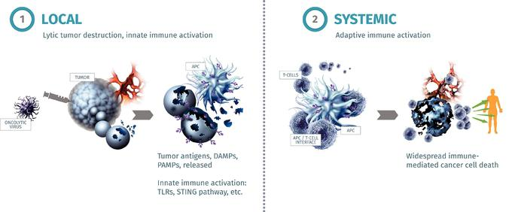

We believe that our ability to incorporate multiple mechanisms of action into a practical, "off-the-shelf" approach to initiating or enhancing an anti-tumor immune response, including to neo-antigens, will offer significant advantages over the various approaches to immune activation that are currently in development, including personalized vaccine treatments. Tumor neo-antigens are uniquely present in tumors as compared to normal tissue because they result from the genetic changes that occur as cancer develops. Unlike the antigens present in normal tissue, the immune system sees neo-antigens as foreign. As a result, the immune system is able to mount an immune response to tumor neo-antigens in the same way that it would to the antigens contained in disease causing micro-organisms, which the immune system also sees as foreign. Researchers believe immune responses to tumor neo-antigens are particularly important in providing the patient's immune system the ability to combat cancer, and as a consequence various "personalized vaccine" approaches to generating immune responses to tumor neo-antigens are in development. These approaches are generally both expensive and time consuming because a vaccine cannot be designed and manufactured until a tumor biopsy is taken and analyzed in the laboratory to identify the mutated tumor antigens that will be targeted by the treatment. We believe that our approach may also offer significant advantages over other approaches to anti-cancer immune activation that only target a single pathway of the immune system, as is the case with most of the other immune-oncology therapies currently under development. Importantly, our product candidates are intended to act to maximally activate an immune response against cancer, the missing element needed to allow anti-PD-1 or anti-PD-L1 therapy to treat more patients and tumor types, unlike some other therapies such as those targeting indoleamine 2,3-dioxygenase, or IDO, which are intended to act by blocking additional defense mechanisms against an anti-tumor immune response once it has been initiated.

Our Immulytic platform

The foundation of our oncolytic immunotherapy product candidates, which we call our Immulytic platform, consists of a proprietary strain of HSV-1 that we have engineered to replicate selectively in tumors and to express a fusogenic glycoprotein, a protein that triggers the fusion of the membranes between cells. HSV-1 is both highly cell lytic and inflammatory, and also has a large carrying capacity, which makes it possible to incorporate multiple genes encoding therapeutic proteins. We believe our combination of HSV-1 with the

104

Table of Contents

expression of the fusogenic glycoprotein increases the natural ability of HSV-1 to kill tumor cells and to induce an anti-tumor immune response. The fusogenic functionality of our product candidates is intended not only to increase the number of tumor cells that are killed, but also to cause highly immunogenic death of tumor cells. We believe that these factors will increase the potency of the systemic anti-tumor immune response that is generated by our product candidates. With the intention of amplifying the anti-tumor response further, we have also engineered our product candidates to express a range of additional, potent, immune activating genes encoding therapeutic proteins, in tumors. Our lead product candidate, RP1, serves as the base for the development of these additional oncolytic immunotherapies expressing further therapeutic proteins. The development process and certain advantages of our Immulytic platform are summarized below:

Selecting the virus species and the virus strain

Although a number of viral species have been developed for oncolytic use, we believe HSV-1 is the most promising for the following reasons:

- HSV-1 can infect many different tumor cell types and, following infection, can destroy tumor cells through highly lytic virus replication;

- HSV-1 rarely produces severe illness in humans;

- The deletion of the genes encoding the HSV-1 ICP34.5 protein provides both tumor-selective virus replication and a well-characterized non-pathogenic phenotype;

- HSV-1 is a highly inflammatory virus, which we believe is beneficial for triggering both innate and adaptive immune responses;

- HSV-1 has a large genome, which has the packaging capacity to allow for the insertion of multiple genes expressing therapeutic proteins that are intended to enhance tumor cell killing and immune activation; and

- Effective anti-viral drugs are available for HSV-1, which could be used to block virus replication if needed.

In addition, HSV-1 has a proven track record in oncolytic immunotherapy, in particular with the approval by the FDA in 2015 of T-Vec for the treatment of unresectable advanced melanoma patients with injectable non-visceral tumors.

Different isolates, or "strains," of HSV-1 have differing properties, including with respect to the ability to infect and kill human tumor cells. Standard "laboratory" strains of HSV-1 may have reduced potency due to long-term culture in the laboratory or because such strains were not selected for the purposes of tumor killing. We believe that "clinical" strains, which are strains taken from individuals who suffer from cold sores, would not have become attenuated through long-term culture and, if selected on the basis of the ability to infect and kill human tumor cells, would provide higher potency than strains that have not been selected in this way.

Based on this rationale, we tested 29 clinical strains of HSV-1 isolated from 183 volunteers. Through this process we expected to sample a broad spectrum of the natural variation among clinical strains of HSV-1, including in relation to their ability to infect and kill human tumor cells. We observed a broad range of killing activity and chose the strain with the most promising overall properties for further development. Through this process we believe we have identified a highly potent strain of HSV-1 that provides a robust foundation for the development of our Immulytic platform.

105

Table of Contents

To render the replication of the virus tumor-selective, we engineered this virus strain to delete the genes encoding the HSV-1 ICP34.5 and ICP47 proteins. This combination of deletions provides the virus with well-characterized non-pathogenic and tumor-selective properties.

To augment the underlying abilities of the virus both to kill tumor cells and to induce an anti-tumor immune response that may maximally activate the immune system against a patient's cancer, we have armed all of our product candidates with genes to express between two and four therapeutic proteins. These therapeutic proteins are expressed in the tumor as the virus replicates, and, as a result, may help to kill tumor cells and drive the initiation of an anti-tumor immune response in the tumor and draining lymph nodes. Once this anti-tumor immune response is initiated, the activated immune cells may also attack not only the injected tumors but also tumors that are distant from the injection sites.

Maximizing direct tumor killing — Expression of a fusogenic protein

To increase the natural ability of HSV-1 to directly kill tumors and to drive the immunogenicity of tumor cell death, we engineered our viruses to express a protein that causes cell-to-cell fusion intended to result in increased immune-stimulating cell death. Although there are various fusogenic proteins available for this purpose, we use the surface glycoprotein, or GP, from another virus, gibbon ape leukemia virus, or GALV, with a specific deletion of the R-peptide. The resulting protein is known as GALV-GP R(-). We believe that the higher levels of tumor antigens released through the expression of GALV-GP R(-), including tumor neo-antigens, combined with enhanced immunogenicity of cell death, increases both systemic immune-mediated anti-tumor effects and local, or injected, tumor destruction.

Enhancing the systemic anti-tumor immune response

With the aim of augmenting the potency of the anti-tumor immune response which is generated, we have also engineered our product candidates to express potent immune-stimulating proteins within tumors as replication occurs.

Expressing GM-CSF

RP1, our lead product candidate, expresses granulocyte-macrophage colony-stimulating factor, or GM-CSF, in addition to GALV-GP R(-). GM-CSF is a potent cytokine that activates and causes the proliferation of APCs and is, therefore, attractive for expression in the tumor to augment the anti-tumor immune response. Due to its ability to enhance immune responses, a number of other oncolytic immunotherapy products and product candidates in development have been designed to express GM-CSF. These include:

- T-Vec, approved in the United States, the European Union and elsewhere for the treatment of advanced melanoma;

- Pexa-Vec, in Phase 3 clinical development by SillaJen, Inc. for the treatment of hepatocellular carcinoma, or HCC; and

- CG0070, in development by Cold Genesys, Inc. for the treatment of bladder cancer.

Expressing additional immune-stimulating proteins

We have designed our further product candidates, RP2 and RP3, to express additional genes encoding therapeutic immune-stimulating proteins.

RP2 is a version of RP1 that includes a gene encoding an anti-CTLA-4 antibody-like protein. We believe that RP2 has the potential to offer advantages over current anti-CTLA-4 approaches, including ipilimumab, an anti-CTLA-4 therapy marketed by BMS. The FDA has approved ipilimumab for intravenous administration

106

Table of Contents

for the treatment of advanced melanoma and has approved nivolumab, an anti-PD-1 therapy also marketed by BMS, for use in combination with ipilimumab, for advanced melanoma and renal cell carcinoma. Ipilimumab has also shown clinical synergy with GM-CSF. Intravenous administration of ipilimumab, however, causes significant toxicity, largely due to auto-immune side effects, particularly in combination with nivolumab. These autoimmune side effects from the systemic administration of ipilimumab appear to result from the blocking of the immune system's ability to recognize normal tissue and not attack it. Because the function of CTLA-4 is to inhibit the induction of immune responses, we believe that blockade of this effect should be needed only at the site where anti-tumor immune response induction occurs, namely at the tumor and the lymph nodes draining from the tumor site. We believe that RP2 will offer advantages compared with current CTLA-4 approaches, including ipilimumab. By expressing anti-CTLA-4 only locally in the tumor and draining lymph nodes, we believe that activity will be retained, but that toxicity will be reduced.

We are designing our RP3 product candidate to express not only GALV-GP R(-) and anti-CTLA-4, but also additional proteins that are intended to stimulate the potency of the anti-cancer T cell response through activation of the immune co-stimulatory pathways. We are studying the effects of incorporating the ligands for co-stimulatory proteins, including those known as CD40, OX40 and 4-1BB, for this purpose, and intend to finalize the version of RP3 that we will seek to progress into clinical development during the second half of 2018. We expect to introduce RP3 into clinical development in the first half of 2020. Currently, numerous antibodies are in clinical development by other companies that target these same pathways, but, as with CTLA-4, the site of action of these pathways is where the anti-tumor immune response is generated, so we believe that local intratumoral expression will be an advantageous approach.

We plan to develop product candidates beyond RP3 that will express additional genes encoding therapeutic proteins targeted at particular aspects of the anti-tumor immune response. As demonstrated by our planned development timelines, we believe that a particular advantage of our Immulytic platform is that it allows us to develop new product candidates containing genes encoding additional therapeutic proteins rapidly from conception through to the initiation of clinical trials. Our current goal in the coming years is to bring one product candidate into the clinic each year.

Synergy with immune checkpoint blockade therapies

While we believe our product candidates will be able to provide a clinical benefit as single agents, we believe their impact will be enhanced in combination with immune checkpoint blockade therapies. We currently intend for our product candidates to be used in combination with immune checkpoint blockade therapies, particularly antibodies targeting PD-1 or PD-L1. Based on a similar rationale and in support of this approach, a number of other oncolytic viruses have previously been tested in combination with immune checkpoint blockade therapies in clinical trials with promising results. In each of the completed single arm clinical trials, so far all in melanoma, a response rate that is higher than would be expected for the immune checkpoint blockade therapy alone has been observed, including a 62% response rate and 33% complete response rate having been seen with T-Vec combined with pembrolizumab. None of these clinical trials showed that oncolytic immunotherapy added significant additional toxicity relative to checkpoint blockade therapy alone.

There has been one randomized, controlled trial to date of an oncolytic immunotherapy combined with immune checkpoint blockade therapy. In that randomized Phase 2 clinical trial, T-Vec was tested in combination with ipilimumab compared to treatment with ipilimumab alone in 198 melanoma patients. The primary endpoint of the study was objective response rate. The combination of T-Vec and ipilimumab gave an objective response rate (meaning the observed measurement of the reduction in tumor size per the

107

Table of Contents

protocol) of 38% compared to 18% with ipilimumab alone (p=.002), which was concluded to be statistically significant. No significant increase in toxicity was observed.

Later-stage clinical development is now underway with T-Vec in combination with pembrolizumab in the following clinical trials:

- A Phase 3 trial of T-Vec in combination with pembrolizumab, compared with pembrolizumab plus a placebo in patients with advanced melanoma; and

- A controlled Phase 2 trial of T-Vec in combination with pembrolizumab in patients with liver metastases from a variety of tumor types.

We believe that the early data, including randomized, controlled data described above, provides promising clinical support for oncolytic immunotherapy in combination with immune checkpoint blockade therapy.

Administration by direct injection into tumors

Our product candidates are injected directly into tumors. We can inject tumors close to the body's surface either visually or with simple ultrasound guidance, and can inject tumors found deeper in the body with imaging guidance techniques that are routinely used to take tumor biopsies. Direct injection is intended to maximize virus-mediated tumor cell death, which is required for the optimal activation of systemic immunity. In addition, we believe that direct injection provides the most efficient delivery of genes encoding therapeutic proteins into the tumor and thereby limits systemic exposure and related toxicities. We believe that only a limited number of injections of our product candidates will be required to initiate an immune response, particularly when combined with immune checkpoint blockade therapies such as those targeting PD-1 or PD-L1. By contrast, we believe that the systemic administration of oncolytic immunotherapy product candidates increases dilution in the blood, decreases tumor targeting, and increases the likelihood of an antiviral immune response, greatly reducing the ability of the virus to reach tumors.

108

Table of Contents

Our product candidate pipeline

We are developing a pipeline of oncolytic immunotherapy product candidates that we believe have the potential to provide meaningful and long-lasting clinical benefits to cancer patients. The following table summarizes our current pipeline and expectations for development timelines:

We believe that our intended step-wise development approach from RP1 through RP3 reduces clinical risk, as we will be able to study the safety profile of each therapeutic protein prior to moving to the next product candidate with an additional therapeutic protein that is intended to provide more potent anti-tumor immune effects.

Lead product candidate: RP1

Our lead product candidate, RP1, is a selectively replicating version of HSV-1 that expresses GALV-GP R(-) and human GM-CSF. RP1 has the following properties:

- We have deleted the ICP34.5-encoding gene, which enables tumor-selective virus replication;

- We have deleted the ICP47-encoding gene, which is intended to prevent the inhibition of the antigen presentation pathway otherwise caused by ICP47 binding to the transporter associated with antigen presentation. ICP47 deletion is also intended to result in the increased and earlier expression of the

109

Table of Contents

HSV-1 US11 gene by placing the HSV-1 US11 gene under the control of ICP47 promoter. This increases virus replication in tumors without reducing tumor-selectivity; and

- We have inserted the sequences for GALV-GP R(-) and human GM-CSF, which results in the expression of these therapeutic proteins with the intention of increasing both the direct tumor cell killing and the potency of the anti-tumor immune response that is induced.

We are developing RP1 for use in combination with immune checkpoint blockade therapy, particularly therapies targeting PD-1 or PD-L1. We believe that the robust release of tumor antigens and the highly immunogenic tumor cell death intended to be caused by RP1 will further increase the synergy previously seen between oncolytic viruses and immune checkpoint blockade therapy.

Preclinical results

In one of our preclinical experiments, tumors were induced in both the left and right flanks of rats. RP1 was then injected into the tumors in only the right flanks. As shown
below, where each line represents an individual tumor and lines of the same color represent the tumors in the left and right flanks of the same rat, we observed destruction
not only of the injected tumors in the right flanks, but also of the large un-injected tumors in the left flanks of 70% of the treated rats. As reflected in the top diagram of
Figure 1 below, when formulation buffer with no RP1 was injected into "control" rats, no impact on the growth of the injected or un-injected tumors was observed. This effect of

RP1 in both injected and un-injected tumors provides support for the potent systemic, or "abscopal," effect of RP1.

Figure 1: RP1 has been shown to treat large injected and un-injected tumors in rats
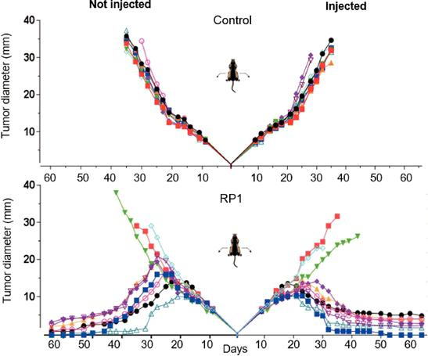

110

Table of Contents

Phase 1/2 clinical trial in multiple tumor types

We are conducting a Phase 1/2 clinical trial of RP1 in approximately 150 patients. The first part of our Phase 1/2 clinical trial is currently being conducted in the United Kingdom and we intend to conduct the second part of the clinical trial in both the United Kingdom and, pending the opening of an IND, in the United States. This is an open-label, multicenter study to investigate the safety, tolerability and efficacy of RP1. We have designed this clinical trial to study RP1 in tumor types that have been shown to have some level of responsiveness to anti-PD-1 or anti-PD-L1 therapy but where we believe there remains significant unmet medical need. In the first part of the clinical trial we are assessing the safety and tolerability of RP1, administered alone in a single tumor, in a minimum of 18 patients with advanced or metastatic solid tumors who have progressed on or cannot tolerate standard therapy. Following the dose escalation phase, up to 15 patients will be enrolled to receive RP1 administered into multiple tumors in combination with nivolumab. In the second part of the clinical trial, we will study the safety and efficacy of RP1 in combination with nivolumab in specific tumor types in four cohorts of 30 patients each. These tumor types are metastatic melanoma, metastatic bladder cancer, microsatellite instability high cancer, and non-melanoma skin cancer. Depending on the tumor type, patients must be eligible to receive PD-1 directed therapy according to the product label or have exhausted, become intolerant to or refused currently available therapies. We have an agreement with BMS for the supply of nivolumab for this clinical trial.

We expect that the results from the first part of the clinical trial will help us determine the safety, tolerability and intended dose of RP1 for further development and to provide initial safety data for RP1 in combination with nivolumab. We have also designed the first part of the trial to provide insights on the effects of RP1 on tumors, including necrosis, inflammation and erythema, the biodistribution of RP1 in the blood, saliva and mucosa, and the impact of RP1 administration on anti-HSV-1 antibody responses. For the patients in the first part of the trial who also receive nivolumab, we will assess certain biomarkers indicative of immune activation in tumor biopsies. These include the infiltration of T cells, expression of PD-L1, and the presence of an "inflamed gene signature," each of which would indicate ongoing immune activation.

Of the approximately 30 patients in the first part of the clinical trial:

- Approximately half will receive RP1 using direct or ultrasound guided injection to administer RP1 to tumors located on or close to the skin, or into lymph nodes located near the skin; and

- Approximately half will receive RP1 using imaging guided injection to administer RP1 to tumors located deeper in the body, including in visceral organs such as the liver.

In the second part of the trial, we intend to continue to assess the safety and begin to assess the efficacy of RP1 in combination with nivolumab in four cohorts of approximately 30 patients, each with one of the different cancer types described above.

We have chosen these tumor types because they have shown that they have some level of underlying responsiveness to treatment with immune checkpoint blockade therapies but for which we believe considerable unmet medical need remains. We intend to expand the number of patients treated and/or add a control arm for each cohort where we see promising signs of efficacy, either as part of the same clinical trial or as separate trials, as a means to gather more definitive data in support of the clinical benefit of the combination of RP1 and nivolumab in these respective tumor types. We believe that these expansion cohorts can be designed to support registration-directed development.

In each of the four cohorts in the second part of the trial, we plan to assess efficacy under the clinical trial protocol by examining the rate and duration of responses, including partial responses (a 30% or greater

111

Table of Contents

reduction in tumor size) and complete responses (a complete eradication of the disease), as well as examining biomarkers of immune response and mechanism of action. For example, we expect that tumors with no or low pre-existing immune responses as evidenced by no or low T cell infiltration at baseline would not respond to anti-PD-1 therapy. Responses in these patients would therefore suggest clinical benefit of the combination of RP1 with anti-PD-1. Likewise, an increase in post-treatment T cells infiltrating into tumors and/or an increase in inflammation as evidenced by the development of an inflammatory gene signature would also support the activity of RP1.

Clinical trial status

The first part of the ongoing Phase 1/2 clinical trial of RP1 commenced in October 2017 in the United Kingdom where 15 patients have been enrolled to date, including patients with melanoma, breast cancer, colorectal cancer, CSCC and esophageal cancer. Each of these patients has advanced, high tumor burden disease and has previously failed multiple other therapies including in clinical trials. Approximately half of the patients have received one or more lines of immune checkpoint blockade therapy. As of June 22, 2018, we have administered injections into a single tumor at first doses of 1x10⁴, 1x10⁵ and 1x10⁶ pfu/ml by direct injection and first doses of 1x10⁴ and 1x10⁵

pfu/ml by imaging guided injection into deeper lesions. Subsequent doses for direct injection have been given at up to 1x10⁸ pfu/ml and for deeper lesions at up to 1x10⁶ pfu/ml so far. Injections have been given up to five times in each patient. During screening and in the weeks following the injections, we have taken swabs of the tumor, biopsies, blood samples, urine samples, vital signs, photographs at various intervals and CT scans are specified at 30 days following the final dose of RP1.

The primary objectives of the first part of the trial are to provide an initial determination of the safety of RP1 alone and in combination with nivolumab and to determine the recommended dose for the second part of the trial. In addition, we intend to assess tumor size, erythema and inflammation in tumor biopsies for indications of biological activity.

The clinical trial is being conducted under the review of a safety review committee, which is responsible for reviewing safety data, deciding whether to move to the next dose cohort, determining the recommended Phase 2 dose, and identifying any safety concerns. The clinical trial is also subject to certain protocol defined safety stopping rules.

Preliminary data as of June 22, 2018 suggest that RP1 is well tolerated. We have observed the expected side effects of local inflammation and erythema combined with mild fevers and other influenza-like symptoms for several days. These side effects are consistent with the side effects previously reported for other oncolytic viruses. One possible dose limiting toxicity, or DLT, elevated lipase levels, has been observed in one patient in the first deep visceral group cohort. At baseline, this patient was HSV seropositive

and already had rising lipase levels. The patient received prior doses of 1x10⁴ pfu/ml and 1x10⁵ pfu/ml with the elevated lipase levels occurring after the patient's third dose, which was at a dose level of 1x10⁶ pfu/ml. The elevated lipase levels then resolved without clinical signs or symptoms being observed and following which two further doses of 1x10⁶ pfu/ml were given with no other potential DLTs occurring. The other two patients in that cohort, who were both HSV seronegative, and the first patient in the next

dose level cohort in the deep visceral group, who was HSV seropositive and given doses of 1x10⁵, 1x10⁶ and three doses of 1x10⁷ pfu/ml, have not experienced any DLTs. However, per protocol, because a potential DLT was observed in the first dose level cohort following review of laboratory values during trial monitoring, this first dose level cohort in the deep visceral group is being expanded to include an additional three patients. As of June 22, 2018, two of these patients have been enrolled, with the first patient

having received doses of 1x10⁴, 1x10⁵ and two doses of 1x10⁶ pfu/ml so far, and the second patient having received a single dose of 1x10⁴ pfu/ml, with no potential DLTs having been observed. While the first part of the clinical trial is being conducted in the United Kingdom,

112

Table of Contents

we intend to conduct the second part of the clinical trial in both the United Kingdom and, pending an opening of an IND, the United States. We may also consider additional countries for this clinical trial.

Regulatory status

In the United Kingdom, prior to filing a Clinical Trial Authorization, or CTA, we participated in a pre-CTA meeting with the Medicines and Healthcare products Regulatory Agency, or MHRA, in February 2017. We subsequently filed our CTA with the MHRA in April 2017 and received full CTA approval from the MHRA in July 2017. An amendment to the trial protocol to specify that the anti-PD-1 therapy to be used is nivolumab, to specify that anti-PD-1 therapy will be included in the Phase 1 expansion cohort and to add nivolumab specific information to the protocol is currently undergoing review by the MHRA. We anticipate that the MHRA will complete its review of the amendment during the third quarter of 2018. This amendment does not affect the ongoing part of the clinical trial.

In the United States, we participated in a pre-IND teleconference with the FDA in October 2017, during which the agency asked that we repeat one of the toxicology and biodistribution studies we previously conducted but with a longer follow-up than was used in the initial study. We filed an IND on February 23, 2018, to enable the FDA to review all other aspects of the IND, which we will update once the additional toxicology and biodistribution data are available. The FDA verbally informed us on March 23, 2018 and confirmed in writing on April 18, 2018 that, as expected, the IND was on clinical hold pending submission of the additional data and review by the FDA. The in-life phase of the toxicology and biodistribution study was completed in May 2018, and no material issues were observed. We anticipate that a draft unaudited toxicology report will be provided by the CRO by the end of July 2018, and intend to submit an amendment to the IND to the FDA in early August 2018.

Controlled Phase 2 clinical trial in CSCC

In the first half of 2019, we intend to initiate a randomized, controlled Phase 2 clinical trial of RP1 combined with cemiplimab, compared to cemiplimab alone, in approximately 240 patients with CSCC. The primary objective of this controlled Phase 2 clinical trial will be to assess the response rate of the combination therapy compared to treatment with anti-PD-1 therapy alone, with key secondary endpoints including the rate of complete response and the duration of response. If compelling clinical data are generated demonstrating the benefits of the combined treatment, we believe the data from the controlled Phase 2 clinical trial could support a filing with regulatory authorities for marketing approval.

Pipeline product candidate: RP2

We have designed our RP2 product candidate to express an anti-CTLA-4 antibody-like protein in order to block the inhibition of the immune response otherwise caused by CTLA-4. We believe that RP2 will offer advantages compared with current CTLA-4 approaches, including ipilimumab. By expressing anti-CTLA-4 only locally in the tumor and draining lymph nodes, we believe that activity will be retained, but that toxicity will be reduced. We intend that our RP2 product candidate will be used in combination with anti-PD-1 therapy, which we believe will result in both synergy with the oncolytic virus and the expression of the anti-CTLA-4 in the tumor.

We intend to administer RP2 in combination with anti-PD-1 or anti-PD-L1 therapy in tumor types that are not responsive to anti-PD-1/L1 therapy alone, and in patients who have not responded to or who have progressed on prior anti-PD-1/L1 therapy. We expect to include patients with triple negative breast cancer and two further indications in our initial clinical trial with RP2. We intend to file an IND and foreign equivalents for RP2 and we expect that we will bring RP2 into clinical development in the first half of 2019.

113

Table of Contents

Preclinical results

We are currently conducting preclinical development of RP2, including toxicology and biodistribution studies, with product already manufactured to GMP standards. Release testing is underway.

We have conducted preclinical tests comparing RP1 and RP2 to determine the effect of expressing the anti-CTLA-4 antibody-like protein, and have observed an enhanced effect with RP2. In one of these preclinical experiments, tumors were induced in both the left and right flanks of mice. Either RP1 or RP2 was then injected into the tumors in only the right flanks. As shown below in Figure 2, where each line represents an individual tumor and lines of the same color represent the tumors in the left and right flanks of the same mouse, we observed enhanced destruction of tumors with RP2 as compared to RP1, particularly of the un-injected tumors. In this experiment only a low dose of virus was used such that with RP1 un-injected tumors only partially responded to the treatment. This was to allow the potential benefits of anti-CTLA-4 expression to be observed. This experiment is illustrated in the figure below:

Figure 2: Expression of anti-CTLA-4 from RP2 showed an increased effect as compared to RP1 in mice
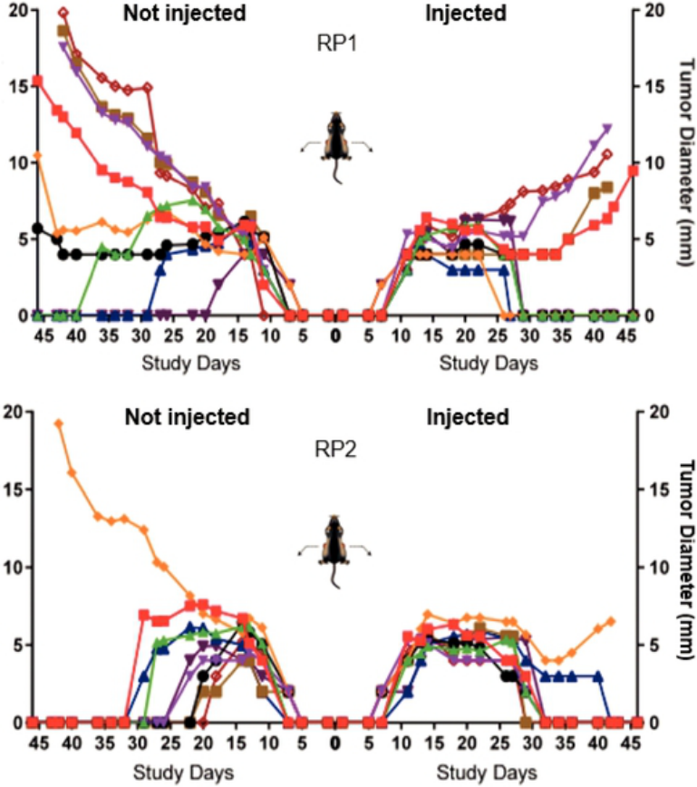

In a further experiment with RP2 in combination with anti-PD-1 therapy, we assessed the durability of response in mice in which tumors had been eradicated and whether these mice were protected against

114

Table of Contents

re-challenge with tumor cells, which would demonstrate that memory immune responses had been induced. In this experiment 15 mice cured of bilateral tumors following administration of RP2 combined with an anti-PD-1 therapy were observed until day 108 following initiation of the experiment and then re-challenged with tumor cells to assess whether the mice were protected against the formation of new tumors. This demonstrated that anti-tumor effects were maintained throughout the experiment and that 14 out of the 15 mice were protected against re-challenge with tumor cells. This experiment is shown in the figure below. Treatment with anti-PD-1 alone has no anti-tumor effect in this model.

Figure 3: The treatment effect with RP2 was shown to be durable and induce memory immune responses in mice
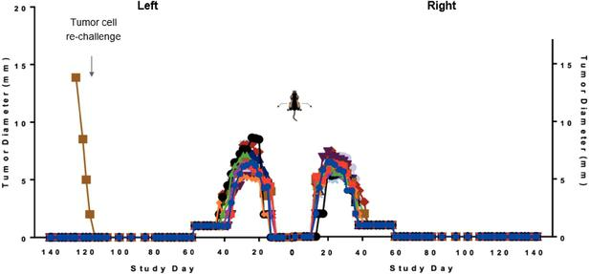

Planned Phase 1/2 clinical trial

We are currently beginning protocol development for a Phase 1/2 clinical trial of RP2 in combination with anti-PD-1 therapy and intend to initiate the clinical trial in the first half of 2019.

Pipeline product candidate: RP3

We are designing our RP3 product candidate to express immune-activating proteins that stimulate T cells, in addition to anti-CTLA-4 and GALV-GP R(-). These immune activating proteins are the ligands for various immune co-stimulatory pathways responsible for T cell proliferation and/or activation, including the CD40, OX40 and 4-1BB pathways. We plan to finalize the version of RP3 for clinical development during 2018. As with RP2, we intend to study RP3 in indications that have not so far responded to anti-PD-1 or anti-PD-L1 therapy. We expect to bring RP3 into clinical development in the first half of 2020.

Preclinical results

We have conducted preclinical tests to assess the benefit of expressing immune co-stimulatory pathway ligands, and have observed an enhanced effect associated with the expression of these proteins as compared to RP1. In one of these preclinical experiments, tumors were induced in both the left and right flanks of mice. Either RP1 or versions of RP1 additionally expressing the ligands which activate CD40, 4-1BB or OX40 were then injected into the tumors in only the right flanks. As shown below, where each line represents an individual tumor and lines of the same color represent the tumors in the left and right flanks of the same mouse, we observed enhanced destruction of tumors with the co-stimulatory pathway ligand expressing viruses as compared to RP1, particularly of the un-injected tumors. In this experiment

115

Table of Contents

only a low dose of virus was used such that with RP1 un-injected tumors only partially responded to the treatment. This was to allow the potential benefits of co-stimulatory pathway ligand expression to be observed. This experiment is illustrated in the figure below:

Figure 4: Comparative effects of RP1 and equivalent viruses also expressing immune co-stimulatory pathway ligands in mice
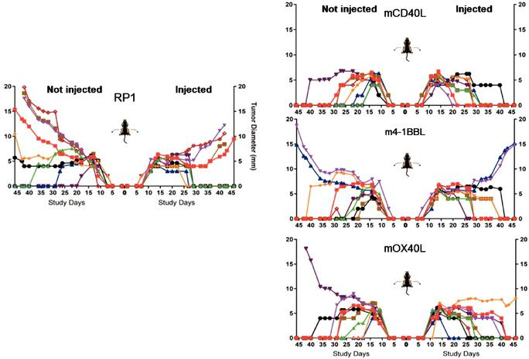

Background on our target indications and current treatment options

Set forth below is a description of the target indications we currently intend to pursue with RP1 or RP2, as well as a summary of the existing treatment options for each target indication. When we refer to "response rates" below, we mean the observed reduction in tumor size, per the criteria set forth in the applicable clinical trial protocol; and when we refer to "complete response rate" below, we mean the observed complete eradication of disease in the patient.

Bladder cancer

According to the American Cancer Society, bladder cancer has an incidence of approximately 81,190 cases annually in the United States, with 17,240 deaths attributable to the disease in 2018. Although 77% of bladder cancer patients survive five years from diagnosis, the five-year relative survival rate for metastatic stage IV bladder cancer is just 15%.

Treatment depends on the stage of disease and may include some combination of surgery, radiation therapy, chemotherapy and immunotherapy. Surgical options may include transurethral resection, partial or complete removal of the bladder, or urinary diversion. Platinum-based chemotherapy is the standard of

116

Table of Contents

care for patients with metastatic disease. Several regimens exist, though the combined treatment of methotrexate, vinblastine, doxorubicin, and cisplatin has been the preferred one; however, patients experience high toxicity associated with these therapies. Patients who relapsed after platinum-based therapy have median survival ranging from five to seven months and no known life-prolonging treatments exist. Immune checkpoint blockade therapies have since shown utility in recurrent advanced bladder cancer. Specifically, pembrolizumab, atezolizumab, avelumab and durvalumab have all been approved in various settings. Pembrolizumab received FDA accelerated approval for first-line use based on a study of 370 patients with locally advanced or metastatic urothelial carcinoma who were not eligible for platinum-containing chemotherapy. The response rate was 29% with a 7% complete response rate. Pembrolizumab is also FDA-approved for patients who have failed platinum-containing chemotherapy based on a 542 patient randomized, controlled clinical trial of pembrolizumab compared to chemotherapy. The response rate was 21% for pembrolizumab compared to 11% for chemotherapy, with complete response rates of 7% and 3%, respectively, and a 27% reduction in the risk of death observed.

Atezolizumab, a PD-L1 inhibitor, has also been found to be active in bladder cancer, and was granted accelerated approval by the FDA in 2016 for patients with locally advanced or metastatic urothelial carcinoma, who progressed on or after platinum-based chemotherapy on the basis of a 310 patient single arm study. Atezolizumab gave a response rate of 14.8% for all patients, a 9.5% response rate for patients with low PD-L1 expression, and a 26% response rate for patients with high PD-L1 expression. Complete response rates were 5.5%, 2.4%, and 12%, respectively. Avelumab and durvalumab, additional antibodies targeting PD-L1, were also granted accelerated approval by the FDA for the treatment of locally advanced and metastatic bladder cancer in May 2017. Avelumab is approved for patients with advanced or metastatic bladder cancer who have disease progression on or following platinum-containing chemotherapy and for patients having disease progression within 12 months of pre- or post-surgery platinum-containing chemotherapy on the basis of a 242 patient single arm clinical trial. The response rate was 13.3% after 13 or more weeks of follow up and 16.1% after six months or more of follow up, with complete response rates of 4% and 5.6%, respectively. There was no clear difference in response rate based on PD-L1 expression. Durvalumab is approved in the same patients on the basis of a single arm 182 patient clinical trial which gave a 17% response rate for all patients, a 26.3% response rate for patients with high PD-L1 expression, and a 4.1% response rate for patients with low PD-L1 expression. Complete response rates were 2.7%, 3.2%, and 1.4%, respectively.

Melanoma

According to the American Cancer Society, melanoma has an incidence of approximately 87,000 cases annually in the United States with over 9,300 deaths attributable to the disease in 2018. For patients with metastatic melanoma, five-year survival rates have historically been very low. While the majority of patients have clinically localized disease at presentation, advanced melanoma spreads in an unpredictable fashion, with widespread metastasis to any organ site but often to skin, lung, brain, liver, or small bowel.

Since most cases of melanoma are diagnosed at an early stage and are curable with surgery alone, the standard treatment option for Stage I to resectable Stage III disease is surgery with or without lymph node dissection. For more advanced stages, until recently, treatment options were limited to chemotherapy, which is of unproven benefit, and Interleukin 2, or IL-2. IL-2 was approved by the FDA in 1998 on the basis of a 270 patient single arm study which demonstrated a 16% response rate and 6% complete response rate. While responses with IL-2 are often of long duration, toxicity is often substantial.

Since 2011, the immunotherapies ipilimumab, pembrolizumab, nivolumab, ipilimumab in combination with nivolumab, and T-Vec have received FDA approval in the United States, as have the molecular targeted therapies vemurafenib and dabrafenib in combination with trametinib. While response rates are often high,

117

Table of Contents

they are also often of limited duration. The more recently approved immunotherapy products have generally been shown to give responses of longer duration.

Ipilimumab was approved on the basis of a 676 patient randomized, controlled trial comparing ipilimumab to a peptide vaccine. The response rate for ipilimumab was 10.9% compared to 1.5% for the peptide vaccine and the risk of death was reduced by 34%.

Pembrolizumab was approved in ipilimumab naïve patients on the basis of an 834 patient randomized, controlled Phase 3 clinical trial testing two dose regimens (every two weeks and every three weeks) of pembrolizumab versus ipilimumab. The response rates for pembrolizumab were 34% and 33%, respectively, and 12% for ipilimumab. The complete response rates were 5%, 6%, and 1%, respectively. The risk of death was reduced by 37% and 31% for pembrolizumab dosing every two weeks and every three weeks, respectively, as compared to treatment with ipilimumab. Pembrolizumab is also approved for ipilimumab refractory patients on the basis of a 540 patient Phase 3 clinical trial comparing the same two dosing regimens of pembrolizumab compared to chemotherapy. Response rates of 21% and 25% for pembrolizumab compared to 4% for chemotherapy and a 14% and 26% reduction in the risk of death, depending on the pembrolizumab dose, were observed. The complete response rate was 2% and 3% for pembrolizumab and 0% for chemotherapy.

Nivolumab was approved in patients with previously treated melanoma on the basis of a 120 patient clinical trial in which a response rate of 32% and a complete response rate of 3.3% was observed in patients treated with nivolumab. Nivolumab was also approved for previously untreated melanoma on the basis of a 418 patient clinical trial comparing nivolumab to chemotherapy in which response rates of 34% for nivolumab and 9% for chemotherapy were observed, with complete response rates of 4% for nivolumab and 1% for chemotherapy and a reduction in risk of death of 58% for nivolumab. Nivolumab was also approved in melanoma in combination with ipilimumab based on a 945 patient clinical trial in which ipilimumab naïve patients were treated with nivolumab alone, ipilimumab alone, or nivolumab together with ipilimumab. While toxicity in the combination arm of the trial was substantially increased as compared to the single agent treated patients, the response rate was 50% for the combination compared to 40% for nivolumab alone and 14% for ipilimumab alone, with complete response rates of 8.9%, 8.5% and 1.9%, respectively. There was also a reduction in the risk of death of 58% as compared to ipilimumab for the combination arm and of 43% for nivolumab compared to ipilimumab alone.

In 2015, T-Vec was approved for the local treatment of unresectable cutaneous, subcutaneous, and nodal lesions in patients with recurrent melanoma after initial surgery on the basis of a 436 patient Phase 3 clinical trial in which patients with previously treated or treatment naïve Stage IIIb to Stage IVM1c disease were randomized, two-to-one, to receive either T-Vec or subcutaneously administered GM-CSF. The primary endpoint was durable response rate, or DRR, the rate of responses lasting continuously for at least six months. The DRR was 16.3% for T-Vec compared to 2.1% for GM-CSF, the overall response rate was 26.4% for T-Vec compared to 5.7% for GM-CSF, and the complete response rate was 10.8% for T-Vec compared to 0.7% for GM-CSF. In combination with ipilimumab, in a 198 patient controlled Phase 2 clinical trial, T-Vec gave a response rate of 39%, compared to 18% for ipilimumab alone. In combination with pembrolizumab, T-VEC gave a response rate of 62% and complete response rate of 33% in a 21 patient Phase 1b clinical trial.

Non-melanoma skin cancer

Non-melanoma skin cancer, or NMSC, is the most common cancer affecting light-skinned individuals and the incidence is increasing worldwide. Although incidence varies by geography, about 80% of all NMSC cases are basal cell carcinoma, or BCC, while CSCC represents about 20%, and other cancer types represent

118

Table of Contents

only 1%. Included in that 1% are primary cutaneous lymphoma, sarcomas of the skin, Merkel cell carcinoma, and appendageal carcinoma. NMSC is often not reported to cancer registries, hence accurate estimates of incidence are difficult to obtain. In 2013, the World Health Organization estimated there to be 2-3 million cases per year. NMSCs, however, are most likely to be under-reported, particularly in light of a recent study that estimated there to be 3.5 million cases each year in the United States alone.

Cutaneous squamous cell carcinoma

According to the American Cancer Society, CSCC has an incidence of more than 700,000 cases annually in the United States, with approximately 4,000-9,000 deaths attributable to the disease each year, and is the second deadliest skin cancer after melanoma. Although the prognosis for patients with CSCC is generally favorable, if distant metastases occurs, the long-term prognosis is extremely poor. Most cases of CSCC can be successfully managed with a variety of simple procedures, such as cryotherapy, curettage and electro desiccation, topical treatments, or simple surgical excision. When lesions are more advanced, micrographic surgery, more extensive surgical resection, or radiation therapy are generally sufficient to control loco-regional disease. The five-year rate of cure in patients with large tumors is 70%, regardless of the treatment chosen. However, for those with metastatic disease, the long-term prognosis is reduced drastically.

Stage IV CSCC can be responsive to various chemotherapeutic agents. However, there are no standard or FDA-approved therapies. Targets being evaluated in clinical trials of CSCC include epidermal growth factor receptor inhibition with drugs such as cetuximab or erlotinib, as well as PD-1 inhibition with drugs such as cemiplimab. Cemiplimab is currently under review for approval in CSCC by the FDA based on data generated in a Phase 2 clinical trial of 82 patients with advanced CSCC in which cemiplimab demonstrated an overall response rate of 46.3%, together with data from a previous Phase 1 clinical trial in 26 patients which gave a 46.2% response rate and a compete response rate of 7.7%.

Basal cell cancer of the skin

Annual rates of basal cell cancer of the skin, or BCC, in the United States have been estimated at up to 485 and up to 253 cases of BCC per 100,000 males and females, respectively. Local treatment measures fail to control disease in 10% of patients, although metastatic disease is rare.

The most frequent site of metastatic involvement is the regional lymph node in 68% of cases. Dissemination through the blood may also occur, affecting the lungs and pleura, liver, and bones. The use of systemic therapy is limited to patients with distant metastases or locally advanced disease that is not suitable for surgery or radiation. In the cases of locally advanced or metastatic disease, systemic therapy with FDA-approved hedgehog pathway inhibitors is recommended. Typical outcomes with this approach include a 43% response rate, with a 7.6 month response duration, and a 30% response rate, with a 7.6 month duration, for locally advanced and metastatic disease, respectively, after which there is no approved therapy. Other drugs, including those targeting PD-1 and PI3K, are being studied in clinical trials.

Merkel cell carcinoma

Merkel cell carcinoma, or MCC, is a rare neuroendocrine malignancy of the skin predominately affecting elderly, light-skinned individuals and may also occur earlier and more frequently in immunosuppressed patients. The incidence of MCC is very low when compared to other cutaneous malignancies, with an estimated 1,500 cases diagnosed annually in the United States. The typical clinical course of the disease is rapid progression of the primary tumor with early and frequent metastasis to the regional lymph nodes. In unresectable or metastatic MCC, chemotherapy achieves high remission rates. However, responses are usually short lived. In March 2017, avelumab, an anti-PD-L1 monoclonal antibody, was approved in the

119

Table of Contents

United States for patients with advanced MCC based upon a single-arm, open-label, Phase 2 clinical trial in 88 metastatic MCC patients who had failed at least one prior chemotherapy treatment. The response rate was 33% with a complete response rate of 11.4%.

Other rare non-melanoma skin cancers

There are many other types of rare skin malignancies that occur. As a group, these tumors are often highly aggressive and initially treated by surgical resection with or without local radiation therapy. Once these tumors recur locally or develop metastases, outcomes are usually poor and no effective systemic therapy is available. These rare tumors include dermatofibroma protuberans, angiosarcoma of the skin, non-HIV-related Kaposi's sarcoma, sebaceous cell carcinoma, and eccrine carcinoma.

Microsatellite instability high or mismatch repair deficient tumors

Microsatellite instability high, or MSI-H, or mismatch repair deficient, or dMMR, tumors are characterized by defects in DNA replication, particularly in the microsatellite regions. Typically, the nucleotide mismatches that occur during DNA replication are corrected by a proofreading system to correct these errors. Microsatellite instability describes the predisposition for mutations in the tandem repeat sequences due to uncorrected base insertion or deletion errors.

Although most microsatellites are located in noncoding regions of the genome, ill-placed uncorrected DNA replication errors can cause mutations within protein coding sequences, often resulting in the expression of functionally inactive mutant proteins that interfere with normal cell regulation and help to drive cancer. The number of mutation-associated neo-antigens resulting from mismatch-repair deficiency is more than 20 times higher than in tumors without this deficiency. The tumor microenvironment of dMMR tumors strongly expresses PD-L1, which indicates that an active response to the neo-antigens is underway.

The presence of MSI-H and dMMR tumors has been reported in diverse cancer types, including endometrial, ovarian, gastric, pancreas, ovary, prostate, central nervous system, and non-small cell lung cancers. The majority of the published data is based on studies of colorectal cancer patients. MSI-H tumors have been reported to be present in between 2% and 30% of primary colorectal tumors and 20% to 77% of metastatic lesions. Stage II colon cancers show higher rates of MSI-H than more advanced tumors, and rectal cancers and other left-sided colon cancers are noted to have lower frequencies of MSI-H tumors. The frequency of dMMR tumors in the other tumor types for which it has been reported is less well documented, and likely lower than seen in colorectal cancer.

Due to the high level of neo-antigens present, MSI-H tumors have been shown to respond to anti-PD-1 therapy. Pembrolizumab received accelerated approval by the FDA in 2017 for MSI-H solid tumors that have progressed following prior treatment, as well as in colorectal cancer that has progressed following chemotherapy. In five uncontrolled, single-arm clinical trials totaling 149 patients with diverse MSI-H tumor types, pembrolizumab gave a response rate of 39.6% and a complete response rate of 7.4%. In the 90 patient subset with MSI-H CRC, pembrolizumab gave a 36% response rate. Nivolumab was also granted accelerated approval for MSI-H colorectal cancer that has progressed following chemotherapy. In a single arm 74 patient clinical trial with nivolumab, the response rate was 32% and the complete response rate was 3%.

Triple negative breast cancer

According to the American Cancer Society, triple negative breast cancer, or TNBC, has an incidence of approximately 37,000 cases and approximately 6,000 deaths attributable to the disease annually in the United States. Globally, TNBC accounts for approximately 12% to 17% of all breast cancers, with approximately 170,000 new cases among an estimated 1 million cases of breast cancer diagnosed annually.

120

Table of Contents

As a group, patients with TNBC have poor outcomes relative to other breast cancer subtypes, with reduced disease-free and overall survival rates.

TNBC refers to any breast cancer that does not express the genes for estrogen receptor, progesterone receptor or Her2/neu. The lack of tumor expression of these receptors precludes the use of targeted therapies, making chemotherapy the primary systemic treatment for patients with TNBC in both the early and advanced-stages of disease. Although responses and complete responses are achieved, they are usually short in duration. Due to the limited efficacy of systemic chemotherapy, fewer than 30% of women with metastatic TNBC survive five years after diagnosis, and virtually all women with metastatic TNBC will ultimately die of the disease.

Studies have shown that the presence of tumor infiltrating lymphocytes, or TILs, is associated with better outcomes for TNBC. In addition, PD-L1 expression is associated with TILs and 20% to 30% of TNBCs express PD-L1. Based upon this high incidence of expression and demonstrated responses in other tumor types, immune-based approaches are being explored using immune checkpoint blockade therapies in TNBC. In a Phase Ib clinical trial of pembrolizumab in 32 heavily pretreated PD-L1-positive patients, the response rate was 18.5% and the complete response rate was 3.7% for the 27 patients who were evaluable for efficacy. A Phase 1 clinical trial of atezolizumab, a monoclonal antibody targeting PD-L1, in 27 heavily pretreated TNBC patients gave a response rate of 19% in 21 efficacy evaluable patients and a complete response rate of 9.5%. A Phase 2 trial (KEYNOTE-082) has also tested pembrolizumab in patients previously treated with chemotherapy for metastatic disease (Cohort A, 170 patients) and patients previously untreated with chemotherapy for metastatic disease with PD-L1 positive tumors (Cohort B, 84 patients). Cohort A gave a response rate of 4.8% for PD-L1 positive patients with a complete response rate of 1% and a response rate of 4.7% for PD-L1 negative patients with a complete response rate of 0.6%. Cohort B gave a response rate of 23% with a complete response rate of 3.6%. Both pembrolizumab and atezolizumab are being tested in Phase 3 trials as single agents or in combination with other therapies.

Intellectual property

We believe our rights under issued patents, if obtained, and patent applications will provide a competitive advantage. Our success depends in part on our ability to obtain and maintain proprietary protection for our product candidates, technology and know-how, to operate without infringing the proprietary rights of others and to prevent others from infringing upon our proprietary rights. Our policy is to seek to protect our proprietary position by, among other methods, filing United States and foreign patent applications related to our proprietary technology, inventions and improvements that are important to the development of our business. We also rely on trade secrets, know-how and continuing technological innovation to develop and maintain our proprietary position.

For the core technology in each of our product candidates, patent applications are pending under the Patent Cooperation Treaty, or PCT, and are currently at the international stage. As of June 22, 2018, we own five PCT applications and four U.S. provisional applications. The applications include claims to oncolytic virus compositions of matter, including RP1, pharmaceutical compositions encompassing the oncolytic viruses, and methods of use in treating cancer, including the target indications discussed above.

The term of individual patents depends upon the legal term of the patents in the countries in which they are obtained. In most countries in which we file, the patent term is 20 years from the earliest date of filing a non-provisional patent application. In the United States, the patent term of a patent that covers an FDA-approved drug may also be eligible for patent term extension, which permits patent term restoration of a portion of the patent term lost during the U.S. clinical development and FDA regulatory review

121

Table of Contents

process. The Hatch-Waxman Act permits a patent term extension of up to five years beyond the expiration of the patent. The length of the patent term extension is related to the length of time the drug is under clinical development in the United States and the length of time the drug is under regulatory review. Patent term extension cannot extend the remaining term of a patent beyond a total of 14 years from the date of product approval and only one patent applicable to an approved drug may be extended. Similar provisions are available in Europe and other foreign jurisdictions to extend the term of a patent that covers an approved drug. In the future, if and when our products receive FDA approval, and if and when patents grant, we expect to apply for patent term extensions on patents covering those products. We plan to seek patent term extensions to any of our issued patents in any jurisdiction where these are available, however there is no guarantee that the applicable authorities, including the FDA in the United States, will agree with our assessment of whether such extensions should be granted, and if granted, the length of such extensions.

We may rely, in some circumstances, on trade secrets to protect our technology. We seek to protect our proprietary technology and processes, in part, by confidentiality agreements with our employees, consultants, scientific advisors and other contractors, as well as physical security of our premises and our information technology systems.

Competition

The biotechnology and pharmaceutical industries are characterized by rapidly advancing technologies, intense competition and a strong emphasis on proprietary rights. We compete in the highly competitive markets that address cancer and face significant competition from many sources, including pharmaceutical, biopharmaceutical and biotechnology companies, as well as universities and private and public research institutions. Many of our competitors have significantly greater financial, manufacturing, marketing and drug development resources than we do. Large biopharmaceutical companies in particular have extensive experience in clinical testing and in obtaining regulatory approvals for drugs and biologicals. These companies also have significantly greater research capabilities than we do. Smaller or early-stage companies may also prove to be significant competitors, particularly through collaborative arrangements with large and established companies or universities and research institutions.

Our competitors fall primarily into the following groups of treatment:

- traditional cancer therapies, including chemotherapy, surgery, radiation and targeted therapies;

- approved immunotherapy antibodies and immunotherapy antibodies in clinical trials;

- oncolytic immunotherapies, including T-Vec, the only FDA-approved oncolytic immunotherapy for treating advanced melanoma, and other oncolytic immunotherapies in clinical trials;

- therapies aimed at activating innate immunity such as those targeting STING and TLRs;

- cancer vaccines including personalized vaccines and those targeting tumor neo-antigens; and

- cell-based therapies, such as CAR-T, T cell receptor-based, and NK cell therapies.

Our commercial opportunity will be reduced or eliminated if our competitors develop and commercialize products that are safer, more effective, have fewer side effects, are easier to administer or are less expensive alone or in combination with other therapies than any products that we may develop alone or in combination with other therapies, especially if these get to market sooner than our products. These third parties also compete with us in recruiting and retaining qualified scientific and management personnel,

122

Table of Contents

establishing clinical trial sites and patient registration for clinical trials, as well as in acquiring technologies and technology licenses complementary to our programs or advantageous to our business.

Our oncolytic product candidates, if and when marketed, will compete with a number of drugs that are currently marketed or in development that also target cancer but that utilize a different mechanism of action. To compete effectively with these agents, our product candidates will need to demonstrate advantages that lead to improved clinical efficacy and safety compared with these competitors. At the same time, however, we believe that our oncolytic product candidates, if and when ultimately marketed, would likely be used principally in combination with checkpoint blockade therapies in addition to existing cancer therapies, including surgery, chemotherapy, radiation therapy and other biological therapies such as antibodies targeting particular surface receptors. We therefore believe that our product candidates, if and when marketed, would largely complement rather than compete directly with these existing treatment options.

We do, however, expect to face direct and increasing competition from a number of companies that are also seeking to develop cancer therapies based on oncolytic viruses and other ways to prime the immune system, including neo-antigen vaccination. We believe that our ability to successfully compete will depend, among other things, on our ability to:

- expeditiously advance the development of our product candidates;

- design, enroll patients in and successfully complete appropriate clinical trials in a timely fashion;

- gain regulatory approval for our product candidates in their first indications as well as further indications;

- establish collaborations and partnerships for the development and marketing of our product candidates;

- commercialize our product candidates successfully, including convincing physicians, insurers and third-party payors of the safety and efficacy of our product candidates over currently approved therapies;

- secure and protect intellectual property rights based on our innovations; and

- manufacture or otherwise obtain and sell commercial quantities of future products to the market.

Manufacturing and suppliers

We have established an operations leadership team with extensive experience in manufacturing biologics based on viruses, including oncolytic products and gene therapy products, and in the construction, validation, approval and operation of facilities designed to manufacture biologics. Our team has already developed a robust and reproducible manufacturing process for our product candidates. We are also developing our product candidates for maximum practicality of use compared with some other oncolytic immunotherapies; in particular, our product candidates do not require refrigeration at -70⁰ Celsius.

To date, our third-party contract manufacturer in Europe has been responsible for sourcing raw materials for use in the manufacture, in accordance with cGMP, of our product candidates for use in our planned early clinical trials. We currently use foetal bovine sera, a commonly used growth supplement, in the initial growth of the mammalian cells used in the production of our viral product candidates and a recombinant human protein to increase the stability of our drug formulation. We are in the process of developing our raw material supply chain for our product candidates as part of the process of establishing our own manufacturing facility and intend to enter into commercial supply, collaboration or similar agreements prior to conducting advanced clinical trials.

123

Table of Contents

We have signed a lease for an approximately 63,000 square-foot facility in Framingham, Massachusetts where we plan to establish, equip, and operate our own in-house manufacturing facility in order to secure supplies for pivotal studies and commercial launch. This facility is intended to give us control over the whole supply chain for our products and product candidates. The facility is intended to be both multi-product and multi-use, so that we will be able to produce two different products in parallel and several different products in the same facility.

By establishing our own manufacturing facility, we aim to minimize or eliminate our reliance on contract manufacturing organizations, which typically have limited capacity at commercial scale and quality. We believe that having control over the whole manufacturing process will allow us to reduce cycle times and cost of goods for commercial production and to shorten overall timelines for new product candidates in our development pipeline, as well as help us to develop drug formulations or presentations to simplify distribution and/or administration of future oncolytic immunotherapies. We also believe that having a dedicated manufacturing facility will allow us to optimize commercial-scale processes and to develop a suitable workforce capable of supporting market launch.

Sales and marketing

None of our product candidates has been approved for sale. If and when our product candidates receive marketing approval, we intend to commercialize them on our own in the United States and potentially with pharmaceutical or biotechnology partners in other geographies. We currently have no sales, marketing or commercialization capabilities and have no experience as a company doing such activities. However, we intend to build the necessary capabilities and infrastructure over time following the advancement of our product candidates. Clinical data, the size of the opportunity and the size of the commercial infrastructure required will influence our commercialization plans and decision making.

Collaborations

BMS

On February 26, 2018, we entered into a Clinical Trial Collaboration and Supply Agreement with BMS. Pursuant to the agreement, BMS will provide to us, at no cost, nivolumab, its anti-PD-1 therapy, for use in combination with RP1 in our ongoing Phase 1/2 clinical trial. Under the agreement, we will sponsor, fund and conduct the clinical trial in accordance with an agreed-upon protocol. Under the agreement, BMS has granted us a non-exclusive, non-transferrable, royalty-free license (with a right to sublicense) under its intellectual property to use nivolumab in the clinical trial and has agreed to manufacture and supply nivolumab, at its cost and for no charge to us, for use in the clinical trial. Both parties will own any study data produced in the clinical trial, other than study data related solely to nivolumab, which will belong solely to BMS, or study data related solely to RP1, which will belong solely to us.

Unless earlier terminated, the agreement will remain in effect until (a) the completion of the clinical trial, (b) all related clinical trial data have been delivered to both parties and

- the completion of any statistical analyses and bioanalyses contemplated by the clinical trial protocol or any analysis otherwise agreed upon by the parties. The agreement may be terminated by either party (i) in the event of an uncured material breach by the other party, (ii) in the event the other party is insolvent or in bankruptcy proceedings or

- for safety reasons. Upon termination, the licenses granted to us to use nivolumab in the clinical trial will terminate. The agreement contains representations, warranties, undertakings and indemnities customary for a transaction of this nature.

124

Table of Contents

Regeneron

On May 29, 2018, we entered into a Master Clinical Trial Collaboration and Supply Agreement with Regeneron Pharmaceuticals, Inc., or Regeneron. Pursuant to the agreement we agreed to undertake one or more clinical trials with Regeneron for the administration of our product candidates in combination with cemiplimab, an anti-PD-1 therapy being developed by Regeneron, across multiple solid tumor types, the first of which is intended to be our planned Phase 2 clinical trial of RP1 in patients with CSCC. Each clinical trial will be conducted pursuant to a to-be agreed upon study plan which, among other things, will identify the name of the sponsor and which party will manage the particular study, and include the protocol, the budget and a schedule of clinical obligations. As of June 22, 2018, we have not yet finalized the first study plan intended to relate to our planned Phase 2 clinical trial of RP1 in patients with CSCC.

Pursuant to the terms of the agreement, each party granted the other party a non-exclusive license of their respective intellectual property and agreed to contribute the necessary resources needed to fulfill their respective obligations, in each case, under the terms of the agreed study plans. Development costs of a particular clinical trial will be split equally. The agreement contains representations, warranties, undertakings and indemnities customary for a transaction of this nature and certain restrictive covenants related to similar clinical trials.

The agreement may be terminated by either party if (i) there is no active study plan for which a final study report has not been completed, (ii) the parties have not entered into a study plan for an additional clinical trial within a period of time after the delivery of the most recent final study report or (iii) in the event of a material breach.

Regulatory matters

Government authorities in the United States, at the federal, state, and local level, and in other countries, extensively regulate, among other things, the research, development, testing, approval, manufacture, packaging, storage, recordkeeping, labeling, advertising, promotion, distribution, marketing, import, and export of biopharmaceutical products such as those we are developing. In addition, manufacturers of biopharmaceutical products participating in Medicaid and Medicare are required to comply with mandatory price reporting, discount, and rebate requirements. The processes for obtaining regulatory approvals in the United States and in foreign countries, along with compliance with applicable statutes and regulations, require the expenditure of substantial time and financial resources.

FDA and EU regulation

In the United States, the FDA regulates biologics under the Federal Food, Drug, and Cosmetic Act, or FDCA, the Public Health Services Act, or PHSA, and their implementing regulations. The process required by the FDA before product candidates may be marketed in the United States generally involves the following:

- completion of preclinical laboratory tests, animal studies, and formulation studies in compliance with GLP regulations;

- submission to the FDA of an IND, which must become effective before human clinical trials may begin at United States clinical trial sites;

- approval by an IRB for each clinical site, or centrally, before each trial may be initiated;

- adequate and well-controlled human clinical trials to establish the safety, purity, and potency of the proposed product candidate for its intended use, performed in accordance with GCPs;

125

Table of Contents

- development of manufacturing processes to ensure the product candidate's identity, strength, quality, purity, and potency;

- submission to the FDA of a BLA;

- satisfactory completion of an FDA advisory committee review, if applicable;

- satisfactory completion of an FDA inspection of the manufacturing facility or facilities at which the products are produced to assess compliance with current cGMPs, and to assure that the facilities, methods, and controls are adequate to preserve the therapeutics' identity, strength, quality, purity, and potency as well as satisfactory completion of an FDA inspection of selected clinical sites and selected clinical investigators to determine GCP compliance; and

- FDA review and approval of the BLA to permit commercial marketing for particular indications for use.

Preclinical studies and IND submission

The testing and approval process of product candidates requires substantial time, effort, and financial resources. Satisfaction of the FDA's pre-market approval requirements typically takes many years and the actual time required may vary substantially based upon the type, complexity, and novelty of the product or disease. Preclinical studies include laboratory evaluation of chemistry, pharmacology, toxicity, and product formulation, as well as animal studies to assess potential safety and efficacy. Such studies must generally be conducted in accordance with the FDA's GLPs. Prior to commencing the first clinical trial at a United States investigational site with a product candidate, an IND sponsor must submit the results of the preclinical tests and preclinical literature, together with manufacturing information, analytical data, any available clinical data or literature, and proposed clinical study protocols among other things, to the FDA as part of an IND.

An IND automatically becomes effective 30 days after receipt by the FDA, unless the FDA, within the 30-day time period, notifies the applicant of safety concerns or questions related to one or more proposed clinical trials and places the trial on a clinical hold. In such a case, the IND sponsor and the FDA must resolve any outstanding concerns before the clinical trial can begin. Clinical holds also may be imposed by the FDA at any time before or during trials due to safety concerns or non-compliance. As a result, submission of an IND may not result in FDA authorization to commence a clinical trial. A separate submission to an existing IND must also be made for each successive clinical trial conducted during product development.

Clinical trials

Clinical trials involve the administration of the investigational product to human subjects under the supervision of qualified investigators in accordance with federal regulations and GCP requirements, which include the requirements that all research subjects provide their informed consent in writing for their participation in any clinical trial, as well as review and approval of the study by an IRB. Investigators must also provide certain information to the clinical trial sponsors to allow the sponsors to make certain financial disclosures to the FDA. Clinical trials are conducted under protocols detailing, among other things, the objectives of the trial, the trial procedures, the parameters to be used in monitoring safety, the effectiveness criteria to be evaluated, and a statistical analysis plan. A protocol for each clinical trial, and any subsequent protocol amendments, must be submitted to the FDA as part of the IND. In addition, an IRB at each study site participating in the clinical trial or a central IRB must review and approve the plan for any clinical trial, informed consent forms, and communications to study subjects before a study commences at that site. An IRB considers, among other things, whether the risks to individuals

126

Table of Contents

participating in the trials are minimized and are reasonable in relation to anticipated benefits, and whether the planned human subject protections are adequate. The IRB must continue to oversee the clinical trial while it is being conducted. Once an IND is in effect, each new clinical protocol and any amendments to the protocol must be submitted to the IND for FDA review, and to the IRB for approval. If a product candidate is being investigated for multiple intended indications, separate INDs may also be required.

Progress reports detailing the results of the clinical trials must also be submitted at least annually to the FDA and the IRB and more frequently if serious adverse events or other significant safety information is found.

The FDA may order the temporary, or permanent, discontinuation of a clinical trial at any time, or impose other sanctions, if it believes that the clinical trial either is not being conducted in accordance with FDA requirements or presents an unacceptable risk to the clinical trial patients. An IRB may also require the clinical trial at the site to be halted, either temporarily or permanently, for failure to comply with the IRB's requirements or if the trial poses an unexpected serious harm to subjects. The FDA or an IRB may also impose conditions on the conduct of a clinical trial. Clinical trial sponsors may also choose to discontinue clinical trials as a result of risks to subjects, a lack of favorable results, or changing business priorities.

Information about certain clinical trials, including a description of the study and study results, must be submitted within specific timeframes to the National Institutes of Health, or NIH, for public dissemination on their clinicaltrials.gov website. Manufacturers or distributors of investigational products for the diagnosis, monitoring, or treatment of one or more serious diseases or conditions must also have a publicly available policy on evaluating and responding to requests for expanded access requests.

Additionally, some clinical trials are overseen by an independent group of qualified experts organized by the clinical trial that regularly reviews accumulated data and advises the study sponsor regarding the continuing safety of the trial. This group may also review interim data to assess the continuing validity and scientific merit of the clinical trial. This group receives special access to unblinded data during the clinical trial and may advise the sponsor to halt the clinical trial if it determined there is an unacceptable safety risk for subjects or on other grounds, such as no demonstration of efficacy.

The manufacture of investigational biologics for the conduct of human clinical trials is subject to current cGMP requirements. Investigational biologics and active ingredients imported into the United States are also subject to regulation by the FDA. Further, the export of investigational products outside of the United States is subject to regulatory requirements of the receiving country as well as United States export requirements under the FDCA.

In general, for purposes of BLA approval, human clinical trials are typically conducted in three sequential phases, which may overlap or be combined.

- Phase 1—Trials are initially conducted in healthy human volunteers or subjects with the target disease or condition and test the product candidate for safety, dosage tolerance, structure-activity relationships, mechanism of action, absorption, metabolism, distribution, and excretion. If possible, Phase 1 trials may also be used to gain an initial indication of product effectiveness.

- Phase 2—Controlled trials are conducted in limited subject populations with a specified disease or condition to evaluate the effectiveness of the product candidate for a particular indication or indications, identify optimal dosages, dosage tolerance and schedule, possible adverse effects and safety risks, and expanded evidence of safety.

127

Table of Contents

- Phase 3—These adequate and well-controlled clinical trials are undertaken in expanded subject populations, generally at geographically dispersed clinical trial sites, to generate enough data to provide statistically significant evidence of clinical efficacy and safety of the product for approval, to establish the overall risk-benefit profile of the product, and to provide adequate information for the labeling of the product. Typically, two Phase 3 trials are required by the FDA for product approval. Under some limited circumstances, however, the FDA may approve a BLA based upon a single Phase 3 clinical trials.

Additional kinds of data may also help to support a BLA, such as patient experience data.

The FDA may also require, or companies may conduct, additional clinical trials for the same indication after a product is approved. These so-called Phase 4 trials may be made a condition to be satisfied after approval. The results of Phase 4 trials can confirm or refute the effectiveness of a product candidate, and can provide important safety information.

Concurrent with clinical trials, companies usually complete additional animal studies and must also develop additional information about the chemistry and physical characteristics of the product candidate as well as finalize a process for manufacturing the product in commercial quantities in accordance with current cGMP requirements. The manufacturing process must be capable of consistently producing quality batches of the product candidate and, among other things, manufacturers must develop methods for testing the identity, strength, quality, potency, and purity of the final product. Additionally, appropriate packaging must be selected and tested, and stability studies must be conducted to demonstrate that the product candidate does not undergo unacceptable deterioration over its shelf life.

In relation to the clinical trial in the United Kingdom and in so far as trials will be conducted in other countries with a view to obtaining a marketing authorization from the European Medicines Agency, there are equivalent cGMP requirements and European Union regulatory rules that are implemented nationally. However, enforcement of such rules is conducted by the regulatory authority in which the trial is carried out, which is the MHRA in the United Kingdom.

BLA submission, review by the FDA, and marketing approval

Assuming successful completion of the required clinical and preclinical testing, the results of product development, including chemistry, manufacture, and controls, non-clinical studies, and clinical trial results, including negative or ambiguous results as well as positive findings, are all submitted to the FDA, along with the proposed labeling, as part of a BLA requesting approval to market the product for one or more indications. In most cases, the submission of a BLA is subject to a substantial application user fee. These user fees must be paid at the time of the first submission of the application, even if the application is being submitted on a rolling basis. Fee waivers or reductions are available in certain circumstances. One basis for a waiver of the application user fee is if the applicant employs fewer than 500 employees, including employees of affiliates, the applicant does not have an approved marketing application for a product that has been introduced or delivered for introduction into interstate commerce, and the applicant, including its affiliates, is submitting its first marketing application. Product candidates that are designated as orphan products, which are further described below, are also not subject to application user fees unless the application includes an indication other than the orphan indication.

In addition, under the Pediatric Research Equity Act, or PREA, a BLA or supplement to a BLA for a new active ingredient, indication, dosage form, dosage regimen, or route of administration, must contain data that are adequate to assess the safety and effectiveness of the product for the claimed indications in all relevant pediatric subpopulations, and to support dosing and administration for each pediatric subpopulation for which the product is safe and effective. Also, under the FDA Reauthorization Act of 2017,

128

Table of Contents

beginning in 2020, for applications for product candidates intended for the treatment of adult cancer which are directed at molecular targets that the FDA determines to be substantially relevant to the growth or progression of pediatric cancer, in place of the PREA investigations, sponsors must submit, with the application, reports from molecularly targeted pediatric cancer investigations designed to yield clinically meaningful pediatric study data, using appropriate formulations, to inform potential pediatric labeling. The FDA may, on its own initiative or at the request of the applicant, grant deferrals for submission of some or all pediatric data until after approval of the product for use in adults, or full or partial waivers from the pediatric data requirements. Orphan products are also exempt from the PREA requirements.

The FDA also may require submission of a REMS to ensure that the benefits of the biologic outweigh the risks. The REMS plan could include medication guides, physician communication plans, and elements to assure safe use, such as restricted distribution methods, patient registries, or other risk minimization tools. An assessment of the REMS must also be conducted at set intervals. Following product approval, a REMS may also be required by the FDA if new safety information is discovered and the FDA determines that a REMS is necessary to ensure that the benefits of the biologic outweigh the risks.

Once the FDA receives an application, it has 60 days to review the BLA to determine if it is substantially complete to permit a substantive review, before it accepts the application for filing. The FDA may request additional information rather than accept a BLA for filing. In this event, the application must be resubmitted with the additional information. The resubmitted application is also subject to review before the FDA accepts it for filing. Once the submission is accepted for filing, the FDA begins an in-depth substantive review.

Under the goals and policies agreed to by the FDA under the Prescription Drug User Fee Act, or PDUFA, the FDA has set the review goal of completing its review of 90% of all applications within ten months from the 60-day filing date for its initial review of a BLA. This review goal is referred to as the PDUFA date. The PDUFA date is only a goal, thus, the FDA does not always meet its PDUFA dates. The review process and the PDUFA date may also be extended if the FDA requests or the sponsor otherwise provides substantial additional information or clarification regarding the submission.

The FDA may also refer certain applications to an advisory committee. Before approving a biologic for which no active ingredient, including any ester or salt of active ingredients, has previously been approved by the FDA, the FDA must either refer that biologic to an external advisory committee or provide in an action letter, a summary of the reasons why the FDA did not refer the product candidate to an advisory committee. An advisory committee is typically a panel that includes clinicians and other experts, which review, evaluate, and make a recommendation as to whether the application should be approved and under what conditions. The FDA is not bound by the recommendations of an advisory committee, but it considers such recommendations carefully when making decisions.

The FDA reviews applications to determine, among other things, whether a product is safe, pure and potent and whether the manufacturing methods and controls are adequate to assure and preserve the product's identity, strength, quality, potency, and purity. Before approving a BLA, the FDA typically will inspect the facility or facilities where the product is manufactured, referred to as a Pre-Approval Inspection. The FDA will not approve an application unless it determines that the manufacturing processes and facilities, including contract manufacturers and subcontractors, are in compliance with current cGMP requirements and adequate to assure consistent production of the product within required specifications. Additionally, before approving a BLA the FDA will inspect one or more clinical trial sites to assure compliance with GCPs.

129

Table of Contents

After evaluating the BLA and all related information, including the advisory committee recommendation, if any, and inspection reports regarding the manufacturing facilities and clinical trial sites, the FDA may issue an approval letter, or, in some cases, a Complete Response Letter, or CRL. A CRL indicates that the review cycle of the application is complete and the application is not ready for approval and describes all of the specific deficiencies that the FDA identified in the BLA. A CRL generally contains a statement of specific conditions that must be met in order to secure final approval of the BLA, and may require additional clinical or preclinical testing in order for the FDA to reconsider the application. The deficiencies identified may be minor, for example, requiring labeling changes, or major, for example, requiring additional clinical trials. If a CRL is issued, the applicant may either: resubmit the BLA, addressing all of the deficiencies identified in the letter; withdraw the application; or request an opportunity for a hearing. The FDA has the goal of reviewing 90% of application resubmissions in either two or six months of the resubmission date, depending on the kind of resubmission. Even with submission of this additional information, the FDA ultimately may decide that the application does not satisfy the regulatory criteria for approval. If and when those conditions have been met to the FDA's satisfaction, the FDA may issue an approval letter. An approval letter authorizes commercial marketing of the product with specific prescribing information for specific indications.

Even if the FDA approves a product, it may limit the approved indications for use of the product, require that contraindications, warnings, or precautions be included in the product labeling, including a boxed warning, require that post-approval studies, including Phase 4 clinical trials, be conducted to further assess a product's safety and efficacy after approval, require testing and surveillance programs to monitor the product after commercialization, or impose other conditions, including distribution restrictions or other risk management mechanisms under a REMS which can materially affect the potential market and profitability of the product. The FDA may also not approve label statements that are necessary for successful commercialization and marketing.

After approval, some types of changes to the approved product, such as adding new indications, manufacturing changes, and additional labeling claims, are subject to further testing requirements and FDA review and approval. The FDA may also withdraw the product approval if compliance with the pre- and post-marketing regulatory standards are not maintained or if problems occur after the product reaches the marketplace. Further, should new safety information arise, additional testing, product labeling, or FDA notification may be required.

Broadly equivalent requirements and controls similarly apply to the submission of marketing authorization applications to the European Medicines Agency in the European Union and, post-approval, to the holding of such marketing authorizations.

Biosimilars and exclusivity

The BPCIA creates an abbreviated approval pathway for biological products shown to be highly similar to or interchangeable with an FDA-licensed reference biological product. Biosimilarity sufficient to reference a prior FDA-approved product requires a high similarity to the reference product notwithstanding minor differences in clinically inactive components, and no clinically meaningful differences between the biological product and the reference product in terms of safety, purity, and potency. Biosimilarity must be shown through analytical studies, animal studies, and at least one clinical trial, absent a waiver by the FDA. There must be no difference between the reference product and a biosimilar in mechanism of action, conditions of use, route of administration, dosage form, and strength. A biosimilar product may be deemed interchangeable with a prior approved product if it meets the higher hurdle of demonstrating that it can be expected to produce the same clinical results as the reference product and, for products administered

130

Table of Contents

multiple times, the biosimilar and the reference biologic may be switched after one has been previously administered without increasing safety risks or risks of diminished efficacy relative to exclusive use of the reference biologic.

A reference biologic is granted 12 years of exclusivity from the time of first licensure of the reference product, and no application for a biosimilar can be submitted for four years from the date of licensure of the reference product. However, certain changes and supplements to an approved BLA, and subsequent applications filed by the same sponsor, manufacturer, licensor, predecessor in interest, or other related entity do not qualify for the twelve-year exclusivity period. The PHSA also includes provisions to protect reference products that have patent protection. The biosimilar product sponsor and reference product sponsor may exchange certain patent and product information for the purpose of determining whether there should be a legal patent challenge. Based on the outcome of negotiations surrounding the exchanged information, the reference product sponsor may bring a patent infringement suit and injunction proceedings against the biosimilar product sponsor. The biosimilar applicant may also be able to bring an action for declaratory judgment concerning the patent.

In the European Union there is a period of 10 years (or 11 years for significant new indications) of data exclusivity so that those seeking to market biosimilars cannot apply on an abridged basis for a marketing authorization for eight years from when the product was first marketed in the European Union and cannot place it on the market for 10 or 11 years from such first marketing.

If approved, biologics may also be eligible for periods of United States patent term restoration. If granted, patent term restoration extends the patent life of a single unexpired patent, that has not previously been extended, for a maximum of five years. The total patent life with the extension also cannot exceed fourteen years from the product's approval date. Subject to the prior limitations, the period of the extension is calculated by adding half of the time from the effective date of an IND to the initial submission of a marketing application, and all of the time between the submission of the marketing application and its approval. This period may also be reduced by any time that the applicant did not act with due diligence.

In the European Union, a supplementary protection certificate, or SPC, can similarly extend a patent term for a maximum of five years. A six-month additional extension, however, is available if the SPC relates to a medicinal product for which data has been submitted according to a Pediatric Investigation Plan.

Post-approval requirements

Any products manufactured or distributed pursuant to FDA approvals are subject to pervasive and continuing regulation by the FDA, including, among other things, requirements related to manufacturing, recordkeeping, and reporting, including adverse experience reporting, deviation reporting, shortage reporting, and periodic reporting, product distribution, advertising, marketing, promotion, certain electronic records and signatures, and post-approval obligations imposed as a condition of approval, such as Phase 4 clinical trials, REMS, and surveillance to assess safety and effectiveness after commercialization.

After approval, most changes to the approved product, such as adding new indications or other labeling claims are subject to prior FDA review and approval. There also are continuing annual program user fee requirements for approved products, excluding, under certain circumstances, orphan products. In addition, manufacturers and other entities involved in the manufacture and distribution of approved therapeutics are required to register their establishments with the FDA and certain state agencies, list their products, and are subject to periodic announced and unannounced inspections by the FDA and these state agencies for compliance with current cGMP and other requirements, which impose certain procedural and

131

Table of Contents

documentation requirements upon us and third-party manufacturers. Manufacturers must continue to expend time, money, and effort in the areas of production and quality-control to maintain compliance with current cGMPs. Regulatory authorities may withdraw product approvals or request product recalls if a company fails to comply with regulatory standards, if it encounters problems following initial marketing, or if previously unrecognized problems are subsequently discovered.

Changes to the manufacturing process are strictly regulated and often require prior FDA approval or notification before being implemented. FDA regulations also require investigation and correction of any deviations from current cGMP and specifications, and impose reporting and documentation requirements upon the sponsor and any third-party manufacturers that the sponsor may decide to use. Accordingly, manufacturers must continue to expend time, money, and effort in the area of production and quality control to maintain current cGMP compliance.

The FDA also strictly regulates marketing, labeling, advertising, and promotion of products that are placed on the market. A company can make only those claims relating to safety and efficacy, purity, and potency that are approved by the FDA. Physicians, in their independent professional medical judgment, may prescribe legally available products for unapproved indications that are not described in the product's labeling and that differ from those tested and approved by the FDA. Biopharmaceutical companies, however, are required to promote their products only for the approved indications and in accordance with the provisions of the approved label. The FDA and other agencies actively enforce the laws and regulations prohibiting the promotion of off-label uses, and a company that is found to have improperly promoted off-label uses may be subject to significant liability, including, but not limited to, criminal and civil penalties under the FDCA and False Claims Act, exclusion from participation in federal healthcare programs, mandatory compliance programs under corporate integrity agreements, suspension and debarment from government contracts, and refusal of orders under existing government contracts.

Moreover, the enacted Drug Quality and Security Act imposes obligations on manufacturers of biopharmaceutical products related to product tracking and tracing. Among the requirements of this legislation, manufacturers are required to provide certain information regarding the products to individuals and entities to which product ownership is transferred, will be required to label products with a product identifier, and are required to keep certain records regarding the product. The transfer of information to subsequent product owners by manufacturers is also required to be done electronically. Manufacturers must also verify that purchasers of the manufacturers' products are appropriately licensed. Further, under this legislation, manufactures have product investigation, quarantine, disposition, and notification responsibilities related to counterfeit, diverted, stolen, and intentionally adulterated products that would result in serious adverse health consequences or death to humans, as well as products that are the subject of fraudulent transactions or which are otherwise unfit for distribution such that they would be reasonably likely to result in serious health consequences or death. Similar requirements additionally are and will be imposed through this legislation on other companies within the biopharmaceutical product supply chain, such as distributors and dispensers.

Adverse event reporting and submission of periodic reports, including annual reports and deviation reports, are required following FDA approval of a BLA. Later discovery of previously unknown problems with a product, including adverse events of unanticipated severity or frequency, or with manufacturing processes, or failure to comply with regulatory requirements, may result in significant regulatory actions. Such actions may include refusal to approve pending applications, license suspension or revocation, imposition of a clinical hold or termination of clinical trials, warning letters, untitled letters, cyber letters, modification of promotional materials or labeling, provision of corrective information, imposition of post-market requirements including the need for additional testing, imposition of distribution or other restrictions under

132

Table of Contents

a REMS, product recalls, product seizures or detentions, refusal to allow imports or exports, total or partial suspension of production or distribution, FDA debarment, injunctions, fines, consent decrees, corporate integrity agreements, suspension and debarment from government contracts, and refusal of orders under existing government contracts, exclusion from participation in federal and state healthcare programs, restitution, disgorgement, or civil or criminal penalties, including fines and imprisonment, and result in adverse publicity, among other adverse consequences.

Additional controls for biologics

To help reduce the increased risk of the introduction of adventitious agents, the PHSA emphasizes the importance of manufacturing controls for products whose attributes cannot be precisely defined. The PHSA also provides authority to the FDA to immediately suspend licenses in situations where there exists a danger to public health, to prepare or procure products in the event of shortages and critical public health needs, and to authorize the creation and enforcement of regulations to prevent the introduction or spread of communicable diseases in the United States and between states.

After a BLA is approved, the product may also be subject to official lot release as a condition of approval. As part of the manufacturing process, the manufacturer is required to perform certain tests on each lot of the product before it is released for distribution. If the product is subject to official release by the FDA, the manufacturer submits samples of each lot of product to the FDA together with a release protocol showing the results of all of the manufacturer's tests performed on the lot. The FDA may also perform certain confirmatory tests on lots of some products before releasing the lots for distribution by the manufacturer.

In addition, the FDA conducts laboratory research related to the regulatory standards on the safety, purity, potency, and effectiveness of biological products.

Fraud and abuse, data privacy and security, and transparency laws and regulations

Our business activities, including but not limited to, research, sales, promotion, distribution, medical education, and other activities following product approval will be subject to regulation by numerous federal and state regulatory and law enforcement authorities in the United States in addition to the FDA, including potentially the Department of Justice, the Department of Health and Human Services and its various divisions, including the CMS and the Health Resources and Services Administration, the Department of Veterans Affairs, the Department of Defense, and state and local governments. Our business activities must comply with numerous healthcare laws, including but not limited to, anti-kickback and false claims laws and regulations as well as data privacy and security laws and regulations, which are described below, as well as state and federal consumer protection and unfair competition laws.

The federal Anti-Kickback Statute, which regulates, among other things, marketing practices, educational programs, pricing policies, and relationships with healthcare provides or other entities, prohibits, among other things, any person or entity, from knowingly and willfully offering, paying, soliciting, or receiving any remuneration, directly or indirectly, overtly or covertly, in cash or in kind, to induce or in return for purchasing, leasing, ordering, or arranging for or recommending the purchase, lease, or order, or the referral to another for the furnishing or arranging for the furnishing of any item or service reimbursable under Medicare, Medicaid, or other federal healthcare programs, in whole or in part. The term "remuneration" has been interpreted broadly to include anything of value. The Anti-Kickback Statute has been interpreted to apply to arrangements between biopharmaceutical manufacturers on one hand and prescribers, purchasers, formulary managers, and beneficiaries on the other, as well as free trial and starter prescriptions provided through pharmacies. There are certain statutory exceptions and regulatory safe harbors protecting some common activities from prosecution. The exceptions and safe harbors are

133

Table of Contents

drawn narrowly, and practices that involve remuneration that may be alleged to be intended to induce prescribing, purchases, or recommendations may be subject to scrutiny if they do not qualify for an exception or safe harbor. Failure to meet all of the requirements of a particular applicable statutory exception or regulatory safe harbor does not make the conduct per se illegal under the Anti-Kickback Statute. Instead, the legality of the arrangement will be evaluated on a case-by-case basis based on a cumulative review of all of its facts and circumstances. Several courts have interpreted the statute's intent requirement to mean that if any one purpose of an arrangement involving remuneration is to induce referrals of federal healthcare covered business, the statute has been violated. The ACA modified the intent requirement under the Anti-Kickback Statute to a stricter standard, such that a person or entity no longer needs to have actual knowledge of the statute or specific intent to violate it in order to have committed a violation. In addition, the ACA also provided that a violation of the federal Anti-Kickback Statute is grounds for the government or a whistleblower to assert that a claim for payment of items or services resulting from such violation constitutes a false or fraudulent claim for purposes of the federal civil False Claims Act.

The federal civil False Claims Act prohibits, among other things, any person or entity from knowingly presenting, or causing to be presented, a false or fraudulent claim for payment to, or approval by, the federal government, knowingly making, using, or causing to be made or used a false record or statement material to a false or fraudulent claim to the federal government, or avoiding, decreasing, or concealing an obligation to pay money to the federal government. A claim includes "any request or demand" for money or property presented to the U.S. government. The civil False Claims Act has been used to assert liability on the basis of kickbacks and other improper referrals, improperly reported government pricing metrics such as Best Price or Average Manufacturer Price, improper use of Medicare provider or supplier numbers when detailing a provider of services, improper promotion of off-label uses not expressly approved by the FDA in a product's label, and allegations as to misrepresentations with respect to the services rendered. In addition, private payers have been filing follow-on lawsuits alleging fraudulent misrepresentation, although establishing liability and damages in these cases is more difficult than under the False Claims Act. Intent to deceive is not required to establish liability under the civil False Claims Act. Civil False Claims Act actions may be brought by the government or may be brought by private individuals on behalf of the government, called "qui tam" actions. If the government decides to intervene in a qui tam action and prevails in the lawsuit, the individual will share in the proceeds from any fines or settlement funds. If the government declines to intervene, the individual may pursue the case alone. The civil False Claims Act provides for treble damages and a civil penalty for each false claim, such as an invoice or pharmacy claim for reimbursement, which can aggregate into millions of dollars. For these reasons, since 2004, False Claims Act lawsuits against biopharmaceutical companies have increased significantly in volume and breadth, leading to several substantial civil and criminal settlements, as much as $3.0 billion, regarding certain sales practices and promoting off label uses. Civil False Claims Act liability may further be imposed for known Medicare or Medicaid overpayments, for example, overpayments caused by understated rebate amounts, that are not refunded within 60 days of discovering the overpayment, even if the overpayment was not caused by a false or fraudulent act. In addition, conviction or civil judgment for violating the False Claims Act may result in exclusion from federal health care programs, and suspension and debarment from government contracts, and refusal of orders under existing government contracts.

The government may further prosecute conduct constituting a false claim under the criminal False Claims Act. The criminal False Claims Act prohibits the making or presenting of a claim to the government knowing such claim to be false, fictitious, or fraudulent and, unlike the civil False Claims Act, requires proof of intent to submit a false claim.

134

Table of Contents

The civil monetary penalties statute is another potential statute under which biopharmaceutical companies may be subject to enforcement. Among other things, the civil monetary penalties statue imposes fines against any person who is determined to have knowingly presented, or caused to be presented, claims to a federal healthcare program that the person knows, or should know, is for an item or service that was not provided as claimed or is false or fraudulent.

Payment or reimbursement of prescription therapeutics by Medicaid or Medicare requires manufacturers to submit certified pricing information to CMS. The Medicaid Drug Rebate statute requires manufacturers to calculate and report price points, which are used to determine Medicaid rebate payments shared between the states and the federal government and Medicaid payment rates for certain therapeutics. For therapeutics paid under Medicare Part B, manufacturers must also calculate and report their Average Sales Price, which is used to determine the Medicare Part B payment rate. In addition, therapeutics covered by Medicaid are subject to an additional inflation penalty which can substantially increase rebate payments. For products approved under a BLA, (including biosimilars) or an NDA, the VHCA requires manufacturers to calculate and report to the Veterans Administration, or VA, a different price called the Non-Federal Average Manufacturing Price, which is used to determine the maximum price that can be charged to certain federal agencies, referred to as the Federal Ceiling Price, or FCP. Like the Medicaid rebate amount, the FCP includes an inflation penalty. A Department of Defense regulation requires manufacturers to provide this discount on therapeutics dispensed by retail pharmacies when paid by the TRICARE Program. All of these price reporting requirements create risk of submitting false information to the government, and potential FCA liability.

The VHCA also requires manufacturers of covered therapeutics participating in the Medicaid program to enter into Federal Supply Schedule contracts with the VA through which their covered therapeutics must be sold to certain federal agencies at FCP. This necessitates compliance with applicable federal procurement laws and regulations, including submission of commercial sales and pricing information, and subjects us to contractual remedies as well as administrative, civil, and criminal sanctions. In addition, the VHCA requires manufacturers participating in Medicaid to agree to provide different mandatory discounts to certain Public Health Service grantees and other safety net hospitals and clinics under the 340B program based on the manufacturer's reported Medicaid pricing information. The 340B program has its own regulatory authority to impose sanctions for non-compliance and adjudicate overcharge claims against manufacturers by the purchasing entities.

The HIPAA, also created federal criminal statutes that prohibit, among other actions, knowingly and willfully executing, or attempting to execute, a scheme to defraud or to obtain, by means of false or fraudulent pretenses, representations or promises, any of the money or property owned by, or under the custody or control of, a healthcare benefit program, regardless of whether the payor is public or private, in connection with the delivery or payment for health care benefits, knowingly and willfully embezzling or stealing from a health care benefit program, willfully obstructing a criminal investigation of a health care offense and knowingly and willfully falsifying, concealing, or covering up by any trick or device a material fact or making any materially false statements in connection with the delivery of, or payment for, healthcare benefits, items, or services relating to healthcare matters. Additionally, the ACA amended the intent requirement of certain of these criminal statutes under HIPAA so that a person or entity no longer needs to have actual knowledge of the statute, or the specific intent to violate it, to have committed a violation.

The ACA further created new federal requirements for reporting, by applicable manufacturers of covered therapeutics, payments and other transfers of value to physicians and teaching hospitals, and ownership

135

Table of Contents

and investment interests held by physicians and other healthcare providers and their immediate family members.

Further, we may be subject to data privacy and security regulation by both the federal government and the states in which we conduct our business. HIPAA, as amended by HITECH, and its respective implementing regulations imposes certain requirements on covered entities relating to the privacy, security, and transmission of certain individually identifiable health information known as protected health information. Among other things, HITECH, through its implementing regulations, makes HIPAA's security standards and certain privacy standards directly applicable to business associates, defined as a person or organization, other than a member of a covered entity's workforce, that creates, receives, maintains, or transmits protected health information on behalf of a covered entity for a function or activity regulated by HIPAA. HITECH also strengthened the civil and criminal penalties that may be imposed against covered entities, business associates, and individuals, and gave state attorneys general new authority to file civil actions for damages or injunctions in federal courts to enforce the federal HIPAA laws and seek attorneys' fees and costs associated with pursuing federal civil actions. In addition, other federal and state laws may govern the privacy and security of health and other information in certain circumstances, many of which differ from each other in significant ways and may not be preempted by HIPPA, thus complicating compliance efforts.

Many states have also adopted laws similar to each of the above federal laws, which may be broader in scope and apply to items or services reimbursed by any third-party payor, including commercial insurers. Certain state laws also regulate manufacturers' use of prescriber-identifiable data. Certain states also require implementation of commercial compliance programs and compliance with the pharmaceutical industry's voluntary compliance guidelines and the applicable compliance guidance promulgated by the federal government, or otherwise restrict payments or the provision of other items of value that may be made to healthcare providers and other potential referral sources; impose restrictions on marketing practices; or require manufacturers to track and report information related to payments, gifts, and other items of value to physicians and other healthcare providers. Recently, states have enacted or are considering legislation intended to make drug prices more transparent and deter significant price increases. These laws may affect our future sales, marketing, and other promotional activities by imposing administrative and compliance burdens.

If our operations are found to be in violation of any of the laws or regulations described above or any other laws that apply to us, we may be subject penalties or other enforcement actions, including criminal and significant civil monetary penalties, damages, fines, disgorgement, imprisonment, exclusion from participation in government healthcare programs, corporate integrity agreements, suspension and debarment from government contracts, and refusal of orders under existing government contracts, reputational harm, diminished profits and future earnings, and the curtailment or restructuring of our operations, any of which could adversely affect our ability to operate our business and our results of operations. Enforcement actions can be brought by federal or state governments, or as "qui tam" actions brought by individual whistleblowers in the name of the government under the civil False Claims Act if the violations are alleged to have caused the government to pay a false or fraudulent claim.

To the extent that any of our products are sold in a foreign country, we may be subject to similar foreign laws and regulations, which may include, for instance, applicable post-marketing requirements, including safety surveillance, anti-fraud and abuse laws, and implementation of corporate compliance programs and reporting of payments or transfers of value to healthcare professionals. In the European Union, the data privacy laws are generally perceived to be stricter than those which apply in the United States and include specific requirements for the transfer of personal data outside the European Union to the United States to ensure that European Union standards of data privacy will be applied to such data.

136

Table of Contents

Coverage and reimbursement generally

The commercial success of our product candidates and our ability to commercialize any approved product candidates successfully will depend in part on the extent to which governmental payor programs at the federal and state levels, including Medicare and Medicaid, private health insurers, and other third-party payors provide coverage for and establish adequate reimbursement levels for our product candidates. Government authorities, private health insurers, and other organizations generally decide which therapeutics they will pay for and establish reimbursement levels for healthcare. Medicare is a federally funded program managed by CMS through local fiscal intermediaries and carriers that administer coverage and reimbursement for certain healthcare items and services furnished to the elderly and disabled. Medicaid is an insurance program for certain categories of patients whose income and assets fall below state defined levels and who are otherwise uninsured that is both federally and state funded and managed by each state. The federal government sets general guidelines for Medicaid and each state creates specific regulations that govern its individual program, including supplemental rebate programs that restrict coverage to therapeutics on the state Preferred Drug List. Similarly, government laws and regulations establish the parameters for coverage of prescription therapeutics by health plans participating in state exchanges and Tricare, the health care program for military personnel, retirees, and related beneficiaries. Some states have also created pharmacy assistance programs for individuals who do not qualify for federal programs. In the United States, private health insurers and other third-party payors often provide reimbursement for products and services based on the level at which the government provides reimbursement through the Medicare or Medicaid programs for such products and services.

In the United States, the European Union, and other potentially significant markets for our product candidates, government authorities and third-party payors are increasingly attempting to limit or regulate the price of medical products and services, particularly for new and innovative products and therapies, which often has resulted in average selling prices lower than they would otherwise be and sometimes at or below the provider's acquisition cost. In the United States, it is also common for government and private health plans to use coverage determinations to leverage rebates from manufacturers in order to reduce the plans' net costs. These restrictions and limitations influence the purchase of healthcare services and products and lower the realization on manufacturers' sales of prescription therapeutics. Third-party payors are developing increasingly sophisticated methods of controlling healthcare costs. Third-party payors may limit coverage to specific therapeutic products on an approved list, or formulary, which might not include all of the FDA-approved products for a particular indication or might impose high copayment amounts to influence patient choice. Third-party payors also control costs by requiring prior authorization or imposing other dispensing restrictions before covering certain products and by broadening therapeutic classes to increase competition. Third-party payors are increasingly challenging the price and examining the medical necessity and cost-effectiveness of medical products and services, in addition to their safety and efficacy. Absent clinical differentiators, third-party payors may treat products as therapeutically equivalent and base formulary decisions on net cost. To lower the prescription cost, manufacturers frequently rebate a portion of the prescription price to the third-party payors. Recently, purchasers and third-party payors have begun to focus on value of new therapeutics and sought agreements in which price is based on achievement of performance metrics.

Federal programs also impose price controls through mandatory ceiling prices on purchases by federal agencies and federally funded hospitals and clinics and mandatory rebates on retail pharmacy prescriptions paid by Medicaid and Tricare. These restrictions and limitations influence the purchase of healthcare services and products. Legislative proposals to reform healthcare or reduce costs under government programs may result in lower reimbursement for our product candidates or exclusion of our product candidates from coverage. In addition, government programs like Medicaid include substantial penalties for

137

Table of Contents

increasing commercial prices over the rate of inflation which can affect realization and return on investment.

Private payors often rely on the lead of the governmental payors in rendering coverage and reimbursement determinations. Therefore, achieving favorable CMS coverage and reimbursement is usually a significant gating issue for successful introduction of a new product. In addition, many government programs as a condition of participation mandate fixed discounts or rebates from manufacturers regardless of formulary position or utilization, and then rely on competition in the market to attain further price reductions, which can greatly reduce realization on the sale.

Further, the increased emphasis on managed healthcare in the United States and on country and regional pricing and reimbursement controls in the European Union will put additional pressure on product pricing, reimbursement, and utilization, which may adversely affect our future product sales and results of operations. These pressures can arise from rules and practices of managed care groups, competition within therapeutic classes, judicial decisions and governmental laws and regulations related to Medicare, Medicaid, and healthcare reform, biopharmaceutical coverage and reimbursement policies, and pricing in general. Patients who are prescribed treatments for their conditions and providers performing the prescribed services generally rely on third-party payors to reimburse all or part of the associated healthcare costs. Sales of our product candidates will therefore depend substantially, both domestically and abroad, on the extent to which the costs of our products will be paid by health maintenance, managed care, pharmacy benefit and similar healthcare management organizations, or reimbursed by government health administration authorities, such as Medicare and Medicaid, private health insurers, and other third-party payors.

As a result of the above, we may need to conduct expensive pharmacoeconomic studies in order to demonstrate the medical necessity and cost-effectiveness of our products, in addition to the costs required to obtain the FDA approvals. Our product candidates may not be considered medically necessary or cost-effective, or the rebate percentages required to secure coverage may not yield an adequate margin over cost.

Moreover, a payor's decision to provide coverage for a product does not imply that an adequate reimbursement rate will be approved. Adequate third-party reimbursement may not be available to enable us to maintain price levels sufficient to realize an appropriate return on our investment in therapeutic development. Legislative proposals to reform healthcare or reduce costs under government insurance programs may result in lower reimbursement for our products and product candidates or exclusion of our products and product candidates from coverage. The cost containment measures that healthcare payors and providers are instituting and any healthcare reform could significantly reduce our revenues from the sale of any approved product candidates. We cannot provide any assurances that we will be able to obtain and maintain third-party coverage or adequate reimbursement for our product candidates in whole or in part.

The absence in Europe of any substantive harmonization of pricing and reimbursement regimes, including health technology assessment, means that separate negotiations will need to take place with the relevant authorities in each member state.

Healthcare reform measures

The United States and some foreign jurisdictions are considering or have enacted a number of legislative and regulatory proposals designed to change the healthcare system in ways that could affect our ability to sell our products profitably. Among policy makers and payors in the United States and elsewhere, there is

138

Table of Contents

significant interest in promoting changes in healthcare systems with the stated goals of containing healthcare costs, improving quality, and expanding access. In the United States, the biopharmaceutical industry has been a particular focus of these efforts and has been significantly affected by major legislative initiatives.

For example, Medicare Part B, which covers products administered by physicians in an outpatient setting, may be undergoing a significant change in payment rates. CMS has proposed a rule that would compensate physicians for therapeutics they administer based on a smaller mark-up over the manufacturer's Average Sales Price and a fixed fee, which is intended to incentivize physicians to purchase and bill Medicare for lower priced products. The proposed rule would also authorize CMS to establish methods for determining comparative cost effectiveness and seek value-based discounts

Similarly, the American Recovery and Reinvestment Act of 2009 established funding for the federal government to compare the effectiveness of different treatments for the same illness. The Agency for Healthcare Research and Quality among other things, conducts patient-centered outcome research, develops evidence-based tools and resources on medication therapies, maintains databases of health care related data and standards, and issues periodic reports on specific studies. Although the results of the comparative effectiveness studies are not intended to mandate coverage policies for public or private payors, it is not clear what effect, if any, the organization's research has had or will have on the sales of any product, if any such product or the condition that it is intended to treat is the subject of a study. It is also possible that comparative effectiveness research demonstrating benefits in a competitor's product could adversely affect the sales of our product candidates. If third-party payors do not consider our product candidates to be cost-effective compared to other available therapies, they may not cover our product candidates, once approved, as a benefit under their plans or, if they do, the level of payment may not be sufficient to allow us to sell our products on a profitable basis.

Moreover, the ACA broadened access to health insurance, attempts to reduce or constrain the growth of healthcare spending, enhanced remedies against fraud and abuse, added new transparency requirements for healthcare and health insurance industries, imposed new taxes and fees on the health care industry, and imposed additional health policy reforms. The law expanded the eligibility criteria and mandatory eligibility categories for Medicaid programs, thereby potentially increasing both the volume of sales and manufacturers' Medicaid rebate liability. The law also expanded the 340B discount program that mandates discounts to certain hospitals, community centers, and other qualifying providers, by expanding the categories of entities eligible to purchase under the program, although, with the exception of children's hospitals, these newly eligible entities are ineligible to receive discounted 340B pricing on orphan therapeutics used to treat an orphan disease or condition. The ACA revised the definition of "average manufacturer price, or AMP, for reporting purposes, which generally increased the amount of Medicaid rebates to states and created a separate AMP for certain categories of therapeutics provided in non-retail outpatient settings. The law additionally extended manufacturer's Medicaid rebate liability to covered therapeutics dispensed to patients enrolled in Medicaid managed care organizations and increased the statutory minimum rebates a manufacturer must pay under the Medicaid Drug Rebate program. The revisions to the AMP definition and Medicaid rebate formula can have the further effect of increasing the required 340B discounts. Further, the ACA requires manufacturers of therapeutics, to pay 50% of the pharmacy charge to Medicare Part D patients while they are in the coverage gap, and this percentage was increased to 70% by the Bipartisan Budget Act of 2018. Finally, the ACA imposes a significant annual fee on companies that manufacture or import branded prescription therapeutic products. Substantial new provisions affecting compliance have also been enacted through the ACA and otherwise, including the reporting of therapeutic sample distribution, which may require us to modify our business practices with

139

Table of Contents

healthcare practitioners. Although the ACA was recently amended to repeal the individual insurance mandate, and efforts to repeal and replace portions of the law may continue, it is likely that pressure on biopharmaceutical pricing, especially under the Medicare program, will continue, and may also increase our regulatory burdens and operating costs. Moreover, in the coming years, additional changes could be made to governmental healthcare programs that could significantly impact the success of our product candidates. Recently, CMS issued regulations reducing Medicare Part B payments to certain hospitals for outpatient therapeutics purchased under the 340B program.

The cost of biopharmaceuticals continues to generate substantial governmental and third-party payor interest. We expect that the biopharmaceutical industry will experience pricing pressures due to the trend toward managed healthcare, the increasing influence of managed care organizations and additional legislative proposals. Our results of operations could be adversely affected by current and future healthcare reforms.

Some third-party payors also require pre-approval of coverage for new or innovative devices or therapies before they will reimburse healthcare providers that use such therapies. While we cannot predict whether any proposed cost-containment measures will be adopted or otherwise implemented in the future, the announcement or adoption of these proposals could have a material adverse effect on our ability to obtain adequate prices for our product candidates and operate profitably.

In addition, other legislative changes have been proposed and adopted since the ACA was enacted. The Budget Control Act of 2011, as amended, created the Joint Select Committee on Deficit Reduction to recommend proposals in spending reductions to Congress. The Joint Select Committee on Deficit Reduction did not achieve its targeted deficit reduction of at least $1.2 trillion for the years 2013 through 2021, triggering the legislation's automatic reductions to several government programs. These reductions include aggregate reductions to Medicare payments to providers of up to 2% per fiscal year. The Bipartisan Budget Act of 2018 retained the federal budget "sequestration" Medicare payment reductions of 2%, and extended it through 2027. The American Taxpayer Relief Act of 2012, further reduced Medicare payments to several categories of healthcare providers and increased the statute of limitations period for the government to recover overpayments to providers from three to five years. These and other healthcare reform initiatives may result in additional reductions in Medicare and other healthcare funding, which could have a material adverse effect on our financial operations. We expect that additional state and federal healthcare reform measures will be adopted in the future, any of which could limit the amounts that federal and state governments will pay for healthcare products and services, which could further limit the prices we are able to charge, or the amounts of reimbursement available, for our product candidates once they are approved. The Bipartisan Budget Act also extended Manufacturer responsibility for prescription costs in the Medicare Part D coverage gap to biosimilars, which had previously been exempt.

The Foreign Corrupt Practices Act

The Foreign Corrupt Practices Act, or FCPA, prohibits any U.S. individual or business from paying, offering, or authorizing payment or offering of anything of value, directly or indirectly, to any foreign official, political party, or candidate for the purpose of influencing any act or decision of the foreign entity in order to assist the individual or business in obtaining or retaining business. The FCPA also obligates companies whose securities are listed in the United States to comply with accounting provisions requiring the company to maintain books and records that accurately and fairly reflect all transactions of the corporation, including international subsidiaries, and to devise and maintain an adequate system of internal accounting controls for international operations. Activities that violate the FCPA, even if they occur wholly outside the United States, can result in criminal and civil fines, imprisonment, disgorgement, oversight, and

140

Table of Contents

suspension and debarment from government contracts, and refusal of orders under existing government contracts.

Other foreign anti-corruption regimes are arguably of wider application. For instance, the U.K. Bribery Act 2010 applies to dealings with any decision maker whether in the private or public sector in a position of trust.

Facilities

Our current corporate headquarters are located in Woburn, Massachusetts. We lease this facility, which consists of approximately 4,000 square feet. Our Woburn lease expires in March 2021. We also lease an approximately 12,000 square-foot facility in Oxfordshire, United Kingdom, containing research and development, laboratory and office space. This lease expires in April 2026 and we have the right to terminate it in April 2021.

On June 22, 2018, we signed a lease for an approximately 63,000 square-foot facility in Framingham, Massachusetts to house our manufacturing operations and our translational science laboratory. We expect that the facility will be ready to produce clinical-grade material during the first half of 2020 and ultimately to be able to support commercial product launch. Pursuant to the lease agreement, the lease term is estimated to commence in November 2018 subject to the landlord completing certain agreed upon landlord improvements. The rent commencement date is estimated to be eight months after the commencement of the lease term. The initial lease term is ten years from the rent commencement date and includes two optional five year extensions.

We believe that our existing and planned facilities will be adequate to meet our planned needs and that our leases can be renewed, or suitable alternative spaces will be available in the future, on commercially reasonable terms.

Employees

As of June 22, 2018, we had 43 employees, including eight who hold Ph.D. or M.D. degrees. We had 27 employees engaged in research and development; our remaining employees are management or administrative staff. None of our employees is subject to a collective bargaining agreement. We believe that we have good relations with our employees.

Research and development

Our research and development expenses were approximately $6.9 million and $13.5 million for the years ended March 31, 2017 and 2018, respectively.

Legal proceedings

We are not currently a party to any material legal proceedings.

141

Table of Contents

Management

Executive officers and directors

The following table sets forth the names and positions of our executive officers and directors, and their ages as of June 22, 2018:

Name | Age | Position(s)
Executive Officers:
Robert Coffin, Ph.D. | 53 | President, Chief Executive Officer and Director
Philip Astley-Sparke | 46 | Executive Chairman, Secretary, Treasurer and Director
Colin Love, Ph.D. | 60 | Chief Operating Officer
Pamela Esposito, Ph.D. | 44 | Chief Business Officer
Howard Kaufman, M.D. | 57 | Chief Medical Officer
Non-Management Directors:
Kapil Dhingra M.B.B.S.⁽¹⁾⁽²⁾ | 58 | Director
Hyam Levitsky, M.D. | 60 | Director
Jason Rhodes⁽²⁾⁽³⁾ | 48 | Director
Joseph Slattery⁽¹⁾⁽²⁾ | 53 | Director
Sander Slootweg⁽¹⁾ | 49 | Director
Otello Stampacchia, Ph.D.⁽³⁾ | 49 | Director
Dieter Weinand | 57 | Director

- Member of the audit committee.

- Member of the compensation committee.

- Member of the nominating and corporate governance committee.

Biographies

Dr. Robert Coffin is one of our co-founders and has served as our President and Chief Executive Officer since our formation in 2015. From 2013 to 2015, Dr. Coffin served as a consultant for a number of biotechnology companies. From 2011 to 2013, Dr. Coffin served as Vice President of Global Development at Amgen. In 1999, Dr. Coffin co-founded BioVex, a spin out from his research group at University College London. Dr. Coffin served as the Chief Technology Officer of BioVex until it was acquired by Amgen in 2011. During his time at BioVex, Dr. Coffin invented all BioVex products and oversaw all research and clinical development, including bringing T-Vec into two pivotal Phase 3 clinical trials. Dr. Coffin was awarded a Ph.D. in Virology from Imperial College London prior to his move to University College London in 1991. Dr. Coffin is qualified to serve on our board of directors due to his prior experience developing an oncolytic immunotherapy and his extensive knowledge of our company based on his role as co-founder and President and Chief Executive Officer.

Philip Astley-Sparke is one of our co-founders and has served as our Executive Chairman since our formation in 2015. Since 2016, Mr. Astley-Sparke has served as Chairman of uniQure N.V., a Nasdaq—listed gene therapy company. From 2013 to 2015, Mr. Astley-Sparke served as uniQure N.V.'s President of U.S. operations, where he established its U.S. infrastructure. Mr. Astley-Sparke served as Vice President and General Manager at Amgen until December 2011, following Amgen's acquisition of BioVex in March 2011. Mr. Astley-Sparke was President and Chief Executive Officer of BioVex. Prior to BioVex, Mr. Astley-Sparke was a healthcare investment banker at Chase H&Q and qualified as a Chartered Accountant with Arthur Andersen LLP. Mr. Astley-Sparke has been a Venture Partner at Forbion Capital Partners, a venture capital fund, since May 2012 and serves as Chairman of the Board of Oxyrane Limited, a biotechnology company. Mr. Astley-Sparke received a B.Sc. in Cellular and Molecular Pathology from Bristol University. Mr. Astley-

142

Table of Contents

Sparke is qualified to serve on our board of directors because of his extensive knowledge of our company based on his role as co-founder and Executive Chairman and his extensive financial and leadership experience.

Dr. Colin Love has served as our Chief Operating Officer since October 2015 and has been a member of the board of directors of Replimune Limited since July 2017. Following the acquisition of BioVex by Amgen in 2011, Dr. Love remained at Amgen as Vice President of Clinical Operations, working on T-Vec until it was approved in 2015. Since 2014, Dr. Love has also provided consulting support to biotechnology companies through Clove Consulting Ltd. From 2000 until it was acquired in 2011, Dr. Love served as Senior Vice President of Product Development at BioVex. Dr. Love received a B.Sc. in Biochemistry and a Ph.D. in Biochemistry from Glasgow University.

Dr. Pamela Esposito has served as our Chief Business Officer since November 2015. Previously, she was Chief Business Officer at Ra Pharmaceuticals, Inc., or Ra, from 2013 to 2015. As a member of Ra's senior management team, Dr. Esposito played a leadership role in strategy, helping Ra transform from a discovery platform to a clinical-stage company. Prior to Ra, from 2010 to 2011, she was Vice President of Business Development at BioVex. Dr. Esposito earned a Ph.D. in Pharmacology from Tufts University School of Medicine in 2002 and a B.A. in Biochemistry/Molecular Biology from Dartmouth College.

Dr. Howard L. Kaufman joined us as Chief Medical Officer in September 2017. He has been the Editor-In-Chief of the Journal of Targeted Therapies in Cancer and a Senior Associate Editor at the Journal of Translational Medicine since 2007. Most recently, Dr. Kaufman was Associate Director for Clinical Science of the Rutgers Cancer Institute of New Jersey from 2014 to 2017. He previously was a leading academic in the study of tumor immunotherapy and the optimization of viral vectors for the treatment of cancer from 1997 to 2017. He was President of the Society for Immunotherapy of Cancer from 2014 to 2016. He previously was the Cancer Center Director and Associate Dean of Rush University Medical Center from 2009 to 2013. Dr. Kaufman has published over 400 peer-reviewed scientific papers, books, and review articles and serves on the editorial board of the Journal for Immunotherapy of Cancer. Dr. Kaufman received his Medical Degree from Loyola University in 1986, completed General Surgery residency at Boston University and fellowship training in Tumor Immunology and Surgical Oncology at the National Cancer institute.

Dr. Kapil Dhingra has been a member of our board of directors since July 2017. Dr. Dhingra currently serves as the Managing Member of KAPital Consulting, LLC, a healthcare consulting firm that he founded in 2008. Dr. Dhingra also currently serves on the boards of directors of Median Technologies Inc., Five Prime Therapeutics Inc., and Autolus Therapeutics plc, a Nasdaq-listed biopharmaceutical company. Dr. Dhingra previously served as a member of the board of directors of Micromet, Inc., until its acquisition by Amgen, and YM Biosciences Inc., until its acquisition by Gilead Sciences, Inc. From 1999 to 2008, Dr. Dhingra worked at Roche where he served as Vice President, Head of the Oncology Disease Biology Leadership Team and Head of Oncology Clinical Development. From 2000 to 2008, he held a Clinical Affiliate appointment at Memorial Sloan Kettering Cancer Center. From 1996 to 1999, Dr. Dhingra worked at Eli Lilly & Co., or Eli Lilly, where he served as Senior Clinical Research Physician. Dr. Dhingra also served as a Clinical Associate Professor of Medicine at the Indiana University School of Medicine from 1997 to 1999. Prior to Eli Lilly, Dr. Dhingra was a member of the faculty of M.D. Anderson Cancer Center from 1989 to 1996. Dr. Dhingra received his M.B.B.S. from the All India Institute of Medical Sciences in New Delhi, India. He completed his residency in Internal Medicine at Lincoln Medical and Mental Health Center and New York Medical College and completed his fellowship in Hematology and Oncology at Emory University School of Medicine. Dr. Dhingra is qualified to serve on our board of directors due to his significant experience as a healthcare consultant and as a senior officer of Roche and Eli Lilly.

143

Table of Contents

Dr. Hyam Levitsky has been a member of our board of directors since May 2018. Dr. Levitsky is currently an Adjunct Professor of Oncology, Medicine, and Urology at The Johns Hopkins University School of Medicine and the Sidney Kimmel Comprehensive Cancer Center in Baltimore, MD where he began as an Assistant Professor of Oncology in 1991, rose to be a Professor in 2002, and has been an Adjunct Professor since 2011. At Johns Hopkins, Dr. Levitsky served as Scientific Director of the George Santos Bone Marrow Transplant Program from 2005 to 2011. He is a founding member of the Executive Council of the Cancer Immunotherapy Consortium of the Cancer Research Institute where he has served since 2005. Dr. Levitsky is an active member of the American Association of Cancer Research and the American Society of Hematology, and advises the FDA on cancer immunotherapy issues. Previously, Dr. Levitsky served as Executive Vice President and Chief Scientific Officer at Juno Therapeutics, Inc. from 2015 to 2018 and was Head of Cancer Immunotherapy Experimental Medicine at Roche from 2011 to 2015. He served on the External Scientific Advisory Board of the Pasteur Institute's Center for Human Immunology from 2008 to 2010. Dr. Levitsky holds a number of honors including being named a Stohlman Scholar by the Leukemia and Lymphoma Society in 2002, and was elected as a member of the American Society for Clinical Investigation in 2002. He was previously an Assistant Chief of Service from 1987 to 1988 and Senior Clinical Fellow from 1988 to 1991 at The Johns Hopkins Hospital and The Johns Hopkins Oncology Center, respectively.

Dr. Levitsky received a B.S. from the University of Pennsylvania School of Engineering and Applied Science in 1980 and an M.D. from The Johns Hopkins School of Medicine in 1984. Dr. Levitsky is qualified to serve on our board of directors because of his experience in management roles at life sciences companies and extensive academic and professional background in the fields of oncology and immunology.

Mr. Jason Rhodes has been a member of our board of directors since September 2015 and a Partner at Atlas Ventures since 2014. He has been a Founder and Chairman of Generation Bio, Co. since 2016 and a Founder, Chairman and currently acting Chief Executive Officer of Disarm Therapeutics, Inc. since 2016. He has been a member of the board of directors of Gemini Therapeutics, Inc. since 2016, Accent Therapeutics, Inc. since 2017, and Bicycle Therapeutics Limited since 2015. From 2010 to 2014, Mr. Rhodes was at Epizyme, Inc., where he most recently served as President and Chief Financial Officer. He led business development at Alnylam from 2007 to 2010.

Mr. Rhodes obtained a B.A. from Yale University in 1991 and an M.B.A. from the Wharton School of the University of Pennsylvania in 1996. Mr. Rhodes is qualified to serve on our board of directors based on his extensive leadership experience, his biotechnology company board experience and his experience investing in life science companies.

Mr. Joseph Slattery has been a member of our board of directors since October 2017. He has served as Executive Vice President and Chief Financial Officer of TransEnterix, Inc. since 2013. From 2010 to 2013, Mr. Slattery served as Executive Vice President and Chief Financial Officer at Baxano Surgical Inc. Previously, from 1996 to 2007, among other roles, he served as Chief Financial Officer and Senior Vice President of Finance and Information Systems of Digene Corp., which was acquired by Qiagen, N.V. Mr. Slattery has also been a member of the boards of directors of Exosome Diagnostics, Inc. since 2013, CVRx Inc. since 2008, and Micromet, Inc. from 2007 to 2012, when it was acquired by Amgen. He earned his Bachelor's Degree in Accountancy from Bentley University in 1987 and is a certified public accountant. Mr. Slattery is qualified to serve on our board of directors based on his experience in public accounting and financial expertise.

Mr. Sander Slootweg has been a member of our board of directors since 2015. Mr. Slootweg co-founded Forbion Capital Partners in 2006 and has served as one of its Managing Partners since that time. Mr. Slootweg has served on the boards of Forbion's portfolio companies, NorthSea Therapeutics, Inc., since 2017, Oxyrane Limited since 2011 and Xention Discovery Ltd. and Ario Pharma Ltd. since 2006. Mr. Slootweg served on the boards of uniQure N.V. from 2012 to 2014, Fovea Pharmaceutics S.A. from

144

Table of Contents

2007 until its sale to Sanofi S.A. in 2009, Argenta Discovery Ltd. from 2001 until its sale to Galapagos N.V. in 2010, BioVex from 2003 until its sale to Amgen in 2011, Alantos Pharmaceuticals, Inc. from 2005 to until its sale to Amgen in 2007, Impella Cardiosystems AG from 2001 to 2003 until its sale to Abiomed, Inc. in 2005, and Glycart AG from 2003 until its sale to F. Hoffmann-La Roche & Co., or Roche, in 2005. Mr. Slootweg has also acted as the Chairman of the Board of AMT N.V., Belgium from 2006 to 2012 and as the Chairman of the Board of Dezima Pharma B.V. from 2012 until its sale to Amgen in 2015. Before co-founding Forbion, he was an Investment Director at ABN AMRO Capital Life Sciences from 1999 to 2006. Mr. Slootweg holds degrees in Business and Financial Economics from the Free University of Amsterdam and Business Administration from Nijenrode University, The Netherlands. Mr. Slootweg is qualified to serve on our board of directors because of his extensive leadership experience, his biotechnology company board experience and his experience investing in life science companies.

Dr. Otello Stampacchia has been a member of our board of directors since May 2015. Since 2006, Dr. Stampacchia has been a managing member at Omega Fund Management. Previously, Dr. Stampacchia was in charge of life sciences direct investments at AlpInvest Partners B.V. from 2001 to 2003. Before AlpInvest Partners B.V., from 2000 to 2001, Dr. Stampacchia was the portfolio manager of the Lombard Odier Immunology Fund. Previously, Dr. Stampacchia was a member of the healthcare corporate finance and mergers and acquisitions team at Goldman Sachs Group, Inc. from 1997 to 2000. Before joining Goldman Sachs Group, Inc., Dr. Stampacchia helped co-found the healthcare investment activities at Index Securities, now Index Ventures, Inc. Dr. Stampacchia is currently a member of the boards of directors of Median Technologies S.A., Trevi Therapeutics, Inc., and Gossamer Bio, Inc. and has served in such roles since 2014, 2017, and 2018, respectively. Dr. Stampacchia received a Ph.D. in Molecular Biology from the University of Geneva, Switzerland in 1997, and a Ph.D. in Biotechnology in 1998. Mr. Stampacchia is qualified to serve on our board of directors because of his extensive leadership experience, his biotechnology company board experience and his experience investing in life science companies.

Mr. Dieter Weinand has been a member of our board of directors since June 2018. Since 2014, Mr. Weinand has been President, Pharmaceutical Division at Bayer AG. From 2013 to 2014 Mr. Weinand was President, Global Commercialization at Otsuka Pharmaceutical Co., Ltd. and from 2010 to 2013 Mr. Weinand was President, Primary Care and Asia-Pacific Region at Pfizer Inc. From 2001 to 2010, Mr. Weinand served as President, Senior Vice President, and Vice President of BMS. Prior to joining BMS,

Mr. Weinand was Senior Vice President at F.H. Faulding, Inc. from 2000 to 2001, Managing Director, Director, Vice President, and Senior Director at Warner-Lambert Company, which was acquired by Pfizer Inc. in 2000, during the period from 1994 to 2000, Vice President at Pharmos Corporation during 1994, and Director, Area Business Operations Coordinator, and International Product Manager at Lederle International during the period from 1990 to 1994. Mr. Weinand has been a member the board of directors of Bayer AG since 2013 and was previously a member of the board of directors of HealthPrize Technologies LLC from 2014 to 2018. Mr. Weinand received a M.S. in Pharmacology and Toxicology from Long Island University in 1987 and a B.A. from Concordia College in 1982. Mr. Weinand is qualified to serve on our board of directors because of his extensive leadership experience, his biotechnology company board experience and his experience in management roles at life sciences companies.

Composition of our board of directors

Our board of directors currently consists of nine directors, each of whom serves pursuant to the board composition provisions of our amended and restated voting agreement which is described under "Certain relationships and related party transactions." These board composition provisions will terminate upon the completion of this offering. Upon the termination of these provisions, there will be no further contractual

145

Table of Contents

obligations regarding the election of our directors. Our nominating and corporate governance committee and our board of directors may therefore consider a broad range of factors relating to the qualifications and background of nominees, which may include diversity, which is not only limited to race, gender or national origin. We have no formal policy regarding board diversity. Our nominating and corporate governance committee's and our board of directors' priority in selecting board members is identification of persons who will further the interests of our stockholders through their established record of professional accomplishment, the ability to contribute positively to the collaborative culture among board members, knowledge of our business, understanding of the competitive landscape and professional and personal experiences and expertise relevant to our growth strategy. Our directors hold office until their successors have been elected and qualified or until the earlier of their resignation or removal.

We anticipate that our board of directors will consist of nine members upon the effectiveness of the registration statement of which this prospectus forms a part. Our board of directors has determined that Mr. Rhodes, Mr. Slootweg, Dr. Stampacchia, Dr. Dhingra, Mr. Slattery, Mr. Weinand and Dr. Levitsky are independent, including for purposes of the rules of Nasdaq and relevant federal securities laws and regulations. Nasdaq independence definition includes a series of objective tests, including that a director is not, and has not been for at least three years, one of our employees and that neither a director nor any of his family members has engaged in various types of business dealings with us. In addition, as required by Nasdaq rules, our board of directors has made a subjective determination as to each independent director that no relationships exist, which, in the opinion of our board of directors, would interfere with the exercise of independent judgment in carrying out the responsibilities of a director. In making these determinations, our board of directors reviewed and discussed information provided by the directors and us with regard to each director's business and personal activities and relationships as they may relate to us and our management. There are no family relationships among any of our directors or executive officers.

Our amended and restated certificate of incorporation and amended and restated bylaws that will become effective immediately prior to the completion of this offering will provide that our board of directors will be divided into three classes, Class I, Class II and Class III, with members of each class serving staggered three-year terms. Upon the completion of this offering, the members of the classes will be divided as follows

- our Class I directors will be Mr. Astley-Sparke, Dr. Dhingra, and Mr. Slattery, and their terms will expire at the annual meeting of stockholders to be held in 2019;

- our Class II directors will be Mr. Rhodes, Mr. Slootweg, and Dr. Stampacchia, and their terms will expire at the annual meeting of stockholders to be held in 2020; and

- our Class III directors will be Dr. Coffin, Dr. Levitsky and Mr. Weinand, and their terms will expire at the annual meeting of stockholders to be held in 2021.

Upon the expiration of the term of a class of directors, directors in that class will be eligible to be elected for a new three-year term at the annual meeting of stockholders in the year in which their term expires.

Board committees

Our board of directors has established an audit committee, a compensation committee and a nominating and corporate governance committee, each of which will operate pursuant to a charter to be adopted by our board of directors and to be effective upon the effectiveness of the registration statement of which this prospectus is a part. Upon the effectiveness of the registration statement of which this prospectus is a

146

Table of Contents

part, the composition and functioning of all of our committees will comply with all applicable requirements of the Sarbanes-Oxley Act, Nasdaq and the SEC rules and regulations. The initial composition and responsibilities of each committee are described below. Members will serve on these committees until their resignation or until otherwise determined.

Audit committee

Our audit committee provides oversight of our accounting and financial reporting process, the audit of our financial statements and our internal control function. Among other matters, the audit committee will be responsible for the following:

- assisting the board of directors in oversight of the independent auditors' qualifications, independence and performance;

- the engagement, retention and compensation of the independent auditors;

- reviewing the scope of the annual audit and reviewing and discussing with management and the independent auditors the results of the annual audit and the review of our quarterly financial statements, including the disclosures in our annual and quarterly reports filed with the SEC;

- reviewing our risk assessment and risk management processes;

- reviewing policies and procedures with respect to our related party transactions policy;

- conducting an annual self-evaluation process;

- establishing procedures for receiving, retaining and investigating complaints received by us regarding accounting, internal accounting controls or audit matters; and

- approving audit and permissible non-audit services provided by our independent auditor.

Effective upon the effectiveness of the registration statement of which this prospectus is a part, the members of our audit committee will be Kapil Dhingra, Sander Slootweg and Joseph Slattery, who will serve as the chair of the committee. All members of our audit committee meet the requirements for financial literacy under the applicable rules and regulations of the SEC and Nasdaq. Our board of directors has determined that Joseph Slattery is an audit committee financial expert as defined under the applicable rules of the SEC and has the requisite financial sophistication as defined under the applicable rules and regulations of Nasdaq. Dr. Dhingra and Mr. Slattery, members of our audit committee, are independent directors as defined under the applicable rules and regulations of the SEC and Nasdaq. Within twelve months of the completion of this offering, we expect Mr. Weinand to replace Mr. Slootweg as a member of the audit committee, at which time all of the members of our audit committee will be independent directors as defined under the applicable rules and regulations of the SEC and Nasdaq.

Compensation committee

Our compensation committee will adopt and administer the compensation policies, plans and benefit programs for our executive officers and all other members of our executive team. Our compensation committee will also be responsible for making recommendations regarding non-employee director compensation to the full board of directors. In addition, among other things, our compensation committee will evaluate annually, in consultation with the board of directors, the performance of our chief executive officer, review and approve corporate goals and objectives relevant to compensation of our chief executive officer and other executives and evaluate the performance of these executives in light of those goals and

147

Table of Contents

objectives. Our compensation committee will also adopt and administer our equity compensation plans. Jason Rhodes, Joseph Slattery and Kapil Dhingra will serve on the compensation committee, which will be chaired by Kapil Dhingra. All of the members of our compensation committee are independent under the applicable rules and regulations of the SEC and Nasdaq.

Nominating and corporate governance committee

Our nominating and corporate governance committee will be responsible for, among other things, making recommendations regarding corporate governance, the composition of our board of directors, the identification, evaluation and nomination of director candidates and the structure and composition of committees of our board of directors. In addition, our nominating and corporate governance committee will oversee our corporate governance guidelines, approve our committee charters, oversee compliance with our code of business conduct and ethics and contribute to succession planning. Jason Rhodes, Otello Stampacchia and Hyam Levitsky will serve on the nominating and corporate governance committee, which will be chaired by Jason Rhodes. All of the members of our nominating and corporate governance committee are independent under the applicable rules and regulations of Nasdaq.

Compensation committee interlocks and insider participation

None of the members of our compensation committee is or has at any time during the past year been one of our officers or employees. None of our executive officers currently serves or in the past year has served as a member of our board of directors or compensation committee of any entity that has one or more executive officers serving on our board of directors or compensation committee.

Board observer rights

We are a party to an amended and restated investors' rights agreement with certain of our investors. Under this agreement, Bain Capital Life Science Fund, L.P. has the right to appoint one person to attend board and committee meetings from time to time in a nonvoting observer capacity. Certain provisions of the amended and restated investors' rights agreement, including the board observer right described above, will terminate immediately prior to the completion of the offering. See "Certain relationships and related party transactions" for further information concerning the amended and restated investors' rights agreement.

Role of the board in risk oversight

Risk is inherent with every business, and how well a business manages risk can ultimately determine its success. We face a number of risks, including risks relating to our financial condition, development and commercialization activities, operations, strategic direction and intellectual property, in each case as more fully discussed under "Risk factors" in this prospectus. Management is responsible for the day-to-day management of the risks we face, while our board of directors, as a whole and through committees, has responsibility for the oversight of risk management. Our board of directors performs this oversight role by using several different levels of review. In connection with its reviews of the operations and corporate functions of our company, our board of directors addresses the primary risks associated with those operations and corporate functions. In addition, our board of directors reviews the risks associated with our company's business strategies periodically throughout the year as part of its consideration of undertaking any such business strategies.

Mr. Astley-Sparke serves as executive chairman of our board of directors. The role of the board of directors in overseeing the management of our risks is conducted primarily through committees of the

148

Table of Contents

board of directors, as disclosed in the descriptions of each of the committees above and in the charters of each such committee. The full board of directors (or the appropriate board committee in the case of risks that are under the purview of a particular committee) discusses with management our major risk exposures, the potential impact on us, and the steps we take to manage them. When a board committee is responsible for evaluating and overseeing the management of a particular risk or risks, the chairperson of the relevant committee reports on the discussion to the full board of directors during the committee reports portion of the next board meeting. This enables the board of directors and its committees to coordinate the risk oversight role, particularly with respect to risk interrelationships.

Code of business conduct and ethics

Prior to the effectiveness of the registration statement of which this prospectus is a part, we will adopt a written code of business conduct and ethics that applies to our directors, officers and employees, including our principal executive officer, principal financial officer, principal accounting officer or controller, or persons performing similar functions. Following the effectiveness of the registration statement of which this prospectus is a part, a current copy of the code will be posted on the Corporate Governance

section of our website, which is located at . If we make any substantive amendments to, or grant any waivers from, the code of business conduct and ethics for any officer or director, we will disclose the nature of such amendment or waiver on our website or in a current report on Form 8-K. We do not incorporate the information on or accessible through our website into this prospectus, and you should not consider any information on, or that can be accessed through, our website as part of this prospectus.

149

Table of Contents

Executive and director compensation

The compensation of our chief executive officer and our other executive officers identified in the summary compensation table below, who we refer to as the named executive officers, has consisted of a combination of base salary, bonuses and long-term incentive compensation in the form of stock options. In preparing to become a public company, we have begun a thorough review of all elements of the compensation of our executives, including our compensation philosophy and the function and design of our long-term incentive compensation programs. We have begun and expect to continue to evaluate the existing executive compensation program to ensure our program is competitive with the companies with which we compete for executive talent and is appropriate for a public company.

Summary compensation table

The following table presents compensation awarded, paid to or accrued for our named executive officers for services rendered during our fiscal year 2018.

 |  |  |  |  |  |  | Option |  | All Other
 |  |  | Salary |  | Bonus |  | awards | compensation |  |  | Total
Name & Principal Position | Year |  | ($) |  | ($)⁽¹⁾ |  | ($)⁽²⁾ |  | ($) |  | ($)
Robert Coffin, Ph.D. | 2018 | $ | 389,478 | $ | 146,817 | $ | 592,000 | $ | — | $ | 1,128,295
President, Chief Executive Officer and Director
Pamela Esposito, Ph.D. | 2018 | $ | 264,633 | $ | 86,815 | $ | 249,750 | $ | — | $ | 601,198
Chief Business Officer
Philip Astley-Sparke | 2018 | $ | 254,687 | $ | 83,765 | $ | 166,500 | $ | — | $ | 504,952
Executive Chairman, Secretary,
Treasurer and Director

- The amounts reported in this column represent bonuses based upon the achievement of company and individual performance objectives for the year ended March 31, 2018, which we paid in April 2018.

- The amounts reported in this column reflect the full grant date fair value for awards granted during fiscal year 2018. The grant date fair value was computed in accordance with Accounting Standards Codification Topic 718, Compensation—Stock Compensation. The assumptions we used in valuing options are described in Note 10 to our audited consolidated financial statements appearing at the end of this prospectus.

Narrative disclosure to summary compensation table

Employment arrangements

Set forth below are descriptions of the employment agreements that we have entered into with each of our named executive officers, including descriptions of our named executive officers' base salary, target annual bonus opportunity and standard benefit plan participation.

Robert Coffin

Effective as of October 1, 2015, Replimune, Inc. entered into an employment agreement with Dr. Coffin for the position of Chief Executive Officer of Replimune. Dr. Coffin currently receives an annual base salary of approximately $500,000. In addition, pursuant to his employment agreement, Dr. Coffin is eligible for annual performance bonuses. Dr. Coffin's annual target bonus is currently up to 50% of his annual base salary. Dr. Coffin is eligible to participate in our employee benefit plans, practices and programs on a basis which is no less favorable than is provided to our other similarly situated executives.

Dr. Coffin's employment agreement further provides that in the event his employment is terminated without "cause," as defined in his employment agreement, or he terminates his employment for "good

150

Table of Contents

reason," as defined in his employment agreement, and subject to customary conditions, including his execution of an acceptable release, Dr. Coffin is entitled to receive
12 months of base salary and monthly cash payments equal to the costs of COBRA health continuation for the earlier of six months or until Dr. Coffin becomes eligible under another employer's group coverage.

In addition, in the event of a change in control of our business, if, within 24 months following such change of control, Dr. Coffin is terminated without "cause" or he has terminated his employment for "good reason," Dr. Coffin will be entitled to receive any accrued but unpaid compensation, together with a lump sum payment equal to the sum of Dr. Coffin's then current base salary or, if greater, the base salary for the year immediately preceding, subject to customary conditions, including his execution of an acceptable release. If an excise tax under Section 4999 of the Code is imposed on the payments and benefits payable to Dr. Coffin in connection with a change in control, Dr. Coffin will be entitled to a tax gross-up payment for such excise taxes.

Pamela Esposito

Effective as of November 1, 2015, Replimune, Inc. entered into an employment agreement with Dr. Esposito for the position of Chief Business Officer of Replimune. Dr. Esposito currently receives an annual base salary of approximately $350,000. In addition, pursuant to her employment agreement, Dr. Esposito is eligible for annual performance bonuses. Dr. Esposito's annual target bonus is currently up to 35% of her annual base salary. Dr. Esposito is eligible to participate in our employee benefit plans, practices and programs on a basis which is no less favorable than is provided to our other similarly situated executives.

Dr. Esposito's employment agreement further provides that in the event her employment is terminated without "cause," as defined in her employment agreement, or she terminates her employment for "good reason," as defined in her employment agreement, and subject to customary conditions, including her execution of an acceptable release, Dr. Esposito is entitled to receive six months of base salary and monthly cash payments equal to the costs of COBRA health continuation for the earlier of six months or until Dr. Esposito becomes eligible under another employer's group coverage.

In addition, in the event of a change in control of our business, if, within twenty-four months following such change of control, Dr. Esposito is terminated without "cause" or she has terminated her employment for "good reason," Dr. Esposito will be entitled to receive any accrued but unpaid compensation, together with a lump sum payment equal to the sum of the Dr. Esposito's then current base salary or, if greater, the base salary for the year immediately preceding, and one hundred percent of her annual bonus, subject to customary conditions, including her execution of an acceptable release. If an excise tax under Section 4999 of the Code is imposed on the payments and benefits payable to Dr. Esposito in connection with a change in control, Dr. Esposito will be entitled to a tax gross-up payment for such excise taxes.

Philip Astley-Sparke

Effective as of October 1, 2015, Replimune, Inc. entered into an employment agreement with Mr. Astley-Sparke for the position of Executive Chairman of Replimune. Mr. Astley-Sparke currently spends 80% of his time working for Replimune and receives an annual base salary of approximately $400,000. In addition, pursuant to his employment agreement, Mr. Astley-Sparke is eligible for annual performance bonuses. Mr. Astley-Sparke's annual target bonus is currently up to 50% of his annual base salary. Mr. Astley-Sparke is eligible to participate in our employee benefit plans, practices and programs on a basis which is no less favorable than is provided to our other similarly situated executives.

151

Table of Contents

Mr. Astley-Sparke's employment agreement further provides that in the event his employment is terminated without "cause," as defined in his employment agreement, or he terminates his employment for "good reason," as defined in his employment agreement, and subject to customary conditions, including his execution of an acceptable release, Mr. Astley-Sparke is entitled to receive 12 months of base salary and monthly cash payments equal to the costs of COBRA health continuation for the earlier of six months or until Mr. Astley-Sparke becomes eligible under another employer's group coverage.

In addition, in the event of a change in control of our business, if, within 24 months following such change of control, Mr. Astley-Sparke is terminated without "cause" or he has terminated his employment for "good reason," Mr. Astley-Sparke will be entitled to receive any accrued but unpaid compensation, together with a lump sum payment equal to the sum of Mr. Astley-Sparke's then current base salary or, if greater, the base salary for the year immediately preceding, subject to customary conditions, including his execution of an acceptable release. If an excise tax under Section 4999 of the Code is imposed on the payments and benefits payable to Mr. Astley-Sparke in connection with a change in control, Mr. Astley-Sparke will be entitled to a tax gross-up payment for such excise taxes.

Pursuant to their employment agreements, our named executive officers are subject to standard covenants of confidentiality and nondisclosure, assignment of intellectual property work product and post-termination noncompetition and non-solicitation of employees, consultants and customers.

Bonuses

In addition to base salaries, our named executive officers are eligible to receive annual performance-based cash incentives, which are designed to motivate our executives to achieve defined annual corporate goals and to reward our executives for their contributions towards the achievement of these goals. The annual performance-based incentive each named executive officer was eligible to receive in fiscal year 2018 was generally based on the extent to which the officer achieved the corporate goals and individual objectives that our board of directors established at the beginning of fiscal year 2018. After the end of fiscal year 2018, our board of directors reviewed performance against each goal and objective and determined the extent to which each goal and objective was achieved.

In our fiscal year 2018, Dr. Coffin was eligible to receive a target bonus of up to 40% of his base salary, while each of Dr. Esposito and Mr. Astley-Sparke was eligible to receive a target bonus of up to 35% of their respective base salary. Our board of directors reviewed the fiscal year 2018 corporate goals and the individual objectives of each named executive officer and determined that on an overall basis, significant progress had been made towards achieving all of those goals. In recognition of these achievements and the efforts of each executive, the committee awarded each of our named executive officers eligible for performance bonuses a portion of their target bonus opportunity for fiscal year 2018. For fiscal year 2018, Dr. Coffin, Dr. Esposito and Mr. Astley-Sparke were paid bonuses of $146,817, $86,815 and $83,756, respectively.

Pension benefits

Our named executive officers did not participate in, or otherwise receive any benefits under, any pension or retirement plan during fiscal year 2017, other than pursuant to the plans described under "—Employee benefit and stock plans—401(k) plan" or "—Employee benefit and stock plans—U.K. pension contribution plan."

152

Table of Contents

Non-qualified deferred compensation

Our named executive officers did not participate in, or earn any benefits under, a non-qualified deferred compensation plan during fiscal year 2017.

Outstanding equity awards at fiscal year end

The following table sets forth information regarding outstanding equity awards held by our named executive officers as of March 31, 2018.

 |  | Option awards |  |  |  |  | Stock awards
 | Number of | Number of |  |  |  |  |  | Market
 | securities | securities |  |  |  |  |  | value of
 | underlying | underlying |  | Option |  |  | Number of | securities
 | unexercised | unexercised | exercise |  | Option |  | securities | that have
 | options (#) | options (#) |  | price | expiration |  | that have | not
Name | exercisable | unexercisable |  | ($) | date |  | not vested | vested
Robert Coffin, Ph.D. | — | 32,000⁽¹⁾ | $ | 32.82 | July 26, 2027 |  | — | —
Pamela Esposito, Ph.D. | 12,500 | 2,500(2)(3) | $ | 10.00 | November 1, 2025 |  | — | —
 | 10,271 | 9,450⁽⁴⁾ | $ | 17.35 | March 1, 2026 |  | — | —
 | — | 13,500⁽¹⁾ | $ | 32.82 | July 26, 2027 |  | — | —
Philip Astley-Sparke | — | 9,000⁽¹⁾ | $ | 32.82 | July 26, 2027 |  | — | —

- 25% of the shares underlying this stock option vest on July 26, 2018 and the remainder of the shares underlying this stock option vest in 36 equal monthly installments thereafter.

- The shares underlying this stock option vest in two equal installments of 1,250 on June 30, 2018 and September 30, 2018.

- The shares underlying this stock option were granted under the Replimune Limited 2015 Enterprise Management Incentive Share Option Plan, or the 2015 Plan, which was terminated in July 2017. Upon termination of the 2015 Plan, all awards issued thereunder were cancelled and replaced with awards issued under our 2017 Plan.

- The shares underlying this stock option vest in 21 equal monthly installments.

Employee benefit and stock plans

2018 Omnibus Incentive Compensation Plan

Purpose and types of grants

The purpose of our 2018 Plan is to attract and retain employees, non-employee directors and consultants, and advisors. Our 2018 Plan provides for the issuance of incentive stock options, non-qualified stock options, stock awards, stock units, stock appreciation rights and other stock-based awards. Our 2018 Plan is intended to provide an incentive to participants to contribute to our economic success by aligning the economic interests of participants with those of our stockholders.

Administration

Our 2018 Plan will be administered by our compensation committee, and our compensation committee will determine all of the terms and conditions applicable to grants under our 2018 Plan. Our compensation committee will also determine who will receive grants under our 2018 Plan and the number of shares of common stock that will be subject to grants. Our compensation committee may delegate authority under the 2018 Plan to one or more subcommittees as it deems appropriate. Subject to compliance with applicable law and the applicable stock exchange rules, our board of directors, in its discretion, may perform any action of our compensation committee under the 2018 Plan. Subject to compliance with applicable law and applicable stock exchange requirements, the compensation committee (or our board of directors or a subcommittee, as applicable) may delegate all or part of its authority to our chief executive officer, as it deems appropriate, with respect to grants to employees or key advisors who are not executive

153

Table of Contents

officers or directors under Section 16 of the Exchange Act. Our compensation committee, our board of directors, any subcommittee or the chief executive officer, as applicable, that has authority with respect to a specific grant will be referred to as "the committee" in this description of the 2018 Plan.

Shares subject to the plan

Subject to adjustment as described below, the maximum aggregate number of shares of common stock that may be issued or transferred under the 2018 Plan is
shares, which is equal to the sum of (i) shares of our common stock, plus (ii) the number of shares of our common stock reserved for issuance under the 2017 Plan that remain available as of the effective date of the 2018 Plan (not to exceed shares of our common stock). If any options or stock appreciation rights, including outstanding options and stock appreciation rights granted under our 2017 Plan (up to shares), terminate, expire, or are canceled, forfeited, exchanged, or

surrendered without having been exercised, or if any stock awards, stock units or other stock-based awards, including outstanding awards granted under our 2017 Plan, are forfeited, terminated, or otherwise not paid in full in shares of common stock, the shares of our common stock subject to such grants will again be available for purposes of our 2018 Plan. In addition, as of the first trading day of each fiscal year during the term of the 2018 Plan (excluding any extensions), an additional number of shares of our common stock equal to 4% of the total number of shares outstanding on the last trading day in the immediately preceding fiscal year (or such lesser amount as determined by our board of directors) will be added to the number of shares authorized under the 2018 Plan.

Subject to adjustment as described below, the aggregate number of shares of common stock that may be issued or transferred under the 2018 Plan pursuant to incentive
stock options will not exceed the lesser of the maximum aggregate number of shares of common stock that may be issued or transferred under the Plan and shares.

Shares of our common stock that are surrendered in payment of the exercise price of an option or stock appreciation right will not be available for issuance under the 2018 Plan. Shares of our common stock that are withheld in satisfaction of the withholding taxes, or surrendered for the payment of taxes, will not be available for issuance under the 2018 Plan. When stock appreciation rights are granted, the full number of shares subject to the stock appreciation rights will be considered issued under the 2018 Plan regardless of the number of shares issued upon exercise of the stock appreciation rights. If any grants are paid in cash, and not in shares of our common stock, any shares of our common stock subject to such grants will also be available for future grants. If we repurchase shares of our common stock on the open market with the proceeds from the exercise price we receive from options, the repurchased shares will not be available for issuance under the 2018 Plan. In addition, shares of our common stock issued under grants made pursuant to assumption, substitution, or exchange of previously granted awards of a company that we acquire will not reduce the number of shares of our common stock available under the 2018 Plan.

The maximum number of shares of our common stock that may be subject to options, stock appreciation rights, stock units and other stock-based awards made to
employees, consultants and advisors under the 2018 Plan in any calendar year will not exceed shares of our common stock in the aggregate. The maximum aggregate grant date value of shares of common stock subject to grants made to any non-employee member of our board of directors during any calendar year for services rendered as a non-employee member of our board, including any cash fees earned for services rendered as a non-employee member of our board of directors during the

calendar year, will not exceed $ in total value. For grants that are made to any non-employee member of our board of directors for services rendered as a non-employee member of our board of directors during the calendar year in which the non-employee member of the board of directors is first appointed to our board of directors, such grants

154

Table of Contents
taken together with any cash fees earned for services rendered as a non-employee member of our board of directors will not exceed $ |  | in total value. In determining
these dollar limits, the value of grants will be calculated based on the grant date fair value of the grants for financial reporting purposes.

Adjustments

In connection with stock splits, stock dividends, recapitalizations, and certain other events affecting our common stock, the committee will make adjustments as it deems appropriate in the maximum number of shares of common stock reserved for issuance as grants; the maximum number and kind of shares for which any individual may receive grants in any year; the number and kind of shares covered by outstanding grants; the number and kind of shares that may be issued or transferred under our 2018 Plan; the price per share or market value of any outstanding grants; the exercise price of options; the base amount of stock appreciation rights; and the performance goals or other terms; and conditions as the committee deems appropriate.

Eligibility

All of our employees are eligible to receive grants under our 2018 Plan. In addition, our non-employee directors and key advisors who perform services for us are also eligible to receive grants under our 2018 Plan. The committee selects the employees, non-employee directors and key advisors who will receive grants.

Vesting

The committee determines the vesting and exercisability terms of awards granted under our 2018 Plan.

Options

Under our 2018 Plan, the committee will determine the exercise price of the options granted and may grant options to purchase shares of common stock in such amounts as it determines. The committee may grant options that are intended to qualify as incentive stock options under Section 422 of the Internal Revenue Code of 1986, as amended, or the Code, or non-qualified stock options, which are not intended to so qualify. Incentive stock options may only be granted to our employees. Anyone eligible to participate in our 2018 Plan may receive a grant of non-qualified stock options. The exercise price of a stock option granted under our 2018 Plan cannot be less than the fair market value of a share of our common stock on the date the option is granted. If an incentive stock option is granted to a 10% stockholder, the exercise price cannot be less than 110% of the fair market value of a share of our common stock on the date the option is granted. The aggregate number of shares of common stock that may be issued or

transferred under the 2018 Plan pursuant to incentive stock options under Section 422 of the Code may not exceed shares of common stock.

The exercise price for any option is generally payable in cash or check. In certain circumstances as permitted by the committee, the exercise price may be paid by the surrender of shares of our common stock with an aggregate fair market value on the date the option is exercised equal to the exercise price; by payment through a broker in accordance with procedures established by the Federal Reserve Board; by withholding shares of common stock subject to the exercisable option which have a fair market value on the date of exercise equal to the aggregate exercise price; or by such other method as the committee approves.

The term of an option cannot exceed ten years from the date of grant, except that if an incentive stock option is granted to a 10% stockholder, the term cannot exceed five years from the date of grant. In the event that on the last day of the term of a non-qualified stock option, the exercise is prohibited by

155

Table of Contents

applicable law, including a prohibition on purchases or sales of our common stock under our insider trading policy, the term of the non-qualified option will be extended for a period of 30 days following the end of the legal prohibition, unless the committee determines otherwise.

Except as provided in the grant instrument, an option may only be exercised while a participant is employed by or providing service to us. The committee will determine in the grant instrument under what circumstances and during what time periods a participant may exercise an option after termination of employment.

Stock appreciation rights

Under our 2018 Plan, the committee may grant stock appreciation rights, which may be granted separately or in tandem with any option. Stock appreciation rights granted with a non-qualified stock option may be granted either at the time the non-qualified stock option is granted or any time thereafter while the option remains outstanding. Stock appreciation rights granted with an incentive stock option may be granted only at the time the grant of the incentive stock option is made. The committee will establish the base amount of the stock appreciation right at the time the stock appreciation right is granted, which will be equal to or greater than the fair market value of a share of our common stock as of the date of grant.

If a stock appreciation right is granted in tandem with an option, the number of stock appreciation rights that are exercisable during a specified period will not exceed the number of shares of our common stock that the participant may purchase upon exercising the related option during such period. Upon exercising the related option, the related stock appreciation rights will terminate, and upon the exercise of a stock appreciation right, the related option will terminate to the extent of an equal number of shares of our common stock. Generally, stock appreciation rights may only be exercised while the participant is employed by, or providing services to, us. When a participant exercises a stock appreciation right, the participant will receive the excess of the fair market value of the underlying common stock over the base amount of the stock appreciation right. The appreciation of a stock appreciation right will be paid in shares of our common stock, cash or both.

The term of a stock appreciation right cannot exceed ten years from the date of grant. In the event that on the last day of the term of a stock appreciation right, the exercise is prohibited by applicable law, including a prohibition on purchases or sales of our common A stock under our insider trading policy, the term of the stock appreciation right will be extended for a period of 30 days following the end of the legal prohibition, unless the committee determines otherwise.

Stock awards

Under our 2018 Plan, the committee may grant stock awards. A stock award is an award of our common stock that may be subject to restrictions as the committee determines. The restrictions, if any, may lapse over a specified period of employment or based on the satisfaction of pre-established criteria, in installments or otherwise, as the committee may determine. Except to the extent restricted under the grant instrument relating to the stock award, a participant will have all of the rights of a stockholder as to those shares, including the right to vote and the right to receive dividends or distributions on the shares. Dividends with respect to stock awards that vest based on performance shall vest if and to the extent that the underlying stock award vests, as determined by the committee. All unvested stock awards are forfeited if the participant's employment or service is terminated for any reason, unless the committee determines otherwise.

156

Table of Contents

Stock units

Under our 2018 Plan, the committee may grant restricted stock units to anyone eligible to participate in our 2018 Plan. Restricted stock units are phantom units that represent shares of our common stock. Stock units become payable on terms and conditions determined by the committee and will be payable in cash or shares of our stock as determined by the committee. All unvested restricted stock units are forfeited if the participant's employment or service is terminated for any reason, unless the committee determines otherwise.

Other stock-based awards

Under our 2018 Plan, the committee may grant other types of awards that are based on, measured by, or payable to, anyone eligible to participate in our 2018 Plan in shares of our common stock. The committee will determine the terms and conditions of such awards. Other stock-based awards may be payable in cash, shares of our common stock, or a combination of the two.

Dividend equivalents

Under our 2018 Plan, the committee may grant dividend equivalents in connection with grants of stock units or other stock-based awards made under our 2018 Plan. Dividend equivalents entitle the participant to receive amounts equal to ordinary dividends that are paid on the shares underlying a grant while the grant is outstanding. The committee will determine whether dividend equivalents will be paid currently or accrued as contingent cash obligations. Dividend equivalents may be paid in cash, in shares of common stock, or in a combination of the two. The committee will determine the terms and conditions of the dividend equivalent grants, including whether the grants are payable upon the achievement of specific performance goals. Dividend equivalents with respect to stock units or other stock-based awards that vest based on performance shall vest and be paid only if and to the extent that the underlying stock units or other stock-based awards vest and are paid as determined by the committee. No dividends or dividend equivalents will be granted in connection with stock options or stock appreciation rights.

Change of control

If we experience a change of control where we are not the surviving corporation (or survive only as a subsidiary of another corporation), all outstanding grants that are not exercised or paid at the time of the change of control will be assumed by, or replaced with grants that have comparable terms by, the surviving corporation (or a parent or subsidiary of the surviving corporation). If the surviving corporation does not assume or replace the outstanding grants with grants that have comparable terms, outstanding stock options and stock appreciation rights will automatically accelerate and become fully exercisable and the restrictions and conditions on outstanding stock awards, stock units, other stock-based awards and dividend equivalents will immediately lapse. However, if the vesting of such grants is based on performance (in whole or in part), the vesting terms applicable to such grants will be determined under the applicable grant instrument.

If there is a change of control and all outstanding grants are not assumed by, or replaced with grants that have comparable terms by, the surviving corporation, the committee may take any of the following action without the consent of any participant:

- pay participants, in an amount and form determined by the committee, in settlement of outstanding stock units, other stock based awards, cash awards, or dividend equivalents;

- require that participants surrender their outstanding stock options, stock appreciation rights or any other exercisable grant, in exchange for a payment by us, in cash or shares of our common stock, equal

157

Table of Contents

to the difference between the exercise price and the fair market value of the underlying shares of common stock; provided, however, if the per share fair market value of the common stock does not exceed the per share stock option exercise price or stock appreciation right base amount, as applicable, we will not be required to make any payment to the participant upon surrender of the stock option or stock appreciation right; or

- after giving participants an opportunity to exercise all of their outstanding stock options and stock appreciation rights, terminate any unexercised stock options and stock appreciation rights on the date determined by our compensation committee.

In general terms, a change of control under our 2018 Plan occurs if:

- a person, entity or affiliated group, with certain exceptions, acquires more than 50% of our then outstanding voting securities;

- we merge into another entity unless the holders of our voting shares immediately prior to the merger have at least 50% of the combined voting power of the securities in the merged entity or its parent;

- we merge into another entity and the members of the board of directors prior to the merger would not constitute a majority of the board of the merged entity or its parent;

- we sell or dispose of all or substantially all of our assets;

- our complete liquidation or dissolution; or

- a majority of the members of our board of directors is replaced during any 12-month period by directors whose appointment or election is not endorsed by a majority of the incumbent directors.

Deferrals

The committee may permit or require participants to defer receipt of the payment of cash or the delivery of shares of common stock that would otherwise be due to the participant in connection with a grant under our 2018 Plan. The committee will establish the rules and procedures applicable to any such deferrals, consistent with the requirements of Section 409A of the Code.

Withholding

All grants under the 2018 Plan are subject to applicable U.S. federal, including Federal Insurance Contributions Act, or FICA, state and local, foreign, or other tax withholding requirements. We may require participants or other persons receiving grants or exercising grants to pay an amount sufficient to satisfy such tax withholding requirements with respect to such grants, or we may deduct from other wages and compensation paid by us the amount of any withholding taxes due with respect to such grant.

The committee may permit or require that our tax withholding obligation with respect to grants paid in our common stock to be paid by having shares withheld up to an amount that does not exceed the participant's minimum applicable withholding tax rate for United States federal, including FICA, state and local tax liabilities, or as otherwise determined by the committee. In addition, the committee may, in its discretion, and subject to such rules as the committee may adopt, allow participants to elect to have such share withholding applied to all or a portion of the tax withholding obligation arising in connection with any particular grant.

158

Table of Contents

Transferability

Except as permitted by the committee with respect to non-qualified stock options, only a participant may exercise rights under a grant during the participant's lifetime. Upon death, the personal representative or other person entitled to succeed to the rights of the participant may exercise such rights. A participant cannot transfer those rights except by will or by the laws of descent and distribution or, with respect to grants other than incentive stock options, pursuant to a domestic relations order. The committee may provide in a grant instrument that a participant may transfer non-qualified stock options to family members, or one or more trusts or other entities for the benefit of or owned by family members, consistent with applicable securities laws.

Amendment; termination

Our board of directors may amend or terminate our 2018 Plan at any time, except that our stockholders must approve an amendment if such approval is required in order to comply with the Code, applicable laws, or applicable stock exchange requirements. Unless terminated sooner by our board of directors or extended with stockholder approval, our 2018 Plan will terminate on the day immediately preceding the tenth anniversary of the effective date of the 2018 Plan.

Establishment of sub-plans

Our board of directors may, from time to time, establish one or more sub-plans under the 2018 Plan to satisfy applicable blue sky, securities, or tax laws of various jurisdictions. Our board of directors may establish such sub-plans by adopting supplements to the 2018 Plan setting forth limitations on the committee's discretion and such additional terms and conditions not otherwise inconsistent with the 2018 Plan as our board of directors will deem necessary or desirable. All such supplements will be deemed part of the 2018 Plan, but each supplement will only apply to participants within the affected jurisdiction.

Clawback

Subject to applicable law, the committee may provide in any grant instrument that if a participant breaches any restrictive covenant agreement between the participant and us, or otherwise engages in activities that constitute cause (as defined in our 2018 Plan) either while employed by, or providing services to, us or within a specified period of time thereafter, all grants held by the participant will terminate, and we may rescind any exercise of an option or stock appreciation right and the vesting of any other grant and delivery of shares upon such exercise or vesting, as applicable on such terms as the committee will determine, including the right to require that in the event of any rescission:

- the participant must return the shares received upon the exercise of any option or stock appreciation right or the vesting and payment of any other grants; or

- if the participant no longer owns the shares, the participant must pay to us the amount of any gain realized or payment received as a result of any sale or other disposition of the shares (if the participant transferred the shares by gift or without consideration, then the fair market value of the shares on the date of the breach of the restrictive covenant agreement or activity constituting cause), net of the price originally paid by the participant for the shares.

The committee may also provide for clawbacks pursuant to a clawback policy, which our board of directors may in the future adopt and amend from time to time. Payment by the participant will be made in such manner and on such terms and conditions as may be required by the committee. We will be entitled to set off against the amount of any such payment any amounts that we otherwise owe to the participant.

159

Table of Contents

2017 Equity Compensation Plan

Our 2017 Plan, was adopted by our board of directors in July 2017, approved by our stockholders in July 2017 and became effective at that time. Our 2017 Plan will be replaced by our 2018 Plan as our board of directors has determined not to make additional awards under the 2017 Plan following the completion of our initial public offering. However, outstanding grants under our 2017 Plan will continue in effect according to their terms, consistent with our 2017 Plan. Our 2017 Plan allows our board of directors or the compensation committee consisting of members thereof to: (i) determine the individuals to whom grants will be made under the 2017 Plan, (ii) determine the type, size and terms of the grants to be made to each such individual, (iii) determine the time when the grants will be made and the duration of any applicable exercise or restriction period, including the criteria for exercisability and the acceleration of exercisability, (iv) amend the terms of any grant previously made under the 2017 Plan and (v) deal with any other matters arising under the 2017 Plan.

We had reserved 267,409 shares of our common stock for the issuance of awards under our 2017 Plan, 253,375 shares of which are subject to outstanding equity awards as of March 31, 2018. Upon the adoption of our 2018 Plan, any reserved shares that are not subject to outstanding equity awards under the 2017 Plan will be added to the shares of common stock available for issuance under our 2018 Plan.

The committee has full power to select, from among the individuals eligible for awards, the individuals to whom awards will be granted, to make any combination of awards to participants, and to determine the specific terms and conditions of each award, subject to the provisions of our 2017 Plan. Persons eligible to participate in our 2017 Plan will be those full or part-time officers, employees, non-employee directors, and other key persons, including consultants, as selected from time to time by the committee in its discretion.

Our 2017 Plan permits the granting of both options to purchase common stock intended to qualify as incentive stock options under Section 422 of the Code and options that do not so qualify. The option exercise price of each option will be determined by the committee but may not be less than 100% of the fair market value of our common stock on the date of grant. The term of each option will be fixed by the committee and may not exceed ten years from the date of grant. The committee will determine at what time or times each option may be exercised.

The committee may award stock appreciation rights subject to such conditions and restrictions as it may determine. Stock appreciation rights entitle the recipient to shares of common stock equal to the value of the appreciation in our stock price over the exercise price. The exercise price may not be less than 100% of the fair market value of our common stock on the date of grant. The term of each stock appreciation right will be fixed by the committee and may not exceed ten years from the date of grant. The committee will determine at what time or times each stock appreciation right may be exercised.

The committee may award other equity-based awards of common stock to participants subject to such conditions and restrictions as it may determine. These conditions and restrictions may include the achievement of certain performance goals and/or other conditions. In the case of equity-based awards other than stock awards, awards may be payable in cash, our capital stock or any combination of the foregoing, as the committee may determine.

Our 2017 Plan provides that in the event of a "Change in Control," as defined in our 2017 Plan, the committee may provide that (i) (x) all outstanding options and SARs will accelerate and become fully exercisable and (y) all outstanding stock awards, stock units and other equity awards will become fully vested and will be payable on terms determined by the committee, (ii) determine that all outstanding options and SARs that are not exercised will be assumed by, or replaced with comparable options by the

160

Table of Contents

surviving corporation, or a parent or subsidiary of the surviving corporation, and other outstanding grants that remain in effect after the Change of Control will be converted to similar grants of the surviving corporation, or a parent or subsidiary of the surviving corporation, (iii) require that grantees surrender their outstanding options and SARs, in whole or in part, in exchange for one or more payments, in cash or our capital stock as determined by the committee, in an amount, if any, equal to the amount by which the then fair market value of the shares of our capital stock subject to the grantee's unexercised options and SARs exceeds the exercise price or base amount of the options and SARs, on such terms as the committee determines or (iv) after giving grantees an opportunity to exercise their outstanding options and SARs, in whole or in part, terminate any or all unexercised options and SARs at such time as the committee deems appropriate. Such assumption, surrender or termination will take place as of the date of the Change of Control or such other date as the committee may specify. Without limiting the foregoing, if the per share fair market value of our capital stock equals or is less than the per share exercise price or base amount, as applicable, we would not be required to make any payment to the grantee upon surrender of the option or SAR.

A "Change of Control" under the 2017 Plan is defined as the occurrence of any of the following: (1) any person becoming a beneficial owner of our securities representing more than fifty percent of the voting power of our existing voting securities, subject to certain carve-outs, including a qualified initial public offering, or (2) the consummation of a merger or consolidation of the Company with another corporation, a sale of all or substantially all of our assets, or our liquidation or dissolution.

Employee Stock Purchase Plan

Purpose and types of grants

The purpose of our ESPP is to enable eligible employees to purchase shares of our common stock at a discount following the completion of this offering. Our ESPP is intended to qualify as an employee stock purchase plan under Section 423 of the Code.

Administration

A committee comprised of two or more of our board of directors (referred to as "the plan administrator" in this description of our ESPP) will administer our ESPP and have authority to authorize offerings under our ESPP that are intended to comply with foreign law, as applicable. We expect to appoint the compensation committee of our board of directors as the plan administrator for our ESPP. The plan administrator has the authority to interpret and construe the provisions of our ESPP, and adopt rules and regulations for administering our ESPP in compliance with Section 423 of the Code, and its decisions are final and binding on all parties having an interest under our ESPP.

Shares subject to our ESPP

Subject to adjustment as described below, the maximum aggregate number of shares of common stock that may be issued or transferred under our ESPP will initially be
limited to shares. In addition, as of the first trading day of each fiscal year during the term of our ESPP (excluding any extensions), an additional number of shares of our common stock equal to 1% of the total number of shares outstanding on the last trading day in the immediately preceding fiscal year or shares, whichever is less (or

such lesser amount as determined by our board of directors) will be added to the number of shares authorized under our ESPP. If the total number of shares of common stock to be purchased pursuant to outstanding purchase rights on any particular date exceed the number of shares then available for issuance under our ESPP, then the plan administrator will allocate the available shares pro-rata and refund any excess payroll deductions or other contributions to participants.

161

Table of Contents

Adjustments

In connection with stock splits, stock dividends, recapitalizations, and certain other events affecting our common stock, the plan administrator will make adjustments as it deems appropriate in the maximum number and kind of shares of our common stock available for issuance under our ESPP, the maximum number of shares of our common stock available for the annual increase in shares available for issuance under our ESPP, the maximum number and kind of shares of common stock purchasable per participant on a purchase date during an offering period, the number and kind of shares in effect under each outstanding purchase right, and the price per share in effect under each outstanding purchase right.

Eligibility

Our employees (and those of participating affiliates) who are regularly expected to work more than 20 hours per week for more than five months per calendar year are eligible to participate in our ESPP, unless otherwise mandated by local law. However, the plan administrator may waive one or both of these service requirements prior to the start of the applicable offering period.

Payroll deductions

Under our ESPP, eligible employees will be able to acquire shares of our common stock by accumulating funds through payroll deductions or other contributions, as determined by the plan administrator. Eligible employees will be able to select a rate of payroll deduction between 1% and 15% of their eligible compensation, unless the plan administrator establishes a different maximum percentage prior to the start date of the applicable offering period.

Offering periods

Our ESPP is implemented through a series of offering periods under which participating employees will automatically be granted a nontransferable purchase right to purchase shares of our common stock in that offering period using their accumulated payroll deductions, or other contributions, if permitted by the plan administrator. Each offering period will consist of one or more periods at the end of which shares will be purchased (each, a purchase interval). Each individual who is an eligible employee on the start date of an offering period under our ESPP may enter that offering period on such start date or on the start date of any purchase interval within that offering period, provided he or she remains an eligible employee. Each individual who first becomes an eligible employee after the start date of an offering period may enter that offering period on the start date of any purchase interval within that offering period on which he or she is an eligible employee. We have not yet determined when or how long the first offering period will be. Purchase intervals will be successive six month periods within an offering period, unless determined otherwise by the plan administrator prior to the start of the applicable offering period. In no event may an offering period exceed 27 months.

Termination and suspension of participation

A participant may irrevocably and prospectively withdraw from an offering period prior to the next scheduled purchase date in that offering period, and may elect to have any payroll deductions or other contributions collected during the purchase interval refunded or held for the purchase of shares on the next purchase date. To resume participation in any subsequent offering period, such individual must re-enroll in the ESPP. A participant's payroll deductions and other contributions will automatically be suspended while on an approved unpaid leave of absence and will terminate if the leave exceeds the longer of three months or the period that the participant has continued re-employment rights under law or contract. A participant's payroll deductions and other contributions will automatically be suspended when any limitations described below are reached. A participant's participation in an offering period

162

Table of Contents

automatically ends when he or she ceases to be an eligible employee, including due to termination of employment for any reason.

Limitation on purchase

Unless the plan administrator determines otherwise prior to the start date of the applicable offering period, and subject to the limitations described below, each purchase right

granted for an offering period will provide the participant with the right to purchase up to shares of common stock on each purchase date within that offering period (but no more than per offering period). Each purchase right will be automatically exercised in installments on each successive purchase date within the offering period to

purchase shares of common stock on behalf of each participant, other than participants whose payroll deductions have previously been refunded pursuant to the termination of purchase right provisions described above, on each such purchase date. Under no circumstances will purchase rights be granted under our ESPP to any eligible employee who would, immediately after the grant, own or hold outstanding options or other rights to purchase stock possessing 5% or more of the total combined voting power or value of all classes of our stock or that of any parent corporation or subsidiary corporation within the meaning of Section 424 of the Code. In addition, the maximum number of

shares purchasable in total by all participants on any one purchase date will not exceed shares. However, the plan administrator has the authority, prior to the start of any offering period, to increase or decrease the limitations to be in effect for the number of shares purchasable per participant and in total by all participants on a purchase date within an offering period.

Accrual limitations

No participant will have the right to purchase shares of our common stock in an amount that, when aggregated with the shares subject to purchase rights under all our employee stock purchase plans that are also in effect in the same calendar year, have a fair market value of more than $25,000, determined as of the first day of the applicable offering period.

Purchase price

The purchase price for shares of our common stock purchased under our ESPP will be established by the plan administrator prior to the start of the offering period, but will not be less than 85% of the lower of the fair market value of our common stock on (i) the date the eligible employee enters an offering period and (ii) the purchase date.

Change of control

If we experience a change of control, each outstanding purchase right will automatically be exercised, immediately prior to the effective date of the change of control. However, the applicable limitation on the number of shares of common stock purchasable per participant will continue to apply to any such purchase, but not the limitation applicable to the maximum number of shares of common stock purchasable in total by all participants.

In general terms, a change of control under our ESPP occurs if:

- any person, entity or affiliated group, with certain exceptions, acquires more than 50% of our then outstanding voting securities;

- we merge into another entity unless the holders of our voting shares immediately prior to the merger have at least 50% of the combined voting power of the securities in the merged entity or its parent;

163

Table of Contents

- we merge into another entity and the members of the board of directors prior to the merger would not constitute a majority of the board of the merged entity or its parent;

- we sell or dispose of all or substantially all of our assets;

- our complete liquidation or dissolution; or

- a majority of the members of our board of directors is replaced during any 12-month period by directors whose appointment or election is not endorsed by a majority of the incumbent directors.

Amendment; termination

Our board of directors may amend, effective as of the start date of the next offering period, our ESPP at any time, except that our stockholders must approve an amendment if such approval is required to comply with Section 423 of the Code or other applicable law. Our board of directors may terminate our ESPP, effective following the close of the purchase interval, at any time. Unless terminated sooner by our board of directors, our ESPP will terminate on the earliest of: (1) the day immediately preceding the tenth anniversary of the effective date of our ESPP, (2) the date on which all shares available for issuance under our ESPP have been sold under our ESPP, or (3) the date on which all purchase rights under our ESPP are exercised in connection with a change of control.

401(k) plan

We participate in a tax-qualified retirement plan that provides eligible U.S. employees with an opportunity to save for retirement on a tax advantaged basis. Eligible employees are able to defer eligible compensation up to certain Code limits, which are updated annually. We provide matching contributions up to 50% of actual dollars contributed, not to exceed a maximum of 6% of gross wages. Employee contributions are allocated to each participant's individual account and are then invested in selected investment alternatives according to the participants' directions. Employees are immediately and fully vested in their own contributions, but any contributions we make vest equally over the first five years of service. After five years of service, contributions we make vest 100%. The 401(k) plan is intended to be qualified under Section 401(a) of the Code, with the related trust intended to be tax exempt under Section 501(a) of the Code. As a tax-qualified retirement plan, contributions to the 401(k) plan are deductible by us when made, and contributions and earnings on those amounts are not taxable to the employees until withdrawn or distributed from the 401(k) plan.

U.K. pension contribution plan

We provide a pension contribution plan for our employees in the United Kingdom, pursuant to which we match our employees' contributions each year in amounts up to 8% of their annual base salary.

Limitation on liability and indemnification matters

Section 145 of the DGCL authorizes a corporation's board of directors to grant, and authorizes a court to award, indemnity to officers, directors and other corporate agents. As permitted by Delaware law, our amended and restated certificate of incorporation as currently in effect provides that, to the fullest extent permitted by Delaware law, no director will be personally liable to us or our stockholders for monetary damages for breach of fiduciary duty as a director. Pursuant to Delaware law, such protection would be not available for liability:

- for any breach of a duty of loyalty to us or our stockholders;

164

Table of Contents

- for acts or omissions not in good faith or that involve intentional misconduct or a knowing violation of law;

- for any transaction from which the director derived an improper benefit; or

- for an act or omission for which the liability of a director is expressly provided by an applicable statute, including unlawful payments of dividends or unlawful stock repurchases or redemptions as provided in Section 174 of the DGCL.

Our amended and restated certificate of incorporation as currently in effect also provides that if Delaware law is amended after the approval by our stockholders of the amended and restated certificate of incorporation to authorize corporate action further eliminating or limiting the personal liability of directors, then the liability of our directors will be eliminated or limited to the fullest extent permitted by Delaware law.

Our amended and restated bylaws as currently in effect further provide that we must indemnify our directors and officers to the fullest extent permitted by Delaware law. Our amended and restated bylaws as currently in effect also authorize us to indemnify any of our employees or agents and permit us to secure insurance on behalf of any officer, director, employee or agent for any liability arising out of their action in that capacity, whether or not Delaware law would otherwise permit indemnification.

In addition, our amended and restated bylaws as currently in effect provide that we are required to advance expenses to our directors and officers as incurred in connection with legal proceedings against them for which they may be indemnified and that the rights conferred in the amended and restated bylaws are not exclusive.

We have entered into indemnification agreements with each of our directors and executive officers. These agreements, among other things, would require us to indemnify each director and officer to the fullest extent permitted by Delaware law, the amended and restated certificate of incorporation and amended and restated bylaws, for expenses such as, among other things, attorneys' fees, judgments, fines and settlement amounts incurred by the director or executive officer in any action or proceeding, including any action by or in our right, arising out of the person's services as our director or executive officer or as the director or executive officer of any subsidiary of ours or any other company or enterprise to which the person provides services at our request. Upon the completion of the offering, we intend to obtain and maintain directors' and officers' liability insurance.

The SEC has taken the position that personal liability of directors for violation of the federal securities laws cannot be limited and that indemnification by us for any such violation is unenforceable. The limitation of liability and indemnification provisions in our amended and restated certificate of incorporation and amended and restated bylaws, each as currently in effect, may discourage stockholders from bringing a lawsuit against our directors and officers for breach of their fiduciary duty. They may also reduce the likelihood of derivative litigation against our directors and officers, even though an action, if successful, might benefit us and other stockholders. Further, a stockholder's investment may be adversely affected to the extent that we pay the costs of settlement and damage awards against directors and officers as required by these indemnification provisions.

Non-Employee director compensation

Other than with respect to the $36,000 of fees paid to Dr. Dhingra, and the $164,237 and $55,590 worth of non-qualified stock options granted to Dr. Dhingra and Mr. Slattery, respectively, no compensation was paid to or earned by our non-employee directors during our fiscal year ended March 31, 2018. Following the completion of this offering, we intend to consider and adopt a compensation policy for non-employee directors.

165

Table of Contents

Certain relationships and related party transactions

Other than compensation arrangements, we describe below transactions and series of similar transactions, during our last three fiscal years, to which we were a party or will be a party, in which:

- the amounts involved exceeded or will exceed $120,000; and

- any of the directors, executive officers or holders of more than 5% of the common stock of Replimune, or any member of the immediate family of the foregoing persons, or person sharing the household with any of these individuals, had or will have a direct or indirect material interest.

Compensation arrangements for our directors and named executive officers are described elsewhere in this prospectus.

Financings

Series seed financing

On May 8, 2015, Replimune Limited entered into an initial share subscription agreement, which provided for the issue and sale by Replimune Limited of (i) an aggregate of 200,000 shares of series seed preferred stock and (ii) warrants to purchase an aggregate of 50,000 shares of series seed preferred stock to an affiliate of Omega Funds and an affiliate of Forbion Capital Partners for aggregate consideration of $2.0 million. The following table sets forth the numbers of shares of our series seed preferred stock and warrants to purchase shares of series seed preferred stock that were purchased by our directors, executive officers and holders of more than 5% of our capital stock and their respective affiliates.

 | Shares of series
 | seed preferred | Number of | Aggregate purchase
Purchaser | stock purchased | warrants | price ($)
Forbion Capital Fund III Coöperatief U.A.⁽¹⁾ | 100,000 | 25,000 | 1,000,000
Omega Fund IV, L.P.⁽²⁾ | 100,000 | 25,000 | 1,000,000

- Forbion Capital Fund III Coöperatief U.A. is a holder of more than 5% of our capital stock and is affiliated with Sander Slootweg, a current member of our board of directors.

- Omega Fund IV, L.P. is a holder of more than 5% of our capital stock and is affiliated with Otello Stampacchia, a current member of our board of directors.

Series A financing

On September 16, 2015, Replimune Limited entered into a subscription agreement, pursuant to which it sold to affiliates of Omega Funds, Forbion Capital Partners and Atlas Ventures an aggregate of 432,276 shares of its series A preferred stock at a price of $34.70 per share for aggregate consideration of approximately $15.0 million. At a subsequent closing on March 10, 2017, Replimune Limited sold to the same group of investors an additional 432,277 shares of its series A preferred stock at a price of $34.70 per share for aggregate consideration of approximately $15.0 million. The following table sets forth the

166

Table of Contents

numbers of shares of our series A preferred stock that were purchased by our directors, executive officers and holders of more than 5% of our capital stock and their respective affiliates.

 | Shares of
 | series A
 | preferred stock | Aggregate purchase
Purchaser | purchased | price ($)
Forbion Capital Fund III Coöperatief U.A.⁽¹⁾ | 259,366 | 4,000,007.80
Omega Fund IV, L.P.⁽²⁾ | 259,366 | 4,000,007.80
Atlas Venture Fund X, L.P.⁽³⁾ | 345,821 | 6,999,996.30

- Forbion Capital Fund III Coöperatief U.A. is a holder of more than 5% of our capital stock and is affiliated with Sander Slootweg, a current member of our board of directors.

- Omega Fund IV, L.P. is a holder of more than 5% of our capital stock and is affiliated with Otello Stampacchia, a current member of our board of directors.

- Atlas Venture Fund X, L.P. is a holder of more than 5% of our capital stock and is affiliated with Jason Rhodes, a current member of our board of directors.

Corporate reorganization

On July 10, 2017, we completed a corporate reorganization, or the reorganization, in which all the shareholders of Replimune Limited exchanged all of the shares in Replimune Limited for shares of capital stock of Replimune Group. Following the reorganization, Replimune Limited is a wholly owned subsidiary of Replimune Group, Inc., a Delaware corporation. In order to give effect to the reorganization, we issued shares of our common stock, series seed preferred stock, series A preferred stock, and warrants to purchase shares of series seed preferred stock to each of the then existing shareholders of Replimune Limited in the same amount and classes of shares, or in the same form with respect to the warrants, as each such shareholder then held in Replimune Limited in exchange for each such shareholder's holdings in Replimune Limited, all pursuant to an exchange and contribution agreement among us, Replimune Limited and the then existing shareholders of Replimune Limited.

In connection with the reorganization, each option issued by Replimune Limited to acquire ordinary shares granted under Replimune Limited's then existing equity compensation plan was terminated and an equivalent number of options to acquire our common stock was granted, pursuant to an option rollover agreement, in the case of options granted in compliance with the requirements of the U.K. government's enterprise management incentive scheme, or pursuant to an option award, in the case of other outstanding options.

Series B financing

We entered into a series B preferred stock purchase agreement pursuant to which we sold an aggregate of 861,415 shares of our series B preferred stock to certain investors at an initial closing on July 21, 2017 and a subsequent closing on September 15, 2017, in each case at a price of $63.79 per share, for aggregate consideration of approximately $55.0 million. The following table sets forth the numbers of shares of our

167

Table of Contents

series B preferred stock that were purchased by our directors, executive officers and holders of more than 5% of our capital stock and their respective affiliates.

 | Shares of
 | series B
 | preferred stock | Aggregate purchase
Purchaser | purchased | price ($)
Forbion Capital Fund III Coöperatief U.A.⁽¹⁾ | 101,896 | 6,499,945.84
Omega Fund IV, LP⁽²⁾ | 101,896 | 6,499,945.84
Atlas Venture Fund X, L.P.⁽³⁾ | 101,896 | 6,499,945.84
Entities affiliated with Foresite Capital⁽⁴⁾ | 156,764 | 9,999,975.66
Entities affiliated with Bain Capital Life Sciences⁽⁵⁾ | 235,146 | 14,999,963.34

- Forbion Capital Fund III Coöperatief U.A. is a holder of more than 5% of our capital stock and is affiliated with Sander Slootweg, a current member of our board of directors.

- Omega Fund IV, L.P. is a holder of more than 5% of our capital stock and is affiliated with Otello Stampacchia, a current member of our board of directors.

- Atlas Venture Fund X, L.P. is a holder of more than 5% of our capital stock and is affiliated with Jason Rhodes, a current member of our board of directors.

- Entities affiliated with Foresite Capital are collectively the holders of more than 5% of our capital stock.

- Entities affiliated with Bain Capital Life Sciences are collectively the holders of more than 5% of our capital stock.

Common A stock

In July 2017, we issued 26,258 shares of common A stock to Colin Love, our Chief Operating Officer, for nominal consideration. Our common A stock carries voting rights, but only nominal economic rights. All such common A stock will be repurchased by us for nominal consideration and cancelled immediately prior to the completion of this offering.

Stockholder agreements

Investors' rights agreement

Following the completion of this offering, the holders of approximately 1.9 million shares of our common stock, or their permitted transferees, will be entitled to the registration rights set forth below with respect to registration of the resale of such shares under the Securities Act, pursuant to the amended and restated investors' rights agreement by and among us and certain of our stockholders. Additionally, each of Dr. Coffin, Mr. Astley-Sparke and Dr. Love will be entitled to the registration rights set forth below with respect to the shares of our common stock he holds on the effective date of the registration statement of which this prospectus is a part only after such time as he no longer provides services to us as an employee, consultant, officer or director. The provisions of the amended and restated investors' rights agreement, other than those relating to registration rights and certain transfer restrictions and lock-up obligations on the holders party thereto, will terminate immediately prior to the completion of this offering.

Demand registration rights

At any time after 180 days after the effective date of this initial public offering as set forth on the cover page of this prospectus, upon the written request of the holders holding at least 30% of the registrable securities then outstanding that we file a registration statement under the Securities Act covering the registration of registrable securities owned by such holder(s) having an anticipated aggregate offering price, net of selling expenses, of at least $30.0 million, we will be obligated to notify all holders of

168

Table of Contents

registrable securities of such request within 10 days of receipt of such notice. As soon as practicable thereafter, and in any event within 60 days after the date such request is received, we will be required to register the sale on a registration statement on Form S-1 of all registrable securities that holders may request to be registered, subject to specified exceptions, conditions and limitations. We may postpone the filing of a registration statement for up to 120 days once in any 12-month period if in the good faith judgment of our board of directors such registration would be materially detrimental to us, and we are not required to effect the filing of a registration statement during the period starting with the date that is 60 days prior to our good faith estimate of the date of filing of a registration statement initiated by us and ending on a date 180 days after the effective date of a registration statement initiated by us. The underwriters of any underwritten offering will have the right to limit the number of shares having registration rights to be included in the registration statement.

"Piggyback" registration rights

If we register any securities for public sale, holders of registration rights will have the right to include their shares in the registration statement. The underwriters of any underwritten offering will have the right to limit the number of registrable securities to be included in the registration statement, but such number may not be below 30% of the total number of shares included in such registration statement. While the holders of such registrable securities will be entitled to notice of this offering and, at their option, to include their registrable securities in the registration statement of which this prospectus forms a part, we anticipate that all registration rights in respect of this offering will be waived and accordingly, no such registrable securities will need to be registered.

Form S-3 registration rights

If we are eligible to file a registration statement on Form S-3, holders of at least 30% of our registrable securities then outstanding have the right to request that we file a registration statement on Form S-3, so long as the aggregate price to the public of the securities to be sold under the registration statement on Form S-3 is at least $3 million or consists of all the remaining registrable securities, and subject to specified exceptions, conditions and limitations.

Expenses of registration

We are generally required to bear all expenses, including the fees and expenses of one counsel, not to exceed $50,000, representing the selling holders, incurred in connection with the demand, piggyback and Form S-3 registrations described above. We are not required to bear selling expenses, which include all underwriting discounts, selling commissions, stock transfer taxes applicable to the sale of registrable securities and fees and disbursements of any additional counsel for any selling holder. We are not required to pay registration expenses if the registration request is withdrawn at the request of the holders of a majority of the registrable securities unless (i) the holders of a majority of the registrable securities then outstanding agree to forfeit their right to one registration or (ii) the withdrawal is due to the discovery of a material adverse change in the conduct of our business.

Termination of registration rights

The demand, piggyback and Form S-3 registration rights discussed above will terminate as to a given holder of registrable securities upon the earlier of (i) the closing of a liquidity event as defined in our certificate of incorporation, (ii) five years following the completion of this offering, and (iii) such time as Rule 144 or another similar exemption under the Securities Act is available for the sale of all shares held by the holder during a three-month period without registration and without the requirement for us to be in compliance with the current public information required under Rule 144(c)(1).

169

Table of Contents

Agreements with our stockholders

In addition to the amended and restated investors' rights agreement, we have also entered into an amended and restated voting agreement and an amended and restated right of first refusal and co-sale agreement with holders of our preferred stock. The amended and restated voting agreement, among other things, provides for the voting of shares with respect to the composition of our board of directors and the voting of shares in favor of specified transactions approved by our board of directors and the holders of a requisite percentage of our preferred stock. The amended and restated right of first refusal and co-sale agreement, among other things, provides first refusal and tag-along sale rights for holders of our preferred stock with respect to transfers by certain stockholders. The provisions each of the amended and restated voting agreement and the amended and restated right of first refusal and co-sale agreement will terminate immediately prior to the completion of this offering.

Other transactions with related persons

Director relationships

Certain of our directors serve on our board of directors as representatives of entities which beneficially own 5% or more of our common stock, as indicated in the table below.

Director | Principal stockholders
Sander Slootweg | Forbion Capital Fund III Coöperatief U.A.
Otello Stampacchia | Omega Fund IV, L.P.
Jason Rhodes | Atlas Venture Fund X, L.P.

In addition, Mr. Astley-Sparke serves as a venture partner at Forbion Capital Partners, pursuant to which he is paid an annual retainer of $25,000. Mr. Astley-Sparke does not serve as a representative of Forbion Capital Partners on our board of directors.

Related party employment relationships

Our executive officers have employment agreements with us for their services. For information about the employment agreements with our named executive officers, refer to "Executive and director compensation—Employment arrangements."

Related party transactions policy

Our board of directors reviews and approves transactions with directors, officers and holders of five percent or more of our voting securities and their affiliates, each a related party. Prior to this offering, the material facts as to the related party's relationship or interest in the transaction are disclosed to our board of directors prior to their consideration of such transaction, and the transaction is not considered approved by our board of directors unless a majority of the directors who are not interested in the transaction approve the transaction. Further, when stockholders are entitled to vote on a transaction with a related party, the material facts of the related party's relationship or interest in the transaction are disclosed to the stockholders, who must approve the transaction in good faith.

In connection with the completion of this offering, we intend to adopt and maintain a written related party transactions policy that such transactions are subject to review and approval or ratification by our audit committee.

Indemnification of directors and officers

See "Executive and director compensation—Limitation on liability and indemnification matters."

170

Table of Contents

Principal stockholders

The following table sets forth information regarding the beneficial ownership of our common stock as of June 22, 2018 by:

- each of our directors and named executive officers;

- all of our directors and executive officers as a group; and

- each person, or group of affiliated persons, who is known by us to beneficially own more than 5% of our common stock.

Beneficial ownership is determined according to the rules of the SEC and generally means that a person has beneficial ownership of a security if he, she or it possesses sole or shared voting or investment power of that security, including options and warrants that are currently exercisable or exercisable within 60 days after June 22, 2018. Shares of our common stock issuable pursuant to stock options and warrants are deemed outstanding for computing the percentage of the person holding such options or warrants and the percentage of any group of which the person is a member but are not deemed outstanding for computing the percentage of any other person. Except as indicated by the footnotes below, we believe, based on the information furnished to us, that the persons named in the table below have sole voting and investment power with respect to all shares of common stock shown that they beneficially own, subject to community property laws where applicable. The information does not necessarily indicate beneficial ownership for any other purpose, including for purposes of Section 13(d) and 13(g) of the Securities Act.

Our calculation of the percentage of beneficial ownership prior to this offering is based on 2,426,751 shares of common stock outstanding as of March 31, 2018, after giving effect to (i) the conversion of all outstanding shares of our preferred stock into an aggregate of 1,925,968 shares of common stock upon the completion of this offering and (ii) all outstanding warrants to purchase shares of preferred stock becoming warrants to purchase shares of common stock upon the completion of this offering, in each case

assuming that this offering was completed on March 31, 2018. Our calculation of the percentage of beneficial ownership after this offering is based on shares of common stock outstanding immediately after the completion of this offering (assuming no exercise of the underwriters' over-allotment option to purchase additional shares of our common stock).

171

Table of Contents

Beneficial owner |  | Prior to this offering |  |  | After this offering
 |  | Number | Percent |  | Number Percent
 | Greater than 5% stockholders:
Atlas Venture Fund X, L.P.⁽¹⁾ |  | 447,717 | 18.4%
 | Bain Capital Life Sciences Fund, L.P.⁽²⁾ | 235,146 | 9.7%
Forbion Capital Fund III Coöperatief U.A.⁽³⁾ |  | 486,262 | 19.8%
 | Foresite Capital⁽⁴⁾ | 156,764 | 6.5%
Omega Fund IV, L.P.⁽⁵⁾ |  | 486,262 | 19.8%
 | Directors and Named Executive Officers:
Philip Astley-Sparke⁽⁶⁾ |  | 147,500 | 6.1%
 | Robert Coffin⁽⁷⁾ | 250,500 | 10.3%
Pamela Esposito⁽⁸⁾ |  | 25,915 | *
 | Jason Rhodes⁽⁹⁾ | 447,717 | 18.4%
Sander Slootweg⁽¹⁰⁾ |  | 486,262 | 19.8%
 | Otello Stampacchia⁽¹¹⁾ | 486,262 | 19.8%
Kapil Dhingra |  | 15,604 | *
 | Hyam Levitsky | — | —
Joseph Slattery |  | — | —
 | Dieter Weinand | — | —
 | All directors and executive officers as a group (12 persons)⁽⁶⁾⁽⁷⁾⁽⁸⁾⁽⁹⁾⁽¹⁰⁾⁽¹¹⁾⁽¹²⁾ | 1,998,268 | 80.6%

* Represents beneficial ownership of less than one percent of our outstanding common stock.

- Consists of (i) 345,821 shares of common stock issuable upon conversion of shares of our series A preferred stock and (ii) 101,896 shares of common stock issuable upon conversion of shares of our series B preferred stock held directly by Atlas Venture Fund X, L.P. Atlas Venture Associates X, L.P. is the general partner of Atlas Venture Fund X, L.P., and Atlas Venture Associates X, LLC is the general partner of Atlas Venture Fund X, L.P. Peter Barrett, Bruce Booth, Jean-Francois Formela, Jeff Fagnan, Chris Lynch and Ryan Moore are the members of Atlas Venture Associated X, LLC and collectively make investment decisions on behalf of Atlas Venture Fund X, LLC. The address for Atlas Venture Fund X, is 25 First Street, Suite 303, Cambridge, Massachusetts 02140.

- Consists of (i) 213,312 shares of common stock issuable upon conversion of shares of our series B preferred stock held directly by Bain Capital Life Sciences Fund, L.P., or BCLS and (ii) 21,834 shares of common stock issuable upon conversion of shares of our series B preferred stock held directly by BCIP Life Sciences Associates, L.P., or BCIP. The governance, investment strategy and decision-making process with respect to investments held by BCLS and BCIP are directed by Bain Capital Life Sciences Investors, LLC, whose managers are Jeffrey Schwartz and Adam Koppel. As a result, each of Bain Capital Life Sciences Investors, LLC, Mr. Schwartz and Dr. Koppel may be deemed to share voting and dispositive power over the shares held by BCLS and BCIP. The address of BCLS is c/o Bain Capital Life Sciences, L.P., 200 Clarendon Street, Boston, Massachusetts 02116.

- Consists of (i) 25,000 shares of common stock issuable upon exercise of warrants to purchase shares of common stock, (ii) 100,000 shares of common stock issuable upon conversion of shares of our series seed preferred stock, (iii) 259,366 shares of common stock issuable upon conversion of shares of our series A preferred stock, and (iv) 101,896 shares of common stock issuable upon conversion of shares of our series B preferred stock held directly by Forbion Capital Fund III Coöperatief U.A. The address for Forbion Capital Fund III Coöperatief U.A. is Gooimeer 2-35, 1411 DC Naarden, the Netherlands.

- Consists of (i) 78,382 shares of common stock issuable upon conversion of shares of our series B preferred stock held directly by Foresite Capital Fund III, or FCF III, and (ii) 78,382
shares of common stock issuable upon conversion of shares of our series B preferred stock held directly by Foresite Capital Fund IV, L.P., or FCF IV. Foresite Capital Management III, LLC, or FCM III is the general partner of FCF III and Foresite Capital Management IV, LLC, or FCM IV, is the general partner of FCF IV. The managing director of FCM III and FCM IV, James Tananbaum, may be deemed to have voting and investment power with respect to such shares. Each of FCM III and its members, FCM IV and its members and Mr. Tananbaum disclaims beneficial ownership of any of these shares except to the extent of any pecuniary interest therein, and this footnote is not an admission that FCM III and its members, FCM IV or

Mr. Tananbaum is the beneficial owner of these shares for purposes of Section 16 or any other purpose. The address of FCF III and FCF IV is c/o Foresite Capital Management, LLC, 600 Montgomery Street, Suite 4500, San Francisco, California 94111.

- Consists of (i) 25,000 shares of common stock issuable upon exercise of warrants to purchase shares of common stock, (ii) 100,000 shares of common stock issuable upon conversion of shares of our series seed preferred stock, (iii) 259,366 shares of common stock issuable upon conversion of shares of our series A preferred stock, and (iv) 101,896 shares of common stock issuable upon conversion of shares of our series B preferred stock held directly by Omega Fund IV, L.P., or Omega IV. Omega Fund IV GP, L.P. is the general partner of Omega IV. Omega Fund IV GP Manager, Ltd., or Omega IV GP Ltd, is the general partner of Omega Fund IV GP, L.P. Otello Stampacchia, Renee Aguiar-

172

Table of Contents

Lucander, Richard Lim, and Anne-Mari Paster are all the shareholders and all the directors of Omega IV GP Ltd. Together they have shared voting and investment power over the shares held by Omega IV. The address of Omega IV and the above named individuals is c/o Omega Fund Management Limited, 1 Royal Plaza, Royal Avenue, St. Peter Port, Guernsey, GY1 2HL. The address of Omega IV GP LP and Omega IV GP Ltd is c/o Omega Fund Management (US) Inc., 545 Boylston St., Suite 802, Boston, Massachusetts 02116.

- Consists of (i) 145,000 shares of our common stock and (ii) 2,250 shares of common stock underlying options that are exercisable within 60 days of June 22, 2018.

- Consists of (i) 242,500 shares of our common stock and (ii) 8,000 shares of common stock underlying options that are exercisable within 60 days of June 22, 2018.

- Consists of 25,915 shares of common stock underlying options that are exercisable within 60 days of June 22, 2018.

- Mr. Rhodes is a partner at Atlas Ventures. Mr. Rhodes disclaims beneficial ownership of all shares held of record by affiliates of Atlas Ventures.

- Mr. Slootweg is a managing partner of Forbion Capital Partners. Mr. Slootweg disclaims beneficial ownership of all shares held of record by a affiliates of Forbion Capital Partners.

- Dr. Stampacchia is a managing member of Omega Fund Management. Dr. Stampacchia disclaims beneficial ownership of all shares held of record by affiliates of Omega Fund Management.

- Consists of (i) 112,500 shares of our common stock and (ii) 26,258 shares of our common A stock, all of which will be repurchased by us at a nominal value and canceled immediately prior to the completion of this offering, in each case, held by Colin Love. None of Hyam Levitsky, Howard Kaufman or Dieter Weinand own any shares of our capital stock.

173

Table of Contents

Description of capital stock

The following description of our capital stock and provisions of our amended and restated certificate of incorporation and bylaws as they will be in effect immediately prior to the completion of this offering are summaries and are qualified in their entirety by reference to our amended and restated certificate of incorporation and bylaws that will be in effect immediately prior to the completion of this offering, the forms of which will be filed as exhibits to the registration statement of which this prospectus forms a part prior to its effectiveness, and by applicable law, including the DGCL.

Upon the completion of this offering, our authorized capital stock will consist of shares of common stock, par value $0.001 per share, and shares of preferred stock, par value $0.001 per share, all of which shares will be undesignated. Unless our board of directors determines otherwise, we will issue all shares of our capital stock in uncertificated form.

As of March 31, 2018, we had approximately 23 stockholders of record and 527,041 shares of our common stock were outstanding, including 26,258 shares of our common A stock which we will repurchase at a nominal value and cancel immediately prior to the completion of this offering. Upon completion of the conversion of our preferred stock into shares of our common stock and the repurchase and cancelation of all outstanding shares of our common A stock, 2,426,751 shares of our common stock will be outstanding. In addition, as of March 31, 2018, we had outstanding options to purchase 253,375 shares of our common stock under our 2017 Plan at a weighted average exercise price of $27.01 per share, 59,559 of which were exercisable as of that date.

Common stock

The holders of our common stock are entitled to one vote for each share held on all matters submitted to a vote of the stockholders. The holders of our common stock do not have any cumulative voting rights. Holders of our common stock are entitled to receive ratably any dividends declared by our board of directors out of funds legally available for that purpose, subject to any preferential dividend rights of any outstanding preferred stock. Our common stock has no preemptive rights, conversion rights or other subscription rights or redemption or sinking fund provisions.

In the event of our liquidation, dissolution or winding up, holders of our common stock will be entitled to share ratably in all assets remaining after payment of all debts and other liabilities and any liquidation preference of any outstanding preferred stock. The shares to be issued by us in this offering will be, when issued and paid for, validly issued, fully paid and non-assessable.

Pursuant to our amended and restated certificate of incorporation as currently in effect, 26,258 shares of our common stock is designated as common A stock. Effective as of immediately prior to the completion of this offering, we will repurchase all outstanding shares of our common A stock at a nominal purchase price and cancel such shares immediately thereafter.

Preferred stock

Immediately prior to the completion of this offering, all outstanding shares of our preferred stock will be converted into shares of our common stock. Upon the completion of
this offering, our board of directors will have the authority, without further action by our stockholders, to issue up to shares of preferred stock in one or more series and to fix the rights, preferences, privileges and restrictions thereof. These rights, preferences and privileges could include dividend rights, conversion rights, voting rights,

174

Table of Contents

terms of redemption, liquidation preferences, sinking fund terms and the number of shares constituting, or the designation of, such series, any or all of which may be greater than the rights of common stock. The issuance of our preferred stock could adversely affect the voting power of holders of common stock and the likelihood that such holders will receive dividend payments and payments upon our liquidation. In addition, the issuance of preferred stock could have the effect of delaying, deferring or preventing a change in control of our company or other corporate action. Immediately after the completion of this offering, no shares of preferred stock will be outstanding, and we have no present plan to issue any shares of preferred stock following this offering.

Options

Upon completion of the offering, we will have options to purchase shares of our common stock outstanding. See "Executive and director compensation—Employee benefit and stock plans" for a discussion of the terms of the 2018 Plan and the 2017 Plan.

Warrants

Immediately prior to the completion of this offering, all warrants to purchase shares of series seed preferred stock will become warrants to purchase shares of common stock on a one-for-one basis.

Anti-takeover effects of provisions of Delaware law and our amended and restated certificate of incorporation and amended and restated bylaws

Requirements for advance notification of stockholder meetings, nominations and proposals

Our amended and restated certificate of incorporation provides that special meetings of the stockholders may be called only by or at the direction of our board of directors. Our amended and restated bylaws prohibit the conduct of any business at a special meeting other than as specified in the notice for such meeting. These provisions may have the effect of deferring, delaying or discouraging hostile takeovers, or changes in control or management of our company.

Our amended and restated bylaws establish advance notice procedures with respect to stockholder proposals and the nomination of candidates for election as directors, other than nominations made by or at the direction of our board of directors or a committee of our board of directors. In order for any matter to be "properly brought" before a meeting, a stockholder will have to comply with advance notice requirements and provide us with certain information. Additionally, vacancies and newly created directorships may be filled only by a vote of a majority of the directors then in office, even though less than a quorum, and not by the stockholders. Our amended and restated bylaws allow the presiding officer at a meeting of the stockholders to adopt rules and regulations for the conduct of meetings which may have the effect of precluding the conduct of certain business at a meeting if the rules and regulations are not followed. These provisions may also defer, delay or discourage a potential acquirer from conducting a solicitation of proxies to elect the acquirer's own slate of directors or otherwise attempting to obtain control of our company.

Our amended and restated certificate of incorporation provides that our board of directors is expressly authorized to adopt, amend or repeal our amended and restated bylaws.

175

Table of Contents

No cumulative voting

The DGCL provides that stockholders are not entitled to cumulate votes in the election of directors unless our amended and restated certificate of incorporation provides otherwise. Our amended and restated certificate of incorporation does not expressly provide for cumulative voting.

Amendments to certificate of incorporation and bylaws

The DGCL provides that, unless a corporation's certificate of incorporation provides otherwise, the affirmative vote of holders of shares constituting a majority of the votes of all shares entitled to vote may approve amendments to the certificate of incorporation.

Our amended and rested certificate of incorporation and amended and restated bylaws will provide that the affirmative vote of holders of at least 75% of the outstanding shares of capital stock, voting together as a single class, and entitled to vote in the election of directors will be required to amend, alter, change or repeal the amended and restated certificate of incorporation and the amended and restated bylaws. This requirement of a supermajority vote to approve amendments to our amended and restated certificate of incorporation and amended and restated bylaws could enable a minority of our stockholders to exercise veto power over such amendments.

Forum selection clause

Our amended and restated certificate of incorporation will provide that, unless we consent in writing to the selection of an alternative forum, the Court of Chancery of the State of Delaware shall, to the fullest extent permitted by law, be the sole and exclusive forum for (i) any derivative action or proceeding brought on our behalf; (ii) any action asserting a claim of breach of a fiduciary duty owed by any of our directors or officers or other employees to us or our stockholders; (iii) any action asserting a claim against us or any director or officer or other employee of ours arising pursuant to any provision of the DGCL or our amended and restated certificate of incorporation or amended and restated bylaws; or (iv) any action asserting a claim against us or any director or officer or other employee of ours governed by the internal affairs doctrine. Our amended and restated certificate of incorporation will further provide that any person or entity that acquires any interest in shares of our capital stock shall be deemed to have notice of and to have consented to the provisions described above. Moreover, our amended and restated certificate of incorporation will provide that the federal district courts of the United States will be the exclusive forum for resolving any complaint asserting a cause of action arising under the Securities Act.

Staggered board

Our amended and restated certificate of incorporation will provide that our board of directors will be divided into three classes of directors, with the number of directors in each class to be as nearly equal as possible. See "Management—Composition of our board of directors."

Stockholder action by written consent

Pursuant to Section 228 of the DGCL, any action required to be taken at any annual or special meeting of the stockholders may be taken without a meeting, without prior notice and without a vote if a consent or consents in writing, setting forth the action so taken, is signed by the holders of outstanding stock having not less than the minimum number of votes that would be necessary to authorize or take such action at a meeting at which all shares of our stock entitled to vote thereon were present and voted, unless the corporation's certificate of incorporation provides otherwise. Our amended and restated certificate of incorporation will prohibit the taking of any action of our stockholders by written consent without a meeting.

176

Table of Contents

Delaware anti-takeover statute

We have not opted out of, and therefore are subject to, Section 203 of the DGCL. Section 203 provides that, subject to certain exceptions specified in the law, a publicly-held Delaware corporation shall not engage in certain "business combinations" with any "interested stockholder" for a three-year period after the date of the transaction in which the person became an interested stockholder unless:

- prior to the date of the transaction, the board of directors of the corporation approved either the business combination or the transaction that resulted in the stockholder becoming an interested stockholder;

- upon completion of the transaction that resulted in the stockholder becoming an interested stockholder, the stockholder owned at least 85% of the voting stock of the corporation outstanding at the time the transaction commenced, excluding for purposes of determining the number of shares outstanding (1) shares owned by persons who are directors and also officers and (2) shares owned under employee stock plans in which employee participants do not have the right to determine confidentially whether shares held subject to the plan will be tendered in a tender or exchange offer; or

- on or subsequent to the date of the transaction, the business combination is approved by the board and authorized at an annual or special meeting of stockholders, and not by written consent, by the affirmative vote of at least 66²/3% of the outstanding voting stock which is not owned by the interested stockholder.

Generally, a business combination includes a merger, asset or stock sale, or other transaction resulting in a financial benefit to the interested stockholder. An interested stockholder is a person who, together with affiliates and associates, owns or, within three years prior to the determination of interested stockholder status, did own 15% or more of a corporation's outstanding voting stock. Since Section 203 will apply to us, we expect that it would have an anti-takeover effect with respect to transactions our board of directors does not approve in advance. In such event, we would also anticipate that Section 203 could discourage attempts that might result in a premium over the market price for the shares of common stock held by stockholders.

Under certain circumstances, Section 203 makes it more difficult for a person who would be an "interested stockholder" to effect various business combinations with a corporation for a three-year period. The provisions of Section 203 may encourage companies interested in acquiring our company to negotiate in advance with our board of directors because the stockholder approval requirement would be avoided if our board of directors approves either the business combination or the transaction that results in the stockholder becoming an interested stockholder. These provisions also may make it more difficult to accomplish transactions that stockholders may otherwise deem to be in their best interests.

Authorized but unissued capital stock

The DGCL does not require stockholder approval for any issuance of authorized shares. However, the listing requirements of Nasdaq, which apply so long as our common stock remains listed on Nasdaq, require stockholder approval of certain issuances equal to or exceeding 20% of the then outstanding voting power or then outstanding number of shares of common stock. These additional shares may be used for a variety of corporate purposes, including future public offerings, to raise additional capital or to facilitate acquisitions.

One of the effects of the existence of unissued and unreserved common stock or preferred stock may be to enable our board of directors to issue shares to persons friendly to current management, which issuance

177

Table of Contents

could render more difficult or discourage an attempt to obtain control of our company by means of a merger, tender offer, proxy contest or otherwise, and thereby protect the continuity of our management and possibly deprive our investors of opportunities to sell their shares of common stock at prices higher than prevailing market prices.

Registration rights

Following the completion of this offering, the holders of approximately 1.9 million shares of our common stock, or their transferees, will be entitled to the registration rights with respect to registration of the resale of such shares under the Securities Act pursuant to the amended and restated investors' rights agreement, by and among us and certain of our investors. See "Certain relationships and related party transactions—Stockholder agreements—Investors' rights agreement" for more information.

Limitations of liability and indemnification

See "Executive and director compensation—Limitation on liability and indemnification matters."

Market listing

We intend to apply to have the common stock listed on Nasdaq under the symbol "REPL."

Transfer agent and registrar

Upon the completion of this offering, the transfer agent and registrar for our common stock will be Computershare.

178

Table of Contents

Material United States federal income tax consequences to non-U.S. holders of our common stock

The following is a discussion of the material U.S. federal income tax consequences of the acquisition, ownership, and disposition of our common stock to a non-U.S. holder that purchases shares of our common stock for cash in this offering. For purposes of this discussion, a "non-U.S. holder" means a beneficial owner (other than a partnership or other pass-through entity) of our common stock that is not, for U.S. federal income tax purposes:

- an individual who is a citizen or resident alien of the United States;

- a corporation or any other organization taxable as a corporation for U.S. federal income tax purposes, created or organized in the United States or under the laws of the United States or of any state thereof or the District of Columbia;

- an estate, the income of which is subject to U.S. federal income tax regardless of its source; or

- a trust if (i) the trust is subject to the primary supervision of a U.S. court and all substantial decisions of the trust are controlled by one or more U.S. persons or (ii) the trust has a valid election in effect under applicable U.S. Treasury regulations to be treated as a U.S. person.

This discussion does not address the tax treatment of partnerships (or other entities that are treated as partnerships, grantor trusts, or other pass-through entities for U.S. federal income tax purposes) or persons that hold their common stock through partnerships, grantor trusts or such other pass-through entities. The tax treatment of a partner in a partnership or a holder of an interest in another pass-through entity that will hold our common stock generally will depend upon the status of the partner or interest holder and the activities of the partner or interest holder and the partnership or other pass-through entity, as applicable. Such a partner or interest holder should consult his, her, or its own tax advisor regarding the tax consequences of the acquisition, ownership and disposition of our common stock through a partnership or other pass-through entity, as applicable.

This discussion is based upon the provisions of the Code, the U.S. Treasury regulations promulgated thereunder, judicial decisions, and published rulings, administrative procedures and other guidance of the Internal Revenue Service, which we refer to as the IRS, all as in effect as of the date hereof. These authorities are subject to change and to differing interpretations, possibly with retroactive effect, which could result in U.S. federal income tax consequences different from those summarized below. No ruling has been or will be sought from the IRS with respect to the matters summarized below, and there can be no assurance that the IRS will not take a contrary position regarding the U.S. federal income tax consequences of the acquisition, ownership, or disposition of our common stock, or that any such contrary position would not be sustained by a court.

This discussion is not a complete analysis of all of the potential U.S. federal income tax consequences relating to the acquisition, ownership, and disposition of our common stock by non-U.S. holders, nor does it address any U.S. federal estate or gift tax or generation-skipping transfer tax consequences, any tax consequences arising under any state, local, or non-U.S. tax laws, the impact of any applicable income tax treaty, any consequences under the Medicare contribution tax on net investment income, the alternative minimum tax, or any consequences under other U.S. federal tax laws. In addition, this discussion does not

179

Table of Contents

address tax consequences resulting from a non-U.S. holder's particular circumstances or to non-U.S. holders that may be subject to special tax rules, including, without limitation:

- non-U.S. governments, agencies or instrumentalities thereof, or entities they control;

- "controlled foreign corporations" and their shareholders;

- "passive foreign investment companies" and their shareholders;

- partnerships, grantor trusts or other entities that are treated as pass-through entities for U.S. federal income tax purposes, and their owners;

- corporations that accumulate earnings to avoid U.S. federal income tax;

- former citizens or former long-term residents of the United States;

- banks, insurance companies or other financial institutions;

- tax-exempt pension funds or other tax-exempt organizations;

- persons who acquired our common stock pursuant to the exercise of employee stock options or otherwise as compensation;

- tax-qualified retirement plans;

- traders, brokers or dealers in securities, commodities or currencies;

- persons who hold our common stock as a position in a hedging transaction, wash sale, "straddle," "conversion transaction" or other risk reduction transaction or synthetic security;

- persons who do not hold our common stock as a capital asset within the meaning of Section 1221 of the Code (generally, for investment purposes);

- persons who own or have owned, or are deemed to own or to have owned, more than 5% of our common stock (except to the extent specifically set forth below);

- accrual method taxpayers who are required to recognize income for U.S. federal income tax purposes no later than when such income is taken into account for financial accounting purposes; or

- persons deemed to sell our common stock under the constructive sale provisions of the Code.

Prospective investors should consult their tax advisors regarding the particular U.S. federal income, estate, gift, and generation-skipping transfer tax consequences to them of acquiring, owning and disposing of our common stock, as well as any tax consequences arising under any state, local or non-U.S. tax laws and any other U.S. federal tax laws. Prospective investors should also consult their tax advisors regarding the potential impact of any applicable income or estate tax treaty between the United States and such prospective investor's country of residence and of the rules described below under the heading "Foreign Account Tax Compliance Act."

Distributions on common stock

As described in the section entitled "Dividend policy," we currently intend to retain all available funds and any future earnings for use in the operation of our business and do not anticipate paying any dividends on our common stock in the foreseeable future. The disclosure in this section addresses the consequences

180

Table of Contents

should our board of directors, in the future, determine to make a distribution of cash or property with respect to our common stock (other than certain distributions of stock which may be made free of tax), or to effect a redemption that is treated for tax purposes as a distribution under U.S. federal income tax principles. Any such distribution will generally constitute a dividend for U.S. federal tax purposes to the extent paid from our current or accumulated earnings and profits, as determined under U.S. federal income tax principles. To the extent such a distribution exceeds both our current and our accumulated earnings and profits, such excess will be allocated ratably among the shares of common stock with respect to which the distribution is made, will constitute a return of capital, and will first be applied against and reduce the non-U.S. holder's adjusted tax basis in those shares of common stock, but not below zero. Distributions in excess of our current and accumulated earnings and profits and in excess of a non-U.S. holder's tax basis in that non-U.S. holder's shares of common stock then will be treated as gain from the sale of that common stock, subject to the tax treatment described below under "Gain on disposition of common stock." A non-U.S. holder's adjusted tax basis in a share of common stock is generally the purchase price of the share, reduced by the amount of any distributions constituting a return of capital with respect to that share.

Any dividend paid to a non-U.S. holder of our common stock generally will be subject to U.S. federal withholding tax at a rate of 30% of the gross amount of the dividend, or such lower rate as may be specified by an applicable income tax treaty between the United States and such non-U.S. holder's country of residence. If a non-U.S. holder is eligible for benefits under an income tax treaty and wishes to claim a reduced rate of withholding, the non-U.S. holder generally will be required to provide us or our paying agent with a properly completed IRS Form W-8BEN, Form W-8BEN-E, or other applicable form, certifying under penalties of perjury the non-U.S. holder's qualification for the reduced rate. This certification must be provided to us or our paying agent prior to the payment of the dividend and may be required to be updated periodically. Special certification requirements apply to non-U.S. holders that hold common stock through certain foreign intermediaries. Non-U.S. holders that do not timely provide the required certifications, but that qualify for a reduced income tax treaty rate, may obtain a refund of any excess amounts withheld by timely filing an appropriate claim for refund with the IRS. If we are not able to determine whether or not a distribution will exceed current and accumulated earnings and profits at the time the distribution is made, we may withhold tax on the entire amount of any distribution at the same rate as we would withhold on a dividend. However, a non-U.S. holder may obtain a refund of amounts that we withhold to the extent attributable to the portion of the distribution in excess of our current and accumulated earnings and profits.

If a non-U.S. holder holds our common stock in connection with the conduct of a trade or business in the United States, and dividends paid on the common stock are effectively connected with the non-U.S. holder's U.S. trade or business (and, if required by an applicable income tax treaty between the United States and such non-U.S. holder's country of residence, are attributable to a permanent establishment or fixed base maintained by the non-U.S. holder in the United States, as defined under the applicable income tax treaty), the non-U.S. holder will be exempt from U.S. federal withholding tax on the dividends. To claim the exemption, the non-U.S. holder must furnish a properly executed IRS Form W-8ECI (or other applicable form) prior to the payment of the dividends. Any dividends paid on our common stock that are effectively connected with a non-U.S. holder's U.S. trade or business (and satisfy any other applicable income tax treaty requirements) generally will be subject to U.S. federal income tax on a net income basis at the regular graduated U.S. federal income tax rates generally applicable to U.S. persons (as defined in the Code). A non-U.S. holder that is treated as a corporation for U.S. federal income tax purposes also may be subject to an additional branch profits tax equal to 30% (or such lower rate as is specified by an applicable income tax treaty between the United States and such non-U.S. holder's country of residence) of

181

Table of Contents

a portion of its earnings and profits for the taxable year that are effectively connected with a U.S. trade or business, as adjusted for certain items.

Gain on disposition of common stock

Subject to the discussion below regarding backup withholding and foreign accounts, a non-U.S. holder generally will not be subject to U.S. federal income tax on any gain realized upon the sale, exchange, or other taxable disposition of our common stock unless:

- the gain is effectively connected with the non-U.S. holder's conduct of a U.S. trade or business (and, if required by an applicable income tax treaty between the United States and such non-U.S. holder's country of residence, the gain is attributable to a permanent establishment or fixed base maintained by the non-U.S. holder in the United States), in which case the non-U.S. holder will generally be required to pay tax on the gain derived from the sale, exchange, or other taxable disposition (net of certain deductions or credits) under regular graduated U.S. federal income tax rates generally applicable to U.S. persons, and in the case of a non-U.S. holder that is treated as a corporation for U.S. federal income tax purposes, such non-U.S. holder may be subject to a branch profits tax at a 30% rate or such lower rate as may be specified by an applicable income tax treaty between the United States and such non-U.S. holder's country of residence;

- the non-U.S. holder is an individual who is present in the United States for a period or periods aggregating 183 days or more during the taxable year in which the sale, exchange, or other taxable disposition occurs and certain other conditions are met, in which case the non-U.S. holder will be subject to U.S. federal income tax at a flat 30% rate (or such lower rate as is specified by an applicable income tax treaty between the United States and such non-U.S. holder's country of residence) on the net gain derived from the sale, exchange, or other taxable disposition, which gain may be offset by U.S. source capital losses (even though the non-U.S. holder is not considered a resident of the United States) provided that the non-U.S. holder has timely filed U.S. federal income tax returns reporting those losses; or

- our common stock is a "United States real property interest" by reason of our status as a "United States real property holding corporation," or USRPHC, for U.S. federal income tax purposes during the five-year period preceding such sale, exchange or other taxable disposition (or the non-U.S. holder's holding period, if shorter). Generally, a corporation is a USRPHC only if the fair market value of its U.S. real property interests equals or exceeds 50% of the sum of the fair market value of its worldwide real property interests plus its other assets used or held for use in a trade or business.

We believe we are not now and we do not anticipate becoming a USRPHC. However, there can be no assurance that we are not now a USRPHC or will not become one in the future. Even if we are or become a USRPHC, for so long as our common stock is "regularly traded," as defined by applicable U.S. Treasury regulations, on an established securities market, sales of our common stock generally will not be subject to tax for non-U.S. holders that have not held more than 5% of our common stock, actually or constructively, during the five-year period preceding such non-U.S. holder's sale, exchange or other taxable disposition of our common stock (or the non-U.S. holder's holding period, if shorter). If we are determined to be a USRPHC and the foregoing exception does not apply, then the non-U.S. holder generally will be taxed on its net gain derived from the disposition at the graduated U.S. federal income tax rates applicable to U.S. persons.

182

Table of Contents

Information reporting and backup withholding

Generally, we or certain financial middlemen must report annually to the IRS and to each non-U.S. holder the gross amount of dividends and other distributions on our common stock paid to the non-U.S. holder and the amount of tax withheld, if any, with respect to those distributions. Pursuant to applicable income tax treaties or other agreements, the IRS may make these reports available to tax authorities in the non-U.S. holder's country of residence or incorporation.

A non-U.S. holder may be subject to backup withholding with respect to dividends paid on shares of our common stock, unless, generally, the non-U.S. holder certifies under penalties of perjury (usually on IRS Form W-8BEN or W-8BEN-E) that the non-U.S. holder is not a U.S. person or otherwise establishes an exemption. The backup withholding rate is currently 24%. Dividends that are paid to non-U.S. holders subject to the withholding of U.S. federal income tax, as described above under the heading "Distributions on common stock" generally will be exempt from U.S. backup withholding.

Additional rules relating to information reporting requirements and backup withholding with respect to payments of the proceeds from the disposition of shares of our common stock are as follows:

- If the proceeds are paid to or through the U.S. office of a broker, the proceeds generally will be subject to backup withholding and information reporting, unless the non-U.S. holder certifies under penalties of perjury (usually on IRS Form W-8BEN or W-8BEN-E) that the non-U.S. holder is not a U.S. person and satisfies certain other requirements or otherwise establishes an exemption.

- If the proceeds are paid to or through a non-U.S. office of a broker that is not a U.S. person and is not a foreign person with certain specified U.S. connections, which we refer to below as a "U.S.-related person," information reporting and backup withholding generally will not apply.

- If the proceeds are paid to or through a non-U.S. office of a broker that is a U.S. person or a U.S.-related person, the proceeds generally will be subject to information reporting (but not to backup withholding), unless the non-U.S. holder certifies under penalties of perjury (usually on IRS Form W-8BEN or W-8BEN-E) that the non-U.S. holder is not a U.S. person. A "U.S.-related person" includes (i) an entity classified as a "controlled foreign corporation" for U.S. federal income tax purposes, (ii) a foreign person, 50% or more of whose gross income from certain periods is effectively connected with a U.S. trade or business, or (iii) a foreign partnership if at any time during its tax year (a) one or more of its partners are U.S. persons who, in the aggregate, hold more than 50% of the income or capital interests of the partnership or (b) the foreign partnership is engaged in a U.S. trade or business.

Backup withholding is not an additional tax. Any amounts withheld from a non-U.S. holder under the backup withholding rules may be allowed as a refund or a credit against the non-U.S. holder's U.S. federal income tax liability, if any, provided that the non-U.S. holder timely furnishes the required information to the IRS. Non-U.S. holders should consult their own tax advisors regarding the application of the information reporting and backup withholding rules to them.

Foreign Account Tax Compliance Act

Sections 1471 to 1474 of the Code (commonly referred to as the Foreign Account Tax Compliance Act, or FATCA) generally impose withholding tax on certain types of payments made to "foreign financial institutions" (as defined in the Code) and other non-U.S. entities unless those institutions and entities meet additional certification, information reporting and other requirements. FATCA generally imposes a 30% withholding tax on dividends on, or gross proceeds from the sale or other disposition of, our common

183

Table of Contents

stock paid to a foreign financial institution unless the foreign financial institution enters into an agreement with the U.S. Treasury to, among other things, (i) undertake to identify accounts held by certain U.S. persons (including certain equity and debt holders of such institution) or by U.S.-owned foreign entities, (ii) annually report certain information about such accounts, and (iii) withhold 30% on payments to account holders whose actions prevent it from complying with these reporting and other requirements. In addition, subject to certain exceptions, FATCA imposes a 30% withholding tax on the same types of payments to a "non-financial foreign entity" (as defined in the Code) unless the entity certifies that it does not have any substantial U.S. owners (which generally include any U.S. persons who directly or indirectly own more than 10% of the entity) or furnishes identifying information regarding each such substantial U.S. owner or agrees to report that information to the IRS. These withholding taxes will be imposed on dividends paid on our common stock, and, after December 31, 2018, on gross proceeds from sales or other dispositions of our common stock. Withholding under FATCA generally will not be reduced or limited by bilateral income tax treaties. However, intergovernmental agreements between the United States and other countries with respect to the implementation of FATCA and non-U.S. laws, regulations and other authorities enacted or issued with respect to those intergovernmental agreements may modify the FATCA requirements described above. Non-U.S. holders should consult their own tax advisors regarding the possible implications of FATCA on their investment in our common stock and the entities through which they hold our common stock, including, without limitation, the process and deadlines for meeting the applicable requirements to prevent the imposition of the 30% withholding tax under FATCA.

184

Table of Contents

Shares eligible for future sale

Prior to this offering, there has been no public market for shares of our common stock and a liquid trading market for our common stock may not develop or be sustained after this offering. We cannot predict the effect, if any, that future sales of shares of common stock, or the availability for future sale of shares of common stock, will have on the market price of shares of our common stock prevailing from time to time. The sale of substantial amounts of shares of our common stock in the public market, or the perception that such sales could occur, could harm the prevailing market price of shares of our common stock.

As of March 31, 2018, 527,041 shares of our common stock were outstanding, including 26,258 shares of our common A stock, which we will repurchase at a nominal value and cancel immediately prior to the completion of this offering. Upon completion of the conversion of our preferred stock into shares of our common stock and the repurchase and cancellation of all outstanding shares of our common A stock, 2,426,751 shares of our common stock will be outstanding. In addition, as of March 31, 2018, we had outstanding options to purchase 253,375 shares of our common stock under our 2017 Plan at a weighted average exercise price of $27.01 per share, 59,559 of which were exercisable as of that date.

Upon the completion of this offering, we will have a total of shares of our common stock outstanding, or shares of common stock if the underwriters exercise in full their option to purchase additional shares of common stock, based on an assumed initial public offering price of $ per share, the midpoint of the price range set

forth on the cover page of this prospectus. All of these shares of common stock will have been sold in this offering and will be freely tradable without restriction or further registration under the Securities Act by persons other than our "affiliates." Under the Securities Act, an "affiliate" of an issuer is a person who directly or indirectly controls, is controlled by or is under common control with that issuer.

As of March 31, 2018, 59,559 shares of common stock were issuable upon the exercise of outstanding stock options. In addition, shares of common stock may be granted under our 2018 Plan and shares of common stock may be purchased under our ESPP. See "Executive and director compensation—Employee benefit and

stock plans—2018 Omnibus Incentive Compensation Plan" and "Executive and director compensation—Employee benefit and stock Plans—Employee stock purchase plan." We intend to file one or more registration statements on Form S-8 under the Securities Act to register shares of common stock or securities convertible into or exchangeable for shares of common stock issued under or covered by our 2017 Plan, 2018 Plan, and ESPP. Any such Form S-8 registration statements will automatically become effective upon filing, subject to vesting restrictions, the lock-up agreements described herein and Rule 144 limitations applicable to affiliates. Accordingly, shares of common stock registered under such registration statements will be available for sale in the open market. We expect that the initial registration statement on Form S-8 will cover all shares of common stock.

Our certificate of incorporation authorizes us to issue additional shares of common stock and options, rights, warrants and appreciation rights relating to common stock for the consideration and on the terms and conditions established by our board of directors in its sole discretion. In accordance with the DGCL and the provisions of our certificate of incorporation, we may also issue preferred stock that has designations, preferences, rights, powers and duties that are different from, and may be senior to, those applicable to shares of common stock. See "Description of capital stock."

185

Table of Contents

Registration rights

Following the completion of this offering, the holders of approximately 1.9 million shares of our common stock, or their transferees, will be entitled to registration rights with respect to registration of the resale of such shares under the Securities Act pursuant to the amended and restated investors' rights agreement, by and among us and certain of our investors. See "Certain relationships and related party transactions—Stockholder agreements—Investors' rights agreement" for more information.

Lock-Up agreements

We, each of our directors and officers and holders of substantially all of our fully diluted outstanding capital stock have agreed to certain restrictions on our and their ability to sell additional shares of our common stock for a period of 180 days after the date of this prospectus. We and they have agreed not to directly or indirectly offer for sale, sell, contract to sell, grant any option for the sale of, or otherwise issue or dispose of, any shares of our common stock, options or warrants to purchase shares of our common stock, or any related security or instrument without the prior written consent of each of J.P. Morgan Securities LLC and Leerink Partners LLC. The agreements provide exceptions for (a) sales to the underwriters in connection with this offering, (b) our sales in connection with existing incentive plans and (c) certain other exceptions. J.P. Morgan Securities LLC and Leerink Partners LLC in their sole discretion may release any of the securities subject to these lock-up agreements at any time. If the restrictions under the lock-up agreements are waived, shares of our common stock may become available for resale into the market, subject to applicable law, which could reduce the market price for our common stock. See "Underwriting."

Rule 144

In general, under Rule 144 a person (or persons whose shares are aggregated) who may be deemed our affiliate is entitled to sell within any three-month period a number of restricted securities that does not exceed the greater of 1% of the then outstanding shares of common stock and the average weekly trading volume during the four calendar weeks preceding each such sale, provided that at least six months has elapsed since such shares of common stock were acquired from us or any affiliate of ours and certain manner of sale, notice requirements and requirements as to availability of current public information about us are satisfied. Any person who is deemed to be our affiliate must also comply with such provisions of Rule 144 (other than the six-month holding period requirement) in order to sell shares of common stock which are not restricted securities (such as shares of common stock acquired by affiliates through purchases in the open market following this offering). A person who is not our affiliate, and who has not been our affiliate at any time during the 90 days preceding any sale, is entitled to sell shares of common stock (i) subject only to the requirements as to availability of current public information about us, provided that a period of at least six months has elapsed since the shares of common stock were acquired from us or any affiliate of ours, and

- without regard to the requirements as to availability of current public information about us or any other requirement of Rule 144, provided that at least one year has elapsed since the shares of common stock were acquired from us or any affiliate of ours.

Stock options and restricted stock

See "Shares eligible for future sale." For a more complete discussion of our stock plans, see "Executive and director compensation—Employee benefit and stock plans."

186

Table of Contents

Rule 701

Rule 701 under the Securities Act, as in effect on the date of this prospectus, permits resales of shares in reliance upon Rule 144 but without compliance with certain restrictions of Rule 144, including the holding period requirement. Most of our employees, executive officers or directors who purchased shares under a written compensatory plan or contract may be entitled to rely on the resale provisions of Rule 701, but all holders of Rule 701 shares are required to wait until 90 days after the date of this prospectus before selling their shares. However, substantially all Rule 701 shares are subject to lock-up agreements as described below and under "Underwriting" included elsewhere in this prospectus and will become eligible for sale upon the expiration of the restrictions set forth in those agreements.

187

Table of Contents

Underwriting

We are offering the shares of common stock described in this prospectus through a number of underwriters. J.P. Morgan Securities LLC and Leerink Partners LLC are acting as book-running managers of the offering and as representatives of the underwriters. We have entered into an underwriting agreement with the representatives. Subject to the terms and conditions of the underwriting agreement, we have agreed to sell to the underwriters, and each underwriter has severally agreed to purchase, at the initial public offering price less the underwriting discounts and commissions set forth on the cover page of this prospectus, the number of shares of common stock listed next to its name in the following table:

 | Number
 | of
Name | shares
J.P. Morgan Securities LLC
Leerink Partners LLC
BMO Capital Markets Corp.

Total

The underwriters are committed to purchase all the common shares offered by us if they purchase any shares. The underwriting agreement also provides that if an underwriter defaults, the purchase commitments of non-defaulting underwriters may also be increased or the offering may be terminated.

The underwriters propose to offer the common shares directly to the public at the initial public offering price set forth on the cover page of this prospectus and to certain
dealers at that price less a concession not in excess of $ per share. Any such dealers may resell shares to certain other brokers or dealers at a discount of up to
- per share from the initial public offering price. After the initial offering of the shares to the public, the offering price and other selling terms may be changed by the underwriters. Sales of shares made outside of the United States may be made by affiliates of the underwriters. The offering of the shares by the underwriters is subject to receipt and acceptance and subject to the underwriters' right to reject any order in whole or in part.

The underwriters have an option to buy up to additional shares of common stock from us to cover sales of shares by the underwriters that exceed the number of shares specified in the table above. The underwriters have 30 days from the date of this prospectus to exercise this option to purchase additional shares. If any shares are purchased with this option to purchase additional shares, the underwriters will purchase shares in approximately the same proportion as shown in the table above. If any additional shares of common stock are purchased, the underwriters will offer the additional shares on the same terms as those on which the shares are being offered.

The underwriting fee is equal to the public offering price per share of common stock less the amount paid by the underwriters to us per share of common stock. The
underwriting fee is $ per share. The following table shows the per share and total underwriting discounts and commissions to be paid to the underwriters assuming both no exercise and full exercise of the underwriters' option to purchase additional shares.

188

Table of Contents

 | Without | With full
 | option to | option to
 | purchase | purchase
 | additional | additional
 | shares | shares
 | exercise | exercise
Per share | $ | $
Total | $ | $

We estimate that the total expenses of this offering, including registration, filing and listing fees, printing fees and legal and accounting expenses, but excluding the
underwriting discounts and commissions, will be approximately $ . We have agreed to reimburse the underwriters for certain expenses related to clearance of this offering with the Financial Industry Regulatory Authority, or FINRA.

A prospectus in electronic format may be made available on the web sites maintained by one or more underwriters, or selling group members, if any, participating in this offering. The underwriters may agree to allocate a number of shares to underwriters and selling group members for sale to their online brokerage account holders. Internet distributions will be allocated by the representatives to underwriters and selling group members that may make Internet distributions on the same basis as other allocations.

We have agreed that we will not (i) offer, pledge, announce the intention to sell, sell, contract to sell, sell any option or contract to purchase, purchase any option or contract to sell, grant any option, right or warrant to purchase or otherwise dispose of, directly or indirectly, or file with the SEC a registration statement under the Securities Act relating to, any shares of our common stock or securities convertible into or exchangeable or exercisable for any shares of our common stock, or publicly disclose the intention to make any offer, sale, pledge, disposition or filing, or (ii) enter into any swap or other arrangement that transfers all or a portion of the economic consequences associated with the ownership of any shares of common stock or any such other securities (regardless of whether any of these transactions are to be settled by the delivery of shares of common stock or such other securities, in cash or otherwise), in each case without the prior written consent of J.P. Morgan Securities LLC and Leerink Partners LLC for a period of 180 days after the date of this prospectus, subject to certain limited exceptions set forth in the underwriting agreement.

Our directors, executive officers and holders of substantially all of our fully diluted outstanding capital stock have entered into lock-up agreements with the underwriters prior to the commencement of this offering pursuant to which each of these persons or entities, with certain limited exceptions, for a period of 180 days after the date of this prospectus, may not, without the prior written consent of J.P. Morgan Securities LLC and Leerink Partners LLC, (i) offer, pledge, announce the intention to sell, sell, contract to sell, sell any option or contract to purchase, purchase any option or contract to sell, grant any option, right or warrant to purchase, or otherwise transfer or dispose of, directly or indirectly, any shares of our common stock or any securities convertible into or exercisable or exchangeable for our common stock (including, without limitation, common stock or such other securities which may be deemed to be beneficially owned by such directors, executive officers, managers and members in accordance with the rules and regulations of the SEC and securities which may be issued upon exercise of a stock option or warrant) or (ii) enter into any swap or other agreement that transfers, in whole or in part, any of the economic consequences of ownership of the common stock or such other securities, whether any such transaction described in clause (i) or (ii) above is to be settled by delivery of common stock or such other securities, in cash or otherwise, or (iii) make any demand for or exercise any right with respect to the

189

Table of Contents

registration of any shares of our common stock or any security convertible into or exercisable or exchangeable for our common stock.

We have agreed to indemnify the several underwriters against certain liabilities, including liabilities under the Securities Act.

We intend to apply to have the common stock listed on Nasdaq under the symbol "REPL."

In connection with this offering, the underwriters may engage in stabilizing transactions, which involves making bids for, purchasing and selling shares of common stock in the open market for the purpose of preventing or retarding a decline in the market price of the common stock while this offering is in progress. These stabilizing transactions may include making short sales of the common stock, which involves the sale by the underwriters of a greater number of shares of common stock than they are required to purchase in this offering, and purchasing shares of common stock on the open market to cover positions created by short sales. Short sales may be "covered" shorts, which are short positions in an amount not greater than the underwriters' option to purchase additional shares referred to above, or may be "naked" shorts, which are short positions in excess of that amount. The underwriters may close out any covered short position either by exercising their option to purchase additional shares, in whole or in part, or by purchasing shares in the open market. In making this determination, the underwriters will consider, among other things, the price of shares available for purchase in the open market compared to the price at which the underwriters may purchase shares through the option to purchase additional shares. A naked short position is more likely to be created if the underwriters are concerned that there may be downward pressure on the price of the common stock in the open market that could adversely affect investors who purchase in this offering. To the extent that the underwriters create a naked short position, they will purchase shares in the open market to cover the position.

The underwriters have advised us that, pursuant to Regulation M of the Securities Act, they may also engage in other activities that stabilize, maintain or otherwise affect the price of the common stock, including the imposition of penalty bids. This means that if the representatives of the underwriters purchase common stock in the open market in stabilizing transactions or to cover short sales, the representatives can require the underwriters that sold those shares as part of this offering to repay the underwriting discount received by them.

These activities may have the effect of raising or maintaining the market price of the common stock or preventing or retarding a decline in the market price of the common stock, and, as a result, the price of the common stock may be higher than the price that otherwise might exist in the open market. If the underwriters commence these activities, they may discontinue them at any time. The underwriters may carry out these transactions on Nasdaq, in the over-the-counter market or otherwise.

Prior to this offering, there has been no public market for our common stock. The initial public offering price will be determined by negotiations between us and the representatives of the underwriters. In determining the initial public offering price, we and the representatives of the underwriters expect to consider a number of factors, including:

- the information set forth in this prospectus and otherwise available to the representatives;

- our prospects and the history and prospects for the industry in which we compete;

- an assessment of our management;

- our prospects for future earnings;

190

Table of Contents

- the general condition of the securities market at the time of this offering;

- the recent market prices of, and demand for, publicly traded common stock of generally comparable companies; and

- other factors deemed relevant by the underwriters and us.

Neither we nor the underwriters can assure investors that an active trading market will develop for our common stock, or that the shares will trade in the public market at or above the initial public offering price.

Other than in the United States, no action has been taken by us or the underwriters that would permit a public offering of the securities offered by this prospectus in any jurisdiction where action for that purpose is required. The securities offered by this prospectus may not be offered or sold, directly or indirectly, nor may this prospectus or any other offering material or advertisements in connection with the offer and sale of any such securities be distributed or published in any jurisdiction, except under circumstances that will result in compliance with the applicable rules and regulations of that jurisdiction. Persons into whose possession this prospectus comes are advised to inform themselves about and to observe any restrictions relating to the offering and the distribution of this prospectus. This prospectus does not constitute an offer to sell or a solicitation of an offer to buy any securities offered by this prospectus in any jurisdiction in which such an offer or a solicitation is unlawful.

Selling restrictions

European Economic Area

In relation to each Member State of the European Economic Area which has implemented the Prospectus Directive, or a Relevant Member State, an offer to the public of any shares of our common stock may not be made in that Relevant Member State, except that an offer to the public in that Relevant Member State of any shares of our common stock may be made at any time under the following exemptions under the Prospectus Directive, if they have been implemented in that Relevant Member State:

- to any legal entity which is a qualified investor as defined in the Prospectus Directive;

- to fewer than 100 or, if the Relevant Member State has implemented the relevant provision of the 2010 PD Amending Directive, 150, natural or legal persons (other than qualified investors as defined in the Prospectus Directive), as permitted under the Prospectus Directive, subject to obtaining the prior consent of the representatives for any such offer; or

- in any other circumstances falling within Article 3(2) of the Prospectus Directive, provided that no such offer of shares of our common stock shall result in a requirement for the publication by us or any underwriter of a prospectus pursuant to Article 3 of the Prospectus Directive.

For the purposes of this provision, the expression an "offer to the public" in relation to any shares of our common stock in any Relevant Member State means the communication in any form and by any means of sufficient information on the terms of the offer and any shares of our common stock to be offered so as to enable an investor to decide to purchase any shares of our common stock, as the same may be varied in that Member State by any measure implementing the Prospectus Directive in that Member State, the expression "Prospectus Directive" means Directive 2003/71/EC (and amendments thereto, including the 2010 PD Amending Directive, to the extent implemented in the Relevant Member State), and includes any

191

Table of Contents

relevant implementing measure in the Relevant Member State, and the expression "2010 PD Amending Directive" means Directive 2010/73/EU.

United Kingdom

Each underwriter has represented and agreed that:

- it has only communicated or caused to be communicated and will only communicate or cause to be communicated an invitation or inducement to engage in investment activity (within the meaning of Section 21 of the Financial Services and Markets Act 2000, or FSMA, received by it in connection with the issue or sale of the shares of our common stock in circumstances in which Section 21(1) of the FSMA does not apply to us; and

- it has complied and will comply with all applicable provisions of the FSMA with respect to anything done by it in relation to the shares of our common stock in, from or otherwise involving the United Kingdom.

Hong Kong

The shares of our common stock have not been offered or sold and will not be offered or sold in Hong Kong, by means of any document, other than (a) to "professional investors" as defined in the Securities and Futures Ordinance (Cap. 571) of Hong Kong and any rules made under that Ordinance; or (b) in other circumstances which do not result in the document being a "prospectus" as defined in the Companies (Winding Up and Miscellaneous Provisions) Ordinance (Cap. 32) of Hong Kong or which do not constitute an offer to the public within the meaning of that Ordinance. No advertisement, invitation or document relating to the shares of our common stock has been or may be issued or has been or may be in the possession of any person for the purposes of issuance, whether in Hong Kong or elsewhere, which is directed at, or the contents of which are likely to be accessed or read by, the public of Hong Kong (except if permitted to do so under the securities laws of Hong Kong) other than with respect to shares of our common stock which are or are intended to be disposed of only to persons outside Hong Kong or only to "professional investors" as defined in the Securities and Futures Ordinance and any rules made under that Ordinance.

Singapore

This prospectus has not been registered as a prospectus with the Monetary Authority of Singapore. Accordingly, this prospectus and any other document or material in connection with the offer or sale, or invitation for subscription or purchase, of the shares of our common stock may not be circulated or distributed, nor may the shares of our common stock be offered or sold, or be made the subject of an invitation for subscription or purchase, whether directly or indirectly, to persons in Singapore other than (i) to an institutional investor under Section 274 of the Securities and Futures Act, Chapter 289 of Singapore, or the SFA, (ii) to a relevant person pursuant to Section 275(1), or any person pursuant to Section 275(1A), and in accordance with the conditions specified in Section 275 of the SFA, or (iii) otherwise pursuant to, and in accordance with the conditions of, any other applicable provision of the SFA.

Where the shares of our common stock are subscribed or purchased under Section 275 of the SFA by a relevant person which is:

- a corporation (which is not an accredited investor (as defined in Section 4A of the SFA)) the sole business of which is to hold investments and the entire share capital of which is owned by one or more individuals, each of whom is an accredited investor; or

- a trust (where the trustee is not an accredited investor) the sole purpose of which is to hold investments and each beneficiary of the trust is an individual who is an accredited investor,

192

Table of Contents

securities (as defined in Section 239(1) of the SFA) of that corporation or the beneficiaries' rights and interest (howsoever described) in that trust shall not be transferred within six months after that corporation or that trust has acquired the shares of our common stock pursuant to an offer made under Section 275 of the SFA except:

- to an institutional investor or to a relevant person defined in Section 275(2) of the SFA, or to any person arising from an offer referred to in Section 275(1A) or Section 276(4)(i)(B) of the SFA;

- where no consideration is or will be given for the transfer;

- where the transfer is by operation of law;

- as specified in Section 276(7) of the SFA; or

- as specified in Regulation 32 of the Securities and Futures (Offers of Investments) (Shares and Debentures) Regulations 2005 of Singapore.

Japan

No registration pursuant to Article 4, paragraph 1 of the Financial Instruments and Exchange Law of Japan (Law No. 25 of 1948, as amended), or the FIEL, has been made or will be made with respect to the solicitation of the application for the acquisition of the shares of our common stock.

Accordingly, the shares of our common stock have not been, directly or indirectly, offered or sold and will not be, directly or indirectly, offered or sold in Japan or to, or for the benefit of, any resident of Japan (which term as used herein means any person resident in Japan, including any corporation or other entity organized under the laws of Japan) or to others for re-offering or re-sale, directly or indirectly, in Japan or to, or for the benefit of, any resident of Japan except pursuant to an exemption from the registration requirements, and otherwise in compliance with, the FIEL and the other applicable laws and regulations of Japan.

For Qualified Institutional Investors, or QII

Please note that the solicitation for newly-issued or secondary securities (each as described in Paragraph 2, Article 4 of the FIEL) in relation to the shares of our common stock constitutes either a "QII only private placement" or a "QII only secondary distribution" (each as described in Paragraph 1, Article 23-13 of the FIEL). Disclosure regarding any such solicitation, as is otherwise prescribed in Paragraph 1, Article 4 of the FIEL, has not been made in relation to the shares of our common stock. The shares of our common stock may only be transferred to QIIs.

For Non-QII Investors

Please note that the solicitation for newly-issued or secondary securities (each as described in Paragraph 2, Article 4 of the FIEL) in relation to the shares of our common stock constitutes either a "small number private placement" or a "small number private secondary distribution" (each as is described in Paragraph 4, Article 23-13 of the FIEL). Disclosure regarding any such solicitation, as is otherwise prescribed in Paragraph 1, Article 4 of the FIEL, has not been made in relation to the shares of our common stock. The shares of our common stock may only be transferred en bloc without subdivision to a single investor.

193

Table of Contents

Australia

No placement document, prospectus, product disclosure statement or other disclosure document has been lodged with the Australian Securities and Investments Commission, or ASIC, in relation to the offering. This prospectus does not constitute a prospectus, product disclosure statement or other disclosure document under the Corporations Act 2001, or the Corporations Act, and does not purport to include the information required for a prospectus, product disclosure statement or other disclosure document under the Corporations Act.

Any offer in Australia of the shares may only be made to persons, or the Exempt Investors, who are "sophisticated investors" (within the meaning of section 708(8) of the Corporations Act), "professional investors" (within the meaning of section 708(11) of the Corporations Act) or otherwise pursuant to one or more exemptions contained in section 708 of the Corporations Act so that it is lawful to offer the shares without disclosure to investors under Chapter 6D of the Corporations Act.

The shares applied for by Exempt Investors in Australia must not be offered for sale in Australia in the period of 12 months after the date of allotment under the offering, except in circumstances where disclosure to investors under Chapter 6D of the Corporations Act would not be required pursuant to an exemption under section 708 of the Corporations Act or otherwise or where the offer is pursuant to a disclosure document which complies with Chapter 6D of the Corporations Act. Any person acquiring shares must observe such Australian on-sale restrictions.

This prospectus contains general information only and does not take into account the investment objectives, financial situation or particular needs of any particular person. It does not contain any securities recommendations or financial product advice. Before making an investment decision, investors need to consider whether the information in this prospectus is appropriate for their needs, objectives and circumstances, and, if necessary, seek expert advice on those matters.

Dubai International Financial Centre

This prospectus relates to an Exempt Offer in accordance with the Offered Securities Rules of the Dubai Financial Services Authority, or DFSA. This prospectus is intended for distribution only to persons of a type specified in the Offered Securities Rules of the DFSA. It must not be delivered to, or relied on by, any other person. The DFSA has no responsibility for reviewing or verifying any documents in connection with Exempt Offers. The DFSA has not approved this prospectus nor taken steps to verify the information set forth herein and has no responsibility for the prospectus. The shares to which this prospectus relates may be illiquid and/or subject to restrictions on their resale. Prospective purchasers of the shares offered should conduct their own due diligence on the shares. If you do not understand the contents of this prospectus you should consult an authorized financial advisor.

Switzerland

The shares of our common stock may not be publicly offered in Switzerland and will not be listed on the SIX Swiss Exchange, or SIX, or on any other stock exchange or regulated trading facility in Switzerland. This document has been prepared without regard to the disclosure standards for issuance prospectuses under art. 652a or art. 1156 of the Swiss Code of Obligations or the disclosure standards for listing prospectuses under art. 27 ff. of the SIX Listing Rules or the listing rules of any other stock exchange or regulated trading facility in Switzerland. Neither this document nor any other offering or marketing material relating to the shares or the offering may be publicly distributed or otherwise made publicly available in Switzerland. Neither this document nor any other offering or marketing material relating to the offering, us or the shares have been or will be filed with or approved by any Swiss regulatory authority. In

194

Table of Contents

particular, this document will not be filed with, and the offer of shares will not be supervised by, the Swiss Financial Market Supervisory Authority FINMA, or FINMA, and the offer of shares has not been and will not be authorized under the Swiss Federal Act on Collective Investment Schemes, or CISA.

The investor protection afforded to acquirers of interests in collective investment schemes under the CISA does not extend to acquirers of shares.

Canada

The shares of our common stock may be sold only to purchasers purchasing, or deemed to be purchasing, as principal that are accredited investors, as defined in National Instrument 45-106 Prospectus Exemptions or subsection 73.3(1) of the Securities Act (Ontario), and are permitted clients, as defined in National Instrument 31-103 Registration Requirements, Exemptions and Ongoing Registrant Obligations. Any resale of the shares of our common stock must be made in accordance with an exemption from, or in a transaction not subject to, the prospectus requirements of applicable securities laws.

Securities legislation in certain provinces or territories of Canada may provide a purchaser with remedies for rescission or damages if this prospectus (including any amendment thereto) contains a misrepresentation, provided that the remedies for rescission or damages are exercised by the purchaser within the time limit prescribed by the securities legislation of the purchaser's province or territory. The purchaser should refer to any applicable provisions of the securities legislation of the purchaser's province or territory for particulars of these rights or consult with a legal advisor.

Pursuant to section 3A.3 (or, in the case of securities issued or guaranteed by the government of a non-Canadian jurisdiction, section 3A.4) of National Instrument 33-105 Underwriting Conflicts (NI 33-105), the underwriters are not required to comply with the disclosure requirements of NI 33-105 regarding underwriter conflicts of interest in connection with this offering.

Other relationships

The underwriters and their respective affiliates are full service financial institutions engaged in various activities, which may include securities trading, commercial and investment banking, financial advisory, investment management, investment research, principal investment, hedging, financing and brokerage activities. Certain of the underwriters and their respective affiliates may in the future perform various financial advisory and investment banking services for us, for which they may receive customary fees and expenses.

In addition, in the ordinary course of business, the underwriters and their respective affiliates may make or hold a broad array of investments including serving as counterparties to certain derivative and hedging arrangements and actively trade debt and equity securities (or related derivative securities) and financial instruments (including bank loans) for their own account and for the accounts of their customers, and such investment and securities activities may involve our securities and/or instruments. The underwriters and their respective affiliates may also make investment recommendations and/or publish or express independent research views in respect of such securities or instruments and may at any time hold, or recommend to clients that they acquire, long and/or short positions in such securities and instruments.

In a series of related transactions in August and September 2017, entities affiliated with Leerink Partners LLC purchased an aggregate of 7,054 shares of our series B preferred stock on the same terms as the other investors in the series B financing. These shares will convert into 7,054 shares of our common stock upon the completion of this offering.

195

Table of Contents

Legal matters

The validity of the shares of common stock offered hereby will be passed upon for us by Morgan, Lewis & Bockius LLP. Certain legal matters in connection with this offering will be passed upon for the underwriters by Cravath, Swaine & Moore LLP.

Experts

The financial statements as of March 31, 2018 and 2017 and for the years then ended included in this prospectus have been so included in reliance on the report (which contains an explanatory paragraph relating to the Company's requirement of additional financing to fund future operations as described in Note 1 to the consolidated financial statements) of PricewaterhouseCoopers LLP, an independent registered public accounting firm, given on the authority of said firm as experts in auditing and accounting.

Where you can find more information

We have filed with the SEC a registration statement on Form S-1 (including exhibits, schedules, and amendments) under the Securities Act with respect to the shares of common stock offered by this prospectus. This prospectus, which constitutes a part of that registration statement, does not contain all the information set forth in the registration statement or the exhibits and schedules that are part of the registration statement. Some items included in the registration statement are omitted from the prospectus in accordance with the rules and regulations of the SEC. For further information about us and the shares of common stock to be sold in this offering, you should refer to the registration statement and the accompanying exhibits and schedules filed therewith. Statements contained in this prospectus relating to the contents of any contract, agreement or other document that is filed as an exhibit to the registration statement are not necessarily complete and are qualified in all respects by the complete text of the applicable contract, agreement or other document, a copy of which has been filed as an exhibit to the registration statement. Whenever this prospectus refers to any contract, agreement, or other document, you should refer to the exhibits that are a part of the registration statement for a copy of the contract, agreement, or document.

You may read and copy all or any portion of the registration statement and the accompanying exhibits or any other information we file at the SEC's public reference room at 100 F Street, N.E., Room 1580, Washington, D.C. 20549. You can request copies of these documents, upon payment of a duplicating fee, by writing to the SEC. Please call the SEC at 1-800-SEC-0330 for further information about the operation of the public reference rooms. Our SEC filings, including the registration statement, are also available to you on the SEC's Website (http://www.sec.gov).

Upon the completion of this offering, we will become subject to the information and periodic reporting requirements of the Exchange Act. Under the Exchange Act, we will file annual, quarterly and current reports, as well as proxy statements and other periodic information with the SEC. These periodic reports, proxy statements, and other information will be available for inspection and copying at the SEC's Public Reference Room and the website of the SEC referred to above.

196

Table of Contents

Index to consolidated financial statements

 |  |  |  |  |  |  | Page
 | Report of independent registered public accounting firm |  |  |  |  |  | F-2
 | Consolidated balance sheets |  |  |  |  |  | F-3
 | Consolidated statements of operations |  |  |  |  |  | F-4
 | Consolidated statements of comprehensive loss |  |  |  |  |  | F-5
 | Consolidated statements of convertible preferred stock and stockholders' deficit |  |  |  |  |  | F-6
 | Consolidated statements of cash flows |  |  |  |  |  | F-7
 | Notes to consolidated financial statements |  |  |  |  |  | F-8
 |  |  |  |  |  | F-1

Table of Contents

Report of Independent Registered Public Accounting Firm

To the Board of Directors and Stockholders of
Replimune Group, Inc.

Opinion on the Financial Statements

We have audited the accompanying consolidated balance sheets of Replimune Group, Inc. and its subsidiaries as of March 31, 2018 and 2017, and the related consolidated statements of operations, of comprehensive loss, of convertible preferred stock and stockholders' deficit and of cash flows for the years then ended, including the related notes (collectively referred to as the "consolidated financial statements"). In our opinion, the consolidated financial statements present fairly, in all material respects, the financial position of the Company as of March 31, 2018 and 2017, and the results of their operations and their cash flows for the years then ended in conformity with accounting principles generally accepted in the United States of America.

Basis for Opinion

These consolidated financial statements are the responsibility of the Company's management. Our responsibility is to express an opinion on the Company's consolidated financial statements based on our audits. We are a public accounting firm registered with the Public Company Accounting Oversight Board (United States) ("PCAOB") and are required to be independent with respect to the Company in accordance with the U.S. federal securities laws and the applicable rules and regulations of the Securities and Exchange Commission and the PCAOB.

We conducted our audits of these consolidated financial statements in accordance with the standards of the PCAOB. Those standards require that we plan and perform the audit to obtain reasonable assurance about whether the consolidated financial statements are free of material misstatement, whether due to error or fraud.

Our audits included performing procedures to assess the risks of material misstatement of the consolidated financial statements, whether due to error or fraud, and performing procedures that respond to those risks. Such procedures included examining, on a test basis, evidence regarding the amounts and disclosures in the consolidated financial statements. Our audits also included evaluating the accounting principles used and significant estimates made by management, as well as evaluating the overall presentation of the consolidated financial statements. We believe that our audits provide a reasonable basis for our opinion.

Emphasis of Matter

As discussed in Note 1 to the consolidated financial statements, the Company will require additional financing to fund future operations. Management's plans in regard to this matter are described in Note 1.

/s/ PricewaterhouseCoopers LLP

Boston, Massachusetts
June 11, 2018

We have served as the Company's auditor since 2018.

F-2

Table of Contents

Replimune Group, Inc.

Consolidated balance sheets

 |  |  | March 31, |  |  |  | Pro forma
 |  |  |  |  |  |  | March 31,
(Amounts in thousands, except share and per share amounts) |  | 2017 |  | 2018 |  |  | 2018
 |  |  |  |  |  | (unaudited)
Assets
Current assets:
Cash and cash equivalents | $ | 20,594 | $ | 17,583 |  | $ | 17,583
Short-term investments |  | — |  | 43,968 |  |  | 43,968
Research and development incentives receivable |  | 1,407 |  | 2,389 |  |  | 2,389
Prepaid expenses and other current assets |  | 401 |  | 763 |  |  | 763
Total current assets |  | 22,402 |  | 64,703 |  |  | 64,703
Property, plant and equipment, net |  | 342 |  | 370 |  |  | 370
Restricted cash |  | 75 |  | 78 |  |  | 78
Total assets | $ | 22,819 | $ | 65,151 |  | $ | 65,151
Liabilities, Convertible Preferred Stock and Stockholders' Equity (Deficit)
Current liabilities:
Accounts payable | $ | 323 | $ | 1,993 |  | $ | 1,993
Accrued expenses and other current liabilities |  | 1,662 |  | 3,171 |  |  | 3,171
Total current liabilities |  | 1,985 |  | 5,164 |  |  | 5,164
Deferred rent, net of current portion |  | 70 |  | 52 |  |  | 52
Warrant liability |  | 670 |  | 1,642 |  |  | —
Total liabilities |  | 2,725 |  | 6,858 |  |  | 5,216
Commitments and contingencies (Note 13)
Convertible preferred stock (series seed, A and B), $0.001 par value; 1,114,553 shares authorized
as of March 31, 2017 and 1,975,968 shares authorized as of March 31, 2018; 1,064,553 shares
issued and outstanding as of March 31, 2017 and 1,925,968 shares issued and outstanding as of
March 31, 2018; no shares issued or outstanding, pro forma (unaudited) as of March 31, 2018 |  | 31,609 |  | 86,361 |  |  | —
Stockholders' Equity (Deficit):
Common stock, $0.001 par value; 1,881,962 shares authorized as of March 31, 2017 and
2,769,635 shares authorized (inclusive of 26,258 shares of common A stock) as of March 31,
2018; 500,000 shares issued and outstanding as of March 31, 2017 and 527,041 issued and
outstanding (inclusive of 26,258 shares of common A stock) as of March 31, 2018; 2,426,751
shares issued and outstanding, pro forma (unaudited) as of March 31, 2018 |  | 1 |  | 1 |  |  | 2
Additional paid-in capital |  | 263 |  | 1,101 |  |  | 89,103
Accumulated deficit |  | (9,230) |  | (28,932) |  |  | (28,932)
Accumulated other comprehensive loss |  | (2,549) |  | (238) |  |  | (238)
Total stockholders' equity (deficit) |  | (11,515) |  | (28,068) |  |  | 59,935
Total liabilities, convertible preferred stock and stockholders' equity (deficit) | $ | 22,819 | $ | 65,151 |  | $ | 65,151

The accompanying notes are an integral part of these consolidated financial statements.

F-3

Table of Contents

Replimune Group, Inc.

Consolidated statements of operations

(Amounts in thousands, except share and per share amounts) |  | Year ended March 31,
(Amounts in thousands, except share and per share amounts) |  | 2017 |  | 2018
Operating expenses:
Research and development | $ | 6,936 | $ | 13,516
General and administrative |  | 2,711 |  | 5,713
Total operating expenses |  | 9,647 |  | 19,229
Loss from operations |  | (9,647) |  | (19,229)
Other income (expense):
Research and development incentives |  | 1,442 |  | 2,267
Interest income |  | 25 |  | 288
Change in fair value of warrant liability |  | (150) |  | (972)
Other income (expense), net |  | 626 |  | (2,056)
Total other income (expense), net |  | 1,943 |  | (473)
Net loss
Net loss |  | (7,704) |  | (19,702)
Net loss attributable to common stockholders | $ | (7,704) | $ | (19,702)
Net loss per share attributable to common stockholders, basic and diluted
 | $ | (15.41) | $ | (39.36)
Weighted average common shares outstanding, basic and diluted |  | 500,000 |  | 500,513
Pro forma net loss per share attributable to common stockholders, basic and diluted (unaudited) |  |  | $ | (8.66)
Pro forma weighted average common shares outstanding, basic and diluted (unaudited) |  |  |  | 2,162,156

The accompanying notes are an integral part of these consolidated financial statements.

F-4

Table of Contents

Replimune Group, Inc.

Consolidated statements of comprehensive loss

(Amounts in thousands) |  | Year ended March 31,
(Amounts in thousands) |  | 2017 |  | 2018
Net loss | $ | (7,704) | $ | (19,702)
Other comprehensive income (loss):
Foreign currency translation gain (loss) |  | (1,437) |  | 2,376
Net unrealized loss on short-term investments, net of tax |  | — |  | (65)
Comprehensive loss | $ | (9,141) | $ | (17,391)

The accompanying notes are an integral part of these consolidated financial statements.

F-5

Table of Contents

Replimune Group, Inc.

Consolidated statements of convertible preferred stock and stockholders' deficit

 |  | Convertible |  |  |  |  |  |  |  |  |  |  |  |  |  | Accumulated
 |  |  |  |  |  |  |  |  |  |  | Additional |  |  |  |  | other |  | Total
 |  | preferred stock |  |  |  |  | Common stock |  |  |  |  |  |  |  |  | other
(Amounts in thousands, |  |  |  |  |  |  |  |  |  |  |  | paid-in Accumulated comprehensive stockholders'
except share amounts) |  | Shares | Amount |  |  |  | Shares | Amount |  |  |  | capital |  | deficit |  | Loss |  | deficit
 | Balances as of March 31, 2016 | 632,276 | $ | 16,609 |  |  | 500,000 | $ | 1 |  | $ | 55 | $ | (1,526) | $ | (1,112) | $ | (2,582)
Issuance of series A convertible preferred stock |  | 432,277 |  | 15,000 |  |  | — |  | — |  |  | — |  | — |  | — |  | —
 | Foreign currency translation adjustment | — |  | — |  |  | — |  | — |  |  | — |  | — |  | (1,437) |  | (1,437)
Stock-based compensation expense |  | — |  | — |  |  | — |  | — |  |  | 208 |  | — |  | — |  | 208
 | Net loss | — |  | — |  |  | — |  | — |  |  | — |  | (7,704) |  | — |  | (7,704)
Balances as of March 31, 2017
 |  | 1,064,553 |  | 31,609 |  |  | 500,000 |  | 1 |  |  | 263 |  | (9,230) |  | (2,549) |  | (11,515)
 | Issuance of series B convertible preferred
 | stock, net of $198 issuance costs | 861,415 |  | 54,752 |  |  | — |  | — |  |  | — |  | — |  | — |  | —
Issuance of common A stock |  | — |  | — |  |  | 26,258 |  | — |  |  | — |  | — |  | — |  | —
 | Foreign currency translation adjustment | — |  | — |  |  | — |  | — |  |  | — |  | — |  | 2,376 |  | 2,376
Unrealized loss on short-term investments, net
 | of tax | — |  | — |  |  | — |  | — |  |  | — |  | — |  | (65) |  | (65)
 | Stock options in exchange for consulting
 | services | — |  | — |  |  | 783 |  | — |  |  | 26 |  | — |  | — |  | 26
Stock-based compensation expense |  | — |  | — |  |  | — |  | — |  |  | 812 |  | — |  | — |  | 812
 | Net loss | — |  | — |  |  | — |  | — |  |  | — |  | (19,702) |  | — |  | (19,702)
Balances as of March 31, 2018
 |  | 1,925,968 | $ | 86,361 |  |  | 527,041 | $ | 1 |  | $ | 1,101 | $ | (28,932) | $ | (238) | $ | (28,068)

The accompanying notes are an integral part of these consolidated financial statements.

F-6

Table of Contents

Replimune Group, Inc.

Consolidated statements of cash flows

 |  |  | Year ended
(Amounts in thousands) |  |  |  | March 31,
 |  |  | 2017 |  | 2018
 | Cash flows from operating activities:
Net loss |  | $ | (7,704) | $ | (19,702)
 | Adjustments to reconcile net loss to net cash used in operating activities:
 | Stock-based compensation expense |  | 208 |  | 812
 | Depreciation and amortization |  | 122 |  | 109
 | Change in fair value of warrant liability |  | 150 |  | 972
 | Stock options in exchange for consulting services |  | — |  | 26
 | Net amortization of premiums and discounts on short-term investments |  | — |  | (123)
 | Changes in operating assets and liabilities:
 | Research and development incentives receivable |  | (1,210) |  | (767)
 | Prepaid expenses and other current assets |  | (325) |  | (305)
 | Accounts payable |  | 203 |  | 1,596
 | Accrued expenses and other current liabilities |  | 1,406 |  | 1,393
 | Deferred rent |  | 73 |  | (25)
 | Net cash used in operating activities |  | (7,077) |  | (16,014)
 | Cash flows from investing activities:
 | Purchases of property, plant and equipment |  | (238) |  | (136)
Purchases of short-term investments |  |  | — |  | (52,463)
 | Proceeds from maturities of short-term investments |  | — |  | 8,553
 | Net cash used in investing activities |  | (238) |  | (44,046)
 | Cash flows from financing activities:
Proceeds from issuance of series A convertible preferred stock |  |  | 15,000 |  | —
 | Proceeds from issuance of series B convertible preferred stock, net of issuance costs |  | — |  | 54,752
 | Net cash provided by financing activities |  | 15,000 |  | 54,752
 | Effect of exchange rate changes on cash and cash equivalents |  | (1,419) |  | 2,297
 | Net increase (decrease) in cash and cash equivalents |  | 6,266 |  | (3,011)
 | Cash and cash equivalents at beginning of year |  | 14,328 |  | 20,594
Cash and cash equivalents at end of year |  | $ | 20,594 | $ | 17,583

The accompanying notes are an integral part of these consolidated financial statements.

F-7

Table of Contents

Replimune Group, Inc.

Notes to consolidated financial statements

(Amounts in thousands, except share and per share amounts)

- Nature of the business

Replimune Group, Inc. (the "Company") is a clinical-stage biotechnology company focused on the development of oncolytic immunotherapies to treat cancer.

Replimune Limited ("Replimune UK") was incorporated in 2015 under the laws of England, and was the sole shareholder of Replimune, Inc. ("Replimune US"), a Delaware corporation. On July 10, 2017, Replimune Group, Inc., a Delaware corporation, was incorporated and the shareholders of Replimune UK effected a share-for-share exchange pursuant to which they exchanged their outstanding shares in Replimune UK for shares in Replimune Group, Inc., on a one-for-one basis. In addition, the holders of warrants and stock options to purchase Replimune UK capital stock canceled their warrants to purchase shares of series seed preferred stock and stock options in Replimune UK and were issued replacement warrants to purchase shares of series seed preferred stock and stock options to acquire Replimune Group, Inc. capital stock on a one-for-one basis. These transactions are collectively referred to as the reorganization. Upon completion of the reorganization, the historical consolidated financial statements of Replimune UK became the historical consolidated financial statements of Replimune Group, Inc. because the reorganization was accounted for similar to a reorganization of entities under common control due to the high degree of common ownership of Replimune UK and Replimune Group, Inc. and lack of economic substance to the transaction. The Company concluded that the reorganization resulted in no change in the material rights and preferences of each respective class of equity interests and no change in the fair value of each respective class of equity interests before and after the reorganization. On December 8, 2017, Replimune UK transferred all outstanding shares of its wholly owned subsidiary, Replimune US to Replimune Group, Inc. Replimune Group. Inc., a Delaware corporation, is the sole shareholder of Replimune UK, Replimune US and Replimune Securities Corporation, a Massachusetts corporation that was incorporated in November 2017.

The Company is subject to risks and uncertainties common to early-stage companies in the biotechnology industry, including, but not limited to, development by competitors of new technological innovations, dependence on key personnel, protection of proprietary technology, compliance with government regulations and the ability to secure additional capital to fund operations. Product candidates currently under development will require significant additional research and development efforts, including preclinical and clinical testing and regulatory approval, prior to commercialization. These efforts require significant amounts of additional capital, adequate personnel and infrastructure and extensive compliance and reporting capabilities. Even if the Company's product development efforts are successful, it is uncertain when, if ever, the Company will realize significant revenue from product sales.

The accompanying consolidated financial statements have been prepared on the basis of continuity of operations, realization of assets and the satisfaction of liabilities and commitments in the ordinary course of business. Through March 31, 2018, the Company has funded its operations primarily with proceeds from the sale of convertible preferred stock. The Company has incurred recurring losses since its inception, including net losses of $7,704 for the year ended March 31, 2017 and $19,702 for the year ended March 31, 2018. In addition, as of March 31, 2018, the Company had an accumulated deficit of $28,932. The Company expects to continue to generate operating losses for the foreseeable future. As of June 11, 2018, the issuance date of the consolidated financial statements for the year ended March 31, 2018, the Company

F-8

Table of Contents

Replimune Group, Inc.

Notes to consolidated financial statements (Continued)

(Amounts in thousands, except share and per share amounts)

expects that its cash and cash equivalents and short-term investments will be sufficient to fund its operating expenses and capital expenditure requirements through at least 12 months from the issuance of the consolidated financial statements. The future viability of the Company beyond that point is dependent on its ability to raise additional capital to finance its operations.

The Company is seeking to complete an initial public offering ("IPO") of its common stock. Upon the completion of a qualified public offering on specified terms, the Company's outstanding convertible preferred stock will convert into shares of common stock (see Note 7). In the event the Company does not complete an IPO, the Company will seek additional funding through private equity financings, debt financings or other capital sources, including collaborations with other companies or other strategic transactions. The Company may not be able to obtain funding on acceptable terms, or at all. The terms of any financing may adversely affect the holdings or the rights of the Company's stockholders.

If the Company is unable to obtain funding it could be forced to delay, reduce or eliminate some or all of its research and development programs, product portfolio expansion or commercialization efforts, which could adversely affect its business prospects, or it may be unable to continue operations. Although management continues to pursue these plans, there is no assurance that the Company will be successful in obtaining sufficient funding on terms acceptable to the Company to fund continuing operations, if at all.

- Summary of significant accounting policies

Principles of consolidation

The accompanying consolidated financial statements have been prepared in accordance with accounting principles generally accepted in the United States of America ("GAAP") and include the accounts of the Company and its wholly owned subsidiaries, Replimune UK, Replimune US and Replimune Securities Corporation, after elimination of all intercompany accounts and transactions. The consolidated financial statements reflect the capital as if Replimune Group, Inc. had been in existence for all periods presented.

Use of estimates

The preparation of consolidated financial statements in conformity with GAAP requires management to make estimates and assumptions that affect the reported amounts of assets and liabilities, the disclosure of contingent assets and liabilities at the date of the consolidated financial statements and the reported amounts of expenses during the reporting periods. Significant estimates and assumptions reflected in these consolidated financial statements include, but are not limited to, the accrual for research and development expenses and the valuation of common stock and stock-based awards. The Company bases its estimates on historical experience, known trends and other market-specific or other relevant factors that it believe to be reasonable under the circumstances. Estimates are periodically reviewed in light of reasonable changes in circumstances, facts and experience. Changes in estimates are recorded in the period in which they become known. Actual results could differ from those estimates or assumptions.

Unaudited pro forma information

The accompanying unaudited pro forma consolidated balance sheet as of March 31, 2018 has been prepared to give effect, upon the completion of the proposed IPO, to (i) the conversion of all outstanding

F-9

Table of Contents

Replimune Group, Inc.

Notes to consolidated financial statements (Continued)

(Amounts in thousands, except share and per share amounts)

shares of convertible preferred stock into 1,925,968 shares of common stock and (ii) all outstanding warrants to purchase shares of series seed preferred stock becoming warrants to purchase shares of common stock, as if the proposed IPO had occurred on March 31, 2018.

In the accompanying consolidated statement of operations, the unaudited pro forma basic and diluted net loss per share attributable to common stockholders for the year ended March 31, 2018 has been prepared to give effect, upon the completion of the proposed IPO, to (i) the conversion of all outstanding shares of convertible preferred stock into shares of common stock and (ii) all outstanding warrants to purchase shares of series seed preferred stock becoming warrants to purchase shares of common stock as if the proposed IPO had occurred on the later of April 1, 2017 or the issuance date of the convertible preferred stock or the warrants.

Foreign currency and currency translation

The functional currency for the Company's wholly owned foreign subsidiary, Replimune UK, is the British Pound. Assets and liabilities of Replimune UK are translated into United States dollars at the exchange rate in effect on the balance sheet date. Revenues and expenses are translated at the average exchange rate in effect during the period. Unrealized translation gains and losses are recorded as a cumulative translation adjustment, which is included in the consolidated statements of convertible preferred stock and stockholders' deficit as a component of accumulated other comprehensive loss. Adjustments that arise from exchange rate changes on transactions denominated in a currency other than the local currency are included in other income (expense), net in the consolidated statements of operations as incurred.

Concentrations of credit risk and of significant suppliers

Financial instruments that potentially expose the Company to concentrations of credit risk consist primarily of cash and cash equivalents as well as short-term investments. The Company deposits its cash in financial institutions in amounts that may exceed federally insured limits, and has not experienced any losses on such accounts and does not believe it is exposed to any unusual credit risk beyond the normal credit risk associated with commercial banking relationships.

The Company relies, and expects to continue to rely, on a small number of vendors to manufacture supplies and raw materials for its development programs. These programs could be adversely affected by a significant interruption in these manufacturing services or the availability of raw materials.

Cash and cash equivalents

The Company considers all highly liquid investments with original maturities of three months or less at date of purchase to be cash equivalents. Cash equivalents consisted of money market funds at March 31, 2018. As of March 31, 2017 and 2018, cash equivalents consisted of $0 and $4,130, respectively.

Restricted cash

The Company maintains certain minimum balances in segregated bank accounts in connection with its corporate credit cards. As of March 31, 2017 and 2018, restricted cash consisted of $75 and $78,

F-10

Table of Contents

Replimune Group, Inc.

Notes to consolidated financial statements (Continued)

(Amounts in thousands, except share and per share amounts)

respectively. These amounts have been classified as non-current assets on the Company's consolidated balance sheets.

Short-term investments

The Company's short-term investments are classified as available-for-sale and are carried at fair value, with the unrealized gains and losses reported as a component of accumulated other comprehensive income (loss) in stockholders' equity (deficit). Realized gains and losses and declines in value determined to be other than temporary are based on the specific identification method and are included as a component of other income (expense), net in the consolidated statements of operations.

The Company evaluates its short-term investments with unrealized losses for other-than-temporary impairment. When assessing short-term investments for other-than-temporary declines in value, the Company considers such factors as, among other things, how significant the decline in value is as a percentage of the original cost, how long the market value of the investment has been less than its original cost, the Company's ability and intent to retain the short-term investment for a period of time sufficient to allow for any anticipated recovery in fair value and market conditions in general. If any adjustment to fair value reflects a decline in the value of the short-term investment that the Company considers to be "other than temporary," the Company reduces the short-term investment to fair value through a charge to the consolidated statements of operations. No such adjustments were necessary during the periods presented.

The Company's short-term investments as of March 31, 2017 and 2018 had original maturities of less than one year.

Deferred offering costs

The Company capitalizes certain legal, professional accounting and other third-party fees that are directly associated with in-process equity financings as deferred offering costs until such financings are consummated. After consummation of the equity financing, these costs are recorded in stockholders' equity (deficit) as a reduction of proceeds generated as a result of the offering. Should an in-process equity financing be abandoned, the deferred offering costs will be expensed immediately as a charge to operating expenses in the consolidated statements of operations. The Company did not record any deferred offering costs as of March 31, 2017 or 2018.

F-11

Table of Contents

Replimune Group, Inc.

Notes to consolidated financial statements (Continued)

(Amounts in thousands, except share and per share amounts)

Property, plant and equipment

Property, plant and equipment are stated at cost, less accumulated depreciation and amortization. Depreciation and amortization expense is recognized using the straight-line method over the estimated useful lives of the respective assets as follows:

 | Estimated useful life
Office equipment | 5 years
Computer equipment | 3 years
Plant and laboratory equipment | 5 years
Leasehold improvements | Lesser of lease term or 10 years

Costs for capital assets not yet placed into service are capitalized as construction-in-progress and depreciated in accordance with the above guidelines once placed into service. Upon retirement or sale, the cost of assets disposed of and the related accumulated depreciation are removed from the accounts and any resulting gain or loss is included in loss from operations. Expenditures for repairs and maintenance are charged to expense as incurred.

Impairment of long-lived assets

Long-lived assets consist of property, plant and equipment. Long-lived assets to be held and used are tested for recoverability whenever events or changes in business circumstances indicate that the carrying amount of the assets may not be fully recoverable. Factors that the Company considers in deciding when to perform an impairment review include significant underperformance of the business in relation to expectations, significant negative industry or economic trends and significant changes or planned changes in the use of the assets. If an impairment review is performed to evaluate a long-lived asset group for recoverability, the Company compares forecasts of undiscounted cash flows expected to result from the use and eventual disposition of the long-lived asset group to its carrying value. An impairment loss would be recognized when estimated undiscounted future cash flows expected to result from the use of an asset group are less than its carrying amount. The impairment loss would be based on the excess of the carrying value of the impaired asset group over its fair value, determined based on discounted cash flows. To date, the Company has not recorded any impairment losses on long-lived assets.

Deferred rent

The Company recognizes rent expense on a straight-line basis over the respective lease terms and has recorded deferred rent for rent expense incurred but not yet paid.

Fair value measurements

Certain assets and liabilities of the Company are carried at fair value under GAAP. Fair value is defined as the exchange price that would be received for an asset or paid to transfer a liability (an exit price) in the principal or most advantageous market for the asset or liability in an orderly transaction between market participants on the measurement date. Valuation techniques used to measure fair value must maximize the use of observable inputs and minimize the use of unobservable inputs. Financial assets and liabilities

F-12

Table of Contents

Replimune Group, Inc.

Notes to consolidated financial statements (Continued)

(Amounts in thousands, except share and per share amounts)

carried at fair value are to be classified and disclosed in one of the following three levels of the fair value hierarchy, of which the first two are considered observable and the last is considered unobservable:

- Level 1—Quoted prices in active markets for identical assets or liabilities.

- Level 2—Observable inputs (other than Level 1 quoted prices), such as quoted prices in active markets for similar assets or liabilities, quoted prices in markets that are not active for identical or similar assets or liabilities, or other inputs that are observable or can be corroborated by observable market data.

- Level 3—Unobservable inputs that are supported by little or no market activity that are significant to determining the fair value of the assets or liabilities, including pricing models, discounted cash flow methodologies and similar techniques.

The Company's short-term investments, cash equivalents and warrant liability are carried at fair value, determined according to the fair value hierarchy described above (see Note 3). The carrying values of research and development incentives receivable, other current assets, accounts payable and accrued expenses and other current liabilities approximate their fair values due to the short-term nature of these assets and liabilities.

Warrant liability

The Company classifies warrants to purchase shares of series seed preferred stock (see Note 8) as a liability on its consolidated balance sheets as these warrants to purchase shares of series seed preferred stock are free-standing financial instruments that may require the Company to transfer assets upon exercise. The warrant liability was initially recorded at fair value upon the date of the warrants' issuance and is subsequently remeasured to fair value at each reporting date. Changes in the fair value of the warrant liability are recognized as a component of other income (expense), net in the consolidated statements of operations. Changes in the fair value of the warrant liability will continue to be recognized until the warrants to purchase shares of series seed preferred stock are exercised, expire or qualify for equity classification.

The Company utilizes the Black-Scholes option-pricing model, which incorporates assumptions and estimates, to value the warrant liability. The Company assesses these assumptions and estimates on a quarterly basis as additional information impacting assumptions is obtained. Estimates and assumptions impacting the fair value measurement include the expected stock price volatility, the expected term of the warrant, the risk-free interest rate for a period that approximates the expected term of the warrant, and the Company's expected dividend yield (see Note 3).

Segment information

The Company manages its operations as a single operating segment for the purposes of assessing performance and making operating decisions. The Company's current focus is on developing oncolytic immunotherapies for the treatment of cancer.

F-13

Table of Contents

Replimune Group, Inc.

Notes to consolidated financial statements (Continued)

(Amounts in thousands, except share and per share amounts)

Research and development costs

Research and development costs are expensed as incurred. Research and development expenses consist of costs incurred in performing research and development activities, including salaries, stock-based compensation and benefits, facilities costs and laboratory supplies, depreciation and external costs of outside vendors engaged to conduct preclinical development, clinical development activities and clinical trials as well as to manufacture clinical trial materials. Non-refundable prepayments for goods or services that will be used or rendered for future research and development activities are deferred and capitalized. Such amounts are recognized as an expense as the goods are delivered or the related services are performed, or until it is no longer expected that the goods will be delivered or the services rendered.

Research contract costs and accruals

The Company has entered into various research and development-related contracts with companies both inside and outside of the United States. These agreements are generally cancelable, and related costs are recorded as research and development expenses as incurred. The Company records accruals for estimated ongoing research costs. When evaluating the adequacy of the accrued liabilities, the Company analyzes progress of the studies or clinical trials, including the phase or completion of events, invoices received and contracted costs. Significant judgments and estimates are made in determining the accrued balances at the end of any reporting period. Actual results could differ from the Company's estimates. The Company's historical accrual estimates have not been materially different from the actual costs.

Patent costs

All patent-related costs incurred in connection with filing and prosecuting patent applications are expensed as incurred due to the uncertainty about the recovery of the expenditure. Amounts incurred are classified as general and administrative expenses.

Stock-based compensation

The Company measures all stock-based awards granted to employees and directors based on the fair value on the date of the grant and recognizes compensation expense for those awards over the requisite service period, which is generally the vesting period of the respective award. The fair value of each stock option grant is estimated on the date of grant using the Black-Scholes option-pricing model, which requires inputs based on certain subjective assumptions, including the expected stock price volatility, the expected term of the option, the risk-free interest rate for a period that approximates the expected term of the option, and the Company's expected dividend yield (see Note 10). Forfeitures are accounted for as they occur. To date, the Company has issued stock-based awards with only service-based vesting conditions and records the expense for these awards using the straight-line method.

For stock-based awards granted to consultants and non-employees, compensation expense is recognized over the shorter of the vesting period or the period during which services are rendered by such consultants and non-employees until completed. At the end of each financial reporting period prior to completion of the service, the fair value of these awards is remeasured using the then-current fair value of the Company's common stock and updated assumption inputs in the Black-Scholes option-pricing model.

F-14

Table of Contents

Replimune Group, Inc.

Notes to consolidated financial statements (Continued)

(Amounts in thousands, except share and per share amounts)

The Company classifies stock-based compensation expense in its consolidated statements of operations in the same manner in which the award recipient's payroll costs are classified or in which the award recipient's service payments are classified.

Research and development incentives and receivable

The Company, through its subsidiary in the United Kingdom, receives reimbursements of certain research and development expenditures as part of a United Kingdom government's research and development tax reliefs program. Under the program, a percentage of qualifying research and development expenses incurred by the Company's subsidiary in the United Kingdom are reimbursed up to 14.5%.

Management has assessed the Company's research and development activities and expenditures to determine which activities and expenditures are likely to be eligible under the research and development incentive program described above. At each period end, management estimates the reimbursement available to the Company based on available information at the time.

The Company recognizes income from the research and development incentives when the relevant expenditure has been incurred, the associated conditions have been satisfied and there is reasonable assurance that the reimbursement will be received. The Company records these research and development incentives as other income. The research and development incentives receivable represents an amount due in connection with the above program. The Company recorded other income from research and development incentives of $1,442 and $2,267 during the years ended March 31, 2017 and 2018, respectively, in the consolidated statements of operations and a research and development incentives receivable of $1,407 and $2,389 as of March 31, 2017 and 2018, respectively, on the consolidated balance sheets.

Comprehensive loss

Comprehensive loss includes net loss as well as other changes in stockholders' equity (deficit) that result from transactions and economic events other than those with stockholders. For the year ended March 31, 2017, comprehensive loss included $(1,437) of foreign currency translation adjustments. For the year ended March 31, 2018, comprehensive loss included $2,376 of foreign currency translation adjustments and $(65), respectively, of unrealized losses on short-term investments, net of tax.

Income taxes

The Company accounts for income taxes using the asset and liability method, which requires the recognition of deferred tax assets and liabilities for the expected future tax consequences of events that have been recognized in the consolidated financial statements or in the Company's tax returns. Deferred tax assets and liabilities are determined on the basis of the differences between the consolidated financial statements and tax basis of assets and liabilities using enacted tax rates in effect for the year in which the differences are expected to reverse. Changes in deferred tax assets and liabilities are recorded in the provision for income taxes. The Company assesses the likelihood that its deferred tax assets will be recovered from future taxable income and, to the extent it believes, based upon the weight of available evidence, that it is more likely than not that all or a portion of the deferred tax assets will not be realized,

F-15

Table of Contents

Replimune Group, Inc.

Notes to consolidated financial statements (Continued)

(Amounts in thousands, except share and per share amounts)

a valuation allowance is established through a charge to income tax expense. Potential for recovery of deferred tax assets is evaluated by estimating the future taxable profits expected and considering prudent and feasible tax planning strategies.

The Company accounts for uncertainty in income taxes recognized in the consolidated financial statements by applying a two-step process to determine the amount of tax benefit to be recognized. First, the tax position must be evaluated to determine the likelihood that it will be sustained upon external examination by the taxing authorities. If the tax position is deemed more-likely-than-not to be sustained, the tax position is then assessed to determine the amount of benefit to recognize in the consolidated financial statements. The amount of the benefit that may be recognized is the largest amount that has a greater than 50% likelihood of being realized upon ultimate settlement. The provision for income taxes includes the effects of any resulting tax reserves, or unrecognized tax benefits, that are considered appropriate as well as the related net interest and penalties.

Net income (loss) per share

The Company follows the two-class method when computing net income (loss) per share as the Company has issued shares that meet the definition of participating securities. The two-class method determines net income (loss) per share for each class of common and participating securities according to dividends declared or accumulated and participation rights in undistributed earnings. The two-class method requires income available to common stockholders for the period to be allocated between common and participating securities based upon their respective rights to receive dividends as if all income for the period had been distributed.

Basic net income (loss) per share attributable to common stockholders is computed by dividing the net income (loss) attributable to common stockholders by the weighted average number of shares of common stock outstanding for the period. Diluted net income (loss) attributable to common stockholders is computed by adjusting net income (loss) attributable to common stockholders to reallocate undistributed earnings based on the potential impact of dilutive securities. Diluted net income (loss) per share attributable to common stockholders is computed by dividing the diluted net income (loss) attributable to common stockholders by the weighted average number of shares of common stock outstanding for the period, including potential dilutive common shares assuming the dilutive effect of common stock equivalents.

Common A shares are excluded when computing net income (loss) per share as they have nominal economic rights.

The Company's convertible preferred stock contractually entitles the holders of such shares to participate in dividends but contractually do not require the holders of such shares to participate in losses of the Company. Accordingly, in periods in which the Company reports a net loss, such losses are not allocated to such participating securities. In periods in which the Company reports a net loss attributable to common stockholders, diluted net loss per share attributable to common stockholders is the same as basic net loss per share attributable to common stockholders, since dilutive common shares are not assumed to have been issued if their effect is anti-dilutive.

F-16

Table of Contents

Replimune Group, Inc.

Notes to consolidated financial statements (Continued)

(Amounts in thousands, except share and per share amounts)

Recently adopted accounting pronouncements

In March 2016, the Financial Accounting Standards Board ("FASB") issued Accounting Standards Update ("ASU") No. 2016-09, Compensation—Stock Compensation (Topic 718): Improvements to Employee Share-Based Payment Accounting ("ASU 2016-09"). ASU 2016-09 addresses several aspects of the accounting for share-based payment transactions, including the income tax consequences, classification of awards as either equity or liabilities, an option to recognize gross share compensation expense with actual forfeitures recognized as they occur, and classification on the consolidated statements of cash flows. Certain of these changes are required to be applied retrospectively, while other changes are required to be applied prospectively. The Company adopted ASU 2016-09 as of the required effective date of April 1, 2017 and elected prospectively to account for forfeitures as they occur rather than apply an estimated forfeiture rate to share-based compensation expense. The adoption of ASU 2016-09 did not have a material impact on the Company's financial position, results of operations or cash flows.

In November 2015, the FASB issued ASU No. 2015-17, Income Taxes (Topic 740): Balance Sheet Classification of Deferred Taxes ("ASU 2015-17"). ASU 2015-17 requires deferred tax liabilities and assets to be classified as non-current in the consolidated balance sheet. The amendment may be applied either prospectively to all deferred tax liabilities and assets or retrospectively to all periods presented. The Company adopted ASU 2015-17 retrospectively to all periods presented as of March 31, 2017, and its adoption had no impact on the Company's financial position, results of operations or cash flows.

In November 2014, the FASB issued ASU No. 2014-16, Determining Whether the Host Contract in a Hybrid Financial Instrument Issued in the Form of a Share Is More Akin to Debt or to Equity ("ASU 2014-16"). The guidance requires an entity to determine the nature of the host contract by considering all stated and implied substantive terms and features of the hybrid financial instrument, weighing each term and feature on the basis of the relevant facts and circumstances (commonly referred to as the whole-instrument approach). The Company adopted ASU 2014-16 as of the required effective date of April 1, 2016 and reflected the adoption on a modified retrospective basis, and its adoption had no impact on the Company's financial position, results of operations or cash flows.

In August 2014, the FASB issued ASU No. 2014-15, Disclosure of Uncertainties about an Entity's Ability to Continue as a Going Concern (Subtopic 205-40) ("ASU 2014-15"). The amendments in this update explicitly require a company's management to assess an entity's ability to continue as a going concern and to provide related footnote disclosures in certain circumstances. The Company adopted ASU 2014-15 as of the required effective date of March 31, 2017. This guidance relates to footnote disclosure only, and its adoption had no impact on the Company's financial position, results of operations or cash flows.

Recently issued accounting pronouncements

In July 2017, the FASB issued ASU No. 2017-11, Earnings Per Share (Topic 260), Distinguishing Liabilities from Equity (Topic 480), Derivatives and Hedging (Topic 815) I. Accounting for Certain Financial Instruments with Down Round Features II. Replacement of the Indefinite Deferral for Mandatorily Redeemable Financial Instruments of Certain Nonpublic Entities and Certain Mandatorily Redeemable Noncontrolling Interests with a Scope Exception ("ASU 2017-11"). Part I applies to entities that issue financial instruments such as warrants, convertible debt or convertible preferred stock that contain

F-17

Table of Contents

Replimune Group, Inc.

Notes to consolidated financial statements (Continued)

(Amounts in thousands, except share and per share amounts)

down-round features. Part II replaces the indefinite deferral for certain mandatorily redeemable noncontrolling interests and mandatorily redeemable financial instruments of nonpublic entities contained within Accounting Standards Codification ("ASC") Topic 480 with a scope exception and does not impact the accounting for these mandatorily redeemable instruments. ASU 2017-11 is required to be adopted for annual periods beginning after December 15, 2018, including interim periods within those fiscal years. The Company is currently evaluating the impact that the adoption of ASU 2017-11 will have on its consolidated financial statements.

In May 2017, the FASB issued ASU No. 2017-09, Compensation—Stock Compensation (Topic 718): Scope of Modification Accounting ("ASU 2017-09"), which clarifies when to account for a change to the terms or conditions of a share-based payment award as a modification. Under the new guidance, modification accounting is required only if the fair value, the vesting conditions, or the classification of the award (as equity or liability) changes as a result of the change in terms or conditions. The standard is effective for annual periods beginning after December 15, 2017, including interim periods within those fiscal years. Early adoption is permitted. The Company will apply ASU 2017-09 to any changes to the terms or conditions of share-based payment awards after the adoption date.

In November 2016, the FASB issued ASU No. 2016-18, Statement of Cash Flows (Topic 230): Restricted Cash ("ASU 2016-18"), which requires restricted cash to be presented with cash and cash equivalents on the consolidated statements of cash flows and disclosure of how the consolidated statements of cash flows reconciles to the balance sheet if restricted cash is shown separately from cash and cash equivalents on the balance sheet. The standard is effective for annual periods beginning after December 15, 2017, including interim periods within those fiscal years. Early adoption is permitted. Upon adoption on April 1, 2018, the amount of cash and cash equivalents previously presented on the consolidated statements of cash flows for the years ended March 31, 2017 and 2018 will increase by $75 and $78, respectively, to reflect the inclusion of restricted cash. Additionally, transfers between restricted and unrestricted cash will no longer be presented as a component of the Company's investing activities.

In October 2016, the FASB issued ASU No. 2016-16, Income Taxes (Topic 740): Intra-Entity Transfer of Assets Other than Inventory ("ASU 2016-16"), which requires the recognition of the income tax consequences of an intra-entity transfer of an asset, other than inventory, when the transfer occurs. The standard is effective for annual periods beginning after December 15, 2017, including interim periods within those fiscal years. The Company is currently evaluating the impact that the adoption of ASU 2016-16 will have on its consolidated financial statements.

In August 2016, the FASB issued ASU No. 2016-15, Statement of Cash Flows: Classification of Certain Cash Receipts and Cash Payments ("ASU 2016-15"), to address diversity in practice in how certain cash receipts and cash payments are presented and classified in the consolidated statements of cash flows. The standard is effective for annual periods beginning after December 15, 2017, including interim periods within those fiscal years. The Company is currently evaluating the impact that the adoption of ASU 2016-15 will have on its consolidated financial statements.

In February 2016, the FASB issued ASU No. 2016-02, Leases (Topic 842) ("ASU 2016-02"), which sets out the principles for the recognition, measurement, presentation and disclosure of leases for both parties to a

F-18

Table of Contents

Replimune Group, Inc.

Notes to consolidated financial statements (Continued)

(Amounts in thousands, except share and per share amounts)

contract (i.e., lessees and lessors). The new standard requires lessees to apply a dual approach, classifying leases as either finance or operating leases based on the principle of whether or not the lease is effectively a financed purchase by the lessee. This classification will determine whether lease expense is recognized based on an effective interest method or on a straight-line basis over the term of the lease, respectively. A lessee is also required to record a right-of-use asset and a lease liability for all leases with a term of greater than 12 months regardless of their classification. Leases with a term of 12 months or less will be accounted for similar to existing guidance for operating leases today. ASU 2016-02 supersedes the previous leases standard, ASC 840, Leases. The standard is effective for public entities for annual periods beginning after December 15, 2018 including interim periods within those fiscal years. Early adoption is permitted. The Company is currently evaluating the impact that the adoption of ASU 2016-02 will have on its consolidated financial statements.

In May 2014, the FASB issued ASU No. 2014-09, Revenue from Contracts with Customers (Topic 606) ("ASU 2014-09"), which supersedes existing revenue recognition guidance under GAAP. The standard's core principle is that a company will recognize revenue when it transfers promised goods or services to customers in an amount that reflects the consideration to which the company expects to be entitled in exchange for those goods or services. The standard defines a five-step process to achieve this principle, and will require companies to use more judgment and make more estimates than under the current guidance. The Company expects that these judgments and estimates will include identifying performance obligations in the customer contract, estimating the amount of variable consideration to include in the transaction price and allocating the transaction price to each separate performance obligation. ASU 2014-09 also requires additional disclosure about the nature, amount, timing and uncertainty of revenue and cash flows arising from customer contracts. In August 2015, the FASB issued ASU No. 2015-14, Revenue from Contracts with Customers (Topic 606): Deferral of the Effective Date, which delays the effective date of ASU 2014-09 such that the standard is effective for public entities for annual periods beginning after December 15, 2017 and for interim periods within those fiscal years. Early adoption of the standard is permitted for annual periods beginning after December 15, 2016. The adoption of ASU 2014-09 is not expected to have an impact on the Company's consolidated financial statements as the Company does not currently have any revenue-generating arrangements.

- Fair value of financial assets and liabilities

The following tables present information about the Company's financial assets and liabilities measured at fair value on a recurring basis:

 |  |  |  |  |  |  | Fair value measurements
 |  |  |  |  |  | as of March 31, 2017 using:
 |  |  |  | Level 1 |  | Level 2 |  | Level 3 |  | Total
 | Liabilities:
 | Warrant liability | $ |  | — | $ | — | $ | 670 | $ | 670
 |  | $ |  | — | $ | — | $ | 670 | $ | 670
 |  | F-19

Table of Contents

Replimune Group, Inc.

Notes to consolidated financial statements (Continued)

(Amounts in thousands, except share and per share amounts)

 |  |  |  |  |  | Fair value measurements
 |  |  |  |  | as of March 31, 2018 using:
 |  |  | Level 1 |  | Level 2 |  | Level 3 |  | Total
Assets:
Money market funds | $ |  | — | $ | 4,130 | $ | — | $ | 4,130
Commercial paper |  |  | — |  | 27,998 |  | — | $ | 27,998
Corporate debt securities |  |  | — |  | 15,970 |  | — |  | 15,970
 | $ |  | — | $ | 48,098 | $ | — | $ | 48,098
Liabilities:
Warrant liability |  | $ | — | $ | — | $ | 1,642 | $ | 1,642
 | $ |  | — | $ | — | $ | 1,642 | $ | 1,642

During the years ended March 31, 2017 and 2018, there were no transfers between levels.

Valuation of cash equivalents and short-term investments

Money market funds, commercial paper and corporate debt securities were valued by the Company using quoted prices in active markets for similar securities, which represent a Level 2 measurement within the fair value hierarchy.

Valuation of warrant liability

The warrant liability is related to the warrants to purchase shares of series seed preferred stock (see Note 8). The fair value of the warrant liability was determined based on significant inputs not observable in the market, which represents a Level 3 measurement within the fair value hierarchy.

The Company used the Black-Scholes option-pricing model, which incorporates assumptions and estimates, to value the warrant liability. Key estimates and assumptions impacting the fair value measurement include (i) the expected term of the warrants, (ii) the risk-free interest rate, (iii) the expected dividend yield and (iv) expected volatility of the price of the underlying series seed preferred stock. The Company estimated the fair value per share of the underlying series seed preferred stock based, in part, on the results of third-party valuations and additional factors deemed relevant. The risk-free interest rate was determined by reference to the U.S. Treasury yield curve for time periods approximately equal to the remaining contractual term of the warrants. The Company estimated a 0% expected dividend yield based on the fact that the Company has never paid or declared dividends and does not intend to do so in the foreseeable future. As the Company is a private company and lacks company-specific historical and implied volatility information of its stock, the expected stock volatility was based on the historical volatility of publicly traded peer companies for a term equal to the remaining expected term of the warrants.

F-20

Table of Contents

Replimune Group, Inc.

Notes to consolidated financial statements (Continued) (Amounts in thousands, except share and per share amounts) The following table presents the unobservable inputs of the warrant liability:

 |  |  | Year ended
 |  |  | March 31,
 |  | 2017 | 2018
 | Risk-free interest rate | 1.33% | 2.69%
 | Expected dividend yield | 0% | 0%
 | Expected term (in years) | 8.5 | 7.5
 | Expected volatility | 75.0% | 65.8%
The following table presents a roll forward of the warrant liability:

 |  |  | Warrant
 |  |  | liability
 | Balance at March 31, 2016 | $ | 520
 | Change in fair value |  | 150
 | Balance at March 31, 2017 |  | 670
 | Change in fair value |  | 972
 | Balance at March 31, 2018 | $ | 1,642
4. Short-term investments
Short-term investments by investment type consisted of the following as of March 31, 2018:

 |  | Amortized | Gross unrealized |  | Gross unrealized |  |  | Fair
 |  | cost |  | gains |  | losses |  | value
Commercial paper | $ | 28,028 | $ | 2 | $ | (32) | $ | 27,998
Corporate debt securities |  | 16,005 |  |  |  | (35) |  | 15,970
 | $ | 44,033 | $ | 2 | $ | (67) | $ | 43,968

The Company did not have any short-term investments as of March 31, 2017.

F-21

Table of Contents

Replimune Group, Inc.

Notes to consolidated financial statements (Continued)

(Amounts in thousands, except share and per share amounts)

- Property, plant and equipment, net

Property, plant and equipment, net consisted of the following:

 |  |  |  | March 31,
 |  | 2017 |  | 2018
Leasehold improvements | $ | 154 | $ | 154
Office equipment |  | 49 |  | 49
Computer equipment |  | 67 |  | 87
Plant and laboratory equipment |  | 219 |  | 336
 |  | 489 |  | 626
Less: Accumulated depreciation and amortization |  | (147) |  | (256)
 | $ | 342 | $ | 370

Depreciation and amortization expense was $122 and $109 for the years ended March 31, 2017 and 2018, respectively.

- Accrued expenses and other current liabilities

Accrued expenses and other current liabilities consisted of the following:

 |  |  |  | March 31,
 |  | 2017 |  | 2018
Accrued research and development costs | $ | 649 | $ | 949
Accrued compensation and benefits costs |  | 514 |  | 949
Accrued professional fees |  | 440 |  | 1,094
Deferred rent |  | 23 |  | 26
Other |  | 36 |  | 153
 | $ | 1,662 | $ | 3,171

- Convertible preferred stock

As of March 31, 2017, the Company's certificate of incorporation, as then in effect, authorized the Company to issue 1,114,553 shares of par value $0.001 per share convertible preferred stock. As of March 31, 2018, the Company's certificate of incorporation, as amended and restated, authorized the Company to issue 1,975,968 shares of par value $0.001 per share convertible preferred stock.

The Company has issued series seed convertible preferred stock (the "series seed preferred stock"), series A convertible preferred stock (the "series A preferred stock") and series B convertible preferred stock (the "series B preferred stock"). The series seed preferred stock, series A preferred stock and series B preferred stock are collectively referred to as the "preferred stock."

F-22

Table of Contents

Replimune Group, Inc.

Notes to consolidated financial statements (Continued)

(Amounts in thousands, except share and per share amounts)

In May 2015, the Company issued and sold 200,000 shares of series seed preferred stock at a price of $10.00 per share for cash proceeds of $2,000. In connection with the series seed preferred stock issuance, the Company issued 50,000 warrants to purchase shares of series seed preferred stock (See Note 8).

In September 2015, the Company entered into a subscription agreement (the "Subscription Agreement") for the sale of series A preferred stock in two investment closings of
- first tranche shares of series A preferred stock and (ii) second tranche shares of series A preferred stock. In September 2015, the Company issued and sold 432,276 first tranche shares of series A preferred stock at a price of $34.70 per share for cash proceeds of $15,000. Under the Subscription Agreement, the issuance and sale of second tranche shares of series A preferred stock was subject to a Milestone, defined as the filing of an Investigational New Drug application by the Company (or a subsidiary thereof) with the U.S. Food and Drug Administration in respect of the Company's first clinical trial becoming effective. In March 2017, Replimune UK's board of directors, including the required number of investor directors, waived the Milestone required by the Subscription Agreement and the Company issued and sold 432,277 second tranche shares of series A preferred stock at a price of $34.70 per share for cash proceeds of $15,000. The Company determined that the future tranche obligation of the Subscription Agreement did not meet the definition of a freestanding financial instrument because, while separately exercisable, it was not legally detachable. Further, the Company determined that, while embedded, the future tranche obligation of the Subscription Agreement did not require bifurcation for accounting purposes as it was clearly and closely related to the economic characteristics and risks of the series A preferred stock and would not meet the definition of a derivative on a standalone basis.

In July 2017, the Company issued and sold 861,415 shares of series B preferred stock at a price of $63.79 per share for cash proceeds of $54,950, net of issuance costs of $198.

As of each balance sheet date, preferred stock consisted of the following:

 |  |  |  | March 31, 2017
 |  |  |  |  |  |  |  | Common
 |  |  | Preferred |  |  |  |  | stock
 |  | Preferred | shares |  |  |  |  | issuable
 |  | shares | issued and |  | Carrying |  | Liquidation | upon
 |  | authorized | outstanding |  | value |  | preference | conversion
 | Series seed preferred stock | 250,000 | 200,000 | $ | 1,609 | $ | 2,000 | 200,000
Series A preferred stock |  | 864,553 | 864,553 |  | 30,000 |  | 30,000 | 864,553
 |  | 1,114,553 | 1,064,553 | $ | 31,609 | $ | 32,000 | 1,064,553
 |  | F-23

Table of Contents

Replimune Group, Inc.

Notes to consolidated financial statements (Continued)

(Amounts in thousands, except share and per share amounts)

 |  |  |  |  |  |  | March 31, 2018
 |  |  |  |  |  |  | Common
 |  | Preferred |  |  |  |  | stock
 | Preferred | shares |  |  |  |  | issuable
 | shares | issued and |  | Carrying |  | Liquidation | upon
 | authorized | outstanding |  | value |  | preference | conversion
Series seed preferred stock | 250,000 | 200,000 | $ | 1,609 | $ | 2,000 | 200,000
Series A preferred stock | 864,553 | 864,553 |  | 30,000 |  | 30,000 | 864,553
Series B preferred stock | 861,415 | 861,415 |  | 54,752 |  | 54,950 | 861,415
 | 1,975,968 | 1,925,968 | $ | 86,361 | $ | 86,950 | 1,925,968

The holders of the preferred stock have the following rights and preferences:

Voting

The holders of the preferred stock are entitled to vote, together with the holders of common stock, on all matters submitted to the stockholders for a vote and are entitled to the number of votes equal to the number of whole shares of common stock into which such holders of preferred stock could convert on the record date of for determination of stockholders entitled to vote. The holders of preferred stock and common stock, voting as a single class, are entitled to elect two directors of the Company. Additionally, the holders of the series seed preferred stock are entitled to elect two directors of the Company, the holders of the series A preferred stock are entitled to elect one director of the Company and the holders of at least 55% of the outstanding series B preferred stock are entitled to elect two directors of the Company.

Conversion

Each share of preferred stock is convertible into common stock, at any time, at the option of the holder, and without the payment of additional consideration, at the applicable conversion ratio then in effect for each series of preferred stock and subject to adjustment in accordance with anti-dilution provisions. In addition, each share of preferred stock will be converted into common stock at the applicable conversion ratio then in effect for each series of preferred stock upon the earlier of (i) the closing of a firm commitment underwritten public offering of the Company's common stock with gross proceeds to the Company of at least $30,000 and at a price per share of not less than $95.69, subject to appropriate adjustment in the event of any stock split, stock dividend, combination or other similar recapitalization, or (ii) a date specified by vote or written consent of the holders of 75% of the outstanding preferred stock (voting together as a single class on an as-converted basis). For any events of deemed liquidation

(as defined below) in which series B preferred stock investors would receive less than their full liquidation preference, a further approval of holders of 55% of the outstanding series B preferred stock is required. As of March 31, 2017 and 2018, each share of preferred stock was convertible into one share of common stock.

The conversion ratio for each series of preferred stock is determined by dividing the original issue price of each series of preferred stock by the conversion price of each series (as defined below). As of March 31, 2017 and 2018, the series seed preferred stock original issue price and series seed preferred stock

F-24

Table of Contents

Replimune Group, Inc.

Notes to consolidated financial statements (Continued)

(Amounts in thousands, except share and per share amounts)

conversion price were $10.00 per share. As of March 31, 2017 and 2018, the series A preferred stock original issue price and Series A preferred stock conversion price were $34.70 per share. As of March 31, 2017 and 2018, the series B preferred stock original issue price and series B preferred stock conversion price were $63.79 per share. Such series seed preferred stock original issue price, series A preferred stock original issue price and series B preferred stock original issue price and series seed preferred stock conversion price, series A preferred stock conversion price and series B preferred stock conversion price, and the rate at which each series of preferred stock may be converted into common stock, are subject to appropriate adjustment from time to time in the event of any stock dividend, stock split, combination or other similar recapitalization with respect to the preferred stock. The series seed preferred stock conversion price, series A preferred stock conversion price and series B preferred stock conversion price are also subject to adjustments based on weighted-average anti-dilution provisions set forth in the Company's certificate of incorporation, as amended and restated, in the event that additional securities are issued at a purchase price less than the series seed preferred stock conversion price, series A preferred stock conversion price or series B preferred stock conversion price then in effect.

Dividends

The holders of the preferred stock are entitled to be paid noncumulative dividends if and when declared by the Company's board of directors. The Company may not pay any dividends on shares of common stock of the Company unless the holders of preferred stock then outstanding simultaneously receive dividends at the same rate and same time as dividends paid with respect to common stock. Dividends shall accrue on a daily basis assuming a 365-day year, and shall be paid in cash. Through March 31, 2017 and 2018, no dividends have been declared or paid.

Liquidation preference

In the event of any voluntary or involuntary liquidation event, dissolution, winding up of the Company or an event of deemed liquidation, each holder of the then outstanding series B preferred stock will be entitled to receive, prior and in preference to any distributions to the holders of series A preferred stock, series seed preferred stock and common stock, an amount equal to the greater of (i) the applicable original issue price, plus any declared but unpaid dividends thereon, or (ii) the amount such holder would have received if such holder had converted its shares into common stock immediately prior to such liquidation event.

After the payment of all preferential amounts to the holders of series B preferred stock, each holder of the then outstanding series A preferred stock will be entitled to receive, prior and in preference to any distributions to the holders of series seed preferred stock and common stock, an amount equal to the greater of (i) the applicable original issue price, plus any declared but unpaid dividends thereon, or (ii) the amount such holder would have received if such holder had converted its shares into common stock immediately prior to such liquidation event.

F-25

Table of Contents

Replimune Group, Inc.

Notes to consolidated financial statements (Continued)

(Amounts in thousands, except share and per share amounts)

After the payment of all preferential amounts to the holders of series A preferred stock, each holder of the then outstanding series seed preferred stock will be entitled to receive, prior and in preference to any distributions to the holders of common stock, an amount equal to the greater of (i) the applicable original issue price, plus any declared but unpaid dividends thereon or (ii) the amount such holder would have received if such holder had converted its shares into common stock immediately prior to such liquidation event.

After payments have been made in full to the holders of preferred stock, then, to the extent available, the remaining amounts will be distributed among the holders of the shares of common stock, the holders of series B preferred stock and the holders of series A preferred stock, pro rata based on the number of shares held by each holder, assuming full conversion of all such preferred stock.

The holders of series B preferred stock and series A preferred stock are subject to a participation cap (as defined below) for remaining amounts that will be distributed, which is $127.58 per share for the series B preferred stock and $69.40 per share for the series A preferred stock.

To the extent available, the remaining amounts greater than the total of the participation caps will be distributed among the holders of the shares of common stock, pro rata based on the number of shares held by each holder.

Unless a majority of the holders of the then outstanding preferred stock, on an as-if-converted basis voting together as a single class, elect otherwise, an event of deemed liquidation shall include a merger or consolidation (other than one in which stockholders of the Company own a majority by voting power of the outstanding shares of the surviving or acquiring corporation), sale, transfer or exclusive license of substantially all of the assets of the Company. The preferred stock is conditionally redeemable upon an event of deemed liquidation, which is defined as any (i) merger, consolidation or acquisition, involving the Company or its Subsidiary Undertaking, in which the Company or its subsidiary undertaking is not the surviving entity, (ii) an asset sale, (iii) a share sale, (iv) an initial public offering, (v) the occurrence of a change of control in respect of the Company, (vi) a winding up (vii) or any other a return of capital to stockholders (other than a conversion, redemption or repurchase of shares made in accordance with the applicable governing documents).

Redemption

The Company's certificate of incorporation, as amended and restated, does not provide redemption rights to the holders of preferred stock.

The holders of shares of convertible preferred stock have liquidation rights in the event of a deemed liquidation that, in certain situations, are not solely within the control of the Company. Therefore, convertible preferred stock is classified outside of stockholders' deficit.

Upon issuance of each class of preferred stock, the Company assessed the embedded conversion and liquidation features of the securities. The Company determined that each class of preferred stock did not require the Company to separately account for the liquidation features. The Company also concluded that no beneficial conversion feature existed upon the issuance date of the series A preferred stock or series B

F-26

Table of Contents

Replimune Group, Inc.

Notes to consolidated financial statements (Continued)

(Amounts in thousands, except share and per share amounts)

preferred stock as of March 31, 2017 or 2018. However, the Company did conclude that a beneficial conversion feature existed upon the issuance date of the series seed preferred stock. As the series seed preferred stock is convertible into common stock, at any time, at the option of the holder, and without the payment of additional consideration, at the applicable conversion ratio then in effect, the Company recognized the accretion of the beneficial conversion feature as a deemed dividend immediately upon the issuance of the series seed preferred stock.

- Preferred stock warrants

In connection with the issuance of the series seed preferred stock, the Company issued to the holders of the series seed preferred stock warrants for the purchase of 50,000 shares of series seed preferred stock, which became fully vested and exercisable in the year of issuance. The warrants to purchase shares of series seed preferred stock were issued at an exercise price of $10.00 per share and expire on the earlier of September 16, 2025 or a qualified change of control event.

The issuance date fair value of the warrants to purchase shares of series seed preferred stock was $391 and was recorded as a liability with a corresponding reduction in the carrying value of the series seed preferred stock. As of March 31, 2017 and 2018, the fair value of the warrant liability was $670 and $1,642, respectively. The Company recognized a loss of $150 and $972 within other income (expense), net in the consolidated statements of operations for the years ended March 31, 2017 and 2018, respectively, related to the change in fair value of the warrant liability.

- Common stock

As of March 31, 2017 and 2018, the Company was authorized to issue 1,881,962 and 2,769,635 shares, respectively, of par value $0.001 per share common stock (including 26,258 authorized shares of common A stock). In July 2017, the Company issued and sold 26,258 shares of par value $0.001 per share common A stock for nominal cash proceeds. The voting, dividend and liquidation rights of the holders of the Company's common stock is subject to and qualified by the rights, powers and preferences of the holders of the preferred stock as set forth above.

As of March 31, 2017 and 2018, the Company had reserved 1,381,962 shares and 2,242,594 shares, respectively, of common stock for the conversion of outstanding shares of preferred stock (see Note 7), the exercise of outstanding stock options, the number of shares remaining available for grant under the Company's 2017 Equity Compensation Plan (see Note 10) and the exercise of the outstanding warrants to purchase shares of series seed preferred stock (see Note 8), assuming all warrants to purchase shares of series seed preferred stock became warrants to purchase shares of common stock at the applicable conversion ratio.

Voting

Each share of common stock, including common A stock, entitles the holder to one vote, together with the holders of preferred stock, on all matters submitted to the stockholders for a vote. The holders of common

F-27

Table of Contents

Replimune Group, Inc.

Notes to consolidated financial statements (Continued)

(Amounts in thousands, except share and per share amounts)

stock, together with the holders of preferred stock and voting as a single class, are entitled to elect two directors of the Company by vote of a majority of such shares.

Dividends

Common stockholders are entitled to receive dividends, as may be declared by the Company's board of directors, if any, subject to the preferential dividend rights of the preferred stock. Through March 31, 2017 and 2018, no cash dividends have been declared or paid.

Each share of common A stock is entitled to receive dividends, as may be declared by the Company's board of directors, if any, equal to a maximum of 100% of each share's par value. Upon an event of deemed liquidation, common A stock is entitled to receive dividends equal to a maximum of 300% of each share's par value.

10. Stock-based compensation

2015 Enterprise Management Incentive Share Option Plan

The 2015 Enterprise Management Incentive Share Option Plan of Replimune UK (the "2015 Plan") provided for Replimune UK to grant incentive stock options, non-statutory stock options, stock awards, stock units, stock appreciation rights and other stock-based awards. Incentive stock options are granted only to the Company's employees, including officers and directors who are also employees. Non-statutory stock options are granted to employees, members of the board of directors, outside advisors and consultants of the Company.

The maximum number of common shares that could be issued under the 2015 Plan was 267,409 as of March 31, 2017, of which 173,908 remained available for future grants as of March 31, 2017.

2017 Equity Compensation Plan

In July 2017, in conjunction with the Reorganization, the 2015 Plan was terminated and all awards were cancelled with replacement awards issued under the 2017 Equity Compensation Plan (the "2017 Plan"). Subsequent to the Reorganization, no additional grants will be made under the 2015 Plan and any outstanding awards under the 2015 Plan will continue with their original terms. The Company concluded that the cancellation of the 2015 Plan and issuance of replacement awards under the 2017 Plan was a modification with no change in the material rights and preferences and therefore no recorded change in the fair value of each respective award.

The Company's 2017 Plan provides for the Company to grant incentive stock options or non-statutory stock options, stock awards, stock units, stock appreciation rights and other stock-based awards. Incentive stock options may be granted only to the Company's employees, including officers and directors who are also employees. Restricted stock awards and non-statutory stock options may be granted to employees, officers, members of the board of directors, advisors and consultants of the Company. The maximum number of common shares that may be issued under the 2017 Plan was 267,409 as of March 31, 2018, of which 13,251 remained available for future grants as of March 31, 2018. Shares with respect to which awards have expired, terminated, surrendered or cancelled under the 2017 Plan without having been fully exercised will

F-28

Table of Contents

Replimune Group, Inc.

Notes to consolidated financial statements (Continued)

(Amounts in thousands, except share and per share amounts)

be available for future awards under the 2017 Plan. In addition, shares of common stock that are tendered to the Company by a participant to exercise an award are added to the number of shares of common stock available for the grant of awards.

The 2017 Plan is and the 2015 Plan was administered by the board of directors or, at the discretion of the board of directors, by a committee of the board of directors. However, the board of directors shall administer and approve all grants made to non-employee directors. The exercise prices, vesting and other restrictions are determined at the discretion of the board of directors, except that the exercise price per share of incentive stock options may not be less than 100% of the fair market value of the common stock on the date of grant (or 110% of fair value in the case of an award granted to employees who hold more than 10% of the total combined voting power of all classes of stock at the time of grant) and the term of stock options may not be greater than five years for an incentive stock option granted to a 10% stockholder and greater than ten years for all other options granted. Stock options awarded under both plans expire ten years after the grant date, unless the board of directors sets a shorter term. Vesting periods for both plans are determined at the discretion of the board of directors. Incentive stock options granted to employees and non-statutory options granted to employees, officers, members of the board of directors, advisors, and consultants of the Company typically vest over four years.

Stock option valuation

The fair value of stock option grants is estimated using the Black-Scholes option-pricing model. The Company historically has been a private company and lacks company-specific historical and implied volatility information. Therefore, it estimates its expected stock volatility based on the historical volatility of a publicly traded set of peer companies and expects to continue to do so until such time as it has adequate historical data regarding the volatility of its own traded stock price. For options with service-based vesting conditions, the expected term of the Company's stock options has been determined utilizing the "simplified" method for awards that qualify as "plain-vanilla" options. The expected term of stock options granted to non-employees is equal to the contractual term of the option award. The risk-free interest rate is determined by reference to the U.S. Treasury yield curve in effect at the time of grant of the award for time periods approximately equal to the expected term of the award. Expected dividend yield is based on the fact that the Company has never paid cash dividends and does not expect to pay any cash dividends in the foreseeable future.

The following table presents, on a weighted-average basis, the assumptions that the Company used to determine the grant-date fair value of stock options granted to employees and directors:

 |  |  | Year ended
 |  |  | March 31,
 |  |  | 2017 | 2018
 | Risk-free interest rate | 1.67% |  | 2.01%
Expected term (in years) |  | 6.0 |  | 6.0
 | Expected volatility | 75.0% |  | 75.0%
Expected dividend yield |  | 0% |  | 0%
 |  | F-29

Table of Contents

Replimune Group, Inc.

Notes to consolidated financial statements (Continued)

(Amounts in thousands, except share and per share amounts)

The following table presents the assumptions that the Company used to determine the grant-date fair value of stock options granted to a non-employee:

 | Year ended
 | March 31, 2018
Risk-free interest rate | 2.29%
Expected term (in years) | 10.0
Expected volatility | 75.0%
Expected dividend yield | 0%

The Company did not grant stock options to non-employees during the year ended March 31, 2017.

Stock options

The following table summarizes the Company's stock option activity since March 31, 2017:

 | Number |  |  | Weighted | Weighted average |  | Aggregate
 | of |  |  | average | contractual term |  | intrinsic
 | shares |  |  | exercise price | (years) |  | value
Outstanding as of March 31, 2017 | 93,501 |  | $ | 16.17 | 9.08 | $ | 93
Granted | 160,657 |  |  | 33.34 | 9.39
Exercised | (783) |  |  | 32.82
Outstanding as of March 31, 2018 | 253,375 |  | $ | 27.01 | 8.91 | $ | 2,808
Options exercisable as of March 31, 2018 | 59,559 |  | $ | 18.22 | 8.22 | $ | 1,184
Options vested and expected to vest as of March 31, 2018 | 253,375 |  | $ | 27.01 | 8.91 | $ | 2,808

The aggregate intrinsic value of stock options is calculated as the difference between the exercise price of the stock options and the fair value of the Company's common stock for those stock options that had exercise prices lower than the fair value of the Company's common stock.

The weighted average grant-date fair value per share of stock options granted during the years ended March 31, 2017 and 2018 was $8.14 and $19.14, respectively.

The total fair value of options vested during the years ended March 31, 2017 and 2018 was $168 and $398, respectively.

As of March 31, 2017 and 2018 there were no outstanding unvested service-based stock options held by non-employees.

F-30

Table of Contents

Replimune Group, Inc.

Notes to consolidated financial statements (Continued)

(Amounts in thousands, except share and per share amounts)

Stock-based compensation

Stock-based compensation expense was classified in the consolidated statements of operations as follows:

 |  |  | Year ended
 |  |  | March 31,
 |  | 2017 |  | 2018
Research and development | $ | 65 | $ | 335
General and administrative |  | 143 |  | 477
Total share based compensation expense | $ | 208 | $ | 812

As of March 31, 2018, total unrecognized compensation cost related to the unvested stock-based awards was $2,765, which is expected to be recognized over a weighted average period of 2.66 years.

11. Income taxes

2017 U.S. tax reform

On December 22, 2017, the U.S. government enacted comprehensive tax legislation commonly referred to as the Tax Cuts and Jobs Act (the "Tax Reform Act"), which significantly reforms the Internal Revenue Code of 1986, as amended (the "Code"). The Tax Reform Act, among other things, contains significant changes to corporate taxation, including reduction of the corporate tax rate from the existing top marginal rate of 35% to a flat rate of 21%, effective as of January 1, 2018; limitation of the deduction for net operating losses to 80% of annual taxable income and elimination of net operating loss carrybacks, in each case, for losses arising in taxable years beginning after December 31, 2017 (though any such tax losses may be carried forward indefinitely); and modifying or repealing many business deductions and credits.

The staff of the Securities and Exchange Commission issued Staff Accounting Bulletin No. 118 ("SAB 118") to address the application of U.S. GAAP in situations when a registrant does not have the necessary information available, prepared, or analyzed (including computations) in reasonable detail to complete the accounting for certain income tax effects of the Tax Reform Act. In connection with the initial analysis of the impact of the Tax Reform Act, the Company remeasured certain deferred tax assets and liabilities based on the rates at which they are expected to reverse in the future, which is generally 21%. The remeasurement of the Company's deferred tax assets and liabilities was offset by a corresponding change in the Company's valuation allowance.

The Company is still in the process of analyzing the impact of the Tax Reform Act. Where the Company has been able to make reasonable estimates of the effects for which its analysis is not yet complete, the Company has recorded provisional amounts. The ultimate impact to the Company's consolidated financial statements of the Tax Reform Act may differ from the provisional amounts due to, among other things, additional analysis, changes in interpretations and assumptions the Company has made, additional regulatory guidance that may be issued, and actions the Company may take as a result of the Tax Reform Act. The accounting is expected to be complete when the Company's 2017 U.S. corporate income tax return is filed in 2018.

F-31

Table of Contents

Replimune Group, Inc.

Notes to consolidated financial statements (Continued)

(Amounts in thousands, except share and per share amounts)

Income taxes

During the years ended March 31, 2017 and 2018, the Company recorded no income tax benefits for the net operating losses incurred and capitalized start-up costs generated during the years then ended, due to its uncertainty of realizing a benefit from those items. The Company's net loss before income taxes were generated in the United States and the United Kingdom.

Net loss before income taxes for the years ended March 31, 2017 and 2018 were as follows:

 |  |  | Year Ended March 31,
 |  |  | 2017 |  | 2018
United States | $ |  | (3,450) | $ | (8,992)
Foreign (United Kingdom) |  |  | (4,254) |  | (10,710)
 | $ |  | (7,704) | $ | (19,702)

A reconciliation of the U.S. federal statutory income tax rate to the Company's effective income tax rate for the years ended March 31, 2017 and 2018 is as follows:

 |  |  | March 31,
 |  |  | 2017 | 2018
 | U.S. Federal statutory income tax rate | (34.00)% |  | (21.00)%
 | State taxes, net of federal benefit | (2.4) |  | (2.6)
 | Research and development expenses | 7.1 |  | 3.8
 | Remeasurement of deferred taxes as a result of tax reform |  | — | 2.6
 | Foreign tax rate differential | 8.8 |  | 2.2
 | Change in valuation allowance | 19.2 |  | 14.0
 | Other |  | 1.3 | 1.0
Effective income tax rate |  | 0.00% |  | 0.00%
 |  | F-32

Table of Contents

Replimune Group, Inc.

Notes to consolidated financial statements (Continued)

(Amounts in thousands, except share and per share amounts)

Components of the Company's deferred tax assets as of March 31, 2017 and 2018 were as follows:

 |  |  | March 31,
 |  |  | 2017 | 2018
Deferred tax assets:
Foreign net operating loss carryforwards | $ |  | 247 | 1,405
State net operating loss carryforwards |  |  | — | 15
Capitalized start-up costs |  |  | 1,661 | 3,340
Other |  |  | 1 | 1
Total deferred tax assets |  |  | 1,909 | 4,761
Deferred tax liabilities:
Property, plant and equipment |  |  | (22) | (37)
Total deferred tax liabilities |  |  | (22) | (37)
Valuation allowance
Valuation allowance |  |  | (1,887) | (4,724)
Net deferred tax assets |  | $ | — $ | —

As of March 31, 2017 and 2018, the Company had foreign net operating loss carryforwards of approximately $1,451 and $8,265 respectively, which can be carried forward indefinitely. As of March 31, 2018, the Company had state net operating loss carryforwards of $235 which will expire in 2038.

Changes in the valuation allowance for deferred tax assets during the years ended March 31, 2017 and 2018 related primarily to the increase in net operating loss carryforwards and capitalized start-up costs in 2018, and were as follows:

 |  | March 31,
 |  | 2017 |  | 2018
Valuation allowance as of beginning of year | $ | 416 |  | 1,887
Increases recorded to income tax provision |  | 1,471 |  | 3,347
Remeasurement of deferred taxes as a result of tax reform |  | — |  | (510)
Valuation allowance as of end of year | $ | 1,887 | $ | 4,724

As of March 31, 2017 and 2018, the Company had not recorded any amounts for unrecognized tax benefits. The Company's policy is to record interest and penalties related to income taxes as part of its income tax provision. As of March 31, 2017 and 2018, the Company had no accrued interest or penalties related to uncertain tax positions and no amounts had been recognized in the Company's consolidated statements of operations and comprehensive loss.

The Company files income tax returns in the United States, Massachusetts and the United Kingdom as prescribed by the tax laws of the jurisdictions in which it operates. In the normal course of business, the Company is subject to examination by U.S. federal, state and foreign jurisdictions, where applicable. There

F-33

Table of Contents

Replimune Group, Inc.

Notes to consolidated financial statements (Continued)

(Amounts in thousands, except share and per share amounts)

are currently no pending tax examinations. The Company is open to future tax examination in the U.S. under statute from 2016 to the present and in the United Kingdom from 2015 to the present.

12. Net loss per share and unaudited pro forma net loss per share

Net loss per share

Basic and diluted net loss per share attributable to common stockholders was calculated as follows:

 |  | Year ended March 31,
 |  | 2017 |  | 2018
Numerator:
Net loss attributable to common stockholders | $ | (7,704) | $ | (19,702)
Denominator:
Weighted average common shares outstanding, basic and diluted |  | 500,000 |  | 500,513
Net loss per share attributable to common stockholders, basic and diluted | $ | (15.41) | $ | (39.36)

The Company's potentially dilutive securities, which include stock options, preferred stock and warrants to purchase shares of series seed preferred stock, have been excluded from the computation of diluted net loss per share as the effect would be to reduce the net loss per share. Common A stock has been excluded from the computation of diluted net loss per share because the shares have nominal economic participation rights. Therefore, the weighted average number of common shares outstanding used to calculate both basic and diluted net loss per share attributable to common stockholders is the same. The Company excluded the following potential common shares, presented based on amounts outstanding at each period end, from the computation of diluted net loss per share attributable to common stockholders for the periods indicated because including them would have had an anti-dilutive effect:

 | Year ended March 31,
 | 2017 | 2018
Options to purchase common stock | 93,501 | 253,375
Convertible preferred stock (as converted to common stock) | 1,064,553 | 1,925,968
Warrants to purchase shares of series seed preferred stock (as converted to common stock) | 50,000 | 50,000
 | 1,208,054 | 2,229,343

Unaudited pro forma net loss per share attributable to common stockholders

The unaudited pro forma basic and diluted net loss per share attributable to common stockholders for the year ended March 31, 2018 has been prepared to give effect to adjustments arising upon the completion of the proposed IPO. The unaudited pro forma net loss attributable to common stockholders used in the calculation of unaudited pro forma basic and diluted net loss per share attributable to common stockholders does not include the effects of the warrant liability because the calculation gives effect, upon

F-34

Table of Contents

Replimune Group, Inc.

Notes to consolidated financial statements (Continued)

(Amounts in thousands, except share and per share amounts)

the proposed IPO, to (i) the conversion of shares of preferred stock into shares of common stock and (ii) the warrants to purchase shares of series seed preferred stock becoming warrants to purchase shares of common stock as if the proposed IPO had occurred on the later of April 1, 2017 or the issuance date of the preferred stock and the warrants to purchase shares of series seed preferred stock.

Unaudited pro forma basic and diluted net loss per share attributable to common stockholders was calculated as follows:

 |  | Year ended
 | March 31, 2018
Numerator:
Net loss attributable to common stockholders | $ | (19,702)
Change in fair value of warrant liability |  | 972
Pro forma net loss attributable to common stockholders | $ | (18,730)
Denominator:
Weighted average common shares outstanding, basic and diluted |  | 500,513
Pro forma adjustment to reflect assumed conversion of preferred stock to common stock upon the completion of the
proposed initial public offering |  | 1,661,643
Pro forma weighted average common shares outstanding, basic and diluted |  | 2,162,156
Pro forma net loss per share attributable to common stockholders, basic and diluted | $ | (8.66)

13. Commitments and contingencies

Lease agreements

In December 2015, the Company entered into a lease agreement for office space in Woburn, Massachusetts, which expires on March 30, 2021. The Company has the option to extend the lease agreement for successive periods of five years. Monthly lease payments, inclusive of base rent and ancillary charges, total $7. Monthly base rent is subject to increase each year in proportion to the Consumer Price Index.

In April 2016, the Company entered into a lease agreement for office and laboratory space in Abingdon, England, which expires on April 3, 2026. The Company has the right to terminate the lease as of April 4, 2021 upon at least nine months' prior written notice. Monthly lease payments are inclusive of base rent, ancillary charges, non-rent shared tenant occupancy costs and the respective value added tax to be paid. Monthly lease payments include base rent of approximately $23 through December 3, 2016 and $31 thereafter. Monthly base rent is subject to increase after April 2021 in proportion to the Retail Price Index.

In April 2016, the Company subleased a portion of the leased premises for monthly base rent of approximately $23. The Company recognized $205 and $0 under the sublease as a reduction to rent expense recorded within research and development expenses in the consolidated statements of operations during the years ended March 31, 2017 and 2018, respectively.

F-35

Table of Contents

Replimune Group, Inc.

Notes to consolidated financial statements (Continued)

(Amounts in thousands, except share and per share amounts)

The Company recorded rent expense of $282 and $430 during the years ended March 31, 2017 and 2018, respectively.

The following table summarizes the future minimum lease payments due under the Company's operating leases as of March 31, 2018:

2019 | $ | 431
2020 |  | 431
2021 |  | 431
 | $ | 1,293

Manufacturing commitments

The Company has entered into an agreement with a contract manufacturing organization to provide clinical trial products. As of March 31, 2017 and 2018, the Company had committed to minimum payments under these arrangements totaling $2,004 and $2,938, respectively, through March 31, 2019.

Indemnification agreements

In the ordinary course of business, the Company may provide indemnification of varying scope and terms to vendors, lessors, business partners and other parties with respect to certain matters including, but not limited to, losses arising out of breach of such agreements or from intellectual property infringement claims made by third parties. In addition, the Company has entered into indemnification agreements with members of its board of directors that will require the Company, among other things, to indemnify them against certain liabilities that may arise by reason of their status or service as directors or officers. The maximum potential amount of future payments the Company could be required to make under these indemnification agreements is, in many cases, unlimited. To date, the Company has not incurred any material costs as a result of such indemnifications. The Company is not aware of any claims under indemnification arrangements, and therefore it has not accrued any liabilities related to such obligations in its consolidated financial statements as of March 31, 2017 or 2018.

Legal proceedings

The Company is not a party to any litigation and does not have contingency reserves established for any litigation liabilities.

Agreement with Bristol-Myers Squibb Company

In February 2018, the Company entered into an agreement with Bristol-Myers Squibb Company ("BMS"). Pursuant to the agreement, BMS will provide to the Company, at no cost, a compound for use in the Company's ongoing clinical trial. Under the agreement, the Company will sponsor, fund and conduct the clinical trial in accordance with an agreed-upon protocol. BMS granted the Company a non-exclusive, non-transferrable, royalty-free license (with a right to sublicense) under its intellectual property to its compound in the clinical trial and agreed to manufacture and supply its compound, at its cost and for no charge to the Company, for use in the clinical trial. Both parties will own and study data produced in the

F-36

Table of Contents

Replimune Group, Inc.

Notes to consolidated financial statements (Continued)

(Amounts in thousands, except share and per share amounts)

clinical trial, other than study data related solely to BMS's compound, which will belong solely to BMS, or study data related solely to the Company's compound, which will belong solely to the Company.

Unless earlier terminated, the agreement will remain in effect until (i) the completion of the clinical trial, (ii) all related clinical trial data have been delivered to both parties and

- the completion of any statistical analyses and bioanalyses contemplated by the clinical trial protocol or any analysis otherwise agreed upon by the parties. The agreement may be terminated by either party (i) in the event of an uncured material breach by the other party, (ii) in the event the other party is insolvent or in bankruptcy proceedings or

- for safety reasons. Upon termination, the licenses granted to the Company to use BMS's compound in the clinical trial will terminate.

14. Benefit plans

The Company established a defined-contribution savings plan under Section 401(k) of the Code (the "401(k) Plan"). The 401(k) Plan covers substantially all employees who meet minimum age and service requirements and allows participants to defer a portion of their annual compensation on a pre-tax basis. Matching contributions to the 401(k) Plan may be made at the discretion of the Company's board of directors. During the years ended March 31, 2017 and 2018, the Company made contributions totaling $8 and $49, respectively, to the 401(k) Plan.

We provide a pension contribution plan for our employees in the United Kingdom, pursuant to which we match our employees' contributions each year in amounts up to 8% of their annual base salary.

15. Geographic information

The Company operates in two geographic regions: the United States (Massachusetts) and the United Kingdom (Oxfordshire). Information about the Company's long-lived assets held in different geographic regions is presented in the tables below:

 |  | March 31,
 |  | 2017 |  | 2018
United States | $ | 30 | $ | 20
United Kingdom |  | 312 |  | 350
 | $ | 342 | $ | 370

16. Subsequent events

For its consolidated financial statements as of March 31, 2018 and for the year then ended, the Company evaluated subsequent events through June 11, 2018, the date on which those financial statements were issued.

F-37

Table of Contents

Replimune Group, Inc.

Notes to consolidated financial statements (Continued)

(Amounts in thousands, except share and per share amounts)

Agreement with Regeneron Pharmaceuticals, Inc.

In May 2018, the Company entered into an agreement with Regeneron Pharmaceuticals, Inc., ("Regeneron"). The Company and Regeneron are each independently developing compounds for the treatment of certain tumor types. Pursuant to the agreement, the Company and Regeneron will undertake one or more clinical trials using a combination of the compounds being developed by each entity. Under the agreement, each study will be conducted under terms set out in a separately agreed upon study plan that will identify the name of the sponsor and which party will manage the particular clinical trial, and include the protocol, the budget and a schedule of clinical obligations. The Company and Regeneron have not yet agreed to any study plan.

Pursuant to the terms of the agreement, each party granted the other party a non-exclusive license under its respective intellectual property and agreed to contribute the necessary resources needed to fulfill its respective obligations, in each case, under the terms of the to-be agreed upon study plans. Development costs of a particular clinical trial will be split equally between the Company and Regeneron.

The agreement may be terminated by either party if (i) there is no active study plan for which a final study report has not been completed, (ii) the parties have not entered into a study plan for an additional clinical trial within a period of time after the delivery of the most recent final study report or (iii) in the event of a material breach.

Events assessed for disclosure subsequent to the original issuance of the consolidated financial statements (unaudited)

Lease agreement

In June 2018, the Company entered into an agreement to lease approximately 63,000 square feet of office, manufacturing and laboratory space within a previously occupied building with approximately 106,000 square feet of rentable space in Framingham, Massachusetts. Pursuant to the lease agreement, the lease term is estimated to commence in November 2018, subject to the landlord completing certain agreed upon landlord improvements. The rent commencement date is estimated to be eight months after the commencement of the lease term. The initial lease term is ten years from the rent commencement date and includes two optional five year extensions. Annual lease payments during the first year are $2,373 with increases of 3.0% each year.

F-38

Table of Contents

shares

Replimune Group, Inc.

Common stock

, 2018

J.P. Morgan

Leerink Partners

BMO Capital Markets

Until , 2018 (25 days after the date of this prospectus), all dealers that effect buy, sell or trade shares of our Common Stock, whether or not

participating in this offering, may be required to deliver a prospectus. This is in addition to the dealers' obligation to deliver a prospectus when acting as underwriter and with respect to their unsold allotments or subscriptions.

Part II

Information not required in prospectus

Item 13. Other expenses of issuance and distribution.

The following table sets forth the fees and expenses in connection with the sale of common stock being registered (excluding the underwriting discount). Except for the Securities and Exchange Commission, or SEC, registration fee and the Financial Industry Regulatory Authority, Inc., or FINRA, filing fee, all amounts are estimates.

 |  | Amount paid
 |  | or to be paid
SEC registration fee | $ | 12,450
FINRA filing fee |  | 15,500

Nasdaq listing fee |  | *
Legal fees and expenses |  | *
Accounting fees and expenses |  | *
Printing expenses |  | *
Transfer agent and registrar fees and expenses |  | *
Miscellaneous |  | *
Total | $ | *

- To be provided by Amendment

Item 14. Indemnification of directors and officers.

Section 145 of the Delaware General Corporation Law, or DGCL, authorizes a corporation's board of directors to grant, and authorizes a court to award, indemnity to officers, directors and other corporate agents.

As permitted by Delaware law, our amended and restated certificate of incorporation to be in effect immediately prior to the completion of this offering provides that, to the fullest extent permitted by Delaware law, no director will be personally liable to us or our investors for monetary damages for breach of fiduciary duty as a director. Pursuant to Delaware law, such protection would be not available for liability:

- for any breach of a duty of loyalty to us or our investors;

- for acts or omissions not in good faith or that involve intentional misconduct or a knowing violation of law;

- for any transaction from which the director derived an improper benefit; or

- for an act or omission for which the liability of a director is expressly provided by an applicable statute, including unlawful payments of dividends or unlawful stock repurchases or redemptions as provided in Section 174 of the DGCL.

Our amended and restated certificate of incorporation to be in effect immediately prior to the completion of this offering also provides that if Delaware law is amended after the approval by our investors of the amended and restated certificate of incorporation to authorize corporate action further eliminating or

II-1

limiting the personal liability of directors, then the liability of our directors will be eliminated or limited to the fullest extent permitted by Delaware law.

Our amended and restated bylaws to be in effect immediately prior to the completion of this offering further provide that we must indemnify our directors and officers to the fullest extent permitted by Delaware law. Our amended and restated bylaws also authorize us to indemnify any of our employees or agents and permit us to secure insurance on behalf of any officer, director, employee or agent for any liability arising out of his or her action in that capacity, whether or not Delaware law would otherwise permit indemnification.

In addition, our amended and restated bylaws to be in effect immediately prior to the completion of this offering provide that we are required to advance expenses to our directors and officers as incurred in connection with legal proceedings against them for which they may be indemnified and that the rights conferred in the amended and restated bylaws are not exclusive.

We have entered into indemnification agreements with each of our directors and executive officers. These agreements, among other things, would require us to indemnify each director and officer to the fullest extent permitted by Delaware law, the amended and restated certificate of incorporation and amended and restated bylaws, for expenses such as, among other things, attorneys' fees, judgments, fines and settlement amounts incurred by the director or executive officer in any action or proceeding, including any action by or in our right, arising out of the person's services as our director or executive officer or as the director or executive officer of any subsidiary of ours or any other company or enterprise to which the person provides services at our request. Upon the completion of the offering, we intend to obtain and maintain directors' and officers' liability insurance.

The SEC has taken the position that personal liability of directors for violation of the federal securities laws cannot be limited and that indemnification by us for any such violation is unenforceable. The limitation of liability and indemnification provisions in our amended and restated certificate of incorporation and amended and restated bylaws, in each case, to be in effect immediately prior to the completion of this offering, may discourage stockholders from bringing a lawsuit against our directors and officers for breach of their fiduciary duty. They may also reduce the likelihood of derivative litigation against our directors and officers, even though an action, if successful, might benefit us and other stockholders. Further, a stockholder's investment may be adversely affected to the extent that we pay the costs of settlement and damage awards against directors and officers as required by these indemnification provisions.

Item 15. Recent sales of unregistered securities

Set forth below is information regarding securities issued by Replimune Group, Inc. within the past three years that were not registered under the Securities Act of 1933, as amended, or the Securities Act:

In July 2017, in connection with the reorganization, we issued the following shares:

- an aggregate of 200,000 shares of our series seed preferred stock to our series seed investors;

- warrants convertible into an aggregate of 50,000 shares of our series seed preferred stock to our series seed investors;

- an aggregate of 864,533 shares of our series A preferred stock to our series A investors; and

- stock options to purchase an aggregate of 93,501 shares of common stock to our executive officers and employees.

II-2

In July 2017 and September 2017, we sold an aggregate of 861,415 shares of our series B preferred stock to our series B investors at a purchase price per share of $63.79 resulting in aggregate gross proceeds of approximately $55 million.

From July 2017 to June 22, 2018, we granted stock options under the 2017 Equity Compensation Plan, or our 2017 Plan, to purchase an aggregate of 160,657 shares of common stock at exercise prices ranging from $32.82 per share to $38.09 per share. During this period options to purchase 783 shares of common stock were exercised.

The offers and sales of the securities described in the foregoing paragraphs were exempt from registration under either (i) Rule 701 promulgated under the Securities Act in that the transactions were under compensatory benefit plans and contracts relating to compensation as provided under Rule 701 or (ii) in reliance on Regulation D, Rule 506 and/or Section 4(a)(2) under the Securities Act. With respect to the offers and sales that were exempt from registration under Rule 701, the recipients of such securities were our employees, directors or consultants and received the securities under our 2017 Plan. Appropriate legends were affixed to the securities issued in these transactions.

Item 16. Exhibits and financial statement schedules

- Exhibits

The exhibits to the registration statement are listed in the Exhibit Index attached hereto and incorporated by reference herein.

- Financial statement schedules

All financial statement schedules have been omitted because they are not required or because the required information is given in the consolidated financial statements or notes to those statements.

Item 17. Undertakings.

The undersigned Registrant hereby undertakes to provide to the underwriters at the closing specified in the underwriting agreement, certificates in such denominations and registered in such names as required by the underwriters to permit prompt delivery to each purchaser.

Insofar as indemnification for liabilities arising under the Securities Act may be permitted to directors, officers and controlling persons of the Registrant pursuant to the foregoing provisions, or otherwise, the Registrant has been advised that in the opinion of the SEC such indemnification is against public policy as expressed in the Securities Act and is, therefore, unenforceable. In the event that a claim for indemnification against such liabilities (other than the payment by the Registrant of expenses incurred or paid by a director, officer or controlling person of the Registrant in the successful defense of any action, suit or proceeding) is asserted by such director, officer or controlling person in connection with the securities being registered, the Registrant will, unless in the opinion of its counsel the matter has been settled by controlling precedent, submit to a court of appropriate jurisdiction the question whether such indemnification by it is against public policy as expressed in the Securities Act and will be governed by the final adjudication of such issue.

The Registrant hereby undertakes that:

- For purposes of determining any liability under the Securities Act, the information omitted from a form of prospectus filed as part of this registration statement in reliance upon Rule 430A and contained in

II-3

the form of prospectus filed by the Registrant pursuant to Rule 424(b)(1) or (4) or 497(h) under the Securities Act shall be deemed to be part of this registration statement as of the time it was declared effective.

- For the purpose of determining any liability under the Securities Act, each post-effective amendment that contains a form of prospectus shall be deemed to be a new registration statement relating to the securities offered therein, and the offering of such securities at that time shall be deemed to be the initial bona fide offering thereof.

II-4

Exhibit index

Number |  |  | Description
1.1* |  | Form of Underwriting Agreement
3.1 |  | Amended and Restated Certificate of Incorporation of the Registrant (conformed to include the amendment to the Amended and
 |  | Restated Certificate of Incorporation filed on June 20, 2018)
3.2 |  | Amended and Restated Bylaws of the Registrant, as currently in effect
3.3* |  | Form of Certificate of Amendment to Amended and Restated Certificate of Incorporation of the Registrant, effecting a stock split,
 |  | to be in effect prior to the effectiveness of this registration statement
3.4* |  | Form of Amended and Restated Certificate of Incorporation of the Registrant, to become effective immediately prior to the
 |  | completion of this offering
3.5* |  | Form of Amended and Restated Bylaws of the Registrant, to become effective immediately prior to the completion of this
 |  | offering
4.1* |  | Form of Common Stock Certificate of the Registrant
4.2 |  | Amended and Restated Investors' Rights Agreement, dated July 10, 2017, by and among the Registrant and the investors set
 |  | forth therein
5.1* |  | Opinion of Morgan Lewis and Bockius, LLP
10.1* Form of Indemnification Agreement by and between the Registrant and its directors and officers

10.2*†2017 Equity Compensation Plan and form of option agreements and notice of exercise

10.3*†2018 Omnibus Incentive Compensation Plan and forms of agreements thereunder, to become effective immediately prior to the completion of this offering

10.4*†Employee Stock Purchase Plan, to become effective on the day immediately prior to the completion of this offering

10.5† Employment Agreement, effective as of October 1, 2015, by and between Robert Coffin and Replimune, Inc.

10.6† Employment Agreement, effective as of October 1, 2015, by and between Philip Astley-Sparke and Replimune, Inc.

10.7† Employment Agreement, effective as of November 1, 2015, by and between Pamela Esposito and Replimune, Inc.

10.8 Lease, dated as of April 1, 2016, by and between Cummings Properties, LLC and the Registrant

10.9 Lease, dated as of April 4, 2016, by and between MEPC Milton Park No. 1 Limited and MEPC Milton Park No. 2 Limited, and the Registrant

10.10‡ Clinical Trial Collaboration and Supply Agreement, dated as of February 26, 2018, by and between Bristol-Myers Squibb Company and the Registrant

10.11‡ Master Clinical Trial Collaboration and Supply Agreement, dated as of May 29, 2018, by and between Regeneron Pharmaceuticals, Inc. and the Registrant

10.12 Indenture of Lease, dated as of June 22, 2018, by and between CRP/King 33 NY Ave. Owner, L.L.C. and the Registrant

23.1 Consent of PricewaterhouseCoopers, Independent Registered Public Accounting Firm

23.2* Consent of Morgan, Lewis & Bockius LLP. Reference is made to exhibit 5.1

24.1 Power of Attorney. Reference is made to the signature page hereto

- To be filed by amendment

- Indicates management contract or compensation plan

- Indicates confidential treatment has been requested with respect to specific portions of this exhibit. Omitted portions have been filed with the Securities and Exchange Commission pursuant to Rule 406 of the Securities Act of 1933, as amended.

II-5

Signatures

Pursuant to the requirements of the Securities Act of 1933, as amended, the Registrant has duly caused this Registration Statement to be signed on its behalf by the undersigned, thereunto duly authorized, in the city of Woburn, Commonwealth of Massachusetts, on June 22, 2018.

REPLIMUNE GROUP, INC.

By: /s/ ROBERT COFFIN

Robert Coffin, Ph.D.
President, Chief Executive Officer and Director

Power of attorney

KNOW ALL PERSONS BY THESE PRESENTS, that each person whose signature appears below constitutes and appoints Philip Astley-Sparke, Robert Coffin and Stephen Gorgol his true and lawful attorney-in-fact and agent with full power of substitution, for him and in his name, place and stead, in any and all capacities, to sign any and all amendments (including post-effective amendments) to this registration statement, and to sign any registration statement for the same offering covered by the registration statement that is to be effective upon filing pursuant to Rule 462(b) promulgated under the Securities Act of 1933, as amended, and all post-effective amendments thereto, and to file the same, with all exhibits thereto and all documents in connection therewith, with the Securities and Exchange Commission, granting unto said attorney-in-fact and agent, full power and authority to do and perform each and every act and thing requisite and necessary to be done in and about the premises, as fully to all intents and purposes as he might or could do in person, hereby ratifying and confirming that all said attorneys-in-fact and agents or any of them, or his or their substitute or substitutes, may lawfully do or cause to be done by virtue hereof.

Pursuant to the requirements of the Securities Act of 1933, as amended, this Registration Statement has been signed by the following persons in the capacities and on the dates indicated.

 |  | Name |  |  | Title |  |  | Date
 | /s/ ROBERT COFFIN |  |  | President, Chief Executive Officer and Director |  |  | June 22, 2018
 | Robert Coffin, Ph.D. |  |  | (Principal Executive Officer)
 | /s/ PHILIP ASTLEY-SPARKE |  |  | Executive Chairman, Treasurer, Secretary and |  |  | June 22, 2018
 | Philip Astley-Sparke |  |  | Director
 | /s/ STEPHEN GORGOL |  |  | Chief Accounting Officer |  |  | June 22, 2018
 | Stephen Gorgol |  |  | (Principal Financial and Accounting Officer)
 | /s/ KAPIL DHINGRA |  |  | Director |  |  | June 22, 2018
 | Kapil Dhingra
 |  |  |  | II-6

 |  | Name |  |  | Title |  | Date
 | /s/ HYAM LEVITSKY |  |  | Director |  | June 22, 2018
 | Hyam Levitsky
 | /s/ JASON RHODES |  |  | Director |  | June 22, 2018
 | Jason Rhodes
 | /s/ JOSEPH SLATTERY |  |  | Director |  | June 22, 2018
 | Joseph Slattery
 | /s/ OTELLO STAMPACCHIA |  |  | Director |  | June 22, 2018
 | Otello Stampacchia
 | /s/ SANDER SLOOTWEG |  |  | Director |  | June 22, 2018
 | Sander Slootweg
 | /s/ DIETER WEINAND |  |  | Director |  | June 22, 2018
 | Dieter Weinand
 |  |  |  | II-7

Exhibit 3.1

State of Delaware
Secretary of State
Division of Corporations
Delivered 12:39 PM 07/21/2017
FILED 12:39 PM 07/21/2017 | SECOND AMENDED AND RESTATED
SR 20175354555 - File Number 6467082 | CERTIFICATE OF INCORPORATION
 | OF
 | REPLIMUNE GROUP, INC.
 | (Pursuant to Sections 242 and 245 of the
 | General Corporation Law of the State of Delaware)

Replimune Group, Inc., a corporation organized and existing under and by virtue of the provisions of the General Corporation Law of the State of Delaware (the “General Corporation Law”),

DOES HEREBY CERTIFY:

FIRST: That the name of this corporation is Replimune Group, Inc., and that this corporation was originally incorporated pursuant to the General Corporation Law on July 5, 2017 under the name Replimune Group, Inc.

SECOND: That the Board of Directors duly adopted resolutions proposing to further amend and restate the Certificate of Incorporation of this corporation, declaring said amendment and restatement to be advisable and in the best interests of this corporation and its stockholders, and authorizing the appropriate officers of this corporation to solicit the consent of the stockholders therefor, which resolution setting forth the proposed amendment and restatement is as follows:

RESOLVED, that the Certificate of Incorporation of this corporation be amended and restated in its entirety as follows:

ARTICLE FIRST

The name of this corporation is Replimune Group, Inc. (the “Corporation”).

ARTICLE SECOND

The address of the registered office of the Corporation in the State of Delaware is 1209 Orange Street, in the City of Wilmington, County of New Castle 19801. The name of its registered agent at such address is The Corporation Trust Company.

ARTICLE THIRD

The nature of the business or purposes to be conducted or promoted is to engage in any lawful act or activity for which corporations may be organized under the General Corporation Law.

ARTICLE FOURTH

The Corporation is authorized to issue two classes of stock to be designated, respectively, common stock and preferred stock. The total number of shares of all classes of stock

which the Corporation shall have authority to issue is four million seven hundred forty five thousand six hundred three (4,745,603). The total number of shares of common stock, $0.001

par value per share, (the “Common Stock”) authorized to be issued is two million seven hundred sixty nine thousand six hundred thirty five (2,769,635), of which twenty six thousand

two hundred fifty eight (26,258 shares are designated as Common A Stock (“Common A Stock”). The total number of shares of preferred stock, $0.001 par value per share, (the

“Preferred Stock”) authorized to be issued is one million nine hundred seventy-five thousand nine hundred sixty-eight (1,975,968), of which (i) two hundred fifty thousand (250,000)

shares are designated as Series Seed Preferred Stock (the “Series Seed Preferred Stock”) (ii) eight hundred sixty-four thousand five hundred fifty-three (864,553) shares are designated

Series A Preferred Stock (the “Series A Preferred Stock”) and (iii) eight hundred sixty-one thousand four hundred fifteen (861,415) shares are designated as Series B Preferred Stock (the

“Series B Preferred Stock”). Other than in respect of the specific rights and limitations of the Common A Stock shares set out in Article IV(A)(3) or unless expressly stated otherwise

herein, for the purposes hereof, the Common Stock and Common A Stock are referred herein together as the “Common Stock”.

The following is a statement of the designations and the powers, privileges and rights, and the qualifications, limitations or restrictions thereof in respect of each class of capital stock of the Corporation,

- COMMON STOCK

  - General. The voting, dividend and liquidation rights of the holders of the Common Stock are subject to and qualified by the rights, powers and preferences of the holders of the Preferred Stock set forth herein.

  - Voting. The holders of the Common Stock are entitled to one vote for each share of Common Stock held at all meetings of stockholders (and written actions in lieu of meetings) The number of authorized shares of Common Stock may be increased or decreased (but not below the number of shares thereof then outstanding) by (in addition to any vote of the holders of one or more series of Preferred Stock that may be required by the terms of the Certificate of Incorporation) the affirmative vote of the holders of shares of capital stock of the Corporation representing a majority of the votes represented by all outstanding shares of capital stock of the Corporation entitled to vote, irrespective of the provisions of Section 242(b)(2) of the General Corporation Law.

  - Dividend and Distribution Rights of Common A Stock. For purposes of Article IV(B)(1) , each share of the Common A Stock shall be entitled solely to a dividend equal to a maximum of 100% of the par value of each share of the Common A Stock. For purposes of Article IV(B)(2.1), each share of the Common A Stock shall be entitled solely to a distribution equal to a maximum of 300% of the par value of each share of the Common A Stock.

- PREFERRED STOCK

The rights, preferences, privileges and restrictions granted to and imposed on the Preferred Stock are as set forth below in this Part B of this Article Fourth. Unless otherwise indicated, references to “sections” or “subsections” in this Part B of this Article Fourth refer to sections and subsections of Part B of this Article Fourth.

- Dividends.

  - Subject to Article IV(A)(3), in respect of the Common A Stock, from and after the date of the issuance of any shares of Preferred Stock, dividends at the rate per annum of six percent (6%) of the Original Issue Price of each such share of Preferred Stock shall accrue on such shares of Preferred Stock (subject to appropriate adjustment in the event of any stock dividend, stock split, combination or other similar recapitalization with respect to the Preferred Stock (“Adjustment Event”)) (the “Accruing Dividends”).

Accruing Dividends shall accrue from day to day, whether or not declared, and shall be non-cumulative; provided, however, that except as set forth in the following sentence of this Section 1 or in Subsection 2.1, such Accruing Dividends shall be payable only when, as, and if declared by the Board of Directors and the Corporation shall be under no obligation to pay such Accruing Dividends. The Corporation shall not declare, pay or set aside any dividends on shares of any other class or series of capital stock of the Corporation (other than dividends on shares of Common Stock payable in shares of Common Stock ) unless (in addition to the obtaining of any consents required elsewhere in the Certificate of Incorporation) the holders of the Preferred Stock then outstanding shall first receive, or simultaneously receive, a dividend on each outstanding share of Preferred Stock in an amount at least equal to an amount per share of Preferred Stock equal to 6 percent of the Original Issue Price of such share of Preferred Stock. The “Original Issue Price” means $63.79 per share (subject to any Adjustment Event) in respect of the Series B Preferred Stock, $34.70 per share (subject to any Adjustment Event) in respect of the Series A Preferred Stock, and $10 per share (subject to any Adjustment Event) in respect of the Series Seed Preferred Stock.

  - After payment of such dividends, any additional dividends or distributions shall be distributed among all holders of Common Stock and Preferred Stock in proportion to the number of shares of Common Stock that would be held by each such holder if all shares of Preferred Stock were converted to Common Stock at the then effective conversion rate.

- Liquidation, Dissolution or Winding Up; Certain Mergers, Consolidations and Asset Sales.

2.1On a Liquidity Event (as defined below), the proceeds or assets from such Liquidity Event (the “Proceeds”) shall be applied:

2.1.1 first, in paying to the holders of Series B Preferred Stock, in priority to any payment to the holders of Series A Preferred Stock, Series Seed Preferred Stock and Common Stock (in respect of the Series A Preferred Stock, Series Seed Preferred

Stock and Common Stock held by such holder), an amount per share of Series B Preferred Stock held by such stockholder equal to $63.79 per share (subject to any Adjustment Event) (the

“Series B Original Issue Price”) plus all dividends and or other sums payable in respect of that share of stock, together with all interest and other amounts payable on that share (the

“Series B Preference Amount”) (provided that if there are insufficient Proceeds to satisfy the full Series B Preference Amount, the entire Proceeds shall be distributed among the holders

of Series B Preferred Stock in proportion to the full preferential amount that each such stockholder is otherwise entitled to receive under this Section 2.1.1);

2.1.2 second, upon completion of the distribution required by Section 2.1.1, in paying to any payment to the holders of Series A Preferred Stock, in priority to the holders of Series Seed Preferred Stock and Common Stock (in respect of the Series Seed Preferred Stock and Common Stock held by such holder), an amount per share of Series A Preferred Stock held by such stockholder equal to $34.70 per share (subject to any Adjustment Event) (the “Series A Original Issue Price”) plus all dividends and or other sums payable in respect of that share of stock, together with all interest and other amounts payable on that share (the “Series A Preference Amount”) (provided that if there are insufficient Proceeds to satisfy the full Series A Preference Amount, the entire Proceeds available to the holders of Series A Preferred Stock shall be distributed among the holders of Series A Preferred Stock in proportion to the full preferential amount that each such stockholder is otherwise entitled to receive under this Section 2.1.2);

2.1.3 third, upon completion of the distributions required by Section 2.1.1 and Section 2.1.2, in paying to any payment to the holders of Seed Preferred Stock, in priority to the holders of Common Stock (in respect of the Common Stock held by such holder), an amount per share of Series Seed Preferred Stock held by such stockholder equal to $10.00 per share (subject to any Adjustment Event) (the “Series Seed Original Issue Price”) plus all dividends and or other sums payable in respect of that share of stock, together with all interest and other amounts payable on that share (the “Seed Preference Amount”) (provided that if there are insufficient Proceeds to satisfy the full Seed Preference Amount, the entire Proceeds available to the holders of Series Seed Preferred Stock shall be distributed among the holders of Series Seed Preferred Stock in proportion to the full preferential amount that each such stockholder is otherwise entitled to receive under this Section 2.1.3); and

2.1.4 fourth, upon completion of the distributions required by Section 2.1.1, Section 2.1.2 and Section 2.1.3, all of the remaining Proceeds shall be distributed to the holders of the Common Stock, the holders of Series B Preferred Stock and the holders of Series A Preferred Stock (assuming full conversion of all such Series A Preferred Stock and Series B Preferred Stock) until, with respect to the holders of Series B Preferred Stock and Series A Preferred Stock, such holders shall have received the applicable Participation Cap (as defined below; thereafter, if Proceeds remain, the holders of Common Stock shall receive all of the remaining Proceeds pro rata based on the number of shares of Common Stock held by each. For purposes of this Certificate of Incorporation, “Participation Cap” shall mean $127.58 for the Series B Preferred Stock and $69.40 for the Series A Preferred Stock (each subject to any Adjustment Event), which includes amounts paid pursuant to Sections 2.1.1. and 2.2.2., respectively; and

2.2 Notwithstanding the foregoing provisions of Section 2.1, if on a Liquidity Event the holders of Preferred Stock would have received more than they are entitled to receive under this Section 2 in respect of their Preferred Stock had the Series Seed Preferred Stock, the Series A Preferred Stock and/or the Series B Preferred Stock, as applicable, been converted into shares of Common Stock (but not Common A Stock) immediately prior to such Liquidity Event, then the holders of Preferred Stock shall receive such higher amount in lieu of the amount payable under Section 2.1.

2.3 In the event that any of the consideration payable upon a Liquidity Event is subject to escrow or other contingencies, then any proceeds available for distribution at the closing of such Liquidity Event (the “Initial Consideration”) shall be distributed in accordance with the liquidation preferences set forth in Section 2.1 as if the Initial Consideration were the only consideration payable upon such Liquidity Event, and any other consideration that is subsequently released from escrow or other contingencies shall be distributed in accordance with Section 2.1 after taking into account the previous payment of the Initial Consideration as part of the same transaction.

2.4 “Liquidity Event” means:

2.4.1 any merger, consolidation or acquisition, involving the Corporation or any of its subsidiaries, in which the Corporation or its subsidiaries is not the surviving entity (except a merger or consolidation in which the holders of the capital stock of the Corporation immediately prior to such merger or consolidation continue to hold at least fifty percent (50%) of the voting power of the capital stock of the Corporation or the surviving or acquiring entity);

2.4.2 the disposal or lease by the Corporation of all or substantially all of its assets or the grant of an exclusive license or lease over all or substantially all of the Intellectual Property of the Corporation (an “Asset Sale”);

2.4.3 the sale of (or the grant of a right to acquire or to dispose of) any of the shares in the capital of the Corporation (in one transaction or as a series of transactions) which will result in the purchaser (including, for the avoidance of doubt, any affiliates, entities controlled by or under common control with such purchaser) of those shares (or grantee of that right) acquiring an interest in shares giving to the holder or holders control of the Corporation, except where the sale is a sale of the entire issued capital stock of the Corporation to a newly formed holding company, pursuant to which the membership, pro rata stockholdings and classes of stock comprised in such holding company matches that of the Corporation immediately following the transfer of the issued capital stock of the Corporation to such holding company (a “Share Sale”);

2.4.4 the occurrence of an event (including a merger or consolidation) where a person who did not previously exercise control over an entity acquires or otherwise becomes able to exercise such control, or where a person who was previously able to exercise control over that entity ceases to be in a position to do so (a “Change of Control”) in respect of the Corporation;

2.4.5 the passing of any resolution for the liquidation, bankruptcy or winding up of the Corporation or any other return of capital or distribution of assets (on liquidation, capital reduction or otherwise but excluding a conversion, redemption or repurchase by the Corporation of shares made in accordance with this Certificate of Incorporation) (a “Winding Up”);

2.4.6 any other a return of capital to stockholders (other than a conversion, redemption or repurchase of shares made in accordance with this

Certificate of Incorporation).

2.4.7 “Intellectual Property” means copyrights, trade and service marks, trade names, rights in logos and get-up, inventions, confidential information, trade secrets and know-how, registered designs, design rights, patents, utility models, semi-conductor topographies, all rights of whatsoever nature in computer software and data, all rights of privacy and all intangible rights and privileges of a nature similar or allied to any of the foregoing, in every case in any part of the world and whether or not registered; and including all granted registrations and all applications for registration in respect of any of the same;

2.5 Exit Provisions.

2.5.1 On a Share Sale, the consideration payable (including any contingent or deferred consideration) whether in cash or otherwise to those stockholders selling shares of stock under a Share Sale (the “Proceeds of Sale”) shall be distributed among the stockholders selling shares in the Share Sale in the manner and order of priority set out in Section 2.1 and the Corporation shall not register any transfer of shares if the Proceeds of Sale are not so distributed, provided that if the Proceeds of Sale are not settled in their entirety upon completion of the Share Sale:

- the Corporation shall not be prohibited from registering the transfer of the relevant Shares so long as the Proceeds of Sale that are settled have been distributed in accordance with this Section 2.5; and

- the stockholders shall take any action reasonably required by the holders of at least 75% of the shares of Preferred Stock (voting together as a single class, on an as-converted basis and not as separate series) (the “Investor Majority”) to ensure that the Proceeds of Sale in their entirety are distributed among the stockholders in accordance with this Section 2.5, provided, however, that the approval of the holders of at least 55% of the Series B Preferred Stock shall be required for any requested action that results in the holders of Series B Preferred Stock receiving less than their full liquidation preference under Section 2.1.1 (the “Series B Approval”).

2.5.2 On an Asset Sale, the surplus assets of the Corporation remaining after payment of its liabilities shall be distributed (to the extent that the Corporation is lawfully permitted to do so) in the order of priority set out in Section 2.1 within ninety (90) days after the closing of the Asset Sale, unless otherwise agreed to by the Investor Majority and the Series B Approval (if applicable).

2.5.3 On an Asset Sale, if the Corporation does not effect a dissolution of the Corporation under the General Corporation Law within ninety (90) days after such Liquidity Event, then (i) the Corporation shall send a written notice to each holder of Preferred Stock no later than the ninetieth (90th) day after the Liquidity Event advising such holders of their right (and the requirements to be met to secure such right) pursuant to the terms of the following clause; (ii) to require the redemption of such shares of Preferred Stock, and (iii) if the holders of at least 75% of the then outstanding shares of Series B Preferred Stock so request in a written instrument delivered to the Corporation not later than one hundred twenty (120) days after such Liquidity Event, the Corporation shall use the consideration received by the Corporation for such Liquidity Event (net of any retained liabilities associated with the assets sold or technology licensed, as determined in good faith by the Board of the Corporation), together with any other assets of the Corporation available for distribution to its stockholders, all to the extent permitted by Delaware law governing distributions to stockholders (the “Available Proceeds”), on the one hundred fiftieth (150th) day after such Liquidity Event, to redeem all outstanding shares of Preferred Stock at a price per share equal to the amount due to such holders of Preferred Stock as set forth in Section 2.1 hereof. Notwithstanding the foregoing, in the event of a redemption pursuant to the preceding sentence, if the Available Proceeds are not sufficient to redeem all outstanding shares of Preferred Stock pursuant to the liquidation preferences under Section 2.1, the Corporation shall ratably redeem each holder’s shares of Preferred Stock to the fullest extent of such Available Proceeds, and shall redeem the remaining shares as soon as it may lawfully do so under Delaware law governing distributions to stockholders.

- Voting.

3.1 General. On any matter presented to the stockholders of the Corporation for their action or consideration at any meeting of stockholders of the Corporation (or by written consent of stockholders in lieu of meeting), each holder of outstanding shares of Preferred Stock shall be entitled to cast the number of votes equal to the number of whole shares of Common Stock into which the shares of Preferred Stock held by such holder are convertible as of the record date for determining stockholders entitled to vote on such matter. Except as provided by law or by the other provisions of the Certificate of Incorporation, holders of Preferred Stock shall vote together with the holders of Common Stock as a single class.

3.2 Election of Directors. The Board shall consist of no more than ten (10) directors. The holders of a majority of the outstanding shares of Common Stock (the “Common Majority”) shall be entitled to elect two (2) directors of the Corporation (the “Common Stockholder Directors”). The holders of the majority of the outstanding shares of Series Seed Preferred Stock shall be entitled to elect two (2) directors of the Corporation (the “Series Seed Directors”). The holders of the majority of the outstanding shares of Series A Preferred Stock shall be entitled to elect one (1) director of the Corporation (the “Series A Director”). The holders of at least 55% of the outstanding shares of Series B Preferred Stock shall be entitled to elect two (2) directors of the Corporation (the “Series B Directors” and together with Series A Director and Series Seed Directors, the “Investor Directors”). The holders of the majority of the outstanding shares of capital stock of the Corporation, voting together as a single class on an as converted basis, shall be entitled to elect three

(3) directors of the Corporation.

3.3 Preferred Stock Protective Provisions. At any time when any shares of Preferred Stock are outstanding, the Corporation shall not, either directly or indirectly by amendment, merger, consolidation or otherwise, do any of the following without (in addition

to any other vote required by law or this Certificate of Incorporation) the prior written consent of the Investor Majority (the “Investor Majority Consent”) and any such act or transaction entered into without such consent or vote shall be null and void, and of no force or effect:

3.3.1 alter or change the rights, preferences or privileges of the Preferred Stock;

3.3.2 amend any provision of the Corporation’s Certificate of Incorporation or bylaws;

3.3.3 create or issue any new class or series of shares in the capital of the Corporation having rights, preferences or privileges senior to or on a parity with the Series B Preferred Stock (including with respect to redemption, liquidation preference, and voting or dividends);

3.3.4 effect a merger, consolidation, sale of any, all or substantially all of the assets of the Corporation, or other reorganization of the Corporation (or a subsidiary of the Corporation) resulting in a Liquidity Event, or consent to any of the foregoing;

3.3.5 sell, exclusively license or otherwise transfer of all or substantially all of the assets of the Corporation or consent to any of the foregoing;

3.3.6 liquidate, dissolve or wind-up the business and affairs of the Corporation, effect any merger or consolidation or any other Liquidity Event, or

consent to any of the foregoing;

3.3.7 acquire a controlling interest in any other person;

3.3.8 acquire or dispose of the all or substantially all the assets of any other person or merge the Corporation or any part of its business with any

other person or propose to do so;

3.3.9 agree to credit lines, leases or borrowings or indebtedness in the nature of borrowings, in a single or related series of transactions, in excess of

$100,000;

3.3.10 adopt any employee stock option plan or other employee compensation or incentive program, or increase the number of shares available under such a plan or arrangement, or otherwise increase the number of shares reserved for issuance to directors, officers, employees or consultants of the Corporation; and

3.3.11 increase or decrease the number of members of the Board.

3.4 Series B Preferred Stock Protective Provisions. Notwithstanding anything to the contrary in Section 3.3, at any time when any shares of Series B Preferred Stock are outstanding, the Corporation shall not, either directly or indirectly by amendment, merger, consolidation or otherwise, do any of the following:

3.4.1 amend, alter or repeal any provision of the Certificate of Incorporation of the Corporation in a manner that disproportionately and adversely affects the powers, preferences or rights of the Series B Preferred Stock without (in addition to any other vote required by law or this Certificate of Incorporation) the prior written consent of the holders of at least 53% of the Series B Preferred Stock and any such act or transaction entered into without such consent or vote shall be null and void, and of no force or effect; provided, however, that the Participation Cap with respect to the Series B Preferred Stock may not be amended, altered, waived or repealed without the prior written consent of the holders of at least 55% of the Series B Preferred Stock and any such act or transaction entered into without such consent or vote shall be null and void, and of no force or effect;

3.4.2 create or issue any new class or series of shares in the capital of the Corporation having rights, preferences or privileges senior to or on parity with the Series B Preferred Stock (including with respect to redemption, liquidation preference, voting or dividends) without (in addition to any other vote required by law or this Certificate of Incorporation) the prior written consent of the holders of at least 53% of the Series B Preferred Stock and any such act or transaction entered into without such consent or vote shall be null and void, and of no force or effect;

3.4.3 effect a merger, consolidation, sale of any, all or substantially all of the assets of the Corporation, or other reorganization of the Corporation (or a subsidiary of the Corporation) resulting in a Liquidity Event, or consent to any of the foregoing that results in the holders of Series B Preferred Stock receiving less than their full liquidation preference as set forth in Section 2.1.1 without (in addition to any other vote required by law or this Certificate of Incorporation) the prior written consent of the holders of at least 55% of the Series B Preferred Stock and any such act or transaction entered into without such consent or vote shall be null and void, and of no force or effect;

3.4.4 liquidate, dissolve or wind-up the business and affairs of the Corporation, effect any merger or consolidation or any other Liquidity Event, or consent to any of the foregoing that results in the holders of Series B Preferred Stock receiving less than their full liquidation preference as set forth in Section 2.1.1 without (in addition to any other vote required by law or this Certificate of Incorporation) the prior written consent of the holders of at least 55% of the Series B Preferred Stock and any such act or transaction entered into without such consent or vote shall be null and void, and of no force or effect;

3.4.5 increase or decrease the authorized number of shares of Series B Preferred Stock without (in addition to any other vote required by law or this Certificate of Incorporation) the prior written consent of the holders of at least 55% of the Series B Preferred Stock and any such act or transaction entered into without such consent or vote shall be null and void, and of no force or effect.

- Optional Conversion. The holders of the Preferred Stock shall have conversion rights as follows (the “Conversion Rights”):

4.1 Right to Convert.

4.1.1 Conversion Ratio. Each share of Preferred Stock shall be convertible, at the option of the holder thereof, at any time and from time to time, and without the payment of additional consideration by the holder thereof, into such number of fully paid and non-assessable shares of Common Stock (but not Common A Stock) as is determined by dividing the applicable Original Issue Price by the applicable Conversion Price (as defined below) in effect at the time of conversion. The “Conversion Price” for (i) the Series Seed Preferred Stock shall initially be equal to $10.00 (the “Series Seed Conversion Price”), (ii) the Series A Preferred Stock shall initially be equal to $34.70 (the “Series A Conversion Price”) and (iii) the Series B Preferred Stock shall initially be equal to $63.79 (the “Series B Conversion Price”). Such initial Conversion Prices, and the rate at which shares of Preferred Stock may be converted into shares of Common Stock, shall be subject to adjustment as provided below.

4.1.2 Termination of Conversion Rights. In the event of a liquidation, dissolution or winding up of the Corporation or a Deemed Liquidation Event, the Conversion Rights shall terminate at the close of business on the last full day preceding the date fixed for the payment of any such amounts distributable on such event to the holders of Preferred Stock.

4.2 Fractional Shares. No fractional shares of Common Stock shall be issued upon conversion of the Preferred Stock. In lieu of any fractional shares to which the holder would otherwise be entitled, the Corporation shall pay cash equal to such fraction multiplied by the fair market value of a share of Common Stock (but not Common A Stock) as determined in good faith by the Board of Directors of the Corporation. Whether or not fractional shares would be issuable upon such conversion shall be determined on the basis of the total number of shares of Preferred Stock the holder is at the time converting into Common Stock (but not Common A Stock) and the aggregate number of shares of Common Stock (but not Common A Stock) issuable upon such conversion.

4.3 Mechanics of Conversion.

4.3.1 Notice of Conversion. In order for a holder of Preferred Stock to voluntarily convert shares of Preferred Stock into shares of Common Stock (but not Common A Stock), such holder shall (a) provide written notice to the Corporation’s transfer agent at the office of the transfer agent for the Preferred Stock (or at the principal office of the Corporation if the Corporation serves as its own transfer agent) that such holder elects to convert all or any number of such holder’s shares of Preferred Stock and, if applicable, any event on which such conversion is contingent and (b), if such holder’s shares are certificated, surrender the certificate or certificates for such shares of Preferred Stock (or, if such registered holder alleges that such certificate has been lost, stolen or destroyed, a lost certificate affidavit and agreement reasonably acceptable to the Corporation to indemnify the Corporation against any claim that may be made against the Corporation on account of the alleged loss, theft or destruction of such certificate), at the office of the transfer agent for the Preferred Stock (or at the principal office of the Corporation if the Corporation serves as its own transfer agent). Such notice shall state such holder’s name or the names of the nominees in which such holder wishes

the shares of Common Stock to be issued. If required by the Corporation, any certificates surrendered for conversion shall be endorsed or accompanied by a written instrument or instruments of transfer, in form satisfactory to the Corporation, duly executed by the registered holder or his, her or its attorney duly authorized in writing. The close of business on the date of receipt by the transfer agent (or by the Corporation if the Corporation serves as its own transfer agent) of such notice and, if applicable, certificates (or lost certificate affidavit and agreement) shall be the time of conversion (the “Conversion Time”), and the shares of Common Stock (but not Common A Stock) issuable upon conversion of the specified shares shall be deemed to be outstanding of record as of such date. The Corporation shall, as soon as practicable after the Conversion Time (i) issue and deliver to such holder of Preferred Stock, or to his, her or its nominees, a certificate or certificates for the number of full shares of Common Stock (but not Common A Stock) issuable upon such conversion in accordance with the provisions hereof and a certificate for the number (if any) of the shares of Preferred Stock represented by the surrendered certificate that were not converted into Common Stock, (ii) pay in cash such amount as provided in Subsection 4.2 in lieu of any fraction of a share of Common Stock (but not Common A Stock) otherwise issuable upon such conversion and (iii) pay all declared but unpaid dividends on the shares of Preferred Stock converted.

4.3.2 Reservation of Shares. The Corporation shall at all times when the Preferred Stock shall be outstanding, reserve and keep available out of its authorized but unissued capital stock, for the purpose of effecting the conversion of the Preferred Stock, such number of its duly authorized shares of Common Stock (but not Common A Stock) as shall from time to time be sufficient to effect the conversion of all outstanding Preferred Stock; and if at any time the number of authorized but unissued shares of Common Stock (but not Common A Stock) shall not be sufficient to effect the conversion of all then outstanding shares of the Preferred Stock, the Corporation shall take such corporate action as may be necessary to increase its authorized but unissued shares of Common Stock (but not Common A Stock) to such number of shares as shall be sufficient for such purposes, including,

without limitation, engaging in best efforts to obtain the requisite stockholder approval of any necessary amendment to the Certificate of Incorporation. Before taking any action which would cause an adjustment reducing the applicable Conversion Price below the then par value of the shares of Common Stock issuable upon conversion of the Preferred Stock, the Corporation will take any corporate action which may, in the opinion of its counsel, be necessary in order that the Corporation may validly and legally issue fully paid and non-assessable shares of Common Stock (but not Common A Stock) at such adjusted applicable Conversion Price.

4.3.3 Effect of Conversion. All shares of Preferred Stock which shall have been surrendered for conversion as herein provided shall no longer be deemed to be outstanding and all rights with respect to such shares shall immediately cease and terminate at the Conversion Time, except only the right of the holders thereof to receive shares of Common Stock in exchange therefor, to receive payment in lieu of any fraction of a share otherwise issuable upon such conversion as provided in Subsection 4.2 and to receive payment of any dividends declared but unpaid thereon. Any shares of Preferred Stock so converted shall be retired and cancelled and may not be reissued as shares of such series, and the Corporation may thereafter take such appropriate action (without the need for stockholder action) as may be necessary to reduce the authorized number of shares of Preferred Stock accordingly.

4.3.4 No Further Adjustment. Upon any such conversion, no adjustment to the applicable Conversion Price shall be made for any declared but unpaid dividends on the Preferred Stock surrendered for conversion or on the Common Stock (but not Common A Stock) delivered upon conversion.

4.3.5 Taxes. The Corporation shall pay any and all issue and other similar taxes that may be payable in respect of any issuance or delivery of shares of Common Stock upon conversion of shares of Preferred Stock pursuant to this Section 4. The Corporation shall not, however, be required to pay any tax which may be payable in respect of any transfer involved in the issuance and delivery of shares of Common Stock in a name other than that in which the shares of Preferred Stock so converted were registered, and no such issuance or delivery shall be made unless and until the person or entity requesting such issuance has paid to the Corporation the amount of any such tax or has established, to the satisfaction of the Corporation, that such tax has been paid.

4.4 Adjustments to Conversion Price for Diluting Issues.

4.4.1 Special Definitions. For purposes of this Article Fourth, the following definitions shall apply:

- “Option” shall mean rights, options or warrants to subscribe for, purchase or otherwise acquire Common Stock or Convertible

Securities.

- “Series B Original Issue Date” shall mean the date on which the first share of Series B Preferred Stock was issued.

- “Convertible Securities” shall mean any evidences of indebtedness, shares or other securities directly or indirectly convertible into or exchangeable for Common Stock (but not Common A Stock), but excluding Options.

- “Additional Shares of Common Stock” shall mean all shares of Common Stock issued (or, pursuant to Subsection 4.4.3 below, deemed to be issued) by the Corporation after the Series B Original Issue Date, other than (1) the following shares of Common Stock and (2) shares of Common Stock deemed issued pursuant to the following Options and Convertible Securities (clauses (1) and (2), collectively, “Exempted Securities”):

  - shares of Common Stock, Options or Convertible Securities issued as a dividend or distribution on Preferred Stock;

  - shares of Common Stock, Options or Convertible Securities issued by reason of a dividend, stock split, split-up or other distribution on shares of Common Stock that is covered by Subsection 4.5, 4.6, 4.7 or 4.8;

  - shares of Common Stock or Options issued to employees or directors of, or consultants or advisors to, the Corporation or

any of its subsidiaries pursuant to a plan, agreement or arrangement approved by the Board of Directors of the Corporation, including a majority of the Investor Directors;

  - shares of Common Stock or Convertible Securities actually issued upon the exercise of Options or shares of Common Stock actually issued upon the conversion or exchange of Convertible Securities, in each case provided such issuance is pursuant to the terms of such Option or Convertible Security (including for the avoidance of doubt, the issuance of Series Seed Preferred Stock pursuant to the exercise of warrants outstanding from time to time);

  - any shares of stock or other securities issued by the Corporation in consideration of a bona fide acquisition by the Corporation of any company or business provided that both the acquisition and the terms of the proposed issuance of shares of stock or other securities have been approved by (a) the Board of Directors of the Corporation, including a majority of the Investor Directors and (b) the Investor Majority; or

  - subject to Section 4.4.2 hereof any shares of stock or Convertible Securities which the Board and the Investor Majority

have agreed in writing should be issued (or granted).

4.4.2 No Adjustment of Conversion Price. No adjustment in the applicable Conversion Price shall be made as the result of the issuance or deemed issuance of Additional Shares of Common Stock if the Corporation receives written notice from the holders of at least 60% of the then outstanding shares of the series of Preferred Stock affected by such adjustment agreeing that no such adjustment shall be made as the result of the issuance or deemed issuance of such Additional Shares of Common Stock as applicable to such affected series of Preferred Stock.

4.4.3 Deemed Issue of Additional Shares of Common Stock.

- If the Corporation at any time or from time to time after the Series B Original Issue Date shall issue any Options or Convertible Securities (excluding Options or Convertible Securities which are themselves Exempted Securities) or shall fix a record date for the determination of holders of any class of securities entitled to receive any such Options or Convertible Securities, then the maximum number of shares of Common Stock (as set forth in the instrument relating thereto, assuming the satisfaction of any conditions to exercisability, convertibility or exchangeability but without regard to any provision contained therein for a subsequent adjustment of such number) issuable upon the exercise of such Options or, in the case of Convertible Securities and Options therefor, the conversion or exchange of such Convertible Securities, shall be deemed to be Additional Shares of Common Stock issued as of the time of such issue or, in case such a record date shall have been fixed, as of the close of business on such record date.

- If the terms of any Option or Convertible Security, the issuance of which resulted in an adjustment to the applicable Conversion Price pursuant to the terms of Subsection 4.4.4, are revised as a result of an amendment to such terms or any other adjustment pursuant to the provisions of such Option or Convertible Security (but excluding automatic adjustments to such terms pursuant to anti-dilution or similar provisions of such Option or Convertible Security) to provide for either (1) any increase or decrease in the number of shares of Common Stock issuable upon the exercise, conversion and/or exchange of any such

Option or Convertible Security or (2) any increase or decrease in the consideration payable to the Corporation upon such exercise, conversion and/or exchange, then, effective upon such increase or decrease becoming effective, the Conversion Price computed upon the original issue of such Option or Convertible Security (or upon the occurrence of a record date with respect thereto) shall be readjusted to such Conversion Price as would have obtained had such revised terms been in effect upon the original date of issuance of such Option or Convertible Security. Notwithstanding the foregoing, no readjustment pursuant to this clause (b) shall have the effect of increasing the Conversion Price to an amount which exceeds the lower of (i) the Conversion Price in effect immediately prior to the original adjustment made as a result of the issuance of such Option or Convertible Security, or (ii) the Conversion Price that

would have resulted from any issuances of Additional Shares of Common Stock (other than deemed issuances of Additional Shares of Common Stock as a result of the issuance of such Option or Convertible Security) between the original adjustment date and such readjustment date.

- If the terms of any Option or Convertible Security (excluding Options or Convertible Securities which are themselves Exempted Securities), the issuance of which did not result in an adjustment to the Conversion Price pursuant to the terms of Subsection 4.4.4 (either because the consideration per share (determined pursuant to Subsection 4.4.5) of the Additional Shares of Common Stock subject thereto was equal to or greater than the Conversion Price then in effect, or because such Option or Convertible Security was issued before the Series B Original Issue Date), are revised after the Series B Original Issue Date as a result of an amendment to such terms or any other adjustment pursuant to the provisions of such Option or Convertible Security (but excluding automatic adjustments to such terms pursuant to anti-dilution or similar provisions of such Option or Convertible Security) to provide for either (1) any increase in the number of shares of Common Stock issuable upon the exercise, conversion or exchange of any such Option or Convertible Security or (2) any decrease in the consideration payable to the Corporation upon such exercise, conversion or exchange, then such Option or Convertible Security, as so amended or adjusted, and the Additional Shares of Common Stock subject thereto (determined in the manner provided in Subsection 4.4.3(a) shall be deemed to have been issued effective upon such increase or decrease becoming effective.

- Upon the expiration or termination of any unexercised Option or unconverted or unexchanged Convertible Security (or portion thereof) which resulted (either upon its original issuance or upon a revision of its terms) in an adjustment to the Conversion Price pursuant to the terms of Subsection 4.4.4, the Conversion Price shall be readjusted to such Conversion Price as would have obtained had such Option or Convertible Security (or portion thereof) never been issued.

- If the number of shares of Common Stock issuable upon the exercise, conversion and/or exchange of any Option or Convertible Security, or the consideration payable to the Corporation upon such exercise, conversion and/or exchange, is calculable at the time such Option or Convertible Security is issued or amended but is subject to adjustment based upon subsequent events, any adjustment to the Conversion Price provided for in this Subsection 4.4.3 shall be effected at the time of such issuance or amendment based on such number of shares or amount of consideration without regard to any provisions for subsequent adjustments (and any subsequent adjustments shall be treated as provided in clauses (b) and (c) of this Subsection 4.4.3). If the number of shares of Common Stock issuable upon

the exercise, conversion and/or exchange of any Option or Convertible Security, or the consideration payable to the Corporation upon such exercise, conversion and/or exchange, cannot be calculated at all at the time such Option or Convertible Security is issued or amended, any adjustment to the Conversion Price that would result under the terms of this Subsection 4.4.3 at the time of such issuance or amendment shall instead be effected at the time such number of shares and/or amount of consideration is first calculable (even if subject to subsequent adjustments), assuming for purposes of calculating such adjustment to the Conversion Price that such issuance or amendment took place at the time such calculation can first be made.

4.4.4 Adjustment of Conversion Price Upon Issuance of Additional Shares of Common Stock. In the event the Corporation shall at any time after the Series B Original Issue Date issue Additional Shares of Common Stock (including Additional Shares of Common Stock deemed to be issued pursuant to Subsection 4.4.3), without consideration or for a consideration per share less than the applicable Conversion Price in effect immediately prior to such issue, then the Conversion Price shall be reduced, concurrently with such issue, to a price (calculated to the nearest one-hundredth of a cent) determined in accordance with the following formula:

CP2 = (CP1 * (A + B)) ÷ (A + C).

For purposes of the foregoing formula, the following definitions shall apply:

- “CP2” shall mean the applicable Conversion Price in effect immediately after such issue of Additional Shares of Common Stock

- “CP1” shall mean the applicable Conversion Price in effect immediately prior to such issue of Additional Shares of Common Stock;

- “A” shall mean the number of shares of Common Stock outstanding immediately prior to such issue of Additional Shares of Common Stock (treating for this purpose as outstanding all shares of Common Stock issuable upon exercise of Options outstanding immediately prior to such issue or upon conversion or exchange of Convertible Securities (including the Preferred Stock) outstanding (assuming exercise of any outstanding Options therefor) immediately prior to such issue);

- “B” shall mean the number of shares of Common Stock that would have been issued if such Additional Shares of Common Stock had been issued at a price per share equal to CP1 (determined by dividing the aggregate consideration received by the Corporation in respect of such issue by CP1); and

- “C” shall mean the number of such Additional Shares of Common Stock issued in such transaction.

4.4.5 Determination of Consideration. For purposes of this Subsection 4.4, the consideration received by the Corporation for the issue of any

Additional Shares of Common Stock shall be computed as follows:

- Cash and Property: Such consideration shall:

  - insofar as it consists of cash, be computed at the aggregate amount of cash received by the Corporation, excluding amounts

paid or payable for accrued interest;

  - insofar as it consists of property other than cash, be computed at the fair market value thereof at the time of such issue, as determined in good faith by the Board of Directors of the Corporation; and

  - in the event Additional Shares of Common Stock are issued together with other shares or securities or other assets of the Corporation for consideration which covers both, be the proportion of such consideration so received, computed as provided in clauses (i) and (ii) above, as determined in good faith by the Board of Directors of the Corporation.

- Options and Convertible Securities. The consideration per share received by the Corporation for Additional Shares of Common

Stock deemed to have been issued pursuant to Subsection 4.4.3, relating to Options and Convertible Securities, shall be determined by dividing:

  - The total amount, if any, received or receivable by the Corporation as consideration for the issue of such Options or Convertible Securities, plus the minimum aggregate amount of additional consideration (as set forth in the instruments relating thereto, without regard to any provision contained therein for a subsequent adjustment of such consideration) payable to the Corporation upon the exercise of such Options or the conversion or exchange of such Convertible Securities, or in the case of Options for Convertible Securities, the exercise of such Options for Convertible Securities and the conversion or exchange of such Convertible Securities, by

  - the maximum number of shares of Common Stock (as set forth in the instruments relating thereto, without regard to any provision contained therein for a subsequent adjustment of such number) issuable upon the exercise of such Options or the conversion or exchange of such Convertible Securities, or in the case of Options for Convertible Securities, the exercise of such Options for Convertible Securities and the conversion or exchange of such Convertible Securities.

4.4.6 Multiple Closing Dates. In the event the Corporation shall issue on more than one date Additional Shares of Common Stock that are a part of one transaction or a series of related transactions and that would result in an adjustment to the Conversion Price pursuant to the terms of Subsection 4.4.4 then, upon the final such issuance, the Conversion Price shall be readjusted to give effect to all such issuances as if they occurred on the date of the first such issuance (and without giving effect to any additional adjustments as a result of any such subsequent issuances within such period).

4.5 Adjustment for Stock Splits and Combinations. If the Corporation shall at any time or from time to time after the Series B Original Issue Date effect a subdivision of the outstanding Common Stock, the Conversion Price in effect immediately before that

subdivision shall be proportionately decreased so that the number of shares of Common Stock issuable on conversion of each share of such series shall be increased in proportion to such increase in the aggregate number of shares of Common Stock outstanding. If the Corporation shall at any time or from time to time after the Series B Original Issue Date combine the outstanding shares of Common Stock, the Conversion Price in effect immediately before the combination shall be proportionately increased so that the number of shares of Common Stock issuable on conversion of each share of such series shall be decreased in proportion to such decrease in the aggregate number of shares of Common Stock outstanding. Any adjustment under this subsection shall become effective at the close of business on the date the subdivision or combination becomes effective.

4.6 Adjustment for Certain Dividends and Distributions. In the event the Corporation at any time or from time to time after the Series B Original Issue Date shall make or issue, or fix a record date for the determination of holders of Common Stock entitled to receive, a dividend or other distribution payable on the Common Stock in additional shares of Common Stock, then and in each such event the Conversion Price in effect immediately before such event shall be decreased as of the time of such issuance or, in the event such a record date shall have been fixed, as of the close of business on such record date, by multiplying the Conversion Price then in effect by a fraction:

- the numerator of which shall be the total number of shares of Common Stock issued and outstanding immediately prior to the time of such issuance or the close of business on such record date, and

- the denominator of which shall be the total number of shares of Common Stock issued and outstanding immediately prior to the time of such issuance or the close of business on such record date plus the number of shares of Common Stock issuable in payment of such dividend or distribution.

Notwithstanding the foregoing (a) if such record date shall have been fixed and such dividend is not fully paid or if such distribution is not fully made on the date fixed therefor, the Conversion Price shall be recomputed accordingly as of the close of business on such record date and thereafter the Conversion Price shall be adjusted pursuant to this subsection as of the time of actual payment of such dividends or distributions; and (b) that no such adjustment shall be made if the holders of Preferred Stock simultaneously receive a dividend or other distribution of shares of Common Stock in a number equal to the number of shares of Common Stock as they would have received if all outstanding shares of Preferred Stock had been converted into Common Stock (but not Common A Stock) on the date of such event.

4.7 Adjustments for Other Dividends and Distributions. In the event the Corporation at any time or from time to time after the Series B Original Issue Date shall make or issue, or fix a record date for the determination of holders of Common Stock entitled to receive, a dividend or other distribution payable in securities of the Corporation (other than a distribution of shares of Common Stock in respect of outstanding shares of Common Stock) or in other property and the provisions of Section 1 do not apply to such dividend or distribution, then and in each such event the holders of Preferred Stock shall receive, simultaneously with the distribution to the holders of Common Stock, a dividend or other distribution of such securities

or other property in an amount equal to the amount of such securities or other property as they would have received if all outstanding shares of Preferred Stock had been converted into Common Stock (but not Common A Stock) on the date of such event.

4.8 Adjustment for Merger or Reorganization, etc. Subject to the provisions of Subsection 2.3, if there shall occur any reorganization, recapitalization, reclassification, consolidation or merger involving the Corporation in which the Common Stock (but not the Preferred Stock) is converted into or exchanged for securities, cash or other property (other than a transaction covered by Subsections 4.4, 4.6 or 4.7), then, following any such reorganization, recapitalization, reclassification, consolidation or merger, each share of Preferred Stock shall thereafter be convertible in lieu of the Common Stock into which it was convertible prior to such event into the kind and amount of securities, cash or other property which a holder of the number of shares of Common Stock of the Corporation issuable upon conversion of one share of Preferred Stock immediately prior to such reorganization, recapitalization, reclassification, consolidation or merger would have been entitled to receive pursuant to such transaction; and, in such case, appropriate adjustment (as determined in good faith by the Board of Directors of the Corporation) shall be made in the application of the provisions in this Section 4 with respect to the rights and interests thereafter of the holders of the Preferred Stock, to the end that the provisions set forth in this Section 4 (including provisions with respect to changes in and other adjustments of the Conversion Price) shall thereafter be applicable, as nearly as reasonably may be, in relation to any securities or other property thereafter deliverable upon the conversion of the Preferred Stock.

4.9 Certificate as to Adjustments. Upon the occurrence of each adjustment or readjustment of the Conversion Price pursuant to this Section 4, the Corporation at its expense shall, as promptly as reasonably practicable but in any event not later than ten (10) days thereafter, compute such adjustment or readjustment in accordance with the terms hereof and furnish to each holder of Preferred Stock a certificate setting forth such adjustment or readjustment (including the kind and amount of securities, cash or other property into which the Preferred Stock is convertible) and showing in detail the facts upon which such adjustment or readjustment is based. The Corporation shall, as promptly as reasonably practicable after the written request at any time of any holder of Preferred Stock (but in any event not later than ten (10) days thereafter), furnish or cause to be furnished to such holder a certificate setting forth (i) the Conversion Price then in effect, and (ii) the number of shares of Common Stock and the amount, if any, of other securities, cash or property which then would be received upon the conversion of Preferred Stock.

4.10 Notice of Record Date. In the event:

- the Corporation shall take a record of the holders of its Common Stock (or other capital stock or securities at the time issuable upon conversion of the Preferred Stock) for the purpose of entitling or enabling them to receive any dividend or other distribution, or to receive any right to subscribe for or purchase any shares of capital stock of any class or any other securities, or to receive any other security; or

- of any capital reorganization of the Corporation, any reclassification of the Common Stock of the Corporation, or any Liquidity Event; or

- of the voluntary or involuntary dissolution, liquidation or winding-up of the Corporation,

then, and in each such case, the Corporation will send or cause to be sent to the holders of the Preferred Stock a notice specifying, as the case may be, (i) the record date for such dividend, distribution or right, and the amount and character of such dividend, distribution or right, or (ii) the effective date on which such reorganization, reclassification, consolidation, merger, transfer, dissolution, liquidation or winding-up is proposed to take place, and the time, if any is to be fixed, as of which the holders of record of Common Stock (or such other capital stock or securities at the time issuable upon the conversion of the Preferred Stock) shall be entitled to exchange their shares of Common Stock (or such other capital stock or securities) for securities or other property deliverable upon such reorganization, reclassification, consolidation, merger, transfer, dissolution, liquidation or winding-up, and the amount per share and character of such exchange applicable to the Preferred Stock and the Common Stock. Such notice shall be sent at least ten (10) days prior to the record date or effective date for the event specified in such notice.

- Mandatory Conversion.

5.1 Trigger Events. Upon either (a) the closing of the sale of shares of Common Stock to the public at a price of at least $95.69 per share (subject to any Adjustment Event), in a firm-commitment underwritten public offering pursuant to an effective registration statement under the Securities Act of 1933, as amended, resulting in at least $30 million of proceeds, net of the underwriting discount and commissions, to the Corporation (“Qualifying IPO”) or (b) the date and time, or the occurrence of an event, specified by vote or written consent of the holders of at least 75% of the then outstanding shares of Preferred Stock, voting together as a single-class on an as-converted basis and not separate series (the time of such closing or the date and time specified or the time of the event specified in such vote or written consent is referred to herein as the “Mandatory Conversion Time”), then

- all outstanding shares of Preferred Stock shall automatically be converted into shares of Common Stock, at the then effective conversion rate as calculated pursuant to Subsection 4.1.1 and (ii) such shares may not be reissued by the Corporation; provided, however, that a mandatory conversion of the outstanding shares of Series B Preferred Stock pursuant to clause

- above that is in connection with a Liquidity Event and the holders of outstanding shares of Series B Preferred Stock (with respect to their shares of Series B Preferred Stock) would

receive less than their full liquidation preference under Section 2.1.1 hereof or less than the amount that the holders of outstanding shares of Series B Preferred Stock (with respect to their shares of Series B Preferred Stock) would have received pursuant to Section 2.1.1 and Section 2.1.4 but for the mandatory conversion under clause (b) above, then the holders of at least 55% of the outstanding shares of Series B Preferred Stock must approve such conversion.

5.2 Procedural Requirements. All holders of record of shares of Preferred Stock shall be sent written notice of the Mandatory Conversion Time and the place designated for mandatory conversion of all such shares of Preferred Stock pursuant to this Section 5. Such notice need not be sent in advance of the occurrence of the Mandatory Conversion Time. Upon receipt of such notice, each holder of shares of Preferred Stock in certificated form shall surrender his, her or its certificate or certificates for all such shares (or, if such holder alleges that such certificate has been lost, stolen or destroyed, a lost certificate

affidavit and agreement reasonably acceptable to the Corporation to indemnify the Corporation against any claim that may be made against the Corporation on account of the alleged loss, theft or destruction of such certificate) to the Corporation at the place designated in such notice. If so required by the Corporation, any certificates surrendered for conversion shall be endorsed or accompanied by written instrument or instruments of transfer, in form satisfactory to the Corporation, duly executed by the registered holder or by his, her or its attorney duly authorized in writing. All rights with respect to the Preferred Stock converted pursuant to Subsection 5.1, including the rights, if any, to receive notices and vote (other than as a holder of Common Stock), will terminate at the Mandatory Conversion Time (notwithstanding the failure of the holder or holders thereof to surrender any certificates at or prior to such time), except only the rights of the holders thereof, upon surrender of any certificate or certificates of such holders (or lost certificate affidavit and agreement) therefor, to receive the items provided for in the next sentence of this Subsection 5.2. As soon as practicable after the Mandatory Conversion Time and, if applicable, the surrender of any certificate or certificates (or lost certificate affidavit and agreement) for Preferred Stock, the Corporation shall (a) issue and deliver to such holder, or to his, her or its nominees, a certificate or certificates for the number of full shares of Common Stock issuable on such conversion in accordance with the provisions hereof and (b)pay cash as provided in Subsection 4.2 in lieu of any fraction of a share of Common Stock otherwise issuable upon such conversion and the payment of any declared but unpaid dividends on the shares of Preferred Stock converted. Such converted Preferred Stock shall be retired and cancelled and may not be reissued as shares of such series, and the Corporation may thereafter take such appropriate action (without the need for stockholder action) as may be necessary to reduce the authorized number of shares of Preferred Stock accordingly.

- Redemption. The Preferred Stock is not redeemable at the option of the holder thereof.

- Waiver. Whenever the capital stock of the Corporation is divided into different classes or series of shares, the special rights attached to any such class or series may only be varied or abrogated with the consent in writing of the holders of a majority of the issued shares of that class or series except that the special rights attaching to each series of Preferred Stock may only be waived with (x) with respect to the Series Seed Preferred Stock and the Series A Preferred Stock, the prior written consent of the holders of at least a majority of the shares of such series then-outstanding, and (y) with respect to the Series B Preferred Stock, the prior written consent of the holders of at least 55% of the shares of Series B Preferred Stock then-outstanding.

- Notices. Any notice required or permitted by the provisions of this Article Fourth to be given to a holder of shares of Preferred Stock shall be mailed, postage prepaid, to the post office address last shown on the records of the Corporation, or given by electronic communication in compliance with the provisions of the General Corporation Law, and shall be deemed sent upon such mailing or electronic transmission.

ARTICLE FIFTH

Subject to any additional vote required by the Certificate of Incorporation or Bylaws, in furtherance and not in limitation of the powers conferred by statute, the Board of Directors is

expressly authorized to make, repeal, alter, amend and rescind any or all of the Bylaws of the Corporation.

ARTICLE SIXTH

Elections of directors need not be by written ballot unless the Bylaws of the Corporation shall so provide.

ARTICLE SEVENTH

Meetings of stockholders may be held within or without the State of Delaware, as the Bylaws of the Corporation may provide. The books of the Corporation may be kept outside the State of Delaware at such place or places as may be designated from time to time by the Board of Directors or in the Bylaws of the Corporation.

ARTICLE EIGHTH

To the fullest extent permitted by law, a director of the Corporation shall not be personally liable to the Corporation or its stockholders for monetary damages for breach of fiduciary duty as a director. If the General Corporation Law or any other law of the State of Delaware is amended after approval by the stockholders of this Article Eighth to authorize corporate action further eliminating or limiting the personal liability of directors, then the liability of a director of the Corporation shall be eliminated or limited to the fullest extent permitted by the General Corporation Law as so amended.

Any repeal or modification of the foregoing provisions of this Article Eighth by the stockholders of the Corporation shall not adversely affect any right or protection of a director of the Corporation existing at the time of, or increase the liability of any director of the Corporation with respect to any acts or omissions of such director occurring prior to, such repeal or modification.

ARTICLE NINTH

To the fullest extent permitted by applicable law, the Corporation is authorized to provide indemnification of (and advancement of expenses to) directors, officers and agents of the Corporation (and any other persons to which General Corporation Law permits the Corporation to provide indemnification) through Bylaw provisions, agreements with such agents or other persons, vote of stockholders or disinterested directors or otherwise, in excess of the indemnification and advancement otherwise permitted by Section 145 of the General Corporation Law.

Any amendment, repeal or modification of the foregoing provisions of this Article Ninth shall not adversely affect any right or protection of any director, officer or other agent of the Corporation existing at the time of such amendment, repeal or modification.

ARTICLE TENTH

The Corporation renounces, to the fullest extent permitted by law, any interest or expectancy of the Corporation in, or in being offered an opportunity to participate in, any Excluded Opportunity. An “Excluded Opportunity” is any matter, transaction or interest that is presented to, or acquired, created or developed by, or which otherwise comes into the possession of (i) any director of the Corporation who is not an employee of the Corporation or any of its subsidiaries, or (ii) any holder of Preferred Stock or any partner, member, director, stockholder, employee or agent of any such holder, other than someone who is an employee of the Corporation or any of its subsidiaries (collectively, “Covered Persons”), unless such matter, transaction or interest is presented to, or acquired, created or developed by, or otherwise comes into the possession of, a Covered Person expressly and solely in such Covered Person’s capacity as a director of the Corporation.

ARTICLE ELEVENTH

Unless the Corporation consents in writing to the selection of an alternative forum, the Court of Chancery in the State of Delaware shall be the sole and exclusive forum for any stockholder (including a beneficial owner) to bring (i) any derivative action or proceeding brought on behalf of the Corporation, (ii) any action asserting a claim of breach of fiduciary duty owed by any director, officer or other employee of the Corporation to the Corporation or the Corporation’s stockholders, (iii) any action asserting a claim against the Corporation, its directors, officers or employees arising pursuant to any provision of the Delaware General Corporation Law or the Corporation’s certificate of incorporation or bylaws or (iv) any action asserting a claim against the Corporation, its directors, officers or employees governed by the internal affairs doctrine, except for, as to each of (i) through (iv) above, any claim as to which the Court of Chancery determines that there is an indispensable party not subject to the jurisdiction of the Court of Chancery (and the indispensable party does not consent to the personal jurisdiction of the Court of Chancery within ten days following such determination), which is vested in the exclusive jurisdiction of a court or forum other than the Court of Chancery, or for which the Court of Chancery does not have subject matter jurisdiction. If any provision or provisions of this Article Eleventh shall be held to be invalid, illegal or unenforceable as applied to any person or entity or circumstance for any reason whatsoever, then, to the fullest extent permitted by law, the validity, legality and enforceability of such provisions in any other circumstance and of the remaining provisions of this Article Eleventh (including, without limitation, each portion of any sentence of this Article Eleventh containing any such provision held to be invalid, illegal or unenforceable that is not itself held to be invalid, illegal or unenforceable) and the application of such provision to other persons or entities and circumstances shall not in any way be affected or impaired thereby.

* * *

THIRD: That the foregoing amendment and restatement was approved by the holders of the requisite number of shares of this corporation in accordance with Section 228 of the General Corporation Law.

FOURTH: That this Amended and Restated Certificate of Incorporation, which restates and integrates and further amends the provisions of this Corporation’s Certificate of Incorporation, has been duly adopted in accordance with Sections 242 and 245 of the General Corporation Law.

IN WITNESS WHEREOF, this Second Amended and Restated Certificate of Incorporation has been executed by a duly authorized officer of this corporation on this 21st day of July, 2017.

By: /s/ Robert Coffin

President

Exhibit 3.2

BYLAWS

OF

REPLIMUNE GROUP, INC.

(a Delaware corporation)

ADOPTED AS OF July 10, 2017

ARTICLE I

OFFICES AND FISCAL YEAR

SECTION 1.01. Registered Office. The registered office of the corporation shall be in the City of Wilmington, County of New Castle, State of Delaware until otherwise established in the manner provided by law.

SECTION 1.02. Other Offices. The corporation may also have offices at such other places within or without the State of Delaware as the board of directors may from time to time determine or the business of the corporation requires.

SECTION 1.03. Fiscal Year. The fiscal year of the corporation shall end on the 31st of December in each year.

ARTICLE II

NOTICE - WAIVERS - MEETINGS

SECTION 2.01. Notice.

- Notice to Stockholders. Whenever, under the provisions of the General Corporation Law of the State of Delaware (the “DGCL”) or the certificate of incorporation or these bylaws, notice is required to be given to any stockholder, it shall mean: (i) notice in writing delivered personally or mailed to the stockholder at his address as it appears on the books of the corporation; or (ii) if consented to by the stockholder, notice by a form of communication, not directly involving the physical transmission of paper, that creates a record that may be retained, retrieved and reviewed by a recipient thereof, and that may be directly reproduced in paper form by such a recipient through an automated process (any such method, an “electronic transmission”).

- Notice to Directors. Whenever, under the provisions of the DGCL or the certificate of incorporation or these bylaws, notice is required to be given to any director, it shall

mean: (i) notice in writing delivered personally or mailed (whether by United States mail, courier or other form of express delivery service) to the director at his address as it appears on the books of the corporation; or (ii) if consented to by the director, notice by electronic transmission.

1

- When Deemed Given. If the notice is sent by mail, it shall be deemed to be given when deposited in the United States mail, postage prepaid, directed to the stockholder or director at such stockholder’s or director’s address as it appears on the books of the corporation. If notice is given by facsimile telecommunication, it shall be deemed to be given when directed to a number at which the stockholder or director has consented to receive notice. If notice is given by electronic mail, it shall be deemed given when directed to an electronic mail address at which the stockholder or director has consented to receive notice. If notice is given by a posting on an electronic network together with separate notice to the stockholder or director of such specific posting, it shall be deemed to be given upon the later of such posting and the giving of such separate notice. If notice is given by another form of electronic transmission, it shall be deemed given when directed to the stockholder or director. Any consent to notice by electronic transmission shall be revocable by the stockholder or director by written notice to the corporation. An affidavit of the secretary or an assistant secretary or of the transfer agent or other agent of the corporation that notice has been given by a form of electronic transmission shall, in the absence of fraud, be prima facie evidence of the facts stated therein.

SECTION 2.02. Notice of Meetings of Board of Directors. Notice of a regular meeting of the board of directors need not be given. Notice of every special meeting of the board of directors shall be given to each director either: (i) in writing delivered personally or mailed (whether by United States mail, courier or other form of express delivery service) to the director at his address as it appears on the books of the corporation; or (ii) by electronic transmission. Notice by personal delivery or electronic transmission shall be given at least 24 hours prior to such special meeting. Notice by courier or express delivery service shall be given at least 48 hours prior to such special meeting. Notice by United States mail shall be given at least five days prior to such special meeting. Every such notice shall state the time and place of the meeting. Neither the business to be transacted at, nor the purpose of, any regular or special meeting of the board need be specified in a notice of the meeting.

SECTION 2.03. Notice of Meetings of Stockholders. Written notice of the place, if any, date and hour of every meeting of the stockholders, whether annual or special, as well as the means of remote communication, if any, by which stockholders and proxyholders may be deemed to be present in person and vote at such meeting, shall be given to each stockholder of record entitled to vote at the meeting not less than ten nor more than 60 days before the date of the meeting. Every notice of a special meeting shall state the purpose or purposes thereof.

SECTION 2.04. Waivers of Notice.

- Written Waiver. Whenever notice is required to be given under any provisions of the DGCL or the certificate of incorporation or these bylaws, a written waiver, signed by the person or persons entitled to the notice, or a waiver by electronic transmission by the person entitled to notice, whether before or after the time stated therein, shall be deemed equivalent to notice. Neither the business to be transacted at, nor the purpose of, any regular or special meeting of the stockholders, directors, or members of a committee of directors need be specified in any written waiver of notice of such meeting or any waiver by electronic transmission.

- Waiver by Attendance. Attendance of a person at a meeting, either in person or by proxy, shall constitute a waiver of notice of such meeting, except where a person attends a 2

meeting for the express purpose of objecting at the beginning of the meeting to the transaction of any business because the meeting was not lawfully called or convened.

SECTION 2.05. Exception to Requirements of Notice.

- General Rule. Whenever notice is required to be given, under any provision of the DGCL or the certificate of incorporation or these bylaws, to any person with whom communication is unlawful, the giving of such notice to such person shall not be required and there shall be no duty to apply to any governmental authority or agency for a license or permit to give such notice to such person. Any action or meeting which shall be taken or held without notice to any such person with whom communication is unlawful shall have the same force and effect as if such notice had been duly given.

- Stockholders Without Forwarding Addresses. Whenever notice is required to be given, under any provision of the DGCL or the certificate of incorporation or these bylaws, to any stockholder to whom: (i) notice of two consecutive annual meetings, and all notices of meetings or of the taking of action by written consent without a meeting to such person during the period between such two consecutive annual meetings; or (ii) all, and at least two, payments (if sent by first class mail) of dividends or interest on securities during a 12 month

period, have been mailed addressed to such person at his address as shown on the records of the corporation and have been returned undeliverable, the giving of such notice to such person shall not be required. Any action or meeting which shall be taken or held without notice to such person shall have the same force and effect as if such notice had been duly given. If any such person shall deliver to the corporation a written notice setting forth the person’s then current address, the requirement that notice be given to such person shall be reinstated. The exception in clause (i) of this subsection (b) shall not be applicable to any notice returned as undeliverable if the notice given was by electronic transmission.

- Undeliverable Electronic Transmissions. Any consent to delivery of notice by electronic transmission shall be deemed revoked if: (i) the corporation is unable to deliver by electronic transmission two consecutive notices by the corporation in accordance with such consent; and (ii) such inability becomes known to the secretary or an assistant secretary of the corporation or to the transfer agent or other person responsible for the giving of notice; provided, however, that the inadvertent failure to treat such inability as a revocation shall not invalidate any meeting or other action. In the event any consent to electronic delivery is deemed revoked under this Section 2.05(c), delivery of notice shall be made by other means unless subject to an exception under subsections (i) or (ii) above.

SECTION 2.06. Conference Meetings. One or more directors may participate in a meeting of the board, or of a committee of the board, by means of conference telephone or other communications equipment by means of which all persons participating in the meeting can hear each other. Participation in a meeting pursuant to this section shall constitute presence in person at such meeting.

3

ARTICLE III

MEETINGS OF STOCKHOLDERS

SECTION 3.01. Place of Meeting; Participation By Remote Communication. All meetings of the stockholders of the corporation shall be held at such place within or without the State of Delaware as shall be designated by the board of directors in the notice of such meeting. The board of directors may, in its sole discretion, determine: (i) that the meeting shall not be held at any place, but shall instead be held solely by means of remote communication equipment; or (ii) that in addition to being held at the place specified in the notice of the meeting, the stockholders may participate in the meeting and be deemed present in person and vote by means of remote communication. Subject to any guidelines or procedures adopted by the board of directors, stockholders and proxyholders not physically present at a meeting of stockholders but who attend by means of remote communication approved by the board of directors may participate in the meeting and be deemed present in person and vote at the meeting; provided, however, that: (i) the corporation must implement reasonable measures to verify that each person deemed present and permitted to vote at the meeting by means of remote communication is a stockholder or proxyholder; (ii) the corporation must implement reasonable measures to provide such stockholders and proxyholders a reasonable opportunity to participate in the meeting and to vote on matters submitted to the stockholders, including an opportunity to read or hear the proceedings of the meeting substantially concurrently with such proceedings; and (iii) if any stockholder or proxyholder votes or takes other action at the meeting by means of remote communication, a record of such vote or other action shall be maintained by the corporation.

SECTION 3.02. Annual Meeting. The board of directors may fix and designate the date and time of the annual meeting of the stockholders, and at said meeting the stockholders then entitled to vote shall elect directors and shall transact such other business as may properly be brought before the meeting.

SECTION 3.03. Special Meetings. Special meetings of the stockholders of the corporation may be called at any time by the chairman of the board, a majority of the board of directors, the president, or at the request, in writing, of stockholders entitled to cast at least a majority of the votes that all stockholders are entitled to cast at the particular meeting. At any time, upon the written request of any person or persons who have duly called a special meeting, which written request shall state the purpose or purposes of the meeting, it shall be the duty of the secretary to fix the date of the meeting which shall be held at such date and time as the secretary may fix, not less than ten nor more than 60 days after the receipt of the request, and to give due notice thereof. If the secretary shall neglect or refuse to fix the time and date of such meeting and give notice thereof, the person or persons calling the meeting may do so.

SECTION 3.04. Quorum, Manner of Acting, and Adjournment.

- Quorum. The holders of a majority in voting power of the shares entitled to vote, present in person or represented by proxy, shall constitute a quorum at all meetings of the stockholders except as otherwise provided by the DGCL, by the certificate of incorporation or by these bylaws. If a quorum is not present or represented at any meeting of the stockholders, the stockholders entitled to vote thereat, present in person or represented by proxy, shall have power to adjourn the meeting from time to time until a quorum is present or represented, without notice

4

other than announcement at the meeting of the time and place, if any, to which the meeting has been adjourned and the means of remote communication, if any, by which stockholders and proxyholders may be deemed to be present in person and vote at such adjourned meeting. At any such adjourned meeting at which a quorum is present or represented, the corporation may transact any business which might have been transacted at the original meeting. If the adjournment is for more than 30 days, or if after the adjournment a new record date is fixed for the adjourned meeting, a notice of the adjourned meeting shall be given to each stockholder of record entitled to vote at the meeting.

- Manner of Acting. Directors shall be elected by a plurality of the votes of the shares present in person or represented by proxy at the meeting and entitled to vote on the election of directors. In all matters other than the election of directors, the affirmative vote of the majority in voting power of shares present in person or represented by proxy at the meeting and entitled to vote thereon shall be the act of the stockholders, unless the question is one upon which, by express provision of the applicable statute or the certificate of incorporation, a different vote is required in which case such express provision shall govern and control the decision of the question. The stockholders present in person or represented by proxy at a duly organized meeting can continue to do business until adjournment, notwithstanding withdrawal of enough stockholders to leave less than a quorum.

SECTION 3.05. Organization. At every meeting of the stockholders, the chairman of the board, if there be one, or in the case of a vacancy in the office or absence of the chairman of the board, one of the following persons present in the order stated: the vice chairman of the board, if one has been appointed, the president, the vice presidents in their order of rank or seniority, a chairman designated by the board of directors or a chairman chosen by the stockholders entitled to cast a majority of the votes which all stockholders present in person or by proxy are entitled to cast, shall act as chairman of the meeting, and the secretary, or, in the absence of the secretary, an assistant secretary, or in the absence of the secretary and the assistant secretaries, a person appointed by the chairman of the meeting, shall act as secretary of the meeting.

SECTION 3.06. Voting.

- General Rule. Unless otherwise provided in the certificate of incorporation, each stockholder shall be entitled to one vote, in person or by proxy, for each share of capital stock having voting power held by such stockholder.

- Voting and Other Action by Proxy.

  - A stockholder may authorize another person or persons to act for the stockholder as proxy. In the case of a proxy granted by execution of a writing, such execution may be accomplished by the stockholder or the authorized officer, director, employee or agent of the stockholder signing such writing or causing his or her signature to be affixed to such writing by any reasonable means including, but not limited to, by facsimile signature. A stockholder may authorize another person or persons to act for the stockholder as proxy by transmitting or authorizing the transmission of a telegram, cablegram, or other means of electronic transmission to the person who will be the holder of the proxy or to a proxy solicitation firm, proxy support

5

service organization or like agent duly authorized by the person who will be the holder of the proxy to receive such transmission if such telegram, cablegram or other means of electronic transmission sets forth or is submitted with information from which it can be determined that the telegram, cablegram or other electronic transmission was authorized by the stockholder.

- No proxy shall be voted or acted upon after three years from its date, unless the proxy provides for a longer period.

- A duly executed proxy shall be irrevocable if it states that it is irrevocable and if, and only so long as, it is coupled with an interest sufficient in law to support an irrevocable power. A proxy may be made irrevocable regardless of whether the interest with which it is coupled is an interest in the stock itself or an interest in the corporation generally.

SECTION 3.07. Consent of Stockholders in Lieu of Meeting. Any action required to be taken at any annual or special meeting of stockholders of the corporation, or any action which may be taken at any annual or special meeting of such stockholders, may be taken without a meeting, without prior notice and without a vote, if a consent or consents in writing, setting forth the action so taken, shall be signed by the holders of outstanding stock having not less than the minimum number of votes that would be necessary to authorize or take such action at a meeting at which all shares entitled to vote thereon were present and voted and shall be delivered to the corporation by delivery to its registered office in Delaware, its principal place of business, or an officer or agent of the corporation having custody of the book in which proceedings of meetings of stockholders are recorded. Every written consent shall bear the date of signature of each stockholder who signs the consent and no written consent shall be effective to take the corporate action referred to therein unless, within 60 days of the earliest dated consent delivered in the manner required in this section to the corporation, written consents signed by a sufficient number of holders to take action are delivered to the corporation by delivery to its registered office in Delaware, its principal place of business, or an officer or agent of the corporation having custody of the book in which proceedings of meetings of stockholders are recorded. Delivery made to a corporation’s registered office shall be by hand or by certified or registered mail, return receipt requested. A telegram, cablegram or other electronic transmission consenting to an action to be taken and transmitted by a stockholder or proxyholder, or by a person or person authorized to act for a stockholder or proxyholder, shall be deemed to be written, signed and dated for purposes of this section, provided that any such telegram, cablegram or other electronic transmission sets forth or is delivered with information from which the corporation can determine: (i) that the telegram, cablegram or other electronic transmission was transmitted by the stockholder; or proxyholder or by a person or persons authorized to act for the stockholder or proxyholder and (ii) the date on which such stockholder or proxyholder or authorized person or persons transmitted such telegram, cablegram or electronic transmission. The date on which such telegram, cablegram or electronic transmission is transmitted shall be deemed to be the date on which such consent was signed. No consent given by telegram, cablegram or other electronic transmission shall be deemed to have been delivered until such consent is reproduced in paper form and until such paper form shall be delivered to the corporation by delivery to its registered office in the State of Delaware, its principal place of business or an officer or agent of the corporation having custody of the book in which proceedings of meetings of stockholders are recorded. Notwithstanding the foregoing limitations on delivery, consents given by telegram, cablegram or other electronic transmission may be otherwise delivered to the principal place of

6

business of the corporation or to an officer or agent of the corporation having custody of the book in which proceedings of meetings of stockholders are recorded if, to the extent and in the manner provided by resolution of the board of directors of the corporation. Any copy, facsimile or other reliable reproduction of a consent in writing may be substituted or used in lieu of the original writing for any and all purposes for which the original writing could be used, provided that such copy, facsimile or other reproduction shall be a complete reproduction of the entire original writing. Prompt notice of the taking of corporate action without a meeting by less than unanimous written consent shall be given to those stockholders who have not consented in writing and who, if the action had been taken at a meeting, would have been entitled to notice of the meeting if the record date for such meeting had been the date that written consents signed by a sufficient number of holders to take the action were delivered to the corporation.

SECTION 3.08. Voting Lists. The officer who has charge of the stock ledger of the corporation shall prepare and make, at least ten days before every meeting of stockholders, a complete list of the stockholders entitled to vote at the meeting. The list shall be arranged in alphabetical order, showing the address of each stockholder and the number of shares registered in the name of each stockholder. Electronic mail addresses or other electronic contact information need not be included on such list. The list shall be open to the examination of any stockholder, for any purpose germane to the meeting for a period of at least 10 days prior to the meeting: (i) on a reasonably accessible electronic network, provided that the information required to gain access to such list is provided with the notice of the meeting; or (ii) during ordinary business hours, at the principal place of business of the corporation. In the event that the corporation determines to make the list available on an electronic network, the corporation may take reasonable steps to ensure that such information is available only to stockholders of the corporation. If the meeting is to be held at a place, then the list shall be produced and kept at the time and place of the meeting during the whole time thereof, and may be inspected by any stockholder who is present. If the meeting is to be held solely by means of remote communication, then the list shall be open to the examination of any stockholder during the whole time of the meeting on a reasonably accessible electronic network, and the information required to access such list shall be provided with the notice of the meeting.

SECTION 3.09. Inspectors of Election.

- Appointment. Elections of directors need not be by written ballot, and the vote upon any other matter need not be by written ballot. In advance of any meeting of stockholders the board of directors may, and if required by law shall, appoint one or more inspectors, who need not be stockholders, to act at the meeting. If inspectors are not so appointed, the chairman of the meeting may, and if required by law shall, and upon the demand of any stockholder or his proxy at the meeting and before voting begins shall, appoint one or more inspectors. The number of inspectors shall be either one or three, as determined in the case of inspectors appointed upon demand of a stockholder or his proxy, by stockholders present entitled to cast a majority of the votes which all stockholders present are entitled to cast thereon. No person who is a candidate for office shall act as an inspector. In case any person appointed as an inspector fails to appear or fails or refuses to act, the vacancy may be filled by appointment made by the board of directors in advance of the convening of the meeting, or at the meeting by the chairman of the meeting.

7

- Duties. If inspectors are appointed, they shall determine the number of shares outstanding and the voting power of each, the shares represented at the meeting, the existence of a quorum and the authenticity, validity, and effect of proxies and ballots, shall receive votes or ballots, shall hear and determine all challenges and questions in any way arising in connection with the right to vote, shall count and tabulate all votes, shall determine the result, and shall do such acts as may be proper to conduct the election or vote with fairness to all stockholders. If there be three inspectors of election, the decision, act or certificate of a majority shall be effective in all respects as the decision, act or certificate of all.

- Report. On request of the chairman of the meeting or of any stockholder or his proxy, or if required by law, the inspectors shall make a report in writing of any challenge or question or matter determined by them, and execute a certificate of any fact found by them.

ARTICLE IV

BOARD OF DIRECTORS

SECTION 4.01. Powers. All powers vested by law in the corporation shall be exercised by or under the authority of, and the business and affairs of the corporation shall be managed under the direction of, the board of directors.

SECTION 4.02. Number and Term of Office. The initial director or directors of the corporation shall be the person or persons specified in the Written Consent of Sole Incorporator of the corporation. Thereafter, the board of directors shall consist of such number of directors as may be determined from time to time by resolution of the board of directors. Each director shall hold office until the expiration of the term for which he or she was selected and until a successor shall have been elected and qualified or until his or her earlier death, resignation or removal. Directors need not be residents of the State of Delaware or stockholders of the corporation.

SECTION 4.03. Vacancies. Vacancies and newly created directorships resulting from any increase in the authorized number of directors elected by all of the stockholders having a right to vote as a single class may be filled by a majority of the directors then in office, though less than a quorum, or by a sole remaining director, and the directors so chosen shall hold office until their successors are elected and qualified or until their earlier death, resignation or removal. If there are no directors in office, then an election of directors may be held in the manner provided by statute. Whenever the holders of any class or classes of stock or series thereof are entitled to elect one or more directors by the provisions of the certificate of incorporation, vacancies and newly created directorships of such class or classes or series may be filled by a majority of the directors elected by such class or classes or series thereof then in office, or by a sole remaining director so elected. If, at the time of filling any vacancy or any newly created directorship, the directors then in office shall constitute less than a majority of the whole board (as constituted immediately prior to any such increase), the Delaware Court of Chancery may, upon application of any stockholder or stockholders holding at

least ten percent of the total number of the shares at the time outstanding having the right to vote for such directors, summarily order an election to be held to fill any such vacancies or newly created directorships, or to replace the directors chosen by the directors then in office.

8

SECTION 4.04. Resignations. Any director may resign at any time upon notice given in writing or by electronic transmission to the corporation. The resignation shall be effective upon receipt thereof by the corporation or at such subsequent time as shall be specified in the notice of resignation and, unless otherwise specified in the notice, the acceptance of the resignation shall not be necessary to make it effective.

SECTION 4.05. Removal. Any director or the entire board of directors may, unless otherwise provided by law, be removed with or without cause by the holders of shares entitled to cast a majority of the votes which all stockholders are entitled to cast at an election of directors.

SECTION 4.06. Organization. At every meeting of the board of directors, the chairman of the board, if there be one, or, in the case of a vacancy in the office or absence of the chairman of the board, one of the following officers present in the order stated: the vice chairman of the board, if there be one, the president, the vice presidents in their order of rank and seniority, or a chairman of the meeting chosen by a majority of the directors present, shall preside, and the secretary, or, in the absence of the secretary, an assistant secretary, or in the absence of the secretary and the assistant secretaries, any person appointed by the chairman of the meeting, shall act as secretary of the meeting.

SECTION 4.07. Place of Meeting. Meetings of the board of directors shall be held at such place within or without the State of Delaware as the board of directors may from time to time determine, or as may be designated in the notice of the meeting.

SECTION 4.08. Regular Meetings. Regular meetings of the board of directors shall be held without notice at such time and place as shall be designated from time to time by resolution of the board of directors.

SECTION 4.09. Special Meetings. Special meetings of the board of directors shall be held whenever called by the president or by two or more of the directors.

SECTION 4.10. Quorum, Manner of Acting, and Adjournment.

- General Rule. At all meetings of the board three directors (including two Common Directors and any two Investor Directors, as such terms are defined in the Company’s certificate of incorporation) shall constitute a quorum for the transaction of business. The vote of a majority of the directors present at any meeting at which a quorum is present shall be the act of the board of directors, except as may be otherwise specifically provided by the DGCL or by the certificate of incorporation. If a quorum is not present at any meeting of the board of directors, the directors present thereat may adjourn the meeting from time to time, without notice other than announcement at the meeting, until a quorum is present.

- Unanimous Written Consent. Unless otherwise restricted by the certificate of incorporation, any action required or permitted to be taken at any meeting of the board of directors may be taken without a meeting, if all members of the board consent thereto in writing or by electronic transmission, and the writing or writings or electronic transmission or transmissions are filed with the minutes of proceedings of the board. Such filing shall be in paper form if the minutes are maintained in paper form and shall be in electronic form if the minutes are maintained in electronic form.

9

SECTION 4.11. Executive and Other Committees.

- Establishment. The board of directors may, by resolution, establish an Executive Committee and one or more other committees, each committee to consist of one or more directors. The board may designate one or more directors as alternate members of any committee, who may replace any absent or disqualified member at any meeting of the committee. In the absence or disqualification of a member of a committee and the alternate or alternates, if any, designated for such member, the member or members of the committee present at any meeting and not disqualified from voting, whether or not they constitute a quorum, may unanimously appoint another director to act at the meeting in the place of any such absent or disqualified member.

- Powers. The Executive Committee, if established, and any such other committee to the extent provided in the resolution establishing such committee shall have and may exercise all the power and authority of the board of directors in the management of the business and affairs of the corporation and may authorize the seal of the corporation to be affixed to all papers which may require it; but no such committee shall have the power or authority in reference to: (i) approving or adopting, or recommending to the stockholders, any action or matter expressly required by the DGCL to be submitted to stockholders for approval; or (ii) adopting, amending or repealing any bylaw of the corporation. The Executive Committee shall, without limitation, have the power and authority to declare dividends, to authorize the issuance of stock and to adopt a certificate of ownership and merger pursuant to Section 253 of the DGCL (provided that no vote of stockholders of the corporation is required for the effectuation of such merger). Other committees shall have such names as may be determined from time to time by resolution adopted by the board of directors. Each committee so formed shall keep regular minutes of its meetings and report the same to the board of directors when required.

- Committee Procedures. The term “board of directors” or “board,” when used in any provision of these bylaws relating to the organization or procedures of or the manner of taking action by the board of directors, shall be construed to include and refer to the Executive Committee and any other committees of the board.

SECTION 4.12. Compensation of Directors. Unless otherwise restricted by the certificate of incorporation, the board of directors shall have the authority to fix the compensation of directors.

ARTICLE V

OFFICERS

SECTION 5.01. Number, Qualifications and Designation. The officers of the corporation shall be chosen by the board of directors and shall include a president, a secretary, a treasurer, and such other officers as may be elected in accordance with the provisions of Section 5.03 of this Article V. Any number of offices may be held by the same person. Officers may, but need not, be directors or stockholders of the corporation. The board of directors may elect from among the members of the board a chairman of the board and a vice chairman of the board who shall be officers of the corporation. The chairman of the board or the president, as

10

designated from time to time by the board of directors, shall be the chief executive officer of the corporation.

SECTION 5.02. Election and Term of Office. The officers of the corporation, except those elected by delegated authority pursuant to section 5.03 of this Article, shall be elected annually by the board of directors, and each such officer shall hold office for a term of one year and until a successor is elected and qualified, or until his or her earlier resignation or removal. Any officer may resign at any time upon written notice to the corporation.

SECTION 5.03. Subordinate Officers, Committees, and Agents. The board of directors may from time to time elect such other officers and appoint such committees, employees or other agents as it deems necessary, who shall hold their offices for such terms and shall exercise such powers and perform such duties as are provided in these bylaws, or as the board of directors may from time to time determine. The board of directors may delegate to any officer or committee the power to elect subordinate officers and to retain or appoint employees or other agents, or committees thereof, and to prescribe the authority and duties of such subordinate officers, committees, employees or other agents.

SECTION 5.04. The Chairman and Vice Chairman of the Board. The chairman of the board, if there be one, or in the absence of the chairman, the vice chairman of the board, if there be one, shall preside at all meetings of the stockholders and of the board of directors, and shall perform such other duties as may from time to time be assigned to them by the board of directors. In the case of an equality of votes for and against a proposal before the Board, the chairman shall have a second or casting vote.

SECTION 5.05. The President. The president shall have general supervision over the business and operations of the corporation, subject, however, to the control of the board of directors. The president shall, in general, perform all duties incident to the office of president, and such other duties as from time to time may be assigned by the board of directors and, if the chairman of the board is the chief executive officer, the chairman of the board.

SECTION 5.06. The Vice Presidents. The vice presidents, if there be any, shall perform the duties of the president in the absence of the president and such other duties as may from time to time be assigned to them by the board of directors or by the president.

SECTION 5.07. The Secretary. The secretary, or an assistant secretary, shall attend all meetings of the stockholders and of the board of directors and shall record the proceedings of the stockholders and of the directors and of committees of the board in a book or books to be kept for that purpose; shall see that notices are given and records and reports properly kept and filed by the corporation as required by law; shall be the custodian of the seal of the corporation and see that it is affixed to all documents to be executed on behalf of the corporation under its seal; and, in general, shall perform all duties incident to the office of secretary, and such other duties as may from time to time be assigned by the board of directors or the president.

SECTION 5.08. The Treasurer. The treasurer, or an assistant treasurer, shall have or provide for the custody of the funds or other property of the corporation; shall collect and receive or provide for the collection and receipt of moneys earned by or in any manner due to or received

11

by the corporation; shall deposit all funds in his or her custody as treasurer in such banks or other places of deposit as the board of directors may from time to time designate; whenever so required by the board of directors, shall render an account showing his or her transactions as treasurer and the financial condition of the corporation; and, in general, shall discharge such other duties as may from time to time be assigned by the board of directors or the president.

SECTION 5.09. Officers’ Bonds. No officer of the corporation need provide a bond to guarantee the faithful discharge of the officer’s duties unless the board of directors shall by resolution so require a bond in which event such officer shall give the corporation a bond (which shall be renewed if and as required) in such sum and with such surety or sureties as shall be satisfactory to the board of directors for the faithful performance of the duties of office.

SECTION 5.10. Salaries. The salaries of the officers and agents of the corporation elected by the board of directors shall be fixed from time to time by the board of directors.

ARTICLE VI

CERTIFICATES OF STOCK, TRANSFER, ETC.

SECTION 6.01. Form and Issuance.

- Issuance. The shares of the corporation shall be represented by certificates unless the board of directors shall by resolution provide that some or all of any class or series of stock shall be uncertificated shares. Any such resolution shall not apply to shares represented by a certificate until the certificate is surrendered to the corporation. Notwithstanding the adoption of any resolution providing for uncertificated shares, every holder of stock represented by certificates and upon request every holder of uncertificated shares shall be entitled to have a certificate signed by, or in the name of the corporation by, the chairman or vice chairman of the board of directors, or the president or vice president, and by the treasurer or an assistant treasurer, or the secretary or an assistant secretary, representing the number of shares registered in certificate form.

- Form and Records. Stock certificates of the corporation shall be in such form as approved by the board of directors. The stock record books and the blank stock certificate books shall be kept by the secretary or by any agency designated by the board of directors for that purpose. The stock certificates of the corporation shall be numbered and registered in the stock ledger and transfer books of the corporation as they are issued.

- Signatures. Any of or all the signatures upon the stock certificates of the corporation may be a facsimile. In case any officer, transfer agent or registrar who has signed, or whose facsimile signature has been placed upon, any share certificate shall have ceased to be such officer, transfer agent or registrar, before the certificate is issued, it may be issued with the same effect as if the signatory were such officer, transfer agent or registrar at the date of its issue.

SECTION 6.02. Transfer. Transfers of shares shall be made on the share register or transfer books of the corporation upon surrender of the certificate therefor, endorsed by the person named in the certificate or by an attorney lawfully constituted in writing. No transfer shall be made which would be inconsistent with the provisions of Article 8, Title 6 of the Delaware Uniform Commercial Code-Investment Securities.

12

SECTION 6.03. Lost, Stolen, Destroyed or Mutilated Certificates. The board of directors may direct a new certificate of stock or uncertificated shares to be issued in place of any certificate theretofore issued by the corporation alleged to have been lost, stolen or destroyed, upon the making of an affidavit of that fact by the person claiming the certificate of stock to be lost, stolen or destroyed. When authorizing such issue of a new certificate or certificates, the board of directors may, in its discretion and as a condition precedent to the issuance thereof, require the owner of such lost, stolen or destroyed certificate or certificates, or the legal representative of the owner, to give the corporation a bond sufficient to indemnify against any claim that may be made against the corporation on account of the alleged loss, theft or destruction of such certificate or the issuance of such new certificate or uncertificated shares.

SECTION 6.04. Record Holder of Shares. The corporation shall be entitled to recognize the exclusive right of a person registered on its books as the owner of shares to receive dividends, and to vote as such owner, and to hold liable for calls and assessments a person registered on its books as the owner of shares, and shall not be bound to recognize any equitable or other claim to or interest in such share or shares on the part of any other person, whether or not it shall have express or other notice thereof, except as otherwise provided by the laws of the State of Delaware.

SECTION 6.05. Determination of Stockholders of Record.

- Meetings of Stockholders. In order that the corporation may determine the stockholders entitled to notice of or to vote at any meeting of stockholders or any adjournment thereof, the board of directors may fix a record date, which record date shall not precede the date upon which the resolution fixing the record date is adopted by the board of directors, and which record date shall not be more than 60 nor less than ten days before the date of such meeting. If no record date is fixed by the board of directors, the record date for determining stockholders entitled to notice of or to vote at a meeting of stockholders shall be at the close of business on the day next preceding the day on which notice is given, or, if notice is waived, at the close of business on the day next preceding the day on which the meeting is held. A determination of stockholders of record entitled to notice of or to vote at a meeting of stockholders shall apply to any adjournment of the meeting unless the board of directors fixes a new record date for the adjourned meeting.

- Consent of Stockholders. In order that the corporation may determine the stockholders entitled to consent to corporate action in writing without a meeting, the board of directors may fix a record date, which record date shall not precede the date upon which the resolution fixing the record date is adopted by the board of directors, and which date shall not be more than ten days after the date upon which the resolution fixing the record date is adopted by the board of directors. If no record date has been fixed by the board of directors, the record date for determining stockholders entitled to consent to corporate action in writing without a meeting, when no prior action by the board of directors is required by the DGCL, shall be the first date on which a signed written consent setting forth the action taken or proposed to be taken is delivered to the corporation by delivery to its registered office in Delaware, its principal place of business, or an officer or agent of the corporation having custody of the book in which proceedings of meetings of stockholders are recorded. Delivery made to a corporation’s registered office shall be by hand or by certified or registered mail, return receipt requested. If no record date has been

13

fixed by the board of directors and prior action by the board of directors is required by the DGCL, the record date for determining stockholders entitled to consent to corporate action in writing without a meeting shall be at the close of business on the day on which the board of directors adopts the resolution taking such prior action.

- Dividends. In order that the corporation may determine the stockholders entitled to receive payment of any dividend or other distribution or allotment of any rights or the stockholders entitled to exercise any rights in respect of any change, conversion or exchange of stock, or for the purpose of any other lawful action, the board of directors may fix a record date, which record date shall not precede the date upon which the resolution fixing the record date is adopted, and which record date shall be not more than 60 days prior to such action. If no record date is fixed, the record date for determining stockholders for any such purpose shall be at the close of business on the day on which the board of directors adopts the resolution relating thereto.

ARTICLE VII

INDEMNIFICATION

SECTION 7.01. Right to Indemnification. The corporation shall indemnify and hold harmless, to the fullest extent permitted by applicable law as it presently exists or may hereafter be amended, any person (an “Indemnitee”) who was or is made or is threatened to be made a party or is otherwise involved in any action, suit or proceeding, whether civil, criminal, administrative or investigative (a “proceeding”), by reason of the fact that he, or a person for whom he is the legal representative, is or was a director or officer of the corporation or, while a director or officer of the corporation, is or was serving at the request of the corporation as a director, officer, employee or agent of another corporation or of a partnership, joint venture, trust, enterprise or nonprofit entity, including service with respect to employee benefit plans, against all liability and loss suffered and expenses (including attorneys’ fees) reasonably incurred by such Indemnitee. Notwithstanding the preceding sentence, except as otherwise provided in Section 7.03, the corporation shall be required to indemnify an Indemnitee in connection with a proceeding (or part thereof) commenced by such Indemnitee only if the commencement of such proceeding (or part thereof) by the Indemnitee was authorized by the board of directors of the corporation.

SECTION 7.02. Prepayment of Expenses. The corporation shall pay the expenses (including attorneys’ fees) incurred by an Indemnitee in defending any proceeding in advance of its final disposition, provided, however, that, to the extent required by law, such payment of expenses in advance of the final disposition of the proceeding shall be made only upon receipt of an undertaking by the Indemnitee to repay all amounts advanced if it should be ultimately determined that the Indemnitee is not entitled to be indemnified under this Article VII or otherwise.

SECTION 7.03. Claims. If a claim for indemnification or payment of expenses under this Article VII is not paid in full within sixty days after a written claim therefor by the Indemnitee has been received by the corporation, the Indemnitee may file suit to recover the unpaid amount of such claim and, if successful in whole or in part, shall be entitled to be paid the expense of (including reasonable attorneys’ fees) prosecuting such claim. In any such action the

14

corporation shall have the burden of proving that the Indemnitee is not entitled to the requested indemnification or payment of expenses under applicable law.

SECTION 7.04. Nonexclusivity of Rights. The rights conferred on any Indemnitee by this Article VII shall not be exclusive of any other rights which such Indemnitee may have or hereafter acquire under any statute, provision of the certificate of incorporation, these bylaws, agreement, vote of stockholders or disinterested directors or otherwise.

SECTION 7.05. Other Sources. The corporation’s obligation, if any, to indemnify or to advance expenses to any Indemnitee who was or is serving at its request as a director, officer, employee or agent of another corporation, partnership, joint venture, trust, enterprise or nonprofit entity shall be reduced by any amount such Indemnitee may collect as indemnification or advancement of expenses from such other corporation, partnership, joint venture, trust, enterprise or nonprofit entity.

SECTION 7.06. Amendment or Repeal. Any repeal or modification of the foregoing provisions of this Article VII shall not adversely affect any right or protection hereunder of any Indemnitee in respect of any act or omission occurring prior to the time of such repeal or modification.

SECTION 7.07. Other Indemnification and Prepayment of Expenses. This Article VII shall not limit the right of the corporation, to the extent and in the manner permitted by law, to indemnify and to advance expenses to persons other than Indemnitees when and as authorized by appropriate corporate action.

ARTICLE VIII

GENERAL PROVISIONS

SECTION 8.01. Dividends. Subject to the restrictions contained in the DGCL and any restrictions contained in the certificate of incorporation, the board of directors may declare and pay dividends upon the shares of capital stock of the corporation.

SECTION 8.02. Contracts. Except as otherwise provided in these bylaws, the board of directors may authorize any officer or officers including the chairman and vice chairman of the board of directors, or any agent or agents, to enter into any contract or to execute or deliver any instrument on behalf of the corporation and such authority may be general or confined to specific instances.

SECTION 8.03. Corporate Seal. The corporation shall have a corporate seal, which shall have inscribed thereon the name of the corporation, the year of its organization and the words “Corporate Seal, Delaware”. The seal may be used by causing it or a facsimile thereof to be impressed or affixed or in any other manner reproduced.

SECTION 8.04. Deposits. All funds of the corporation shall be deposited from time to time to the credit of the corporation in such banks, trust companies, or other depositories as the board of directors may approve or designate, and all such funds shall be withdrawn only upon checks signed by such one or more officers or employees as the board of directors shall from time to time determine.

15

SECTION 8.05. Corporate Records.

- Examination by Stockholders. Every stockholder shall, upon written demand under oath stating the purpose thereof, have a right to examine, in person or by agent or attorney, during the usual hours for business, for any proper purpose, the stock ledger, list of stockholders, books or records of account, and records of the proceedings of the stockholders and directors of the corporation, and to make copies or extracts therefrom. A proper purpose shall mean a purpose reasonably related to such person’s interest as a stockholder. In every instance where an attorney or other agent shall be the person who seeks the right to inspection, the demand under oath shall be accompanied by a power of attorney or such other writing which authorizes the attorney or other agent to so act on behalf of the stockholder. The demand under oath shall be directed to the corporation at its registered office in Delaware or at its principal place of business. Where the stockholder seeks to inspect the books and records of the corporation, other than its stock ledger or list of stockholders, the stockholder shall first establish: (i) that the stockholder has complied with the provisions of this section respecting the form and manner of making demand for inspection of such documents; and (ii) that the inspection sought is for a proper purpose. Where the stockholder seeks to inspect the stock ledger or list of stockholders of the corporation and has complied with the provisions of this section respecting the form and manner of making demand for inspection of such documents, the burden of proof shall be upon the corporation to establish that the inspection sought is for an improper purpose.

- Examination by Directors. Any director shall have the right to examine the corporation’s stock ledger, a list of its stockholders, and its other books and records for a purpose reasonably related to the person’s position as a director.

SECTION 8.06. Amendment of Bylaws. These bylaws may be altered, amended or repealed or new bylaws may be adopted either: (i) by vote of the stockholders at a duly organized annual or special meeting of stockholders; or (ii) by vote of a majority of the board of directors at any regular or special meeting of directors if such power is conferred upon the board of directors by the certificate of incorporation.

* * * * *

16

 |  |  | Exhibit 4.2
 |  | AMENDED AND RESTATED INVESTORS’ RIGHTS AGREEMENT
 |  | TABLE OF CONTENTS
 |  |  | Page
1. | Definitions |  | 1
2. | Registration Rights |  | 5
 | 2.1 | Demand Registration | 5
 | 2.2 | Company Registration | 6
 | 2.3 | Underwriting Requirements | 7
 | 2.4 | Obligations of the Company | 8
 | 2.5 | Furnish Information | 9
 | 2.6 | Expenses of Registration | 10
 | 2.7 | Delay of Registration | 10
 | 2.8 | Indemnification | 10
 | 2.9 | Reports Under Exchange Act | 12
 | 2.10 | Limitations on Subsequent Registration Rights | 13
 | 2.11 | “Market Stand-off” Agreement | 13
 | 2.12 | Restrictions on Transfer | 14
 | 2.13 | Termination of Registration Rights | 15
3. | Covenants of the Company |  | 15
4. | Information and Observer Rights |  | 16
 | 4.1 | Observer Rights | 19
 | 4.2 | Termination of Information and Observer Rights | 20
 | 4.3 | Confidentiality | 20
 | 4.4 | Announcements | 21
 | 4.5 | Rights to Future Stock Issuances | 21
 | 4.6 | Termination | 23
5. | Additional Covenants |  | 23
 | 5.1 | Employee Stock | 23
 | 5.2 | Matters Requiring Investor Director Approval | 23
 | 5.3 | Board Matters | 24
 | 5.4 | Successor Indemnification | 25
 | 5.5 | Indemnification and Insurance Matters | 25
 | 5.6 | FCPA | 26
 | 5.7 | Termination of Covenants | 27
6. | Miscellaneous |  | 27
 | 6.1 | Successor and Assigns | 27
 | 6.2 | Governing Law | 27
 | 6.3 | Ceasing to Hold Shares | 27
 | 6.4 | Counterparts | 27
 | 6.5 | Titles and Subtitles | 28
 | 6.6 | Notices | 28
 | 6.7 | Amendments and Waivers | 28
 | 6.8 | Severability | 28
 |  | i
 |  | TABLE OF CONTENTS
 |  | (continued)
 |  |  | Page
 | 6.9 | Additional Parties | 29
 | 6.10 | Entire Agreement | 29
 | 6.11 | Dispute Resolution | 29
 | 6.12 | Acknowledgment | 30
 | 6.13 | Delays or Omissions | 30

ii

AMENDED AND RESTATED INVESTORS’ RIGHTS AGREEMENT

THIS AMENDED AND RESTATED INVESTORS’ RIGHTS AGREEMENT (this “Agreement”), is made as of the 21 day of July, 2017, by and among Replimune Group, Inc., a Delaware corporation (the “Company”), each of the investors listed on Schedule A (the “Investors”) and each of the stockholders listed on Schedule B hereto, each of whom is referred to herein as a “Key Holder”.

WHEREAS, the Company and certain of the Investors (the “Prior Investors”) previously entered into the Investors’ Rights Agreement, dated July 10, 2017 (the “Prior Agreement”), in connection with the acquisition of shares of Series Seed Preferred Stock of the Company, par value $0.001 per share (the “Series Seed Preferred Stock”) and/or shares

of Series A Preferred Stock of the Company, par value $0.001 per share (the “Series A Preferred Stock”);

WHEREAS, the Prior Investors and the Company desire to induce certain of the Investors to purchase shares of Series B Preferred Stock of the Company, par value $0.001 per share (“Series B Preferred Stock” and together with the Series Seed Preferred Stock and Series A Preferred Stock, the “Preferred Stock”), pursuant to the Series B Preferred Stock Purchase Agreement dated as of the date hereof by and among the Company and certain of the Investors (the “Purchase Agreement”) by amending and restating the Prior Agreement to provide the Investors with the rights and privileges as set forth herein.

NOW, THEREFORE, the Company and the Investors (including the Prior Investors) each hereby agree to amend and restate the Prior Agreement in its entirety as set forth herein, and the parties hereto further) agree as follows:

NOW, THEREFORE, the Company and the Investors agree as follows:

- Definitions. For purposes of this Agreement:

1.1 “Affiliate” means, with respect to any specified Person, any other Person who, directly or indirectly, controls, is controlled by, or is under common control with such Person, including without limitation any general partner, managing member, officer or director of such Person or any venture capital fund now or hereafter existing that is controlled by one or more general partners or managing members of, or shares the same management company with, such Person.

1.2 “Business Day” means a day on which clearing banks are ordinarily open for the transaction of normal banking business in the city of New York (other than a Saturday or Sunday).

1.3 “Common Stock” means shares of the Company’s common stock, par value $0.001 per share.

1.4 “Damages” means any loss, damage, claim or liability (joint or several) to which a party hereto may become subject under the Securities Act, the Exchange

Act, or other

federal or state law, insofar as such loss, damage, claim or liability (or any action in respect thereof) arises out of or is based upon: (i) any untrue statement or alleged untrue statement of a material fact contained in any registration statement of the Company, including any preliminary prospectus or final prospectus contained therein or any amendments or supplements thereto; (ii) an omission or alleged omission to state therein a material fact required to be stated therein, or necessary to make the statements therein not misleading; or (iii) any violation or alleged violation by the indemnifying party (or any of its agents or Affiliates) of the Securities Act, the Exchange Act, any state securities law, or any rule or regulation promulgated under the Securities Act, the Exchange Act, or any state securities law.

1.5 “Exchange Act” means the Securities Exchange Act of 1934, as amended, and the rules and regulations promulgated thereunder.

1.6 “Excluded Registration” means (i) a registration relating to the sale of securities to employees of the Company or a subsidiary pursuant to a stock option, stock purchase, or similar plan; (ii) a registration relating to an SEC Rule 145 transaction; (iii) a registration on any form that does not include substantially the same information as would be required to be included in a registration statement covering the sale of the Registrable Securities; (iv) a registration in which the only Common Stock being registered is Common Stock issuable upon conversion of debt securities that are also being registered; or (v) the Company’s IPO.

1.7 “Form S-1” means such form under the Securities Act as in effect on the date hereof or any successor registration form under the Securities Act subsequently adopted by the SEC.

1.8 “Form S-3” means such form under the Securities Act as in effect on the date hereof or any registration form under the Securities Act subsequently adopted by the SEC that permits incorporation of substantial information by reference to other documents filed by the Company with the SEC.

1.9 “Fully Diluted Capital Stock” means the capital stock of the Company from time to time (assuming that all options and warrants over shares in the Company and all rights of conversion into shares in the Company are exercised in full, irrespective of whether or not such options, warrants or rights of conversion, as the case may be, are, on their terms, exercisable or convertible at such time, in respect of the maximum number of shares into which they are capable of being exercised or converted).

1.10 “Fund” means a limited partnership, limited liability partnership, partnership, company, syndicate, body corporate, trust or other undertaking or entity formed for the purpose of investment, whose principal business is to make investments, or whose business is managed by a Fund Manager.

1.11 “Fund Manager” means a person whose principal business is to make, manage or advise upon investments in securities.

1.12 “Group” means the Company and its subsidiary or subsidiaries (if any) from time to time and “Group Company” shall be construed accordingly;

2

1.13 “Holder” means any holder of Registrable Securities who is a party to this Agreement.

1.14 “Immediate Family Member” means a child, stepchild, grandchild, parent, stepparent, grandparent, spouse, civil partner, sibling, mother-in-law, father-in-law, son-in-law, daughter-in-law, brother-in-law, or sister-in-law, including, adoptive relationships, of a natural person referred to herein.

1.15 “Initiating Holders” means, collectively, Holders who properly initiate a registration request under this Agreement.

1.16 “Investor Director Consent” means the prior written consent of a majority of the Investor Directors (as such term is defined in the Company’s Second Amended and Restated Certificate of Incorporation (the “Restated Certificate”)) either given in writing or orally at a Board meeting (provided that the same is properly recorded in the minutes of such meeting).

1.17 “IPO” means the Company’s first underwritten public offering of its Common Stock under the Securities Act.

1.18 “Key Employee” means any employee, contractor or advisor who is employed or engaged by a Group Company:

- in the case of an employee as a director or at management grade; or

- in a senior capacity with a basic salary of $75,000 per annum or more (or such higher amount as the majority of Investor Directors may approve in

writing from time to time).

1.19 “Key Holder Registrable Securities” means, for only when such Key Holder no longer provides services to the Company as an employee, consultant, officer or director, (i) the 500,000 shares of Common Stock held by the Key Holders, and (ii) any Common Stock issued as (or issuable upon the conversion or exercise of any warrant, right, or other security that is issued as) a dividend or other distribution with respect to, or in exchange for or in replacement of such shares.

1.20 “New Securities” means any shares or other securities convertible into, or carrying the right to subscribe for, shares issued or proposed to be issued by the Company after the Date of Adoption.

1.21 “Preferred Stock” means, collectively, shares of the Company’s Series B Preferred Stock, Series A Preferred Stock and Series Seed Preferred Stock.

1.22 “Registrable Securities” means (i) the Common Stock issuable or issued upon conversion of the Preferred Stock, (ii) any Common Stock, or any Common Stock issued or issuable (directly or indirectly) upon conversion and/or exercise of any other securities of the Company, acquired by the Investors after the date hereof; (iii) Key Holder Registrable Securities;

3

and (iv) any Common Stock issued as (or issuable upon the conversion or exercise of any warrant, right, or other security that is issued as) a dividend or other distribution with respect to, or in exchange for or in replacement of, the shares referenced in clauses (i) and (ii) above; excluding in all cases, however, any Registrable Securities sold by a Person in a transaction in which the applicable rights under this Agreement are not assigned pursuant to this Agreement, and excluding for purposes of Section 2 any shares for which registration rights have terminated pursuant to Section 2.13 of this Agreement.

1.23 “Registrable Securities then outstanding” means the number of shares determined by adding the number of shares of outstanding Common Stock that are Registrable Securities and the number of shares of Common Stock issuable (directly or indirectly) pursuant to then exercisable and/or convertible securities that are Registrable Securities.

1.24 “Restricted Securities” means the securities of the Company required to be notated with the legend set forth in Section 2.12(b) hereof.

1.25 “SEC” means the Securities and Exchange Commission.

1.26 “SEC Rule 144” means Rule 144 promulgated by the SEC under the Securities Act.

1.27 “SEC Rule 145” means Rule 145 promulgated by the SEC under the

Securities Act.

1.28 “Securities Act” means the Securities Act of 1933, as amended, and the rules and regulations promulgated thereunder.

1.29 “Selling Expenses” means all underwriting discounts, selling commissions, and stock transfer taxes applicable to the sale of Registrable Securities, and fees and disbursements of counsel for any Holder, except for the fees and disbursements of the Selling Holder Counsel borne and paid by the Company as provided in Section 2.6.

1.30 “Series A Preferred Stock” means shares of the Company’s Series A Preferred Stock, par value $0.001 per share.

1.31 “Series B Preferred Stock” means shares of the Company’s Series B Preferred Stock, par value $0.001 per share.

1.32 “Series Seed Preferred Stock” means shares of the Company’s Series A Preferred Stock, par value $0.001 per share.

1.33 “Social Obligations” means:

- any common or statutory law, regulation, directive, code of practice or other law in any jurisdiction relating to the relationship between the Company and its employees, any potential employee and any trade unions and/or the health and safety of its employees; and

4

- any agreements or arrangements between the Company and its employees and/or any trade union or other organization which represents some or all of

its employees.

1.34 “Warrants” means warrants to subscribe for shares of Series Seed Preferred Stock issued by the Company from time to time;

- Registration Rights. The Company covenants and agrees as follows:

2.1Demand Registration.

  - Form S-1 Demand. If at any time after the earlier of (i) three (3) years after the date of this Agreement or (ii) one hundred eighty (180) days after the effective date of the registration statement for the IPO, the Company receives a request from Investors holding at least 30% of the Registrable Securities then outstanding and held by the Investors that the Company file a Form S-1 registration statement with respect to the outstanding Registrable Securities of such Holders having an anticipated offering price, net of Selling Expenses, of at least $30 million, then the Company shall (x) within ten (10) days after the date receipt by the Company of such notice, give notice thereof (the “Demand Notice”) to all Holders other than the Initiating Holders; and (y) as soon as practicable, and in any event within sixty (60) days after the date such request is given by the Initiating Holders, file a Form S-1 registration statement under the Securities Act covering all Registrable Securities that the Initiating Holders requested to be registered and any additional Registrable Securities requested to be included in such registration by any other Holders, as specified by notice given by each such Holder to the Company within twenty (20) days of the date the Demand Notice is given, and in each case, subject to the limitations of Sections 2.1(c) and 2.3.

  - Form S-3 Demand. If at any time when it is eligible to use a Form S-3 registration statement, the Company receives a request from Investors holding at least thirty percent (30%) of the Registrable Securities then outstanding and held by the Investors that the Company file a Form S-3 registration statement with respect to outstanding Registrable Securities of such Holders having an anticipated aggregate offering price, net of Selling Expenses, of at least $3 million, then the Company shall (i) within ten (10) days after the date such request is given, give a Demand Notice to all Holders other than the Initiating Holders; and (ii) as soon as practicable, and in any event within forty-five (45) days after the date such request is given by the Initiating Holders, file a Form S-3 registration statement under the Securities Act covering all Registrable Securities requested to be included in such registration by any other Holders, as specified by notice given by each such Holder to the Company within twenty (20) days of the date the Demand Notice is given, and, in each case, subject to the limitations of Sections 2.1(c) and 2.3.

  - Notwithstanding the foregoing obligations, if the Company furnishes to Holders requesting a registration pursuant to this Section 2.1 a certificate signed by the Company’s chief executive officer stating that in the good faith judgment of the Company’s Board of Directors it would be materially detrimental to the Company and its stockholders for such registration statement to be filed and it is therefore necessary to defer the filing of such registration statement, then the Company shall have the right to defer taking action with respect

5

to such filing for a period of not more than one hundred twenty (120) days after the request of the Initiating Holders is given; provided however, that the Company may not invoke this right more than once in any twelve (12) month period; and provided further that the Company shall not register any securities for its own account or that of any other stockholder during such one hundred twenty (120) day period other than pursuant to a registration relating to the sale of securities to employees of the Company or a subsidiary pursuant to a stock option, stock purchase, or similar plan; a registration on any form that does not include substantially the same information as would be required to be included in a registration statement covering

the sale of the Registrable Securities; or a registration in which the only Common Stock being registered is Common Stock issuable upon conversion of debt securities that are also being registered.

- The Company shall not be obligated to effect, or to take any action to effect, any registration pursuant to Section 2.1(a) (i) during the period that is sixty (60) days before the Company’s good faith estimate of the date of filing of, and ending on a date that is one hundred eighty (180) days after the effective date of, a Company-initiated registration, provided that the Company is actively employing in good faith commercially reasonable efforts to cause such registration statement to become effective; (ii) after the Company has effected two registrations pursuant to Section 2.1(a); or (iii) if the Initiating Holders propose to dispose of shares of Registrable Securities that may be immediately registered on Form S-3 pursuant to a request made pursuant to Section 2.1(b). The Company shall not be obligated to effect, or to take any action to effect, any registration pursuant to Section 2.1(b) (i) during the period that is thirty (30) days before the Company’s good faith estimate of the date of filing of, and ending on a date that is ninety (90) days after the effective date of, a Company-initiated registration, provided that the Company is actively employing in good faith commercially reasonable efforts to cause such registration statement to become effective; or (ii) if the Company has effected two registrations pursuant to Section 2.1(b) within the twelve (12) month period immediately preceding the date of such request. A registration shall not be counted as “effected” for purposes of this Section 2.1(d) until such time as the applicable registration statement has been declared effective by the SEC, unless the Initiating Holders withdraw their request for such registration, elect not to pay the registration expenses therefor, and forfeit their right to one demand registration statement pursuant to Section 2.6, in which case such withdrawn registration statement shall be counted as “effected” for purposes of this Section 2.1(d).

2.2 Company Registration. If the Company proposes to register (including, for this purpose, a registration effected by the Company for stockholders other than the Investors) any of its Common Stock under the Securities Act in connection with the public offering of such securities solely for cash (other than in an Excluded Registration), the Company shall, at such time, promptly give each Holder notice of such registration. Upon the request of each Holder given within twenty (20) days after such notice is given by the Company, the Company shall, subject to the provisions of Section 2.3, cause to be registered all of the Registrable Securities that each such Holder has requested to be included in such registration. The Company shall have the right to terminate or withdraw any registration initiated by it under this Section 2.2 before the effective date of such registration, whether or not any Holder has elected to include Registrable Securities in such registration. The expenses (other than Selling Expenses) of such withdrawn registration shall be borne by the Company in accordance with Section 2.6.

6

2.3 Underwriting Requirements.

- If, pursuant to Section 2.1, the Initiating Holders intend to distribute the Registrable Securities covered by their request by means of an underwriting, they shall so advise the Company as a part of their request made pursuant to Section 2.1, and the Company shall include such information in the Demand Notice. The underwriter(s) will be selected by the Initiating Holders, subject only to the reasonable approval of the Company. In such event, the right of any Holder to include such Holder’s Registrable Securities in such registration shall be conditioned upon such Holder’s participation in such underwriting and the inclusion of such Holder’s Registrable Securities in the underwriting to the extent provided herein. All Holders proposing to distribute their securities through such underwriting shall enter into an underwriting agreement in customary form with the underwriter(s) selected for such underwriting. Notwithstanding any other provision of this Section 2.3, if the underwriter(s) advise(s) the Initiating Holders in writing that marketing factors require a limitation on the number of shares to be underwritten, then the Initiating Holders shall so advise all Holders of Registrable Securities that otherwise would be underwritten pursuant hereto, and the number of Registrable Securities that may be included in the underwriting shall be allocated among such Holders of Registrable Securities, including the Initiating Holders, in proportion (as nearly as practicable) to the number of Registrable Securities owned by each Holder or in such other proportion as shall mutually be agreed to by all such selling Holders; provided, however, that the number of Registrable Securities held by the Holders to be included in such underwriting shall not be reduced unless all other securities are first entirely excluded from the underwriting. To facilitate the allocation of shares in accordance with the above provisions, the Company or the underwriters may round the number of shares allocated to any Holder to the nearest one hundred (100) shares.

- In connection with any offering involving an underwriting of shares of the Company’s capital stock pursuant to Section 2.2, the Company shall not be required to include any of the Holders’ Registrable Securities in such underwriting unless the Holders accept the terms of the underwriting as agreed upon between the Company and its underwriters, and then only in such quantity as the underwriters in their sole discretion determine will not jeopardize the success of the offering by the Company. If the total number of securities, including Registrable Securities, requested by stockholders to be included in such offering exceeds the number of securities to be sold (other than by the Company) that the underwriters in their reasonable discretion determine is compatible with the success of the offering, then the Company shall be required to include in the offering only that number of such securities, including Registrable Securities, which the underwriters and the Company in their sole discretion determine will not jeopardize the success of the offering. If the underwriters determine that less than all of the Registrable Securities requested to be registered can be included in such offering, then the Registrable Securities that are included in such offering shall be allocated among the selling Holders in proportion to the number of Registrable Securities owned by each selling Holder or in such other proportions as shall mutually be agreed to by all such selling Holders. To facilitate the allocation of shares in accordance with the above provisions, the Company or the underwriters may round the number of shares allocated to any Holder to the nearest one hundred (100) shares. Notwithstanding the foregoing, in no event shall (i) the number of Registrable Securities included in the offering be reduced unless all other securities (other than securities to be sold by the Company) are first entirely excluded from the offering, or (ii) the

7

number of Registrable Securities included in the offering be reduced below thirty percent (30%) of the total number of securities included in such offering, unless such offering is the IPO, in which case the selling Holders may be excluded further if the underwriters make the determination described above and no other stockholder’s securities are included in such offering or

- notwithstanding (ii) above, any Registrable Securities which are not Key Holder Registrable Securities be excluded from such underwriting unless all Key Holder Registrable Securities are first excluded from such offering. For purposes of the provision in this Section 2.3(b) concerning apportionment, for any selling Holder that is a partnership, limited liability company, or corporation, the partners, members, retired partners, retired members, stockholders, and Affiliates of such Holder, or the estates and Immediate Family Members of any such partners, retired partners, members, and retired members and any trusts for the benefit of any of the foregoing Persons, shall be deemed to be a single “selling Holder,” and any pro rata reduction with respect to such “selling Holder” shall be based upon the aggregate number of Registrable Securities owned by all Persons included in such “selling Holder,” as defined in this sentence.

  - For purposes of Section 2.1, a registration shall not be counted as “effected” if, as a result of an exercise of the underwriter’s cutback provisions in Section 2.3(b), fewer than fifty percent (50%) of the total number of Registrable Securities that Holders have requested to be included in such registration statement are actually included.

2.4 Obligations of the Company. Whenever required under this Section 2 to effect the registration of any Registrable Securities, the Company shall, as expeditiously as reasonably possible:

  - prepare and file with the SEC a registration statement with respect to such Registrable Securities and use its commercially reasonable efforts to cause such registration statement to become effective and, upon the request of the Holders of a majority of the Registrable Securities registered thereunder, keep such registration statement effective for a period of up to one hundred twenty (120) days or, if earlier, until the distribution contemplated in the registration statement has been completed; provided, however, that

- such one hundred twenty (120) day period shall be extended for a period of time equal to the period the Holder refrains, at the request of an underwriter of Common Stock (or other securities) of the Company, from selling any securities included in such registration, and (ii) in the case of any registration of Registrable Securities on Form S-3 that are intended to be offered on a continuous or delayed basis, subject to compliance with applicable SEC rules, such one hundred twenty (120) day period shall be extended for up to sixty (60) days, if necessary, to keep the registration statement effective until all such Registrable Securities are sold;

  - prepare and file with the SEC such amendments and supplements to such registration statement, and the prospectus used in connection with such registration statement, as may be necessary to comply with the Securities Act in order to enable the disposition of all securities covered by such registration statement;

  - furnish to the selling Holders such numbers of copies of a prospectus, including a preliminary prospectus, as required by the Securities Act, and such

other

8

documents as the Holders may reasonably request in order to facilitate their disposition of their Registrable Securities;

- use its commercially reasonable efforts to register and qualify the securities covered by such registration statement under such other securities or blue-sky laws of such jurisdictions as shall be reasonably requested by the selling Holders; provided that the Company shall not be required to qualify to do business or to file a general consent to service of process in any such states or jurisdictions, unless the Company is already subject to service in such jurisdiction and except as may be required by the Securities Act;

- in the event of any underwritten public offering, enter into and perform its obligations under an underwriting agreement, in usual and customary form, with the underwriter(s) of such offering;

- use its commercially reasonable efforts to cause all such Registrable Securities covered by such registration statement to be listed on a national securities exchange or trading system and each securities exchange and trading system (if any) on which similar securities issued by the Company are then listed;

- provide a transfer agent and registrar for all Registrable Securities registered pursuant to this Agreement and provide a CUSIP number for all such Registrable Securities, in each case not later than the effective date of such registration;

- promptly make available for inspection by the selling Holders, any managing underwriter(s) participating in any disposition pursuant to such registration statement, and any attorney or accountant or other agent retained by any such underwriter or selected by the selling Holders, all financial and other records, pertinent corporate documents, and properties of the Company, and cause the Company’s officers, directors, employees, and independent accountants to supply all information reasonably requested by any such seller, underwriter, attorney, accountant, or agent, in each case, as necessary or advisable to verify the accuracy of the information in such registration statement and to conduct appropriate due diligence in connection therewith;

- notify each selling Holder, promptly after the Company receives notice thereof, of the time when such registration statement has been declared effective or a supplement to any prospectus forming a part of such registration statement has been filed; and

- after such registration statement becomes effective, notify each selling Holder of any request by the SEC that the Company amend or supplement such registration statement or prospectus.

2.5 Furnish Information. It shall be a condition precedent to the obligations of the Company to take any action pursuant to this Section 2 with respect to the Registrable Securities of any selling Holder that such Holder shall furnish to the Company such information regarding itself, the Registrable Securities held by it, and the intended method of disposition of such securities as is reasonably required to effect the registration of such Holder’s Registrable Securities.

9

2.6 Expenses of Registration. All expenses (other than Selling Expenses) incurred in connection with registrations, filings, or qualifications pursuant to Section 2, including all registration, filing, and qualification fees; printers’ and accounting fees; fees and disbursements of counsel for the Company; and the reasonable fees and disbursements, not to exceed $50,000, of one counsel for the selling Holders (“Selling Holder Counsel”), shall be borne and paid by the Company; provided, however, that the Company shall not be required to pay for any expenses of any registration proceeding begun pursuant to Section 2.1 if the registration request is subsequently withdrawn at the request of the Holders of a majority of the Registrable Securities to be registered (in which case all selling Holders shall bear such expenses pro rata based upon the number of Registrable Securities that were to be included in the withdrawn registration), unless the Holders of a majority of the Registrable Securities agree to forfeit their right to one registration pursuant to Sections 2.1(a) or 2.1(b), as the case may be; provided further that if, at the time of such withdrawal, the Holders shall have learned of a material adverse change in the condition, business, or prospects of the Company from that known to the Holders at the time of their request and have withdrawn the request with reasonable promptness after learning of such information then the Holders shall not be required to pay any of such expenses and shall not forfeit their right to one registration pursuant to Sections 2.1(a) or 2.1(b). All Selling Expenses relating to Registrable Securities registered pursuant to this Section 2 shall be borne and paid by the Holders pro rata on the basis of the number of Registrable Securities registered on their behalf.

2.7 Delay of Registration. No Holder shall have any right to obtain or seek an injunction restraining or otherwise delaying any registration pursuant to this Agreement as the result of any controversy that might arise with respect to the interpretation or implementation of this Section 2.

2.8 Indemnification. If any Registrable Securities are included in a registration statement under this Section 2:

- To the extent permitted by law, the Company will indemnify and hold harmless each selling Holder, and the partners, members, officers, directors, and stockholders of each such Holder; legal counsel and accountants for each such Holder; any underwriter (as defined in the Securities Act) for each such Holder; and each Person, if any, who controls such Holder or underwriter within the meaning of the Securities Act or the Exchange Act, against any Damages, and the Company will pay to each such Holder, underwriter, controlling Person, or other aforementioned Person any legal or other expenses reasonably incurred thereby in connection with investigating or defending any claim or proceeding from which Damages may result, as such expenses are incurred; provided, however, that the indemnity agreement contained in this Section 2.8(a) shall not apply to amounts paid in settlement of any such claim or proceeding if such settlement is effected without the consent of the Company, which consent shall not be unreasonably withheld, nor shall the Company be liable for any Damages to the extent that they arise out of or are based upon actions or omissions made in reliance upon and in conformity with written information furnished by or on behalf of any such Holder, underwriter, controlling Person, or other aforementioned Person expressly for use in connection with such registration.

10

- To the extent permitted by law, each selling Holder, severally and not jointly, will indemnify and hold harmless the Company, and each of its directors, each of its officers who has signed the registration statement, each Person (if any), who controls the Company within the meaning of the Securities Act, legal counsel and accountants for the Company, any underwriter (as defined in the Securities Act), any other Holder selling securities in such registration statement, and any controlling Person of any such underwriter or other Holder, against any Damages, in each case only to the extent that such Damages arise out of or are based upon actions or omissions made in reliance upon and in conformity with written information furnished by or on behalf of such selling Holder expressly for use in connection with such registration; and each such selling Holder will pay to the Company and each other aforementioned Person any legal or other expenses reasonably incurred thereby in connection with investigating or defending any claim or proceeding from which Damages may result, as such expenses are incurred; provided, however, that the indemnity agreement contained in this Section 2.8(b) shall not apply to amounts paid in settlement of any such claim or proceeding if such settlement is effected without the consent of the Holder, which consent shall not be unreasonably withheld; and provided further that in no event shall the aggregate amounts payable by any Holder by way of indemnity or contribution under Sections 2.8(b) and 2.8(d) exceed the proceeds from the offering received by such Holder (net of any Selling Expenses paid by such Holder), except in the case of fraud or willful misconduct by such Holder.

- Promptly after receipt by an indemnified party under this Section 2.8 of notice of the commencement of any action (including any governmental action) for which a party may be entitled to indemnification hereunder, such indemnified party will, if a claim in respect thereof is to be made against any indemnifying party under this Section 2.8, give the indemnifying party notice of the commencement thereof. The indemnifying party shall have the right to participate in such action and, to the extent the indemnifying party so desires, participate jointly with any other indemnifying party to which notice has been given, and to assume the defense thereof with counsel mutually satisfactory to the parties; provided, however, that an indemnified party (together with all other indemnified parties that may be represented without conflict by one counsel) shall have the right to retain one separate counsel, with the fees and expenses to be paid by the indemnifying party, if representation of such indemnified party by the counsel retained by the indemnifying party would be inappropriate due to actual or potential differing interests between such indemnified party and any other party represented by such counsel in such action. The failure to give notice to the indemnifying party within a reasonable time of the commencement of any such action shall relieve such indemnifying party of any liability to the indemnified party under this Section 2.8, to the extent that such failure materially prejudices the indemnifying party’s ability to defend such action. The failure to give notice to the indemnifying party will not relieve it of any liability that it may have to any indemnified party otherwise than under this Section 2.8.

- To provide for just and equitable contribution to joint liability under the Securities Act in any case in which either: (i) any party otherwise entitled to indemnification hereunder makes a claim for indemnification pursuant to this Section 2.8 but it is judicially determined (by the entry of a final judgment or decree by a court of competent jurisdiction and the expiration of time to appeal or the denial of the last right of appeal) that such indemnification may not be enforced in such case, notwithstanding the fact that this Section 2.8 provides for indemnification in such case, or (ii) contribution under the Securities Act may be

11

required on the part of any party hereto for which indemnification is provided under this Section 2.8, then, and in each such case, such parties will contribute to the aggregate losses, claims, damages, liabilities, or expenses to which they may be subject (after contribution from others) in such proportion as is appropriate to reflect the relative fault of each of the indemnifying party and the indemnified party in connection with the statements, omissions, or other actions that resulted in such loss, claim, damage, liability, or expense, as well as to reflect any other relevant equitable considerations. The relative fault of the indemnifying party and of the indemnified party shall be determined by reference to, among other things, whether the untrue or allegedly untrue statement of a material fact, or the omission or alleged omission of a material fact, relates to information supplied by the indemnifying party or by the indemnified party and the parties’ relative intent, knowledge, access to information, and opportunity to correct or prevent such statement or omission; provided, however, that, in any such case (x) no Holder will be required to contribute any amount in excess of the public offering price of all such Registrable Securities offered and sold by such Holder pursuant to such registration statement, and (y) no Person guilty of fraudulent misrepresentation (within the meaning of Section 11(f) of the Securities Act) will be entitled to contribution from any Person who was not guilty of such fraudulent misrepresentation; and provided further that in no event shall a Holder’s liability pursuant to this Section 2.8(d), when combined with the amounts paid or payable by such Holder pursuant to Section 2.8(b), exceed the proceeds from the offering received by such Holder (net of any Selling Expenses paid by such Holder), except in the case of willful misconduct or fraud by such Holder.

- Notwithstanding the foregoing, to the extent that the provisions on indemnification and contribution contained in the underwriting agreement entered into in connection with the underwritten public offering are in conflict with the foregoing provisions, the provisions in the underwriting agreement shall control.

- Unless otherwise superseded by an underwriting agreement entered into in connection with the underwritten public offering, the obligations of the Company and Holders under this Section 2.8 shall survive the completion of any offering of Registrable Securities in a registration under this Section 2, and otherwise shall survive the termination of this Agreement.

2.9 Reports Under Exchange Act. With a view to making available to the Holders the benefits of SEC Rule 144 and any other rule or regulation of the SEC that may at any time permit a Holder to sell securities of the Company to the public without registration or pursuant to a registration on Form S-3, the Company shall:

- make and keep available adequate current public information, as those terms are understood and defined in SEC Rule 144, at all times after the effective date of the registration statement filed by the Company for the IPO;

- use commercially reasonable efforts to file with the SEC in a timely manner all reports and other documents required of the Company under the Securities Act and the Exchange Act (at any time after the Company has become subject to such reporting requirements); and

12

- furnish to any Holder, so long as the Holder owns any Registrable Securities, forthwith upon request (i) to the extent accurate, a written statement by the Company that it has complied with the reporting requirements of SEC Rule 144 (at any time after ninety (90) days after the effective date of the registration statement filed by the Company for the IPO), the Securities Act, and the Exchange Act (at any time after the Company has become subject to such reporting requirements), or that it qualifies as a registrant whose securities may be resold pursuant to Form S-3 (at any time after the Company so qualifies); (ii) a copy of the most recent annual or quarterly report of the Company and such other reports and documents so filed by the Company; and (iii) such other information as may be reasonably requested in availing any Holder of any rule or regulation of the SEC that permits the selling of any such securities without registration (at any time after the Company has become subject to the reporting requirements under the Exchange Act) or pursuant to Form S-3 (at any time after the Company so qualifies to use such form).

2.10 Limitations on Subsequent Registration Rights. From and after the date of this Agreement, the Company shall not, without the prior written consent of the Holders of at least 75% of the Registrable Securities then outstanding, enter into any agreement with any holder or prospective holder of any securities of the Company that would provide to such holder the right to include securities in any registration on other than with respect to Registrable Securities on a subordinate basis after all Holders have had the opportunity to include in the registration and offering all shares of Registrable Securities that they wish to so include.

2.11 “Market Stand-off” Agreement. Each Holder hereby agrees that it will not, without the prior written consent of the managing underwriter, during the period commencing on the date of the final prospectus relating to the IPO, and ending on the date specified by the Company and the managing underwriter (such period not to exceed one hundred eighty (180) days, or such other period as may be requested by the Company or an underwriter to accommodate regulatory restrictions on (1) the publication or other distribution of research reports, and (2) analyst recommendations and opinions, including, but not limited to, the restrictions contained in FINRA Rule 2711(f)(4) or NYSE Rule 472(f)(4), or any successor provisions or amendments thereto), (i) lend; offer; pledge; sell; contract to sell; sell any option or contract to purchase; purchase any option or contract to sell; grant any option, right, or warrant to purchase; or otherwise transfer or dispose of, directly or indirectly, any shares of Common Stock or any securities convertible into or exercisable or exchangeable (directly or indirectly) for Common Stock held immediately before the effective date of the registration statement for the IPO or (ii) enter into any swap or other arrangement that transfers to another, in whole or in part, any of the economic consequences of ownership of such securities, whether any such transaction described in clause (i) or (ii) above is to be settled by delivery of Common Stock or other securities, in cash, or otherwise. The foregoing provisions of this Section 2.11 shall not apply to the sale of any shares to an underwriter pursuant to an underwriting agreement, shares purchased in the IPO or open market transactions, the transfer of any shares to any trust for the direct or indirect benefit of the Holder or the immediate family of the Holder, provided that the trustee of the trust agrees to be bound in writing by the restrictions set forth herein, and provided further that any such transfer shall not involve a disposition for value, and shall be applicable to the Holders only if all officers, directors and stockholders individually owning more than one percent (1%) of the Company’s outstanding Common Stock (after giving effect to conversion into Common Stock of all outstanding Preferred Stock) are subject to the same restrictions. The

13

underwriters in connection with such registration are intended third-party beneficiaries of this Section 2.11 and shall have the right, power and authority to enforce the provisions hereof as though they were a party hereto. Each Holder further agrees to execute such agreements as may be reasonably requested by the underwriters in connection with such registration that are consistent with this Section 2.11 or that are necessary to give further effect thereto. Any discretionary waiver or termination of the restrictions of any or all of such agreements by the Company or the underwriters shall apply pro rata to all Holders subject to such agreements, based on the number of shares subject to such agreements.

2.12 Restrictions on Transfer.

- The Preferred Stock and the Registrable Securities shall not be sold, pledged, or otherwise transferred, and the Company shall not recognize and shall issue stop-transfer instructions to its transfer agent with respect to any such sale, pledge, or transfer, except upon the conditions specified in this Agreement, which conditions are intended to ensure compliance with the provisions of the Securities Act. A transferring Holder will cause any proposed purchaser, pledgee, or transferee of the Preferred Stock and the Registrable Securities held by such Holder to agree to take and hold such securities subject to the provisions and upon the conditions specified in this Agreement.

- Each certificate, instrument, or book entry representing (i) the Preferred Stock, (ii) the Registrable Securities, and (iii) any other securities issued in respect of the securities referenced in clauses (i) and (ii), upon any stock split, stock dividend, recapitalization, merger, consolidation, or similar event, shall (unless otherwise permitted by the provisions of Section 2.12(c)) be notated with a legend substantially in the following form:

THE SECURITIES REPRESENTED HEREBY HAVE BEEN ACQUIRED FOR INVESTMENT AND HAVE NOT BEEN REGISTERED UNDER THE SECURITIES ACT OF 1933. SUCH SHARES MAY NOT BE SOLD, PLEDGED, OR TRANSFERRED IN THE ABSENCE OF SUCH REGISTRATION OR A VALID EXEMPTION FROM THE REGISTRATION AND PROSPECTUS DELIVERY REQUIREMENTS OF SAID ACT.

THE SECURITIES REPRESENTED HEREBY MAY BE TRANSFERRED ONLY IN ACCORDANCE WITH THE TERMS OF AN AGREEMENT BETWEEN THE COMPANY AND THE STOCKHOLDER, A COPY OF WHICH IS ON FILE WITH THE SECRETARY OF THE COMPANY.

- The Holders consent to the Company making a notation in its records and giving instructions to any transfer agent of the Restricted Securities in order to implement the restrictions on transfer set forth in this Section 2.12.

- The holder of such Restricted Securities, by acceptance of ownership thereof, agrees to comply in all respects with the provisions of this Section 2. Before any proposed sale, pledge, or transfer of any Restricted Securities, unless there is in effect a registration statement under the Securities Act covering the proposed transaction, the Holder thereof shall give notice to the Company of such Holder’s intention to effect such sale, pledge, or

14

transfer. Each such notice shall describe the manner and circumstances of the proposed sale, pledge, or transfer in sufficient detail and, if reasonably requested by the Company, shall be accompanied at such Holder’s expense by either (i) a written opinion of legal counsel who shall, and whose legal opinion shall, be reasonably satisfactory to the Company, addressed to the Company, to the effect that the proposed transaction may be effected without registration under the Securities Act; (ii) a “no action” letter from the SEC to the effect that the proposed sale, pledge, or transfer of such Restricted Securities without registration will not result in a recommendation by the staff of the SEC that action be taken with respect thereto; or (iii) any other evidence reasonably satisfactory to counsel to the Company to the effect that the proposed sale, pledge, or transfer of the Restricted Securities may be effected without registration under the Securities Act, whereupon the Holder of such Restricted Securities shall be entitled to sell, pledge, or transfer such Restricted Securities in accordance with the terms of the notice given by the Holder to the Company. The Company will not require such a legal opinion or “no action” letter (x) in any transaction in compliance with SEC Rule 144; or (y) in any transaction in which such Holder distributes Restricted Securities to an Affiliate of such Holder for no consideration; provided that each transferee agrees in writing to be subject to the terms of this Section 2.12. Each certificate, instrument, or book entry representing the Restricted Securities transferred as above provided shall be notated with, except if such transfer is made pursuant to SEC Rule 144, the appropriate restrictive legend set forth in Section 2.12(b),except that such certificate instrument, or book entry shall not be notated with such restrictive legend if, in the opinion of counsel for such Holder and the Company, such legend is not required in order to establish compliance with any provisions of the Securities Act.

- The registration rights contained in this Section 2 may be transferred to any transferee who acquires at least five (5%) percent of an Investor’s Registrable Securities, provided that the transfer has been made in compliance with this Agreement. For the avoidance of doubt, no transfer of Registrable Securities by an Investor to an Affiliate of such Investor will be subject to the restrictions in this Section 2.12(e).

2.13 Termination of Registration Rights. The right of any Holder to request registration or inclusion of Registrable Securities in any registration pursuant to Sections

2.1 or 2.2 shall terminate upon the earliest to occur of:

  - the closing of a Liquidity Event, as such term is defined in the Restated Certificate;

  - such time as Rule 144 or another similar exemption under the Securities Act is available for the sale of all of such Holder’s shares without limitation during a three-month period without registration; and

  - the fifth anniversary of the IPO.

- Covenants of the Company. The Company covenants as follows:

  - The Company shall take out and maintain insurance satisfactory to the Investors and shall on request supply the Investors with a schedule of such

insurance.

15

- The Company shall take all such reasonable action as may be required of it by the Investors to protect its intellectual property rights and/or other

property and assets.

- All new business opportunities relevant to the Company shall only be taken up through the Company or a wholly owned subsidiary.

- New employees engaged by the Company shall not bring with them and employ Intellectual Property (as defined in the Restated Certificate) belonging to their ex-employers and other third parties.

  - All present and future employees engaged by the Company shall enter into agreements containing non-solicitation provisions with a restrictive period of 12 months, together with non-disclosure and developments provisions, in each case in a form reasonably acceptable to an Investor Majority (as defined in the Restated Certificate).

  - The Company shall comply with the terms of this Agreement, the Right of First Refusal and Co-Sale Agreement dated on or about the date hereof among the Company, the Investors and the Key Holders (the “ROFR Agreement”), the Voting Agreement dated on or about the date hereof among the Company, the Investors and the Key Holders (the “Voting Agreement”) and the Restated Certificate (together, the “Transaction Documents”);

  - The Company shall comply with all applicable laws and regulations and maintain all required licenses and consents and shall immediately notify the Investors if the Company loses any such license or consent.

  - The Company shall enter into such tax elections as required by applicable law in respect of any securities acquired by its stockholders.

  - The Company shall comply with its Social Obligations.

  - The Company shall comply with Forbion Policy for Responsible Investments (Environment, Social and Governance (ESG)) policy.

  - The Company shall inform the Board (including the Investor Directors) of any investment proposals, merger or sale opportunities from any person as soon as practicable and in any event within two (2) Business Days after receiving or becoming aware of the same.

- Information and Observer Rights.

  - Delivery of Financial Statements. The Company shall deliver to each Investor:

    - as soon as practicable, but in any event within one hundred twenty (120) days after the end of each fiscal year of the Company (i) a balance sheet as of the end of such year, (ii) statements of income and of cash flows for such year, and (iii) a statement of stockholders’ equity as of the end of such year, all such financial statements audited and

16

certified by independent public accountants of nationally recognized standing selected by the Company;

- as soon as practicable, but in any event within one hundred twenty (120) days after the end of each fiscal year of the Company, a comparison between (x) the actual amounts in 4(a)(i)-(ii) above, as of and for such fiscal year and (y) the comparable amounts for the prior year and as included in the Budget (as defined below), with an explanation of any material differences between such amounts and a schedule as to the sources and applications of funds for such year,

- as soon as practicable, but in any event within forty-five (45) days after the end of each of the first three (3) quarters of each fiscal year of the Company, unaudited statements of income and cash flows for such fiscal quarter, and an unaudited balance sheet and a statement of stockholders’ equity as of the end of such fiscal quarter, all prepared in accordance with GAAP (except that such financial statements may (i) be subject to normal year-end audit adjustments; and (ii) not contain all notes thereto that may be required in accordance with GAAP);

- as soon as practicable, but in any event within forty-five (45) days after the end of each of the first three (3) quarters of each fiscal year of the Company, a statement showing the number of shares of each class and series of capital stock and securities convertible into or exercisable for shares of capital stock outstanding at the end of the period, the Common Stock issuable upon conversion or exercise of any outstanding securities convertible or exercisable for Common Stock and the exchange ratio or exercise price applicable thereto, and the number of shares of issued stock options and stock options not yet issued but reserved for issuance, if any, all in sufficient detail as to permit the Major Investors to calculate their respective percentage equity ownership in the Company, and certified by the chief financial officer or chief executive officer of the Company as being true, complete, and correct;

- as soon as practicable, but in any event within thirty (30) days of the end of each month, an unaudited income statement and statement of cash flows for such month, and an unaudited balance sheet and statement of stockholders’ equity as of the end of such month, all prepared in accordance with GAAP (except that such financial statements may (i) be subject to normal year-end audit adjustments and (ii) not contain all notes thereto that may be required in accordance with GAAP);

- as soon as practicable, but in any event thirty (30) days before the end of each fiscal year, a budget and business plan for the next fiscal year (collectively, the “Budget”), approved by the Board of Directors and prepared on a monthly basis, including balance sheets, income statements, and statements of cash flow for such months and, promptly after prepared, any other budgets or revised budgets prepared by the Company;

- such other information relating to the financial condition, business, prospects, or corporate affairs of the Company as any Investor may from time to time reasonably request; provided, however, that the Company shall not be obligated under this Subsection 4(a) to provide information (i) that the Company reasonably determines in good faith to be a trade secret or confidential information (unless covered by an enforceable confidentiality

17

agreement, in a form acceptable to the Company); or (ii) the disclosure of which would adversely affect the attorney-client privilege between the Company and its counsel.

If, for any period, the Company has any subsidiary whose accounts are consolidated with those of the Company, then in respect of such period the financial statements delivered pursuant to the foregoing sections shall be the consolidated and consolidating financial statements of the Company and all such consolidated subsidiaries.

Notwithstanding anything else in this Subsection 4(a) to the contrary, the Company may cease providing the information set forth in this Subsection 4(a) during the period starting with the date sixty (60) days before the Company’s good-faith estimate of the date of filing of a registration statement if it reasonably concludes it must do so to comply with the SEC rules applicable to such registration statement and related offering; provided that the Company’s covenants under this Subsection 4(a) shall be reinstated at such time as the Company is no longer actively employing its commercially reasonable efforts to cause such registration statement to become effective.

- Inspection. The Company shall permit each Investor (provided that the Board of Directors has not reasonably determined that such Investor is a competitor of the Company), at such Investor’s expense, to visit and inspect the Company’s properties; examine its books of account and records; and discuss the Company’s affairs, finances, and accounts with its officers, during normal business hours of the Company as may be reasonably requested by the Investor; provided, however, that the Company shall not be obligated pursuant to this Subsection 4(b) to provide access to any information that it reasonably and in good faith considers to be a trade secret or confidential information (unless covered by an enforceable confidentiality agreement, in form acceptable to the Company) or the disclosure of which would adversely affect the attorney-client privilege between the Company and its counsel.

- The Company shall promptly provide the Investors with full details of any offer or proposed offer from any person wishing to enter into any sale or purchase any of the Company’s assets or equity which may from time to time be brought to its or their attention.

- If the Company does not comply with its obligations in Sections 4(a) to 4(c), the Investors, the Investor Directors (as such term is defined in the Restated Certificate) and a firm of accountants nominated by the Investors at the Company’s expense will be entitled to attend the Company’s premises to examine the books and accounts of the Company and to discuss the Company’s affairs, finances and accounts with its directors, officers and senior employees. The Company undertakes to the Investors to co-operate with any accountants or representatives appointed by the Investors pursuant to this Section 4(d).

- The Investor Directors shall be at liberty from time to time to make full disclosure to their respective appointing Investor(s) of any information relating

to the Company.

- Each Investor shall be at liberty from time to time to make such disclosure:

18

  - to its employees, directors, officers, limited partners, trustees, stockholders, unitholders and other participants and/or to any member of the same Group as an Investor for the purposes of, but not limited to, reviewing existing investments and investment proposals; and

  - to any lender or bona fide prospective lender to the Company and/or to any stockholder of the Company;

  - about the Company as shall be required or requested by law and any regulatory authority to which any Investor is subject;

  - to the Company’s auditors and/or any other professional advisers of the Company; and

  - to the Investor’s professional advisers and to the professional advisers of any person to whom the Investor is entitled to disclose information pursuant to this clause 4.7, in relation to the business affairs and financial position of the Company as it may in its reasonable discretion think fit.

- Notwithstanding anything in this Section 4, the Company shall not be obligated to provide or to provide access to information under this Section 4:

  - which the Company reasonably determines in good faith to be a trade secret or confidential information (unless covered by an enforceable confidentiality agreement in a form reasonably acceptable to the Company); or

  - the disclosure of which would adversely affect the attorney-client privilege between the Company and its counsel.

- Part of the monies invested by the Investors is coming from the EIF-ERP, the LfA-EIF facilities and from KFW (through the ERP - Venture Capital Fondsfinanzierung facility) and ERP-Sondervermögen (ERP-SV) facilities. In connection therewith, the Company acknowledges and agrees that EIF, KFW, the German Ministry of Economic Affairs (Bundesministerium für Wirtschaft und Energie), the German Federal Court of Auditors, the LfA, the KFW and any third party authorized by the LfA or KFW will have the right to have unlimited access to the premises of the Company and to examine all relevant books and documents of the Company and the management.

4.1 Observer Rights. Bain (as defined in Schedule A hereto) shall be entitled to appoint one person to act as an observer (an “Observer”) to the Board, to the board of directors of any subsidiary and any committee of the Board or board of directors of any subsidiary established from time to time, subject to the execution by the Observer of a confidentiality agreement reasonably satisfactory to the Board and which imposes confidentiality obligations which are substantially the same as those set forth herein.

- The Observer shall be entitled to attend and speak at all meetings of the Board and receive copies of all Board papers as if he or she were a director but shall not be entitled to vote on any resolutions proposed at a Board meeting (provided that the Board may

19

exclude an Observer from any meeting or part of a meeting to the extent that the presence of the Observer would, based on the advice of the Company’s outside counsel, adversely affect the attorney-client privilege between the Company and its counsel.

- The Observer appointed by Bain shall initially be Ricky Sun.

4.2 Termination of Information and Observer Rights. The covenants set forth in Sections 4(a)-(h) and Section 4.1 shall terminate and be of no further force or effect

- with respect to any Investor, when such Investor no longer holds at least 50% of the shares of Registrable Securities originally purchased by such Investor, (ii) immediately before the consummation of the IPO, (iii) when the Company first becomes subject to the periodic reporting requirements of Section 12(g) or 15(d) of the Exchange Act, or (iv) upon a Liquidity Event, as such term is defined in the Restated Certificate, whichever event occurs first.

4.3 Confidentiality. Subject to this Section 4.3, each of the parties agrees to keep secret and confidential and not to use, disclose or divulge to any third party or to enable or cause any person to become aware of (except for the purposes of the Company’s business or, with respect to an Investor, for the purposes of monitoring its investment in the Company in accordance with this Section 4.3) any confidential information in any medium or format relating to the Company including but not limited to Intellectual Property (as defined in the Restated Certificate) (whether owned or licensed by the Company), lists of customers and suppliers, reports, notes, memoranda and all other documentary records pertaining to the Company or its business affairs, finances, suppliers, customers, officers, employees or contractors or contractual or other arrangements but excluding any information which is in the public domain (otherwise than through the wrongful disclosure of any Party) or which they are required to disclose by law or by the rules of any regulatory body or securities exchange to which the Company is subject.

- Notwithstanding this Section 4.3, the Company acknowledges that the Investors are in the business of venture capital investing and therefore review the business plans and related proprietary information of many enterprises, including enterprises which may have products or services which compete directly or indirectly with those of the Company. Nothing in this Agreement shall preclude or in any way restrict the Investors from:

  - investing or participating in any particular enterprise whether or not such enterprise has products or services which compete with those of the

Company; or

  - disclosing confidential information:

    - to its attorneys, accountants, consultants, and other professionals to the extent necessary to obtain their services in connection with

monitoring its investment in the Company;

    - to any prospective purchaser of any shares of stock from such Investor, if such prospective purchaser agrees to be bound by the

provisions of this Section 4.3;

20

  - to any existing or prospective affiliate, partner, member, stockholder, or wholly owned subsidiary of such Investor in the ordinary course of business, provided that such Investor informs such person that such information is confidential and directs such person to maintain the confidentiality of such information; or

  - as may otherwise be (a) required or requested by law, including under a judicial or governmental order or in connection with a judicial or governmental proceeding, or (b) required or requested under any regulation or any regulatory or supervisory authority with authority over such Investor, provided that, to the extent permitted to do so under applicable law, rule, regulation or order, the Investor promptly notifies the Company of such disclosure (other than in the case of where such disclosure is made in connection with an examination by any regulatory or supervisory authority) and takes reasonable steps to minimize the extent of any such required disclosure.

- The Investor Directors shall be at liberty from time to time to make full disclosure to their respective appointing Investor of any information relating to

the Company.

4.4 Announcements.

- Except in accordance with Section 4.3 or (a), the parties shall not make any public announcement or issue a press release or respond to any enquiry from the press or other media concerning or relating to this Agreement or its subject matter (including but not limited to the Investors’ investment in the Company) or any ancillary matter without the prior written consent of the Investor Directors (as defined in the Restated Certificate.)

- Notwithstanding Section 4.4, any party may:

  - with the prior approval of the Board, make a press release to the effect that it has made an investment in the Company and/or that it is a

Stockholder; or

  - after consultation with the other parties and with the prior written approval of an Investor Majority (as defined in the Restated Certificate) and the Board as to its form and content or if and to the extent required by:

    - law; or

    - any securities exchange on which any party’s securities are listed or traded; or any regulatory or governmental or other authority with relevant powers to which any party is subject or submits, whether or not the requirement has the force of law, make or permit to be made an announcement concerning or relating to this Agreement or its subject matter or any ancillary matter.

4.5 Rights to Future Stock Issuances.

- Right of First Offer. Subject to Section 4.5(b), if the Company proposes to issue any New Securities, those New Securities shall not be issued to any person unless the Company has in the first instance offered to the Investors the proportion of the total

21

number of New Securities to be issued as represents the “Preferred Proportion” of such number (being the proportion that the number of shares of Common Stock such Investors would hold on conversion of all of the shares of Preferred Stock at the Conversion Rate bears to the Fully Diluted Capital Stock from time to time) on the same terms and at the same price as those New Securities are being offered to other persons on a pari passu basis and, as between the Investors, on a pro rata basis to the number of shares of Preferred Stock held by them (as nearly as may be without involving fractions) (a “Preferred Stockholder Offer”).

- A Preferred Stockholder Offer:

  - shall be in writing, and shall give details of the number and subscription price of the New Securities which are being offered to each Investor;

  - shall remain open for a period of at least 10 Business Days from the date of service of the offer;

  - shall stipulate that any Investor that wishes to subscribe for a number of the Preferred Proportion of the New Securities in excess of the proportion to which each is entitled shall in their acceptance state the number of excess New Securities (“Excess Securities”) for which they wish to subscribe;

  - and made to an Investor that is a Fund shall be on terms which allow (at the option of the Fund and in the proportions which the Fund may

direct) the offer to be accepted by:

    - such Fund; or

    - any other Fund of which the Fund Manager of such Fund is the fund manager at the time the Preferred Stockholder Offer is made;

- Any amount of the Preferred Proportion of the New Securities not accepted by Investors (or any other applicant pursuant to Section 4.5(b)(iv)) pursuant to the offer made to them in accordance with Section 4.5(a) shall be used for satisfying any requests for Excess Securities made pursuant to Section 4.5(b) and in the event that there are insufficient Excess Securities to satisfy such requests, the Excess Securities shall be allocated to the applicants on a pro rata basis to the number of shares of Preferred Stock held by such applicants immediately prior to the offer made to Investors in accordance with Section 4.5(a) (as nearly as may be without involving fractions or increasing the number allocated to any Investors beyond that applied for by it).

- Following the issuance under Section 4.5(c) any Excess Securities remaining, together with the remaining New Securities which were not part of the Preferred Proportion, shall then be offered to any other person as the Board may determine at the same price and on the same terms as the Preferred Proportion was offered to the Investors.

- For the purposes of this Agreement, an issue of new “New Securities” shall not include any Exempted Securities (as defined in the Restated

Certificate):

22

- Except with the consent of the Board acting with Investor Director Consent, no Shares shall be issued to any Employee, director, officer, prospective Employee, prospective director or prospective officer unless such person has entered into a tax election required by any applicable jurisdiction.

4.6 Termination. The covenants set forth in Section 4 shall terminate and be of no further force or effect (i) immediately before the consummation of the IPO,

- when the Company first becomes subject to the periodic reporting requirements of Section 12(g) or 15(d) of the Exchange Act, or (iii) upon a Liquidity Event (as defined in the Restated Certificate),, whichever event occurs first.

  - Additional Covenants.

5.1 Employee Stock. The Company shall maintain an Employee Stock Option Plan in a form acceptable to the Investor Majority whereby options over shares of Common Stock, subject to a maximum option pool of such number of shares of Common Stock as equals 10% of the Fully Diluted Capital Stock as of the date of this Agreement, may be granted to directors, officers, employees and consultants of the Company pursuant to the Employee Stock Option Plan in such number as may be decided by the Board (or a committee thereof.) Unless otherwise approved by the Board, all employees of the Company or its subsidiaries who purchase, receive options to purchase, or receive awards of shares of the Company’s capital stock after the date hereof shall be required to execute restricted stock or option agreements, as applicable, providing for vesting of shares over a four (4) year period, with the first twenty-five percent (25%) of such shares vesting following twelve (12) months of continued employment or service (or the date of grant in the case of a grant to an existing employee), and the remaining shares vesting in equal monthly installments over the following thirty-six (36) months.

5.2 Matters Requiring Investor Director Approval. The Company shall not do any of the following, without Investor Director Consent:

- Approve and modify the annual budget by more than $100,000;

- Incur any capital expenditure (including obligations under hire-purchase and leasing arrangements, and whether in respect of a single item or multiple related items) which exceeds the amount for capital expenditure in the Company’s capital expenditure budget by more than $100,000;

- Dispose (otherwise than in accordance with any relevant capital disposals forecast in the Company’s budget) of any asset of a capital nature having a book or market value greater than $100,000;

- Modify the strategy of the Company;

- Execute finance leases;

- Agree to credit lines, leases or borrowings or indebtedness in the nature of borrowings in excess of $100,000;

23

- Mortgage or charge or permit the creation of or suffer to subsist any mortgage or fixed or floating charge, lien (other than a lien arising by operation of law) or other Encumbrance over the whole or any part of its undertaking, property or assets;

- Make any loan or advance or give any credit (other than in the ordinary course of business) to any person or acquire any loan capital of any corporate

body (wherever incorporated);

- Appoint or dismiss Key Employees;

- Engage any employee or consultant on terms that either his contract cannot be terminated by three months’ notice or less or his emoluments and/or commissions or bonuses are or are likely to be at the rate of $200,000 per annum or more or increase the emoluments and/or commissions or bonuses of any employee or consultant to more than $200,000 per annum or vary the terms of employment of any employee earning (or so that after such variation he will, or is likely to earn) more than $200,000 per annum;

- Vary or make any binding decisions on the terms of employment and service of any director, officer, Key Employee of the Company, increase or vary the salary or other benefits of any such officer, or appoint or dismiss any such officer;

- Appoint legal counsel responsible for monitoring the corporate matters of the Company and subsidiaries;

- Conduct any litigation material to the Company, except for the collection of debts arising in the ordinary course of the business carried on by the Company or any application for an interim injunction or other application or action (including interim defense) which is urgently required in the best interests of the Company in circumstances in which it is not reasonably practicable to obtain prior consent; or

- Otherwise enter into or be a party to any transaction with any director, stockholder, officer, or employee of the Company or any “associate” (as defined in Rule 12b-2 promulgated under the Exchange Act) of any such Person.

5.3 Board Matters. Unless otherwise agreed by the Board of Directors (the “Board”) with Investor Director Consent, the Board shall meet bi-monthly for the year following the execution date of this Agreement and thereafter shall meet as determined by the Board. Board meetings may be held by telephone or video conference between the Directors who are not all in one place so long as they are all able to speak and hear each other, provided that at least two Board meetings per calendar year will take place in person.

- Except with Investor Director Consent, no business shall be transacted at any meeting of the Board (or committee of the Board) except for that specified in the agenda referred to in Section 4.3(b).

- The Company shall send to the Directors (in electronic form if so required):

24

  - reasonable advance notice of each meeting of the Board (being not fewer than five Business Days) and each committee of the Board, such notice to be accompanied by a written agenda specifying the business to be discussed at such meeting together with such reporting information as the Board requires (the format of such reporting information to be agreed at the first meeting of the Board and amended thereafter with the consent of the Board) and all relevant papers; and

  - as soon as practicable after each meeting of the Board (or committee of the Board), a copy of the minutes.

- The Investor Directors shall be entitled to call a Board meeting on the giving of one week’s notice to the remaining members of the Board.

- The Company will reimburse the non-employee Directors and Observers for the reasonable costs and out of pocket expenses incurred by them in respect of attending meetings of the Company or carrying out authorised business on behalf of the Company.

- The Board shall maintain a compensation committee consisting of any two Investor Directors (one of whom shall be the Series B Director) together with the Independent Director (to the extent an Independent Director has been appointed in accordance with the Restated Certificate), which shall be responsible for setting compensation for directors, officers and employees (including determining the allocation of equity pursuant to any Employee Stock Option Plan).

- The Investor Directors may sit on any committee formed by the Board.

- The composition of the board of directors of any subsidiary shall be determined by the Board acting with Investor Director Consent.

5.4 Successor Indemnification. If the Company or any of its successors or assignees consolidates with or merges into any other Person and is not the continuing or surviving corporation or entity of such consolidation or merger, then to the extent necessary, proper provision shall be made so that the successors and assignees of the Company assume the obligations of the Company with respect to indemnification of members of the Board of Directors as in effect immediately before such transaction, whether such obligations are contained in the Company’s Bylaws, its Certificate of Incorporation, or elsewhere, as the case may be.

5.5 Indemnification and Insurance Matters. Every director and officer of the Company shall be entitled to be indemnified by the Company (and the Company shall also indemnify directors of any associated company) out of the Company’s assets against all liabilities incurred by him in the actual or purported execution or discharge of his duties or the exercise or purported exercise of his powers or otherwise in relation to or in connection with his duties, powers or office, provided that no director of the Company or any associated company is indemnified by the Company against:

25

- any liability incurred by the director or officer to the Company or any associated company;

- any liability incurred by the director or officer to pay a fine imposed in criminal proceedings or a sum payable to a regulatory authority by way of a penalty in respect of non-compliance with any requirements of a regulatory nature;

- any liability incurred by the director or officer;

  - in defending any criminal proceedings in which he is convicted; or

  - in defending civil proceedings brought by the Company or any associated company in which final judgment is given against him.

- The Board may exercise all the powers of the Company to purchase and maintain insurance for any such director or officer against any liability which by virtue of any rule of law would otherwise attach to him in respect of any negligence, default, breach of duty or breach of trust of which he may be guilty in relation to the Company, or any associated company including.

- The Company shall (at the cost of the Company) effect and maintain for each Director policies of insurance insuring each Director against risks in relation to his office as each Director may reasonably specify including without limitation, any liability which by virtue of any rule of law may attach to him in respect of any negligence, default of duty or breach of trust of which he may be guilty in relation to the Company.

5.6 FCPA. The Company represents that it shall not (and shall not permit any of its subsidiaries or affiliates or any of its or their respective directors, officers, managers, employees, independent contractors, representatives or agents to) promise, authorize or make any payment to, or otherwise contribute any item of value to, directly or indirectly, to any third party, including any Non-U.S. Official (as (as such term is defined in the U.S. Foreign Corrupt Practices Act of 1977, as amended (the “FCPA”)), in each case, in violation of the FCPA, the U.K. Bribery Act, or any other applicable anti-bribery or anti-corruption law. The Company further represents that it shall (and shall cause each of its subsidiaries and affiliates to) cease all of its or their respective activities, as well as remediate any actions taken by the Company, its subsidiaries or affiliates, or any of their respective directors, officers, managers, employees, independent contractors, representatives or agents in violation of the FCPA, the U.K. Bribery Act, or any other applicable anti-bribery or anti-corruption law. The Company further represents that it shall (and shall cause each of its subsidiaries and affiliates to) maintain systems of internal controls (including, but not limited to, accounting systems, purchasing systems and billing systems) to ensure compliance with the FCPA, the U.K. Bribery Act, or any other applicable anti-bribery or anti-corruption law. Upon request, the Company agrees to provide responsive information and/or certifications concerning its compliance with applicable anti-corruption laws. The Company shall promptly notify each Investor if the Company becomes aware of any enforcement action. The Company shall, and shall cause any direct or indirect subsidiary or entity controlled by it, whether now in existence or formed in the future, to comply with the

26

FCPA. The Company shall use its best efforts to cause any direct or indirect subsidiary, whether now in existence or formed in the future, to comply in all material respects with all applicable laws.

5.7 Termination of Covenants. The covenants set forth in this Section 5 shall terminate and be of no further force or effect (i) immediately before the consummation of the IPO, (ii) when the Company first becomes subject to the periodic reporting requirements of Section 12(g) or 15(d) of the Exchange Act, or (iii) upon a Liquidity Event, as such term is defined in the Restated Certificate, whichever event occurs first.

5.8 PFIC Status. The Company shall provide to the Investors an annual statement setting forth its calculations with respect to its determination of whether it is a “passive foreign investment company,” as defined in 16 U.S.C. § 1297 (a “PFIC”), by the seventy-five (75) days after the end of each fiscal year of the Company. If at any time the Company determines that it is a PFIC, it shall provide the Investors with written notice of such status and a statement summarizing calculations with respect to such determination within thirty (30) days of any such determination.

5.9 CFC Status The Company shall provide to the Investors an annual statement setting forth its calculations with respect to its determination of whether it is a “controlled foreign corporation,” as defined in Section 957 of the Internal Revenue Code of 1986, as amended (a “CFC”), by the seventy-five (75) days after the end of each fiscal year of the Company. If at any time the Company determines that it is a CFC, it shall provide the Investors with written notice of such status and a statement summarizing calculations with respect to such determination within thirty (30) days of any such determination.

- Miscellaneous.

6.1Successor and Assigns.

  - Any Investor may assign the whole or part of any of its rights in this Agreement to any person who has received a transfer of shares of capital stock of the Company from such Investor in accordance with the terms of Restated Certificate this Agreement and who has executed an adoption agreement.

6.2 Governing Law. This Agreement shall be governed by the internal law of the State of Delaware.

6.3 Ceasing to Hold Shares. A party shall cease to be a party to this Agreement for the purpose of receiving benefits and enforcing his rights with effect from the date he (and each of his Permitted Transferees or nominees appointed from time to time, if any) ceases to hold or beneficially own any shares in the capital of the Company (but without prejudice to any benefits and rights enjoyed prior to such cessation).

6.4 Counterparts. This Agreement may be executed in two (2) or more counterparts, each of which shall be deemed an original, but all of which together shall constitute one and the same instrument. Counterparts may be delivered via facsimile, electronic mail (including pdf or any electronic signature complying with the U.S. federal ESIGN Act of 2000,

27

e.g., www.docusign.com) or other transmission method and any counterpart so delivered shall be deemed to have been duly and validly delivered and be valid and effective for all purposes.

6.5 Titles and Subtitles. The titles and subtitles used in this Agreement are for convenience only and are not to be considered in construing or interpreting this

Agreement.

6.6 Notices. All notices and other communications given or made pursuant to this Agreement shall be in writing and shall be deemed effectively given upon the earlier of actual receipt or (i) personal delivery to the party to be notified; (ii) when sent, if sent by electronic mail or facsimile during the recipient’s normal business hours, and if not sent during normal business hours, then on the recipient’s next business day; (iii) five (5) days after having been sent by registered or certified mail, return receipt requested, postage prepaid; or (iv) one (1) business day after the business day of deposit with a nationally recognized overnight courier, freight prepaid, specifying next-day delivery, with written verification of receipt. All communications shall be sent to the respective parties at their addresses as set forth on Schedule A hereto, or to the principal office of the Company and to the attention of the Chief Executive Officer, in the case of the Company, or to such email address, facsimile number, or address as subsequently modified by written notice given in accordance with this Section 6.6. If notice is given to the Company, it shall be sent to 18 Commerce Way, Woburn, MA 01801, USA; Attn: President.

6.7 Amendments and Waivers. This Agreement may be amended, modified or terminated and the observance of any term hereof may be waived (either generally or in a particular instance and either retroactively or prospectively) only by a written instrument executed by (a) the Company and (b) the holders of at least 75% of the outstanding shares of Common Stock issued or issuable upon conversion of Preferred Stock (voting as a single class and on an as-converted basis). Notwithstanding the foregoing: (a) Schedule A hereto may be amended by the Company from time to time to add information regarding additional transferees without the consent of the other parties hereto; (b) any provision hereof may be waived by the waiving party on such party’s own behalf, without the consent of any other party; and (c) if the rights of the holders of Series B Preferred Stock are abrogated in any manner with respect to Sections 1.2, 4(a)—(f), and 4.5, then such amendment, modification, termination or waiver shall require the approval of the holders of at least 53% of the Series B Preferred Stock. Any amendment, modification, termination or waiver so effected shall be binding upon the Company, the Investors and all of their respective successors and permitted assigns whether or not such party, assignee or other stockholder entered into or approved such amendment, modification, termination or waiver. The Company shall give prompt written notice of any amendment, modification or termination hereof or waiver hereunder to any party hereto that did not consent in writing to such amendment, modification, termination or waiver. No waivers of or exceptions to any term, condition or provision of this Agreement, in any one or more instances, shall be deemed to be, or construed as, a further or continuing waiver of any such term, condition or provision. Notwithstanding the foregoing, Section 4.1 may not be amended, modified, terminated or waived without the prior written consent of Bain.

6.8 Severability. In case any one or more of the provisions contained in this Agreement is for any reason held to be invalid, illegal or unenforceable in any respect, such invalidity, illegality, or unenforceability shall not affect any other provision of this Agreement,

28

and such invalid, illegal, or unenforceable provision shall be reformed and construed so that it will be valid, legal, and enforceable to the maximum extent permitted by law.

6.9 Additional Parties. Notwithstanding anything to the contrary contained herein, if the Company issues additional shares of the Company’s Preferred Stock after the date hereof, any purchaser of such shares of Preferred Stock may become a party to this Agreement by executing and delivering an additional counterpart signature page to this Agreement, and thereafter shall be deemed an “Investor” for all purposes hereunder. No action or consent by the Investors shall be required for such joinder to this Agreement by such additional Investor, so long as such additional Investor has agreed in writing to be bound by all of the obligations as an “Investor” hereunder.

6.10 Entire Agreement. This Agreement (including any Schedules and Exhibits hereto) constitutes the full and entire understanding and agreement among the parties with respect to the subject matter hereof, and any other written or oral agreement relating to the subject matter hereof existing between the parties is expressly canceled. Upon the effectiveness of this Agreement, the Prior Agreement shall be deemed amended and restated and superseded and replaced in its entirety by this Agreement, and shall be of no further force or effect.

6.11 Dispute Resolution. The parties (a) hereby irrevocably and unconditionally submit to the jurisdiction of the state courts of Delaware and to the jurisdiction of the United States District Court for the District of Delaware for the purpose of any suit, action or other proceeding arising out of or based upon this Agreement, (b) agree not to commence any

suit, action or other proceeding arising out of or based upon this Agreement except in the state courts of Delaware or the United States District Court for the District of Delaware, and

- hereby waive, and agree not to assert, by way of motion, as a defense, or otherwise, in any such suit, action or proceeding, any claim that it is not subject personally to the jurisdiction of the above-named courts, that its property is exempt or immune from attachment or execution, that the suit, action or proceeding is brought in an inconvenient forum, that the venue of the suit, action or proceeding is improper or that this Agreement or the subject matter hereof may not be enforced in or by such court.

WAIVER OF JURY TRIAL: EACH PARTY HEREBY WAIVES ITS RIGHTS TO A JURY TRIAL OF ANY CLAIM OR CAUSE OF ACTION BASED UPON OR ARISING OUT OF THIS AGREEMENT, THE OTHER TRANSACTION DOCUMENTS, THE SECURITIES OR THE SUBJECT MATTER HEREOF OR THEREOF. THE SCOPE OF THIS WAIVER IS INTENDED TO BE ALL-ENCOMPASSING OF ANY AND ALL DISPUTES THAT MAY BE FILED IN ANY COURT AND THAT RELATE TO THE SUBJECT MATTER OF THIS TRANSACTION, INCLUDING, WITHOUT LIMITATION, CONTRACT CLAIMS, TORT CLAIMS (INCLUDING NEGLIGENCE), BREACH OF DUTY CLAIMS, AND ALL OTHER COMMON LAW AND STATUTORY CLAIMS. THIS SECTION HAS BEEN FULLY DISCUSSED BY EACH OF THE PARTIES HERETO AND THESE PROVISIONS WILL NOT BE SUBJECT TO ANY EXCEPTIONS. EACH PARTY HERETO HEREBY FURTHER WARRANTS AND REPRESENTS THAT SUCH PARTY HAS REVIEWED THIS WAIVER WITH ITS LEGAL COUNSEL, AND THAT SUCH PARTY KNOWINGLY AND VOLUNTARILY WAIVES ITS JURY TRIAL RIGHTS FOLLOWING CONSULTATION WITH LEGAL COUNSEL.

29

The prevailing party shall be entitled to reasonable attorney’s fees, costs, and necessary disbursements in addition to any other relief to which such party may be entitled. Each of the parties to this Agreement consents to personal jurisdiction for any equitable action sought in the U.S. District Court for the District of Delaware or any court of the State of Delaware having subject matter jurisdiction.

6.12 Acknowledgment. The Company acknowledges that the Investors are in the business of venture capital investing and therefore review the business plans and related proprietary information of many enterprises, including enterprises which may have products or services which compete directly or indirectly with those of the Company. Nothing in this Agreement shall preclude or in any way restrict the Investors from investing or participating in any particular enterprise whether or not such enterprise has products or services which compete with those of the Company. No Investor nor any Investor Director (as such term is defined in the Restated Certificate) shall be under any obligation to disclose any information or opportunities to the Company (except to the extent that the information or opportunity was passed to an Investor Director expressly in his capacity as a Director).

6.13 Delays or Omissions. No delay or omission to exercise any right, power, or remedy accruing to any party under this Agreement, upon any breach or default of any other party under this Agreement, shall impair any such right, power, or remedy of such nonbreaching or nondefaulting party, nor shall it be construed to be a waiver of or acquiescence to any such breach or default, or to any similar breach or default thereafter occurring, nor shall any waiver of any single breach or default be deemed a waiver of any other breach or default theretofore or thereafter occurring. All remedies, whether under this Agreement or by law or otherwise afforded to any party, shall be cumulative and not alternative.

[Remainder of Page Intentionally Left Blank]

30





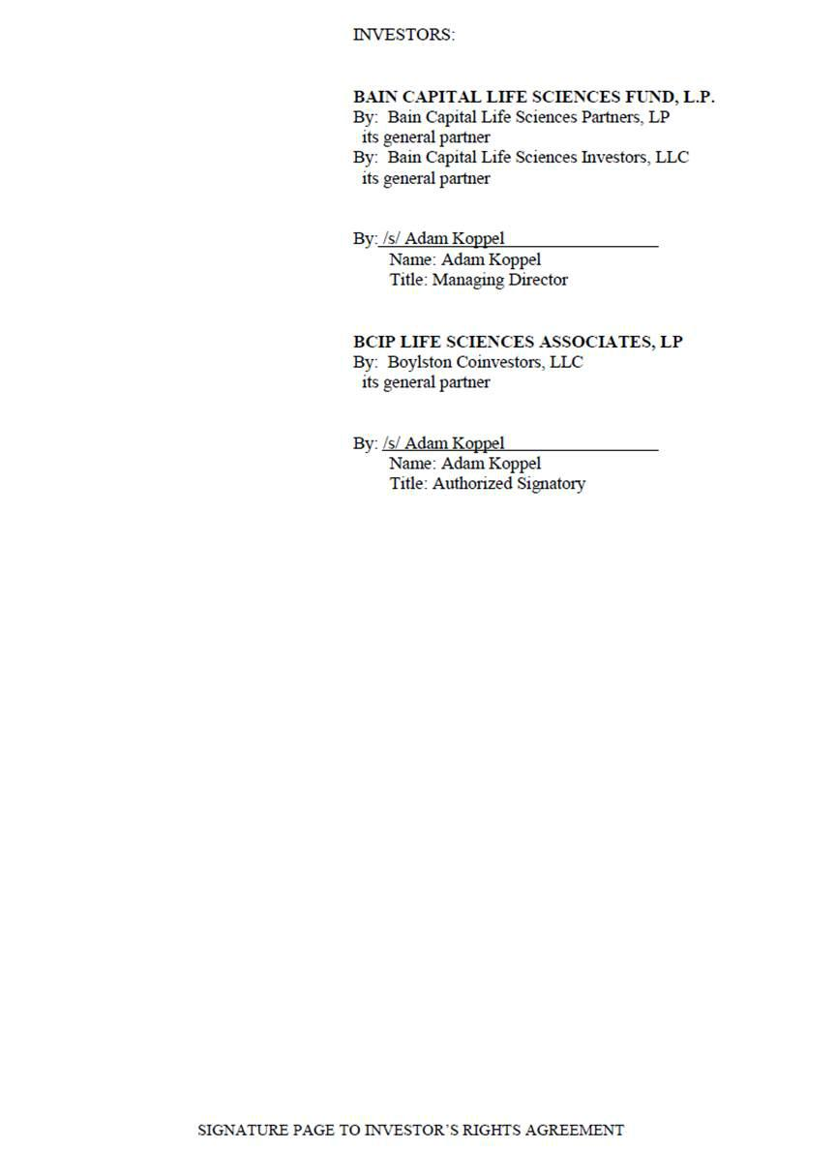

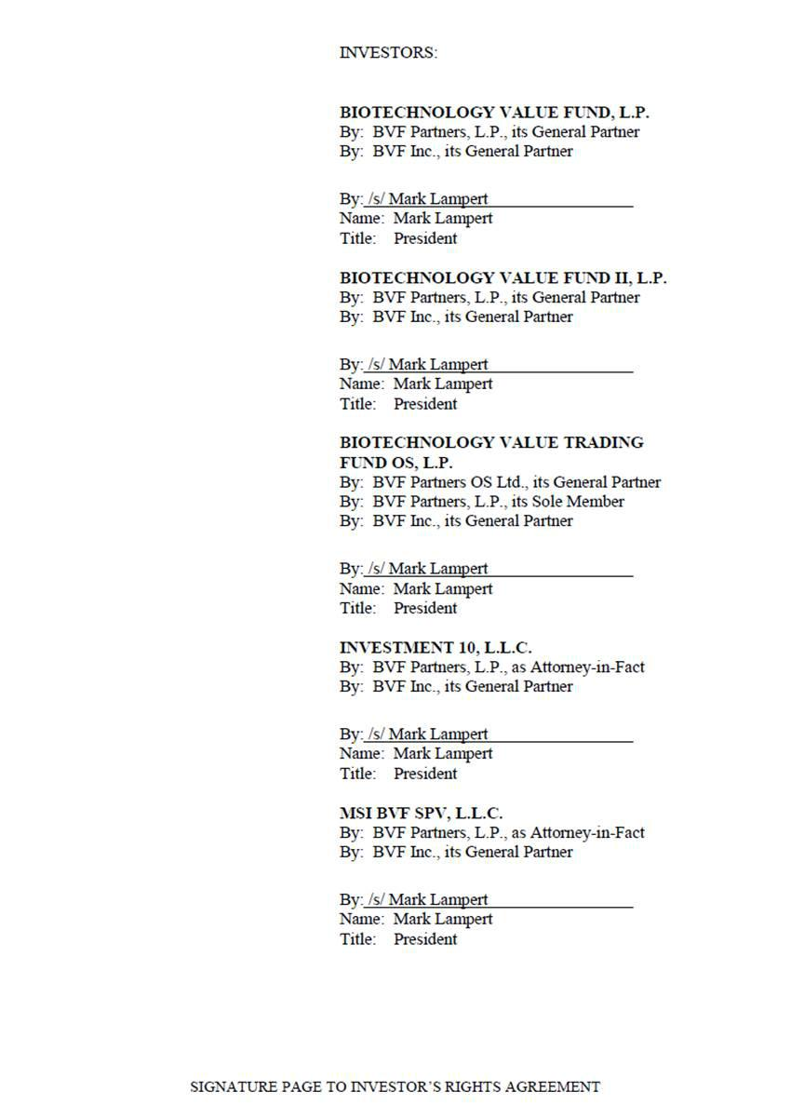

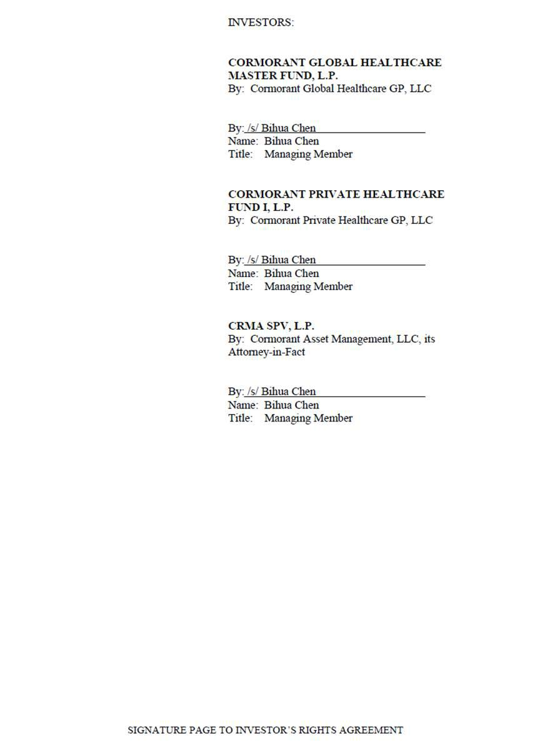



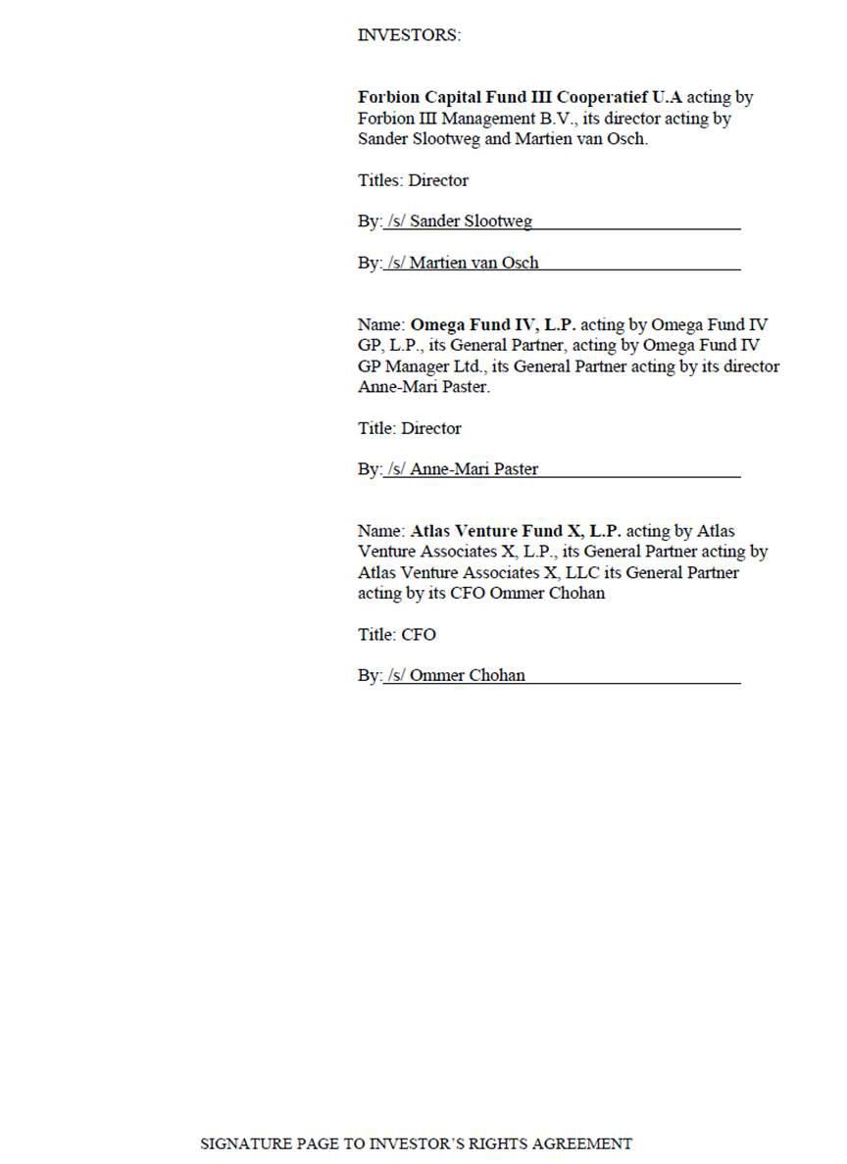

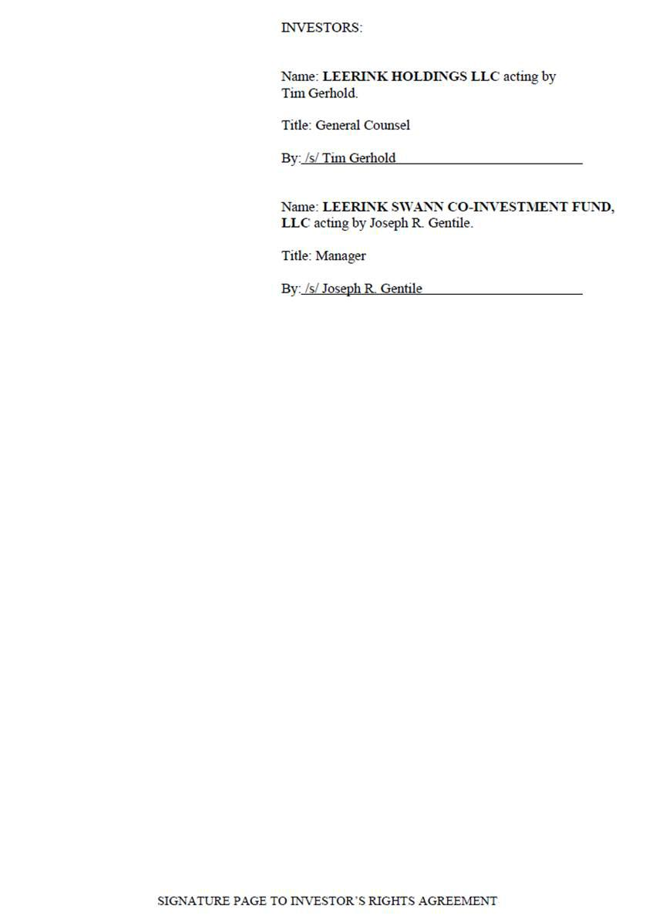

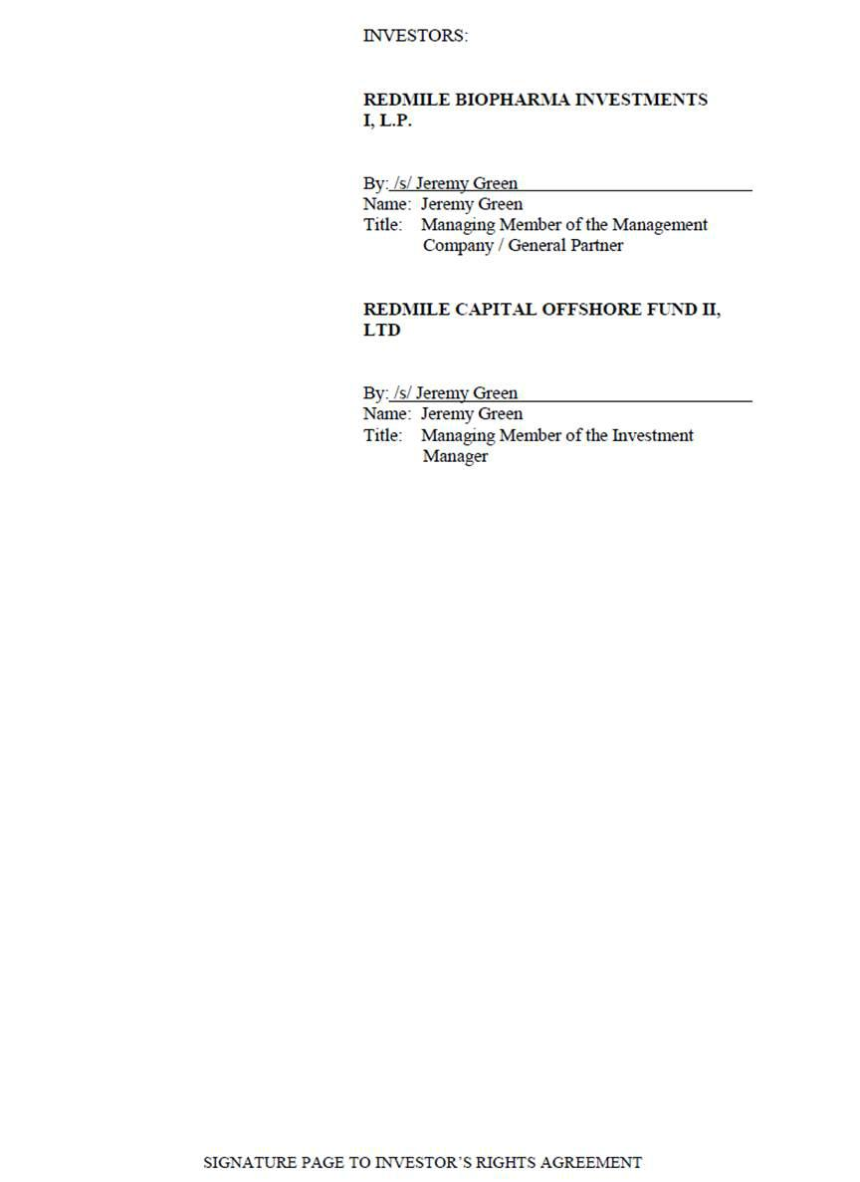



SCHEDULE A

Investors

Forbion Capital Fund III Cooperatief U.A

Gooimeer 2 – 35, PO Box 5187, 1410 AD,

Naarden, The Netherlands

Attention: Sander Slootweg

Tel: +31 35 699 3000

Fax: +31 35 699 3001

Email: sander.slootweg@forbion.com; marco.boorsma@forbion.com

Omega Fund IV, L.P

c/o Omega Fund Management (US) Inc.

185 Dartmouth Street, Suite 502

Boston, MA 02116

Attention: Richard J. Lim

Email: rjl@omegafunds.net

Atlas Venture Associates X, L.P

c/o Atlas Venture

400 Technology Square, 10th Floor

Cambridge, MA, USA 02139

Attention: Ommer Chohan

Tel: +1.857.201.2745

Email: ommer@atlastventure.com

Foresite Capital Fund III, L.P. (“Foresite”)

600 Montgomery Street, Suite 4500

San Francisco, CA 94111

Attention: Brett Zbar

Email: brett@foresitecapital.com

Foresite Capital Fund IV, L.P. (“Foresite”)

600 Montgomery Street, Suite 4500

San Francisco, CA 94111

Attention: Brett Zbar

Email: brett@foresitecapital.com

Bain Capital Life Sciences Fund, L.P. (“Bain”)

c/o Bain Capital Life Sciences, LP

200 Clarendon Street

Boston, Massachusetts 02116

BCIP Life Sciences Associates, LP (“Bain”)

c/o Bain Capital Life Sciences, LP

200 Clarendon Street

Boston, Massachusetts 02116

Redmile Biopharma Investments I, L.P.

(“Redmile”)

Redmile Capital Offshore Fund II, Ltd (“Redmile”)

Cormorant Global Healthcare Master Fund, LP (“Cormorant”)

200 Clarendon Street, 52nd Floor

Boston, MA 02116

Cormorant Private Healthcare Fund I, LP (“Cormorant”)

200 Clarendon Street, 52nd Floor

Boston, MA 02116

CRMA SPV, L.P. (“Cormorant”)

PO Box 309, Ugland House

Grand Cayman; KY1-1104 Cayman Islands

Biotechnology Value Fund, L.P. (“BVF”)

Spike Loy

c/o BVF Partners L.P.

One Sansome Street, 30th Floor

San Francisco, CA 94104

(415) 525-8890

Biotechnology Value Fund, L.P. (“BVF”)

Spike Loy

c/o BVF Partners L.P.

One Sansome Street, 30th Floor

San Francisco, CA 94104

(415) 525-8890

Biotechnology Value Trading Fund OS, L.P. (“BVF”)

Spike Loy

c/o BVF Partners L.P.

One Sansome Street, 30th Floor

San Francisco, CA 94104

(415) 525-8890

Investment 10, L.L.C. (“BVF”)

Spike Loy

c/o BVF Partners L.P.

One Sansome Street, 30th Floor

San Francisco, CA 94104

(415) 525-8890

MSI BVF SPV, L.L.C (“BVF”)

Spike Loy

c/o BVF Partners L.P.

One Sansome Street, 30th Floor

San Francisco, CA 94104

(415) 525-8890

Leerink Holdings LLC (“Leerink”)

One Federal Street, 37th Floor

Boston, MA 02110

Attention: General Counsel

Email: Staurt.Nayman@leerink.com; Sarah.Quinlan@leerink.com

Leerink Swann Co-Investment Fund, LLC (“Leerink”)

One Federal Street, 37th Floor

Boston, MA 02110

Attention: General Counsel

Email: Staurt.Nayman@leerink.com; Sarah.Quinlan@leerink.com

SCHEDULE B

Key Holders

Robert Coffin

37 Beacon Street, #63,

Boston, MA 02108, USA

Email: rsc5321@gmail.com

Philip Astley-Sparke

8 Amanda Lane, Weston,

MA, USA

Email: pastleysparke@gmail.com

Colin Love

20 Woodhurst Road, Maidenhead

Berkshire, SL6 8TF, UK

Email: colinalove99@gmail.com

Exhibit 10.5

Employment Agreement

This Employment Agreement (the “Agreement”) is made and entered into as of September , 2015, by and between Robert Coffin (the “Executive”) and Replimune, Inc., a Delaware Corporation (the “Company”).

WHEREAS, the Company desires to employ the Executive on the terms and conditions set forth herein; and

WHEREAS, the Executive desires to be employed by the Company on such terms and conditions.

NOW, THEREFORE, in consideration of the mutual covenants, promises and obligations set forth herein, the parties agree as follows:

- Term.

The Executive’s employment hereunder shall be effective as of October 1, 2015 (the “Effective Date”) and shall continue until the second anniversary thereof, unless terminated earlier pursuant to Section 5 of this Agreement; provided that, on such second anniversary of the Effective Date and each annual anniversary thereafter (such date and each annual anniversary thereof, a “Renewal Date”), the Agreement shall be deemed to be automatically extended, upon the same terms and conditions, for successive periods of one year, unless either party provides written notice of its intention not to extend the term of the Agreement at least 90 days’ prior to the applicable Renewal Date. The period during which the Executive is employed by the Company hereunder is hereinafter referred to as the “Employment Term”.

- Position and Duties.

2.1Position.

During the Employment Term, the Executive shall serve as the Director and Chief Executive Officer of the Company, initially reporting to the Board of Directors of the Company (the “Board”). In such position, the Executive shall have such duties, authority and responsibility as shall be determined from time to time by the Board, which duties, authority and responsibility are consistent with the Executive’s position. The Executive shall, if requested, also serve as an officer or director of any affiliate of the Company for no additional compensation.

2.2 Duties.

During the Employment Term, the Executive shall devote substantially all of his business time and attention to the performance of the Executive’s duties hereunder and will not engage in any other business, profession or occupation for compensation or otherwise which would conflict or interfere with the performance of his services to the Company either directly or indirectly without the prior written consent of the Board. Notwithstanding the foregoing, the Executive will

be permitted to engage in such business or other activities as disclosed in writing to the Board by the Executive on or prior to the date of this Agreement.

- Place of Performance.

The principal place of Executive’s employment shall be the Company’s executive office (as and when established) in the Boston area; provided that, the Executive may work remotely and may be required to travel both domestically and internationally on Company business during the Employment Term.

- Compensation.

4.1Base Salary.

The Company shall pay the Executive an annualized base salary of $340,000.00 in periodic installments in accordance with the Company’s customary payroll practices, but no less frequently than semi-monthly. The Executive’s base salary shall be reviewed at least annually by the Board and the Board may, but shall not be required to, increase the base salary during the Employment Term. The Executive’s annual base salary, as in effect from time to time, is hereinafter referred to as “Base Salary”.

4.2 Annual Bonus.

For each fiscal year of the Employment Term, the Executive shall be eligible to receive a discretionary annual bonus (not to exceed 35% of the Executive’s Base Salary) (the “Annual Bonus”). However, the decision to provide any Annual Bonus and the amount and terms of any Annual Bonus shall be in the sole and absolute discretion of the Board. Because one of the objectives of the Annual Bonus is employee retention, in order to remain eligible and receive an Annual Bonus, the Executive must be an active employee in good standing at the time such bonus payments are made. The Executive is considered to be an “active employee in good standing” if (i) his employment has not been terminated for any reason, (ii) he is not in breach of any of his obligations to the Company and he is not in breach of any of the Company’s material written guidelines, procedures or policies, (iii) he is not on probation of any kind from the Company, (iv) he has not resigned or provided the Company with notice of his intention to terminate his employment, and (v) the Company has not provided the Executive with notice of its intention to terminate his employment.

4.3 Equity Awards.

During the Employment Term, the Executive shall be eligible to participate in the share option plan established pursuant to the Shareholders Agreement relating to Replimune Limited between the Series A Investors, the Original Investors, the Managers (each as defined therein) and Replimune Limited executed on or around the date of this Agreement or any successor plan (the “Share Option Plan”), subject to the terms of the Share Option Plan, as determined by the Board or the Compensation Committee, in its discretion. Any grant of an option or other equity

2

instrument under the Share Option Plan will be issued under and be governed by the terms and provisions of the Share Option Plan and the applicable option award agreement.

4.4 Employee Benefits.

During the Employment Term, the Executive shall be entitled to participate in all employee benefit plans, practices and programs maintained by the Company, as in effect from time to time (collectively, “Employee Benefit Plans”), on a basis which is no less favorable than is provided to other similarly situated executives of the Company, to the extent consistent with applicable law and the terms of the applicable Employee Benefit Plans. The Company reserves the right to amend or cancel any Employee Benefit Plans at any time in its sole discretion, subject to the terms of such Employee Benefit Plan and applicable law.

4.5 Paid Time-off.

During the Employment Term, the Executive shall be entitled to 25 paid time off (“PTO”) days per calendar year (prorated for partial years) in accordance with the Company’s PTO policies, as in effect from time to time. The Executive may use PTO for vacation, personal time, or sick time (in accordance with applicable law).

4.6 Business Expenses.

The Executive shall be entitled to reimbursement for all reasonable and necessary out-of-pocket business, entertainment and travel expenses incurred by the Executive in connection with the performance of the Executive’s duties hereunder in accordance with the Company’s expense reimbursement policies and procedures.

- Termination of Employment.

The Employment Term and the Executive’s employment hereunder may be terminated by either the Company or the Executive at any time and for any reason; provided that, unless otherwise provided herein, either party shall be required to give the other party at least thirty (30) calendar days advance written notice of any termination of the Executive’s employment. Upon termination of the Executive’s employment during the Employment Term, the Executive shall be entitled to the compensation and benefits further described in this Section 5 and shall have no further rights to any compensation or any other benefits from the Company or any of its affiliates. Should the Company elect to forego the aforementioned notice provision, it shall remit to the Executive payment in lieu of notice equal to the salary he would have received during the notice period.

5.1 Termination of Employment for Cause or Without Good Reason.

- The Executive’s employment hereunder may be terminated upon either party’s failure to renew the Agreement in accordance with Section 1, by the Company for Cause or by the Executive without Good Reason. If the Executive’s employment is terminated upon either

3

party’s failure to renew the Agreement, by the Company for Cause or by the Executive without Good Reason, the Executive shall be entitled to receive:

- any accrued but unpaid Base Salary and accrued but unused PTO which shall be paid on the Termination Date (as defined below);

- any unearned Annual Bonus with respect to any completed fiscal year immediately preceding the Termination Date, which shall be paid on the otherwise applicable payment date; provided that, if the Executive’s employment is terminated by the Company for Cause, then any such unearned Annual Bonus shall be forfeited;

- reimbursement for unreimbursed business expenses properly incurred by the Executive, which shall be subject to and paid in accordance with the Company’s expense reimbursement policy; and

- such employee benefits (including equity compensation), if any, to which the Executive may be entitled under the Company’s employee benefit plans as of the Termination Date; provided that, in no event shall the Executive be entitled to any payments in the nature of severance or termination payments except as specifically provided herein.

Items 5.1(a)(i) through 5.1(a)(iv) are referred to herein collectively as the “Accrued Amounts”.

- For purposes of this Agreement, “Cause” shall mean: (i) conduct by the Executive constituting a material act of misconduct, including, without limitation, embezzlement or misappropriation of funds or property of the Company or any of its subsidiaries or affiliates, other than the occasional, customary and de minimis use of Company property for personal purposes; (ii) the commission by the Executive of, the indictment or charging of the Executive of, or the plea by the Executive of nolo contendere to, a felony or a misdemeanor involving moral turpitude, deceit, dishonesty or fraud, or any conduct by the Executive that would reasonably be expected to result in material injury or reputational harm to the Company or any of its subsidiaries and affiliates if he were retained in his position; (iii) continued non-performance by the Executive of his duties hereunder (other than by reason of the Executive’s physical or mental illness, incapacity or disability) which has continued for more than ten (10) days following written notice from the Board of such non-performance; (iv) a breach by the Executive of any of the provisions contained in Section 6, Section 7, Section 8 and Section 9 of this Agreement; (v) a material violation by the Executive of the Company’s written employment policies; or (vi) failure of the Executive to cooperate with a bona fide internal investigation or an investigation by regulatory or law enforcement authorities, after being instructed by the Company to cooperate, or the willful destruction or failure to preserve documents or other materials known to be relevant to such investigation or the inducement of others to fail to cooperate or to produce documents or other materials in connection with such investigation.

For purposes of this provision, no act or failure to act on the part of the Executive shall be considered “willful” unless it is done, or omitted to be done, by the Executive in bad faith or without reasonable belief that the Executive’s action or omission was in the best interests of the

4

Company. Any act, or failure to act, based upon authority given pursuant to a resolution duly adopted by the Board or upon the advice of counsel for the Company shall be conclusively presumed to be done, or omitted to be done, by the Executive in good faith and in the best interests of the Company.

- For purposes of this Agreement, “Good Reason” shall mean that the Executive has complied with the “Good Reason Process” (hereinafter defined) following the occurrence of any of the following, in each case during the Employment Term: (i) a material diminution in the Executive’s Base Salary of at least ten (10) percent, except for across-the-board salary reductions based on the Company’s financial performance similarly affecting all or substantially all senior management employees of the Company; (ii) a material change of more than fifty (50) miles in the geographic location at which the Executive provides services to the Company; (iii) the material breach of this Agreement by the Company; or (iv) a material adverse change in the Executive’s title, authority, duties, or reporting structure (other than temporarily while the Executive is physically or mentally incapacitated or as required by applicable law). “Good Reason Process” shall mean that (1) the Executive reasonably determines in good faith that a “Good Reason” condition has occurred; (2) the Executive notifies the Board in writing of the first occurrence of the Good Reason condition within sixty (60) days of the first occurrence of such condition; (3) the Executive cooperates in good faith with the Board’s efforts, for a period not less than thirty (30) days following such notice (the “Cure Period”), to remedy the condition; (4) notwithstanding such efforts, the Good Reason condition continues to exist; and (5) the Executive terminates his employment within sixty (60) days after the end of the Cure Period. If the Company cures the Good Reason condition during the Cure Period, Good Reason shall be deemed not to have occurred.

5.2 Termination of employment Without Cause or for Good Reason.

The Employment Term and the Executive’s employment hereunder may be terminated by the Executive for Good Reason or by the Company without Cause. In the event of such termination, the Executive shall be entitled to receive the Accrued Amounts and subject to the Executive’s compliance with Section 6, Section 7, Section 8 and Section 9 of this Agreement and his execution of a release of claims in favor of the Company, its affiliates and their respective officers and directors in a form provided by the Company (the “Release”) and such Release becoming effective within sixty (60) days following the Termination Date, the Executive shall be entitled to receive the following:

- a payment equal to the sum of the Executive’s Base Salary for the year in which the Termination Date occurs, which shall be paid in equal periodic installments over a period of 12 months following the Termination Date in accordance with the Company’s customary payroll practices, but no less frequently than semi-monthly;

- if the Executive was participating in the Company’s group health plan immediately prior to the Termination Date and elects COBRA health continuation, then the Company shall pay to the Executive a monthly cash payment for the earlier of six (6) months following the Termination Date or (B) until the Executive becomes eligible for coverage under another employer’s group coverage, and the Executive agrees to notify the Company promptly and in writing should that eligibility occur.

5

5.3 Death or Disability.

- The Executive’s employment hereunder shall terminate automatically upon the Executive’s death during the Employment Term, and the Company may terminate the Executive’s employment on account of the Executive’s Disability.

- If the Executive’s employment is terminated during the Employment Term on account of the Executive’s death or Disability, the Executive (or the Executive’s estate and/or beneficiaries, as the case may be) shall be entitled to receive the following:

  - the Accrued Amounts; and

  - a lump sum payment equal to the pro-rated bonus, if any, that the Executive would have earned for the fiscal year in which the Termination Date occurs based on the achievement of applicable performance goals for such year, which shall be payable on the date that annual bonuses are paid to the Company’s similarly situated executives, but in no event later than two-and-a-half (2 1/2) months following the end of the fiscal year in which the Termination Date occurs.

- For purposes of this Agreement, Disability shall mean the Executive’s inability, due to physical or mental incapacity, to substantially perform his duties and responsibilities under this Agreement for one hundred eighty (180) days out of any three hundred sixty-five (365) day period or one hundred twenty (120) consecutive days.

5.4 Change in Control Termination.

- Notwithstanding any other provision contained herein, if the Executive’s employment hereunder is terminated by the Executive for Good Reason or by the Company without Cause (other than on account of the Executive’s death or Disability), in each case within twenty four (24) months following a Change in Control, the Executive shall be entitled to receive the Accrued Amounts and subject to the Executive’s compliance with Section 6, Section 7, Section 8 and Section 9 of this Agreement and his execution of a Release which becomes effective within sixty (60) days following the Termination Date, the Executive shall be entitled to receive a lump sum payment equal to the sum of the Executive’s Base Salary for the year in which the Termination Date occurs (or if greater, the year immediately preceding the year in which the Change in Control occurs), which shall be paid within thirty (30) days following the Release becoming irrevocable. For the avoidance of doubt, any amount payable under this clause 5.4 shall be in lieu of, not in addition to, any amount payable under clause 5.2(a).

- For purposes of this Agreement, “Change in Control” shall mean the occurrence of any of the following after the Effective Date:

- one person (or more than one person acting as a group) acquires ownership of stock of the Company that, together with the stock held by such person or group, constitutes more than 50% of the total fair market value or total voting power of the stock of such

6

corporation; provided that, a Change in Control shall not occur if any person (or more than one person acting as a group) owns more than 50% of the total fair market value or total voting power of the Company’s stock and acquires additional stock;

- a majority of the members of the Board are replaced during any twelve-month period by directors whose appointment or election is not endorsed by a majority of the Board before the date of appointment or election; or

- the sale of all or substantially all of the Company’s assets.

Notwithstanding the foregoing, a Change in Control shall not occur unless such transaction constitutes a change in the ownership of the Company, a change in effective control of the Company, or a change in the ownership of a substantial portion of the Company’s assets under Section 409A.

5.5 Notice of Termination.

Any termination of the Executive’s employment hereunder by the Company or by the Executive during the Employment Term (other than termination pursuant to Section 5.3(a) on account of the Executive’s death) shall be communicated by written notice of termination (“Notice of Termination”) to the other party hereto. The Notice of Termination shall specify:

- The termination provision of this Agreement relied upon;

- To the extent applicable, the facts and circumstances claimed to provide a basis for termination of the Executive’s employment under the provision so indicated; and

- The applicable Termination Date.

5.6 Termination Date.

The Executive’s Termination Date shall be:

- If the Executive’s employment hereunder terminates on account of the Executive’s death, the date of the Executive’s death;

- If the Executive’s employment hereunder is terminated on account of the Executive’s Disability, the date that it is determined that the Executive has a Disability;

- If the Company terminates the Executive’s employment hereunder for Cause, the date the Notice of Termination is delivered to the Executive;

- If the Company terminates the Executive’s employment hereunder without Cause, the date specified in the Notice of Termination, which shall be no less than seven (7) days following the date on which the Notice of Termination is delivered;

7

- If the Executive terminates his employment hereunder with or without Good Reason, the date specified in the Executive’s Notice of Termination, which shall be no less than seven

(7) days following the date on which the Notice of Termination is delivered; and

- If the Executive’s employment hereunder terminates because either party provides notice of non-renewal pursuant to Section 1, the Renewal Date immediately following the date on which the applicable party delivers notice of non-renewal.

Notwithstanding anything contained herein, the Termination Date shall not occur until the date on which the Executive incurs a “separation from service” within the meaning of Section 409A.

5.7 Resignation of All Other Positions.

Upon termination of the Executive’s employment hereunder for any reason, the Executive agrees to resign, effective on the Termination Date from all positions that the Executive holds as an officer or member of the board of directors (or a committee thereof) of the Company or any of its affiliates.

5.8 Section 280G.

If any of the payments or benefits received or to be received by the Executive (including, without limitation, any payment or benefits received in connection with a Change in Control or the Executive’s termination of employment, whether pursuant to the terms of this Agreement or any other plan, arrangement or agreement, or otherwise) (all such payments collectively referred to herein as the “280G Payments”) constitute “parachute payments” within the meaning of Section 280G of the Code and will be subject to the excise tax imposed under Section 4999 of the Code (the “Excise Tax”), the Company shall pay to the Executive, no later than the time such Excise Tax is required to be paid by the Executive or withheld by the Company, an additional amount equal to the sum of the Excise Tax payable by the Executive, plus the amount necessary to put the Executive in the same after-tax position (taking into account any and all applicable federal, state and local excise, income or other taxes at the highest applicable rates on such 280G Payments and on any payments under this Section 5.9 or otherwise) as if no Excise Tax had been imposed.

5.9 Section 409A.

- Anything in this Agreement to the contrary notwithstanding, if at the time of the Executive’s separation from service within the meaning of Section 409A of the Code, the Company determines that the Executive is a “specified employee” within the meaning of Section 409A(a)(2)(B)(i) of the Code, then to the extent any payment or benefit that the Executive becomes entitled to under this Agreement on account of the Executive’s separation from service would be considered deferred compensation otherwise subject to the twenty percent (20%) additional tax imposed pursuant to Section 409A(a) of the Code as a result of the application of Section 409A(a)(2)(B)(i) of the Code, such payment shall not be payable and such benefit shall not be provided until the date that is the earlier of (A) six (6) months and one day after the Executive’s separation from service, or (B) the Executive’s death. If any such delayed cash payment is otherwise payable on an installment basis, the first payment shall include a catch-up

8

payment covering amounts that would otherwise have been paid during the six (6) month period but for the application of this provision, and the balance of the installments shall be payable in accordance with their original schedule.

- All in-kind benefits provided and expenses eligible for reimbursement under this Agreement shall be provided by the Company or incurred by the Executive during the time periods set forth in this Agreement. All reimbursements shall be paid as soon as administratively practicable, but in no event shall any reimbursement be paid after the last day of the taxable year following the taxable year in which the expense was incurred. The amount of in-kind benefits provided or reimbursable expenses incurred in one taxable year shall not affect the in-kind benefits to be provided or the expenses eligible for reimbursement in any other taxable year (except for any lifetime or other aggregate limitation applicable to medical expenses). Such right to reimbursement or in-kind benefits is not subject to liquidation or exchange for another benefit.

- To the extent that any payment or benefit described in this Agreement constitutes “nonqualified deferred compensation” under Section 409A of the Code, and to the extent that such payment or benefit is payable upon the Executive’s termination of employment, then such payments or benefits shall be payable only upon the Executive’s “separation from service.” The determination of whether and when a separation from service has occurred shall be made in accordance with the presumptions set forth in Treasury Regulation Section 1.409A-1(h).

- The intent of the parties is that payments and benefits under this Agreement comply with or be exempt from Section 409A of the Code and the regulations promulgated thereunder and the Company shall interpret this Agreement and any associated documents shall be interpreted in any reasonable manner that establishes an exemption from (or compliance with) the requirements of Section 409A of the Code. The parties also intend that this Agreement will be administered in accordance with Section 409A of the Code. If for any reason, such as imprecision in drafting, any provision of this Agreement (or of any award of compensation, including, without limitation, equity compensation or benefits) does not accurately reflect its intended establishment of an exemption from (or compliance with) Section 409A of the Code, as demonstrated by consistent interpretations or other evidence of intent, such provision shall be considered ambiguous as to its exemption from (or compliance with) Code Section 409A and shall be interpreted by the Company in a manner consistent with such intent so that all payments hereunder comply with Section 409A of the Code. Each payment pursuant to this Agreement is intended to constitute a separate payment for purposes of Treasury Regulation Section 1.409A-2(b)(2). The parties agree that this Agreement may be amended, as reasonably requested by either party, and as may be necessary to fully comply with Section 409A of the Code and all related rules and regulations in order to preserve the payments and benefits provided hereunder without additional cost to either party.

- The Company makes no representation or warranty and shall have no liability to the Executive or any other person if any provisions of this Agreement are determined to constitute deferred compensation subject to Section 409A of the Code but do not satisfy an exemption from, or the conditions of, such Section.

9

- Confidential Information.

The Executive understands and acknowledges that during the Employment Term, he will have access to and learn about Confidential Information, as defined below.

6.1 Confidential Information Defined.

- Definition. For purposes of this Agreement, “Confidential Information” includes, but is not limited to, all information not generally known to the public, in spoken, printed, electronic or any other form or medium, relating directly or indirectly to: business processes, practices, methods, policies, plans, publications, documents, research, operations, services, strategies, techniques, agreements, contracts, terms of agreements, transactions, potential transactions, negotiations, know-how, trade secrets, computer programs, computer software, applications, operating systems, software design, web design, work-in-process, databases, manuals, records, articles, systems, material, supplier information, vendor information, financial information, results, accounting information, accounting records, legal information, marketing information, advertising information, pricing information, credit information, design information, payroll information, staffing information, personnel information, employee lists, supplier lists, vendor lists, developments, reports, internal controls, security procedures, graphics, drawings, sketches, market studies, sales information, revenue, costs, formulae, notes, communications, algorithms, product plans, designs, styles, audiovisual programs, inventions, unpublished patent applications, original works of authorship, discoveries, experimental processes, experimental results, specifications, customer information, customer lists, client information, client lists, manufacturing information, factory lists, distributor lists, and buyer lists of the Company or its businesses or any existing or prospective customer, supplier, investor or other associated third party, or of any other person or entity that has entrusted information to the Company in confidence.

The Executive understands that the above list is not exhaustive, and that Confidential Information also includes other information that is marked or otherwise identified as confidential or proprietary, or that would otherwise appear to a reasonable person to be confidential or proprietary in the context and circumstances in which the information is known or used.

The Executive understands and agrees that Confidential Information includes information developed by him in the course of his employment by the Company as if the Company furnished the same Confidential Information to the Executive in the first instance. Confidential Information shall not include information that is generally available to and known by the public at the time of disclosure to the Executive; provided that, such disclosure is through no direct or indirect fault of the Executive or person(s) acting on the Executive’s behalf.

- Company Creation and Use of Confidential Information. The Executive understands and acknowledges that the Company has invested, and continues to invest, substantial time, money and specialized knowledge into developing its resources, creating a customer base, generating customer and potential customer lists, training its employees, and improving its offerings in the field of oncolytic immunotherapy development. The Executive understands and acknowledges that as a result of these efforts, the Company has created, and continues to use and create Confidential Information. This Confidential Information provides the Company with a competitive advantage over others in the marketplace.

10

- Disclosure and Use Restrictions. The Executive agrees and covenants: (i) to treat all Confidential Information as strictly confidential; (ii) not to directly or indirectly disclose, publish, communicate or make available Confidential Information, or allow it to be disclosed, published, communicated or made available, in whole or part, to any entity or person whatsoever (including other employees of the Company) not having a need to know and authority to know and use the Confidential Information in connection with the business of the Company and, in any event, not to anyone outside of the direct employ of the Company except as required in the performance of the Executive’s authorized employment duties to the Company or with the prior consent of the Board in each instance (and then, such disclosure shall be made only within the limits and to the extent of such duties or consent); and (iii) not to access or use any

Confidential Information, and not to copy any documents, records, files, media or other resources containing any Confidential Information, or remove any such documents, records, files, media or other resources from the premises or control of the Company, except as required in the performance of the Executive’s authorized employment duties to the Company or with the prior consent of the Board in each instance (and then, such disclosure shall be made only within the limits and to the extent of such duties or consent). Nothing herein shall be construed to prevent disclosure of Confidential Information as may be required by applicable law or regulation, or pursuant to the valid order of a court of competent jurisdiction or an authorized government agency, provided that the disclosure does not exceed the extent of disclosure required by such law, regulation or order. The Executive shall promptly provide written notice of any such order to the Board.

The Executive understands and acknowledges that his obligations under this Agreement with regard to any particular Confidential Information shall commence immediately upon the Executive first having access to such Confidential Information (whether before or after [he/she] begins employment by the Company) and shall continue during and after his employment by the Company until such time as such Confidential Information has become public knowledge other than as a result of the Executive’s breach of this Agreement or breach by those acting in concert with the Executive or on the Executive’s behalf.

- Restrictive Covenants.

7.1 Noncompetition & Nonsolicitation.

The Executive hereby undertakes and covenants with the Company that he shall not, during the Restricted Period:

- within the Restricted Area carry on or be concerned, engaged or interested directly or indirectly in any capacity whatsoever in any trade or business competing with the Business in which he shall have been engaged or involved at any time during the Lookback Period;

- either on his own behalf or in any other capacity whatsoever directly or indirectly do or say anything which may lead to any person ceasing to do business with the Company on substantially the same terms as previously (or at all);

- either on his own behalf or in any other capacity whatsoever directly or indirectly endeavor to entice away from the Company or solicit any person, firm or company who was a 11

client, customer, supplier, agent or distributor of the Company during the Lookback Period with whom he shall have been engaged or involved by virtue of his duties during the Lookback Period;

- either on his own behalf or in any other capacity whatsoever directly or indirectly have any dealings with any person, firm or company who was a client, customer, supplier, agent or distributor of the Company during the Lookback Period with whom he shall have been engaged or involved by virtue of his duties during the Lookback Period where such dealing may lead to any person ceasing to do business with the Company on substantially the same terms as previously (or at all); or

- either on his own behalf or in any other capacity whatsoever directly or indirectly employ, engage or induce, or seek to induce, to leave the service of the Company any person who is or was a Key Employee with whom he shall have had dealings during the Lookback Period whether or not such person would commit any breach of his contract of employment by reason of so leaving the service of the Company or otherwise; or

- at any time after the Termination Date represent himself as being in any way currently connected with or interested in the Business (other than as a shareholder, director, employee or consultant if that be the case).

7.2 Severability.

Each of the restrictions contained in each sub-paragraph of clause 7.1 is separate and distinct and is to be construed separately from the other such restrictions. The Executive hereby acknowledges that he considers such restrictions to be reasonable both individually and in the aggregate and that the duration extent and application of each of such restrictions are no greater than is necessary for the protection of the goodwill of the Business. However, if any such restriction shall be found to be void or unenforceable but would be valid or enforceable if some part or parts thereof were deleted or the period or area of application reduced, the Executive hereby agrees that such restriction shall apply with such modification as may be necessary to make it valid.

7.3 Injunction.

The Executive agrees that it would be difficult to measure any damages caused to the Company which might result from any breach by the Executive of the promises set forth in this Section 7, and that in any event money damages would be an inadequate remedy for any such breach. The Executive agrees that if the Executive breaches, or proposes to breach, any portion of this Section 7, the Company shall be entitled, in addition to all other remedies that it may have, to an injunction or other appropriate equitable relief, as deemed appropriate by a relevant court of tribunal, to restrain any such breach without showing or proving any actual damage to the Company and without the requirement to post a bond or similar undertaking. The obligations under this Section 7 shall survive the termination or expiration of this Agreement and any termination of the Executive’s employment.

12

7.4 Third-Party Agreements & Rights.

The Executive hereby confirms that the Executive is not bound by the terms of any agreement with any previous employer or other party which restricts in any way the Executive’s use or disclosure of information or the Executive’s engagement in any business. The Executive represents to the Company that the Executive’s execution of this Agreement, the Executive’s employment with the Company and the performance of the Executive’s proposed duties for the Company will not violate any obligations the Executive may have to any such previous employer or other party. In the Executive’s work for the Company, the Executive will not disclose or make use of any information in violation of any agreements with or rights of any such previous employer or other party, and the Executive will not bring to the premises of the Company any copies or other tangible embodiments of non-public information belonging to or obtained from any such previous employment or other party.

7.5 Definitions.

For purposes of this Agreement, the following definitions shall apply as used in this Section 7:

- “Business” means the business of the Company from time to time, being at the date of this Agreement the pre-clinical and clinical development of oncolytic immunotherapies;

- “First Completion” has the meaning given in the Subscription Agreement;

- “Group Company” has the meaning given in the New Articles;

- “Key Employee” means any employee, contractor or advisor who is employed or engaged by a Group Company: (i) in the case of an employee as a Director or at management grade; or (ii) in a senior capacity with a basic salary of $75,000 per annum or more (or such higher amount as the Investor Director majority may approve in writing from time to time);

- “Investor Director” has the meaning given in the Subscription Agreement;

- “New Articles” means the new articles of association of the Company in the agreed form to be adopted on or prior to First Completion, as amended or superseded from time to time;

- “Lookback Period” means the period of one year immediately preceding the Termination Date;

- “Restricted Area” means the United States of America, Canada and countries within Europe, in respect of which: (i) any Restricted Company has material business operations as at the Termination Date; or (ii) the Executive had direct or indirect responsibility or received confidential information of or relating to the Company or its Business during the Lookback Period;

- “Restricted Company” means any Group Company with which the Executive shall have been engaged or involved or about or in respect of which he received confidential information (of or relating to such company or its business) at any time during the Lookback Period;

13

- “Restricted Period” means:

  - if the Executive’s employment hereunder is terminated by the Executive for Good Reason or by the Company without Cause, a period of 12 months commencing on the Termination Date; or

  - if the Executive’s employment hereunder is terminated by the Executive without Good Reason or by the Company for Cause, a period of 24 months commencing on the Termination Date;

- “Subscription Agreement” means the agreement between Series A Investors and the Company’s parent, Replimune Limited, a company incorporated and registered in England with company number 9496393 whose registered office is at The Magdalen Centre, Oxford Science Park, Oxford, Oxfordshire OX4 4GA, United Kingdom and, under which the Series A Investors agreed to subscribe for Series A Shares in the Company in two tranches in accordance with the terms of the Subscription Agreement.

- Non-disparagement.

The Executive agrees and covenants that he will not at any time make, publish or communicate to any person or entity or in any public forum any defamatory or disparaging remarks, comments or statements concerning the Company or its businesses, or any of its employees, officers, and existing and prospective customers, suppliers, investors and other associated third parties.

This Section 8 does not, in any way, restrict or impede the Executive from exercising protected rights to the extent that such rights cannot be waived by agreement or from complying with any applicable law or regulation or a valid order of a court of competent jurisdiction or an authorized government agency, provided that such compliance does not exceed that required by the law, regulation or order. The Executive shall promptly provide written notice of any such order to the Board.

- Proprietary Rights.

9.1Work Product.

The Executive acknowledges and agrees that all writings, works of authorship, technology, inventions, discoveries, ideas and other work product of any nature whatsoever, that are created, prepared, produced, authored, edited, amended, conceived or reduced to practice by the Executive individually or jointly with others during the period of his employment by the Company and relating in any way to the business or contemplated business, research or development of the Company (regardless of when or where the Work Product is prepared or whose equipment or other resources is used in preparing the same) and all printed, physical and electronic copies, all improvements, rights and claims related to the foregoing, and other tangible embodiments thereof (collectively, “Work Product”), as well as any and all rights in and to copyrights, trade secrets, trademarks (and related goodwill), patents and other intellectual property rights therein arising in any jurisdiction throughout the world and all related rights of priority under international conventions with respect thereto, including all pending and future

14

applications and registrations therefor, and continuations, divisions, continuations-in-part, reissues, extensions and renewals thereof (collectively, “Intellectual Property Rights”), shall be the sole and exclusive property of the Company.

9.2. Work Made for Hire; Assignment.

The Executive acknowledges that, by reason of being employed by the Company at the relevant times, to the extent permitted by law, all of the Work Product consisting of copyrightable subject matter is “work made for hire” as defined in 17 U.S.C. § 101 and such copyrights are therefore owned by the Company. To the extent that the foregoing does not apply, the Executive hereby irrevocably assigns to the Company, for no additional consideration, the Executive’s entire right, title and interest in and to all Work Product and Intellectual Property Rights therein, including the right to sue, counterclaim and recover for all past, present and future infringement, misappropriation or dilution thereof, and all rights corresponding thereto throughout the world. Nothing contained in this Agreement shall be construed to reduce or limit the Company’s rights, title or interest in any Work Product or Intellectual Property Rights so as to be less in any respect than that the Company would have had in the absence of this Agreement.

9.3 No License.

The Executive understands that this Agreement does not, and shall not be construed to, grant the Executive any license or right of any nature with respect to any Work Product or Intellectual Property Rights or any Confidential Information, materials, software or other tools made available to him by the Company.

- Exit Obligations.

Upon (a) voluntary or involuntary termination of the Executive’s employment or (b) the Company’s request at any time during the Executive’s employment, the Executive shall (i) provide or return to the Company any and all Company \property, including keys, key cards, access cards, identification cards, security devices, employer credit cards, network access devices, computers, cell phones, smartphones, PDAs, pagers, fax machines, equipment, manuals, reports, files, books, compilations, work product, e-mail messages, recordings, disks, thumb drives or other removable information storage devices, hard drives, and data and all Company documents and materials belonging to the Company and stored in any fashion, including but not limited to those that constitute or contain any Confidential Information or Work Product, that are in the possession or control of the Executive, whether they were provided to the Executive by the Company or any of its business associates or created by the Executive in connection with his employment by the Company; and (ii) delete or destroy all copies of any such documents and materials not returned to the Company that remain in the Executive’s possession or control, including those stored on any non-Company devices, networks, storage locations and media in the Executive’s possession or control.

15

- Governing Law, Jurisdiction, & Venue.

This Agreement, for all purposes, shall be construed in accordance with the laws of the Commonwealth of Massachusetts without regard to conflicts of law principles. Any action or proceeding by either of the parties to enforce this Agreement shall be brought only in a state or federal court located in the Commonwealth of Massachusetts, county of Suffolk. The

parties hereby irrevocably submit to the exclusive jurisdiction of such courts and waive the defense of inconvenient forum to the maintenance of any such action or proceeding in such venue.

- Executive’s Covenant

The Executive represents to the Company that he is entitled to enter into this Agreement and to implement and carry out its terms and that by so doing he shall not be in breach of any obligation (contractual or otherwise) to any third party which would entitle that third party to damages or any other remedy at law.

- Assignment.

The Company shall assign this Agreement and its rights and obligations hereunder in whole, but not in part, to any Company of other entity with or into which the Company may hereafter merge or consolidate, or to which the Company may transfer all or substantially all of its assets. In any such case said Company or other entity shall by operation of law or expressly in writing assume all obligations of the Company hereunder as fully as if it had been originally made a party hereto. The Executive may not assign or transfer this Agreement or any rights or obligations hereunder.

- Entire Agreement.

Unless specifically provided herein, this Agreement contains all of the understandings and representations between the Executive and the Company pertaining to the subject matter hereof and supersedes all prior and contemporaneous understandings, agreements, representations and warranties, both written and oral, with respect to such subject matter. The parties mutually agree that the Agreement can be specifically enforced in court and can be cited as evidence in legal proceedings alleging breach of the Agreement.

- Modification & Waiver.

No provision of this Agreement may be amended or modified unless such amendment or modification is agreed to in writing and signed by the Executive and by a Director of the Company (other than the Executive) and approved by the Board. No waiver by either of the parties of any breach by the other party hereto of any condition or provision of this Agreement to be performed by the other party hereto shall be deemed a waiver of any similar or dissimilar provision or condition at the same or any prior or subsequent time, nor shall the failure of or delay by either of the parties in exercising any right, power or privilege hereunder operate as a waiver thereof to preclude any other or further exercise thereof or the exercise of any other such right, power or privilege.

16

- Severability.

Should any provision of this Agreement be held by a court of competent jurisdiction to be enforceable only if modified, or if any portion of this Agreement shall be held as unenforceable and thus stricken, such holding shall not affect the validity of the remainder of this Agreement, the balance of which shall continue to be binding upon the parties with any such modification to become a part hereof and treated as though originally set forth in this Agreement.

The parties further agree that any such court is expressly authorized to modify any such unenforceable provision of this Agreement in lieu of severing such unenforceable provision from this Agreement in its entirety, whether by rewriting the offending provision, deleting any or all of the offending provision, adding additional language to this Agreement or by making such other modifications as it deems warranted to carry out the intent and agreement of the parties as embodied herein to the maximum extent permitted by law.

The parties expressly agree that this Agreement as so modified by the court shall be binding upon and enforceable against each of them. In any event, should one or more of the provisions of this Agreement be held to be invalid, illegal or unenforceable in any respect, such invalidity, illegality or unenforceability shall not affect any other provisions hereof, and if such provision or provisions are not modified as provided above, this Agreement shall be construed as if such invalid, illegal or unenforceable provisions had not been set forth herein.

- Captions.

Captions and headings of the sections and paragraphs of this Agreement are intended solely for convenience and no provision of this Agreement is to be construed by reference to the caption or heading of any section or paragraph.

- Integration.

This Agreement constitutes the entire agreement between the parties with respect to the subject matter hereof and supersedes all prior agreements between the parties with respect to any related subject matter.

- Counterparts.

This Agreement may be executed in separate counterparts, each of which shall be deemed an original, but all of which taken together shall constitute one and the same instrument.

- Tolling.

Should the Executive violate any of the terms of the restrictive covenant obligations articulated herein, the obligation at issue will run from the first date on which the Executive ceases to be in violation of such obligation.

17

- Notice.

Notices and all other communications provided for in this Agreement shall be in writing and shall be delivered personally or sent by registered or certified mail, return receipt requested, or by overnight carrier to the parties at the addresses set forth below (or such other addresses as specified by the parties by like notice):

If to the Company:

Replimune, Inc.

c/o CT Corporation System

155 Federal Street, Suite 700

Boston, MA 02110

If to the Executive:

Robert Coffin

37 Beacon Street, #63

Boston, MA 02108, USA

- Survival.

Upon the expiration or other termination of this Agreement, the respective rights and obligations of the parties hereto shall survive such expiration or other termination to the extent necessary to carry out the intentions of the parties under this Agreement.

THE EXECUTIVE ACKNOWLEDGES AND AGREES THAT HE HAS FULLY READ, UNDERSTANDS AND VOLUNTARILY ENTERS INTO THIS AGREEMENT. THE EXECUTIVE ACKNOWLEDGES AND AGREES THAT HE HAS HAD AN OPPORTUNITY TO ASK QUESTIONS AND CONSULT WITH AN ATTORNEY OF HIS CHOICE BEFORE SIGNING THIS AGREEMENT.

IN WITNESS WHEREOF, the parties hereto have executed this Agreement as of the date first above written.

Replimune, Inc.

By | /s/ Philip Astley-Sparke
Name: |  | Philip Astley-Sparke
Title: |  | Executive Chairman

18

Robert Coffin
Signature: | /s/ Robert Coffin
Print Name: | Robert Coffin

19

Exhibit 10.6

Employment Agreement

This Employment Agreement (the “Agreement”) is made and entered into as of September , 2015 by and between Philip Astley-Sparke (the “Executive”) and Replimune, Inc., a Delaware Corporation (the “Company”).

WHEREAS, the Company desires to employ the Executive on the terms and conditions set forth herein; and

WHEREAS, the Executive desires to be employed by the Company on such terms and conditions.

NOW, THEREFORE, in consideration of the mutual covenants, promises and obligations set forth herein, the parties agree as follows:

- Term.

The Executive’s employment hereunder shall be effective as of October 1, 2015 (the “Effective Date”) and shall continue until the second anniversary thereof, unless terminated earlier pursuant to Section 5 of this Agreement; provided that, on such second anniversary of the Effective Date and each annual anniversary thereafter (such date and each annual anniversary thereof, a “Renewal Date”), the Agreement shall be deemed to be automatically extended, upon the same terms and conditions, for successive periods of one year, unless either party provides written notice of its intention not to extend the term of the Agreement at least 90 days’ prior to the applicable Renewal Date. The period during which the Executive is employed by the Company hereunder is hereinafter referred to as the “Employment Term”.

- Position and Duties.

2.1Position.

During the Employment Term, the Executive shall serve as the Director and Executive Chairman of the Company, initially reporting to the Board of Directors of the Company (the “Board”). In such position, the Executive shall have such duties, authority and responsibility as shall be determined from time to time by the Board, which duties, authority and responsibility are consistent with the Executive’s position. The Executive shall, if requested, also serve as an officer or director of any affiliate of the Company for no additional compensation.

2.2 Duties.

During the Employment Term, the Executive shall devote sixty percent (60%) of his business time and attention to the performance of the Executive’s duties hereunder and will not engage in any other business, profession or occupation for compensation or otherwise which would be inconsistent or conflict with such time commitment without the prior written consent of the Board.

- Place of Performance.

The principal place of Executive’s employment shall be the Company’s executive office (as and when established) in the Boston area; provided that, the Executive may work remotely and may be required to travel both domestically and internationally on Company business during the Employment Term.

- Compensation.

4.1Base Salary.

The Company shall pay the Executive an annualized base salary of $204,000.00 in periodic installments in accordance with the Company’s customary payroll practices, but no less frequently than semi-monthly. The Executive’s base salary shall be reviewed at least annually by the Board and the Board may, but shall not be required to, increase the base salary during the Employment Term. The Executive’s annual base salary, as in effect from time to time, is hereinafter referred to as “Base Salary”.

4.2 Annual Bonus.

For each fiscal year of the Employment Term, the Executive shall be eligible to receive a discretionary annual bonus (not to exceed 30% of the Executive’s Base Salary) (the “Annual Bonus”). However, the decision to provide any Annual Bonus and the amount and terms of any Annual Bonus shall be in the sole and absolute discretion of the Board. Because one of the objectives of the Annual Bonus is employee retention, in order to remain eligible and receive an Annual Bonus, the Executive must be an active employee in good standing at the time such bonus payments are made. The Executive is considered to be an “active employee in good standing” if (i) his employment has not been terminated for any reason, (ii) he is not in breach of any of his obligations to the Company and he is not in breach of any of the Company’s material written guidelines, procedures or policies, (iii) he is not on probation of any kind from the Company, (iv) he has not resigned or provided the Company with notice of his intention to terminate his employment, and (v) the Company has not provided the Executive with notice of its intention to terminate his employment.

4.3 Equity Awards.

During the Employment Term, the Executive shall be eligible to participate in the share option plan established pursuant to the Shareholders Agreement relating to Replimune Limited between the Series A Investors, the Original Investors, the Managers (each as defined therein) and Replimune Limited executed on or around the date of this Agreement or any successor plan (the “Share Option Plan”), subject to the terms of the Share Option Plan, as determined by the Board or the Compensation Committee, in its discretion. Any grant of an option or other equity instrument under the Share Option Plan will be issued under and be governed by the terms and provisions of the Share Option Plan and the applicable option award agreement.

2

4.4 Employee Benefits.

During the Employment Term, the Executive shall be entitled to participate in all employee benefit plans, practices and programs maintained by the Company, as in effect from time to time (collectively, “Employee Benefit Plans”), on a basis which is no less favorable than is provided to other similarly situated executives of the Company, to the extent consistent with applicable law and the terms of the applicable Employee Benefit Plans. The Company reserves the right to amend or cancel any Employee Benefit Plans at any time in its sole discretion, subject to the terms of such Employee Benefit Plan and applicable law.

4.5 Paid Time-off.

During the Employment Term, the Executive shall be entitled to 15 paid time off (“PTO”) days per calendar year (prorated for partial years) in accordance with the Company’s PTO policies, as in effect from time to time. The Executive may use PTO for vacation, personal time, or sick time (in accordance with applicable law).

4.6 Business Expenses.

The Executive shall be entitled to reimbursement for all reasonable and necessary out-of-pocket business, entertainment and travel expenses incurred by the Executive in connection with the performance of the Executive’s duties hereunder in accordance with the Company’s expense reimbursement policies and procedures.

- Termination of Employment.

The Employment Term and the Executive’s employment hereunder may be terminated by either the Company or the Executive at any time and for any reason; provided that, unless otherwise provided herein, either party shall be required to give the other party at least thirty (30) calendar days advance written notice of any termination of the Executive’s employment. Upon termination of the Executive’s employment during the Employment Term, the Executive shall be entitled to the compensation and benefits further described in this Section 5 and shall have no further rights to any compensation or any other benefits from the Company or any of its affiliates. Should the Company elect to forego the aforementioned notice provision, it shall remit to the Executive payment in lieu of notice equal to the salary he would have received during the notice period.

5.1 Termination of Employment for Cause or Without Good Reason.

- The Executive’s employment hereunder may be terminated upon either party’s failure to renew the Agreement in accordance with Section 1, by the Company for Cause or by the Executive without Good Reason. If the Executive’s employment is terminated upon either party’s failure to renew the Agreement, by the Company for Cause or by the Executive without Good Reason, the Executive shall be entitled to receive:

3

- any accrued but unpaid Base Salary and accrued but unused PTO which shall be paid on the Termination Date (as defined below);

- any unearned Annual Bonus with respect to any completed fiscal year immediately preceding the Termination Date, which shall be paid on the otherwise applicable payment date; provided that, if the Executive’s employment is terminated by the Company for Cause, then any such unearned Annual Bonus shall be forfeited;

- reimbursement for unreimbursed business expenses properly incurred by the Executive, which shall be subject to and paid in accordance with the Company’s expense reimbursement policy; and

- such employee benefits (including equity compensation), if any, to which the Executive may be entitled under the Company’s employee benefit plans as of the Termination Date; provided that, in no event shall the Executive be entitled to any payments in the nature of severance or termination payments except as specifically provided herein.

Items 5.1(a)(i) through 5.1(a)(iv) are referred to herein collectively as the “Accrued Amounts”.

- For purposes of this Agreement, “Cause” shall mean: (i) conduct by the Executive constituting a material act of misconduct, including, without limitation, embezzlement or misappropriation of funds or property of the Company or any of its subsidiaries or affiliates, other than the occasional, customary and de minimis use of Company property for personal purposes; (ii) the commission by the Executive of, the indictment or charging of the Executive of, or the plea by the Executive of nolo contendere to, a felony or a misdemeanor involving moral turpitude, deceit, dishonesty or fraud, or any conduct by the Executive that would reasonably be expected to result in material injury or reputational harm to the Company or any of its subsidiaries and affiliates if he were retained in his position; (iii) continued non-performance by the Executive of his duties hereunder (other than by reason of the Executive’s physical or mental illness, incapacity or disability) which has continued for more than ten (10) days following written notice from the Board of such non-performance; (iv) a breach by the Executive of any of the provisions contained in Section 6, Section 7, Section 8 and Section 9 of this Agreement; (v) a material violation by the Executive of the Company’s written employment policies; or (vi) failure of the Executive to cooperate with a bona fide internal investigation or an investigation by regulatory or law enforcement authorities, after being instructed by the Company to cooperate, or the willful destruction or failure to preserve documents or other materials known to be relevant to such investigation or the inducement of others to fail to cooperate or to produce documents or other materials in connection with such investigation.

For purposes of this provision, no act or failure to act on the part of the Executive shall be considered “willful” unless it is done, or omitted to be done, by the Executive in bad faith or without reasonable belief that the Executive’s action or omission was in the best interests of the Company. Any act, or failure to act, based upon authority given pursuant to a resolution duly adopted by the Board or upon the advice of counsel for the Company shall be conclusively

4

presumed to be done, or omitted to be done, by the Executive in good faith and in the best interests of the Company.

- For purposes of this Agreement, “Good Reason” shall mean that the Executive has complied with the “Good Reason Process” (hereinafter defined) following the occurrence of any of the following, in each case during the Employment Term: (i) a material diminution in the Executive’s Base Salary of at least ten (10) percent, except for across-the-board salary reductions based on the Company’s financial performance similarly affecting all or substantially all senior management employees of the Company; (ii) a material change of more than fifty (50) miles in the geographic location at which the Executive provides services to the Company; (iii) the material breach of this Agreement by the Company; or (iv) a material adverse change in the Executive’s title, authority, duties, or reporting structure (other than temporarily while the Executive is physically or mentally incapacitated or as required by applicable law). “Good Reason Process” shall mean that (1) the Executive reasonably determines in good faith that a “Good Reason” condition has occurred; (2) the Executive notifies the Board in writing of the first occurrence of the Good Reason condition within sixty (60) days of the first occurrence of such condition; (3) the Executive cooperates in good faith with the Board’s efforts, for a period not less than thirty (30) days following such notice (the “Cure Period”), to remedy the condition; (4) notwithstanding such efforts, the Good Reason condition continues to exist; and (5) the Executive terminates his employment within sixty (60) days after the end of the Cure Period. If the Company cures the Good Reason condition during the Cure Period, Good Reason shall be deemed not to have occurred.

5.2 Termination of employment Without Cause or for Good Reason.

The Employment Term and the Executive’s employment hereunder may be terminated by the Executive for Good Reason or by the Company without Cause. In the event of such termination, the Executive shall be entitled to receive the Accrued Amounts and subject to the Executive’s compliance with Section 6, Section 7, Section 8 and Section 9 of this Agreement and his execution of a release of claims in favor of the Company, its affiliates and their respective officers and directors in a form provided by the Company (the “Release”) and such Release becoming effective within sixty (60) days following the Termination Date, the Executive shall be entitled to receive the following:

- a payment equal to the sum of the Executive’s Base Salary for the year in which the Termination Date occurs, which shall be paid in equal periodic installments over a period of 12 months following the Termination Date in accordance with the Company’s customary payroll practices, but no less frequently than semi-monthly;

- if the Executive was participating in the Company’s group health plan immediately prior to the Termination Date and elects COBRA health continuation, then the Company shall pay to the Executive a monthly cash payment for the earlier of six (6) months following the Termination Date or (B) until the Executive becomes eligible for coverage under another employer’s group coverage, and the Executive agrees to notify the Company promptly and in writing should that eligibility occur.

5

5.3 Death or Disability.

- The Executive’s employment hereunder shall terminate automatically upon the Executive’s death during the Employment Term, and the Company may terminate the Executive’s employment on account of the Executive’s Disability.

- If the Executive’s employment is terminated during the Employment Term on account of the Executive’s death or Disability, the Executive (or the Executive’s estate and/or beneficiaries, as the case may be) shall be entitled to receive the following:

  - the Accrued Amounts; and

  - a lump sum payment equal to the pro-rated bonus, if any, that the Executive would have earned for the fiscal year in which the Termination Date occurs based on the achievement of applicable performance goals for such year, which shall be payable on the date that annual bonuses are paid to the Company’s similarly situated executives, but in no event later than two-and-a-half (2 1/2) months following the end of the fiscal year in which the Termination Date occurs.

- For purposes of this Agreement, Disability shall mean the Executive’s inability, due to physical or mental incapacity, to substantially perform his duties and responsibilities under this Agreement for one hundred eighty (180) days out of any three hundred sixty-five (365) day period or one hundred twenty (120) consecutive days.

5.4 Change in Control Termination.

- Notwithstanding any other provision contained herein, if the Executive’s employment hereunder is terminated by the Executive for Good Reason or by the Company without Cause (other than on account of the Executive’s death or Disability), in each case within twenty four (24) months following a Change in Control, the Executive shall be entitled to receive the Accrued Amounts and subject to the Executive’s compliance with Section 6, Section 7, Section 8 and Section 9 of this Agreement and his execution of a Release which becomes effective within sixty (60) days following the Termination Date, the Executive shall be entitled to receive a lump sum payment equal to the sum of the Executive’s Base Salary for the year in which the Termination Date occurs (or if greater, the year immediately preceding the year in which the Change in Control occurs), which shall be paid within thirty (30) days following the Release becoming irrevocable. For the avoidance of doubt, any amount payable under this clause 5.4 shall be in lieu of, not in addition to, any amount payable under clause 5.2(a).

- For purposes of this Agreement, “Change in Control” shall mean the occurrence of any of the following after the Effective Date:

- one person (or more than one person acting as a group) acquires ownership of stock of the Company that, together with the stock held by such person or group, constitutes more than 50% of the total fair market value or total voting power of the stock of such corporation; provided that, a Change in Control shall not occur if any person (or more

6

than one person acting as a group) owns more than 50% of the total fair market value or total voting power of the Company’s stock and acquires additional stock;

- a majority of the members of the Board are replaced during any twelve-month period by directors whose appointment or election is not endorsed by a majority of the Board before the date of appointment or election; or

- the sale of all or substantially all of the Company’s assets.

Notwithstanding the foregoing, a Change in Control shall not occur unless such transaction constitutes a change in the ownership of the Company, a change in effective control of the Company, or a change in the ownership of a substantial portion of the Company’s assets under Section 409A.

5.5 Notice of Termination.

Any termination of the Executive’s employment hereunder by the Company or by the Executive during the Employment Term (other than termination pursuant to Section 5.3(a) on account of the Executive’s death) shall be communicated by written notice of termination (“Notice of Termination”) to the other party hereto. The Notice of Termination shall specify:

- The termination provision of this Agreement relied upon;

- To the extent applicable, the facts and circumstances claimed to provide a basis for termination of the Executive’s employment under the provision so indicated; and

- The applicable Termination Date.

5.6 Termination Date.

The Executive’s Termination Date shall be:

- If the Executive’s employment hereunder terminates on account of the Executive’s death, the date of the Executive’s death;

- If the Executive’s employment hereunder is terminated on account of the Executive’s Disability, the date that it is determined that the Executive has a Disability;

- If the Company terminates the Executive’s employment hereunder for Cause, the date the Notice of Termination is delivered to the Executive;

- If the Company terminates the Executive’s employment hereunder without Cause, the date specified in the Notice of Termination, which shall be no less than seven (7) days following the date on which the Notice of Termination is delivered;

7

- If the Executive terminates his employment hereunder with or without Good Reason, the date specified in the Executive’s Notice of Termination, which shall be no less than seven

(7) days following the date on which the Notice of Termination is delivered; and

- If the Executive’s employment hereunder terminates because either party provides notice of non-renewal pursuant to Section 1, the Renewal Date immediately following the date on which the applicable party delivers notice of non-renewal.

Notwithstanding anything contained herein, the Termination Date shall not occur until the date on which the Executive incurs a “separation from service” within the meaning of Section 409A.

5.7 Resignation of All Other Positions.

Upon termination of the Executive’s employment hereunder for any reason, the Executive agrees to resign, effective on the Termination Date from all positions that the Executive holds as an officer or member of the board of directors (or a committee thereof) of the Company or any of its affiliates.

5.8 Section 280G.

If any of the payments or benefits received or to be received by the Executive (including, without limitation, any payment or benefits received in connection with a Change in Control or the Executive’s termination of employment, whether pursuant to the terms of this Agreement or any other plan, arrangement or agreement, or otherwise) (all such payments collectively referred to herein as the “280G Payments”) constitute “parachute payments” within the meaning of Section 280G of the Code and will be subject to the excise tax imposed under Section 4999 of the Code (the “Excise Tax”), the Company shall pay to the Executive, no later than the time such Excise Tax is required to be paid by the Executive or withheld by the

Company, an additional amount equal to the sum of the Excise Tax payable by the Executive, plus the amount necessary to put the Executive in the same after-tax position (taking into account any and all applicable federal, state and local excise, income or other taxes at the highest applicable rates on such 280G Payments and on any payments under this Section 5.9 or otherwise) as if no Excise Tax had been imposed.

5.9 Section 409A.

- Anything in this Agreement to the contrary notwithstanding, if at the time of the Executive’s separation from service within the meaning of Section 409A of the Code, the Company determines that the Executive is a “specified employee” within the meaning of Section 409A(a)(2)(B)(i) of the Code, then to the extent any payment or benefit that the Executive becomes entitled to under this Agreement on account of the Executive’s separation from service would be considered deferred compensation otherwise subject to the twenty percent (20%) additional tax imposed pursuant to Section 409A(a) of the Code as a result of the application of Section 409A(a)(2)(B)(i) of the Code, such payment shall not be payable and such benefit shall not be provided until the date that is the earlier of (A) six (6) months and one day after the Executive’s separation from service, or (B) the Executive’s death. If any such delayed cash payment is otherwise payable on an installment basis, the first payment shall include a catch-up

8

payment covering amounts that would otherwise have been paid during the six (6) month period but for the application of this provision, and the balance of the installments shall be payable in accordance with their original schedule.

- All in-kind benefits provided and expenses eligible for reimbursement under this Agreement shall be provided by the Company or incurred by the Executive during the time periods set forth in this Agreement. All reimbursements shall be paid as soon as administratively practicable, but in no event shall any reimbursement be paid after the last day of the taxable year following the taxable year in which the expense was incurred. The amount of in-kind benefits provided or reimbursable expenses incurred in one taxable year shall not affect the in-kind benefits to be provided or the expenses eligible for reimbursement in any other taxable year (except for any lifetime or other aggregate limitation applicable to medical expenses). Such right to reimbursement or in-kind benefits is not subject to liquidation or exchange for another benefit.

- To the extent that any payment or benefit described in this Agreement constitutes “nonqualified deferred compensation” under Section 409A of the Code, and to the extent that such payment or benefit is payable upon the Executive’s termination of employment, then such payments or benefits shall be payable only upon the Executive’s “separation from service.” The determination of whether and when a separation from service has occurred shall be made in accordance with the presumptions set forth in Treasury Regulation Section 1.409A-1(h).

- The intent of the parties is that payments and benefits under this Agreement comply with or be exempt from Section 409A of the Code and the regulations promulgated thereunder and the Company shall interpret this Agreement and any associated documents shall be interpreted in any reasonable manner that establishes an exemption from (or compliance with) the requirements of Section 409A of the Code. The parties also intend that this Agreement will be administered in accordance with Section 409A of the Code. If for any reason, such as imprecision in drafting, any provision of this Agreement (or of any award of compensation, including, without limitation, equity compensation or benefits) does not accurately reflect its intended establishment of an exemption from (or compliance with) Section 409A of the Code, as demonstrated by consistent interpretations or other evidence of intent, such provision shall be considered ambiguous as to its exemption from (or compliance with) Code Section 409A and shall be interpreted by the Company in a manner consistent with such intent so that all payments hereunder comply with Section 409A of the Code. Each payment pursuant to this Agreement is intended to constitute a separate payment for purposes of Treasury Regulation Section 1.409A-2(b)(2). The parties agree that this Agreement may be amended, as reasonably requested by either party, and as may be necessary to fully comply with Section 409A of the Code and all related rules and regulations in order to preserve the payments and benefits provided hereunder without additional cost to either party.

- The Company makes no representation or warranty and shall have no liability to the Executive or any other person if any provisions of this Agreement are determined to constitute deferred compensation subject to Section 409A of the Code but do not satisfy an exemption from, or the conditions of, such Section.

9

- Confidential Information.

The Executive understands and acknowledges that during the Employment Term, he will have access to and learn about Confidential Information, as defined below.

6.1 Confidential Information Defined.

- Definition. For purposes of this Agreement, “Confidential Information” includes, but is not limited to, all information not generally known to the public, in spoken, printed, electronic or any other form or medium, relating directly or indirectly to: business processes, practices, methods, policies, plans, publications, documents, research, operations, services, strategies, techniques, agreements, contracts, terms of agreements, transactions, potential transactions, negotiations, know-how, trade secrets, computer programs, computer software, applications, operating systems, software design, web design, work-in-process, databases, manuals, records, articles, systems, material, supplier information, vendor information, financial information, results, accounting information, accounting records, legal information, marketing information, advertising information, pricing information, credit information, design information, payroll information, staffing information, personnel information, employee lists, supplier lists, vendor lists, developments, reports, internal controls, security procedures, graphics, drawings, sketches, market studies, sales information, revenue, costs, formulae, notes, communications, algorithms, product plans, designs, styles, audiovisual programs, inventions, unpublished patent applications, original works of authorship, discoveries, experimental processes, experimental results, specifications, customer information, customer lists, client information, client lists, manufacturing information, factory lists, distributor lists, and buyer lists of the Company or its businesses or any existing or prospective customer, supplier, investor or other associated third party, or of any other person or entity that has entrusted information to the Company in confidence.

The Executive understands that the above list is not exhaustive, and that Confidential Information also includes other information that is marked or otherwise identified as confidential or proprietary, or that would otherwise appear to a reasonable person to be confidential or proprietary in the context and circumstances in which the information is known or used.

The Executive understands and agrees that Confidential Information includes information developed by him in the course of his employment by the Company as if the Company furnished the same Confidential Information to the Executive in the first instance. Confidential Information shall not include information that is generally available to and known by the public at the time of disclosure to the Executive; provided that, such disclosure is through no direct or indirect fault of the Executive or person(s) acting on the Executive’s behalf.

- Company Creation and Use of Confidential Information. The Executive understands and acknowledges that the Company has invested, and continues to invest, substantial time, money and specialized knowledge into developing its resources, creating a customer base, generating customer and potential customer lists, training its employees, and improving its offerings in the field of oncolytic immunotherapy development. The Executive understands and acknowledges that as a result of these efforts, the Company has created, and continues to use and create

10

Confidential Information. This Confidential Information provides the Company with a competitive advantage over others in the marketplace.

- Disclosure and Use Restrictions. The Executive agrees and covenants: (i) to treat all Confidential Information as strictly confidential; (ii) not to directly or indirectly disclose, publish, communicate or make available Confidential Information, or allow it to be disclosed, published, communicated or made available, in whole or part, to any entity or person whatsoever (including other employees of the Company) not having a need to know and authority to know and use the Confidential Information in connection with the business of the Company and, in any event, not to anyone outside of the direct employ of the Company except as required in the performance of the Executive’s authorized employment duties to the Company or with the prior consent of the Board in each instance (and then, such disclosure shall be made only within the limits and to the extent of such duties or consent); and (iii) not to access or use any Confidential Information, and not to copy any documents, records, files, media or other resources containing any Confidential Information, or remove any such documents, records, files, media or other resources from the premises or control of the Company, except as required in the performance of the Executive’s authorized employment duties to the Company or with the prior consent of the Board in each instance (and then, such disclosure shall be made only within the limits and to the extent of such duties or consent). Nothing herein shall be construed to

prevent disclosure of Confidential Information as may be required by applicable law or regulation, or pursuant to the valid order of a court of competent jurisdiction or an authorized government agency, provided that the disclosure does not exceed the extent of disclosure required by such law, regulation or order. The Executive shall promptly provide written notice of any such order to the Board.

The Executive understands and acknowledges that his obligations under this Agreement with regard to any particular Confidential Information shall commence immediately upon the Executive first having access to such Confidential Information (whether before or after [he/she] begins employment by the Company) and shall continue during and after his employment by the Company until such time as such Confidential Information has become public knowledge other than as a result of the Executive’s breach of this Agreement or breach by those acting in concert with the Executive or on the Executive’s behalf.

- Restrictive Covenants.

7.1 Noncompetition & Nonsolicitation.

The Executive hereby undertakes and covenants with the Company that he shall not, during the Restricted Period:

- within the Restricted Area carry on or be concerned, engaged or interested directly or indirectly in any capacity whatsoever in any trade or business competing with the Business in which he shall have been engaged or involved at any time during the Lookback Period;

- either on his own behalf or in any other capacity whatsoever directly or indirectly do or say anything which may lead to any person ceasing to do business with the Company on substantially the same terms as previously (or at all);

11

- either on his own behalf or in any other capacity whatsoever directly or indirectly endeavor to entice away from the Company or solicit any person, firm or company who was a client, customer, supplier, agent or distributor of the Company during the Lookback Period with whom he shall have been engaged or involved by virtue of his duties during the Lookback Period;

- either on his own behalf or in any other capacity whatsoever directly or indirectly have any dealings with any person, firm or company who was a client, customer, supplier, agent or distributor of the Company during the Lookback Period with whom he shall have been engaged or involved by virtue of his duties during the Lookback Period where such dealing may lead to any person ceasing to do business with the Company on substantially the same terms as previously (or at all); or

- either on his own behalf or in any other capacity whatsoever directly or indirectly employ, engage or induce, or seek to induce, to leave the service of the Company any person who is or was a Key Employee with whom he shall have had dealings during the Lookback Period whether or not such person would commit any breach of his contract of employment by reason of so leaving the service of the Company or otherwise; or

- at any time after the Termination Date represent himself as being in any way currently connected with or interested in the Business (other than as a shareholder, director, employee or consultant if that be the case).

7.2 Severability.

Each of the restrictions contained in each sub-paragraph of clause 7.1 is separate and distinct and is to be construed separately from the other such restrictions. The Executive hereby acknowledges that he considers such restrictions to be reasonable both individually and in the aggregate and that the duration extent and application of each of such restrictions are no greater than is necessary for the protection of the goodwill of the Business. However, if any such restriction shall be found to be void or unenforceable but would be valid or enforceable if some part or parts thereof were deleted or the period or area of application reduced, the Executive hereby agrees that such restriction shall apply with such modification as may be necessary to make it valid.

7.3 Injunction.

The Executive agrees that it would be difficult to measure any damages caused to the Company which might result from any breach by the Executive of the promises set forth in this Section 7, and that in any event money damages would be an inadequate remedy for any such breach. The Executive agrees that if the Executive breaches, or proposes to breach, any portion of this Section 7, the Company shall be entitled, in addition to all other remedies that it may have, to an injunction or other appropriate equitable relief, as deemed appropriate by a relevant court of tribunal, to restrain any such breach without showing or proving any actual damage to the Company and without the requirement to post a bond or similar undertaking. The obligations

12

under this Section 7 shall survive the termination or expiration of this Agreement and any termination of the Executive’s employment.

7.4 Third-Party Agreements & Rights.

The Executive hereby confirms that the Executive is not bound by the terms of any agreement with any previous employer or other party which restricts in any way the Executive’s use or disclosure of information or the Executive’s engagement in any business. The Executive represents to the Company that the Executive’s execution of this Agreement, the Executive’s employment with the Company and the performance of the Executive’s proposed duties for the Company will not violate any obligations the Executive may have to any such previous employer or other party. In the Executive’s work for the Company, the Executive will not disclose or make use of any information in violation of any agreements with or rights of any such previous employer or other party, and the Executive will not bring to the premises of the Company any copies or other tangible embodiments of non-public information belonging to or obtained from any such previous employment or other party.

7.5 Definitions.

For purposes of this Agreement, the following definitions shall apply as used in this Section 7:

- “Business” means the business of the Company from time to time, being at the date of this Agreement the pre-clinical and clinical development of oncolytic immunotherapies;

- “First Completion” has the meaning given in the Subscription Agreement;

- “Group Company” has the meaning given in the New Articles;

- “Key Employee” means any employee, contractor or advisor who is employed or engaged by a Group Company: (i) in the case of an employee as a Director or at management grade; or (ii) in a senior capacity with a basic salary of $75,000 per annum or more (or such higher amount as the Investor Director majority may approve in writing from time to time);

- “Investor Director” has the meaning given in the Subscription Agreement;

- “New Articles” means the new articles of association of the Company in the agreed form to be adopted on or prior to First Completion, as amended or superseded from time to time;

- “Lookback Period” means the period of one year immediately preceding the Termination Date;

- “Restricted Area” means the United States of America, Canada and countries within Europe, in respect of which: (i) any Restricted Company has material business operations as at the Termination Date; or (ii) the Executive had direct or indirect responsibility or received confidential information of or relating to the Company or its Business during the Lookback Period;

13

- “Restricted Company” means any Group Company with which the Executive shall have been engaged or involved or about or in respect of which he received confidential information (of or relating to such company or its business) at any time during the Lookback Period;

- “Restricted Period” means:

  - if the Executive’s employment hereunder is terminated by the Executive for Good Reason or by the Company without Cause, a period of 12 months commencing on the Termination Date; or

  - if the Executive’s employment hereunder is terminated by the Executive without Good Reason or by the Company for Cause, a period of 24 months commencing on the Termination Date;

- “Subscription Agreement” means the agreement between Series A Investors and the Company’s parent, Replimune Limited, a company incorporated and registered in England with company number 9496393 whose registered office is at The Magdalen Centre, Oxford Science Park, Oxford, Oxfordshire OX4 4GA, United Kingdom and, under which the Series A Investors agreed to subscribe for Series A Shares in the Company in two tranches in accordance with the terms of the Subscription Agreement.

- Non-disparagement.

The Executive agrees and covenants that he will not at any time make, publish or communicate to any person or entity or in any public forum any defamatory or disparaging remarks, comments or statements concerning the Company or its businesses, or any of its employees, officers, and existing and prospective customers, suppliers, investors and other associated third parties.

This Section 8 does not, in any way, restrict or impede the Executive from exercising protected rights to the extent that such rights cannot be waived by agreement or from complying with any applicable law or regulation or a valid order of a court of competent jurisdiction or an authorized government agency, provided that such compliance does not exceed that required by the law, regulation or order. The Executive shall promptly provide written notice of any such order to the Board.

- Proprietary Rights.

9.1Work Product.

The Executive acknowledges and agrees that all writings, works of authorship, technology, inventions, discoveries, ideas and other work product of any nature whatsoever, that are created, prepared, produced, authored, edited, amended, conceived or reduced to practice by the Executive individually or jointly with others during the period of his employment by the Company and relating in any way to the business or contemplated business, research or development of the Company (regardless of when or where the Work Product is prepared or whose equipment or other resources is used in preparing the same) and all printed, physical and electronic copies, all improvements, rights and claims related to the foregoing, and other tangible

14

embodiments thereof (collectively, “Work Product”), as well as any and all rights in and to copyrights, trade secrets, trademarks (and related goodwill), patents and other intellectual property rights therein arising in any jurisdiction throughout the world and all related rights of priority under international conventions with respect thereto, including all pending and future applications and registrations therefor, and continuations, divisions, continuations-in-part, reissues, extensions and renewals thereof (collectively, “Intellectual Property Rights”), shall be the sole and exclusive property of the Company.

9.2. Work Made for Hire; Assignment.

The Executive acknowledges that, by reason of being employed by the Company at the relevant times, to the extent permitted by law, all of the Work Product consisting of copyrightable subject matter is “work made for hire” as defined in 17 U.S.C. § 101 and such copyrights are therefore owned by the Company. To the extent that the foregoing does not apply, the Executive hereby irrevocably assigns to the Company, for no additional consideration, the Executive’s entire right, title and interest in and to all Work Product and Intellectual Property Rights therein, including the right to sue, counterclaim and recover for all past, present and future infringement, misappropriation or dilution thereof, and all rights corresponding thereto throughout the world. Nothing contained in this Agreement shall be construed to reduce or limit the Company’s rights, title or interest in any Work Product or Intellectual Property Rights so as to be less in any respect than that the Company would have had in the absence of this Agreement.

9.3 No License.

The Executive understands that this Agreement does not, and shall not be construed to, grant the Executive any license or right of any nature with respect to any Work Product or Intellectual Property Rights or any Confidential Information, materials, software or other tools made available to him by the Company.

- Exit Obligations.

Upon (a) voluntary or involuntary termination of the Executive’s employment or (b) the Company’s request at any time during the Executive’s employment, the Executive shall (i) provide or return to the Company any and all Company \property, including keys, key cards, access cards, identification cards, security devices, employer credit cards, network access devices, computers, cell phones, smartphones, PDAs, pagers, fax machines, equipment, manuals, reports, files, books, compilations, work product, e-mail messages, recordings, disks, thumb drives or other removable information storage devices, hard drives, and data and all Company documents and materials belonging to the Company and stored in any fashion, including but not limited to those that constitute or contain any Confidential Information or Work Product, that are in the possession or control of the Executive, whether they were provided to the Executive by the Company or any of its business associates or created by the Executive in connection with his employment by the Company; and (ii) delete or destroy all copies of any such documents and materials not returned to the Company that remain in the Executive’s possession or control,

15

including those stored on any non-Company devices, networks, storage locations and media in the Executive’s possession or control.

- Governing Law, Jurisdiction, & Venue.

This Agreement, for all purposes, shall be construed in accordance with the laws of the Commonwealth of Massachusetts without regard to conflicts of law principles. Any action or proceeding by either of the parties to enforce this Agreement shall be brought only in a state or federal court located in the Commonwealth of Massachusetts, county of Suffolk. The parties hereby irrevocably submit to the exclusive jurisdiction of such courts and waive the defense of inconvenient forum to the maintenance of any such action or proceeding in such venue.

- Executive’s Covenant

The Executive represents to the Company that he is entitled to enter into this Agreement and to implement and carry out its terms and that by so doing he shall not be in breach of any obligation (contractual or otherwise) to any third party which would entitle that third party to damages or any other remedy at law.

- Assignment.

The Company shall assign this Agreement and its rights and obligations hereunder in whole, but not in part, to any Company of other entity with or into which the Company may hereafter merge or consolidate, or to which the Company may transfer all or substantially all of its assets. In any such case said Company or other entity shall by operation of law or expressly in writing assume all obligations of the Company hereunder as fully as if it had been originally made a party hereto. The Executive may not assign or transfer this Agreement or any rights or obligations hereunder.

- Entire Agreement.

Unless specifically provided herein, this Agreement contains all of the understandings and representations between the Executive and the Company pertaining to the subject matter hereof and supersedes all prior and contemporaneous understandings, agreements, representations and warranties, both written and oral, with respect to such subject matter. The parties mutually agree that the Agreement can be specifically enforced in court and can be cited as evidence in legal proceedings alleging breach of the Agreement.

- Modification & Waiver.

No provision of this Agreement may be amended or modified unless such amendment or modification is agreed to in writing and signed by the Executive and by a Director of the Company (other than the Executive) and approved by the Board. No waiver by either of the parties of any breach by the other party hereto of any condition or provision of this Agreement to be performed by the other party hereto shall be deemed a waiver of any similar or dissimilar provision or condition at the same or any prior or subsequent time, nor shall the failure of or delay by either of the parties in exercising any right, power or privilege hereunder operate as a

16

waiver thereof to preclude any other or further exercise thereof or the exercise of any other such right, power or privilege.

- Severability.

Should any provision of this Agreement be held by a court of competent jurisdiction to be enforceable only if modified, or if any portion of this Agreement shall be held as unenforceable and thus stricken, such holding shall not affect the validity of the remainder of this Agreement, the balance of which shall continue to be binding upon the parties with any such modification to become a part hereof and treated as though originally set forth in this Agreement.

The parties further agree that any such court is expressly authorized to modify any such unenforceable provision of this Agreement in lieu of severing such unenforceable provision from this Agreement in its entirety, whether by rewriting the offending provision, deleting any or all of the offending provision, adding additional language to this Agreement or by making such other modifications as it deems warranted to carry out the intent and agreement of the parties as embodied herein to the maximum extent permitted by law.

The parties expressly agree that this Agreement as so modified by the court shall be binding upon and enforceable against each of them. In any event, should one or more of the provisions of this Agreement be held to be invalid, illegal or unenforceable in any respect, such invalidity, illegality or unenforceability shall not affect any other provisions hereof, and if such provision or provisions are not modified as provided above, this Agreement shall be construed as if such invalid, illegal or unenforceable provisions had not been set forth herein.

- Captions.

Captions and headings of the sections and paragraphs of this Agreement are intended solely for convenience and no provision of this Agreement is to be construed by reference to the caption or heading of any section or paragraph.

- Integration.

This Agreement constitutes the entire agreement between the parties with respect to the subject matter hereof and supersedes all prior agreements between the parties with respect to any related subject matter.

- Counterparts.

This Agreement may be executed in separate counterparts, each of which shall be deemed an original, but all of which taken together shall constitute one and the same instrument.

- Tolling.

Should the Executive violate any of the terms of the restrictive covenant obligations articulated herein, the obligation at issue will run from the first date on which the Executive ceases to be in violation of such obligation.

17

- Notice.

Notices and all other communications provided for in this Agreement shall be in writing and shall be delivered personally or sent by registered or certified mail, return receipt requested, or by overnight carrier to the parties at the addresses set forth below (or such other addresses as specified by the parties by like notice):

If to the Company:

Replimune, Inc.

c/o CT Corporation System

155 Federal Street, Suite 700

Boston, MA 02110

If to the Executive:

Philip Astley-Sparke

8 Amanda Lane

Weston, MA, USA

- Survival.

Upon the expiration or other termination of this Agreement, the respective rights and obligations of the parties hereto shall survive such expiration or other termination to the extent necessary to carry out the intentions of the parties under this Agreement.

THE EXECUTIVE ACKNOWLEDGES AND AGREES THAT HE HAS FULLY READ, UNDERSTANDS AND VOLUNTARILY ENTERS INTO THIS AGREEMENT. THE EXECUTIVE ACKNOWLEDGES AND AGREES THAT HE HAS HAD AN OPPORTUNITY TO ASK QUESTIONS AND CONSULT WITH AN ATTORNEY OF HIS CHOICE BEFORE SIGNING THIS AGREEMENT.

IN WITNESS WHEREOF, the parties hereto have executed this Agreement as of the date first above written.

Replimune, Inc.

By | /s/ Robert Coffin
Name: |  | Robert Coffin
Title: |  | CEO

18

Philip Astley-Sparke

Signature: | /s/ Philip Astley-Sparke
Print Name: | Philip Astley-Sparke

19

Exhibit 10.7

Employment Agreement

This Employment Agreement (the “Agreement”) is made and entered into as of 20 January, 2016 by and between Pamela Esposito (the “Executive”) and Replimune, Inc., a Delaware Corporation (the “Company”).

WHEREAS, the Company desires to employ the Executive on the terms and conditions set forth herein; and

WHEREAS, the Executive desires to be employed by the Company on such terms and conditions.

NOW, THEREFORE, in consideration of the mutual covenants, promises and obligations set forth herein, the parties agree as follows:

- Term.

The Executive’s employment hereunder shall be effective as of November 1, 2015 (the “Effective Date”) and shall continue until the second anniversary thereof, unless terminated earlier pursuant to Section 5 of this Agreement; provided that, on such second anniversary of the Effective Date and each annual anniversary thereafter (such date and each annual anniversary thereof, a “Renewal Date”), the Agreement shall be deemed to be automatically extended, upon the same terms and conditions, for successive periods of one year, unless either party provides written notice of its intention not to extend the term of the Agreement at least 90 days’ prior to the applicable Renewal Date. The period during which the Executive is employed by the Company hereunder is hereinafter referred to as the “Employment Term”.

- Position and Duties.

2.1 Position.

During the Employment Term, the Executive shall serve as the Chief Business Officer of the Company, reporting to the Executive Chairman of the Company (the “Board”). In such position, the Executive shall have such duties, authority and responsibility as shall be determined from time to time by the Board, which duties, authority and responsibility are consistent with the Executive’s position. The Executive shall, if requested, also serve as Chief Business Officer of any affiliate of the Company for no additional compensation.

2.2 Duties.

During the Employment Term, the Executive shall devote sixty percent (80%) of her business time and attention to the performance of the Executive’s duties hereunder and will not engage in any other business, profession or occupation for compensation or otherwise which would be inconsistent or conflict with such time commitment without the prior written consent of the Board.

- Place of Performance.

The principal place of Executive’s employment shall be the Company’s executive office (as and when established) in the Boston area; provided that, the Executive may work remotely and may be required to travel both domestically and internationally on Company business during the Employment Term.

- Compensation.

4.1Base Salary.

The Company shall pay the Executive an annualized base salary of $220,000.00 in periodic installments in accordance with the Company’s customary payroll practices, but no less frequently than semi-monthly. The Executive’s base salary shall be reviewed at least annually by the Board and the Board may, but shall not be required to, increase the base salary during the Employment Term. The Executive’s annual base salary, as in effect from time to time, is hereinafter referred to as “Base Salary”.

4.2 Annual Bonus.

For each fiscal year of the Employment Term, the Executive shall be eligible to receive a discretionary annual bonus (of up to 30% of the Executive’s Base Salary) (the “Annual Bonus”). However, the decision to provide any Annual Bonus and the amount and terms of any Annual Bonus shall be in the sole and absolute discretion of the Board. Because one of the objectives of the Annual Bonus is employee retention, in order to remain eligible and receive an Annual Bonus, the Executive must be an active employee in good standing at the time such bonus payments are made. The Executive is considered to be an “active employee in good standing” if (i) her employment has not been terminated for any reason, (ii) she is not in breach of any of her obligations to the Company and she is not in breach of any of the Company’s material written guidelines, procedures or policies, (iii) she is not on probation of any kind from the Company, (iv) she has not resigned or provided the Company with notice of her intention to terminate her employment, and (v) the Company has not provided the Executive with notice of its intention to terminate her employment.

4.3 Equity Awards.

During the Employment Term, the Executive shall be eligible to participate in any share option plan established by the Company or Replimune Limited (the “Share Option Plan”), subject to the terms of the Share Option Plan, as determined by the Board or the Compensation Committee, in its discretion. Any grant of an option or other equity instrument under the Share Option Plan will be issued under and be governed by the terms and provisions of the Share Option Plan and/or any applicable option award agreement.

2

4.4 Employee Benefits.

During the Employment Term, the Executive shall be entitled to participate in all employee benefit plans, practices and programs maintained by the Company, as in effect from time to time (collectively, “Employee Benefit Plans”), on a basis which is no less favorable than is provided to other similarly situated executives of the Company, to the extent consistent with applicable law and the terms of the applicable Employee Benefit Plans. The Company reserves the right to amend or cancel any Employee Benefit Plans at any time in its sole discretion, subject to the terms of such Employee Benefit Plan and applicable law.

4.5 Paid Time-off.

During the Employment Term, the Executive shall be entitled to 20 paid time off (“PTO”) days per calendar year (prorated for partial years) in accordance with the Company’s PTO policies, as in effect from time to time. The Executive may use PTO for vacation, personal time, or sick time (in accordance with applicable law). Any entitlement to PTO unused at the end of any calendar year shall lapse without entitlement to payment in lieu.

4.6 Business Expenses.

The Executive shall be entitled to reimbursement for all reasonable and necessary out-of-pocket business, entertainment and travel expenses incurred by the Executive in connection with the performance of the Executive’s duties hereunder in accordance with the Company’s expense reimbursement policies and procedures. The Company will be responsible for reasonable

expenses the Executive incurs by operating a home office including cell phone service. Similarly, the Company will be responsible for Executive to lodge near offices, wherever offices may be.

- Termination of Employment.

The Employment Term and the Executive’s employment hereunder may be terminated by either the Company or the Executive at any time and for any reason; provided that, unless otherwise provided herein, either party shall be required to give the other party at least six (6) months’ advance written notice of any termination of the Executive’s employment. Upon termination of the Executive’s employment during the Employment Term, the Executive shall be entitled to the compensation and benefits further described in this Section 5 and shall have no further rights to any compensation or any other benefits from the Company or any of its affiliates. Should the Company elect to forego the aforementioned notice provision, it shall remit to the Executive payment in lieu of notice equal to the salary she would have received during the notice period.

5.1 Termination of Employment for Cause or Without Good Reason.

- The Executive’s employment hereunder may be terminated upon either party’s failure to renew the Agreement in accordance with Section 1, by the Company for Cause or by the Executive without Good Reason. If the Executive’s employment is terminated upon either party’s failure to renew the Agreement, by the Company for Cause or by the Executive without Good Reason, the Executive shall be entitled to receive:

3

- any accrued but unpaid Base Salary and accrued but unused PTO which shall be paid on the Termination Date (as defined below);

- any unearned Annual Bonus with respect to any completed fiscal year immediately preceding the Termination Date, which shall be paid on the otherwise applicable payment date; provided that, if the Executive’s employment is terminated by the Company for Cause, then any such unearned Annual Bonus shall be forfeited;

- reimbursement for unreimbursed business expenses properly incurred by the Executive, which shall be subject to and paid in accordance with the Company’s expense reimbursement policy; and

- such employee benefits (including equity compensation), if any, to which the Executive may be entitled under the Company’s employee benefit plans as of the Termination Date; provided that, in no event shall the Executive be entitled to any payments in the nature of severance or termination payments except as specifically provided herein,

Items 5.1(a)(i) through 5.1(a)(iv) are referred to herein collectively as the “Accrued Amounts”.

- For purposes of this Agreement, “Cause” shall mean: (i) conduct by the Executive constituting a material act of misconduct, including, without limitation, embezzlement or misappropriation of funds or property of the Company or any of its subsidiaries or affiliates, other than the occasional, customary and de minimis use of Company property for personal purposes; (ii) the commission by the Executive of, the indictment or charging of the Executive of, or the plea by the Executive of nolo contendere to, a felony or a misdemeanor involving moral turpitude, deceit, dishonesty or fraud, or any conduct by the Executive that would reasonably be expected to result in material injury or reputational harm to the Company or any of its subsidiaries and affiliates if she were retained in her position; (iii) continued non-performance by the Executive of her duties hereunder (other than by reason of the Executive’s physical or mental illness, incapacity or disability) which has continued for more than ten (10) days following written notice from the Board of such non-performance; (iv) a breach by the Executive of any of the provisions contained in Section 6, Section 7, Section 8 and Section 9 of this Agreement; (v) a material violation by the Executive of the Company’s written employment policies; or (vi) failure of the Executive to cooperate with a bona fide internal investigation or an investigation by regulatory or law enforcement authorities, after being instructed by the Company to cooperate, or the willful destruction or failure to preserve documents or other materials known to be relevant to such investigation or the inducement of others to fail to cooperate or to produce documents or other materials in connection with such investigation.

For purposes of this provision, no act or failure to act on the part of the Executive shall be considered “willful” unless it is done, or omitted to be done, by the Executive in bad faith or without reasonable belief that the Executive’s action or omission was in the best interests of the Company. Any act, or failure to act, based upon authority given pursuant to a resolution duly adopted by the Board or upon the advice of counsel for the Company shall be conclusively

4

presumed to be done, or omitted to be done, by the Executive in good faith and in the best interests of the Company.

- For purposes of this Agreement, “Good Reason” shall mean that the Executive has complied with the “Good Reason Process” (hereinafter defined) following the occurrence of any of the following, in each case during the Employment Term: (i) a material diminution in the Executive’s Base Salary of at least ten (10) percent, except for across-the-board salary reductions based on the Company’s financial performance similarly affecting all or substantially all senior management employees of the Company; (ii) a material change of more than fifty (50) miles in the geographic location at which the Executive provides services to the Company; (iii) the material breach of this Agreement by the Company; or (iv) a material adverse change in the Executive’s title, authority, duties, or reporting structure (other than temporarily while the Executive is physically or mentally incapacitated or as required by applicable law). “Good Reason Process” shall mean that (1) the Executive reasonably determines in good faith that a “Good Reason” condition has occurred; (2) the Executive notifies the Board in writing of the first occurrence of the Good Reason condition within sixty (60) days of the first occurrence of such condition; (3) the Executive cooperates in good faith with the Board’s efforts, for a period not less than thirty (30) days following such notice (the “Cure Period”), to remedy the condition; (4) notwithstanding such efforts, the Good Reason condition continues to exist; and (5) the Executive terminates her employment within sixty (60) days after the end of the Cure Period. If the Company cures the Good Reason condition during the Cure Period, Good Reason shall be deemed not to have occurred.

5.2 Termination of employment Without Cause or for Good Reason.

The Employment Term and the Executive’s employment hereunder may be terminated by the Executive for Good Reason or by the Company without Cause. In the event of such termination, the Executive shall be entitled to receive the Accrued Amounts and subject to the Executive’s compliance with Section 6, Section 7, Section 8 and Section 9 of this Agreement and her execution of a release of claims in favor of the Company, its affiliates and their respective officers and directors in a form provided by the Company (the “Release”) and such Release becoming effective within sixty (60) days following the Termination Date, the Executive shall be entitled to receive the following:

- a payment equal to fifty per cent (50%) of the sum of the Executive’s Base Salary for the year in which the Termination Date occurs, which shall be paid in equal periodic installments over a period of six (6) months following the Termination Date in accordance with the Company’s customary payroll practices, but no less frequently than semi-monthly;

- if the Executive was participating in the Company’s group health plan immediately prior to the Termination Date and elects COBRA health continuation, then the Company shall pay to the Executive a monthly cash payment for the earlier of six (6) months following the Termination Date or (B) until the Executive becomes eligible for coverage under another employer’s group coverage, and the Executive agrees to notify the Company promptly and in writing should that eligibility occur.

5

5.3 Death or Disability.

- The Executive’s employment hereunder shall terminate automatically upon the Executive’s death during the Employment Term, and the Company may terminate the Executive’s employment on account of the Executive’s Disability.

- If the Executive’s employment is terminated during the Employment Term on account of the Executive’s death or Disability, the Executive (or the Executive’s estate and/or beneficiaries, as the case may be) shall be entitled to receive the following:

  - the Accrued Amounts;

  - a lump sum payment equal to the pro-rated bonus, if any, that the Executive would have earned for the fiscal year in which the Termination Date occurs based on the achievement of applicable performance goals for such year, which shall be payable on the date that annual bonuses are paid to the Company’s similarly situated executives, but in no event later than two-and-a-half (2 1/2) months following the end of the fiscal year in which the Termination Date occurs; and

  - a payment equal to fifty per cent (50%) of the sum of the Executive’s Base Salary for the year in which the Termination Date occurs, which shall be paid in equal periodic installments over a period of six (6) months following the Termination Date in accordance with the Company’s customary payroll practices, but no less frequently than semi-monthly.

- For purposes of this Agreement, Disability shall mean the Executive’s inability, due to physical or mental incapacity, to substantially perform her duties and responsibilities under this Agreement for one hundred eighty (180) days out of any three hundred sixty-five (365) day period or one hundred twenty (120) consecutive days.

5.4 Change in Control Termination.

- Notwithstanding any other provision contained herein, if the Executive’s employment hereunder is terminated by the Executive for Good Reason or by the Company without Cause (other than on account of the Executive’s death or Disability), in each case within twenty four (24) months following a Change in Control, the Executive shall be entitled to receive the Accrued Amounts and subject to the Executive’s compliance with Section 6, Section 7, Section 8 and Section 9 of this Agreement and her execution of a Release which becomes effective within sixty (60) days following the Termination Date, the Executive shall be entitled to receive a lump sum payment equal to the sum of the Executive’s Base Salary for the year in which the Termination Date occurs (or if greater, the year immediately preceding the year in which the Change in Control occurs) plus 100% of Annual Bonus, which shall be paid within thirty (30) days following the Release becoming irrevocable. For the avoidance of doubt, any amount payable under this clause 5.4 shall be in lieu of, not in addition to, any amount payable under clause 5.2(a).

6

- For purposes of this Agreement, “Change in Control” shall mean the occurrence of any of the following after the Effective Date:

  - one person (or more than one person acting as a group) acquires ownership of stock of the Company that, together with the stock held by such person or group, constitutes more than 50% of the total fair market value or total voting power of the stock of such corporation; provided that, a Change in Control shall not occur if any person (or more than one person acting as a group) owns more than 50% of the total fair market value or total voting power of the Company’s stock and acquires additional stock;

  - a majority of the members of the Board are replaced during any twelve-month period by directors whose appointment or election is not endorsed by a majority of the Board before the date of appointment or election; or

  - the sale of all or substantially all of the Company’s assets.

Notwithstanding the foregoing, a Change in Control shall not occur unless such transaction constitutes a change in the ownership of the Company, a change in effective control of the Company, or a change in the ownership of a substantial portion of the Company’s assets under Section 409A.

5.5 Notice of Termination.

Any termination of the Executive’s employment hereunder by the Company or by the Executive during the Employment Term (other than termination pursuant to Section 5.3(a) on account of the Executive’s death) shall be communicated by written notice of termination (“Notice of Termination”) to the other party hereto. The Notice of Termination shall specify:

- The termination provision of this Agreement relied upon;

- To the extent applicable, the facts and circumstances claimed to provide a basis for termination of the Executive’s employment under the provision so indicated; and

- The applicable Termination Date.

5.6 Termination Date.

The Executive’s Termination Date shall be:

- If the Executive’s employment hereunder terminates on account of the Executive’s death, the date of the Executive’s death;

- If the Executive’s employment hereunder is terminated on account of the Executive’s Disability, the date that it is determined that the Executive has a Disability; 7

- If the Company terminates the Executive’s employment hereunder for Cause, the date the Notice of Termination is delivered to the Executive;

- If the Company terminates the Executive’s employment hereunder without Cause, the date specified in the Notice of Termination, which shall be no less than seven (7) days following the date on which the Notice of Termination is delivered;

- If the Executive terminates her employment hereunder with or without Good Reason, the date specified in the Executive’s Notice of Termination, which shall be no less than seven

(7) days following the date on which the Notice of Termination is delivered; and

- If the Executive’s employment hereunder terminates because either party provides notice of non-renewal pursuant to Section 1, the Renewal Date immediately following the date on which the applicable party delivers notice of non-renewal.

Notwithstanding anything contained herein, the Termination Date shall not occur until the date on which the Executive incurs a “separation from service” within the meaning of Section 409A.

5.7 Resignation of All Other Positions.

Upon termination of the Executive’s employment hereunder for any reason, the Executive agrees to resign, effective on the Termination Date from all positions that the Executive holds as an officer or member of the board of directors (or a committee thereof) of the Company or any of its affiliates.

5.8 Section 280G.

If any of the payments or benefits received or to be received by the Executive (including, without limitation, any payment or benefits received in connection with a Change in Control or the Executive’s termination of employment, whether pursuant to the terms of this Agreement or any other plan, arrangement or agreement, or otherwise) (all such payments collectively referred to herein as the “280G Payments”) constitute “parachute payments” within the meaning of Section 280G of the Code and will be subject to the excise tax imposed under Section 4999 of the Code (the “Excise Tax”), the Company shall pay to the Executive, no later than the time such Excise Tax is required to be paid by the Executive or withheld by the Company, an additional amount equal to the sum of the Excise Tax payable by the Executive, plus the amount necessary to put the Executive in the same after-tax position (taking into account any and all applicable federal, state and local excise, income or other taxes at the highest applicable rates on such 280G Payments and on any payments under this Section 5.9 or otherwise) as if no Excise Tax had been imposed.

5.9 Section 409A.

- Anything in this Agreement to the contrary notwithstanding, if at the time of the Executive’s separation from service within the meaning of Section 409A of the Code, the Company determines that the Executive is a “specified employee” within the meaning of Section 409A(a)(2)(B)(i) of the Code, then to the extent any payment or benefit that the Executive

8

becomes entitled to under this Agreement on account of the Executive’s separation from service would be considered deferred compensation otherwise subject to the twenty percent (20%) additional tax imposed pursuant to Section 409A(a) of the Code as a result of the application of Section 409A(a)(2)(B)(i) of the Code, such payment shall not be payable and such benefit shall not be provided until the date that is the earlier of (A) six (6) months and one day after the Executive’s separation from service, or (B) the Executive’s death. If any such delayed cash payment is otherwise payable on an installment basis, the first payment shall include a catch-up payment covering amounts that would otherwise have been paid during the six (6) month period but for the application of this provision, and the balance of the installments shall be payable in accordance with their original schedule.

- All in-kind benefits provided and expenses eligible for reimbursement under this Agreement shall be provided by the Company or incurred by the Executive during the time periods set forth in this Agreement. All reimbursements shall be paid as soon as administratively practicable, but in no event shall any reimbursement be paid after the last day of the taxable year following the taxable year in which the expense was incurred. The amount of in-kind benefits provided or reimbursable expenses incurred in one taxable year shall not affect the in-kind benefits to be provided or the expenses eligible for reimbursement in any other taxable year (except for any lifetime or other aggregate limitation applicable to medical expenses). Such right to reimbursement or in-kind benefits is not subject to liquidation or exchange for another benefit.

- To the extent that any payment or benefit described in this Agreement constitutes “nonqualified deferred compensation” under Section 409A of the Code, and to the extent that such payment or benefit is payable upon the Executive’s termination of employment, then such payments or benefits shall be payable only upon the Executive’s “separation from service.” The determination of whether and when a separation from service has occurred shall be made in accordance with the presumptions set forth in Treasury Regulation Section 1.409A-1(h).

- The intent of the parties is that payments and benefits under this Agreement comply with or be exempt from Section 409A of the Code and the regulations promulgated thereunder and the Company shall interpret this Agreement and any associated documents shall be interpreted in any reasonable manner that establishes an exemption from (or compliance with) the requirements of Section 409A of the Code. The parties also intend that this Agreement will be administered in accordance with Section 409A of the Code. If for any reason, such as imprecision in drafting, any provision of this Agreement (or of any award of compensation, including, without limitation, equity compensation or benefits) does not accurately reflect its intended establishment of an exemption from (or compliance with) Section 409A of the Code, as demonstrated by consistent interpretations or other evidence of intent, such provision shall be considered ambiguous as to its exemption from (or compliance with) Code Section 409A and shall be interpreted by the Company in a manner consistent with such intent so that all payments hereunder comply with Section 409A of the Code. Each payment pursuant to this Agreement is intended to constitute a separate payment for purposes of Treasury Regulation Section 1.409A-2(b)(2). The parties agree that this Agreement may be amended, as reasonably requested by either party, and as may be necessary to fully comply with Section 409A of the Code and all related rules and regulations in order to preserve the payments and benefits provided hereunder without additional cost to either party.

9

- The Company makes no representation or warranty and shall have no liability to the Executive or any other person if any provisions of this Agreement are determined to constitute deferred compensation subject to Section 409A of the Code but do not satisfy an exemption from, or the conditions of, such Section.

- Confidential Information.

The Executive understands and acknowledges that during the Employment Term, she will have access to and learn about Confidential Information, as defined below.

6.1 Confidential Information Defined.

- Definition. For purposes of this Agreement, “Confidential Information” includes, but is not limited to, all information not generally known to the public, in spoken, printed, electronic or any other form or medium, relating directly or indirectly to: business processes, practices, methods, policies, plans, publications, documents, research, operations, services, strategies, techniques, agreements, contracts, terms of agreements, transactions, potential transactions, negotiations, know-how, trade secrets, computer programs, computer software, applications, operating systems, software design, web design, work-in-process, databases, manuals, records, articles, systems, material, supplier information, vendor information, financial information, results, accounting information, accounting records, legal information, marketing information, advertising information, pricing information, credit information, design information, payroll information, staffing information, personnel information, employee lists, supplier lists, vendor lists, developments, reports, internal controls, security procedures, graphics, drawings, sketches, market studies, sales information, revenue, costs, formulae, notes, communications, algorithms, product plans, designs, styles, audiovisual programs, inventions, unpublished patent applications, original works of authorship, discoveries, experimental processes, experimental results, specifications, customer information, customer lists, client information, client lists, manufacturing information, factory lists, distributor lists, and buyer lists of the Company or its businesses or any existing or prospective customer, supplier, investor or other associated third party, or of any other person or entity that has entrusted information to the Company in confidence.

The Executive understands that the above list is not exhaustive, and that Confidential Information also includes other information that is marked or otherwise identified as confidential or proprietary, or that would otherwise appear to a reasonable person to be confidential or proprietary in the context and circumstances in which the information is known or used.

The Executive understands and agrees that Confidential Information includes information developed by him in the course of her employment by the Company as if the Company furnished the same Confidential Information to the Executive in the first instance. Confidential Information shall not include information that is generally available to and known by the public at the time of disclosure to the Executive; provided that, such disclosure is through no direct or indirect fault of the Executive or person(s) acting on the Executive’s behalf.

- Company Creation and Use of Confidential Information. The Executive understands and acknowledges that the Company has invested, and continues to invest, substantial time, money

10

and specialized knowledge into developing its resources, creating a customer base, generating customer and potential customer lists, training its employees, and improving its offerings in the field of oncolytic immunotherapy development. The Executive understands and acknowledges that as a result of these efforts, the Company has created, and continues to use and create Confidential Information. This Confidential Information provides the Company with a competitive advantage over others in the marketplace.

- Disclosure and Use Restrictions. The Executive agrees and covenants: (i) to treat all Confidential Information as strictly confidential; (ii) not to directly or indirectly disclose, publish, communicate or make available Confidential Information, or allow it to be disclosed, published, communicated or made available, in whole or part, to any entity or person whatsoever (including other employees of the Company) not having a need to know and authority to know and use the Confidential Information in connection with the business of the Company and, in any event, not to anyone outside of the direct employ of the Company except as required in the performance of the Executive’s authorized employment duties to the Company or with the prior consent of the Board in each instance (and then, such disclosure shall be made only within the limits and to the extent of such duties or consent); and (iii) not to access or use any

Confidential Information, and not to copy any documents, records, files, media or other resources containing any Confidential Information, or remove any such documents, records, files, media or other resources from the premises or control of the Company, except as required in the performance of the Executive’s authorized employment duties to the Company or with the prior consent of the Board in each instance (and then, such disclosure shall be made only within the limits and to the extent of such duties or consent), Nothing herein shall be construed to prevent disclosure of Confidential Information as may be required by applicable law or regulation, or pursuant to the valid order of a court of competent jurisdiction or an authorized government agency, provided that the disclosure does not exceed the extent of disclosure required by such law, regulation or order. The Executive shall promptly provide written notice of any such order to the Board.

The Executive understands and acknowledges that her obligations under this Agreement with regard to any particular Confidential Information shall commence immediately upon the Executive first having access to such Confidential Information (whether before or after she begins employment by the Company) and shall continue during and after her employment by the Company until such time as such Confidential Information has become public knowledge other than as a result of the Executive’s breach of this Agreement or breach by those acting in concert with the Executive or on the Executive’s behalf.

- Restrictive Covenants.

7.1 Noncompetition & Nonsolicitation.

The Executive hereby undertakes and covenants with the Company that she shall not, during the Restricted Period:

- within the Restricted Area carry on or be concerned, engaged or interested directly or indirectly in any capacity whatsoever in any trade or business competing with the Business in which she shall have been engaged or involved at any time during the Lookback Period;

11

- either on her own behalf or in any other capacity whatsoever directly or indirectly do or say anything which may lead to any person ceasing to do business with the Company on substantially the same terms as previously (or at all);

- either on her own behalf or in any other capacity whatsoever directly or indirectly endeavor to entice away from the Company or solicit any person, firm or company who was a client, customer, supplier, agent or distributor of the Company during the Lookback Period with whom she shall have been engaged or involved by virtue of her duties during the Lookback Period;

- either on her own behalf or in any other capacity whatsoever directly or indirectly have any dealings with any person, firm or company who was a client, customer, supplier, agent or distributor of the Company during the Lookback Period with whom she shall have been engaged or involved by virtue of her duties during the Lookback Period where such dealing may lead to any person ceasing to do business with the Company on substantially the same terms as previously (or at all); or

- either on her own behalf or in any other capacity whatsoever directly or indirectly employ, engage or induce, or seek to induce, to leave the service of the Company any person who is or was a Key Employee with whom she shall have had dealings during the Lookback Period whether or not such person would commit any breach of her contract of employment by reason of so leaving the service of the Company or otherwise; or

- at any time after the Termination Date represent himself as being in any way currently connected with or interested in the Business (other than as a shareholder, director, employee or consultant if that be the case).

7.2 Severability.

Each of the restrictions contained in each sub-paragraph of clause 7.1 is separate and distinct and is to be construed separately from the other such restrictions. The Executive hereby acknowledges that she considers such restrictions to be reasonable both individually and in the aggregate and that the duration extent and application of each of such restrictions are no greater than is necessary for the protection of the goodwill of the Business. However, if any such restriction shall be found to be void or unenforceable but would be valid or enforceable if some part or parts thereof were deleted or the period or area of application reduced, the Executive hereby agrees that such restriction shall apply with such modification as may be necessary to make it valid.

7.3 Injunction.

The Executive agrees that it would be difficult to measure any damages caused to the Company which might result from any breach by the Executive of the promises set forth in this Section 7, and that in any event money damages would be an inadequate remedy for any such breach. The Executive agrees that if the Executive breaches, or proposes to breach, any portion of this

12

Section 7, the Company shall be entitled, in addition to all other remedies that it may have, to an injunction or other appropriate equitable relief, as deemed appropriate by a relevant court of tribunal, to restrain any such breach without showing or proving any actual damage to the Company and without the requirement to post a bond or similar undertaking. The obligations under this Section 7 shall survive the termination or expiration of this Agreement and any termination of the Executive’s employment.

7.4 Third-Party Agreements & Rights.

The Executive hereby confirms that the Executive is not bound by the terms of any agreement with any previous employer or other party which restricts in any way the Executive’s use or disclosure of information or the Executive’s engagement in any business. The Executive represents to the Company that the Executive’s execution of this Agreement, the Executive’s employment with the Company and the performance of the Executive’s proposed duties for the Company will not violate any obligations the Executive may have to any such previous employer or other party. In the Executive’s work for the Company, the Executive will not disclose or make use of any information in violation of any agreements with or rights of any such previous employer or other party, and the Executive will not bring to the premises of the Company any copies or other tangible embodiments of non-public information belonging to or obtained from any such previous employment or other party.

7.5 Definitions.

For purposes of this Agreement, the following definitions shall apply as used in this Section 7:

- “Articles” means the articles of association of the Company, as amended or superseded from time to time;

- “Business” means the business of the Company from time to time, being at the date of this Agreement the pre-clinical and clinical development of oncolytic immunotherapies;

- “Group Company” has the meaning given in the Articles;

- “Key Employee” means any employee, contractor or advisor who is employed or engaged by a Group Company: (i) in the case of an employee as a Director or at management grade; or (ii) in a senior capacity with a basic salary of $75,000 per annum or more (or such higher amount as determined by the Board);

- “Lookback Period” means the period of one year immediately preceding the Termination Date;

- “Restricted Area” means the United States of America, Canada and countries within Europe, in respect of which: (i) any Restricted Company has material business operations as at the Termination Date; or (ii) the Executive had direct or indirect responsibility or received confidential information of or relating to the Company or its Business during the Lookback Period;

13

- “Restricted Company” means any Group Company with which the Executive shall have been engaged or involved or about or in respect of which she received confidential information (of or relating to such company or its business) at any time during the Lookback Period;

- “Restricted Period” means:

  - if the Executive’s employment hereunder is terminated by the Executive for Good Reason or by the Company without Cause, a period of 12 months commencing on the Termination Date; or

  - if the Executive’s employment hereunder is terminated by the Executive without Good Reason or by the Company for Cause, a period of 24 months commencing on the Termination Date;

- [Not used]

- Proprietary Rights.

9.1Work Product.

The Executive acknowledges and agrees that all writings, works of authorship, technology, inventions, discoveries, ideas and other work product of any nature whatsoever, that are created, prepared, produced, authored, edited, amended, conceived or reduced to practice by the Executive individually or jointly with others during the period of her employment by the Company and relating in any way to the business or contemplated business, research or development of the Company (regardless of when or where the Work Product is prepared or whose equipment or other resources is used in preparing the same) and all printed, physical and electronic copies, all improvements, rights and claims related to the foregoing, and other tangible embodiments thereof (collectively, “Work Product”), as well as any and all rights in and to copyrights, trade secrets, trademarks (and related goodwill), patents and other intellectual property rights therein arising in any jurisdiction throughout the world and all related rights of priority under international conventions with respect thereto, including all pending and future applications and registrations therefor, and continuations, divisions, continuations-in-part, reissues, extensions and renewals thereof (collectively, “Intellectual Property Rights”), shall be the sole and exclusive property of the Company.

9.2. Work Made for Hire; Assignment.

The Executive acknowledges that, by reason of being employed by the Company at the relevant times, to the extent permitted by law, all of the Work Product consisting of copyrightable subject matter is “work made for hire” as defined in 17 U.S.C. § 101 and such copyrights are therefore owned by the Company. To the extent that the foregoing does not apply, the Executive hereby irrevocably assigns to the Company, for no additional consideration, the Executive’s entire right, title and interest in and to all Work Product and Intellectual Property Rights therein, including the right to sue, counterclaim and recover for all past, present and future infringement, misappropriation or dilution thereof, and all rights corresponding thereto throughout the world.

14

Nothing contained in this Agreement shall be construed to reduce or limit the Company’s rights, title or interest in any Work Product or Intellectual Property Rights so as to be less in any respect than that the Company would have had in the absence of this Agreement.

9.3 No License.

The Executive understands that this Agreement does not, and shall not be construed to, grant the Executive any license or right of any nature with respect to any Work Product or Intellectual Property Rights or any Confidential Information, materials, software or other tools made available to him by the Company.

- Exit Obligations.

Upon (a) voluntary or involuntary termination of the Executive’s employment or (b) the Company’s request at any time during the Executive’s employment, the Executive shall (i) provide or return to the Company any and all Company \property, including keys, key cards, access cards, identification cards, security devices, employer credit cards, network access devices, computers, cell phones, smartphones, PDAs, pagers, fax machines, equipment, manuals, reports, files, books, compilations, work product, e-mail messages, recordings, disks, thumb drives or other removable information storage devices, hard drives, and data and all Company documents and materials belonging to the Company and stored in any fashion, including but not limited to those that constitute or contain any Confidential Information or Work Product, that are in the possession or control of the Executive, whether they were provided to the Executive by the Company or any of its business associates or created by the Executive in connection with her employment by the Company; and (ii) delete or destroy all copies of any such documents and materials not returned to the Company that remain in the Executive’s possession or control, including those stored on any non-Company devices, networks, storage locations and media in the Executive’s possession or control provided however the Executive may keep one copy for archival purposes.

- Governing Law, Jurisdiction, & Venue.

This Agreement, for all purposes, shall be construed in accordance with the laws of the Commonwealth of Massachusetts without regard to conflicts of law principles. Any action or proceeding by either of the parties to enforce this Agreement shall be brought only in a state or federal court located in the Commonwealth of Massachusetts, county of Suffolk. The parties hereby irrevocably submit to the exclusive jurisdiction of such courts and waive the defense of inconvenient forum to the maintenance of any such action or proceeding in such venue.

- Executive’s Covenant

The Executive represents to the Company that she is entitled to enter into this Agreement and to implement and carry out its terms and that by so doing she shall not be in breach of any obligation (contractual or otherwise) to any third party which would entitle that third party to damages or any other remedy at law.

15

- Assignment.

The Company shall assign this Agreement and its rights and obligations hereunder in whole, but not in part, to any Company of other entity with or into which the Company may hereafter merge or consolidate, or to which the Company may transfer all or substantially all of its assets. In any such case said Company or other entity shall by operation of law or expressly in writing assume all obligations of the Company hereunder as fully as if it had been originally made a party hereto. The Executive may not assign or transfer this Agreement or any rights or obligations hereunder.

- Entire Agreement.

Unless specifically provided herein, this Agreement contains all of the understandings and representations between the Executive and the Company pertaining to the subject matter hereof and supersedes all prior and contemporaneous understandings, agreements, representations and warranties, both written and oral, with respect to such subject matter. The parties mutually agree that the Agreement can be specifically enforced in court and can be cited as evidence in legal proceedings alleging breach of the Agreement.

- Modification & Waiver.

No provision of this Agreement may be amended or modified unless such amendment or modification is agreed to in writing and signed by the Executive and by a Director of the Company (other than the Executive) and approved by the Board. No waiver by either of the parties of any breach by the other party hereto of any condition or provision of this Agreement to be performed by the other party hereto shall be deemed a waiver of any similar or dissimilar provision or condition at the same or any prior or subsequent time, nor shall the failure of or delay by either of the parties in exercising any right, power or privilege hereunder operate as a waiver thereof to preclude any other or further exercise thereof or the exercise of any other such right, power or privilege.

- Severability.

Should any provision of this Agreement be held by a court of competent jurisdiction to be enforceable only if modified, or if any portion of this Agreement shall be held as unenforceable and thus stricken, such holding shall not affect the validity of the remainder of this Agreement, the balance of which shall continue to be binding upon the parties with any such modification to become a part hereof and treated as though originally set forth in this Agreement.

The parties further agree that any such court is expressly authorized to modify any such unenforceable provision of this Agreement in lieu of severing such unenforceable provision from this Agreement in its entirety, whether by rewriting the offending provision, deleting any or all of the offending provision, adding additional language to this Agreement or by making such other modifications as it deems warranted to carry out the intent and agreement of the parties as embodied herein to the maximum extent permitted by law.

16

The parties expressly agree that this Agreement as so modified by the court shall be binding upon and enforceable against each of them. In any event, should one or more of the provisions of this Agreement be held to be invalid, illegal or unenforceable in any respect, such invalidity, illegality or unenforceability shall not affect any other provisions hereof, and if such provision or provisions are not modified as provided above, this Agreement shall be construed as if such invalid, illegal or unenforceable provisions had not been set forth herein.

- Captions.

Captions and headings of the sections and paragraphs of this Agreement are intended solely for convenience and no provision of this Agreement is to be construed by reference to the caption or heading of any section or paragraph.

- Integration.

This Agreement constitutes the entire agreement between the parties with respect to the subject matter hereof and supersedes all prior agreements between the parties with respect to any related subject matter.

- Counterparts.

This Agreement may be executed in separate counterparts, each of which shall be deemed an original, but all of which taken together shall constitute one and the same instrument.

- Tolling.

Should the Executive violate any of the terms of the restrictive covenant obligations articulated herein, the obligation at issue will run from the first date on which the Executive ceases to be in violation of such obligation.

- Notice.

Notices and all other communications provided for in this Agreement shall be in writing and shall be delivered personally or sent by registered or certified mail, return receipt requested, or by overnight carrier to the parties at the addresses set forth below (or such other addresses as specified by the parties by like notice):

If to the Company:

Replimune, Inc.

c/o CT Corporation System

155 Federal Street, Suite 700

Boston, MA 02110

If to the Executive:

Pamela Esposito

9 Bournes Pond Rd

17

East Falmouth

MA 02536 USA

- Survival.

Upon the expiration or other termination of this Agreement, the respective rights and obligations of the parties hereto shall survive such expiration or other termination to the extent necessary to carry out the intentions of the parties under this Agreement.

THE EXECUTIVE ACKNOWLEDGES AND AGREES THAT SHE HAS FULLY READ, UNDERSTANDS AND VOLUNTARILY ENTERS INTO THIS AGREEMENT. THE EXECUTIVE ACKNOWLEDGES AND AGREES THAT SHE HAS HAD AN OPPORTUNITY TO ASK QUESTIONS AND CONSULT WITH AN ATTORNEY OF HER CHOICE BEFORE SIGNING THIS AGREEMENT.

IN WITNESS WHEREOF, the parties hereto have executed this Agreement as of the date first above written.

Replimune, Inc.

By | /s/ Philip Astley-Sparke
Name: | Philip Astley-Sparke
Title: | Chairman

Pamela Esposito

Signature: /s/ Pamela Esposito

18

Exhibit 10.8
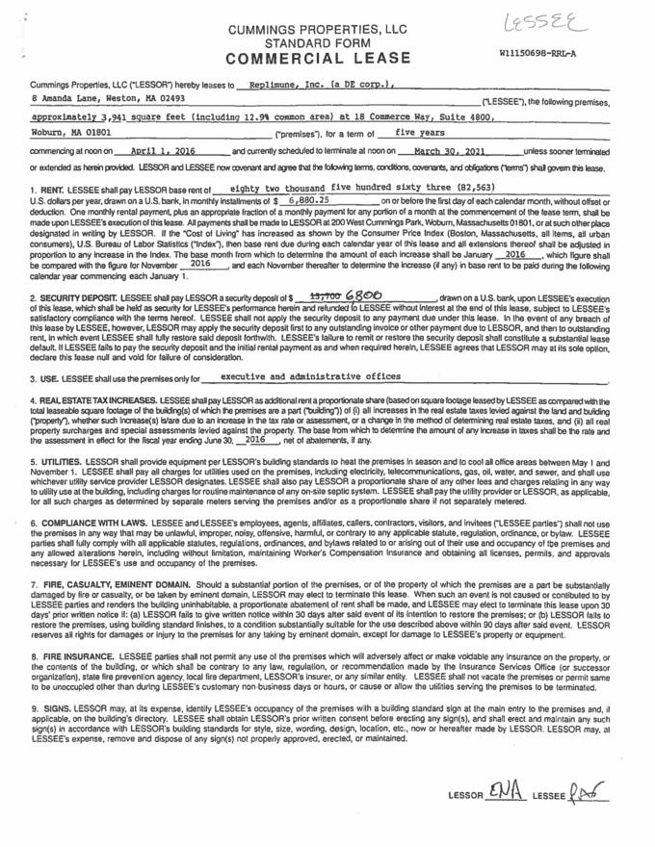

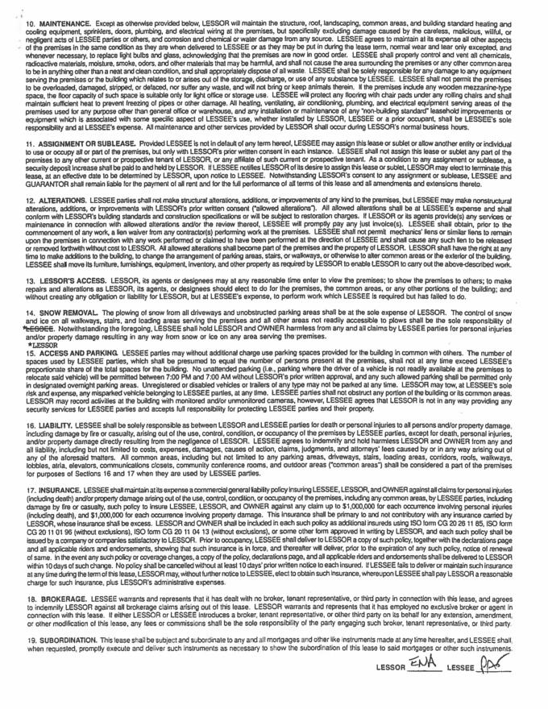

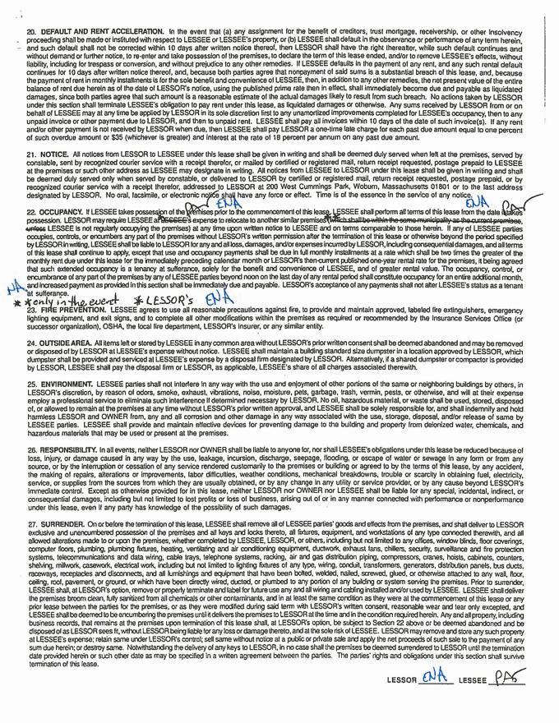

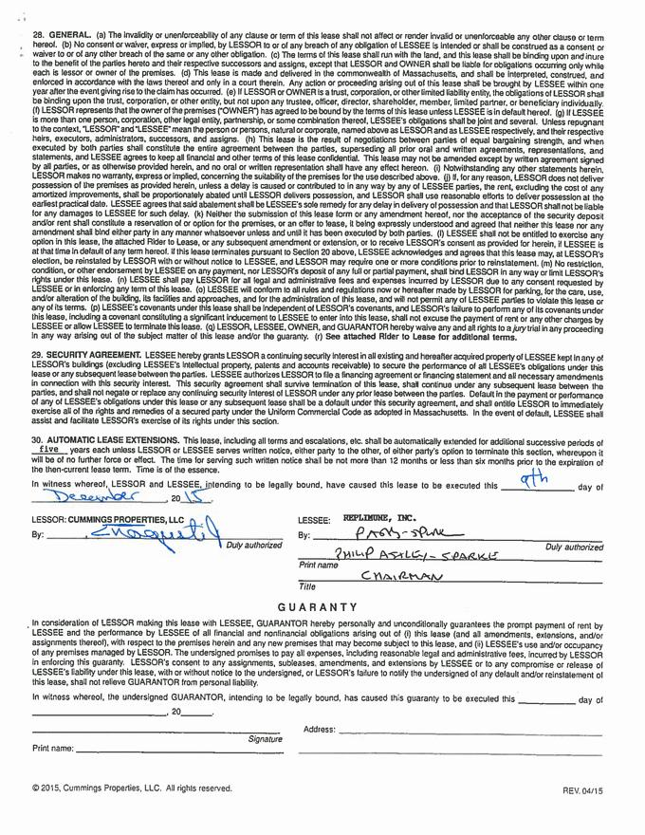

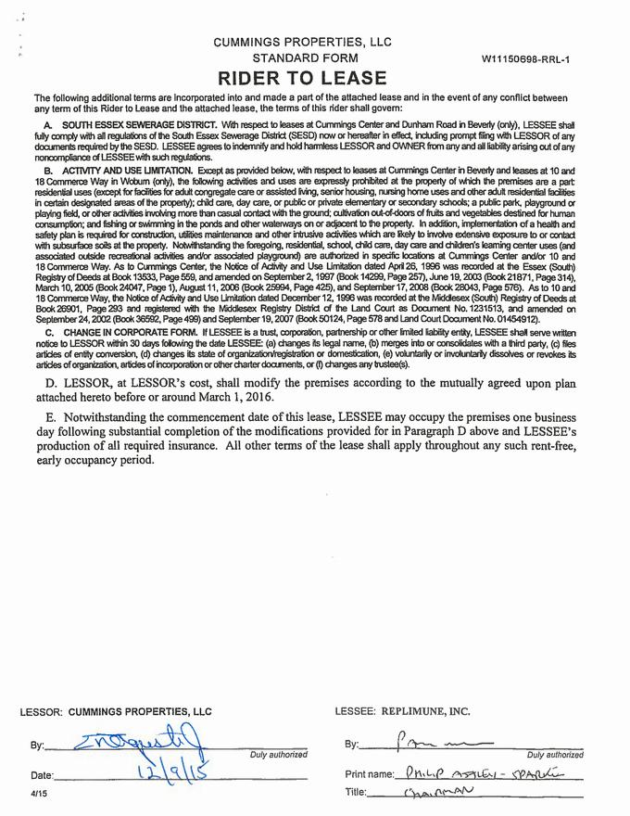

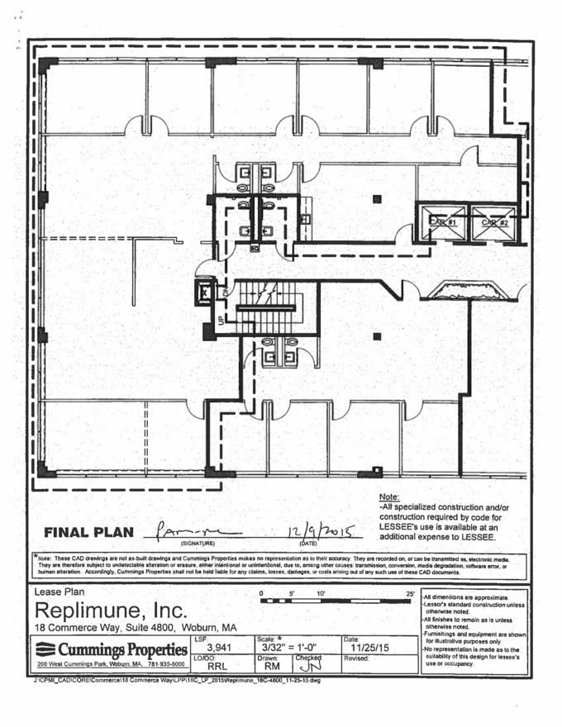

Exhibit 10.9
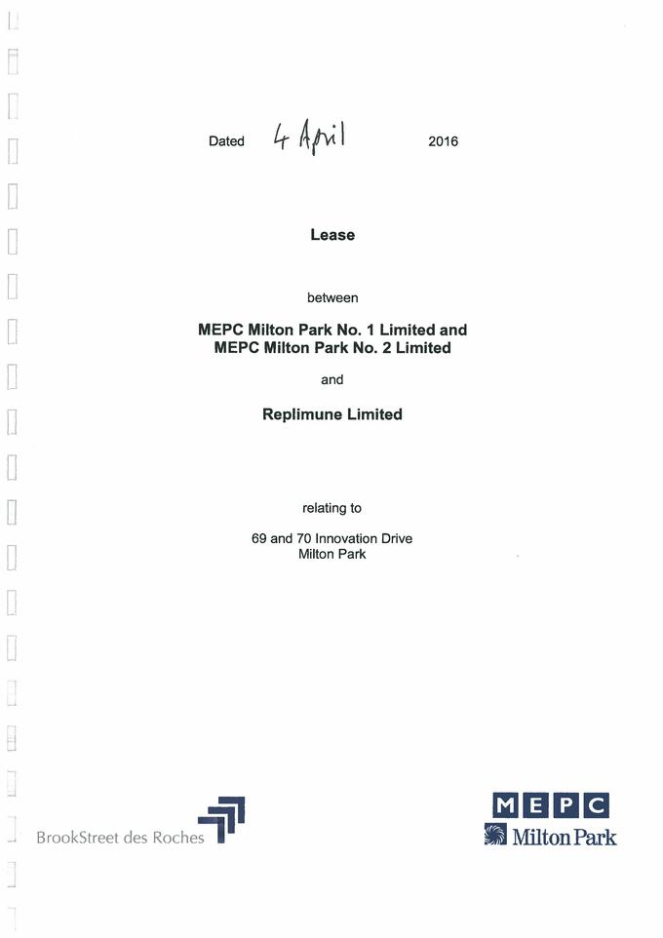

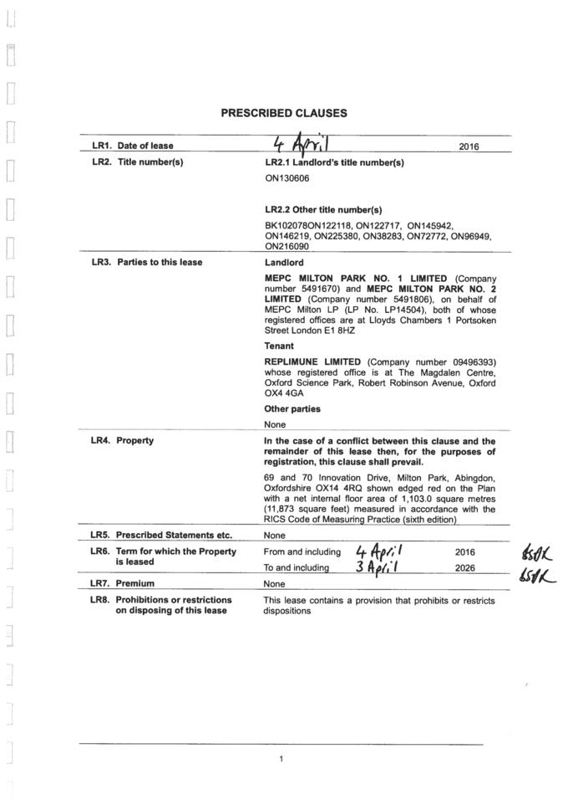

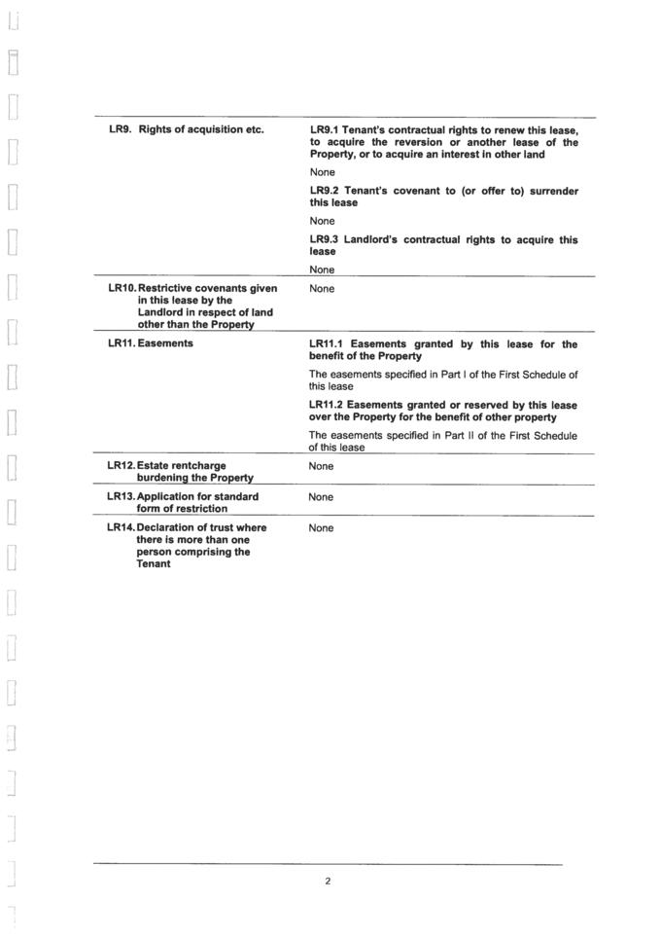

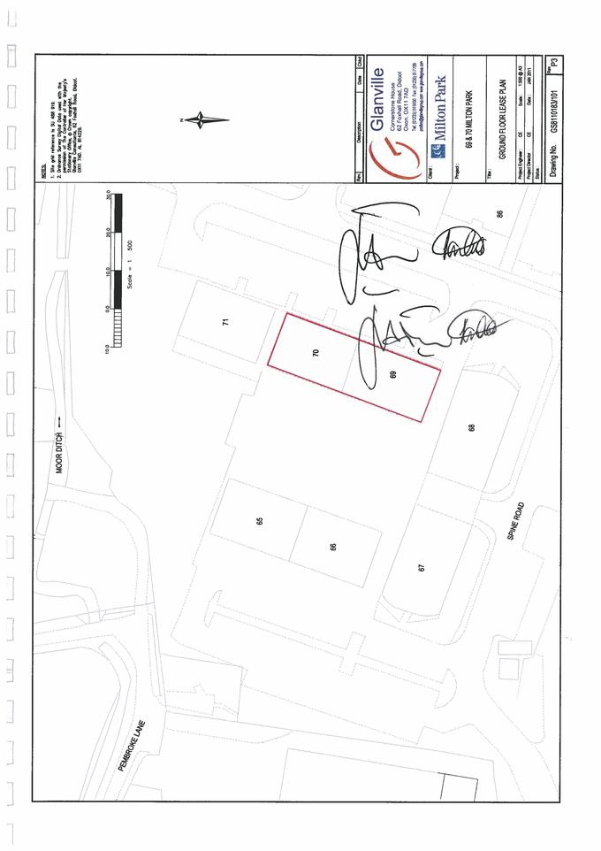

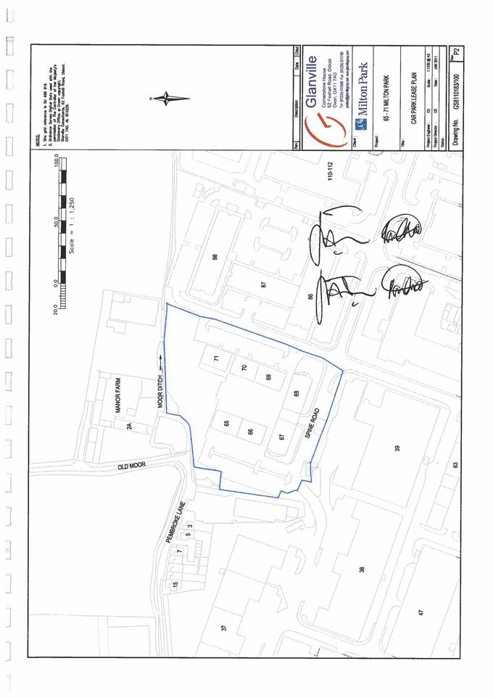

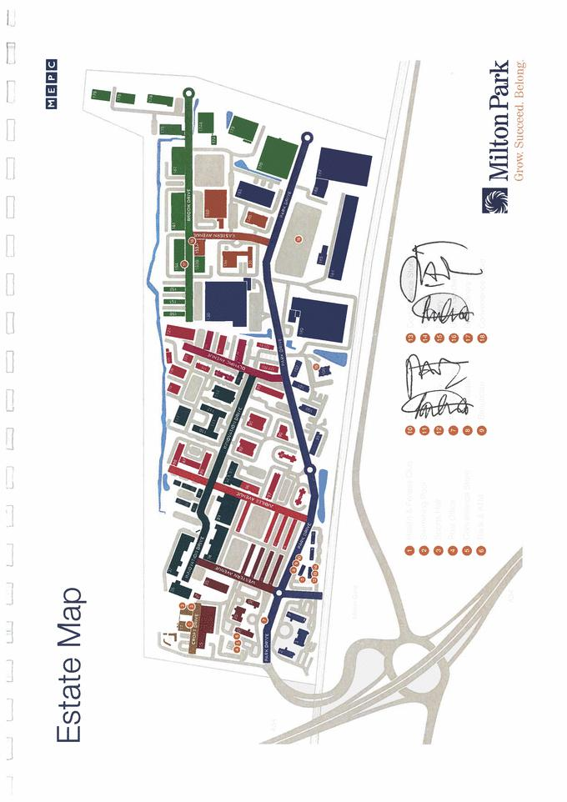

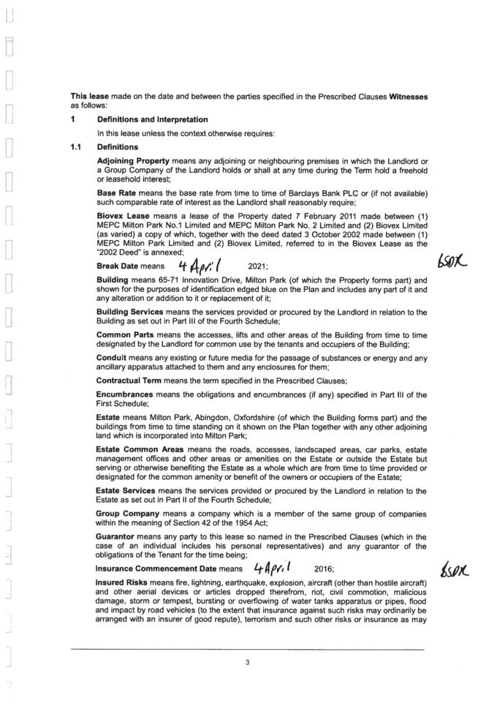

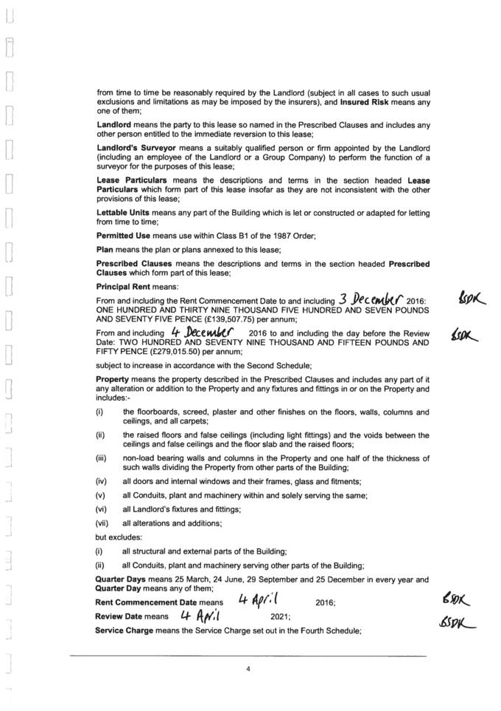

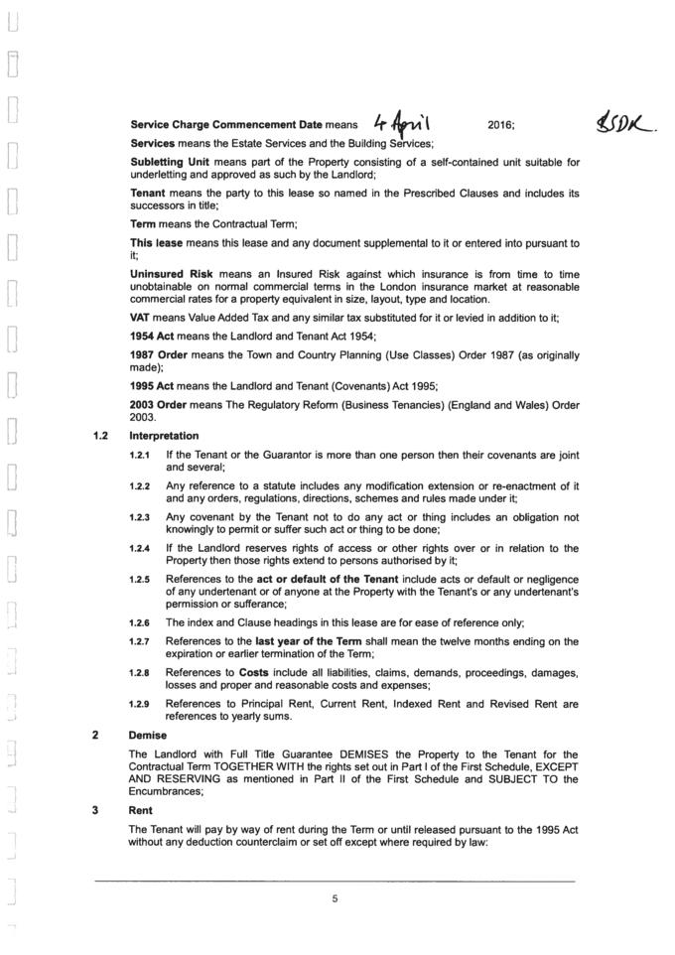

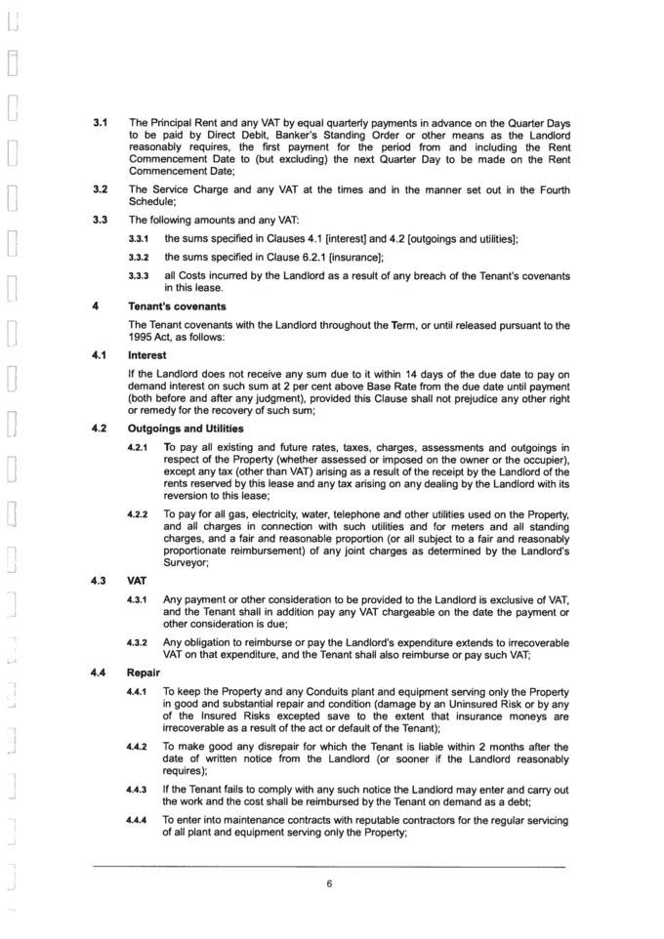

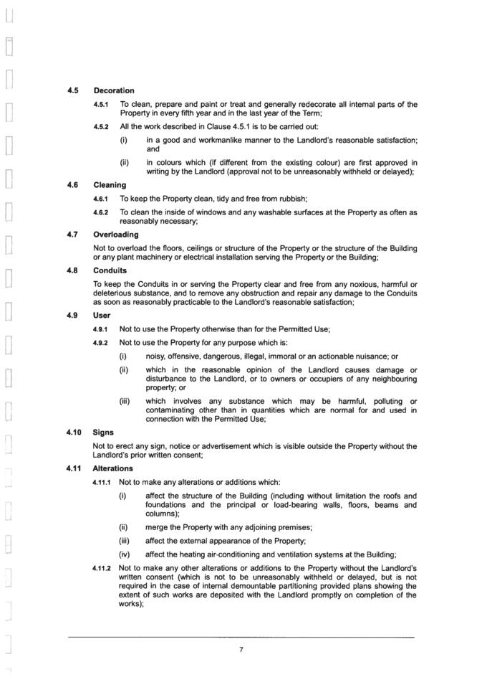

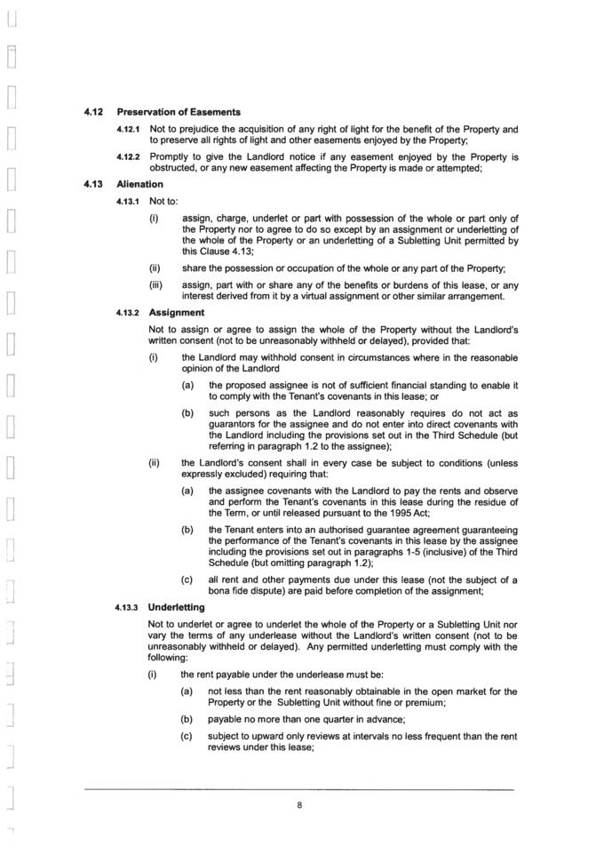

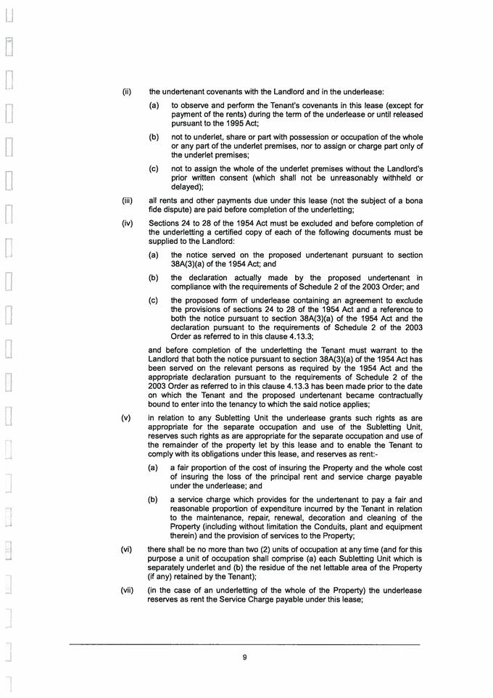

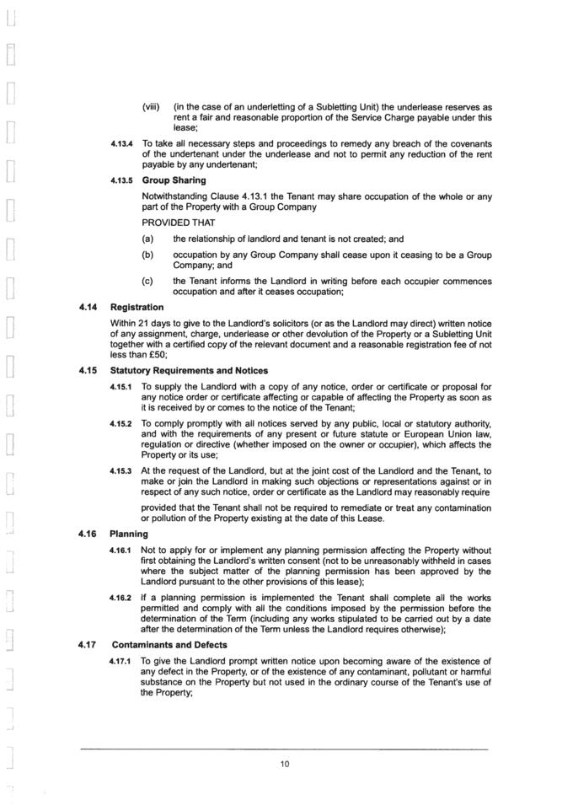

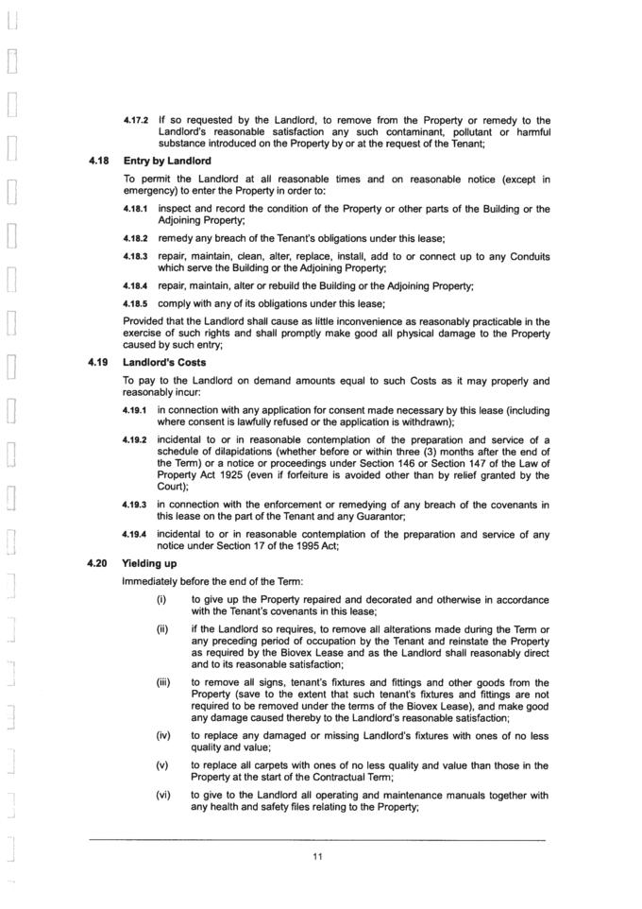

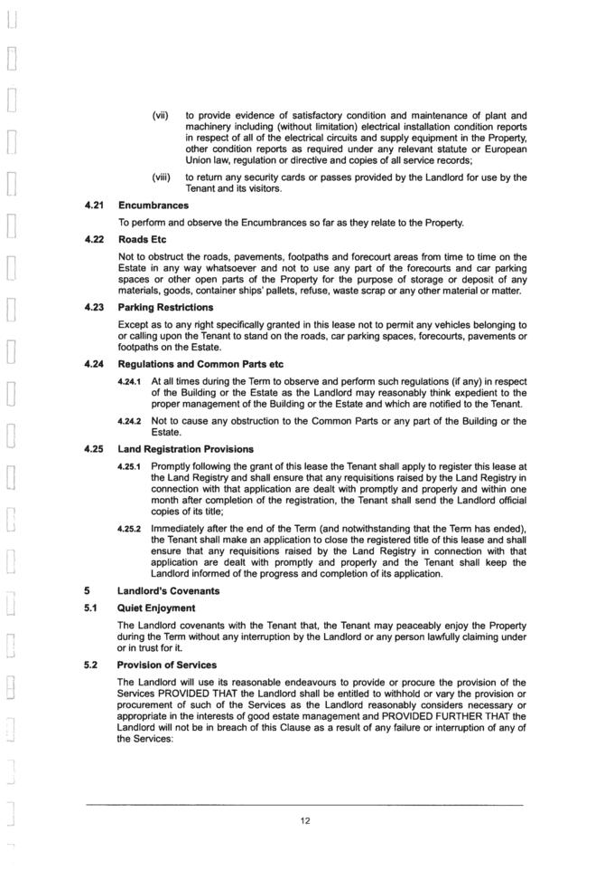

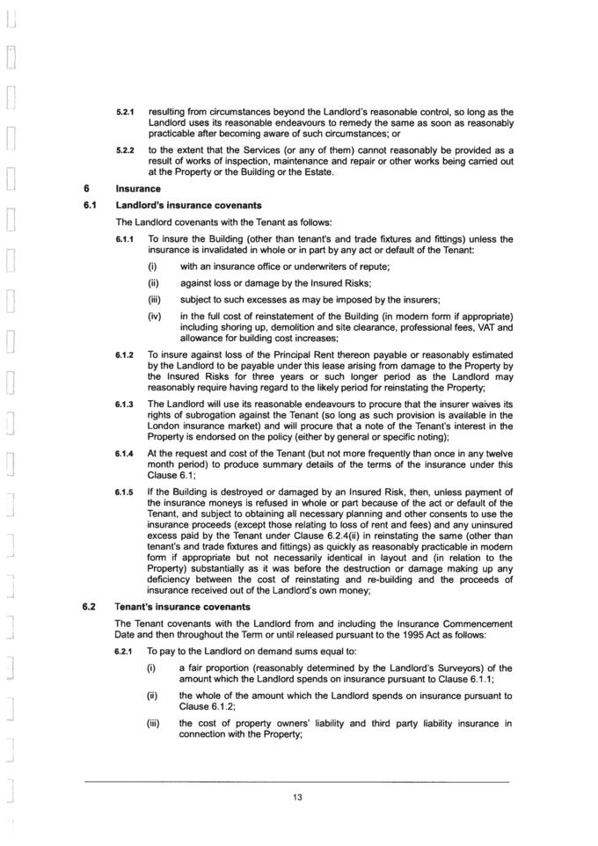

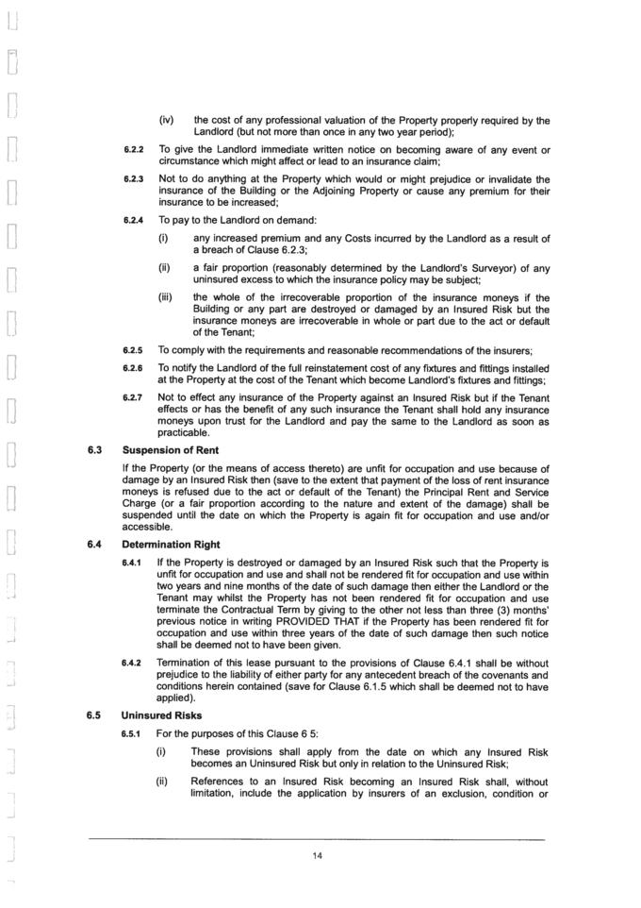

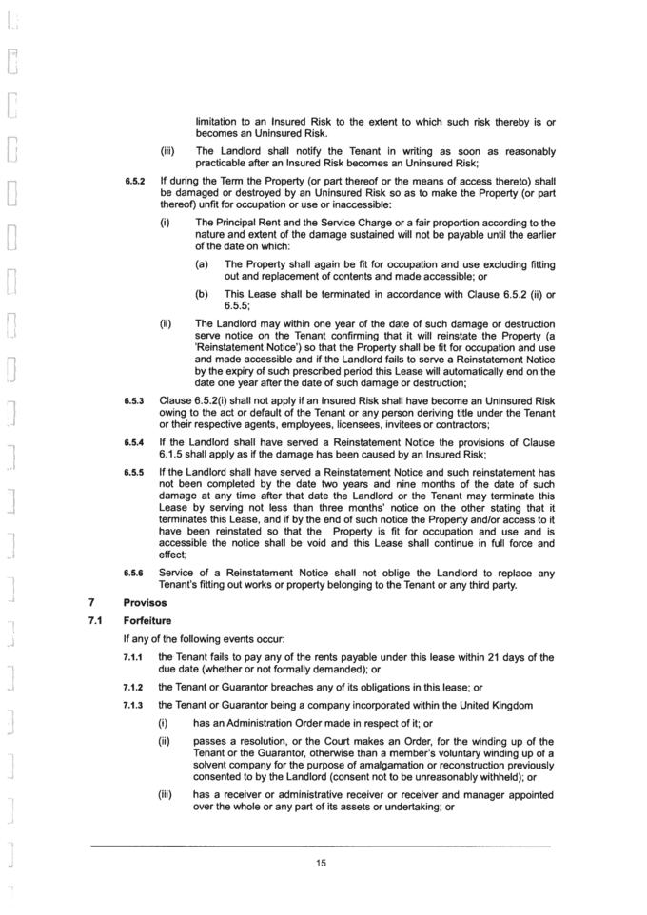

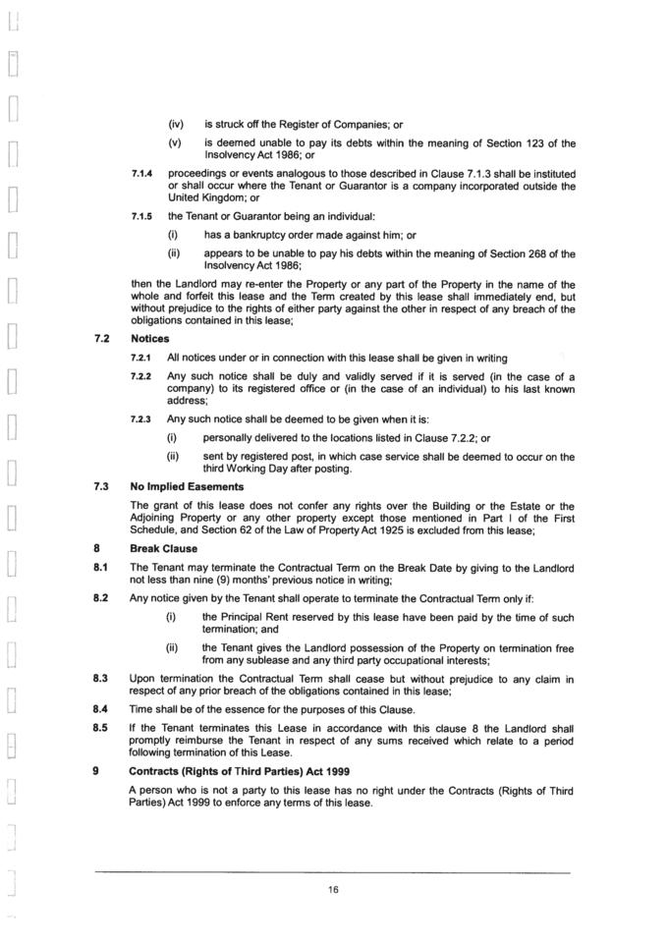



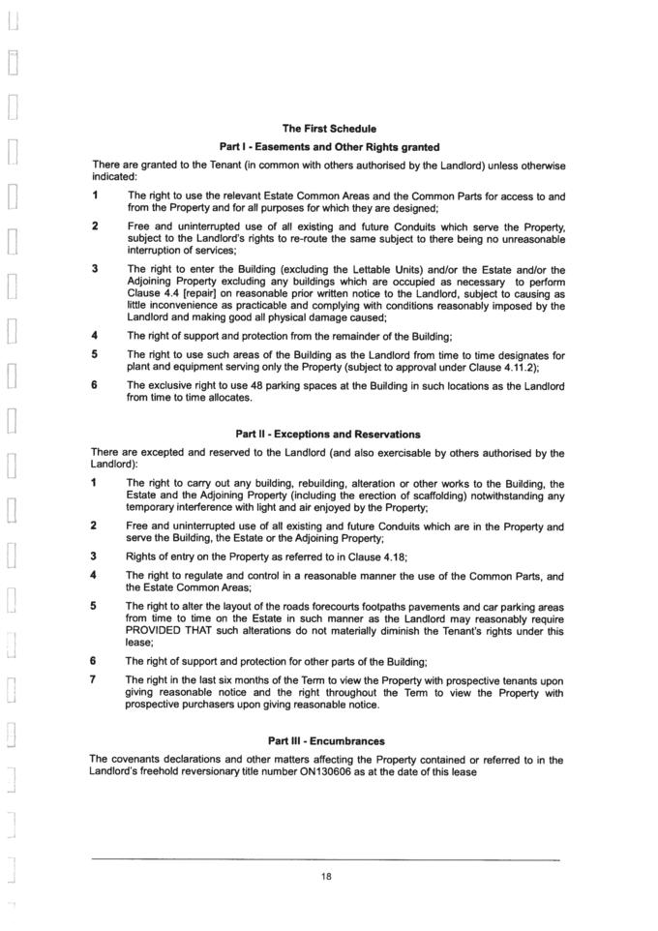

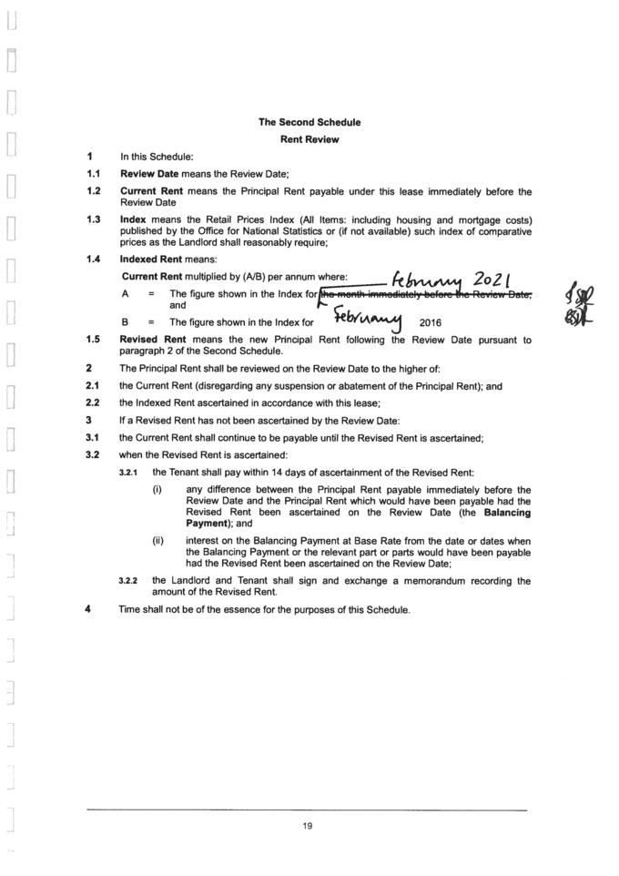

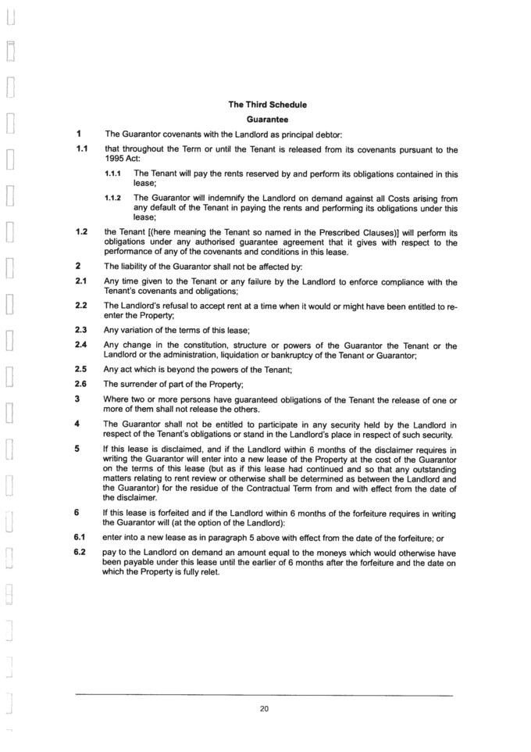

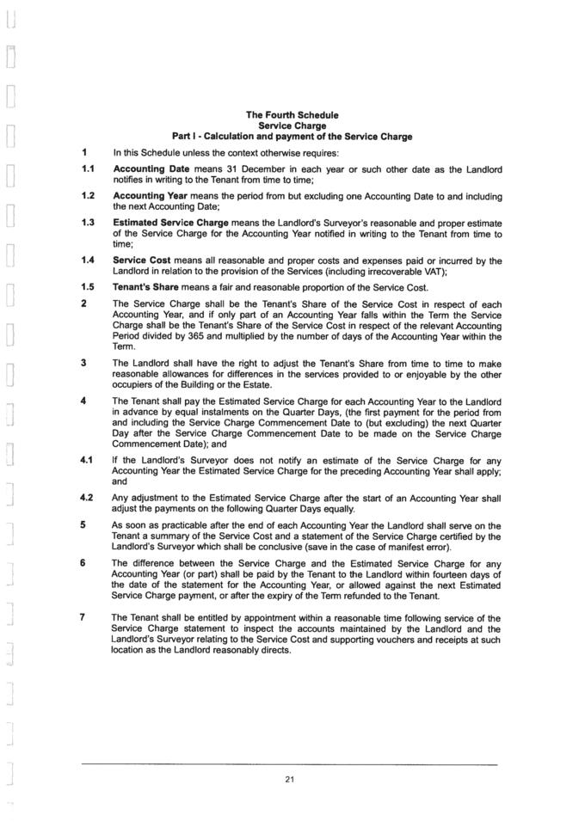

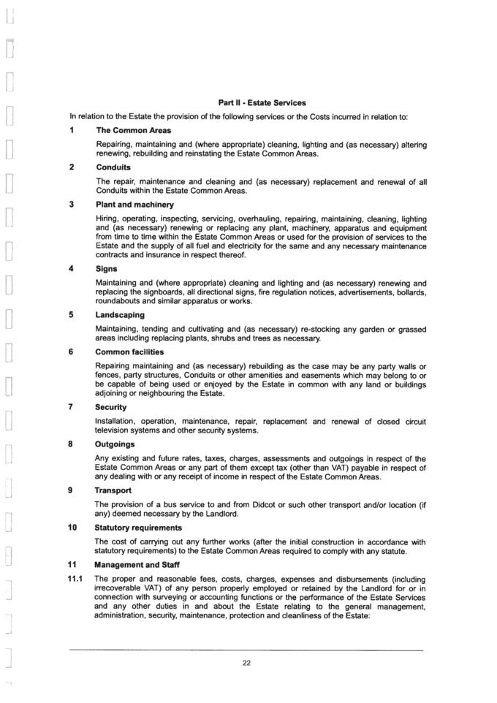

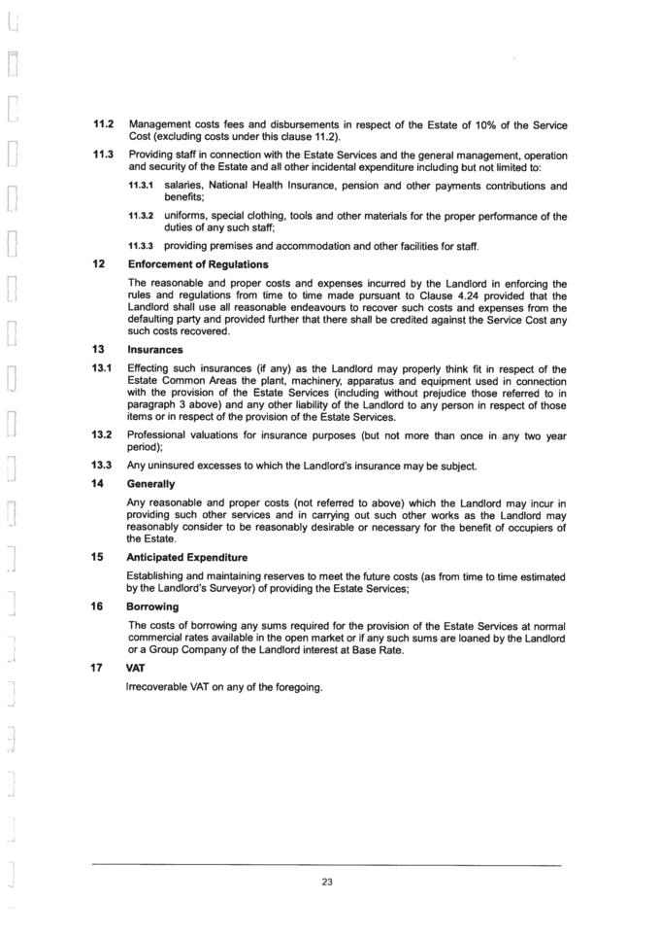

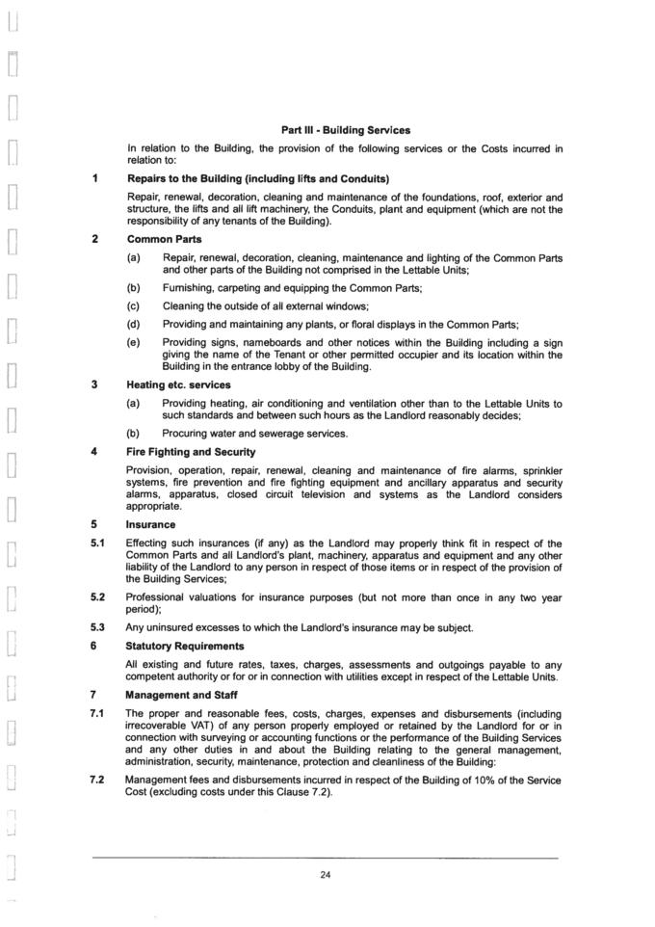

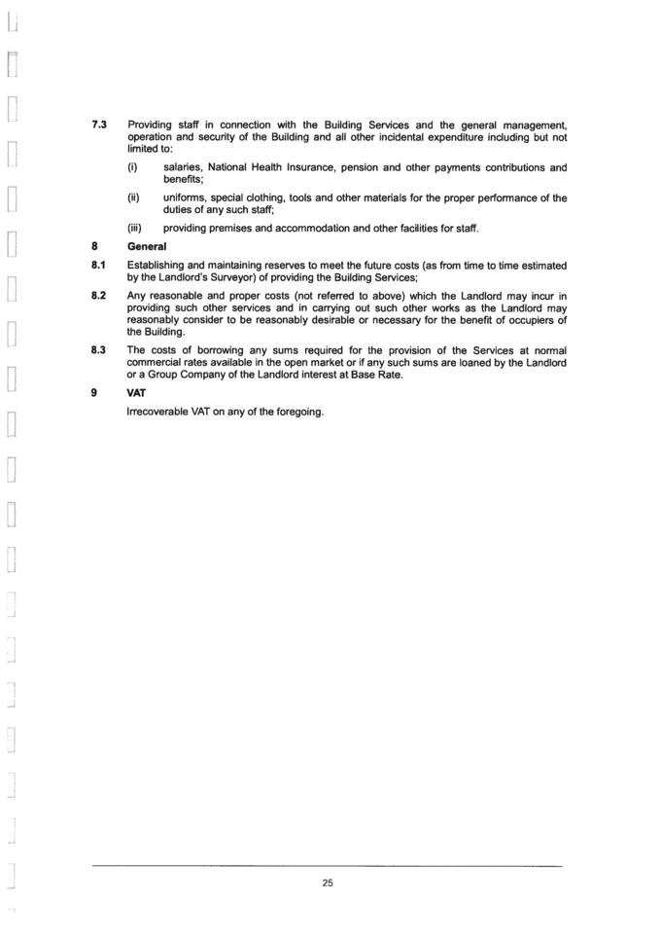



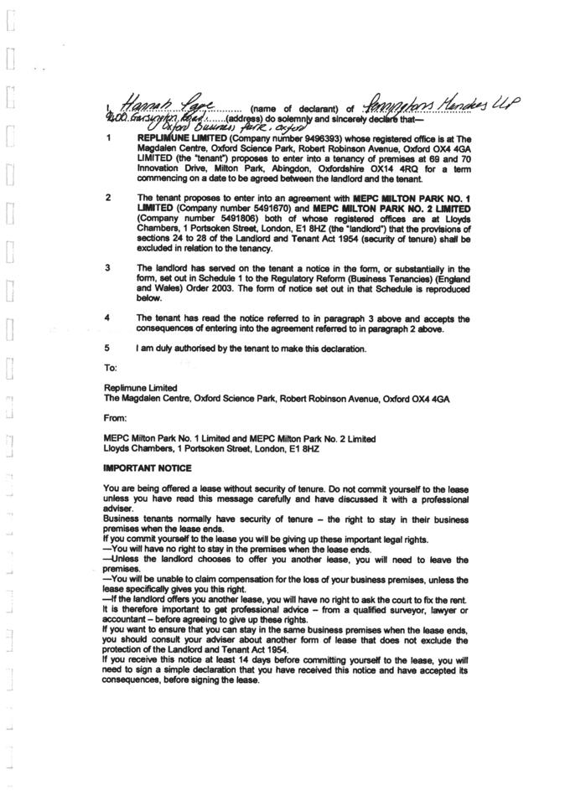

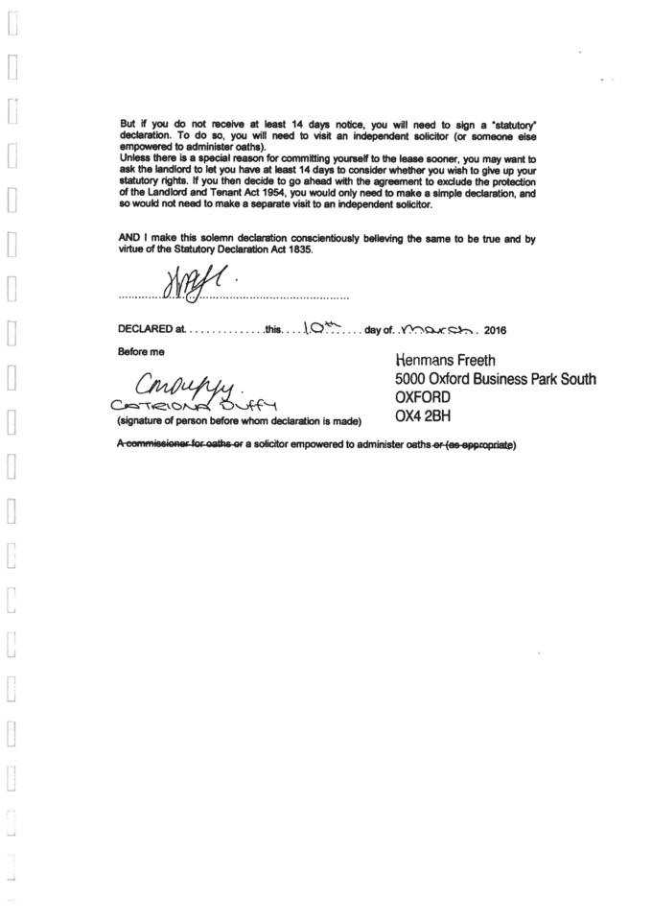



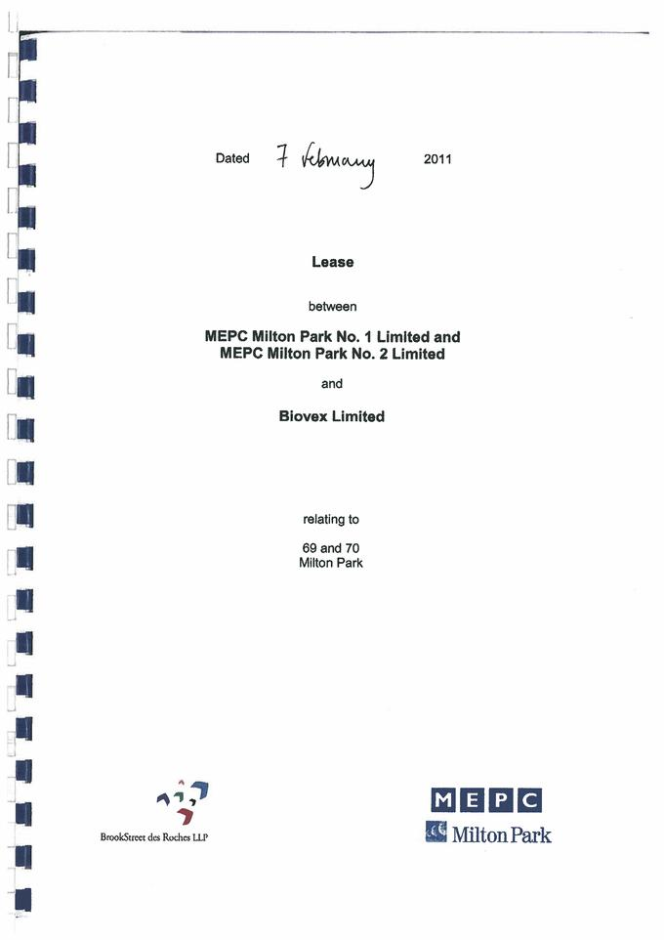

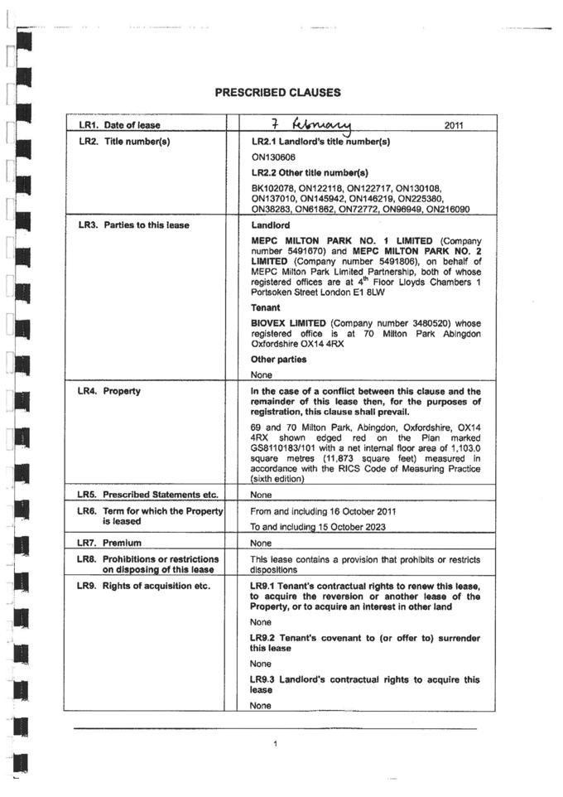

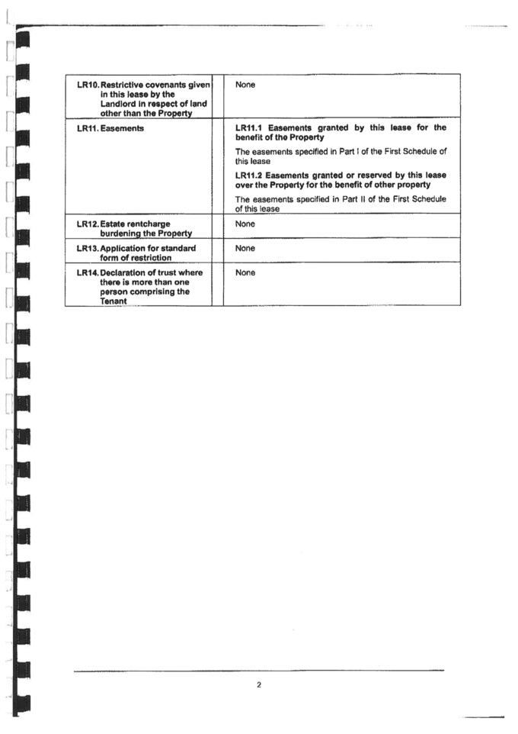

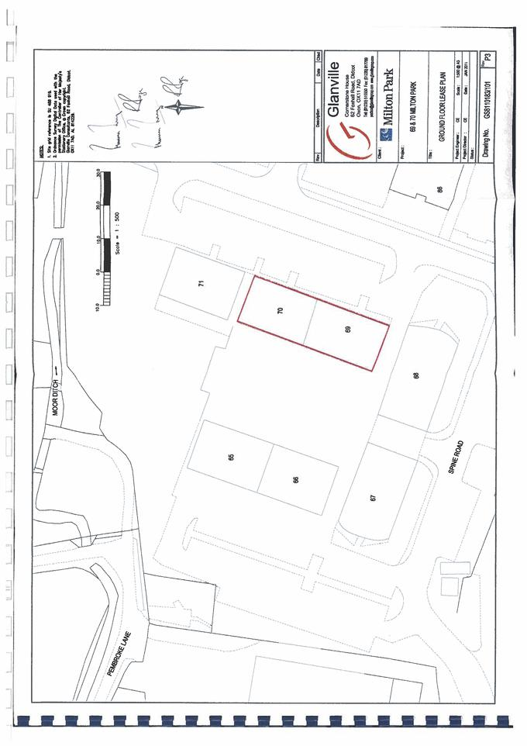

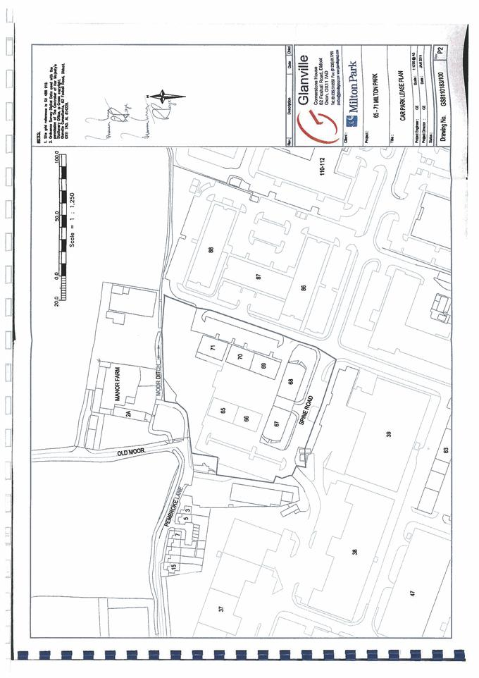

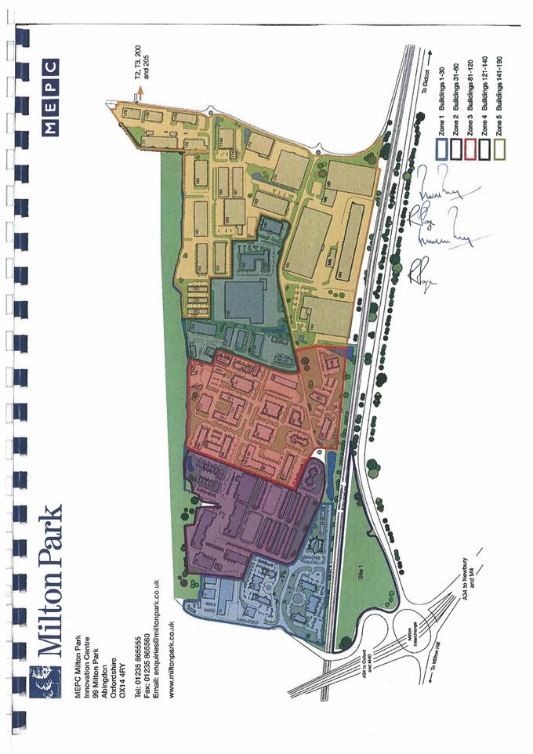

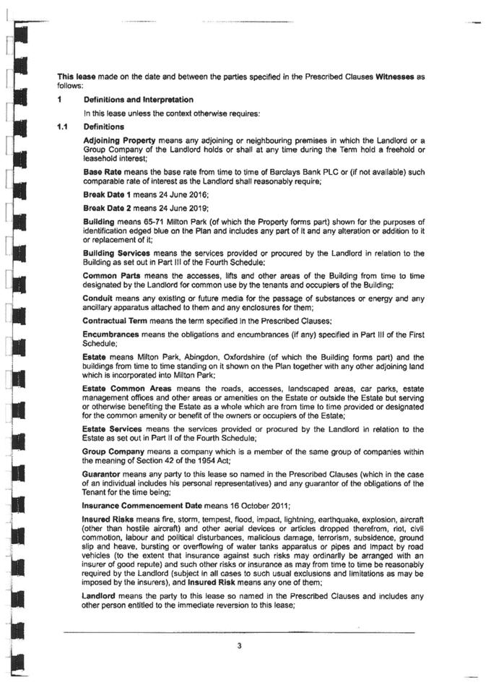

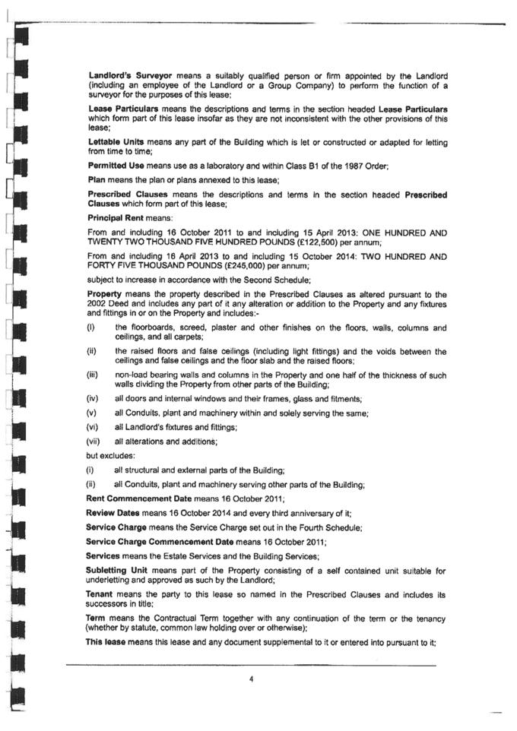

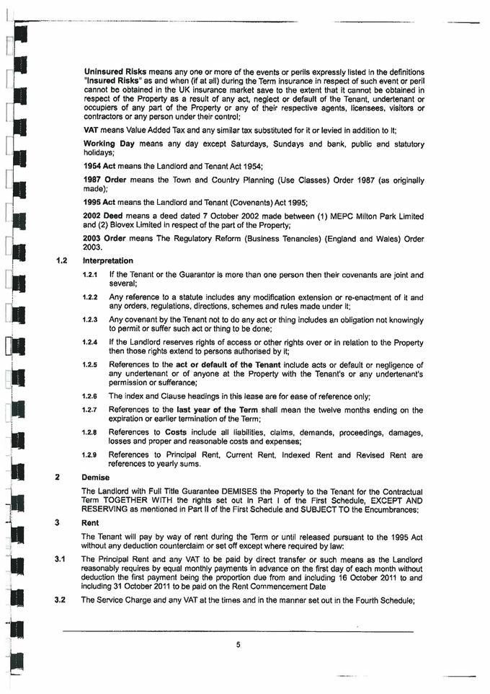

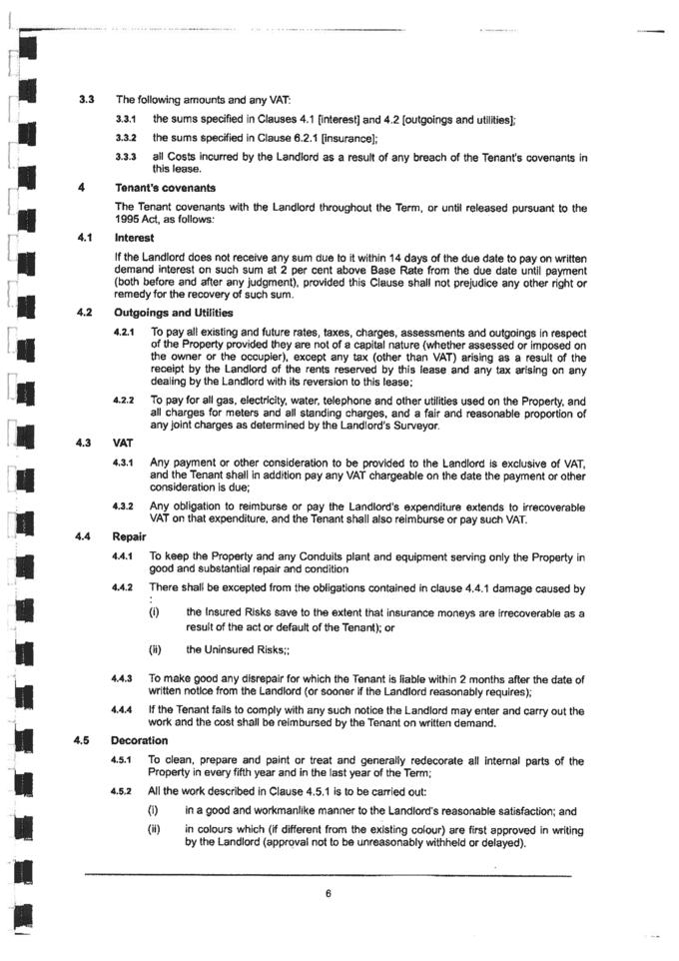

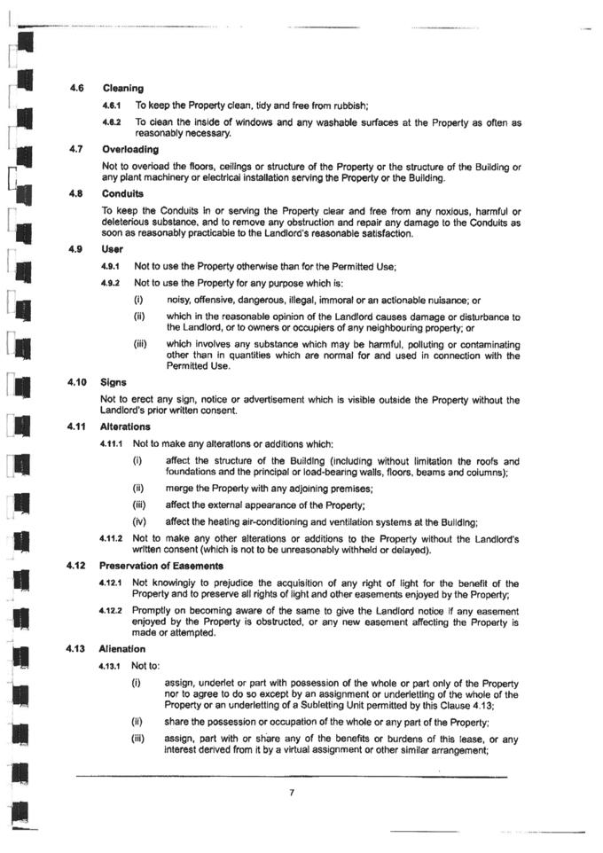

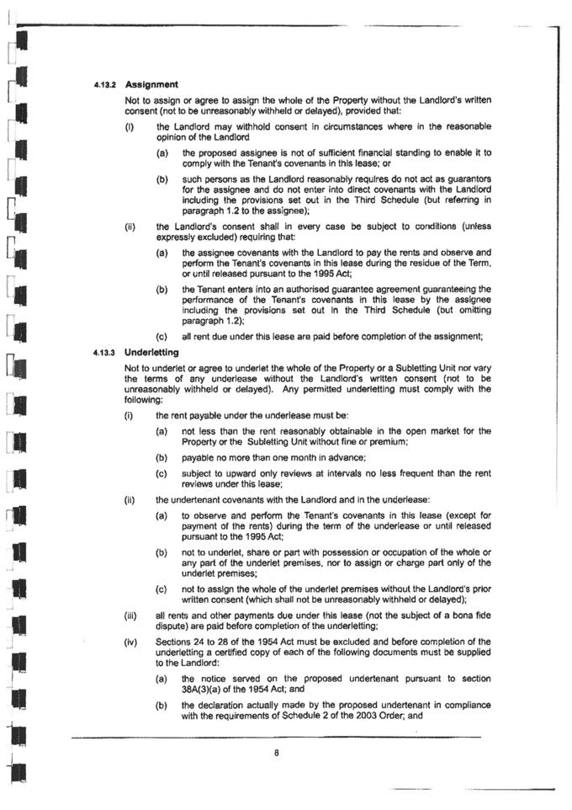

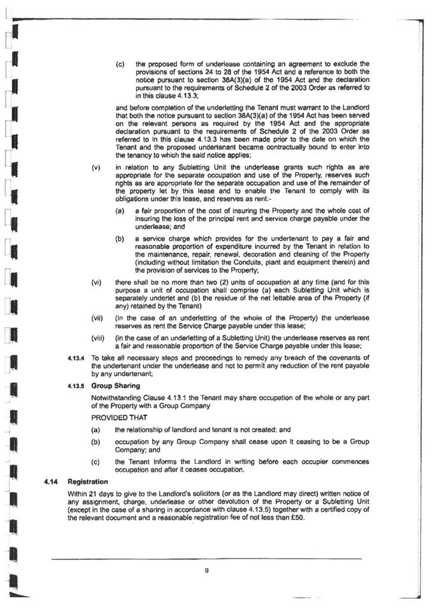

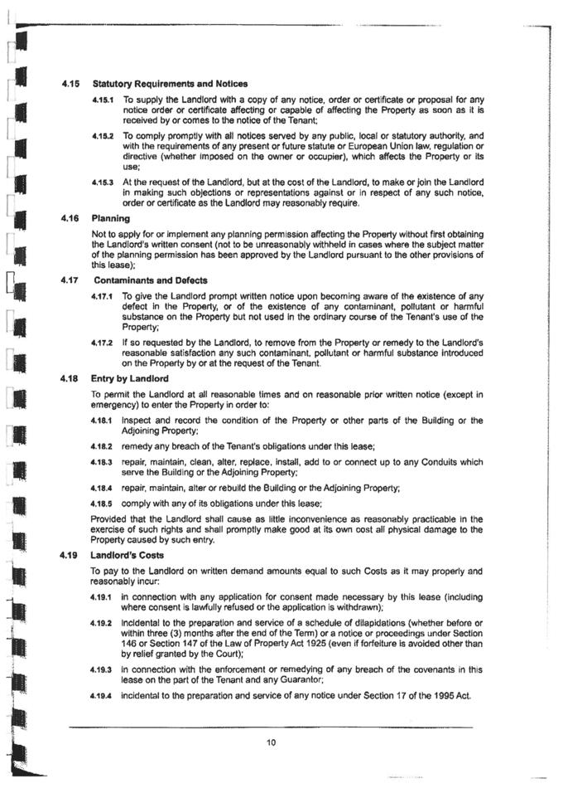

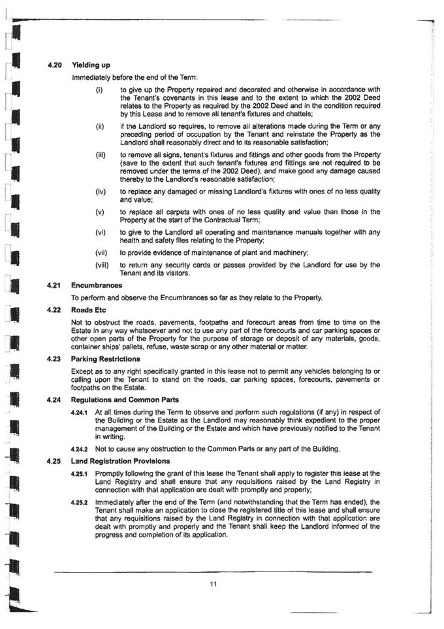

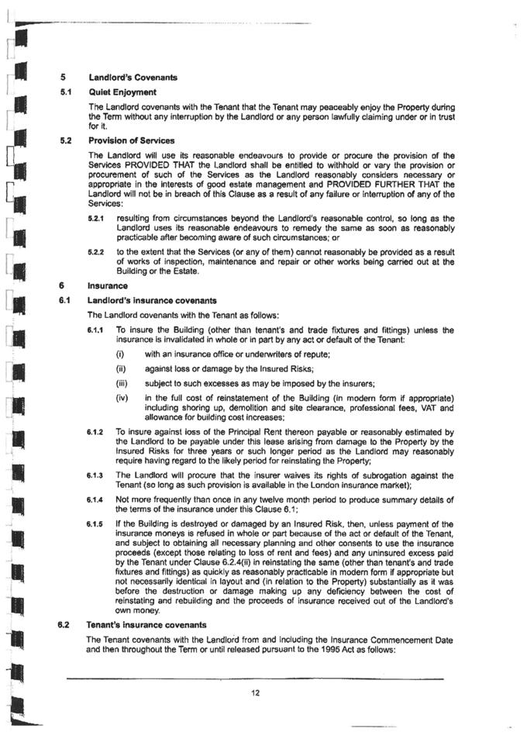

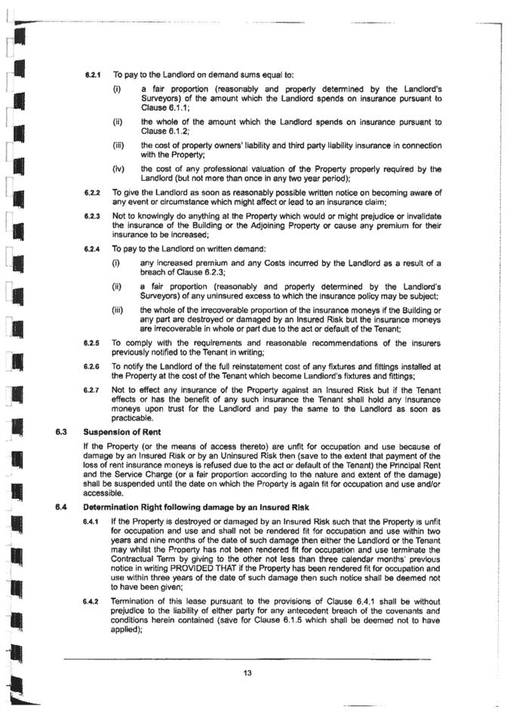

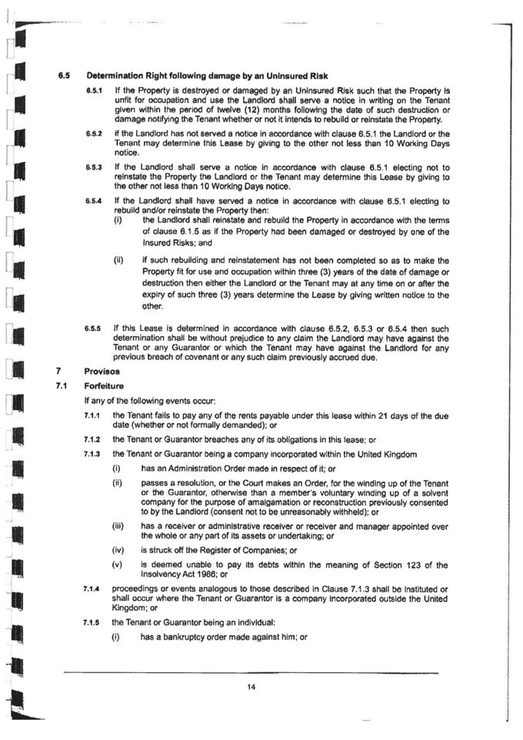

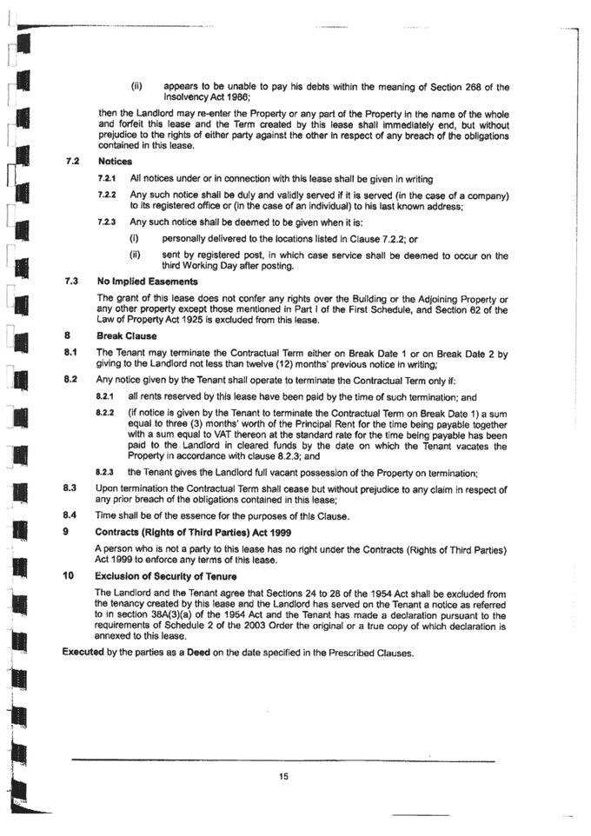

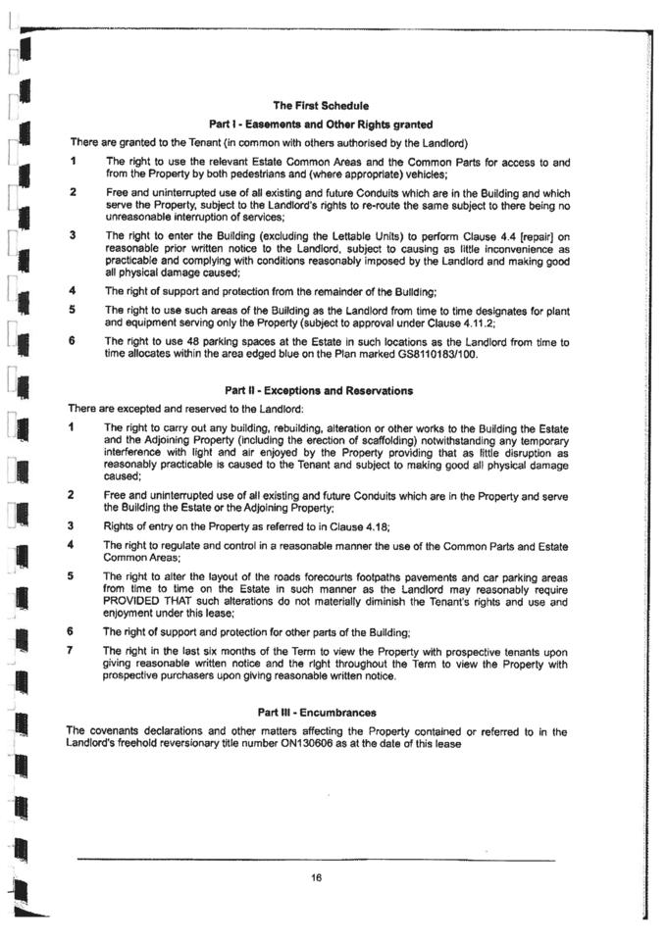

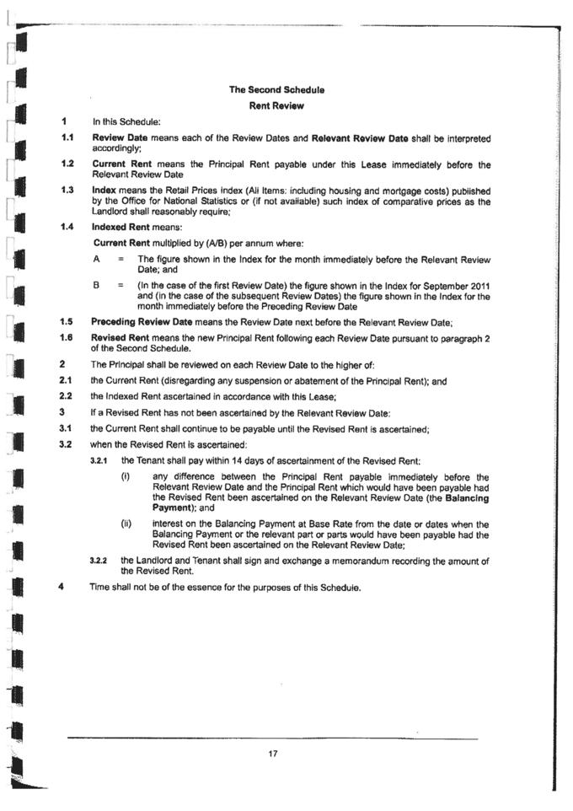

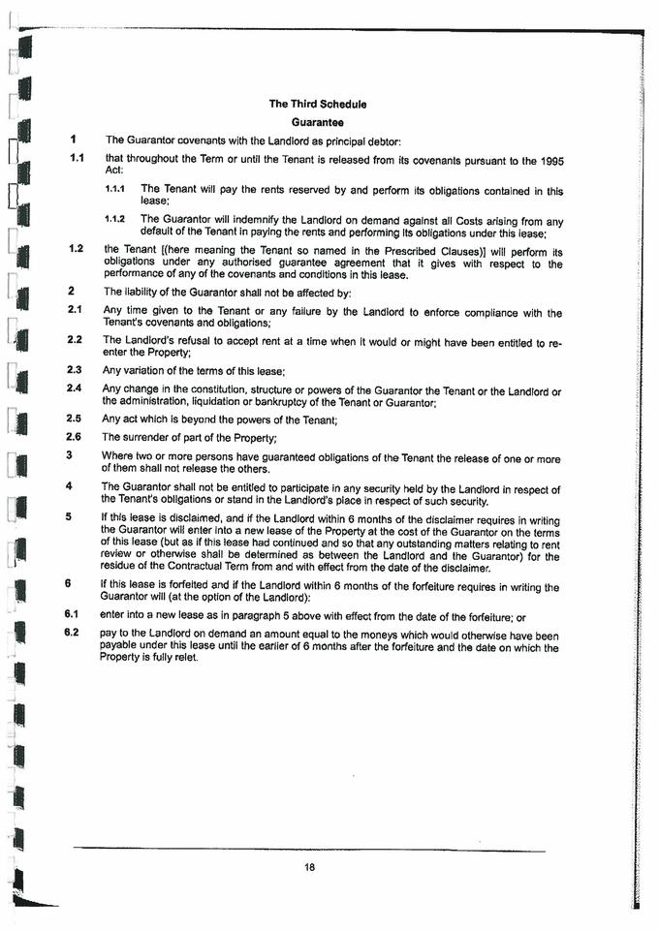

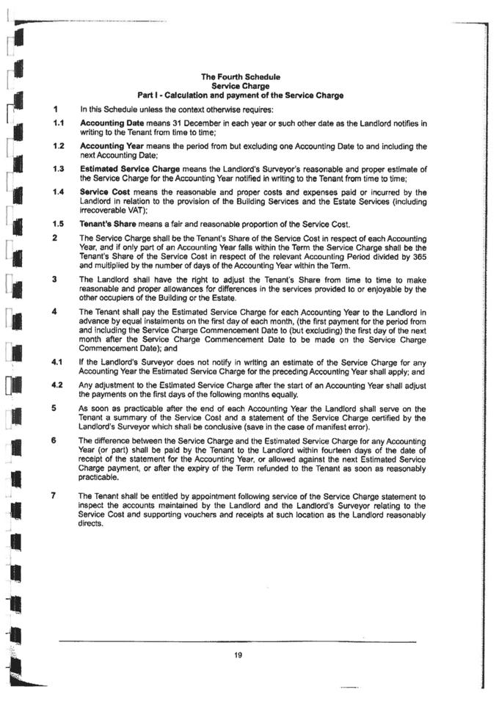

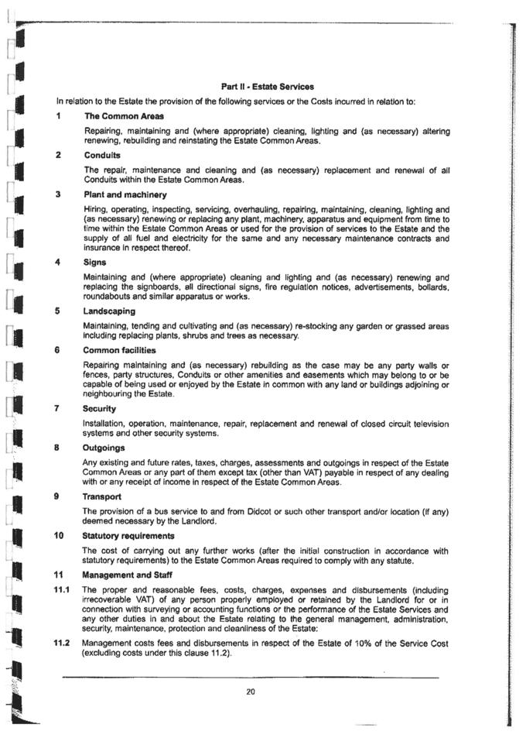

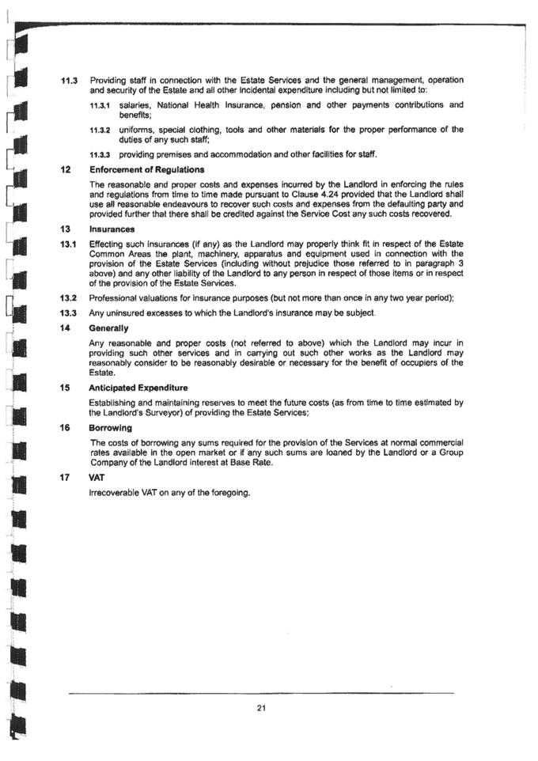

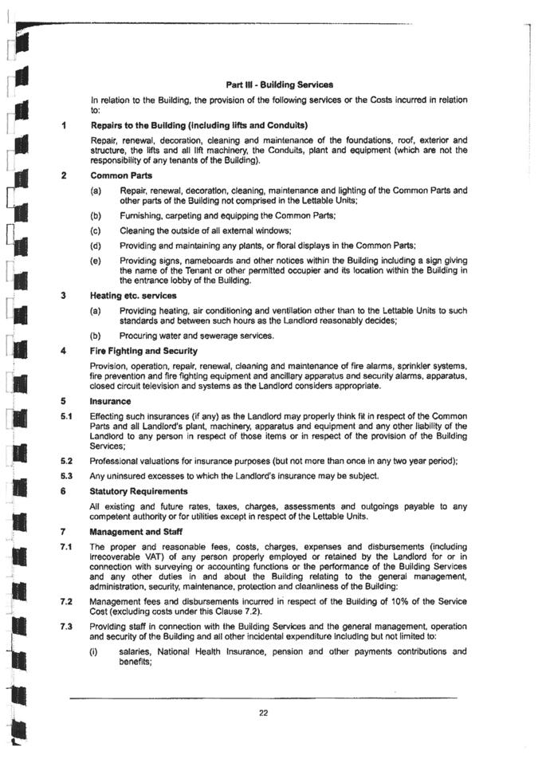





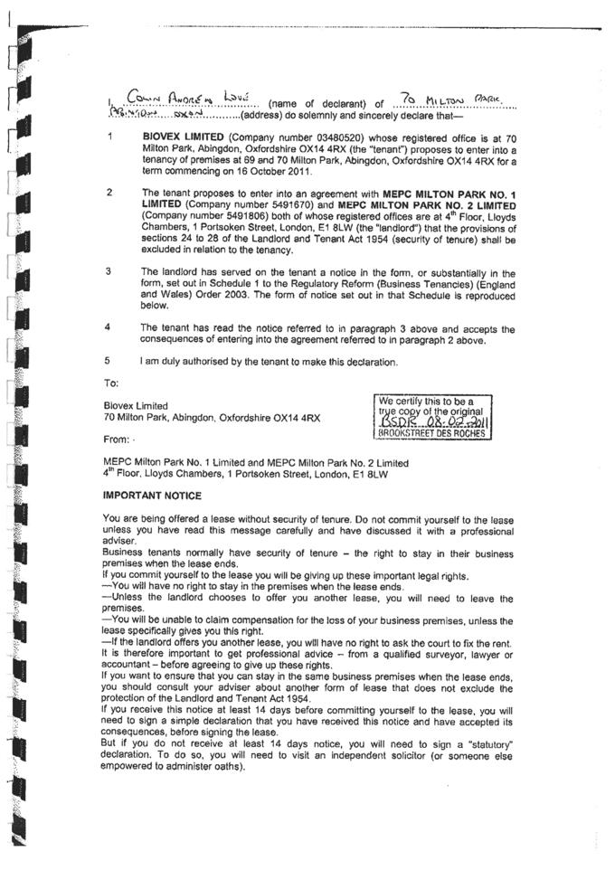

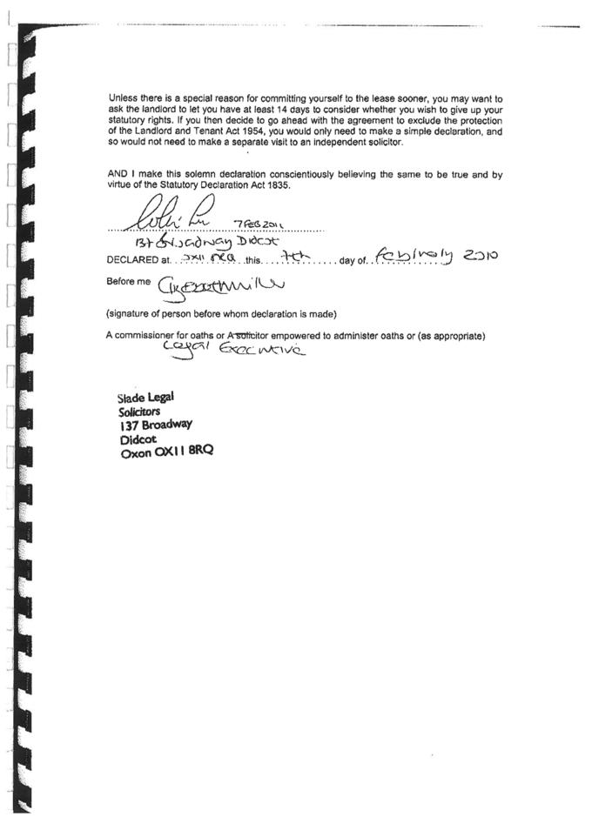

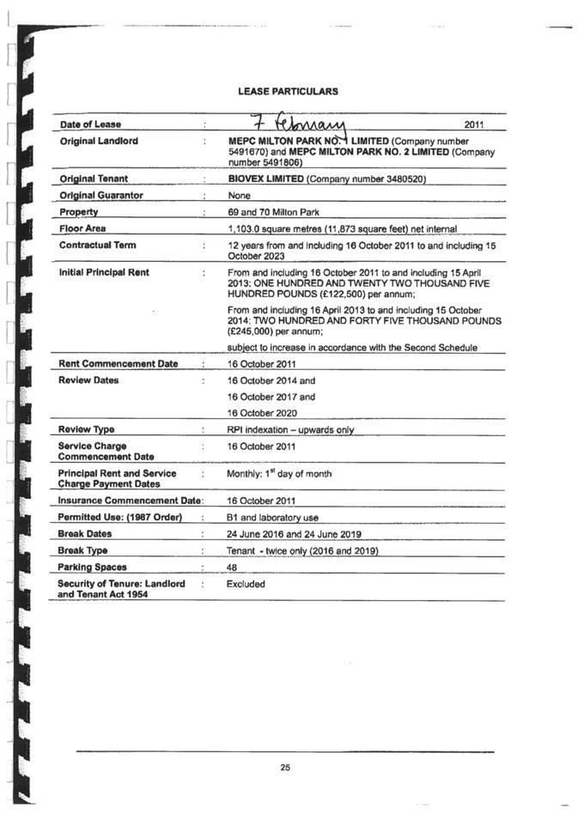

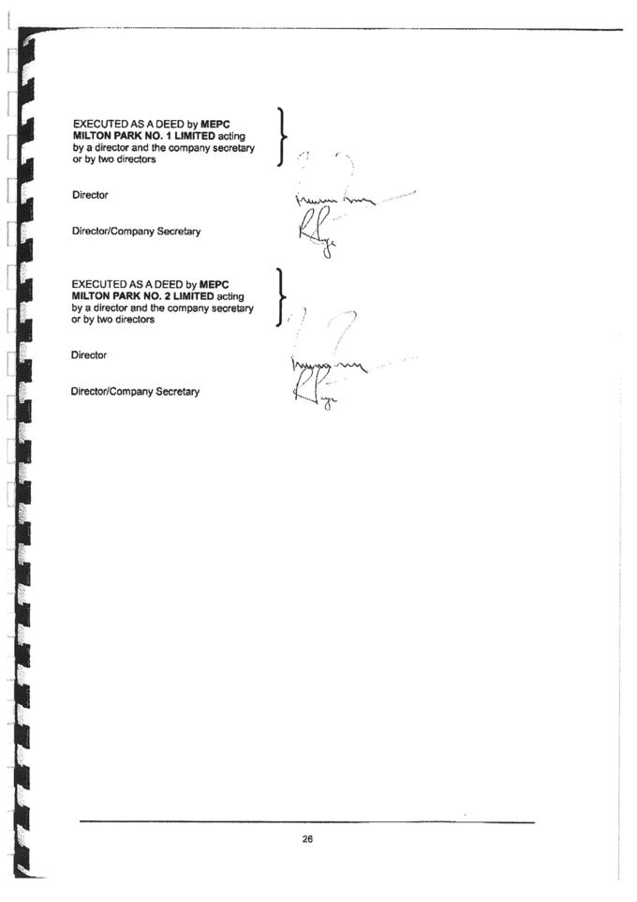

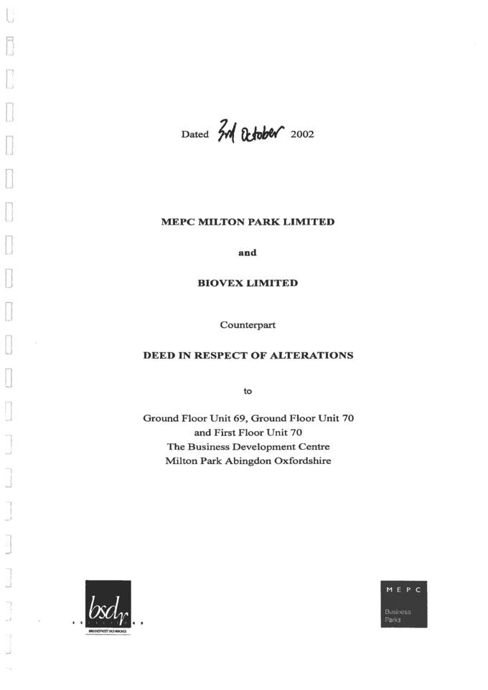

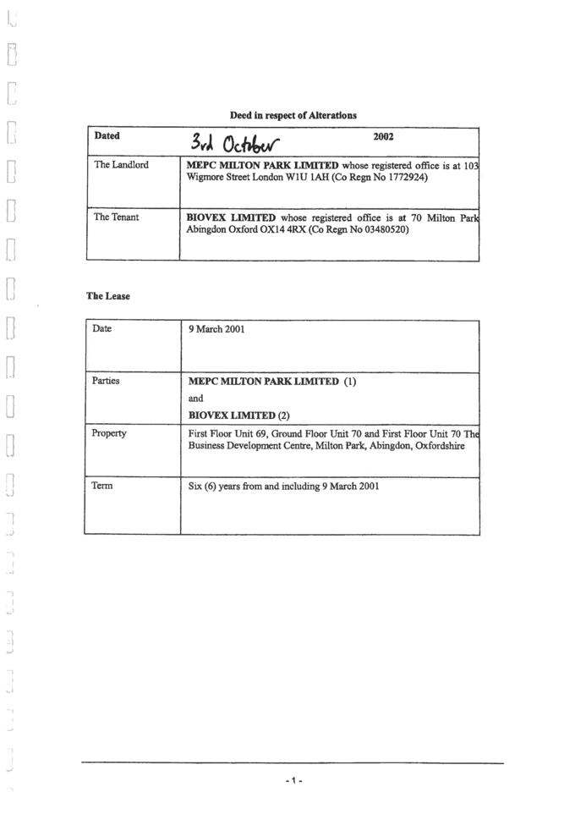

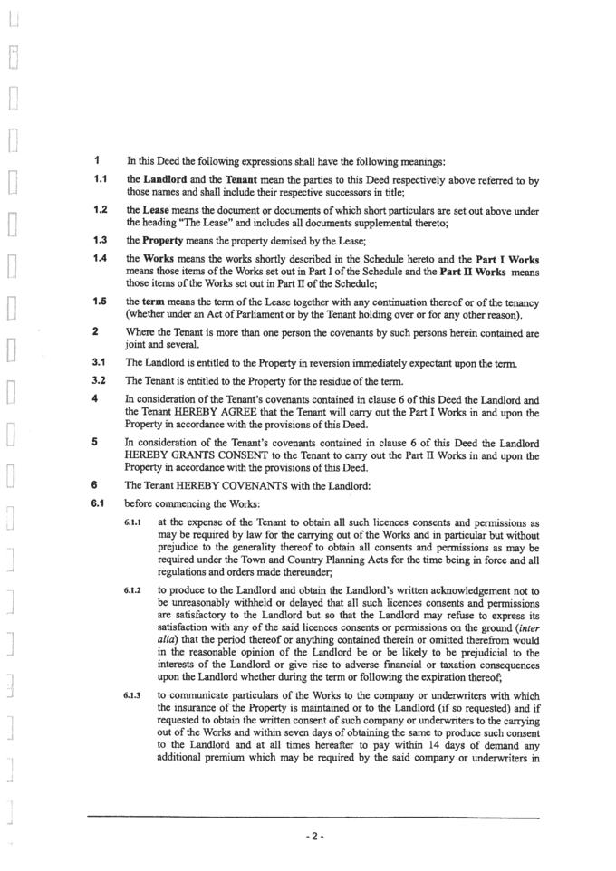

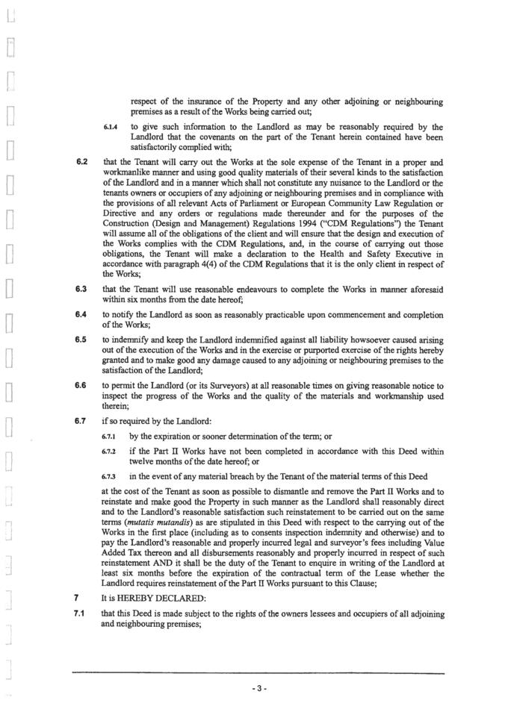

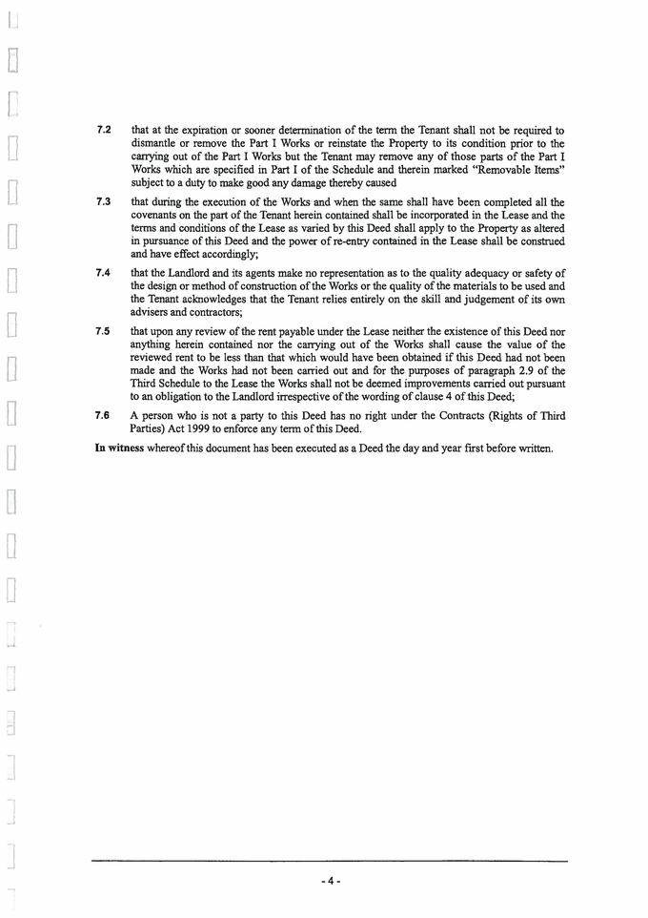

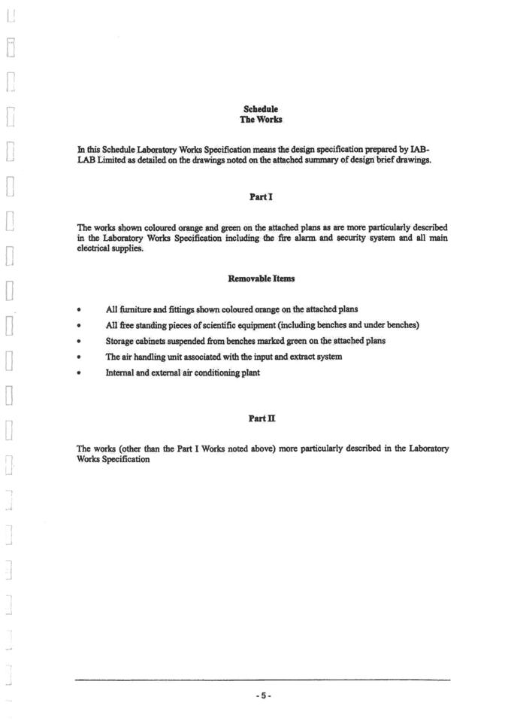

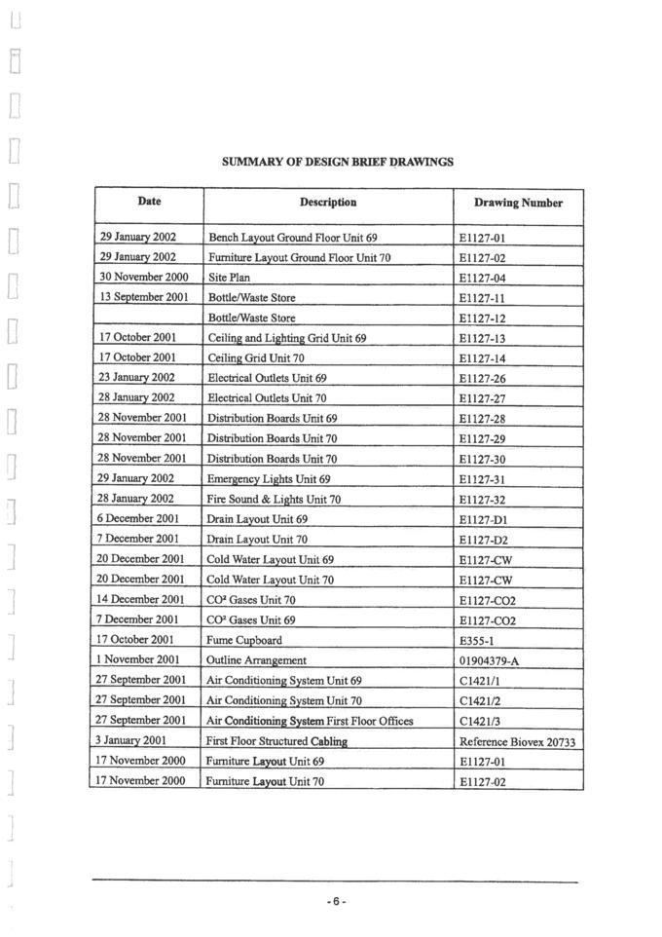

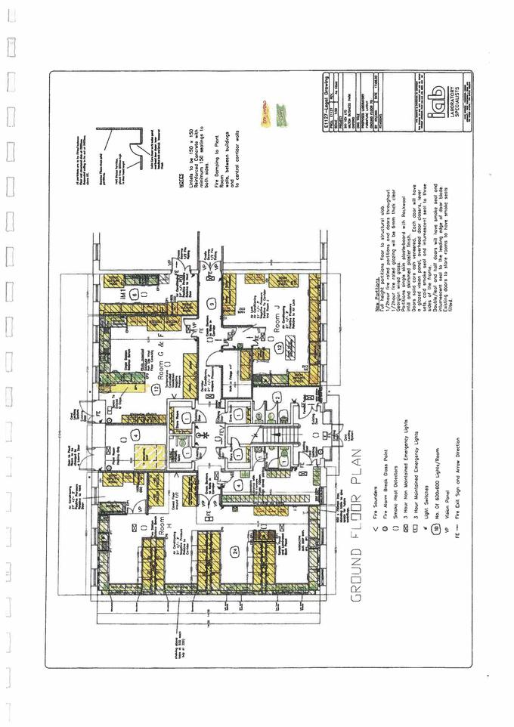

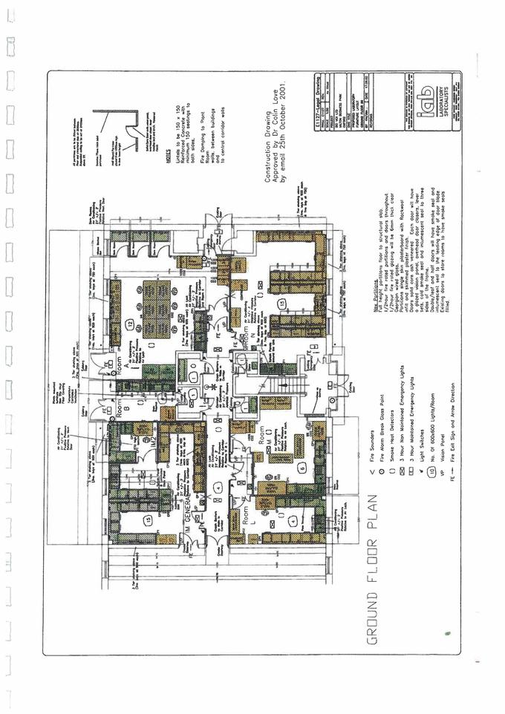

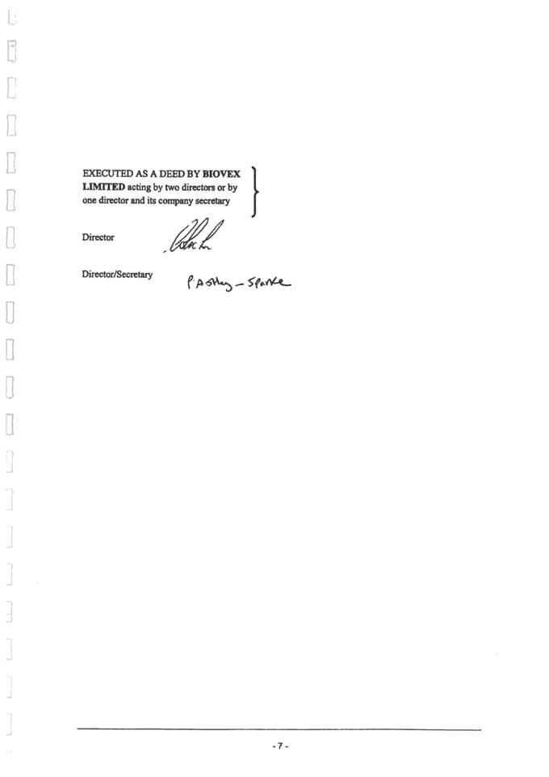

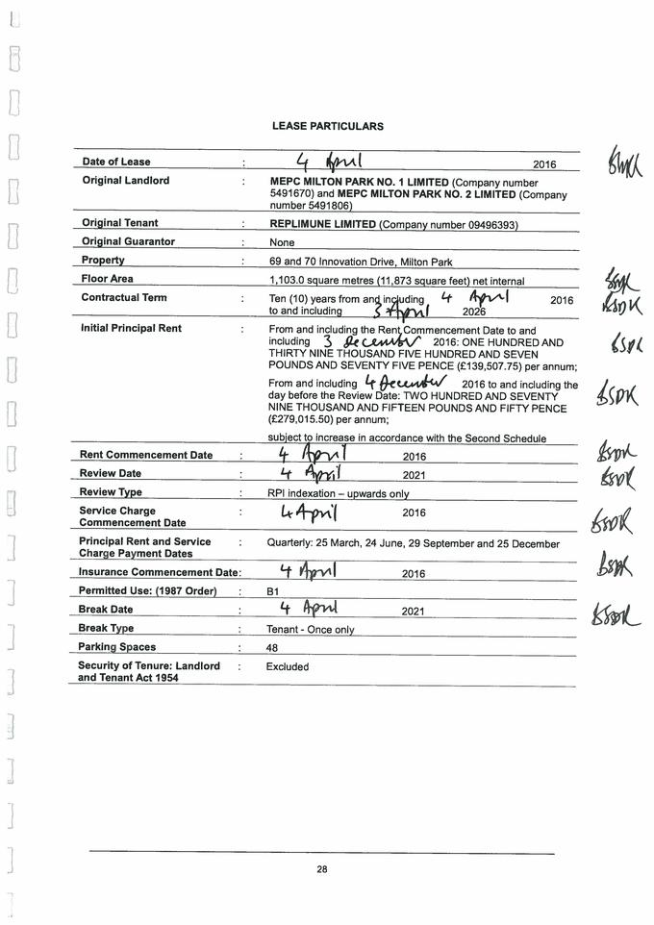

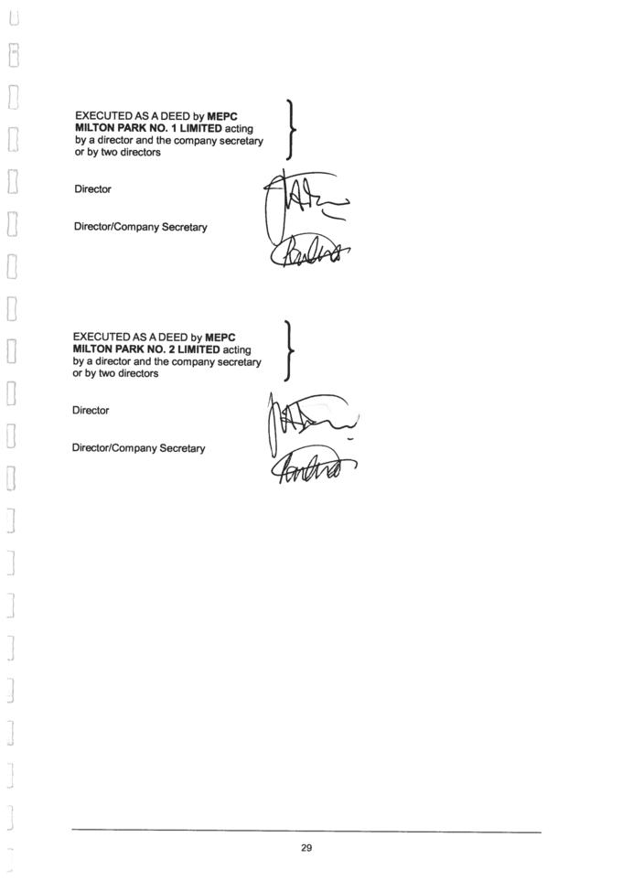

EXHIBIT 10.10

REPLIMUNE GROUP, INC. REQUESTS THAT THE MARKED PORTIONS OF THIS EXHIBIT BE GRANTED CONFIDENTIAL TREATMENT UNDER RULE 24B-2 OF THE SECURITIES EXCHANGE ACT OF 1934, AS AMENDED

Execution

CLINICAL TRIAL COLLABORATION AND SUPPLY AGREEMENT

This CLINICAL TRIAL COLLABORATION AND SUPPLY AGREEMENT (the “Agreement”) is made and entered into effective as of the date signed by the last Party to sign below (the “Effective Date”) by and between Replimune Inc., a corporation organized under the laws of Delaware, having a place of business at 18 Commerce Way, Woburn, MA 01801 (the “Recipient”) and Bristol-Myers Squibb Company, having a place of business at 345 Park Avenue, New York, NY 10154 (“BMS”). The Recipient and BMS are sometimes individually referred to in this Agreement as a “Party” and collectively as the “Parties.”

PRELIMINARY STATEMENTS

A. The Recipient desires to conduct, and BMS desires to supply the BMS Study Drug (as defined below) for the conduct of, a Combined Therapy Clinical Trial (as defined below) in accordance with the Protocol (as defined below) therefor and in accordance with the terms of this Agreement.

- The Parties desire to agree on various terms and conditions to govern the Parties’ obligations in connection with the performance of the Combined Therapy Clinical Trial. NOW, THEREFORE, in consideration of the foregoing premises and the mutual promises and covenants contained herein, the Parties agree as follows:

ARTICLE 1

DEFINITIONS

The terms in this Agreement with initial letters capitalized, whether used in the singular or the plural, shall have the meaning set forth below or, if not listed below, the meaning designated in places throughout this Agreement.

“Adverse Event,” (“AE”) “Serious Adverse Event” (“SAE”) and “Serious Adverse Drug Reaction” (“SADR”) shall have the meanings provided to such terms in the International Conference on Harmonization (“ICH”) guideline for industry on Clinical Safety Data Management (E2A, Definitions and Standards for Expedited Reporting).

“Affiliates” means, with respect to a particular Party, an entity that, directly or indirectly, through one or more intermediaries, controls, is controlled by or is under common control with such Party, only for so long as such control exists. As used in this definition, the term “controls” (with correlative meanings for the terms “controlled by” or “under common control with”) means (a) that an entity or company owns, directly or indirectly, more than fifty percent (50%) of the voting stock of another entity, or (b) that an entity, person or group otherwise has the actual ability to control and direct the management of the entity, whether by contract or otherwise.

“Agreement” shall have the meaning set forth in the preamble to this Agreement, and includes the Appendices attached hereto, the Supply and Quality Documentation and any and all amendments of any of the foregoing hereafter signed by the Parties with reference to this Agreement and made part hereof.

CONFIDENTIAL

*CONFIDENTIAL TREATMENT REQUESTED.

“Applicable Law” means all applicable laws, rules and regulations (whether federal, state or local) that may be in effect from time to time, including current Good Clinical Practices (GCP), Good Laboratory Practices (GLP) and Good Manufacturing Practices (GMP).

“Arbitration Matter” means any disputed matter that relates to or arises out of the validity, interpretation or construction of, or the compliance with or breach of, this Agreement; provided that such disputed matter has been considered, but not resolved, by the Executive Officers as set forth in Section 13.3. For clarity, no Publication Dispute, or any matter requiring mutual agreement of both Parties shall be an Arbitration Matter.

“BMS Class Drug” means (i) the BMS Study Drug and (ii) any other antibodies that are designed to selectively bind to PD-1 or PD-L1.

“BMS Indemnitees” shall have the meaning set forth in Section 11.2.

“BMS Independent Patent Rights” means any Patent Rights Controlled by BMS (or its Affiliates) (a) as of the Effective Date or (b) during the Term the subject matter of which was conceived or first reduced to practice through activities other than those performed pursuant to this Agreement, in each case of (a) or (b) that Cover the use (whether alone or in combination with other agents), manufacture, formulation or composition of matter of the BMS Study Drug.

“BMS Regulatory Documentation” means any Regulatory Documentation pertaining to the BMS Study Drug that exists as of the Effective Date or that is created during the Term through efforts outside this Agreement.

“BMS Study Data” shall have the meaning set forth in Section 8.2.

“BMS Study Drug” means BMS’s proprietary anti-PD-1 monoclonal antibody product known as Opdivo® (nivolumab).

“BMS Study Invention” means any Invention that pertains to (a) the composition of matter of any BMS Class Drug (and not any Recipient Class Drug), (b) method of manufacture or formulation of any BMS Class Drug (and not any Recipient Class Drug) as a Single Agent Compound, and/or (c) a method of use of any BMS Class Drug (and not any Recipient Class Drug) as a monotherapy or as used with other agents, antibodies or compounds (other than an Invention pertaining, whether generically or specifically, to the composition of matter, method of manufacture or formulation, or a method of use of both a BMS Class Drug and a Recipient Class Drug).

“BMS Study Patent Rights” means any Patent Rights that Cover any BMS Study Invention (and not a Recipient Study Invention or Combined Therapy Invention), excluding BMS Independent Patent Rights and BMS Technology. For avoidance of doubt, any Patent Rights that cover both (a) a BMS Study Invention and (b) any other type of Invention is included within the Combined Therapy Patent Rights.

“BMS Technology” means all Technology Controlled by BMS (or its Affiliates) as of the Effective Date or during the Term created through efforts outside of this Agreement related to the BMS Study Drug or the Combined Therapy and necessary for the conduct of the Combined Therapy Clinical Trial. For clarity, BMS Technology does not include (a) Inventions, (b) Study Data, or (c) Combined Therapy Clinical Trial Regulatory Documentation.

“Breaching Party” shall have the meaning set forth in Section 12.2(a).

“Business Day” means a day other than Saturday, Sunday or any day on which commercial banks located in New York, NY are authorized or obligated by Applicable Law to

close.

CONFIDENTIAL

*CONFIDENTIAL TREATMENT REQUESTED.

“CDA” shall have the meaning set forth in Section 9.1(a).

“Clinical Hold” means that (a) the FDA has issued an order to a Party pursuant to 21 CFR §312.42 to delay a proposed clinical investigation or to suspend an ongoing clinical investigation of the Combined Therapy or such Party’s Single Agent Compound in the United States or (b) a Regulatory Authority other than the FDA has issued an equivalent order to that set forth in (a) in any other country or group of countries.

“Combined Therapy” means a therapy using the Recipient Study Drug and the BMS Study Drug in combination, with or without another agent.

“Combined Therapy Clinical Trial” means the human clinical trial using the Recipient Study Drug and the BMS Study Drug, which will be conducted under the Recipient’s protocol (said, protocol, as it may be amended from time to time in accordance with this Agreement, the “Protocol”) and is incorporated herein by reference. A draft Protocol summary as of the Effective Date is attached as Appendix A hereto. The draft Protocol shall be jointly agreed by the Parties as set forth in Section 2.1(a).

“Combined Therapy IND” shall have the meaning set forth in Section 2.1(b).

“Combined Therapy Invention” means an Invention that is not a Recipient Study Invention or a BMS Study Invention.

“Combined Therapy Patent Right(s)” means any Patent Rights that Cover any Combined Therapy Invention or Combined Therapy Study Data. For clarity, “Combined Therapy Patent Right(s)” do not include any BMS Independent Patent Rights and Recipient Independent Patent Rights.

“Combined Therapy Clinical Trial Regulatory Documentation” means any Regulatory Documentation to be submitted for the conduct of the Combined Therapy Clinical Trial, but excluding (a) any Recipient Regulatory Documentation and (b) any BMS Regulatory Documentation.

“Combined Therapy Study Data” shall have the meaning set forth in Section 8.2.

“Commercially Reasonable Efforts” means, with respect to a Party, the level of effort and resources normally devoted by such Party to conduct a clinical trial for a biopharmaceutical product or compound that is owned by it or to which it has rights, which is of similar market potential, profit potential or strategic value and at a similar stage in its development or product life based on conditions then prevailing.

“Confidential Information” shall have the meaning set forth in Section 9.1(a).

“Control” or “Controlled” means, with respect to particular information or intellectual property, that the applicable Party owns or has a license to such information or intellectual property and has the ability to grant a right, license or sublicense to the other Party as provided for herein without violating the terms of any agreement or other arrangement with any Third Party.

“Cover” means, with respect to a Patent Right, that, but for rights granted to a Person under such Patent Right, the practice by such Person of an invention described in such Patent Right would infringe a claim included in such Patent Right, or in the case of a Patent Right that is a patent application, would infringe a claim in such patent application if it were to issue as a patent. “Covered” or “Covering” shall have correlative meanings.

“CRO” means any Third Party contract research organization used to conduct the Combined Therapy Clinical Trial, including laboratories and Third Parties used to maintain the safety database from the Combined Therapy Clinical Trial, but, for clarity, excluding clinical trial sites and any Third Parties who are individuals.

CONFIDENTIAL

*CONFIDENTIAL TREATMENT REQUESTED.

“Cure Period” shall have the meaning set forth in Section 12.2(a).

- ]*

- ]*

“Date of First Receipt” means, with respect to a Party, the date on which any employee of such Party, its Affiliates or its Third Party subcontractors first becomes aware of safety-related information.

“Designated Clinical Contact” shall have the meaning set forth in Section 2.3.

“Designated Supply Contact” shall have the meaning set forth in Section 4.7.

“Dispute” shall have the meaning set forth in Section 13.3(b).

“Effective Date” shall have the meaning set forth in the preamble to this Agreement.

“Executive Officers” means the Chief Executive Officer of the Recipient and the Head of Oncology Development of BMS (or their respective designees).

“FDA” means the United States Food and Drug Administration, or any successor agency having the same or similar authority.

“Filing Party” shall have the meaning set forth in Section 6.1(c).

“Global Safety Database” means the database containing Adverse Events, Serious Adverse Events, Serious Adverse Drug Reactions and pregnancy reports for the Combined Therapy, and shall be the authoritative data source for regulatory reporting and responding to regulatory queries with respect to the Combined Therapy Clinical Trial.

“Good Clinical Practices” or “GCP” means, as to the United States and the European Union, applicable good clinical practices as in effect in the United States and the European Union, respectively, during the Term and, with respect to any other jurisdiction, clinical practices equivalent to good clinical practices as then in effect in the United States or the European Union.

“Good Laboratory Practices” or “GLP” means, as to the United States and the European Union, applicable good laboratory practices as in effect in the United States and the European Union, respectively, during the Term and, with respect to any other jurisdiction, laboratory practices equivalent to good laboratory practices as then in effect in the United States or the European Union.

“Good Manufacturing Practices” or “GMP” means, as to the United States and the European Union, applicable good manufacturing practices as in effect in the United States and the European Union, respectively, during the Term and, with respect to any other jurisdiction, manufacturing practices equivalent to good manufacturing practices as then in effect in the United States or the European Union.

“ICF” shall have the meaning set forth in Section 5.1(f).

“IND” means (a) an Investigational New Drug Application as defined in the United States Food, Drug and Cosmetic Act, as amended, and regulations promulgated thereunder, or any successor application or procedure required to initiate clinical testing of a drug in humans in the United States, (b) a counterpart of such an Investigational New Drug Application that is required in any other country before beginning clinical testing of a drug in humans in such country, including, for clarity, a “Clinical Trial Application” in the European Union, and (c) all supplements and amendments to any of the foregoing.

“Indemnify” shall have the meaning set forth in Section 11.1.

CONFIDENTIAL

*CONFIDENTIAL TREATMENT REQUESTED.

“Infringe” and “Infringement” means any alleged or threatened (in writing) infringement, or misappropriation by a Third Party, of any Patent Rights.

“Invention” means any invention or Technology, whether or not patentable, that is made, conceived, or first actually reduced to practice after the Effective Date by, for or on behalf of a Party, or by, for or on behalf of the Parties together (including by a Third Party in the performance of the Combined Therapy Clinical Trial), (a) in relation to the Combined Therapy Clinical Trial to be conducted under this Agreement or (b) by or resulting from the use of Study Data, but excluding in each case any Study Data itself.

“IRB” means an Investigational Review Board or Ethics Committee (or similar body in a given country).

“Licensee” shall have the meaning set forth in Section 13.10(b).

“Losses” shall have the meaning set forth in Section 11.1.

“Manufacture” or “Manufacturing” means manufacturing, processing, formulating, packaging, labeling, holding (including storage), and quality control testing of a Single Agent Compound or the Combined Therapy, in each case so as to be suitable for use in the Combined Therapy Clinical Trial under Applicable Law.

“Material Safety Issue” means a Party’s good faith belief that there is an unacceptable risk for harm in humans based upon: (a) pre-clinical safety data, including data from animal toxicology studies, or (b) the observation of Serious Adverse Events in humans after the Recipient Study Drug or the BMS Study Drug, either as a Single Agent Compound or in combination with another pharmaceutical agent (including as the Combined Therapy), has been administered to or taken by humans, such as during the Combined Therapy Clinical Trial.

“NDA” means (a) any new drug application or biologics license application filed with the FDA, or any successor application or procedure required to introduce a drug or biologic into commerce in the United States, (b) a counterpart of such a new drug application or biologics license application that is required in any other country before beginning the commercialization of a drug or a biologic in humans in such country, and (c) all supplements and amendments to any of the foregoing.

“Non-Breaching Party” shall have the meaning set forth in Section 12.2(a).

“Officials” shall have the meaning set forth in Section 10.9.

- ]*

- ]*

- ]*

“Operational Matters” shall have the meaning set forth in Section 5.1.

“Party” or “Parties” shall have the meaning set forth in the preamble to this Agreement.

“Patent Rights” means any (a) United States or foreign patents, (b) United States or foreign patent applications, including all provisional applications, substitutions, continuations, continuations-in-part, divisions, renewals, and all patents granted thereon, (c) United States or foreign patents-of-addition, reissues, reexaminations (including ex parte reexaminations, inter partes reviews, inter partes reexaminations, post grant reviews and supplemental examinations) and extensions or restorations by existing or future extension or restoration mechanisms, including supplementary protection certificates,

CONFIDENTIAL

*CONFIDENTIAL TREATMENT REQUESTED.

patent term extensions, or the equivalents thereof, and (d) any other form of government-issued right substantially similar to any of the foregoing.

“Payment” shall have the meaning set forth in Section 10.9.

“Person” means any individual, sole proprietorship, partnership, limited partnership, limited liability partnership, corporation, limited liability company, business trust, joint stock company, trust, unincorporated association, joint venture or other similar entity or organization, including a government or political subdivision, department or agency of a government.

“Personal Data” means any information relating to an identified or identifiable natural person.

“POTV” shall have the meaning set forth in Section 9.6(a).

“Protocol” shall have the meaning set forth in the definition of Combined Therapy Clinical Trial.

“Publication Dispute” shall have the meaning set forth in Section 9.5(b).

“Quarter” means a calendar quarter.

“Recipient Class Drug” means the Recipient Study Drug and any oncolytic virus derived from a potent herpes simplex virus strain expressing gibbon ape leukemia virus glycoprotein and eliciting anti-tumor activity.

“Recipient Indemnitees” shall have the meaning set forth in Section 11.1.

“Recipient Independent Patent Rights” means any Patent Rights Controlled by the Recipient or a Recipient Affiliate (a) as of the Effective Date or (b) during the Term the subject matter of which was conceived or first reduced to practice through activities other than those performed pursuant to this Agreement, in each case (a) and (b) that Cover the use (either alone or in combination with other agents), manufacture, formulation or composition of matter of the Recipient Study Drug.

“Recipient Regulatory Documentation” means any Regulatory Documentation pertaining to the Recipient Study Drug that exists as of the Effective Date or that is created during the Term through efforts outside this Agreement.

“Recipient Study Data” shall have the meaning set forth in Section 8.2.

“Recipient Study Drug” means the Recipient’s proprietary oncolytic virus known as RP-1.

“Recipient Study Invention” means any Invention that pertains to (a) the composition of matter of any Recipient Class Drug (and not any BMS Class Drug), (b) method of manufacture or formulation of any Recipient Class Drug (and not any BMS Class Drug) as a Single Agent Compound, or (c) a method of use of the Recipient Class Drug (and not any BMS Class Drug) as a monotherapy or as used in combination with other agents, antibodies or compounds (other than Invention pertaining, whether generically or specifically, to the composition of matter, method of manufacture, formulation or a method of use of both a BMS Class Drug and a Recipient Class Drug.

“Recipient Study Patent Rights” means any Patent Rights that Cover any Recipient Study Invention (and not a BMS Study Invention or a Combined Therapy Invention), excluding Recipient Independent Patent Rights and Recipient Technology. For avoidance of doubt, any Patent Rights that cover both (a) a Recipient Study Invention and (b) any other type of Invention is included within the Combined Therapy Patent Rights.

CONFIDENTIAL

*CONFIDENTIAL TREATMENT REQUESTED.

“Recipient Technology” means all Technology Controlled by the Recipient or a Recipient Affiliate as of the Effective Date or during the Term which is created through efforts outside of this Agreement related to the Recipient Study Drug or the Combined Therapy and necessary for the conduct of the Combined Therapy Clinical Trial. For clarity, Recipient Technology does not include (a) Inventions, (b) Study Data, or (c) Combined Therapy Clinical Trial Regulatory Documentation.

“Regulatory Authority” means the FDA or any other governmental authority outside the United States (whether supranational, national, federal, provincial and/or local) that is the counterpart to the FDA, including the European Medicines Agency for the European Union.

“Regulatory Documentation” means, with respect to a Party’s Single Agent Compound, all submissions to Regulatory Authorities in connection with the development of such Single Agent Compound, as applicable, including all INDs and amendments thereto, NDAs and amendments thereto, drug master files, correspondence with regulatory agencies, periodic safety update reports, adverse event files, complaint files, inspection reports and manufacturing records, in each case together with all supporting documents (including documents that include clinical data).

“Results” shall have the meaning set forth in Section 9.5(b).

“Right of Cross-Reference” means, with regard to a Party, allowing the applicable Regulatory Authority in a country to have access to relevant information (by cross-reference, incorporation by reference or otherwise) contained in Regulatory Documentation (and any data contained therein) filed with such Regulatory Authority with respect to a Party’s Single Agent Compound (and, in the case of BMS, the Right to Cross-Reference the Combined Therapy IND), only to the extent necessary for the conduct of the Combined Therapy Clinical Trial in such country or as otherwise expressly permitted or required under this Agreement to enable a Party to exercise its rights or perform its obligations hereunder, and, except as to information contained in the Combined Therapy IND pertaining to the Combined Therapy, without the disclosure of such information to such Party.

“Safety Issue” means any information suggesting an emerging safety concern or possible change in the risk-benefit balance for a drug, including information on a possible causal relationship between an Adverse Event and a drug, the relationship being unknown or incompletely documented previously.

“Safety Signal” means information arising from one or multiple sources, including observations and experiments, which suggests a new potentially causal association, or a new aspect of a known association between an intervention and an event or set of related events, either adverse or beneficial, that is judged to be of sufficient likelihood to justify verificatory action.

“Samples” means biological specimens collected from Combined Therapy Clinical Trial study subjects (including fresh and/or archived tumor samples, serum, peripheral blood mononuclear cells, plasma, and whole blood for RNA and DNA sample isolation).

“Shortage” shall have meaning set forth in Section 4.5.

“Single Agent Compound” or “Compound” means, with respect to (a) the Recipient, the Recipient Study Drug, as monotherapy, and (b) BMS, the BMS Study Drug, as monotherapy.

“Sponsor” means an applicant or holder of clinical studies applications/notifications.

“Study Data” shall have the meaning set forth in Section 8.1.

“Sunshine Laws” shall have the meaning set forth in Section 9.6(c).

“Supply and Quality Documentation” shall have the meaning set forth in Section 4.3.

CONFIDENTIAL

*CONFIDENTIAL TREATMENT REQUESTED.

“Technology” means information, inventions, discoveries, trade secrets, knowledge, technology, methods, processes, practices, formulae, instructions, skills, techniques, procedures, experiences, ideas, technical assistance, designs, drawings, assembly procedures, computer programs, specifications, data and results not generally known to the public (including biological, chemical, pharmacological, toxicological, pharmaceutical, physical and analytical, pre-clinical, clinical, safety, manufacturing and quality control data and know-how, including study designs and protocols), in all cases, whether or not patentable, in written, electronic or any other form now known or hereafter developed and materials, including Regulatory Documentation.

“Term” shall have the meaning set forth in Section 12.1.

“Territory” means the United States, including Puerto Rico, and the European Union (including the United Kingdom, whether or not an EU member state). For clarity, the Territory excludes the [ ]*.

“Third Party” means any Person or entity other than the Recipient and BMS and their respective Affiliates.

“Third Party Claim” shall have the meaning set forth in Section 11.1.

“Third Party License Payments” means any payments (e.g., upfront payments, milestones, royalties) due to any Third Party under license agreements or other written agreements granting rights to intellectual property owned or controlled by such Third Party to the extent that such rights are necessary for (a) the making, using or importing of a Party’s Single Agent Compound for the conduct of the Combined Therapy Clinical Trial, or (b) the conduct of the Combined Therapy Clinical Trial.

“TP Study Costs” shall have the meaning set forth in Section 7.2.

ARTICLE 2

SCOPE

2.1 Scope.

- The Recipient will conduct the Combined Therapy Clinical Trial in accordance with the Protocol and the terms of this Agreement. The Parties will use good faith efforts to jointly agree on a draft Protocol within [ ]* following the Effective Date, which shall be based on the draft Protocol summary attached as Appendix A hereto. The Recipient shall be solely responsible for the content of the Protocol following agreement by the Parties on the draft Protocol; provided that: (i) the Recipient will notify BMS of any proposed amendments to the draft Protocol agreed by the Parties (or to the final Protocol initially approved by an IRB) and the Recipient will consider any comments provided by BMS regarding the proposed amendments (it being understood that the Parties will endeavor to set forth in writing the circumstances (e.g., administrative matters) where it may be feasible for the Recipient to make specific Protocol amendments without the need for BMS to comment), and (ii) any changes to the draft Protocol agreed by the Parties (or to the final Protocol initially approved by an IRB) that pertain to the administration of the BMS Study Drug must be reviewed and expressly approved by BMS in writing or the change may not be implemented. BMS shall have [ ]* from the date on which the Recipient provides the applicable Protocol amendment to BMS to approve or provide any comments to the Recipient concerning the proposed amendment. For clarity, Recipient shall not conduct any patient recruitment activities for, or otherwise initiate, the Combined Therapy Clinical Trial until the draft Protocol is jointly agreed by the Parties.

- The Combined Therapy Clinical Trial shall be conducted under a combination IND, for which the Recipient will be the sponsor of record (the “Combined Therapy IND”) and shall be

CONFIDENTIAL

*CONFIDENTIAL TREATMENT REQUESTED.

conducted only in the Territory. The Recipient shall be the sole holder of all legal interests in the Combined Therapy IND; provided, however, that the Recipient may not grant any Third Party any Right of Cross-Reference with respect to any portion of the Combined Therapy IND pertaining to BMS’s Single Agent Compound for use as monotherapy or for use in combination with any molecules, agents, antibodies or compounds other than the Recipient Study Drug.

- BMS will make available its current package insert for the BMS Study Drug in the Territory available to the Recipient and will provide any updates thereto at the same time as the same are made publicly available.

- If the Recipient and BMS agree that the Recipient will require access to the investigator’s brochure for the BMS Study Drug in order for the site to conduct the Combined Therapy Clinical Trial, then (i) BMS will provide the current version of its investigator brochure to the Recipient promptly and (ii) will thereafter, until the conclusion of the Combined Therapy Clinical Trial, provide to the Recipient, upon reasonable request, the latest investigator’s brochure for the BMS Study Drug or any amendments thereto in accordance with BMS’s customary practices for same. The Recipient shall, and shall require that any clinical trial sites for the Combined Therapy Clinical Trial shall, use any such data provided pursuant to this Section 2.1(d) solely (A) to evaluate the safety and efficacy of the BMS Study Drug and the Combined Therapy for use in Combined Therapy Clinical Trial, (B) to meet any regulatory requirements pertaining to the conduct of the Combined Therapy Clinical Trial and (C) to enable the Recipient to draft and update as necessary the investigator’s brochure for the Combined Therapy Clinical Trial. The Recipient will ensure that clinical trial sites for the Combined Therapy Clinical Trial are obligated to protect such information and disclosures as set forth in Article 9. The Recipient’s right to use the investigator’s brochure provided by BMS shall terminate upon the completion or termination of the Combined Therapy Clinical Trial and shall not be used for purposes of conducting any other clinical studies.

- If requested in writing by the Recipient and agreed to by BMS (such consent not to be unreasonably withheld), BMS shall provide a Right of Cross-Reference as needed to its existing Regulatory Documentation for BMS’s Single Agent Compound for those countries in the Territory where the Combined Therapy Clinical Trial will be conducted solely as necessary to allow the Combined Therapy Clinical Trial to be conducted under the Combined Therapy IND in an applicable country; provided that such Right of Cross-Reference shall terminate upon the expiration or termination of this Agreement and shall not be used for purposes of conducting any other clinical studies, except that, in the case of termination for a Material Safety Issue pursuant to Section 12.4, such Right of Cross-Reference shall remain in effect solely (i) to the extent necessary to permit the Recipient to comply with any outstanding obligations required by a Regulatory Authority and/or Applicable Law or (ii) as necessary to permit the Recipient to continue to dose subjects enrolled in the Combined Therapy Clinical Trial through completion of the Protocol if required by the applicable Regulatory Authority(ies) and/or Applicable Laws.

- If PDL-1 biomarker testing is incorporated into the Protocol, the Recipient agrees to use the commercially available [ ]* to perform such testing.

- The Recipient shall refer to the applicable BMS Study identification number in all Combined Therapy Clinical Trial reports, reports of Serious Adverse Events, BMS Study Drug requests, and all other material submissions or communications to BMS relating to the Protocol.

2.2 Adverse Event Reporting.

- This Section 2.2 shall govern safety reporting arising from the Combined Therapy Clinical Trial. The Recipient will manage all drug safety reporting activities for the Combined Therapy Clinical Trial.

CONFIDENTIAL

*CONFIDENTIAL TREATMENT REQUESTED.

- The Recipient will forward to BMS at the contact information below via fax or secure e-mail in a format to be agreed to by the Parties all fatal or life threatening SAE reports within four (4) calendar days of Date of First Receipt, all other SAE reports, reports of exposure during pregnancy (maternal and paternal) and reports of suspected transmission of an infectious agent via the BMS Study Drug or Combined Therapy within nine (9) calendars days of Date of First Receipt, in each case for the BMS Study Drug and the Combined Therapy administered in the Combined Therapy Clinical Trial.

BMS – Adverse Event Reporting Contact

E-mail

Fax

Acknowledgment of ICSR receipt:

[ ]*

[ ]*

[ ]*

- Each Party shall collect, use and disclose Personal Data obtained in the course of performing the pharmacovigilance activities under this Section 2.2 solely for the purposes of complying with the regulatory obligations as described in this Agreement, or as otherwise required by Applicable Law or by a court order. Both Parties will use electronic, physical, and other safeguards appropriate to the nature of the information to prevent any use or disclosure of Personal Data other than as provided for by this Agreement and permitted under the ICF. Both Parties will also take reasonable precautions to protect such Personal Data from accidental, unauthorized, or unlawful alteration or destruction. Each Party will notify the other Party promptly of any accidental, unauthorized, or unlawful destruction, loss, alteration, or disclosure of, or access of such Personal Data.

- The Recipient will promptly make available to BMS upon request such records that the Recipient Controls as is necessary or useful to perform medical assessment of any Adverse Event associated with the use of the BMS Study Drug or Combined Therapy reported during the Combined Therapy Clinical Trial that is forwarded to BMS

under this Agreement. The Recipient will designate a single point of contact within its organization (and will provide to BMS the email address of such point of contact prior to the start of the Combined Therapy Clinical Trial) for any pharmacovigilance-related follow-up questions that BMS would have.

- The Recipient shall perform case level reconciliation to confirm that BMS has received all reports required under this Agreement. The Recipient shall e-mail [ ]* to request a reconciliation report for the Combined Therapy Clinical Trial. The Recipient shall reconcile the cases identified as being transmitted to BMS on BMS’s reconciliation report and those contained in the Combined Therapy Clinical Trial database. The Recipient shall send missing case-level events to BMS Global Pharmacovigilance at [ ]* or by fax at [ ]*. The Recipient shall perform such reconciliation every [ ]*, unless otherwise agreed by BMS in writing.

- As Sponsor, the Recipient will be responsible for submitting all applicable Individual Case Safety Report (ICSRs) and aggregate report submissions to Regulatory Authorities for the Combined Therapy Clinical Trial. The Recipient will provide BMS with the final version of any aggregate report at the time of submission. The Recipient will also submit appropriate safety letters or safety reports to study investigators, the reviewing IRB and authorized Regulatory Authorities in accordance with Applicable Law.

- In the event that BMS produces any Development Safety Update Report (“DSUR”) in respect to the BMS Study Drug, BMS will provide to the Recipient upon request, and for the duration of the Combined Therapy Clinical Trial, copies of the executive summary and any line listings of Serious Adverse Drug Reactions extracted from the final DSUR for information purposes only and to assist the Recipient in generation of their own clinical trial aggregate report, where applicable. The Recipient agrees not to forward such BMS DSUR sections to any Third Party, except to its Affiliates, consultants, advisors and contractors under obligations of confidentiality for generation of such a clinical trial aggregate

CONFIDENTIAL

*CONFIDENTIAL TREATMENT REQUESTED.

report or as otherwise permitted with respect to BMS Confidential Information under Section 9.3(b), (d), (e), and (f).

- If the Recipient determines there is a significant Safety Issue or significant Safety Signals arising in a clinical trial that may be associated with the BMS Study Drug or Combined Therapy, the Recipient will disclose such information to BMS promptly after such determination.

- BMS will ensure that any urgent Safety Issues or Safety Signals relating to the BMS Study Drug will be communicated to the Recipient promptly after such

determination.

2.3 Clinical Study Designated Contact. Each Party will designate an employee within its organization (the “Designated Clinical Contact”) who will coordinate and/or facilitate:

- the review of Protocol amendments submitted by the Recipient for BMS approval and with whom comments thereon may be discussed;

- any BMS clinical and regulatory responsibilities and communications regarding the Combined Therapy Clinical Trial;

- internal BMS review of any document or regulatory communication and the provision of any BMS comments; and

- discussion of any other topics or issues relating to the Combined Therapy Clinical Trial requested by the Recipient or BMS.

2.4 Conduct. Each Party shall use Commercially Reasonable Efforts to (a) perform and fulfill its respective activities under the Combined Therapy Clinical Trial and this Agreement on a timely basis and in an effective manner consistent with prevailing standards, (b) supply the quantities of its Compound in accordance with Article 4 as needed to conduct the Combined Therapy Clinical Trial on a timely basis, and, in the case of the Recipient, package and deliver same to study sites on a timely basis, and (c) in the case of the Recipient, conduct and complete the Combined Therapy Clinical Trial on a timely basis in accordance with the Protocol and Third Party agreements relating thereto, and provide sufficient resources, funding and personnel to conduct and perform the Combined Therapy Clinical Trial on a timely basis in accordance with the Protocol for same and the terms of this Agreement. Each Party shall perform its duties for the Combined Therapy Clinical Trial in accordance with Applicable Law, including GCP, GLP and GMP as applicable.

ARTICLE 3

LICENSE GRANTS

3.1 Grant by BMS. Subject to the terms of this Agreement, BMS hereby grants, and shall cause its Affiliates to grant, to the Recipient a non-exclusive, non-transferable, royalty-free license (with the right to sublicense solely pursuant to the terms of and subject to the limitations of Section 3.2) under the BMS Independent Patent Rights and BMS Technology to use the BMS Study Drug solely within the Territory and solely to the extent necessary to discharge the Recipient’s obligations under this Agreement with respect to the conduct of the Combined Therapy Clinical Trial in the Territory.

3.2 Sublicensing.

- The Recipient shall have the right to grant sublicenses under the licenses granted to it under Section 3.1, to Affiliates and to Third Parties, if required for an Affiliate or a Third Party to perform its duties with respect to the conduct of the Combined Therapy Clinical Trial, solely as necessary

CONFIDENTIAL

*CONFIDENTIAL TREATMENT REQUESTED.

to assist the Recipient in carrying out its responsibilities with respect to the Combined Therapy Clinical Trial.

- With regard to any such sublicenses permitted and made under this Agreement, (i) the sublicensees, except Affiliates (so long as they remain Affiliates of a Party), shall be subject to written agreements that bind such sublicensees to obligations that are consistent with a Party’s obligations under this Agreement including confidentiality and non-use provisions no less restrictive than those set forth in herein, and provisions regarding intellectual property that ensure that the Parties will have the rights provided under this Agreement to any intellectual property relating to their Single Agent Compound and/or the Combined Therapy created by such sublicensee, (ii) each Party shall provide written notice to the other Party of any such sublicense (and obtain approval for sublicenses to Third Parties other than clinical trial sites); and (c) the licensing Party shall remain liable to the other Party for all actions of the sublicensing Party’s sublicensees.

3.3 No Implied Licenses. Unless and except as specifically set forth in this Agreement, neither Party shall acquire any license or other intellectual property interest, by implication or otherwise, in any intellectual property of the other Party, including Confidential Information disclosed to it under this Agreement or under any Patent Rights Controlled by the other Party or its Affiliates.

ARTICLE 4

MANUFACTURE AND SUPPLY

4.1 Recipient Study Drug Manufacture and Supply.

- The Recipient shall be responsible, at its sole costs and expense, for manufacturing, packaging and labeling (or having manufactured, packaged or labeled) GMP-grade quantities of the Recipient Study Drug, as well as obtaining any other drug (other than the BMS Study Drug provided by BMS pursuant to Section 4.2) required for the conduct of the Combined Therapy Clinical Trial, and shall package and label if and as required by the Protocol and/or applicable Regulatory Authorities all drugs (including the BMS

Study Drug) used in the Combined Therapy Clinical Trial, on a timely basis and in accordance with applicable specifications as required for the conduct of the Combined Therapy Clinical Trial. The Recipient Study Drug shall be manufactured in accordance with Applicable Law (including GMP) and shall be of similar quality to the Recipient Study Drug used by the Recipient for its other clinical trials of the Recipient Study Drug.

- The Recipient shall provide BMS with prompt notice of any Manufacturing and supply issues with respect to the Recipient Study Drug, or any defects or manufacturing problems identified with respect to the BMS Study Drug supplied to Recipient, that may adversely impact the conduct or timelines of the Combined Therapy Clinical Trial.

4.2 BMS Study Drug.

- Manufacture and Supply. BMS shall Manufacture or have Manufactured the BMS Study Drug in reasonable quantities needed, and at the points in time as agreed to by the Parties, for the Combined Therapy Clinical Trial, and shall supply such BMS Study Drug as either commercially labeled or unlabeled vials to the Recipient or its designee for use solely in the Combined Therapy Clinical Trial. The Recipient will at its sole expense, package and label the BMS Study Drug for use in the Combined Therapy Clinical Trial to the extent necessary. The cost of Manufacture and supply (including shipping, taxes and duty, if applicable) of the BMS Study Drug for the Combined Therapy Clinical Trial shall be borne solely by BMS, and BMS shall bear the risk of loss for such quantities of BMS Study Drug until delivery of such quantities of BMS Study Drug to the Recipient or its designee. BMS shall also be responsible for the payment of any Third Party License Payments that may be due based on the manufacture,

CONFIDENTIAL

*CONFIDENTIAL TREATMENT REQUESTED.

supply and use of the BMS Study Drug used in the Combined Therapy Clinical Trial. The BMS Study Drug shall be manufactured in accordance with Applicable Law (including GMP) and shall be of similar quality to the BMS Study Drug used by BMS for its other clinical trials of the BMS Study Drug. BMS shall deliver certificates of analysis, and any other documents specified in the Supply and Quality Documentation, including such documentation as is necessary to allow the Recipient to compare the BMS Study Drug certificate of analysis to the BMS Study Drug specifications. Pursuant to the Supply and Quality Documentation, BMS shall be responsible for the regulatory compliance of the quality of the BMS Study Drug at the time the BMS Study Drug is delivered to the Recipient with the regulatory filings in the countries in the Territory where the Combined Therapy Clinical Trial will be performed. Subject to Section 4.4, the Parties shall cooperate in accordance with Applicable Law to minimize indirect taxes (such as value added tax, sales tax, consumption tax and other similar taxes) relating to the BMS Study Drug in connection with this Agreement.

- Use of BMS Study Drug Supplied by BMS to the Recipient. The Recipient shall use the quantities of BMS Study Drug supplied to it under this Agreement solely as necessary for, and in accordance with, this Agreement and the Protocol, and for no other purpose, including as a reagent or tool to facilitate its internal research efforts, for any commercial purpose, or for other clinical or non-clinical research unrelated to the Combined Therapy Clinical Trial. Except as may be required or expressly permitted by the Protocol or the Supply and Quality Documentation, the Recipient shall not perform, and shall not allow any Third Party to perform, any analytical testing of the quantities of BMS Study Drug supplied to it under this Agreement. If Study Drug supplied by BMS is lost, damaged, destroyed or becomes unable to comply with applicable specifications while under the control of the Recipient or any of its (sub)contractors, including common carriers and clinical study sites contracted by the Recipient, BMS shall not be obligated to replace same, and if BMS does elect to do so, BMS may elect to charge the Recipient a reasonable replacement cost to replace same.

4.3 Supply and Quality Documentation. BMS shall supply the BMS Study Drug to the Recipient in accordance with such supply and quality addenda or agreement(s) as the Parties may agree (the “Supply and Quality Documentation”). The Parties shall finalize and execute the Supply and Quality Documentation within [ ]* of the Effective Date, but in no event later than the date on which the first shipment of the BMS Study Drug is supplied for use in the Combined Therapy Clinical Trial. The Supply and Quality Documentation shall outline the additional roles and responsibilities relative to the quality of BMS Study Drug in support of the Combined Therapy Clinical Trial. It shall include the responsibility for quality elements as well as exchanged GMP documents and certifications required to release the BMS Study Drug for the Combined Therapy Clinical Trial. In addition, the Supply and Quality Documentation shall detail the documentation required for each shipment of BMS Study Drug supplied to the Recipient or its designee for use in the Combined Therapy Clinical Trial.

4.4 Supply Forecast. Estimated supply and delivery details will be outlined in the Supply and Quality Documentation and will be updated by the Parties by mutual agreement (which agreement can be effected by the Parties’ Designated Supply contacts and without need for an amendment to this Agreement) based on the actual enrollment. The Recipient will promptly inform BMS of any change in its requirements, and BMS will endeavor to accommodate any change in the supply quantities requested by the Recipient so long as it does not unduly disrupt BMS’s ongoing business activities.

4.5 Shortages. BMS shall provide the Recipient with prompt notice of any Manufacturing and supply issues with respect to the BMS Study Drug that may adversely impact the conduct or timelines of the Combined Therapy Clinical Trial. In the event of a supply interruption or shortage of BMS Study Drug as determined by BMS pursuant to its internal processes and policies (a “Shortage”), such that BMS reasonably believes that it will not be able to fulfill its supply obligations under this Agreement, BMS will provide prompt written notice thereof to the Recipient (including the quantity of BMS Study Drug that BMS reasonably estimates it will be able to supply) and, upon request, the Parties will promptly discuss such situation (including how the quantities of BMS Study Drug that BMS is able to supply under this

CONFIDENTIAL

*CONFIDENTIAL TREATMENT REQUESTED.

Agreement will be allocated within the Combined Therapy Clinical Trial). Notwithstanding anything to the contrary contained herein, in the event of a Shortage of the BMS Study Drug, BMS will have sole discretion, subject to Applicable Law, to determine the quantity of BMS Study Drug it will be able to supply as a result of such Shortage; provided, however, that BMS shall consider in good faith the needs of patients who are actively being treated with BMS Study Drug, including Combined Therapy Clinical Trial patients, in making such determination. BMS will not be deemed to be in breach of this Agreement for failure to supply any other quantities of BMS Study Drug hereunder as a result of a Shortage. Any such allocation of the BMS Study Drug in accordance with this Section 4.5 will be the Recipient’s exclusive remedy with respect to a Shortage.

4.6 Customs Valuation. The Recipient will provide BMS in writing with a list of each country in which it proposes to conduct the Combined Therapy Clinical Trial prior to execution of any site agreement or CRO agreement for that country. During the conduct of the Combined Therapy Clinical Trial, the Recipient will send in writing any changes to the list of participating countries to BMS one month prior to the end of each Quarter. If no changes are sent to BMS by the Recipient for a particular Quarter, the prior Quarter’s participating country list will be used as the basis for customs valuation for that Quarter. BMS will provide the Recipient with country-specific customs valuations initially for the BMS Study Drug prior to initiation of the Combined Therapy Clinical Trial and at the end of each Quarter during the conduct of the Combined Therapy Clinical Trial. The Recipient will use the BMS provided values for the import/export process to the listed participating countries and not make any change to such valuations without BMS’s prior written consent.

4.7 Designated Supply Contact. Each Party will designate an individual (the “Designated Supply Contact”) that a Party may contact to assist with coordinating supplies and facilitating the resolution of any issues or concerns arising in connection with the supply of the BMS Study Drug for use in the Combined Therapy Clinical Trial.

ARTICLE 5

RESPONSIBILITIES

5.1 Specific Responsibilities of the Recipient. The Recipient shall, subject to the terms of the Protocol, applicable terms and conditions of this Agreement, and any other agreement between the Parties relating to the Combined Therapy Clinical Trial, manage and be responsible for the conduct of the Combined Therapy Clinical Trial, including timelines and contingency planning. In particular, and not in limitation of the foregoing, the Recipient shall perform (itself and/or through Third Parties, including clinical trial sites, CROs and investigators) and/or be responsible for the following (items (a) to (p) below, collectively the “Operational Matters”) with respect to the Combined Therapy Clinical Trial:

- compiling, amending and filing all necessary Combined Therapy Clinical Trial Regulatory Documentation with Regulatory Authority(ies), maintaining and acting as the sponsor of record as provided in 21 CFR 312.50 (and applicable comparable ex-US laws) with responsibility, unless otherwise delegated in accordance with 21 CFR 312.52

(and applicable comparable ex-US laws), for the Combined Therapy Clinical Trial and making all required submissions to Regulatory Authorities related thereto on a timely basis;

- conducting clinical study start-up activities, communicating with and obtaining approval from IRBs for the Protocol and other relevant documents for the Combined Therapy Clinical Trial as applicable, as well as patient recruitment and retention activities;

CONFIDENTIAL

*CONFIDENTIAL TREATMENT REQUESTED.

- listing of the Combined Therapy Clinical Trial, if it is required to be listed on a public database on www.clinicaltrials.gov or other public registry in any country in which such Combined Therapy Clinical Trial is being conducted, all in accordance with Applicable Law and in accordance with its internal policies relating to clinical trial registration;

- providing BMS with reasonable advance notice of scheduled meetings or other pre-planned non-written communications with a Regulatory Authority and the opportunity to participate in each such meeting or other non-written communication, to the extent involving a safety, efficacy or toxicology issue relating to the Combined Therapy or the BMS Study Drug or any other matter related to the Combined Therapy or Combined Therapy Clinical Trial that it determines in its reasonable judgement could potentially have an adverse effect on the BMS Study Drug. In such case, the Recipient will provide BMS with the opportunity to review, provide comments to the Recipient within [ ]* on, and, if inconsistent with the Protocol, approve all submissions and written correspondence with a Regulatory Authority that relates to the BMS Study Drug;

- provide BMS (i) a written notice to the BMS Designated Clinical Contact (via email to the email address designated by BMS) of meetings or other substantive non-written communications with a Regulatory Authority within [ ]* of such meeting or communication, and if requested by BMS following such notice, a written summary of such meeting or communication within ten (10) days of such request, and (ii) copies of any official correspondence to or from a Regulatory Authority within [ ]* of receipt or provision, in each case of (i) or (ii) to the extent involving a safety, efficacy or toxicology issue relating to the Combined Therapy or the BMS Study Drug or any other matter related to the Combined Therapy or Combined Therapy Clinical Trial that it determines in its reasonable judgement could potentially have an adverse effect on the BMS Study Drug, and copies of all material Combined Therapy Clinical Trial Regulatory Documentation and correspondence that relates to same within [ ]* of submission to Regulatory Authorities;

- subject to the terms of this Agreement, the selection and payment of, negotiation of the terms of, contracting with, managing and overseeing compliance of its agreement by and the receipt of contract deliverables from, any CRO or vendor selected by the Recipient to assist in the performance of the Combined Therapy Clinical Trial. The Recipient shall determine and approve contract deliverables and manage contract performance, including executing site contracts, drafting and obtaining IRB approval for site informed consent forms (each an “ICF”), obtaining signed ICFs, monitoring plans, etc. The Recipient will be responsible for ensuring that all such contracts and ICFs: (i) do not conflict with the terms of this Agreement, (ii) allow the Recipient to provide BMS with access to and use of Study Data, Samples, and other information and documents as required pursuant to this Agreement (and in no event less than the same use rights granted to the Recipient), (iii) do not impose a new obligation, whether direct, indirect, or contingent, upon BMS that is not set forth in this Agreement, and (iv) retain each of the Parties’ respective intellectual property rights in and access to the BMS Technology, BMS Independent Patent Rights, Study Data, Samples, Recipient Study Drug, BMS Study Drug and Combined Therapy consistent with this Agreement, and (vi) comply with Applicable Law;

- providing BMS (if requested by BMS) with copies of each final site template of the Combined Therapy Clinical Trial’s ICF. The Recipient shall ensure that each ICF does not impose any financial obligation, liability, damages or other cost upon BMS with respect to any injury (including death) suffered by a Combined Therapy Clinical Trial subject whether or not resulting from the administration of the BMS Study Drug or direct a study subject to BMS to seek reimbursement for any costs or seek compensation for any injury incurred in connection with the Combined Therapy Clinical Trial;

- if requested by BMS, providing BMS within [ ]* with minutes from any and all external drug safety monitoring boards for the Combined Therapy Clinical Trial after receipt by the Recipient, to the extent relating to the BMS Study Drug or the Combined Therapy;

CONFIDENTIAL

*CONFIDENTIAL TREATMENT REQUESTED.

- informing and updating BMS on a [ ]* basis (with significant issues to be communicated promptly after the Recipient becomes aware of same) regarding all Operational Matters, so that if BMS has any significant concerns or material disagreements regarding same, the matter can be discussed with the Recipient. Without limiting the foregoing, the Recipient shall inform BMS [ ]* as to the overall Combined Therapy Clinical Trial progress, [ ]*, and any other Combined Therapy Clinical Trial-related matters requested by BMS to the extent involving a safety, efficacy or toxicology issue relating to the Combined Therapy or the BMS Study Drug or any other matter that could have an adverse effect on the BMS Study Drug;

- owning and being responsible for (or appointing a Third Party to be responsible for) the maintenance of the Global Safety Database and being responsible for safety reporting, collecting, evaluating and reporting Serious Adverse Events, other safety data and any further pharmacovigilance information from the Combined Therapy Clinical Trial;

- analyzing the Study Data in a timely fashion and providing BMS with access to the Study Data as follows:

  - top line data and a copy of all Clinical Study Reports (CSRs), in each case, as and when received by the Recipient’s clinical management;

  - if requested by BMS, sharing with BMS for review and comment drafts of interim and/or final clinical trial report (and/or statistical analysis in accordance with the Protocol) from the Combined Therapy Clinical Trial;

  - if requested by BMS, within [ ]* after database lock, access to those safety databases that will be used for any interim review by an external consultant (or drug safety monitoring board, if required);

  - if requested by BMS, within [ ]* after database lock, access to case report forms or patient profiles for all patients in the Combined Therapy Clinical

Trial;

  - if requested by BMS, within [ ]* of the creation of an electronic clean database for the Combined Therapy Clinical Trial, an electronic copy of the clean database (the form and format of the clean database to be reasonably acceptable to both Parties);

  - if requested by BMS, subject to any third party requirements, providing BMS with any programs or SAS codes to be used for any statistical analysis plan for the Combined Therapy Clinical Trial; and

  - (A) safety analyses, (B) new and/or changing Safety Signals and Safety Issues, (C) new and/or changing toxicology and efficacy signals, and (D) any statistical analysis, immunogenicity analysis, or bioanalysis, in each case relating to the BMS Study Drug, the Recipient Study Drug and/or the Combined Therapy, as and when the same are received by the Recipient;

- obtaining supplies of any co-medications, to the extent any such co-medications are required for use in the Combined Therapy Clinical Trial, and providing to BMS any information related to the Combined Therapy Clinical Trial that is provided to the manufacturer of any co-medication within [ ]* after the provision of the information to the manufacturer;

- if requested by BMS, information that Recipient has available to it as of such time (and with no duty to conduct any interim analysis) regarding either (i) the pharmacokinetics and safety of the Recipient Study Drug alone or (ii) the pharmacokinetics, efficacy and safety of the Recipient Study Drug in combination with the BMS Study Drug;

CONFIDENTIAL

*CONFIDENTIAL TREATMENT REQUESTED.

- performing either directly or through third parties collection of Samples required by the Protocol;

- handling and addressing inquiries from the Combined Therapy Clinical Trial subjects and investigators; and

- such other responsibilities as may be agreed to by the Parties.

5.2 BMS Operational Responsibilities. BMS shall be responsible for the following activities:

- Manufacturing and supplying GMP-grade quantities of the BMS Study Drug, as further described in Article 4 above, and, where and to the extent provided in the Supply and Quality Documentation, providing necessary GMP information and documentation that enables the Recipient Qualified Person (as such term will be defined in the Supply and Quality Documentation) to release BMS Study Drug for the Combined Therapy Clinical Trial;

- where and to the extent provided in the Supply and Quality Documentation, providing for the release by a Qualified Person or providing the necessary documentation in support of such quality release, of the BMS Study Drug if such release is required for the Combined Therapy Clinical Trial;

- to the extent necessary for the conduct of the Combined Therapy Clinical Trial, providing a Right of Cross-Reference to the relevant Regulatory Documentation for the BMS Study Drug as set forth in Section 2.1(b) and/or (e), if applicable, to the BMS investigator’s brochure for the BMS Study Drug (and updates thereto) as provided in
Section 2.1(d); and

- such other responsibilities as may be agreed to by the Parties.

5.3 Other Clinical Trials. Nothing in this Agreement shall preclude either Party from conducting any other clinical trials as it may determine in its discretion, so long as it does not use or rely on the Confidential Information that is solely owned by the other Party in doing so.

5.4 Potential Subsequent Studies. During the Term, each of the Parties agrees to discuss in good faith, for a period of no longer than [ ]*, additional Combined Therapy Clinical Trials of the BMS Study Drug with the Recipient Study Drug (and/or follow-on versions of the Recipient Study Drug). If the Parties jointly agree to conduct any such further clinical trials (each, a “Subsequent Study”), this Agreement and the Supply and Quality Documentation shall be amended to provide for such Subsequent Study under the terms thereof. The Parties agree to discuss whether it may be useful or desirable to include [ ]* as part of a Subsequent Study. For clarity, no Party shall be obligated to collaborate with the other Party or agree on terms with the other Party with respect to any additional clinical trials (or other collaboration opportunities) pursuant to this Section 5.4.

ARTICLE 6

INTELLECTUAL PROPERTY

6.1 Inventions and Related Patent Rights. All rights to Inventions shall be allocated as follows:

- Recipient Ownership. Subject to the terms of this Agreement, all Recipient Study Inventions and Recipient Study Patent Rights shall be owned solely by the Recipient, and the Recipient will have the full right to exploit such Recipient Study Inventions and Recipient Study Patent Rights without the consent of, or any obligation to account to, BMS. BMS shall assign and hereby assigns (and shall cause its Affiliates and contractors to assign) its right, title and interest in any Recipient Study Inventions and Recipient Study Patent Rights to the Recipient. BMS shall execute such further documents and provide

CONFIDENTIAL

*CONFIDENTIAL TREATMENT REQUESTED.

other assistance as may be reasonably requested by the Recipient to perfect the Recipient’s rights in such Recipient Study Inventions and Recipient Study Patent Rights, all at the Recipient’s expense. The Recipient shall have the sole right but not the obligation to prepare, file, prosecute (including any proceedings relating to reissues, reexaminations, protests, interferences, oppositions, post-grant reviews or similar proceedings and requests for patent extensions) and maintain any Recipient Study Patent Rights at its own expense.

- BMS Ownership. Subject to the terms of this Agreement, all BMS Study Inventions shall be owned solely by BMS, and BMS will have the full right to exploit such BMS Study Inventions without the consent of, or any obligation to account to, the Recipient. The Recipient shall assign and hereby assigns (and shall cause its Affiliates and contractors to assign) all its right, title and interest in any BMS Study Inventions and BMS Study Patent Rights to BMS. The Recipient shall execute such further documents and provide other assistance as may be reasonably requested by BMS to perfect BMS’s rights in such BMS Study Inventions and BMS Study Patent Rights, all at BMS’s expense. BMS shall have the sole right but not the obligation to prepare, file, prosecute (including any proceedings relating to reissues, reexaminations, protests, interferences, oppositions, post-grant reviews or similar proceedings and requests for patent extensions) and maintain any BMS Study Patent Rights at its own expense.

- Combined Therapy Inventions.

  - All Combined Therapy Inventions and Combined Therapy Patent Rights shall be jointly owned by the Parties, and either Party shall have the right to freely exploit the Combined Therapy Inventions and Combined Therapy Patent Rights, both within and outside the scope of this Agreement, without accounting or any other obligation to the other Party (except as expressly set forth in this Section 6.1(c) and Section 6.3(d) with regard to the filing, prosecution, maintenance and enforcement of Combined Therapy Patent Rights) and each Party may use, exploit and grant licenses (with right to sublicense) to Third Parties under its interest in such Combined Therapy Inventions and Combined Therapy Patent Rights. The Recipient, using outside counsel acceptable to both Parties, shall be responsible, at its sole discretion, for preparing and prosecuting Patent applications and maintaining Patents within the Combined Therapy Patent Rights. The Recipient shall keep BMS advised as to material developments and steps to be taken with respect to prosecuting any such Patent Rights and shall furnish BMS with copies of applications for such Patent Rights, amendments thereto and other related correspondence to and from patent offices, and permit BMS a reasonable opportunity to review and offer comments prior to submitting such applications and correspondence to the applicable governmental authority (and will take BMS’s comments into account in preparing same). BMS shall reasonably assist and cooperate in obtaining, prosecuting and maintaining the Combined Therapy Patent Rights.

  - Notwithstanding the foregoing clause (i), the Recipient shall not take any position in a submission to a patent office concerning a Combined Therapy Invention that interprets the scope of a Patent Right of BMS without the prior written consent of BMS, provided that BMS has notified the Recipient in writing of the existence and scope of such BMS Patent Right. The Recipient shall be reimbursed for any costs and expenses incurred in prosecuting Combined Therapy Patent Rights and the subsequent maintenance of Combined Therapy Patent Rights by BMS such that BMS shall be responsible for [ ]* of such costs. From time-to-time, the Recipient shall invoice BMS such amounts and BMS shall pay the Recipient such invoiced amounts within thirty (30) days after receipt of an invoice therefor.

  - The Parties shall discuss in good faith the countries in which the Combined Therapy Patent Rights will be filed. In case one of the two Parties decides that Combined Therapy Patent Right should not be filed or maintained in a given country (and also elects not to reimburse the other Party for [ ]* of the costs of prosecution and maintenance of such Combined Therapy Patent Right in such country), the other Party shall have the right to file, prosecute and maintain such Combined Therapy Patent Right in such country in its own name and at its own expense upon the prior consent of the other Party, which shall not be unreasonably withheld, conditioned or delayed. In this case, the Party who decides that a Combined Therapy Patent Right should not be filed or maintained (and who also decides not to

CONFIDENTIAL

*CONFIDENTIAL TREATMENT REQUESTED.

reimburse the other Party for its share of the costs of for a given country shall promptly assign its rights to the Combined Therapy Patent Right in said country to the Party (the “Filing Party”) who wishes to file or maintain said Combined Therapy Patent Right in such country and the Filing Party shall grant, and hereby grants, to the other Party an irrevocable, perpetual, fully-paid, non-exclusive license, with the right to grant and authorize sublicenses, under such Combined Therapy Patent Rights to make, have made, use, sell, offer for sale, import and other exploit products and services in such country. The Party who does not wish to file or maintain a Combined Therapy Patent Right in any country shall assist in the timely provision of all documents required under national provisions to register said assignment of rights with the corresponding national authorities at the sole expenses of the Party who wishes to file or maintain such Combined Therapy Patent Right in that given country. If the Parties cannot agree with respect to the decision to file or maintain a Combined Therapy Patent Right within

- ]* subsequent to the initiation of the Parties’ good faith efforts to resolve any disagreement, then either Party (whichever files first) shall have the right to file or maintain any Combined Therapy Patent Right in the names of both Parties, provided that: (i) any such Combined Therapy Patent Right shall be jointly owned by the Parties and subject to the freedom to use and operate under such Combined Therapy Patent Right as set forth in the first sentence of this Section 6.1(c); (ii) such prosecuting Party obtains the prior consent of the non-prosecuting Party, which consent shall not be unreasonably withheld or delayed, and (iii) the non-prosecuting party reimburses the prosecuting party for its [ ]* share of the patent costs.

  - Separation of Patent Rights. In order to more efficiently enable the prosecution and maintenance of the BMS Study Patent Rights, the Recipient Study Patent Rights and Combined Therapy Patent Rights relating to Inventions as described above, the Parties will use good faith efforts to separate BMS Study Patent Rights, the Recipient Study Patent Rights, Combined Therapy Patent Rights, BMS Independent Patent Rights and the Recipient Independent Patent Rights into separate patent filings to the extent possible and without adversely impacting such prosecution and maintenance or the scope of the protected subject matter.

6.2 Disclosure and Assignment of Inventions; Ownership of Independent Patent Rights. Each Party shall disclose promptly to the other Party in writing and on a confidential basis all Inventions, prior to any public disclosure thereof or filing of Patent Rights therefor and allowing sufficient time for comment by the other Party. In addition, each Party shall, and does hereby, assign, and shall cause its Affiliates and contractors to so assign, to the other Party, without additional compensation, such right, title and interest in and to any Inventions as well as any Patent Rights and other intellectual property rights with respect thereto, as is necessary to fully effect, as applicable, the sole ownership provided for in Sections 6.1(a) and 6.1(b) and the joint ownership provided for in Section 6.1(c). Each Party shall ensure that each of its employees and contractors conducting activities under this Agreement is under written obligation to assign all right, title and interest in and to all Inventions and Study Data and all intellectual property rights therein to such Party. Except for the license granted in Section 3.1, nothing in this Agreement shall be construed to grant or transfer to Recipient any rights in the BMS Independent Patent Rights, which shall be the sole and exclusive property of BMS, and nothing in this Agreement shall be construed to grant or transfer to BMS any rights in the Recipient Independent Patent Rights, all of which shall be the sole and exclusive property of Recipient.

6.3 Infringement of Patent Rights by Third Parties.

- Notice. Each Party shall promptly notify the other Party in writing of any Infringement of Combined Therapy Patent Rights, of which its in-house patent

counsel becomes aware.

- Infringement of Recipient Study Patent Rights. For all Infringements of Recipient Study Patent Rights anywhere in the world, the Recipient shall have the exclusive right to prosecute such Infringements as it may determine in its sole and absolute discretion, and the Recipient shall bear all related expenses and retain all related recoveries. BMS shall reasonably cooperate with the

CONFIDENTIAL

*CONFIDENTIAL TREATMENT REQUESTED.

Recipient or its designee (to the extent BMS has relevant information arising out of this Agreement), at the Recipient’s request and expense, in any such action.

- Infringement of BMS Study Patent Rights. For all Infringements of BMS Study Patent Rights anywhere in the world, BMS shall have the exclusive right to prosecute such Infringements as it may determine in its sole and absolute discretion, and BMS shall bear all related expenses and retain all related recoveries. The Recipient shall reasonably cooperate with BMS or its designee (to the extent that the Recipient has relevant information arising out of this Agreement), at BMS’s request and expense, in any such action.

- Infringement of Combined Therapy Patent Rights.

  - With respect to Infringements of Combined Therapy Patent Rights, the Parties shall mutually agree as to whether to bring an enforcement action to seek the removal or prevention of such Infringements and damages therefor and, if so, which Party shall bring such action, with any costs and expenses relating thereto to be allocated in accordance with Section 6.3(d)(ii).

  - Regardless of which Party brings an enforcement action pursuant to Section 6.3(d)(i) or whether the Parties reach agreement to initiate such an enforcement action, the other Party hereby agrees to cooperate reasonably in any such action, including, if required, by bringing a legal action, furnishing a power of attorney or jointing as a plaintiff to such a legal action. If the Parties mutually agree to bring an enforcement action, BMS shall be responsible for [ ]*, and the Recipient shall be responsible for [ ]*, of the reasonable and verifiable costs and expenses incurred in connection with any such action. If either Party recovers monetary damages from any Third Party in an action agreed to by the Parties, such recovery shall be allocated first to the reimbursement of any actual, unreimbursed costs and expenses incurred by the Parties in such litigation (including, for this purpose, a reasonable allocation of expenses of internal counsel) pro rata in accordance with the aggregate amounts spent by both Parties, and any remaining amounts shall be split [ ]* to the Recipient and [ ]* to BMS, unless the Parties agree in writing to a different allocation. If the Parties do not agree to initiating such an enforcement action, (A) the Party initiating such enforcement action shall be responsible for the costs and expenses incurred in connection with such action and shall reimburse the other Party for the costs the other Party incurs for the assistance and cooperation requested by such Party and (B) the Party initiating such enforcement action shall retain all recoveries from such enforcement action. In connection with any proceeding under this Section 6.3(d), neither Party shall enter into any settlement without the prior written consent of the other Party.

6.4 Infringement of Third Party Rights.

- Notice. If the activities relating to the Combined Therapy Clinical Trial become the subject of a claim of infringement of a patent, copyright or other proprietary right by a Third Party anywhere in the world, the Party first having notice of the claim shall promptly notify the other Party and, without regard to which Party is charged with said infringement and the venue of such claim, the Parties shall promptly confer to discuss the claim.

- Defense. If both Parties are charged with infringement pursuant to a claim described in Section 6.4(a), each Party shall have the right to defend itself against such claim and the Parties shall discuss in good faith defending such claim jointly. If only one Party is charged with infringement, such Party will have the first right but not the obligation to defend such claim. If the charged Party does not commence actions to defend such claim within thirty (30) calendar days after request by the other Party to do so, then the other Party shall have the right, but not the obligation, to defend any such claim to the extent such claim pertains to the other Party’s Compound. In any event, the non-defending Party shall reasonably cooperate with the Party conducting the defense of the claim and shall have the right to participate with separate counsel at its own expense, and the defending Party shall consider comments and

CONFIDENTIAL

*CONFIDENTIAL TREATMENT REQUESTED.

suggestions on strategy for defending the action by the non-defending Party in good faith. The Party defending the claim shall bear the cost and expenses of the defense of any such Third Party infringement claim and shall have sole rights to any recovery. If the Parties jointly defend the claim, the Recipient shall bear [ ]*, and BMS shall bear [ ]* of any costs and expenses of the defense of any such Third Party infringement claim; provided, however, that, notwithstanding the foregoing, if the claim relates solely to one Party’s Compound, such Party will bear one hundred percent (100%) of the costs and expenses of the defense of such claim and shall have the sole right, but not the obligation, to defend, settle and otherwise handle the disposition of such claim. Neither Party shall enter into any settlement concerning activities under this Agreement or the Combined Therapy that affects the other Party’s rights under this Agreement or imposes any obligations on the other Party, including any admissions of wrongdoing on behalf of the other Party, without such other Party’s prior written consent, not to be unreasonably withheld or delayed, except that a Party may settle any claim that solely relates to its Compound without the consent of the other Party as long as such other Party’s rights under this Agreement are not adversely impacted (in which case, it will obtain such other Party’s prior written consent, not to be unreasonably withheld or delayed). If any claim described in this Section 6.4(b) is subject to a Party’s indemnification obligations under Article 11, then Article 11 shall govern such claim and not this Section 6.4(b).

6.5 Combined Therapy Clinical Trial Regulatory Documentation. Subject to the license and other rights granted by each Party to the other Party pursuant to this Agreement, the Recipient shall solely own all right, title and interest in and to the Combined Therapy Clinical Trial Regulatory Documentation; provided, however, that BMS shall retain sole and exclusive ownership of any BMS Regulatory Documentation that is submitted with or referenced in the Combined Therapy Clinical Trial Regulatory Documentation and that the Recipient shall retain sole and exclusive ownership of any Recipient Regulatory Documentation that is submitted with or referenced in the Combined Therapy Clinical Trial Regulatory Documentation. This Section 6.5 is without limitation of any other disclosure obligations under this Agreement.

6.6 No Other Use. Except as expressly provided in Section 6.1, the Recipient agrees not to make or file any Patent Rights application based on or containing BMS Confidential Information, and to give no assistance to any Third Party for such application without BMS’s prior written authorization, and BMS agrees not to make or file any Patent Rights application based on or containing the Recipient’s Confidential Information, and to give no assistance to any Third Party for such application without the Recipient’s prior written authorization.

6.7 Joint Research Agreement. The Parties acknowledge and agree that this Agreement is a “joint research agreement” as defined in 35 USC § 100 (h).

ARTICLE 7

COSTS AND EXPENSES

7.1 Manufacturing and IP Costs. Expenses incurred as described in Article 4 (regarding Manufacturing and Supply) and Article 6 (regarding Intellectual Property) shall be borne or shared by the Parties as provided in such Articles.

7.2 TP Study Costs. For all expenses (other than those set forth in section 7.1) that are directly attributable or reasonably allocable to the conduct of the Combined Therapy Clinical Trial: (a) the Recipient will solely bear all out-of-pocket costs reasonably incurred by the Recipient (or by BMS pursuant to the following sentence) to Third Parties (including to CROs, laboratories and clinical sites/IRBs) in connection with the performance of the Combined Therapy Clinical Trial (“TP Study Costs”), and (b) each Party shall

CONFIDENTIAL

*CONFIDENTIAL TREATMENT REQUESTED.

be solely responsible for all of its own internal costs (including costs of individual independent contractors) incurred by such Party or any of its Affiliates. It is not expected that BMS will incur any TP Study Costs; however, in the event BMS should incur any TP Study Costs in connection with the conduct of the Combined Therapy Clinical Trial as contemplated by the budget therefor or as previously agreed to in writing by the Parties, the Recipient will reimburse BMS for same on a [ ]* following submission of an invoice therefor and appropriate supporting documentation.

7.3 Third Party License Payments. If the conduct of the Combined Therapy Clinical Trial requires a Third Party License Payment with respect to the manufacture, supply and use of the BMS Study Drug used in the Combined Therapy Clinical Trial, then BMS shall be responsible for the payment of any such Third Party License Payment. If the conduct of the Combined Therapy Clinical Trial requires a Third Party License Payment with respect to the manufacture, supply and use of the Recipient Study Drug used in the Combined Therapy Clinical Trial, then Recipient shall be responsible for the payment of any such Third Party License Payment.

ARTICLE 8

RECORDS AND STUDY DATA

8.1 Records. Each Party shall maintain complete and accurate records of all work conducted with respect to the Combined Therapy Clinical Trial and of all results, information, data, data analyses, reports, records, methods, processes, practices, formulae, instructions, skills, techniques, procedures, experiences and developments made by or provided to either Party, or by the Parties together, in the course of such Party(ies)’ efforts with respect to the Combined Therapy Clinical Trial (including any statistical analysis plan and any bioanalysis plan to be conducted pursuant to the Protocol or otherwise agreed to by the Parties) (such results, information, data, data analyses, reports, case report forms, adverse event reports, trial records, methods, processes, practices, formulae, instructions, skills, techniques, procedures, experiences, developments, and the Protocol referred to as the “Study Data”). Such records shall fully and properly reflect all work done and results achieved in the performance of the Combined Therapy Clinical Trial in sufficient detail and in good scientific manner appropriate for patent and regulatory purposes.

8.2 Ownership of Study Data. BMS shall own the Study Data to the extent that it relates exclusively to the BMS Study Drug (“BMS Study Data”), and the Recipient shall own the Study Data to the extent that it relates exclusively to the Recipient Study Drug (“Recipient Study Data”). Both Parties shall jointly own any Study Data that does not relate exclusively to the Recipient Study Drug or the BMS Study Drug (“Combined Therapy Study Data”). Each Party shall, and does hereby, assign, and shall cause its Affiliates to so assign, to the other Party, without additional compensation, such right, title and interest in and to any Study Data as is necessary to fully effect the foregoing, and agrees to execute all instruments as may be reasonably necessary to effect same.

8.3 Use of Study Data.

- Use of a Party’s Own Study Data. BMS may use and analyze the BMS Study Data for any purpose without obligation or accounting to the Recipient, who shall hold the BMS Study Data in confidence pursuant to this Agreement. The Recipient may use and analyze the Recipient Study Data for any purpose without obligation or accounting to BMS, who shall hold the Recipient Study Data in confidence pursuant to this Agreement.

- Use of Combined Therapy Study Data by BMS. BMS, [ ]* and their respective Affiliates and (sub)licensees shall have the right to use and analyze the Combined Therapy Study Data (i) in connection with the independent development, commercialization or other exploitation of the BMS Study Drug (alone or in combination with other drugs and/or other pharmaceutical agents) and/or for inclusion in the safety database for the BMS Study Drug, in each case without the consent of, or any obligation to

CONFIDENTIAL

*CONFIDENTIAL TREATMENT REQUESTED.

account to, the Recipient, and (ii) to conduct studies with Samples pursuant to Section 8.5. Subject to Section 8.5, the results of all such analyses or uses shall be owned by BMS, including any intellectual property arising out of same, unless the Parties shall have agreed otherwise in a writing separate from this Agreement. BMS, [ ]*, and their respective Affiliates and (sub)licensees shall also be entitled to use the Combined Therapy Study Data during and following the Term to (1) make regulatory filings, meet regulatory requirements, and seek approvals for the BMS Study Drug, either alone or as part of the Combined Therapy, (2) evaluate the safety and efficacy of the Combined Therapy and the BMS Study Drug, (3) promote indications based on, and to disseminate, the Combined Therapy Study Data for the benefit of the BMS Study Drug, either alone or as part of the Combined Therapy, where permitted by

and in accordance with Applicable Law; provided that nothing in the foregoing is intended or shall be construed as granting BMS any right or license, expressly or impliedly to make, have made, use, sell, offer for sale, or import the Recipient Study Drug; and (4) include in Patent Rights filings made in the course of the prosecution of BMS Independent Patent Rights that do not Cover both the composition of matter of the Recipient Study Drug, its manufacture or formulation, method of use and the BMS Study Drug. The Recipient grants BMS, [ ]*, their respective Affiliates and (sub)licensees (of rights to the BMS Study Drug) a Right of Cross-Reference to the Recipient Regulatory Documentation Controlled by Recipient for the Recipient Study Drug and the Combined Therapy Clinical Trial Regulatory Documentation for the Recipient Study Drug or the Combined Therapy for the sole purpose of enabling BMS,

- ]* and their Affiliates and sublicensees to exercise its rights under clause (1) of this Section 8.3(b), which right shall survive any expiration or termination of this Agreement.

  - Use of Combined Therapy Study Data by the Recipient. The Recipient and its Affiliates and licensees shall have the right to use and analyze the Combined Therapy Study Data (i) in connection with the independent development, commercialization or other exploitation of the Recipient Study Drug (alone or in combination with other drugs and/or other pharmaceutical agents) and/or for inclusion in the safety database for the Recipient Study Drug, in each case without the consent of, or any obligation to account to, BMS and (ii) to conduct studies with Samples pursuant to Section 8.5. Subject to Section 8.5, the results of all such analyses or uses shall be owned by the Recipient, including any intellectual property arising out of same, unless the Parties shall have agreed otherwise in writing separate from this Agreement. The Recipient, its Affiliates and (sub)licensees shall be entitled to use the Combined Therapy Study Data during and following the Term to (1) make regulatory filings, meet regulatory requirements and seek approvals for the Recipient Study Drug, either alone or as part of the Combined Therapy, (2) evaluate the safety and efficacy of the Combined Therapy and the Recipient Study Drug, (3) promote indications based on, and to disseminate, the Combined Therapy Study Data for the benefit of the Recipient Study Drug, either alone or as part of the Combined Therapy, where permitted by and in accordance with Applicable Law; provided that nothing in the foregoing is intended or shall be construed as granting the Recipient any right or license, expressly or impliedly, to make, have made, use, sell, offer for sale, or import the BMS Study Drug; and (4) and include in Patent Rights filings made in the course of the prosecution of Recipient Independent Patent Rights that do not Cover both the composition of matter of the BMS Study Drug, its manufacture or formulation, method of use and the Recipient Study Drug. BMS grants the Recipient, its Affiliates and licensees of the Recipient Study Drug a Right of Cross-Reference to the relevant Regulatory Documentation Controlled by BMS for the BMS Study Drug for the sole purpose of enabling the Recipient, its Affiliates and (sub)licensees to exercise its rights under clause (1) of this Section 8.3(c) (for clarity, such Right of Cross-Reference shall not extend to any [ ]*-controlled Regulatory Documentation) in all countries and territories of the world, which right shall survive any expiration or termination of this Agreement.

  - Biomarker/Dx Agent Development. Each Party may use and disclose to a Third Party the Combined Therapy Study Data and its Compound’s Study Data, under obligations of confidentiality consistent with this Agreement, to develop and commercialize a biomarker or diagnostic test for use with its Compound (including without limitation another combination therapy involving its Compound) and/or the Combined Therapy, and, unless otherwise mutually agreed by the Parties in writing,

CONFIDENTIAL

*CONFIDENTIAL TREATMENT REQUESTED.

will own any intellectual property arising out of the work funded or conducted by it with or through such Third Party. Each Party shall grant, and hereby grants, to the other Party a worldwide, perpetual, irrevocable, fully paid-up, royalty-free non-exclusive license, with the right to grant and authorize sublicenses, under such intellectual property and data to develop and commercialize biomarkers and/or diagnostic tests for use with the Combined Therapy. The Parties will discuss in good faith any opportunities to jointly participate in the development of any such biomarker or diagnostic test for use with the Combined Therapy.

- No Other Uses. All other uses of Combined Therapy Study Data (by either Party), Recipient Study Data (by BMS) and BMS Study Data (by the Recipient) are limited solely to those permitted by this Agreement, and neither Party may use such Study Data for any other purpose without the consent of the other Party during and after the Term.

8.4 Access to Study Data. Subject to the provisions of Sections 8.1, each Party shall have access to all Combined Therapy Study Data, Recipient Study Data and BMS Study Data (including de-identified patient records). The relevant Party shall make such Study Data in its possession available to the other Party within a reasonable period, not to exceed
- ]*, after such Study Data is available to or generated by the applicable Party.

8.5Samples.

  - Samples shall be jointly owned by the Parties (to the extent not owned by the patient and/or the clinical trial site). Any such Samples shall be collected in accordance with the Protocol and applicable ICFs. Except as set forth in the Protocol, neither Party shall be permitted to use such Samples for any purpose without the prior written consent of the other Party, which consent shall not be unreasonably withheld if such use is directed to the Combined Therapy and with the terms of such use to be set forth in a written agreement between the Parties setting forth the Samples to be used, and any appropriate terms/restrictions on such use. For clarity, Replimune shall have the right, without further consent of BMS, to use and study any such Samples as set forth in the Protocol, it being understood that if the Protocol does not reference specific assays to be utilized in the analysis of any such Samples and such analysis will be in the discretion of Replimune. Except for intellectual property pertaining solely to the [ ]* (which shall be owned by BMS), any data and intellectual property arising out of such Sample use shall be owned by the Party conducting such study using same, provided that, to the extent that any such data or intellectual property relates solely to the Combined Therapy (or biomarkers solely for use with the Combined Therapy), shall be considered Combined Therapy Study Data, Combined Therapy Inventions and/or Combined Therapy Patent Rights, as the case may be. All Samples, including Samples for PK and ADA serum analysis will be stored for future use in the Recipient’s sample repository, unless the Parties mutually agree that BMS would store such samples, provided that, if the Party holding the Samples determines that it no longer has a use for the Samples and the other Party determines that it does, then the Samples shall, subject to Applicable Law and the terms of the signed ICFs, be transferred to the other Party and may be used solely thereafter by the other Party. If neither Party has any further use for the Samples, then the remaining Samples will be destroyed pursuant to the respective Party’s standard operating procedures for sample retention and destruction, subject to the terms of and permission(s) granted in the informed consent forms signed by the subjects contributing the Samples in the Combined Therapy Clinical Trial.

  - If required by a Regulatory Authority or necessary as part of the Protocol or related bioanalysis plan, BMS will arrange for the Recipient to use BMS’s preferred Third Party vendor(s), at the Recipient’s expense, for bioanalytical work of Samples from Combined Therapy Clinical Trial subjects on the BMS Study Drug. Such vendor(s) will provide the results of their bioanalytical work of such Samples to the Recipient and BMS, which results will be included in the final clinical study report, along with the bioanalytical work of the Recipient Study Drug and BMS Study Drug performed by or on behalf of the Recipient. For the avoidance of doubt, all bioanalytical results for the BMS Study Drug and

CONFIDENTIAL

*CONFIDENTIAL TREATMENT REQUESTED.

the Recipient Study Drug are deemed Study Data. All data derived pursuant to the Protocol from such Samples is deemed Study Data.

ARTICLE 9

CONFIDENTIALITY

9.1 Nondisclosure of Confidential Information.

- Prior to the Effective Date, the Recipient and BMS entered into a certain Confidentiality Agreement dated March 27, 2017 (the “CDA”). As it relates to disclosures involving the BMS Study Drug, the Recipient Study Drug or the conduct of the Combined Therapy Clinical Trial only, the CDA is hereby terminated and replaced by the terms of this Agreement. Any Confidential Information relating thereto previously disclosed by the Parties pursuant to the CDA shall now be Confidential Information for purposes of this Agreement and the Parties shall treat it as such in accordance with the terms hereof. All written, visual, oral and electronic data, information, know-how or other proprietary information or materials, both technical and non-technical, disclosed by one Party to the other Party pursuant to this Agreement, and disclosed in the manner specified herein, that (a) if in tangible form, is labeled in writing as “proprietary” or “confidential” (or similar reference), or (b) if in oral or visual form, is identified as proprietary or confidential or for internal use only at the time of disclosure or within thirty (30) calendar days thereafter shall be “Confidential Information” of the disclosing Party, and all Study Data and Inventions shall be the Confidential Information of the Party (or Parties) owning such Study Data or Invention (as provided in Section 8.2 with regard to Study Data and Section 6.1 with regard to Inventions). For purposes

of this Agreement, regardless of which Party discloses such Confidential Information to the other, (i) all Recipient Study Inventions, Recipient Technology and Recipient Regulatory Documentation shall be Confidential Information of the Recipient and BMS shall be the receiving Party, and (ii) all BMS Study Inventions, BMS Technology, and BMS Regulatory Documentation shall be Confidential Information of BMS and the Recipient shall be the receiving Party.

- The Parties agree that the terms of this Agreement shall be treated as Confidential Information of both Parties, and thus may be disclosed only as permitted by Section 9.3. Except as required by Applicable Law, each Party agrees not to issue any press release or public statement disclosing information relating to this Agreement or the transactions contemplated hereby or the terms hereof without the prior written consent of the other Party, except as permitted by Sections 9.3 and 9.6(b).

- Except to the extent expressly authorized in this Section 9.1 and Sections 9.2, 9.3 and 9.6 below, or as otherwise agreed in writing by the Parties, each Party agrees that, for the Term and for a period of [ ]* thereafter, it shall (A) keep confidential and shall not publish or otherwise disclose and shall not use for any purpose other than as expressly provided for in this Agreement any Confidential Information of the other Party (including information relating to this Agreement or the transactions contemplated hereby or the terms hereof), (B) treat the other Party’s Confidential Information with the same degree of care the receiving Party uses for its own confidential information but in no event with less than a reasonable degree of care; and (C) reproduce the disclosing Party’s Confidential Information solely to the extent necessary or reasonably useful to accomplish the receiving Party’s obligations under this Agreement or exercise the receiving Party’s rights to use and disclose such Confidential Information as expressly provided for in this Agreement, with all such reproductions being considered the disclosing Party’s Confidential Information, provided that, with respect to BMS Confidential Information that was received as confidential information from [ ]*, the obligations of confidentiality and nonuse shall continue until BMS has obtained [ ]* written consent that the same may be freely used. Notwithstanding anything to the contrary in this Section 9.1, and subject to Section 8.3, the receiving Party may disclose the disclosing Party’s Confidential Information to its employees, consultants, agents or permitted (sub)licensees solely on a need-to-know basis for the purpose of fulfilling the receiving Party’s obligations under this Agreement or exercising the receiving

CONFIDENTIAL

*CONFIDENTIAL TREATMENT REQUESTED.

Party’s rights to use and disclose such Confidential Information as expressly provided for in this Agreement; provided, however, that (1) any such employees, consultants, agents or permitted (sub)licensees are bound by obligations of confidentiality and non-use at least as restrictive as those set forth in this Agreement, and (2) the receiving Party remains liable for the compliance of such employees, consultants, agents or permitted (sub)licensees with such obligations. Each receiving Party acknowledges that in connection with its and its representatives examination of the Confidential Information of the disclosing Party, the receiving Party and its representatives may have access to material, non-public information, and that the receiving Party is aware, and will advise its representatives who are informed as to the matters that are the subject of this Agreement, that State and Federal laws, including United States securities laws, may impose restrictions on the dissemination of such information and trading in securities when in possession of such information. Each receiving Party agrees that it will not, and will advise its representatives who are informed as to the matters that are the subject of this Agreement to not, purchase or sell any security of the disclosing Party on the basis of the Confidential Information to the extent such Confidential Information constitute material nonpublic information about the disclosing Party or such security.

- Combined Therapy Study Data shall be treated as Confidential Information of each Party and shall not be disclosed to Third Parties except to the extent it falls within the exceptions set forth in Section 9.2 below, is authorized under this Section 9.1 or Section 9.3, is required to be filed with a Regulatory Authority or included in a product’s label or package insert, is reasonably necessary to be disclosed in order for a Party to exercise its rights under Section 8.3(b) or 8.3(c) or it is disclosed pursuant to Section 9.5.

9.2 Exceptions. The obligations in Section 9.1 shall not apply with respect to any portion of Confidential Information that the receiving Party can demonstrate by contemporaneous tangible records or other competent proof:

- was already known to the receiving Party (or its Affiliates), other than under an obligation of confidentiality, either (i) at the time of disclosure by the disclosing Party, or (ii) if applicable, at the time that it was generated hereunder, whichever ((i) or (ii)) is earlier;

- was generally available to the public or otherwise part of the public domain either (i) at the time of its disclosure to the receiving Party, or (ii) if applicable, at the time that it was generated hereunder, whichever ((i) or (ii)) is earlier;

- became generally available to the public or otherwise part of the public domain after its disclosure and other than through any act or omission of the receiving Party in breach of this Agreement;

- was disclosed to the receiving Party (or its Affiliates), other than under an obligation of confidentiality, by a Third Party who had no obligation to the Party owning or Controlling the information not to disclose such information to others; or

- was independently discovered or developed by the receiving Party (or its Affiliates) without the use of, or reference to, the Confidential Information belonging

to the disclosing Party.

9.3 Authorized Disclosure. Notwithstanding any other provision of this Agreement, each Party may disclose Confidential Information belonging to the other Party to the extent such disclosure is reasonably necessary in the following instances:

- filing or prosecuting Patent Rights pursuant to Section 6.1(c);

- prosecuting or defending litigation;

CONFIDENTIAL

*CONFIDENTIAL TREATMENT REQUESTED.

- complying with Applicable Law or the rules or regulations of any securities exchange on which such Party’s stock is listed;

- disclosure, in connection with the performance of this Agreement, to Affiliates, permitted (sub)licensees, contractors, IRBs, CROs, academic institutions, consultants, agents, investigators, and employees and contractors engaged by study sites and investigators involved with the Combined Therapy Clinical Trial, each of whom prior to disclosure must be bound by terms of confidentiality and non-use at least as protective of Confidential Information as those set forth in this Article 9;

- disclosure of the Combined Therapy Study Data, Combined Therapy Inventions and Combined Therapy Patent Rights to Regulatory Authorities in connection with the development and obtaining of regulatory approval of the Combined Therapy, the Recipient Study Drug or the BMS Study Drug;

- disclosure of relevant safety information contained within the Combined Therapy Study Data to investigators, IRBs and/or ethics committees and Regulatory Authorities that are involved in other clinical trials of the Recipient Study Drug with respect to the Recipient, and the BMS Study Drug with respect to BMS, and, in the event of a Material Safety Issue, to Third Parties that are collaborating with the Recipient or BMS, respectively in the conduct of such other clinical trials of the Recipient Study Drug or the BMS Study Drug, in each case solely to the extent necessary for the conduct of such clinical trials and/or to comply with Applicable Law and regulatory requirements; and

- subject to a [ ]* advance written notice to BMS, in communications with [ ]* under confidentiality provisions as least as protective of Confidential Information as those of this Agreement; provided that with respect to [ ]* such disclosure shall be limited to the terms and conditions of this Agreement and the Combined Therapy Study Data.

Notwithstanding the foregoing, if a Party is required or otherwise intends to make a disclosure of any other Party’s Confidential Information pursuant to Section 9.3(b) and/or Section 9.3(c), it shall give advance notice to such other Party of such impending disclosure and endeavor in good faith to secure confidential treatment of such Confidential Information and/or reasonably assist the Party that owns such Confidential Information in seeking a protective order or other confidential treatment.

9.4 Disclosure to [ ]*. Notwithstanding any other provision of this Agreement, BMS shall be entitled to disclose to [ ]* (a) the existence (but not the terms) of this Agreement, the Combined Therapy Clinical Trial and the Protocol, and (b) any other Recipient Confidential Information necessary for BMS to fulfill its obligations to [ ]* under the [ ]*-BMS Agreements; provided that [ ]* is under confidentiality obligations at least as restrictive as set forth herein. BMS shall be free to disclose to [ ]* and permit [ ]* to use the BMS Study Data and the Combined Therapy Study Data as BMS may determine (so long as such use is consistent with BMS’s permitted uses under Section 8.3(b)).

9.5 Press Releases and Publications.

- The Parties shall jointly agree to the content and timing of all public communications with respect to this Agreement, press releases, Q&As, and the content of, and wording for, any listing of the Combined Therapy Clinical Trial required to be listed on a public database or other public registry such as www.clinicaltrials.gov). For clarity, if either Party terminates this Agreement pursuant to Section 12.4, the Parties shall mutually agree upon any external communication related to such termination, which shall not include the rationale for such termination unless (and to the extent) mutually agreed by the Parties. Notwithstanding the foregoing in this Section 9.5(a), either Party shall be permitted to publicly disclose information that such Party determines in good faith is necessary to be disclosed to comply with

CONFIDENTIAL

*CONFIDENTIAL TREATMENT REQUESTED.

Applicable Law or the rules or regulations of any securities exchange on which such Party’s stock may be listed, or pursuant to an order of a court or governmental entity.

  - The Recipient and BMS agree to collaborate to publicly disclose, publish or present (i) top-line results from the Combined Therapy Clinical Trial, limited if possible to avoid jeopardizing the future publication of the Study Data at a scientific conference or in a scientific journal, solely for the purpose of disclosing, as soon as reasonably practicable, the safety or efficacy results and conclusions that are material to either Party under applicable securities laws, and (ii) the conclusions and outcomes (the “Results”) of the Combined Therapy Clinical Trial at a scientific conference as soon as reasonably practicable following the database lock date for such Combined Therapy Clinical Trial, subject in the case of (ii) to the following terms and conditions. The Party proposing to disclose, publish or present the Results shall deliver to the other Party a copy of the proposed disclosure, publication or presentation at least [ ]* before submission to a Third Party. The reviewing Party shall determine whether any of its Confidential Information that may be contained in such disclosure, publication or presentation should be modified or deleted, whether to file a patent application on any Recipient Study Invention (solely with respect to the Recipient) or BMS Study Invention (solely with respect to BMS) or Combined Therapy Invention disclosed therein. The disclosure, publication or presentation shall be delayed for an additional [ ]* (i.e., a total of [ ]* from the initial proposal) if the reviewing Party reasonably requests such extension to allow time for the preparation and filing of relevant patent applications consistent with the terms of this Agreement. If the reviewing Party reasonably requests modifications to the disclosure, publication or presentation to prevent the disclosure of Confidential Information of the reviewing Party (other than the Results or Study Data), the publishing Party shall edit such publication to prevent the disclosure of such information prior to submission of the disclosure, publication or presentation. In the event of a disagreement as to content, timing and/or venue or forum for any disclosure, publication or presentation of the Results, such dispute (a “Publication Dispute”) shall be referred to the Executive Officers (or their respective designees); provided that, in the absence of agreement after such good faith discussions, and upon expiration of the additional [ ]* -period, (A) academic collaborators or clinical trial sites engaged by the Recipient in connection with the performance of the Combined Therapy Clinical Trial may publish Combined Therapy Study Data obtained by such academic collaborator or clinical trial site solely to the extent that such ability to publish such Combined Therapy Study Data is set forth in an agreement between the Recipient and such academic collaborator or clinical trial site relating to the conduct of Combined Therapy Clinical Trial and
- the publishing Party may proceed with the disclosure, publication or presentation provided that such disclosure, publication or presentation is consistent with its internal publication guidelines and customary industry practices for the publication of similar data and does not disclose the Confidential Information of the other Party (other than the Results or Study Data). Authorship of any publication shall be determined based on the accepted standards used in peer-reviewed academic journals at the time of the proposed disclosure, publication or presentation. The Parties agree that they shall make reasonable efforts to prevent publication of a press release that could jeopardize the future publication of Study Data at a scientific conference or in a scientific journal but in no way will this or any other provision of this Agreement supersede the requirements of any Applicable Law or the rules or regulations of any securities exchange or listing entity on which a Party’s stock is listed (including any such rule or regulation that may require a Party to make public disclosures about interim results of the Combined Therapy Clinical Trial). Notwithstanding the foregoing, nothing herein shall prevent or restrict [ ]* from making any disclosures of published Study Data disclosed to it by BMS pursuant to Section 9.4 or of the existence of this Agreement, in each case in order for [ ]* to comply with requirements of Applicable Law, the rules or regulations of any securities exchange or listing entity on which its stock may be traded or pursuant to an order of a court or governmental entity to publicly disclose the existence of the Agreement and the Study Data, provided that if any such disclosure is made

CONFIDENTIAL

*CONFIDENTIAL TREATMENT REQUESTED.

by [ ]* it will only disclose the minimum amount of information necessary to achieve compliance and will provide the Recipient with reasonable advance notice of such disclosure.

- The Recipient agrees to include in all permitted press releases, presentations and publications it makes related to the Combined Therapy Clinical Trial specific mention, if applicable, of the BMS Study Drug and the support and involvement of BMS. BMS agrees to include in all permitted press releases, presentations and publications it makes related to the Combined Therapy Clinical Trial specific mention, if applicable, of the Recipient Study Drug and the support and involvement of the Recipient.

9.6 Compliance with Sunshine Laws.

- For purposes of compliance with reporting obligations under Sunshine Laws, as between the Parties, the Recipient/the Recipient represents that it is not, as of the Effective Date, subject to reporting obligations under the Sunshine Laws. Therefore, as between the Parties, BMS will report payments or other transfers of value (“POTV”) made by the Recipient or the CRO related to the conduct of the Combined Therapy Clinical Trial and any applicable associated contractor engagements as required under the Sunshine Laws for the Combined Therapy Clinical Trial. BMS shall request delayed publication for any reported POTV for studies sponsored by the Recipient as permitted under the Sunshine Laws and if consistent with BMS’s normal business practices. In the event that the Recipient becomes responsible for reporting POTV for studies sponsored by it in a given country during the Term, the Recipient shall provide written notification to BMS and the Parties will meet to confer to discuss how they wish to handle reporting thereafter. Interpretation of the Sunshine Laws for purposes of reporting any POTV by a Party shall be in such Party’s sole discretion so long as the interpretation complies with Applicable Law.

- The Recipient (i) will provide (to the extent in the possession of the Recipient), or will utilize Commercially Reasonable Efforts to obligate and ensure that each CRO and other applicable Third Party contractors for the Combined Therapy Clinical Trial provides, BMS with any information requested by BMS as BMS may reasonably determine is necessary for BMS to comply with its reporting obligations under Sunshine Laws (with such amounts paid to, or at the direction of, healthcare providers, teaching hospitals and/or any other persons for whom POTVs must be reported under Sunshine Laws to be reported to BMS within a reasonable time period specified by BMS) and (ii) will reasonably cooperate with, and will utilize Commercially Reasonable Efforts to obligate and ensure that each CRO and other applicable Third Party contractors for the Combined Therapy Clinical Trial reasonably cooperates with, BMS in connection with its compliance with such Sunshine Laws. The form in which the Recipient provides any such information shall be mutually agreed but sufficient to enable BMS to comply with its reporting obligations and BMS may disclose any information that it believes is necessary to comply with Sunshine Laws. Without limiting the foregoing, BMS shall have the right to allocate POTVs in connection with this Agreement in any required reporting under Sunshine Laws in accordance with its normal business practices. These obligations shall survive the expiration and termination of this Agreement to the extent necessary for BMS to comply with Sunshine Laws. The Recipient shall not be required to provide any information to BMS that is subject to disclosure pursuant to the Recipient’s own obligations under the Sunshine Laws.

- For purposes of this Section 9.7, “Sunshine Laws” shall mean Applicable Laws requiring collection, reporting and disclosure of POTVs to certain healthcare providers, entities and individuals. These Applicable Laws may include relevant provisions of the Patient Protection and Affordable Health Care Act of 2010 and implementing regulations thereunder.

9.7 Destruction of Confidential Information. Upon expiration or termination of the Agreement, the receiving Party shall, upon request by the other Party, immediately destroy or return all of the other Party’s Confidential Information relating solely to its Compound as monotherapy (but not to the Combined Therapy or the Combined Therapy Study Data) in its possession; provided, however, that the receiving Party shall be entitled to retain one (1) copy of Confidential Information solely for record-keeping

CONFIDENTIAL

*CONFIDENTIAL TREATMENT REQUESTED.

purposes and shall not be required to destroy any Confidential Information required, or reasonably necessary, to be retained for any clinical trial activities that continue after expiration or termination, or off-site computer files created during automatic system back up which are subsequently stored securely by the receiving Party.

9.8 Nonsolicitation of Employees. Each Party agrees that, during the [ ]* thereafter, neither it nor any of its Affiliates shall recruit, solicit or induce any employee of the other Party directly involved in the development or other activities conducted by the other Party under this Agreement to terminate his or her employment with such other Party and become employed by or consult for such other Party, whether or not such employee is a full-time employee of such other Party, and whether or not such employment is pursuant to a written agreement or is at-will. For purposes of the foregoing, “recruit”, “solicit” or “induce” shall not be deemed to mean (a) circumstances where an employee of one Party initiates contact with the other Party or any of its Affiliates with regard to possible employment, or (b) general solicitations of employment not specifically targeted at employees of a Party or any of its Affiliates, including responses to general advertisements.

ARTICLE 10

REPRESENTATIONS AND WARRANTIES

10.1 Authority and Binding Agreement. Each Party represents and warrants to the other Party that (a) it has the corporate power and authority and the legal right to enter into this Agreement and perform its obligations hereunder, (b) it has taken all necessary corporate action on its part required to authorize the execution and delivery of the Agreement and the performance of its obligations hereunder, and (c) the Agreement has been duly executed and delivered on behalf of such Party and constitutes a legal, valid and binding obligation of such Party that is enforceable against it in accordance with its terms subject to bankruptcy, insolvency, reorganization, arrangement, winding-up, moratorium, and similar laws of general application affecting the enforcement of creditors’ rights generally, and subject to general equitable principles, including the fact that the availability of equitable remedies, such as injunctive relief or specific performance, is in the discretion of the court.

10.2 No Conflicts. Each Party represents and warrants to the other Party that, to the best of its knowledge, it has not entered as of the Effective Date, and shall not enter, into any agreement with any Third Party that is in conflict with the rights granted to the other Party under this Agreement, and has not taken any action that would in any way prevent it from granting the rights granted to the other Party under this Agreement, or that would otherwise materially conflict with or adversely affect the rights granted to the other Party under this Agreement.

10.3 Litigation. Each Party represents and warrants to the other Party, to the best of its knowledge as of the Effective Date, it is not aware of any pending or threatened litigation (and has not received any communication) that alleges that its activities related to this Agreement have violated, or that by conducting the activities as contemplated in this Agreement it would violate, any of the intellectual property rights of any other Person (after giving effect to the license grants in this Agreement).

10.4 No Adverse Proceedings. Each Party represents and warrants to the other Party that, except as otherwise notified to the other Party, as of the Effective Date, there is not pending or, to the knowledge of such Party, threatened, against such Party, any claim, suit, action or governmental proceeding that would, if adversely determined, materially impair the ability of such Party to perform its obligations under this Agreement.

10.5 Consents. Each Party represents and warrants to the other Party that, to the best of its knowledge, all necessary consents, approvals and authorizations of all regulatory and governmental authorities and other Persons (a) required as of the Effective Date to be obtained by such Party in connection

CONFIDENTIAL

*CONFIDENTIAL TREATMENT REQUESTED.

with the execution and delivery of this Agreement have been obtained (or will have been obtained prior to such execution and delivery) and (b) required to be obtained by such Party in connection with the performance of its obligations under this Agreement have been obtained or will be obtained prior to such performance.

10.6 No Debarment. Each Party hereby certifies to the other that it has not used, and will not use the services of any person disqualified, debarred, banned, subject to debarment or convicted of a crime for which a person could be debarred by the FDA under 21 U.S.C. 335a, as amended (or subject to a similar sanction of any other Regulatory Authority), in any capacity in connection with any of the services or work provided under the Combined Therapy Clinical Trial and that this certification may be relied upon in any applications to the FDA or any other Regulatory Authority. It is understood and agreed that this certification imposes a continuing obligation upon each Party to notify the other promptly of any change in the truth of this certification. Upon request by a Party, the other Party agrees to provide a list of persons used to perform the services or work provided under any activities conducted for or on behalf of such Party or any of its Affiliates pursuant to this Agreement who, within the five (5) years preceding the Effective Date, or subsequent to the Effective Date, were or are convicted of one of the criminal offenses required by 21 U.S.C. 335a, as amended, to be listed in any application for approval of an abbreviated application for drug approval.

10.7 Compliance with Applicable Law. Each Party represents and warrants to the other Party that it shall comply with all Applicable Law of the country or other jurisdiction, or any court or agency thereof, applicable to the performance of its activities hereunder or any obligation or transaction hereunder, including those pertaining to the production and handling of drug products, such as those set forth by the Regulatory Authorities, as applicable, and the applicable terms of this Agreement in the performance of its obligations hereunder.

10.8 Affiliates. Each Party represents and warrants to the other Party that, to the extent the intellectual property, Regulatory Documentation or Technology licensed by it hereunder are Controlled by its Affiliates or a Third Party, it has the right to use, and has the right to grant (sub)licenses to the other Party to use, such intellectual property, Regulatory Documentation or Technology in accordance with the terms of this Agreement.

10.9 Ethical Business Practices. Each Party represents and warrants to the other Party that neither it nor its Affiliates will make any payment, either directly or indirectly, of money or other assets, including the compensation such Party derives from this Agreement (collectively a “Payment”), to government or political party officials, officials of International Public Organizations, candidates for public office, or representatives of other businesses or persons acting on behalf of any of the foregoing (collectively “Officials”) where such Payment would constitute violation of any law, including the Foreign Corrupt Practices Act of 1977, 15 U.S.C. §§ 78dd-1, et seq. In addition, regardless of legality, neither it nor its Affiliates will make any Payment either directly or indirectly to Officials if such Payment is for the purpose of improperly influencing decisions or actions with respect to the subject matter of this Agreement. All activities will be conducted in compliance with the U.S. False Claims Act and the U.S. Anti-Kickback Statute.

10.10 Accounting. Each Party represents and warrants to the other Party that all transactions under the Agreement shall be properly and accurately recorded in all material respects on its books and records and that each document upon which entries in such books and records are based is complete and accurate in all material respects.

10.11 Single Agent Compound Safety Issues. Each Party represents and warrants that, to the best of its knowledge as of the Effective Date, it is not aware of any material safety or toxicity issues with respect to its Single Agent Compound that are not reflected in the investigator’s brochure for its Single Agent Compound existing as of the Effective Date.

CONFIDENTIAL

*CONFIDENTIAL TREATMENT REQUESTED.

10.12 Compliance with Licensor Agreements. Each Party will use, and will cause its Affiliates to use, Commercially Reasonable Efforts to comply with its obligations under any agreements entered into by it or its Affiliates with a Third Party under which it is licensed any intellectual property rights or confidential information relating to a Compound (and not to voluntarily terminate same) to the extent necessary for the Combined Therapy Clinical Trial to be conducted and completed in accordance with the terms of this Agreement and for the other Party to receive the rights and benefits provided to it under this Agreement.

10.13 DISCLAIMER OF WARRANTY. THE EXPRESS REPRESENTATIONS AND WARRANTIES STATED IN THIS ARTICLE 10 ARE IN LIEU OF, AND THE PARTIES DO HEREBY DISCLAIM, ALL OTHER REPRESENTATIONS AND WARRANTIES, EXPRESS, IMPLIED OR STATUTORY, INCLUDING WARRANTIES OF MERCHANTABILITY, FITNESS FOR A PARTICULAR PURPOSE OR USE, AND NON-INFRINGEMENT OF THIRD PARTY INTELLECTUAL PROPERTY RIGHTS.

ARTICLE 11

INDEMNIFICATION

11.1 BMS Indemnification. BMS hereby agrees to defend, hold harmless and indemnify (collectively, “Indemnify”) the Recipient, its Affiliates, and its and their agents, directors, officers, employees and subcontractors (the “Recipient Indemnitees”) from and against any and all liabilities, expenses and/or losses, including reasonable legal expenses and attorneys’ fees (collectively “Losses”) resulting from Third Party suits, claims, actions and demands (each, a “Third Party Claim”) to the extent that they arise or result from (a) the negligence or intentional misconduct of any BMS Indemnitee or any (sub)licensee of BMS conducting activities on behalf of BMS under this Agreement, (b) any breach by BMS of any provision of this Agreement, (c) any injury (other than resulting from known adverse effects) to a subject in the Combined Therapy Clinical Trial to the extent caused by the BMS Study Drug, or (d) the use by BMS, its Affiliates, contractors or (sub)licensees of Combined Therapy Study Data, BMS Study Data, BMS Study Inventions, BMS Study Patent Rights, Combined Therapy Inventions and Combined Therapy Patent Rights (other than with respect to Third Party Claims that are covered under Section 6.4); but excluding, in each case

((a) through (d)), any such Losses to the extent arising or resulting from a cause or event for which the Recipient is obligated to Indemnify the BMS Indemnitees pursuant to Section 11.2.

11.2 Recipient Indemnification. The Recipient hereby agrees to Indemnify BMS, its Affiliates, and its and their agents, directors, officers, employees and subcontractors (the “BMS Indemnitees”) from and against any and all Losses resulting from Third Party Claims to the extent that they arise or result from (a) the negligence or intentional misconduct of any Recipient Indemnitee or any (sub)licensee of the Recipient conducting activities on behalf of the Recipient under this Agreement, (b) any breach by the Recipient of any provision of this Agreement, (c) any injury to a subject in the Combined Therapy Clinical Trial not caused by the BMS Study Drug, or (d) the use by the Recipient, its Affiliates, contractors or (sub)licensees of Combined Therapy Study Data, Recipient Study Data, Recipient Study Inventions, Recipient Study Patent Rights, Combined Therapy Inventions and Combined Therapy Patent Rights (other than with respect to Third Party Claims that are covered under Section 6.4); but excluding, in each case ((a) through (d)), any such Losses to the extent arising or resulting from a cause or event for which BMS is obligated to Indemnify the Recipient Indemnitees pursuant to Section 11.1.

11.3 Indemnification Procedure. Each Party’s agreement to Indemnify the other Party is conditioned on the performance of the following by the Party seeking indemnification: (a) providing written notice to the Indemnifying Party of any Loss and/or Third Party Claim of the types set forth in Section 11.1 and 11.2 promptly, and in any event within sixty (60) calendar days, after the Party seeking indemnification has knowledge of such Loss and/or Third Party Claim; provided that, any delay in complying with the

CONFIDENTIAL

*CONFIDENTIAL TREATMENT REQUESTED.

requirements of this clause (a) will only limit the Indemnifying Party’s obligation to the extent of the prejudice caused to the Indemnifying Party by such delay, (b) permitting the Indemnifying Party to assume full responsibility to investigate, prepare for and defend against any such Loss and/or Third Party Claim, (c) providing reasonable assistance to the Indemnifying Party, at the Indemnifying Party’s expense, in the investigation of, preparation for and defense of any Loss and/or Third Party Claim, and (d) not compromising or settling such Loss and/or Third Party Claim without the Indemnifying Party’s written consent, such consent not to be unreasonably withheld or delayed.

11.4 Separate Defense of Claims. In the event that the Parties cannot agree as to the application of Sections 11.1 and/or 11.2 to any particular Loss, the Parties may conduct separate defenses of such Loss. Each Party further reserves the right to claim indemnity from the other in accordance with Sections 11.1 and/or 11.2 upon resolution of the underlying claim, notwithstanding the provisions of Section 11.3(b).

11.5 Insurance. Each Party shall maintain commercially reasonable levels of insurance or other adequate and commercially reasonable forms of protection or self-insurance to satisfy its indemnification obligations under this Agreement. Each Party shall provide the other Party with written notice at least thirty (30) calendar days prior to the cancellation, non-renewal or material change in such insurance or self-insurance which would materially adversely affect the rights of the other Party hereunder. The maintenance of any insurance shall not constitute any limit or restriction on damages available to a Party under this Agreement.

11.6 LIMITATION OF LIABILITY. NEITHER PARTY SHALL BE LIABLE TO THE OTHER PARTY FOR INDIRECT, INCIDENTAL, CONSEQUENTIAL OR SPECIAL DAMAGES, INCLUDING LOST PROFITS, ARISING FROM OR RELATING TO THIS AGREEMENT AND/OR SUCH PARTY’S PERFORMANCE HEREUNDER, REGARDLESS OF ANY NOTICE OF THE POSSIBILITY OF SUCH DAMAGES AND REGARDLESS OF THE CAUSE OF ACTION (WHETHER IN CONTRACT, TORT, BREACH OF WARRANTY OR OTHERWISE). NOTHING IN THIS SECTION 11.6 IS INTENDED TO LIMIT OR RESTRICT THE INDEMNIFICATION RIGHTS OR OBLIGATIONS OF A PARTY UNDER SECTIONS 11.1 OR 11.2 IN RELATION TO, OR DAMAGES AVAILABLE FOR, BREACHES OF CONFIDENTIALITY OBLIGATIONS IN ARTICLE 9 OR FOR A PARTY’S GROSS NEGLIGENCE OR WILLFUL MISCONDUCT.

ARTICLE 12

TERM AND TERMINATION

12.1 Term. This Agreement shall be effective as of the Effective Date and, unless earlier terminated pursuant to this Section 12.1, Sections 12.2, 12.3 or 12.4 or any other termination right expressly stated in this Agreement, shall continue in effect until completion of the Combined Therapy Clinical Trial by all centers participating in the Combined Therapy Clinical Trial, delivery of all Study Data, including all completed case report forms, all final analyses and all final clinical study reports contemplated by the Combined Therapy Clinical Trial to both Parties, and the completion of any statistical analyses and bioanalyses contemplated by the Protocol or otherwise agreed to by the Parties to be conducted under this Agreement (the “Term”). Notwithstanding the foregoing, either Party shall have the right to immediately terminate this Agreement if the Parties do not agree to a draft Protocol pursuant to Section 2.1(a) within [ ]* after the Effective Date on written notice to the other Party within [ ]* after the end of such [ ]* period; provided that Recipient shall reimburse BMS its cost of Manufacture and supply (including shipping, taxes and duty, if applicable) for any BMS Study Drug supplied to Recipient for the Combined Therapy Clinical Trial prior to such termination.

CONFIDENTIAL

*CONFIDENTIAL TREATMENT REQUESTED.

12.2 Termination for Material Breach.

- Notice and Cure Period. If a Party (the “Breaching Party”) is in material breach of its obligations under this Agreement, the other Party (the “Non-Breaching Party”) shall have the right to give the Breaching Party notice specifying the nature of such material breach. The Breaching Party shall have a period of [ ]* after receipt of such notice to cure such material breach (the “Cure Period”) in a manner reasonably acceptable to the Non-Breaching Party. For the avoidance of doubt, this provision is not intended to restrict in any way either Party’s right to notify the other Party of any other breach or to demand the cure of any other breach.

- Termination Right. The Non-Breaching Party shall have the right to terminate this Agreement, upon written notice, in the event that the Breaching Party has not cured such material breach within the Cure Period, provided, however, that if such breach is capable of cure but cannot be cured within the Cure Period, and the Breaching Party

commences actions to cure such material breach within the Cure Period and thereafter diligently continue such actions, the Breaching Party shall have an additional [ ]* to cure such breach. If a Party contests such termination pursuant to the dispute resolution procedures under Section 13.3, such termination shall not be effective until a conclusion of the dispute resolution procedures in Section 13.3, as applicable, resulting in a determination that there has been a material breach that was not cured within the Cure Period (which Cure Period shall be tolled for the period from notice of such dispute until resolution of such dispute pursuant to Section 13.3 or abandonment of such dispute by the disputing Party).

12.3 Termination for Bankruptcy. Either Party may terminate this Agreement if, at any time, the other Party shall file in any court or agency pursuant to any statute or regulation of any state, country or jurisdiction, a petition in bankruptcy or insolvency or for reorganization or for an arrangement or for the appointment of a receiver or trustee of such other Party or of such other Party’s assets, or if the other Party proposes a written agreement of composition or extension of its debts, or if the other Party shall be served with an involuntary petition against it, filed in any insolvency proceeding, and such petition shall not be dismissed or stayed within [ ]* after the filing thereof, or if the other Party will propose or be a party to any dissolution or liquidation, or if the other Party shall make an assignment for the benefit of its creditors.

12.4 Termination due to Material Safety Issue; Clinical Hold.

- Either Party shall have the right to terminate this Agreement immediately (after meeting and discussing with the other Party in good faith as described in the following sentence) upon written notice if it deems it necessary to protect the safety, health or welfare of subjects enrolled in the Combined Therapy Clinical Trial due to the existence of a Material Safety Issue. In the event of a termination due to a Material Safety Issue, prior to the terminating Party providing written notice, each Party’s safety committee shall, to the extent practicable, meet and discuss in good faith the safety concerns raised by the terminating Party and consider in good faith the input, questions and advice of the non-terminating Party, but should any dispute arise in such discussion, the dispute resolution processes set forth in Section 13.3 shall not apply to such dispute and the terminating Party shall have the right to issue such notice and such termination shall take effect without the Parties first following the procedures set forth in Section 13.3.

- If a Clinical Hold with respect to either the BMS Study Drug or the Recipient Study Drug should arise at any time after the Effective Date, the Parties will meet and discuss the basis for the Clinical Hold, how long the Clinical Hold is expected to last, and how they might address the issue that caused the clinical hold. If, after [ ]* of discussions following the Clinical Hold, either Party reasonably concludes that the issue adversely impacts the Combined Therapy Clinical Trial and is not solvable or that unacceptable and material additional costs/delays have been and/or will continue to be incurred in the conduct of the Combined Therapy Clinical Trial, then such Party may immediately terminate this Agreement.

CONFIDENTIAL

*CONFIDENTIAL TREATMENT REQUESTED.

12.5 Effect of Termination. Upon expiration or termination of this Agreement, (a) the licenses granted to the Recipient to conduct the Combined Therapy Clinical Trial in Section 3.1 (and any sublicenses granted under Section 3.2) shall terminate, and (b) the Parties shall use reasonable efforts to wind down activities under this Agreement in a reasonable manner and avoid incurring any additional expenditures or non-cancellable obligations; provided that, in the case of termination pursuant to Section 12.4, the Recipient may continue to dose subjects enrolled in the Combined Therapy Clinical Trial through completion of the Protocol if dosing is required by the applicable Regulatory Authority(ies) and/or Applicable Law. Any such wind-down activities will include the return to BMS, or destruction, of all BMS Study Drug provided to the Recipient and not consumed in the Combined Therapy Clinical Trial, except in the event that the Recipient terminates this Agreement pursuant to Section 12.2 or 12.3, in which case the Recipient shall continue to have the right to use any BMS Study Drug provided to Recipient for the conduct of the Combined Therapy Clinical Trial.

12.6 Survival. The following Articles and Sections of this Agreement and all definitions relating thereto shall survive any expiration or termination of this Agreement for any reason: Section 2.1(b), Section 2.4, Section 4.5, Sections 5.1(e)-(h), Section 5.1(j), Section 5.1(k), Section 5.1(o), Article 6 (“Intellectual Property”), Article 7 (“Costs and Expenses), Article 8 (“Records and Study Data”), Article 9 (“Confidentiality”); Article 10 (“Representations and Warranties”), Article 11 (“Indemnification”), Section 12.5 (“Effect of Termination”), Section 12.6 (“Survival”), Section 13.1 (“Entire Agreement”), Section 13.2 (“Governing Law”), Section 13.3 (“Dispute Resolution”), Section 13.4 (“Injunctive Relief”), Section 13.6 (“Notices”), Section 13.7 (“No Waiver, Modifications”), Section 13.8 (“No Strict Construction”), Section 13.9 (“Independent Contractor”), Section 13.10 (“Assignment, Licenses”), Section 13.11 (“Headings”), Section 13.13 (“Severability”), Section 13.15 (“No Benefit to Third Parties”), and Section 13.16 (“Construction”).

ARTICLE 13

MISCELLANEOUS

13.1 Entire Agreement. The Parties acknowledge that this Agreement shall govern all activities of the Parties with respect to the Combined Therapy Clinical Trial from the Effective Date forward. This Agreement, including the Exhibits hereto and together with the Supply and Quality Documentation, sets forth the complete, final and exclusive agreement between the Parties concerning the subject matter hereof and supersedes all prior agreements and understandings between the Parties with respect to such subject matter. There are no covenants, promises, agreements, warranties, representations, conditions or understandings, either oral or written, between the Parties with respect to such subject matter other than as are set forth in this Agreement. All Exhibits attached hereto are incorporated herein as part of this Agreement.

13.2 Governing Law. This Agreement shall be governed and construed in accordance with the internal laws of the State of Delaware, USA, excluding any choice of law rules that may direct the application of the laws of another jurisdiction.

13.3 Dispute Resolution.

- The Parties’ Designated Clinical Contacts (for clinical and regulatory matters) and the Parties Designated Supply Contacts (for supply matters) shall attempt in good faith to resolve any dispute or concern that either Party may bring to the other Party’s attention.

- In the event of any dispute, controversy or claim arising out of, relating to or in connection with any provision of this Agreement (each a “Dispute”), other than a Publication Dispute or a dispute as to whether a Material Safety Issue exists, that cannot be resolved by the applicable Designated

CONFIDENTIAL

*CONFIDENTIAL TREATMENT REQUESTED.

Contacts of each Party after a period of [ ]*, then upon the request of either Party by written notice, the Parties shall refer such Dispute to the Executive Officers. This Agreement shall remain in effect during the pendency of any such dispute. In the event that no resolution is made by the Executive Officers (or their designee) in good faith negotiations within [ ]* after such referral to them, then:

- if such Dispute constitutes an Arbitration Matter, such Dispute shall be resolved through arbitration in accordance with the remainder of this Section 13.3; provided, however, that with respect to any such Arbitration Matter Dispute that relates to a matter described in Section 13.4, either Party shall have the right to seek an injunction or other equitable relief without waiting for the expiration of such [ ]* -period;

- if such Dispute constitutes a Publication Dispute, the specific dispute resolution processes contained in Section 9.6(b) will apply;

- if such Dispute regards the supply, quality or compliance with specifications of the Recipient Study Drug, the Recipient shall have the final say regarding such Dispute; provided that (A) the Recipient shall have no authority to amend, change or waive compliance with this Agreement, which matters may be approved only by the written consent of both Parties, (B) all determinations made by the Recipient shall be consistent with the terms of this Agreement;

- if such Dispute regards the supply, quality or compliance with specifications of the BMS Study Drug, BMS shall have the final say regarding such Dispute; provided that (A) BMS shall have no authority to amend, change or waive compliance with this Agreement, which matters may be approved only by the written consent of both

Parties, (B) all determinations made by BMS shall be consistent with the terms of this Agreement.

If a Dispute that constitutes an Arbitration Matter remains unresolved after escalation to the Executive Officers as described above, either Party may refer such matter to arbitration as described herein. Any arbitration of an Arbitration Matter under this Agreement shall be shall be conducted under the auspices of the American Arbitration Association by a panel of three

- arbitrators pursuant to that organization’s Commercial Arbitration Rules then in effect.

  - The fees and expenses of the arbitrators shall be borne in equal shares by the Parties. Each Party shall bear the fees and expenses of its legal representation in the arbitration. The arbitral tribunal shall not reallocate either the fees and expenses of the arbitrators or of the Parties’ legal representation. The arbitration shall be held in New York, New York, which shall be the seat of the arbitration. The language of the arbitration shall be English.

13.4 Injunctive Relief. Notwithstanding anything herein to the contrary, a Party may seek an injunction or other injunctive relief from any court of competent jurisdiction in order to prevent immediate and irreparable injury, loss or damage on a provisional basis. For the avoidance of doubt, if either Party (a) discloses Confidential Information of the other Party other than as permitted under Article 9, (b) uses (in the case of the Recipient) the BMS Study Drug or BMS Technology or (in the case of BMS) the Recipient Study Drug or Recipient Technology in any manner other than as expressly permitted under this Agreement or (c) otherwise is in material breach of this Agreement and such material breach could cause immediate harm to the value of the Recipient Study Drug (by the Recipient) or the BMS Study Drug (by BMS), the other Party shall have the right to seek an injunction or other equitable relief precluding the other Party from continuing its activities related to the Combined Therapy Clinical Trial without waiting for the conclusion of the dispute resolution procedures under Section 13.3.

13.5 Force Majeure. The Parties shall be excused from the performance of their obligations under this Agreement (other than the payment of monies owed to the other Party) to the extent that such

CONFIDENTIAL

*CONFIDENTIAL TREATMENT REQUESTED.

performance is prevented by force majeure and the non-performing Party promptly provides notice of the prevention to the other Party. Such excuse shall be continued so long as the condition constituting force majeure continues and the nonperforming Party takes reasonable efforts to remove the condition. For purposes of this Agreement, force majeure shall mean acts of God, strikes or other concerted acts of workers, civil disturbances, fires, earthquakes, acts of terrorism, floods, explosions, riots, war, rebellion, sabotage or failure or default of public utilities or common carriers or similar conditions beyond the control of the Parties.

13.6 Notices. Any notice required or permitted to be given under this Agreement shall be in writing, shall specifically refer to this Agreement and shall be deemed to have been sufficiently given for all purposes if such notice is timely and is: (a) mailed by first class certified or registered mail, postage prepaid, return receipt requested, (b) sent by express delivery service, or (c) personally delivered. Unless otherwise specified in writing, the mailing addresses of the Parties shall be as described below.

For the Recipient:

Replimune Inc.

18 Commerce Way

Wolburn, MA 10801

Attention: Rob Coffin, CEO

For BMS:

Bristol-Myers Squibb Company

Route 206 and Province Line Road

Princeton, NJ 08543-4000

Attention: VP, Business Development

With a copy to:

Bristol-Myers Squibb Company

Route 206 and Province Line Road

Princeton, NJ 08543-4000

Attention: VP & Assistant General Counsel, Licensing and Business Development

Any such communication shall be deemed to have been received when delivered. It is understood and agreed that this Section 13.6 is not intended to govern the day-to-day business communications necessary between the Parties in performing their duties, in due course, under the terms of this Agreement.

13.7 No Waiver; Modifications. It is agreed that no waiver by a Party hereto of any breach or default of any of the covenants or agreements herein set forth shall be deemed a waiver as to any subsequent and/or similar breach or default. No amendment, modification, release or discharge shall be binding upon the Parties unless in writing and duly executed by authorized representatives of both Parties.

13.8 No Strict Construction. This Agreement has been prepared jointly and shall not be strictly construed against either Party. No presumption as to construction of this Agreement shall apply against either Party with respect to any ambiguity in the wording of any provision(s) of this Agreement irrespective of which Party may be deemed to have authored the ambiguous provision(s).

13.9 Independent Contractor. The Parties are independent contractors of each other, and the relationship between the Parties shall not constitute a partnership, joint venture or agency. Neither Party shall be the agent of the other or have any authority to act for, or on behalf of, the other Party in any matter.

13.10 Assignment; Licensees.

- Assignment. Neither Party may assign or transfer this Agreement or any rights or obligations hereunder without the prior written consent of the other Party, except that a Party may make such an assignment without the other Party’s consent (i) to an Affiliate, (ii) to a Third Party that merges

CONFIDENTIAL

*CONFIDENTIAL TREATMENT REQUESTED.

with, consolidates with or acquires substantially all of the assets or voting control of the assigning Party or (iii) to a Third Party that acquires all the rights of the assigning Party to the Recipient Study Drug, in the case of the Recipient, or the BMS Study Drug, in the case of BMS. If assigned or transferred to an Affiliate, the assigning/transferring Party shall remain jointly and severally responsible and liable with the assignee/transferee Affiliate for the assigned rights and/or obligations. If assigned to a Third Party, any permitted successor or assignee of rights and/or obligations hereunder shall, in a writing to the other Party, expressly assume performance of such rights and/or obligations. Any assignment or attempted assignment by any Party in violation of the terms of this Section 13.10(a) shall be null and void and of no legal effect.

- Licensees. If a Party grants a third party a license (other than a license solely to make a product for a Party and other than any license rights granted to [ ]* for the [ ]* Territory) to develop and commercialize its Single Agent Compound on a worldwide basis or in any geographic region and/or for all purposes or a limited field, (a “Licensee”), such Party will obtain the Licensee’s agreement to abide by the terms of this Agreement as and to the extent necessary in order for its obligations hereunder to be fulfilled in the same manner as the licensing Party; and in such event the licensing Party may exercise its rights granted hereunder (including rights to use Study Data and practice Inventions) through the Licensee.

13.11 Headings. The captions to the several Sections and Articles hereof are not a part of this Agreement, but are included merely for convenience of reference only and shall not affect its meaning or interpretation.

13.12 Counterparts.

one (1) and the same instrument.

were original signature.

This Agreement may be executed in two (2) or more counterparts, each of which shall be deemed an original, but all of which together shall constitute This Agreement may be executed by facsimile or electronic (e.g., pdf) signatures and such signatures shall be deemed to bind each Party hereto as if they

13.13 Severability. If any provision of this Agreement is held to be illegal, invalid or unenforceable under any present or future law, and if the rights or obligations of a Party under this Agreement will not be materially and adversely affected thereby, (a) such provision shall be fully severable, (b) this Agreement shall be construed and enforced as if such illegal, invalid or unenforceable provision had never comprised a part hereof, (c) the remaining provisions of this Agreement shall remain in full force and effect and shall not be affected by the illegal, invalid or unenforceable provision or by its severance herefrom and (d) in lieu of such illegal, invalid or unenforceable provision, there shall be added automatically as a part of this Agreement a legal, valid and enforceable provision as similar in terms to such illegal, invalid or unenforceable provision as may be possible and reasonably acceptable to the Parties.

13.14 Further Assurance. Each Party shall duly execute and deliver, or cause to be duly executed and delivered, such further instruments and do and cause to be done such further acts and things, including the filing of such assignments, agreements, documents and instruments, as may be necessary or as the other Party may reasonably request in order to perfect any license, assignment or other transfer or any properties or rights under, or pursuant, to this Agreement.

13.15 No Benefit to Third Parties. The representations, warranties and agreements set forth in this Agreement are for the sole benefit of the Parties and their successors and permitted assigns, and they shall not be construed as conferring any rights on any other parties.

13.16 Construction.

- General. Except as otherwise explicitly specified to the contrary, (i) references to a Section, Article or Exhibit means a Section or Article of, or Exhibit to, this Agreement and all subsections thereof, unless another agreement is specified, (ii) references to a particular statute or regulation include all rules and regulations promulgated thereunder and any successor statute, rules or regulations then in effect, in each case including the then-current amendments thereto, (iii) words in the singular or plural

CONFIDENTIAL

*CONFIDENTIAL TREATMENT REQUESTED.

form include the plural and singular form, respectively, (iv) the terms “including,” “include(s),” “such as,” and “for example” used in this Agreement mean including the generality of any description preceding such term and will be deemed to be followed by “without limitation”, and (v) the words “hereof,” “herein,” “hereunder,” “hereby” and derivative or similar words refer to this Agreement. No presumption as to construction of this Agreement shall apply against either Party with respect to any ambiguity in the wording of any provision(s) of this Agreement irrespective of which Party may be deemed to have authored the ambiguous provision(s).

- No Response. Except as expressly set forth in this Agreement, where a provision of this Agreement provides for a Party to respond within a designated period following written notice from the other Party, and if such Party fails to respond, then the failure to respond shall not be deemed to create or imply: (i) that the non-responding Party agrees or disagrees with the proposed action to be taken by the other Party, (ii) any amendment, change or waiver of the terms of this Agreement, or (iii) any consent that an action proposed to be taken may be taken if it conflicts with the terms of this Agreement and/or waiver of any rights it may have to seek remedies at law or in equity for breach of this Agreement as a result of the action taken.

[Signature page follows]

CONFIDENTIAL

*CONFIDENTIAL TREATMENT REQUESTED.

IN WITNESS WHEREOF, the Parties, intending to be legally bound hereby, have caused this Agreement to be executed by their duly authorized representatives as of the Effective Date.

Replimune Inc. |  |  | Bristol-Myers Squibb Company
By: | /s/ Robert Coffin |  | By: | /s/ Fouad Namouni
Name: | Robert Coffin |  | Name: | Dr. Fouad Namouni, MD
Title: | CEO |  | Title: | Head of Oncology Development
Date: | 21st February 2018 |  | Date: | February 26, 2018
CONFIDENTIAL |  | *CONFIDENTIAL TREATMENT REQUESTED.

APPENDIX A

DRAFT PROTOCOL SUMMARY

[ ]*

CONFIDENTIAL

*CONFIDENTIAL TREATMENT REQUESTED.

EXHIBIT 10.11

REPLIMUNE GROUP, INC. REQUESTS THAT THE MARKED PORTIONS OF THIS EXHIBIT BE GRANTED CONFIDENTIAL TREATMENT UNDER RULE 24B-2 OF THE SECURITIES EXCHANGE ACT OF 1934, AS AMENDED

EXECUTION VERSION

MASTER CLINICAL TRIAL COLLABORATION AND SUPPLY AGREEMENT

This MASTER CLINICAL TRIAL COLLABORATION AND SUPPLY AGREEMENT (this “Agreement”), made as of May 29, 2018 (the “Effective Date”), is by and between Regeneron Pharmaceuticals, Inc., having a place of business at 777 Old Saw Mill River Road, Tarrytown, NY 10591 (“Regeneron”), and Replimune Group Inc. having a place of business at 18 Commerce Way, Woburn MA 01801 (“Replimune”). Regeneron and Replimune are each referred to herein individually as a “Party” and collectively as the “Parties”.

RECITALS

- Regeneron holds intellectual property rights with respect to the Regeneron Compound (as defined below).

- Replimune holds intellectual property with respect to the Replimune Compound (as defined below).

- Replimune is developing the Replimune Compound for the treatment of certain tumor types.

- Regeneron is developing the Regeneron Compound for the treatment of certain tumor types.

- The Parties now wish to undertake one or more Combination Clinical Trials (as defined below) in which the Replimune Compound and the Regeneron Compound would be dosed concurrently or in combination to treat various types of cancer (each, a “Study”, as defined below). For each such Study, the Parties are to complete and enter into a Study Plan (as defined below), which, among other items, identifies the Party that is the Sponsoring Party for such Study and includes the Protocol, Budget, Sample Testing and Clinical Obligations Schedule (each as defined below) for such Study.

- Regeneron and Replimune, consistent with the terms of this Agreement, desire to collaborate as more fully described herein, including by providing the Regeneron Compound and the Replimune Compound for each Study.

NOW, THEREFORE, in consideration of the premises and of the following mutual promises, covenants and conditions, the Parties, intending to be legally bound, mutually agree as follows:

CONFIDENTIAL

*CONFIDENTIAL TREATMENT REQUESTED.

- Definitions.

For all purposes of this Agreement, the capitalized terms defined in this Article 1 and throughout this Agreement shall have the meanings herein specified.

1.1 “Affiliate” means, with respect to either Party, a firm, corporation or other entity which directly or indirectly owns or controls said Party, or is owned or controlled by said Party, or is under common ownership or control with said Party. The word “control” means (i) the direct or indirect ownership of fifty percent (50%) or more of the outstanding voting securities of a legal entity, or (ii) possession, directly or indirectly, of the power to direct the management or policies of a legal entity, whether through the ownership of voting securities, contract rights, voting rights, corporate governance or otherwise.

1.2 “Agreement” means this agreement, as amended by the Parties from time to time, and as set forth in the preamble.

1.3 “Applicable Law” means all federal, state, local, national and regional statutes, laws, rules, regulations and directives applicable to a particular activity hereunder, including performance of clinical trials, medical treatment and the processing and protection of personal and medical data, that may be in effect from time to time, including those promulgated by the United States Food and Drug Administration (“FDA”), the European Medicines Agency (“EMA”) and any successor agency to the FDA or EMA or any agency or authority performing some or all of the functions of the FDA or EMA in any jurisdiction outside the United States or the European Union (each a “Regulatory Authority” and collectively, “Regulatory Authorities”), and including without limitation cGMP and GCP (each as defined below); all data protection requirements such as those specified in the EU Data Protection Directive and the regulations issued under the United States Health Insurance Portability and Accountability Act of 1996 (“HIPAA”); export control and economic sanctions regulations which prohibit the shipment of United States-origin products and technology to certain restricted countries, entities and individuals; anti-bribery and anti-corruption laws pertaining to interactions with government agents, officials and representatives; laws and regulations governing payments to healthcare providers; and any United States or other country’s or jurisdiction’s successor or replacement statutes, laws, rules, regulations and directives relating to the foregoing.

1.4 “Audit Arbitrator” has the meaning set forth in Section 7.3.3.

1.5 “Budget” has the meaning set forth in Section 7.1.

1.6 “Business Day” means any day other than a Saturday, Sunday or any public holiday in the country where the applicable obligations are to be performed.

1.7 “Calendar Quarter” means a three-month period beginning on January, April, July or October 1st.

1.8 “Calendar Year” means a one-year period beginning on January 1st and ending on December 31st.

CONFIDENTIAL

*CONFIDENTIAL TREATMENT REQUESTED.

2

1.9 “cGMP” means the current Good Manufacturing Practices officially published and interpreted by EMA, FDA and other applicable Regulatory Authorities that may be in effect from time to time and are applicable to the Manufacture of the Compounds.

1.10 “Change of Control” means with respect to a Party: (1) the sale of all or substantially all of such Party’s assets or business relating to this Agreement; (2) a merger, reorganization or consolidation involving a Party in which the voting securities of such Party outstanding immediately prior thereto cease to represent at least fifty percent (50%) of the combined voting power of the surviving entity immediately after such merger, reorganization or consolidation; or (3) a person or entity, or group of persons or entities, acting in concert acquire more than fifty percent (50%) of the voting equity securities or management control of the Party.

1.11 “Clinical Data” means, for each Study, the data and results generated under such Study, including such Study’s Sample Testing Results.

1.12 “Clinical Supply Quality Agreement” means a Clinical Supply Quality Agreement the Parties agree to enter into for a particular Study.

1.13 “Clinical Obligations Schedule” means, for each Study, the schedule attached to the Study Plan for such Study setting forth the obligations of the Parties in connection with the conduct of the applicable Study.

1.14 “Collaboration Know-How” has the meaning set forth in Section 10.1.1.

1.15 “Combination” means the use or method of using the Replimune Compound and the Regeneron Compound in concomitant or sequential administration.

1.16 “Combination Clinical Trial” means a clinical trial to be conducted under this Agreement for the Combination.

1.17 “Competitive Study” has the meaning set forth in Section 2.7.

1.18 “Compounds” means the Replimune Compound and the Regeneron Compound. A “Compound” means either the Replimune Compound or the Regeneron Compound, as applicable.

1.19 “Confidential Information” means any information, Know-How or other proprietary information or materials furnished to one Party by the other Party in connection with this Agreement or a Study Plan, except to the extent that it can be established by the receiving Party that such information or materials: (a) were already known to the receiving Party, other than under an obligation of confidentiality, at the time of disclosure by the disclosing Party as demonstrated by competent business records; (b) were generally available to the public or otherwise part of the public domain at the time of its disclosure to the receiving Party; (c) became generally available to the public or otherwise part of the public domain after their disclosure and other than through any act or omission of the receiving Party in breach of this Agreement; (d) were disclosed to the receiving Party by a Third Party who had no obligation to the disclosing Party not to disclose such information to others; or (e) were subsequently developed by the

CONFIDENTIAL

*CONFIDENTIAL TREATMENT REQUESTED.

3

receiving Party without use of or reference to the Confidential Information as demonstrated by competent business records.

1.20 “Continuing Party” has the meaning set forth in Section 10.1.2.

1.21 “CTA” means an application to a Regulatory Authority for purposes of requesting the ability to start or continue a clinical trial.

1.22 “Development Costs” means, [ ]*, in each case, that are incurred as an expense in accordance with such Party’s accounting standards (consistently applied) and consistent with the applicable Study Plan and Budget for such Study; provided that in all cases, Development Costs [ ]*. For clarity, Development Costs will be calculated separately for each Study.

1.23 “Development FTE Cost” means, for a given period, the Development FTE Rate multiplied by the number of FTEs in such period utilized in connection with a Study (and other activities related thereto as set forth in the Study Plan, including regulatory activities).

1.24 “Development FTE Rate” means a rate of [ ]*; provided that, starting January 1, 2019, [ ]* (as of January 1 of a given Calendar Year).

1.25 “Disposition Package” has the meaning set forth in Section 8.7.1.

1.26 “Dispute” has the meaning set forth in Section 21.1.

1.27 “Effective Date” has the meaning set forth in the preamble.

1.28 “EMA” has the meaning set forth in the definition of Applicable Law.

1.29 [ ]*

1.30 “Final Study Report” means, for each Study, the final written report on the results of such Study as prepared by the Responsible Party for such Study.

1.31 “First Site Ready” means, for a Study, the date on which the first clinical site has all deliverables in place to support patient enrollment in such Study.

1.32 “FDA” has the meaning set forth in the definition of Applicable Law.

1.33 “FTE” means [ ]* devoted to or in support of the conduct of a Study under a Study Plan and that is carried out by one or more employees of Replimune or Regeneron (or their respective Affiliates), as applicable, or any prorated portion thereof.

1.34 “GCP” means the Good Clinical Practices officially published by EMA, FDA and the International Conference on Harmonisation of Technical Requirements for Registration of Pharmaceuticals for Human Use (ICH) that may be in effect from time to time and are applicable to the testing of the Compounds.

CONFIDENTIAL

*CONFIDENTIAL TREATMENT REQUESTED.

4

1.35 “Government Official” means: (a) any officer or employee of a government or any department, agency or instrument of a government; (b) any person acting in an official capacity for or on behalf of a government or any department, agency, or instrument of a government; (c) any officer or employee of a company or business owned in whole or part by a government; (d) any officer or employee of a public international organization such as the World Bank or United Nations; (e) any officer or employee of a political party or any person acting in an official capacity on behalf of a political party; and/or (f) any candidate for political office; who, when such Government Official is acting in an official capacity, or in an official decision-making role, has responsibility for performing regulatory inspections, government authorizations or licenses, or otherwise has the capacity to take decisions with the potential to affect the business of either of the Parties.

1.36 “HIPAA” has the meaning set forth in the definition of Applicable Law.

1.37 “IND” means the Investigational New Drug Application filed or to be filed with the FDA as described in Title 21 of the U.S. Code of Federal Regulations, Part 312, and the equivalent application in the jurisdictions outside the United States, including an “Investigational Medicinal Product Dossier” filed or to be filed with the EMA.

1.38 “Inventions” means all inventions and discoveries that are made or conceived in the performance of a Study.

1.39 “Jointly Owned Invention” has the meaning set forth in Section 10.1.1.

1.40 “Joint Patent Application” has the meaning set forth in Section 10.1.2.

1.41 “Joint Patent” means a patent that issues from a Joint Patent Application.

1.42 “Know-How” means any proprietary invention, innovation, improvement, development, discovery, computer program, device, trade secret, method, know-how, process, technique or the like, including manufacturing, use, process, structural, operational and other data and information, whether or not written or otherwise fixed in any form or medium, regardless of the media on which contained and whether or not patentable or copyrightable, that is not generally known or otherwise in the public domain.

1.43 “Liability” has the meaning set forth in Section 14.2.1.

1.44 “Manufacture,” “Manufactured,” or “Manufacturing” means all stages of the manufacture of a Compound, including planning, purchasing, manufacture, processing, compounding, storage, filling, packaging, waste disposal, labeling, leafleting, testing, quality assurance, sample retention, stability testing, release, dispatch and supply, as applicable.

1.45 “Manufacturer’s Release” or “Release” has the meaning ascribed to such term in the Clinical Supply Quality Agreement.

CONFIDENTIAL

*CONFIDENTIAL TREATMENT REQUESTED.

5

1.46 “Manufacturing Site” means the facilities where a Compound is Manufactured by or on behalf of a Party, as such Manufacturing Site may change from time to time in accordance with Section 8.6.

1.47 “Non-Conformance” means, with respect to a given unit of Compound, an event that deviates from (i) the approved Specifications for such Compound; (ii) the applicable Clinical Supply Quality Agreement; and (iii) all Applicable Law, including cGMP and health, safety and environmental protections.

1.48 “Non-filing Party” has the meaning set forth in Section 10.1.2.

1.49 “Non-Responsible Party” means, with respect to a right or obligation under this Agreement, including any Study Plan, the Party that is not the Responsible Party with respect to such right or obligation.

1.50 “Non-Sponsor Party” means, for each Study, the Party that is not the Sponsor of such Study.

1.51 “Oncolytic Virus” means [ ]*

1.52 “Opting-Out Party” has the meaning set forth in Section 10.1.2.

1.53 “Other Party’s Compound” means, with respect to Replimune, the Regeneron Compound, and with respect to Regeneron, the Replimune Compound.

1.54 “Party” has the meaning set forth in the preamble.

1.55 “PD-1 Antagonist” means [ ]*

1.56 “Pharmacovigilance Agreement” means a pharmacovigilance agreement the Parties agree to enter into to cover a particular Study.

1.57 “Protocol” means, for each Study, the written documentation that describes such Study and sets forth specific activities to be performed as part of the conduct of such Study. The final Protocol shall be agreed as set forth in Section 4.1.

1.58 “Regeneron Compound” means [ ]* that targets [ ]* and is formulated for IV administration. For the purposes of Sections 2.3, 2.5, 3.3 and Article 8, reference to the Regeneron Compound shall also include any [ ]*.

1.59 “Regeneron Compound Specific Clinical Data” has the meaning set forth in Section 3.7.

1.60 “Regulatory Approvals” means, with respect to a compound and a country, any and all permissions (other than the Manufacturing approvals) required to be obtained from Regulatory Authorities and any other competent authority for the development, registration,

CONFIDENTIAL

*CONFIDENTIAL TREATMENT REQUESTED.

6

importation, use (including use in clinical trials), distribution, sale and marketing of such compound in such country, including any pricing or reimbursement approvals.

1.61 “Regulatory Authorities” has the meaning set forth in the definition of Applicable Law.

1.62 “Replimune Compound” means any of Replimune’s proprietary oncolytic viruses. For the purposes of Sections 2.3, 2.5, 3.3 and Article 8, reference to the Replimune Compound shall also include any RP-1 placebo that is part of any Study.

1.63 “Replimune Compound Specific Clinical Data” has the meaning set forth in Section 3.7.

1.64 “Responsible Party” means, for each Study, that Party expressly designated in Articles 1 through 25 of this Agreement or in the applicable Study Plan for such Study as the responsible party with respect to a particular activity or obligation in connection with the conduct of such Study. Unless explicitly stated otherwise in this Agreement or in the applicable Study Plan, the Responsible Party shall be the Sponsoring Party.

1.65 “Samples” means, for each Study, the samples described in the applicable Study Plan for such Study.

1.66 “Sample Testing” means, for each Study, the studies to be performed by each Party using the applicable Samples for such Study as set forth in the applicable Study

Plan.

1.67 “Sample Testing Results” means, for each Study, those results arising from the Sample Testing that are to be shared between Regeneron and Replimune, as set forth in the applicable Study Plan for such Study.

1.68 “Specifications” means, with respect to a Compound to be used in a Study, the set of requirements for such Compound as set forth in the Clinical Supply Quality Agreement covering such Study.

1.69 “Sponsoring Party” means, for each Study, the sponsor of such Study as the term “sponsor” is defined in Title 21 C.F.R. Part 312.3(b). Each Study Plan for a Study will expressly state which of the Parties shall be the Sponsoring Party for such Study.

1.70 “Study” means each clinical trial to be conducted under this Agreement pursuant to an executed Study Plan for the concomitant or sequenced administration of the Regeneron Compound and the Replimune Compound as outlined in the Protocol that is attached to the applicable Study Plan, which Protocol may be amended by the JDC in accordance with Section 4.1. Each Study will be a Combination Clinical Trial in subjects with the tumor type identified in the applicable Study Plan.

1.71 “Study Completion” has the meaning set forth in Section 3.9.

CONFIDENTIAL

*CONFIDENTIAL TREATMENT REQUESTED.

7

1.72 “Study Effective Date” means the effective date of the applicable Study Plan as set forth on such Study Plan.

1.73 “Study Plan” means, for each Study, the plan substantially in the form of Appendix A, including all Exhibits thereto, that is completed and entered into by the Parties for such Study as further described in Section 2.1.

1.74 “[ ]*” has the meaning [ ]*.

1.75 “Taxes” has the meaning set forth in [ ]*.

1.76 “Toxicity and Safety Data” means all clinical adverse event information and/or patient-related safety data, as more fully described in the Pharmacovigilance Agreement.

1.77 “Third Party” means any person or entity other than Replimune, Regeneron or their respective Affiliates.

- Scope of the Agreement.

2.1 The Parties intend to undertake one or more Studies under this Agreement to evaluate the Combination in subjects with certain cancer or tumor types. Prior to the commencement of each Study, the Parties shall complete and enter into a Study Plan for such Study substantially in the form of Appendix A. The Study Plan for each Study shall be sequentially numbered and shall set forth: (a) the Sponsoring Party for such Study; (b) the Project Manager for each Party; (c) the Protocol for such Study, or a Protocol synopsis if the final Protocol has not been agreed to by the Parties prior to the Study Effective Date; (d) a schedule setting forth the quantities and timelines for the supply of each Party’s Compound for such Study as further described in Article 8; (e) the applicable Samples to be obtained and Sample Testing for such Study; (f) the Clinical Obligations Schedule for such Study; (g) the budget and cost-sharing arrangement for such Study, if applicable, as further described in Section 4.1; (h) the Study Effective Date for such Study Plan; and (i) any mutually agreed upon deviations from the terms of this Agreement, or additional terms that are necessary for the performance of such Study by the Parties as determined by the JDC. Each Study Plan shall come into full force and effect upon execution and delivery thereof by both of the Parties. Neither Party shall have any obligation to enter into any Study Plan. In the event of conflict between the terms described in Articles 1 through 25 of this Agreement and the terms of any Study Plan, the terms of Articles 1 through 25 of this Agreement shall govern and control unless otherwise explicitly stated as an intended change from Articles 1 through 25 of this Agreement in such Study Plan.

2.2 Each Party shall contribute to each Study such resources as are necessary to fulfill its obligations as set forth in this Agreement or any Study Plan.

2.3 Each Party shall grant and hereby grants the other Party a non-exclusive license under its intellectual property and the intellectual property of its Affiliates, for the sole purpose of the other Party’s performance of activities under an in accordance with the relevant Study Plan.

CONFIDENTIAL

*CONFIDENTIAL TREATMENT REQUESTED.

8

2.4 Each Party agrees to act in good faith in performing its obligations under this Agreement and shall notify the other Party as promptly as possible in the event of any Manufacturing or other delay that is likely to adversely affect supply of its Compound or timely performance of its obligations as contemplated by this Agreement or any Study Plan.

2.5 Replimune agrees to Manufacture and supply the Replimune Compound for purposes of each Study as set forth in Article 8, and Replimune hereby represents and warrants to Regeneron that, at the time of Delivery of the Replimune Compound, such Replimune Compound shall have been Manufactured and supplied in compliance with: (i) the Specifications for the Replimune Compound; (ii) the applicable Clinical Supply Quality Agreement; and (iii) all Applicable Law, including cGMP and health, safety and environmental protections. Regeneron agrees to Manufacture and supply the Regeneron Compound for purposes of each Study as set forth in Article 8, and Regeneron hereby represents and warrants to Replimune that, at the time of Delivery of the Regeneron Compound, such Regeneron Compound shall have been Manufactured and supplied in compliance with: (a) the Specifications for the Regeneron Compound; (b) the Clinical Supply Quality Agreement; and (c) all Applicable Law, including cGMP and health, safety and environmental protections. Without limiting the foregoing, each Party is responsible for obtaining all regulatory approvals (including facility licenses) that are required to Manufacture its Compound in accordance with Applicable Law (provided that for clarity, the Sponsoring Party shall be responsible for obtaining Regulatory Approvals for each Study as set forth in Section 3.5).

2.6 Each Party shall have the right to subcontract any portion of its obligations hereunder to subcontractors, provided that the subcontracting Party shall consult with the JDC regarding the use of such Third Parties in the performance of such obligations (but for clarity, shall not have the right to approve such Third Parties), and further provided that such Party shall remain solely and fully liable for the performance of such subcontractors. Each Party shall ensure that each of its subcontractors performs its obligations pursuant to the terms of this Agreement, including the Appendices attached hereto. Each Party shall use reasonable efforts to obtain and maintain copies of documents relating to the obligations performed by such subcontractors that are held by or under the control of such subcontractors and that are required to be provided to the other Party under this Agreement. The non-Sponsoring Party, through the JDC shall have the right to review and comment on (but for clarity, shall not have the right to approve) the site template used by the Sponsoring Party or any clinical research organization used by the Sponsoring Party for the Study.

2.7 Third Party Collaborations and [ ]*.

- With respect to (i) the [ ]* which is agreed to be in Cutaneous Squamous Cell Carcinoma and set forth in the Study Plan and will be mutually agreed to promptly following the Effective Date in accordance with Section 4.1 [ ]*, Replimune will not except as otherwise provided in this Section 2.7(a), [ ]* for such Study (each of (i), (ii), (iii) and (iv), a “Replimune Competitive Study”). Replimune’s performance of a study for the use of the Replimune Compound and [ ]* shall not be deemed to be a Replimune Competitive Study if [ ]*

CONFIDENTIAL

*CONFIDENTIAL TREATMENT REQUESTED.

9

in the conduct of such study. [ ]*.

- With respect to (i) the [ ]* which is agreed to be in Cutaneous Squamous Cell Carcinoma and set forth in the Study Plan and will be mutually agreed to promptly following the Effective Date in accordance with Section 4.1 and [ ]* for such Study (each of (i), (ii), (iii) and (iv), a “Regeneron Competitive Study”). Regeneron’s performance of a study for the use of the Regeneron Compound and [ ]* in concomitant or sequential administration shall not be deemed to be a Regeneron Competitive Study [ ]* in the conduct of such study. [ ]*.

- With respect to each Study set forth under a Study Plan, during the period commencing with the date of [ ]* and ending [ ]* thereafter, Replimune will not initiate a Replimune Competitive Study and Regeneron will not initiate a Regeneron Competitive Study (such studies referred to hereafter as to each Party as a “Competitive Study”), and neither Party will agree to perform a Competitive Study, or discuss a Competitive Study with a Third Party without complying with this Section 2.7. In the event a Party wishes to enter into exclusive negotiations with the other Party regarding [ ]*, such Party so desiring to negotiate shall provide the other Party with notice thereof within [ ]*. If such Party fails to delivers such notice to the other Party within such [ ]*, then the other Party shall thereafter be free to engage in [ ]* negotiations with Third Parties for, and enter into a written agreement for [ ]* with any Third Party without further obligations under this Section 2.7(c). In the event the Party so desiring to negotiate delivers such notice within the [ ]* period, the Parties will engage in good faith negotiations, and each Party will permit the other Party to conduct and facilitate the other Party’s conduct of, technical due diligence for a period of up to [ ]* after [ ]* (“Exclusive Negotiation Period”) in an attempt to agree upon the terms and conditions pursuant to which the Parties would [ ]*. If the Parties are able to reach agreement on such terms and conditions during the Exclusive Negotiation Period, then the Parties shall promptly thereafter (but in any event within [ ]* after agreement on such terms and conditions) enter into a definitive agreement reflecting such terms and the Exclusive Negotiation Period shall continue until the Parties have executed such definitive agreement. If the Parties fail to reach agreement

CONFIDENTIAL

*CONFIDENTIAL TREATMENT REQUESTED.

10

during the Exclusive Negotiation Period on terms and conditions pursuant to which the Parties [ ]*, then each Party shall thereafter be free to engage in negotiations with Third Parties for, and enter into agreements with Third Parties [ ]* without further obligations under this Section 2.7(c).

  - For clarity, nothing in Section 2.7(a), (b), and (c) shall be deemed to restrict Replimune or Regeneron from entering into a transaction with any Third Party to license, sell or otherwise grant or transfer, including by option, rights in or to further develop or commercialize the Replimune Compound or the Regeneron Compound.

  - This Agreement does not create any obligation on the part of Regeneron to provide the Regeneron Compound for any activities other than each Study, nor does it create any obligation on the part of Replimune to provide the Replimune Compound for any activities other than each Study, and except as set forth in Section 2.7(a), (b), and (c), nothing in this Agreement shall (A) prohibit either Party from performing studies relating to its own Compounds, either individually or in combination with any other compound or product, in any therapeutic area, or (B) create an exclusive relationship between the Parties with respect to any Compound, including the Regeneron Compound and the Replimune Compound.

- Conduct of Each Study.

3.1 Each Study Plan for a Study will expressly state which of the Parties shall be the Sponsoring Party for such Study. The Sponsoring Party shall hold the IND relating to such Study.

3.2 The Sponsoring Party shall ensure that such Study is performed in accordance with this Agreement, the Study Plan, the Protocol and all Applicable Law, including GCP, provided, however, that to the extent the Non-Sponsor Party is the Responsible Party for a particular clinical activity in accordance with the Clinical Obligations Schedule for a particular Study, it shall ensure such activities are performed in accordance with this Agreement, the Study Plan, the Protocol and all Applicable Law, including GCP.

3.3 The Parties hereby agree to use commercially reasonable, good faith efforts in executing their obligations under this Agreement and each Study Plan, including a Party’s supply obligations under Article 8.

3.4 For each Study, the Sponsoring Party for such Study shall ensure that all directions in relation to its obligations as such Study’s sponsor from any Regulatory Authority and/or ethics committee with jurisdiction over such Study are followed. Further, for each Study, the Sponsoring Party for such Study, in working with the Non-Sponsor Party, shall ensure that all Regulatory Approvals from any Regulatory Authority and/or ethics committee with jurisdiction over such Study are obtained prior to initiating performance of such Study.

3.5 Regulatory Interactions and Filings.

- Each Party (the “Granting Party”) grants to the other Party (the “Referencing Party”) a nonexclusive, non-transferable (except in connection with a

permitted

CONFIDENTIAL

*CONFIDENTIAL TREATMENT REQUESTED.

11

assignment of this Agreement) “right of reference” (as defined in US FDA 21 CFR 314.3(b)), or similar “right of reference” as defined in applicable regulations in the relevant jurisdiction outside the U.S., with respect to the Regeneron Compound Specific Clinical Data (in the case where Regeneron is the Granting Party) and/or Replimune Compound Specific Clinical Data (in the case where Replimune is the Granting Party), solely as necessary for such Referencing Party to prepare, submit and maintain regulatory submissions related to such Referencing Party’s Compound and Regulatory Approvals related thereto for use in the Combination, as and to the extent permitted in accordance with Section 3.7. Further, the Granting Party shall provide to the Referencing Party a cross-reference letter or similar communication to the applicable Regulatory Authority to effectuate such right of reference. Notwithstanding anything to the contrary in this Agreement, neither Party shall have any right to access the other Party’s CMC data with respect to such Other Party’s Compound. Regeneron will authorize FDA and other applicable Regulatory Authorities to cross-reference the appropriate Regeneron Compound INDs and CTAs to provide data access to Replimune sufficient to support conduct of each Study. Replimune will authorize FDA and other applicable Regulatory Authorities to cross-reference the appropriate Replimune Compound INDs and CTAs to provide data access to Regeneron sufficient to support conduct of each Study.

- For so long as Replimune has not obtained Regulatory Approval for the Replimune Compound as a monotherapy in the United States and the European Union, Replimune shall use commercially reasonable efforts to prepare, submit and file for Regulatory Approval to the FDA and the European Medicines Agency for the Combination in the indication that was evaluated under a given Study, assuming such Study results adequately support such a filing, subject to Regeneron’s consent rights in Section 3.7. If Replimune determines that it does not wish to prepare, submit and file for Regulatory Approval for the Combination as set forth in the previous sentence, it shall promptly provide a written explanation to Regeneron outlining the scientific, clinical and/or commercial rationale for not doing so and Replimune shall consider any comment made by Regeneron in good faith in determining whether such decision by Replimune is consistent with its obligation to use such commercially reasonable efforts.

- If Replimune is the Sponsoring Party, Regeneron shall have the right (but no obligation) to participate in any discussions between Replimune and any Regulatory Authority regarding matters related specifically to either the Regeneron Compound or the Combination in connection with each Study, and to the extent reasonably practicable, Replimune shall provide sufficient advance notice to Regeneron of any such discussions to allow inclusion of questions from Regeneron. Regeneron shall have the right, (but no obligation) to include questions to any Regulatory Authority in connection with either the Regeneron Compound or the Combination in connection with each Study. If Replimune receives any comments or other inquiries from a Regulatory Authority that pertain to the Combination or the Regeneron Compound, Replimune shall promptly provide such comments to Regeneron, and Regeneron shall provide its response to Replimune no later than [ ]* from the date that Regeneron receives such comments or other inquiries from Replimune or such

shorter period as may be required by such Regulatory Authority (“Regeneron Response Period”). For all comments or inquiries from a Regulatory Authority that pertain to the Combination, but not specifically to the Regeneron Compound, Replimune will consider in good faith Regeneron’s reasonable comments. If such comments or other inquiries pertain specifically to the Regeneron Compound, Regeneron will promptly review and respond within the Regeneron Response Period and Replimune will forward such response to

CONFIDENTIAL

*CONFIDENTIAL TREATMENT REQUESTED.

12

the Regulatory Authority on Regeneron’s behalf. In the event that it will take Regeneron more than [ ]* to provide a response, Regeneron will notify Replimune promptly (but no later than the end of the Regeneron Response Period), and provide Replimune with the reason the response cannot be provided within the Regeneron Response Period and with the timeframe within which Regeneron will provide its response, in which case Replimune will make reasonable efforts to accommodate Regeneron’s reasonable request for additional time. If Regeneron does not provide such response or notice within the Regeneron Response Period, then Replimune may proceed to respond to the applicable Regulatory Authority in Replimune’s sole good faith discretion. In any event, Regeneron shall endeavor to promptly provide such response to Replimune so that Replimune may provide a timely response to the Regulatory Authority. With respect to any comments or other inquiries from a Regulatory Authority regarding a Study that pertain specifically to the Regeneron Compound, Regeneron shall also be permitted to respond directly to such Regulatory Authority; provided however, that prior to providing its response to such Regulatory Authority, Regeneron shall (i) notify Replimune in writing within the applicable Regeneron Response Period that Regeneron intends to respond directly to such Regulatory Authority; (ii) provide Replimune with Regeneron’s proposed response in writing; (iii) consider in good faith Replimune’s reasonable comments thereto; and (iv) provide Replimune with a final copy of Regeneron’s response for Replimune’s records; provided, however, that Regeneron shall have the right to redact any proprietary information that is not related to the applicable Study or the Combination (such as CMC or critical material information). Subject to the conditions set forth in the foregoing sentence, if Regeneron elects to respond directly to such Regulatory Authority, Regeneron shall be responsible for providing its response within the deadline prescribed by such Regulatory Authority (if none, Regeneron shall nonetheless provide such response promptly). Unless otherwise agreed in the applicable Clinical Obligations Schedule, and. except for direct responses from Regeneron in accordance with this Section 3.5(b), Replimune shall conduct communications with Regulatory Authorities relating to each Study for which Replimune is the Sponsoring Party.

- If Regeneron is the Sponsoring Party, Replimune shall have the right (but no obligation) to participate in any discussions between Regeneron and any Regulatory Authority regarding matters related specifically to either the Combination or the Replimune Compound in connection with each Study, and to the extent reasonably practicable, Regeneron shall provide sufficient advance notice to Replimune of any such discussions to allow inclusion of questions from Replimune. Replimune shall have the right, (but no obligation) to include questions to any Regulatory Authority in connection with either the Replimune Compound or the Combination in connection with each Study. If Regeneron receives any comments or other inquiries from a Regulatory Authority that pertain to the Combination or the Replimune Compound, Regeneron shall promptly provide such comments to Replimune, and Replimune shall provide its response to Regeneron no later than [ ]* from the date that Replimune receives such comments or other inquiries from Regeneron or such shorter period as may be required by such Regulatory Authority (“Replimune Response Period”). For all comments or inquiries that pertain to the Combination, but not specifically to the Replimune Compound, Regeneron will consider in good faith Replimune’s reasonable comments. If such comments or other inquiries pertain specifically to the Replimune Compound, Replimune will promptly review and respond within the Replimune Response Period and Regeneron will forward such response to the Regulatory Authority on Replimune’s behalf. In the event that it will take Replimune more than [ ]* to

CONFIDENTIAL

*CONFIDENTIAL TREATMENT REQUESTED.

13

provide a response, Replimune will notify Regeneron promptly (but no later than the end of the Replimune Response Period), and provide Regeneron with the reason the response cannot be provided within the Replimune Response Period and with the timeframe within which Replimune will provide its response, in which case Regeneron will make reasonable efforts to accommodate Replimune’s reasonable request for additional time. If Replimune does not provide such response or notice within the Replimune Response Period, then Regeneron may proceed to respond to the applicable Regulatory Authority in Regeneron’s sole good faith discretion. In any event, Replimune shall endeavor to promptly provide such response to Regeneron so that Regeneron may provide a timely response to the Regulatory Authority. With respect to any comments or other inquiries from a Regulatory Authority regarding a Study that pertain specifically to the Replimune Compound, Replimune shall also be permitted to respond directly to such Regulatory Authority; provided however, that prior to providing its response to such Regulatory Authority, Replimune shall (i) notify Regeneron in writing within the applicable Replimune Response Period that Replimune intends to respond directly to such Regulatory Authority; (ii) provide Regeneron with Replimune’s proposed response in writing; (iii) consider in good faith Regeneron’s reasonable comments thereto; and (iv) provide Regeneron with a final copy of Replimune’s response for Regeneron’s records; provided, however, that Replimune shall have the right to redact any proprietary information that is not related to such Study or the Combination (such as CMC or critical material information). Subject to the conditions set forth in the foregoing sentence, if Replimune elects to respond directly to such Regulatory Authority, Replimune shall be responsible for providing its response within the deadline prescribed by such Regulatory Authority (if none, Replimune shall nonetheless provide such response promptly). Unless otherwise agreed in the applicable Clinical Obligations Schedule, and except for direct responses from Replimune in accordance with this Section 3.5(d)), Regeneron shall have the right to conduct communications with Regulatory Authorities relating to each Study for which Regeneron is the Sponsoring Party.

- Each Party shall maintain reports and all related documentation in good scientific manner and in compliance with Applicable Law in connection with each Study. Each Party shall provide to the other Party all Study information and documentation reasonably requested by such Party to enable such Party to (i) comply with any of its legal, regulatory and/or contractual obligations, or any request by any Regulatory Authority, related to the Regeneron Compound, the Replimune Compound, or the Combination, as applicable, and (ii) determine whether such Study has been performed in accordance with this Agreement.

3.6 The Responsible Party shall provide to the other Party copies of all Clinical Data (except the Sample Testing Results which are separately covered by Section 3.8), in electronic form or other mutually agreeable alternate form and on mutually agreeable timelines. The Responsible Party shall require that Study investigators obtain patient authorizations and consents required under HIPAA, the EU Data Protection Directive or any other similar Applicable Law in connection with each Study, to permit such sharing of Clinical Data with the other Party.

3.7 All Clinical Data from any Regeneron Compound monotherapy arm of a Study or any other Clinical Data specific to the Regeneron Compound from a Study shall be owned by Regeneron (“Regeneron Compound Specific Clinical Data”) and Replimune shall assign and hereby assigns to Regeneron, all of Replimune’s interest in Regeneron Compound Specific

CONFIDENTIAL

*CONFIDENTIAL TREATMENT REQUESTED.

14

Clinical Data. All Clinical Data from any Replimune Compound monotherapy arm of a Study or any other Clinical Data specific to the Replimune Compound from a Study shall be owned by Replimune (“Replimune Compound Specific Clinical Data”) and Regeneron shall assign and hereby assigns to Replimune, all of Regeneron’s interest in Replimune Compound Specific Clinical Data. All Clinical Data, generated under each Study, except for Regeneron Compound Specific Clinical Data, Replimune Compound Specific Clinical Data and Sample Testing Results, shall be jointly owned by Replimune and Regeneron. With respect to a given Study, and notwithstanding the foregoing or anything to the contrary in this Agreement, (i) (a) Replimune and its Affiliates shall have the right, without the consent of, or any obligation to account to Regeneron, following Regulatory Approval of the Regeneron Compound as a monotherapy or for use in combination with another active agent, in each case in the indication that is being evaluated under such Study, to use all Regeneron Compound Specific Clinical Data from such Study to make regulatory filings, meet regulatory requirements and seek Regulatory Approval for the Combination and (b) if Regulatory Approval of the Regeneron Compound as a monotherapy or for use in combination with another active agent in each case in the indication that is being evaluated under such Study has not been achieved, Regeneron’s written consent shall be required for Replimune to use Regeneron Compound Specific Clinical Data from such Study to make regulatory filings, meet regulatory requirements and seek Regulatory Approval for the Combination, such consent not to be unreasonably withheld, conditioned or delayed; and (ii) (a) Regeneron and its

Affiliates shall have the right, without the consent of, or any obligation to account to Replimune, following Regulatory Approval of the Replimune Compound as a monotherapy or for use in combination with any other active agent in each case in the indication that is being evaluated under such Study, to use all Replimune Compound Specific Clinical Data from such Study to make regulatory filings, meet regulatory requirements and seek Regulatory Approval for the Combination, including the filing of any amendment or supplement to its Regulatory Approval of the Regeneron Compound, in each case, where permitted by and in accordance with Applicable Law and (b) if Regulatory Approval of the Replimune Compound as a monotherapy or for use in combination with another active agent in each case in the indication that is being evaluated under such Study has not been achieved, Replimune’s written consent shall be required for Regeneron to use Replimune Compound Specific Clinical Data from such Study to make regulatory filings, meet regulatory requirements and seek Regulatory Approval for the Combination, including the filing of any amendment or supplement to its Regulatory Approval of the Regeneron Compound, in each case, where permitted by and in accordance with Applicable Law, such consent not to be unreasonably withheld, conditioned or delayed provided that nothing in the foregoing clauses

- and (ii) is intended or shall be construed as granting Replimune any right or license, expressly or impliedly, to make, have made, use, sell, offer for sale, or import the Regeneron Compound, or as granting Regeneron any right or license, expressly or impliedly, to make, have made, use, sell, offer for sale, or import the Replimune Compound. For the avoidance of doubt, Replimune shall not be able to use the Regeneron Compound Specific Clinical Data, and Regeneron shall not be able to use the Replimune Compound Specific Clinical Data, in each case for any purpose whatsoever other than as expressly specified in this Agreement, without the prior written consent of the other Party, subject to the rights of each Party to disclose such data to the extent permitted under Article 9. Regeneron Compound Specific Clinical Data shall be the Confidential Information of Regeneron and Replimune Compound Specific Clinical Data shall be the Confidential Information of Replimune. Notwithstanding the above and without limiting Section 2.7, these restrictions set

CONFIDENTIAL

*CONFIDENTIAL TREATMENT REQUESTED.

15

forth in this Section 3.7 and the restrictions set forth in Article 9, shall no longer apply to any portion of Clinical Data that has been made available to the public in accordance with this Agreement. Notwithstanding the above or anything to the contrary herein, either Party may share any Clinical Data as required by a Regulatory Authority or as may otherwise be required by Applicable Law. Notwithstanding anything to the contrary herein, to the extent Clinical Data includes Toxicity and Safety Data, and where because of its severity, frequency or lack of reversibility either Party needs to utilize such Toxicity and Safety Data with respect to its respective Compound or of the Combination in order to ensure patient safety, such Party may share such Toxicity and Safety Data with Third Parties.

3.8 Each Party shall use the Samples only for Sample Testing. The Sponsoring Party shall own Sample Testing Results unless otherwise set forth in the applicable Study Plan. The Sponsoring Party shall provide to the Non-Sponsoring Party the Sample Testing Results for the Sample Testing conducted by or on behalf of the Sponsoring Party, in electronic form or other mutually agreeable alternate form and on the timelines specified in the applicable Study Plan. The Non-Sponsoring Party may use the Sponsoring Party’s Sample Testing Results, only for the purposes of (i) seeking Regulatory Approval of (A) its respective Compound as a monotherapy (provided that the Non-Sponsoring Party would not have the right to use any Sponsoring Party’s Sample Testing Results that solely relate to that Sponsoring Party’s Compound in seeking Regulatory Approval of such Non-Sponsoring Party’s Compound), or the Combination, to the extent permitted under Section 3.7 and/or (B) any companion diagnostic to any pharmaceutical product containing its respective Compound for use as a monotherapy or the Combination, and (ii) filing and prosecuting patent applications for Joint Inventions and enforcing any resulting patents in accordance with Article 10; provided, however, that these restrictions shall no longer apply once the Sample Testing Results or portions thereof are available to the public in accordance with this Agreement. Further, the permitted uses that apply to jointly owned Clinical Data as set forth in the last sentence of Section 3.7 shall apply with respect to Sample Testing Results that are jointly owned to the extent set forth in the applicable Study Plan.

3.9 Within [ ]* following Study Completion for each Study, and in accordance with the timeframes set forth in this Section 3.9, the Responsible Party with respect to preparing the Final Study Report for such Study shall provide the Non-Responsible Party with an electronic draft of the Final Study Report for such Study, for the Non-Responsible Party to provide comments to the Responsible Party within [ ]* of its receipt of the draft of such Final Study Report. The Responsible Party shall consider in good faith such comments and, at either Party’s reasonable request, the Parties shall meet in person or via teleconference within [ ]* after the Responsible Party’s receipt of such comments to discuss such comments in good faith. The Responsible Party shall provide the Non-Responsible Party with a draft final version of each Final Study Report within [ ]* of the Responsible Party’s receipt of the Non-Responsible Party’s comments or a meeting between the Parties to discuss such comments, whichever is later. The Responsible Party shall consider in good faith any further comments of the Non-Responsible Party, and each Final Study Report shall not be deemed final until the Parties have mutually so agreed. In the event that the Parties are unable to agree upon a Final Study Report, the matter will be escalated to the Replimune Chief Medical Officer and the Regeneron Senior Vice President, Global Clinical Development, provided however that (1) in the event that the matter relates solely to the Regeneron Compound, Regeneron shall have final decision-making authority and (2) in the

CONFIDENTIAL

*CONFIDENTIAL TREATMENT REQUESTED.

16

event that the matter relates solely to the Replimune Compound, Replimune shall have final decision-making authority. “Study Completion” shall occur (i) for a randomized Study, on the fifth (5th) day after database lock of the Study results for such Study and (ii) for an open-label Study, when at least [ ]* patients in such Study, or if Study enrollment is less than [ ]* patients, the total enrolled patients in such Study, in each case have received [ ]* of treatment under the Study.

3.10 Subject to (i) Regeneron’s consent rights with respect to Replimune’s use of Regeneron Compound Specific Clinical Data and Replimune’s consent rights with respect to Regeneron’s use of Replimune Compound Specific Clinical Data and (iii) Section 3.7, in the event that either Party seeks Regulatory Approval either (x) to change its respective Compound’s label (where such Regulatory Approval has already been obtained), or (y) to obtain initial approval of its Compound or the Combination, in each case, based in whole or in part on the results of a Study, the Parties will reasonably cooperate in the preparation of the requisite filings with Regulatory Authorities, including the Responsible Party providing the Non-Responsible Party with any information related to such Study required for such Party’s filing (e.g., investigator financial disclosures).

3.11 Governance. The Parties shall form a joint development team (the “Joint Development Committee” or “JDC”), made up of an equal number of representatives of Regeneron and Replimune (not to exceed three (3) each), which shall have responsibility for coordinating all clinical, regulatory, Compound supply and other activities under, and pursuant to, this Agreement. Each Party may invite a reasonable number of additional representatives to JDC meetings, provided that advance notice is provided. In addition, the JDC will have responsibility for reviewing and agreeing upon any proposed changes to the Clinical Obligations Schedule for a Study that may be proposed by either Party. If the JDC does not reach consensus on a proposed change to the Clinical Obligations Schedule for a Study, then the then-existing Clinical Obligations Schedule for such Study shall govern. For each Study, each Party shall designate a project manager (the “Project Manager”) on the applicable Study Plan who shall be responsible for implementing and coordinating activities, and facilitating the exchange of information between the Parties, with respect to the applicable Study. The JDC shall meet as soon as practicable after the first Study Effective Date and then during such time as there is an ongoing Study, no less than once each Calendar Quarter, and more often as reasonably considered necessary at the request of either Party with reasonable notice, to provide an update on progress of each Study and make decisions regarding the conduct of each Study and any modifications to such Study’s Protocol and Budget. Prior to any such meeting, each respective Project Manager shall provide an update in writing to the other Party’s Project Manager, which update shall contain information about, as applicable, overall Study progress, recruitment status, ongoing data (if results are available), interim analysis (if results are available), final analysis and other information relevant to the conduct of the applicable Study. The JDC will attempt to reach decisions by consensus, except that Regeneron will determine in its sole discretion the dose and dosing regimen for the Regeneron Compound and Replimune will determine in its sole discretion the dose and dosing regimen for the Replimune Compound. The Parties hereby agree that changes to the responsibilities as set forth on the applicable Clinical Obligations Schedule require JDC consensus, and that changes to the Protocol may only be made in accordance with Section 4.1. When consensus is not achieved on any matter, the matter will be escalated to the

CONFIDENTIAL

*CONFIDENTIAL TREATMENT REQUESTED.

17

Replimune Chief Medical Officer and the Regeneron Senior Vice President, Global Clinical Development, provided however that (1) in the event that the matter relates solely to the Regeneron Compound, Regeneron shall have final decision-making authority and (2) in the event that the matter relates solely to the Replimune Compound, Replimune shall have final decision-making authority.

- Protocol and Related Documents.

4.1 Unless otherwise agreed by the Parties as stated in the applicable Study Plan, the Protocol or Protocol synopsis and preliminary budget (as applicable) for each Study that has been agreed to by the Parties as of the Study Effective Date for such Study shall be attached to each Study Plan for such Study. Notwithstanding the foregoing, the Parties intend to finalize such Protocol within [ ]* (or such other time period as may be expressly stated in the applicable Study Plan) of the Study Effective Date, subject to the approval rights of each Party set forth in this Section 4.1; provided, that (a) if the Parties do not agree on a finalized Protocol within [ ]* days (or such other time period as may be expressly stated in the applicable Study Plan) of the Study Effective Date, then either Party may, by written notice to the other Party, terminate the applicable Study Plan, it being understood that a lack of agreement on the final Protocol within such time periods shall not be a breach of this Agreement by either Party, and (b) such right to terminate due to failure to agree upon the final Protocol must be based on material changes to the Protocol or Protocol synopsis attached to the Study Plan and agreed to by the Parties as of the Study Effective Date for such Study required or requested by a Regulatory Authority. Notwithstanding the above, Regeneron will determine the dose and dosing regimen for the Regeneron Compound and will have the final decision on all matters relating specifically to the Regeneron Compound and any information regarding the Regeneron Compound included in the Protocol for each Study,

and Replimune will determine the dose and dosing regimen for the Replimune Compound and will have the final decision on all matters relating specifically to the Replimune Compound and any information regarding the Replimune Compound included in the Protocol for each Study. Subject to the third sentence of Section 7.1 and Section 8.1, to the extent any changes need to be made to the mutually agreed Protocol, the Sponsoring Party shall have the final decision regarding the contents of such Protocol; provided that any material changes (other than relating solely to the Non-Sponsoring Party’s Compound) to such Protocol, and any changes (whether or not material) relating to the Non-Sponsoring Party’s Compound, shall require the Non-Sponsoring Party’s prior written consent. The Non-Sponsoring Party will provide such consent, or a written explanation for why such consent is being withheld, within [ ]* of receiving the Sponsoring Party’s request therefor.

4.2 The Responsible Party shall prepare the patient informed consent form for the applicable Study in consultation with the other Party (it being understood that the portion of the informed consent form relating to the Other Party’s Compound will be provided by such other Party). Any changes to such form that relate to the Other Party’s Compound shall be subject to such other Party’s written consent. The other Party will provide such consent, or a written explanation for why such consent is being withheld, within [ ]* of receiving the Responsible Party’s request therefore.

CONFIDENTIAL

*CONFIDENTIAL TREATMENT REQUESTED.

18

4.3 Financial Disclosure. The Responsible Party, in working with the Other Party, shall be responsible for (a) tracking and collecting financial disclosure information from all “clinical investigators” involved in the Study and (b) preparing for submission by the Sponsor the certification and/or disclosure of the same in accordance with all Applicable Law, including, but not limited to, Part 54 of Title 21 of the United States Code of Federal Regulations (Financial Disclosure by Clinical Investigators) and related FDA Guidance Documents. The Responsible Party shall track and collect from all “clinical investigators” involved in the Study using one (1) “combined” certification and/or disclosure form for both Regeneron and Replimune. For purposes of this Section 4.3, the term “clinical investigators” shall have the meaning set forth in Part 54.2(d) of Title 21 of the United States Code of Federal Regulations.

4.4 Transparency Reporting. The Party making any payments and other transfers of value, including supply of Regeneron Compound and Replimune Compound, made to health care professionals, including, without limitation, investigators, steering committee members, data monitoring committee members, and consultants in connection with each Study in accordance with reporting requirements under Applicable Law, including, the Physician Payment Sunshine Act and state gift laws, and the European Federation of Pharmaceutical Industries and Associations Disclosure Code, and Replimune’s and Regeneron’s applicable policies, shall be solely responsible for reporting to the applicable Regulatory Authority such payments or transfers of value.

- Adverse Event Reporting.

The Responsible Party will be solely responsible for compliance with all Applicable Law pertaining to safety reporting for the applicable Study and related activities. As soon as reasonably practical after the Study Effective Date (but in all cases prior to the first dosing of the first patient with a Product in a Study), the Parties will execute a new Pharmacovigilance Agreement or modify an existing Pharmacovigilance Agreement, as determined by the Sponsoring Party of the applicable Study to ensure the exchange of relevant safety data within appropriate timeframes and in appropriate format to enable the Parties to fulfill local and international regulatory reporting obligations and to facilitate appropriate safety reviews. The Pharmacovigilance Agreement will include safety data exchange procedures governing the coordination of collection, investigation, reporting, and exchange of information concerning any adverse experiences, pregnancy reports, and any other safety information arising from or related to the use of the Regeneron Compound and Replimune Compound in each Study, consistent with Applicable Law. Such guidelines and procedures shall be in accordance with, and enable the Parties and their Affiliates to fulfill local and international regulatory reporting obligations to Regulatory Authorities and the investigators. The Responsible Party will transmit to the other Party serious related life threatening or death events as set forth in the applicable Pharmacovigilance Agreement. The Responsible Party will be responsible for reporting all adverse events to the applicable Regulatory Authorities and the investigators. Execution of the Pharmacovigilance Agreement covering a Study is a prerequisite to the initiation of the Study.

CONFIDENTIAL

*CONFIDENTIAL TREATMENT REQUESTED.

19

- Term and Termination.

6.1 The term of this Agreement shall commence on the Effective Date and shall continue in full force and effect until terminated by either Party pursuant to this Article 6. The term of any Study Plan under this Agreement shall commence on the [ ]* for such [ ]* and shall continue in full force and effect until completion of the [ ]* for the relevant Study or until earlier terminated by either Party pursuant to this Article 6.

6.2 In the event that the Non-Sponsoring Party reasonably believes that its Compound is being used in a Study in an unsafe manner and the Sponsoring Party fails to incorporate changes into the applicable Protocol reasonably requested by the Non-Sponsoring Party to address such issue, the Non-Sponsoring may immediately terminate the Study Plan covering such Study and the supply of its Compound for such Study upon written notice to the Sponsoring Party.

6.3 Either Party may terminate this Agreement or a Study Plan if the other Party commits a material breach of this Agreement or a material breach of its obligations under the particular Study Plan, as the case may be, and such material breach continues for [ ]* after receipt of written notice thereof from the non-breaching Party specifying such material breach; provided that if such material breach cannot reasonably be cured within such [ ]*, the breaching Party shall be given a reasonable period of time to cure such breach (not to exceed [ ]* after receipt of notice).

6.4 Either Party may terminate this Agreement upon delivery of [ ]* written notice to the other Party if (a) at the time of delivery of a Final Study Report, there is no other active Study Plan for which a Final Study Report has not been delivered, and (b) within [ ]* after the delivery of the Final Study Report described in 6.4(a) above, the Parties have not entered into a Study Plan for another Study.

6.5 Either Party may terminate a Study Plan immediately upon written notice to the other party if the terminating Party determines in good faith, based on a review of the Clinical Data or other Study-related Know-How or information, that the Study performed pursuant to such Study Plan may unreasonably affect patient safety.

6.6 (a) Either Party may terminate a Study Plan immediately upon written notice to the other Party in the event that any Regulatory Authority takes any action, or raises any objection, that prevents the terminating Party from supplying its Compound for purposes of the Study performed pursuant to such Study Plan. (b) Additionally, either Party shall have the right to terminate this Agreement immediately (in whole or in part) upon written notice to the other Party in the event that it determines in its sole discretion to discontinue development of its Compound, for safety or legal reasons.

6.7 Each Party shall have the right to terminate this Agreement immediately upon any violation of Section 13.3 or any breach of a representation or warranty contained in Section 13.3 by the other Party. The non-terminating Party shall have no claim against the terminating Party for compensation for any loss of whatever nature by virtue of the termination of this Agreement in accordance with this Section 6.7. To the extent (and only to the extent) that the laws of the territory provide for any such compensation to be paid to the non-terminating Party upon the

CONFIDENTIAL

*CONFIDENTIAL TREATMENT REQUESTED.

20

termination of this Agreement under this Section 6.7, the non-terminating Party hereby expressly agrees (to the extent possible under the laws of the territory) to waive or to repay to the Party terminating this Agreement any such compensation or indemnity.

6.8 In the event that an individual Study Plan is terminated, Replimune shall, at Regeneron’s sole discretion, promptly either return or destroy all unused Regeneron Compound provided by Regeneron to be used in connection with the Study performed under such Study Plan, pursuant to Regeneron’s instructions. If Regeneron requests that Replimune destroy the unused Regeneron Compound, Replimune shall provide written certification of such destruction. Likewise, Regeneron shall, at Replimune’s sole discretion, promptly either return or destroy all unused Replimune Compound provided by Replimune to be used in connection with the Study performed under such Study Plan, pursuant to Replimune’s instructions. If Replimune requests that Regeneron destroy the unused Replimune Compound, Regeneron shall provide written certification of such destruction. Notwithstanding the foregoing, the providing party may, in its sole discretion, permit the receiving party to reallocate unused Compound for other ongoing Studies being conducted under other Study Plans. In the event that this Agreement is terminated, Replimune shall, at Regeneron’s sole discretion, promptly either return or destroy all unused Regeneron Compound pursuant to Regeneron’s instructions. If Regeneron requests that Replimune destroy the unused Regeneron Compound, Replimune shall provide written certification of such destruction. Likewise, Regeneron shall, at Replimune’s sole discretion, promptly either return or destroy all unused Replimune Compound pursuant to Replimune’s instructions. If Replimune requests that Regeneron destroy the unused Replimune Compound, Regeneron shall provide written certification of such destruction.

6.9 The provisions of Sections 2.7, 3.5, 3.7, 3.8, 6.9 through 6.11, 9.1 through 9.3, 13.2, 13.4, 14.2 14.3 and Articles 1 (Definitions), 5 (Adverse Event Reporting) (solely as to adverse event reporting required for any SADRs/SAEs arising from a Study and occurring post-termination), 7 (Costs of Collaboration Program), 10 (Intellectual Property), 11 (Reprints; Rights of Cross-Reference), 12 (Publications), 15 (Use of Name), 18 (Assignment and Sub-Contracting), 20 (No Additional Obligations), 21 (Dispute Resolution and Jurisdiction), 22 (Notices), 23 (Relationship of the Parties) and 25 (Construction) shall survive the expiration or termination of this Agreement, in each case for such time period as may be expressly provided therefor.

6.10 Termination of this Agreement shall be without prejudice to any claim or right of action of either Party against the other Party for any prior breach of this Agreement.

6.11 Upon termination of this Agreement, each Party and its Affiliates shall promptly return to the other Party or destroy any Confidential Information of the other Party (other than Clinical Data and Inventions) furnished to the receiving Party by the other Party, except that the receiving Party shall have the right to retain one copy for record-keeping purposes.

- Costs of Collaboration Program.

7.1 Costs of Collaboration Program. In addition to the preliminary budget attached to the Study Plan at the Study Effective Date pursuant to Section 4.1, unless otherwise specified in

CONFIDENTIAL

*CONFIDENTIAL TREATMENT REQUESTED.

21

the applicable Study Plan, the final budget for each Study (“Budget”) will be approved contemporaneously with the final Protocol in accordance with Section 4.1. Unless otherwise specified in the applicable Study Plan, Regeneron and Replimune will share equally the Development Costs of the Study as set forth in the applicable Budget. Any increase in the cost of a Study that exceeds the Budget by [ ]* of the total cost of such Study as set forth in the Budget must be agreed upon in advance by the JDC. The Parties hereby acknowledge and agree that any material change to a Protocol may require an increase to the corresponding Budget. The Parties further agree that (i) Regeneron shall provide the Regeneron Compound for use in each Study, as described in Article 8 below; and (ii) Replimune shall provide the Replimune Compound for use in each Study, as described in Article 8 below.

7.2 Payment Terms. Within [ ]* following the end of each calendar quarter during the Term and on a Study-by-Study basis, each Party (including any Affiliate) that has incurred any Development Costs in such calendar quarter in connection with the conduct of each Study hereunder shall deliver to the other Party a written report (each, a “Development Costs Report”) setting forth in detail with supporting documentation the Development Costs incurred by such Party in such calendar quarter, by activity and in accordance with the applicable Budget. To the extent that the Development Costs Report shows that one Party has incurred and reported more Development Costs (that were included in the Budget for a particular Study or were otherwise approved in writing by the Parties) than the other Party with respect to the applicable calendar quarter (taking into account Prior Amounts), the Party incurring lesser Development Costs for such Study shall, within [ ]* of receipt (or delivery, as applicable) of the other Party’s Development Costs Report with appropriate supporting documentation and a corresponding invoice, pay to such other Party an amount equal to fifty percent (50%) of the excess Development Costs incurred by such other Party for the applicable calendar quarter for such Study (taking into account Prior Amounts) . All payments made by a Party to the other Party under this Agreement shall be made in U.S. Dollars via wire transfer to the accounts as set forth in the applicable Study Plan. For the purpose of calculating any sums due under, or otherwise reimbursable pursuant to, this Agreement, a Party shall convert any amount expressed in a foreign currency into U.S. Dollar equivalents using the average rate of exchange for the calendar quarter to which such payment relates using the arithmetic mean of the daily rate of exchange, as reported in Thomson Reuters Eikon as the “Mid Price Close”, or using any other source as agreed to by the Parties.

7.3 Records and Audit.

7.3.1 Each Party shall, and shall cause its Affiliates to, keep complete books and records pertaining to Development Costs in sufficient detail to calculate all amounts payable hereunder. Each Party shall retain all such books and records for a period of at least three (3) years after the end of the period to which such books and records pertain, or for such longer period as may be required by Applicable Law.

7.3.2 At the request of a Party, the other Party shall permit an independent public accounting firm of nationally recognized standing designated by such auditing

Party and

CONFIDENTIAL

*CONFIDENTIAL TREATMENT REQUESTED.

22

reasonably acceptable to the other Party, at reasonable times during normal business hours and upon reasonable notice, to audit the books and records maintained pursuant to this Section 7.3 to ensure the accuracy of all reports and payments made hereunder; provided that the auditing Party shall cause such accounting firm to enter into a confidentiality agreement with the other Party in a form reasonably acceptable to such other Party obligating such firm to retain all such financial information in confidence pursuant to such confidentiality agreement. Such examinations may not (a) be conducted for any Calendar Quarter more than three (3) years after the end of such quarter, (b) be conducted more than once in any twelve

- month period, or (c) be repeated for any Calendar Quarter. The accounting firm shall disclose to the auditing Party only whether the reports are correct and the specific details concerning any discrepancies. No other information shall be shared. Except as provided in Section 7.3.3, the cost of this audit shall be borne by the auditing Party, unless the audit reveals a variance of more than the greater of [ ]* or [ ]* from the reported amount, in which case the audited Party shall bear the cost of the audit. Subject to Section 7.3.3, no later than thirty (30) days after completion of the audit and reporting of the findings to the Parties, the audited Party shall pay the additional amounts, or the auditing Party shall reimburse the excess payments, as applicable.

7.3.3 In the event of a dispute with respect to any audit under Section 7.3.2, the Parties shall work in good faith to resolve the disagreement. If the Parties are unable to reach a mutually acceptable resolution of any such dispute within thirty (30) days, the dispute shall be submitted for resolution to a certified public accounting firm selected by the audited Party (subject to the approval of the auditing Party, such approval not to be unreasonably withheld, conditioned, or delayed) (the “Audit Arbitrator”); provided that the Parties shall cause the Audit Arbitrator to enter into a confidentiality agreement with the audited Party reasonably acceptable to the audited Party obligating such firm to retain all such financial information in confidence pursuant to such confidentiality agreement. The decision of the Audit Arbitrator shall be final and the costs of such arbitration as well as the initial audit shall be borne between the Parties in such manner as the Audit Arbitrator shall determine. Not later than [ ]* after such decision and in accordance with such decision, the audited Party shall pay the additional amounts, or the auditing Party shall reimburse the excess payments, as applicable.

7.3.4 Upon the expiration of the [ ]* period following the rendering of a Development Cost Report, such report shall be binding on the Parties, and each of the Parties and its Affiliates shall be released from any liability or accountability with respect to Development Costs for the period covered by such report.

7.4 Taxes. Replimune shall be liable for all income and other taxes (including interest) (“Taxes”) imposed upon any payments made by Regeneron to Replimune under this Article 7, and likewise, Regeneron shall be liable for all Taxes imposed upon any payments made by Replimune to Regeneron under this Article 7. All payments made shall not be subject to withholding unless required by Applicable Law. If Applicable Law requires the withholding of Taxes, the payor shall make such withholding payments and shall subtract the amount thereof from the payments being made pursuant to this Agreement. The payor shall submit to the payee appropriate proof of payment of the withheld Taxes as well as the official receipts on a timely basis. Each Party agrees to reasonably cooperate with the other Party in claiming refunds or

CONFIDENTIAL

*CONFIDENTIAL TREATMENT REQUESTED.

23

exemptions from such deductions or withholdings under any relevant agreement or treaty which is in effect.

- Supply and Use of the Compounds.

8.1 Supply of the Compounds. Replimune and Regeneron will each use commercially reasonable efforts to supply, or cause to be supplied, the quantities of its respective Compound as are set forth on the applicable Study Plan, on the timelines set forth in the applicable Study Plan, in each case, for use in the applicable Study. In the event the Parties agree to amend a Protocol in such a manner that may affect the quantities of each Party’s Compound to be provided, the Parties shall discuss in good faith the appropriate quantities of each Party’s Compound to be provided consistent with such amended Protocol and shall within [ ]* after such Protocol amendment update the applicable Study Plan to reflect the quantities of each Party’s Compound to be provided and the schedule on which such quantities shall be provided consistent with such amended Protocol. If for any other reason either Party determines that the quantities of Compounds set forth on the applicable Study Plan are not sufficient to complete the applicable Study, such Party shall so notify the other Party, and the Parties shall discuss in good faith additional quantities of each Party’s Compound to be provided and the schedule on which such additional quantities shall be provided for such Study. Each Party shall also provide to the other Party a contact person for the supply of its Compound under each Study Plan. Notwithstanding the foregoing, or anything to the contrary herein, in the event that a Party is not supplying its Compound in accordance with the terms of a Study Plan or this Agreement then the other Party shall have no obligation to supply its Compound under such Study Plan or hereunder, and in the event that a Party is allocating supply of its Compound pursuant to Section 8.10, then the other Party may allocate proportionally.

8.2 Minimum Shelf Life Requirements. Each Party shall use commercially reasonable efforts to supply its Compound hereunder for each Study with sufficient shelf-life remaining at time of Delivery for its anticipated use in the relevant Study.

8.3 Provision of Compounds. The Responsible Party with respect to supply of Compounds to the Study sites will obtain such Compounds as set forth in this Section 8.3.

8.3.1 The Non-Responsible Party with respect to supply of Compounds to the Study sites for a particular Study will deliver the Non-Responsible Party’s Compound DAP (INCOTERMS 2010) to the Responsible Party’s, or its designee’s, location as specified by the Responsible Party (“Delivery” with respect to such Non-Responsible Party’s Compound). The Parties will discuss and align on a mutually agreed-to lead time for supply of the Non-Responsible Party’s Compound. Risk of loss for the Non-Responsible Party’s Compound shall transfer from the Non-Responsible Party to the Responsible Party at Delivery. The cost incurred by the Non-Responsible Party for supplying (including all Manufacturing, acceptance and release testing) the Non-Responsible Party’s Compound to the Responsible Party shall not be deemed a Development Cost for purposes of Section 7.2. All costs associated with the subsequent transportation, warehousing and distribution of the Non-Responsible Party’s Compound from the Responsible Party to clinical sites shall be a Development Cost in accordance with Section 7.2. The Responsible Party will: (i) take delivery of the Non-Responsible Party’s Compound supplied

CONFIDENTIAL

*CONFIDENTIAL TREATMENT REQUESTED.

24

hereunder; (ii) perform acceptance (including testing, if any) procedures allocated to it under the applicable Clinical Supply Quality Agreement; and promptly ship the Non-Responsible Party’s Compound to the applicable Study sites, in compliance with cGMP, GCP and other Applicable Law and the applicable Clinical Supply Quality Agreement; and (iv) provide, from time to time at the reasonable request of the Non-Responsible Party, the following information: any applicable chain of custody forms, in-transport temperature recorder(s), records and receipt verification documentation, such other transport or storage documentation as may be reasonably requested by the Non-Responsible Party, and usage and inventory reconciliation documentation related to the Non-Responsible Party’s Compound.

8.3.2 The Responsible Party is solely responsible, [ ]*, for supplying (including all Manufacturing, packaging, labeling, acceptance and release testing) the Responsible Party’s Compound for each Study in accordance with Section 8.1. The cost incurred by the Responsible Party for supplying (including all Manufacturing, acceptance and release testing) the Responsible Party’s Compound [ ]*. Further, the Responsible Party is solely responsible for the subsequent handling, storage, transportation, warehousing and distribution of the Responsible Party’s Compound supplied hereunder from the Responsible Party to clinical sites, [ ]*. The Responsible Party shall (i) release the Responsible Party’s Compound and (ii) subsequently label and pack, and promptly ship, the Responsible Party’s Compound to the applicable Study sites in compliance with cGMP, GCP and other Applicable Law and the applicable Clinical Supply Quality Agreement.

8.4 Labeling and Packaging; Use, Handling and Storage.

8.4.1 The Parties’ obligations with respect to the labeling and packaging of the Compounds are as set forth in the applicable Clinical Supply Quality Agreement. The Non-Responsible Party with respect to supply of Compounds to the Study sites for a particular Study shall provide the Non-Responsible Party’s Compound to the Responsible Party in packaged and labeled form for clinical use, and otherwise in accordance with all Applicable Law, including cGMP, GCP, and health, safety and environmental protections.

8.4.2 The Responsible Party shall (i) use the Non-Responsible Party’s Compound supplied for a particular Study solely for purposes of shipment to the applicable Study sites for such Study; (ii) not use the Non-Responsible Party’s Compound in any manner inconsistent with this Agreement or for any commercial purpose; and (iii) use, store, transport, handle and dispose of the Non-Responsible Party’s Compound in compliance with Applicable Law and the applicable Clinical Supply Quality Agreement, as well as all reasonable instructions of the Non-Responsible Party. The Responsible Party shall not reverse engineer, reverse compile, disassemble or otherwise attempt to derive the composition or underlying information, structure or ideas of the Non-Responsible Party’s Compound, and in particular shall not analyze the Non-Responsible Party’s Compound by physical, chemical or biochemical means except as necessary to perform its obligations under the applicable Clinical Supply Quality Agreement.

8.5 Product Specifications. A certificate of analysis shall accompany each shipment of the Non-Responsible Party’s Compound to the Responsible Party. The Responsible Party shall

CONFIDENTIAL

*CONFIDENTIAL TREATMENT REQUESTED.

25

be responsible for any failure of the Non-Responsible Party’s Compound to meet the Specifications to the extent caused by shipping, storage or handling conditions after Delivery to the Responsible Party hereunder.

8.6 Changes to Manufacturing. Each Party may make changes from time to time to its Compound or the Manufacturing Site without notice to the other Party; provided that such changes shall be in accordance with the applicable Clinical Supply Quality Agreement.

8.7 Product Testing; Noncompliance.

8.7.1 After Manufacturer’s Release. After Manufacturer’s Release of the Non-Responsible Party’s Compound and concurrent with shipment to the Responsible Party, the Non-Responsible Party shall provide the Responsible Party with such certificates and documentation as are described in the applicable Clinical Supply Quality Agreement, which documentation will support release of the Non-Responsible Party’s Compound for human use (“Disposition Package”). The Responsible Party shall, upon receipt of the Non-Responsible Party’s Compound and within the time defined in the applicable Clinical Supply Quality Agreement, perform with respect to the Non-Responsible Party’s Compound, the acceptance (including testing, if any) procedures allocated to it under the applicable Clinical Supply Quality Agreement. As described in the Clinical Supply Quality Agreement, the Responsible Party shall be solely responsible for taking all steps necessary to determine that the Responsible Party’s Compound and the Non-Responsible Party’s Compound, as applicable, are suitable for release before making such Responsible Party’s Compound or Non-Responsible Party’s Compound, as applicable, available for human use. For clarity, the Responsible Party shall be responsible for storage and maintenance of the Non-Responsible Party’s Compound until it is shipped to the Study sites, which storage and maintenance shall be in compliance with (a) the Specifications for the Non-Responsible Party’s Compound, the applicable Clinical Supply Quality Agreement and Applicable Law, and (b) any specific storage and maintenance requirements as may be provided by the Non-Responsible Party from time to time.

8.7.2 Non-Conformance.

- In the event that the Responsible Party becomes aware that the Non-Responsible Party’s Compound may have a Non-Conformance, despite testing and quality assurance activities (including any activities conducted by the Parties under Sections 8.7.1), the Responsible Party shall immediately notify the Non-Responsible Party in accordance with the procedures of the applicable Clinical Supply Quality Agreement. The Parties shall investigate any Non-Conformance in accordance with Section 8.9 and any discrepancy between them shall be resolved in accordance with Section 8.8.

- In the event that any proposed or actual shipment of the Non-Responsible Party’s Compound (or portion thereof) shall be agreed to have a Non-Conformance at the time of Delivery to the Responsible Party, then unless otherwise agreed to by the Parties, the Non-Responsible Party shall replace, using diligent efforts, such Non-Responsible Party’s Compound as is found to have a Non-Conformance (with respect to the Non-Responsible Party’s Compound that has not yet been administered in the course of performing the applicable Study). Unless

CONFIDENTIAL

*CONFIDENTIAL TREATMENT REQUESTED.

26

otherwise agreed to by the Parties in writing, the sole and exclusive remedies of the Responsible Party with respect to any Non-Responsible Party’s Compound that is found to have a Non-Conformance at the time of Delivery shall be (i) replacement of such Non-Responsible Party’s Compound as set forth in this Section 8.7.2(b), (ii) indemnification under Section 14.2 (to the extent applicable) and (iii) termination of the applicable Study Plan covering the Study for which the shipment was made pursuant to Section 6.3 (to the extent applicable, but subject to the applicable cure periods set forth therein); provided that, for clarity, the Responsible Party shall not be deemed to be waiving any rights under Section 8.16. In the event the Non-Responsible Party’s Compound is lost or damaged by the Responsible Party after Delivery, the Non-Responsible Party shall provide additional amounts of the Non-Responsible Party’s Compound (if available for the applicable Study) to the Responsible Party; provided that the Responsible Party shall reimburse the Non-Responsible Party for its fully-burdened manufacturing costs of such replaced Non-Responsible Party’s Compound. Except as set forth in the foregoing sentence, the Non-Responsible Party shall have no obligation to replace the Non-Responsible Party’s Compound with any amounts of the Non-Responsible Party’s Compound other than the amounts of such Non-Responsible Party’s Compound as has been agreed or determined to have a Non-Conformance at the time of Delivery to the Responsible Party.

- The Responsible Party shall be responsible for, and the Non-Responsible Party shall have no obligations or liability with respect to, any amounts of the Responsible Party’s Compound supplied hereunder that is found to have a Non-Conformance. The Responsible Party shall replace, using diligent efforts, any of the Responsible Party’s Compound as is found to have a Non-Conformance (with respect to the Responsible Party’s Compound that has not yet been administered in the course of performing the applicable Study). Unless otherwise agreed to by the Parties in writing, the sole and exclusive remedies of the Non-Responsible Party with respect to any amounts of the Responsible Party’s Compound that is found to have a Non-Conformance at the time of Delivery shall be (i) replacement of such amounts of the Responsible Party’s Compound as set forth in this Section 8.7.2(c), (ii) indemnification under Section 14.2 (to the extent applicable) and (iii) termination of the applicable Study Plan covering the Study for which the shipment was made pursuant to Section 6.3 (to the extent applicable, but subject to the applicable cure periods set forth therein); provided that, for clarity, the Non-Responsible Party shall not be deemed to be waiving any rights under Section 8.16.

8.8 Resolution of Discrepancies. If the Non-Responsible Party disagrees with any determination of Non-Conformance of the Non-Responsible Party’s Compound by the Responsible Party, such discrepancy shall be escalated to the head of quality of each Party (or such person’s designee) for resolution.

8.9 Investigations. The process for investigations of any Non-Conformance shall be handled in accordance with the provisions set forth in the applicable Clinical Supply Quality Agreement.

8.10 Shortage; Allocation. Without limiting Section 8.1, in the event of a shortage of a Compound such that a Party reasonably believes that it will not be able to fulfill its supply obligations hereunder with respect to its Compound, such Party will provide prompt written notice to the other Party thereof (including the quantity of its Compound that such Party

CONFIDENTIAL

*CONFIDENTIAL TREATMENT REQUESTED.

27

reasonably determines it will be able to supply) and, upon request, the Parties will promptly discuss such situation (including how the quantities of Compound that such Party is able to supply hereunder will be allocated within the applicable Study, or among any ongoing Studies). Notwithstanding anything to the contrary contained herein, in the event of a shortage of a Party’s Compound, the Party experiencing such shortage shall have sole discretion, subject to Applicable Law, to determine the quantity of Compound that it will be able to supply as a result of such shortage, and such Party shall not be deemed to be in breach of this Agreement for failure to supply quantities of such Party’s Compound hereunder as a result of such shortage. In case of one Party’s shortage of its Compound, the other Party shall be relieved of its obligations under this Agreement as they directly relate to the shortage.

8.11 Regulatory Responsibility. The responsibilities of the Parties with respect to communication and filings with Regulatory Authorities related to the Compounds supplied hereunder in connection with the applicable Study will be as set forth in the Pharmacovigilance Agreement and the applicable Clinical Supply Quality Agreement entered into by the Parties or their Affiliates in connection herewith, except that the Non-Responsible Party will separately submit any CMC information with respect to the Non-Responsible Party’s Compound directly to any Regulatory Authorities, or delegate such responsibility to the Responsible Party, as may be necessary.

8.12 Records; Audit Rights. The Responsible Party will keep complete and accurate records pertaining to its use and disposition of the Non-Responsible Party’s Compound (including its storage, shipping (cold chain) and chain of custody activities) and, upon reasonable request of the Non-Responsible Party, will make such records open to review by the Non-Responsible Party for the purpose of conducting investigations for the determination of the safety and/or efficacy of the Non-Responsible Party’s Compound and the Responsible Party’s compliance with this Agreement with respect to the Non-Responsible Party’s Compound.

8.13 Quality. Quality matters related to the Manufacture and supply of the Compounds shall be governed by the terms of the applicable Clinical Supply Quality Agreement in addition to the relevant quality terms of this Agreement. As soon as reasonably practical after the Study Effective Date (but in all cases before the first shipment of Product to a Party hereunder), the Parties shall enter into the Clinical Supply Quality Agreement with respect to the supply of Product to be supplied to the other Party hereunder.

8.14 Quality Control. Each Party shall implement and perform operating procedures and controls for sampling, stability and other testing of its Compound, and for validation, documentation and release of its Compound and such other quality assurance and quality control procedures as are required by the Specifications, cGMPs and the applicable Clinical Supply Quality Agreement.

8.15 Audits and Inspections. The Parties’ audit and inspection rights are governed by the terms of the applicable Clinical Supply Quality Agreement.

8.16 Recalls. Recalls of the Compounds shall be governed by the terms of the applicable Clinical Supply Quality Agreement.

CONFIDENTIAL

*CONFIDENTIAL TREATMENT REQUESTED.

28

- Confidentiality.

9.1 Obligations of Non-Use and Non-Disclosure.

9.1.1 Replimune and Regeneron agree to hold in confidence any Confidential Information provided by the other Party, and neither Party shall use Confidential Information of the other Party except to fulfill such Party’s obligations under this Agreement. Without limiting the foregoing, Regeneron may not use Confidential Information disclosed by or on behalf of Replimune relating to the [ ]*. Replimune may not use Confidential Information disclosed by or on behalf of Regeneron relating to the [ ]* or the [ ]* other than for purposes of each Study.

9.1.2 Neither Party shall, without the prior written permission of the other Party, disclose any Confidential Information of the other Party to any Third Party except to the extent disclosure (i) is required by Applicable Law, including any securities laws or regulations; (ii) is pursuant to the terms of this Agreement; or (iii) is necessary for the conduct of each Study, and in each case ((i) through (iii)) provided that the disclosing Party shall provide reasonable advance notice to the other Party before making such disclosure and further provided that the recipient of such Confidential Information shall be bound by an obligation of confidentiality at least as stringent as the obligations contained herein, except where otherwise provided in Section 9.1.3. For the avoidance of doubt, the Responsible Party may, without the other Party’s consent, disclose the other Party’s Confidential Information to clinical trial sites and clinical trial investigators performing the applicable Study, vendors that provide clinical trial services, the data safety monitoring and advisory board relating to the applicable Study, and regulatory agencies such as the FDA, EMA or other Regulatory Authorities working with the Responsible Party on the applicable Study, in each case to the extent necessary for the performance of the applicable Study and provided that such persons (other than governmental entities) are bound by an obligation of confidentiality at least as stringent as the obligations contained herein for a period of at least five (5) years.

9.1.3 Notwithstanding the foregoing, Regeneron may share Confidential Information of Replimune with [ ]* in connection with the development and commercialization of the Regeneron Compound under Regeneron’s collaboration with [ ]*. In addition, and notwithstanding the foregoing clauses of this Section 9.1, each Party may disclose Confidential Information belonging to the other Party to the extent such disclosure is reasonably necessary in the following instances:

- prosecuting or defending litigation;

- complying with the rules or regulations of any securities exchange on which such Party’s stock is listed; and

- (A) in communications with actual and/or bona fide [ ]* under confidentiality provisions as least as protective of Confidential Information as those of this Agreement; provided such disclosure shall be limited to the [ ]*; provided that (i) neither Party may disclose [ ]* in violation of the exclusivity restrictions on Competitive Studies as set forth in Section 2.7 and (ii) Regeneron may not disclose [ ]* and Replimune may not disclose [ ]*, in each

CONFIDENTIAL

*CONFIDENTIAL TREATMENT REQUESTED.

29

case with respect to a [ ]* Study, in the case where Sponsoring Party is in compliance with respect to its obligations under Section 12.2 but the data from the Study has not yet been published or publicly presented, unless the other Party has had an opportunity to review and approve the contents of such disclosure, such approval not to be unreasonably withheld, it being understood that no such consent may not be withheld for the disclosure [ ]* from such Study, and (B) in communications with actual and/or bona fide potential investors (including firewalled strategic investors) under confidentiality provisions as least as protective of Confidential Information as those of this Agreement; provided that, such disclosure shall be limited to Clinical Data and such confidentiality obligations shall extend for such time periods as are common in the industry, but in no event for less than twelve (12) months. [ ]*

9.2 Notwithstanding the foregoing, if a Party is required or otherwise intends to make a disclosure of any other Party’s Confidential Information pursuant to this Section 9.1.3(a), it shall give [ ]* advance notice to such other Party of such impending disclosure and, in the case of disclosures under clause (a), endeavor in good faith to secure confidential treatment of such Confidential Information and/or reasonably assist the Party that owns such Confidential Information in seeking a protective order or other confidential treatment. If a Party is required by Applicable Law to disclose Confidential Information that is subject to 9.1.3(b), such Party shall, to the extent permitted by Applicable Law, [ ]* inform the other Party of the disclosure that is being sought in order to provide the other Party an opportunity to challenge or limit the disclosure obligations and such Party shall disclose only that portion of the Confidential Information it is required to disclose by Applicable Law. The Party required by Applicable Law to disclose the other Party’s Confidential Information shall cooperate with the other Party, at the other Party’s expense, in any attempt the other Party may make to obtain a protective order for its Confidential Information. If either Party concludes that a copy of this Agreement must be filed with the United States Securities and Exchange Commission or similar regulatory agency in a country other than the

United States, such Party will provide the other Party with a copy of this Agreement showing any provisions hereof as to which the Party proposes to request confidential treatment, will provide the other Party with an opportunity to comment on any such proposed redactions and to suggest additional redactions, and will take such Party’s reasonable and timely comments into consideration before filing the Agreement. Notwithstanding the foregoing Sections 9.1.1 and 9.1.2, (i) Inventions that constitute Confidential Information and are jointly owned by the Parties shall constitute the Confidential Information of both Parties and each Party shall have the right to use such Confidential Information consistent with Articles 10, 11 and 12 and (ii) Inventions that constitute Confidential Information and are solely owned by one Party shall constitute the Confidential Information of that Party and each Party shall have the right to use such Confidential Information consistent with Articles 10, 11 and 12.

9.3 All Confidential Information containing personal identifiable data shall be handled in accordance with all data protection and privacy laws, rules and regulations applicable to such Party.

CONFIDENTIAL

*CONFIDENTIAL TREATMENT REQUESTED.

30

- Intellectual Property.

10.1 Joint Ownership and Prosecution.

10.1.1 Subject to the provisions of Sections 10.2 and 10.3, all rights to all Inventions relating to the Combination or improvements thereto (each a “Jointly Owned Invention”), and all Know-How that (i) is generated by either or both of the Parties in the course of the conduct of its activities under this Agreement, and (ii) is not a Jointly Owned Invention (“Collaboration Know-How”), shall be owned jointly by Replimune and Regeneron, and each Party hereby assigns to the other a joint ownership interest in all such Jointly Owned Inventions and Collaboration Know-How. Replimune and Regeneron shall each be entitled to use the Jointly Owned Inventions and Collaboration Know-How without accounting or financial payment to the other Party and without the consent of the other Party. For those countries where a specific license is required for a joint owner of a Jointly Owned Invention or Collaboration Know-How to practice such Jointly Owned Invention or Collaboration Know-How in such countries, or to sublicense its rights thereunder (i) Regeneron hereby grants to Replimune a perpetual, irrevocable, non-exclusive, worldwide, royalty-free, fully paid-up license, transferable and sublicensable, under Regeneron’s right, title and interest in and to all Jointly Owned Inventions and Collaboration Know-How to use such Inventions in accordance with the terms and conditions of this Agreement (including subject to Section 2.7) and

- Replimune hereby grants to Regeneron a perpetual, irrevocable, non-exclusive, worldwide, royalty-free, fully paid-up license, transferable and sublicensable, under Replimune’s right, title and interest in and to all Jointly Owned Inventions and Collaboration Know-How to use such Inventions in accordance with the terms and conditions of this Agreement. For clarity, the terms of this Agreement do not provide Replimune or Regeneron with any rights, title or interest or any license to the other Party’s background intellectual property except as necessary to conduct the applicable Study hereunder.

10.1.2 Promptly following the Effective Date, patent representatives of each of the Parties shall meet (in person or by telephone) to discuss the patenting strategy for any Jointly Owned Inventions that may arise. In particular, the Parties shall discuss which Party will file a patent application (including any provisional, substitution, divisional, continuation, continuation in part, reissue, renewal, reexamination, extension, supplementary protection certificate and the like) in respect of any Jointly Owned Invention (each, a “Joint Patent Application”) and whether the Parties wish to appoint joint patent counsel. In any event, the Parties shall consult and reasonably cooperate with one another in, and shall equally share the expenses for, the preparation, filing, prosecution (including prosecution strategy) and maintenance of Joint Patent Applications and Joint Patents, including defense of any invalidity challenges thereto. In the event that one Party (the “Filing Party”) wishes to file a patent application for a Jointly Owned Invention and the other Party (the “Non-filing Party”) does not want to file any patent application for such Jointly Owned Invention or does not want to file in a particular country, the Non-filing Party shall execute such documents and perform such acts at the Filing Party’s expense as may be reasonably necessary to effect an assignment of such Jointly Owned Invention to the Filing Party (in such country or all countries, as applicable) in a timely manner to allow the Filing Party to prosecute such patent application. Likewise, if a Party (the “Opting-out Party”) wishes to discontinue the prosecution and maintenance of a Joint Patent Application, the other Party, at its sole option (the “Continuing Party”), may continue such prosecution and maintenance. In such event, the Opting-out Party shall execute such documents and perform such acts at the Continuing Party’s expense as may be reasonably necessary to effect an assignment of such Joint Patent Application to the Continuing Party (in such country or all countries, as applicable) in a timely manner to allow the Continuing Party to prosecute and maintain such patent application. Any Joint Patent Application

CONFIDENTIAL

*CONFIDENTIAL TREATMENT REQUESTED.

31

or Jointly Owned Invention so assigned shall thereafter be owned solely by the Continuing Party or Filing Party (as applicable), and the Opting-out Party or Non-filing Party (as applicable) (i) to the extent in the United States, the European Union, the United Kingdom or Japan, the Opting-out Party or Non-filing Party (as applicable) shall have no right to practice under such Joint Patent Application or any patent claiming such Jointly Owned Invention in the applicable country or countries and, for the avoidance of doubt, any such patent, when issued, shall not be a Joint Patent and (ii) to the extent not in the United States, the European Union, the United Kingdom or Japan, the Opting-out Party or Non-filing Party (as applicable) shall have [ ]*.

10.1.3 Except as expressly provided in Section 10.1.2, each Party agrees to make no patent application based on the other Party’s Confidential Information, and to give no assistance to any Third Party for such application, without the other Party’s prior written authorization.

10.1.4 Each Party shall promptly provide the other Party with written notice reasonably detailing any known or alleged infringement or misappropriation by a Third Party of Joint Patents, as well as any declaratory judgment or similar actions alleging the invalidity, unenforceability or non-infringement of Joint Patents. Replimune shall have the first right to initiate legal action to enforce all Joint Patents against infringement or misappropriation by any Third Party that is manufacturing, developing, marketing, or seeking to market, an Oncolytic Virus, or to defend any declaratory judgment action relating thereto, at its sole expense. In the event such course of action includes litigation, Regeneron may choose, at its own expense, to be represented in such action by counsel of its own choice. If Regeneron is required as a necessary party to such action, each Party shall pay their respective expenses associated therewith. In the event that Replimune fails to initiate or defend such action, Regeneron shall not have any right to do so without consent of Replimune. Each Party shall keep the other Party reasonably informed as to any legal or commercial courses of action it pursues pursuant to this subsection. Regeneron shall have the first right to initiate legal action to enforce all Joint Patents against infringement or misappropriation by any Third Party that is manufacturing, developing, marketing, or seeking to market, a PD-1 Antagonist, or to defend any declaratory judgment action relating thereto, at its sole expense. In the event such course of action includes litigation, Replimune may choose, at its own expense, to be represented in such action by counsel of its own choice. If Replimune is required as a necessary party to such action, each Party shall pay their respective expenses associated therewith. In the event that Regeneron fails to initiate or defend such action, Replimune shall not have any right to do so without consent of Regeneron. Each Party shall keep the other Party reasonably informed as to any legal or commercial courses of action it pursues pursuant to this subsection. In connection with any proceeding, neither Party shall enter into any settlement without the prior written consent of the other Party. Neither Party shall have the first right to initiate legal action to enforce all Joint Patents against infringement or misappropriation by any Third Party that is manufacturing, developing, marketing, or seeking to market, the Combination, or to defend any declaratory judgment action relating thereto, at its sole expense, and the Parties shall not proceed in any such action unless and until they agree on which Party shall be the initiating Party in any such action.

CONFIDENTIAL

*CONFIDENTIAL TREATMENT REQUESTED.

32

10.1.5 If one Party brings any prosecution or enforcement action or proceeding against a Third Party with respect to any Joint Patent, the second Party agrees to be joined as a party plaintiff where necessary and to give the first Party reasonable assistance and authority to file and prosecute the suit, at the first Party’s expense. The costs and expenses of the Party bringing suit under this Section 10.1.5 shall be borne by such Party, and any damages or other monetary awards recovered shall be shared as follows, unless otherwise agreed

by the Parties: (i) the amount of such recovery actually received by the Party controlling such action shall be first applied proportionately to the out-of-pocket costs of each Party in connection with such action; and then (ii) any remaining proceeds shall be divided evenly between Replimune and Regeneron. A settlement or consent judgment or other voluntary final disposition of a suit under this Section 10.1.5 may not be entered into without the consent of the Party not bringing the suit.

10.2 Inventions Owned by Replimune. Notwithstanding Section 10.1, the Parties agree that all rights to (a) all Inventions relating solely to the Replimune Compound (regardless of inventorship) and (b) all Know-How (as distinct from Clinical Data which is covered by Section 3.7) that is generated (by either or both Parties) in the course of the conduct of its activities under this Agreement and relating solely to the Replimune Compound, in each case, are the exclusive property of Replimune, and Regeneron hereby assigns any rights therein to Replimune. Replimune shall be entitled to file in its own name relevant patent applications and to own resultant patent rights for any such Invention.

10.3 Inventions Owned by Regeneron. Notwithstanding Section 10.1, the Parties agree that all rights to (a) all Inventions relating solely to the Regeneron Compound (regardless of inventorship) and (b) all Know-How (as distinct from Clinical Data which is covered by Section 3.7) that is generated (by either or both Parties) in the course of the conduct of its activities under this Agreement and relating solely to the Regeneron Compound, in each case, are the exclusive property of Regeneron, and Replimune hereby assigns any rights therein to Regeneron. Regeneron shall be entitled to file in its own name relevant patent applications and to own resultant patent rights for any such Invention.

- Reprints; Rights of Cross-Reference.

Consistent with applicable copyright and other laws, each Party may use, refer to, and disseminate reprints of scientific, medical and other published articles and materials from journals, conferences and/or symposia relating to each Study which disclose the name of the other Party, provided such use does not constitute an endorsement of any commercial product or service by the other Party.

- Publications.

12.1 The Sponsoring Party will register each Study with the Clinical Trials Registry located at www.clinicaltrials.gov no sooner than one (1) week prior to the date of First Site Ready for such Study (the “First Site Ready Date”), and no later than the First Site Ready Date, except to the extent required otherwise by Applicable Law. The Sponsoring Party is committed to timely publication of the results following Study Completion for a Study, after the Parties (or relevant Party) have taken appropriate action to secure intellectual property rights (if any) arising

CONFIDENTIAL

*CONFIDENTIAL TREATMENT REQUESTED.

33

from such Study. Authorship of publications of the Clinical Data for a Study will be determined in accordance with appropriate scientific and academic standards and customs. Proper acknowledgement will be made for the contributions of each Party to the Clinical Data for each Study.

12.2 The Sponsoring Party shall use reasonable efforts to publish or present scientific papers dealing with each Study in accordance with accepted scientific practice and its internal policies and procedures.

12.3 The Parties agree that prior to submission of the results of each Study for publication or presentation or any other dissemination of results including oral dissemination, the publishing Party shall invite the other to comment on the content of the material to be published or presented according to the following procedure:

- At least [ ]* prior to submission for publication of any paper, letter or any other publication, or [ ]* prior to submission for presentation of any abstract, poster, talk or any other presentation, the publishing Party shall provide to the other Party the full details of the proposed publication or presentation in an electronic version (cd-rom or email attachment). Upon written request from the other Party, the publishing Party agrees not to submit data for publication/presentation for [ ]* in order to allow for actions to be taken to preserve rights for patent protection.

- The publishing Party shall give reasonable consideration to any request by the other Party made at least [ ]* prior to the running of the periods mentioned in clause (i) above to modify the publication.

- The publishing Party shall remove all Confidential Information of the other Party as requested by the other Party before finalizing the publication.

12.4 Neither Party shall publish, for any purpose, the results of the applicable Study without the prior written approval of the other Party, which approval shall be obtained in accordance with the procedure set forth in Section 12.3 (i) through (iii) and shall not be unreasonably delayed, conditioned or withheld.

12.5 Except as required by judicial order or Applicable Law, neither Party shall make any public announcement concerning this Agreement or any Study Plan without the prior written consent of the other Party. The Party preparing any such public announcement pursuant to the previous sentence shall provide the other Party with a draft thereof at least [ ]* prior to the date on which such Party would like to make the public announcement. Notwithstanding the foregoing, the Parties may issue a joint press release announcing the execution of this Agreement and the associated Study Plan executed concurrently with this Agreement. Each Party agrees to identify the other Party and acknowledge its support in any press release and any other publication or presentation of the results of the applicable Study.

CONFIDENTIAL

*CONFIDENTIAL TREATMENT REQUESTED.

34

- Representations and Warranties; Disclaimers.

13.1 Each of Replimune and Regeneron represents and warrants to the other that it has the full right and authority to enter into this Agreement and to perform its obligations hereunder, that it is authorized by any necessary corporate action to enter into this Agreement and that it has no impediment to enter into the transaction contemplated in this Agreement.

13.2 Neither Party undertakes that any Study shall lead to any particular result, nor is the success of a Study guaranteed. Neither Party accepts any responsibility for any use that the other Party may make of any Clinical Data nor for advice or information given in connection therewith.

13.3 Anti-Corruption.

13.3.1 In performing their respective obligations hereunder, the Parties acknowledge that the corporate policies of Replimune and Regeneron and their respective Affiliates require that each Party’s business be conducted within the letter and spirit of the law. By signing this Agreement, each Party agrees to conduct the business contemplated herein in a manner that is consistent with all Applicable Law, including the U.S. Foreign Corrupt Practices Act, good business ethics, and its ethics and other corporate policies.

13.3.2 Each Party shall not contact, or otherwise knowingly meet with, any Government Official for the purpose of discussing activities arising out of or in connection with this Agreement, without the prior written approval of the other Party, except where such meeting is consistent with the purpose and terms of this Agreement and in compliance with Applicable Law.

13.3.3 Each Party represents that shall not employ or subcontract with any person or entity that is excluded, debarred, suspended or otherwise ineligible for government programs in the course of performing activities under this Agreement.

13.3.4 Each Party represents that it is not excluded, debarred, suspended, proposed for suspension or debarment, or otherwise ineligible for government programs.

13.4 EXCEPT AS EXPRESSLY PROVIDED HEREIN, REGENERON MAKES NO WARRANTIES, EXPRESS OR IMPLIED, INCLUDING ANY WARRANTY OF MERCHANTABILITY OR FITNESS FOR A PARTICULAR PURPOSE, WITH RESPECT TO THE REGENERON COMPOUND, AND REPLIMUNE MAKES NO WARRANTIES, EXPRESS OR IMPLIED, INCLUDING ANY WARRANTY OF MERCHANTABILITY OR FITNESS FOR A PARTICULAR PURPOSE, WITH RESPECT TO THE REPLIMUNE COMPOUND. Replimune assumes no responsibility and shall have no liability for the nature, conduct or results of any research, testing or other work performed by or on behalf of Regeneron hereunder. Regeneron assumes no responsibility and shall have no liability for the nature, conduct or results of any research, testing or other work performed by or on behalf of Replimune hereunder

CONFIDENTIAL

*CONFIDENTIAL TREATMENT REQUESTED.

35

- Insurance; Indemnification; Limitation of Liability.

14.1 Insurance. Each Party warrants that it maintains a policy or program of insurance or self-insurance at levels sufficient to support the indemnification obligations assumed herein. Specifically with regards to clinical trials, whichever party is designated as the Sponsor for the clinical trial, that party will be responsible to procure Products & Clinical Trial Liability insurance with an insurer that has an A.M. Best rating of at least A- VII that is valid for each country/geography that the trial is being conducted in and will name the other party as additional insured on the insurance policy. Upon written request, a Party shall provide evidence of such insurance.

14.2 Indemnification.

14.2.1 Indemnification by Replimune. Replimune agrees to defend, indemnify and hold harmless Regeneron, its Affiliates, and its and their employees, directors, subcontractors and agents from and against any loss, damage, reasonable costs and expenses (including reasonable attorneys’ fees and expenses) incurred in connection with any claim, proceeding, or investigation by a Third Party arising out of this Agreement or any Study (a “Liability”), to the extent that such Liability (A) was directly caused by (i) negligence or willful misconduct on the part of Replimune (or any of its Affiliates, or its or their employees, directors, subcontractors or agents); (ii) a breach on the part of Replimune of any of its representations and warranties or any other covenants or obligations of Replimune (or any of its Affiliates, or its or their employees, directors, subcontractors or agents) under this Agreement or any Study Plan; or (iii) a breach of Applicable Law by Replimune, or (B) is determined to be attributable solely to the Replimune Compound and not the Combination.

14.2.2 Indemnification by Regeneron. Regeneron agrees to defend, indemnify and hold harmless Replimune, its Affiliates, and its and their employees, directors, subcontractors and agents from and against any Liability to the extent such Liability (A) was directly caused by (i) negligence or willful misconduct on the part of Regeneron (or any of its Affiliates, or its and their employees, directors, subcontractors or agents); (ii) a breach on the part of Regeneron of any of its representations and warranties or any other covenants or obligations of Regeneron (or any of its Affiliates, or its or their employees, directors, subcontractors or agents) under this Agreement or any Study Plan; or (iii) a breach of Applicable Law by Regeneron; or (B) is determined to be attributable solely to the Regeneron Compound and not the Combination.

14.2.3 Other Liability. Any Liability that is not indemnifiable under either Section 14.2.1 or 14.2.2 shall be shared equally by the Parties.

14.2.4 Procedure. The obligations of Regeneron and Replimune under this Section 14.2 are conditioned upon the delivery of written notice to Regeneron or Replimune, as the case might be, of any potential Liability within a reasonable time after the indemnified Party becomes aware of such potential Liability. The indemnifying Party will have the right to assume the defense of any suit or claim related to the Liability if it has assumed responsibility for the suit or claim in writing. The indemnified Party may participate in (but not control) the defense thereof at its sole cost and expense.

CONFIDENTIAL

*CONFIDENTIAL TREATMENT REQUESTED.

36

14.2.5 Study Subjects. Neither Party shall offer compensation on behalf of the other Party to any Study subject or bind the other Party to any indemnification obligations in favor of any Study subject without the express written consent of such other Party.

14.3 LIMITATION OF LIABILITY. OTHER THAN WITH RESPECT TO THE OBLIGATIONS OF EACH PARTY UNDER SECTION 2.7 AND ARTICLE 9, IN NO EVENT SHALL EITHER PARTY (OR ANY OF ITS AFFILIATES OR SUBCONTRACTORS) BE LIABLE TO THE OTHER PARTY FOR, NOR SHALL ANY INDEMNIFIED PARTY HAVE THE RIGHT TO RECOVER, EXCEPT AS PROVIDED BELOW, ANY SPECIAL, INDIRECT, INCIDENTAL, PUNITIVE OR CONSEQUENTIAL DAMAGES (INCLUDING LOST PROFITS OR DAMAGES FOR LOST OPPORTUNITIES), WHETHER IN CONTRACT, WARRANTY, NEGLIGENCE, TORT, STRICT LIABILITY OR OTHERWISE, ARISING OUT OF (x) THE MANUFACTURE OR USE OF ANY COMPOUND SUPPLIED HEREUNDER OR (y) ANY BREACH OF OR FAILURE TO PERFORM ANY OF THE PROVISIONS OF THIS AGREEMENT OR ANY REPRESENTATION, WARRANTY OR COVENANT CONTAINED IN OR MADE PURSUANT TO THIS AGREEMENT, EXCEPT THAT SUCH LIMITATION SHALL NOT APPLY TO ANY LIABILITY FOR DAMAGES PAID OR PAYABLE TO A THIRD PARTY BY AN INDEMNIFYING PARTY HEREUNDER.

- Use of Name.

Except as otherwise provided herein, neither Party shall have any right, express or implied, to use in any manner the name or other designation of the other Party or any other trade name, trademark or logo of the other Party for any purpose in connection with the performance of this Agreement.

- Force Majeure.

If in the performance of this Agreement, one of the Parties is prevented, hindered or delayed by reason of any cause beyond such Party’s reasonable control (e.g., war, riots, fire, strike, governmental laws), such Party shall be excused from performance to the extent that it is necessarily prevented, hindered or delayed (“Force Majeure”). The non-performing Party will notify the other Party of such Force Majeure within ten (10) days after such occurrence by giving written notice to the other Party stating the nature of the event, its anticipated duration, and any action being taken to avoid or minimize its effect. The suspension of performance will be of no greater scope and no longer duration than is necessary and the non-performing Party will use commercially reasonable efforts to remedy its inability to perform.

- Entire Agreement; Modification.

The Parties agree to the full and complete performance of the mutual covenants contained in this Agreement. This Agreement, together with the Clinical Supply Quality Agreement(s), the Pharmacovigilance Agreement and any Study Plan, constitutes the sole, full and complete agreement by and between the Parties with respect to the subject matter of this Agreement, and all prior agreements, understandings, promises and representations, whether written or oral, with respect thereto are superseded by this Agreement. No amendments, changes, additions, deletions

CONFIDENTIAL

*CONFIDENTIAL TREATMENT REQUESTED.

37

or modifications to or of this Agreement shall be valid unless reduced to writing and signed by the Parties hereto.

- Assignment.

Neither Party shall assign or transfer this Agreement or any Study Plan without the prior written consent of the other Party, which consent shall not be unreasonably withheld; provided, however, that either Party may assign this Agreement or any Study Plan, in whole or in part, to one or more of its Affiliates without the other Party’s consent, and any and all rights and obligations of either Party may be exercised or performed by its Affiliates, provided that such Affiliates agree to be bound by this Agreement. Notwithstanding the foregoing, Regeneron may, without Replimune’s consent, assign this Agreement and the Study Plans and its rights and obligations hereunder and thereunder in connection with a Change of Control of Regeneron and Replimune may, without Regeneron’s consent, assign this Agreement and the Study Plans and its rights and obligations hereunder and thereunder in connection with a Change of Control of Replimune.

- Invalid Provision.

If any provision of this Agreement is held to be illegal, invalid or unenforceable, the remaining provisions shall remain in full force and effect and will not be affected by the illegal, invalid or unenforceable provision. In lieu of the illegal, invalid or unenforceable provision, the Parties shall negotiate in good faith to agree upon a reasonable provision that is legal, valid and enforceable to carry out as nearly as practicable the original intention of the entire Agreement.

- No Additional Obligations.

Replimune and Regeneron have no obligation to renew this Agreement or apply this Agreement to any clinical trial other than each Study. Neither Party is under any obligation to enter into another type of agreement at this time or in the future.

- Dispute Resolution and Jurisdiction.

21.1 The Parties shall attempt in good faith to settle all disputes arising out of or in connection with this Agreement or any Study Plan in an amicable manner. Any claim, dispute or controversy arising out of or relating to this Agreement or any Study Plan, including the breach, termination or validity hereof or thereof (each, a “Dispute”), shall be governed by and construed in accordance with the substantive laws of the State of New York, without giving effect to its choice of law principles.

21.2 Each Party irrevocably and unconditionally submits to the exclusive jurisdiction of the United States District Court for the Southern District of New York solely and specifically for the purposes of any action or proceeding arising out of or in connection with this Agreement (other than appeals therefrom), waives any objections to such jurisdiction and venue and agrees not to commence any action, suit or proceeding relating to this Agreement except in such courts.

CONFIDENTIAL

*CONFIDENTIAL TREATMENT REQUESTED.

38

21.3 Nothing contained in this Agreement or any Study Plan shall deny either Party the right to seek injunctive or other equitable relief from a court of competent jurisdiction in the context of a bona fide emergency or prospective irreparable harm, and such an action may be filed or maintained notwithstanding any ongoing discussions between the Parties.

- Notices.

All notices or other communications that are required or permitted hereunder shall be in writing and delivered personally, sent by facsimile (and promptly confirmed by personal delivery or overnight courier), or sent by internationally-recognized overnight courier addressed as follows:

If to Replimune, to:

Replimune Group, Inc.

18 Commerce Way Suite 4800

Woburn, Massachusetts 01801

Attention: Robert Coffin, CEO

With a copy to:

Replimune Group, Inc.

18 Commerce Way Suite 4800

Woburn, Massachusetts 01801

Attention: Pamela Esposito, CBO

If to Regeneron, to:

Regeneron Pharmaceuticals, Inc.

777 Old Saw Mill River Road

Tarrytown, New York 10591

Attention: General Counsel

With a copy (which shall not constitute notice) to:

Regeneron Pharmaceuticals, Inc.

777 Old Saw Mill River Road

Tarrytown, New York 10591

Attention: Vice President, Head of Business Development

CONFIDENTIAL

*CONFIDENTIAL TREATMENT REQUESTED.

39

- Relationship of the Parties.

The relationship between the Parties is and shall be that of independent contractors, and does not and shall not constitute a partnership, joint venture, agency or fiduciary

relationship. Neither Party shall have the authority to make any statements, representations or commitments of any kind, or take any actions, which are binding on the other Party, except

with the prior written consent of the other Party to do so. All persons employed by a Party will be the employees of such Party and not of the other Party and all costs and obligations incurred by reason of any such employment shall be for the account and expense of such Party.

- Counterparts and Due Execution.

This Agreement and any amendment may be executed in two (2) or more counterparts (including by way of facsimile or electronic transmission), each of which shall be deemed an original, but all of which together shall constitute one and the same instrument, notwithstanding any electronic transmission, storage and printing of copies of this Agreement from computers or printers. When executed by the Parties, this Agreement shall constitute an original instrument, notwithstanding any electronic transmission, storage and printing of copies of this Agreement from computers or printers. For clarity, facsimile signatures and signatures transmitted via PDF shall be treated as original signatures.

- Construction.

Except where the context otherwise requires, wherever used, the singular will include the plural, the plural the singular, the use of any gender will be applicable to all genders, and the word “or” is used in the inclusive sense (and/or). Whenever this Agreement refers to a number of days, unless otherwise specified, such number refers to calendar days. The captions of this Agreement are for convenience of reference only and in no way define, describe, extend or limit the scope or intent of this Agreement or the intent of any provision contained in this Agreement. The term “including” as used herein shall be deemed to be followed by the phrase “without limitation” or like expression. The term “will” as used herein means shall. References to “Article,” “Section” or “Appendix” are references to the numbered sections of this Agreement and the appendices attached to this Agreement, unless expressly stated otherwise. Except where the context otherwise requires, references to this “Agreement” shall include the appendices attached to this Agreement. The language of this Agreement shall be deemed to be the language mutually chosen by the Parties and no rule of strict construction will be applied against either Party hereto.

[Remainder of page intentionally left blank.]

CONFIDENTIAL

*CONFIDENTIAL TREATMENT REQUESTED.

40

IN WITNESS WHEREOF, the respective representatives of the Parties have executed this Agreement as of the Effective Date.

REPLIMUNE, INC

By: /s/ Robert Coffin

Robert Coffin

Name

Chief Executive Officer

Title

CONFIDENTIAL

*CONFIDENTIAL TREATMENT REQUESTED.

IN WITNESS WHEREOF, the respective representatives of the Parties have executed this Agreement as of the Effective Date.

REGENERON PHARMACEUTICALS, INC.

By: /s/ Leonard Schleifer

Leonard Schleifer, MD, PhD

Name

Chief Executive Officer

Title

CONFIDENTIAL

*CONFIDENTIAL TREATMENT REQUESTED.

Appendix A

FORM OF STUDY PLAN

Study Plan No. [·]

This Study Plan No. [·] (“Study Plan No. [·]”) is governed by the terms of that certain Master Clinical Trial Collaboration and Supply Agreement in effect by and among is by and among Regeneron Pharmaceuticals, Inc., having a place of business at 777 Old Saw Mill River Road, Tarrytown, NY 10591 (“Regeneron”), and [Replimune Ltd. having a place of business at 18 Commerce Way, Woburn, MA 01801] (“Replimune”), dated [DATE], 2018 (the “Agreement”). Any item in this Study Plan No. [·] that is inconsistent with Sections 1-25 of the Agreement is invalid unless this Study Plan No. [·] expressly states that the Parties intend to amend a specific provision of Sections 1-25 of the Agreement and has been duly executed by appropriate authorized representatives of the Parties.

- Study Identifier (including tumor type, line of therapy, study number):

- Study Effective Date: [DATE]

- Sponsoring Party: [PARTY]

- Project Manager:

  - Replimune:

  - Regeneron:

- Wire Instructions:

  - Replimune:

  - Regeneron:

- Protocol (or Protocol Synopsis): See Exhibit 1.

- Compound Supply: See Exhibit 2.

- Sample Analysis and Ownership and Sharing: See Exhibit 3.

- Clinical Obligations Schedule: See Exhibit 4.

- Budget and Cost Share: See Exhibit 5.

- Press Release: See Exhibit 6. [NTD: Include only if Study is not the subject of a Press Release issued upon execution of the Master Agreement]

CONFIDENTIAL

*CONFIDENTIAL TREATMENT REQUESTED.

A-1

- Other deviations

[Remainder of page intentionally left blank]

CONFIDENTIAL

*CONFIDENTIAL TREATMENT REQUESTED.

A-2

IN WITNESS WHEREOF, the respective representatives of the Parties have executed this Study Plan No. [·] as of the Study Effective Date.

REPLIMUNE, INC.

By:

Name

Title

CONFIDENTIAL

*CONFIDENTIAL TREATMENT REQUESTED.

A-3

IN WITNESS WHEREOF, the respective representatives of the Parties have executed this Study Plan No. [·] as of the Study Effective Date.

REGENERON PHARMACEUTICALS, INC.

By:

Name:

Title:

CONFIDENTIAL

*CONFIDENTIAL TREATMENT REQUESTED.

A-4

Exhibit 1

PROTOCOL (OR PROTOCOL SYNOPSIS)

[SEE ATTACHED]

CONFIDENTIAL

*CONFIDENTIAL TREATMENT REQUESTED.

A-5

Exhibit 2

COMPOUND SUPPLY

[SEE ATTACHED]

CONFIDENTIAL

*CONFIDENTIAL TREATMENT REQUESTED.

A-6

Exhibit 3

SAMPLE ANALYSIS OWNERSHIP AND SHARING

[SEE ATTACHED]

CONFIDENTIAL

*CONFIDENTIAL TREATMENT REQUESTED.

A-7

Exhibit 4

CLINICAL OBLIGATIONS SCHEDULE

[SEE ATTACHED]

CONFIDENTIAL

*CONFIDENTIAL TREATMENT REQUESTED.

A-8

Exhibit 5

BUDGET AND COST SHARE

[SEE ATTACHED]

CONFIDENTIAL

*CONFIDENTIAL TREATMENT REQUESTED.

A-9

Exhibit 6

PRESS RELEASE

[SEE ATTACHED]

CONFIDENTIAL

*CONFIDENTIAL TREATMENT REQUESTED.

A-10

 |  |  |  |  |  |  |  |  |  |  |  |  |  | Exhibit 10.12
 |  |  |  |  |  |  |  |  |  |  | 33 NEW YORK AVENUE
 |  |  |  |  |  |  |  |  |  |  | FRAMINGHAM, MASSACHUSETTS 01701
 |  |  |  |  |  |  |  |  |  |  | LEASE SUMMARY SHEET
 | Execution Date: |  |  |  |  |  |  |  |  |  | June 22, 2018
 | Tenant: |  |  |  |  |  |  |  |  |  | Replimune Group, Inc., a Delaware corporation
 | Landlord: |  |  |  |  |  |  |  |  |  | CRP/King 33 NY Ave. Owner, L.L.C., a Delaware limited liability company
 | Building: |  |  |  |  |  |  |  |  |  | The building known and numbered as 33 New York Avenue, Framingham, Massachusetts 01701. The Building consists of approximately
 |  |  |  |  |  |  |  |  |  |  | 106,438 rentable square feet. The land on which the Building is located (the “Land”) is more particularly described in Exhibit 2 attached
 |  |  |  |  |  |  |  |  |  |  | hereto and made a part hereof (such land, together with the Building, are hereinafter collectively referred to as the “Property”).
 | Premises: |  |  |  |  |  |  |  |  |  | Approximately 63,278 rentable square feet of space on the first and second floors of the Building, as more particularly shown as hatched,
 |  |  |  |  |  |  |  |  |  |  | highlighted or outlined on the plan attached hereto as Exhibit 1A and made a part hereof (the “Premises Plan”). Landlord and Tenant
 |  |  |  |  |  |  |  |  |  |  | acknowledge and agree that the Premises contains four (4) of the Building’s six (6) loading bays, which four loading bays are dedicated
 |  |  |  |  |  |  |  |  |  |  | to Tenant’s exclusive use and are separately demised.
 | Term Commencement Date: |  |  |  |  |  |  |  |  |  | The date on which Landlord delivers the Premises to Tenant with the Initial Phase of Landlord’s Work (as hereinafter defined)
 |  |  |  |  |  |  |  |  |  |  | Substantially Complete, as defined in Section 3.2 and otherwise in the condition required pursuant to Section 3.1 of this Lease, which
 |  |  |  |  |  |  |  |  |  |  | date is estimated to occur on or about November 30, 2018 (the “Initial Phase Target Date”).
 | Rent Commencement Date:
 |  | Base Rent: |  |  |  |  |  |  |  |  | Subject to the provisions of Section 3.1 below, the date that is eight (8) months after the Term Commencement Date, provided, however,
 |  |  |  |  |  |  |  |  |  |  | that the Base Rent Commencement Date shall be extended by the period of time (if any) that Tenant is delayed in performing and
 |  |  |  |  |  |  |  |  |  |  | substantially completing Tenant’s Work by reason of Landlord Delays, as defined in Section 3.3(b).
 |  | Additional Rent: |  |  |  |  |  |  |  |  | The Base Building Certificate of Occupancy Date, as defined in Section 3.2(c).
 | Expiration Date: |  |  |  |  |  |  |  |  |  | The last day of the tenth (10th) Rent Year.
 | Extension Terms: |  |  |  |  |  |  |  |  |  | Subject to Section 1.2 below, two (2) extension terms of five (5) years each.
 |  |  |  |  |  |  |  |  |  |  | i

Landlord’s Contribution:

Permitted Uses:

Base Rent:

Subject to Section 3.4 below, Nine Million Four Hundred Ninety-One Thousand Seven Hundred Dollars ($9,491,700.00).

Subject to Section 3.3(f) below, general office, research, development, light manufacturing and laboratory use, and, subject to Legal Requirements, such other ancillary uses related to the foregoing.

RENT YEAR(1) |  |  | ANNUAL BASE RENT |  |  | MONTHLY PAYMENT
1 |  | $ | 2,372,925.00 |  | $ | 197,743.75
2 | $ |  | 2,444,429.14 |  | $ | 203,702.43
3 | $ |  | 2,517,831.62 |  | $ | 209,819.30
4 | $ |  | 2,593,132.44 |  | $ | 216,094.37
5 | $ |  | 2,670,964.38 |  | $ | 222,580.37
6 | $ |  | 2,751,327.44 |  | $ | 229,277.29
7 | $ |  | 2,833,588.84 |  | $ | 236,132.40
8 | $ |  | 2,918,381.36 |  | $ | 243,198.45
9 | $ |  | 3,005,705.00 |  | $ | 250,475.42
10 | $ |  | 3,096,192.54 |  | $ | 258,016.05

Operating Costs and Taxes: |  |  |  | See Sections 5.2 and 5.3.
Tenant’s Share: |  |  |  | A fraction, the numerator of which is the number of rentable square feet in the Premises, and the denominator of which is
 |  |  |  | the number of rentable square feet in the Building. As of the Execution Date, Tenant’s Share is 59.45%, which shall only
 |  |  |  | be subject to increase pursuant to Section 15 or an expansion of the Premises.
Letter of Credit: |  |  |  | $1,779,693.75, subject to reduction in accordance with Section 7.
EXHIBIT 1A |  |  |  | PREMISES PLAN
EXHIBIT 1B |  |  |  | PLAN OF LAND (SHOWING OUTDOOR PATIO, GENERATOR LOCATION, AND NITROGEN TANK PREMISES)
EXHIBIT 1C |  |  |  | PLAN OF ROOFTOP PREMISES
EXHIBIT 2 |  |  |  | LEGAL DESCRIPTION
EXHIBIT 3 |  |  |  | INTENTIONALLY OMITTED
EXHIBIT 4A |  |  |  | DESIGN DEVELOPMENT PLANS AND LANDLORD’S TENANT IMPROVEMENT WORK
EXHIBIT 4B |  |  |  | BALANCE OF LANDLORD’S BASE BUILDING WORK
EXHIBIT 4C |  |  |  | POST-CERTIFICATE OF OCCUPANCY PHASE OF LANDLORD’S BASE BUILDING WORK AND TARGET COMPLETION DATE
EXHIBIT 4D |  |  |  | PRE-APPROVED TENANT DESIGN TEAM

- For the purposes of this Lease, the first “Rent Year” shall be defined as the period commencing as of the Base Rent Commencement Date and ending on the last day of the month in which the first (1st) anniversary of the Base Rent Commencement Date occurs; provided, however, that if the Base Rent Commencement Date occurs on the first day of a calendar month, then the first Rent Year shall expire on the day immediately preceding the first (1st) anniversary of the Base Rent Commencement Date. Thereafter, “Rent Year” shall be defined as any subsequent twelve (12) month period during the Term of this Lease.

ii

EXHIBIT 4E TENANT’S PROGRAM

EXHIBIT 4F | TENANT WORK DESIGN SCHEDULE
EXHIBIT 5 | FORM OF LETTER OF CREDIT
EXHIBIT 6 | LANDLORD’S SERVICES
EXHIBIT 7 | TENANT’S HAZARDOUS MATERIALS
EXHIBIT 8 | RULES AND REGULATIONS
EXHIBIT 9 | FORM OF NOTICE OF LEASE
EXHIBIT 10 | SIGNAGE GUIDELINES
EXHIBIT 11 | MATTERS OF RECORD
EXHIBIT 12 | FORM OF SUBORDINATION, NONDISTURBANCE AND ATTORNMENT AGREEMENT
EXHIBIT 13 | LANDLORD’S SCREENING STANDARDS
EXHIBIT 14 | ESTIMATED PRELIMINARY BUDGET FOR LANDLORD’S TENANT IMPROVEMENT WORK
EXHIBIT 15 | ALTERATIONS WHICH ARE NOT SPECIALTY ALTERATIONS
 | iii

THIS INDENTURE OF LEASE (this “Lease”) is hereby made and entered into on the Execution Date by and between Landlord and Tenant.

Each reference in this Lease to any of the terms and titles contained in any Exhibit attached to this Lease shall be deemed and construed to incorporate the data stated under that term or title in such Exhibit. All capitalized terms not otherwise defined herein shall have the meanings ascribed to them as set forth in the Lease Summary Sheet which is attached hereto and incorporated herein by reference.

- LEASE GRANT; TERM; APPURTENANT RIGHTS; EXCLUSIONS

1.1 Lease Grant. Landlord hereby leases to Tenant, and Tenant hereby leases from Landlord, the Premises upon and subject to terms and conditions of this Lease, for a term of years commencing on the Term Commencement Date and, unless earlier terminated or extended pursuant to the terms hereof, ending on the Expiration Date (the “Initial Term”; the Initial Term and any duly exercised Extension Terms are hereinafter collectively referred to as the “Term”). Landlord represents and warrants that: (i) except as listed on Exhibit 11 attached, there are no liens, encumbrances or other documents of record affecting the Property as of the Execution Date, and (ii) as of the Execution Date, business or professional office; research and development laboratories; and light manufacturing are permitted uses at the Property under applicable zoning and land use laws, codes and ordinances (without regard to any Alterations, including without limitation, Tenant’s Work).

1.2 Extension Terms.

- Provided Tenant then satisfies the following conditions (“Extension Option Conditions”): (i) that subleases for more than fifty percent (50%) of the Premises are not then in effect (excluding any Permitted Transfers) (the “Occupancy Condition”); (ii) Tenant has not been in default of its obligations for an aggregate of thirty (30) days or more prior to the date of the Extension Notice, and (iii) no Event of Default is then continuing (1) as of the date of the Extension Notice (hereinafter defined), and (2) at the commencement of the applicable Extension Term (hereinafter defined), Tenant shall have the option (“Extension Option”) to extend the Term for two (2) additional terms of five (5) years each (each, an “Extension Term”), commencing as of the expiration of the Initial Term, or the prior Extension Term, as the case may be. Tenant must exercise such option to extend by giving Landlord written notice (the “Extension Notice”) on or before the date (the “Extension Deadline”) that is twelve (12) months prior to the expiration of the then-current Term of this Lease, time being of the essence. Upon the timely giving of such notice, the Term shall be deemed extended upon all of the terms and conditions of this Lease, except that Base Rent during each Extension Term shall be calculated in accordance with this Section 1.2, Landlord shall have no obligation to construct or renovate the Premises pursuant to Section 3, and Tenant shall have one (1) fewer option to extend the Term. If Tenant fails to give timely notice, as aforesaid, Tenant shall have no further right to extend the Term. Notwithstanding the fact that Tenant’s proper and timely exercise of such option to extend the Term shall be self-executing, the parties shall promptly execute a lease amendment reflecting such Extension Term after Tenant exercises such option. The execution of such lease amendment shall not be deemed to waive any of the conditions to Tenant’s exercise of its rights under this Section 1.2.

- If Tenant then has an Extension Option remaining, Tenant has not previously given an Extension Notice to Landlord exercising such Extension Option, and Tenant then satisfies the Extension Option Conditions, Landlord shall, within fifteen (15) days of Landlord’s receipt of written request (“Tenant’s Request”) from Tenant (Tenant’s Request may be made no earlier than sixteen (16) months, and no later than thirteen (13) months prior to the expiration of the then current Term of the Lease), deliver to Tenant an offer (“Landlord’s Offer”) to lease the Premises to Tenant at a Base Rent based upon Landlord’s good faith estimate of the fair market rental value (as described in the following paragraph) of the Premises for the next following Extension Term. Tenant may accept Landlord’s Offer by giving written notice to Landlord (“Acceptance Notice”) within fifteen (15) days after Tenant’s

1

receipt of Landlord’s Offer. If Tenant timely gives an Acceptance Notice, then the Term of the Lease shall be extended for the next following Extension Term based upon the Base Rent set forth in Landlord’s Offer. If Tenant fails timely to give an Acceptance Notice, then Landlord’s Notice shall be void and without any further force or affect (including, without limitation, in the determination of the Extension Term Base Rent if Tenant timely exercises its Extension Option).

  - If the Base Rent with respect to an Extension Term is not determined pursuant to Section 1.2(b) above, and Tenant timely and properly exercises its Extension Option with respect to such Extension Term, then the Base Rent during such Extension Term (the “Extension Term Base Rent”) shall be determined in accordance with the process described hereafter. Extension Term Base Rent shall be the fair market rental value of the Premises then demised to Tenant as of the commencement of the applicable Extension Term as determined in accordance with the process described below, for renewals of combination laboratory and office space in the City of Framingham, Massachusetts, of equivalent quality, size, utility and location, with the length of the Extension Term, the credit standing of Tenant and all other relevant factors to be taken into account, provided, however, any improvements paid for by Tenant shall not be taken into account. Within thirty (30) days after receipt of the Extension Notice or in any event within 30 days following any request from Tenant, Landlord shall deliver to Tenant written notice of its reasonable, good faith determination of the Extension Term Base Rent for the applicable Extension Term (“Landlord’s Rent Estimate”). Tenant shall, within thirty (30) days after receipt of such notice (or, if received prior the Extension Deadline, no later than the timely giving of its Extension Notice), notify Landlord in writing whether Tenant accepts or rejects Landlord’s determination of the Extension Term Base Rent (“Tenant’s Response Notice”). If Tenant fails timely to deliver Tenant’s Response Notice and has timely given its Extension Notice, Landlord’s determination of the Extension Term Base Rent shall be binding on Tenant.

  - If and only if Tenant’s Response Notice and Extension Notice is timely delivered to Landlord and indicates both that Tenant rejects Landlord’s determination of the Extension Term Base Rent and desires to submit the matter to arbitration, then the Extension Term Base Rent shall be determined in accordance with the procedure set forth in this Section 1.2(c). In such event, within ten (10) days after receipt by Landlord of Tenant’s Response Notice indicating Tenant’s desire to submit the determination of the Extension Term Base Rent to arbitration, Tenant and Landlord shall each notify the other, in writing, of their respective selections of a commercial real estate broker or appraiser (respectively, “Landlord’s Appraiser” and “Tenant’s Appraiser”). Landlord’s Appraiser and Tenant’s Appraiser shall then jointly select a third appraiser (the “Third Appraiser”) within ten
- days of their appointment. All of the brokers/appraisers selected shall be individuals with at least ten (10) consecutive years’ commercial experience in the area in which the Premises are located, and in the case of appraisers, shall be members of the Appraisal Institute (M.A.I.). The Third Appraiser shall not have acted in any capacity for either Landlord or Tenant within ten (10) years of his or her selection. The three appraisers shall determine the Extension Term Base Rent in accordance with the requirements and criteria set forth in

Section 1.2(b) above, employing the method commonly known as Baseball Arbitration, whereby Landlord’s Appraiser and Tenant’s Appraiser each sets forth its determination of the Extension Term Base Rent as defined above, and the Third Appraiser must select one or the other (it being understood that the Third Appraiser shall be expressly prohibited from selecting a compromise figure). Landlord’s Appraiser and Tenant’s Appraiser shall deliver their determinations of the Extension Term Base Rent to the Third Appraiser within five (5) days of the appointment of the Third Appraiser and the Third Appraiser shall render his or her decision within ten (10) days after receipt of both of the other two determinations of the Extension Term Base Rent. The Third Appraiser’s decision shall be binding on both Landlord and Tenant. Each party shall bear the cost of its own appraiser and the cost of the Third Appraiser shall be paid by the party whose determination is not selected.

1.3 Appurtenant Rights.

- Common Areas. Subject to the terms of this Lease and the Rules and

2

Regulations (hereinafter defined), Tenant shall have, as appurtenant to the Premises, rights to use in common with others entitled thereto, the following areas (such areas are hereinafter referred to as the “Common Areas”): (i) the common hallway of the Building serving the Premises (the “Common Hallway”), (ii) common walkways and driveways necessary for access to the Building, (iii) risers, shafts, chases, and conduits designated by Landlord for use by tenants and/or other occupants, (iv) parking areas as further described in the immediately following paragraph, (v) areas of the Building and on the rooftop of the Building necessary for access to the Rooftop Premises and/or the Common Hallway, (vi) common electrical and service facilities; and (vii) other areas and facilities designated by Landlord from time to time for the common use of tenants of the Building, if any; and except as provided under common law or as expressly set forth in this Lease, no other appurtenant rights or easements.

- Parking. During the Term, Landlord shall, subject to the terms hereof, make available up to one hundred ninety (190) parking spaces (i.e., 3 parking spaces per 1,000 rentable square feet of the Premises) for Tenant’s use in the parking area serving the Building at no charge; provided that the foregoing shall not be deemed to exclude costs associated with the parking areas from Operating Costs or Taxes to the extent not otherwise excluded under Section 5.2(b). The number of parking spaces in the parking areas allocated to Tenant, as modified pursuant to this Lease or as otherwise permitted by Landlord, are hereinafter referred to as the “Parking Spaces.” Tenant shall have no right to hypothecate or encumber the Parking Spaces, and shall not sublet, assign, or otherwise transfer the Parking Spaces, other than to employees of Tenant occupying the Premises or a transferee pursuant to an approved Transfer (or Transfer not requiring approval) under Section 13 of this Lease. Said Parking Spaces will be on an unassigned, non-reserved basis. Landlord shall not grant any other tenant in the Building the right to reserved or assigned parking spaces without granting Tenant an equivalent amount in proportion to the respective tenants’ rentable square footage in the Building. All of the Parking Spaces shall be subject to such reasonable Rules and Regulations as may be in effect for the use of the parking areas from time to time.

Notwithstanding anything to the contrary contained herein, (i) Landlord shall have the right, during the performance of Landlord’s restoration obligations set forth in Section 15 below, to temporarily relocate all or any portion of the Parking Spaces to the parking areas located within a reasonable vicinity of the Building, and (ii) Landlord shall have the one-time right, upon at least six (6) months’ written notice to Tenant but not prior to the third anniversary of the Term Commencement Date, in connection with Future Development (as defined in Section 2.2), to temporarily relocate all or any portion of the Parking Spaces located in the Common Parking area to the parking areas located within a radius of 0.33 miles’ walking distance from the main entrance to the Premises for a period of no more than twelve (12) months. Landlord shall use reasonable efforts to stage any Future Development in a manner that minimizes the duration of such temporary relocation. Notwithstanding the foregoing, in the event Landlord exercises its right to relocate any Parking Spaces under clause

- above, Landlord expressly agrees that it will not relocate thirty-five (35) parking spaces from the site that will be dedicated for use by Tenant during the period of time when the balance of Tenant’s Parking Spaces are relocated from the Property.

  - Rooftop Premises. During the Term, Tenant shall have the right to use the portion of the rooftop of the Building shown on the plan attached hereto as Exhibit 1C (the “Rooftop Premises”) for the installation and operation of mechanical and communications equipment (A) serving only the Premises, (B) approved by Landlord, and
(C) purchased and installed by Tenant in accordance with the terms of this Lease (any equipment installed within the Rooftop Premises, as the same may be modified, altered or replaced during the Term, is collectively referred to herein as “Tenant’s Rooftop Equipment”). Landlord’s approval of such equipment shall not be unreasonably withheld, conditioned or delayed. Landlord acknowledges that the equipment described on Exhibit 1C attached hereto has been approved by Landlord (subject to the provisions of Sections 3 (if applicable) and 11 governing the installation thereof. Tenant shall operate Tenant’s Rooftop Equipment in a manner that does not interfere

3

with (x) any make-up air installations to the extent installed prior to the date of installation of Tenant’s Rooftop Equipment, (y) any other tenant’s rooftop equipment to the extent installed prior to the date of installation of Tenant’s Rooftop Equipment or (z) base building equipment operated by Landlord to the extent installed prior to the date of installation of Tenant’s Rooftop Equipment. Any installation of Tenant’s Rooftop Equipment (i) will not affect the structural integrity of the Building or impact the roof or the roof membrane in any manner;

- shall be adequately screened in accordance with Landlord’s screening standards as further described on Exhibit 13 attached, and in compliance with the City of Framingham zoning requirements so as to minimize the visibility of such equipment; and (iii) shall be adequately sound-proofed to meet all requirements of Legal Requirements. Tenant shall not install or operate Tenant’s Rooftop Equipment until Tenant has obtained and submitted to Landlord copies of all required governmental permits, licenses, and authorizations necessary for the installation and operation thereof. In addition, Tenant shall comply with all reasonable construction Rules and Regulations promulgated by Landlord in connection with the installation, maintenance and operation of Tenant’s Rooftop Equipment. Landlord shall have no obligation to provide any services including, without limitation, electric current or gas service, to the Rooftop Premises or to Tenant’s Rooftop Equipment, it being understood and agreed that Tenant shall be responsible for constructing any risers, shafts, chases, or conduits necessary to connect the necessary services from the Premises to Tenant’s Rooftop Equipment. Tenant shall be responsible for repairing and maintaining Tenant’s Rooftop Equipment at Tenant’ sole cost and, subject to the provisions of Section 14.5, the cost of repairing any damage to the Building, or the cost of any necessary improvements to the Building, caused by or as a result of the installation, replacement and/or removal of Tenant’s Rooftop Equipment. Landlord makes no warranties or representations to Tenant as to the suitability of the Rooftop Premises for the installation and operation of Tenant’s Rooftop Equipment. In the event that at any time during the Term, the operation and/or periodic testing of any other rooftop equipment installed after Tenant’s Rooftop Equipment interferes with Tenant’s make-up air installations or the operation of the Tenant’s Rooftop Equipment or the business operations of Tenant, then Landlord shall, upon notice from Tenant, cause (if Building rooftop equipment) or use commercially reasonable efforts to cause the operator of the interfering equipment (if other tenant’s rooftop equipment) to cease such testing or interference, as applicable. In the event that at any time during the Term, Landlord determines, in its bona fide and good faith business judgment, that the operation and/or periodic testing of Tenant’s Rooftop Equipment unreasonably interferes with the operation of the Building or the business operations of any of the occupants of the Building (other than interference with rooftop equipment installed after the installation of Tenant’s Rooftop Equipment), recognizing the use of the Building for the Permitted Uses, then Tenant shall, upon notice from Landlord, cease using such interfering equipment and cause all further testing of Tenant’s Rooftop Equipment to occur after normal business hours (hereinafter defined). From and after the Execution Date, Landlord shall include substantially similar provisions governing rooftop equipment in any other leases at the Building (giving priority to previously installed rooftop equipment vis-à-vis subsequently installed rooftop equipment) and shall not enforce such provisions in a discriminatory manner.

  - On-Site Generator. Subject to Legal Requirements and Landlord’s prior written approval of plans and specifications therefor, Tenant may install, operate and maintain, in one of the locations shown on Exhibit 1B attached or another location mutually agreed to by the parties (the “Generator Location”), an up to 1,000 KW emergency generator (the “Emergency Back-up Equipment”) at Tenant’s sole cost and expense; provided, however, that if any Emergency Back-up Equipment is located in the parking areas, any parking spaces used/lost as a result thereof shall be included in Tenant’s parking allotment as described in Section 1.3(b) above. Landlord shall have no obligation to provide any services including, without limitation, electric current or gas service, to the Emergency Back-up Equipment, provided, however, subject to Legal Requirements and Landlord’s prior written approval of plans and specifications therefor, Tenant may also install, maintain and operate necessary utility connections between the Emergency Back-up Equipment and the Premises (which utility connections shall be deemed part of the Emergency Back-up Equipment). Landlord may, in its sole and absolute discretion, require Tenant, at Landlord’s cost, to relocate any or all of the Emergency Back-up Equipment to a location with comparable functionality, which relocation shall be performed by Tenant

4

within a reasonable period following such request (taking into account any reasonable time necessary to obtain permits and approvals for such work, Tenant hereby agreeing to use diligent good faith efforts to obtain the same and to promptly commence and prosecute to completion such relocation thereafter). Landlord agrees to require such relocation no more than once during the Term (provided that such limitation shall not apply to temporary relocations required in connection with any required maintenance, repair or replacement by Landlord). Landlord’s approval of the Emergency Back-up Equipment shall not be unreasonably withheld, conditioned or delayed. Tenant shall be responsible for the cost of repairing and maintaining the Emergency Back-up Equipment in good order, condition and repair and in compliance with Legal Requirements and, subject to the provisions of Section 14.5, for the cost of repairing any damage to the Property, or the cost of any necessary improvements to the Property, caused by or as a result of the installation, replacement and/or removal of the Emergency Back-up Equipment. Landlord makes no warranties or representations to Tenant as to the suitability of the Generator Location for the installation and operation of the Emergency Back-up Equipment. Tenant shall not install or operate the Emergency Back-up Equipment until Tenant has obtained and submitted to Landlord copies of all required governmental permits, licenses, and authorizations necessary for the installation and operation thereof. In addition, Tenant shall comply with all reasonable Rules and Regulations in connection with the installation, maintenance and operation of the Emergency Back-up Equipment.

- Outdoor Patio. Subject to the Rules and Regulations and the provisions of this Lease, Landlord agrees that Tenant shall have, as appurtenant to the Premises, the non-exclusive right to use the area adjacent to the Building designated by Landlord, as more particularly shown on the plan attached hereto as “Outdoor Patio Location” on Exhibit 1B attached hereto (the “Outside Seating Area”) throughout the Term hereof. In no event shall Landlord permit smoking or vaping within 20 feet of the Building or any Tenant entrance to

the Building. Notwithstanding anything to the contrary contained herein, Landlord shall have the right, upon as much notice as is practicable under the circumstances and in any event no less than forty-eight (48) hours (except that no notice shall be required in the event of an emergency) to close all or any portion of the Outside Seating Area in connection with the performance of repairs, maintenance, and/or construction (if such closure cannot be reasonably avoided in connection with such repairs, maintenance and/or construction). Landlord shall install and maintain, at its sole cost and expense, all desired furniture, equipment and lighting (collectively, “Furniture”) in the Outside Seating Area.

- Nitrogen Tanks. Subject to Legal Requirements and Landlord’s prior written approval of plans and specifications therefor, which approval shall not be unreasonable withheld, Tenant may install, operate and maintain, in one or more of the locations outside of the Building, as shown on Exhibit 1B attached or another location or locations mutually agreed to by the parties (the “Nitrogen Tank Premises”), one or more nitrogen tanks necessary to serve Tenant’s use of the Premises (collectively, the “Nitrogen Tanks”) at Tenant’s sole cost and expense; provided, however, that: (i) if the Nitrogen Tanks are located in the parking areas, any parking spaces used/lost as a result thereof shall be included in Tenant’s parking allotment as described in Section 1.3(b) above, and (ii) if Tenant desires to install more than one Nitrogen Tank, then Tenant’s right to do so shall be subject to Landlord’s prior written approval. Landlord agrees that it will not unreasonably withhold its approval to install Nitrogen Tanks in excess of one Nitrogen Tank, provided that it shall be reasonable for Landlord to withhold such approval if, in Landlord’s bona fide business judgment, such installation shall preclude another tenant of the Building from installing nitrogen tanks which are necessary for its operations in the Building. Tenant’s plans for the Nitrogen Tanks shall include a secondary containment system to protect against and contain any release of Hazardous Materials. Tenant shall inspect such secondary containment system on a periodic basis that is sufficient to avoid leaks. Landlord shall have no obligation to provide any services including, without limitation, electric current or gas service, to the Nitrogen Tanks, provided, however, subject to Legal Requirements and Landlord’s prior written approval of plans and specifications therefor, Tenant may also install, maintain and operate necessary utility connections between the Nitrogen Tanks and the Premises (which utility connections shall be deemed part of the Nitrogen Tanks). Landlord may, in its sole and absolute discretion, require Tenant, at Landlord’s cost, to relocate the Nitrogen Tanks

5

to a location with comparable functionality, which relocation shall be performed by Tenant within a reasonable period following such request (taking into account any reasonable time necessary to obtain permits and approvals for such work, Tenant hereby agreeing to use diligent good faith efforts to obtain the same and to promptly commence and prosecute to completion such relocation thereafter). Landlord agrees to require such relocation no more than once during the Term (provided that such limitation shall not apply to temporary relocations required in connection with any required maintenance, repair or replacement by Landlord). Landlord’s approval of the Nitrogen Tanks shall not be unreasonably withheld, conditioned or delayed and shall not prohibit use of a tank sufficiently large to serve Tenant’s operations in the Premises. Tenant shall be responsible for the cost of repairing and maintaining the Nitrogen Tanks in good order, condition and repair and in compliance with Legal Requirements and, subject to the provisions of Section 14.5, for the cost of repairing any damage to the Property, or the cost of any necessary improvements to the Property, caused by or as a result of the installation, replacement and/or removal of the Nitrogen Tanks. Landlord makes no warranties or representations to Tenant as to the suitability of the Nitrogen Premises for the installation and operation of the Nitrogen Tanks. Tenant shall not install or operate the Nitrogen Tanks until Tenant has obtained and submitted to Landlord copies of all required governmental permits, licenses, and authorizations necessary for the installation and operation thereof. In addition, Tenant shall comply with all reasonable Rules and Regulations in connection with the installation, maintenance and operation of the Nitrogen Tanks.

1.4 Tenant’s Access.

  - From and after the Term Commencement Date and until the end of the Term, Tenant shall have access to the Premises twenty-four (24) hours a day, seven

- days a week, subject to Legal Requirements, the Rules and Regulations, the terms of this Lease and matters of record as of the Execution Date.

  - Upon at least two (2) business days’ notice, Tenant shall have the right to access the Premises with a Landlord representative present, at Tenant’s sole risk, after the Execution Date but prior to the Term Commencement Date for taking measurements and other non-construction activities to facilitate space planning, provided such access does not materially interfere with the preparation for or performance of Landlord’s Work (hereinafter defined). Tenant shall, prior to the first entry to the Premises pursuant to this Section 1.4(b), provide Landlord with certificates of insurance evidencing that the insurance required in Section 14 hereof is in full force and effect and covering any person or entity entering the Building. Tenant shall defend, indemnify and hold the Landlord Parties (hereinafter defined) harmless from and against any and all Claims (hereinafter defined) for injury to persons or property to the extent resulting from or relating to Tenant’s access to the Premises prior to the Term Commencement Date as provided under this Section 1.4(b). Tenant shall coordinate any access to the Premises prior to the Term Commencement Date with Landlord’s property manager.

1.5 Notice of Lease. Neither party shall record this Lease, but each of the parties hereto agrees to join in the execution, in recordable form, of a statutory notice of lease in substantially the form attached hereto as Exhibit 9 in which shall be stated the Term Commencement Date, the Additional Rent Commencement Date, the Base Rent Commencement Date, the number and length of the Extension Terms and the Expiration Date, which notice of lease may be recorded by Tenant with the Middlesex South Registry of Deeds and/or filed with the Registry District of the Land Court, as appropriate (collectively, the “Registry”) at Tenant’s sole cost and expense (provided, however, that Landlord shall provide such evidence of authority as is reasonably required for the filing of the notice of lease at Landlord’s sole cost and expense). If a notice of lease was previously recorded with the Registry, upon the expiration or earlier termination of this Lease, Landlord shall deliver to Tenant a notice of termination of lease and Tenant shall promptly execute and deliver the same to Landlord for Landlord’s execution and recordation with the Registry, which obligation shall survive the expiration or earlier termination of the Lease.

6

1.6 Exclusions. The following are expressly excluded from the Premises and reserved to Landlord: all the perimeter walls of the Premises (except the inner surfaces thereof), [Subject to further review of Landlords plans:] the Common Areas, and any space in or adjacent to the Premises used for shafts, stacks, pipes, conduits, wires and appurtenant fixtures, fan rooms, ducts, electric or other utilities, sinks and other facilities serving portions of the Building other than the Premises, and the use of all of the foregoing, except as expressly permitted pursuant to Section 1.3(a) above.

- RIGHTS RESERVED TO LANDLORD

2.1 Additions and Alterations. Landlord reserves the right, at any time and from time to time, to make such changes, alterations, additions, improvements, repairs or replacements in or to the Property (including the Premises but, with respect to the Premises, only for purposes of repairs, maintenance, replacements and other rights expressly reserved to Landlord hereunder) and the fixtures and equipment therein, as well as in or to the street entrances and/or the Common Areas, as it may deem necessary or desirable, provided, however, that there be no material obstruction of access to, or interference (other than de minimis interference consistent with the undertaking of ordinary alterations, repairs and maintenance in a first class office and laboratory and GMP manufacturing buildings) with the use and enjoyment of, the Premises and Tenant’s express appurtenant rights in the Property described herein (subject to the provisions of Section 1.3, above) and such changes are consistent with an occupied first-class office and laboratory and GMP manufacturing building in the area. Subject to the foregoing, and subject to Section 1.3(b) above, Landlord expressly reserves the right to temporarily close all, or any portion, of the Common Areas for the purpose of making repairs or changes thereto, provided that the duration of such closure will be limited to a reasonable period of time in light of the nature of the repairs or changes being made thereto, consistent with an occupied first-class office and laboratory building. In no event shall Landlord exercise any of its rights under this Section 2.1 without giving Tenant reasonable prior notice of the same. In no event shall Landlord be permitted pursuant to this Section 2.1 or otherwise to construct additional leasable areas above the Premises.

2.2 Additions to the Property. Landlord may at any time or from time to time (but not prior to the third anniversary of the Term Commencement Date) construct additional buildings and related site improvements (collectively, the “Future Development”) on the Property and/or on property (“Adjacent Property”) adjacent to the Property, provided that Future Development shall not require use of the Premises or any portion of the Building connected to or serving the Premises. In addition, but subject to Section 1.3 above, Landlord may change the location or arrangement of any improvement outside the Building in or on the Property or all or any part of the Common Areas, or add or deduct any land to or from the Property. There shall be no increase in Tenant’s obligations or interference with Tenant’s rights under this Lease in connection with the exercise of the foregoing reserved rights (other than de minimis impacts not inconsistent with occupied first class office and laboratory buildings). Landlord’s plans and specifications for any Future Development shall be subject to Tenant’s prior written approval, which approval shall not be unreasonably withheld, conditioned, or delayed. Tenant shall respond in writing to any request from Landlord for its approval of Landlord’s plans and specifications for any Future Development, as soon as reasonably possible, but in any event within thirty (30) days of Tenant’s receipt of such request and plans and specifications.

In connection with any Future Development, in no event shall Tenant be denied reasonable access to the parking required under Section 1.3(b), as such parking may be relocated pursuant thereto. Landlord agrees, in connection with any such development or redevelopment, to utilize all commercially reasonable efforts to mitigate the impacts of earthwork and other construction activities on Tenant’s business operations consistent with standards for occupied first-class suburban office, laboratory and research and development projects.

Landlord shall prepare and deliver a reasonable construction mitigation plan after consulting with Tenant, which plan shall incorporate such measures as are reasonably required to maintain and operate Tenant’s business in the Premises in a manner consistent with first class office and laboratory use. Tenant shall have the right to approve such mitigation plan, such approval not to be

7

unreasonably withheld, conditioned or delayed (and any objections to such plan must be specifically described in writing so that Landlord may respond to them). Landlord will cause all blasting, pile driving or other work resulting in vibrations within the Premises in excess of customary levels of activity in an occupied first class office and laboratory building to take place during normal business hours unless required by Legal Requirements (including without limitation the City of Framingham), Landlord hereby agreeing not to request that the City or any other governmental authority require that such blasting occur at any particular time) and such work must be scheduled with at least thirty (30) days’ prior written notice to Tenant.

Landlord and Tenant each hereby acknowledges and agrees that, in connection with Future Development, (a) Landlord shall have the right to subject the Land, Adjacent Property (if applicable), and the improvements located now or in the future located thereon to a commercial condominium regime (“Condominium”) on terms and conditions consistent with first-class office and laboratory parks in the Framingham area, in which the Building shall be a single unit; (b) upon Landlord’s request in connection with the recording of the Master Deed for the Condominium and the Unit Deed for the Building, Tenant shall execute a reasonable instrument in recordable form making this Lease subject and subordinate to the Master Deed and other documents evidencing the Condominium (collectively, the “Condo Documents”) provided that such Condo Documents continue to provide Tenant with all of the rights and obligations contained in this Lease (e.g., the appurtenant right to use all Common Areas) and the Condo Documents comply with the provisions of this Section 2.2; (c) Landlord shall have the right to enter into, and subject the Property to the terms and conditions of, a reciprocal easement agreement with any one or more of the neighboring property owners in order to create a commercial campus-like setting (“REA”) provided that such REA continues to provide Tenant with all of the rights and obligations contained in this Lease as of the Execution Date (e.g., the appurtenant right to use all Common Areas) and the REA complies with the provisions of this Section 2.2; (d) Landlord shall submit to Tenant for Tenant’s approval drafts of the Condo Documents and the REA (and any amendments thereto) prior to their execution; (e) Tenant shall have the right to notify Landlord within twenty (20) days after receipt of the draft Condo Documents and/or REA (or any amendments thereto) of Tenant’s disapproval thereof, but only to the extent such draft(s) (i) adversely affect Tenant’s use of, or access to, the Premises, the Building systems or the Rooftop Premises in more than a de minimis manner, (ii) adversely affect in more than a de minimis manner the operation of Tenant’s business from the Premises in accordance with the terms of this Lease, or Tenant’s rights under and pursuant to the terms of this Lease, including without limitation Tenant’s rights with respect to the Common Areas, and/or (iii) result in any increase in Tenant’s payment or other obligations under this Lease in more than a de minimis manner; (f) upon Landlord’s request in connection with the recording of the REA, Tenant shall execute a commercially reasonable instrument in recordable form making this Lease subject and subordinate to the REA; (g) Landlord shall have the right to subdivide the Property so long as Tenant continues to have all of the rights and obligations contained in this Lease (e.g. the appurtenant right to use all Common Areas); and (h) Tenant shall execute such reasonable documents (which may be in recordable form) evidencing the foregoing promptly upon Landlord’s request. Landlord shall reimburse Tenant for the reasonable out-of-pocket costs incurred by Tenant, if any, to review and comment on any documents or instruments presented to Tenant pursuant to this paragraph.

2.3 Name and Address of Building. Landlord reserves the right at any time and from time to time to change the name or address of the Building and/or the Property, provided Landlord gives Tenant at least three (3) months’ prior written notice thereof. Notwithstanding the foregoing to the contrary, so long as Tenant’s Share is at least 50%, Landlord shall not voluntarily change the address of the Building without Tenant’s prior written consent, not to be unreasonably withheld, conditioned or delayed. Within thirty (30) days after receipt of a reasonably detailed invoice, Landlord shall reimburse Tenant for up to $2,500 of the reasonable out-of-pocket costs incurred by Tenant in connection with any such change. Landlord shall not name the Building after any tenant or occupant and any such name shall be consistent with first-class office and laboratory buildings in the area.

8

2.4 Landlord’s Access.

  - Subject to the terms hereof, Tenant shall (i) upon as much advance notice as is practical under the circumstances, and in any event at least twenty-four (24) hours’ prior written notice (except that no notice shall be required in emergency situations), permit Landlord and any holder of a Mortgage (hereinafter defined) (each such holder, a “Mortgagee”), and their agents, representatives, employees and contractors, to have reasonable access to the Premises at all reasonable hours for the purposes of inspection, making repairs, replacements or improvements in or to the Premises or the Building or equipment therein (including, without limitation, sanitary, electrical, heating, air conditioning or other systems), complying with all applicable laws, ordinances, rules, regulations, statutes, by-laws, court decisions and orders and requirements of all public authorities (collectively, “Legal Requirements”), or exercising any right reserved to Landlord under this Lease requiring such entry (but expressly excluding the right to store within the Premises any materials, tools and equipment); (ii) permit Landlord and its agents and employees, at reasonable times, upon reasonable advance notice, to show the Premises during normal business hours (i.e. Monday — Friday 8 A.M. - 6 P.M., excluding holidays) to any prospective Mortgagee or purchaser of the Building and/or the Property or of the interest of Landlord therein, and, during the last twelve (12) months of the Term, prospective tenants; (iii) upon reasonable prior written notice from Landlord, permit Landlord and its agents, at Landlord’s sole cost and expense, to perform environmental audits, environmental site investigations and environmental site assessments (“Site Assessments”) in, on, under and at the Premises and the Land, it being understood that Landlord shall repair any damage arising as a result of the Site Assessments, and such Site Assessments may include both above and below the ground testing and such other tests as may be necessary or appropriate to conduct the Site Assessments, Landlord hereby agreeing to provide Tenant with a copy of the resulting Site Assessment reports when issued in its final form, and (iv) to the extent that it is necessary to enter the Premises in order to access any area that serves any portion of the Building outside the Premises, then Tenant shall, upon as much advance notice as is practical under the circumstances, and in any event at least twenty-four (24) hours’ prior written notice (except that no notice shall be required in emergency situations), permit contractors engaged by other occupants of the Building to pass through the Premises in order to access such areas but only if accompanied by a representative of Landlord.

  - Except in emergency situations, anyone who has access to any portion of the Premises pursuant to this Section 2.4 after Tenant has first commenced to use the Premises for the Permitted Uses may, at Tenant’s election, be subject to Tenant’s reasonable security measures and protocols, which may include requiring that any party accessing the Premises under Section 2.4(a)(ii) and (iv) execute a commercially reasonable confidentiality agreement, requiring the wearing of an ID badge, and obligating visitors to comply with reasonable protocols so as protect confidential information contained within the Premises and comply with Tenant’s reasonable health and safety procedures. No measures undertaken by Tenant with respect to Landlord’s right to enter the Premises to maintain compliance of Tenant’s activities within the Premises with applicable Laws, and advisory guidance governing Tenant’s research, development, or manufacturing process at the Premises, shall be deemed unreasonable. Except in the event of an emergency threatening personal injury or damage to property or a violation of any Legal Requirement, and except as otherwise approved by Tenant, any entry in the Premises must be done in the presence of a representative of Tenant so long as Tenant makes such representative available in a reasonable manner. Tenant may prohibit access pursuant to this Section 2.4 to (i) Tenant’s GMP manufacturing facility and
- certain areas of the Premises (collectively, “Secure Areas”) reasonably identified by Tenant in a prior written notice to Landlord from time to time, which notice shall set forth the reasonable basis on which Tenant has determined that access must be prohibited to such areas in non-emergency situations. In no event shall Landlord be deemed to be in default hereunder, nor shall Landlord have any liability hereunder, to the extent that Landlord is prevented from performing any of its obligations as a result of its inability to access the Secure Areas in non-emergency situations. Notwithstanding the foregoing, in case of emergency, Landlord may enter any part of the Premises (including without limitation the Secure Areas) without prior notice or a Tenant’s

9

representative; provided that Landlord provides Tenant with notice of such entry as soon as reasonably possible thereafter and Landlord takes reasonable precautions to protect the health and safety of its entrants. Nothing in this paragraph will be construed as permitting Tenant to prohibit such access to any portion of the Premises other than Secure Areas. Upon Tenant’s request, Landlord shall require any Landlord or property manager personnel needing access to the Premises to undergo training in Tenant’s health and safety protocols.

- Except in the event of an emergency, (i) Landlord shall schedule any of such access under this Section 2.4 with Tenant in advance; and (ii) to the extent such access shall, in Tenant’s reasonable judgment, be likely to cause material interference with Tenant’s business operations, Landlord shall, at Tenant’s request, schedule any such entry pursuant to Sections 2.4(a)(i) and (iii) after normal business hours.

- Except to the extent arising as a result of the negligence or willful misconduct of the Tenant Parties, Landlord shall, subject to Section 14.5 below, defend, indemnify and hold Tenant harmless from and against any and all Claims (as defined below) resulting from or relating to access to the Premises as provided under this Section 2.4.

- Any provision of this Lease that requires or gives Landlord the right to enter the Premises during the Term shall be governed by the provisions of this Section 2.4 and this Section 2.

2.5 Pipes, Ducts and Conduits. Tenant shall permit Landlord to erect, use, maintain and relocate pipes, ducts and conduits in and through the Premises (other than those exclusively serving Tenant), provided the same are located to the exterior of any interior walls, above any drop ceilings or otherwise the lowest level of the roof structure, or below the floor, do not reduce the floor area or materially adversely affect the appearance thereof.

2.6 Minimize Interference. Except in the event of an emergency, Landlord shall use commercially reasonable efforts to minimize any interference with Tenant’s business operations and use and occupancy of the Premises in connection with the exercise any of the foregoing rights under this Section 2.

- CONDITION OF PREMISES; CONSTRUCTION.

3.1 Condition of Premises. Landlord shall deliver the Premises to Tenant on the Term Commencement Date: (a) broom clean, (b) free of all personal property and occupants, (c) in compliance with Legal Requirements, (d) free of Hazardous Materials in excess of Reportable Concentrations and Reportable Quantities (as defined in Environmental Laws (hereinafter defined)), and (e) with the Initial Phase of Landlord’s Work Substantially Complete (as said terms are hereinafter defined). On or before the Base Building Certificate of Occupancy Date (hereinafter defined), the structural elements of the Building, the electric service, plumbing and life/safety systems, and other systems serving the Building in general, the Common Areas, the roof and roof system of the Building, the exterior wall system, and the exterior windows of the Premises shall be weather tight and in good repair and working order (such condition of the systems and portions of the Building and the Common Areas being referred to herein as “Satisfactory Building Condition”). Subject to the foregoing, and subject to Landlord’s obligation to perform Landlord’s Work, Tenant acknowledges and agrees that Tenant is leasing the Premises in their “AS IS,” “WHERE IS” physical condition and with all faults on the Execution Date, without representations or warranties, express or implied, in fact or by law, of any kind.

10

3.2 Landlord’s Work.

- Definition of Landlord’s Work. Landlord shall perform Landlord’s Work (as hereinafter defined). “Landlord’s Work” shall consist of Landlord’s Base Building Work and Landlord’s Tenant Improvement Work (as said terms are hereinafter defined). The “Initial Phase of Landlord’s Work” consists of the Initial Phase of Landlord’s Base Building Work, as hereinafter defined, and Landlord’s Tenant Improvement Work, as hereinafter defined.

  - “Landlord’s Base Building Work” shall mean the work shown on the Landlord Work Plans attached hereto as Exhibit 4A (“Design Development Plans”), as such work shall be further described in complete, coordinated construction documents (“Construction Documents”) which are consistent with the Design Development Plans and prepared by Landlord and approved by Tenant in accordance with Section 3.2(b) below.

    - Cost of Landlord’s Base Building Work. Landlord’s Base Building Work shall be performed at Landlord’s sole cost and expense, except to the extent of actual, net out-of-pocket increases in cost arising from delays due to any act or (where Tenant has a duty to act) omission by Tenant and/or Tenant’s agents, servants, employees, consultants, contractors, subcontractors, licensees and/or subtenants (collectively with the Tenant, the “Tenant Parties”) that causes an actual delay in the performance of Landlord’s Work (“Tenant Delays”) (provided that no Tenant Delay shall be deemed to occur under this Lease until Landlord gives Tenant written notice of the event giving rise to such claimed Tenant Delay and a reasonable description of the same). Landlord shall: (1) give Tenant written notice of Landlord’s good faith estimate of costs arising from Tenant Delays, based upon input from Landlord’s general contractor and design consultants, at the time that Landlord notifies Tenant of the applicable Tenant Delay, (2) use reasonable efforts to mitigate any such increases in the cost of Landlord’s Base Building Work, and (3) following completion of the Base Building Work, provide Tenant with reasonable evidence of the actual costs incurred by Landlord on account of such Tenant Delay prior to invoicing Tenant for such costs.

    - Phases of Landlord’s Base Building Work. Landlord’s Base Building Work shall be completed within three phases, each as hereinafter defined: (1) the Initial Phase of Landlord’s Base Building Work, (2) the Balance of Landlord’s Base Building Work, and (3) the Post-Certificate of Occupancy Phase of Landlord’s Base Building Work. The “Initial Phase of Landlord’s Base Building Work” shall consist of all of Landlord’s Base Building Work other than the Balance of Landlord’s Base Building Work and the Post-Certificate of Occupancy Phase of Landlord’s Base Building Work. The “Balance of Landlord’s Base Building Work” shall be the work listed on Exhibit 4B. The “Post-Certificate of Occupancy Phase of Landlord’s Base Building Work” shall be the work listed on Exhibit 4C.

- “Landlord’s Tenant Improvement Work” shall be as described in the Design Development Documents and on Exhibit 4D, and will be shown in the Construction Documents. Tenant shall be responsible for the entire cost incurred by Landlord with respect to Landlord’s Tenant Improvement Work (“Total Cost of Landlord’s Tenant Improvement Work”), as reasonably evidenced to Tenant. The Total Cost of Landlord’s Tenant Improvement Work consists of the sum of: (x) Hard Cost of Landlord’s Tenant Improvement Work, as hereinafter

11

defined, plus (y) any engineering and design fees incurred by Landlord in connection with the design and construction administration of Landlord’s Tenant Improvement Work (“Soft Cost of Landlord’s Tenant Improvement Work”). The parties estimate that the Total Cost of Landlord’s Tenant Improvement Work is $1,057,618.00, as set forth on the Estimated Preliminary Budget for Landlord’s Tenant Improvement Work, attached hereto as Exhibit 14.

- Payment Procedures for the Total Cost of Landlord’s Tenant Improvement Work.

  - Soft Cost of Landlord’s Tenant Improvement Work. Tenant shall be responsible for 100% of the Soft Cost of Landlord’s Tenant Improvement Work, subject to Landlord’s Contribution in accordance with Section 3.4(b).

  - Hard Cost of Landlord’s Tenant Improvement Work. Tenant shall be responsible for 100% of the Hard Cost of Landlord’s Tenant Improvement Work, subject to Landlord’s Contribution in accordance with Section 3.4(b). The parties acknowledge that Landlord’s Tenant Improvement Work will be performed by the contractor (“Landlord’s Contractor”) which Landlord engages to perform Landlord’s Work. Accordingly, Landlord’s Tenant Improvement Work will be performed by subcontractors (“Landlord’s Tenant Improvement Work Subcontractors”) who will also be performing portions of Landlord’s Base Building Work. Therefore, Tenant shall pay Tenant’s Hard Cost Share, as hereinafter defined, of each requisition from Landlord’s Contractor which includes payment to Landlord’s Contractor on account of the work performed by Landlord’s Tenant Improvement Work Subcontractors. “Tenant’s Hard Cost Share” shall be determined as the ratio of Landlord’s good faith estimate of Actual Subcontracted Costs to the total cost of Landlord’s Contractors subcontracts with Landlord’s Tenant Improvement Work Subcontractors. For example, if Landlords good faith estimate of the Actual Subcontracted Cost is $750,000 and the total cost of the Landlord’s Contractor’s subcontracts with Landlord’s Tenant Improvement Work Subcontractors is $1,500,000, then Tenant will fund 50% of the portion each such requisition that relates to such subcontracts, and Landlord shall be responsible for the remainder.

  - Billing Process for Tenant’s Share of the Total Cost of Landlord’s Tenant Improvement Work. Tenant shall, within thirty (30) days of invoice, pay the Total Cost of Landlord’s Tenant Improvement Work to Landlord, as such costs incurred by Landlord. Landlord may only submit invoices to Tenant on account of the Total Cost of Landlord’s Tenant Improvement Work only one time per calendar month.

  - Reconciliation of the Total Cost of Landlord’s Tenant Improvement Work. Within 60 days following the Base Building Certificate of Occupancy Date and the closing out of the subcontract(s) that include Actual Subcontract Costs, Landlord shall provide to Tenant a full accounting of the Total Cost of Landlord’s Tenant Improvement Work, together with such reasonable back-up as is required to evidence the same, and the parties shall reconcile amounts

previously paid by Tenant such that Landlord is paid in full for Landlord’s Tenant Improvement Work (i.e with Landlord reimbursing Tenant on account of any overpayment of Tenant of the Total Cost of

12

Landlord’s Tenant Improvement Work or Tenant paying to Landlord any underpayment of Landlord’s Tenant Improvement Work).

    - Application of Landlord’s Contribution towards Payment of the Total Cost of Landlord’s Tenant Improvement Work. Upon the completion of such reconciliation, as set forth in Section 3.2(a)(iii)(d) above: (i) Tenant shall be deemed to have submitted a requisition (“Deemed Requisition”) to Landlord for payment to Tenant from Landlord’s Contribution in accordance with Section 3.4(b) on account of the amount of Total Cost of Landlord’s Tenant Improvement Work paid for by Tenant, and (ii) Landlord shall, subject to the provisions of Section 3.4(b), make payment to Tenant on account of such Deemed Requisition.

  - Determination of Hard Cost of Landlord’s Tenant Improvement Work. For the purpose of determining Hard Cost of Landlord’s Tenant Improvement Works, the parties agree that the following terms shall apply:

·“Actual Subcontracted Cost” shall be defined as the actual costs of performing Landlord’s Tenant Improvement Work performed by subcontractors of Landlord’s Contractor. Since the same subcontractors who will be performing Landlord’s Tenant Improvement Work will also be performing other portions of Landlord’s Work, the Actual Subcontracted Cost shall be determined based upon the good faith allocation by Landlord’s Contractor and relevant subcontractors of the costs payable to such subcontractors in performing Landlord’s Work. Landlord shall make available the bid tabs for subcontracts in excess of $50,000 associated with the Landlord’s Tenant Improvement Work for purposes of Tenant confirming the pricing and costs of the same.

·“General Conditions Cost” shall be defined as 9% of the Actual Subcontracted Cost ·“Insurance Cost” shall be defined as 1% of the Actual Subcontracted Cost

·“Direct Cost” shall be defined as the sum of: (i) Actual Subcontracted Cost, (ii) General Conditions Cost, plus (iii) Insurance Cost ·“Fee” shall be defined as 3% of Direct Cost
·“Building Permit Cost” shall be defined as 1.5% of the Actual Subcontracted Cost.

·“Hard Cost of Landlord’s Tenant Improvement Work” shall be defined as the sum of: (i) the Direct Cost, (ii) the Fee, plus (iii) the Building Permit Cost.

- Construction Documents. Landlord shall cause its architect to prepare the Construction Documents. The Construction Documents shall subject to Tenant’s prior written approval, which approval shall not be unreasonably withheld, conditioned, or delayed; provided, however, in no event shall any changes to the Construction Documents modify or be inconsistent with the requirements set forth herein or modify Landlord’s Tenant Improvement Work. Tenant agrees to respond to any request for approval of the Construction Documents within five (5) business days after receipt thereof and to respond to any re-submitted request for approval of the Construction Documents following initial

13

submittal of the same within three (3) business days after receipt thereof. The weekly meetings described in Section 3.2(b) below shall include discussions of any changes to Landlord’s Work (other than minor changes in the nature of field work). Landlord shall promptly provide Tenant with copies of any changes in the Construction Documents. Following the approval by Landlord of Tenant’s Schematic Plans, Landlord shall reimburse Tenant for any reasonable increase in the out-of-pocket costs of the design and construction of Tenant’s Work to the extent resulting directly from any material changes in the Construction Documents (it being understood that minor changes in the nature of field work and changes that are reasonably inferable from the Construction Documents shall not be deemed material) as reasonably documented by Tenant to Landlord so long as Tenant notified Landlord of the need therefor reasonably in advance of implementing the same, giving Landlord a reasonable opportunity to attempt to eliminate the need for such changes to Tenant’s Plans. Landlord shall provide to Tenant a status report and update of the schedule for the design of Landlord’s Work until the Construction Documents have been completed and approved.

  - Performance. Landlord’s Work shall be performed by B.W. Kennedy Company (or such other general contractor selected by Landlord and reasonably approved by Tenant) under a construction contract with Landlord. Landlord’s Work will be designed and constructed in a good and workmanlike manner, and in full compliance with all Legal Requirements. Landlord will procure in a timely fashion and thereafter maintain all necessary approvals and permits from all state and local governmental agencies having authority over the construction of Landlord’s Work. Landlord shall provide Tenant with copies of such permits (if already issued) or after the issuance thereof, as applicable. Landlord shall:

- commence the Initial Phase of Landlord’s Work before or promptly after the Execution Date, (y) subject to delays caused by Force Majeure and/or Tenant Delay, use diligent efforts to Substantially Complete the Initial Phase of Landlord’s Work on or before the Initial Phase Target Date, and (z) subject to delays caused by Force Majeure and/or Tenant Delay, use diligent efforts to achieve the Base Building Certificate of Occupancy Date on or before March 1, 2019 (“Estimated Base Building Certificate of Occupancy Date”). Landlord shall schedule and conduct weekly meetings regarding the scheduling, progress, performance and construction of Landlord’s Work. Subject to delays caused by Force Majeure and/or Tenant Delay, Landlord shall complete each portion of the Post-Certificate of Occupancy Phase of Landlord’s Base Building Work on or before June 1, 2019 (the “Target Date for Completion of such Portion of Post-Certificate of Occupancy Phase of Landlord’s Base Building Work”). Periodically between such meetings, at Tenant’s request, Landlord shall provide Tenant with status updates regarding the progress of Landlord’s Work. During the course of design and construction, Landlord shall cause the construction schedule for Landlord’s Work to be updated periodically to reflect the actual progress of design and construction, as applicable, and shall cause such updates to be delivered to Tenant at the next weekly meeting after Landlord’s receipt thereof, but such updates shall not result in or be deemed to constitute Tenant’s approval of any failure to timely Substantially Complete the Initial Phase of Landlord’s Work or to achieve the Base Building Certificate of Occupancy Date in the absence of a Tenant Delay or Force Majeure.

  - Substantial Completion; Base Building Certificate of Occupancy Date; Punchlist Items.

    - Initial Phase of Landlord’s Work. Subject to Section 3.2(d)(iii) below, “Substantially Complete,” when referring to the Initial Phase of Landlord’s Work, shall mean that the Initial Phase of Landlord’s Work is complete, except for any Initial Phase Punchlist items, as hereinafter defined, and Tenant has received a certificate from Landlord’s architect confirming the same. Tenant may, within five (5) business days following delivery of the Landlord’s architect’s certificate, dispute the occurrence of Substantial Completion by written notice to Landlord.

14

  - Balance of Landlord’s Work. Subject to Section 3.2(d)(iii) below, the “Base Building Certificate of Occupancy Date” shall mean the date when: (w) the Satisfactory Building Conditions, as defined in Section 3.1, are satisfied, (x) all of Landlord’s Work other than the Post-Certificate of Occupancy Phase of Landlord’s Base Building Work is complete, except for any Balance of Landlord’s Work Punchlist items, as hereinafter set forth, (y) all conditions for the issuance of a temporary or permanent certificate of occupancy for the Building and Premises, or such other documentation (“Other Documentation”) as will permit Tenant to lawfully occupy the Premises and conduct its business in accordance with this Lease (Collectively, “CO Conditions”) are satisfied, other than to the extent resulting from the state of Tenant’s Work, and (z) Landlord provides Tenant with a certificate of Landlord’s architect confirming the same. If the City of Framingham subsequently withdraws any Other Documentation (or otherwise prohibits Tenant from occupying the Premises for the conduct of its business notwithstanding the existing of the Other Documentation) following satisfaction of the CO Conditions based on such Other Documentation, then the CO Conditions shall not be deemed to be satisfied until the City of Framingham either issues a Certificate of Occupancy or again issues Other Documentation. Tenant may, within five

- business days following delivery of the Landlord’s architect’s certificate, dispute the occurrence of the Base Building Certificate of Occupancy Date by written notice to Landlord.

- Effect of Tenant Delays. Notwithstanding anything to the contrary herein contained: (x) in the event of any Tenant Delay affecting the Initial Phase of Landlord’s Work, the date of Substantial Completion of the Initial Phase of Substantial Completion of Landlord’s Work shall be the date that Landlord would have achieved Substantial Completion of the Initial Phase of Landlord’s Work, but for such Tenant Delay, (y) in the event of any Tenant Delay affecting the Balance of Landlord’s Work, the Base Building Certificate of Occupancy Date shall be the date that Landlord would have achieved the Base Building Certificate of Occupancy Date, but for such Tenant Delay, (z) in the event of any Tenant Delay affecting the completion of any portion of the Post-Certificate of Occupancy Phase of Landlord’s Base Building Work, the date of completion of such portion of the Post-Certificate of Occupancy Phase of Landlord’s Base Building Work shall be the date that Landlord would have achieved completion of such portion of Post-Certificate of Occupancy Phase of Landlord’s Base Building Work, but for such Tenant Delay. Nothing in this paragraph shall relieve Landlord of its obligation to complete the Landlord’s Work in accordance with this Lease.

- Punchlist.

  - Initial Phase Punchlist. Within ten (10) days following Substantial Completion of the Initial Phase of Landlord’s Work, Landlord shall provide Tenant with a Punchlist (“Initial Phase Punchlist”) prepared by Landlord’s architect incorporating those items, jointly identified by Landlord and Tenant during their joint inspection of the Initial Phase of Landlord’s Work that shall have occurred at or within five (5) days after Substantial Completion, of outstanding items which (a) need to be performed to complete the Initial Phase of Landlord’s Work, (b) do not individually or in the aggregate prevent the commencement and prosecution of Tenant’s Work (the “Initial Phase Punchlist Items”). Subject to Force Majeure and Tenant Delays, Landlord shall complete the Initial Phase Punchlist on or before the Base Building Certificate of Occupancy Date in a manner that does not disturb or interfere with the progress of Tenant’s Work.

  - Balance of Landlord’s Work Punchlist. Within ten (10) days following the Base Building Certificate of Occupancy Date, Landlord shall provide Tenant with a Punchlist (“Balance of Landlord’s Work Punchlist”) prepared by Landlord’s architect incorporating those items, jointly identified by Landlord and Tenant during their joint inspection of Landlord’s Work that shall have occurred at or within five (5) days after Substantial Completion, of outstanding items which do not individually or in the aggregate prevent the use of the Premises for the Permitted Uses, or the exercise of

15

Tenant’s rights under this Lease, all in a manner consistent with Punchlist items typically found in a first-class office and laboratory facility (the “Balance of Landlord’s Work Punchlist Items”). Subject to Force Majeure and Tenant Delays, Landlord shall complete all Balance of Landlord’s Work Punchlist Items which are located within the Premises or which affect Tenant’s use of the Premises, the Building or the Property within thirty (30) days of the date of the Balance of Landlord’s Work Punchlist, provided that Tenant reasonably cooperates (without requiring Tenant to incur any costs or to alter its operations in the Premises in more than a de minimis manner except to the extent necessary for Tenant to perform its obligations under Section 11.3 below) in connection with the completion of such Balance of Landlord’s Work Punchlist Items). Prior to Base Building Certificate of Occupancy Date, Landlord shall obtain all applicable municipal sign-offs and/or approvals of Landlord’s Work which are necessary in order to obtain the Base Building Certificate of Occupancy (except to the extent that any such sign-off and/or approval is unavailable due to the status of Tenant’s Work, in which event Landlord shall obtain the same as soon as possible thereafter).

- Warranty. Subject to the terms of this Section 3.2(e), Landlord warrants that the materials and workmanship comprising Landlord’s Work will be free from defects or deficiencies. Any portion of Landlord’s Work not conforming to the previous sentence may be considered defective. Landlord’s warranty excludes remedy for damage caused by abuse by any of the Tenant Parties or modifications not made by Landlord or any Landlord Party or improper or insufficient maintenance to the extent that such maintenance is not the responsibility of Landlord hereunder, it being understood and agreed that normal wear and tear and normal usage are not deemed defects or deficiencies. Landlord agrees that it shall, without cost to Tenant, correct any portion of Landlord’s Work which is found to be defective promptly following the date that Tenant gives Landlord written notice (a “Defect Notice”) of such defective condition, provided that the Defect Notice is delivered to Landlord on or before the date (the “Warranty Expiration Date”) that is three hundred sixty (360) days following the substantial completion of such portion of Landlord’s Work, time being of the essence, it being understood and agreed that there shall be separate Warranty Expiration Dates for the Initial Portion of Landlord’s Work and the Balance of Landlord’s Work. Landlord’s obligations under this Section 3.2(e) with respect to each portion of Landlord’s Work shall expire on the applicable Warranty Expiration Date and be of no further force and effect except with respect to any defects or deficiencies in Landlord’s Work disclosed in any Defect Notice delivered before the applicable Warranty Expiration Date. In addition to and notwithstanding the foregoing, Landlord hereby agrees, at no cost to Tenant, to use reasonable efforts to enforce its warranties against any contractor performing any portion of Landlord’s Work and, if Landlord reasonably concludes in good faith that the cost to bring the claim and the resulting benefits to the Building and the occupants therein do not justify pursuing the warranty claim then Tenant may, but is not required to, obtain a non-exclusive assignment of such claim from Landlord and to pursue the same at Tenant’s sole cost and expense. Nothing in this Section 3.2(e) shall be deemed to limit Landlord’s obligations for maintenance and repair in accordance with Section 10.2 of the Lease.

- Remedies for Delay in the Term Commencement Date. Except as set forth in this Section 3.3(f), Landlord’s failure to cause the Term Commencement Date to occur on or before the Initial Phase Target Date shall not be a default by Landlord or otherwise render Landlord liable for damages. Notwithstanding anything to the contrary contained herein, if the Term Commencement Date has not occurred:

  - Rent Credit: by the date which is one (1) month after the Initial Phase Target Date (the “Outside Date”), subject to Tenant Delays and Force Majeure (provided that Landlord shall use commercially reasonable efforts to mitigate the impacts of Force Majeure and promptly notify Tenant of the occurrence of the same), then Tenant shall be entitled to one (1) day’s abatement of Base Rent following the Base Rent Commencement Date for each of the first forty-five (45) days that the Term

16

Commencement Date has not occurred, and two (2) days’ Base Rent for each such day thereafter, until the Term Commencement Date occurs, and

  - Self Help Right: by the date which is six (6) months after the Initial Phase Target Date (the “Drop-Dead Date”), subject to Tenant Delays and Force Majeure (provided that Landlord shall use commercially reasonable efforts to mitigate the impacts of Force Majeure and promptly notify Tenant of the occurrence of the same, and provided that such extensions for Force Majeure shall not exceed fifteen (15) months in the aggregate), then Tenant shall have the right to either (A) terminate this Lease by at least thirty (30) days’ prior written notice to Landlord (provided that if substantial completion occurs within such 30 day period then Tenant’s termination notice shall be null and void), or (B) substantially complete Landlord’s Work, on Landlord’s behalf, in which event Landlord shall reimburse Tenant within thirty (30) days after receipt of a reasonably detailed invoice for all reasonable costs and expenses incurred by Tenant in connection therewith. Tenant’s self-help rights under Section 3.2(f)(ii)(B) shall be exercised by Tenant only after Tenant has provided Landlord with notice of Tenant’s intention to exercise such right (which notice shall be delivered in an envelope that conspicuously states the following in bold caps: “TENANT NOTICE OF INTENTION TO EXERCISE SELF-HELP” and which notice shall include an explicit statement that such notice is a notice delivered pursuant to Section 3.2(f)(ii) and Landlord’s failure to perform the specified obligation will trigger the provisions of Section 3.2(f)(ii), and Landlord has failed to commence action to remedy the condition complained of within ten

- days after its receipt of such notice (or if Landlord commences to do the act required within such ten (10) day period but fails to proceed diligently thereafter). The rights set forth in Section 3.2(f)(ii)(B) are personal to Replimune Group, Inc. and its Successor(s). If Landlord fails to reimburse Tenant for Tenant’s costs incurred pursuant to this Section 3.2(f)(ii) within the aforementioned thirty (30) day period, then Tenant may send Landlord a notice in an envelope that conspicuously states the following in bold caps: “TENANT NOTICE OF INTENTION TO EXERCISE OFF-SET” and which notice shall include an explicit statement that such notice is a notice delivered pursuant to this Section 3.2(f)(ii) and describing Landlord’s failure to make such reimbursement and, if Landlord fails to reimburse Tenant within ten (10) days following delivery of such notice, then Tenant may off-set such amounts, together with interest at the Default Rate from the date incurred by Tenant, against the Rent due hereunder until Tenant is paid in full.

    - Remedies in the Event of Delay in Achieving the Estimated Base Building Certificate of Occupancy Date. Except as set forth in this Section 3.3(g), Landlord’s failure to achieve the Base Building Certificate of Occupancy Date on or before Estimated Base Building Certificate of Occupancy Date, as hereinafter defined, shall not be a default by Landlord or otherwise render Landlord liable for damages. Notwithstanding anything to the contrary contained herein:

      - Rent Credit. Notwithstanding anything to the contrary contained herein, if Landlord does not achieve the Base Building Certificate of Occupancy Date on or before the Target Base Building Certificate of Occupancy Date, subject to extension as a result of Tenant Delay or Force Majeure (provided that Landlord shall use commercially reasonable efforts to mitigate the impacts of Force Majeure and promptly notify Tenant of the occurrence of the same), then, subject to Section 3.3(g)(ii), Tenant shall be entitled to a credit against Tenant’s obligation to pay Base Rent under this Lease equal to $6,591.46 for each day between the Target Base Building Certificate of Occupancy Date, as it may be

extended, as aforesaid, and the date that Landlord achieves the Base Building Certificate of Occupancy Date. The “Target Base Building Certificate of Occupancy Date” shall be the later of:

- the earlier to occur of: (x) the actual Substantial Completion of Tenant’s Work, or (y) in that the Substantial Completion Date is delayed as the result of any Landlord Delays, the date that the Substantial Completion of Tenant’s Work would have occurred in the absence of such Landlord Delay, or

17

- thirty (30) days after the Estimated Base Building Certificate of Occupancy Date, and

- Tenant Self-Help Right. Notwithstanding anything to the contrary contained herein, if any portion of the Balance of Landlord’s Work is not substantially complete on or before the date which is six (6) months after the Estimated Base Building Certificate of Occupancy Date, then Tenant shall have the right to substantially complete such portion of the Balance of Landlord’s Work, on Landlord’s behalf, in which event Landlord shall reimburse Tenant within thirty (30) days after receipt of a reasonably detailed invoice for all reasonable costs and expenses incurred by Tenant in connection therewith. Tenant’s self-help rights under this Section 3.2(g)(ii) shall be exercised by Tenant only after Tenant has provided Landlord with notice of Tenant’s intention to exercise such right (which notice shall be delivered in an envelope that conspicuously states the following in bold caps: “TENANT NOTICE OF INTENTION TO EXERCISE SELF-HELP” and which notice shall include an explicit statement that such notice is a notice delivered pursuant to this Section 3.2(g)(ii) and Landlord’s failure to perform the specified obligation will trigger the provisions of this Section 3.2(g)(ii), and Landlord has failed to commence action to remedy the condition complained of within ten (10) days after its receipt of such notice (or if Landlord commences to do the act required within such ten (10) day period but fails to proceed diligently thereafter). The provisions of this Section 3.2(g)(ii) are personal to Replimune Group, Inc. and its Successor(s). If Landlord fails to reimburse Tenant for Tenant’s costs incurred pursuant to this Section 3.2(g)(ii) within the aforementioned thirty (30) day period, then Tenant may send Landlord a notice in an envelope that conspicuously states the following in bold caps: “TENANT NOTICE OF INTENTION TO EXERCISE OFF-SET” and which notice shall include an explicit statement that such notice is a notice delivered pursuant to this

Section 3.2(g)(ii) and describing Landlord’s failure to make such reimbursement and, if Landlord fails to reimburse Tenant within ten (10) days following delivery of such notice, then Tenant may off-set such amounts, together with interest at the Default Rate from the date incurred by Tenant, against the Rent due hereunder until Tenant is paid in full

3.3 Tenant’s Work

- Tenant’s Plans. In connection with the performance of the work necessary to prepare the Premises for Tenant’s initial occupancy and business operations, including without limitation, the installation of all furniture and fixtures (“Tenant’s Work”), (A) Tenant has submitted to Landlord, and Landlord has approved, a preliminary description of certain aspects of Tenant’s Work attached hereto as Exhibit 4E (“Tenant’s Program”), and (B) Tenant shall submit to Landlord for Landlord’s approval (i) the name of and other reasonably requested information regarding Tenant’s proposed architect, licensed structural engineer, HVAC and MEP engineers and general contractor; (ii) its schematic plans for Tenant’s Work (the “Schematic Plans”), its initial set of permit plans sufficient to permit Tenant to commence Tenant’s Work (“Permit Plans”), and a full set of construction drawings (“Final Tenant’s Work Construction Drawings”) for Tenant’s Work, all in accordance with the Tenant’s Work Design Schedule attached hereto as Exhibit 4F. If Tenant is delayed in the delivery of the foregoing plans by reason of a Landlord Delay, the applicable dates shall be extended by the period of time which Tenant is so delayed. The Schematic Plans, the Permit Plans and the Final Tenant’s Work Construction Drawings are collectively referred to herein as the “Plans.” Landlord’s approval of the architect, HVAC and MEP engineers and general contractor shall not be unreasonably withheld, conditioned or delayed. Landlord acknowledges that the architect, HVAC and MEP engineers and general contractor listed on Exhibit 4D attached hereto are hereby approved. Landlord’s approval of the Plans shall not be unreasonably withheld, conditioned or delayed. Landlord’s approval is solely given for the benefit of Landlord and Tenant under this Section 3.3(a) and neither Tenant nor any third party shall have the right to rely upon Landlord’s approval of the Plans for any other purpose whatsoever. Landlord agrees to respond to any request for approval of the Plans within five (5) business days after receipt thereof and to respond to any re-submitted request for approval of the Plans following initial submittal of the same within three (3)

18

business days after receipt thereof. Landlord shall cooperate with Tenant, at Tenant’s sole cost and expense, in connection with Tenant’s application for any state or municipal permits or approvals required in connection with the design, construction or maintenance of Tenant’s Work, including signing applications therefor to the extent required of building or property owners; provided, however, in no event shall Tenant apply for any special permits or variances from the City of Framingham without Landlord’s approval, not to be unreasonably withheld, conditioned or delayed, it being understood and agreed that in no event shall any special permit or variance for which Tenant applies impose any conditions on Landlord unless approved by Landlord in its sole discretion.

- Landlord Delay. A “Landlord Delay” shall be defined as any act or omission (where Landlord has a duty to act) by Landlord or any agent, employee, consultant, contractor or subcontractor of Landlord which causes an actual delay in the design or completion of Tenant’s Work, provided that no Landlord Delay shall be deemed to occur until Tenant gives Landlord written notice of the event giving rise to such claimed Landlord Delay and a reasonable description of the same.

- Weekly Meetings. During the course of design and construction of Tenant’s Work, Tenant shall schedule and conduct weekly meetings regarding the scheduling, progress, performance and construction of Tenant’s Work. Tenant shall cause its approved architect, engineers and contractor to participate in such meetings as reasonably necessary and/or as reasonably requested by Landlord. Landlord and Landlord’s agents, contractors, representatives, and lenders may attend such meetings and Tenant shall provide reasonably requested information thereto at such meetings. Draft requisitions (as defined in Section 3.4 below) shall be reviewed and discussed at such meetings before being submitted to Landlord. Tenant shall periodically between such meetings, at Landlord’s request, provide Landlord with status updates regarding the progress of Tenant’s Work. During the course of design and construction, Tenant shall cause the construction schedule for Tenant’s Work to be updated periodically to reflect the actual progress of design and construction, as applicable, and shall cause such updates to be delivered to Landlord at the next weekly meeting after Tenant’s receipt thereof, but such updates shall not result in or be deemed to constitute Landlord’s approval of any failure to timely Substantially Complete Tenant’s Work in the absence of a Landlord Delay or Force Majeure.

- Completion of Tenant’s Work. Tenant shall Substantially Complete (hereinafter defined) Tenant’s Work on or before the date that is eighteen (18) months after the Term Commencement Date (the “Outside Tenant Work Completion Date”), provided that if Tenant is delayed in the performance of Tenant’s Work by reason of a Landlord Delay or Force Majeure, the Outside Tenant Work Completion Date shall be extended by the period of time which Tenant is so delayed. For purposes hereof, Tenant’s Work shall be deemed “Substantially Complete” and “Substantial Completion” shall be deemed to have occurred if Tenant has obtained a temporary (subject only to conditions that do not prohibit Tenant from utilizing the Premises for the conduct of its business), permanent certificate of occupancy, or Other Documentation from the City of Framingham, Massachusetts, which shall be deemed to occur earlier than actual issuance of the same for purposes of the first sentence of this paragraph to the extent that a certificate of occupancy is not available as a result of Landlord’s Work or any other work being performed outside the Premises in the Building.

- Cost of Tenant’s Work; Priority of Work. Except for Landlord’s Contribution (hereinafter defined), all of Tenant’s Work shall be performed at Tenant’s sole cost and expense, and shall be performed in accordance with the provisions of this Lease (including, without limitation, Section 11). Landlord and Tenant acknowledge and agree that Punchlist Items relating to Landlord’s Work and Tenant’s Work may be performed concurrently. The parties shall cooperate in all commercially reasonable ways to avoid any delay in either Landlord’s Work or Tenant’s Work or any conflict with the performance of either Landlord’s Work or Tenant’s Work.

19

- Construction of Mezzanine Level. The parties acknowledge that: (i) Landlord’s Tenant Improvement Work includes the installation of structural framing to enable Tenant to in-fill a portion of the mechanical mezzanine area located in the Premises, and (ii) Tenant’s Work or future Alterations may include the in-fill such portion of the mechanical mezzanine area. If Tenant infills such a portion of the mechanic mezzanine, Tenant acknowledges and agrees that (i) in no event shall Tenant use such space for any purpose that increases the Gross Floor Area (as defined in the City of Framingham zoning bylaw at the time of the issuance of the building permit for such work) of the Building (the parties acknowledging that use of the mechanical mezzanine area for Mechanical Uses, as hereinafter defined, complies with the requirements of this clause (i)), and (ii) such space shall be devoted exclusively to the operation and maintenance of equipment and machinery serving the Premises, such as heating, ventilating and cooling equipment, electrical and telephone

facilities, fuel storage, elevator machinery or mechanical equipment (collectively, for the purposes of this Section 3.3(f), “Mechanical Uses”. In no event shall any such mezzanine level be counted towards the measurement of the rentable square footage of the Premises hereunder.

- Loading Bays. Landlord acknowledges that Tenant shall have the exclusive right to four (4) loading bays, subject to compliance with the terms of this Section 3

and/or 11, as applicable.

- Connection Work. Landlord and Tenant acknowledge and agree that, as part of Tenant’s Work, Tenant may elect to perform the following work (“Connection

Work”): (x) connect additional Tenant exclusive sewer and wastewater discharge pipes from the existing drain located within the loading area within the Premises to Landlord’s existing out-flow connection to municipal sewer (“Discharge Connections”), and (b) install conduit in subsurface locations outside of the Building to connect the Premises to Tenant’s nitrogen tank and emergency generator (“Tank and Generator Connections”). The Connection Work shall be performed in accordance with the provisions of this Section 3 and the other provisions of this Lease (including, without limitation, Tenant’s obligations to obtain all necessary governmental permits and approvals in order to perform any Connection Work, and Tenant’s obtaining Landlord’s prior written approval of Tenant’s plans and specifications for the performance of the Connection Work, which approval shall not be unreasonably withheld, conditioned, or delayed. In no event shall Tenant be permitted to submit any building permit application for any Connection Work until such time as Landlord has obtained its building permit for the Landlord’s Work. If Tenant or its contractors encounters any Hazardous Materials when making such connections, (i) Tenant shall notify Landlord immediately thereof and cease, or cause to be ceased, such work pending further direction from Landlord and (b) promptly after receipt of such notice from Tenant Landlord shall undertake the remediation of such conditions as further provided in Section 17.8 below, at its sole cost and expense such that Tenant can complete its installation without the necessity of taking any special precautions (including the remediation of soils or shipping soils off site) for Hazardous Materials. With respect to the Discharge Connections only (the parties expressly agreeing that this sentence does not apply to the Tenant and Generator Connections), so long as Tenant is working within the area approved by Landlord in connection with its approval of such work, Landlord acknowledges that any delay in the progress of the Discharge Connections resulting from remediation pursuant to the immediately preceding sentence may be a Landlord Delay. During the Term, Tenant may operate and shall repair and maintain such pipes and connections in accordance with the standards set forth in Section 10.1 below.

3.4 Landlord’s Contribution.

- Amount. As an inducement to Tenant’s entering into this Lease, Landlord shall, subject to Section 3.4(c) below and the last sentence of this Section 3.4(a), provide to Tenant a special tenant improvement allowance in an amount equal to $150.00 per rentable square foot of the Premises (“Landlord’s Contribution”) to be used by Tenant solely for (A) the Total Cost of Landlord’s Tenant Improvement Work and (B) hard and soft costs (including without limitation space planning and design,

20

signage, equipment, and telephone & data cabling) incurred by Tenant for Tenant’s Work, provided, however, in no event shall more than ten percent (10%) of Landlord’s Contribution be used for such soft costs. For the purposes hereof, the cost to be so reimbursed by Landlord shall not include: (i) except as set forth above, the cost of any of Tenant’s Property (hereinafter defined), and (ii) any fees paid to Tenant or any affiliate of Tenant.

  - Requisitions. Subject to Section 3.4(c) below, Landlord shall pay Landlord’s Proportion (hereinafter defined) of the cost shown on each requisition (hereinafter defined) submitted by Tenant to Landlord within thirty (30) days of submission thereof by Tenant to Landlord until the entirety of Landlord’s Contribution has been exhausted. “Landlord’s Proportion” shall be a fraction, the numerator of which is Landlord’s Contribution and the denominator of which is the sum of: (i) total price for all of Tenant’s Work for the Premises (as evidenced by reasonably detailed documentation, including without limitation copies of all contracts therefor, delivered to Landlord with the requisition first submitted by Tenant), plus (ii) Total Cost of Landlord’s Tenant Improvement Work, but in no event greater than one (1). A “requisition” shall mean written documentation (including, without limitation, invoices or bills from Tenant’s contractors, vendors, service providers and consultants (collectively, “Contractors”) and partial lien waivers and subordinations of lien in statutory form, as specified in M.G.L. Chapter 254, Section 32 for applicable contractors and service providers (“Lien Waivers”) with respect to the prior month’s requisition, and such other documentation as Landlord or any Mortgagee may reasonably request) showing in reasonable detail the costs of the item in question or of the improvements installed to date in the Premises, accompanied by reasonable evidence (including certifications executed by Tenant or Tenant’s architect, subject to the architect’s standard of care) that the amount of the requisition in question does not exceed the cost of the items, services and work covered by such requisition. Notwithstanding the foregoing or anything herein to the contrary, Tenant shall not be required to deliver Lien Waivers (i) at the time of the first requisition, but shall deliver the Lien Waivers and evidence of payment of the first requisition in full within five (5) days following payment of Landlord’s Contribution with respect to such first requisition, or (ii) from any subcontractors or suppliers providing services or materials [STILL WAITING FOR CONFIRMATION FROM LANDLORD’S MORTGAGEE: costing less than $25,000 in the aggregate]. Landlord shall have the right, upon reasonable advance notice to Tenant, to inspect Tenant’s books and records relating to each requisition in order to verify the amount thereof. Tenant shall submit requisition(s) no more often than monthly. Furthermore, Tenant shall have no obligation to submit a requisition or related materials with respect to Landlord’s Tenant Improvement Work, such amounts being due and payable to Tenant upon Tenant’s request in accordance with Section 3.2(a).

  - Notwithstanding anything to the contrary herein contained: (i) Landlord shall have no obligation to advance funds on account of Landlord’s Contribution more than once per month (other than with respect to Landlord’s Tenant Improvement Work).; (ii) if Tenant fails to pay to Tenant’s contractors the amounts paid by Landlord to Tenant in connection with any previous requisition(s), Landlord shall thereafter have the right to have Landlord’s Contribution paid directly to Tenant’s contractors; (iii) Landlord shall have no obligation to pay any portion of Landlord’s Contribution with respect to any requisition submitted after the date (the “Outside Requisition Date”) which is, subject to extension to the extent that the completion of the Tenant’s Work is delayed due to Force Majeure and Landlord Delay, the earlier of: (a) six (6) months after the completion of Tenant’s Work, or
- twenty-four (24) months after the Term Commencement Date; provided, however, that if Tenant certifies to Landlord that it is engaged in a good faith dispute with any contractor, such Outside Requisition Date shall be extended while such dispute is ongoing, so long as Tenant is diligently prosecuting the resolution of such dispute; (iv) Tenant shall not be entitled to any unused portion of Landlord’s Contribution; (v) Landlord’s obligation to pay any portion of Landlord’s Contribution shall be conditioned upon there existing no default by Tenant in its obligations under this Lease at the time that Landlord would otherwise be required to make such payment (it being understood and agreed that if Tenant cures any such defaults

21

prior to the expiration of applicable notice and cure periods, Landlord shall thereafter make such payment); and (vi) in addition to all other requirements hereof, Landlord’s obligation to pay the final five percent (5%) of Landlord’s Contribution shall be subject to simultaneous delivery of all Lien Waivers relating to items, services and work performed in connection with Tenant’s Work.

  - If Landlord fails to timely pay any installment of Landlord’s Contribution pursuant to this Section 3.4, then Tenant may send Landlord a notice in an envelope that conspicuously states the following in bold caps: “TENANT NOTICE OF INTENTION TO EXERCISE OFF-SET” and which notice shall include an explicit statement that such notice is a notice delivered pursuant to this Section 3.4(d) and describing Landlord’s failure to make such payment and, if Landlord fails to make such payment to Tenant within ten
- days following delivery of such notice, then Tenant may off-set against the Rent due hereunder an amount equal to such installment(s) of Landlord’s Contribution which Landlord fails to timely pay, together with interest at the Default Rate from the date on which such installment was due, until (i) Tenant is paid in full for such installment, or (ii) Landlord pays the balance of such installment to Tenant.

- USE OF PREMISES

4.1 Permitted Uses. During the Term, Tenant shall use the Premises only for the Permitted Uses and for no other purposes. Service and utility areas (whether or not a part of the Premises) shall be used only for the particular purpose for which they are designed.

4.2 Prohibited Uses.

- Notwithstanding any other provision of this Lease, Tenant shall not use the Premises or the Building, or any part thereof, or suffer or permit the use or occupancy of the Premises or the Building or any part thereof by any of the Tenant Parties (i) in a manner which violates any of the covenants, agreements, terms, provisions and conditions of this Lease; (ii) for any unlawful purposes or in any unlawful manner; (iii) which, in the reasonable good faith judgment of Landlord (taking into account the use of the Building as a combination laboratory, research and development, GMP manufacturing, and office building and the Permitted Uses) shall (a) impair the appearance or reputation of the Building; (b) impair, interfere with or otherwise diminish the quality of any of the Building services, or the use of any of the Common Areas; (c) occasion discomfort, inconvenience or annoyance in any material respect, or cause any injury or damage to any other tenants or occupants of the Building or their property; or (d) cause harmful air emissions, laboratory odors or noises or any unusual or other objectionable odors, noises or emissions to emanate from the Premises taking into account the use of the Building as a combination laboratory, research

and development, GMP manufacturing, and office building and the Permitted Uses); (iv) in a manner which is materially inconsistent with the operation and/or maintenance of the Building as a first-class combination office, research, development, GMP manufacturing, and laboratory facility; (v) [intentionally omitted]; or (vi) in a manner which shall increase such insurance rates on the Building or on property located therein over that applicable when Tenant first took occupancy of the Premises hereunder unless Tenant pays such increase within thirty (30) days after demand therefor from time to time. From and after the Execution Date, Landlord shall include substantially similar provisions in any other leases at the Building and shall not enforce such provisions in a discriminatory manner.

- With respect to the use and occupancy of the Premises and the Common Areas, Tenant will not: (i) place or maintain any signage (except as set forth in Section 12.2 below), trash, refuse or other articles in any vestibule or entry of the Premises, on the footwalks or corridors adjacent thereto or elsewhere on the exterior of the Premises, nor obstruct any driveway, corridor, footwalk, parking area, mall or any other Common Areas; (ii) permit undue accumulations of or burn garbage, trash, rubbish or other refuse within or without the Premises; (iii) permit the parking of vehicles

22

so as to interfere with the use of any driveway, corridor, footwalk, parking area, or other Common Areas; (iv) receive or ship articles of any kind outside of those areas reasonably designated by Landlord; (v) conduct or permit to be conducted any auction, going out of business sale, bankruptcy sale (unless directed by court order), or other similar type sale in or connected with the Premises; (vi) use the name of Landlord, or any of Landlord’s affiliates in any publicity, promotion, trailer, press release, advertising, printed, or display materials without Landlord’s prior written consent, which shall not be unreasonably withheld, conditioned or delayed; or (vii) except in connection with Alterations (hereinafter defined) approved by Landlord or otherwise not requiring Landlord’s approval, cause or permit any hole to be drilled or made in any part of the Building.

- RENT; ADDITIONAL RENT

5.1 Base Rent. During the Term, Tenant shall pay to Landlord Base Rent in equal monthly installments, in advance and without demand on the first day of each month for and with respect to such month. The payment of Base Rent shall commence as of the Base Rent Commencement Date, the payment of Tenant’s Share of Operating Costs and Tenant’s Share of Taxes shall commence as of the Additional Rent Commencement Date, and, unless otherwise expressly stated in this Lease, all other Additional Rent and other charges reserved and covenanted to be paid under this Lease with respect to the Premises shall commence on the Term Commencement Date, and shall be prorated for any partial months. Base Rent, Tenant’s Share of Operating Costs, Tenant’s Share of Taxes, and all other Additional Rent and other charges reserved and covenanted to be paid under this Lease with respect to the Premises are referred to collectively herein as “Rent”. Rent shall be payable to Landlord or, if Landlord shall so direct in writing, to Landlord’s agent or nominee, in lawful money of the United States which shall be legal tender for payment of all debts and dues, public and private, at the time of payment.

5.2 Operating Costs.

- “Operating Costs” shall mean all reasonable costs incurred and expenditures of whatever nature made by Landlord in the operation, management, repair, replacement, maintenance and insurance of the Property or allocated to the Property, including without limitation any costs for utilities supplied to exterior areas of the Property and the Common Areas, and any costs for repair and replacements, cleaning and maintenance of exterior areas and the Common Areas, related equipment, facilities and appurtenances and HVAC equipment, a commercially reasonable management fee paid to Landlord’s property manager not to exceed 4% of gross rents from the Building, and the cost of operating and maintaining the Outside Seating Area, as defined in Section 1.3(e) of this Lease. Operating Costs shall not include Excluded Costs (hereinafter defined) and shall be calculated in accordance with sound accounting principles and practices.

- “Excluded Costs” shall be defined as (i) any mortgage charges (including interest, principal, points and fees, including attorneys’ fees); (ii) brokerage commissions; (iii) salaries of executives and owners not directly employed in the management/operation of the Property or above the level of property manager; (iv) the cost of work done by Landlord or services for any particular tenant; (v) the cost of items which, by generally accepted accounting principles, would be capitalized on the books of Landlord or are otherwise not properly chargeable against income, except to the extent such capital item is (A) required by any Legal Requirements enacted after the Commencement Date, or (B) reasonably projected to reduce Operating Costs, but only to the extent in any fiscal year of the savings in Operating Costs actually resulting from such capital expenditure, in each case amortized over its useful life as determined in accordance with GAAP, together with interest accruing on the amount of such capital expenditure over the period of such amortization at the actual rate of interest incurred by Landlord (if Landlord financed such capital expenditure by borrowing) or 8.5% per annum (if Landlord paid for such capital expenditure using its own funds) (such interest rate being referred to herein as the “Capital Expenditure Interest Rate”); (vi) the costs of Landlord’s Work (including any costs to correct defects in

23

the Landlord’s Work pursuant to Section 3.2 above) and any contributions made by Landlord to any tenant of the Property in connection with the build-out of its premises; (vii) franchise or income taxes imposed on Landlord; (viii) costs paid directly by individual tenants to suppliers, including tenant electricity, telephone and other utility costs; (ix) increases in premiums for insurance when such increase is caused by the use of the Building by Landlord or any other tenant of the Building; (x) maintenance and repair of capital items not a part of the Building or the Property; (xi) depreciation of the Building; (xii) costs relating to maintaining Landlord’s existence as a corporation, partnership or other entity; (xiii) advertising and other fees and costs incurred in procuring tenants; (xiv) the cost of any items for which Landlord is reimbursed by insurance, condemnation awards, refund, rebate or otherwise, and any expenses for repairs or maintenance to the extent covered by warranties, guaranties and service contracts; (xv) costs incurred in connection with any disputes between Landlord and its employees, between Landlord and Building management, or between Landlord and other tenants or occupants; (xvi) accounting fees; (xvii) fines and penalties; (xviii) costs and expenses of investigating, monitoring or remediating existing hazardous materials on, under or about the Building or the Property; (xix) costs of selling, syndicating, financing or refinancing any portion of the Property and/or of Landlord’s interest therein (including interest, principal, points and fees, interest on debt or amortization payments on any mortgage or deed to secure debt and rental under any ground lease, master lease or other underlying lease, and other debt costs, if any); (xx) charitable or political contributions; (xxi) all items and services for which Tenant is separately charged, reimburses Landlord or pays third persons; (xxii) reserves of any kind (including without limitation reserves for bad debts or rent loss) or any bad debt loss or rent loss; (xxiii) the costs of goods and services provided by affiliates of Landlord, to the extent only that the costs of such goods and/or services exceed the market rate for goods or services of comparable quality provided by unrelated third parties; (xxiv) costs incurred to develop and construct additional structures on the Property (including without limitation any Future Development), (xxv) costs appropriately allocable to any other building (any Operating Costs that are incurred with respect to the Building and any other building located on the Property or another property shall be allocated between such buildings based on the rentable square footage of such buildings unless another method more equitably reflects the benefit of such costs), (xxvi) the cost of acquiring (as opposed to leasing) sculptures, paintings and other objects of art (provided, however, that any costs of leasing sculptures, paintings and other objects of art shall be customary for first-class buildings in the vicinity of the Property); (xxvii) the cost of advertising or promotion of (A) the Property or any part thereof or (B) any operations at the Property; (xxviii) Landlord’s general overhead.

- Payment of Operating Costs. Tenant shall pay to Landlord, as Additional Rent, Tenant’s Share of Operating Costs. Landlord shall make a good faith estimate of Tenant’s Share of Operating Costs for any fiscal year or part thereof during the Term and notify Tenant of such estimate no later than thirty (30) days prior to each fiscal year, and Tenant shall pay to Landlord, on the Additional Rent Commencement Date and on the first (1st) day of each calendar month thereafter, an amount equal to Tenant’s Share of Operating Costs for such fiscal year and/or part thereof divided by the number of months therein. Upon at least thirty (30) days’ notice, Landlord may estimate and re-estimate Tenant’s Share of Operating Costs and deliver a copy of the estimate or re-estimate to Tenant, provided that no more than one re-estimate may be made in any given fiscal year. Thereafter, the monthly installments of Tenant’s Share of Operating Costs shall be appropriately adjusted in accordance with the estimations so that, by the end of the fiscal year in question, Tenant shall have paid all of Tenant’s Share of Operating Costs as estimated by Landlord. Any amounts paid based on such an estimate shall be subject to reconciliation as herein provided when actual Operating Costs are available for each fiscal year.

- Annual Reconciliation. Landlord shall, within one hundred twenty (120) days after the end of each fiscal year, deliver to Tenant a reasonably detailed statement of the actual amount of Operating Costs for such fiscal year (“Year End Statement”). Failure of Landlord to provide the Year End Statement within the time prescribed shall not relieve Tenant from its obligations hereunder, provided, however, Landlord shall be deemed to have waived any costs actually incurred but not billed to Tenant within two (2) years after the end of the fiscal year in which such cost was incurred by Landlord.

24

If the total of such monthly remittances on account of any fiscal year is greater than Tenant’s Share of Operating Costs actually incurred for such fiscal year, then, provided no Event of Default nor any event which, with the passage of time and/or the giving of notice would constitute an Event of Default, is then continuing (it being understood and agreed that if Tenant cures any default(s) within the applicable cure period(s) provided in Section 20 below, then Tenant shall thereafter be entitled to take such credit), Tenant may credit the difference against the next installment(s) of Additional Rent on account of Operating Costs due hereunder, except that if such difference is determined after the end of the Term, Landlord shall refund such difference to Tenant within thirty (30) days after such determination to the extent that such difference exceeds any amounts then due from Tenant to Landlord. If the total of such remittances is less than Tenant’s Share of Operating Costs actually incurred for such fiscal year, Tenant shall pay the difference to Landlord, as Additional Rent hereunder, within thirty

- days of Tenant’s receipt of an invoice therefor. Landlord’s estimate of Operating Costs for the next fiscal year shall be based upon the Operating Costs actually incurred for the prior fiscal year as reflected in the Year-End Statement plus a reasonable adjustment based upon estimated increases in Operating Costs, if any. The provisions of this Section 5.2(d) shall survive the expiration or earlier termination of this Lease.

  - Partial Years. If the Additional Rent Commencement Date or the Expiration Date occurs in the middle of a fiscal year, Tenant shall be liable for only that portion of the Operating Costs with respect to such fiscal year within the Term from and after the Additional Rent Commencement Date.

  - Gross-Up. If, during any fiscal year, less than 95% of the Building is occupied by tenants or if Landlord was not supplying all tenants with the services being supplied to Tenant hereunder, actual Operating Costs incurred shall be reasonably extrapolated by Landlord on an item-by-item basis to the reasonable Operating Costs that would have been incurred if the Building was 95% occupied and such services were being supplied to all tenants, and such extrapolated Operating Costs shall, for all purposes hereof, be deemed to be the Operating Costs for such fiscal year. This “gross up” treatment shall be applied only with respect to variable Operating Costs arising from services provided to Common Areas or to space in the Building being occupied by tenants (which services are not provided to vacant space, i.e. such Operating Costs vary with occupancy, or may be provided only to some tenants) in order to allocate equitably such variable Operating Costs to the tenants receiving the benefits thereof.

  - Audit. Provided there is no Event of Default nor any event which, with the passage of time and/or the giving of notice would constitute an Event of Default, Tenant may, upon at least ten (10) days’ prior written notice, inspect or audit Landlord’s records relating to Operating Costs and/or Taxes for any periods of time within the previous fiscal year before the audit or inspection (it being understood that if Tenant shall cure any such default within applicable notice and/or cure periods provided in Section 20.1 below, then Tenant shall thereafter be entitled to perform such inspection or audit). Landlord shall provide Tenant with access to such records at a location within the Greater Boston area in accordance with this Section 5.2(g) within ten (10) days after receipt of notice from Tenant. However, no audit or inspection shall extend to periods of time before the Additional Rent Commencement Date. If Tenant fails to object to the calculation of Tenant’s Share of Operating Costs and/or Taxes on the Year-End Statement within ninety (90) days after such statement has been delivered to Tenant and/or fails to complete any such audit or inspection within sixty (60) days after Landlord’s records are made available to Tenant in accordance with this

Section 5.2(g), then Tenant shall be deemed to have waived its right to object to the calculation of Tenant’s Share of Operating Costs and/or Taxes, as the case may be, for the year in question and the calculation thereof as set forth on such statement shall be final. Tenant’s audit or inspection shall be conducted only at Landlord’s offices or the offices of Landlord’s property manager at a location within the Greater Boston area during business hours reasonably designated by Landlord. Tenant shall pay the cost of such audit or inspection, provided, however, that if such audit discloses that Tenant has been overcharged by more than five percent (5%), Landlord shall reimburse Tenant for Tenant’s reasonable out-of-pocket costs incurred in connection with such audit. Tenant may not conduct an inspection or have an audit performed more than once during any

25

fiscal year. If such inspection or audit reveals that an error was made in the calculation of Tenant’s Share of Operating Costs or Taxes previously charged to Tenant, then, provided there is no Event of Default nor an event which, with the passage of time and/or the giving of notice would constitute an Event of Default, Tenant may credit the difference against the next installment of Additional Rent on account of Operating Costs or Taxes, as the case may be, due hereunder (it being understood that if Tenant shall cure any such default within applicable notice and/or cure periods provided in Section 20.1 below, then Tenant shall thereafter be entitled to take such credit), except that if such difference is determined after the end of the Term, Landlord shall refund such difference to Tenant within thirty (30) days after such determination to the extent that such difference exceeds any amounts then due from Tenant to Landlord. If such inspection or audit reveals an underpayment by Tenant, then Tenant shall pay to Landlord, as Additional Rent hereunder, any underpayment of any such costs, after deducting the reasonable out of pocket costs of such inspection or audit, within thirty (30) days after such underpayment is determined. Tenant shall maintain the results of any such audit or inspection confidential and shall not be permitted to use any third party to perform such audit or inspection, other than an independent firm of certified public accountants (A) reasonably acceptable to Landlord, (B) which is not compensated on a contingency fee basis or in any other manner which is dependent upon the results of such audit or inspection, and (C) which executes Landlord’s standard confidentiality agreement whereby it shall agree to maintain the results of such audit or inspection confidential. The provisions of this Section 5.2(g) shall survive the expiration or earlier termination of this Lease.

5.3 Taxes.

  - “Taxes” shall mean the real estate taxes and other taxes, levies and assessments imposed upon the Building and the Land, and upon any personal property of Landlord used in the operation thereof, or on Landlord’s interest therein or such personal property; charges, fees and assessments for transit, housing, police, fire or other services or purported benefits to the Building and the Land (including without limitation any community preservation assessments) that are charged on the real estate tax bills issued by the City of Framingham to all property owners in the City; service or user payments in lieu of taxes; and any and all other taxes, levies, betterments, assessments and charges arising from the ownership, leasing, operation, use or occupancy of the Building and the Land or based upon rentals derived therefrom, which are or shall be imposed by federal, state, county, municipal or other governmental authorities. From and after substantial completion of any occupiable improvements constructed as part of a Future Development, if such improvements are not separately assessed, Landlord shall reasonably allocate Taxes between the Building and such improvements and the land area associated with the same and shall, as soon as possible thereafter, seek to have such building separately assessed. From and after the issuance of a building permit for construction of any occupiable improvements constructed as part of a Future Development, Taxes shall not include any Taxes assessed on such improvements under construction to the extent evidenced by the City of Framingham’s assessors’ records. Taxes shall not include (i) any inheritance, estate, succession, gift, franchise, rental, income or profit tax, capital stock tax, capital levy or excise, or any income taxes arising out of or related to the ownership and operation of the Building and the Land, provided, however, that any of the same and any other tax, excise, fee, levy, charge or assessment, however described, that may in the future be levied or assessed as a substitute for or an addition to, in whole or in part, any tax, levy or assessment which would otherwise constitute Taxes, whether or not now customary or in the contemplation of the parties on the Execution Date of this Lease, shall constitute Taxes, but only to the extent calculated as if the Building and the Land were the only real estate owned by Landlord, (ii) any interest or penalties resulting from the late payment of Taxes by Landlord (except to the extent due to Tenant’s failure to make timely payments),

- any taxes assessed against air or other development rights; (iv) any environmental assessments, charges or liens arising in connection with the remediation of Hazardous Materials from the Building or Property (provided that the foregoing shall not be deemed to derogate from Tenant’s obligations set forth in Section 17 below with respect to Hazardous Materials);

- costs or fees payable to public authorities in connection with the Landlord’s Work (other than real estate taxes resulting from the construction of the Landlord’s Work) and any future construction of additional buildings or similar improvements on the

26

Property (including any such fees for transit, housing, schools, open space, child care, arts programs, traffic mitigation measures, environmental impact reports and traffic studies);

- reserves for future Taxes; and any personal property taxes attributable to sculptures, paintings or other objects of art. “Taxes” shall also include reasonable expenses (including without limitation legal and consultant fees) of tax abatement or other proceedings contesting assessments or levies.

  - “Tax Period” shall be any fiscal/tax period in respect of which Taxes are due and payable to the appropriate governmental taxing authority (i.e., as mandated by the governmental taxing authority), any portion of which period occurs during the Term of this Lease.

  - Payment of Taxes. Tenant shall pay to Landlord, as Additional Rent, Tenant’s Building Share of Taxes relating to or allocable to the Building and Tenant’s Share of Taxes relating to or allocable to the Land. At least thirty (30) days prior to the Additional Rent Commencement Date, Landlord shall notify Tenant of Landlord’s good faith estimate of the Taxes to be due by Tenant for the Tax Period in which the Additional Rent Commencement Date occurs, and Tenant shall pay to Landlord, on the Additional Rent Commencement Date and on the first (1st) day of each calendar month thereafter, an amount equal to Landlord’s estimate of Tenant’s Share of Taxes for such Tax Period or part thereof divided by the number of months therein. Upon at least thirty (30) days’ notice, Landlord may estimate and re-estimate Tenant’s Share of Taxes and deliver a copy of the estimate or re-estimate to Tenant, provided that Landlord shall not re-estimate Tenant’s Share of Taxes more than one time in any fiscal year. Thereafter, the monthly installments of Tenant’s Share of Taxes shall be appropriately adjusted in accordance with the estimations so that, by the end of the Tax Period in question, Tenant shall have paid all of Tenant’s Share of Taxes as estimated

by Landlord. Any amounts paid based on such an estimate shall be subject to adjustment as herein provided when actual Taxes are available for each Tax Period. If the total of such monthly remittances is greater than Tenant’s Share of Taxes actually due for such Tax Period, then, provided no Event of Default nor any event which, with the passage of time and/or the giving of notice would constitute an Event of Default is then continuing (it being understood and agreed that if Tenant cures any default(s) within the applicable cure period(s) provided in Section 20 below, then Tenant shall thereafter be entitled to take such credit), Tenant may credit the difference against the next installment(s) of Additional Rent on account of Taxes due hereunder, except that if such difference is determined after the end of the Term, Landlord shall refund such difference to Tenant within thirty (30) days after such determination to the extent that such difference exceeds any amounts then due from Tenant to Landlord. If the total of such remittances is less than Tenant’s Share of Taxes actually due for such Tax Period, Tenant shall pay the difference to Landlord, as Additional Rent hereunder, within thirty (30) days of Tenant’s receipt of an invoice therefor. Landlord’s estimate for the next Tax Period shall be based upon actual Taxes for the prior Tax Period plus a reasonable adjustment based upon estimated increases in Taxes. The provisions of this Section 5.3(c) shall survive the expiration or earlier termination of this Lease.

  - Abatements.

    - Landlord may at any time contest any valuation of the Land, the Building or the Premises, or any tax rate, or the amount of any Taxes, by legal proceedings or in such other manner as it may deem suitable. If Tenant desires to institute such a contest, Tenant shall notify Landlord of such desire on or before the date which is thirty
- days before the deadline to contest the same. Unless Landlord notifies Tenant at least ten (10) business days before such deadline that Landlord will institute such a contest, then, provided that during such real estate tax year Tenant’s Share is at least fifty percent (50%), Tenant shall have the right during or after the Term of this Lease to contest or review any valuation of the Building or the Premises, or any tax rate, of the amount of any Taxes for such real estate tax year, by legal proceedings or in such other manner as it may deem suitable. If Tenant elects to institute such a proceeding, Tenant shall conduct it in the name of Tenant, provided that if any such proceeding which Tenant elects to institute must be prosecuted in the name of Landlord, Landlord shall permit Tenant to institute and prosecute it in the name of Landlord as provided above, but Landlord shall

27

not settle any proceeding so instituted by Tenant without Tenant’s prior written approval in each instance. If any such proceeding is instituted in the name of Tenant, Tenant shall not settle such proceeding without Landlord’s prior written approval in each instance, which approval shall not be unreasonably withheld. If Tenant institutes such a proceeding, Tenant (A) shall prosecute it diligently and in good faith at all times, (B) shall prosecute it at its sole cost and expense (subject to reimbursement as provided below in this Section 5.3(d), (C) shall periodically advise Landlord as to the status thereof, and (D) shall not abandon the same without first offering to Landlord the right to prosecute the same (and in the event that Landlord elects to continue such proceeding, Tenant shall promptly assign and turn over to Landlord the control of such proceeding, and thereafter Tenant shall have no further liability or responsibility in connection therewith). Landlord (at no cost to Landlord) shall cooperate with Tenant to the extent reasonably necessary to enable Tenant to institute and prosecute such proceeding including, without limitation, providing all information and documents reasonably requested by Tenant, executing all documents necessary to accomplish the foregoing, and making such appearances as Tenant may reasonably request.

- If Landlord or Tenant obtains a refund or abatement of Taxes, (A) the parties shall first be entitled to receive reimbursement from any refund or abatement for all expenses, including reasonable attorney’s fees, incurred by it in connection with obtaining such refund or abatement, and (B) then, if Tenant has paid Taxes or estimated Taxes for the period for which the refund has paid Taxes or estimated Taxes for the period for which the refund or abatement was granted, Tenant shall be entitled to receive Tenant’s Share of the abatement (with interest, if any, paid by the Governmental Authority on such abatement), adjusted for any period for which Tenant had made a partial payment.

- Appropriate credit against Taxes (or payments to Tenant following the termination this Lease) shall be given for any refund obtained by reason of a reduction in any Taxes by the assessors or the administrative, judicial or other governmental agency responsible therefor after deduction of Landlord’s expenditures for reasonable legal fees and for other reasonable expenses incurred in obtaining the Tax refund. If Tenant provides Landlord with reasonable evidence that any exemption from real property taxes for the Property is due to any Tax Increment Financing Agreement (“TIFA”) entered into by Tenant and the City of Framingham, then the benefit of such exemption shall be allocated entirely to Tenant.

- Part Years. If the Additional Rent Commencement Date or the Expiration Date occurs in the middle of a Tax Period, Tenant shall be liable for only that portion of the Taxes, as the case may be, with respect to such Tax Period within the Term from and after the Additional Rent Commencement Date.

5.4 Late Payments.

- Any payment of Rent due hereunder not paid when due shall bear interest for each month or fraction thereof from the due date until paid in full at the annual rate of twelve percent (12%), or at any applicable lesser maximum legally permissible rate for debts of this nature (the “Default Rate”). Notwithstanding the foregoing, Landlord shall not charge such interest with respect to the first late payment in any twelve (12) month period so long as received by Landlord within five (5) business days after the due date therefor.

- Additionally, if Tenant fails to make any payment within five (5) days after the due date therefor, Landlord may charge Tenant a fee, which shall constitute liquidated damages, equal to One Thousand and NO/100 Dollars ($1,000.00) for each such late payment. Notwithstanding the foregoing, Landlord shall not charge such fee with respect to the first late payment in any twelve (12) month period so long as received by Landlord within five (5) business days after the due date therefor.

- For each Tenant payment check to Landlord that is returned by a bank for any

28

reason, Tenant shall pay a returned check charge equal to the amount as shall be customarily charged by Landlord’s bank at the time.

- Money paid by Tenant to Landlord shall be applied to Tenant’s account in the following order: first, to any unpaid Additional Rent, including without limitation late charges, returned check charges, legal fees and/or court costs chargeable to Tenant hereunder; and then to unpaid Base Rent.

- The parties agree that the late charge referenced in Section 5.4(b) represents a fair and reasonable estimate of the costs that Landlord will incur by reason of any late payment by Tenant, and the payment of late charges and interest are distinct and separate in that the payment of interest is to compensate Landlord for the use of Landlord’s money by Tenant, while the payment of late charges is to compensate Landlord for Landlord’s processing, administrative and other costs incurred by Landlord as a result of Tenant’s delinquent payments. Acceptance of a late charge or interest shall not constitute a waiver of Tenant’s default with respect to the overdue amount or prevent Landlord from exercising any of the other rights and remedies available to Landlord under this Lease or at law or in equity now or hereafter in effect.

- If Tenant is not then a publicly traded entity on a nationally recognized stock exchange and during any six (6) month period shall be more than five (5) days delinquent in the payment of any regular monthly installment of Base Rent, Operating Costs or Taxes on three (3) or more occasions, then, notwithstanding anything herein to the contrary, Landlord may, by written notice to Tenant, elect to require Tenant to pay all Base Rent and Additional Rent on account of Operating Costs and Taxes quarterly in advance. Such right shall be in addition to and not in lieu of any other right or remedy available to Landlord hereunder or at law on account of Tenant’s default hereunder.

5.5 No Offset; Independent Covenants; Waiver. Rent shall be paid without notice or demand, and, except as expressly set forth herein, without setoff, counterclaim, defense, abatement, suspension, deferment, reduction or deduction. TENANT HEREBY ACKNOWLEDGES AND AGREES THAT THE OBLIGATIONS OF TENANT
HEREUNDER SHALL BE SEPARATE AND INDEPENDENT COVENANTS AND AGREEMENTS, THAT RENT SHALL CONTINUE TO BE PAYABLE IN ALL EVENTS AND THAT THE OBLIGATIONS OF TENANT HEREUNDER SHALL CONTINUE UNAFFECTED, UNLESS THE REQUIREMENT TO PAY OR PERFORM THE SAME SHALL HAVE BEEN ABATED OR TERMINATED PURSUANT TO AN EXPRESS PROVISION OF THIS LEASE. LANDLORD AND TENANT EACH ACKNOWLEDGES AND AGREES THAT THE INDEPENDENT NATURE OF THE OBLIGATIONS OF TENANT HEREUNDER REPRESENTS FAIR, REASONABLE, AND ACCEPTED COMMERCIAL PRACTICE WITH RESPECT TO THE TYPE OF PROPERTY SUBJECT TO THIS LEASE, AND THAT THIS AGREEMENT IS THE PRODUCT OF FREE AND INFORMED NEGOTIATION DURING WHICH BOTH LANDLORD AND TENANT WERE REPRESENTED BY COUNSEL SKILLED IN NEGOTIATING AND DRAFTING COMMERCIAL LEASES IN MASSACHUSETTS, AND THAT THE ACKNOWLEDGEMENTS AND AGREEMENTS CONTAINED

HEREIN ARE MADE WITH FULL KNOWLEDGE OF THE HOLDING IN WESSON V. LEONE ENTERPRISES, INC., 437 MASS. 708 (2002). SUCH ACKNOWLEDGEMENTS, AGREEMENTS AND WAIVERS BY TENANT ARE A MATERIAL INDUCEMENT TO LANDLORD ENTERING INTO THIS LEASE.

5.6 Survival. Any obligations under this Section 5 which shall not have been paid at the expiration or earlier termination of the Term shall survive such expiration or earlier termination and shall be paid when and as the amount of same shall be determined and be due.

29

- RIGHT OF FIRST OFFER

  - Right of First Offer. Subject to the provisions of this Section 6, from and after the date on which the Building is 100% leased (the “ROFO Date”) and provided that

(i) as of the date of the ROFO Notice (hereinafter defined), there is no Event of Default then continuing, (ii) as of the date of the ROFO Notice, Tenant meets the Occupancy Threshold, and (iii) as of the date on which the Available Space is expected to be delivered to Tenant, there remain at least three (3) years left in the Term (it being understood and agreed that Tenant shall have the right to elect to unconditionally exercise its option to extend the Term pursuant to Section 1.2 above, if any such right remains in force, if necessary to meet this precondition (provided that the determination of the Extension Term Base Rent shall occur as if Tenant provided its Extension Notice twelve (12) months prior to the expiration of the then-current term), Tenant shall have a continuous right of first offer to lease the other rentable areas of the Building (the “ROFO Space”) if, as and when the same shall become available for lease (as reasonably determined by Landlord, the “Available Space”), in their as-is condition, broom clean, free of personal property and decommissioned in accordance with reasonable industry standards, at then-fair market rent (based on such condition) (“ROFO FMR”), for a term co-terminus with the Term hereof, and otherwise upon the terms and conditions specified in the ROFO Notice. Tenant’s right of first offer under this Section 6 is further subject to all extension rights existing as of the ROFO Date.

  - Offer and Acceptance Procedures for Right of First Offer.

    - After Landlord reasonably determines that the ROFO Space is available for lease (meaning that it is or shall be available for lease within the next twelve-(12)-month period) and all of the preconditions to the right of first offer granted to Tenant in this Section 6 have been satisfied, Landlord shall deliver to Tenant a written notice offering to lease the Available Space to Tenant upon the terms and conditions set forth herein (the “ROFO Notice”). Tenant then shall have ten (10) days after receipt of the ROFO Notice to notify Landlord in writing whether Tenant will exercise its right to lease the Available Space upon the terms and conditions described in the ROFO Notice. If Tenant fails to notify Landlord in writing within such ten-(10)-day period that Tenant accepts the offer contained in the ROFO Notice, or if Tenant refuses in writing the offer contained in the ROFO Notice, Landlord shall have the right to lease the Available Space to any third-party tenant on the terms of the ROFO Notice provided that the net effective rent may be ten percent (10%) less than the net effective rent set forth in the ROFO Notice. As used herein, the term “net effective rent” shall mean the net present value of the rent, additional rent, and other charges that would be payable to Landlord under the terms of any proposed lease for and with respect to that portion of the term of the proposed lease equal to the period from the commencement date of such proposed lease through the expiration date, taking into account any construction allowance, the cost of any leasehold improvements proposed to be performed by Landlord, any free rent, and any other monetary inducements payable by Landlord under such proposed lease. If Landlord does not execute a lease with a third party with respect to the Available Space in question within twelve (12) months after the date on which Tenant refuses or is deemed to have refused the offer set forth in the applicable ROFO Notice, or if Landlord desires to offer the applicable Available Space on material terms different than previously described in the ROFO Notice (subject to the proviso regarding net effective rent set forth above), then Landlord must deliver a new ROFO Notice to Tenant in accordance with Section 6(a) above.

    - If Tenant timely notifies Landlord of its desire to lease the Available Space pursuant to this Section 6 (such notice, the “ROFO Acceptance”), Landlord shall submit to Tenant, and Tenant shall execute and deliver to Landlord within forty-five (45) days of receipt thereof, a reasonable form of lease amendment which incorporates all of the terms and conditions set forth in the ROFO Notice. Landlord and Tenant shall reasonably diligently negotiate such lease amendment in good faith. If the determination of the ROFO FMR is to be determined in accordance with Section 6(b) (iii) below and the ROFO FMR has not been determined prior to the expiration of such forty-five-(45)-day period, then the parties shall execute the lease amendment with the base rent amounts blank and deliver such executed originals into escrow with Landlord’s counsel. Notwithstanding anything to the contrary, the failure by

30

either party (or both parties) to execute such lease amendment shall not be deemed to nullify, cancel, modify or otherwise affect Tenant’s binding acceptance (as evidenced by the ROFO Acceptance) of the offer set forth in the ROFO Notice.

  - If Tenant timely provides the ROFO Acceptance and indicates in such ROFO Acceptance that Tenant (A) rejects Landlord’s determination of ROFO FMR,

- desires to submit the matter to arbitration, and (C) identifies Tenant’s Appraiser, then the ROFO FMR shall be determined in accordance with the procedure set forth in this

Section 6(b) (iii). In such event, within five (5) days after receipt by Landlord of Tenant’s ROFO Acceptance, Landlord shall notify Tenant in writing of Landlord’s Appraiser. Landlord’s Appraiser and Tenant’s Appraiser shall then jointly select the Third Appraiser within ten (10) days of their appointment. All of the brokers/appraisers selected meet the requirements set forth in Section 1.2(c) above. Landlord’s Appraiser and Tenant’s Appraiser shall deliver their determinations of the ROFO FMR to the Third Appraiser within five (5) days of the appointment of the Third Appraiser and the Third Appraiser shall render his or her decision within ten (10) days after receipt of both of the other two determinations of the ROFO FMR. The Third Appraiser’s decision shall be binding on both Landlord and Tenant. Each party shall bear the cost of its own appraiser and the cost of the Third Appraiser shall be paid by the party whose determination is not selected. If such determination is rendered after the 45-day period described in Section 6(b) (ii) above, then Landlord and Tenant shall jointly instruct Landlord’s counsel to insert into the escrowed amendments the ROFO FMR determined in accordance with this Section 6.1(b) (iii) and to release such completed amendments from escrow.

6.3 Termination of Rights. All rights of Tenant under this Section 6 shall terminate upon the expiration or earlier termination of the Term of this Lease.

6.4 Rights Personal to Tenant. Tenant may not assign, mortgage, pledge, encumber or otherwise transfer its interest or rights under this Section 6 other than to an assignee of Tenant, and any such purported transfer or attempt to transfer shall be void and without effect, shall terminate Tenant’s rights under this Section 6, and shall constitute an Event of Default under this Lease.

6.5 Time is of the Essence. Time is of the essence with respect to all aspects of this Section 6.

- LETTER OF CREDIT

7.1 Amount. Contemporaneously with the execution of this Lease, Tenant shall deliver an irrevocable letter of credit to Landlord which shall (a) be in the amount specified in the Lease Summary Sheet and otherwise in the form attached hereto as Exhibit 5; (b) issued by a bank with a rating of A or better and otherwise reasonably acceptable to Landlord upon which presentment may be made in Boston, Massachusetts, by facsimile if to another jurisdiction, or otherwise at a location reasonably acceptable to Landlord (Landlord acknowledging that Silicon Valley Bank is acceptable for purposes of this clause (b)); and (c) be for a term of one (1) year, subject to extension in accordance with the terms hereof (the “Letter of Credit”). The Letter of Credit shall be held by Landlord, without liability for interest, as security for the faithful performance by Tenant of all of the terms, covenants and conditions of this Lease by the Tenant to be kept and performed during the Term. In no event shall the Letter of Credit be deemed to be a prepayment of Rent nor shall it be considered a measure of liquidated damages. Unless the Letter of Credit is automatically renewing, at least thirty (30) days prior to the maturity date of the Letter of Credit (or any replacement Letter of Credit), Tenant shall deliver to Landlord a replacement Letter of Credit which shall have a maturity date no earlier than the next anniversary of the Term Commencement Date or one (1) year from its date of delivery to Landlord, whichever is later.

7.2 Application of Proceeds of Letter of Credit. Upon an Event of Default, or if any proceeding shall be instituted by or against Tenant pursuant to any of the provisions of any Act of

31

Congress or State law relating to bankruptcy, reorganizations, arrangements, compositions or other relief from creditors (and, in the case of any proceeding instituted against it, if Tenant shall fail to have such proceedings dismissed within sixty (60) days) or if Tenant is adjudged bankrupt or insolvent as a result of any such proceeding, Landlord at its sole option may draw down all or a part of the Letter of Credit. The balance of any Letter of Credit cash proceeds shall be held in accordance with Section 7.5 below. Should the entire Letter of Credit, or any portion thereof, be drawn down by Landlord, Tenant shall, upon the written demand of Landlord, deliver a replacement Letter of Credit in the amount drawn, and Tenant’s failure to do so within ten (10) days after receipt of such written demand shall constitute an additional Event of Default hereunder. The application of all or any part of the cash proceeds of the Letter of Credit to any obligation or default of Tenant under this Lease shall not deprive Landlord of any other rights or remedies Landlord may have nor shall such application by Landlord constitute a waiver by Landlord.

7.3 Transfer of Letter of Credit. In the event that Landlord transfers its interest in the Premises, Tenant shall upon notice from and at no material cost to Landlord, deliver to Landlord an amendment to the Letter of Credit or a replacement Letter of Credit naming Landlord’s successor as the beneficiary thereof. If Tenant fails to deliver such amendment or replacement within ten (10) business days after written notice from Landlord, Landlord shall have the right to draw down the entire amount of the Letter of Credit and hold the proceeds thereof in accordance with Section 7.5 below.

7.4 Credit of Issuer of Letter of Credit. In the event of a material adverse change in the financial position of any bank or institution which has issued the Letter of Credit or any replacement Letter of Credit hereunder, Landlord reserves the right to require that Tenant change the issuing bank or institution to another bank or institution reasonably approved by Landlord. Tenant shall, within ten (10) days after receipt of written notice from Landlord, which notice shall include the basis for Landlord’s reasonable belief that there has been a material adverse change in the financial position of the issuer of the Letter of Credit, replace the then-outstanding letter of credit with a like Letter of Credit from another bank or institution approved by Landlord.

7.5 Cash Proceeds of Letter of Credit. Landlord shall hold the balance of proceeds remaining after a draw on the Letter of Credit (referred to as the “Cash Security Deposit”) as security for Tenant’s performance of all its Lease obligations. After an Event of Default, Landlord may apply the Cash Security Deposit, or any part thereof, to Landlord’s damages without prejudice to any other Landlord remedy. Landlord shall keep the Cash Security Deposit in an interest bearing account and any such interest shall be payable to Tenant. Landlord may co-mingle the Cash Security Deposit with Landlord’s funds. If Landlord conveys its interest under this Lease, the Cash Security Deposit, or any part not applied previously, may be turned over to the grantee in which case Tenant shall look solely to the grantee for the proper application and return of the Cash Security Deposit. So long as the Property is subject to a Mortgage, Landlord shall cause its first Mortgagee to hold any Cash Security Deposit, subject to the terms of this Section 7.

7.6 Return of Security Deposit or Letter of Credit. Should Tenant comply with all of such terms, covenants and conditions and promptly pay all sums payable by Tenant to Landlord hereunder, the Cash Security Deposit and/or Letter of Credit or the remaining proceeds therefrom, as applicable, shall be returned to Tenant within forty-five (45) days after the end of the Term, less any portion thereof which may have been utilized by Landlord to cure any default or applied to any actual damage suffered by Landlord.

7.7 Reduction in Letter of Credit. On the condition (the “Reduction Condition”) that as of the Effective Reduction Date, as hereinafter defined, there then exists no uncured Event of Default by Tenant under the Lease, then upon the date (the “Effective Reduction Date”) that Tenant executes an initial public offering, the amount of the Letter of Credit may, at Tenant’s election, be reduced to $1,186,462.50 (“Reduced Letter of Credit Amount”).

32

If the Reduction Condition is satisfied, Tenant may give Landlord written notice (the “Reduction Notice”) so notifying Landlord, together with evidence, reasonably satisfactory to Landlord, of Tenant’s status as a publicly traded company together with: (i) a Substitute Letter of Credit in the applicable reduced amount, in form satisfying the requirements of this Section 7, or (ii) an amendment to the existing Letter of Credit, in form and substance reasonably acceptable to Landlord, reducing the amount of the existing Letter of Credit to the Reduced Letter of Credit Amount. If Tenant delivers to Landlord a Substitute Letter of Credit satisfying the foregoing requirements, as aforesaid, then Landlord shall exchange the existing Letter of Credit which Landlord is then holding for such Substitute Letter of Credit within ten (10) business days after Landlord receives such Substitute Letter of Credit to Landlord. If Landlord declines to reduce the Letter of Credit based upon the fact that any of the Reduction Condition have not been satisfied, but Tenant subsequently satisfies the Reduction Condition, then Tenant may submit a new Reduction Notice to Landlord for the reduction in the Letter of Credit in accordance with the provisions of this Section 7.7.

In no event shall the Letter of Credit ever be less than $1,186,462.50. The Letter of Credit, as it may be reduced in accordance with the foregoing, shall continue to be held by Landlord throughout the Term of the Lease, as it may be extended hereunder.

- NO SECURITY INTEREST IN TENANT’S PROPERTY. Landlord hereby waives any right to claim a security interest or lien right in Tenant’s Property (hereinafter defined). Landlord hereby agrees to execute a waiver and agreement in Landlord’s commercially reasonable form for the benefit of any national banking association or institutional lender of Tenant (the “Secured Party”); provided, however, that it is understood and agreed by Tenant that:

  - the foregoing provisions shall not affect the prohibition set forth in Section 26.13 hereof;

  - Landlord’s waiver shall only relate to items of Tenant’s Property which are specifically listed in such waiver and agreement the Secured Party shall give Landlord at least five (5) business days’ written notice prior to exercising any right which the Secured Party has to enter the Premises or the Building;

  - the Secured Party shall only access the Premises or Building during the Term of this Lease;

  - the Secured Party shall not hold any auction or foreclosure sale in the Premises or the Building;

  - the Secured Party shall either repair any damage to the Premises or the Building caused by the installation or removal of Tenant’s Property by anyone claiming by, through, or under the Secured Party or reimburse Landlord for any physical damage to the Premises actually caused by the installation or removal of Tenant’s Property;

  - the removal of any of the Tenant’s Property from the Premises or the Building shall be completed in a manner that does not damage or injure the Premises or

Building;

  - if Tenant’s Property is not removed from the Premises on or before the expiration or prior termination of the Lease, the provisions of Section 21.2 of this Lease

shall apply; and

  - The Secured Party shall defend, indemnify and hold Landlord, Landlord’s managing agent, and their respective partners, officers, directors, successors and assigns, harmless from and against any and all claims, actions, damages, costs, expenses (including reasonable attorneys’ fees) for personal property damage or personal injury arising from the Secured Party’s entry in the Premises

33

and the Building.

- UTILITIES, LANDLORD’S SERVICES

9.1Electricity.

Commencing on the Additional Rent Commencement Date, Tenant shall pay all charges for electricity furnished to the Premises and any equipment exclusively serving the Premises, as Additional Rent, as measured by a separate check meter installed by Tenant as part of Tenant’s Work. Tenant shall, at Tenant’s sole cost and expense, maintain and keep in good order, condition and repair the metering equipment used to measure electricity furnished to the Premises and any equipment exclusively serving the same. Tenant shall pay to

Landlord the full amount of any charges attributable to such check meter (without mark-up to Landlord), based on Landlord’s reading of such check meter, on or before the later to occur of the due date therefor or 30 days following delivery of an invoice for such costs from Landlord.

9.2 Water. Tenant shall pay all charges for water furnished to the Premises and/or any equipment exclusively serving the Premises as Additional Rent, based on separate check meters installed by Tenant, as part of Tenant’s Work. Tenant shall, at Tenant’s sole cost and expense, maintain and keep in good order, condition and repair the metering equipment used to measure water furnished to the Premises and any equipment exclusively serving the same. Tenant shall pay to Landlord the full amount of any charges attributable to such meter based on Landlord’s reading of such check meter (without mark-up to Landlord), on or before the later to occur of the due date therefor or 30 days following delivery of an invoice for such costs from Landlord.

9.3 Gas. Tenant shall pay all charges for gas furnished to the Premises and/or any equipment exclusively serving the Premises as Additional Rent, based on separate check meters installed by Tenant as part of Tenant’s Work. Tenant shall, at Tenant’s sole cost and expense, maintain and keep in good order, condition and repair the metering equipment used to measure gas furnished to the Premises and any equipment exclusively serving the same. Tenant shall pay to Landlord the full amount of any charges attributable to such meter based on Landlord’s reading of such check meter (without mark-up to Landlord), on or before the later to occur of the due date therefor or 30 days following delivery of an invoice for such costs from Landlord.

9.4 Other Utilities. Subject to Landlord’s reasonable Rules and Regulations governing the same, Tenant shall obtain and pay, as and when due, for all other utilities and services consumed in and/or furnished to the Premises, together with all taxes, penalties, surcharges and maintenance charges pertaining thereto.

9.5 Interruption or Curtailment of Utilities.

  - When necessary by reason of accident or emergency, or for repairs, alterations, replacements or improvements which in the reasonable judgment of Landlord are desirable or necessary to be made, Landlord reserves the right (“Landlord’s Service Interruption Right”), in accordance with the provisions of this Section 9.5(a), to interrupt, curtail, or stop (i) the furnishing of hot and/or cold water, and (ii) the operation of the plumbing and electric systems (Landlord agreeing to use commercially reasonable efforts to

- minimize the duration of any such interruption and (B) schedule such interruptions that are planned by Landlord, if any, after Tenant’s normal business hours and outside of the operation of Tenant’s GMP manufacturing facility; if such duration is reasonably expected to be for greater than 24 hours during any of Tenant’s normal business hours (as defined in Section 2.4(a) above) or during the operation of Tenant’s GMP manufacturing facility, then Landlord shall provide alternate services during such period). Except in an emergency imminently threatening life or property, Landlord may exercise Landlord’s Service Interruption Right only after giving Tenant written notice at least the Minimum Notice Period, as hereinafter defined, prior to the commencement of the interruption,

34

curtailment or stoppage in question. The “Minimum Notice Period” shall be at least ten (10) business days, unless the interruption, curtailment or stoppage in question will not affect Tenant’s GMP manufacturing facility, in which event the Minimum Notice period shall be at least three (3) business days. Landlord shall exercise reasonable diligence to eliminate the cause of any such interruption, curtailment, stoppage or suspension, but there shall be no diminution or abatement of Rent or other compensation due from Landlord to Tenant hereunder, nor shall this Lease be affected or any of Tenant’s obligations hereunder reduced, and Landlord shall have no responsibility or liability for any such interruption, curtailment, stoppage, or suspension of services or systems.

  - Notwithstanding anything to the contrary in this Lease contained, if the Premises are rendered untenantable, in whole or in part (including without limitation by Tenant’s inability to conduct GMP manufacturing processes), due to the failure of Landlord to (i) provide any of Landlord’s Services, or (ii) Landlord’s failure to provide reasonable means of access or egress to/from the Premises or to perform its repair or maintenance obligations (such failures of Landlord being collectively referred to herein as “Landlord’s Interruption Causes”), such that, in either event, for the duration of the Interruption Cure Period (hereinafter defined), the continued operation in the ordinary course of Tenant’s business in any portion of the Premises (the “Affected Portion”) is materially and adversely affected and if Tenant ceases to use the Affected Portion in the ordinary course as the direct result of such lack of service or failure, then, provided that Landlord’s inability to cure such condition is not caused by the negligence or willful misconduct of any of the Tenant Parties, Base Rent, and Additional Rent on account of Operating Costs and Taxes shall be abated in proportion to such untenantability until the day such condition is completely corrected commencing on the first (1st) day after such Interruption Cure Period. For purposes hereof, the “Interruption Cure Period” shall be defined as (A) three (3) consecutive business days after Landlord’s receipt of written notice from Tenant of the condition causing the lack of service in the Affected Portion or lack of reasonable means of access/egress to/from the Premises, or (B) ten

- consecutive business days after receipt of written notice from Tenant of the Landlord default in its repair and maintenance obligations (which written notice shall indicate that such default is causing such material and adverse effects on Tenant’s business operations in the ordinary course) (such notice by Tenant to Landlord under subsection (A) or (B), the “Interruption Notice”) (The foregoing right to receive an abatement of rent is referred to herein as the “Service Interruption Rent Abatement Right”). If the Interruption Notice indicates that the interruption event giving rise to a rent abatement pursuant to this paragraph materially and adversely interferes with Tenant’s use of at least 50% of the Premises (as measured in rentable square feet) or a portion of the Premises necessary to conduct Tenant’s research and development or light manufacturing uses substantially in the ordinary course, and, despite Tenant’s good faith efforts to take reasonable prudent measures and safeguards to avoid such interference and/or effects, such event materially and adversely interferes with Tenant’s use of at least 50% of the Premises (as measured in rentable square feet) or portion of the Premises necessary to conduct Tenant’s research and development or light manufacturing uses substantially in the ordinary course for a period of at least three hundred sixty-five (365) consecutive days after the Interruption Notice, then provided that Landlord’s inability to cure such condition is not caused by the negligence or willful misconduct of any of the Tenant Parties, Tenant may elect to terminate this Lease upon at least thirty (30) days’ written notice to Landlord; provided, however, if such interruption event ceases within such 30 day period, then Tenant’s termination notice shall be null and void. The provisions of this Section 9.5(b) shall not apply in the event of Casualty or Taking (which shall be governed by Section 15 below).

9.6 Landlord’s Services. Subject to reimbursement to the extent provided pursuant to Section 5.2 above, Landlord shall provide the services described in Exhibit 6 attached hereto and made a part hereof (“Landlord’s Services”).

- MAINTENANCE AND REPAIRS

10.1 Maintenance and Repairs by Tenant. Tenant shall keep neat and clean and free of insects, rodents, vermin and other pests and in good repair, order and condition the Premises, including

35

without limitation the entire interior of the Premises, all electronic, phone and data cabling and related equipment that is installed by or for the exclusive benefit of the Tenant (whether located in the Premises or other portions of the Building), all fixtures, equipment and lighting therein, electrical equipment wiring, doors, non-structural walls, and floor coverings, reasonable wear and tear and damage by Casualty excepted. Tenant shall be solely responsible, at Tenant’s sole cost and expense, for the proper maintenance of all building systems, life-safety, sanitary, electrical, heating, air conditioning, plumbing, security or other systems and of all equipment and appliances to the extent exclusively serving the Premises. Notwithstanding the foregoing: (i) Landlord shall perform the replacement of the elevator system during the Term, if necessary, and (ii) Tenant shall pay the cost of such replacement as part of Operating Costs in accordance with Section 5.2, except that: (x) Tenant’s Share of such costs shall be 100%, and (y) such replacement cost shall be amortized over the useful life of the replaced elevator system as determined in accordance with GAAP, together with interest accruing on the amount of such replacement cost over the period of such amortization the Capital Expenditure Interest Rate, as defined in Section 5.2(b). Tenant shall make such payments to Landlord at the same time and in the same manner as Tenant pays Tenant’s Share of Operating Expenses to Landlord pursuant to Section 5 of the Lease. Tenant agrees to provide regular maintenance by contract with a reputable qualified service contractor for the heating and air conditioning equipment servicing the Premises. Such maintenance contract and contractor shall be subject to Landlord’s reasonable approval. Tenant, at Landlord’s request, shall at reasonable intervals provide Landlord with copies of such contracts and maintenance and repair records and/or reports. To the extent that Landlord’s obligations under this Section 10.1 require Tenant to repair or maintain any elements of the Landlord’s Work, Landlord shall assign to Tenant any contractor or manufacturer’s warranties and guarantees for the same, provide Tenant with a copy of such warranties and guarantees, and cooperate with Tenant in such manner as Tenant may reasonably request, in order to enable Tenant to enforce the same.

10.2 Maintenance and Repairs by Landlord. Except as otherwise provided in Section 15, and subject to Tenant’s obligations in Section 10.1 above, Landlord shall maintain and keep in good condition, consistent with first class office and laboratory buildings, the components of the Building constructed by Landlord or its predecessors-in-interest, including the master fire alarm panel, Landlord’s Work, Building foundation, the roof and roof systems, Building structure, exterior wall system, façade, weight bearing walls, windows,

structural floor and ceiling slabs and columns and the common components of life-safety, sanitary, electrical, heating, air conditioning, plumbing, security, mechanical, and other Building systems. In addition, Landlord shall be responsible for the replacement of the elevator system, if necessary during the Term, and shall operate and maintain the Common Areas in substantially the same manner as comparable first class buildings in the vicinity of the Premises.

10.3 Accidents to Sanitary and Other Systems. Tenant shall give to Landlord prompt notice of any fire or accident in the Premises or in the Building and of any damage to, or defective condition in, any part or appurtenance of the Building including, without limitation, sanitary, electrical, ventilation, heating and air conditioning or other systems located in, or passing through, the Premises (provided that it shall not be a default of Tenant if it fails to do so). Except as otherwise provided in Section 15, and subject to Tenant’s obligations in Section 10.1 above, such damage or defective condition shall be remedied by Landlord with reasonable diligence, but, subject to Section 14.5 below, if such damage or defective condition was caused by any of the Tenant Parties, the cost to remedy the same shall be paid by Tenant.

10.4 Floor Load—Heavy Equipment. Tenant shall not place a load upon any floor of the Premises exceeding the floor load per square foot of area which such floor was designed to carry (i.e., 125 pounds per square foot for the first floor of the Building and 100 pounds per square foot for the second floor of the Building) and which is allowed by Legal Requirements. Landlord reserves the right to prescribe the weight and position of all safes, heavy machinery, heavy equipment, freight, unusually bulky matter or fixtures (collectively, “Heavy Equipment”), which shall be placed so as to distribute the weight. Heavy Equipment shall be placed and maintained by Tenant at Tenant’s expense in settings

36

sufficient in Landlord’s reasonable judgment to absorb and prevent vibration, noise and annoyance. Tenant shall not move any Heavy Equipment into or out of the Building without giving Landlord prior written notice thereof and observing all of Landlord’s Rules and Regulations with respect to the same. If such Heavy Equipment requires special handling, Tenant agrees to employ only persons holding a Master Rigger’s License to do said work, and that all work in connection therewith shall comply with Legal Requirements. Any such moving shall be at the sole risk and hazard of Tenant and Tenant will defend, indemnify and save Landlord and Landlord’s agents (including without limitation its property manager), contractors and employees (collectively with Landlord, the “Landlord Parties”) harmless from and against any and all claims, damages, losses, penalties, costs, expenses and fees (including without limitation reasonable legal fees) (collectively, “Claims”) resulting directly or indirectly from such moving, except, subject to Section 14.5, to the extent resulting from Landlord’s negligence or willful misconduct. Proper placement of all Heavy Equipment in the Premises shall be Tenant’s responsibility.

- ALTERATIONS AND IMPROVEMENTS BY TENANT

11.1 Landlord’s Consent Required. Tenant shall not make any alterations, decorations, installations, removals, additions or improvements (collectively with Tenant’s Work, “Alterations”) in or to the Premises without Landlord’s prior written approval of the contractor(s), written plans and specifications and a time schedule therefor, which approval of contractor(s) and schedule shall not be unreasonably withheld, conditioned or delayed (and shall not require Tenant to conduct such Alterations after normal business hours or on weekends except as otherwise expressly required pursuant to this Lease or as may be required pursuant to Section 11.3 below). Notwithstanding anything to the contrary, in no event shall any Alterations involve the removal of any improvements made by, or paid for by, Landlord without Landlord’s prior approval in Landlord’s sole discretion. Landlord shall respond to any request for approval of Alterations within ten (10) business days after receipt of the foregoing required information and shall promptly notify Tenant if any submission is incomplete. Notwithstanding the foregoing, Landlord’s consent shall not be required with respect to any Alterations that are purely decorative in nature nor with respect to non-structural Alterations costing less than $250,000 in any one instance (and $750,000 in the aggregate per year) so long as such Alterations do not materially adversely affect the roof, Building systems or Building exterior (each, a “Permitted Alteration”), provided Tenant shall provide Landlord with reasonably detailed written notice thereof. Landlord reserves the right to require that Tenant use Landlord’s preferred vendor(s) for any Alterations that involve roof penetrations, alarm tie-ins, sprinklers, fire alarm and other life safety equipment, provided that such vendors are available at commercially reasonable rates. Tenant shall not make any amendments or additions to plans and specifications (other than minor amendments in the nature of field changes) approved by Landlord without Landlord’s prior written consent (the standard of which consent shall be governed by the provisions of this Section 11). Landlord’s approval of Alterations shall not be unreasonably withheld, conditioned or delayed. Notwithstanding the foregoing, Landlord may withhold its consent in its sole discretion (a) to any Alteration to or affecting the roof (other than the Rooftop Premises) and/or materially and adversely affecting any building systems, (b) with respect to matters of aesthetics relating to Alterations to or affecting the exterior of the Building, and (c) to any Alteration adversely affecting the Building structure, with Tenant being obligated to provide Landlord with reasonable evidence that such Alteration does not adversely affect any portion of the Building structure. Tenant shall be responsible for all elements of the design of Tenant’s plans (including, without limitation, compliance with Legal Requirements, functionality of design, the structural integrity of the design, the configuration of the Premises and the placement of Tenant’s furniture, appliances and equipment), and Landlord’s approval of Tenant’s plans shall in no event relieve Tenant of the responsibility for such design. Landlord shall provide Tenant with copies of Landlord Work Plans and all other plans for the Building in Landlord’s possession or control. Landlord shall have no liability or responsibility for any claim, injury or damage alleged to have been caused by the particular materials (whether building standard or non-building standard), appliances or equipment selected by Tenant in connection with any work performed by or on behalf of Tenant. Except as otherwise expressly set forth herein, all Alterations shall be done at Tenant’s sole cost and expense and at such times and in such manner as Landlord may from time to time

37

reasonably designate (provided that Tenant shall not be required to conduct such Alterations after normal business hours or on weekends except as otherwise expressly required pursuant to Section 11.2 or as may be required pursuant to Section 11.3). Subject to the provisions of this Section 11.1, if Tenant makes any Alterations that require unusual expense to readapt the Premises to normal use as an office, light manufacturing, and research and development facility (“Specialty Alterations”) (and expressly excluding any non-structural Alterations to the office areas of the Premises), then Landlord may elect to require Tenant at the expiration or sooner termination of the Term to remove such Specialty Alterations and repair any damage to the Premises caused by such removal (which election shall be made at the time of Landlord’s approval of such Alterations). Without limiting the foregoing, Alterations associated with Tenant’s light manufacturing operations in the Premises, including, without limitation, any mezzanine or catwalk installed in the Premises as part of the Tenant’s Work (collectively “Light Manufacturing Alterations”) may, at Landlord’s election, be deemed to be Specialty Alterations. Notwithstanding the foregoing, Tenant shall not be required to remove, upon the expiration or earlier termination of the Lease, Alterations of the nature shown or otherwise described on Exhibit 15 (the “Alterations Which Are Not Specialty Alterations”) except as indicated thereon. Tenant shall provide Landlord with reproducible record drawings (in CAD format) of all Alterations susceptible to the creation of record drawings within sixty (60) days after completion thereof. During the Term only, Tenant shall be treated as the owner of all Alterations for all purposes under the Lease, including but not limited to the depreciation of such Alterations.

11.2 After-Hours. Landlord and Tenant recognize that to the extent Tenant elects to perform some or all of the Alterations during times other than normal construction hours (i.e., Monday - Friday, 7:00 a.m. to 6:00 p.m., excluding holidays), Landlord may need to make arrangements to have supervisory personnel on site. Accordingly, Landlord and Tenant agree as follows: Tenant shall give Landlord at least two (2) business days’ prior written notice of any time outside of normal construction hours when Tenant intends to perform any Alterations (the “After-Hours Work”). In addition, if construction during normal construction hours unreasonably disturbs other tenants of the Building, in Landlord’s sole discretion, Landlord may require Tenant to stop the performance of Alterations during normal construction hours and to perform the same after hours. From and after the Execution Date, Landlord shall include substantially similar provisions in any other leases at the Building and shall not enforce such provisions in a discriminatory manner.

11.3 Harmonious Relations. Tenant agrees that it will not, either directly or indirectly, use any contractors and/or materials if their use creates, or is reasonably expected to create, any difficulty, whether in the nature of a labor dispute or otherwise (including, without limitation, picketing), with other contractors and/or labor engaged by Tenant or Landlord or others in the construction, maintenance and/or operation of the Building, the Property or any part thereof (Landlord acknowledging that the use of union carpenters shall not be deemed to be a default under this sentence, unless any difficulty with other contractors and/or labor engaged by Tenant, Landlord or others occurs by reason of Tenant’s use of union carpenters). In the event of any such difficulty, upon Landlord’s request, Tenant shall cause all contractors, mechanics or laborers causing such difficulty (including, without limitation, union carpenters) to leave the Property immediately. From and after the Execution Date, Landlord shall include substantially similar provisions in any other leases at the Building and shall not enforce such provisions in a discriminatory manner. Tenant expressly acknowledges that the contractor engaged by Landlord to perform Landlord’s Base Building Work is a non-union contractor, and Tenant further assures Landlord that Tenant’s contractor will not cause any disruption or interference in the performance of Landlord’s Base Building Work by Landlord’s contractor as a result of said contractor’s non-union status.

11.4 Liens. No Alterations shall be undertaken by Tenant unless (i) Tenant obtains statutory lien waivers from all contractors for such Alteration as such work progresses (Landlord agreeing however, that, Tenant will not be required to obtain lien waivers from any contractor who is performing work for a cost which does not exceed $25,000); and (ii) with respect to work (excluding Tenant’s Work performed by, through or under The Richmond Group, Inc.) in excess of $600,000 in the aggregate

38

(which amount shall be increased to $1,000,000 if Tenant or any Unconditional Guarantor, as defined in Section 7.7,under this Lease is a publicly traded entity on a nationally recognized stock exchange), Tenant has procured appropriate surety payment and performance bonds which shall name Landlord as an additional obligee and has filed lien bond(s) (in jurisdictions where available) on behalf of such contractors. Any mechanic’s lien filed against the Premises or the Building for work claimed to have been done for, or materials claimed to have been furnished to, Tenant shall be discharged by Tenant within fifteen (15) days after notice thereof, at Tenant’s expense by filing the bond required by law or otherwise.

11.5 General Requirements. Unless Landlord and Tenant otherwise agree in writing, Tenant shall (a) procure or cause others to procure on its behalf all necessary permits before undertaking any Alterations in the Premises (and provide copies thereof to Landlord); (b) perform all of such Alterations in a good and workmanlike manner, employing materials of good quality and in compliance with Landlord’s construction Rules and Regulations, all insurance requirements of this Lease and Legal Requirements; and (c) defend, indemnify and hold the Landlord Parties harmless from and against any and all Claims occasioned by or growing out of the performance of such Alterations. Tenant shall cause contractors employed by Tenant to (i) carry Worker’s Compensation Insurance in accordance with statutory requirements, (ii) carry Automobile Liability Insurance and Commercial General Liability Insurance

- naming Landlord as an additional insured, and (B) covering such contractors on or about the Premises in the amounts stated in Section 14 hereof or in such other reasonable amounts as Landlord shall require, and (iii) cause such contractors submit binders or other evidence of insurance evidencing such coverage to Landlord prior to the commencement of any such Alterations.

- SIGNAGE

12.1 Restrictions. Tenant shall have the right to install Building standard signage identifying Tenant’s business at the entrance to the Premises, which signage shall be subject to Landlord’s prior written consent (which consent shall not be unreasonably withheld, conditioned or delayed so long as it complies with the signage guidelines attached hereto as Exhibit 10 (the “Signage Guidelines”)). Subject to the foregoing, and subject to Section 12.2 below, Tenant shall not place or suffer to be placed or maintained on the exterior of the Premises, or any part of the interior visible from the exterior thereof, any sign, banner, advertising matter or any other thing of any kind (including, without limitation, any hand-lettered advertising), and shall not place or maintain any decoration, letter or advertising matter on the glass of any window or door of the Premises visible from the exterior of the Premises without first obtaining Landlord’s written approval. No signs may be put on or in any window or elsewhere if visible from the exterior of the Building. No blinds may be put on or in any window or elsewhere if visible from the exterior of the Building without Landlord’s reasonable prior consent.

12.2 Exterior Signage. Provided that and for so long as Tenant satisfies the Occupancy Condition, as defined in Section 1.2, Tenant shall have the right to erect and maintain one (1) sign on the exterior of the Building at the entrance to the Premises (the “Exterior Signage”), provided (i) the Exterior Signage complies with the Signage Guidelines and all Legal Requirements (and Tenant shall have obtained any necessary permits prior to erecting the Exterior Signage), (ii) the location of the Exterior Signage shall be subject to Landlord’s reasonable approval, (iii) the materials, design, lighting and method of installation of the Exterior Signage, and any requested changes thereto, shall be subject to Landlord’s prior written approval, which approval shall not be unreasonably withheld, conditioned or delayed, and (iv) Tenant shall at all times maintain the Exterior Signage in good order, condition and repair and shall remove the Exterior Signage at the expiration or earlier termination of the Term hereof or upon Landlord’s written demand after the failure of Tenant to comply with the provisions of this Section 12.2, and shall repair any damage to the Building caused by the Exterior Signage or the installation or removal thereof. Tenant shall have the right, from time to time throughout the Term of this Lease, to replace its signage (if any) with signage which is equivalent to the signage being replaced, subject to all of the terms and conditions of this Section 12.2.

39

In addition to the Exterior Signage, provided that and for so long as Tenant meets the Occupancy Threshold, Landlord shall list Tenant on the multi-tenant Building monument signage the “Monument Signage”) that will be installed by Landlord as part of the Base Building Work and will be maintained by Landlord in a manner comparable to those listings provided to other tenants in the Building. In no event shall Landlord disapprove of the inclusion of Tenant corporate branding and logo (which may include the use of Tenant’s name) on any of Tenant’s Monument Signage. Neither Landlord nor any of its affiliates shall make or permit any improvements to the Property that would adversely affect the visibility of Exterior Signage installed by Tenant pursuant to this Section 12.2.

- ASSIGNMENT, MORTGAGING AND SUBLETTING

13.1 Landlord’s Consent Required. Except as expressly otherwise set forth herein, Tenant shall not, without Landlord’s prior written consent, assign, sublet, mortgage, license, transfer or encumber this Lease or the Premises in whole or in part whether by changes in the control of Tenant (other than as the result of transfers of interests among parties holding a direct or indirect interest in Tenant), or permit the occupancy of all or any portion of the Premises by any person or entity other than Tenant’s employees (each of the foregoing, a “Transfer”). Any purported Transfer made without Landlord’s consent, if required hereunder, shall be void and confer no rights upon any third person, provided that if there is a Transfer, Landlord may collect rent from the transferee without waiving the prohibition against Transfers, accepting the transferee, or releasing Tenant from full performance under this Lease. No Transfer shall relieve Tenant of its primary obligation as party-Tenant hereunder, nor shall it reduce or increase Landlord’s obligations under this Lease. In no event shall the issuance of any beneficial interests in Tenant or any entity holding an interest in Tenant or the trading of any stock in any entity directly or directly holding an interest in Tenant on a nationally-recognized stock exchange be deemed to result in a Transfer hereunder.

13.2 Landlord’s Recapture Right

- Tenant shall, prior to entering into any Transfer (other than a Permitted Transfer (hereinafter defined)) for all or substantially all of the balance of the Term of this Lease and affecting fifty percent (50%) or more of the Premises (individually or in the aggregate with other Transfers (other than a Permitted Transfer) in effect) (such a Transfer, a “Material Transfer”), give a written notice (the “Recapture Notice”) to Landlord which: (i) states that Tenant desires to make a Material Transfer, (ii) identifies the affected portion of the Premises (the “Recapture Premises”), (iii) identifies the date on which the Material Transfer is proposed to take effect, and (iv) offers to Landlord to terminate this Lease with respect to the Recapture Premises. Landlord shall have ten (10) business days within which to respond to the Recapture Notice and, if Landlord accepts Tenant’s Recapture Notice, then this Lease shall terminate with respect to the Recapture Premises effective on the proposed effective date of such Material Transfer as set forth in the Recapture Notice.

- If Tenant does not enter into a Transfer on the terms and conditions contained in the Recapture Notice on or before the date which is one hundred eighty (180) days after the earlier of: (x) the expiration of the ten-(10)-business day period specified in Section 13.2(a) above, or (y) the date that Landlord notifies Tenant that Landlord will not accept Tenant’s offer contained in the Recapture Notice, time being of the essence, then prior to entering into any Transfer after such one-hundred-eighty-(180)-day period, Tenant must deliver to Landlord a new Recapture Notice in accordance with Section 13.2(a) above.

- Notwithstanding anything to the contrary contained herein, if Landlord notifies Tenant that it accepts the offer contained in the Recapture Notice or any subsequent Recapture Notice, Tenant shall have the right, for a period of ten (10) days following receipt of such notice from Landlord, time being of the essence, to notify Landlord in writing that it wishes to withdraw such offer and this Lease shall continue in full force and effect.

40

13.3 Standard of Consent to Transfer. If Landlord does not timely give written notice to Tenant accepting a Recapture Offer or declines to accept the same, then Landlord agrees that, subject to the provisions of this Section 13, Landlord shall not unreasonably withhold, condition or delay its consent to a Transfer on the terms contained in the Recapture Notice to an entity which will use the Premises for the Permitted Uses and: (a) with respect to any assignment of this Lease or a sublet of all or substantially all of the Premises, has a tangible net worth and other financial indicators at least equal to Tenant’s as of the date of the Recapture Notice (or, if Tenant or any Unconditional Guarantor of this Lease is a publicly traded entity on a nationally recognized stock exchange, at least sufficient to meet such assignee or sublessee’s obligations under this Lease or such sublease, as applicable); and (b) has a business reputation compatible with the operation of a first-class combination laboratory, research, development and office building and in any event, shall grant or deny such consent within fifteen (15) business days after Tenant’s request for such consent.

13.4 Listing Confers no Rights. The listing of any name other than that of Tenant, whether on the doors of the Premises or on the Building directory, or otherwise, shall not operate to vest in any such other person, firm or corporation any right or interest in this Lease or in the Premises or be deemed to effect or evidence any consent of Landlord, it being expressly understood that any such listing is (except to the extent of Tenant’s express signage rights provided under Section 12) a privilege extended by Landlord revocable at will by written notice to Tenant.

13.5 Profits In Connection with Transfers. Tenant shall, within thirty (30) days of receipt thereof, pay to Landlord fifty percent (50%) of any rent, sum or other consideration to be paid or given in connection with any Transfer, either initially or over time, after deducting reasonable actual out-of-pocket legal and brokerage expenses incurred by Tenant, rent concessions, tenant improvement allowances, and other third party costs incurred by Tenant in connection with such Transfer and the depreciated value (in accordance with generally accepted accounting principles) of the cost of Alterations performed at Tenant’s expense to prepare the Premises for Tenant’s use and occupancy (i.e., amounts in excess of Landlord’s Contribution), prorated according to the fraction of rentable area of the Premises affected the Transfer, in excess of Rent hereunder as if such amount were originally called for by the terms of this Lease as Additional Rent.

13.6 Prohibited Transfers. Notwithstanding any contrary provision of this Lease, Tenant shall have no right to make a Transfer unless on both (i) the date on which Tenant notifies Landlord of its intention to enter into a Transfer and (ii) the date on which such Transfer is to take effect, Tenant is not in default of any of its obligations under this Lease (it being understood and agreed that if Tenant cures any default(s) within the applicable cure period(s) provided in Section 20 below, then Tenant shall thereafter be entitled to make the Transfer in question). Notwithstanding anything to the contrary contained herein, Tenant agrees that in no event shall Tenant make a Transfer to (a) any government agency so long as no other portion of the Building is leased to a governmental agency; (b) any tenant, subtenant or occupant of other space in the Building provided that comparable space is then available for lease in the Building; or (c) any entity with whom Landlord shall have negotiated for space in the Property in the three (3) months immediately preceding such proposed Transfer.

13.7 Permitted Transfers.

- Notwithstanding anything to the contrary herein contained, Tenant shall have the right, without obtaining Landlord’s consent, to (i) make a Transfer to an Affiliate, and (ii) to assign all of its right, title and interest in and to the Premises pursuant to this Lease to a Successor, provided that, in the event of an assignment of Tenant’s interest in this Lease (except as the result of a merger), such Affiliate or Successor, as the case may be, and Tenant execute and deliver to Landlord a commercially reasonable assignment and assumption agreement whereby such Affiliate or Successor, as the case may be, shall agree to be independently bound by and upon all of the covenants, agreements, terms, provisions and conditions set forth in this Lease on the part of Tenant to be performed, and whereby such Affiliate or

41

Successor, as the case may be, shall expressly agree that the provisions of this Section 13 shall, notwithstanding such assignment, continue to be binding upon it with respect to all future Transfers. Tenant shall deliver such assignment and assumption agreement to Landlord prior to the effective date of such assignment unless Tenant is contractually or legally prohibited from doing so, in which event such agreement shall be delivered to Landlord within ten (10) days after the effective date thereof. For the purposes hereof, an “Affiliate” shall be defined as any entity which is controlled by, is under common control with, or which controls Tenant. For the purposes hereof, a “Successor” shall be defined as any entity into or with which Tenant is merged or with which Tenant is consolidated or which acquires all or substantially all of Tenant’s stock or assets, or any other corporate reorganization of Tenant, provided that the surviving entity shall have a net worth and other financial indicators at least equal to Tenant’s immediately prior to such event.

  - Notwithstanding any provision to the contrary in this Lease, occupancy of less than ten thousand (10,000) rentable square feet of the Premises by companies, firms or other entities (i) who are members of a group with whom Tenant has a contractual or other relationship providing for cooperative or collaborative research or development work, who are or typically would be located by Tenant in one of its facilities, and/or (ii) in which Tenant has a beneficial interest and which are actively engaged in research activities using technology, techniques and/or equipment developed by Tenant (each such entity, an “Approved User”) shall not be a Transfer for the purposes of this Section 13 and shall be permitted without the necessity of obtaining Landlord’s consent thereto, but Tenant shall provide Landlord with prior written notice thereof (which notice shall include the identity of such entities, the number of square feet in occupancy by such entities and such other information reasonably required for financing, insurance and other risk management purposes, but which notice may otherwise be limited in detail to the extent required by applicable confidentiality agreements).

  - Notwithstanding any provision to the contrary in this Lease, occupancy of less than ten thousand (10,000) rentable square feet of the Premises by companies, firms or other entities who are Tenant’s vendors, customers and/or suppliers, who are or typically would be located by Tenant in one of its facilities (each such entity, an “Approved User”) shall not be a Transfer for the purposes of this Section 13 and shall be permitted without the necessity of obtaining Landlord’s consent thereto, but Tenant shall provide Landlord with prior written notice thereof (which notice shall include the identity of such entities, the number of square feet in occupancy by such entities and such other information reasonably required for financing, insurance and other risk management purposes, but which notice may otherwise be limited in detail to the extent required by applicable confidentiality agreements). Notwithstanding the foregoing or anything herein to the contrary, in no event shall the use of the Premises by Approved Users under subparagraphs (b) and (c) of this Section exceed 10,000 rentable square feet in the aggregate at any one time.

  - If any Approved Users occupy any such portion of the Premises as described herein, (i) the Approved Users shall comply with all provisions of this Lease (other than the obligations to pay Rent), and a default by any Approved User shall be deemed a default by Tenant under this Lease; (ii) all notices required to be provided by Landlord under this Lease shall be forwarded only to Tenant in accordance with the terms of this Lease, and in no event shall Landlord be required to send any notices to any Approved Users;

- in no event shall any use or occupancy of such portion of the Premises by any Approved User release or relieve Tenant from any of its obligations under this Lease; (iv) the Approved Users shall be deemed to be Tenant Parties for purposes of Tenant’s indemnification obligations set forth in this Lease; (v) in no event shall the occupancy of such portion of the Premises by Approved Users be deemed to create a landlord/tenant relationship between Landlord and such Approved Users, and, in all instances, Tenant shall be considered the sole tenant under this Lease notwithstanding the occupancy of such portion of the Premises by the Approved Users; (vi) no demising walls shall be installed separating all or any portion of the area(s) used by Approved Users from the remainder of the Premises; (vii) there shall be no separate entrance to the Premises for the Approved Users (but an Approved User may utilize one or more offices within the Premises); and (viii) no signage identifying an Approved User shall be

42

installed anywhere outside of the Premises or within the Premises if it is visible from outside of the Premises.

  - Notwithstanding the provisions of this Section 13.7, no transaction or series of transactions which are effected solely for the purpose of qualifying as a transaction which does not require Landlord’s consent (i.e. and thereby avoiding the operation of the provisions of this Section 13) shall be permitted pursuant to this Section 13.7.

  - Transfers not requiring Landlord consent pursuant to this Section 13.7 are referred to herein as “Permitted Transfers.”

- INSURANCE; INDEMNIFICATION; EXCULPATION 14.1 Tenant’s Insurance.
  - Tenant shall procure, pay for and keep in force throughout the Term (and for so long thereafter as Tenant remains in occupancy of the Premises) commercial general liability insurance insuring Tenant on an occurrence basis against all claims and demands for personal injury liability (including, without limitation, bodily injury, sickness, disease, and death) or damage to property which may be claimed to have occurred from and after the time any of the Tenant Parties shall first enter the Premises, of not less than Two Million Dollars ($2,000,000) per occurrence, Three Million ($3,000,000) in the aggregate, and from time to time thereafter shall be not less than such higher amounts, if procurable, as may be reasonably required by Landlord if consistent with limits carried by similar tenants at similar properties in the vicinity (but in any event such amounts shall not be increased more often than once every five years commencing at the conclusion of the fifth (5th) Rent Year). Tenant shall also carry umbrella liability coverage in an amount of no less than Five Million Dollars ($5,000,000). Such policy shall also include contractual liability coverage covering Tenant’s liability assumed under this Lease, including without limitation Tenant’s indemnification obligations under Section 14.2 below. Such insurance policy(ies) shall name Landlord, Landlord’s managing agent and such persons claiming by, through or under them identified by Landlord in writing, if any, as additional insureds.

- Tenant shall take out and maintain throughout the Term a policy of fire, vandalism, malicious mischief, extended coverage and so-called “all risk” coverage insurance in an amount equal to one hundred percent (100%) of the replacement cost insuring (i) all items or components of Alterations (collectively, the “Tenant-Insured Improvements”), and (ii) all of Tenant’s furniture, equipment, fixtures and property of every kind, nature and description related or arising out of Tenant’s leasehold estate hereunder, which may be in or upon the Premises or the Building, including without limitation Tenant’s Rooftop Equipment (collectively, “Tenant’s Property”). Such insurance shall insure the interests of both Landlord and Tenant as their respective interests may appear from time to time.

- Tenant shall take out and maintain a policy of business interruption insurance throughout the Term sufficient to cover at least twelve (12) months of Rent due hereunder and Tenant’s business losses during such twelve (12) month period.

- Tenant shall procure and maintain at its sole expense such additional insurance as may be necessary to comply with any Legal Requirements.

- The insurance required pursuant to Sections 14.1(a), (b), (c) and (d) (collectively, “Tenant’s Insurance Policies”) shall be effected with insurers reasonably approved by Landlord, with a rating of not less than “A-/VII” in the current Best’s Insurance Reports, and authorized to do business in the Commonwealth of Massachusetts under valid and enforceable policies. Tenant s Insurance Policies shall not be canceled or modified by Tenant without at least thirty (30) days’ prior written notice, ten (10) days for nonpayment of premium, to each insured named therein. Tenant’s Insurance Policies may

43

include deductibles in an amount no greater than the greater of $25,000 or commercially reasonable amounts. On or before the date on which any of the Tenant Parties shall first enter the Premises and thereafter prior to the expiration of each policy, Tenant shall deliver to Landlord certificates evidencing the coverage required hereunder with evidence satisfactory to Landlord of the payment of all premiums for such policies. In the event of any claim, and upon Landlord’s request from time to time, Tenant shall deliver to Landlord complete copies of Tenant’s Insurance Policies. Upon request of Landlord, Tenant shall deliver to any Mortgagee copies of the foregoing documents.

14.2 Indemnification.

- Except to the extent caused by the negligence or willful misconduct of any of the Landlord Parties, Tenant shall defend, indemnify and save the Landlord Parties harmless from and against any and all Claims asserted by or on behalf of any third party which is unrelated to Landlord, or any Landlord Party arising from:

  - Tenant’s breach of any covenant or obligation under this Lease;

  - Any injury to or death of any person, or loss of or damage to property, sustained or occurring in, upon or at the Premises; and

  - Any injury to or death of any person, or loss of or damage to property (A) arising out of the use or occupancy of the Premises by any of the Tenant Parties, and (B) at the Property arising out the negligence or willful misconduct of any of the Tenant Parties.

- Except to the extent caused by the negligence or willful misconduct of any of the Tenant Parties, Landlord shall defend, indemnify and save the Tenant Parties harmless from and against any and all Claims asserted by or on behalf of third party which is unrelated to Tenant or any Tenant Party arising from:

  - Landlord’s breach of any covenant or obligation under this Lease; and

  - Any injury to or death of any person, or loss of or damage to property at the Property arising out the negligence or willful misconduct of any of the

Landlord Parties.

14.3 Property of Tenant. Tenant covenants and agrees that, to the maximum extent permitted by Legal Requirements, all of Tenant’s Property at the Premises shall be at the sole risk and hazard of Tenant, and that if the whole or any part thereof shall be damaged, destroyed, stolen or removed from any cause or reason whatsoever, no part of said damage or loss shall be charged to, or borne by, Landlord, except, subject to Section 14.5 hereof, to the extent such damage or loss is due to the negligence or willful misconduct of any of the Landlord Parties.

14.4 Limitation of Landlord’s Liability for Damage or Injury. Landlord shall not be liable for any injury or damage to persons or property resulting from fire, explosion, falling plaster, steam, gas, air contaminants or emissions, electricity, electrical or electronic emanations or disturbance, water, rain or snow or leaks from any part of the Building or from the pipes, appliances, equipment or plumbing works or from the roof, street or sub-surface or from any other place or caused by dampness, vandalism, malicious mischief or by any other cause of whatever nature, except (subject to Section 14.5 hereof) to the extent caused by or due to the negligence or willful misconduct of any of the Landlord Parties or Landlord’s breach of this Lease and then, where notice and an opportunity to cure are appropriate (i.e., where Tenant has active and actual knowledge of such condition sufficiently in advance of the occurrence of any such injury or damage resulting therefrom as would have enabled Landlord to prevent such damage or loss had Tenant notified Landlord of such condition) only after

- notice to Landlord of the condition claimed to have constituted negligence or willful misconduct, and (ii) the expiration of a 44

reasonable time after notice has been received by Landlord without Landlord having commenced to take all reasonable and practicable means to cure or correct such condition; and pending such cure or correction by Landlord, Tenant shall take all reasonably prudent temporary measures and safeguards to prevent any injury, loss or damage to persons or property. Notwithstanding the foregoing, in no event shall any of the Landlord Parties be liable for any property loss which is covered by insurance policies actually carried or required to be carried by this Lease; nor shall any of the Landlord Parties be liable for any such damage caused by other tenants or persons in the Building or caused by operations in construction of any private, public or quasi-public work. Nothing in this Section 14.4 shall derogate or diminish Landlord’s obligations under Section 10.2 above.

14.5 Waiver of Subrogation; Mutual Release. Landlord and Tenant each hereby waives on behalf of itself and its property insurers (none of which shall ever be assigned any such claim or be entitled thereto due to subrogation or otherwise) any and all rights of recovery, claim, action, or cause of action against the other and its agents, officers, servants, partners, shareholders, or employees (collectively, the “Related Parties”) for any loss or damage that may occur to or within the Premises or the Building or any improvements thereto, or any personal property of such party therein which is insured against under any property insurance policy actually being maintained by the waiving party from time to time, even if not required hereunder, or which would be insured against under the terms of any insurance policy required to be carried or maintained by the waiving party hereunder, whether or not such insurance coverage is actually being maintained, including, in every instance, such loss or damage that may be caused by the negligence of the other party hereto and/or its Related Parties. Landlord and Tenant each agrees to cause appropriate clauses to be included in its property insurance policies necessary to implement the foregoing provisions.

14.6 Tenant’s Acts—Effect on Insurance. Tenant shall not do or permit any Tenant Party to do any act or thing upon the Premises or elsewhere in the Building which will invalidate or be in conflict with any insurance policies covering the Building and the fixtures and property therein of which Tenant has prior written notice (Landlord acknowledging that the use of the Premises for the Permitted Uses (as opposed to the manner of use of the Premises by Tenant or any Tenant Party) is not in violation of the provisions of this sentence. If by reason of the failure of Tenant to comply with the provisions hereof the insurance rate applicable to any policy of insurance shall at any time thereafter be higher than it otherwise would be, Tenant shall cease the applicable acts or reimburse Landlord upon demand for that part of any insurance premiums which shall have been charged because of such failure by Tenant, together with interest at the Default Rate until paid in full, within ten (10) days after receipt of an invoice therefor.

14.7 Landlord’s Insurance. Landlord shall take out and maintain in force throughout the Term hereof, in a company or companies authorized to do business in the Commonwealth of Massachusetts: (a) property insurance on the Building (exclusive of Tenant’s Property, Tenant-Insured Improvements and personal property of, and alterations by, other tenants or occupants) in an amount equal to the full replacement value of the Building (exclusive of foundations and those items set forth in the preceding parenthetical in this sentence), covering fire, vandalism, malicious mischief, extended coverage and so-called “all risk”; (b) rental interruption insurance sufficient to cover at least twelve (12) months of rents from the Property and Landlord’s rental losses during such 12-moonth period, and (c) commercial general liability insurance against claims of bodily injury (including, without limitation, sickness, disease, and death resulting therefrom) and property damage which may be claimed to have occurred from and after the date any of the Tenant Parties shall first enter the Premises arising

out of Landlord’s operation of the Property of not less than Two Million Dollars ($2,000,000). Landlord shall also carry umbrella liability coverage in an amount of no less than Ten Million Dollars ($10,000,000). Such liability policy shall also include contractual liability coverage covering Landlord’s liability assumed under this Lease under Section 14.2. The foregoing insurance may be maintained in the form of a blanket policy covering the Property as well as other properties owned by Landlord and Landlord’s affiliates. The insurance required pursuant this paragraph shall be effected with insurers with a rating of not less than “A-/VII” in the current Best’s Insurance Reports, and authorized to do business in the

45

Commonwealth of Massachusetts under valid and enforceable policies. Landlord’s insurance policies may include deductibles under its property insurance policies insuring the Property not exceeding a commercially reasonable amount (Tenant hereby agreeing that, as of the Term Commencement Date, $25,000 is a commercially reasonable deductible). Landlord shall deliver to Tenant certificates evidencing the coverage required hereunder upon Tenant’s request.

- CASUALTY; TAKING

15.1 Damage. If the Premises or any appurtenant areas of the Building or Property necessary to provide access to the Premises or services to, or rights of, Tenant as required hereunder (collectively, the “Restoration Areas”) are damaged in whole or part because of fire or other insured casualty (“Casualty”), or if the Restoration Areas are subject to a taking in connection with the exercise of any power of eminent domain, condemnation, or purchase under threat or in lieu thereof (any of the foregoing, a “Taking”), then unless this Lease is terminated in accordance with Section 15.2 below, Landlord shall, subject to the last sentence of this Section 15.1, restore the Restoration Areas to substantially the same condition as existed prior to such Casualty, or in the event of a partial Taking which affects the Restoration Areas, restore the remainder of the Restoration Areas not so Taken to substantially the same condition as is reasonably feasible. If any other portion of the Building is damaged by Casualty or Taking, then Landlord may elect not to restore the same so long as the affected portions of the Building (other than the Restoration Areas) are otherwise repaired in a manner consistent with first class office and laboratory use. If, in Landlord’s reasonable judgment, any element of the Tenant-Insured Improvements can more effectively be restored as an integral part of Landlord’s restoration of the Building or the Premises, such restoration shall also be made by Landlord, but at Tenant’s sole cost and expense (subject to the amount of insurance proceeds received by Tenant or that would have been received by Tenant had it been maintaining the coverages required under this Lease). Subject to rights of Mortgagees, Tenant Delays, Legal Requirements then in existence and to delays for adjustment of insurance proceeds or Taking awards, as the case may be, and instances of Force Majeure, Landlord shall use good faith efforts to obtain all required permits therefor and to thereafter promptly commence and diligently prosecute restoration so as to substantially complete restoration of the Premises within twelve (12) months after the date of the Casualty with respect to substantial reconstruction of at least 50% of the Building, or, within one hundred eighty (180) days after the date of the Casualty in the case of restoration of less than 50% of the Building. During such restoration, Landlord shall have the right to relocate Tenant’s Parking Spaces in accordance with Section 1.3(b) above. Upon substantial completion of such restoration by Landlord, Tenant shall use diligent efforts to complete restoration of the Premises to substantially the same condition as existed immediately prior to such Casualty or Taking, as the case may be, as soon as reasonably possible. Tenant agrees to cooperate with Landlord in such manner as Landlord may reasonably request to assist Landlord in collecting insurance proceeds due in connection with any Casualty which affects the Restoration Areas. In no event shall Landlord be required to expend more than the Net (hereinafter defined) insurance proceeds Landlord receives for damage to the Premises and/or the Building or the Net Taking award attributable to the Premises and/or the Building. “Net” means the insurance proceeds or Taking award actually paid to Landlord (and not paid over to a Mortgagee) less all reasonable third party costs and expenses, including adjusters and attorney’s fees, of obtaining the same. In the fiscal year in which a Casualty occurs, there shall be included in Operating Costs Landlord’s deductible under its property insurance policy. Except as Landlord may elect pursuant to this Section 15.1, under no circumstances shall Landlord be required to repair any damage to, or make any repairs to or replacements of, any Tenant-Insured Improvements.

15.2 Termination Rights.

- Landlord’s Termination Rights. Landlord may terminate this Lease upon thirty (30) days’ prior written notice to Tenant if: (i) any material portion of the

Building or all reasonable

46

means of access thereto is taken (other than a Taking for temporary use, as defined in Section 15.3 hereof); (ii) more than thirty-five percent (35%) of the Building is damaged by Casualty; (iii) if the estimated time to complete restoration, as provided to Tenant by Landlord within ninety (90) days following the occurrence of such Casualty (based on a good faith estimate by a qualified general contractor), exceeds twelve (12) months from the date of Casualty; or (iv) if the estimated cost of Landlord’s restoration obligations exceeds the amount of the insurance proceeds released by Landlord’s Mortgagee for such purpose by more than $1,000,000. Landlord shall not exercise its termination rights pursuant to this Section 15.2(a) unless Landlord is terminating the leases of all tenants at the Building.

  - Tenant’s Termination Rights.

    - If (A) this Lease is not terminated and Landlord fails to complete restoration of the Premises, base Building systems serving the same, reasonable means of access to the Premises and the parking areas serving Tenant (collectively, the “Primary Areas”) within the time frames and subject to the conditions set forth in Section 15.1 above, or (B) if the estimated time to complete restoration of the Primary Areas (as provided pursuant to the immediately preceding paragraph) exceeds the timeframes set forth in Section 15.1 above, then Tenant may terminate this Lease upon thirty (30) days’ written notice to Landlord; provided, however, that if Landlord completes such restoration within thirty
- days after receipt of any such termination notice, such termination notice shall be null and void and this Lease shall continue in full force and effect.

    - In addition, if Landlord’s Mortgagee does not release sufficient insurance proceeds to cover the cost of Landlord’s restoration obligations, then Landlord shall notify Tenant thereof. If such notice by Landlord does not include an agreement by Landlord to pay for the difference between the cost of such restoration and such released insurance proceeds, then Tenant may terminate this Lease by written notice to Landlord on or before the date that is thirty (30) days after such notice.

    - The remedies set forth in this Section 15.2 are Tenant’s sole and exclusive rights and remedies based upon Landlord’s failure to complete the restoration of the Premises as set forth herein.

  - Either Party May Terminate. In the case of any Casualty or Taking affecting the Premises and occurring during the last twelve (12) months of the Term and the restoration of the Restoration Areas is estimated to take greater than twenty-five percent (25%) of the then-remaining Term, then either Landlord or Tenant shall have the option to terminate this Lease upon thirty (30) days’ written notice to the other. If this Lease is terminated as a result of any Casualty or Taking, Landlord shall promptly refund to Tenant any rent and other payments paid prior to such termination but relating to periods from and after such termination. Landlord shall not exercise its termination rights pursuant to this
Section 15.2(c) unless Landlord terminates the leases of all tenants at the Building.

  - Automatic Termination. In the case of a Taking of the entire Premises, then this Lease shall automatically terminate as of the date of possession by the Taking

authority.

  - Rent Abatement. Following any Casualty or Taking, the Rent under this Lease shall be equitably abated for the period of any restoration of the Premises and a reasonable means of access thereto and a reasonable additional period thereafter for the restoration of any Tenant-Insured Improvements, such abatement to be based on the portion of the Premises rendered untenantable on account of the Casualty or Taking.

15.3 Taking for Temporary Use. If the Premises are Taken for temporary use, this Lease and Tenant’s obligations, including without limitation the payment of Rent, shall continue and Tenant

47

shall be entitled to all of the proceeds of such temporary taking to the extent relating to periods of time within the Term. For purposes hereof, a “Taking for temporary use” shall mean a Taking of ninety (90) days or less.

15.4 Disposition of Awards. Except for any separate award for Tenant’s movable trade fixtures and relocation expenses (provided that the same may not reduce Landlord’s award), and unamortized leasehold improvements paid for by Tenant (i.e., in excess of Landlord’s Contribution and any other improvements paid for by Landlord), all Taking awards to Landlord or Tenant shall be Landlord’s property without Tenant’s participation, and Tenant hereby assigns to Landlord Tenant’s interest, if any, in such award. Tenant may pursue its own claim against the Taking authority.

- ESTOPPEL CERTIFICATE. Tenant shall at any time and from time to time upon not less than ten (10) business days’ prior notice from Landlord, execute, acknowledge and deliver to Landlord a statement in writing certifying that this Lease is unmodified and in full force and effect (or if there have been modifications, that the same is in full force and effect as modified and stating the modifications), and the dates to which Rent has been paid in advance, if any, stating whether or not, to the knowledge of Tenant, Landlord is in default in performance of any covenant, agreement, term, provision or condition contained in this Lease and, if so, specifying each such default, and such other facts as Landlord may reasonably request, it being intended that any such statement delivered pursuant hereto may be relied upon by any prospective purchaser of the Building or of any interest of Landlord therein, any Mortgagee or prospective Mortgagee thereof, any lessor or prospective lessor thereof, any lessee or prospective lessee thereof, or any prospective assignee of any mortgage thereof. Landlord shall at any time and from time to time upon not less than ten (10) business days’ prior notice from Tenant execute, acknowledge and deliver to Tenant a statement in writing certifying that this Lease is unmodified and in full force and effect (or if there have been modifications, that the same is in full force and effect as modified and stating the modifications), and the dates to which Rent has been paid in advance, if any, stating whether or not, to the knowledge of Landlord, Tenant is in default in performance of any covenant, agreement, term, provision or condition contained in this Lease and, if so, specifying each such default, and such other facts as Tenant may reasonably request, it being intended that any such statement delivered pursuant hereto may be relied upon by any prospective Transferee, or any lender or prospective lender of any Tenant. Time is of the essence with respect to any such requested certificate, the parties hereby acknowledging the importance of such certificates in mortgage financing arrangements, prospective sales and the like. In the case of any discrepancy between the Lease and the Estoppel Certificate, the Lease shall govern.

- HAZARDOUS MATERIALS

17.1 Prohibition. Tenant shall not, without the prior written consent of Landlord, bring or permit to be brought or kept in or on the Premises or elsewhere in the Building or the Property (i) any inflammable, combustible or explosive fluid, material, chemical or substance (except for standard office supplies stored in proper containers and Hazardous Materials in compliance with the following provisions of this Lease), provided that Tenant shall not be entitled to store more than Tenant’s Share of inflammable materials allowable pursuant to applicable Legal Requirements at the Building without obtaining a license therefor (which License shall be held in the name of Landlord but obtained with the cooperation of Landlord and Tenant); and (ii) any Hazardous Material (hereinafter defined), other than the types and quantities of Hazardous Materials which are listed on Exhibit 7 attached hereto or otherwise required in the normal operation of Tenant’s business (“Tenant’s Hazardous Materials”) or otherwise, provided that the same shall at all times be brought upon, kept or used in so-called ‘control areas’ (the number and size of which shall be reasonably determined by Landlord, but in no event shall the Premises be required to contain less than Tenant’s Share of the fire control and chemical storage areas permitted in the Building throughout the Term) and in accordance with all applicable Environmental Laws (hereinafter defined) and prudent environmental practice and (with respect to medical waste and so-called “biohazard” materials) good scientific and medical practice. Notwithstanding the foregoing, Tenant shall be allocated

48

two (2) of the four (4) first (1st) floor control areas in accordance with the 9th Edition of the State Building Code 780 CMR Table 414.2.2 and shall be allowed to possess up to the allowable limits of Hazardous Materials as defined in 780 CMR Table 307.1. Tenant shall be responsible for assuring that all laboratory uses are adequately and properly vented. On or before each anniversary of the Base Rent Commencement Date, and on any earlier date during the twelve-(12)-month period on which Tenant intends to materially increase the number or quantity of any Hazardous Material to the list of Tenant’s Hazardous materials, and additionally at Landlord’s request (made no more often than once per Rent Year) or in connection with a sale or financing of all or any portion of Landlord’s interest in the Property, Tenant shall submit to Landlord an updated list of the types and quantities of Tenant’s Hazardous Materials. Landlord shall have the right, from time to time, to inspect the Premises for compliance with the terms of this Section 17.1 subject to the provisions of Section 2.4 of this Lease. Notwithstanding the foregoing, with respect to any of Tenant’s Hazardous Materials which Tenant does not properly handle, store or dispose of in compliance with all applicable Environmental Laws (hereinafter defined), prudent environmental practice and (with respect to medical waste and so-called “biohazard materials) good scientific and medical practice, Tenant shall, upon written notice from Landlord, no longer have the right to bring such material into the Building or the Property until Tenant has demonstrated, to Landlord’s reasonable satisfaction, that Tenant has implemented programs to thereafter properly handle, store or dispose of such material. In the event Tenant desires to use radioactive materials during the Term of this Lease, Tenant shall so notify Landlord and Tenant shall be required, as a condition to such use, to obtain additional insurance coverages customarily carried by tenants of similar life science where similar quantities of radioactive materials will be used (provided that, if Tenant is publicly traded entity with a net worth of at least $50,000,000, Tenant may self-insure any such risk).

17.2 Environmental Laws. For purposes hereof, “Environmental Laws” shall mean all laws, statutes, ordinances, rules and regulations of any local, state or federal governmental authority having jurisdiction concerning environmental, and human health and safety matters, including but not limited to any discharge by any of the Tenant Parties into the air, surface water, sewers, soil or groundwater of any Hazardous Material (hereinafter defined) whether within or outside the Premises, including, without limitation (a) the Federal Water Pollution Control Act, 33 U.S.C. Section 1251 et seq., (b) the Federal Resource Conservation and Recovery Act, 42 U.S.C. Section 6901 et seq., (c) the Comprehensive Environmental Response, Compensation and Liability Act, 42 U.S.C. Section 9601 et seq., (d) the Toxic Substances Control Act of 1976, 15 U.S.C. Section 2601 et seq., and (e) Chapter 21E of the General Laws of Massachusetts. Tenant, at its sole cost and expense, shall comply with (i) Environmental Laws, and (ii) any rules, requirements and safety procedures of the Massachusetts Department of Environmental Protection, the City of Framingham and the reasonable requirements of any insurer of the Building or the Premises (provided that the same are consistent with those applicable to similar uses in similar buildings in the areas) with respect to Tenant’s use, storage and disposal of any Hazardous Materials.

17.3 Hazardous Material Defined. As used herein, the term “Hazardous Material” means asbestos, oil or any hazardous, radioactive or toxic substance, material or waste or petroleum derivative which is or becomes regulated by any Environmental Law, including without limitation live organisms used in Tenant’s research and development or manufacturing processes, viruses and fungi used in Tenant’s research and development or manufacturing processes, medical waste and any so-called “biohazard” materials. The term “Hazardous Material” includes, without limitation, oil and/or any material or substance which is (i) designated as a “hazardous substance,” “hazardous material,” “oil,” “hazardous waste” or toxic substance under any Environmental Law.

17.4 Testing. If Landlord reasonably believes that any Hazardous Materials have been released on, in, under or at the Premises in violation of this Lease or any Legal Requirement, Landlord shall have the right to conduct appropriate tests of the Premises or any portion thereof to demonstrate that Hazardous Materials are present or that contamination has occurred due to the acts or omissions of any of the Tenant Parties. Tenant shall pay all reasonable costs of such tests if such tests reveal that Hazardous

49

Materials exist at the Premises in violation of this Lease or any Legal Requirement. If any Mortgagee or governmental authority requires testing to determine whether there has been any release of Hazardous Materials and such testing is required as a result of the acts or omissions of any of the Tenant Parties, then Tenant shall reimburse Landlord upon demand, as additional rent, for the reasonable costs thereof, together with interest at the Default Rate until paid in full. Further, Landlord shall have the right to request from Tenant a report from a third party safety consultant engaged by Tenant which is reasonably acceptable to Landlord, or, if Tenant does not obtain and deliver such a report to Landlord, within ten (10) Business Days of written request from Landlord and an additional five-(5)-Business-Day period following notice from Landlord, to cause a third party consultant reasonably approved by Tenant and retained by Landlord (“Landlord’s Safety Consultant”) to review, but not more than once in any calendar year, Tenant’s lab operations, procedures and permits to ascertain whether or not Tenant is complying with law and adhering to best industry practices, provided that such consultant enters into a non-disclosure agreement reasonably satisfactory to Tenant and Tenant is provided a copy of any such report. Tenant agrees to cooperate in good faith, at no expense to Tenant (subject to the next following sentence), with any such review and to provide to such consultant any information requested by such consultant and reasonably required in order for such consultant to perform such review, but nothing contained herein shall require Tenant to provide proprietary or confidential information to such consultant. Landlord shall bear the cost of Landlord’s Safety Consultant, unless it is determined that, based upon the inspection of Landlord’s Safety Consultant that Tenant is in breach of its obligations under this Section 17, in which event Tenant shall be responsible for the costs incurred by Landlord in engaging Landlord’s Safety Consultant pursuant to this Section 17.4.

17.5 Indemnity; Remediation.

- Tenant hereby covenants and agrees to indemnify, defend and hold the Landlord Parties harmless from and against any and all Claims against any of the Landlord Parties arising out of contamination of any part of the Property or other adjacent property, which contamination arises as a result of: (i) the presence of Hazardous Material in the Premises, the presence of which is caused by any act or omission of any of the Tenant Parties, or (ii) from a breach by Tenant of its obligations under this Section 17. This indemnification of the Landlord Parties by Tenant includes, without limitation, reasonable third party costs incurred in connection with any investigation of site conditions or any cleanup, remedial, removal or restoration work or any other response action required by any federal, state or local governmental agency or political subdivision because of Hazardous Material present in the soil, soil vapor, or ground water on or under, or any indoor air in the Building based upon the circumstances identified in the first sentence of this Section 17.5. The indemnification and hold harmless obligations of Tenant under this Section 17.5 shall survive the expiration or any earlier termination of this Lease. Without limiting the foregoing, if the presence of any Hazardous Material in the Building or otherwise in the Property is caused or, where any third party is under the control of a Tenant Party, permitted by any of the Tenant Parties and results in any contamination of any part of the Property or any adjacent property, Tenant shall promptly take all actions at Tenant’s sole cost and expense as are necessary to return the Property and/or the Building or any adjacent property to their condition as of the date of this Lease, provided that Tenant shall first obtain Landlord’s written approval of such actions, which approval shall not be unreasonably withheld, conditioned or delayed so long as such actions, in Landlord’s reasonable discretion, would not potentially have any adverse effect on the Property, and, in any event, Landlord shall not withhold its approval of any proposed actions which are required by applicable Environmental Laws. For the avoidance of doubt, the parties acknowledge that Tenant shall not be required to perform remediation to reduce the level of contamination of the Premises, Building, or Property below the levels of contamination which exist as of the Execution Date. The provisions of this Section 17.5 shall survive the expiration or earlier termination of the Lease.

- Without limiting the obligations set forth in Section 17.5(a) above, if any Hazardous Material is in, on, under, at or about the Building or the Property as a result of the acts or omissions of any of the Tenant Parties and results in any contamination of any part of the Property or any

50

adjacent property that is in violation of any applicable Environmental Law or that requires the performance of any response action pursuant to any Environmental Law, Tenant shall promptly take all actions at Tenant’s sole cost and expense as are necessary to reduce such Hazardous Material to amounts below any applicable Reportable Quantity, any applicable Reportable Concentration and any other applicable standard set forth in Environmental Laws such that no further response actions are required; provided that Tenant shall first obtain Landlord’s written approval of such actions, which approval shall not be unreasonably withheld, conditioned or delayed so long as such actions would not be reasonably expected to have an adverse effect on the market value or utility of the Property for the Permitted Uses, and in any event, Landlord shall not withhold its approval of any proposed actions which are required by applicable Environmental Laws (such approved actions, “Tenant’s Remediation”).

  - In the event that Tenant fails to complete Tenant’s Remediation prior to the end of the Term, then:

    - provided that Landlord does not permit occupancy of the Premises prior to the completion of Tenant’s Remediation, until the completion of Tenant’s Remediation (as evidenced by the certification of Tenant’s Licensed Site Professional (as such term is defined by applicable Environmental Laws), who shall be reasonably acceptable to Landlord) (the “Remediation Completion Date”), Tenant shall pay to Landlord, with respect to the portion of the Premises which reasonably cannot be occupied by a new tenant until completion of Tenant’s Remediation, (A) Additional Rent on account of Operating Costs and Taxes and (B) Base Rent in an amount equal to the greater of (1) the fair market rental value of such portion of the Premises (determined in substantial accordance with the process described in Section 1.2 above), and (2) Base Rent attributable to such portion of the Premises in effect immediately prior to the end of the Term; and

    - Tenant shall maintain responsibility for Tenant’s Remediation and Tenant shall complete Tenant’s Remediation as soon as reasonably practicable in accordance with Environmental Laws. If Tenant does not diligently pursue completion of Tenant’s Remediation, Landlord shall have the right to either (A) assume control for overseeing Tenant’s Remediation, in which event Tenant shall pay all reasonable costs and expenses of Tenant’s Remediation (it being understood and agreed that all costs and expenses of Tenant’s Remediation incurred pursuant to contracts entered into by Tenant shall be deemed reasonable) within thirty (30) days of demand therefor (which demand shall be made no more often than monthly), and Landlord shall be substituted as the party identified on any governmental filings as the party responsible for the performance of such Tenant’s Remediation or

- require Tenant to maintain responsibility for Tenant’s Remediation, in which event Tenant shall complete Tenant’s Remediation as soon as reasonably practicable in accordance with Environmental Laws, it being understood that Tenant’s Remediation shall not contain any requirement that Tenant remediate any contamination to levels or standards more stringent than those associated with the Property’s current office, research and development, laboratory, and vivarium uses.

  - The provisions of this Section 17.5 shall survive the expiration or earlier termination of this Lease.

17.6 Disclosures. In connection with bringing any Hazardous Material into any part of the Property, Tenant shall maintain, and upon Landlord’s request, deliver to Landlord (subject to the provisions of Section 26.16) the following information with respect thereto: (a) a description of handling, storage, use and disposal procedures; (b) all life or environmental safety plans or disclosures and/or emergency response plans which Tenant has prepared, including without limitation Tenant’s Spill Response Plan, and all plans which Tenant is required to supply to any governmental agency or authority pursuant to any Environmental Laws; (c) copies of all Required Permits relating thereto; and (d) other information related to life or environmental safety reasonably requested by Landlord.

51

17.7 Removal. Tenant shall be responsible, at its sole cost and expense, for Hazardous Material and other biohazard disposal services for the Premises. Such services shall be performed by contractors reasonably acceptable to Landlord and on a sufficient basis to ensure that the Premises are at all times kept neat, clean and free of waste, Hazardous Materials and biohazards except in appropriate, specially marked containers reasonably approved by Landlord. Furthermore, if any Legal Requirements require that any substances be disposed of separately from ordinary trash, Tenant shall make arrangements at Tenant’s expense for such disposal directly with a qualified and licensed disposal company reasonably acceptable to Landlord at a lawful disposal site.

17.8 Landlord’s Obligations.

- Landlord Representations, Covenants and Indemnity. Landlord hereby represents and warrants to Tenant that, to the Best of Landlord’s Knowledge (as that term is defined in clause (c) below), except to the extent (if any) as may be disclosed in the following described environmental assessment reports which have been made available by Landlord to Tenant (the “Disclosed Materials”), there exist, as of the Execution Date of this Lease, no Hazardous Materials on the Property which are in violation of applicable Environmental Laws or that require reporting, investigation, remediation or other response under Chapter 21E or other Environmental Laws:

  - 33 NY Ave_PSA Schedule 6.2 (Decommissioning Checklist)

  - UST Closure Assessment Summary Report, 33 New York Ave., Framingham, MA, dated 11/7/17 prepared by Capital Environmental, LLC

  - Massachusetts Department of Environmental Protection, Bureau of Resource Protection — Drinking Water Program dated 11/9/17

  - Oil Water Separator Closure Assessment Summary Report dated 11/10/17 prepared by Capital Environmental, LLC

  - Massachusetts Department of Environmental Protection, Underground Storage Tank Program, Tank Status Changes Submission dated 11/13/17

  - Oil Water Separator Closure Assessment Summary Report Revised dated 12/8/17 prepared by Capital Environmental, LLC

Landlord covenants that neither Landlord nor any of the Landlord Parties shall bring any Hazardous Materials in or on to the Property or discharge any Hazardous Materials in or on to the Property which are, in either case, in violation of applicable Environmental Laws. Landlord hereby indemnifies and shall defend and hold Tenant, its officers, directors, employees, and agents harmless from any Claims arising as result of any breach by Landlord of its representations, warranties, or covenants under this Section 17.8(a).

- Landlord Remediation. If Hazardous Materials are discovered in, on or under the Property which are not in compliance with applicable Environmental Laws or that require reporting, investigation, remediation or other response under Chapter 21E or other Environmental Laws, and which are not the responsibility of Tenant pursuant to this Article 17, then Landlord shall remove or remediate the same, when, if, and in the manner required by applicable Environmental Laws.

- To the Best of Landlord’s Knowledge. The phrase “to the Best of Landlord’s Knowledge” under shall mean the best of the knowledge of Tyson Reynoso, Landlord’s asset manager with respect to the Property.

- RULES AND REGULATIONS.

18.1 Rules and Regulations. Tenant will faithfully observe and comply with all reasonable

52

rules and regulations promulgated from time to time with respect to the Building, the Property and construction within the Property of which Tenant has prior written notice (collectively, the “Rules and Regulations”). The current version of the Rules and Regulations is attached hereto as Exhibit 8. In the case of any conflict between the provisions of this Lease and any future rules and regulations, the provisions of this Lease shall control. Landlord agrees to enforce the Rules and Regulations against all tenants of the Building in a uniform and non-discriminatory manner, but Landlord shall not be liable to Tenant for violation of the same by any other tenant, its servants, employees, agents, contractors, visitors, invitees or licensees.

18.2 Energy Conservation. Landlord may institute upon written notice to Tenant such reasonable conservation and/or preservation of energy or energy services policies, programs and measures:

- as may be necessary, required, or expedient, in Landlord’s good faith judgment (“Elective Conservation Programs”), provided however, that: (i) no Elective Conservation Program shall reduce the level of energy or energy services (A) being provided to the Premises below the level of energy or energy services then being provided in comparable combination laboratory, research and development, GMP manufacturing, and office buildings in the vicinity of the Premises or (B) required pursuant to terms and conditions of this Lease, and (ii) Tenant shall have no obligation, as the result of an Elective Conservation Program, to incur any additional costs (other than de minimis costs) or alter any of its operations in the Premises in a manner that could adversely affect Tenant’s business to do so; or

- as may be necessary or required to comply with Legal Requirements (collectively, the “Required Conservation Program”).

Landlord shall consult with Tenant prior to implementing any Conservation Program.

18.3 Recycling. Upon written notice, Landlord may establish policies, programs and measures for the recycling of paper, products, plastic, tin and other materials (a “Recycling Program”). Upon receipt of such notice, Tenant will comply with the Recycling Program at Tenant’s sole cost and expense.

- LAWS AND PERMITS.

19.1 Legal Requirements. Tenant shall be responsible at its sole cost and expense for complying with (and keeping the Premises in compliance with) all Legal Requirements which are applicable to Tenant’s particular use or occupancy of, as opposed to office and laboratory use generally, or Alterations made by or on behalf of Tenant to, the Premises. Tenant shall furnish all data and information to governmental authorities, with a copy of any non-proprietary information to Landlord, as required in accordance with Legal Requirements as they relate to Tenant’s use or occupancy of the Premises or the Building. If Tenant receives notice of any violation of Legal Requirements applicable to the Premises or the Building, it shall give prompt notice thereof to Landlord (provide that failure to do so shall not be deemed to be a default hereunder). Nothing contained in this Section 19.1 shall be construed to expand the uses permitted hereunder beyond the Permitted Uses. Landlord shall comply with any Legal Requirements and with any direction of any public office or officer relating to the maintenance or operation of the Building as a combination laboratory, research and development and office building, and the costs so incurred by Landlord shall be included in Operating Costs in accordance with, and subject to the limitations set forth in, the provisions of Section 5.2.

19.2 Required Permits. Tenant shall, at Tenant’s sole cost and expense, use diligent good faith efforts to apply for, seek and obtain all necessary state and local licenses, permits and approvals

53

needed for the operation of Tenant’s business and/or Tenant’s Rooftop Equipment (collectively, the “Required Permits”), as soon as reasonably possible, and in any event shall not undertake any operations or use of Tenant’s Rooftop Equipment unless all applicable Required Permits are in place. Tenant shall thereafter maintain all Required Permits. Tenant, at Tenant’s expense, shall at all times comply with the terms and conditions of each such Required Permit. Landlord shall cooperate with Tenant, at Tenant’s sole cost and expense, in connection with its application for Required Permits.

19.3 Traffic Management. Tenant acknowledges that the Property may become subject to a traffic mitigation and/or management plan (the “PTDM”). Tenant agrees not to violate the terms of the PTDM applicable to tenants of the Building. Tenant shall, at Tenant’s sole expense, for so long as the PTDM remains applicable to the Property, (a) to the extent required by the PTDM, allow employees at the Premises to set-aside pre-tax funds as allowable under the Commuter Choice provision of the Federal tax code, and (b) reasonably cooperate with Landlord in (i) connection with Landlord’s reporting obligations under the PTDM and any amendments thereto, and (ii) to the extent required by the PTDM, encouraging employees to avoid vehicle trips at peak commuting hours and to seek alternate modes of transportation. The costs incurred by Landlord in connection with compliance with the PTDM (and expressly excluding any capital expenditures) shall be included in Operating Costs.

- DEFAULT

20.1 Events of Default. The occurrence of any one or more of the following events shall constitute an “Event of Default” hereunder by Tenant:

  - If Tenant fails to make any payment of Rent or any other payment required hereunder, as and when due, and such failure shall continue for a period of five

(5) days after notice thereof from Landlord to Tenant; provided, however, an Event of Default shall occur hereunder without any obligation of Landlord to give any notice if (i) Tenant fails to make any payment within five (5) days after the due date therefor, and (ii) Landlord has given Tenant written notice under this Section 20.1(a) on more than one (1) occasion during the twelve (12) month interval preceding such failure by Tenant;

  - If Tenant shall fail to execute and deliver to Landlord an estoppel certificate pursuant to Section 16 above or a subordination and attornment agreement pursuant to Section 22 below, within the timeframes set forth therein, following notice and an additional five (5) day period in which to cure such failure;

  - If Tenant shall fail to maintain any insurance required hereunder;

- If Tenant shall fail to restore the Security Deposit to its original amount or deliver a replacement Letter of Credit as required under Section 7 above;

- If Tenant shall make a Transfer in violation of the provisions of Section 13 above, or if any event shall occur or any contingency shall arise whereby this Lease, or the Term and estate thereby created, would (by operation of law or otherwise) devolve upon or pass to any person, firm or corporation other than Tenant, except as expressly permitted under Section 13 hereof, and Tenant does not cure such default with ten (10) days following notice from Landlord;

- The failure by Tenant to observe or perform any of the covenants or provisions of this Lease to be observed or performed by Tenant, other than as specified above, and such failure continues for more than thirty (30) days after notice thereof from Landlord; provided, further, that if the nature of Tenant’s default is such that more than thirty (30) days are reasonably required for its cure, then Tenant shall not be deemed to be in default if Tenant shall commence such cure within said thirty (30) day period and thereafter diligently prosecute such cure to completion;

54

- If Tenant shall make an admission in writing of Tenant’s inability to pay its debts generally as they become due;

- If Tenant shall make an assignment or trust mortgage, or other conveyance or transfer of like nature, of all or a substantial part of its property for the benefit of

its creditors,

- If an attachment on mesne process, on execution or otherwise, or other legal process shall issue against Tenant or a material property of Tenant and a sale of any of its assets shall be held thereunder;

- If the leasehold hereby created shall be taken on execution or by other process of law and shall not be revested in Tenant within sixty (60) days thereafter;

- If a receiver, sequesterer, trustee or similar officer shall be appointed by a court of competent jurisdiction to take charge of all or any part of Tenant’s Property and such appointment shall not be vacated within sixty (60) days; or

- If any proceeding shall be instituted by or against Tenant pursuant to any of the provisions of any Act of Congress or State law relating to bankruptcy, reorganizations, arrangements, compositions or other relief from creditors, and, in the case of any proceeding instituted against it, if Tenant shall fail to have such proceedings dismissed within sixty (60) days or if Tenant is adjudged bankrupt or insolvent as a result of any such proceeding.

Wherever “Tenant” is used in subsections (h), (i), (j), (l) or (m) of this Section 20.1, it shall be deemed to include any guarantor of any of Tenant’s obligations under this Lease.

20.2 Remedies. Upon an Event of Default, Landlord may, by notice to Tenant, elect to terminate this Lease; and thereupon (and without prejudice to any remedies which might otherwise be available for arrears of Rent or preceding breach of covenant or agreement and without prejudice to Tenant’s liability for damages as hereinafter stated), upon the giving of such notice, this Lease shall terminate as of the date specified therein as though that were the Expiration Date. Upon such termination, Landlord shall have the right to utilize the Security Deposit or draw down the entire Letter of Credit, as applicable, and apply the proceeds thereof to its damages hereunder. Without being taken or deemed to be guilty of any manner of trespass or conversion, and without being liable to indictment, prosecution or damages therefor, Landlord may, by lawful process, enter into and upon the Premises (or any part thereof in the name of the whole); repossess the same, as of its former estate; and expel Tenant and those claiming under Tenant. The words “re-entry” and “re-enter” as used in this Lease are not restricted to their technical legal meanings.

20.3 Damages - Termination.

- Upon the termination of this Lease under the provisions of this Section 20, Tenant shall pay to Landlord Rent up to the time of such termination, shall continue to be liable for any preceding breach of covenant, and in addition, shall pay to Landlord as damages, at the election of Landlord, either:

  - the amount (discounted to present value at the rate of eight percent (8%) per annum) by which, at the time of the termination of this Lease (or at any time thereafter if Landlord shall have initially elected damages under Section 20.3(a)(ii) below), (x) the aggregate of Rent projected over the period commencing with such termination and ending on the Expiration Date, exceeds (y) the aggregate projected rental value of the Premises for such period, taking into account a reasonable time period during which the Premises shall be unoccupied, plus all Reletting Costs (hereinafter defined); or

55

  - amounts equal to Rent which would have been payable by Tenant had this Lease not been so terminated, payable upon the due dates therefor specified herein following such termination and until the Expiration Date, provided, however, if Landlord shall re-let the Premises during such period, that Landlord shall credit Tenant with the net rents received by Landlord from such re-letting, such net rents to be determined by first deducting from the gross rents as and when received by Landlord from such re-letting the expenses incurred or paid by Landlord in terminating this Lease, as well as the expenses of re-letting, including altering and preparing the Premises for new tenants, brokers’ commissions, and all other similar and dissimilar expenses properly chargeable against the Premises and the rental therefrom (collectively, “Reletting Costs”), it being understood that any such re-letting may be for a period equal to or shorter or longer than the remaining Term; and provided, further, that (x) in no event shall Tenant be entitled to receive any excess of such net rents over the sums payable by Tenant to Landlord hereunder and (y) in no event shall Tenant be entitled in any suit for the collection of damages pursuant to this Section 20.3(a)(ii) to a credit in respect of any net rents from a re-letting except to the extent that such net rents are actually received by Landlord prior to the commencement of such suit. If the Premises or any part thereof should be re-let in combination with other space, then proper apportionment on a square foot area basis shall be made of the rent received from such re-letting and of the expenses of re-letting.

- In calculating the amount due under Section 20.3(a)(i), above, there shall be included, in addition to the Base Rent, all other considerations agreed to be paid or performed by Tenant, including without limitation Tenant’s Share of Operating Costs and Taxes, on the assumption that all such amounts and considerations would have increased at the rate of five percent (5%) per annum for the balance of the full term hereby granted.

- Suit or suits for the recovery of such damages, or any installments thereof, may be brought by Landlord from time to time at its election, and nothing contained herein shall be deemed to require Landlord to postpone suit until the date when the Term would have expired if it had not been terminated hereunder.

- Nothing herein contained shall be construed as limiting or precluding the recovery by Landlord against Tenant of any sums or damages to which, in addition to the damages particularly provided above, Landlord may lawfully be entitled by reason of any Event of Default hereunder. After a termination of this Lease pursuant to this Section 20, Landlord will use reasonable efforts to relet the Premises after Tenant vacates the Premises; however, the marketing of the Premises in a manner similar to the manner in which Landlord markets other premises in the Building shall be deemed to have satisfied Landlord’s obligation to use “reasonable efforts.” In no event shall Landlord be required to (i) solicit or entertain negotiations with any other prospective tenants for the Premises unless and until Landlord obtains full and complete possession of the Premises, including the final and unappealable legal right to relet the Premises free of any claim of Tenant, (ii) lease the Premises to a tenant whose proposed use, in Landlord’s reasonable judgment, will be unacceptable, (iii) relet the Premises prior to leasing any other vacant space in the Building, suitable for the use of the prospective tenant, (iv) lease the Premises for a rental rate less than the current fair market rent then prevailing for similar space in the Building, or (v) enter into a lease with any proposed tenant that does not have, in Landlord’s reasonable opinion, sufficient financial wherewithal and resources to satisfy its financial obligations under the prospective lease. Landlord shall be entitled to take into account in connection with any such reletting of the Premises all relevant factors which would be taken into account by a sophisticated landlord in securing a replacement tenant for the Premises including the first class quality of the Property, and the financial responsibility of any such replacement tenant.

- In lieu of any other damages or indemnity and in lieu of full recovery by Landlord of all sums payable under all the foregoing provisions of this Section 20.3, Landlord may, by written notice to Tenant, at any time after this Lease is terminated under any of the provisions herein contained or is otherwise terminated for breach of any obligation of Tenant and before such full recovery,

56

elect to recover, and Tenant shall thereupon pay, as liquidated damages, an amount equal to the aggregate of (x) an amount equal to the lesser of (1) Rent accrued under this Lease in the twelve (12) months immediately prior to such termination, or (2) Rent payable during the remaining months of the Term if this Lease had not been terminated, plus (y) the amount of Rent accrued and unpaid at the time of termination, less (z) the amount of any recovery by Landlord under the foregoing provisions of this Section 20.3 up to the time of payment of such liquidated damages.

20.4 Landlord’s Self-Help. If Tenant shall default in the performance of any covenant on Tenant’s part to be performed in this Lease contained, including without limitation the obligation to maintain the Premises in the required condition pursuant to Section 10.1 above, Landlord may, after the expiration of the cure periods set forth in Section 20.1 above and upon reasonable advance notice (except that in an emergency or if any such default constitutes a violation of Legal Requirements no notice shall be required and Landlord shall not be required to wait for the expiration of such cure periods), immediately, or at any time thereafter, perform the same for the account of Tenant. Tenant shall pay to Landlord upon demand therefor any reasonable costs incurred by Landlord in connection therewith, together with interest at the Default Rate until paid in full.

20.5 Waiver of Redemption, Statutory Notice and Grace Periods. Tenant does hereby waive and surrender all rights and privileges which it might have under or by reason of any present or future Legal Requirements to redeem the Premises or to have a continuance of this Lease for the Term hereby demised after being dispossessed or ejected therefrom by process of law or under the terms of this Lease or after the termination of this Lease as herein provided. Except to the extent prohibited by Legal Requirements, any statutory notice and grace periods provided to Tenant by law are hereby expressly waived by Tenant.

20.6 Landlord’s Remedies Not Exclusive. The specified remedies to which Landlord may resort hereunder are cumulative and are not intended to be exclusive of any remedies or means of redress to which Landlord may at any time be lawfully entitled, and Landlord may invoke any remedy (including the remedy of specific performance) allowed at law or in equity as if specific remedies were not herein provided for.

20.7 No Waiver. Either party’s failure to seek redress for violation, or to insist upon the strict performance, of any covenant or condition of this Lease, or any of the

Rules and Regulations promulgated hereunder, shall not prevent a subsequent act, which would have originally constituted a violation, from having all the force and effect of an original

violation. The receipt by Landlord of Rent with knowledge of the breach of any covenant of this Lease shall not be deemed a waiver of such breach. The failure of Landlord to enforce

any of such Rules and Regulations against Tenant and/or any other tenant in the Building shall not be deemed a waiver of any such Rules and Regulations. No provisions of this Lease

shall be deemed to have been waived by either party unless such waiver be in writing signed by such party. No payment by Tenant or receipt by Landlord of a lesser amount than the Rent

herein stipulated shall be deemed to be other than on account of the stipulated Rent, nor shall any endorsement or statement on any check or any letter accompanying any check or

payment as Rent be deemed an accord and satisfaction, and Landlord may accept such check or payment without prejudice to Landlord’s right to recover the balance of such Rent or

pursue any other remedy in this Lease provided.

20.8 Restrictions on Tenant’s Rights. During the continuation of any monetary or material non-monetary Event of Default, (a) Landlord shall not be obligated to provide Tenant with any notice pursuant to Sections 2.3 and 2.4 above; and (b) Tenant shall not have the right to make, nor to request Landlord’s consent or approval with respect to, any Alterations or Transfers.

20.9 Landlord Default.

- Notwithstanding anything to the contrary contained in the Lease, Landlord shall 57

in no event be in default in the performance of any of Landlord’s obligations under this Lease unless Landlord shall have failed to perform such obligations within thirty (30) days (or such additional time as is reasonably required to correct any such default, provided Landlord commences cure within thirty (30) days and thereafter diligently prosecute such cure to completion) after notice by Tenant to Landlord properly specifying wherein Landlord has failed to perform any such obligation. Except as expressly set forth in this Lease, Tenant shall not have the right to terminate or cancel this Lease or to withhold rent or to set-off or deduct any claim for damages against rent as a result of any default by Landlord or breach by Landlord of its covenants or any warranties or promises hereunder, except in the case of a wrongful eviction of Tenant from the Premises (constructive or actual) by Landlord, unless same continues after notice to Landlord thereof and an opportunity for Landlord to cure the same as set forth above. In addition, other than as set forth in Section 9.6(b). Tenant shall not assert any right to deduct the cost of repairs or any monetary claim against Landlord from rent thereafter due and payable under this Lease except as expressly set forth in Section 20.9(b) below.

- If Landlord is in default (determined in accordance with Section 20.9(a) above) under any provision of this Lease other than Section 3 hereof (it being understood and agreed that Tenant’s remedies for Landlord’s default of Landlord’s Section 3 obligations are set forth in said Section 3), or if Landlord’s failure to perform any of its obligations hereunder poses an imminent risk of damage or injury to persons or property or constitutes a violation of Legal Requirements and if such default or failure, as the case may be, materially adversely affects Tenant’s ability to operate its business in the ordinary course in accordance with the terms of this Lease, then Tenant shall have the right to cure such default or perform such obligation which Landlord failed to perform, as the case may be, on Landlord’s behalf (provided that Tenant shall not violate or render void any warranties maintained by Landlord of which Tenant has prior written notice, and in no event shall any such cure affect any other tenant in the Building), in which event Landlord shall reimburse Tenant within thirty (30) days after receipt of a reasonably detailed invoice for all reasonable costs and expenses incurred by Tenant in connection therewith, together with interest at the Default Rate. Tenant’s self-help rights under this Section 20.9(b) shall be exercised by Tenant only (i) with respect to conditions that materially adversely affect Tenant’s ability to operate its business in the ordinary course in accordance with the terms of this Lease, and (ii) except in the event of an emergency or a violation of Legal Requirements (in either of which events Tenant shall provide notice to Landlord’s designated emergency contact, which notice may be by e-mail or oral, which contact information shall be provided in writing to Tenant and may be changed by Landlord by written notice from time to time), after Tenant has provided Landlord with notice of Tenant’s intention to exercise such right (which notice shall be delivered in an envelope that conspicuously states the following in bold caps: “TENANT NOTICE OF INTENTION TO EXERCISE SELF-HELP” and which notice shall include an explicit statement that such notice is a notice delivered pursuant to this Section 20.9 and Landlord’s failure to perform the specified obligation will trigger the provisions of this Section 20.9, and which notice shall include a copy of the default notice delivered pursuant to Section 20.9(a) above), and Landlord has failed to commence action to remedy the condition complained of within ten (10) days after its receipt of such notice (or if Landlord commences to do the act required within such ten (10) day period but fails to proceed diligently thereafter). The provisions of this Section 20.9(b) are personal to Replimune Group, Inc. and its Successor(s). If Landlord fails to reimburse Tenant for Tenant’s costs incurred pursuant to this

Section 20.9(b) within the aforementioned 30 day period, then Tenant may send Landlord a notice in an envelope that conspicuously states the following in bold caps: “TENANT NOTICE OF INTENTION TO EXERCISE OFF-SET” and which notice shall include an explicit statement that such notice is a notice delivered pursuant to this Section 20.9(b) and describing Landlord’s failure to make such reimbursement and, if Landlord fails to reimburse Tenant within ten (10) days following delivery of such notice, then Tenant may off-set such amounts, together with interest at the Default Rate from the date incurred by Tenant, against the Rent due hereunder until Tenant is paid in full (provided that such off-set shall not exceed 15% of the Base Rent due from Tenant in any one month).

58

- SURRENDER; ABANDONED PROPERTY; HOLD-OVER 21.1 Surrender.
  - Upon the expiration or earlier termination of the Term, Tenant shall (i) peaceably quit and surrender to Landlord the Premises (including without limitation all fixed lab benches, fume hoods, electric, plumbing, heating and sprinkling systems, fixtures and outlets, vaults, paneling, molding, shelving, radiator enclosures, cork, rubber, linoleum and composition floors, ventilating, silencing, air conditioning and cooling equipment therein) broom clean in the condition in which Tenant was obligated to maintain the same, excepting only ordinary wear and tear and damage by fire or other Casualty; (ii) remove all of Tenant’s Property, all autoclaves and cage washers and, to the extent specified by Landlord in accordance with Section 11.1 above, Alterations made by Tenant; and (iii) repair any damages to the Premises or the Building caused by the installation or removal of Tenant’s Property and/or such Alterations. Tenant’s obligations under this Section 21.1(a) shall survive the expiration or earlier termination of this Lease.

  - Prior to the expiration of this Lease (or within thirty (30) days after any earlier termination), Tenant shall clean and otherwise decommission all interior surfaces (including floors, walls, ceilings, and counters), piping, supply lines, waste lines, acid neutralization systems and plumbing in and/or exclusively serving the Premises, and all exhaust or other ductwork in and/or exclusively serving the Premises, in each case which has carried or released or been contacted by any Hazardous Materials or other chemical or biological materials used in the operation of the Premises, and shall otherwise clean the Premises so as to permit the Surrender Plan (defined below) to be issued. At least thirty (30) days prior to the expiration of the Term (or, if applicable, within five (5) business days after any earlier termination of this Lease), Tenant shall deliver to Landlord a reasonably detailed narrative description of the actions proposed (or required by any Legal Requirements) to be taken by Tenant in order to render the Premises (including any Alterations permitted or required by Landlord to remain therein) free of Hazardous Materials introduced by Tenant or any other Tenant Party to the Premises, the Building or the Property (“Tenant HM”), so that the use and occupancy of the Property is not restricted in any way as the result of any Tenant HM, including without limitation, to the extent applicable, causing the Premises to be decommissioned in accordance with the regulations of the U.S. Nuclear Regulatory Commission and/or the Massachusetts Department of Public health (the “MDPH”) for the control of radiation, and cause the Premises to be released for unrestricted use by the Radiation Control Program of the MDPH (the “Surrender Plan”). For avoidance of doubt, however, the parties acknowledge that Tenant shall not be required to perform remediation to reduce the level of contamination of the Premises, Building, or Property below the levels of contamination which exist as of the Execution Date. The Surrender Plan (i) shall be accompanied by a current list of (A) all Required Permits held by or on behalf of any Tenant Party with respect to Hazardous Materials in, on, under, at or about the Premises, and (B) Tenant’s Hazardous Materials, and (ii) shall be subject to the reasonable review and approval of Landlord’s environmental consultant. In

connection with review and approval of the Surrender Plan, upon request of Landlord, Tenant shall deliver to Landlord or its consultant such additional non-proprietary information concerning the use of and operations within the Premises as Landlord shall reasonably request. On or before the expiration of the Term (or within thirty (30) days after any earlier termination of this Lease, during which period Tenant’s use and occupancy of the Premises shall be governed by Section 21.3 below), Tenant shall deliver to Landlord a certification from a qualified third-party environmental professional reasonably approved by Landlord or from an industrial hygienist reasonably acceptable to Landlord certifying that the portions of the Premises subject to decommissioning under the Surrender Plan do not contain any Tenant HM and evidence that the approved Surrender Plan shall have been satisfactorily completed by a contractor reasonably acceptable to Landlord, and Landlord shall have the right, subject to reimbursement at Tenant’s expense as set forth below if Tenant is not in compliance with the terms of this subparagraph, to cause Landlord’s environmental consultant to inspect the Premises and perform such additional procedures as may be deemed reasonably necessary to confirm that the Premises are, as of the expiration of the Term (or, if applicable, the date which is thirty (30) days after any earlier termination of this Lease), free of Hazardous Materials to the extent set forth above and otherwise

59

available for unrestricted use and occupancy for the Permitted Uses. Landlord shall have the unrestricted right to deliver the Surrender Plan and any report by Landlord’s environmental consultant with respect to the surrender of the Premises to third parties; however, only Landlord Parties and Landlord’s lender(s) shall be entitled to rely on the Surrender Report. If Tenant shall fail to prepare or submit a Surrender Plan approved by Landlord, or if Tenant shall fail to complete the approved Surrender Plan, or if such Surrender Plan, whether or not approved by Landlord, shall fail to adequately address the use of Hazardous Materials by any of the Tenant Parties in, on, at, under or about the Premises, (A) Landlord shall have the right to take any such actions as Landlord may deem reasonable or appropriate to assure that the Premises and the Property are surrendered in the condition required hereunder, the reasonable third-party cost of which actions shall be reimbursed by Tenant as Additional Rent upon demand; and (B) if the Term shall have ended, unless and until Landlord elects to take such actions to assure that the Premises are surrendered in the condition required hereunder, Tenant shall be deemed to be a holdover tenant subject to the provisions of Section 21.3 below until the earlier to occur of the date on which (i) Tenant delivers the Surrender Report (in the form required hereunder) to Landlord, or (ii) Landlord or any other third party takes occupancy of the Premises or otherwise enters the Premises to commence demolition or other work. Tenant’s obligations under this Section 21.1(b) shall survive the expiration or earlier termination of the Term.

- No act or thing done by Landlord during the Term shall be deemed an acceptance of a surrender of the Premises, and no agreement to accept such surrender shall be valid, unless in writing signed by Landlord. Unless otherwise agreed by the parties in writing, no employee of Landlord or of Landlord’s agents shall have any power to accept the keys of the Premises prior to the expiration or earlier termination of this Lease. The delivery of keys to any employee of Landlord or of Landlord’s agents shall not operate as a termination of this Lease or a surrender of the Premises.

- Notwithstanding anything to the contrary contained herein, Tenant shall, at its sole cost and expense, remove from the Premises, prior to the end of the Term, any item installed by or for Tenant that has been exposed to Hazardous Materials, and which, pursuant to Legal Requirements, must be removed therefrom on account of such exposure before the Premises may be used by a subsequent tenant.

21.2 Abandoned Property. After the expiration or earlier termination hereof, if Tenant fails to remove any property from the Building or the Premises which Tenant is obligated by the terms of this Lease to remove within five (5) business days after written notice from Landlord, such property (the “Abandoned Property”) shall be conclusively deemed to have been abandoned, and may either be retained by Landlord as its property or sold or otherwise disposed of in such manner as Landlord may see fit. If any item of Abandoned Property shall be sold, Tenant hereby agrees that Landlord may receive and retain the proceeds of such sale and apply the same, at its option, to the expenses of the sale, the cost of moving and storage, any damages to which Landlord may be entitled under Section 20 hereof or pursuant to law, and to any arrears of Rent.

21.3 Holdover. If any of the Tenant Parties holds over after the end of the Term, Tenant shall be deemed a tenant-at-sufferance subject to the provisions of this Lease; provided that whether or not Landlord has previously accepted payments of Rent from Tenant, (i) Tenant shall pay Base Rent at 150% of the last applicable rate of Base Rent for the first thirty (30) days of such holdover and thereafter 200% of the last applicable rate of Base Rent payable during the Term, which such Base Rent shall be prorated on a per diem basis for partial months, (ii) Tenant shall continue to pay to Landlord all Additional Rent, and (iii) if such holdover continues for more than thirty (30) days, Tenant shall be liable for all actual damages, including without limitation lost business and consequential damages, incurred by Landlord as a result of such holding over, Tenant hereby acknowledging that Landlord may need the Premises after the end of the Term for other tenants and that the damages which Landlord may suffer as the result of Tenant’s holding over cannot be determined as of the Execution Date. Nothing contained herein shall

60

grant Tenant the right to holdover after the expiration or earlier termination of the Term.

- MORTGAGEE RIGHTS

22.1 Subordination. Tenant’s rights and interests under this Lease shall be (i) subject and subordinate to any ground lease, overleases, mortgage, deed of trust, or similar instrument covering the Premises, the Building and/or the Land and to all advances, modifications, renewals, replacements, and extensions thereof (each of the foregoing, a “Mortgage”) so long as the applicable Mortgagee and Tenant execute a commercially reasonable subordination, non-disturbance and attornment agreement (“SNDA”) (the form of SNDA attached as Exhibit 12 being deemed commercially reasonable, subject to appropriate revisions following the completion of the Landlord’s Work and funding of Landlord’s Contribution), or (ii) if any Mortgagee elects, prior to the lien of any present or future Mortgage. Tenant further shall attorn to and recognize any successor landlord, whether through foreclosure or otherwise, as if the successor landlord were the originally named landlord. Tenant agrees to execute, acknowledge and deliver such instruments, confirming such subordination and attornment, within fifteen (15) days of request therefor. Simultaneously with the execution and delivery of this Lease, Landlord, Tenant, and Landlord’s current Mortgagee shall enter into an SNDA in the form attached as Exhibit 12.

22.2 Notices. Subject to the terms of any SNDA, Tenant shall give each Mortgagee of which Tenant has been provided prior written notice the same notices given to Landlord concurrently with the notice to Landlord, and each Mortgagee shall have a reasonable opportunity thereafter concurrent with Landlord’s cure period but including such additional time required to take possession of the Premises if such possession is reasonably necessary to cure such default, but not to exceed 180 days in the aggregate) to cure a Landlord default, and Mortgagee’s curing of any of Landlord’s default shall be treated as performance by Landlord.

22.3 Intentionally Omitted.

22.4 Mortgagee Liability. Subject to the terms of any SNDA, Tenant acknowledges and agrees that if any Mortgage shall be foreclosed, (a) the liability of the Mortgagee and its successors and assigns shall exist only so long as such Mortgagee or purchaser is the owner of the Premises, and such liability shall not continue or survive after further transfer of ownership; and (b) such Mortgagee and its successors or assigns shall not be (i) liable for any act or omission of any prior lessor under this Lease; (ii) liable for the performance of Landlord’s covenants pursuant to the provisions of this Lease which arise and accrue prior to such entity succeeding to the interest of Landlord under this Lease or acquiring such right to possession; (iii) subject to any offsets or defense which Tenant may have at any time against Landlord (other than Tenant’s express rights under Sections 3.2, 3.4(d), 9.5(b) and 20.9(b) of this Lease); (iv) bound by any base rent or other sum which Tenant may have paid previously for more than one (1) month; or (v) liable for the performance of any covenant of Landlord under this Lease which is capable of performance only by the original Landlord, provided that in no event shall the foregoing clauses (i)-(iii) or (v) relieve any such Mortgagee and its successors and assigns from ongoing Landlord’s obligations to provide maintenance, repair or any other on-going Landlord’s Services (defined in Section 9.6 and listed in Exhibit 6 of this Lease) following the date of such succession.

- QUIET ENJOYMENT. Landlord covenants that so long as Tenant keeps and performs each and every covenant, agreement, term, provision and condition herein contained on the part and on behalf of Tenant to be kept and performed, subject to applicable notice and cure periods, Tenant shall peaceably and quietly hold, occupy and enjoy the Premises during the Term from and against the claims of all persons lawfully claiming by, through or under Landlord subject, nevertheless, to the covenants, agreements, terms, provisions and conditions of this Lease, and any matters of record set forth on Exhibit 11.

61

- NOTICES. Any notice, consent, request, bill, demand or statement hereunder (each, a “Notice”) by either party to the other party shall be in writing and shall be deemed to have been duly given when either delivered by hand or by nationally recognized overnight courier (in either case with evidence of delivery or refusal thereof) addressed as follows:

If to Landlord:

CRP/King 33 NY Ave. Owner, L.L.C.

c/o King Street Properties

800 Boylston Street, Suite 1570

Boston, MA 02199

Attention: Stephen D. Lynch

With a copy to:

Goulston & Storrs, P.C.

400 Atlantic Avenue

Boston, MA 02110

Attention: King Street

If to Tenant:

Replimune Group, Inc.

18 Commerce Way, Suite 4800

Woburn, MA 01801

With a copy to:

DLA Piper LLP (US)

33 Arch Street

Boston, MA 02110

Attention: Geoff Howell, Esq.

Notwithstanding the foregoing, any notice from Landlord to Tenant regarding ordinary business operations (e.g., exercise of a right of access to the Premises, maintenance activities, invoices, etc.) that do not have a binding legal effect may also be given by written notice delivered by facsimile to any person at the Premises whom Landlord reasonably believes is authorized to receive such notice on behalf of Tenant without copies as specified above. Either party may at any time change the address or specify an additional address for such Notices by delivering or mailing, as aforesaid, to the other party a notice stating the change and setting forth the changed or additional address, provided such changed or additional address is within the United States. Notices shall be effective (i.e., deemed received) upon the date of receipt or refusal thereof. Notice may be given by counsel to either party.

- INTENTIONALLY OMITTED

- MISCELLANEOUS

26.1 Separability. If any provision of this Lease or portion of such provision or the application thereof to any person or circumstance is for any reason held invalid or unenforceable, the remainder of this Lease (or the remainder of such provision) and the application thereof to other persons or circumstances shall not be affected thereby.

26.2 Captions. The captions are inserted only as a matter of convenience and for reference, and in no way define, limit or describe the scope of this Lease nor the intent of any provisions thereof.

26.3 Broker. Tenant and Landlord each warrants and represents that it has dealt with no broker in connection with the consummation of this Lease other than Newmark Knight Frank and Cushman & Wakefield (collectively, the “Broker”). Tenant and Landlord each agrees to defend, indemnify and save the other harmless from and against any Claims arising in breach of the representation and warranty set forth in the immediately preceding sentence. Landlord shall be solely responsible for the payment of any brokerage commissions to Broker.

62

26.4 Entire Agreement. This Lease, Lease Summary Sheet and Exhibits 1 — 15 attached hereto and incorporated herein contain the entire and only agreement between the parties and any and all statements and representations, written and oral, including previous correspondence and agreements between the parties hereto, are merged herein. In the event of any conflict between any Exhibit and the body of this Lease, the body of this Lease shall control. Tenant acknowledges that all representations and statements upon which it relied in executing this Lease are contained herein and that Tenant in no way relied upon any other statements or representations, written or oral. This Lease may not be modified orally or in any manner other than by written agreement signed by the parties hereto.

26.5 Governing Law. This Lease is made pursuant to, and shall be governed by, and construed in accordance with, the laws of the Commonwealth of Massachusetts and any applicable local municipal rules, regulations, by-laws, ordinances and the like.

26.6 Representation of Authority. By his or her execution hereof, each of the signatories on behalf of the respective parties hereby warrants and represents to the other that he or she is duly authorized to execute this Lease on behalf of such party. Upon Landlord’s request, Tenant shall provide Landlord with reasonable evidence that any requisite resolution, corporate authority and any other necessary consents have been duly adopted and obtained.

26.7 Expenses Incurred by Landlord Upon Tenant Requests. Tenant shall, upon demand, reimburse Landlord for all reasonable third party expenses, including, without limitation, legal fees, incurred by Landlord in connection with the review and approval of Tenant’s plans and specifications in connection with proposed Alterations to be made by Tenant to the Premises or in connection with requests by Tenant for Landlord’s consent to make a Transfer or in connection with a request for a Landlord waiver pursuant to Section 8. Such costs shall be deemed to be Additional Rent under this Lease. Notwithstanding the foregoing, Tenant shall not be obligated to reimburse Landlord for third party expenses incurred in connection with the review and approval of Tenant’s plans and specifications for Tenant’s Work and charged to Landlord by Landlord’s architect and/or engineers to the extent Tenant engages the same architect and/or engineers.

26.8 Incentives. Landlord shall reasonably cooperate with Tenant at no material cost and expense to Landlord in making application for forms of state and municipal financial assistance with respect to Tenant’s relocation to the Building. To the extent Tenant provides Landlord with reasonable evidence that any such state or municipal financial assistance, including without limitation TIFA, is attributable to Tenant’s occupancy of the Premises, then the whole of any economic benefit therefrom shall inure solely to Tenant.

26.9 Survival. Without limiting any other obligation of the parties which may survive the expiration or prior termination of the Term, all obligations on the part of Landlord or Tenant to indemnify, defend, or hold the other harmless, as set forth in this Lease shall survive the expiration or prior termination of the Term for three (3) years (or such other period as may be expressly set forth herein).

26.10 Limitation of Liability. Tenant shall neither assert nor seek to enforce any claim against Landlord or any of the Landlord Parties, or the assets of any of the Landlord Parties, for breach of this Lease or otherwise, other than against Landlord’s interest in the Building and in the uncollected rents, issues, insurance and condemnation proceeds, and profits thereof, and Tenant agrees to look solely to such interest for the satisfaction of any liability of Landlord under this Lease. This Section 26.10 shall not limit any right that Tenant might otherwise have to obtain injunctive relief against Landlord. Landlord and Tenant specifically agree that in no event shall any officer, director, trustee, employee or representative of Landlord or Tenant or any of the other Landlord Parties or any of the other Tenant Parties ever be personally liable for any obligation under this Lease, nor shall

63

Landlord or any of the other Landlord Parties or Tenant or any of the other Tenant Parties be liable for consequential or incidental damages or for lost profits whatsoever in connection with this Lease (except pursuant to Sections 17 and/or 21.3).

26.11 Binding Effect. The covenants, agreements, terms, provisions and conditions of this Lease shall bind and benefit the successors and assigns of the parties hereto with the same effect as if mentioned in each instance where a party hereto is named or referred to, except that no violation of the provisions of Section 13 hereof shall operate to vest any rights in any successor or assignee of Tenant.

26.12 Landlord Obligations upon Transfer. Upon any sale, transfer or other disposition of the Building, Landlord shall be entirely freed and relieved from the performance and observance thereafter of all covenants and obligations hereunder on the part of Landlord to be performed and observed to the extent that such covenants and obligations are assumed by Landlord’s successor, it being understood and agreed in such event (and it shall be deemed and construed as a covenant running with the land) that the person succeeding to Landlord’s ownership of said reversionary interest shall thereupon and thereafter assume, and perform and observe, any and all of such covenants and obligations of Landlord.

26.13 No Grant of Interest. Notwithstanding anything to the contrary contained herein, Tenant shall not grant any interest whatsoever in any fixtures within the Premises or any item paid in whole or in part by Landlord’s Contribution or by Landlord.

26.14 Prevailing Party. If any party to this Agreement shall institute an action to enforce the terms hereof, the prevailing party shall be entitled to reasonable attorneys’ fees and costs from the party determined to have breached the terms of this Agreement. An award of reasonable attorneys’ fees and costs shall be determined by the court. The “prevailing party” shall be the party that obtains final judgment in its favor. If the institution of an action to enforce the terms of this contract is resolved by settlement, the parties will determine what portion, if any, of the injured party’s legal fees and costs will be paid by the breaching party.

26.15 Force Majeure. Neither Landlord nor Tenant shall in any event be liable for failure to perform any of its obligations under this Lease when prevented from doing so by causes beyond its reasonable control, including, without limitation, labor disputes affecting the area generally, breakdown, accident, order or regulation of or by any governmental authority, or failure of supply, or inability by the exercise of reasonable diligence to obtain supplies, parts, or employees necessary to furnish services required under this Lease, or because of war or other emergency, (each, an event of “Force Majeure”); provided, however, in no event shall any such cause limit, affect, delay, detract from, or abate the obligations of either party to make any payments required under this Lease on a timely basis in accordance with the terms and conditions hereof.

26.16 Confidentiality.

- In connection with this Lease, from time to time Tenant has delivered and/or will deliver to Landlord, and the Landlord Parties may observe or have the opportunity to review, certain information about Tenant and/or its affiliates, including but not limited to financial information and other information related to the business operations of Tenant and/or its affiliates (such information whether furnished, observed, or reviewed before or after the Execution Date, whether oral, written, or visual, and regardless of the manner in which it is furnished, observed or reviewed, is collectively hereinafter referred to as “Tenant’s Proprietary Information”). Tenant’s Proprietary Information does not include, however, information which (1) is or becomes generally available to the public other than as a result of a disclosure in violation of this Section 26.16 by Landlord or Landlord’s Engaged Persons (as defined below); (2) was available to Landlord on a non-confidential basis prior to its disclosure by Tenant; or (3) becomes available to Landlord on a non-confidential basis from a person other than Tenant who is not to the knowledge of Landlord or Landlord’s Engaged Persons otherwise bound by a confidentiality

64

agreement with Tenant, or is otherwise not under an obligation to Tenant not to transmit the information to Landlord.

    - Subject to the provisions of this Section 26.16(a), Landlord hereby covenants and agrees (A) to keep all Tenant’s Proprietary Information confidential;

- not to disclose or reveal any Tenant’s Proprietary Information to any person other than those persons, including without limitation its and its affiliates’ employees, investors, lenders, agents and representatives, whose duties and responsibilities reasonably require that Tenant’s Proprietary Information be disclosed to them in connection with the ownership, financing, and/or sale of any of Landlord’s interest in and to the Property or any portion thereof including the Premises (such persons are hereinafter referred to as “Landlord’s Engaged Persons”);

- to cause Landlord’s Engaged Persons to observe the terms of this Section 26.16; and (D) not to use any Tenant’s Proprietary Information for any purpose other than in connection with the ownership, financing, and/or sale of any of Landlord’s interest in and to the Property or any portion thereof including the Premises.

    - Notwithstanding the anything to the contrary in this Section 26.16 contained, nothing herein shall preclude Landlord from disclosing Tenant’s Proprietary Information if: (x) required by Legal Requirements, order of governmental authority, or court order, provided that Landlord first notifies Tenant and, to the extent permissible pursuant to applicable Legal Requirements, Tenant is given the reasonable opportunity to seek applicable protections from the recipient (whether by redaction or otherwise) regarding the materials being submitted, so long as any delay resulting from such efforts to Tenant does not result in any liability to Landlord or (y) in any litigation or other dispute resolution proceeding between the parties hereto to the extent that the inability to disclose Tenant’s Proprietary Information in such proceeding will be prejudicial to Landlord’s rights. In the event that Landlord is requested pursuant to, or required by, applicable law or regulation or by legal process to disclose any Tenant’s Proprietary Information, Landlord agrees that it will provide Tenant with reasonable notice, in the circumstances, of such request or requirement in order to enable Tenant to seek an appropriate protective order or other remedy, to resist or narrow the scope of such request or legal process, or to waive compliance, in whole or in part, with the terms of this Section 26.16. In any such event Landlord will use reasonable efforts under the circumstances in which disclosure is sought to ensure that all Tenant’s Proprietary Information will be accorded confidential treatment by the entity compelling such disclosure and Tenant shall respond in such a time and manner that does not put Landlord or any of its Engaged Persons at risk of violation of such law or regulation or legal process.

    - Without prejudice to the rights and remedies otherwise available at law or in equity, Landlord agrees that Tenant shall be entitled to seek equitable relief by way of injunction or otherwise if Landlord or any of Landlord’s Engaged Persons breach or threaten to breach any of the provisions of this Section 26.16.

  - In connection with this Lease, from time to time Landlord has delivered and/or will deliver to Tenant certain information about the Property, which may include, without limitation, title, zoning, geotechnical, permitting, environmental and operational materials relating to the Property (such information whether furnished, observed, or reviewed before or after the Execution Date, whether oral, written, or visual, and regardless of the manner in which it is furnished, observed or reviewed, is collectively hereinafter referred to as “Landlord’s Proprietary Information”). Landlord’s Proprietary Information does not include, however, information which (1) is or becomes generally available to the public other than as a result of a disclosure in violation of this Section 26.16 by Tenant or Tenant’s Engaged Persons (as defined below); (2) was available to Tenant on a non-confidential basis prior to its disclosure by Landlord; or (3) becomes available to Tenant on a non-confidential basis from a person other than Landlord who is not to the knowledge of Tenant or Tenant’s Engaged Persons otherwise bound

65

by a confidentiality agreement with Landlord, or is otherwise not under an obligation to Landlord not to transmit the information to Tenant.

  - Subject to the provisions of this Section 26.16(b), Tenant hereby covenants and agrees (A) to keep all Landlord’s Proprietary Information confidential;

- not to disclose or reveal any Landlord’s Proprietary Information to any person other than those persons, including without limitation its and its affiliates’ employees, investors, lenders, agents and representatives, whose duties and responsibilities reasonably require that Landlord’s Proprietary Information be disclosed to them in connection with this Lease (such persons are hereinafter referred to as “Tenant’s Engaged Persons”); (C) to cause Tenant’s Engaged Persons to observe the terms of this Section 26.16; and (D) not to use any Landlord’s Proprietary Information for any purpose other than in connection with this Lease.

  - Notwithstanding the anything to the contrary in this Section 26.16 contained, nothing herein shall preclude Tenant from disclosing Landlord’s Proprietary Information if: (x) required by Legal Requirements, order of governmental authority, or court order, or (y) in any litigation or other dispute resolution proceeding between the parties hereto. In the event that Tenant is requested pursuant to, or required by, applicable law or regulation or by legal process to disclose any Landlord’s Proprietary Information, Tenant agrees that it will provide Landlord with reasonable notice of such request or requirement in order to enable Landlord to seek an appropriate protective order or other remedy, to resist or narrow the scope of such request or legal process, or to waive compliance, in whole or in part, with the terms of this Section 26.16. In any such event Tenant will use reasonable efforts under the circumstances in which disclosure is sought to ensure that all Landlord’s Proprietary Information will be accorded confidential treatment by the entity compelling such disclosure and Landlord shall respond in such a time and manner that does not put Tenant or any of its Engaged Persons at risk of violation of such law or regulation or legal process.

  - Without prejudice to the rights and remedies otherwise available at law or in equity, Tenant agrees that Landlord shall be entitled to seek equitable relief by way of injunction or otherwise if Tenant or any of Tenant’s Engaged Persons breach or threaten to breach any of the provisions of this Section 26.16.

- Landlord will be responsible for any breach of the terms of this Section 26.16 by it and/or Landlord’s Engaged Persons. Tenant will be responsible for any breach of the terms of this Section 26.16 by it and/or Tenant’s Engaged Persons.

- The obligations of the parties under this Section 26.16 shall survive the expiration or prior termination of the Term for three (3) years.

26.17 Financial Information. Unless Tenant is traded on a U.S. public stock exchange, Tenant shall deliver to Landlord, within thirty (30) days after Landlord’s reasonable request (which request may be made no more than two (2) times per year, provided that such limitation shall not apply in the event of a sale or financing of any of Landlord’s interest in the Lease or the property of which the Premises are a part, or if there is an Event of Default by Tenant under this Lease), (a) Tenant’s most recently completed audited statements of income, shareholder’s equity and cash flows statements, and (b) Tenant’s most recently completed balance sheet (audited or reviewed by an independent certified public accountant if available, and certified by an officer of Tenant, if not so reviewed or audited, as being true and correct in all material respects). Any such financial information may be relied upon by any actual or potential lessor, purchaser, or mortgagee of the Property or any portion thereof.

[SIGNATURES ON FOLLOWING PAGE]

66

IN WITNESS WHEREOF the parties hereto have executed this Lease as a sealed instrument as of the Execution Date.

LANDLORD

CRP/KING 33 NY AVE. OWNER, L.L.C., a

Delaware limited liability company

By: | CRP/King 33 NY Ave. Venture, L.L.C., its sole member
 | By: | King Jackson LLC, its administrative member
 |  | By: | King Street Properties Investments LLC,
 |  |  | its manager
 |  |  | By: | /s/ Thomas Ragno
 |  |  |  | Thomas Ragno, Manager

TENANT

REPLIMUNE GROUP, INC., a Delaware corporation

By: | /s/ Robert Coffin
 | Name: | Robert Coffin
 | Title: | CEO and President

Signature Page

EXHIBIT 1A

PREMISES PLAN
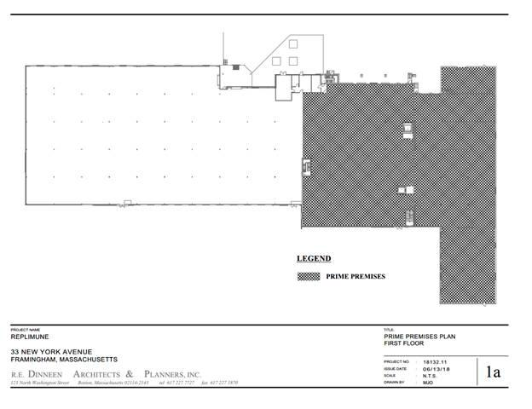

1

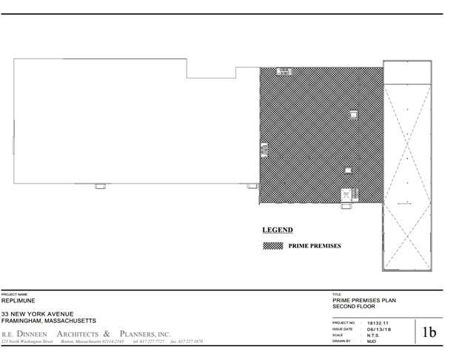

2

EXHIBIT 1B

PLAN OF LAND (SHOWING OUTDOOR PATIO, GENERATOR LOCATION

AND NITROGEN TANKS LOCATION)

1

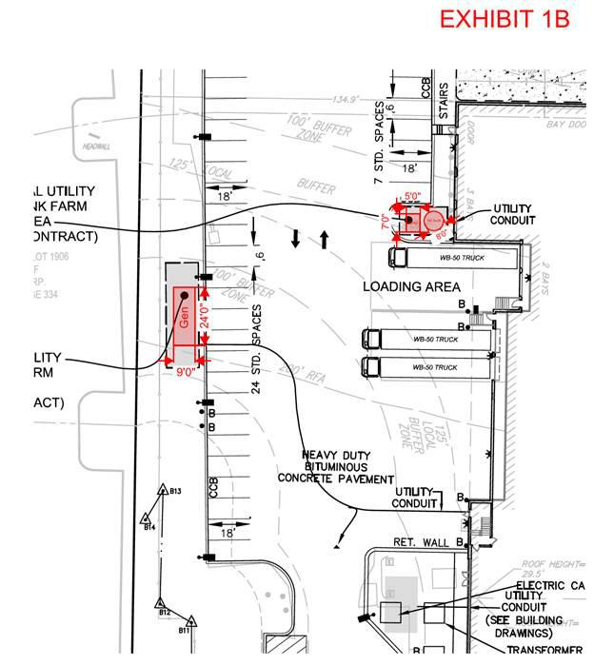

2

EXHIB IT 1C

PLAN OF ROOFTOP PREMISES
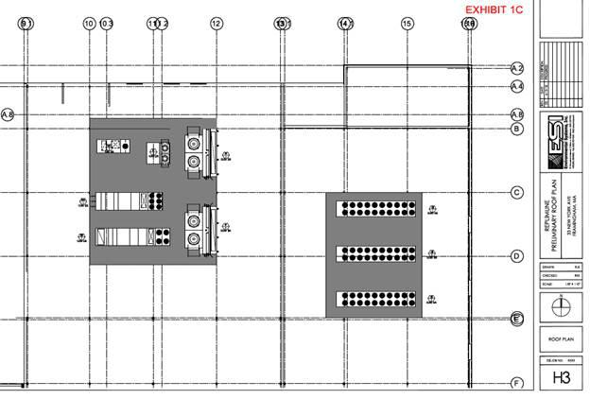

1

EXHIBIT 2

LEGAL DESCRIPTION

A certain parcel of land situated in Framingham, Middlesex County, Massachusetts, on the northerly side of New York Avenue being shown as Lot 25B on “Plan of Land in Framingham Mass. Owned by: Hendrie’s Inc. Dec. 29, 1977 Survey by: MacCarthy & Sullivan Engineering Inc.” which plan is recorded with the Middlesex South District Registry of Deeds in Book 13375, Page 284, said Lot 25B being bounded and more particularly described according to said plan as follows:

SOUTHERLY:

by New York Avenue in two lines together measuring, five hundred ninety two and 43/100 (592.43) feet;

WESTERLY:

by land now or formerly of Paramount Development Associates, Inc. as shown on said plan, seven hundred forty three and 01/100 (743.01) feet;

NORTHERLY:

by land of the Commonwealth of Massachusetts Metropolitan District Commission as shown on said plan, five hundred ninety two and 03/100 (592.03) feet; and

EASTERLY:

by Lot 25A as shown on said plan, seven hundred twenty four and 15/100 (724.15) feet.

Containing 10 acres according to said plan.

Together with the appurtenant sewer easement as described in Grant of Easement from Paramount Development Associates, Inc., dated April 13, 1978, recorded in Book 13424, Page 51.

1

EXHIBIT 3

INTENTIONALLY OMITTED

1

EXHIBIT 4A

DESIGN DEVELOPMENT PLANS AND LANDLORD’S TENANT IMPROVEMENT WORK

1

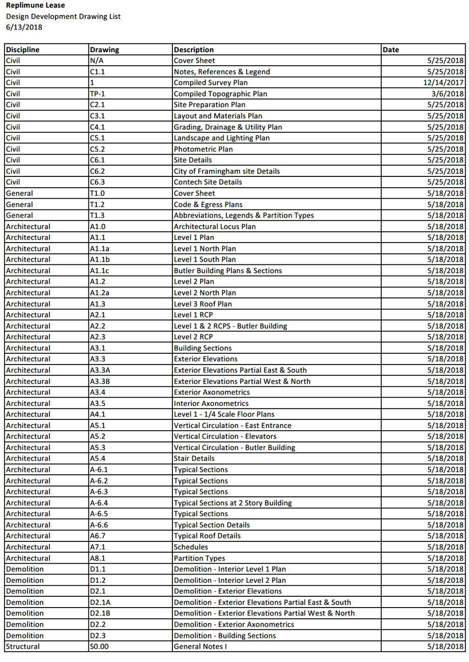

2

3

EXHIBIT 4B

BALANCE OF LANDLORD’S BASE BUILDING WORK

4
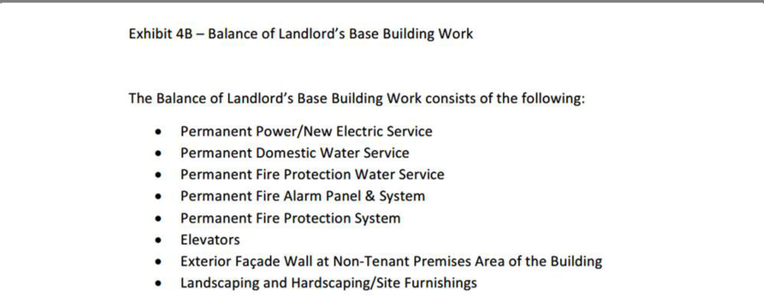

5


6

EXHIBIT 4D

PRE-APPROVED TENANT DESIGN TEAM

Landlord hereby approves the below-listed architect, contractors, and engineers in connection with the performance of Tenant’s Work:

· | Design Builder: | The Richmond Group
· | Architect: | RE Dineen Associates, Boston, MA
· | Code: | Code Red Associates, Framingham, MA
· | Process: | DPS Consulting, Framingham, MA
· | HVAC: | ESI Mechanical Contractors, North Attleboro, MA
· | Fire Protection: | Noremac Sprinkler Corporation, East Douglas, MA
· | Plumbing: | North Shore Mechanical Contractors, Topsfield, MA
· | Electrical: | Nappa Electrical Contractors, Burlington, MA
 |  | 7
 |  | EXHIBIT 4E
 |  | TENANT’S PROGRAM

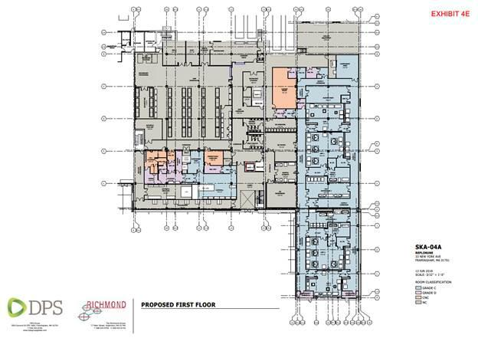

8
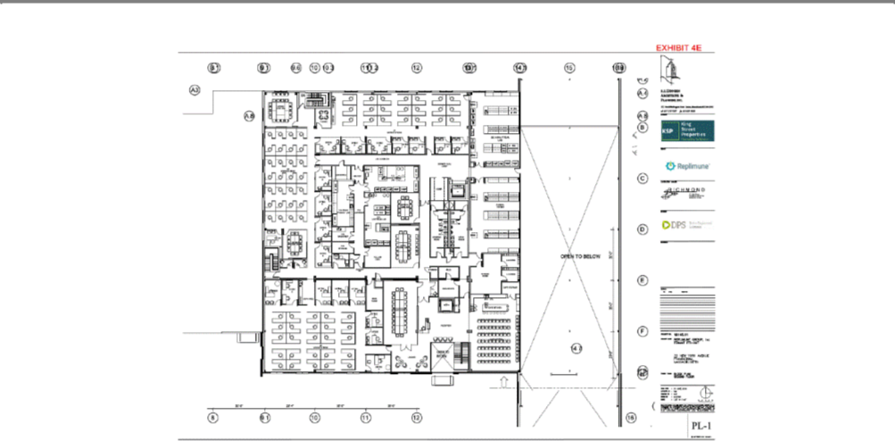

9

EXHIBIT 4F

TENANT’S WORK DESIGN SCHEDULE

10

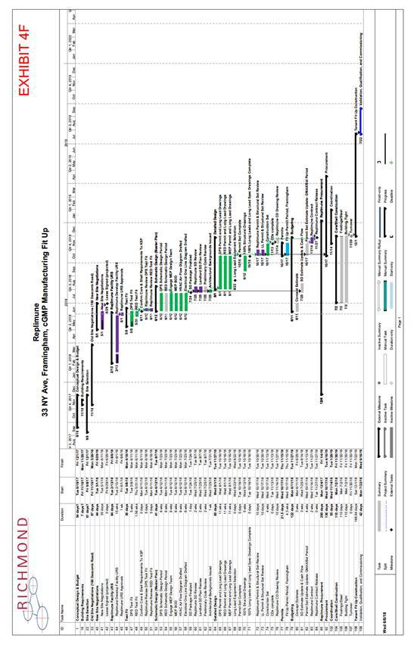

11

EXHIBIT 5

L/C DRAFT LANGUAGE

[To be replaced with final approved form of SVB LC]

IRREVOCABLE STANDBY LETTER OF CREDIT NUMBER

ISSUE DATE:

ISSUING BANK:

SILICON VALLEY BANK

3003 TASMAN DRIVE

2ND FLOOR, MAIL SORT HF210

SANTA CLARA, CALIFORNIA 95054

BENEFICIARY:

APPLICANT:

AMOUNT: US$ ( AND /100 U.S. DOLLARS)

EXPIRATION DATE:

LOCATION: SANTA CLARA, CALIFORNIA

DEAR SIR/MADAM:

WE HEREBY ESTABLISH OUR IRREVOCABLE STANDBY LETTER OF CREDIT NO. SVBSF IN YOUR FAVOR AVAILABLE BY YOUR DRAFTS DRAWN ON US AT SIGHT IN THE FORM OF EXHIBIT “A” ATTACHED AND ACCOMPANIED BY THE FOLLOWING DOCUMENTS:

- THE ORIGINAL OF THIS LETTER OF CREDIT AND ALL AMENDMENT(S), IF ANY.

- BENEFICIARY’S DATED STATEMENT SIGNED BY AN AUTHORIZED OFFICER/OFFICIAL CERTIFYING THAT THE BENEFICIARY IS ENTITLED TO DRAW UPON

THIS LETTER OF CREDIT (IN THE AMOUNT OF THE DRAFT SUBMITTED HEREWITH) PURSUANT TO THIS LEASE (THE “LEASE”) DATED |  | , 2018, BY
AND BETWEEN CRP/KING 33 NY AVE. OWNER, L.L.C., AS LANDLORD, AND | , AS TENANT, AND/OR ANY AMENDMENT TO THE LEASE OR
ANY OTHER AGREEMENT BETWEEN SUCH PARTIES RELATED TO THE LEASE.
1

PARTIAL DRAWS AND MULTIPLE PRESENTATIONS ARE ALLOWED.

THIS ORIGINAL LETTER OF CREDIT MUST ACCOMPANY ANY DRAWINGS HEREUNDER FOR ENDORSEMENT OF THE DRAWING AMOUNT AND WILL BE RETURNED TO THE BENEFICIARY UNLESS IT IS FULLY UTILIZED.

THIS LETTER OF CREDIT SHALL BE AUTOMATICALLY EXTENDED FOR AN ADDITIONAL PERIOD OF ONE YEAR, WITHOUT AMENDMENT, FROM THE PRESENT OR EACH FUTURE EXPIRATION DATE UNLESS AT LEAST 30 DAYS PRIOR TO THE THEN CURRENT EXPIRATION DATE WE SEND YOU A NOTICE BY REGISTERED MAIL OR OVERNIGHT COURIER SERVICE AT THE ABOVE ADDRESS THAT THIS LETTER OF CREDIT WILL NOT BE EXTENDED BEYOND THE CURRENT

EXPIRATION DATE. IN NO EVENT SHALL THIS LETTER OF CREDIT BE AUTOMATICALLY EXTENDED BEYOND .

THIS LETTER OF CREDIT IS TRANSFERABLE ONE OR MORE TIMES, BUT IN EACH INSTANCE ONLY TO A SINGLE BENEFICIARY AS TRANSFEREE AND ONLY UP TO THE THEN AVAILABLE AMOUNT, ASSUMING SUCH TRANSFER TO SUCH TRANSFEREE WOULD BE IN COMPLIANCE WITH THEN APPLICABLE LAW AND REGULATION, INCLUDING BUT NOT LIMITED TO THE REGULATIONS OF THE U. S. DEPARTMENT OF TREASURY AND U. S. DEPARTMENT OF COMMERCE. AT THE TIME OF TRANSFER, THE ORIGINAL LETTER OF CREDIT AND ORIGINAL AMENDMENT(S), IF ANY, MUST BE SURRENDERED TO US AT OUR ADDRESS INDICATED IN THIS LETTER OF CREDIT TOGETHER WITH OUR TRANSFER FORM ATTACHED HERETO AS EXHIBIT “B” DULY EXECUTED. THE CORRECTNESS OF THE SIGNATURE AND TITLE OF THE PERSON SIGNING THE TRANSFER FORM MUST BE VERIFIED BY BENEFICIARY’S BANK. APPLICANT SHALL PAY OUR TRANSFER FEE OF ¼ OF 1% OF THE TRANSFER AMOUNT (MINIMUM US$250.00) UNDER THIS LETTER OF CREDIT. HOWEVER, APPLICANT’S PAYMENT OF SUCH TRANSFER FEE SHALL NOT BE A CONDITION OF SUCH TRANSFER. EACH TRANSFER SHALL BE EVIDENCED BY OUR ENDORSEMENT ON THE REVERSE OF THE LETTER OF CREDIT AND WE SHALL FORWARD THE ORIGINAL OF THE LETTER OF CREDIT SO ENDORSED TO THE TRANSFEREE.

DRAFT(S) AND DOCUMENTS MUST INDICATE THE NUMBER AND DATE OF THIS LETTER OF CREDIT.

DOCUMENTS MUST BE FORWARDED TO US BY OVERNIGHT DELIVERY SERVICE TO: SILICON VALLEY BANK, 3003 TASMAN DRIVE, SANTA CLARA, CA 95054,

ATTN: INTERNATIONAL DIVISION.

WE HEREBY AGREE WITH THE BENEFICIARY THAT THE DRAFTS DRAWN UNDER AND IN ACCORDANCE WITH THE TERMS AND CONDITIONS OF THIS LETTER OF CREDIT SHALL BE DULY HONORED UPON PRESENTATION TO US ON OR BEFORE THE EXPIRATION DATE OF THIS LETTER OF CREDIT.

IF ANY INSTRUCTIONS ACCOMPANYING A DRAWING UNDER THIS LETTER OF CREDIT REQUEST THAT PAYMENT IS TO BE MADE BY TRANSFER TO YOUR ACCOUNT WITH ANOTHER BANK, WE WILL ONLY EFFECT SUCH PAYMENT BY FED WIRE TO A U.S. REGULATED BANK, AND WE AND/OR SUCH OTHER BANK MAY RELY ON AN ACCOUNT NUMBER SPECIFIED IN SUCH INSTRUCTIONS EVEN IF THE NUMBER IDENTIFIES A PERSON OR ENTITY DIFFERENT FROM THE INTENDED PAYEE.

2

THIS LETTER OF CREDIT IS SUBJECT TO THE INTERNATIONAL STANDBY PRACTICES (ISP98), INTERNATIONAL CHAMBER OF COMMERCE, PUBLICATION NO.

590.

 | AUTHORIZED SIGNATURE |  |  | AUTHORIZED SIGNATURE
IRREVOCABLE STANDBY LETTER OF CREDIT NUMBER
 |  | EXHIBIT “A”
DATE: |  |  |  | REF. NO.
AT SIGHT OF THIS DRAFT
PAY TO THE ORDER OF |  |  |  | US$

US DOLLARS

DRAWN UNDER SILICON VALLEY BANK, SANTA CLARA, CALIFORNIA, STANDBY LETTER OF CREDIT NUMBER NO.

DATED

TO: SILICON VALLEY BANK 3003 TASMAN DRIVE SANTA CLARA, CA 95054

(BENEFICIARY’S NAME)

Authorized Signature

GUIDELINES TO PREPARE THE DRAFT

- DATE: ISSUANCE DATE OF DRAFT.

- REF. NO.: BENEFICIARY’S REFERENCE NUMBER, IF ANY.

- PAY TO THE ORDER OF: NAME OF BENEFICIARY AS INDICATED IN THE L/C (MAKE SURE BENEFICIARY ENDORSES IT ON THE REVERSE SIDE).

- US$: AMOUNT OF DRAWING IN FIGURES.

- USDOLLARS: AMOUNT OF DRAWING IN WORDS.

3

- LETTER OF CREDIT NUMBER: SILICON VALLEY BANK’S STANDBY L/C NUMBER THAT PERTAINS TO THE DRAWING.

- DATED: ISSUANCE DATE OF THE STANDBY L/C.

- BENEFICIARY’S NAME: NAME OF BENEFICIARY AS INDICATED IN THE L/C.

- AUTHORIZED SIGNATURE: SIGNED BY AN AUTHORIZED SIGNER OF BENEFICIARY.

IF YOU HAVE QUESTIONS RELATED TO THIS STANDBY LETTER OF CREDIT PLEASE CONTACT US AT .

IRREVOCABLE STANDBY LETTER OF CREDIT NUMBER

EXHIBIT

TRANSFER FORM

DATE:
TO: | SILICON VALLEY BANK
 | 3003 TASMAN DRIVE |  | RE: IRREVOCABLE STANDBY LETTER OF CREDIT
 | SANTA CLARA, CA 95054 |  | NO. | ISSUED BY
 | ATTN:INTERNATIONAL DIVISION. |  |  | SILICON VALLEY BANK, SANTA CLARA
 | STANDBY LETTERS OF CREDIT |  | L/C AMOUNT:

GENTLEMEN:

FOR VALUE RECEIVED, THE UNDERSIGNED BENEFICIARY HEREBY IRREVOCABLY TRANSFERS TO:

(NAME OF TRANSFEREE)

(ADDRESS)

ALL RIGHTS OF THE UNDERSIGNED BENEFICIARY TO DRAW UNDER THE ABOVE LETTER OF CREDIT UP TO ITS AVAILABLE AMOUNT AS SHOWN ABOVE AS OF THE DATE OF THIS TRANSFER.

BY THIS TRANSFER, ALL RIGHTS OF THE UNDERSIGNED BENEFICIARY IN SUCH LETTER OF CREDIT ARE TRANSFERRED TO THE TRANSFEREE. TRANSFEREE SHALL HAVE THE SOLE RIGHTS AS BENEFICIARY THEREOF, INCLUDING SOLE RIGHTS RELATING TO ANY

4

AMENDMENTS, WHETHER INCREASES OR EXTENSIONS OR OTHER AMENDMENTS, AND WHETHER NOW EXISTING OR HEREAFTER MADE. ALL AMENDMENTS ARE TO BE ADVISED DIRECTLY TO THE TRANSFEREE WITHOUT NECESSITY OF ANY CONSENT OF OR NOTICE TO THE UNDERSIGNED BENEFICIARY.

THE ORIGINAL OF SUCH LETTER OF CREDIT IS RETURNED HEREWITH, AND WE ASK YOU TO ENDORSE THE TRANSFER ON THE REVERSE THEREOF, AND FORWARD IT DIRECTLY TO THE TRANSFEREE WITH YOUR CUSTOMARY NOTICE OF TRANSFER.

SINCERELY,

(BENEFICIARY’S NAME)

(SIGNATURE OF BENEFICIARY)

(NAME AND TITLE)

SIGNATURE AUTHENTICATED

The name(s), title(s), and signature(s) conform to that/those on file with us for the company and the signature(s) is/are authorized to execute this instrument.

We further confirm that the company has been identified applying the appropriate due diligence and enhanced due diligence as required by BSA and all its subsequent amendments.

(Name of Bank)

(Address of Bank)

(City, State, ZIP Code)

(Authorized Name and Title)

(Authorized Signature)

(Telephone number)

5

EXHIBIT 6

LANDLORD’S SERVICES

- Electricity and lighting for Common Areas

- Management and administrative services

- Landscaping and grounds maintenance

- Cleaning of Common Areas

- HVAC to Common Areas in customary amounts for similar first-class office and laboratory buildings

- Snow and ice removal for roofs, walks, drives and parking areas

- Provide connections to fire protection and life safety system

- Electrical service to the Building not less than 4,000 Amp - 480/277V, 3-phase, 4 wire, of which Tenant shall have 3,000 amps

- Gas service via a 2” natural gas line from the street

- Municipal water service via (i) 4” domestic water service main to the Building and (ii) 8” fire protection service to the Building

All of Landlord’s services shall be provided in a manner consistent with similar services in comparable first class office and laboratory buildings in the area.

1

EXHIBIT 7

TENANT’S HAZARDOUS MATERIALS

The following Hazardous Materials will be used at the Premises, each stored in quantities not to exceed the amount allowable in applicable control areas by the state building code:

- Sodium Hydroxide (Wastewater Neutralization System)

- Sulfuric Acid (Wastewater Neutralization System)

- Hydrochloric acid

- Isopropyl Alcohol (Cleaning / Sanitization Chemical)

- SporKlenz (Cleaning / Sanitization Chemical)

- Vesphene & LpH (or similar for Cleaning / Sanitization)

- Ethanol (for column storage)

- Sodium Hypochlorite (inactivating bulk liquids and room sanitization)

- Methanol

- Hydrogen peroxide (Cleaning / Sanitization Chemical)

- Gases stored at the site; CO2, N2, O2 and LN2.

- Biological Hazards cat 2 recombinant viruses

1

EXHIBIT 8

RULES AND REGULATIONS

- General

  - Tenant and its employees shall not in any way obstruct the sidewalks, halls, stairways, or exterior vestibules of the Building, and shall use the same only as a means of passage to and from their respective offices. At no time shall Tenants permit its employees, contractors, or other representatives to loiter in Common Areas or elsewhere in and about the Property.

  - Corridor doors, when not in use, shall be kept closed.

  - Areas used in common by tenants shall be subject to such reasonable regulations as are posted therein.

  - Any Tenant or vendor sponsored activity or event in any Common Area must be approved and scheduled through Landlord’s representative, which approval shall not be unreasonably withheld.

  - No animals, except Seeing Eye dogs, shall be brought into or kept in, on or about the Premises or Common Areas.

  - Alcoholic beverages (without Landlord’s prior written consent), illegal drugs or other illegal controlled substances are not permitted in the Common Areas, nor will any person under the influence of the same be permitted in the Common Areas. Landlord reserves the right to exclude or expel from the Building any persons who, in the judgment of the Landlord, is under the influence of alcohol or drugs, or shall do any act in violation of the rules and regulations of the Building.

  - No firearms or other weapons are permitted in the Common Areas.

  - No fighting or “horseplay” will be tolerated at any time in the Common Areas.

  - Tenant shall not cause any unnecessary janitorial labor or services in the Common Areas by reason of Tenant’s carelessness or indifference in the preservation of good order and cleanliness.

  - Smoking and discarding of smoking materials by Tenant and/or any Tenant Party is permitted only in exterior locations designated by Landlord. Tenant will instruct and notify its employees and visitors of such policy.

  - Bicycles and other vehicles are not permitted inside or on the walkways outside the Building, except in those areas specifically designated by Landlord for such purposes

  - Tenant shall not operate or permit to be operated on the Premises any coin or token operated vending machine or similar device (including, without limitation, telephones, lockers, toilets, scales, amusement devices and machines for sale of beverages food, candy, cigarettes or other goods), except for those vending machines or similar devices which are for the sole and exclusive use of tenant’s employees.

  - Canvassing, soliciting, and peddling in or about the Building is prohibited. Tenant, its employees, agents and contractors shall cooperate with said policy, and Tenant shall cooperate and use best efforts to prevent the same by Tenant’s invitees.

  - Fire protection and prevention practices implemented by the Landlord from time to time in the Common Areas, including participation in fire drills, must be observed by Tenant

1

at all times.

  - Except as provided for in the Lease, no signs, advertisements or notices shall be painted or affixed on or to any windows, doors or other parts of the Building that are visible from the exterior of the Building unless approved in writing by the Landlord.

  - The restroom fixtures shall be used only for the purpose for which they were constructed and no rubbish, ashes, or other substances of any kind shall be thrown into them. Tenant will bear the expense of any damage resulting from misuse.

  - Tenant shall utilize a pest control service reasonably approved by Landlord to control pests in the Premises. Except as included in Landlord’s Services, tenants shall bear the cost and expense of such pest control services.

  - Tenant shall not install, operate or maintain in the Premises or in any other area of the Building, any electrical equipment which does not bear the U/L (Underwriters Laboratories) seal of approval, or which would overload the electrical system or any part thereof beyond its capacity for proper, efficient and safe operation as determined by Landlord, taking into consideration the overall electrical system and the present and future requirements of the Building.

  - Tenants shall not perform improvements or alterations within the Building or their Premises, if the work has the potential of disturbing the fireproofing which has been applied on the surfaces of structural steel members, without the prior written consent of Landlord, subject to the provisions of the Lease.

  - Tenants shall manage its waste removal program, at its sole cost and expense, keeping any recyclables, garbage, trash, rubbish and refuse in vermin- proof containers for Tenants sole use within the Landlord designated area until removed.

  - Lab operators who travel outside lab space must abide by the one glove rule and remove lab coats where predetermined.

  - Chemical lists and MSDS sheets must be readily available at the entrance to each lab area. In the event of an emergency, first responders will require this information in order to properly evaluate the situation.

  - Tenant shall provide Landlord, in writing, the names and contact information of two (2) representatives authorized by Tenant to request Landlord services, either billable or non-billable and to act as a liaison for matters related to the Premises.

- Access & Security

  - Tenant shall not place any additional lock or locks on any exterior door in the Premises or Building or on any door in the Building core within the Premises, including doors providing access to the telephone and electric closets and the slop sink, without Landlord’s prior written consent. A reasonable number of keys to the locks on the doors in the Premises shall be furnished by Landlord to Tenant at the cost of Tenant, and Tenant shall not have any duplicate keys made. All keys shall be returned to Landlord at the expiration or earlier termination of this Lease.

  - Landlord may from time to time adopt appropriate systems and procedures for the security or safety of the Building, its occupants, entry and use, or its contents, provided that Tenant shall have access to the Building 24 hours per day, 7 days a week. Tenant, Tenant’s agents, employees, contractors, guests and invitees shall comply with Landlord’s reasonable requirements relative thereto. Tenant acknowledges that Property security problems may occur which may require the employment of extreme security

2

measures in the day-to-day operation of the Common Areas. Accordingly, Tenant agrees to cooperate and cause its employees, contractors, and other representatives to cooperate fully with Landlord in the implementation of any reasonable security procedures concerning the Common Areas.

  - Tenant and its employees, agents, contractors, invitees and licensees are limited to the Premises and the Common Areas. Tenants and its employees, agents, contractors, invitees and licensees may not enter other areas of the Project (other than the Common Areas) except when accompanied by an escort from the Landlord.

C. Shipping/Receiving

  - Dock areas for the Building shall not be used for storage or staging by Tenant.

  - In no case shall any truck or trailer be permitted to remain in a loading dock area for more than forty-eight (48) hours.

  - There shall not be used in any Common Area, either by Tenant or by delivery personnel or others, in the delivery or receipt of merchandise, any hand trucks, except those equipped with rubber tires and sole guards.

  - Lab operators carrying any lab related materials may only travel within the Premises. At no time should any lab materials travel in the Common Areas.

  - Any dry ice brought into the building must be delivered through the loading dock serving the Premises.

  - All nitrogen tanks must travel through the loading dock serving the Premises and should never be left unattended outside of the Premises.

3

CONTRACTOR

RULES AND REGULATIONS

Construction/Remodeling

Lincoln Property Company’s construction work procedure is designed to provide efficient scheduling of work while protecting other tenants from unnecessary noise and inconvenience.

The Lincoln Property Company Construction Rules and Regulations; Hot Work Protocol and Hot Work Checklist attached to this document contain detailed information to assist you and your General Contractor in planning construction projects. Please review it carefully before design begins.

Please note that the summary below highlights key aspects of the Detailed Construction Rules and Regulations for your convenience and does not supersede it in any way.

Summary:

Before starting a project — contact the Lincoln Property Company Management Office at (781) 890-9800. The Property Manager will be happy to assist you in completing your project efficiently.

Use reasonable efforts to incorporate the provisions of the attached document into all of your agreements and contracts. You will need written approval from the Property Manager before contracting any work to the extent provided in the Lease.

Before construction provide two (2) sets of drawings and plans to the Property Manager for approval. The Property Manager must also approve your list of contractors and subcontractors to the extent provided in the Lease.

Schedule a pre-construction meeting with the Property Management Team. Meeting materials should include detailed schedules; addresses and telephone numbers of supervisors, contractors and subcontractors: copies of permits; proof of current insurance (including all subcontractor); payment, performance and lien bonds where applicable; and notice of any contractor’s involvement in a labor dispute.

We expect all contractors to maintain safe and orderly conditions, labor harmony, and proper handling of any hazardous materials. MSDS sheets must be supplied to the management office. We may stop any work that does not meet the conditions outlined in the attached document.

Before occupying the completed space, submit the final certificate of occupancy (to the extent available in light of other work in the building) and any other approvals to the Property Manager. We also require an air balancing report signed by a professional engineer and “as built” set of drawings in AutoCAD format on disk and one (1) hard copy showing all of the work in full detail where such work is susceptible to as built plans.

Detailed Construction Rules and Regulations:

The following Rules and Regulations have been established by Lincoln Property Company (LPC) and shall be adhered to by all contractors/vendors working the Premises. Building management shall reserve the right to have any individual(s) or company removed from the building for any violation of these provisions.

4

Building Management:

Lincoln Property Company (LPC)

Property Manager:

Wendy Pierce, 617-674-9841

Regular Business Hours:

Monday through Friday -

8:00 a.m. to 6:00 p.m.

- General:

  - This document will be an Exhibit for all construction contracts for work at this property.

  - No construction or alterations of the property may be started without the prior approval of LPC subject to the terms of the Lease. Prior to the requested start of work, the contractor must submit to LPC a full set of stamped architectural drawings for approval, reflecting the full and complete scope of the project.

  - LPC requires copies of certificates of insurance for all contractors working inside the building per the buildings insurance requirements.

  - LPC requires that the general contractor provide a project superintendent licensed by the Department of Public Safety and hold a current license designation of “Licensed Construction Supervisor”. The project superintendent shall be on site every day when construction activities are in progress and on site for all after hours work.

  - Prior to the commencement and upon completion of each project, LPC and the contractor will walk-through the public areas, i.e., restrooms, common corridors, stairwells, etc. Any prior damage will be noted. Any subsequent damage to the surrounding areas will be the responsibility of the general contractor to repair.

  - The contractor is responsible for filing and obtaining all required local building, fire and/or utility permits, as applicable, prior to the commencement of any work and must be licensed or certified to perform all work where specified or required by law. The contractor shall comply with all inspectional services and fire department requirements related to the issuance of the building permits and shall display the building permit and inspection records as required by building code. Where applicable, permits are to be posted as directed by LPC.

  - The contractor shall not borrow any materials, i.e., tools, extension cords, dollies, ladders, etc., from the maintenance department. The contractor is not allowed access to the maintenance shop or storage closets. Prior authorization, which shall not be unreasonably withheld, is required from LPC for access to any electric, plumbing, telephone or HVAC closets. Should access be permitted, the contractor will be responsible for any damage.

  - All work undertaken by contractors on site must be performed in accordance with safety standards, which include, but are not limited to, compliance with Occupational Safety and Health Administration (OSHA). Contractor’s safety procedures may exceed OSHA standards but in no case shall they fail to meet these minimum requirements.

5

  - All accidents, disturbances, labor disputes or threats thereof, and other noteworthy events pertaining to the building or a tenant’s property shall be reported to LPC. A written report must follow within 24 hours.

- Building Permits & Certificates of Occupancy

  - A copy of the building permit, if one is required by law, must be delivered to LPC prior the start of any construction project and the permit card must be posted on the construction site in full view at all times.

  - A copy of the fully executed building permit, showing all final inspection sign-offs must be delivered to LPC prior to the receipt of the certificate of occupancy, if one is required by law.

  - Any original certificate of occupancy must be delivered to LPC as soon as it is issued.

- Building Standards

  - All materials and MEP equipment shall conform to the approved plans.

  - All window blind systems shall be reasonably approved by Landlord to be consistent with existing blind systems.

- Construction Work Rules

  - The general contractor will be responsible for providing fire extinguishers throughout the construction area. There should be one fire extinguisher every seventy-five feet within the construction area. Base building fire extinguishers may not be removed from stairwell cabinets for construction purposes.

- The contractor must remove an exterior window and install a painted plywood panel that will allow dust control by a contractor-provided HEPA filter unit. The window will be installed in an area that will not affect the construction or new interior walls. The general contractor will provide an electrical outlet for the HEPA filter unit. The general contractor will be responsible to clean any spaces in the building that become contaminated with construction dust. The HEPA filter will be operational 24/7 during the construction project.

- Work shall be scheduled in accordance with the Lease. No new construction work shall take place or other trades be permitted access to the construction area until the construction area is completely demolished. All debris is to be removed daily.

- All construction involving high levels of noise, including, but not limited to, coring, drilling, ram setting, shooting of floor track or ceiling track must be performed between the hours of 6:00 p.m. and 7:30 a.m. Monday through Friday or anytime on a scheduled weekend.

- All spray painting and staining is to be performed after normal business hours and is to be coordinated with LPC to ensure proper ventilation if determined that this work will impact the other tenants in the building. Large spray areas (3,000 sf plus) must be done on a Saturday to provide at least two days of ventilation. All oil base painting must be performed over a weekend period.

6

  - All work requiring the shutdown associated with electrical, mechanical, sprinkler or plumbing work outside the Premises shall be supervised by a representative of LPC, the cost of which shall be charged directly to Tenant at the prevailing building rate.

  - If work is required to be performed in adjacent tenant space, this work shall be performed after normal business hours and shall be supervised by a building engineer. The LPC engineer’s cost will be a Tenant expense.

  - The contractor shall provide a workbox and pull strings for telephone work. Tel/data work is by the tenant’s contractor.

  - All contractors working in the building are required to provide their own ladders with a rubber shoe on each leg. Ladders shall be certified to meet OSHA and ANSI standards. All push carts and dumpsters shall have rubber tires to reduce the construction noise.

  - The general contractor’s vacuums shall have filters in place and be in good working condition.

  - The contractor shall install temporary partitions (sheet rock) for security purposes and site protection in any public corridor where doors are being relocated or moved. Temporary access doors for construction areas connecting with a public corridor will be building standard, i.e., door, frame, hardware and lockset, with a copy of the key to be furnished to LPC.

  - No building entry, suite entry, stairwell or any other applicable common area of building closet doors are to be propped open under any circumstance.

  - The general contractor shall inform LPC in advance if there will be any odor producing construction work, i.e., IDEA wall paint or floor adhesives. The contractor will inform LPC if high VOC products are being utilized. 113 Hartwell Avenue promotes green practices and all materials shall be low VOC. LPC reserves the right to stop this work if the work creates a disturbance to other building tenants.

- Safety and Protection of Property

  - Contractors shall police ongoing construction operations and activities at all times, keeping the premises orderly, maintaining cleanliness in and about the premises, and ensuring safety and protection of all areas, including loading docks, elevators, lobbies and all other public areas which are used for access to the premises.

  - Construction materials shall only be stored in the premises where they are to be installed. No storage of materials will be permitted in any public areas, loading docks or corridors leading to the premises, nor in any mechanical rooms, electrical rooms, etc. Materials left in unauthorized areas may be disposed of by LPC.

  - LPC assumes no responsibility for tools, materials or equipment stored at the building.

  - Contractors shall provide adequate protection to all carpets, wall surfaces, doors and trim in all public areas through which materials are transported. Contractors shall continuously clean such areas. Protective measures shall include runners over carpet, padding in elevators and any other

7

measures determined by LPC. Any damage to existing walls, carpets, doors or trim during construction shall be repaired by the contractor to the satisfaction of LPC.

- Parking

Tenant shall not permit any parking in the loading docks serving other tenants of the Building. Tenant acknowledges that Landlord may enforce the carpool and handicapped parking designations, including the right to have violating vehicles towed at the expense of the owner of such vehicles.

- Conduct

  - While in or about the building, all contractors shall perform in a dignified, quiet, courteous and professional manner at all times. Contractors shall wear clothing suitable for their work and shall remain fully attired at all times.

  - No smoking is allowed in the building. Smoking is permitted only in designated outdoor areas at a minimum of 25 feet away from any public entrances. At no time is smoking permitted in the loading dock, stairwells, basement, within the construction area or any other area within the building.

  - The use of alcohol, narcotics and/or controlled substances is strictly prohibited on site, as well as firearms, ammunition, cameras, and any recording devices. Any contractor or their employee found in violation of these regulations will be asked to leave the building.

  - Radios are not permitted on the work site.

- MEP Work Rules

  - All MEP work shall comply with requirements of local building code, building department, building management rules and regulations and all authorities having jurisdiction. The contractor is to inform the engineer of record and LPC of any existing work or materials which violate any of the above laws and regulations. Any work done by the contractor causing such violation shall be corrected at the contractor’s expense.

  - All work performed shall be in accordance with the latest version of NEPA, NEC, NESC and with all applicable state and local codes.

  - The contractor shall perform all city inspections as required and obtain all equipment use permits as required by state and local authorities. Permits shall be turned over to LPC at job completion.

- Fire Protection Work

  - The contractor shall provide LPC with a copy of the sprinkler permit prior to the commencement of any work.

  - Sprinkler heads can be relocated during normal business hours if approved by the Framingham Fire Department and Building Inspector. The contractor shall schedule the drain down with LPC at least 24 hours in advance and will provide LPC with the time for the system fill, so that it can be scheduled with the building’s fire alarm contractor.

8

  - The contractor must be on site before any impairment to the system is made.

  - The sprinkler systems must be restored to full service by the end of the business day. Sprinklers shall not be left impaired overnight.

  - The contractor shall inspect the system for any leaks and remain on site until the system has full operating pressure and the fire alarm panel is free from any trouble conditions.

- Fire Alarm Work

  - The building’s fire alarm contractor is BEF Alarms. The general contractor’s electrical contractor can install the fire alarm devices and branch wiring, but all final wiring, programming of the FA panel and City of Framingham testing shall be performed and coordinated by the building’s fire alarm contractor. The building’s fire alarm contractor should be a subcontractor to the project’s electrical contractor. All fire alarm system testing is to be performed after normal business hours.

- Loading Dock

  - All material deliveries must be made through the loading dock and must be transported directly to the job site. The contactor may not use the passenger elevators for the transportation of materials at any time.

  - All vehicles are to be removed from the dock as soon as the delivery is complete. Unattended vehicles will be towed at the contractor’s expense.

- Salvage and Waste Removal

  - The contractor is responsible for disposing of all construction debris. The building’s trash/recycling compactor is not available. The contractor must make arrangements with LPC for the scheduling and location of all dumpsters. The contractor is to place protection board under the dumpster and is responsible for any damage to the loading dock’s deck. The loading dock floor is to be swept and washed by the contractor at the completion of each shift.

9

*LPC Hot Work Protocol for construction renovation or building repairs dated October 26, 2010 below. This HW protocol is to be followed by all contractors working on the Premises.

LINCOLN PROPERTY COMPANY

HOT WORK PROTOCOL

CONSTRUCTION RENOVATIONS AND BUILDING REPAIRS

Definition:

Hot work is any work activity that generates a flame, heat or sparks such as soldering, brazing, welding, or torch cutting and grinding.

Before any hot work shall commence the following Fire Safety Precautions must be taken:

- Notification

Notify building management, in writing, 72 hours in advance of the location and purpose of planned hot work in the facility. Any heavy hot work, such as structural work or confined space welding, shall take place after normal business hours. Refer to the building’s rules and regulations for the defined normal business hours.

- Permit

Provide building management with a copy of the hot work permit from the local authority.

- Sprinkler and Fire Alarm System Impairment

The sprinkler system in the area of the hot work shall not be impaired during the hot work time period. The fire alarm system may only be impaired or zoned out in the area of the hot work with express permission of the local authority.

- Fire Watch

A designated person from the local fire department authority shall be present during all hot work. The person performing the fire watch shall be completely informed of the work to be undertaken and be in radio or telecommunications contact with the local fire station.

- Hot Work Area Condition & Preparation

Floors are to be swept clean. Any accumulation of dust shall be removed. Combustible materials shall be removed from the area of hot work and the hot work area shall be properly ventilated. Hot work is not to be conducted in the presence of flammable gases, vapors, liquids or dusts. If hot work is to be performed in a confined area atmospheric testing shall be performed prior to and during the hot work procedure to ensure the work site atmosphere is below the low explosive limit.

10

- Person(s) Conducting Hot Work

The person conducting hot work shall be certified, fully trained and competent in use of the equipment and wear the appropriate personal protective equipment.

- Fire Fighting Equipment & Site Preparation

Fire extinguishers shall be present and within reach during all hot work. The person conducting hot work and fire watch personnel shall be informed of the location and have access to all fire-fighting equipment. Shields are to be erected where electric welding is to take place to prevent ultra-violet light exposure to others in the area. Floor or wall openings located 10 feet or less from the work site are to be covered to prevent hot sparks from entering walls or shafts and falling to floors below.

- Fire Watch Standby

Fire watch personnel shall remain on site 20 minutes after hot work has been completed. Notification shall be sent to the local authorities after hot work is completed. Fire alarm system point zoning shall be restored to active condition after work area is ventilated.

11

LINCOLN PROPERTY COMPANY

Hot Work Protocol

Check List

- Contractor Compliance

Is contractor in compliance with LPC protocol?

- Type of hot work

Welding, cutting, grinding-soldering, structural

- Location of hot work

- Date and time to be performed

- Permit provided to LPC

- Certificate of Insurance for all contractors and subcontractors presented to building management

- Is a fire watch required by local authority?

- Any fire protection sprinklers impaired?

- Fire alarm system to be temporarily zoned out in work area

- Work area free of combustible equipment?

- Work area properly ventilated prior to and during hot work

- All floor and wall openings covered and protected to prevent sparks and slag from traveling to other unprotected shafts and voids to the floor below

- Portable fire extinguisher onsite and fully charged

- Person(s) onsite performing hot work are qualified and have proper protective clothing and face shields

- Person conducting fire watch from local authority is on site and is in telecommunication contact with fire chief on duty

12

EXHIBIT 9

FORM OF NOTICE OF LEASE

Notice is hereby given pursuant to Chapter 183, Section 4 of the General Laws, of a lease upon the following terms:

Landlord:
Tenant:
Date of Lease Execution: | , 2018.
Premises: | . The land on which the Premises are located is more particularly described on Exhibit A attached hereto and incorporated herein.
Term Commencement Date:
Additional Rent Commencement Date:
Base Rent Commencement Date:
Term: | The period commencing as of the Term Commencement Date and expiring approximately ten (10) years following the Base Rent
 | Commencement Date. It is estimated that the Term Commencement Date will occur on or about |  |  |  | , the Additional Rent
 | Commencement Date will occur on or about |  | , the Base Rent Commencement Date will occur on or about |  |  | , and the Term will
 | expire on or about | , 20 .
Extension Options: | Two (2) extension options of five (5) years each.
Right of First Offer | Subject to the terms and conditions of the Lease, Tenant has a Right of First Offer to lease any portion of the Building outside of the
 | Premises.

This Notice of Lease has been executed merely to give notice of the Lease, and all of the terms, conditions and covenants thereof which are incorporated herein by reference. The parties hereto do not intend this Notice of Lease to modify or amend the terms, conditions and covenants of the Lease.

1

 | Executed as an instrument under seal this day of |  | , 20 .
LANDLORD: |  |  | TENANT:
CRP/KING 33 NY AVE. OWNER, L.L.C., |  |  | REPLIMUNE GROUP, INC.,
Delaware limited liability company |  |  | a Delaware corporation
By: | CRP/King 33 NY Ave. Venture, L.L.C.,
 | its sole member |  | By:
 |  |  | Name:
 | By: | King Jackson LLC, its administrative member | Title:

By: King Street Properties Investments LLC, its manager

By:

Name:

Title:

[ADD NOTARY BLOCKS]

2

EXHIBIT 10

SIGNAGE GUIDELINES
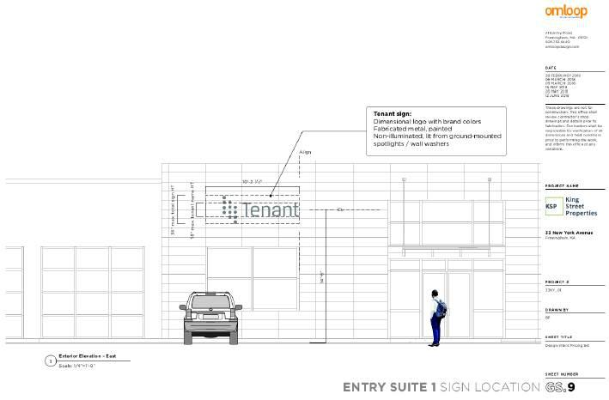

1

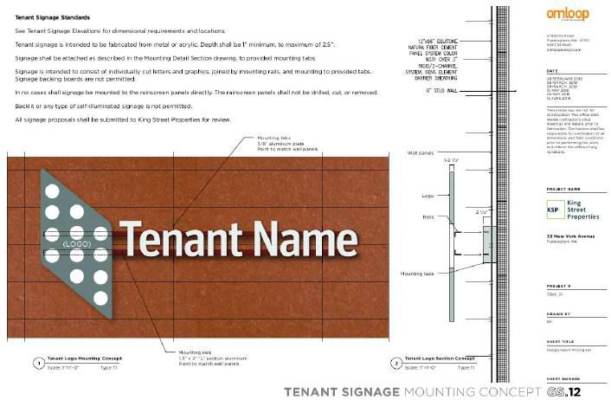

2

EXHIBIT 11

MATTERS OF RECORD

and easements as set forth in Deed dated March 6, 1970 and recorded with said Deeds in Book 11808, Page 638. Limited to only the following matters:

  - 30’ Wide Drain Easement as referenced in paragraph “(b)” of said Deeds and as depicted on a certain “Plan of Land in Framingham Mass.” dated February 19, 1970 prepared by MacCarthy Engineering Service, Inc. recorded with said Deeds.

  - Intentionally omitted.

  - The following matters noted in a certain Confirmation from the Land Court recorded in Book 10263, Page 558:

i.Agreement dated March 14, 1961 between the Town of Framingham and Cerel-Perini Associates Inc. recorded with said Deeds in Book 9863, Page 494, as affected by Release by the Framingham Board of Public Works, dated March 10, 1970, recorded in Book 11808, Page 637. NOTE: The Company insures against any assessments against the property pursuant to this agreement being due and payable at Date of Policy.

- Subject to sewer easement dated April 13, 1978 and recorded with said Deeds in Book 13424, Page 051. (affects appurtenant easement only)

- Order of Conditions by Framingham Conservation Commission dated March 2, 1988 and recorded with said Deeds in Book 19001, Page 267, as affected by Certificate of Compliance recorded on March 31, 1995 in Book 25261, Page 561.

- Easement to New England Telephone and Telegraph Company dated December 7, 1977, recorded at Book 13352, Page 343.

- Order of Conditions from Framingham Conservation Commission (MassDEP No. 158-1444) recorded in Book 70673, Page 347. [Tyson to confirm if this was closed out]

- Covenant for Operations and Maintenance Plan with attached Stormwater Operation & Maintenance Plan recorded on March 1, 2018 in Book 70686, Page 122.

1

EXHIBIT 12

FORM OF SNDA

SUBORDINATION, NON-DISTURBANCE AND

ATTORNMENT AGREEMENT

This Subordination, Non-Disturbance and Attornment Agreement (hereinafter, the “Agreement”) is made this day of , 2018, by and among CRP/KING 33 NY AVE.

OWNER, LLC (hereinafter, the “Landlord” or “Borrower”), with an address of c/o King Street Properties, 800 Boylston Street, Suite 1570, Boston, MA 02199, REPLIMUNE, INC.

(hereinafter, the “Tenant”), with an address of 18 Commerce Way, Suite 4800, Woburn, MA 01801, and , a (hereinafter, the “Mortgagee”), with a principal place of business at .

Introductory Provisions

- Mortgagee is relying on this Agreement as an inducement to Mortgagee in making and maintaining a loan (hereinafter, the “Loan”) secured by, among other things, a Mortgage and Security Agreement dated as of February 27, 2018, and filed with the Middlesex County (Southern District) Registry of Deeds in Book 70673, Page 371 (hereinafter, the “Mortgage”) given by Borrower covering property commonly known as and numbered 33 New York Avenue, Framingham, Middlesex County, Massachusetts (hereinafter, the “Property”).

B. Tenant is the holder of and tenant under that certain lease (hereinafter, as it may be amended, the “Lease”) dated June , 2018, made with Landlord, covering certain premises (hereinafter, as it may be modified from time to time, the “Demised Premises”) at the Property.

- Mortgagee requires, as a condition to the making and maintaining of the Loan, that the Mortgage be and remain superior to the Lease.

- Tenant requires, as a condition to the Lease being subordinate to the Mortgage, that its rights under the Lease be recognized.

- Mortgagee, Landlord, and Tenant desire to confirm their understanding with respect to the Mortgage and the Lease.

NOW, THEREFORE, in consideration of the foregoing, the mutual covenants and agreements contained herein, and other valuable consideration, the receipt and adequacy of which are hereby acknowledged, and with the understanding by Tenant that Mortgagee will rely hereon in making and maintaining the Loan, Mortgagee, Landlord, and Tenant agree as follows:

1

- The Lease is subordinate to the lien of the Mortgage and any renewal, substitution, extension or replacement thereof and each advance made thereunder as though said Mortgage, and each such renewal, substitution, extension or replacement were executed, recorded and the advance made before the execution of the Lease.

- So long as Tenant is not in default (beyond any period expressed in the Lease within which Tenant may cure such default) in the payment of rent or in the performance or observance of any of the terms, covenants or conditions of the Lease on Tenant’s part to be performed or observed, (i) Tenant’s occupancy of the Demised Premises shall not be disturbed by Mortgagee, nor will Tenant’s rights under the Lease be impaired (except as expressly provided in this Agreement), in the exercise of any of its rights under the Mortgage during the term of the Lease or any extension or renewal thereof, made in accordance with the terms of the Lease, and (ii) Mortgagee will not join Tenant as a party defendant in any action or proceeding for the purpose of terminating Tenant’s interest and estate under the Lease because of any default under the Mortgage.

- In the event any proceedings are brought for the foreclosure of the Mortgage, or if the Property or the Demised Premises are sold pursuant to the power of sale under the Mortgage, Tenant shall attorn to the purchaser upon any such foreclosure sale and shall recognize such purchaser thereafter as the Landlord under the Lease. Such attornment shall be effective and self-operative without the execution of any further instrument on the part of any of the parties hereto. Tenant agrees, however, to execute and deliver at any time and from time to time, upon the request of any holder(s) of any of the indebtedness or other obligations secured by the Mortgage, or upon request of any such purchaser, (a) any reasonable instrument or certificate which, in the reasonable judgment of such holder(s), or such purchaser, may be necessary or appropriate in any such foreclosure proceeding or otherwise to evidence such attornment on the terms and conditions set forth in this Agreement, and (b) on the conditions set forth in the Lease applicable to estoppel certificates, an estoppel certificate regarding the status of the Lease, consisting of statements, if true (and if not true, specifying in what respect), (i) that the Lease is in full force and effect, (ii) the date through which rentals have been paid, (iii) the duration and date of the commencement of the term of the Lease, (iv) the nature of any amendments or modifications to the Lease, and (v) that to the best of Tenant’s knowledge, no default, or state of facts, which with the passage of time, or notice, or both, would constitute a default, exists on the part of either party to the Lease.

- If Mortgagee shall succeed to the interest of Landlord under the Lease in any manner, or if any purchaser acquires the Property, or the Demised Premises, upon any foreclosure of the Mortgage, Mortgagee or such purchaser, as the case may be, shall have the same remedies by entry, action or otherwise in the event of any default by Tenant (beyond any period expressed in the Lease within which Tenant may cure such default) in the payment of rent or in the performance or observance of any of the terms, covenants and conditions of the Lease on Tenant’s part to be performed or observed that the Landlord had or would have had if Mortgagee or such purchaser had not succeeded to the interest of the present Landlord. From and after any such succession, Mortgagee or such purchaser shall be bound to Tenant under all the terms, covenants and conditions of the Lease, and Tenant shall have the same remedies against Mortgagee, or such purchaser, for the breach of an agreement contained in the Lease that Tenant might have had under the Lease against Landlord if Mortgagee or such purchaser had not succeeded to the interest of Landlord; provided, however, that Mortgagee or such purchaser shall only be bound during the period of its ownership, all Tenant claims shall be satisfied only out of the interest, if any, of Mortgagee or such purchaser in the Property and the proceeds therefrom, and Mortgagee and such purchaser shall not be (a) liable for any act or omission of any prior landlord (including the Landlord) provided, that, nothing in this clause (a) being deemed to relieve Mortgagee or any such purchaser of its continuing obligations as landlord under the Lease with respect to the period from and after the date of such succession; or (b) liable for or incur any obligation with respect to the construction of the Property or any improvements therein (provided that nothing in this Agreement shall prohibit or delay Tenant from

2

the exercise of its express remedies set forth in Sections 3.2, 3.4, 9.5, 20.9, or Article 15 of the Lease, regardless of when such remedies are triggered or whether the events giving rise to such remedies arose out of the act of Landlord prior to such succession); or (c) subject to any offsets or defenses which Tenant might have against any prior landlord (including the Landlord) (other than Tenant’s express rights of offset under Sections 3.4 and 20.9 of the Lease); or (d) bound by any rent or additional rent which Tenant might have paid for more than one month in advance of the date due to any prior landlord (including the Landlord); or (e) bound by any amendment or modification of any term of the Lease (other than amendments exercising the rights of Tenant that are expressly contemplated by the Lease, such as for extension or expansion) made without Mortgagee’s prior written consent, such consent not be unreasonably withheld, conditioned or delayed; or (f) bound by or responsible for any security deposit or prepaid rent not actually received by Mortgagee; or (g) liable for or incur any obligation with respect to any breach of representations of any nature under the Lease made prior to the date of such succession including without limitation any representations respecting use, compliance with zoning, landlord’s title, landlord’s authority, habitability and/or fitness for any purpose, or possession; or (h) liable for consequential damages.

  - Nothing herein contained is intended, nor shall it be construed, to abridge or adversely affect any right or remedy of the Landlord under the Lease, or any subsequent Landlord, in the event of any default by Tenant (beyond any period expressed in the Lease within which Tenant may cure such default) in the payment of rent or in the performance or observance of any of the terms, covenants or conditions of the Lease on Tenant’s part to be performed or observed.

  - Tenant agrees to provide Mortgagee with a copy of each notice of default given to Landlord under the Lease, at the same time as such notice of default is given to the Landlord, and that in the event of any default by the Landlord under the Lease, Tenant will take no action to terminate the Lease unless the default remains uncured for a period of thirty
- days after written notice thereof shall have been delivered in the manner required below to Mortgagee at its address stated in (or pursuant to) Section 7 below; provided, however, that if any such default is such that it reasonably cannot be cured within said thirty-day period, such period shall be extended for such additional period of time as shall be reasonably necessary for Mortgagee to obtain possession of the Property and to foreclose the Mortgage (but in any event not to exceed 180 days in the aggregate), if Mortgagee gives Tenant written notice of Mortgagee’s election to undertake the cure of the default within such 30 day period and if curative action (including, without limitation, action to obtain possession and foreclose) is instituted within such 30 day period and is thereafter diligently pursued. Mortgagee shall have no obligation to cure any default under the Lease prior to the time that it succeeds to the interest of Landlord under the Lease. Nothing in this Section 6 shall be deemed to prohibit or delay Tenant from exercising its express remedies under the Lease pursuant to Sections 3.2, 3.4, 9.5, 20.9, or Article 15 on the terms and conditions contained therein.

  - Any notice or communication required or permitted hereunder shall be in writing, and shall be given or delivered by United States mail, registered or certified, postage fully prepaid, return receipt requested, or by recognized courier service addressed to the party to whom it is being given at its address set forth above, or such other address as such party may have specified theretofore by notice delivered in accordance with this sentence. Any such notice shall be deemed to have been given and received on the date delivered or tendered for delivery during normal business hours as herein provided. A copy of any notice to Tenant shall also be sent to DLA Piper LLP (US), 33 Arch Street, Boston, MA 02110, Attn: Geoff Howell, Esq.

  - This Agreement may not be modified orally or in any manner than by an agreement in writing signed by the parties hereto or their respective successors in interest. This Agreement shall inure to the benefit of and be binding upon the parties hereto, their respective heirs, personal representatives,

3

successors and assigns, and any purchaser or purchasers at foreclosure of the Property or any portion thereof, and their respective heirs, personal representatives, successors and assigns.

- In the event the Mortgagee notifies Tenant of an Event of Default under the Loan and demands that Tenant pay its rent and all other sums due under the Lease to Mortgagee, Tenant agrees that it will honor such demand and pay its rent and all other sums due under the Lease to the Mortgagee. Landlord joins in this Agreement for the purpose of acknowledging that any payments to Mortgagee pursuant to this Section 9 shall be treated as payments of rent under the Lease, without any obligation of Tenant to verify the authenticity of such notice from Mortgagee.

- Provided that there is no Event of Default under the Mortgage which is continuing that is susceptible to cure by Tenant and of which Tenant has been given notice and that has not been cured by Tenant within 30 days after such notice (Tenant having no obligation to undertake such cure), Mortgagee acknowledges and agrees that it shall permit the use of any insurance or condemnation proceeds by Landlord for the restoration of damage to the Premises or other Restoration Areas of the Property to the extent required by Article 15 of the Lease so long as Tenant is not in default under the Lease beyond applicable notice and cure periods.

[REMAINDER OF PAGE INTENTIONALLY BLANK]

4

IN WITNESS WHEREOF, the parties hereto have caused this Agreement to be duly executed as an instrument under seal as of the date first above written.

 |  |  | MORTGAGEE:
 |  |  |  |  |  |  | , a
 |  |  | By:
 |  |  |  | Name:
 |  |  |  | Title:
 |  |  | TENANT:
 |  |  | REPLIMUNE GROUP, INC.,
 |  |  | a Delaware corporation
 |  |  | By:
 |  |  |  | Name:
 |  |  |  | Title:
 |  |  | By:
 |  |  |  | Name:
 |  |  |  | Title:
 |  |  | LANDLORD:
 |  |  | CRP/KING 33 NY AVE. OWNER, L.L.C.,
 |  |  | Delaware limited liability company
 |  |  | By: CRP/King 33 NY Ave. Venture, L.L.C.,
 |  |  |  | its sole member
 |  |  |  | By: | King Jackson LLC, its administrative
 |  |  |  |  | member
 |  |  |  |  | By: King Street Properties
 |  |  |  |  |  | Investments LLC, its manager
 |  |  |  |  |  | By:
 |  |  |  |  |  |  |  | Name:
 |  | 5 |  |  |  |  |  | Title:
 |  | COMMONWEALTH OF MASSACHUSETTS
, ss.
On this date, | , 2018, before me, the undersigned notary public, personally appeared |  |  |  |  | , the |  |  |  | of | , proved to me
through satisfactory evidence of identification, which were |  | to be the person whose name is signed on the preceding or attached document, and acknowledged to
me that he/she signed it voluntarily for its stated purpose, in such capacity.
 |  |  | Notary Public
 |  |  | My commission expires:
 |  | COMMONWEALTH OF MASSACHUSETTS
, ss.
On this date, | , 2018, before me, the undersigned notary public, personally appeared |  |  |  |  | , the |  |  |  | of | , proved to me
through satisfactory evidence of identification, which were |  | to be the person whose name is signed on the preceding or attached document, and acknowledged to
me that he/she signed it voluntarily for its stated purpose, in such capacity.

Notary Public

My commission expires:

6

 |  | COMMONWEALTH OF MASSACHUSETTS
, ss.
On this date, | , 2018, before me, the undersigned notary public, personally appeared |  |  | , the |  | of | , proved to me
through satisfactory evidence of identification, which were |  | to be the person whose name is signed on the preceding or attached document, and acknowledged to
me that he/she signed it voluntarily for its stated purpose, in such capacity.
 |  |  | Notary Public
 |  |  | My commission expires:
 |  | COMMONWEALTH OF MASSACHUSETTS
, ss.
On this date, | , 2018, before me, the undersigned notary public, personally appeared |  |  | , the |  | of | , proved to me
through satisfactory evidence of identification, which were |  | to be the person whose name is signed on the preceding or attached document, and acknowledged to
me that he/she signed it voluntarily for its stated purpose, in such capacity.

Notary Public

My commission expires:

7

CRP/King 33 NY AVE. OWNER, L.L.C., a Delaware limited liability company, as Landlord under the Lease, and Mortgagor under the Mortgage, agrees for itself and its successors and assigns that:

The above agreement does not:

constitute a waiver by Mortgagee of any of its rights under the Mortgage or any of the other Loan documents; or

in any way release Mortgagor or Borrower from their obligations to comply with the terms, provisions, conditions, covenants and agreements and clauses of the Mortgage and other Loan documents;

The provisions of the Mortgage remain in full force and effect and must be complied with by Borrower; and

Following an Event of Default under the Mortgage, Tenant may pay all rent and other sums due under the Lease to Mortgagee as provided for above.

LANDLORD

CRP/KING 33 NY AVE. OWNER, L.L.C.,

Delaware limited liability company

By: CRP/King 33 NY Ave. Venture, L.L.C.,

its sole member

By: | King Jackson LLC, its administrative
 | member
 | By: King Street Properties
 | Investments LLC, its manager
 | By:
 |  | Name:
 |  | Title:

8

EXHIBIT 13

LANDLORD’S SCREENING STANDARDS

1

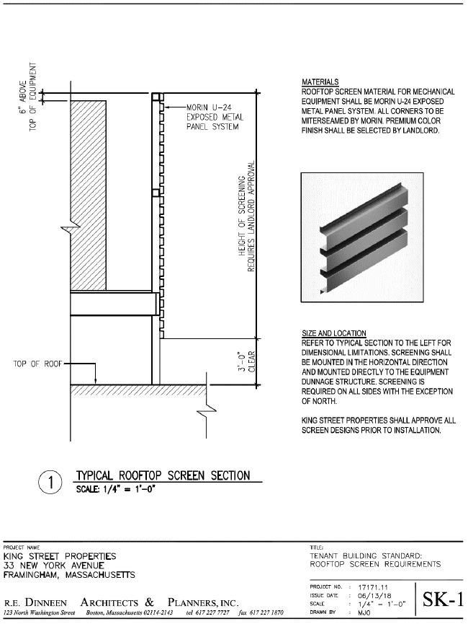

2
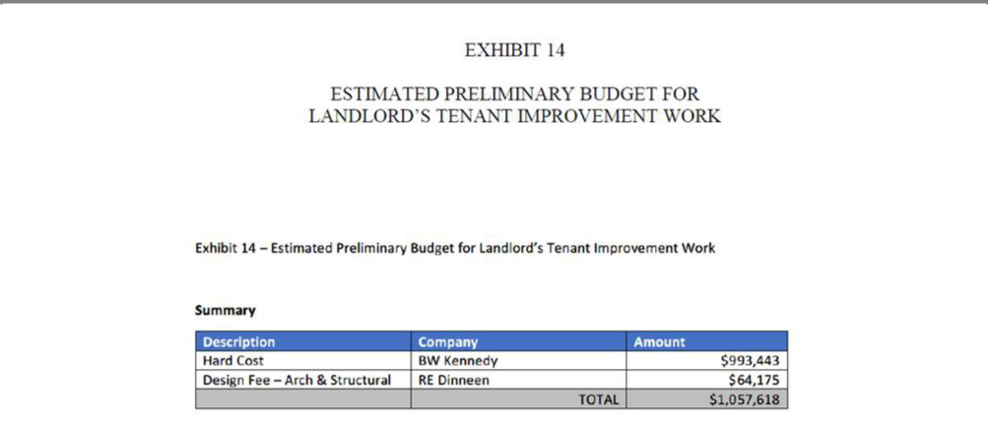

1

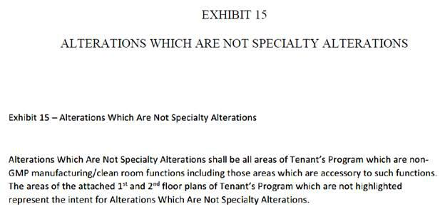

1

QuickLinks -- Click here to rapidly navigate through this document

Exhibit 23.1

Consent of independent registered public accounting firm

We hereby consent to the use in this Registration Statement on Form S-1 of Replimune Group, Inc. of our report dated June 11, 2018 relating to the financial statements of Replimune Group, Inc., which appears in this Registration Statement. We also consent to the reference to us under the heading "Experts" in such Registration Statement.

/s/ PricewaterhouseCoopers LLP

Boston, Massachusetts
June 22, 2018

QuickLinks

Exhibit 23.1

Consent of independent registered public accounting firm

